
FullArmor PolicyPortal
Technical Brief

A Windows Azure/Software + Services Solution
December 2009



Introduction
The development of “cloud” computing (the hosting and management of Web applications and services on the Internet through data centers), Web services, and related technologies have profoundly changed how technology companies create IT solutions. Cloud computing has also opened new markets by providing customers with access to cost-effective, scalable technologies that address the needs of organizations around the world.

FullArmor, a Microsoft Gold Certified Partner, exemplifies how solution providers are taking advantage of these new technologies in rich, innovative ways. FullArmor started out providing traditional client/server applications and hosted services to help organizations manage end-user policies and security for PCs, laptops, and other endpoint devices.

The company then made a strategic decision to revamp the architecture of its core product, FullArmor PolicyPortal, using a combined software-plus-services and cloud-computing approach. The new design provides software that “just works” with all the benefits of an infinitely scalable data center.

FullArmor used Windows Azure, a cloud-services operating system from Microsoft, which serves as the development, service hosting, and service management environment for the Windows Azure platform. When redesigning PolicyPortal for Windows Azure, FullArmor developers were able to use their expertise with the Microsoft Visual Studio 2008 development system, working in their preferred development environment with common development standards and protocols. The company’s existing software was easily modified to add cloud-based capabilities.

This paper provides an overview of the architecture and design approach FullArmor used for PolicyPortal. It begins with a brief discussion about one FullArmor customer—the government of an emerging African country—that helps to highlight key benefits that result from the technology. That discussion is followed by details about PolicyPortal components and technologies.

Helping a Nation’s Educational System
One of the early customers for FullArmor following its redesign of PolicyPortal was the government of an emerging African nation. That nation’s education ministry wanted to deploy laptops to about 250,000 primary and secondary school teachers across the country.

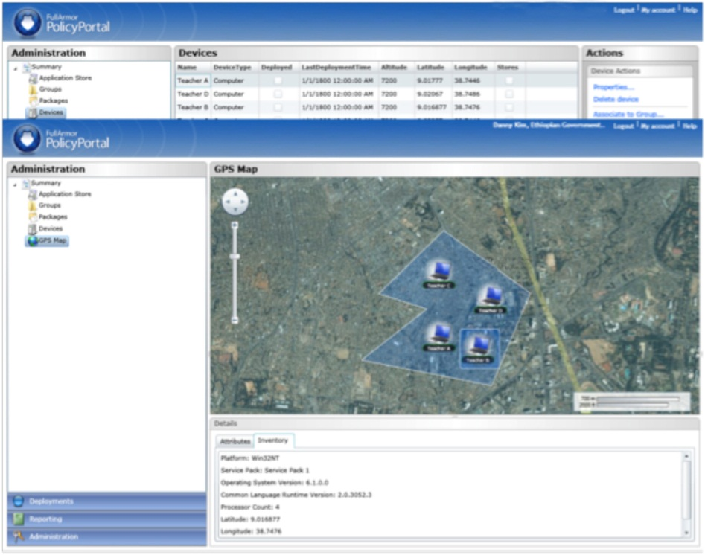
The project faced considerable hurdles. The nation’s IT infrastructure, including its data centers and Internet technology, is in the earliest stages of development. The country lacks capital for large investments in server hardware and enterprise management software. Moreover, the nation’s Internet backbone is prone to frequent outages, many caused by rolling power blackouts. In discussions with FullArmor, the country’s officials also expressed concerns about the need for basic security and management capabilities after the laptops were distributed. How would they keep track of their assets? How could they remotely provide a level of security for the information saved on the laptops? Would it be possible to deploy applications and operating system updates with a very limited IT budget?

The FullArmor PolicyPortal product, redesigned using a software-plus-services approach supported by the Windows Azure platform, provided a viable option to address these needs. Without requiring upfront capital costs for infrastructure, FullArmor could now provide management of the laptops from the cloud. The capital expenditures that the customer would have had to spend on a more traditional solution were instead converted to operational expenditures, helping the customer save money. Notes Danny Kim, Chief Technology Officer for FullArmor, “The Windows Azure environment, supporting the software-plus-services approach, is an ideal scenario for emerging markets where infrastructure costs are a huge barrier to technology deployment.”
A PolicyPortal management view showing the names and locations of laptops that have been deployed.

The next section provides an overview of how the PolicyPortal solution works.

PolicyPortal: A Closer Look
The PolicyPortal solution, based on the software-plus-services approach and the Windows Azure platform, was created with the following Microsoft products and technologies:

- Microsoft SQL Azure database
- Microsoft .NET Framework, a development environment for object-oriented programming and code execution
- Microsoft ASP.NET, a unified Web development model that includes the services necessary to build enterprise-class Web applications
- Microsoft Silverlight, a cross-browser, cross-platform, and cross-device browser plug-in used to design, develop, and deliver applications and experiences on the Web
- Microsoft Application Virtualization (App-V), a component of the Microsoft Desktop Optimization Pack (MDOP) that makes it possible for applications to be transformed into centrally managed virtual services
- Group Policy, a Windows Server operating system feature used for centralized configuration management of the operating system and applications that run on the operating system
- Active Directory, a component of Windows Server used to manage user identities and relationships on a network
- Microsoft Background Intelligent Transfer Service (BITS), a Windows Server component that optimizes the transfer of software updates over Internet connections
- Windows Identify Foundation, a federated identity framework that supports formats such as Active Directory and Windows Live ID for authenticating end users and devices
- Windows PowerShell, an interactive command-line interface and scripting technology
- Windows Sensor and Location, a technology introduced in the Windows 7 client operating system that works with sensors such as GPS devices to provide location and other information about devices and applications

These products and technologies buttress the five components that constitute the core of the PolicyPortal solution:
- Windows Azure operating system
- PolicyPortal Services
- PolicyPortal Data Store
- PolicyPortal Agent
- Windows client operating systems (Windows 7, Windows Vista, and Windows XP)

Each of these components is more fully described in the next section.

PolicyPortal: Key Components
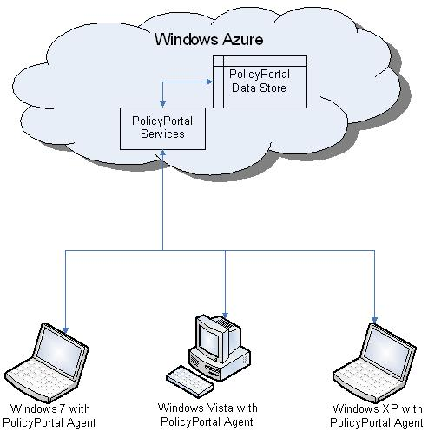

Windows Azure
Laptops running the Windows client operating system connect over the Internet to the PolicyPortal Windows Azure platform.

Windows Azure provides the cloud-based operating system and services for the PolicyPortal solution. By basing its solution on Windows Azure, FullArmor can use the Internet to host, scale, and manage software used on its customers’ devices. Information and services are managed through Microsoft data centers.

PolicyPortal Services
PolicyPortal Services use a Windows Azure computational service to execute .NET code within Microsoft data centers. By tapping into the Windows Azure functionality, FullArmor was able to take advantage of the scalability and failover provided by the Microsoft data centers and available through the cloud.

PolicyPortal Data Store
The PolicyPortal data store uses the simple data storage services of Windows Azure, which include queues, blobs (binary data stored as single entities), and SQL Azure tables. By using the native Windows Azure data storage, FullArmor avoided the need to create its own storage solution for PolicyPortal and instead was able to take advantage of the redundancy and scalability of existing Microsoft database technology.

PolicyPortal Agent
The PolicyPortal Agent is a small software application that runs on Windows-based portable computers. The PolicyPortal Agent can apply system-wide policies to a type of device, or apply policies to users of a single device, such as a group of people sharing one PC. Additionally, the PolicyPortal Agent can be used to download software packages to remote PCs. Configuration information collected by the PolicyPortal Agent can be uploaded to PolicyPortal on Windows Azure.

Windows Client Operating Systems
In the African nation scenario, the initial deployment of the PolicyPortal solution included PCs running the Windows Vista and Windows XP operating systems. PolicyPortal also supports Windows 7 and takes advantage of that operating system’s new and enhanced technologies. These include the Windows 7 Sensor Platform, which has application programming interfaces (APIs) that supply information such as the location of a laptop and the current temperature where the laptop is being used. The Location API simplifies location-aware programming and automatically handles transitions between location data providers.

The next section examines how the PolicyPortal solution uses these key components.

PolicyPortal: Architecture
The PolicyPortal architecture consists of several elements, including Web services, tables, blobs, a data channel, queues, worker services, and an agent system service.
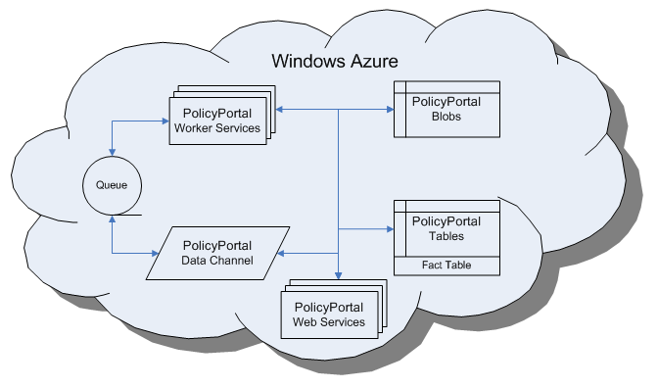

PolicyPortal Web Services
/Core elements of the PolicyPortal architecture.

PolicyPortal Web Services support a browser-based application that is built on Microsoft Silverlight. The application is used by IT administrators to monitor, manage, and secure laptops in the field.

SQL Azure Tables
The PolicyPortal SQL Azure tables store configuration data about devices, including device name, what version of the operating system a device is running, and the device’s IP address. PolicyPortal Web Services read data from the tables to display information to administrators and end users. The Web services also update the data using business logic interfaces and specialized data management logic that warehouses the data into forms suitable for multiple purposes.

PolicyPortal Blobs
Blobs store items such as application installation files, templates for Group Policy objects (GPOs), and documents. Each blob item has a unique identifier used to access a data item. Blob Storage is also used to provide a transient store for spooled data and diagnostics logging.

PolicyPortal Queues
PolicyPortal Queues are the method by which PolicyPortal Web Services communicate with PolicyPortal Worker Services.

PolicyPortal Worker Services
PolicyPortal Worker Services are accessible only through requests that are put into Queues, typically by PolicyPortal Web Services. PolicyPortal Worker Services perform computational and data-intensive tasks asynchronously. These services also perform warehousing, summarizing, refactoring, and integrity maintenance of data.

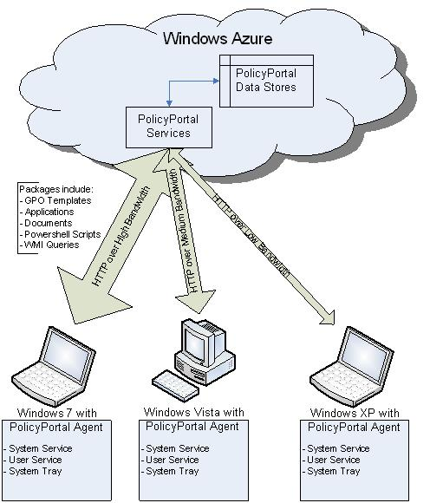
PolicyPortal Agent System Service
The PolicyPortal Agent System Service collects configuration information from devices that have the PolicyPortal Agent installed, through Windows Management Instrumentation (WMI) queries and registry inspections. In continually connected environments, this service is typically conducted once an hour. However, in the African government scenario, where Internet connectivity is frequently interrupted, the service is carried out only when a connection is enabled.
The PolicyPortal Agent System Service includes Agency System Trays that can be used for providing notifications of the agent’s activities. The trays also serve as diagnostics collection tools.

The PolicyPortal Agent takes note of any policies it doesn’t presently have and begins a low-bandwidth download of each item. The Agent System Service also helps deliver various kinds of packages, such as GPO templates containing changes to security settings.

Conclusion: PolicyPortal at Work
The FullArmor PolicyPortal deployment in a developing African nation demonstrates the efficiency of using a software-plus-services approach and the Windows Azure platform for a large-scale, cost-effective solution with enhanced security procedures, even in an environment with considerable Internet connectivity issues.

When a teacher receives a portable PC, he or she is also provided with an e-mail address and a Windows CardSpace identity. Windows CardSpace is used when administrators need to transmit confidential information or send out laptop- or user-specific policy updates. In addition, PolicyPortal provides a set of management tools presented through a Web browser that make it possible for administrators to perform tasks such as issuing software updates, adding authorized users to specific laptops, or conducting asset inventories.

To help connect remote laptops with the cloud-based services, PolicyPortal has an Internet Service Bus (ISB). The ISB is used to push centralized information out to individual PCs, such as announcements about new government policies or updates on food shortages that may affect teachers.

The solution works effectively within the African nation’s Internet infrastructure, which can be very slow or, at times, entirely disrupted. The delivery of software packages is optimized using the Background Intelligent Transfer Service (BITS). BITS sends small portions of software updates at a time. If an Internet connection is disrupted while a package is being downloaded to a PC, BITS helps to identify where the download was stopped, and then begins the process at that point when the connection is restored.

The African government began distributing laptops to teachers across the country in early 2010. A full deployment of approximately 250,000 laptops was scheduled for completion by 2013.

“The customer was looking at upgrading the quality of its educational system and teachers. It not only wanted to connect all the teachers together, but also to train them so there is a consistent way of delivering education. PolicyPortal helps deliver applications to endpoints through the cloud. It also helps deploy security policies, get status information, inventory, and compliance,” Kim says, noting that the software-plus-services approach and the Windows Azure platform helped to create a solution that can be replicated in emerging markets.

“We can scale this application from 10 users to half a million users in the blink of an eye,” Kim says. “The fact that Microsoft created a development environment for the cloud platform using familiar Visual Studio tools made the transition very easy. We ourselves were stunned at how quickly we could develop a solution for a large government agency and get the service up and running.”

For More Information
Microsoft Corporation
To learn more about Windows Azure, visit www.windowsazure.com. To learn more about the Microsoft approach to software-plus-services, visit www.microsoft.com/softwareplusservices.

FullArmor
To learn more about Full Armor, visit the company’s Web site at www.fullarmor.com, or call (800) 653-1783.

The information contained in this document represents the current view of Microsoft Corporation on the issues discussed as of the date of publication. Because Microsoft must respond to changing market conditions, it should not be interpreted to be a commitment on the part of Microsoft, and Microsoft cannot guarantee the accuracy of any information presented after the date of publication. This white paper is for informational purposes only. MICROSOFT MAKES NO WARRANTIES, EXPRESS OR IMPLIED, IN THIS DOCUMENT. © 2009 Microsoft Corporation. All rights reserved.

