Microsoft Education
Customer Solution Case Study
 | 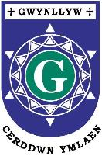 |  |   Welsh Interface Supports Language Immersion at Secondary School

Overview  Country or Region: Wales  Industry: Education  Customer Profile  Ysgol Gyfun Gwynllyw is a Welsh comprehensive school in Torfaen, Wales, with 950 students aged between 11 and 18 years.  Business Situation  As a Welsh-language school, Ysgol Gyfun Gwynllyw wanted the best technology appropriate for an educational setting provided in the national language.  Solution  Through the Microsoft Local Language Program, Microsoft Office Language Interface Packs integrated Welsh into the learning environment using cutting-edge technology.  Benefits  - Active learning  - Modern context  - Intuitive interface  - Seamless implementation  - Smooth integration  - Modern context  - Intuitive interface  - Seamless implementation  - Smooth integration |  |  | “Overall, I would say the Welsh interface for Microsoft Office is excellent. I thoroughly recommend that all Welsh schools use it.”  Alun Thomas, Head of Information Communications and Technology (ICT), Ysgol Gyfun Gwynllyw
 |  |  | Although the Welsh language is an integral part of Wales’s national identity, the number of speakers has dwindled over the past 100 years. However, with emphasis on the use of Welsh in schools and other public sector organisations, the number of Welsh speakers has increased at the last National Census in 2001. At Ysgol Gyfun Gwynllyw, students receive an education completely immersed in the Welsh language, with all subjects being taught in Welsh. The Microsoft Local Language Program (LLP) supports this commitment to immersive education, with the Microsoft Office Language Interface Pack (LIP) integrating the language into the interface of Microsoft products used on campus. The school’s Learning Plaza—a state-of-the-art multimedia learning environment—gives teachers the tools they need to integrate technology across the curriculum with cutting-edge solutions, such as Windows 7 and Microsoft Surface.
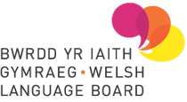

Situation
Welsh is one of Europe’s oldest languages. Although the number of Welsh speakers has decreased historically, it rose from 509,098 in 1991 to 582,000 in 2001. This is attributed to an increase in the number of speakers among young people, particularly between the ages of five and 15 years. Schools have played a large part in this shift, as has the Welsh Language Act of 1993, which requires public bodies providing a service to people in Wales to implement a Welsh Language Scheme, providing those services in both Welsh and English. The act emphasises that the Welsh language is: “an essential and enduring component in the history, culture, and social fabric of the nation.”
“When students see Welsh integrated into the latest technology, it reinforces the work we do here to show that Welsh is relevant to all aspects of today’s society.”
Alun Thomas, Head of Information Communications and Technology (ICT), Ysgol Gyfun Gwynllyw

Located in Torfaen, Wales, Ysgol Gyfun Gwynllyw is a Welsh-medium comprehensive school serving the counties of Newport, Blaenau Gwent, Monmouthshire, and Torfaen. Founded in 1988 with 51 students, the school currently has 950 students between the ages of 11 and 18 years, who come from a range of Welsh-language feeder schools.

Around 97 per cent of the students speak English at home. They all speak Welsh as a first language within the school, and all subjects, except other languages, are taught in Welsh. Alun Thomas, Head of Information Communications and Technology (ICT) at Ysgol Gyfun Gwynllyw, says: “In south-east Wales, generations of families had a connection with Welsh, but lost it over the past two or three generations. Many of our parents send their children here because they want to give them opportunities they didn’t have. They understand that within a modern, bilingual society, the ability to communicate in both languages will not only save our heritage, but can improve the prospects of students leaving school.” Thomas adds that 75 per cent of students at Ysgol Gyfun Gwynllyw go on to further and higher education—well above the national average.

Technology plays an important role in this vision for a 21st-century education. Several computer labs on campus were used by instructors for lessons across the curriculum. While students could create documents in Welsh, and look up Welsh websites, the interface of the applications students used was in English. “The tool bar and menus were in English. I found myself having to use English words to talk about the technology,” says Thomas. “This was interrupting our practice of immersive learning, and giving the impression that Welsh is not a language used within modern technology.”

Solution
Microsoft technology is renowned for its worldwide applications and has funded free Microsoft Office Language Interface Packs (LIPs) for many languages, giving users the opportunity to experience the features of Microsoft Office Excel, Office Outlook, Office PowerPoint, and Office Word in their native language. The Welsh LIP is also available for Windows operating systems, including Windows 7.

In 2003, Microsoft partnered with the Welsh Language Board to develop the first Welsh LIPs, for Windows XP and Office 2003. Dr. Jeremy Evas, Leader of the Research, Grants, and Language Technology Unit at the Welsh Language Board worked closely with Microsoft during the process, managing the project, conducting quality control, and helping to implement a Microsoft Style Guide and terminology list in Welsh. Evas says: “I work with a lot of translators on many different types of projects, and am really happy with such a high quality translation of Office and Windows. It flows well and is easy to read. That’s important when Welsh is being integrated into a new context.”
When the Welsh-language interface was complete, Ysgol Gyfun Gwynllyw was eager to integrate the technology. Thomas says: “Overall, I would say the Welsh interface for Microsoft Office is excellent. I thoroughly recommend that all Welsh schools use it.”
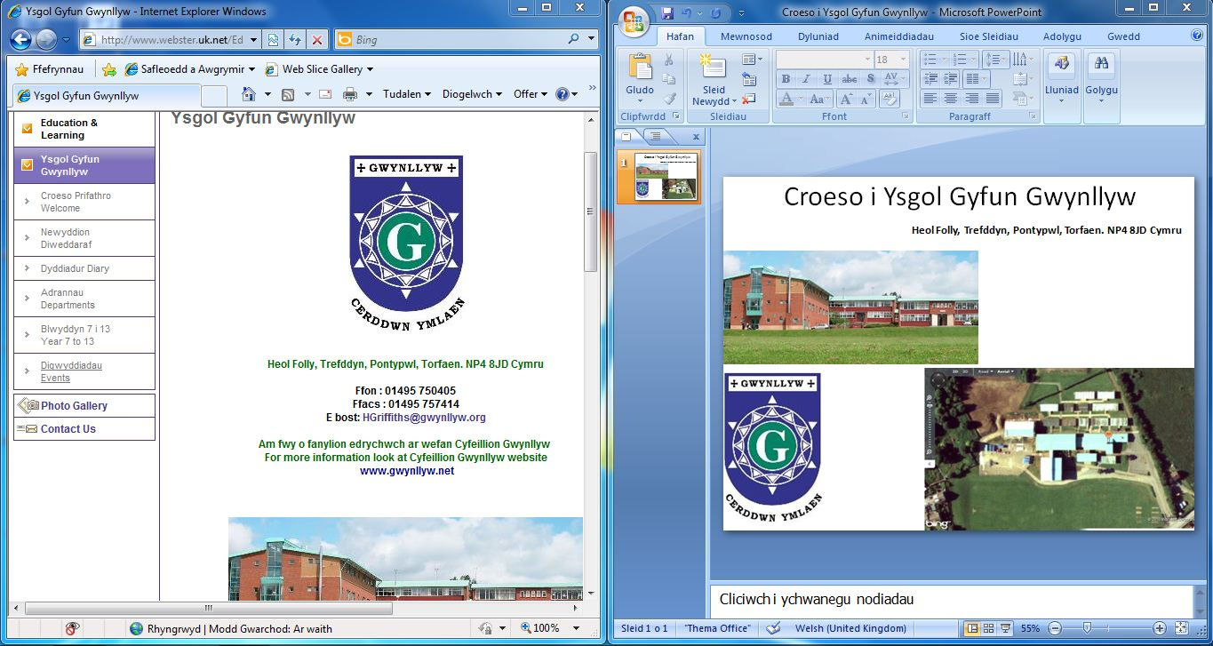
In 2010, Ysgol Gyfun Gwynllyw received a grant from the European Objective 1 Fund, supplemented by the Welsh Assembly Government to update the technology used for teaching and learning. In addition to portable computers running on the Windows 7 operating system for every classroom, the school invested in a Learning Plaza, a multimedia centre providing cutting-edge technology to aid learning. Students and staff at Ysgol Gyfun Gwynllyw call the Learning Plaza “Talwrn,” which means “a meeting place,” in Welsh.

Following the local authority’s strategy for technology-rich learning, Torfaen Council worked closely with the school to implement a learning environment that will enhance the curriculum. Council IT staff installed all of the latest Microsoft technologies, including a full suite of desktop and portable computers equipped with Windows 7. Teachers can use Microsoft Office Communications Server 2007 R2 to set up video conferences with other schools. Approximately three lessons a day are conducted using videoconferencing with the partner school Ysgol Gyfun Cwm Rhymni. Subjects include mathematics, business studies, law, sociology, and travel and tourism. Videoconferencing is also used to communicate with feeder schools and universities, to ease the transition for students entering Ysgol Gyfun Gwynllyw and leaving the school for university.

There are two Microsoft Surface tables equipped with multitouch technology that users can interact with, moving items around the screen by touching them. A peer-to-peer program links applications running on the tables with computers in the Talwrn. The school also received a fully equipped production studio for students to create and broadcast videos. A dedicated team at the council focuses on developing curriculum applications that take advantage of Microsoft Surface technology.
The option of displaying two windows, side by side, makes it easy for students to refer to online resources while creating documents.

Benefits
The Talwrn, supplemented by the latest Welsh-language version of Windows 7 provides an environment where students are actively engaged in their own learning and supports work being done on portable computers in the classrooms. Teachers move between groups of students, acting as mentors and guiding them towards arriving at their own conclusions. Welsh is naturally integrated into the user interface, illustrating its use in a technology-rich environment.

Technology Encourages Active Learning
The interactive nature of the technology encourages students to participate actively in their own learning. Cutting-edge technology such as three-dimensional video and touch-screen applications make learning fun, encouraging creativity and fostering a sense of independence. Glyn Rogers, Geography Teacher at Ysgol Gyfun Gwynllyw, says: “Students look forward to spending class time here and I look forward to designing lessons that make the best of the technology. It makes learning fun.”
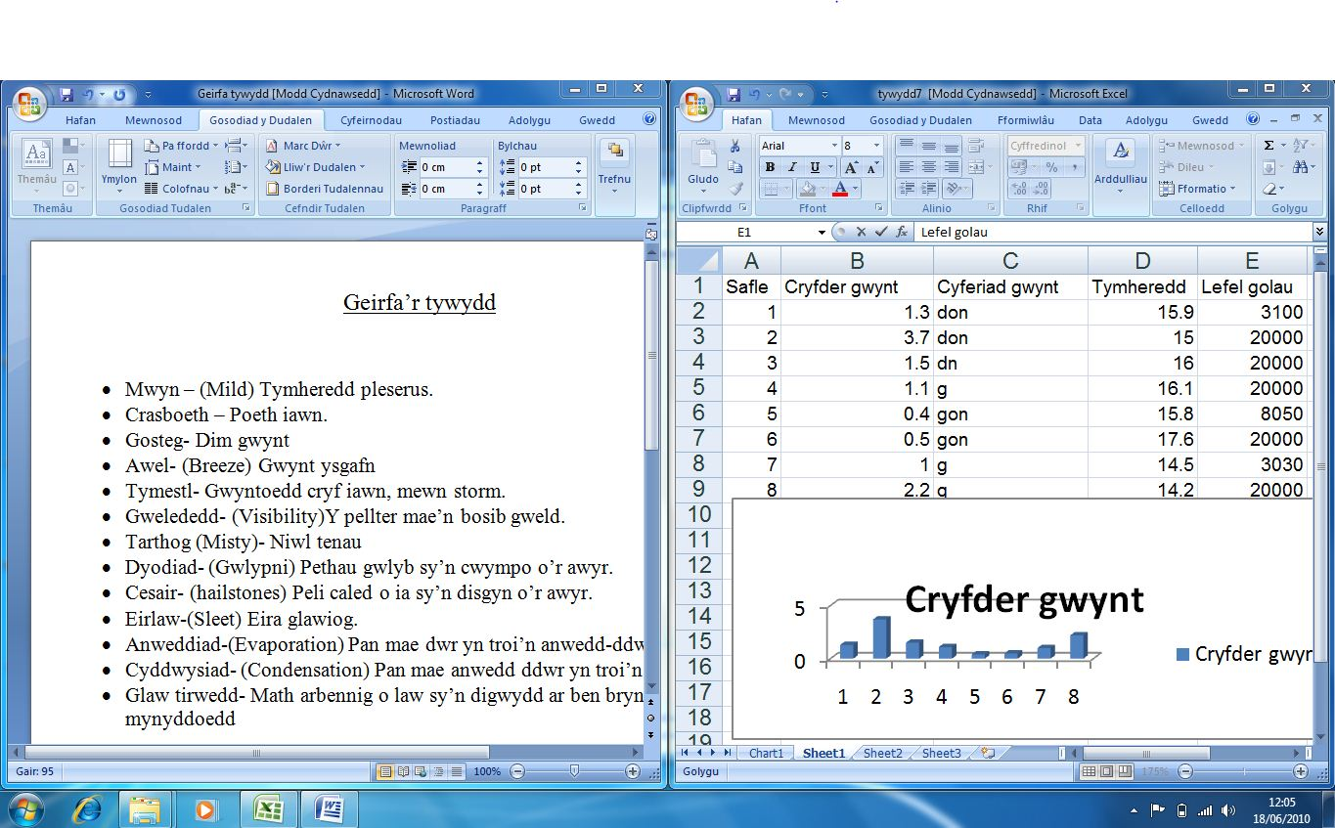

Students See the Language Used in a Modern Context
With a Welsh user interface, including menus and tool bars, students see the language in a modern context. Thomas says: “When students see Welsh integrated into the latest technology, it reinforces the work we do here to show that Welsh is relevant to all aspects of today’s society. When students understand this, they are more likely to speak Welsh when they leave school.” This supports the goal of Ysgol Gyfun Gwynllyw to help students become active members of a modern, bilingual society that values heritage while looking towards the future.

The bilingual nature of language in Wales is also addressed with easy ability to switch between Welsh and English interfaces. It can be set to open in the preferred language of each specific user. Evas says: “Considering that 80 per cent of children between the ages of three and 15 years live in homes where not everyone speaks Welsh, this is a useful feature.”

Teachers Like Intuitive Welsh Interface
The modern look and feel of Windows 7 with a Welsh-language interface increases the use of technology across the curriculum. Thomas says: “Teachers of subjects that do not traditionally use computing in the classroom have embraced the technology, especially with the integration of Welsh.”

The user-friendly interface of Windows 7 has the look and feel that students expect to see, while features, such as side-by-side viewing and easy search and document management, are simple for students and teachers to use without training or technical support.
The user interface enables all menus and tool bars to show the Welsh language in a modern context.

Seamless Implementation Easily Adopted by Staff and Students
The conversion of Microsoft Office applications from English to Welsh was seamless. Once the interface was implemented, the applications automatically opened in Welsh. Thomas says: “Everybody’s accepted the new interface easily. The technology that used to be in English is now in Welsh. Staff have taken to it well because it’s easy to integrate it into more lessons. Even people who were used to working on an English menu are using it more because it supports the ethos of our school—providing an immersive education in Welsh.”

Windows 7 Integrates Smoothly with all Technology in the Talwrn
Supported by Windows Server 2008 R2 at the district office, and wireless Internet connection on campus, Windows 7 integrates smoothly with all technology on campus. “We used to have a lot of separate systems and applications, but now everything integrates seamlessly,” says Thomas. “For example, Microsoft Surface and Windows 7 will integrate in a way that will encourage teams of students to work together on projects such as designing and publishing our student magazine.”

This easy integration encourages even more use of other technologies. Thomas says: “One of the most effective lessons I’ve seen using multiple technologies at the same time was a politics lesson that required students to write a newspaper article about an historic event after viewing newsreels, listening to speeches, and reading accounts of the event.”

Microsoft Education
Software and Services  - Microsoft Office  - Microsoft Office Language Interface Pack  - Microsoft Office Excel  - Microsoft Office Outlook  - Microsoft Office PowerPoint  - Microsoft Office Word | - Microsoft Server Product Portfolio  - Windows Server 2008 R2  - Windows 7  Hardware  - Microsoft Surface

This case study is for informational purposes only. MICROSOFT MAKES NO WARRANTIES, EXPRESS OR IMPLIED, IN THIS SUMMARY.

Document published September 2010

For More Information
For more information about Microsoft products and services, call the Microsoft Sales Information Center at (800) 426-9400. In Canada, call the Microsoft Canada Information Centre at (877) 568-2495. Customers in the United States and Canada who are deaf or hard-of-hearing can reach Microsoft text telephone (TTY/TDD) services at (800) 892-5234. Outside the 50 United States and Canada, please contact your local Microsoft subsidiary. To access information using the World Wide Web, go to:
www.microsoft.com

For more information about the Local Language Program or to download the Welsh Language Interface Pack, visit the website at:
http://www.microsoft.com/LLP

For more information about The Welsh Language Board products and services, visit the website at:
www.byig-wlb.org.uk

For more information about Ysgol Gyfun Gwynllyw products and services, visit the website at:
www.gwynllyw.org

Microsoft technology, programs, and solutions can improve teaching and learning opportunities for instructors and students and make education administration more successful.

For more information about Microsoft Education, please go to:
www.microsoft.com/education
www.microsoft.com/education/schools
www.microsoft.com/education/highered

