Windows 7 & HomeGroup
Sharing with Windows XP, Windows Vista & other Operating Systems
Abstract
The purpose of this white paper is to explain how your computers that are running previous versions of Windows can access the files and printers shared with your homegroup on your computer(s) running Windows 7.
HomeGroup takes the headache out of sharing files and printers on a home network. It is a collection of two or more computers in the home that are automatically set up for easy sharing of music, pictures, video, and document libraries, as well as any connected printers with others in your home. It also allows you to stream media to devices.
Version 1.0.0 – October 1, 2009
The information contained in this document represents the current view of Microsoft Corporation on the issues discussed as of the date of publication. Because Microsoft must respond to changing market conditions, it should not be interpreted to be a commitment on the part of Microsoft, and Microsoft cannot guarantee the accuracy of any information presented after the date of publication.
This White Paper is for informational purposes only. MICROSOFT MAKES NO WARRANTIES, EXPRESS, IMPLIED OR STATUTORY, AS TO THE INFORMATION IN THIS DOCUMENT.
Complying with all applicable copyright laws is the responsibility of the user. Without limiting the rights under copyright, no part of this document may be reproduced, stored in or introduced into a retrieval system, or transmitted in any form or by any means (electronic, mechanical, photocopying, recording, or otherwise), or for any purpose, without the express written permission of Microsoft Corporation.
Microsoft may have patents, patent applications, trademarks, copyrights, or other intellectual property rights covering subject matter in this document. Except as expressly provided in any written license agreement from Microsoft, the furnishing of this document does not give you any license to these patents, trademarks, copyrights, or other intellectual property.
© 2009 Microsoft Corporation. All rights reserved.
Microsoft®, Windows®, Windows Vista®, Windows XP® are either registered trademarks or trademarks of Microsoft Corporation in the United States and/or other countries.
Apple®, Mac®, and Mac OS® are trademarks of Apple Inc., registered in the U.S. and other countries.
Ubuntu® is a registered trademark of Canonical Ltd.
Linux® is a registered trademark of Linus Torvalds in the U.S. and other countries.

Contents
Introduction 3
Windows Libraries 3
Sharing On Windows 7 4
Setting up a password protected sharing account 7
Accessing content shared with the homegroup from computers not running Windows 7 10
Using Windows Vista to access homegroup content 11
Using Windows XP to Access homegroup content 12
Using Mac OS X to access homegroup content 13
Using Ubuntu (release 8.04) Linux to access homegroup content 15
Installing HomeGroup Printers on previous versions of Windows 17
Using Windows Vista to install a homegroup printer 17
Using Windows XP to install a homegroup printer 22
Sharing with Windows 7 from Windows XP or Windows Vista 25
Sharing on Windows XP 25
Sharing in Windows Vista 26
Sharing on Linux (Ubuntu) 26
Sharing on Mac OS X 26
Troubleshooting 27
Security 27
Authentication 27
Encryption 29
Workgroups 29
Network Discovery 30
Hiding the user account from the login screen 31
All versions of Windows 7 31
Windows 7 Ultimate and Professional 31

Introduction
HomeGroup is a new feature in Windows® 7 that allows you to connect two or more computers running Windows 7 and easily share your Music, Pictures, Video, and Document libraries as well as printers with others in your home. HomeGroup also automatically sets up sharing so that all media shared with the homegroup is accessible from Windows Media Player, Windows Media Center, and other compatible media devices in the home. In addition to HomeGroup, Windows 7 continues to support all existing sharing functionality available since the Windows Vista® operating system, and it can also share with the Windows XP® operating system. Even though previous versions of Windows do not support HomeGroup, it is still possible to access all of your shared homegroup content with computers running previous versions of Windows and other operating systems. A general white paper on HomeGroup is available here.
The purpose of this white paper is to explain how your computers that are running previous versions of Windows can access the files and printers shared with your homegroup on your computer(s) running Windows 7. Note that if you own multiple computers running Windows 7, this document is not required for you to share files and printers. All you need is to use the HomeGroup feature that is automatically enabled on your Windows 7 PCs. See this online help topic.
This white paper covers the following tasks:
- Setting up your computer(s) running Windows 7 to enable access from other computers including:
  - Computers running previous versions of Windows
    - Windows Vista
    - Windows XP
  - An Apple® computer running Mac OS® X operating system software
  - Computers running Ubuntu® Linux®
- Enabling previous versions of Windows to install printers shared with the homegroup on a computer running Windows 7.
- A brief overview of sharing from previous versions of Windows to Windows 7, and associated help links.
Readers who encounter problems should also read the Troubleshooting section of this white paper, which covers some additional security and encryption requirements for sharing.

Windows Libraries
Libraries, a new feature in Windows 7, gather files from different locations into one place. Windows 7 allows users to share their libraries with others in their home using a homegroup. Every Windows 7 computer that is part of the homegroup is then able to view and access shared libraries in a seamless manner.
It is important to note that Windows Vista and Windows XP do not provide support for sharing in the home using HomeGroup or libraries. As a result, when sharing between a computer running Windows 7 and a computer running a previous version of Windows, only folders will be visible. When sharing between computers running Windows 7, libraries and folders will be visible.
For example, the Music library includes two folders by default: My Music and Public Music. If you share your Music library with a computer running Windows Vista or Windows XP, the library itself won’t be visible, but the folders included in it will. Note that individual folders can be shared between Windows 7 computers independently of libraries by sharing the folder with the homegroup.

Sharing On Windows 7
This section discusses different ways to access homegroup data shared on a computer running Windows 7 from a computer not running Windows 7.
To begin, make sure that your computer running Windows 7 is already part of a homegroup. If you set up your computer while on your home network, it is likely that your computer is already part of a homegroup. Open HomeGroup in Control Panel and make sure that you are sharing some libraries with the homegroup. If your computer isn’t part of a homegroup, go ahead and create one or join one, depending on what is displayed in the HomeGroup Control Panel. As an example, this is what the HomeGroup Control Panel looks like when you are part of a homegroup.
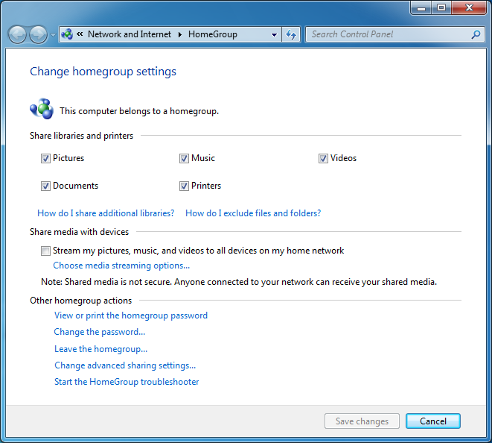
Share more content with the Share With menu in Windows Explorer. You can control how others may access your shared content and what permissions they have when accessing the content as defined below:
- Homegroup (Read) – Your files cannot be changed; they can only be viewed and copied.
- Homegroup (Read/Write) – Your files can be changed, deleted, viewed, and copied, and new files can be created in the shared folder by others.
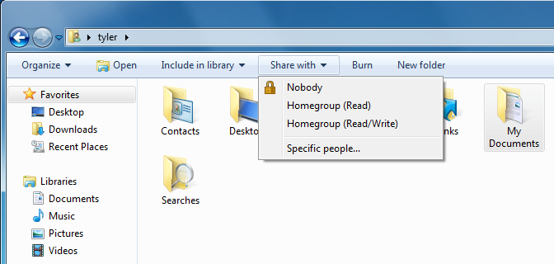
- Option 1: Using a password protected sharing account (Recommended option)
  - This is the preferred way to enable sharing between Windows 7 computers and previous versions of Windows or other operating systems. Only users that know a specific user name and password can access the shared files, ensuring that you control who sees the shared data.
  - Why make a special account just for sharing? If you make a special account, you can give the user name and password to anyone you want to share with the homegroup. If you don’t make a separate account, you’ll have to give out your personal user name and password in order to enable sharing. Additionally, all the data in your user account will also be accessible. Making a separate sharing account prevents this and ensures that only data that is shared with the homegroup is accessible.
  - When creating a user account solely for the purpose of sharing, it is recommended that you create it as a Standard user account and not an Administrative user. This provides even greater security when giving out the user name and password for the sharing user account to others because the account will not have any administrative rights on your computer.
- Option 2: Synchronizing user accounts and passwords across all of your computers (Advanced users)
  - If you are an advanced user, you might have set up all of your computers with the same user accounts and passwords. HomeGroup supports this, as everything you share with the homegroup is also shared with your user account. You can change the per-user setting “HomeGroup connections” in Advanced sharing settings in Control Panel to use your user account and password. When you connect to other computers (in your homegroup or just on your network), you will automatically authenticate with your user credentials instead of HomeGroup credentials and get access to all content shared with you as opposed to just the homegroup. This setting is only recommended for advanced users.
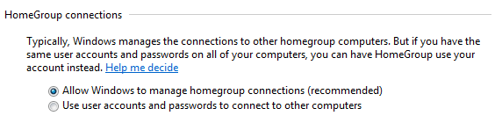
- Option 3: Disable password protected sharing and sharing data with “Everyone” (Not recommended)
  - This will cause content shared with “Everyone” to be accessible by any anonymous user on your network.
  - This is not the preferred way of sharing as it can compromise the security of your data by providing access to anyone on your network.
  - If required, you can disable the password protected sharing setting in Advanced sharing settings in Control Panel.

Setting up a password protected sharing account
This section will guide you through the process of setting up your computer running Windows 7 to allow access to shared data from other computers. After you complete this section, you will have created a new user account that you can use on your other computers to access content shared with the homegroup on this computer running Windows 7.
On your computer running Windows 7:
- Click the Start button, type “user accounts” in the search box, and then click User Accounts and Family Safety.
- Click Add or remove user accounts, and then click Create a new account.
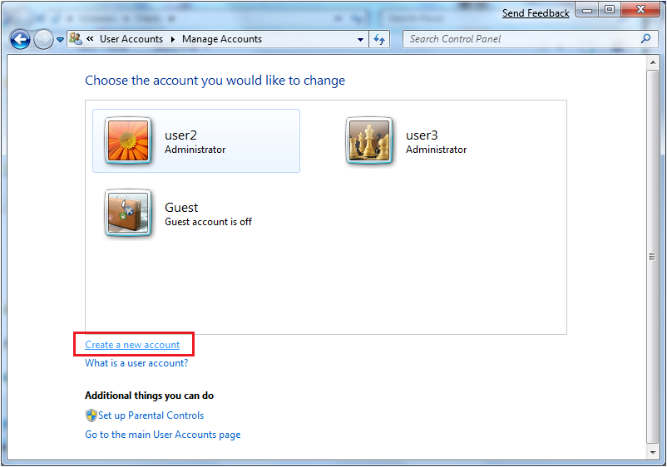
- Type a name for the new account, such as “share.”
Note: For the rest of this document, the steps and screenshots refer to share as the account created specifically to allow access to homegroup shares.
- Click Standard user, and then click Create Account.
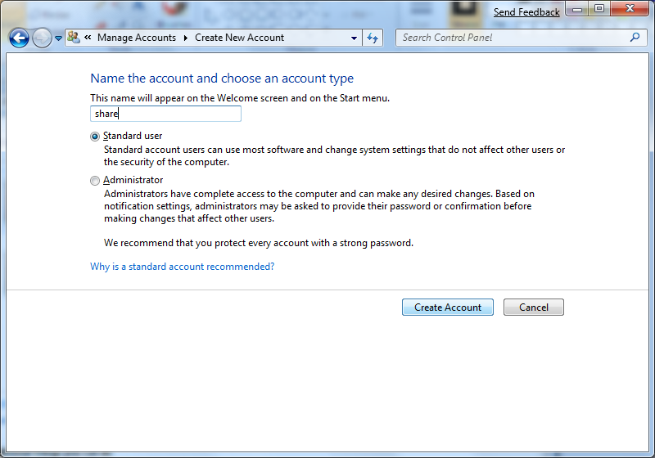
- Click the tile for the user account you just created, and then click Create a password.
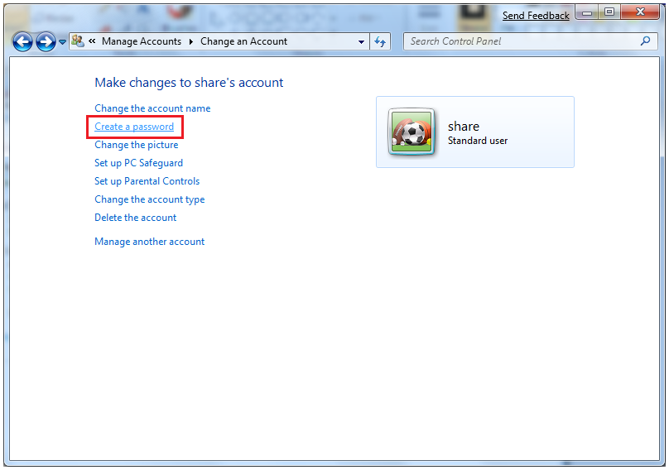
- Enter a memorable password. Don’t use the same password you use for your computer account or for important websites such as banking websites. Unless you control all of the computers you want to share with, make it a password that you are comfortable giving out to people you trust.
- Type a password hint, and then click Create password.
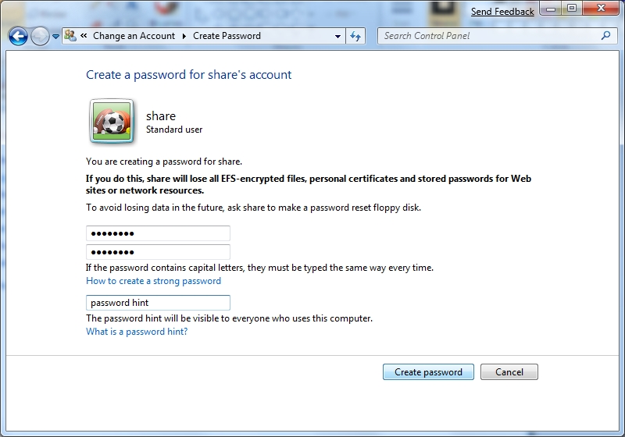
- Log on as the user you created (for example, share), and then log off. (This is required so that the user account is created with the correct credentials.)
- Repeat these steps on every Windows 7 computer that you need to access from another operating system.
Note: If desired, see the “Hiding the Sharing User Account from the Login Screen” section at the end of this white paper for instructions on removing this user name (for example, share) from the logon screen.

Accessing content shared with the homegroup from computers not running Windows 7
Make sure you know the user name and password of the sharing account you created in the section above (Setting up a password protected sharing account).
If you are using a computer running Windows Vista or Windows XP, continue directly to that section below. If your computer is running Mac OS X or Ubuntu Linux, first write down the following information:
The following steps explain how to gather some critical information for connecting to the computer running Windows 7.
On the computer running Windows 7, find the computer name:
- Click the Start button, right-click Computer, and then click Properties.
- Write down the computer name. 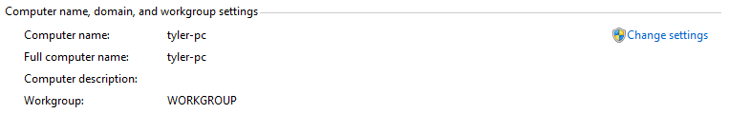
Get the computer’s IP address:
- Click the Start button, type “network” in the search box, and then click Network and Sharing Center.
- Next to “Connections,” click the link for your home network, and then click Details.
- Note the number next to “IPv4 Address” (usually 192.168.*.* or 10.*.*.*).
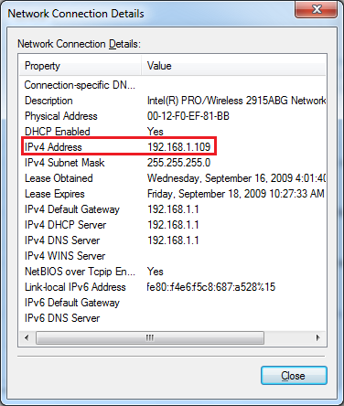
You will need these three pieces of information below.

Using Windows Vista to access homegroup content
If you have a computer running Windows Vista, follow these steps to access homegroup content shared by your computer running Windows 7.
- Click Start, click Network, and then double-click the computer you want to access.
- When prompted for credentials, use the user account and password you created earlier (for example, share).
- If you don’t want to be asked for a password every time you access the shared folder, click Remember my password.
- Click the Users share to access the files and folders that are shared with the homegroup.
- If desired, you can set up quick access to folders you want to access frequently by dragging the folder to the left pane, under Favorite Links. The folder will be saved as a favorite, and you can always access it from the Favorite Links area.
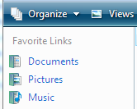

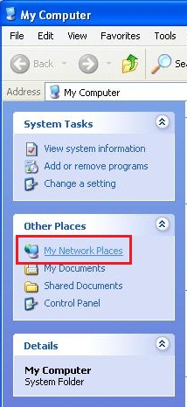
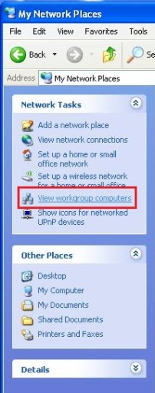
Using Windows XP to Access homegroup content
If you have a computer running Windows XP, follow these steps to access homegroup content shared by your computer running Windows 7.
- Click Start, click My Computer, click My Network Places, and then click View workgroup computers.
- Double-click the computer you want to access.
- When prompted for credentials, use the user account and password you created earlier (for example, share).
- If desired, you can set up quick access to folders you want to access frequently by right-clicking the Users folder (or a subfolder) and then clicking Map Network Drive. Follow the instructions that appear.
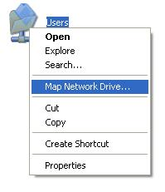
- You can then access the mapped drive by clicking Start and then clicking My Computer. The folder will be listed under Network Drives.
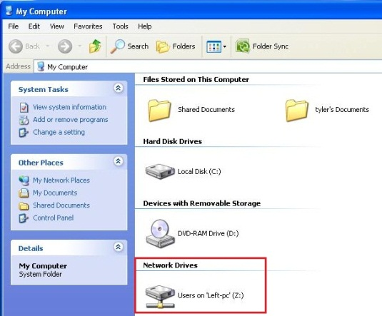

Using Mac OS X to access homegroup content
If you have an Apple computer and are using Mac OS X, follow these steps to access homegroup content shared by your computer running Windows 7.
- If the computer running Windows 7 appears under the Shared section in Finder, use the user name and password that you created earlier to connect to it.
If the computer running Windows 7 doesn’t appear automatically in Finder:
- First review the following support article from Apple: http://docs.info.apple.com/article.html?path=Mac/10.5/en/8208.html
If that information doesn’t help you solve the problem, follow these steps:
- Open Finder.
- In the toolbar, click Go, and then click Connect to Server (or use keyboard shortcut Command +K).
- In OS X 10.3.x and later, click Browse, select the computer running Windows 7, and then click Connect. (Or follow the common instructions below.)
- In OS X 10.2.x, click the pull-down menu, select the computer running Windows 7, and then click Connect. (Or follow the common instructions below.)
Common Instructions: In any OS X version, you can do the following:
Note: Recall the computer name and IP address you collected from section Accessing content shared with the homegroup from computers not running Windows 7.
- Type smb://username@computername/users
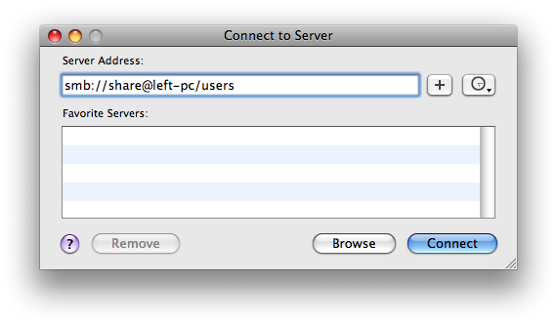
- Connect as username and enter your password.
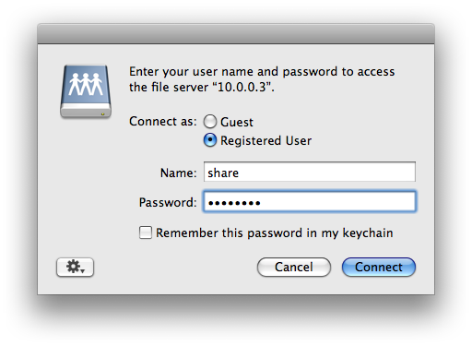
Note: If the connection is unsuccessful, try using the IP address instead. For example, type the following:
smb://username@ipaddress/users
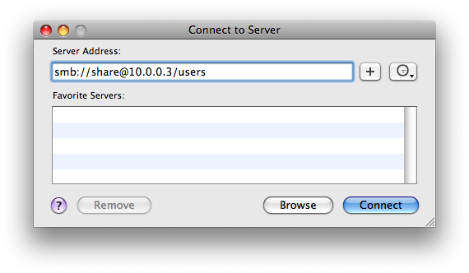
The computer running Windows 7 should now be available in Finder when you click Go and then click Network. The computer will also appear under Shared in Finder.
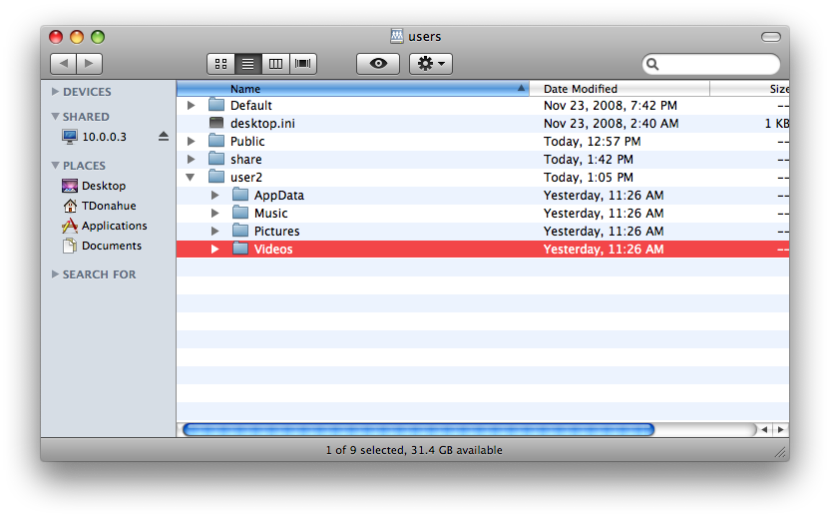

Using Ubuntu (release 8.04) Linux to access homegroup content
If you have a computer running Ubuntu Linux, follow these steps to access homegroup content shared by your computer running Windows 7.
- Open Places, and then click Network. The Windows 7 computers on your network might be visible, but they won’t be accessible.
- Using the button on the left end of the Location bar, toggle the Location bar to text.
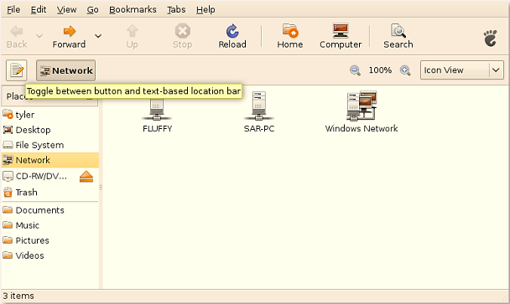
- Type smb://username@computername/users or smb://username@ipaddress/users
- Type your password.
- If you want to always connect to this share, click Remember forever.
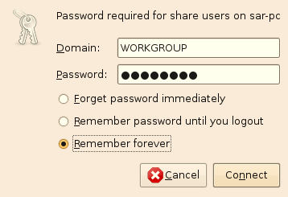
- Double-click the user name you want to access. The files that are shared with the homegroup will be displayed.
Note: The shared folder is mounted on your desktop and in the navigation pane automatically.
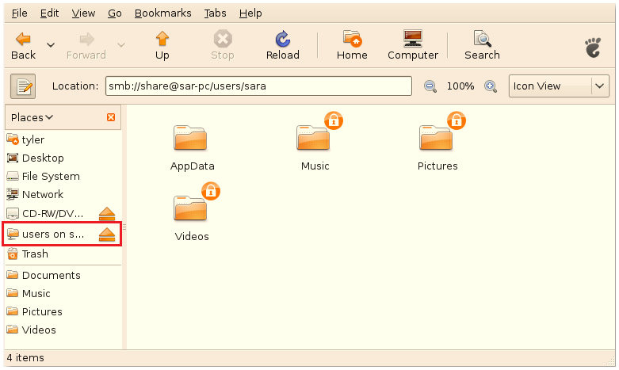

Installing HomeGroup Printers on previous versions of Windows
This section explains the steps you need to take on your computer running Windows Vista or Windows XP to access printers installed on your homegroup computer running Windows 7.
After creating and joining a homegroup, printers that you install will be automatically installed on other homegroup computers. If you want to connect to these printers from Windows Vista or Windows XP, you will need to create a sharing account. If you have not yet created a sharing account to access content from previous version of Windows, see the Setting up a password protected sharing account section of this white paper.

Using Windows Vista to install a homegroup printer
If you have a computer running Windows Vista and want to use a printer that is installed on a homegroup computer running Windows 7, follow these steps.
- On the computer running Windows Vista, open Printers in Control Panel.
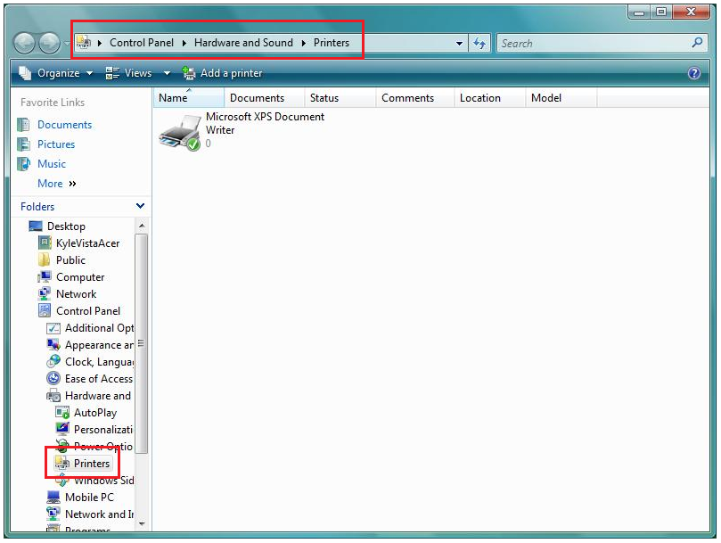

- In the command bar, click Add a printer, and then click Add a network, wireless, or Bluetooth printer.
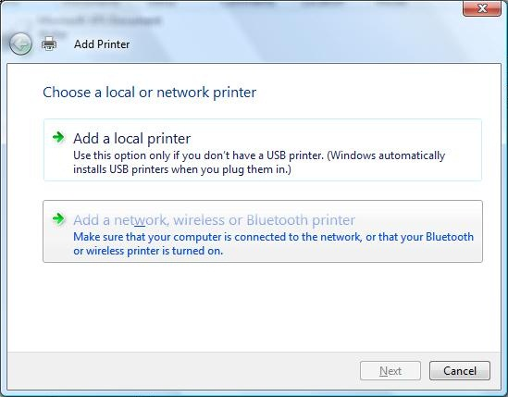

- Windows will search for shared printers, but won’t find ones that you don’t have access to. Click The printer that I want isn’t listed.
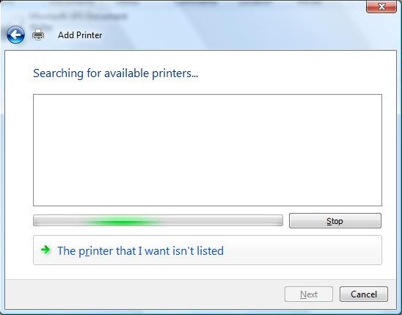

- You can manually enter the name of the printer in the dialog box or select Browse for a printer and then click Next.
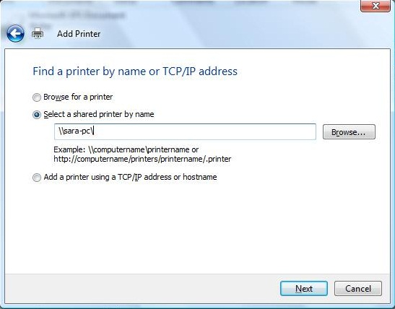

- In this example, we are going to browse for a printer. Click the computer that installed the printer, and then click Select.
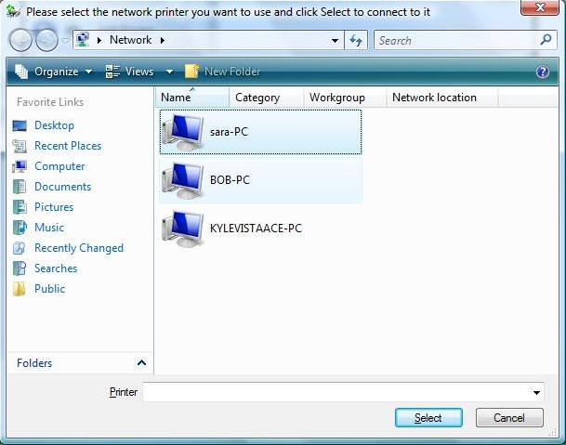

- When prompted for credentials, enter the user name and password for the sharing account you created on your Windows 7 computer.
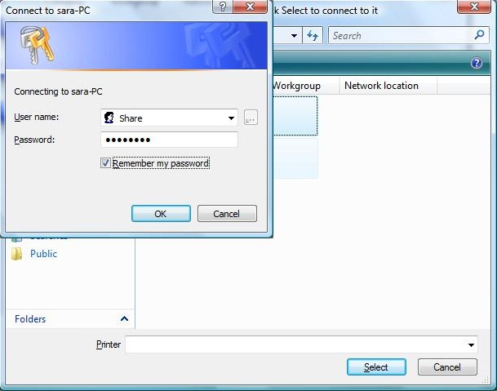

- The available printers will appear. Click the printer you want to install, and then click Select.
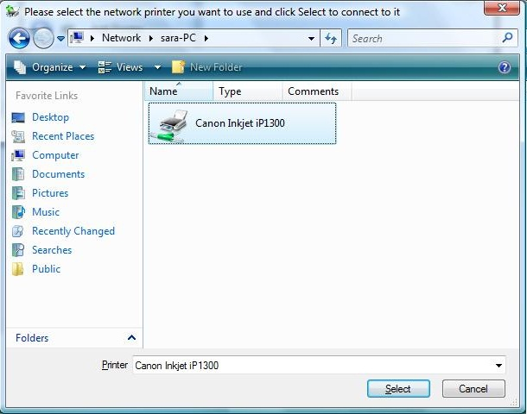

- When the information for the printer to be installed appears, click Next.
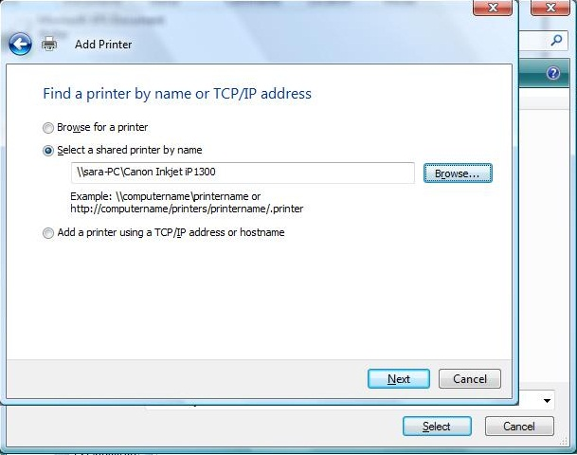

- Windows will connect to the computer and attempt to install the printer.
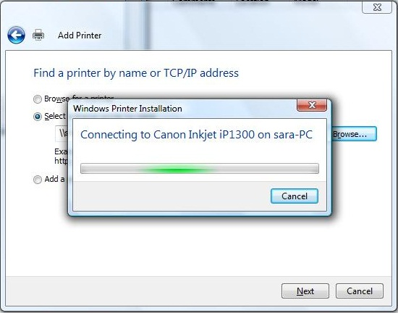

- If Windows has a driver available for the printer, it will automatically be installed. After installation, the printer will appear in the Printers folder (click Start and then click Printers).
If Windows doesn’t have the correct driver, follow these steps:
- Download the correct driver from the printer manufacturer’s website.
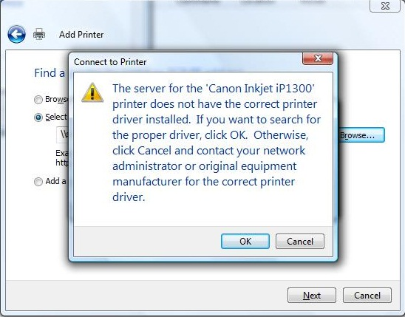

- Click Browse, and then select the file you downloaded.
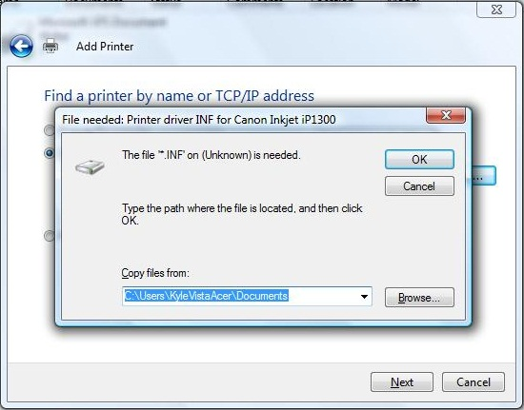
Now you are ready to print to the shared printer from your computer running Windows Vista.

Using Windows XP to install a homegroup printer
If you have a computer running Windows XP and you want to use a printer that is installed on a homegroup computer running Windows 7, follow these steps.
- On the computer running Windows XP, click Start, click My Computer, and then click My Network Places.
- In the left pane, click View workgroup computers.
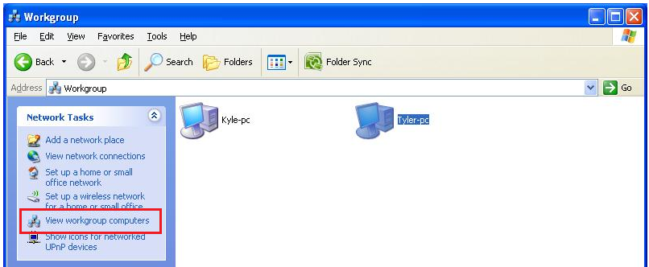

- Double-click the computer where the printer is installed. When prompted for credentials, provide the user name and password of the sharing account you created earlier.
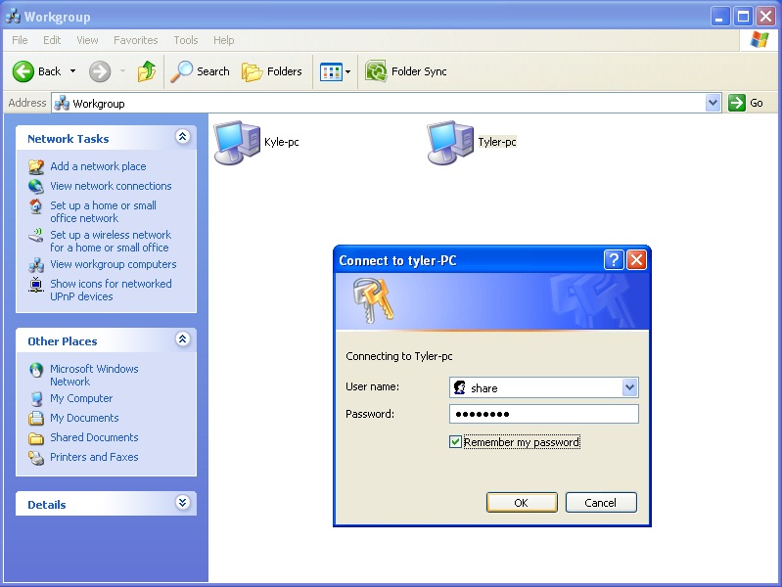

- The shared files and printers will appear. Double-click or right-click the printer you want to install, click Connect, and click Yes to dismiss the security warning.
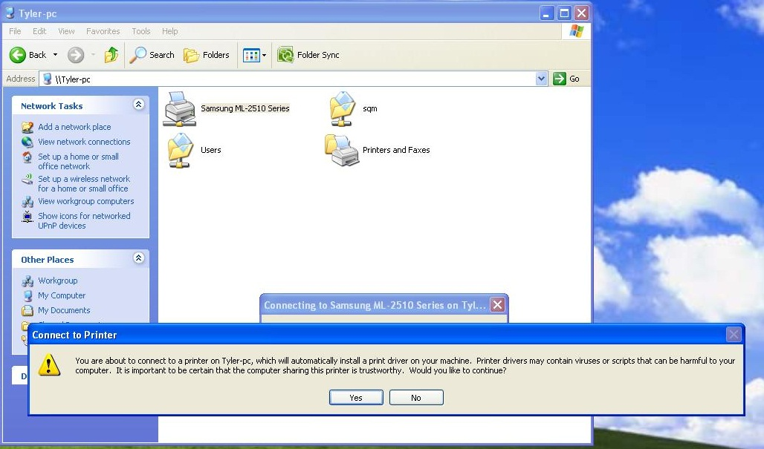

- Windows will attempt to connect to the printer and install the driver automatically.
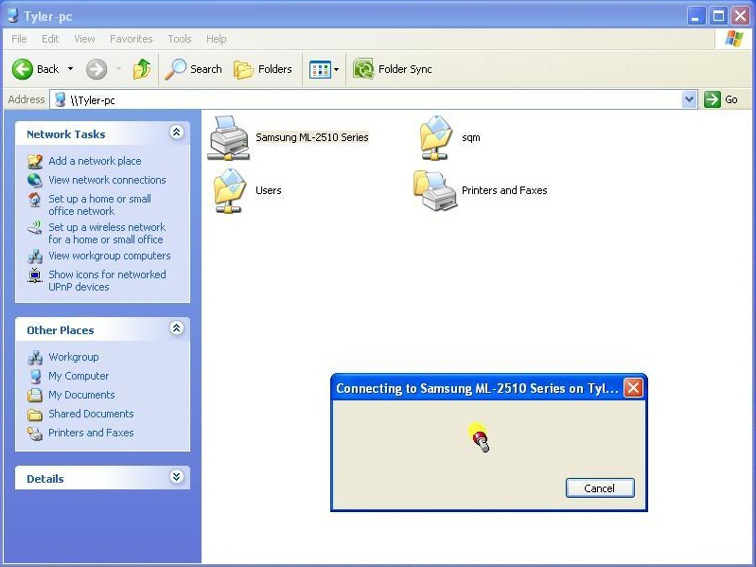

- If Windows has a driver available for the printer, it will install it automatically. To view the installed printer, click Start, and then click Printers and Faxes.
If Windows doesn’t have the correct driver, follow these steps:
- Download the correct driver from the printer manufacturer’s website.
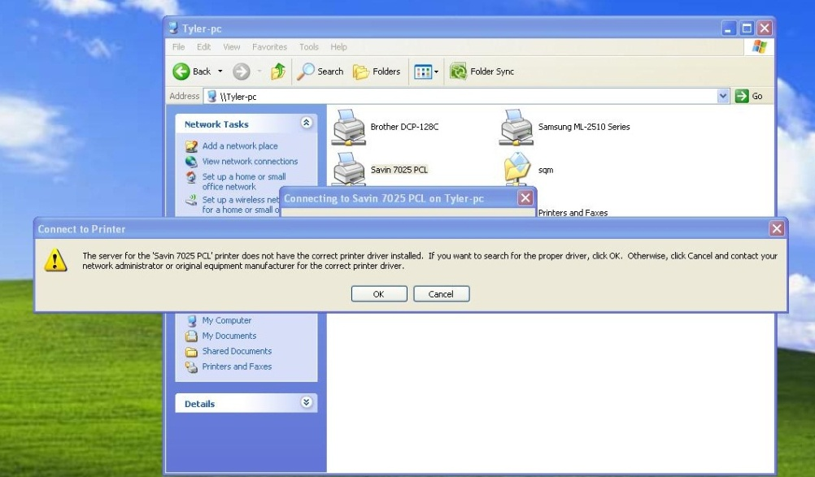

- Click Browse, and then select the file you downloaded.
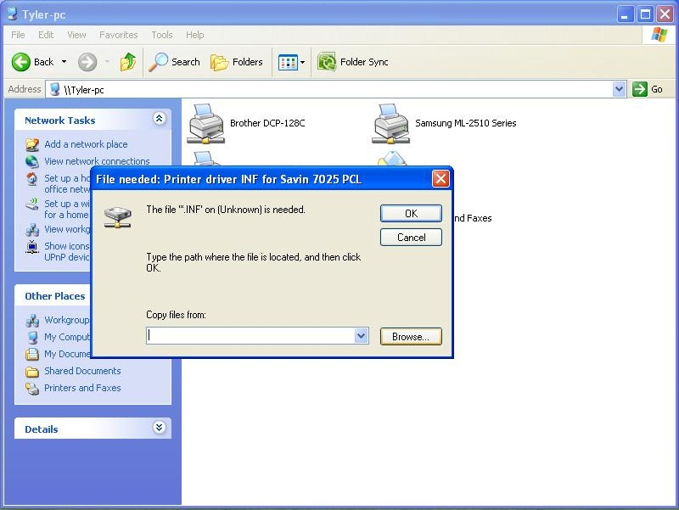
Now you are ready to print to the shared printer from your computer running Windows XP.

Sharing with Windows 7 from Windows XP or Windows Vista
This section outlines some basic steps and resources for sharing content on a computer running Windows Vista or Windows XP on your home network.

Sharing on Windows XP
You can share files on Windows XP by using Simple File Sharing on a computer that is not domain-joined (part of a corporate controlled network). You can learn more about Simple File Sharing here: http://support.microsoft.com/kb/304040/.
To configure a folder to be visible to everyone on the network:
- Right-click the folder, and then click Sharing and Security.
- Under Network Sharing and Security, click Share this folder on the network.
- If you want the folder and files it contains to be read-only, clear the Allow network users to change my files check box, and then click OK.
- If you want the folder and files it contains to be read/write, select the Allow network users to change my files check box, and then click OK.
To access the shared folder on a computer running Windows 7:
- Click Start, and then click Computer, and then, in the left pane, click Network.
- Double-click the computer running Windows XP that you want to access.

Sharing in Windows Vista
Sharing is done in Windows Vista in almost the same way sharing is done in Windows 7 if not using a homegroup.
There are two ways to share folders in Windows Vista:
- Sharing any folder
- Sharing Public folders
Additionally, you can share files securely with password protected sharing, or insecurely by turning off password protected sharing. It is recommended that you share files securely by turning password protected sharing on. If you turn password protected sharing off, anyone on your network can access your files.
A comprehensive guide to file and printer sharing in Windows Vista is available here: http://technet.microsoft.com/en-us/library/bb727037.aspx.
To access the shared folder on a computer running Windows 7:
- Click Start, and then click Computer.
- In the left pane, click Network, and then double-click the computer you want to access.
If password protected sharing is enabled on the computer running Windows Vista, you will need to know a user account and password on that computer to access the share. If password protected sharing is disabled on the computer running Windows Vista, you won’t need to provide credentials to access the share.
More resources on sharing in Windows Vista are available here:
Enable File and Printer Sharing:
http://windowshelp.microsoft.com/Windows/en-US/Help/e2e03106-2546-4085-bd07-6c3ac95003111033.mspx
File Sharing Essentials:
http://windowshelp.microsoft.com/Windows/en-US/Help/e20e6875-7210-47bb-bf19-5c60e6ae86151033.mspx
Share files with someone:
http://windowshelp.microsoft.com/Windows/en-US/Help/9636e0f2-0223-45d2-89cb-3e317c4509051033.mspx#E4

Sharing on Linux (Ubuntu)
More information on sharing on computers running Ubuntu Linux is available here: https://help.ubuntu.com/community/InternetAndNetworking, and here: https://help.ubuntu.com/community/MountWindowsSharesPermanently

Sharing on Mac OS X
More information on sharing on computers running Mac OS X is available here: http://support.apple.com/kb/HT1549

Troubleshooting

Security

Authentication
Windows Vista and Windows 7 use NTLMv2 for authentication. Some devices might not support NTLMv2. You can revert to less secure authentication methods by modifying the Local Security Policy. You should only do this if you are encountering problems accessing shares; it is less secure and not recommended.
- Click Start, type “admin tools” in the search box, and then click Administrative Tools.
- Double-click Local Security Policy.
- In the Local Security Policy window, click Local Policies, and then click Security Options.
- Double click Network Security: LAN Manager authentication level.
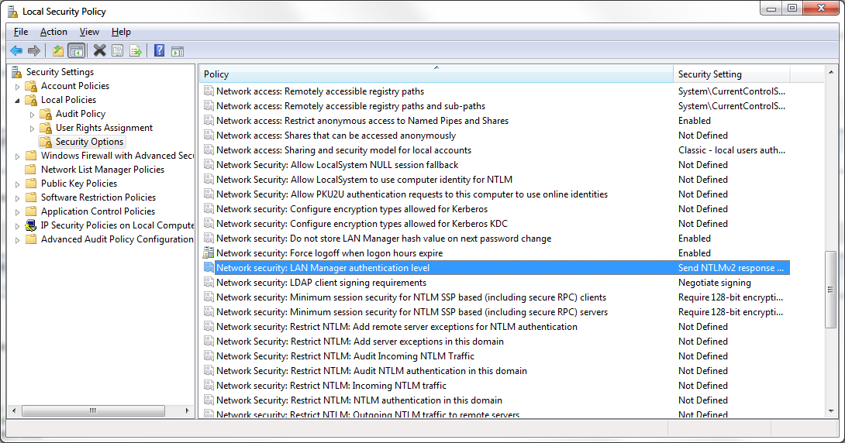
- In the dialog box that appears, select Send LM & NTLM – Use NTLMv2 session security if negotiated, and then click OK.
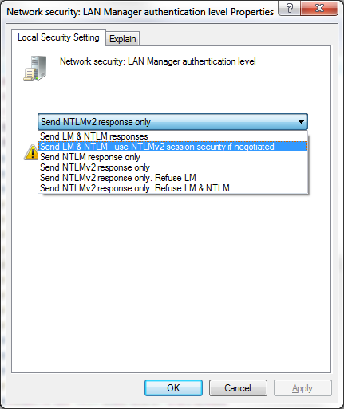

Encryption
Windows 7 defaults to 128-bit encryption to help protect file sharing operations. Previous versions of Windows used less secure encryption (56-bit). Some devices and protocols might only support 40- or 56-bit encryption. You can override the default encryption level to a less secure setting in Advanced Sharing Settings. You should only do this if you are encountering problems accessing shares; it is less secure and not recommended.
- Click the Start button, type “advanced” in the search box, and then click Manage advanced sharing settings.
- Expand the network location you want to modify, and then scroll down to File sharing connections.
- Select Enable file sharing for devices that use 40- or 56-bit encryption.
- Click Save changes.
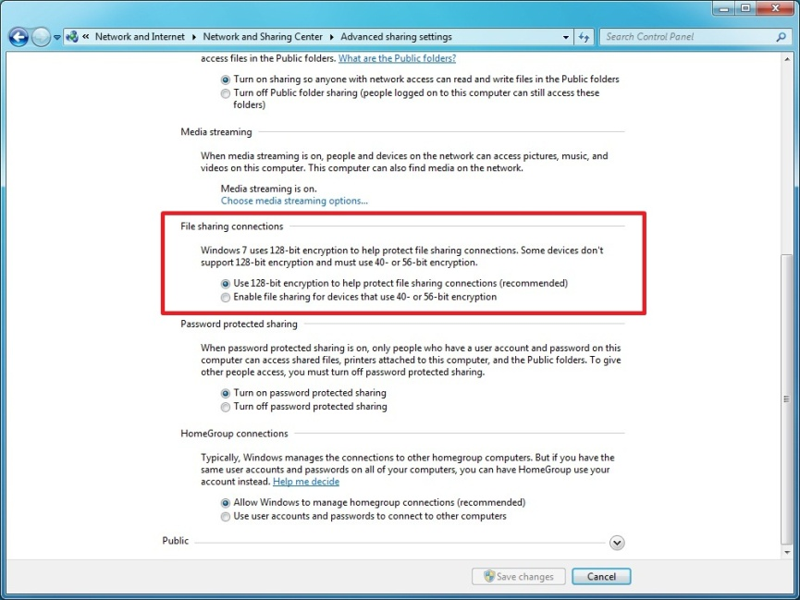

Workgroups
Windows XP and Mac OS X might require all your computers to be in the same workgroup before they can be visible in the network folder or Finder. As a result, ensure that the workgroup name of each computer is the same.
- More information, including how to change the workgroup in Windows XP, is available here: http://support.microsoft.com/kb/295017.
- More information, including how to change the workgroup in Windows Vista, is available here: http://windowshelp.microsoft.com/Windows/en-US/Help/5723d061-b884-40da-b5e7-94a55f6fcead1033.mspx#EPG under From a computer running Windows XP, I can’t see any network computers running Windows Vista.

Network Discovery
On Windows Vista, you must be on a home network (which automatically enables network discovery). More information on network discovery is available here: http://windowshelp.microsoft.com/Windows/en-US/Help/0e5f2e0c-9906-4518-b7c7-d3632105dcad1033.mspx

Hiding the user account from the login screen
If a special sharing account was created, it is unlikely that you will log in as that user frequently. Advanced users might want to prevent the share account from appearing on the logon screen.

All versions of Windows 7

- At an elevated command prompt, type the following command, where “accountname” is the special sharing account:
net localgroup users /delete accountname
For example, if you created an account named share, the command would look like this:
net localgroup users /delete share

Windows 7 Ultimate and Professional
Users running Ultimate and Professional versions of Windows 7 can edit users directly through the User Manager.
- Click the Start button, right-click Computer, and then click Manage.
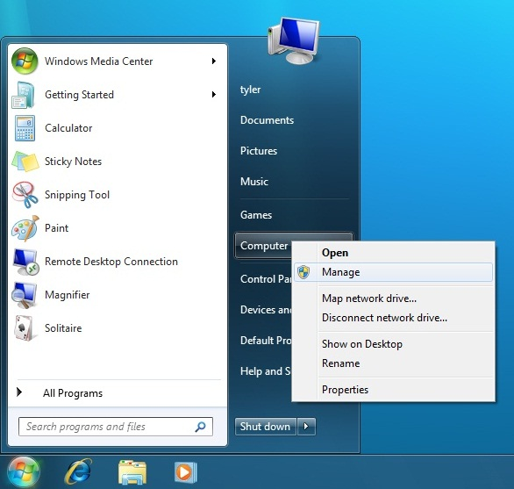
- In the left pane, double-click Local Users and Groups, and then double-click Users.
- Right-click the account you created for sharing, and then click Properties.
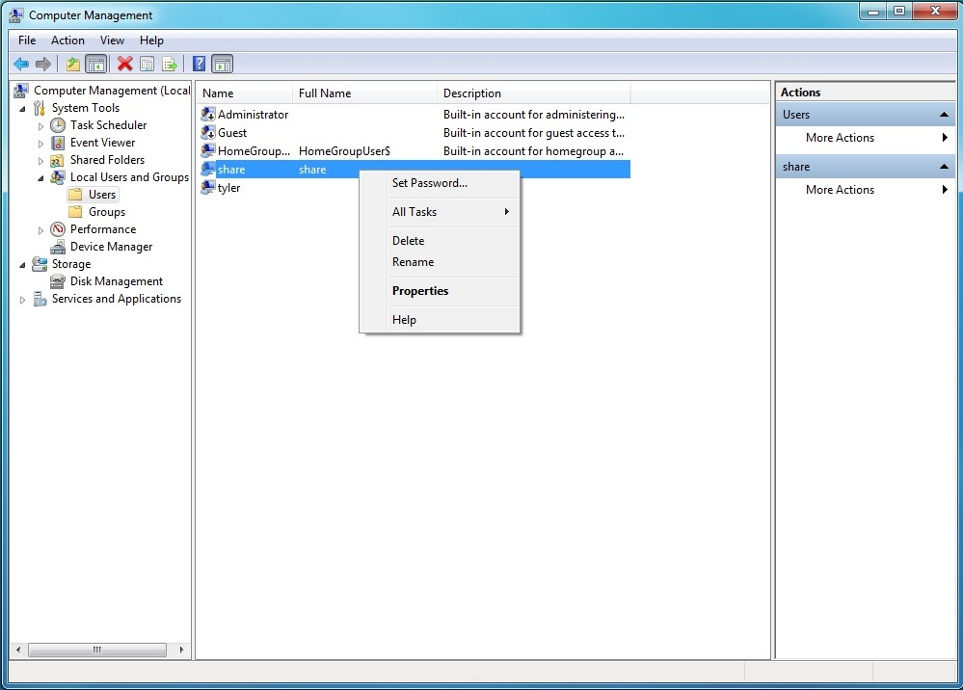
- On the Member Of tab, click the Users group, and then click Remove.
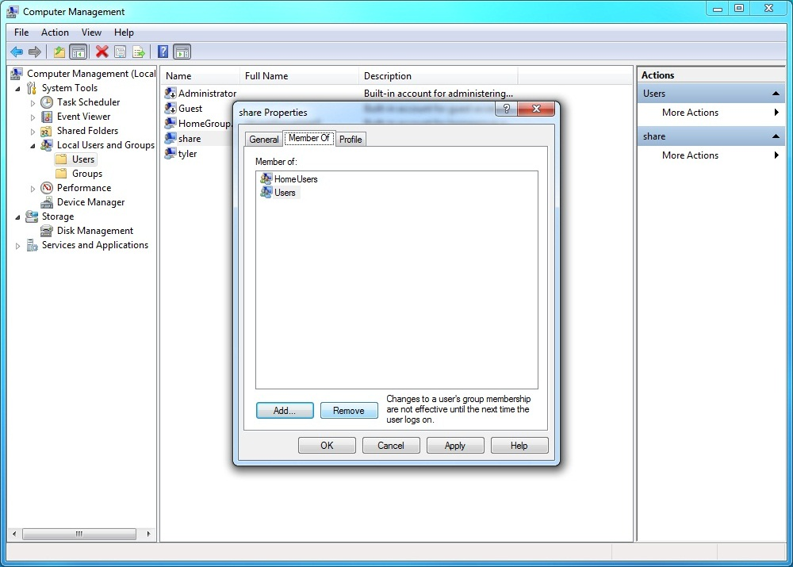

- Click OK. The account should no longer appear on the logon screen.
