

Windows® Small Business Server 2008
Reviewer’s Guide

Microsoft Corporation
Published: October 2008

Abstract
Microsoft® Windows® Small Business Server 2008 is an essential business solution from Microsoft for small businesses with between five and seventy-five PCs. It provides small businesses with simplified setup, intuitive management of day-to-day tasks, comprehensive network and data protection, and rich business productivity features, combined with high performance within a Windows environment.
This reviewer's guide describes the Windows Small Business Server 2008 solution, discusses several features and benefits of a server-based small business solution, outlines the requirements for installing Windows Small Business Server 2008, and presents a guided walkthrough of the Windows Small Business Server 2008 installation and configuration experience.

Disclaimer
THIS IS NOT A PRODUCT SPECIFICATION.
This document supports Microsoft Windows Small Business Server 2008.

The information contained in this document represents the current view of Microsoft Corp. on the issues disclosed as of the date of publication. Because Microsoft must respond to changing market conditions, this document should not be interpreted to be a commitment on the part of Microsoft, and Microsoft cannot guarantee the accuracy of any information presented. This document is for informational purposes only. MICROSOFT MAKES NO WARRANTIES, EXPRESS OR IMPLIED, IN THIS DOCUMENT.
Information in this document, including URL and other Internet Web site references, is subject to change without notice. Unless otherwise noted, the companies, organizations, products, domain names, e-mail addresses, logos, people, places and events depicted in examples herein are fictitious. No association with any real company, organization, product, domain name, e-mail address, logo, person, place or event is intended or should be inferred. Complying with all applicable copyright laws is the responsibility of the user. Microsoft grants you the right to reproduce this guide, in whole or in part.
Microsoft may have patents, patent applications, trademarks, copyrights or other intellectual property rights covering subject matter in this document, except as expressly provided in any written license agreement from Microsoft, the furnishing of this document does not give you any license to these patents, trademarks, copyrights or other intellectual property.
Microsoft, Windows Server, the Windows logo, Windows, Active Directory, SQL Server, SharePoint, Forefront, OneCare, Vista, Response Point, TS RemoteApp, and Outlook are trademarks of the Microsoft group of companies.

The names of actual companies and products mentioned herein may be the trademarks of their respective owners. The example companies, organizations, products, domain names, e-mail addresses, logos, people, places, and events depicted herein are fictitious. No association with any real company, organization, product, domain name, e-mail address, logo, person, places, or events is intended or should be inferred.

© 2008 Microsoft Corp. All rights reserved.

Last Updated: 21-August-2008

Contents

Disclaimer 1
Contents 2
Section 1: Introduction to Windows Small Business Server 2008 3
1.01 The Small Business Challenge 4
1.02 The Windows Small Business Server 2008 Solution 4
How a Small Business Benefits 4
How the Partner Community Benefits 8
Section 2: Windows Small Business Server 2008 10
2.01 Overview 11
A Complete Small Business Solution 11
Simplified Licensing 13
System Requirements 14
2.03 The Windows SBS Console 16
The Home Tab 17
The Users and Groups Tab 17
The Network Tab 19
The Shared Folders and Web Sites Tab 21
The Backup and Server Storage Tab 23
The Reports Tab 25
The Security Tab 27
2.04 The Business-driven Experience 28
Remote Web Workplace 29
Office Live Integration 30
Certificate Installation Package 30
Restore or Recover Files 30
Mobility features 31
Desktop Gadget 32
Section 4: Installing Windows Small Business Server 2008 32
4.01 Preparing for a Windows Small Business Server 2008 Installation 33
4.02 Installing Windows Small Business Server 2008 34
4.03 Getting Started Tasks 40
Getting Started Tasks 40
Connect to the Internet 41
Protect Your Data 49
Add Users, Computers, and Devices 57

Section 1: Introduction to Windows Small Business Server 2008

1.01 The Small Business Challenge

Today’s small business owners face daily challenges in running a business. One of the more difficult challenges is managing an IT infrastructure. Most business owners aren’t computer and networking specialists; they prefer to focus time on their core competencies in the business rather than deciphering installation manuals. Because IT investment directly impacts the bottom line, there is a constant need to mitigate costs against a backdrop of time pressures and limited technical skills.
The competitive marketplace offers numerous technology solutions designed for businesses of all sizes. However, the solutions that are suitable for a large or midsize business are often too complex for a small business with between five and seventy-five personal computers (PCs). Yet many of the over 39 million small businesses worldwide have requirements similar to those of big businesses—they need to share data with their customers, partners, and employees; they have concerns about spam, malware, and security; and they need to manage resources and employee access to those resources. There is one clear difference: small businesses typically have to meet these requirements without an in-house IT staff.
To help small businesses solve these issues, Microsoft built upon its success with Microsoft® Windows® Small Business Server 2003 to develop Windows Small Business Server 2008. Windows Small Business Server 2008 is the latest small business solution from Microsoft designed to help small businesses operate at the same technology level as much larger organizations, but without the added costs and complexities of managing an intricate IT infrastructure.

1.02 The Windows Small Business Server 2008 Solution

Technology has always promised to solve problems, not create them. Windows Small Business Server 2008 simplifies business technology and delivers on that promise.
Previous versions of Windows Small Business Server took significant steps toward reducing the complexity of implementing and managing server technology in a small business environment. Windows Small Business Server 2008 builds upon that foundation with an easier setup and installation experience, a simplified management experience, and better network-wide security features for the small business customer. It incorporates the latest Microsoft technologies for networking, data storage and backup, advanced e-mail and calendar capabilities, network security, database, and document and printer sharing.
Partners are also a great way to reduce complexity for businesses. Windows Small Business Server makes it easier for partners to deliver value to customers through simplified installation, administration and mitigated costs.

How a Small Business Benefits
Windows Small Business Server 2008 provides small businesses with a simplified installation and management experience making the transition from peer-to-peer networks to server-based technology painless. It also helps in keeping small business’ data and systems highly secure – including e-mail and documents - from malicious attacks, disasters, or technology failures. Windows Small Business Server 2008 increases productivity through anytime, anywhere access – for employees or partners - to business information regardless of their location.

Simplified Setup and Management
Rather than requiring customers to identify, purchase, install, and manage multiple products or technologies, Windows Small Business Server 2008 brings these technologies together into a fully integrated single-server installation and management experience. For small businesses apprehensive about server technology, the simplified installation and the easy-to-use management tools will help ease concerns about adding a new server to the business.

An Integrated Setup Experience
One of Microsoft’s design goals for Windows Small Business Server 2008 was to deliver a comprehensive small business solution—one that spanned multiple Microsoft server technologies—that could be fully implemented in just a few hours. New and migration installations are managed from a single deployment wizard that works across all product technologies.
The deployment wizard integrates the setup and configuration of all Windows Small Business Server 2008 workloads. The administrator performs Getting Started Tasks that configure Windows Small Business Server 2008 to business’s organizational needs. When compared with the installation and configuration of the standalone Microsoft product technologies, the setup wizards significantly decrease deployment times.
Note
For an example of deploying Windows Small Business Server 2008, see the Installing Windows Small Business Server 2008 section in this document.

Simplified Management
By its very nature, an operating system running multiple technologies tends toward complex management. However, managing a complex environment does not have to expose that complexity for all tasks. Windows Small Business Server 2008 reduces operating system complexities by using an intuitive management console, one that presents an administrator with relevant system information and a matching set of tasks. These tasks are the ones most commonly needed by administrators and have been streamlined. Tasks that may take hours to complete with standalone product technologies become very simple, efficient, and effective processes that a non-technical person can perform.
For example, adding a new user to the Windows Small Business Server 2008 network requires a small set of user-specific information and three clicks in a wizard. Windows Small Business Server 2008 handles the rest, automating user account creation—creating the user e-mail alias, providing permissions to server resources, and building the user’s root directory.
Note
For more information on managing Windows Small Business Server 2008, see the Windows SBS Console section in this document.

Network-wide Protection
As the digital age increases the volume of business data, and increases reliance on communication tools such as e-mail, line-of-business applications, or remote access, businesses of all sizes need to protect these assets.
The more sophisticated the collaboration and business data becomes, the greater the need for complete, network-wide protection. Whether protecting against e-mail-based viruses or backing up critical data, Windows Small Business Server 2008 integrates leading-edge protection technologies that help guard a small business network and its data.
Windows Small Business Server 2008 provides the administrator immediate visibility into the network’s status. Real-time status icons, daily health reports, automatic updating of signature files for integrated antivirus and malicious software technologies, automated data backups, and centralized update deployment are all available within Windows Small Business Server 2008.
Management tools also extend beyond the Windows Small Business Server 2008 server. Administrators can easily determine which client computers are missing critical protection technologies and prevent the clients from joining the domain until the necessary requirements are met. The ability to monitor and manage client computers extends the reach of the administrator without requiring advanced knowledge or troubleshooting skills.
Note
For more information on managing Windows Small Business Server 2008, see the Windows SBS Console section in this document.

E-mail Protection
The most common path for network infection is through e-mail: viruses, worms, and malicious software. Windows Small Business Server 2008 includes protection from threats and attacks that attempt entry into your network through e-mail. Advanced protection is provided by Microsoft Forefront™ Security for Exchange Server, an enterprise-class antivirus and anti-spam server technology. It provides “always-on” protection, delivering robust and aggressive e-mail filtering to small businesses.

Server Protection
A second layer of protection is available for your server. For those times when malicious software is brought into your network from external sources, Windows Small Business Server includes protection for your server and keeps your key services running. Microsoft Windows Live™ OneCare™ for Small Business Server is a malware and malicious software defensive program that protects server data from attacks across the network.

Client Protection
Desktop clients sometimes change on a daily basis as employees add, remove, or modify applications and information without your knowledge. Windows Small Business Server monitors your desktop clients for antivirus status, update compliance, and overall security health. This gives administrators a quick view into overall client status and helps address issues before they arise.

Simplified Backup for Business Data
Backup capabilities on the server have been extended to include external drives. Businesses can easily back up data to external drives and rotate the drives to offsite storage locations. This simplifies the ability of businesses to secure its data and keep it safe.

Enhanced Business Productivity
To remain competitive, small businesses must ultimately rely on complex technologies – often the same technologies used by much larger organizations. Windows Small Business Server 2008 provides a solid foundation for business workloads and provides big business technology at an affordable price. These technologies enable businesses to enhance employee productivity and gain a competitive advantage.

Secure Access with Remote Web Workplace
Remote Web Workplace is a dynamically-updated Web site that provides a single, simple, consolidated, and highly secure entry point into a small business network, including a fully-configured internal Web site managed by Windows SharePoint® Services. Employees or partners can gain access to e-mail, files, or even a desktop computer through Remote Web Workplace. From a deployment perspective, the administrator runs a wizard and Windows Small Business Server 2008 automates the entire installation and configuration of the underlying technologies.

Desktop Synergies with Vista and Office 2007
When you invest in the Windows Vista® Business operating system and Microsoft Office Professional 2007 productivity and content management tools and add them to the server functionality of Windows Small Business Server 2008, you’ll have the IT foundation you need to work fast, smart, and together, to take it on the road, and to help protect all your business data—from the inside out. Easily find and organize information on your PC, in e-mail, and on the network. Create internal team sites for group collaboration with mobile access capabilities. Take advantage of faster communication between Vista and servers running Windows Server 2008. The workplace isn’t just the office—it’s wherever your employees happen to be.

Mobile Device Support
Windows Small Business Server 2008 offers enhanced support for Windows Mobile 6.0-enabled smartphone devices. These devices give highly-mobile employees such as sales staff or field personnel access to e-mail, contact lists, calendars, and documents stored on the company Web site. Businesses can administer mobile devices as if they were on the local network, installing certificates or remotely wiping devices for security purposes.

Internet Business Presence
There’s growing trend for customers to search for products and services on the Internet, and their expectation is that businesses of all sizes will have a Web site. A proper Web presence is rapidly becoming as essential as having business cards or a phone number. Windows Small Business Server 2008 offers integration with Microsoft Office Live Small Business, an Internet-based set of tools that help small businesses quickly and easily create a professional Web presence. This enables small businesses to stay in touch with customers and easily access company information from one location.

How the Partner Community Benefits
The partner community can realize significant benefits from selling and supporting Windows Small Business Server 2008. Its intuitive and streamlined management tools simplify management, reducing guesswork and allowing partners to optimize their time. For example, the daily health reports can help a partner determine which customer sites might require some remote administration tasks, or which ones may require a site visit in the near future. Expansion and data management features, such as the Move Exchange Server Data wizard, minimize the time required to grow the network to match business needs.
These tools, and the underlying design goals of Windows Small Business Server 2008, will afford the partner community the ability to move beyond traditional break-fix services. Partners can become specialists in vertical market technology and provide value-added services to their customers. Infrastructure management is not a commodity, but it is one that can’t be heavily promoted as a value-add line item; customers expect that the infrastructure is configured properly, is highly secure, and “just works.” By providing a core infrastructure that already meets customer expectations, it frees the partner to focus on and promote value-add solutions to the customer – in other words, the partner gets to focus on doing what the partner does best.
Partners can also increase customer trust by providing them with a known-good, highly-secure infrastructure. As businesses grow, the potential for loss increases and the more products need to be installed and configured to help reduce the risk. Even when products are supplied by the same vendor, additional configuration and modification is needed to ensure the products work efficiently and securely. This requires that partners become knowledgeable about different products so that the systems will be highly secure. Yet there can be lingering questions, wondering if all the options been properly set or whether something was missed from the best practice guide. With a core infrastructure in place that has already been configured according to best practice guidelines, partners can increase customer trust and improve their status as a true strategic partner for the midsize business.
Windows Small Business Server 2008 provides an unparalleled out-of-the-box experience for a small business customer. For the partner community, Windows Small Business Server 2008 provides the solid foundation to grow the partner business, both by adding more customers without adding staff, and to grow the business into value-add services.

Business Internet presence
Today’s businesses regard a Web site as a must-have item: customers seek out information on products and services they may be interested in, and use a Web site as a primary source of information. While business Web sites don’t have to be flashy or extensive, they should provide potential customers with the right information at the right time – and ideally prompt the customer to contact the business.
Microsoft Office Live Small Business is built into Windows Small Business Server, enabling even the smallest businesses to have a big-business Internet presence. Everything you need to create a professional Internet presence, including free Web hosting, easy-to-use site design tools, site traffic reports, and more is available for business Web sites. Collaborate and share information with customers, partners, or employees with password-protected Internet workspaces, or set up simple e-commerce Web pages and search engine marketing for your customers.

Out-of-box customization
Windows SharePoint Services can be easily customized with business-specific templates and process workflows available for download from the Microsoft Web site. Partners can deliver targeted solutions to small businesses with little additional cost, helping enhance your reputation as someone who “gets” small businesses and providing additional revenue opportunity for first-server or new-server installations.

Line-of-business offerings
Windows Small Business Server 2008 Premium Edition adds a second server running Windows Server 2008 and SQL Server 2008. This server, which can be either 32-bit or 64-bit, is the ideal repository for customer data and applications and can host customer databases or applications that require databases. Partners can expand their solution offerings to include line of business (LOB) applications or vertical-market packages. Most partners focus on specific customer segments and become trusted experts in recommending hardware, software, and vertical applications. With the solid foundation of Windows Server 2008 and SQL Server 2008, you can now offer turnkey solutions for your customers that are easy-to-manage, reducing your per-customer management overhead. For customers running LOB applications that are not certified on newer versions of SQL Server, SQL Server 2005 Standard Edition is included with Windows Small Business Server 2008 Premium Edition.

Application Access using Terminal Services
The second server in Premium Edition also provides Terminal Services capabilities for application access. This enables businesses to provide secure remote access to key LOB applications through the Remote Web Workplace interface, helping bring business data to where it can be the most effective (customer site, supply chain partner, branch offices). Using the Terminal Services technology found in Windows Server 2008, partners can deliver entire desktops, or only applications to business users using TS RemoteApp™. This improves the ability to keep applications consistent between users and between sessions, keeps maintenance and upgrades simpler, and improves security for critical application data. You must purchase additional licenses to use Terminal Services on your network.

Foundation for Unified Messaging
For businesses that require message consolidation (e-mail, fax, voice mail) into a single location, Windows Small Business Server 2008 provides a foundation for adding unified messaging to a small business, giving partners the ability to offer unified messaging hardware, software, and services to small businesses. Partners can purchase and install Microsoft Response Point™ or other VoIP solutions, giving small businesses the reach and power of big-business solutions.

Section 2: Windows Small Business Server 2008

2.01 Overview
Windows Small Business Server 2008 minimizes initial acquisition and deployment times by offering an easily deployed single server solution that combines several server technologies under one Microsoft license.
With Windows Small Business Server 2008, small businesses or partners are not tasked with identifying, purchasing, or licensing multiple server technologies, or subsequently matching them to appropriate hardware resources. They also benefit from an integrated deployment experience – one delivered on a single piece of media that fully integrates the configurations of all underlying server technologies into a single server installation wizard.

A Complete Small Business Solution
Windows Small Business Server 2008 incorporates best-of-breed 64-bit product technologies to deliver a fully integrated environment well suited for most small businesses. The product technologies include:


- Server Operating System: Microsoft Windows Server 2008 product technologies provide the core foundation of Windows Small Business Server 2008. Windows Server 2008 is the most flexible and robust Windows Server operating system to date. For more information, visit the Microsoft Windows Server 2008 Web site.



- Messaging and Collaboration: Microsoft Exchange Server 2007 product technologies introduce advanced e-mail and calendar functionality to Windows Small Business Server 2008. Exchange Server 2007 delivers a seamless end-user collaboration experience and unparalleled security features. For more information, visit the Microsoft Exchange Server 2007 Web site.

- E-mail Security: Microsoft Forefront Security for Exchange Server (Forefront) helps protect e-mail from viruses, worms, and spam. Forefront incorporates multiple industry-leading antivirus engines for layered protection against the latest e-mail-based threats. For more information, visit the Microsoft Forefront Security for Exchange Server Web site.
Note
Windows Small Business Server 2008 includes a 120-day trial version of Forefront. For permanent use, you must license Forefront separately. For more information on purchasing Microsoft Forefront Security for Exchange Server, see How to Buy Microsoft Forefront Security for Exchange Server on the Microsoft Web site.
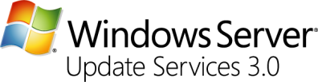
- Network Updates and Protection: Microsoft Windows Server Update Services (WSUS) enables administrators to deploy the latest Microsoft product updates to computers running the Windows operating system. By using WSUS, administrators can fully manage the distribution of updates that are released through Microsoft Update to computers in their network. For more information, visit the Windows Server Update Services Web site.

- Server Protection: Microsoft Windows Live OneCare for Server (OneCare) protects, maintains, and manages your server with the always-on service. Working quietly in the background on your computer, OneCare protects against viruses, spyware, hackers, and other unwanted intruders. For more information, visit the Windows Live OneCare Web site.
Note
Windows Small Business Server 2008 includes a 120-day trial version of OneCare. For permanent use, you must license OneCare separately. Not available in all markets and languages. See www.microsoft.com/sbs08 for a list of markets and languages.

- Take business online. Office Live Small Business provides everything needed to take, promote, and manage a business on the Internet. Customers can create a professional Web presence without the hassle or expense of setting up a complicated infrastructure or hiring technical staff to maintain it. Office Live Small Business is a hosted service for customers with an Internet connection. For more information, visit the Office Live Small Business Web site.


- Database: Windows Small Business Server 2008 Premium Edition adds a second server to Standard Edition. Premium Edition includes a second copy of Windows Server 2008 Standard Edition technologies and Microsoft SQL Server 2008 Standard Edition technologies, providing customers and partners with a comprehensive data management and analysis solution. SQL Server 2008 is a performance-leader and the fastest growing database solution in the industry today. For customers using applications that are not yet certified for use on SQL Server 2008, a copy of SQL Server 2005 Standard Edition is included in Premium Edition. For more product-specific information, visit the Microsoft SQL Server 2008 Standard Edition Web site.


- Collaboration and Productivity: Microsoft Windows SharePoint Services 3.0 is a versatile technology that organizations and business units of all sizes can use to increase the efficiency of business processes and improve team productivity. With tools for collaboration that help people stay connected across organizational and geographic boundaries, Windows SharePoint Services gives people access to information they need. For more product-specific information, visit the Windows SharePoint Services Web site.

Simplified Licensing
Windows Small Business Server 2008 will be offered in two editions: Windows Small Business Server 2008 Standard and Windows Small Business Server 2008 Premium.
Each edition is covered by a single server license that provides licensing for all the included product technologies. Each edition also includes five temporary client access licenses (CALs) that allow users to connect to the respective product technologies. The CALs may be designated as per-user or per-device, enabling a small business to choose the licensing model that best suits its needs. For additional users and devices, customers and partners must purchase additional user and device CALs.
Note
User CALs are assigned to a specific user, allowing the use of any number of devices to access Windows Small Business Server 2008. Device CALs are assigned to a specific device, allowing any number of users – but only one user at a time – to access Windows Small Business Server 2008.
User and device CALs will be available in two types of license Suites. The first type, Windows Small Business Server 2008 CAL Suite, provides licensing for the Standard product technologies, and provides licensing for access to other computers running Windows Server 2008 and Exchange Server 2007 Standard Edition on the network. This license may be used with Windows Small Business Server 2008 Standard or Premium, and is best for users or devices that do not require access to the Premium technologies.
The second type, Windows Small Business Server 2008 CAL Suite for Premium Users or Devices, provides licensing for Standard and Premium technologies, including SQL Server 2008 Standard Edition. The Premium CAL Suite also provides licensing for access to other computers running SQL Server 2008 Standard Edition on the network. This type of license is best for users or devices that require access to the Premium Edition technologies.
License Suites are sold in denominations of one, five, and twenty licenses. The single-license CAL is a new addition to the available License Suites, giving partners and customers greater flexibility to match licenses to numbers of employees or devices. This helps cost-conscious customers and partners buy only the licenses that are needed and reduce overall license management costs.
Microsoft will also be announcing a new program to enable flexibility within this licensing to allow customers to move between Standard and Premium versions of both Server and CAL suite. You can find out more about the Solutions Pathway on the Microsoft Web site (http://www.microsoft.com/windowsserver/essential/pathway.mspx).

System Requirements
The following items represent the minimum hardware requirements for the server that will run the Windows Small Business Server 2008 solution. The minimum hardware requirements listed in this document are specifically applicable to Windows Small Business Server 2008 and should be considered preliminary. All requirements are subject to change, dependent on Microsoft’s internal Windows Small Business Server 2008 quality assurance and testing efforts.
Note
Windows Small Business Server 2008 Standard Edition is only available as a 64-bit operating system; your server hardware must have a 64-bit processor to install and use Windows Small Business Server 2008 server. Windows Small Business Server 2008 Premium Edition adds a second server running either 32-bit or 64-bit versions of the operating system.
Your server hardware should have the “Certified for Windows Server 2008” logo. The logo helps identify products that deliver a high-quality computing experience with Microsoft® Windows Server operating systems. You can find a list of certified hardware and server systems on the Windows Server Catalog Web site (http://www.windowsservercatalog.com).
Processors
- Systems with a single-core CPU – x64 with a 2.66 GHz minimum clock speed.
- Systems with a multiple-core CPU – x64 with a 1.5 GHz minimum clock speed.
- Systems with multiple physical CPUs – x64 with a 1.5 GHz minimum clock speed.
Note
Windows Small Business Server 2008 is only available as a 64-bit operating system and can only be installed on a server with a 64-bit processor.
Memory
- Minimum 4 GB of RAM
Hard Disk Drives
- Operating system drive partition – Minimum of 60 GB of free drive space.
- Backup drives – Minimum of 1 External USB Drive, for additional redundancy 2 external USB hard disk drives are recommended. Windows Small Business Server 2008 supports USB 1.1, 2.0, and IEEE 1394 external hard disks drives.
Other Requirements
- DVD-ROM – Bootable from the system BIOS or a peripheral connection (such as USB).
- Network interface card (NIC) – One network adapter supporting a 100 Mb or greater link speed.
- Internet connection – Certain features require a publicly accessible Internet connection with a firewall, or firewall-enabled router/modem.
- USB 2.0 or faster external hard disk drive – Most new external hard disk drives require a USB 2.0 connection. Earlier versions of the technology have significantly slower data transfer speeds that will affect the speed of your backups.
- Internet domain name – An existing domain name or you may optionally use the Internet Address Management Wizard to purchase a new one.

2.03 The Windows SBS Console

Small businesses perform a balancing act of trying to reduce costs while increasing profits. The Windows SBS Console offers small businesses an intuitive and uncomplicated IT management tool that controls IT management costs while providing a customizable environment designed to help them reach their full potential.
The Windows SBS Console is the primary hub for managing most aspects of the small business. It helps minimize the cost of managing and maintaining multiple applications, systems, and network resources such as users, computers, and devices. Designed for simplicity, the Windows SBS Console abstracts away management complexities by providing a streamlined interface into the most common client and server administration tasks for a small business environment. It also offers real-time insight into an organization’s overall health, security, and network management.
The Windows SBS Console launches automatically after a successful installation or after a server restart. It can also be launched using the Desktop shortcut or by clicking Start ->All Programs ->Windows Small Business Server -> Windows SBS Console.
The Windows SBS Console collects primary management tasks and status indicators into related tabs. Each tab focuses on a set of tasks or functions that can be applied to similar resources on the network. As an example, you can add or modify a user or group through the Users and Groups tab, set a user’s access to various resources, establish mailbox storage quotas for a user, assign a user to a specific client computer, or redirect a user’s My Documents folder to additional storage volumes on the network. Grouping the tasks together makes it easier for administrators to determine where to go to manage the network and what to do once there.
The Console’s tabs include:
- Home – includes Getting Started Tasks, most frequently used tasks, an overall system health summary, and links to community resources;
- Users and Groups – focal point for managing users, user roles, and groups;
- Network – management of computers, devices (including printer and fax devices), and network connections;
- Shared Folders and Web Sites – manages Windows shares and Web sites;
- Backup and Server Storage – manages backup settings and server disk drives;
- Reports – includes standard reports and allows creation of custom reports; and
- Security – provides security summary and control over Windows updates.
Each of these tabs contains related information and tasks. Secondary tabs enable additional categorization of information or tasks. Several of the main tabs use color-coded icons to represent the overall health of a particular set of objects. For example, if a computer on the network has not received the latest operating system update, the Security tab displays a red ‘X’ on the tab, indicating there is an item needing attention. The system administrator can then click the tab, find the computer that generated the alert, and take appropriate action.

The Home Tab
The Home tab lists the Getting Started Tasks. These tasks must be completed as part of the setup process. The tasks are discussed in detail in the Completing the Installation section of this document.
The Home tab also includes the Network Essentials Summary (right pane). It displays real-time status of the network’s overall health and security. Color-coded icons provide an overall assessment of a particular security or health function. For example, the Updates summary shows a yellow icon, indicating a warning condition (figure 1). Expanding the item shows that some updates have not been installed, and provides a link directly to the Security tab where the administrator can find out more information and take any necessary action.
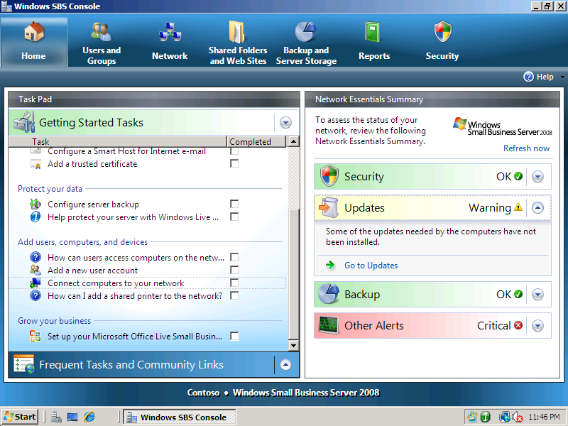
Figure 1 - The Windows SBS Console's Home tab

Using the Home Tab
Launching the Windows SBS Console will always default to the Home tab. Administrators can rely on the Home tab to quickly determine the overall health and security state of their Windows Small Business Server 2008 deployment. If an issue exists, additional information is accessible from other Console tabs.

The Users and Groups Tab
The Users and Groups tab provides management for all users added to the Windows Small Business Server 2008 network. It also helps the administrator determine how those users interact with other servers and resources in the business environment. With the Users and Groups tab, the administrator may:
- Manage users including adding, deleting, or changing existing user properties. Quick task links provide access to password resets or account disables;
- Manage user roles including the ability to build predetermined roles for different user types within the Windows Small Business Server 2008 environment;
- Manage security groups (Security or Distribution Lists) including adding, deleting, or changing memberships.
The user account properties available through the Windows SBS Console’s Users and Groups tab represent a cross-set of information that is available in other tools such as Active Directory. For advanced management, the complete set of management tools is available through the Start menu. This gives partners and administrators the ability to access the full power of Microsoft operating systems and product technologies whenever it is needed.
The primary design principle was to make management user-centric. With other products and technologies, administrators need to go to the application to manage the users. With the Users and Groups tab, the Windows SBS Console consolidates all the primary user resource information onto a single property page, making management simple and straightforward.

Using the Users & Groups Tab
The Users and Groups tab includes three sub-tabs: Users, User Roles, and Groups. Each sub-tab provides a details pane and a tasks pane. The Users sub-tab lists all user accounts on the network, while the tasks pane lists common tasks that are applicable to managing one user or many users on the network. This layout is used throughout the Console.

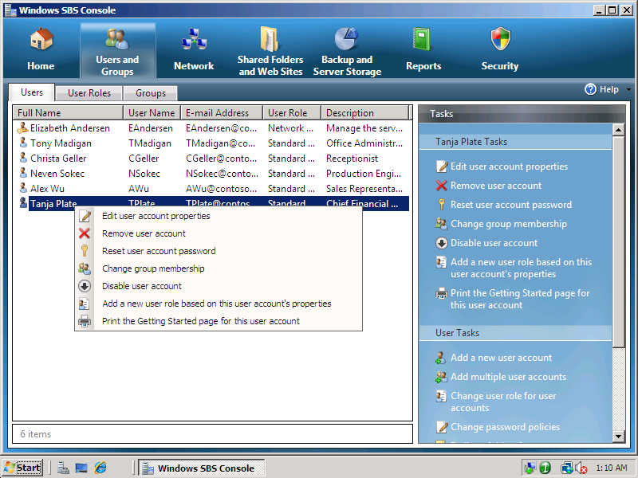
Figure 2 - Managing Users with the Users and Groups Tab
For example, as shown in figure 2, when you right-click a user a menu appears containing the actions that an administrator may perform on that user. These actions are also available in the tasks pane.
Users can be managed using global tasks. Adding a new user to the Windows Small Business Server 2008 environment is the matter of only a few clicks (see Using the Add a New User Account wizard). Using global tasks, the administrator may also add multiple users by using the Add Multiple User Accounts wizard. As shown in figure 3, the administrator selects a specific user role for all the users being added and then adds one or more users to the wizard. Once all the new users are defined, a single click automates the creation of the new user accounts.
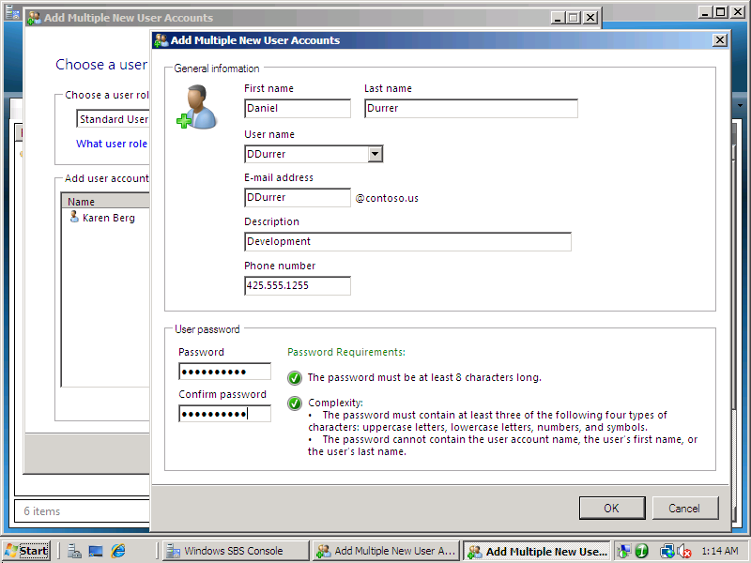
Figure 3 - Adding Multiple User Accounts
The administrator may also access other advanced configuration tasks including changing password policies (password aging, complexity, and length requirements) or establishing My Documents folder redirection for one or more users.
By exposing and simplifying the most common small business administration tasks, managing the environment is made easier and less time-consuming for the administrator.

The Network Tab
The Network tab is the primary location for managing physical devices on the Windows Small Business Server 2008 network. It is also the configuration point for all network services for the small business. On the Network tab, the administrator may:
- View the overall health and security status of devices on the network. This includes a snapshot of the device’s security and update compliance;
- Repair the server’s networking settings with a single wizard;
- Offer Remote Assistance to a client computer or remotely control the client through Terminal Services Remote Desktop Protocol;
- View a computer’s properties and configure which users may use that client computer;
- Share printers and fax devices with users on the network; and
- Reconfigure the services established using the Getting Started Tasks shown in Connect to the Internet section of this document.

Using the Network Tab
The Network tab monitors and manages the overall health for devices on the network. It includes three sub-tabs for Computers, Devices, and Connectivity. The Computers sub-tab provides the administrator with real-time insight into the operational health and security of each individual network attached device. In figure 4 a client computer is showing an Unknown condition for its overall Status, Security Status, and Update Status. To find out more, right-click the computer and then select an action from the context menu, or select the computer and then click a task in the right pane.
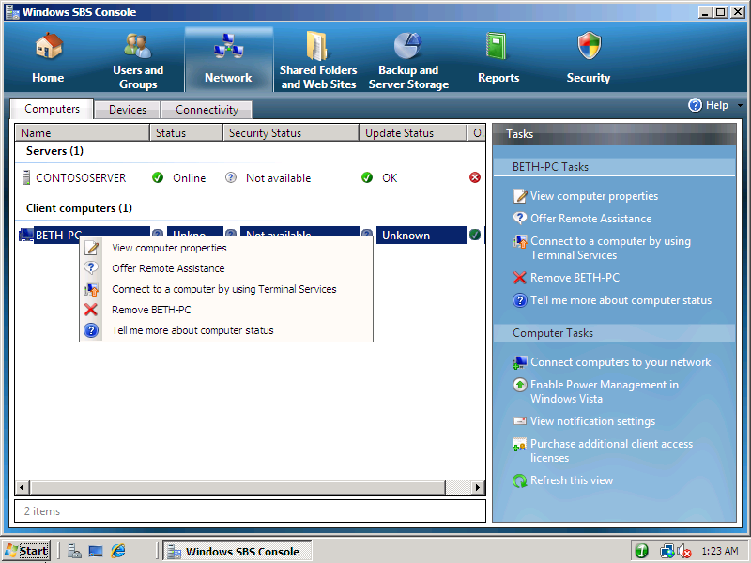
Figure 4 - The Windows SBS Console's Network Tab
The Connectivity sub-tab includes network configuration tasks required for establishing and maintaining Internet, e-mail, and remote access connectivity. These features were configured as detailed in Connect to the Internet. Each wizard may be run again to modify settings as needed by the business. New to Windows Small Business Server 2008 is the Fix my Network wizard (figure 5). The wizard finds errors on your network and attempts to repair them. If it cannot repair them, it offers guidance on how to repair them manually.
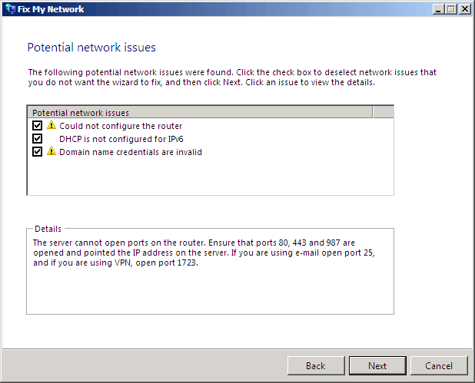
Figure 5 - The Fix my Network Wizard

The Shared Folders and Web Sites Tab
The Shared Folders and Web Sites tab offers the administrator a streamlined interface for managing shared folders and Web sites. With the Shared Folders and Web Sites tab, the administrator can:
- View summary information on all folder shares including paths, available free space, and established quotas;
- Stop sharing a folder with the click of a button;
- Create new shared folders using a wizard to define paths, access permissions, access methods, storage quotas, and permissible file types;
- View information on all Windows Small Business Server 2008 Web sites, including URL paths and status;
- Enable or disable a Web site through a single click;
- Change configuration properties or start management tools such as Internet Information Services Manager or the SharePoint Service Central Administration tool; and
- Quickly modify access permissions on existing Web sites.

Using the Shared Folders and Web Sites Tab
The Shared Folders and Web Site tab (figure 6) includes two sub-tabs for Shared Folders and Web Sites. The Shared Folders sub-tab The Provision a Shared Folder Wizard is a convenient method for creating shares that can be managed through the Windows SBS Console. This gives administrators the ability to see how much free space is available and what the storage quota is for any shares on the server.
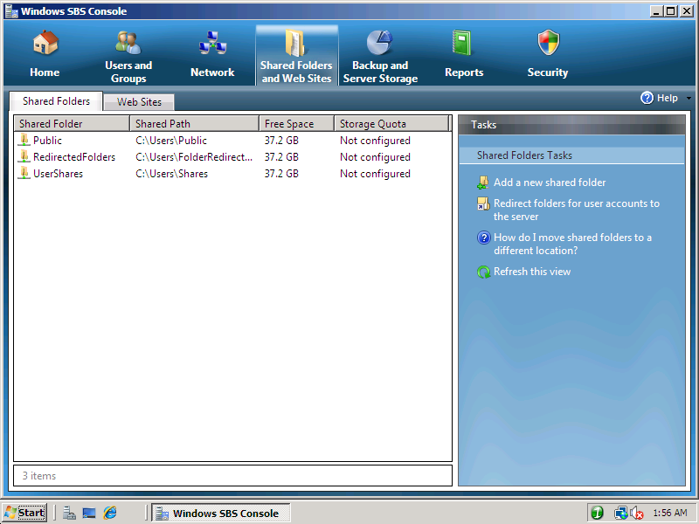
Figure 6 - Managing Shared Folders
With the Web Sites sub-tab (figure 7), the administrator has quick access to the most common settings used to manage the company Web sites, including Remote Web Workplace, SharePoint, and Outlook® Web Access. The administrator can perform basic configurations, such as enabling or disabling the site, or can set permissions for specific Web sites.
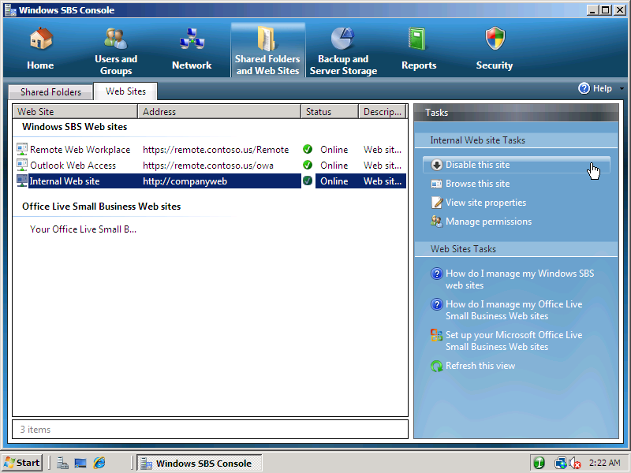
Figure 7 - Accessing Web Site Properties
The Web Sites sub-tab also provides the tools to configure and manage the Office Live Small Business Web site. This service delivers Web site hosting for customers who don’t want to host a Web site themselves, plus provides additional Web tools such as e-commerce capabilities and shared Internet workspaces. Figure 8 shows the Web traffic being redirected to the Office Live servers.
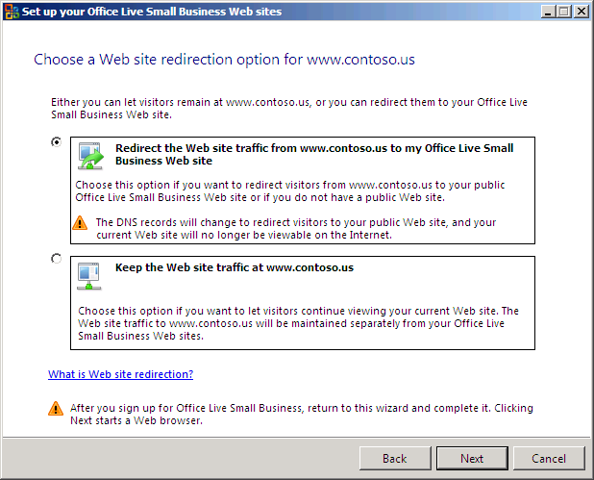
Figure 8 – Setting Up Office Live Small Business Web Site

The Backup and Server Storage Tab
The Backup and Server Storage tab provides an administrator with a streamlined toolset for creating and managing server backups. It is the primary interface for maintaining hard disk drives within Windows Small Business Server 2008. With the Backup and Server Storage tab, the administrator can:
- Use the Configure Server Backup wizard to create backup schedules, identify a backup storage medium, and define the items to backup;
- View color-coded indicators of backup successes or failures;
- Modify existing backup schedules to conform to changing requirements;
- Start a backup with a single click;
- Restore files, folders, or volumes from existing backups;
- View existing hard disk drives, sizes, current usage, and available free space; and
- Move server data, including Exchange Server, SharePoint Services, User Shares, redirected My Document folders, or Microsoft Update data to an alternate storage location.

Using the Backup and Server Storage Tab
The Backup and Server Storage tab includes two sub-tabs: Backup and Server Storage. Both sub-tabs include color-coded status indicators. As shown in figure 9, the latest backup event was successful. Given the importance of backing up a business’s data, the overall backup status rolls up to the Network Essentials Summary pane located on the Console’s Home tab.
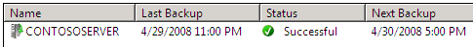
Figure 9 - Windows Small Business Server 2008 Backup Status
When you select the server running Windows Small Business Server 2008, backup-specific tasks appear in the top of the tasks pane. The administrator may modify the existing backup settings including schedule, locations, and the items included in the backup. Figure 10 shows the dialog for changing an existing backup schedule.
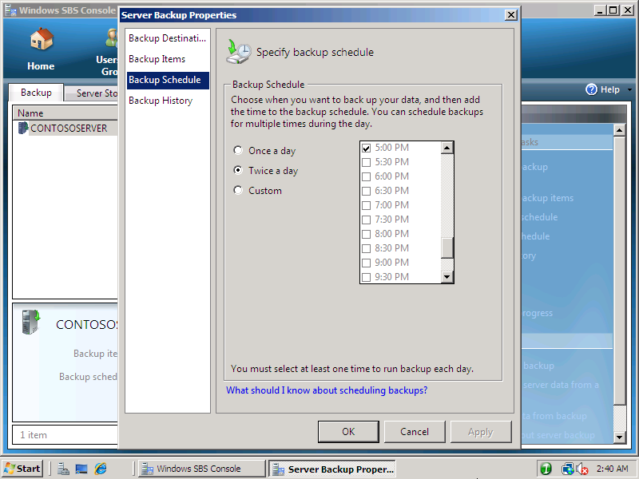
Figure 10 – Changing a Backup Schedule
The administrator may also start a backup, pause the current backup schedule, disable backup, view backup history, or restore data. When restoring data, the administrator redirects from the Windows SBS Console to the Windows Server Backup tool at the operating system level.
The Server Storage sub-tab provides insight into overall storage health including current usage and free space for each known hard disk drive.
One feature that partners will appreciate is the ability to move server data to new storage. With its support for external hard disk drives, it is easy to add additional storage to Windows Small Business Server 2008 without having to shut down the server. As shown in figure 11, the administrator may move Exchange Server data, SharePoint Services data, User’s Shared Data, Redirected Documents data, or Windows Update Repository data to a new location using a wizard. Moving data is as simple as selecting a volume with enough storage space and then approving the move.
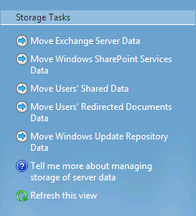
Figure 11 – Options for Moving Server Data to Alternate Locations

The Reports Tab
The Reports tab provides consolidated reporting information on the Windows Small Business Server 2008 environment and a means to distribute status information to desired recipients. With the Reports tab, the administrator can:
- Leverage native reports to get a complete snapshot of the environment;
- Generate reports immediately or on a schedule with automatic e-mail forwarding; and
- Create custom reports, or view past reports through the reports archive.
Reporting information may include:
- Security – Status of antivirus and malicious software filtering on Exchange Server 2007, and on clients running Windows XP and Windows Vista on the network;
- Updates – Update compliance, synchronization status, and current policy settings;
- Backup – Backup history and results;
- Other Alerts – Critical server events and client and server threshold monitoring;
- E-mail Usage – Incoming and outgoing per-user mail volume and mailbox sizes;
- Server Event Logs – Roll up of all critical events on the server.
Reports are available at any time in the Windows SBS Console, and reports can also be delivered to multiple recipients through e-mail. By default a daily summary report is sent to the network administrator every night, and a weekly detailed status report (figure 12) is sent to the network administrator once a week.
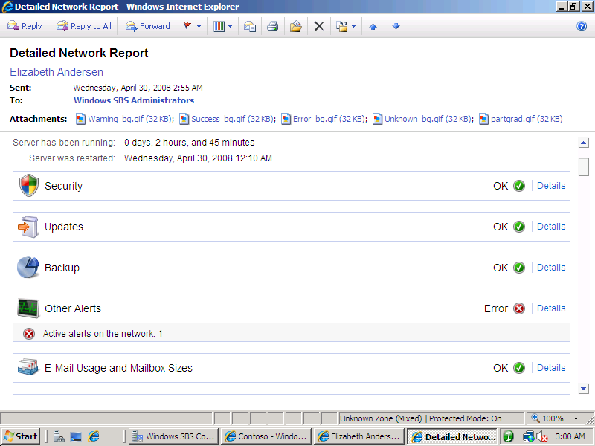
Figure 12 – Detailed Network Report
The reports can be customized to include as much or as little information as you want, and can be generated at any time or according to a schedule.

Using the Reports Tab
Creating new reports, or modifying existing ones, is straightforward. Four sections help build the custom report structure. The sections include General, for naming the report; Content, for selecting content to include in the report; E-mail, for selecting report recipients (as shown in figure 13); and Schedule, for defining the delivery date and time. The Archives section is active when editing an existing report.
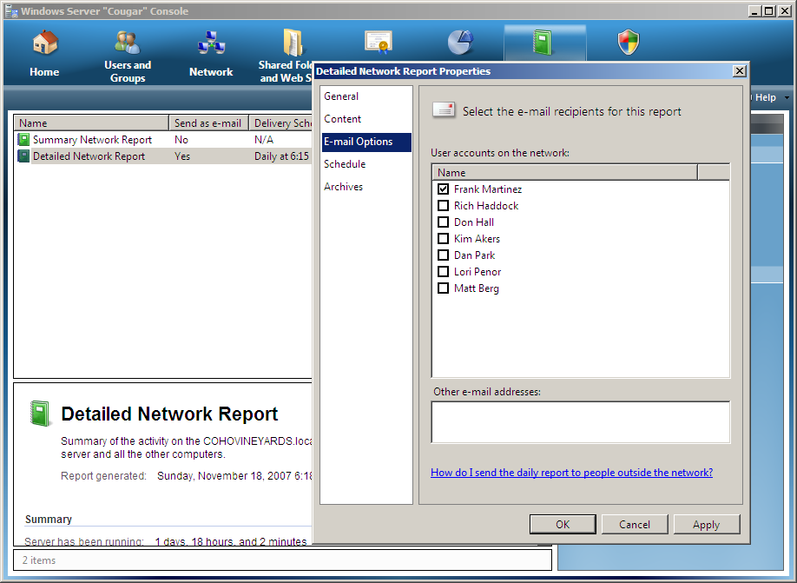
Figure 13 - Selecting a User E-mail for Automated Report Generation

The Security Tab
The Security tab provides real-time information about network security. It is also the main tool for configuring, monitoring, and managing Windows Server Update Services. With the Security tab, the administrator can:
- Quickly identify anti-spam, antivirus, server antivirus, and malicious software status and alerts through color-coded health indicators;
- View definition or signature file versions for anti-spam and antivirus;
- Determine if any client computers lack security updates;
- Receive summary information on the Windows Server Update Services environment including pending approvals and update errors;
- Deploy or decline updates with a single click;
- Change Windows Server Update Services synchronization or automatic approval options; and
- Generate reports showing how an update affects the network.

Using the Security Tab
The Security tab includes two sub-tabs: Security and Updates. The Security sub-tab is an information pane for determining the overall state of all security components. As shown in figure 14, a color-coded icon indicates either a healthy or an unhealthy state for each security component. When selected, the security component’s current signature or virus definition version is displayed.
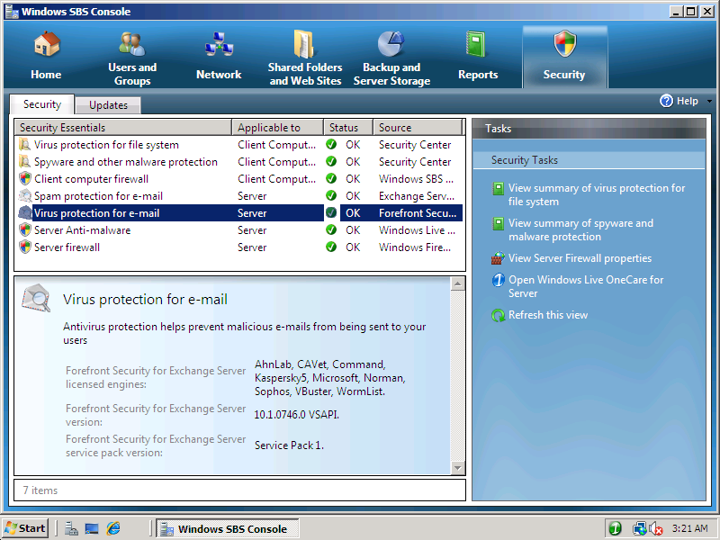
Figure 14 – Security Components Health Status
By default, security settings conform to Microsoft-recommended best security practices for small businesses. If more control or customization is needed, an administrator may launch the security component’s native management console to modify settings as needed. For example, to select a different combination of antivirus engines used for e-mail services, the administrator would launch the Forefront Security for Exchange Windows SBS Console, located in the Start menu.
The Updates sub-tab consolidates information and settings from Windows Server Update Services, which downloads and deploys updates for Microsoft products to registered client computers on the network. The sub-tab displays network device status to ensure the devices remain up-to-date. The information provided includes Updates Pending Approval, Update Errors, Optional Updates, and Updates in Progress.
The default configuration automatically approves all security, critical, and definition updates that are applicable to computers on the network. In the case of optional updates, which are not approved by default, the administrator may approve them manually, allowing time to test the updates or research them before deploying them throughout the business.

2.04 The Business-driven Experience
Server-based IT solutions deliver savings in time and effort needed to administer them. But no matter how competent the server, the solution must help the true end users: the business employees who will work with the solution as part of their daily routine.
Windows Small Business Server 2008 delivers significant savings to businesses by making it simpler to do daily tasks. Powerful Web-based tools make it easy to share information and work with documents in a collaborative environment, whether that information is being shared within the business or with partners and customers over the Internet. Even retrieving “lost” information is only two clicks away.
Employees using Windows Mobile devices can synchronize calendars and contacts, read and respond to e-mail and browse internal Web sites while on the road or at customer sites. This can provide a competitive advantage to small businesses that can provide answers to customers in minutes rather than hours or days.

Remote Web Workplace
Remote Web Workplace is a dynamically-updated Web site that provides a single, simple, consolidated, and secure entry point into a small business network. Authorized users can connect to Remote Web Workplace using any computer connected to the Internet with Internet Explorer installed. It brings flexibility to small businesses by offering anytime, anywhere access for employees.
Employees can take advantage of remote access to business information and applications, including e-mail, shared folders and files, or remote connectivity to their desktop computer at the office. With Remote Web Workplace, remote employees enjoy an experience similar to their office counterparts.
Remote Web Workplace provides two interfaces: one for employees and one for administrators. For employees, Remote Web Workplace:
- Offers full access to e-mail and calendars through Outlook Web Access; to an intranet portal via SharePoint Services; or to computer desktops using Remote Desktop Protocol (RDP);
- Provides a single sign-on experience—an employee’s initial authentication will pass through to all subsequent actions within Remote Web Workplace for which they have permissions; and
- Offers self-service password resets.
For administrators, Remote Web Workplace:
- Offers the same access as employees plus access to the Windows SBS Console through an RDP connection; and
- Provides links to administrative tools.
By default, all users can access Remote Web Workplace. The administrator can control which users have access to Remote Web Workplace by defining a custom role that disables remote access, by changing access permissions through the Shared Folders and Web Site tab, or by setting individual permissions through each user’s account properties.
Installation and configuration of Remote Web Workplace occurs automatically during the completion of the Connect to the Internet tasks. For an example of completing the Connect to the Internet tasks, see the Connect to the Internet section of this document.
Figure 15 shows the Remote Web Workplace home page as presented to a user with administrator permissions. Functionally it is identical to a standard user’s view except for the administration section in the lower right. With administrator permissions, the user has remote access to the Windows SBS Console through RDP and can access the pre-configured Help Desk portal in Windows SharePoint Services.
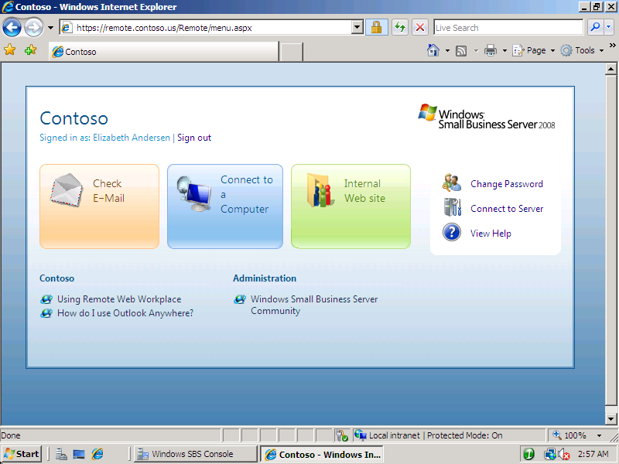
Figure 15 - Remote Web Workplace for an Administrator

Office Live Integration
Windows Small Business Server 2008 integrates with the Internet-based Office Live Small Business to provide everything needed to publish, promote, and manage a business on the Internet. Within the Windows Small Business Server 2008 management console, customers can set up and manage Office Live Small Business workspaces and their public Web site, helping them improve collaboration between employees and with partners, and to present a more professional online image. This integration reflects Microsoft’s growing “software plus services” strategy to give customers choices and combinations of on-premise and service-based solutions. Note: Some features in Windows Small Business Server 2008 are dependent on market and language availability. For more information on availability please check the Microsoft Web site (http://www.microsoft.com/sbs08).
Figure 16 shows the Web site designer that is available within Office Live. Customers can create a professional Web presence without the hassle or expense of setting up a complicated infrastructure or hiring technical staff to maintain it. Templates, market-specific designs, and Web parts are available so partners or customers can customize any part of the site – color, fonts, look and feel, and content.
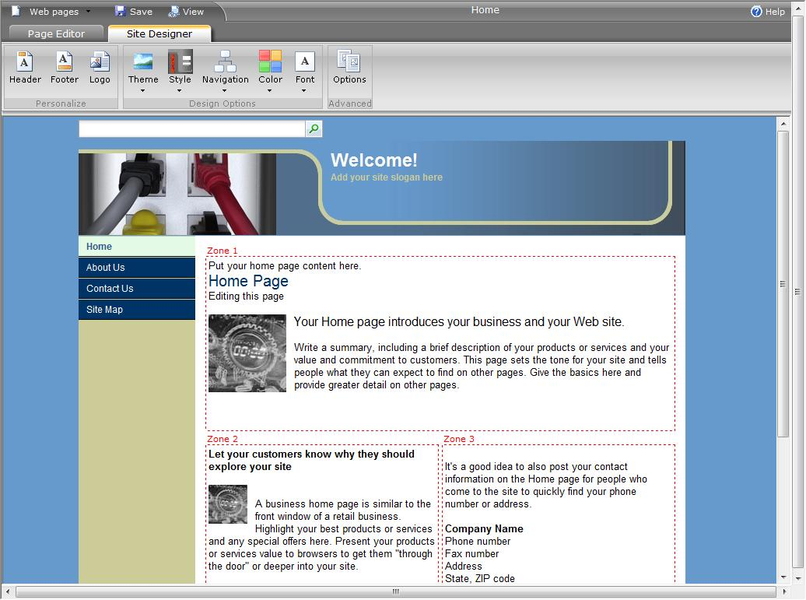
Figure 16 – Office Live Web site designer
Office Live is more than hosting a business Web site. It also provides businesses with the ability to connect with customers, vendors, and suppliers easily and professionally. Online marketing tools and business applications (Figure 17) include collaboration spaces, project tracking and workflow, marketing newsletters and campaign management. They work together to differentiate the Windows SBS 2008 business from the competition and improve the ability to find and retain customers.
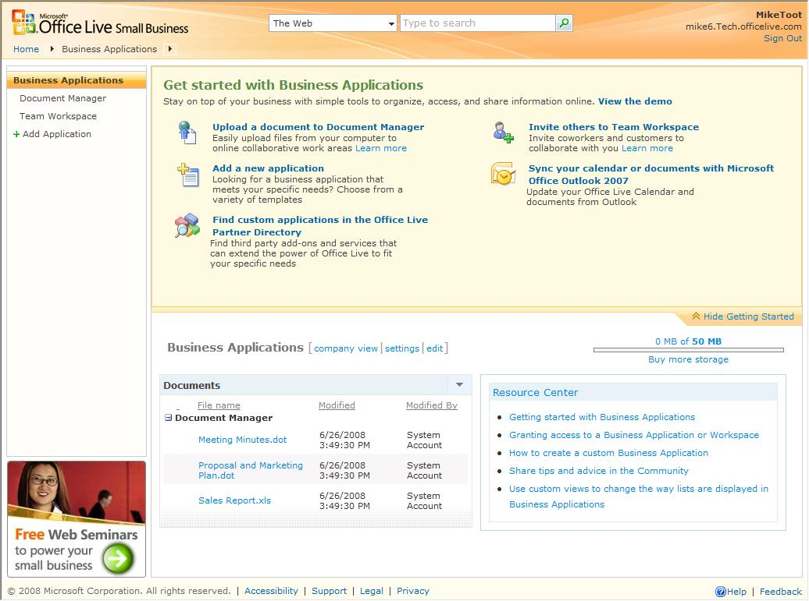
Figure 17 – Office Live Business Applications

Desktop Links Gadget
Users running Vista have access to the Windows SBS 2008 Desktop Links Gadget (Figure 18). The gadget provides links to Windows Small Business Server applications, organization inks, and administration links for administrative users.
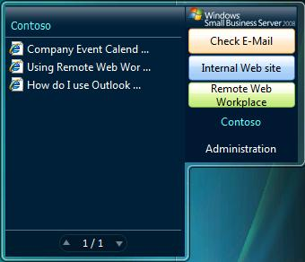
Figure 18 – Desktop Links Gadget
Any of the three sections can be customized so users have one-click access to commonly-used resources, Web sites, or applications. Administrators can assign the gadget to groups of users or restrict access depending on business needs. Figure 19 shows the configuration options for the gadget.
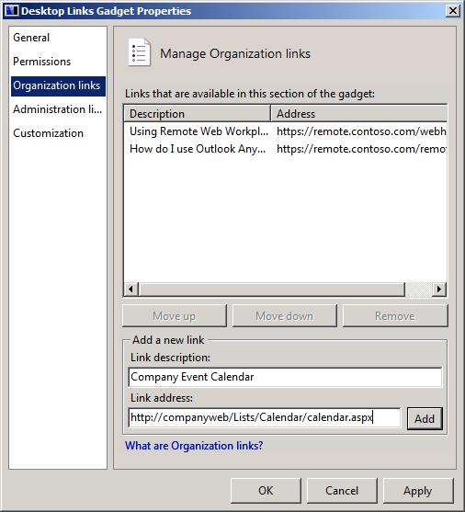
Figure 19 – Customize the Desktop Links Gadget

Restore or Recover Files
In any environment that involves users and data there is always the risk that documents may be accidentally overwritten with data. In the past, when a document was overwritten, a version had to be restored from a backup tape, which often took hours to accomplish. With Windows Small Business Server 2008, employees can restore previous versions of files without requiring intervention by an administrator. By redirecting My Documents from the client PC to the server, the automatic back up protection of the network allows users to quickly recover a previous version. In the Document Properties dialog box, an end user clicks the Previous Versions tab and then selects the version to restore (Figure 20). The Volume Shadow Copy feature restores the earlier version in seconds, not hours, and the user can continue working with the correct document version.
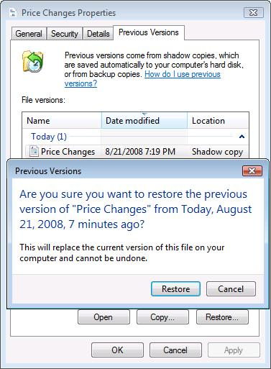
Figure 20 – Restore a previous version

Mobility features
Mobility is a feature in Windows Small Business Server 2008 that provides an easier way for partners to support their customers’ mobile devices. Users of Windows Small Business Server 2008 can easily configure their portable devices to calendars and contacts, read and respond to e-mail and browse internal Web sites while on the road or at customer sites. The mobility solution in Windows Small Business Server 2008 simplifies the setup and provisioning of devices running Microsoft Windows Mobile™ 6.0 software. This provides a competitive advantage to small businesses that want to provide answers to customers in minutes rather than hours or days.

Certificate Installation Package
For employees not located at the main office, it can be difficult to connect to work resources over the Internet. This typically occurs when the business uses a self-signed certificate for the company Web site. Self-signed certificates are not automatically trusted as they do not have a chain of authenticity from a trusted certificate issuer. For partners or businesses, this often meant that the self-signed certificate had to be manually installed on remote computers to access resources. With Windows Small Business Server 2008 there is a Certificate Installation package available (Figure 21). It includes the self-signed certificate plus an application that automatically installs the certificate on the remote computer. The certificate package can be transferred to removable media such as a USB drive or burned to a CD and then sent to the remote users.
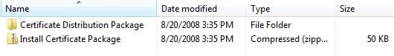
Figure 21 – Certificate Installation Package
The Certificate Installation Package can be found in the Public Downloads folder on the server running Windows SBS 2008.

Section 4: Installing Windows Small Business Server 2008

4.01 Preparing for a Windows Small Business Server 2008 Installation
This walkthrough provides readers with an example of the installation and configuration experience with Windows Server 2008 Release Candidate. If you want to use the Release Candidate release of Windows Small Business Server 2008 in a test environment, you should refer to the Windows Small Business Server 2008 Installation Guide that provides the deployment and configuration steps for Windows Small Business Server 2008. Do not deploy Windows Small Business Server 2008 in a production environment.
Note
Windows Small Business Server 2008 currently supports the English language. The final release of Windows Small Business Server 2008 will be localized into Brazilian, Chinese (Simplified and Traditional), Czech, Dutch, English, French, German, Greek, Hungarian, Italian, Japanese, Korean, Polish, Portuguese, Russian, Spanish, Swedish, and Turkish languages.
Prior to beginning the installation of Windows Small Business Server 2008, you should verify that your system meets the minimum hardware requirements and that the necessary cables and network devices are available to configure your environment. For more information on system requirements, see the System Requirements section in this document.
Note
Windows Small Business Server 2008 supports new installations and migrations only. It does not support in-place upgrades.

4.02 Installing Windows Small Business Server 2008
- After starting your server from the Windows Essential Business Server 2008 Management Server DVD (Disc 1), select your language, time and currency format, and keyboard or input method. | 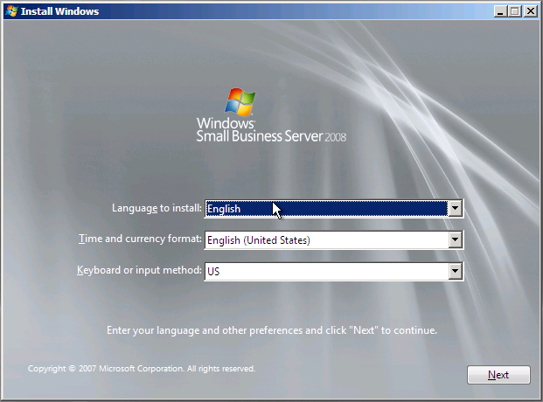
- Select “Install Now” to start the Windows Essential Business Server 2008 installation process.  - Optionally, you may select to repair an existing installation | 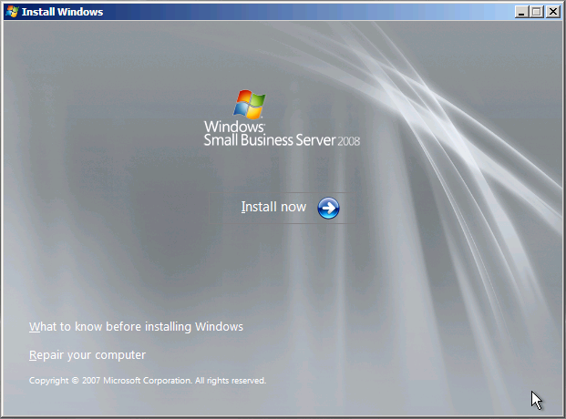
- Type in your product key in the space provided. Optionally, you may configure Windows Small Business Server 2008 to automatically activate when the server connects to the Internet.  - You may continue to install Windows Small Business Server 2008 without a product key. However, you will be required to enter a valid product key during the Windows activation process. | 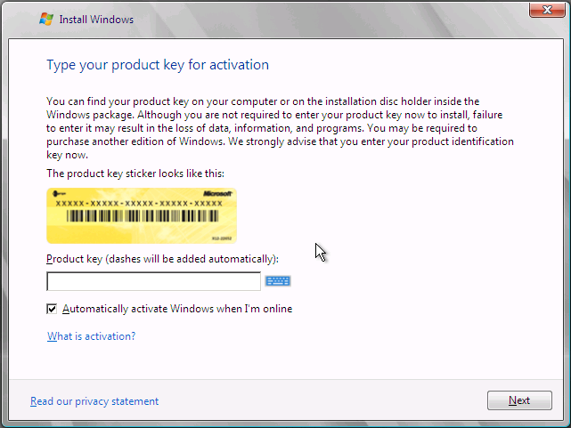
- Review and accept the Microsoft software license terms. | 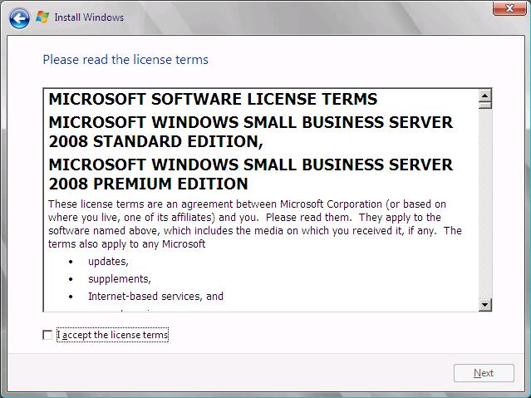
- Select the type of installation you want to perform. At this time, the upgrade option is not available in Windows Small Business Server 2008. | 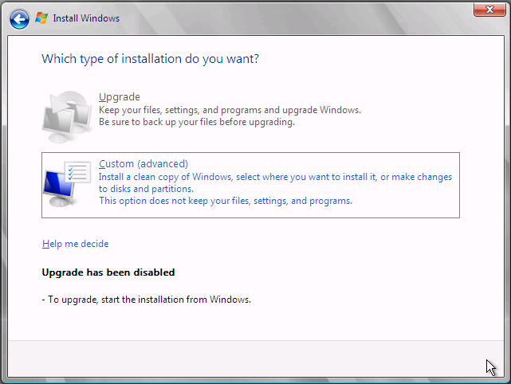
- Select the hard disk where you want to install Windows Small Business Server 2008.  - You may also access Drive Options to partition your drive or perform additional drive maintenance. You may also use Load Drivers to add additional driver support. | 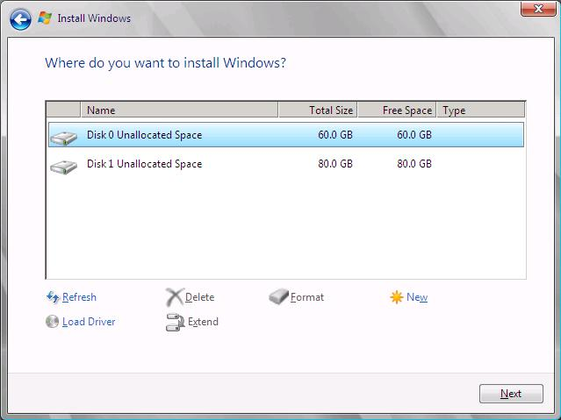
- Windows Small Business Server 2008 begins the installation process. Progress indicators show the status for this first part of the installation. The server will automatically restart during this process. | 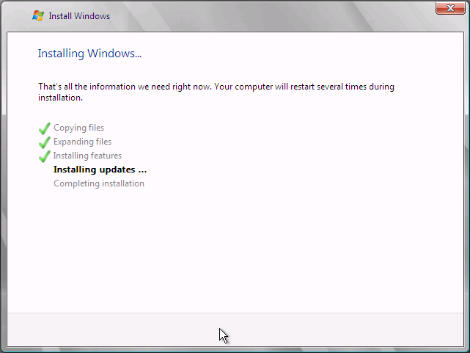
- Windows Small Business Server 2008 notifies you that the initial phase is complete. On subsequent screens, you will enter configuration information for the server. | 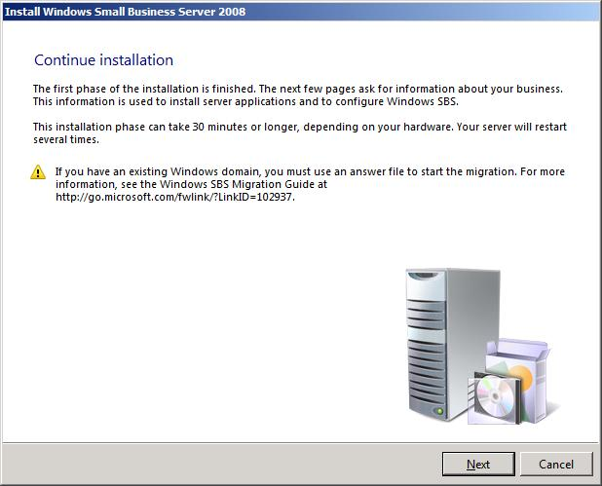
- Verify the local time and time zone settings for your server. This is important for synchronizing e-mail, server updates, and time-dependent applications. | 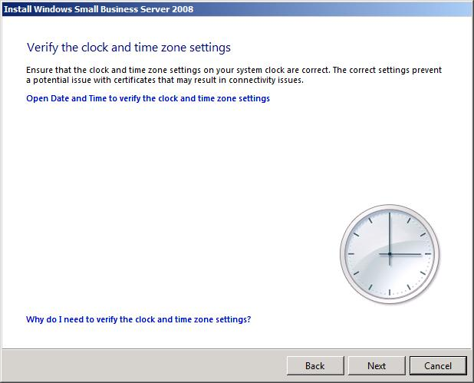
- The configuration wizard can search for, download, and install the latest updated installation files for your system from Microsoft Update. To ensure a more secure installation, you should allow the Windows Small Business Server 2008 configuration wizard to update your system. | 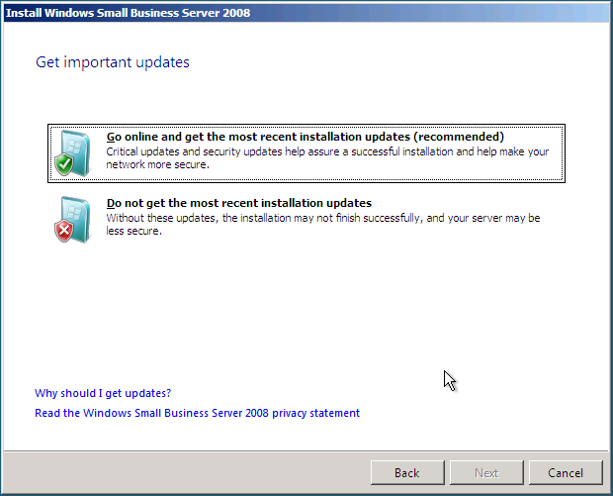
- Windows Small Business Server 2008 connects to your existing network and downloads the latest updates. | 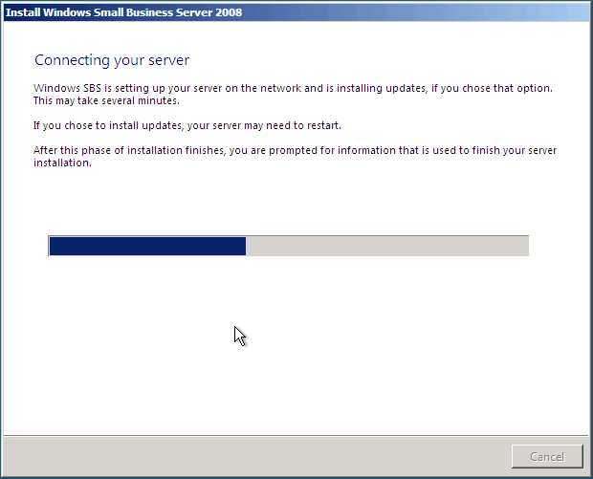
- Enter your company information. This information is used throughout the Windows Small Business Server 2008 solution, including generating the server name for your network. | 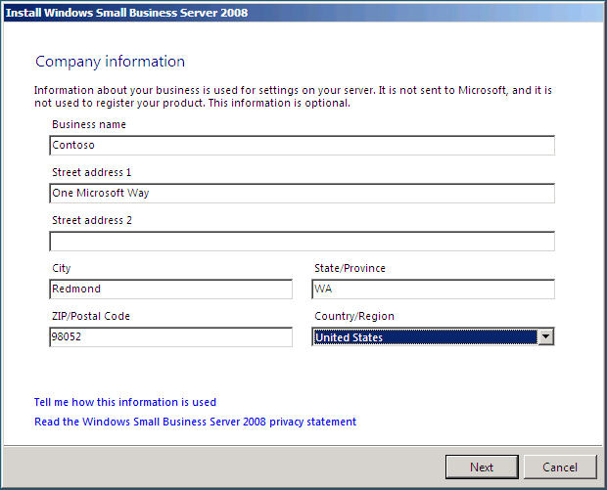
- The software suggests a server name and internal domain name based on the company information provided.  - You may optionally enter unique values for both the server name and Internet domain name. | 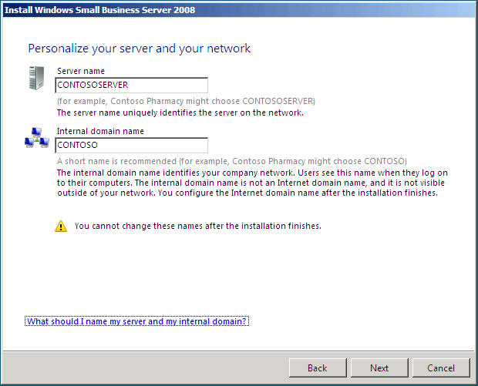
- Next, provide a name for the administrator account. The account password must meet minimum password complexity requirements.  - Note: The administrator’s user name is automatically populated based on the first and last name entered. You may accept the default value or enter a unique name. | 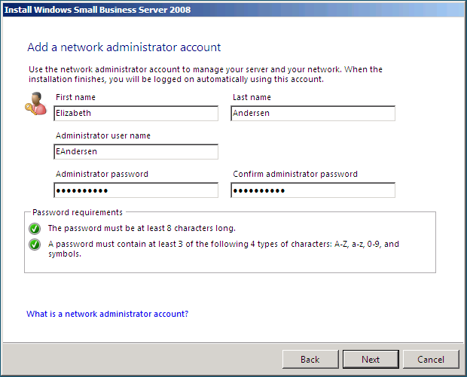
- Windows Small Business Server includes 120-day trial software for Windows Live OneCare for Server and Microsoft Forefront Security for Exchange Server. You can use install these products to provide malware and antivirus protection for your server. Or, if you have existing software that provides these services, you can choose not to install the Microsoft products on your server. Once you’ve made your selection, click Next. | 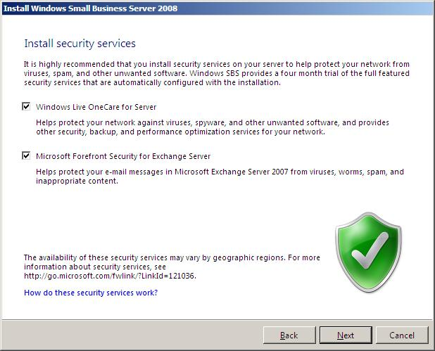
- Before setup continues, your server information is displayed. If you want to change any information, click Back. | 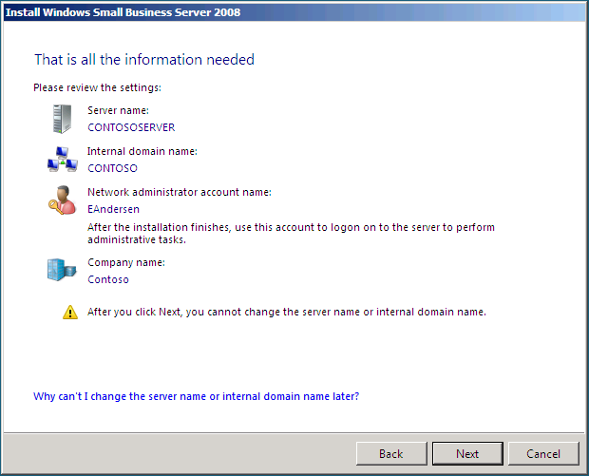
- Windows Small Business Server 2008 completes the installation phase of your deployment. Your server will restart several times during this process. | 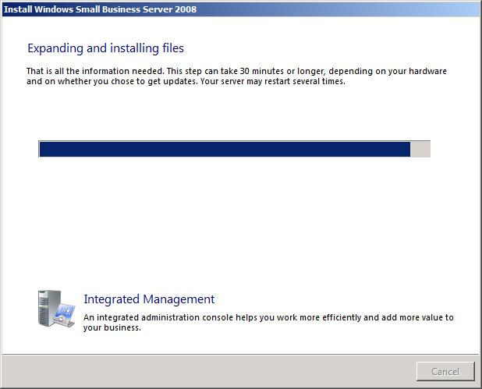
- The Windows Small Business Server 2008 installation was successful. If issues were encountered during installation, such as not having a functional network connection, you are provided with additional information about the issues so that you may resolve them before continuing with setup.  - Once installation is complete, you then perform a series of Getting Started Tasks. These tasks are available by clicking “Start using this server”. | 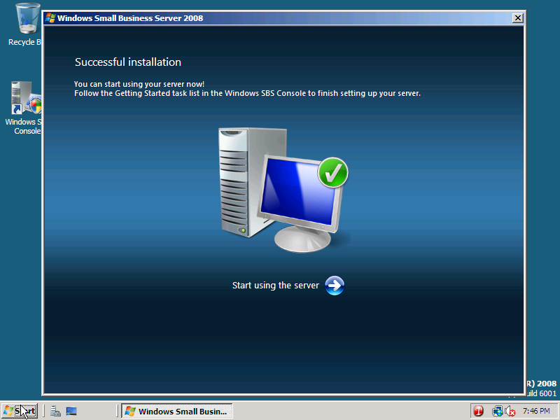

4.03 Getting Started Tasks
Once the installation phase is complete, you must complete additional configuration tasks on the server. These include connecting the server to the Internet, setting up an Internet address, enabling server backup, adding new user accounts, adding computers, and setting up client access licenses.
The Getting Started Tasks shown in figure 22 are located in the Windows SBS Console on the Home tab. The Windows SBS Console launches automatically after a successful installation. It can also be launched from the Desktop shortcut or by clicking Start ->All Programs ->Windows Small Business Server -> Windows SBS Console.
Note
The Windows SBS Console is the central point for managing most aspects of the Windows Small Business Server environment. For a detailed view of the Console, see the Windows Small Business Server Console section of this document.
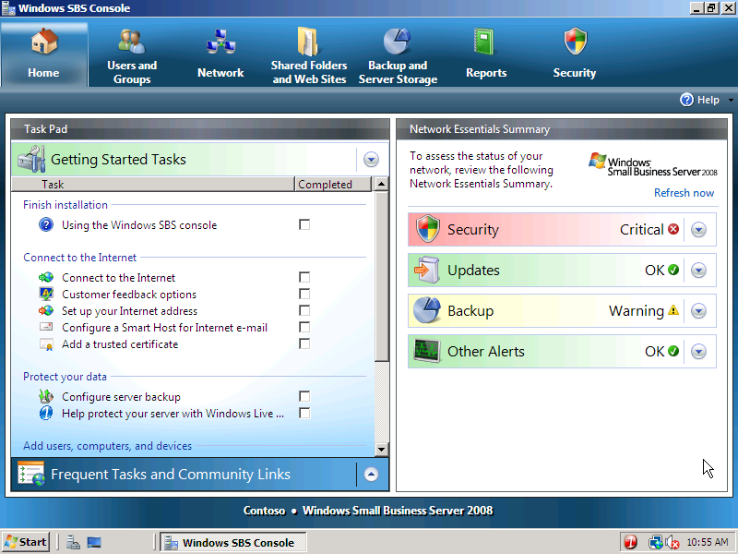
Figure 22 – Getting Started Tasks

Getting Started Tasks
The Getting Started Tasks provide the administrator with a consolidated and easy-to-follow set of steps that complete the Windows Small Business Server 2008 configuration. At any point, the administrator can determine which tasks have been completed and which must still be performed. Getting Started Tasks should be performed in the order provided.
Note
During several of the tasks, Windows Small Business Server 2008 communicates and configures UPnP-capable firewall devices. When a wizard is unable to communicate with a firewall device, Windows Small Business Server 2008 provides detailed information on how the administrator should configure the device manually to allow network access.

Connect to the Internet
The Connect to the Internet task connects the Windows Small Business Server 2008 environment to an existing network. It consists of two wizards that help automate the Internet connection process. The Connect to the Internet Wizard configures basic networking, including setting up the server’s IP address and configuring DHCP services for the network. The Internet Address Management wizard helps the administrator configure the server’s domain name and register that name with an Internet registrar. For businesses that already have a domain name, the wizard allows the administrator to manually configure the appropriate settings.
Both wizards simplify the task of connecting a business to the Internet and minimize the time needed to get the business up and running.

Using the Connect to the Internet wizard
The Connect to the Internet wizard configures the basic network settings for the new server, whether connecting to an existing network or setting up a network for the first time. It automates many of the traditional network configuration processes and helps eliminate errors that may arise from configuration mistakes.
The wizard detects UPnP-enabled firewall devices located on the non-routable segment 192.168.nnn.nnn, determines the current settings in use on the network, and configures Windows Small Business Server 2008 server accordingly. Prior to starting the Connect to the Internet wizard, you should know the internal IP address of your firewall device. If applicable, you should also know the user name and password in case you need to configure the firewall device manually. Figure 23 shows the Connect to the Internet welcome page.
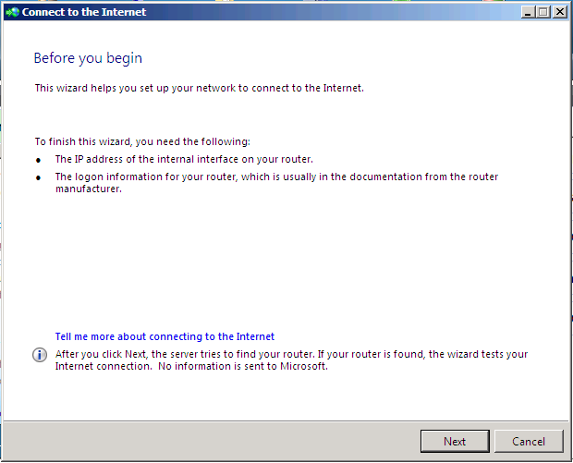
Figure 23 - Connect to the Internet Welcome Page
As shown in figure 24, the Connect to the Internet wizard conducts tests to determine the existing network infrastructure.
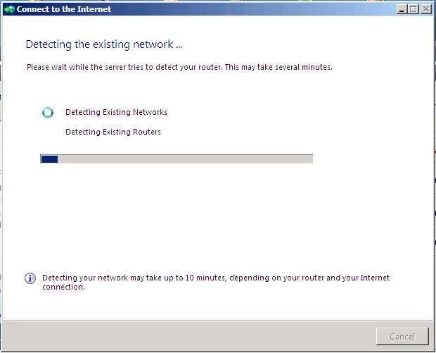
Figure 24 – Detecting the Network Environment
If Windows Small Business Server 2008 is unable to communicate directly with a firewall device through UPnP, the Connect to the Internet wizard provides guidance to help the administrator configure the firewall device manually. As shown in figure 25, the Connect to the Internet wizard notifies the administrator that the conflicting DHCP Services on the firewall device need to be disabled.
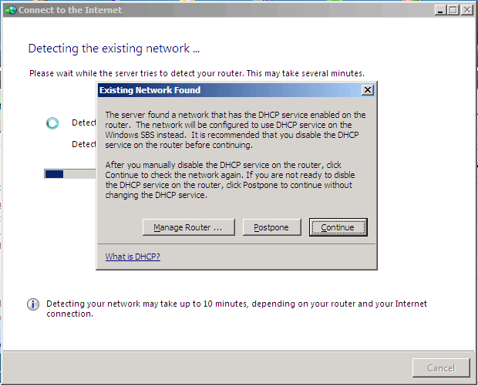
Figure 25 – Configuring a Firewall Device Manually
When the Connect to the Internet wizard successfully detects a firewall device, the IP address is shown as in figure 26. When the Connect to the Internet wizard cannot automatically detect a firewall device, the administrator must enter the firewall device’s IP address manually.
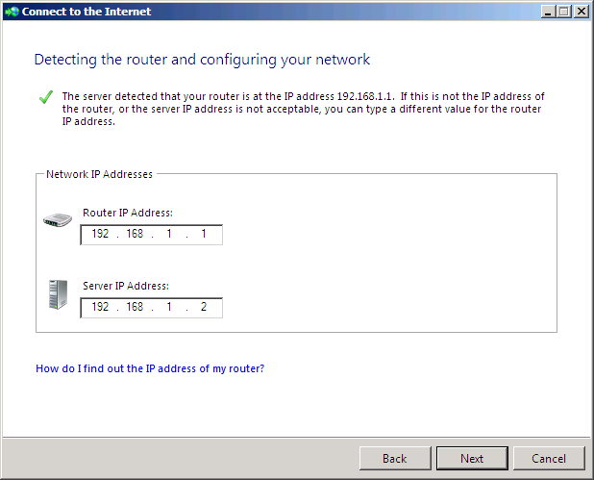
Figure 26 – Determining the IP Address of a Firewall Device
Finally the Connect to the Internet wizard confirms that it is connected to the Internet (figure 27). Windows Small Business Server 2008 is now configured for the local network and will provide IP address management for DHCP-enabled devices on the network.
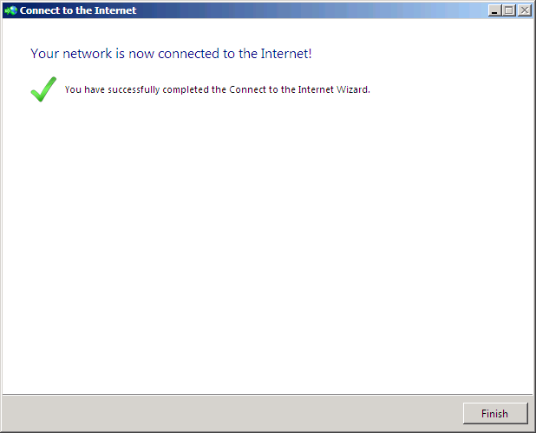
Figure 27 – A Successful Windows Small Business Server 2008 Configuration

Using the Internet Address Management wizard
The Internet Address Management Wizard (IAMW) configures domain name settings for the network. It helps an administrator obtain a new domain name or work with an existing one. The IAMW automatically configures e-mail services (Exchange Server) and remote access services (Remote Web Workplace) based on the domain name information provided.
Note
When registering a new domain name or transferring the management of an existing domain name using one of the registrars listed in the wizard, all Domain Name System (DNS) records are automatically configured at the registrar. When manually configuring an existing domain name, you are responsible for working with the registrar of your choice to manage the appropriate DNS records.
Prior to starting the Internet Address Management Wizard, you should have an idea of the domain name that you intend to use. When transferring an existing domain name, you should know the domain name, the name of your domain provider, and the credentials for logging on to your domain name provider’s system. Figure 28 shows the Internet Address Management Wizard welcome page.
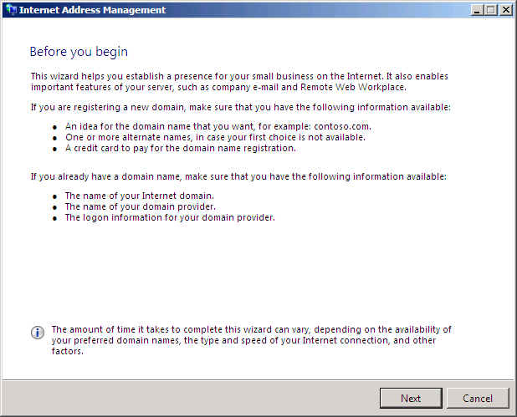
Figure 28 – Starting the Internet Address Wizard
As shown in figure 29, there are three specific options available within the Internet Address Management Wizard:
- Register for a new domain name from within Windows Small Business Server 2008 through one or more Domain Name Registrar partners;
- Transfer the management of an existing domain name from within Windows Small Business Server 2008 through one or more Domain Name Registrar partners; and
- Integrate an existing domain into the Windows Small Business Server 2008 environment and managed it manually.
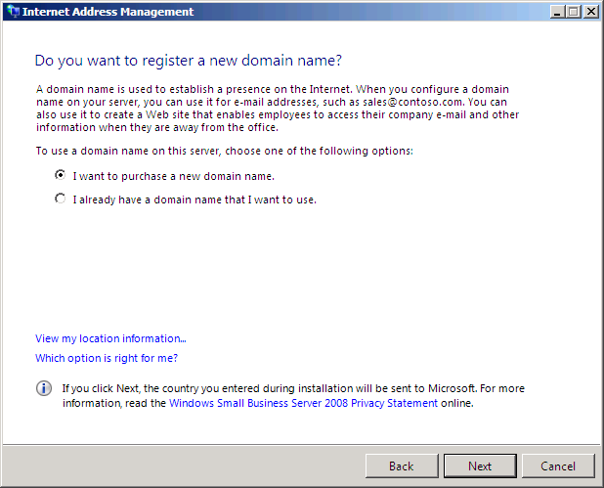
Figure 29 – Integrating Domains in Windows Small Business Server 2008
The Internet Address Management Wizard lists any domain name extension supported by the registrar; however you can purchase any domain name extension regardless of whether it is listed by the registrar. Microsoft has enrolled several domain name registrars to simplify the creation and management of domain names. The program is open to all registrars that want to participate. Additional registrars will be added in the final release of Windows Small Business Server 2008.
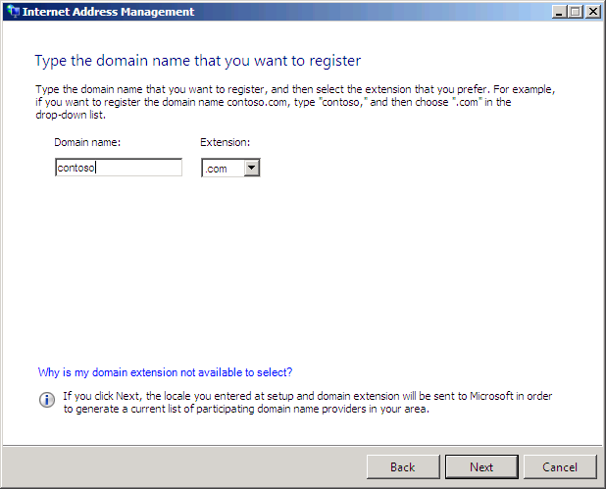
Figure 30 – Registering a New Domain
As shown in figure 31, you must select a Domain Name Registrar to continue.
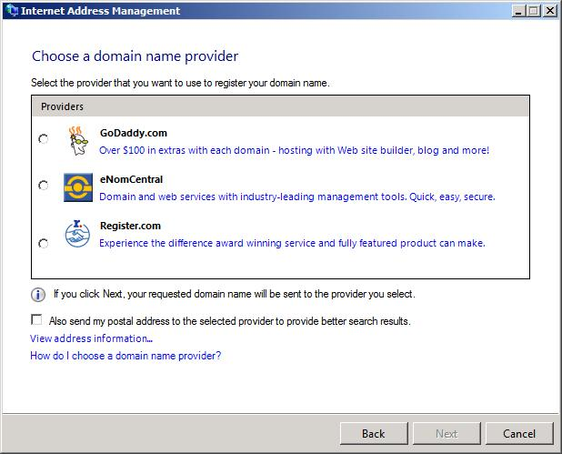
Figure 31 – Selecting a Domain Name Registrar
If the domain name chosen is not available, the Internet Address Management Wizard provides a list of currently available domain names. As shown in figure 32, if the available domain names do not meet your requirements, you may initiate a new name search.
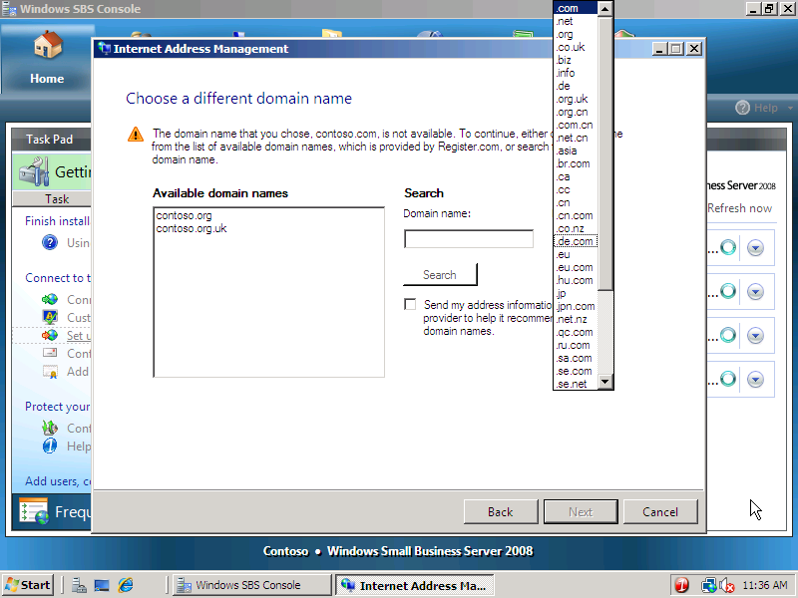
Figure 32 – Selecting Alternative Domain Names
To manage a domain name and DNS records manually, you should choose the last option as shown in figure 33.
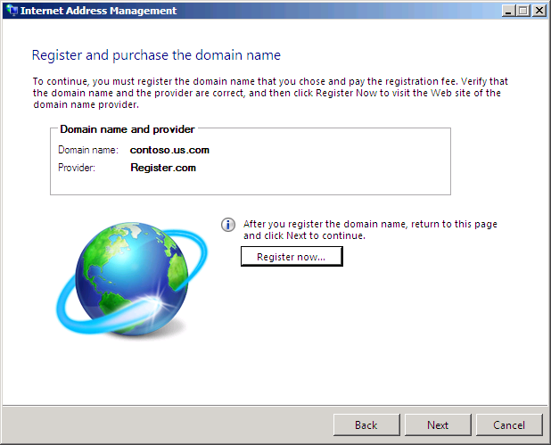
Figure 33 – Using an Existing Domain with Windows Small Business Server 2008
Based on the domain name information provided, the Windows Small Business Server 2008 Internet Address Management Wizard will automatically configure Remote Web Workplace, Microsoft Exchange Server, and the local UPnP-enabled firewall device (figure 34).
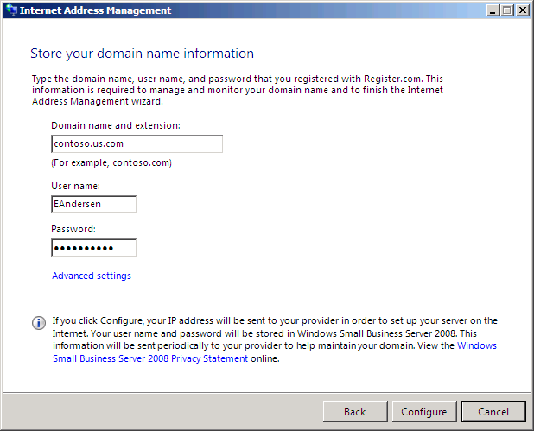
Figure 34 – Completing the Internet Address Management Wizard
Figure 35 shows a successful installation and the DNS settings that have been configured automatically, including the URL for remote access and the e-mail domain.
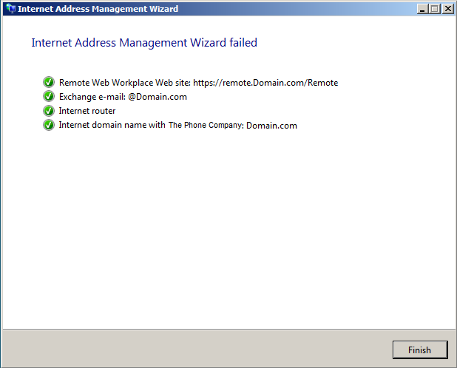
Figure 35 – Installation Summary – Succeeded

A non-UPnP-enabled firewall device generates a warning for the administrator (figure 36) stating that additional steps are required to complete the configuration. Clicking “View Warning Details” provides the administrator with appropriate guidance for completing those tasks.
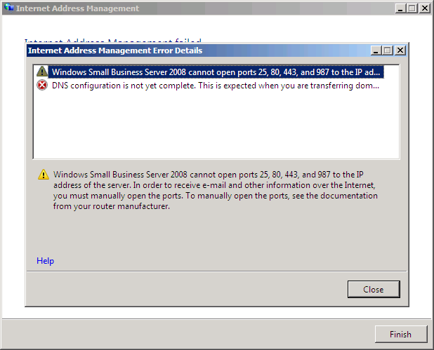
Figure 36 – Guidance for Completing the Installation
When using Windows Small Business Server 2008 to manage your domain name, the process of configuring and maintaining your DNS records is automatic. Windows Small Business Server 2008 initially creates appropriate DNS with the selected Domain Name Registrar, automatically updates DNS records when your external IP Address changes (Dynamic DNS), and periodically verifies that your records are correct.

Protect Your Data
Business data is one of the most critical assets that any business creates. Without the data, a business can go from “Open” to “Closed” in a matter of days. To protect business data, Windows Small Business Server 2008 uses backup technology to ensure the data can be saved in a different location and uses server-based antivirus technology to protect the data from loss. These two technologies work together to add layers of protection to the business and help ensure the business is protected from loss or can quickly recover from loss.

Using the Configure Server Backup wizard
The Configure Server Backup wizard simplifies the process of backing up critical Windows Small Business Server 2008 data to external hard disk drives. It can back up important data such as files, folders, and volumes from product technologies such as Exchange Server, SharePoint, or SQL Server to one or more external USB (1.1 or 2.0) or IEEE 1394 (FireWire™) hard disk drives.
The Configure Server Backup wizard lets you choose where to back up data, select the type of data to back up, and schedule the automated backup process. Prior to launching the Configure Server Backup wizard, the external hard disk should be attached to the server and be available for use. The wizard’s welcome page indicates the number of available storage drives discovered on the server (figure 37).
Note
When using the Configure Server Backup wizard, the external hard disk drives are formatted during the initial configuration.
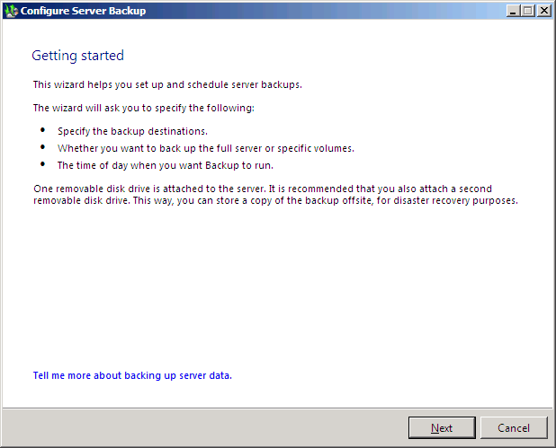
Figure 37 – Configure Server Backup Welcome Page
As shown in figure 38, the administrator can select one or more external USB hard disk drives to be part of the Windows Small Business Server 2008 backup scheme. Using more than one hard disk drive provides added redundancy by allowing rotation and offsite storage of one device.
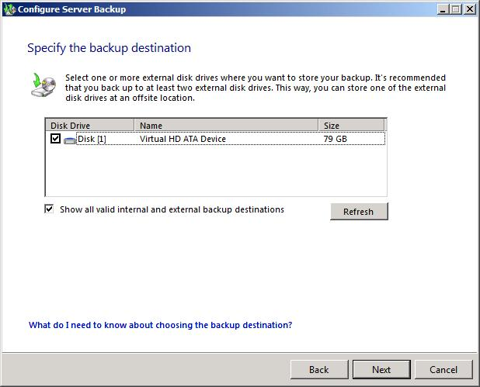
Figure 38 – Selecting Server Backup Targets
As shown in figure 39, each hard disk drive should be appropriately named to simplify management of backup data.
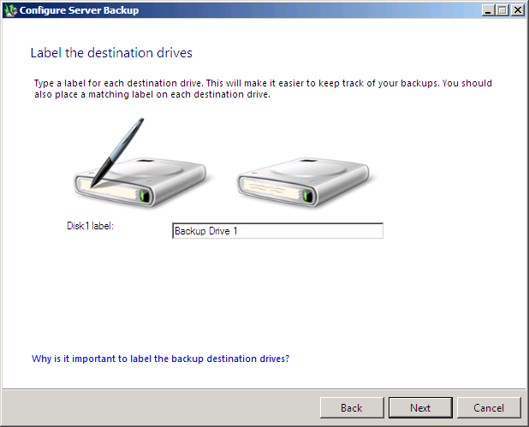
Figure 39 – Labeling Backup Targets
By default, the Configure Server Backup wizard selects the drive that includes the Windows Small Business Server 2008 operating system files and critical applications. When additional hard disk drives are available, the administrator may select additional volumes to include in the backup routine (figure 40).
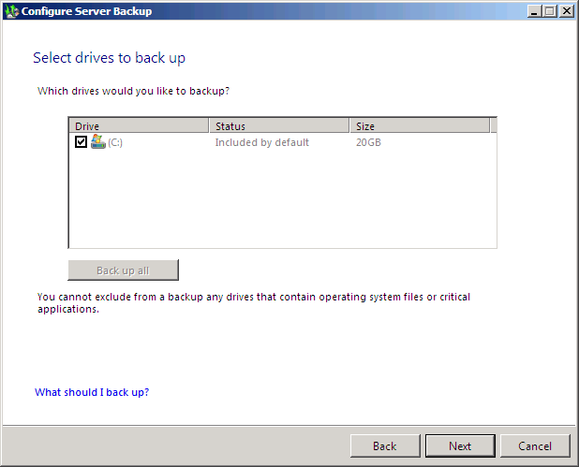
Figure 40 – Selecting a Backup Source
As shown in figure 41, the Configure Server Backup wizard schedules backups to occur twice a day by default (5:00PM and 11:00PM). Alternatively, the administrator can create a custom schedule or choose to perform backups only once per day.
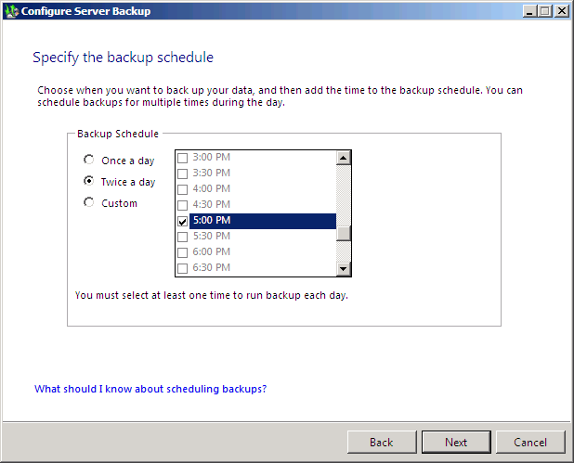
Figure 41 – Setting a Backup Schedule
The Configure Server Backup wizard summarizes the current backup settings (figure 42). The administrator may hit the Back button to modify any settings before completing the configuration. When the Next button is clicked, the external hard disk drive is formatted and the hard disk drive is ready to receive data.
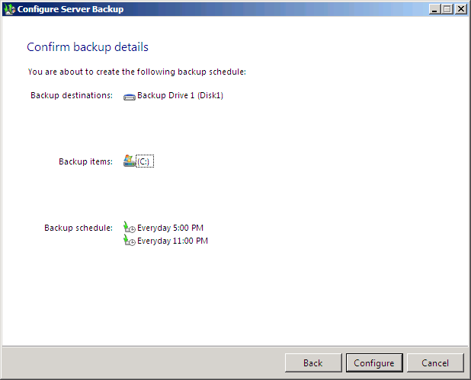
Figure 42 – Confirming Backup Schedule, Targets, and Sources
The Configure Server Backup wizard notifies the administrator of a successful configuration. If any errors were encountered during the configuration, Windows Small Business Server 2008 provides additional information to help with problem resolution.
To modify an existing backup schedule, or to restore previously backed up data, you can access advanced backup settings and tasks through the Windows SBS Console’s Backup and Server Storage tab. See Backup and Server Storage for a detailed view of the Windows Small Business Server 2008 backup and restore capabilities.

Using Windows OneCare
Windows Live OneCare for Server provides server protection from malware or malicious software that may be on your network. It helps protects business data in real time and provides an at-a-glance icon in the notification area. It is also integrated into the Windows SBS Console reporting feature so that you can see your server’s ongoing health status even when you are away from the office.
Note
Windows Small Business Server 2008 includes a free 120-day trial version of OneCare. For permanent use, you must license OneCare separately. Not available in all markets and languages. See www.microsoft.com/sbs08 for a list of markets and languages.
To start your OneCare trial, click the Help protect your server with Windows Live OneCare task in the Getting Started Tasks list. Figure 43 shows you the Welcome page for Windows Live OneCare.
Figure 43 – Starting the OneCare wizard
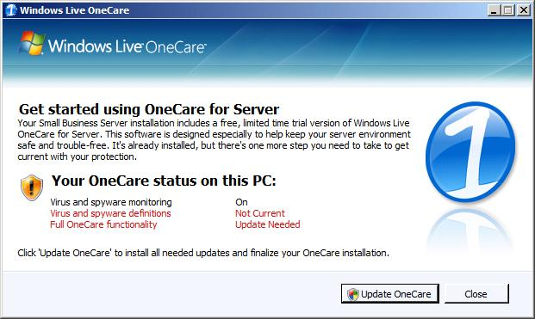
When the wizard starts it reports on your server’s current protection status. You can then start your free trial of OneCare and enable its protection for your server.
Select your language for your area (figure 44). This helps ensure that any updates you receive are appropriate for your area.
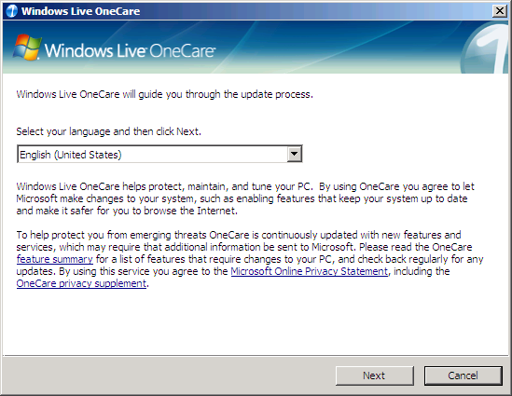
Figure 44 – Select your language
Take a moment to review the Microsoft software license terms, shown in figure 45. When you are ready accept them and continue with the wizard.

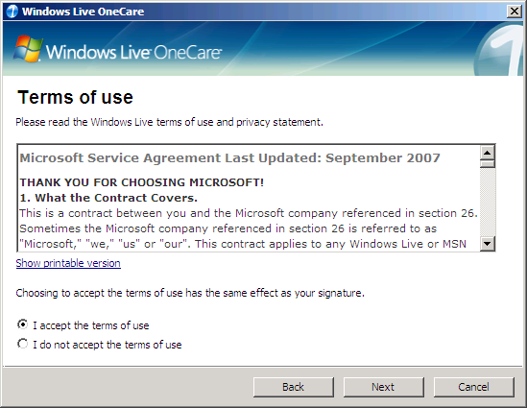
Figure 45 – Accept the software license terms
Windows Live OneCare contacts the update service and downloads any updates that have been released (figure 46). These updates will be automatically installed on your server.

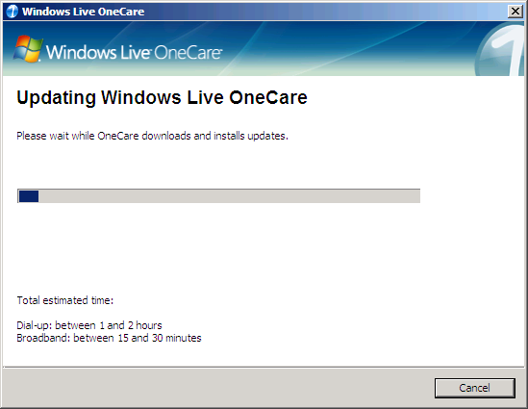
Figure 46 – Updating Windows Live OneCare
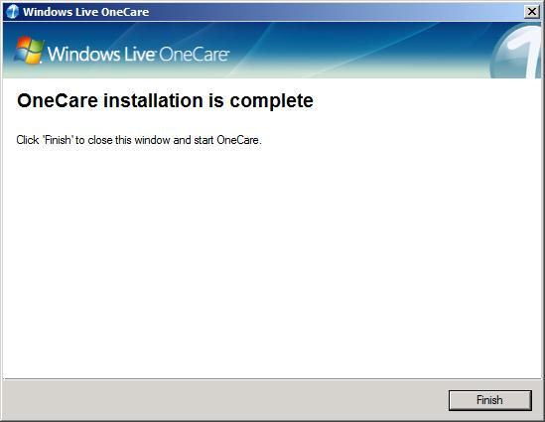
Once the updates are installed, your server is protected (figure 47).

Figure 47 – Restart Your Server to finish updating OneCare
You have the option of enrolling in a subscription to OneCare for Small Business Server. You can elect to do this immediately, or do it at a later time as shown in figure 48. To enroll at a later time you can re-run this wizard and then choose to enroll with OneCare.

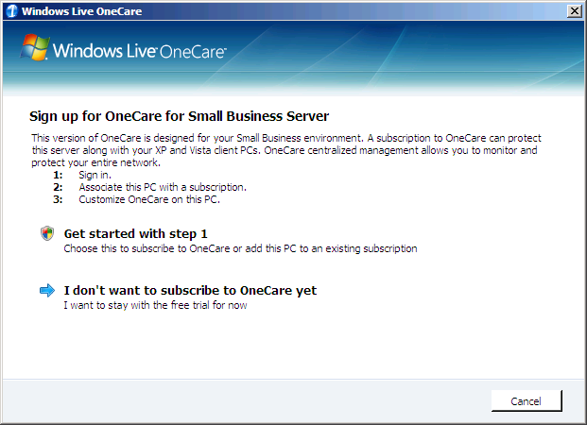
Figure 48 – Sign Up for OneCare for Small Business Server
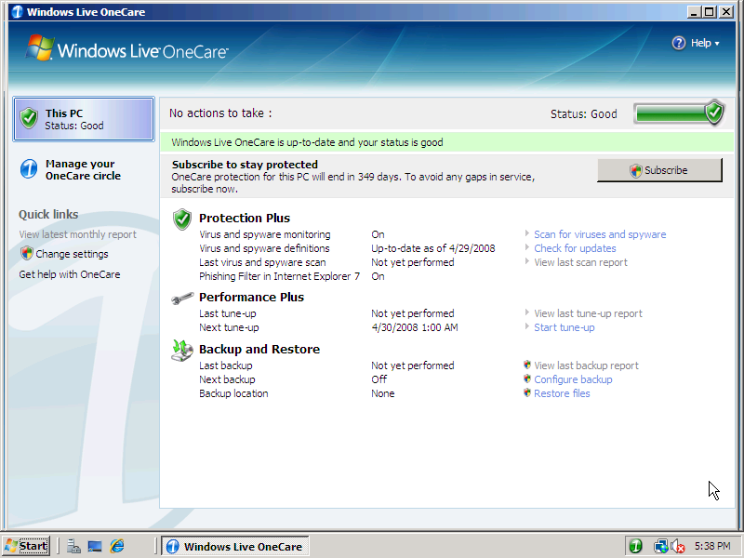
Figure 49 – Your server is protected
Your server is now protected with Windows Live OneCare for Small Business Server (figure 49).

Add Users, Computers, and Devices
Adding and maintaining users and devices on the network is one of the most common tasks for any system administrator. Even in small businesses employees are added or removed frequently, and maintaining the list of computers and other devices in the network can be a full-time job. It can be challenging to recall which settings are required for specific groups or users, or know which device is assigned to specific users.
Windows Small Business Server 2008 takes the intricate, often time-consuming task of creating users or adding devices and automates the process. With only a few key pieces of information, any administrator can quickly, easily, and securely configure users and devices for the network. This gives administrators and business owners a known, repeatable, and simple method of growing or modifying the business environment.

Using the Add a New User Account wizard
The Add a New User Account wizard simplifies the task of creating user accounts. The wizard creates a user account, an e-mail alias, provides the user with appropriate permissions for accessing shared folders, and enables remote access through Remote Web Workplace.
Note
The Add a New User Account wizard is also available under the Users and Groups tab of the Windows SBS Console. For a detailed look and managing users and groups in Windows Small Business Server 2008, see the Users and Groups section of this document.
The first step in creating a new user, as shown in figure 50, requires only a basic set of user information. The Add a New User Account wizard dynamically creates user logon names and e-mail aliases based on the first and last name provided. The administrator can accept the default suggested value, select from a dropdown list of alternative iterations, or enter a custom user name. The e-mail address is automatically generated using the selected user name. The next time the wizard is used Windows Small Business Server 2008 recalls the last naming convention and uses it for subsequent user accounts.
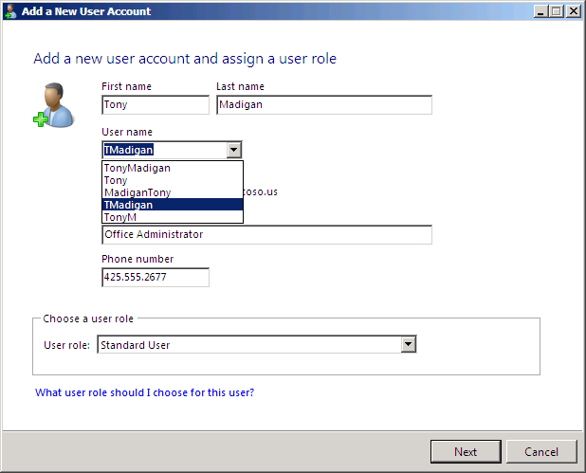
Figure 50 – Enter New User Information
It is also where you can assign a user role to the user. Three roles ship by default with Windows Small Business Server 2008:
- Standard user. Standard users have access to shared folders, printers and faxes, e-mail, the internal company Web site, Remote Web Workplace, and the Internet.
- Standard user with administration links. These users have all the rights of the standard user role but can also view the administration links on Remote Web Workplace. If they click one of these links they must enter network administrator credentials to use the tools. This helps delegate common management tasks to trusted employees.
- Network Administrator. This role has unrestricted system access.
Custom roles can be defined at any time and then assigned to users. This gives flexibility to administrators who need to tailor a specific role for groups of users. One example would be to create a role that has Standard User rights but that does not have Internet access. This helps enforce business policies that restrict Internet access to groups of users who do not need it to perform their duties.
As shown in figure 51, the second step creates a user password. By default, passwords must meet minimum length and complexity requirements. This helps improve the security of the small business environment. Administrators may configure alternate password policies through the Windows SBS Console’s Users and Groups tab.
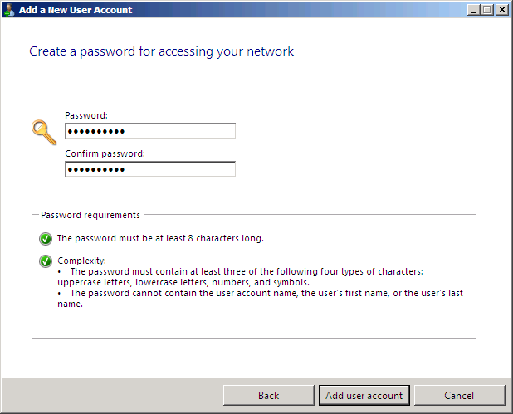
Figure 51 – Create a new user’s password
After entering the user’s information, the wizard creates the account and configures the appropriate domain settings (figure 52). This includes defining the user in Active Directory Domain Services, creating a user-specific shared folder, setting up an e-mail account and e-mail storage quotas, and sending a welcome e-mail to the user.
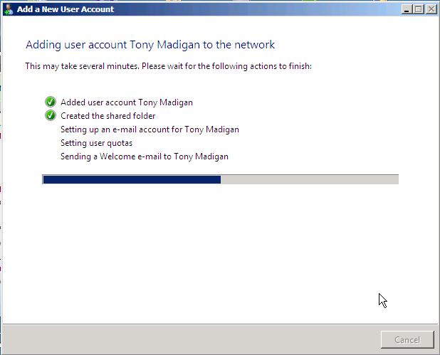
Figure 52 – Configuring a New User’s Settings

Once the new user’s account has been created you have the option of configuring a computer for that account (figure 53). If the user already has a computer on the network, you can assign that computer to your new user. Or you can assign a new computer to that user. Both tasks will configure the appropriate device permissions in Active Directory.
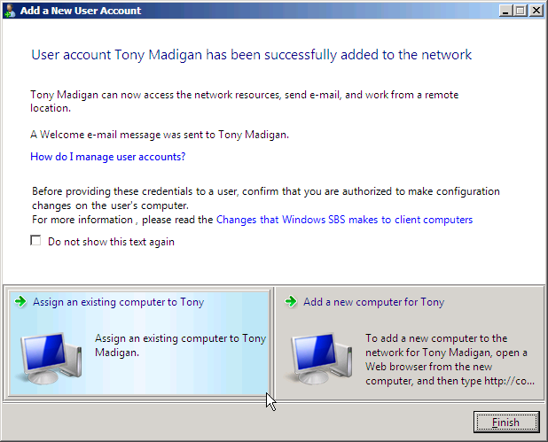
Figure 53 – Option to Configure a Computer for the New User
You do not need to assign computers at this time; you can create all your users first and then assign computers as needed.

Connect Computers to your Network
The Connect Computers to Your Network task adds computers to the Windows Small Business Server 2008 environment. Computers are added to the network by running the Connect Computer program on each computer. The wizard joins the computer to the domain, performs a series of validation checks, adds the computer account to Active Directory, and then creates appropriate permissions for the computer on the domain (figure 54).
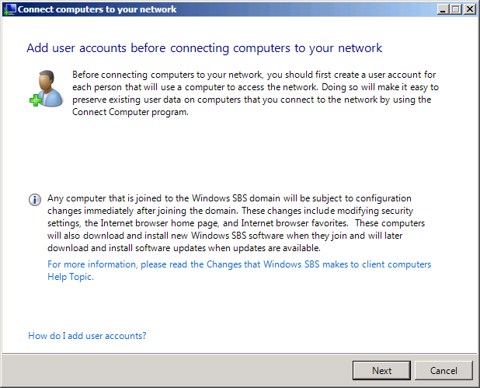
Figure 54 – The Connect Computers to Your Network Task
Note
User accounts should be created prior to connecting client computers to the domain.
Two Connect Computer options are available to an administrator (figure 55). Computers can connect by browsing to a local Web page that runs the wizard, or the wizard can be copied onto portable media. Most computers can be connected over the intranet; the second option allows an administrator to set up the necessary account information and then deliver a CD or memory stick to computers at remote locations.
Figure 55 – The Connect Computers Task
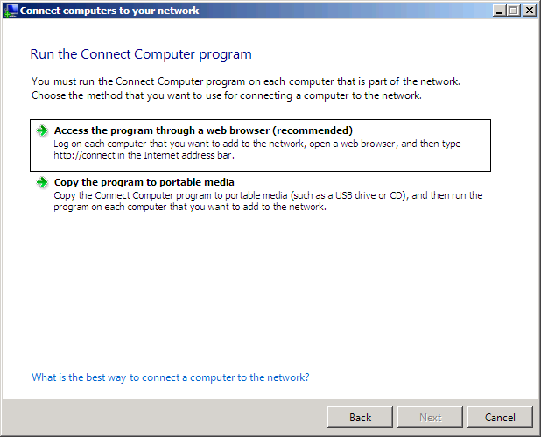
The Connect Computers task provides instruction on how to join computers to the domain (figure 56).
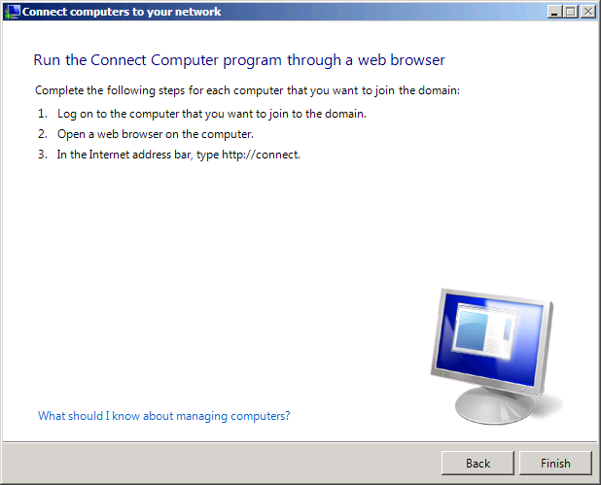

Figure 56 – The Connect Computers Task
Go to a user’s computer and log on. Open a Web browser and type http://connect. The Web browser connects to Windows Small Business Server 2008 and launches the Connect Computer program (figure 57).
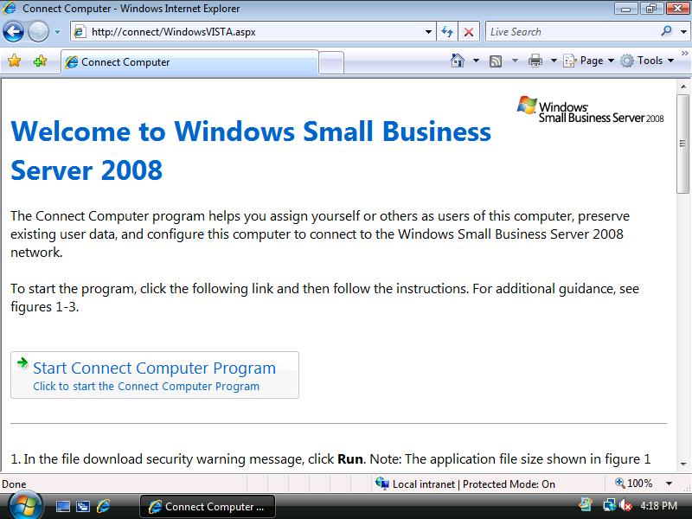
Figure 57 – The Connect Computer Web Site

The administrator may run the Connect Computer program on behalf of a user (figure 58). When a user account is added to a computer, by default the account is added to the Local User group. This helps reduce security exposure as user accounts are no longer members of the Local Administrator group on the assigned computers.
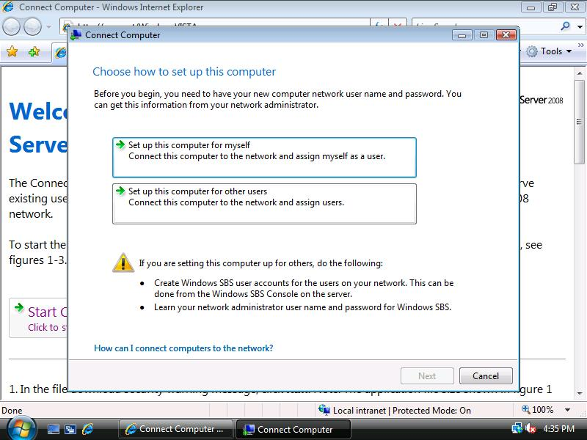
Figure 58 – Connect Computer Options
The client computer’s operating system is automatically determined by the Connect Web site and a series of validation checks are performed (figure 59). The checks help ensure the client computer can interact fully with the Windows Small Business Server 2008 network. If a client is missing any components that would allow it to fully participate on the network, the Connect Computer program generates a report. The administrator can then review the report and the suggestions on how to resolve the issue.
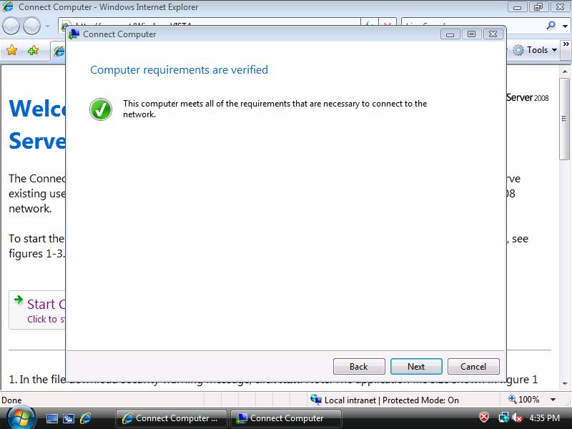
Figure 59 – Validating Computer Requirements
The end user or the administrator enters the necessary credentials (figure 60).
Figure 60 – Authenticating the User
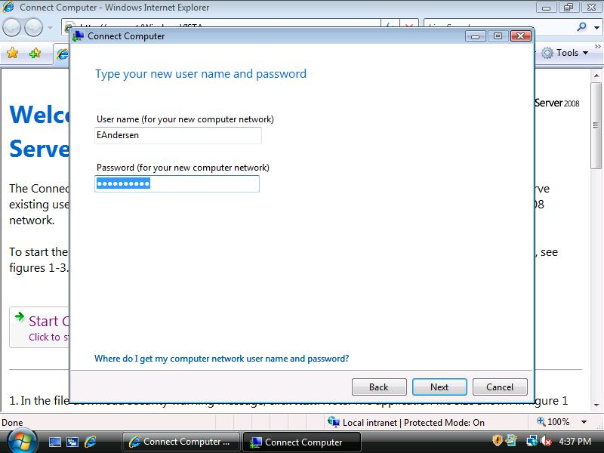
The administrator has the option of using the existing computer’s name or changing the computer name and description (figure 61). If changing the name and description, consider using either an employee’s name, if only one person will be using the computer, or a location name, if several employees will be using the computer.
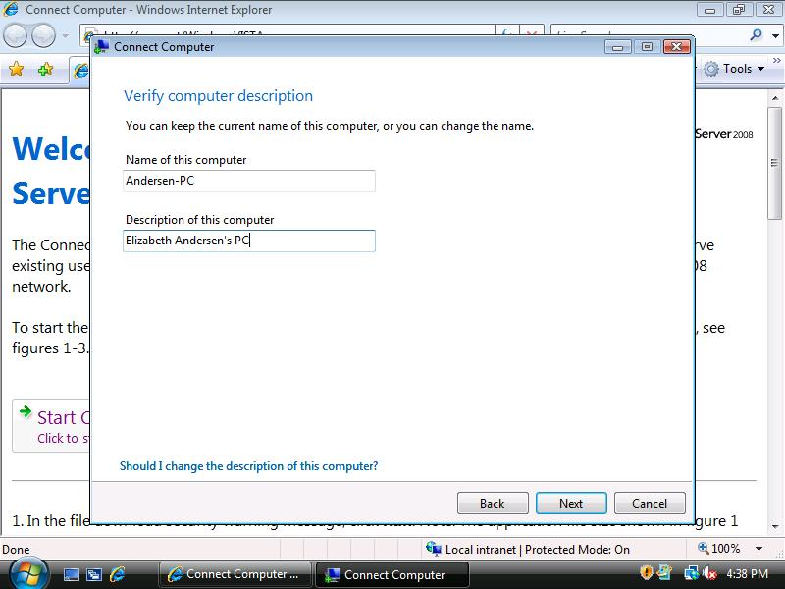
Figure 61 – Confirm or Change Computer Name and Description
If the user has an existing profile on the computer, the wizard moves the profile and the user’s Documents and Settings into the new user profile (figure 62). This reduces the amount of hands-on configuration required on each individual’s computer.
Figure 62 – Move Existing User Profile to New Account
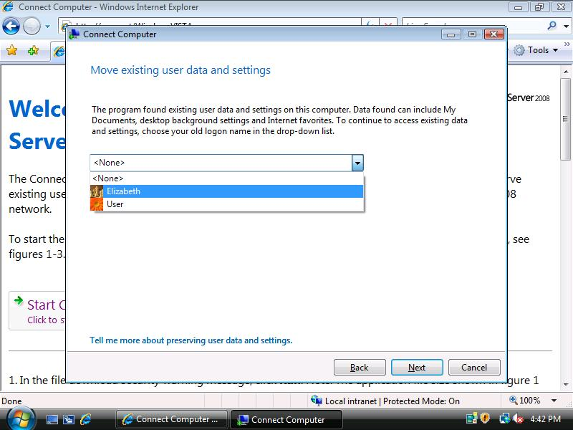
The Connect computer program provides a confirmation dialog so you can change any of the settings prior to joining the computer to the domain (figure 63).
Figure 63 – Confirm your Selections
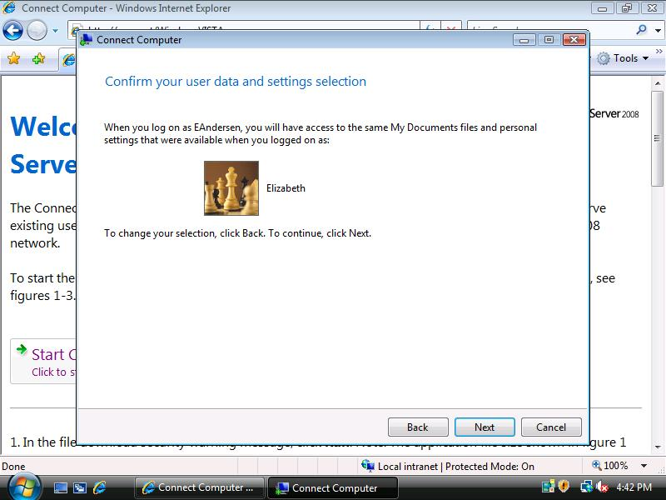
When the Connect Computer program completes, the computer will be a member of the Windows Small Business Server 2008 Active Directory domain (figure 64).
Figure 64 – Restart the Computer
