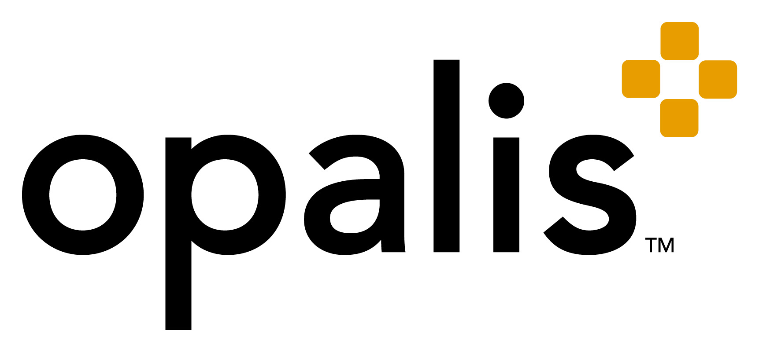

Opalis Integration Guide
A Best-Practice Guide to Understanding Your
Integration Requirements

Disclaimer and Copyright Notice
The information contained in this document represents the current view of Microsoft Corporation on the issues discussed as of the date of publication. Because Microsoft must respond to changing market conditions, it should not be interpreted to be a commitment on the part of Microsoft, and Microsoft cannot guarantee the accuracy of any information presented after the date of publication.

This White Paper is for informational purposes only. MICROSOFT MAKES NO WARRANTIES, EXPRESS, IMPLIED, OR STATUTORY, AS TO THE INFORMATION IN THIS DOCUMENT.

Complying with all applicable copyright laws is the responsibility of the user. Without limiting the rights under copyright, no part of this document may be reproduced, stored in, or introduced into a retrieval system, or transmitted in any form or by any means (electronic, mechanical, photocopying, recording, or otherwise), or for any purpose, without the express written permission of Microsoft Corporation.

Microsoft may have patents, patent applications, trademarks, copyrights, or other intellectual property rights covering subject matter in this document. Except as expressly provided in any written license agreement from Microsoft, the furnishing of this document does not give you any license to these patents, trademarks, copyrights, or other intellectual property.

© 2010 Microsoft Corporation. All rights reserved.
Microsoft and the Microsoft logo are trademarks of the Microsoft group of companies.
All other trademarks are property of their respective owners.

CONTENTS

Overview 4
Integration 4
Opalis Integration Fundamentals 5
Opalis Data Bus 6
Opalis Foundation Object Library 7
Opalis Integration Packs 7
Opalis Quick Integration Kit (QIK) 7
Integration Methods 8
Standard/Generic Integration 8
Tool Specific Integration 11
Full List of Integration Packs 11

Overview
System Center lowers the cost of delivering datacenter services through integrated, end-to-end management of physical and virtual environments. Through adopting System Center, customers are able to standardize their datacenter management environment for significantly lower costs than competitive solutions while implementing best practices that can deliver thousands of dollars of operational savings each year. This is delivered through simplified management of the datacenter via an integrated set of tools that automate server management and optimize the use of server and datacenter resources.
As a part of the System Center portfolio, Opalis extends automation, optimization and simplification through process automation. Opalis workflow processes orchestrate System Center products and integrate them with non-Microsoft systems to enable interoperability across the entire datacenter.
The combined offering reduces the cost of delivering and managing datacenter services by:
- Defining and orchestrating processes across System Center products
- Integrating non-Microsoft tools as part of a complete workflow
- Passing and sharing data between systems without code/scripts

Integration
Integration, taken in the context of modern IT, applies to the topic of systems integration. Here, integration defines a process through which multiple tools are “brought together” to deliver a service. The ultimate goal for such an effort would be to solve a problem that is outside the scope of the individual products.
Customers have become increasingly aware of the benefits of adopting best-practice standard processes such as MOF and ITIL. Standard processes that, in essence, define the integration between people, process and tools.
IT Process Automation (ITPA) offers the ability to automate the processes that support IT services - this is achieved by orchestrating and integrating systems. ITPA typically delivers the greatest value when it is used to automate processes which span multiple technology domains and systems, organizations and geographies.
Where integration has traditionally been applied “point-to-point”, Opalis introduces the concept of script/code free, cross silo automation. With the Opalis integration is no longer a 1:1 exercise, rather it becomes a 1:N proposition.

Opalis Integration Fundamentals
Opalis provides a rich set of integration capabilities to customers via Opalis Integration Packs, the Opalis Foundation Object Library and the Opalis Quick Integration Kit (QIK) SDK. These mechanisms (illustrated in figure 1) provide customers with a powerful set of integration capabilities.
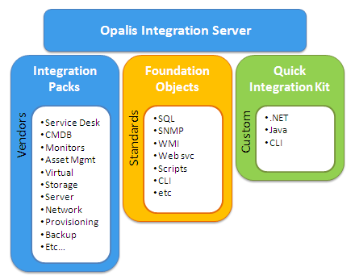
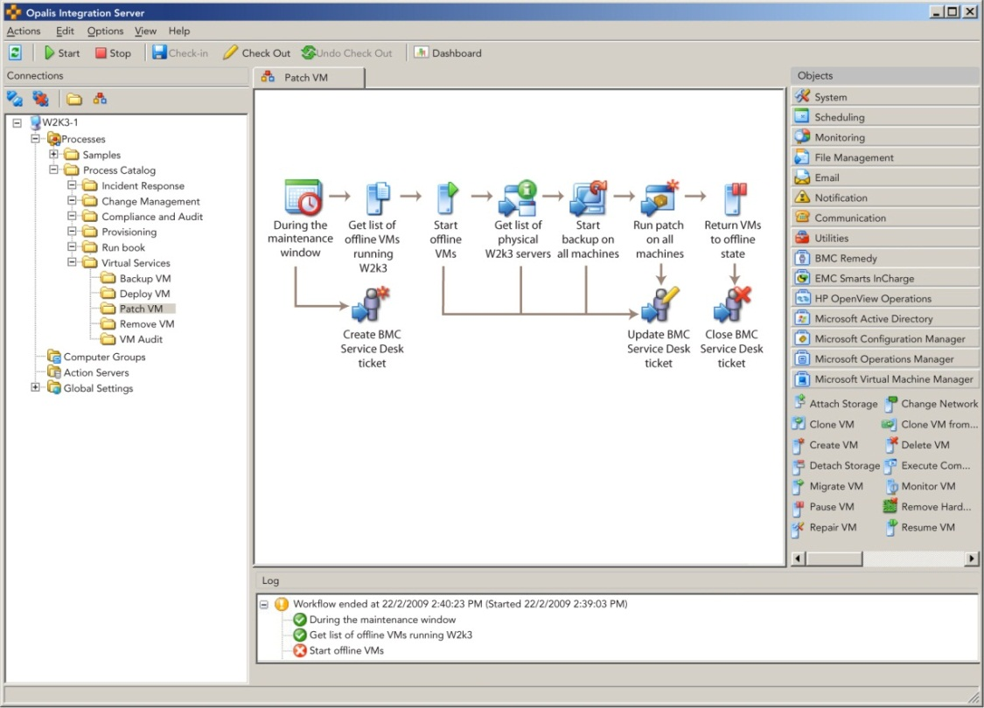
Figure 1 - Integration Capabilities of Opalis Integration Server

Opalis Data Bus
Most ITPA solutions in the market today are programming tools. This means that once an end-to-end process has been defined it must be handed over to a development team to build, test and migrate into production. The same programming team would also be required to make any changes to existing workflows that have to be adapted because of changes in end systems or the process overall.
Opalis is the only vendor with a script free publish/subscribe data bus. The data bus is how Opalis integrates systems, without code. The data bus collects data published when a workflow object runs. Details such as time, status, output, strings, fields, etc are added to the data bus at run time. This data can then be used by subsequent workflow objects to dynamically configure them. It can also be used as logic to control branching.
In the process below, Opalis monitors Operations Manager for a critical performance alert, running on a virtual machine. To triage the cause, it retrieves the host name and checks performance on the host and virtual machines. If the host is the issue, it initiates Virtual Machines Manager to migrate the VM. Once complete it verifies performance and updates/closes the originating alert. If the VM is the issue, it creates and populates a ticket in Service Manager, initiates VMM to start a standby VM and updates the Service Manager incident with new VM details.

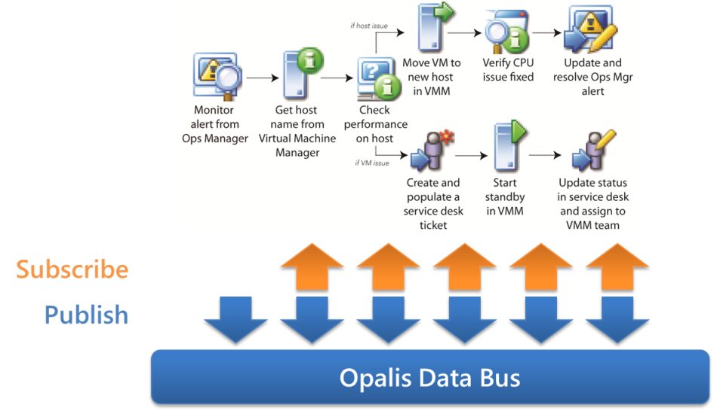

Figure 2. Incident Management Workflow

Opalis Foundation Object Library
The workflow objects in Opalis Integration Server consist of over 100 reusable activity templates that represent the ‘building blocks” of IT Process Automation. Examples of Foundation Objects contained in the library would be “Query WMI” , “Write to Database”, “Invoke Web Service”, “Copy File”, “Read Text File”, “Send SNMP Trap”, etc. The Foundation Object Library is common to all Opalis Customers, although different customers will make use of different objects in the library based on the needs of the processes they seek to automate. It is not uncommon for customers to use the Foundation Objects to build workflow-based integrations with tools in their environment for which Opalis does not offer an Integration Pack.

Opalis Integration Packs
Integration Packs are high-quality, integrations built and managed by Opalis. Each Opalis Integration Pack contains Opalis Workflow Objects native to the solution it was built to integrate. For example, The Opalis Integration Pack for EMC Smarts includes the workflow objects “Get Notification”, “Update Notification”, “Add Audit to Notification”, “Create Notification”, etc. Integration Packs are fully supported by Opalis, which means the complexity of connecting systems and updating integration when versions or configuration changes is also managed by Opalis. Customers looking to invest in IT Process Automation will typically purchase a ’la carte Integration Packs based on the needs of the processes they seek to automate.

Opalis Quick Integration Kit (QIK)
The Opalis SDK is available to Opalis customers and partners. The CLI Wizard doesn’t require a programming background, although a basic understanding of command-line tools in general and pattern matching is helpful. It is likewise intuitive and easy to use. The SDK includes a packaging component that allows for the quick and easy packaging of integrations into Integration Packs that are easy to load into the Opalis Integration Server.

Integration Methods

Standard/Generic Integration
Opalis provides standard/generic integration that can be used in a wide range of applications. These integration options are available in the Opalis Foundation Object
Mechanism | Details
WMI | 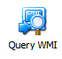  The Query WMI object will send a WMI query to a system that you specify and return the results.
Windows Event Log | 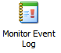  The Monitor Event Log object triggers Policies when new events that match a filter that you specify appear in the Windows Event Log. The second mode triggers your Policy when the size of the Windows Event Log reaches the maximum size allowed.
Windows  Perfmon  Counters | 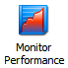  The Monitor Performance object triggers Policies when the Windows performance counters of the computer has exceeded the thresholds that you have configured. One Monitor Performance object is able to monitor multiple performance counters simultaneously.
SNMP | 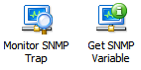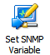  The Get SNMP Variable object will query a network device for the value of variable that is assigned to the Management Information Base address that you specify.  The Send SNMP Trap object will raise an SNMP event that can be detected by a network systems manager application.  By using an enterprise identifier of a known network device, you can send SNMP Traps on behalf of a network device in your system.  The Set SNMP Variable object will modify a variable, specified by its MIB, on a network device.
Syslog | 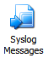  The Send Syslog Log Message object will create a message on the Syslog server that you specify.
SQL | 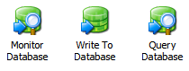  The Query Database object will query a database and return the resulting rows as Published Data.The Write to Database object writes a row into a database table.
Text Files | 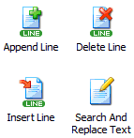  These objects provide extremely rich features for managing the content of text files. Most of the functions of these objects are fairly obvious. These objects work with a wide range of encoding options including ASCIIK, Unicode, Unicode Big Endian and UTF-8.  The Read Text Log object will read lines in a structured text log file. If you have log files that change names, you can configure the Read Text Log object to read from the newest file in a folder that matches a file name pattern.
Web Services | 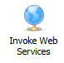  The Invoke Web Service object will execute a web service with XML parameters that you specify.
Email | 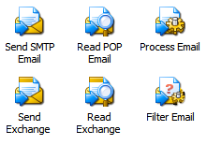  These objects provide the ability to interact with email systems, specifically Microsoft Exchange and SMTP/POP mail.  The Filter Mail object is used to filter incoming mail messages received by the Read Email object against criteria you specify.  The Process Email object will reply, forward, redirect, and delete email that has been received by the Read Email object or filtered with the Filter Email object.
Command-Line Interfaces | 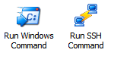  The Run SSH Command object opens an SSH connection to a remote server and runs shell commands on that server.  The Run Program object can run a program or command on a Windows computer in your domain in interactive or background mode given appropriate permissions.  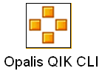  The Opalis QIK CLI allows you to take command-line interfaces (CLIs) and convert them into Opalis objects via a Wizard-driven utility. Objects so created are subsequently packed so they can be deployed as an Integration Pack.
API | 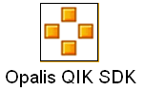  The Opalis QIK SDK provides a declarative programming model based on .NET of Java. It permits for custom integration with vendor APIs. Objects complied with QIK are packaged such that they can be deployed as an Integration Pack.

Tool Specific Integration
Opalis provides Integration Packs, specific to an infrastructure or management tool. Each Integration Pack offers a set of reusable workflow objects that provide out-of-the-box integration. Here is an example of the Operations Manager Integration Pack
Object | Description
Monitor Alert | Filters for Operations Manager Alerts used to trigger Opalis workflows.
Get Alert | Queries for data and properties of existing Operations Manager Alerts.
Create Alert | Create custom Alerts within the Operations Manager Console from 3rd party or custom systems.
Update Alert | Updates, changes the status, or closes Operations Manager Alerts.
Get State | Queries for health states in Operations Manager.
Get Monitor | Queries and filters for Monitors in Operations Manager
  Start Maintenance  Mode | Suspends monitoring during ad-hoc or scheduled maintenance.
  Stop Maintenance  Mode | Resumes monitoring after ad-hoc or scheduled maintenance.

Full List of Integration Packs

> BladeLogic Operations Manager
> BMC Atrium CMDB
> BMC Event Manager
> BMC PATROL
> BMC Remedy ARS
> CA AutoSys
> CA eHealth
> CA NSM
> CA Service Desk
> CA Spectrum
> EMC Smarts InCharge
> FTP
> HP Asset Manager
> HP iLO
> HP OpenView Operations
> HP OpenView Service Desk
> HP Service Manager
> HP Network Node Manager
> IBM Tivoli NetCool / OMNIbus
> IBM Tivoli Enterprise Console
> IBM Tivoli Storage Manager
> Microsoft Active Directory
> Microsoft Systems Management Server
> Microsoft Operations Manager
> Microsoft Configuration Manager*
> Microsoft Virtual Machine Manager*
> Microsoft Service Manager*
> Symantec Net Backup
> VMware vSphere
* Roadmap 2010

