Role-Based Template for SharePoint My Sites: HR Manager
Technical Overview for
IT Professionals
Template Data and Integration
Role-Based Templates for SharePoint® My Sites are pre-configured to display, in a common environment, role-relevant data from sources such as line of business systems, desktop tools, and portals. The templates make use of Microsoft® Office SharePoint Server 2007 capabilities, such as audience targeting, key performance indicators (KPIs), workflows, Excel® services, Business Data Catalog (BDC), and others. IT departments can integrate the Role-Based Templates for SharePoint My Sites with existing systems, as well as customize, extend and even replicate them. This enables quick deployment of role-based portals and provides cost-effective and easy-to-use solutions that integrate with important IT investments. The templates are built using existing out-of-the-box SharePoint Web parts, and are flexible, providing a starting point for custom development. They come with a sample SQL Server™ 2005 database, a BDC application file and a SQL Server 2005 Analysis Services (SSAS) cube to show sample data. This datasheet describes the web parts and functionality Microsoft used when designing the templates. The role-based My Site template Setup Guide explains in detail how to configure them for your own data.

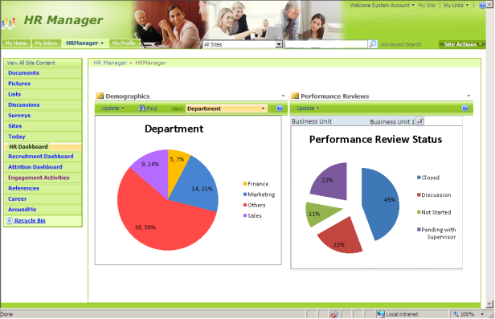
Description of Template
The HR Manager role-based template for SharePoint My Sites helps HR Managers keep a tab on the employee composition and distribution within the organization. During the performance review cycle, the template provides information on the status of performance reviews and helps the HR Manager in quickly identifying bottlenecks associated with it. As a part of employee engagement, the template displays various activities conducted on a monthly basis. It also displays details about training conducted for employees under various categories, info about attrition rates at the organization and business unit level, shows job opening details and employee referrals along with interview schedules for hiring to help with recruitment management.

Customized Pages and Web Parts Utilized in this Role-Based My Site Template

The following is a list of all the custom pages that make up the HR Manager role-based My Site template. Also included is a description of the web parts utilized on each page.

Today: Provides a quick glance into the user’s personal inbox, calendar and task list. It also displays user tasks assigned to them on SharePoint sites.
- My Inbox, My Calendar, and My Tasks utilize Outlook® Web Access web parts to fetch data from the Microsoft Exchange Server and display the user’s personal inbox, calendar and task list. These web parts are configured with the mail server address and take in the user context by default to display their data from Exchange Server.
- User Tasks web part displays the tasks assigned to the user in SharePoint tasks lists, enabling them to view and update the SharePoint tasks.

HR Dashboard: Displays demographics of the organization and performance review status charts.
- Demographics and Performance Reviews are Excel Web Access web parts. The Demographics web part displays different view of company demographics information, such as Department, Location, Grade, and Organization experience. The Performance Reviews web part displays the review status of the organization with a chart using different business units as parameters. The data for both web parts is pulled from the backend system through an Office Data Connection (.odc) file and is published with Excel Services.

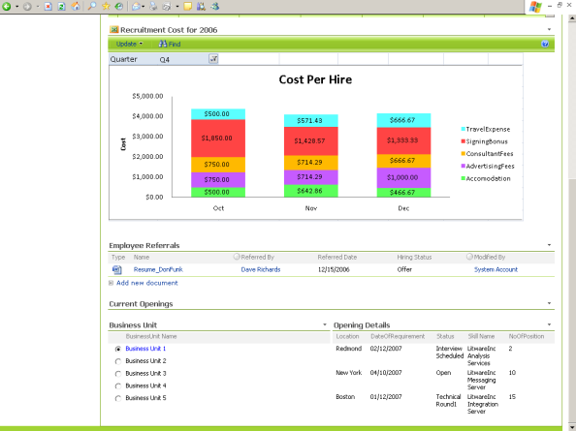
Recruitment Dashboard: Provides recruitment related details like current openings for business units, recruitment cost per hire, employee referral profiles and interview schedules. The information is pulled from BDC to create dynamic data views.
- Interview Schedules is a Calendar List web part displaying the HR Manager schedule for conducting interviews. This list can be connected to Outlook 2007 and compared with the personal calendar for conflicts. An Alerts workflow is attached to trigger an email one hour before the interview is scheduled.
- Recruitment Cost is an Excel Web Access web part that displays the recruitment expenses per hire. The chart shows the details of expenses like Travel Expenses, Signing Bonus, Consultant Fees, Adverting Fees and Accommodation expenses. The HR Manager has the option of selecting a quarter from the filter and can view expenses for all three months of that quarter.
- Employee Referrals is a Document Library View web part that contains profiles of candidates referred by employees of the organization.
- Current Openings uses two different BDC web parts to display available positions by business unit. The Business Unit section uses a Business Data List web part that lists business units and is used to filter position opening details. Opening Details uses a Business Data Related List web part to dynamically display position opening information related to the selected business unit. It is connected to the Business Unit web part, returning the details entity for the selected unit.
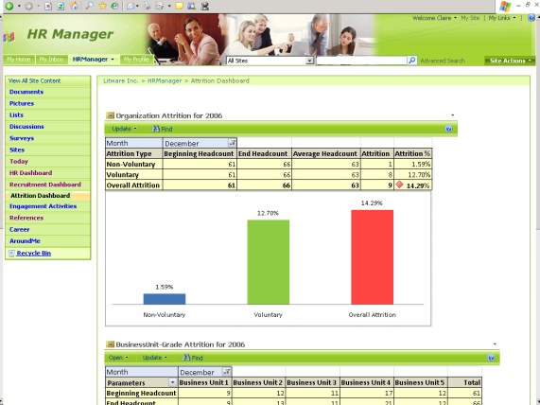
Attrition Dashboard: Displays attrition metrics at both the organizational and business unit/grade levels, and shows Key Performance Indicators (KPIs) for different quarters of a financial year.
- Organization Attrition and Business Unit-Grade Attrition are Excel Web Access web parts that display a chart mapping out attrition information. Data is pulled from the backend system into the workbook an Office Data Connection (.odc) file and published using Excel services. Organization Attrition shows attrition details at the organization level. Conditional formatting is applied to the Overall Attrition percentage, showing a health indicator. Business Unit-Grade Attrition shows the attrition for a particular month against business unit and grade. Conditional formatting is applied to Total shows health indicators. A pivot table is created with month as the report parameter and published in Excel Services.
- Attrition Rate is KPI web part that displays indicators for attrition rate for different quarters. The KPIs are retrieved from the backend SSAS and the web part is connected to the data through an Office Data Connection file (.odc) residing in the Data Connections library.

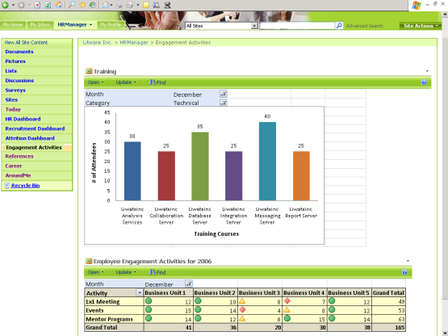
Engagement Activities: Shows details on training and engagement activities for the organization and business units.
- Training and Engagement Activities are Excel Web Access web parts. Training shows a chart with the number of attendees for different training courses. It uses different training categories and months as filter parameters. Engagement Activities displays a table of different activities such as one-on-one meetings, team events and mentor programs conducted for different business units in a particular month. Conditional formatting is applied to show health indicators.

References: Provides links, contacts, meeting outcomes and a document repository with policies, reports, executive summaries, presentations, and other templates.
- Policies, Client Presentations and Reports and Executive Summaries are Document Library View web parts. Policies and Client Presentations are pre-defined document repositories for storing related files. Reports and Executive Summaries is a repository for storing important reports and summaries, and has an Approval workflow attached. Workflow status is displayed in the Reports and Executive Summaries web part.
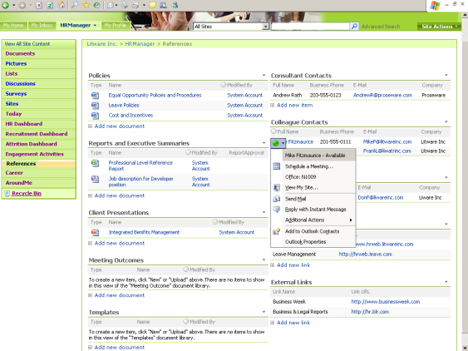
- Meeting Outcomes and Templates are Form Library View web parts. Meeting Outcomes is attached to the Meeting Outcomes form library; Templates is attached to the Templates form library. Both have Microsoft Office InfoPath® form templates attached, though the Templates library has different forms to choose from, such as Job Details, Performance Application and Travel Request.
- Contacts and Links are List View web parts. The three contact lists (Consultants, Colleagues and Direct Reports) display frequently used contacts. Colleagues and Direct Reports are enabled with the presence icon. Two Links lists (Internal and External) display links to other systems and websites.

Around Me and Career: Around Me provides one page to keep track of news, announcement and events relevant to the HR Manager to keep them informed and in touch with the company. The Career page helps facilitate career planning by providing a place to keep track of objectives and performance.
- Around Me: Corporate News, International News and Industry News are RSS Feed Viewer web parts and display news feeds from external web sites. System Downtime Announcements is a List View web part displaying announcement details by the administrator. Team Announcements is a List View web part displaying announcements created by the HR Manager. Corporate, Industry and Marketing Events are List View web parts that display corresponding events. An Alerts workflow is attached to these lists.
- Career: Training, Awards and Rewards, and Organizational Objectives are List View web parts that help keep a track of one’s career. All have personalized views so that only items created or modified by the logged-in HR Manager are visible.

Technical Dependencies
To use the HR Manager template, you must have a server running the following:
- Microsoft Office SharePoint Server 2007
- Microsoft Office SharePoint Server 2007 Client Access License, Enterprise Edition
For more information on additional dependencies, please review the Setup Guide.
Licensing information can be found at: http://go.microsoft.com/fwlink/?LinkId=86927

More Information
For more information on the technologies described in this article, please visit:

Microsoft Office SharePoint Server 2007:  http://www.microsoft.com/sharepoint | Role-Based Templates for SharePoint My Sites:  http://go.microsoft.com/?linkid=6060804
Business Intelligence with Office SharePoint Server 2007:
http://go.microsoft.com/fwlink/?LinkId=86668

