
Adding Workstations to HPC Server Clusters
Published: July 2010
This is a preliminary document and may be changed substantially prior to final commercial release of the software described herein. The information contained in this document represents the current view of Microsoft Corporation on the issues discussed as of the date of publication. Because Microsoft must respond to changing market conditions, it should not be interpreted to be a commitment on the part of Microsoft, and Microsoft cannot guarantee the accuracy of any information presented after the date of publication.
This white paper is for informational purposes only. MICROSOFT MAKES NO WARRANTIES, EXPRESS, IMPLIED, OR STATUTORY, AS TO THE INFORMATION IN THIS DOCUMENT.
Complying with all applicable copyright laws is the responsibility of the user. Without limiting the rights under copyright, no part of this document may be reproduced, stored in or introduced into a retrieval system, or transmitted in any form or by any means (electronic, mechanical, photocopying, recording, or otherwise), or for any purpose, without the express written permission of Microsoft Corporation.
Microsoft may have patents, patent applications, trademarks, copyrights, or other intellectual property rights covering subject matter in this document. Except as expressly provided in any written license agreement from Microsoft, the furnishing of this document does not give you any license to these patents, trademarks, copyrights, or other intellectual property.
© 2010 Microsoft Corporation. All rights reserved.
Microsoft, Active Directory, SQL Server, Windows, the Windows logo, and Windows Server are either registered trademarks or trademarks of Microsoft Corporation in the United States and/or other countries.
The names of actual companies and products mentioned herein may be the trademarks of their respective owners.

Table of Contents
Introduction 1
Why Include Workstations in Clusters? 1
Elements of a Cluster of Workstations 1
Differences between Workstation Nodes and Compute Nodes 2
What Controls a Node? 2
What is the Role of the Node? 2
What is the Operating System of the Node? 3
Scenarios for Adding Workstations to HPC Clusters 3
Advantages of Adding Workstations to HPC Clusters 4
Requirements 4
Networking Topologies 5
Cluster of Workstations Licensing 6
Implementing a Cluster of Workstations 6
Installing and Configuring the Head Node 7
Creating a Node Template for Workstation Nodes 8
Installing HPC Pack on Workstation Nodes 9
Assigning a Workstation Node Template 11
Availability of Workstation Nodes 12
Changing the Availability Schedule of Workstation Nodes 13
Changing the Assigned Template for a Workstation Node 15
Summary 16

Introduction
Windows ® HPC Server 2008 R2 brings high performance computing (HPC) to industry-standard, low-cost servers that support larger and heterogeneous clusters. In addition, Windows HPC Server 2008 R2 introduces a new type of HPC clustering called Cluster of Workstations that enables enterprises to take advantage of their existing investments in client computers to run HPC jobs during the idle periods of those computers.
This paper provides an overview of the features and capabilities of a Windows HPC Server Cluster of Workstations and the basic implementation steps. Specifically, it covers:
- The definition of Cluster of Workstations
- Advantages of using Cluster of Workstations
- System requirements for Cluster of Workstations
- How to implement Cluster of Workstations
Note Detailed step-by-step instructions for implementation are covered in the Microsoft® TechNet article “Adding Workstation Nodes in Windows HPC Server 2008 R2 Step-by-Step Guide” available at http://technet.microsoft.com/en-us/library/ff601849(WS.10).aspx.

Why Include Workstations in Clusters?
The new Cluster of Workstations feature in Windows HPC Server 2008 R2 allows enterprises to use their existing client workstations as members of an HPC cluster. A Cluster of Workstations cluster is composed entirely of workstation nodes or can include a mix of dedicated compute nodes and workstation nodes.
The primary motivation for most workstation clusters is to take advantage of the computing power of workstations during their idle periods, allowing them to run HPC jobs. An important secondary motivation is to expand and augment existing cluster resources during times when the workstations aren’t being heavily used.

Elements of a Cluster of Workstations
A Windows HPC Cluster of Workstations is just like a typical HPC cluster, with one important exception—it includes nodes that are running Windows 7. The rest of the cluster has the same elements, including a head node, and optionally:
- A redundant head node using Windows Server 2008 R2 Failover Clustering
- A Microsoft® SQL Server® 2008 database
- Broker nodes
- Compute nodes
As with all Windows HPC Server 2008 clusters, an Active Directory® domain environment is required. Any workstation nodes must be members of the same Active Directory domain as the head node.

Differences between Workstation Nodes and Compute Nodes
How is a workstation node different from a compute node? In at least three very important ways:
- Control of the node
- Role of the node
- Operating system of the node

What Controls a Node?
When an HPC cluster is composed entirely of compute nodes, the cluster “owns” the nodes and can add users and administrators to the node as required. The cluster administrator can also change the operating system, enforce updates, and generally administer the compute nodes in a cluster.
A workstation node, however, is someone’s everyday computer, and is controlled by the enterprise administrators and by the individual user. The cluster is simply “borrowing” it when it isn’t being used, and therefore can make no substantive changes to the node. It cannot add users or administrators, nor make any change that will affect the users that typically log on to and use the workstation.

What is the Role of the Node?
A compute node in a Windows HPC Server 2008 R2 cluster is a dedicated node whose only role is to run HPC jobs as directed by the job scheduler for that cluster. It is expected to be always available and only performing the jobs and tasks assigned to it by the head node.
A workstation node is primarily a client computer with the usual tasks and software that are part of its role in the enterprise. It is only available to the HPC cluster at specified times when it isn’t being used for other tasks. When it is available for running HPC jobs, it acts as a compute node in the cluster. The job scheduler will submit jobs that can run on workstation nodes.

What is the Operating System of the Node?
A compute node must be running Windows Server 2008 R2, or a 64-bit edition of Windows Server 2008. This could be the Standard, Enterprise, or HPC edition. The operating system and software installed on the compute node is directly controlled by the head node, and, in most cases, is deployed directly from the head node.
A workstation node, however, is running a client version of the Windows® 7 operating system. The node can be running Windows 7 Professional, Enterprise, or Ultimate, and can run either a 32-bit or 64-bit version of Windows 7. Further, a workstation node can’t be solely used for running HPC jobs, but has a primary role as a regular client computer in the enterprise domain. Enterprise policies control the operating system and software on the workstation node and deployment is not from the cluster head node.

Scenarios for Adding Workstations to HPC Clusters
The following customer scenarios illustrate how customers use workstations in HPC clusters.
The first targeted scenario is a business that doesn’t currently have an HPC cluster, but does have client computers sitting idle during predictable times. By creating a cluster of workstations, the customer has a way to take advantage of their existing investment in workstations to run HPC jobs. In this scenario, the cluster is composed of a head node and workstation nodes, but will generally have no dedicated compute nodes. In most cases, the cluster will use a single enterprise network for all nodes.
In the second targeted scenario, an enterprise has an HPC cluster but also needs to run some jobs across a larger cluster and wants to use their existing workstations to expand the cluster during off-hours. Workstations nodes usually don’t have multiple high-speed network cards and won’t have direct connections to the HPC clusters’ private and application networks. Workstations attached to clusters through an enterprise network will not provide performance as high or reliable as dedicated compute nodes managed by HPC services running on the head node.

Advantages of Adding Workstations to HPC Clusters
Adding workstations to your HPC environment, or using them to create your first HPC environment, gives you the ability to use your computing resources more effectively and efficiently. You have tens, hundreds, even thousands of Windows-based computers that sit idle every night. Now you can let them work on parallel computing tasks when they’d otherwise be doing nothing.
If you currently have an HPC cluster, adding a workstations allows you to expand your cluster for jobs that require more processing width without having to buy and license dedicated compute nodes.
Where you don’t currently have an HPC cluster, creating a cluster of workstations gives you the ability to work with HPC clusters for your workloads that can benefit from the parallel processing capabilities of an HPC cluster without having to make a large initial investment in dedicated compute nodes.
Another advantage of adding workstations to your HPC cluster is the ability to use 32-bit workstations as well as 64-bit. This allows you to target a 32-bit platform with specific applications that will run better there.

Requirements
Table 1 shows the basic system requirements for a Windows HPC Server 2008 R2 cluster of workstations. Where there are compute nodes as part of the cluster, the requirements for the compute nodes are the same as for the head node except that they can be running Windows Server 2008 or Windows Server 2008 R2. Additionally, all nodes in the cluster must be joined to the same Active Directory domain as the head node.
Table 1. Basic System Requirements
Component | Head Node | Workstation Node
Processor | x64-based | x86- or x64-based
Maximum CPU Sockets | 4 (8 with Enterprise Edition) | 2
RAM | 512 MB | 1 GB (x86), 2 GB (x64)
Maximum RAM | 32 GB(Standard Edition), 128 GB (HPC Edition), 2 terabytes (Enterprise Edition) | 4 GB (x86), 192 GB (x64)
Network | 1 network interface card | 1 network interface card
Operating System | Windows Server 2008 R2 | Windows 7
Supported Editions | Standard, Enterprise, HPC | Professional, Enterprise, Ultimate

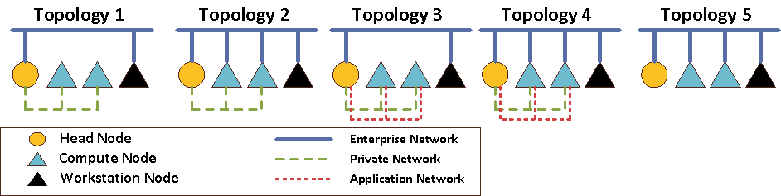
Networking Topologies
Windows HPC Server 2008 R2 supports five networking topologies, as shown in Figure 1.
Figure 1. Supported network topologies
When adding workstations to a cluster, all five topologies are supported, but there are considerations that make topologies 2, 4, and 5 preferred.
Topology 5 is the most common scenario when the cluster has only a head node and workstation nodes, or when existing compute nodes are already using Topology 5.
Adding workstation nodes with only a single, enterprise network connection to clusters running Topology 1 or Topology 3 is not recommended, but is supported. Special considerations for routing and communications will be required since the dedicated compute nodes are on private and possibly application networks that are isolated from the other nodes on the enterprise networks.
Adding workstation nodes to clusters running Topology 2 or Topology 4 will have a performance impact on the overall cluster because all communications between workstation nodes and compute nodes may route over the enterprise network, even when the added workstation nodes have network cards connected to the private and application networks.
Note: For each topology, the workstations may also be connected to the private or application networks, although this is not expected to be common.
For detailed information about network topologies and the impact of adding workstation nodes to an existing cluster, see Cluster Network Topologies for Workstation Nodes at http://technet.microsoft.com/en-us/library/gg145543(WS.10).aspx

Cluster of Workstations Licensing
To add workstation nodes to an HPC cluster, each of those workstation nodes must have a Windows 7 license ( Professional, Enterprise or Ultimate edition) along with Windows Client Access Licenses (CALs) for connecting to the enterprise domain), as well as a license for HPC Pack 2008 R2 for Workstations. The head node must have a license for HPC Pack 2008 R2 Enterprise edition. If used in High Availability mode, both head nodes must be licensed for HPC Pack 2008 R2 Enterprise edition and Windows Server 2008 R2 Enterprise.

Note that the End User License Agreement (EULA) requires that these workstations not be single-purpose, dedicated cluster nodes.

Implementing a Cluster of Workstations
The detailed step-by-step for implementing a Cluster of Workstations is available on TechNet at http://technet.microsoft.com/en-us/library/ff601849(WS.10).aspx, and you should refer to those steps when you begin your actual implementation. This section will give you an overview of the process. The basic steps are:
- Install and configure the head node. (Not required if adding workstations to an existing cluster.)
- Create a workstation node template.
- Install the HPC Pack on the workstation(s) to be added to the cluster.
- Assign the workstation node template to the workstation(s).

Installing and Configuring the Head Node
Installing a head node for use with a Cluster of Workstations requires essentially the same steps as creating any other head node. After the operating system and HPC Pack are installed on the head node, you need to complete the initial To-Do List, shown in Figure 2.
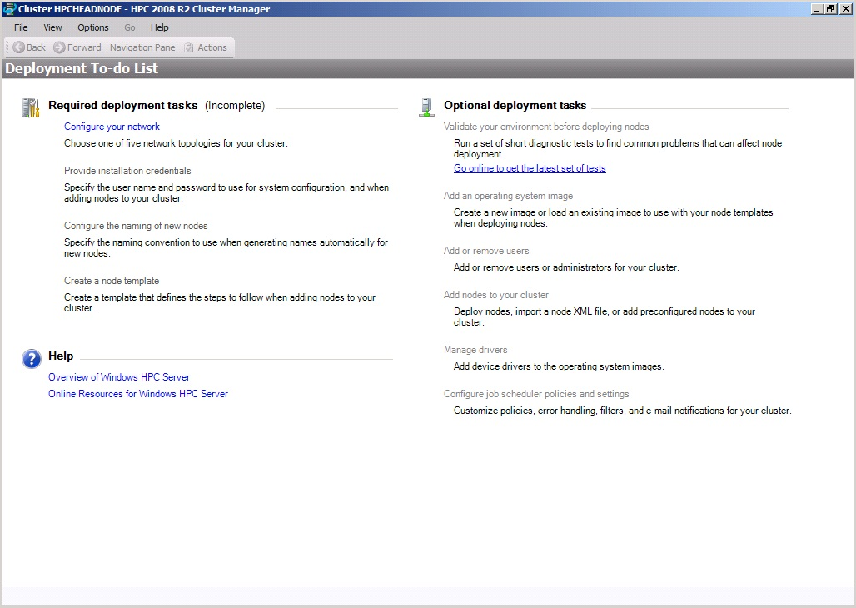
Figure 2. The To-do List for a new cluster
Configure networking (choose Topology 5 if this cluster will consist of only a head node and workstation nodes connected only to an enterprise network). Then provide the necessary credentials for deploying nodes and configuring the system, and define the node naming convention you want to use for new nodes. This node naming convention won’t get used for workstation nodes, because they will be existing nodes in your organization.

Creating a Node Template for Workstation Nodes
All nodes in an HPC cluster must have a node template assigned to them. There are three kinds of node templates: compute node templates, broker node templates, and workstation node templates, as shown in Figure 3.
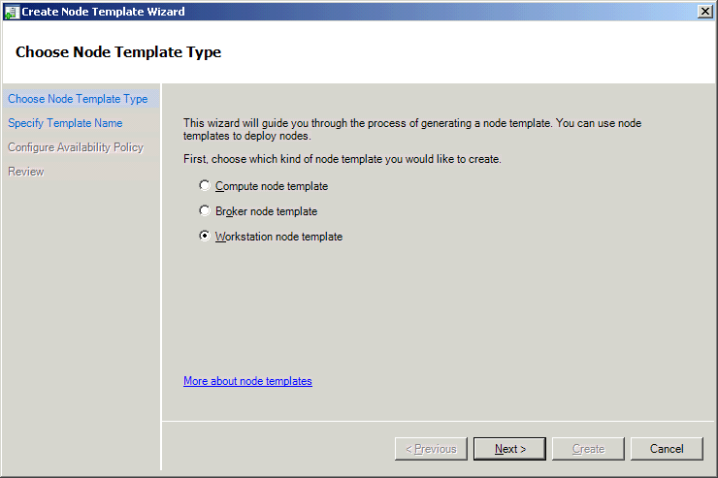
Figure 3. Choosing a node template type
For a cluster of workstations, you need to create a workstation node template. When you create a workstation node template, you are prompted to choose when the workstation nodes using template will be available for use by the cluster. You can choose to have workstation nodes available only when you specifically bring them online (manual mode), or have them automatically brought online at certain times of the day and days of the week, as shown in Figure 4.
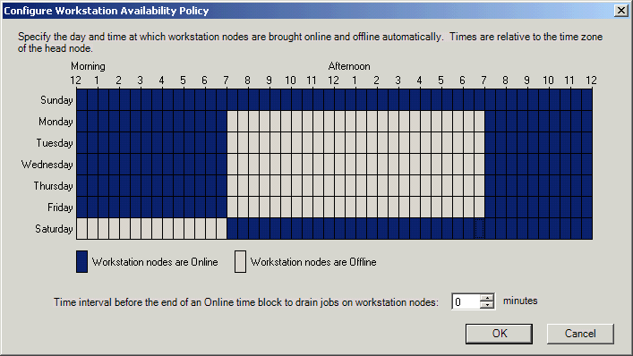
Figure 4. Setting weekly workstation node availability
Note For more details on node templates and details on using the HPC Cluster Manager, see the “Windows HPC Server 2008 System Management Overview” white paper at http://www.microsoft.com/downloads/details.aspx?FamilyId=8B2231FA-80C2-4994-BBFC-12DA56964C75&displaylang=en.

Installing HPC Pack on Workstation Nodes
After the basic configuration of the head node is complete and you’ve configured a workstation node template for use with the cluster, you need to configure the workstation nodes. The first step of configuring the node is to install the HPC Pack 2008 R2 on the Windows 7 computer that will be a workstation node.
You can install the HPC Pack by running Setup.exe interactively from the HPC Pack DVD, or by deploying it automatically using command-line unattended installation. If you’re running the installation interactively, the wizard will ask you a series of questions about what kind of installation this is, where to install, what cluster to join (name of head node), and so on, as shown in Figure 5.

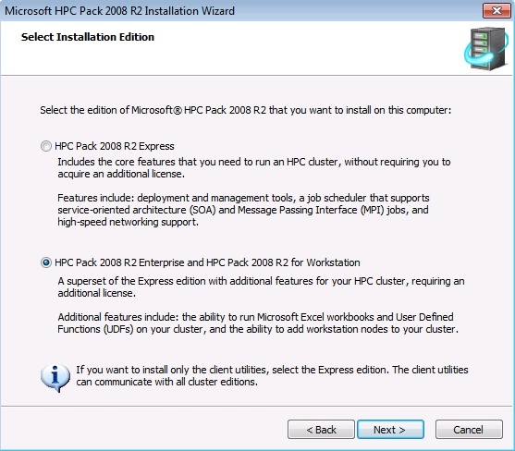
Figure 5. The HPC Pack 2008 R2 Installation Wizard
To simplify automated deployment, the HPC Pack supports a command-line deployment. To perform an unattended installation of the HPC Pack on a workstation, use the command line:
setup.exe -unattend -workstationnode:<head_node>
You can add the client HPC utilities at the same time by adding a –client to the command line above.

Assigning a Workstation Node Template
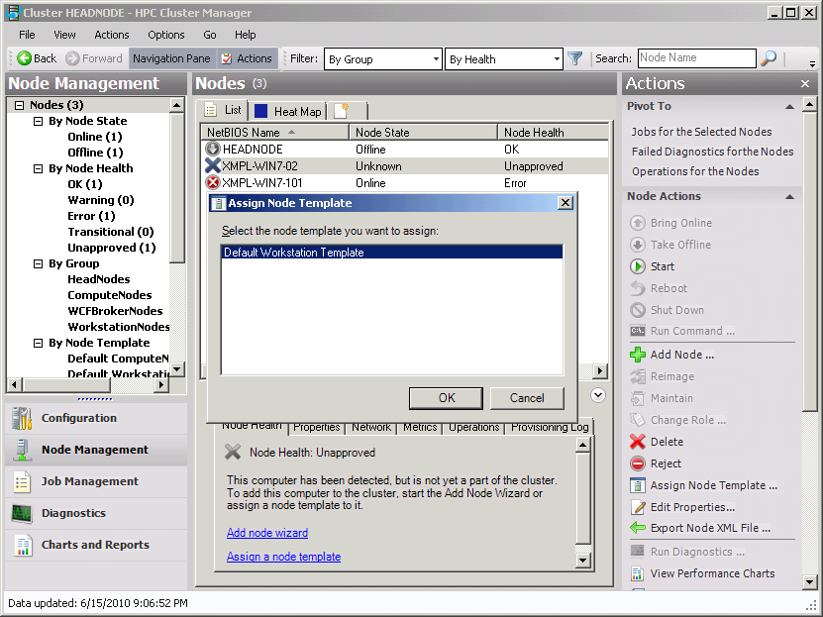
After you’ve installed the HPC Pack on the workstation node, you need to assign a node template to it before the node can be used by the cluster. The new workstation node should automatically be displayed in the Node Management pane of the HPC Cluster Manager, with a Node Health status of Unapproved. After the node is visible in the Cluster Manager, you can add it to the cluster by selecting the node and clicking Assign Node Template on the Actions menu, as shown in Figure 6, and assigning a node template that you previously created for workstation nodes.

Figure 6. Assigning a workstation node template to a workstation node
After the workstation node template has been assigned, the node is approved to run as part of the cluster. Whether the node is brought online after being approved for inclusion in the cluster will be determined by the availability setting in the node template.

Troubleshooting
When setting up a workstation node, some basic troubleshooting can reduce problems. When adding the HPC Pack to a workstation, you should be able to choose the head node name from a drop down list during the setup. If not, this means that there is an issue with Active Directory. Verify that the workstation is a member of the same Active Directory domain as the head node.
If the workstation node was able to choose the head node, but doesn’t appear in the HPC Cluster Manager, this indicates a connectivity issue between the head node and the workstation node. Follow basic TCP/IP troubleshooting steps to identify and correct connectivity issues, starting with “ping”.

Availability of Workstation Nodes
Managing the availability of workstation nodes is somewhat different than managing a dedicated compute node. Because the nodes are not dedicated to cluster operations, but are shared with their regular users, there are some limitations on how nodes are made available. This is controlled by the workstation node template assigned to a particular node, and all nodes with the same node template have the same availability. This means that if you have different groups of workstations that you want to make available as a cluster of workstations, and some can be available to the cluster from 6 P.M. until 8 A.M., while others need to be available to their regular users until 11 P.M., you would need two workstation node templates, one for each availability schedule. If you want to be able to manually bring workstation nodes online and offline, you should create a workstation node template that has manual node availability, as shown in Figure 7.
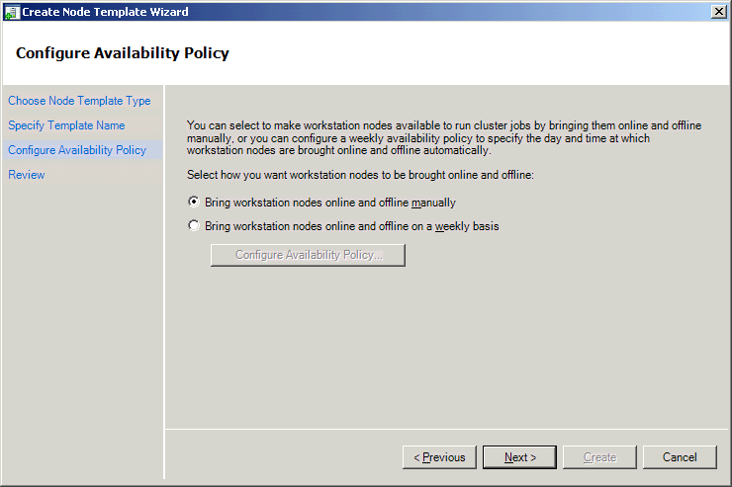
Figure 7. Creating a workstation node template for manual availability control

Changing the Availability Schedule of Workstation Nodes
You can change the availability of all workstations using a specific workstation node template by editing the availability schedule for that template. In the Configuration pane of the HCP Cluster Manager, select the workstation node template you want to change and then select Edit from the action menu, as shown in Figure 8.
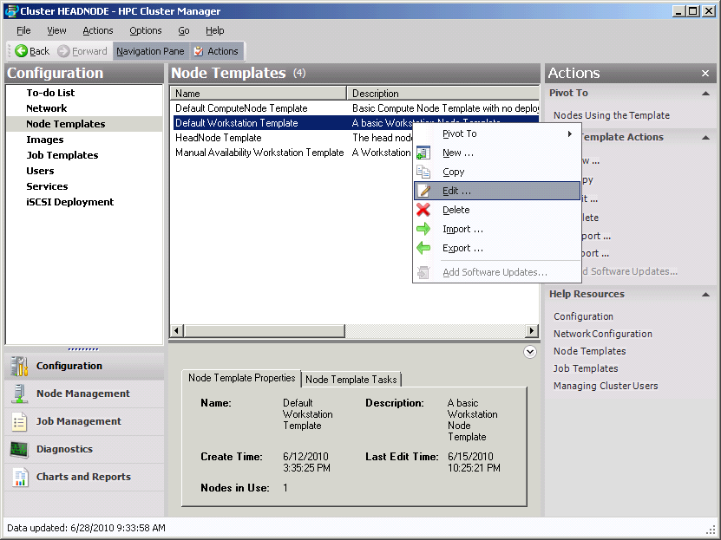
Figure 8. Editing a node template
If you edit the settings of a node template, the new settings will propagate to all nodes that have that node template assigned to them. When you edit the node template, you can set the length of time that the node is allowed to drain any running jobs before the node is forced offline if the changed template requires that, as shown in Figure 9.

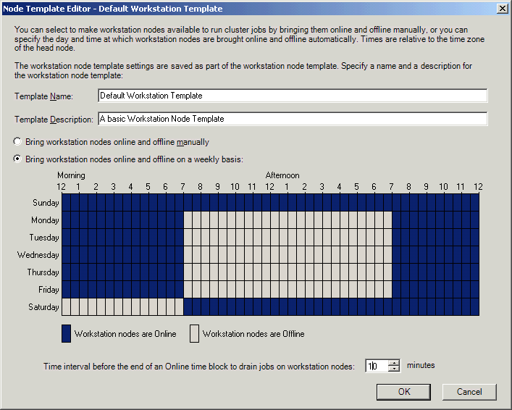
Figure 9. Modifying the node template with the Node Template Editor

Changing the Assigned Template for a Workstation Node
You can also change the workstation node template assigned to a workstation node by simply assigning a different node template to the node in the Node Management pane of the HPC Cluster Manager. After you change the node template, the availability options of the newly assigned node template control whether a node is online or offline.

Summary
This paper provides an overview of the new feature in Windows HPC Server 2008 R2 for adding workstations to an HPC cluster. This feature allows HPC customers to use their existing compute resources and investments in desktop computers to build or extend an HPC cluster.
When you add workstations to HPC clusters, the workstations continue to be controlled and managed by the enterprise policies. A workstation node is only available to the cluster during times when it isn’t in typical use, and the HPC cluster makes no changes to the workstation that inhibits its original role.
Workstation nodes are only supported on Windows 7 editions that can join a domain, and must be joined to the domain of the head node of the cluster they are assigned to. The availability of a workstation node for cluster use is controlled by the node template assigned to the node.
For additional details on Windows HPC Server 2008 R2 and Cluster of Workstations, see the Windows HPC home page at http://www.microsoft.com/hpc.

