Brief

Licensing Windows 7 for Use with Virtual Machine Technologies March 2010

Microsoft Volume Licensing Programs

Summary
This licensing brief is an overview of Microsoft licensing updates for the desktop PC operating system, including updates and clarifications on how to use the Windows 7® operating system products with virtual machine (VM) technologies such as Microsoft® Virtual PC and Microsoft Hyper-V™.

The updates covered in this licensing brief are described in the context of Windows 7 Upgrade licenses and Software Assurance purchased under Microsoft Volume Licensing. However, some updates may also apply to licenses acquired from other channels, such as original equipment manufacturers (OEMs), and full-package products (FPPs). Please review the license terms that accompany the products to determine which updates apply to the software you are using.

Note: Definitions of certain terms are included at the end of this licensing brief, which can be helpful in understanding virtual machine technology and your use rights for Windows 7 products.

What’s New in this Brief
- This brief replaces a previous version published in January 2009.
- Significant changes in this new version include:
  - Updated references to the Windows 7 operating system.

Details

Virtual Machine Technology on x86 and x64 Hardware Platforms

With virtual machine technology, you can run multiple operating system environments on a single physical hardware system (for example, a PC) (Figure 1). Before VM technology existed, you could run only one operating system environment on a PC at a time because every operating system was a physical one. However, current technologies such as Microsoft Virtual PC add a “virtual” layer on top of the physical operating system, which makes it possible to run multiple operating system environments on the same PC. VM technology allocates virtualized hardware resources to virtual hardware systems or virtual machines. Virtual operating system environments run on virtual machines.

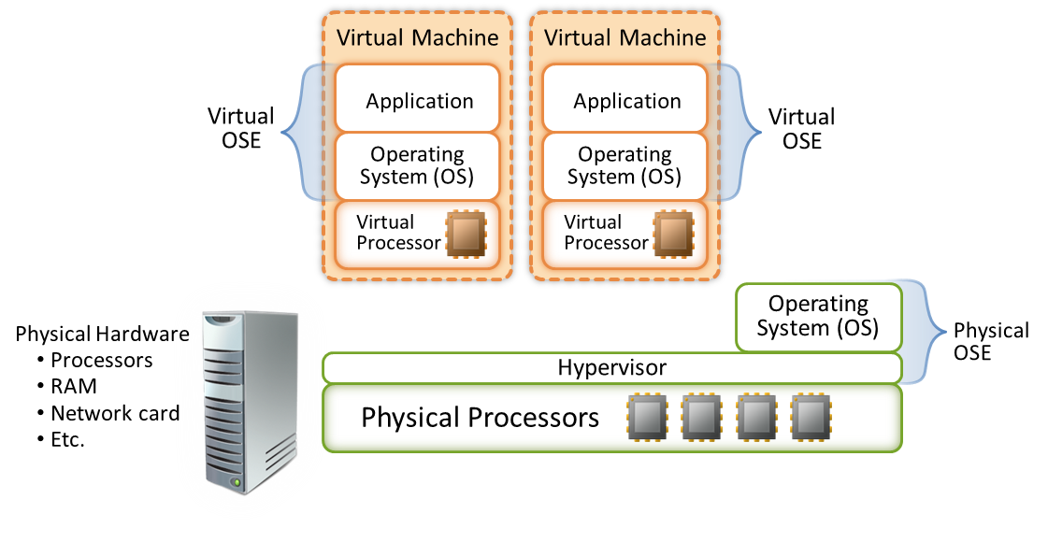

Figure 1: Physical and virtual hardware and operating system environments

Updates to Licensing for Microsoft Desktop Operating System Products

Microsoft is updating the licensing use rights for Windows 7 products so that you can take advantage of the benefits and capabilities of VM technology. If you do not use VM technology or license versions of Windows 7 that grant virtualization use rights, these updates and clarifications do not significantly affect your use of Windows® operating system products.

Updated Licensing Overview

The following is an overview of the updated desktop PC operating system licensing models and clarifications to existing licensing policies.

Products | Summary
- Windows 7 Professional Upgrade License (Volume Licensing Upgrade License)  - Windows 7 Enterprise | - Before you use an eligible Windows 7 licensed product, you must assign or allocate that license to a PC. That PC is referred to as the “licensed device.”  - Use terms specify the maximum number of copies of the software per license that you may run on or remotely access from the licensed device at a time.  - Copies may be run either directly on the physical hardware or in virtual machines (or otherwise emulated hardware systems).  - You may run on the licensed device at any one time one copy, or instance, of the software directly on the hardware (the physical operating system environment)  - If you have Windows 7 Enterprise with active Software Assurance, you may run up to four instances of the software in virtual machines. You may create and store an unlimited number of copies (for example, copies in VMs) for use on any licensed device.  - Each hardware partition or blade is a separate physical hardware system and therefore requires a separate license.  - In most cases, you may not reassign licenses for desktop PC operating system products within your organization.  - PCs without a hard drive (or diskless PCs) are treated the same as traditional PCs for the purposes of licensing.
- Windows Virtual Enterprise Centralized Desktop (VECD)  - Windows VECD for Software Assurance | - VECD for Software Assurance and VECD are licensed on a per-device, non-perpetual, subscription basis.  - Before you run any instance of the software under a license, you must assign that license to a device. That device is referred to as the “licensed device.” A hardware partition or blade is considered to be a separate device.  - You may create and store an unlimited number of copies of the software on a network server or storage media for use on any VECD licensed device.  - You may remotely access from the licensed device, at any one time: one running instance of the software in one physical operating system environment, or up to four running instances of the software in virtual machines or otherwise emulated hardware systems.  - If the licensed device is assigned a Windows 7 Professional license, you may run one or more of the permitted instances locally in a virtual operating system environment on the licensed device either using the Microsoft Desktop Optimization Pack (MDOP) component technology, Microsoft Enterprise Desktop Virtualization (MEDV), other similar technologies or from a storage device (such as a network server) over an internal network.

Your review of these changes should not substitute for careful review and understanding of your rights and obligations as described in your Microsoft Volume Licensing agreement. These updates apply to the use of Windows XP Professional or Windows Vista Business in place of licensed copies of Windows 7 under Volume Licensing prior version rights. Customers should consult their Volume License agreements for further details regarding downgrade rights. For further detail, please see the Product Use Rights (PUR) at http://www.microsoft.com/licensing/.

Virtualization Use Rights for Windows 7 Enterprise

For each device licensed for Windows 7 Professional Upgrade with active Software Assurance:
- Installation rights: Customers may install unlimited copies of the software on the licensed device. However, at any one time, they may run no more than one instance directly on the physical hardware and no more than four instances in virtual machines. Despite the allowance of more than one copy, use of the software is limited to one user at a time.
- Host operating system: If customers use all five permitted instances, the instances running directly on the physical hardware may be used solely to:
- Run the hardware virtualization product.
- Manage and service the virtual (or otherwise emulated) hardware systems on that device.
- Alternative installations: Customers may install and use a second instance on the licensed device in a separate hard-drive partition. Choosing this option forfeits the right to run four virtualized instances.
- Editions: Customers may use Windows 7 Professional, Windows 7 Enterprise or a prior version for any instance running in a virtual machine. Likewise, customers electing the alternative right to run a second copy in a hard-drive partition, or otherwise choosing not to invoke the virtual machine rights, may use prior versions in place of a permitted copy or copies. (Please refer to your agreement and Product List for full information on prior version rights for Windows. Customers must have active Software Assurance to have the rights to run the 4 local virtual Machines. Customer can use a prior version of Windows 7 Professional or Enterprise as long as their agreement has active SA.

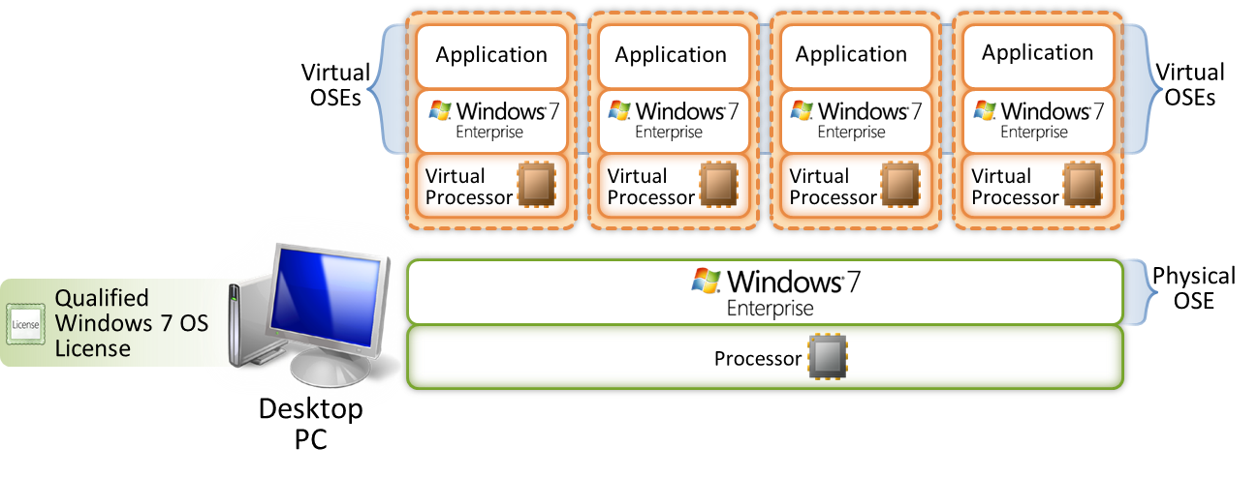

Figure 2: Virtualization use rights for operating systems versions

Virtualization Use Rights for Windows VECD and Windows VECD for Software Assurance

Microsoft Volume Licensing features two additional products that you can use to license the Windows desktop PC operating system for use in virtual machine environments. For traditional PCs licensed for Windows 7 with Software Assurance use VECD for Software Assurance. For thin clients, use VECD. See Figure 3 in this brief. Both VECD and the VECD for Software Assurance products are licensed on a per-device, non-perpetual subscription basis and include a “Work at Home” license.

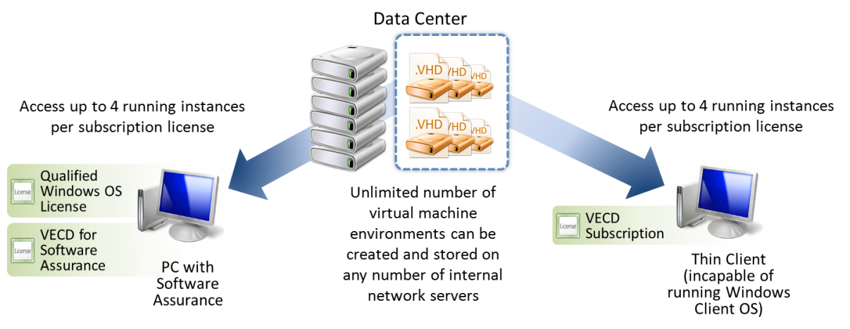

Figure 3: Virtualization use rights in PC and thin-client scenarios

Windows Virtual Enterprise Centralized Desktop for Software Assurance

VECD for Software Assurance is a Windows 7 Enterprise license for customers who want to procure VECD for their Software Assurance-covered traditional PCs (or similarly licensed diskless PCs). To be eligible for VECD for Software Assurance, the licensed PC in question must be currently covered with Software Assurance for Windows 7.

Customers may acquire a VECD for Software Assurance subscription license if they meet the following criteria:
- Currently have or plan to have an Enterprise Agreement (EA), Select License Agreement, Open Value, or Campus and School Agreement (CASA).
- Have covered their identified/target workstations with Software Assurance for Windows 7.

On meeting the above criteria, customers can purchase the Windows Virtual Enterprise Centralized Desktop for Software Assurance licenses through Microsoft Volume Licensing.

Windows Virtual Enterprise Centralized Desktop
Customers may acquire a VECD for thin-client license if they meet the following criteria:

- Currently have or plan to have an Enterprise Agreement, Select License Agreement, Open Value, or School Agreement.
- Have or plan to have thin clients or PCs as the primary accessing device but do not have Software Assurance for Windows 7 on those devices.

On meeting the above criteria, customers can purchase Windows Virtual Enterprise Centralized Desktop licenses through Microsoft Volume Licensing. The use rights for this offering are noted above.

Installation and Use Rights:

- Remote Access: Customers may install unlimited copies of the software on a network server or remote storage device (for example, storage area network [SAN]). However, at any one time, they may run no more than four instances in virtual machines (or otherwise emulated hardware systems) and remotely access those from the licensed device. Despite the allowance of more than one instance, use of the software is limited to one user at a time.

- Local Access: Customers may store a copy of the software on a portable storage device (for example, DVD, USB) and run one or more of the permitted instances locally in a virtual operating system environment on the Windows VECD licensed device, if that device is also assigned a Windows 7 Professional license.

- Home Use: The primary user of the corresponding VECD for Software Assurance or VECD licensed device may use a single home device to remotely access an instance of the software or locally run an instance of the software in a virtual operating system environment. Local home use under the “Work At Home” license requires that the home device is assigned a license for an edition of Windows XP, Windows Vista or Windows 7, and that software is installed on it.

Frequently Asked Questions

Can I install multiple copies of the operating system with my Windows 7 Professional Upgrade license?
You can install multiple copies of the operating system only if the desktop PC licensed for Windows 7 Professional is covered with active Software Assurance. The right to install and use additional copies of the software is granted under supplemental use rights associated with active Windows 7 Software Assurance.

What are the differences between the virtualization use rights associated with Windows 7 Software Assurance and with VECD including the Remote Boot right (previously in Software Assurance)?
The difference in the configurations is summarized as follows:

Summary of Flexible Computing Offerings

 | Windows 7 with active Software Assurance | Windows 7 Enterprise using Diskless PCs | Windows VECD
Where is the operating system installed? | On the licensed desktop PC | On an internal network server or network storage device (for example, SAN) | On an internal network server or network storage device (for example, SAN)
Where does the operating system run or execute its code? | On the licensed desktop PC | On the licensed desktop PC | On an internal network server or in an emulated hardware system on the VECD licensed device
Where is the presentation of the operating system? | On the licensed desktop PC | On the licensed desktop PC | On a licensed desktop PC or thin client over a remote connection

If I install and run four additional copies of the operating system, do I have to use Windows 7 Enterprise as the host operating system?
No. You may use prior versions of Windows, including Windows Vista Business and Windows XP Pro. In addition to third-party product to host the four virtual machine environments, Volume Licensing customers have some flexibility in how they can deploy Windows 7 in their organizations. As a benefit of Software Assurance coverage for Windows desktops, customers may leverage virtualization use rights. This use right allows running the software in up to four local virtual machines. While a customer’s right to use Windows 7 Enterprise may survive the expiration of their Software Assurance coverage, the Virtualization Use Right does not.

Can I store my virtual machine in a .vhd file on removable storage media and open the .vhd file on another PC?
Yes, as long as both PCs are licensed for Windows VECD and are not already running more than three copies of the software.

Are there any unique restrictions when running the operating system in a virtual machine?
No unique restrictions exist when running the operating system in a virtual machine. However, we advise against playing or accessing content or using applications protected by other digital, information, or enterprise rights management technology or other rights management services or using full-volume disk drive encryption.

Can other users remotely access virtual machines that I’m not using on my PC while I’m using my PC?
No. The use of the software is limited to one user at any given time.

Can I remotely access multiple VMs running on my Windows 7 Enterprise PC as the primary user from multiple devices at the same time?
No. The use rights only permit one remote access connection at a time to the licensed device.

What is the difference between Windows VECD for Software Assurance and VECD?
VECD for Software Assurance is for traditional PCs that are already licensed for Windows 7 and have Software Assurance, while VECD is for licensing thin clients or PCs that are not covered with Software Assurance.

Can my VECD license be re-assigned to another device?
Yes. You may reassign your license, but not on a short-term basis (defined as within 90 days of the last assignment) except if there is a permanent hardware failure of the licensed device. In this case, the VECD license can be re-assigned sooner to a replacement device. In the case of VECD for Software Assurance, you may reassign your license to any other licensed device for which you have active Windows Software Assurance coverage.

Can the four VMs I’m licensed to run on a server be shared with other users under a single VECD license?
No. The four VMs permitted under each VECD license may be remotely accessed only from the licensed device. More users can use the licensed device but not at any one time.

Can I continue to order or use VECD for Software Assurance after my agreement (and corresponding Software Assurance) has expired?
No. VECD for Software Assurance (the license intended for traditional PCs licensed for Windows 7 with Software Assurance) may not be ordered or used after the expiration of Software Assurance coverage. The license is only available for PCs with active Windows Software Assurance coverage. VECD (for thin clients or Windows PCs without Software Assurance) may be procured under any valid EA, Select, Open Value or CASA enrollment. However, the subscription co-terminates with the enrollment or agreement and may not be extended beyond the expiration date without the renewal of that enrollment or agreement.

Can I acquire Microsoft Desktop Optimization Pack (MDOP) for my VECD licensed devices?
Yes. Active VECD subscriptions qualify you for an MDOP purchase.

How do I license my employee and contractor owned PCs so that they have access to my centralized desktop PC environment?
Employee- and contractor-owned devices can be licensed with Windows VECD, which enables them to remotely access your centralized desktop PC environment. Additionally, for devices with a pre-assigned Windows 7 Professional license, they may run the permitted instances locally in a virtual machine on the Windows VECD licensed device.

Definitions

Device: A device is a physical hardware system. A hardware partition or blade is considered to be a separate physical hardware system and, therefore, is a separate device.

Assigning a license: To assign a license means simply to designate that license to one device. The purpose of this designation is to avoid sharing a license across multiple devices at the same time.
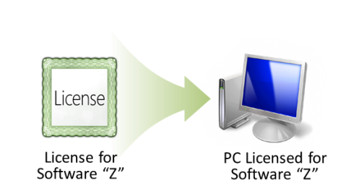

Figure D1: Assigning a license

Operating system environment: An operating system environment is one instance of an operating system and instances of applications, if any, configured to run on that operating system instance. The two types of operating system environments are physical and virtual. A physical operating system environment is configured to run directly on a physical hardware system. A virtual operating system environment is configured to run on a virtual (or otherwise emulated) hardware system. A physical hardware system can have either or both of the following:
- one physical operating system environment
- one or more virtual operating system environments

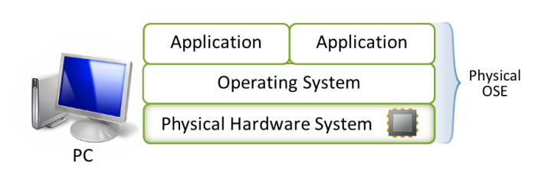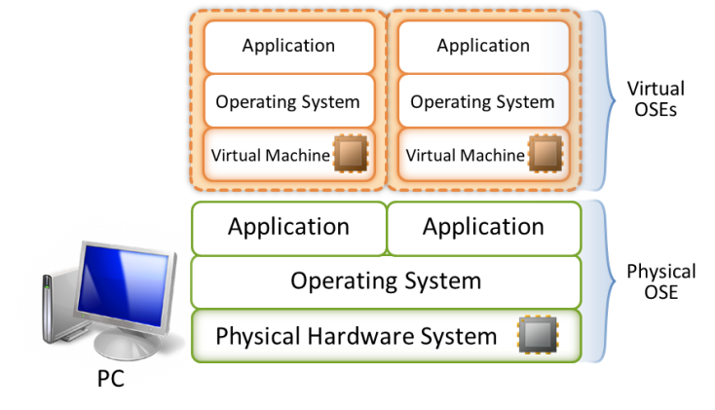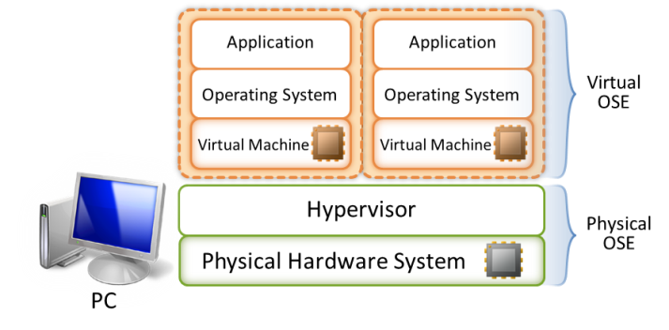

Figure D2: Different types of operating system environments on a PC

Hardware partitioning technology can also be used to run multiple operating system environments on a physical hardware system. However, this technology is primarily available on high-end systems.

