




Deployment Cookbook: Onsite Backup
Microsoft® System Center Data Protection Manager 2007 & Microsoft® Virtual Server 2005 R2 Service Pack 1

Table of Contents
Introduction 2
Before You Begin 3
Section 1: Install and Configure Virtual Server 13
Section 2: Install and Configure Data Protection Manager 24
Section 3: Back Up Data 40
Section 4: Monitor and Report 56
Section 5: Restore Data 62
Section 6: Back Up and Restore Data to a Running Virtual Machine 78
Appendix A: DPM Protocols and Ports 94
Appendix B: Install IIS via Control Panel 95
Appendix C: Virtual Server Security Considerations 99
Appendix D: Install the iSCSI Initiator 100
Related Links 107
Version 1.0
Document Conventions
The following are the conventions for this document:
Black text = Indicates required boilerplate text. Do not change or remove this text.
Blue text = Indicates elements that you must fill in with the correct information. Change all blue text to black text prior to handing off for review.
Red text = Indicates instructions or example text. This is hidden text. Delete all red text prior to handing off for review.

Introduction
Many mid-sized and larger businesses may want to deploy Microsoft® System Center Data Protection Manager (DPM) 2007 within their infrastructure, but worry about meeting the special protection needs of production virtual machines. With Service Pack 1 (SP1) for Microsoft® Virtual Server 2005 R2, DPM 2007 can provide continuous data protection for Virtual Server-based virtual machines. This means that you can take full advantage of server virtualization in your IT environment and enjoy best-of-breed protection for you virtualized workloads without pausing or turning off your virtual machines.
The scenario presented in this cookbook will take you through the steps necessary to backup running servers and virtual machines to local disk storage. This cookbook also includes steps on restoring servers from disk-based backup and for archiving and restoring backups to and from tape-based long-term backup.

Intended Audience
This deployment cookbook is written for you, the IT generalist setting up DPM to back up virtual machines. The goal of this guide is to provide all of the steps and guidance necessary for you to successfully install and configure Microsoft Virtual Server 2005 R2 SP1 and System Center Data Protection Manager 2007 so that you can protect your virtualized server workloads and your users.

Using This Guide
This cookbook serves two purposes. First, you can follow the step-by-step instructions in a test environment to get a basic understanding of the concepts, techniques, and applications used in this scenario. Second, you can refer back to this cookbook as a how-to guide for performing specific tasks in a production environment.
To cover the bases, this cookbook probably contains more information than you need. In addition to the Table of Contents at the beginning of this guide, each section also includes its own table of contents so that you can easily find the steps that you need most. If you already have a component installed or a step completed, move on to the next step or section.

Before You Begin
This cookbook assumes that you already have either Windows Server® 2003 Standard Edition, Enterprise Edition, Datacenter Edition, or later versions; or Windows Server® 2003 Standard x64 Edition, Enterprise x64 Edition, Datacenter x64 Edition, or later versions installed on your servers. This guide also assumes that you have the latest service pack for Windows Server 2003 installed on your server.
In this section, we also cover other prerequisites for you and your environment, as well as other specifics that will help you get the most out of this guide.

Necessary Hardware to Follow Along
In order to learn the basics of using DPM deployed on virtual machines for data protection, you will need the following hardware in your test environment when going through this cookbook:

One (1) physical server
This server will host the virtual machine that you will create while following this cookbook, and this physical server must have one of the following operating systems installed on it:
- Windows Server 2003 Standard Edition, Enterprise Edition, Datacenter Edition, or later versions
- Windows Server 2003 Standard x64 Edition, Enterprise x64 Edition, Datacenter x64 Edition, or later versions
- Windows® Small Business Server 2003 Standard Edition or Premium Edition
- Windows® XP Professional Service Pack 2 (SP2)
To best ensure the responsiveness of the virtual machine that you will create and to shorten the wait time for installation to complete, this server should have at least the following characteristics:
- 2 gigabytes (GB) RAM
- 1 GHz or faster CPU, such as an Intel® Xeon® processor
- 4.5 GB free hard drive space
- 1 NIC
- Processors with hardware-assisted virtualization technology such as Intel® Virtualization Technology. For more information on Intel Virtualization Technology, see Intel Virtualization Technology Support in the Virtual Server 2005 R2 SP1 section later in this document.
For specific system requirement and recommendation information, consult the Virtual Server 2005 R2 SP1 and Data Protection Manager 2007 sections later in this cookbook. See the Bandwidth Considerations section for more specific information on network cards for your physical server.

One (1) physical domain controller
The virtual machine that you will create while following this cookbook to the end and the server running DPM will each need to be joined to an Active Directory® domain. In addition to being a domain controller, this server is also a DHCP server, an Active Directory-integrated DNS server.

One (1) virtual machine to protect
This virtual machine will be on your domain. Note that if you choose to use your domain controller as the computer that you protect, you will limit some of the scenarios that you can test, such as restoring the entire computer (as attempting this would break your domain and, by extension, your virtual machine).

One (1) mass storage device or solution
Protecting data means storing backup data. In the case of the test environment you are working in, it should not be large: you control the size of the volumes and files of the computer you will practice protecting—in the interest of your own time, keep this as small as possible. However, this cookbook will take you through interacting with a mass storage apparatus like a storage area network (SAN) or a direct-attached storage (DAS) device. You can alter the steps presented in this cookbook to use hard drive space on the computer hosting your DPM virtual machine, but you will only be depriving yourself of the vital experience of getting a virtual machine that you have made to work with mass storage as you would in a production setting.
Because your mass storage will have to work with virtual machines both in your test environment and in your production environment, your mass storage must use iSCSI. For a deeper discussion of the storage considerations for this deployment scenario, see the Storage Type Considerations section later in this guide.

One (1) dedicated DPM server
This is the physical server on which you will install DPM. DPM will then be used to back up the virtual machine that you create.

Test Network Topology
In the course of the going through this cookbook, you will install DPM on a server attached to mass storage of some kind. You will also create a virtual machine to serve as your domain controller. (You may also choose to create a virtual machine to protect with DPM). Your domain controller will be called DC_SRV; the physical machine that is hosting DPM will be called DPM_SRV; the virtual machine that you will be protecting will be called Protected_SRV; and the physical machine that hosts Protected_SRV will be called Host_1.
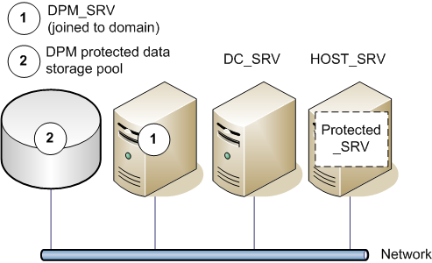
Figure 1 Test network topology for this cookbook
Table 1 lists in greater detail the virtual machines created and the physical host computer used in the test environment for this cookbook.
Table 1 Virtual machine and host computer configuration for cookbook test environment
 | DC_SRV | DPM_SRV | Protected_SRV | HOST_SRV
Operating system | Windows Server 2003 R2  Standard Edition SP2 | Windows Server 2003 R2  Standard Edition SP2 | Windows Server 2003 R2  Standard Edition SP2 | Windows Server  2003 R2  Standard Edition SP2
Memory | 512 MB  (physical) | 1024 MB  (physical) | 256 MB  (assigned) | 1024 MB  (physical)
IP addressing information | 192.168.10.10 | 192.168.10.11 | 192.168.10.12 | 192.168.10.20
Installed  services | - DHCP  - DNS  - WINS | None  (DPM installed in course of cookbook) | None  (Virtual machine created and DPM agent installed in  course of cookbook) | None  (Virtual Server installed in course  of cookbook)
Physical or virtual | Physical | Physical | Virtual | Physical
Host server | - | - | HOST_SRV | -
Domain name | contoso.com | contoso.com | contoso.com | contoso.com

Production Network Topology
Figure 1 depicts DPM protecting not just the physical servers and workstations of an IT environment, but also the virtual machines running on them.
Advances in server hardware make this scenario more likely for more organizations as virtual machines can handle more workloads in production environments. For example, Intel has created a set of hardware enhancements, called Intel Virtualization Technology, for Intel Xeon processor-based server platforms. Intel Virtualization Technology can improve software-based virtualization solutions, such as Virtual Server 2005 R2 SP1, with processor and input/output (I/O) enhancements that deliver more performance directly to virtual machines through an approach called hardware-assisted virtualization. For more information on Intel Virtualization Technology, see Intel Virtualization Technology Support in the Virtual Server 2005 R2 SP1 section later in this document.
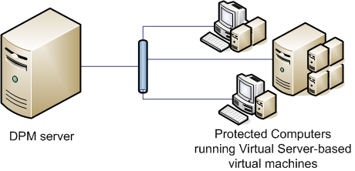
Figure 2 Onsite backup infrastructure

Storage Type Considerations
The volume of storage required to back up even a modest number of computers generally necessitates a storage area network (SAN) or direct-attached storage (DAS) appliance of some kind, the specifics of which you will need to learn from your mass storage vendor.

Bandwidth Considerations
Network bandwidth can always be in short supply for a small or mid-sized business. In this cookbook, we will introduce you to the network bandwidth throttling, data compression, and backup scheduling functionality in DPM so that you can ensure that backing up your servers doesn’t take up all of your network bandwidth during business hours.
Depending on your network configuration, you may need to perform firewall configuration to enable communication between DPM, the file servers, and the domain controllers. To help with firewall configuration, Appendix B provides details about some of the protocols and ports used by DPM.

Virtual Server 2005 R2 SP1
This section will outline the requirements and considerations for running Virtual Server in your environment.

Virtual Server 2005 R2 Glossary
Here are some of the basic terms concerning virtual machines in general, and Virtual Server in particular, that you will encounter repeatedly in this cookbook.

guest operating system
The operating system running on a virtual machine.

host computer
The physical computer running the Virtual Server service.

Internet small computer system interface (iSCSI)
A network protocol standard that allows high-speed, parallel SCSI to transfer data by using the Transmission Control Protocol/Internet Protocol (TCP/IP) protocol suite. In the context of Virtual Server, the iSCSI protocol standard provides virtual machines with a high-speed data connection to mass storage apparatuses.

logical unit number (LUN)
A logical partition (or volume) of a set of connected storage disks.

storage area network (SAN)
A set of interconnected devices (such as disks and tapes) and servers that are connected to a common communication and data transfer infrastructure such as iSCSI.

virtual hard disk
For Virtual Server and Virtual PC, a file, referred to as a .vhd file, which provides storage for a virtual machine. The .vhd file can reside on any storage topology that the host operating system can access, including external devices, storage area networks, and network-attached storage.

virtual machine
Essentially a computer within a computer, implemented in software. A virtual machine emulates a complete hardware system, from processor to network card, in a self-contained, isolated software environment, enabling the simultaneous operation of otherwise incompatible operating systems. Each operating system runs in its own isolated software partition.

Virtual Machine Additions
Software drivers that maximize performance and provide a better UI experience within a virtual machine. Virtual Machine Additions are available for the following guest operating systems:
- Windows Server 2003 R2 (all versions)
- Windows Server 2003 (all versions)
- Windows XP (all versions)
- Microsoft® Windows® 2000 Server
- Microsoft® Windows® 2000 Professional
- Microsoft® Windows® Millennium Edition (ME)
- Microsoft® Windows® NT Server 4.0 with Service Pack 6a (SP6a)
- Microsoft® Windows® 98
- Microsoft® Windows® 95

Virtual Machine Remote Control (VMRC)
A feature of Virtual Server that enables a running virtual machine to be managed remotely.

Virtual Server 2005 R2 System Requirements
The server hosting your virtual machine should conform to the following requirements and recommendations:
Table 2: Virtual Server system requirements
Minimum CPU speed | 550 MHz
Recommended CPU speed | 1.0 GHz or higher
Processor information | Intel Celeron, Pentium III, Pentium 4, Xeon, or Core 2 Duo
Supported host operating systems | - Windows Server 2003 Standard Edition, Enterprise Edition, or Datacenter Edition or later  - Windows Server 2003 Standard x64 Edition, Enterprise x64 Edition, Datacenter x64 Edition or later versions  - Windows Small Business Server 2003 Standard Edition or Premium Edition  - Windows XP Professional SP2 or later (for non-production use only)
Minimum RAM | 256 MB (additional memory needed for each guest operating system)
Required available hard-disk space | 2 GB (additional disk space needed for each guest operating system)
Other processor support | AMD Opteron, Athlon, Athlon 64, or Athlon X2
Note: For this scenario, Virtual Server 2005 R2 SP1 should be installed on editions of Windows Server 2003 and Windows Server 2003 R2 for production purposes. Installation on Windows Small Business Server 2003 or Windows XP Professional SP2 is acceptable for test purposes or for purposes of evaluating the deployment and configuration steps outlined in this cookbook.

Licensing Considerations
The license for Windows Server 2003 Enterprise Edition, Windows Server 2003 Enterprise x64 Edition, or later versions on the server hosting your DPM virtual machines enables you to run up to four instances of Windows Server 2003 Standard Edition, Enterprise Edition, or later versions as the operating systems for those virtual machines, at no extra cost.
The license for Windows Server 2003 Datacenter Edition, Windows Server 2003 Datacenter x64 Edition, or later versions on the server hosting your DPM virtual machines enables you to run an unlimited number of instances of Windows Server 2003 Standard Edition, Enterprise Edition, Datacenter Edition, or later versions as the operating systems for those virtual machines, at no extra cost.

Intel Virtualization Technology Support
Service Pack 1 (SP1) for Virtual Server 2005 R2 includes a new feature that takes advantage of the hardware assistance for virtual machines provided by multi-core Intel Xeon processor-based servers through Intel Virtualization Technology.
Virtual Server takes advantage of this hardware assistance by controlling the virtual machine-specific operations of the processor, thereby allowing the virtual machine to run processor operations at the privilege level that the processor expects. These integrated features give virtualization software the ability to take advantage of offloading workload to the system hardware, enabling more streamlined virtualization software stacks and "near native" performance characteristics. In addition, Quad-Core Intel Xeon processor servers with virtualization hardware assistance offer additional application headroom, memory flexibility, and increased security for virtual and dedicated environments.
The performance improvements of virtual machines running on Virtual Server 2005 R2 SP1 with hardware assistance from Intel Virtualization Technology provide direct performance benefits. In this deployment scenario, for example, the increased performance makes running several virtual machines on a single physical server possible, while maintaining performance.

Data Protection Manager 2007
DPM is designed to run on a dedicated, single-purpose server. The server must not be a domain controller or application server, and must not double as the host for the DPM Management Pack (the management pack that enables administrators to monitor DPM in Microsoft® Operations Manager 2005). You will need to take into careful consideration the total memory and hard drive space requirements for the DPM machine. The requirements and recommendations for the components of a DPM machine break down as follows:
Table 3: Requirements for a DPM machine
Component | Requirement | Recommendation
Memory | 512 MB RAM | 1 GB RAM
Disk space for DPM virtual hard disks | - System drive: 100 MB  - Program files drive: 160 MB  - Database files drive: 900 MB | N/A
For the protected data storage pool disk space, DPM requires equal to 1.5 times the size of the protected data. However, Microsoft recommends having a storage pool two to three times the size of the customer data that you are protecting.

Data Protection Manager 2007 Glossary
Here are some of the basic terms concerning DPM 2007 that you will encounter repeatedly in this cookbook:

archive
The process by which an administrator copies the contents of the DPM server to tape by using tape backup software. Archiving the replicas provides for long-term storage and access to protected data. Archiving the DPM database and the Report database provides for restoring the DPM server in the event of disaster.

autodiscovery
The daily process by which DPM automatically detects new or removed servers on the network and discovers changes to protected file servers, such as the addition, removal, or renaming of shares and volumes.

consistency check
The process by which DPM checks for and corrects inconsistencies between a protected volume and its replica. A consistency check is performed only when normal mechanisms for recording changes to protected volumes, and for applying those changes to replicas, have been interrupted.

data source
A share, volume, folder, or file that is a member of a protection group.

DPM Administrator Console
A Microsoft® Management Console (MMC) snap-in that provides access to the administrative functions of DPM. DPM Administrator Console allows administrators to configure data protection, perform data recovery operations, and monitor and report on these activities.

DPM database (DPMDB.mdf)
The Microsoft® SQL Server™ database that stores DPM settings and configuration information.

DPM File Agent
Software, installed on a file server, that records changes to protected data in a synchronization log, and transfers the log from the file server to the DPM server.

end-user recovery
A feature that enables an end user to independently recover data by retrieving a shadow copy. This feature requires the shadow copy client software.

network bandwidth throttling
A performance optimization in DPM that limits the percentage of network bandwidth that protection and recovery jobs can consume.

on-the-wire compression
A performance optimization in DPM that reduces the size of data transferred during replica creation and synchronization, thereby increasing the rate of data throughput without negatively affecting network performance.

protection
In DPM, the process of protecting data from loss or corruption by centrally creating and maintaining replicas and shadow copies of the data. DPM is designed to provide short-term disk-based backup, to support rapid and reliable recovery of data.

protection group
A collection of data sources that share the same protection configuration and schedule.

protection group member
A data source within a protection group. A protection group member can be a share, volume, or folder.

recovery
In DPM, the process by which an administrator or end user recovers previous versions of shares, volumes, folders, or files from the shadow copies on the DPM server.

recovery collection
The aggregate of all recovery jobs associated with a single recovery operation.

replica
A complete copy of the protected data on a single volume. Each volume in a protection group is associated with a replica on the DPM server.

replica creation
The process by which a full copy of data sources, selected for inclusion in a protection group, is transferred to the DPM storage pool. The replica can be created over the network from live data on the file server or from a tape backup system. Replica creation is an initialization process that is performed for each volume when the volume is added to a protection group.

Report database (ReportServer.mdf)
The SQL Server database that stores DPM reporting information.

restore
In DPM, the process by which an administrator retrieves a protected file or rebuilds a DPM server by using data that has been archived to disk or tape.

shadow copy
A point-in-time copy of files and folders that is stored on the DPM server. Shadow copies are sometimes referred to as snapshots.

shadow copy client software
Client software that enables an end user to independently recover data by retrieving a shadow copy.

storage pool
A set of disks that store replicas, shadow copies, and transfer logs for protected data.

synchronization
The process by which DPM transfers the synchronization log from the file server to the DPM server, and applies the changes stored in the log to the replica of the protected volume.

Section 1:
Install and Configure Virtual Server
Setting up Virtual Server consists of two steps—installing Microsoft® Internet Information Services (IIS), and installing Virtual Server. The instructions in this section will also lead you through delegating a given user’s credentials (to allow remote connection to the Virtual Server Administration Website) and through enabling Virtual Server to delegate the logged-on user’s credentials to another computer (so that Virtual Server can access data on other computers, such as disk images).
Steps covered in this section:
Install IIS by using the Configure Your Server Wizard 14
Internet Information Services is a prerequisite for installing Microsoft Virtual Server. Microsoft Virtual Server uses a Web-based management console that depends on the Internet Information Server World Wide Web service.
Install Virtual Server 2005 R2 SP1 15
The installation process will automatically set up the Virtual Server Administration Website
Create a virtual machine 17
Here you will create the virtual machine on which DPM will run.
Allow Virtual Server to delegate the credentials of the logged-on user to another computer 20
Allowing this delegation permits Virtual Server to access guest operating system installation files that may be stored on another computer.
Install the guest operating system from a startup CD or image file 20
The virtual machine that you have created is analogous to a physical server that you have just taken out of the box; you will need to install an operating system on it before you can install DPM.
Install Virtual Machine Additions 22
Virtual Machine Additions improves mouse cursor tracking and control, and also greatly improves overall performance of the guest operating system on the DPM virtual machine.
Allow the Virtual Server host computer to delegate a user's credentials to the Virtual Server service 23
Allowing this delegation permits authorized users to access the Virtual Server Administration Website from remote workstations. If you do not delegate a user’s credentials to the virtual server service, then only local administration will be possible.

Install IIS by using the Configure Your Server Wizard
You must install the World Wide Web Service component of IIS so that you can use the Administration Website to manage Virtual Server. You should install IIS on Host_1.
- From the Start menu of the physical computer that will run the Virtual Server service, select Programs > Administrative Tools > Manage Your Server.
- Under Managing Your Server Roles, click Add or remove a role.
- Read the preliminary steps in the Configure Your Server Wizard, and then click Next.
- Under Server Role, click Application server (IIS, ASP.NET), and then click Next.
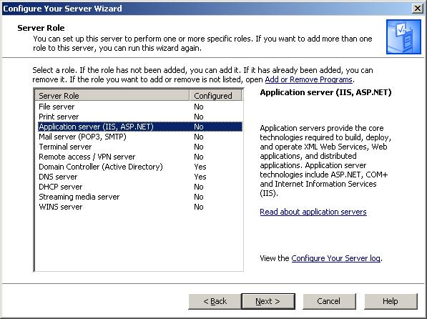
Figure 3 Select Application Server in Configure Your Server Wizard
Note: By default, the wizard installs and enables IIS, COM+, and DTC. In addition, the Configure Your Server Wizard enables Microsoft® ASP.NET by default.
- Read the summary, and then click Next. You will need the installation medium (CD, .iso file, or network file share) for the operating systems of this computer to complete this step.
- Complete the wizard, and then click Finish.

Install Virtual Server 2005 R2 SP1
You will need to install Virtual Server on Host_1.
- Start Microsoft Virtual Server 2005 Setup (Setup Wizard) from the Virtual Server 2005 CD-ROM.
Note: If you start the Setup Wizard manually, be sure to use Setup.exe.
- Proceed through the wizard until you reach the Setup Type page.
- On the Setup Type page, click Complete, which installs Virtual Server by using the default configuration, and then click Next.
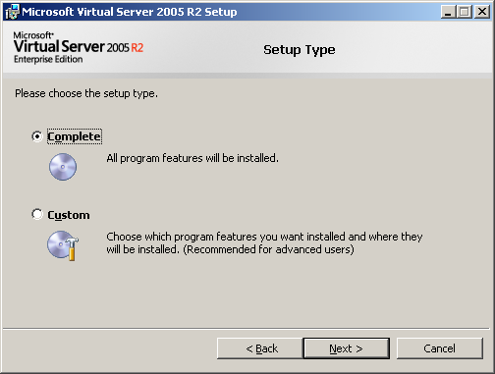
Figure 4 Virtual Server Setup Wizard, Setup Type page
- On the Configure Components page, either accept the default Web site port value of 1024, or type a new value for the port, and then click Next. In this example we will use the default.
You have an additional choice to make:
- If you plan to always run the Administration Website as the authenticated user—to access resource files only on the local computer—accept the default setting Configure the Administration Website.
- If you plan to access resource files on a remote computer, select Configure the Administration Website to always run as the Local System account.
To allow the most flexibility in accessing resources (particularly in a production environment), we will select Configure the Administration Website to always run as the Local System account, and then click Next.
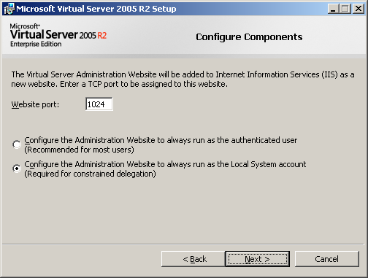
Figure 5 Virtual Server Setup Wizard, Configure Components page 1
Note: If you are installing the Administration Website on a computer running Windows XP SP2, the default Website port is 80.
- On the second Configure Components page, leave the Enable Virtual Server exceptions in Windows Firewall check box selected and click Next.
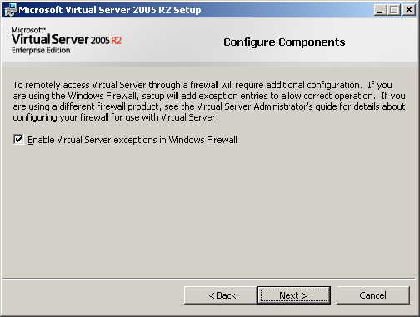
Figure 6 Virtual Server Setup Wizard, Configure Components page 2
With Enable Virtual Server exceptions in Windows Firewall selected, setup adds an exception for the Virtual Server service (vssrvc.exe) to every port on the computer. It also adds an exception to port 135 for Remote Procedure Call, which is required for the Distributed Component Object Model (DCOM)-based services upon which Virtual Server depends.
- Click Install to begin the installation.
- When the installation is complete, the Setup Complete page appears. Click Finish to close the page and exit the Setup Wizard.
Note: You can close the Installation Summary page that opens in Windows® Internet Explorer® when the installation is complete.

Create a virtual machine
Now that Virtual Server is installed, we can create the virtual machine, called Protected_SRV.
- If it is not already open, open the Virtual Server Administration Website. On the desktop Host_1, click Start > All Programs > Microsoft Virtual Server > Virtual Server Administration Website.
- In the left column of the Virtual Server Administration Website, under Virtual Machines, click Create.
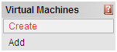
Figure 7 Create new virtual machine
- In the Virtual machine name field, type a descriptive name for the virtual machine. If you do not want the virtual machine (.vmc) file to be created in the default configuration folder, specify a fully qualified path to the location where you want to create the virtual machine. In this example, as shown in Figure 8, the virtual machine is named Protected_SVR. Feel free to use it in your own test environment, though it is not necessary to successfully create a virtual machine.
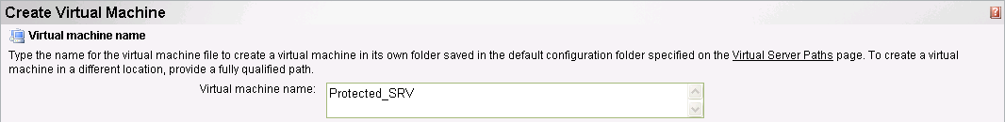
Figure 8 New virtual machine name
- In the Virtual machine memory field, type a value in megabytes for the amount of RAM that is used by the virtual machine. Figure 9 shows 256 GB of RAM allocated to the virtual machine; this is close to the value recommended for a production virtual machine. In this example we will enter 256 as the amount of memory to dedicate to this virtual machine.

Figure 9 New virtual machine memory
- In the Virtual hard disk section, click Create a new virtual hard disk. Next, to set the size of the virtual hard disk, specify a value in Size, and then select either MB for megabytes or GB for gigabytes. For our purposes here, it is okay to leave the virtual hard disk’s maximum size at 127 GB and to leave the Bus at the default selection of IDE. In this example we will create a 127 GB virtual hard disk.
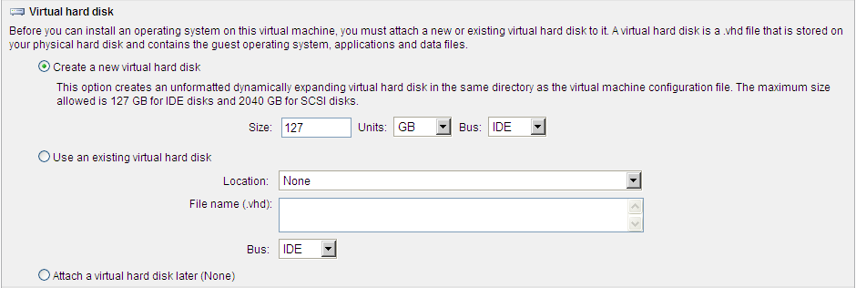
Figure 10 New virtual machine virtual hard disk
There are two other options in the Virtual hard disk section that we will not use in the steps laid out in this guide:
  - Click Use an existing virtual hard disk if you are creating a virtual machine that you want to use an existing .vhd file for its hard disk. If the virtual hard disk (.vhd) file is located in a directory included in Virtual Server Search Paths, you can select the .vhd file from the Location drop-down menu. Otherwise, in the File name (.vhd) field, type the complete path to the location of the .vhd file.
  - Click Attach a virtual hard disk later to create a virtual machine without a virtual hard disk.
- Under Virtual network adapter, select the host computer’s NIC (or the most appropriate one for your needs if you have multiple NICs on the server) from the Connected to drop-down menu.
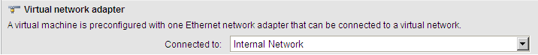
Figure 11 New virtual machine virtual network adapter
Note: The last section on this page is Virtual Machine Additions. We will address Virtual Machine Additions in Install Virtual Machine Additions later in this guide.
- Click Create.
Note: By default, hardware-assisted virtualization is enabled if it is enabled on the host computer. Support for Intel Virtualization Technology can also be specifically enabled or disabled on a per-virtual-machine basis by toggling the Enable hardware-assisted virtualization if available option in the general properties configuration page. However, you should refer to your Intel processor-based host server’s documentation on how to enable Intel Virtualization Technology in the host machine’s BIOS (if available on your server processor).

Allow Virtual Server to delegate the credentials of the logged-on user to another computer
This process allows Virtual Server to access installation data on computers other than the computer running the Virtual Server service (that is, the computer hosting the virtual machine). Allowing this delegation is only necessary if you are going to perform a network-based installation of the operating system on the virtual machine you created; you may skip it if you are going to use physical installation media or a local .iso file.
Also, since this scenario will most likely be unnecessary in a test environment where you will be using local .iso files, you might want to bypass this step in the example lab environment.
- On the domain controller of the physical computer that is hosting the virtual machine, open Active Directory Users and Computers.
- In the console tree, under DomainName, click Computers. In this case, DomainName refers to the domain to which the computer hosting the virtual machine is attached.
- Right-click the computer that will host the virtual machine, and then click Properties.
- On the Delegation tab, click Trust this computer for delegation to specified services only.
- Click Use any authentication protocol.
- Click Add, and then click Users and Computers.
- Type the name of the computer hosting the resource files, and then click OK.
- From the list of available services, select cifs, and then click OK.

Install the guest operating system from a startup CD or image file
The virtual machine that you just created is now analogous to a bare-metal physical server that you just took out of the box. We need to install an operating system on it before we can install applications on it.
- If it is not already open, open the Virtual Server Administration Website. On the desktop of the computer running the Virtual Server service, click Start > All Programs > Microsoft Virtual Server > Virtual Server Administration Website.
- In the left column of the Virtual Server Administration Website, under Virtual Machines, point to Configure, and then click the appropriate virtual machine. In Figure 11, this is Protected_SVR.
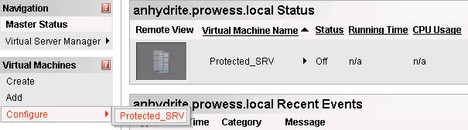
Figure 12 Virtual Machine Administration Website, Configure virtual machine
- In the Configuration section for the virtual machine that you are configuring, click CD/DVD and do one of the following:
  - Insert the startup CD for the operating system into the CD drive on the physical computer running the Virtual Server service. On the CD/DVD Drive Properties page of the virtual machine that you are configuring, under Capture, click Physical CD/DVD drive. If necessary, select the corresponding CD or DVD drive letter from the drop-down menu.
  - On the CD/DVD Drive Properties page of the virtual machine that you are configuring, under Capture, click Known image files. If the image file containing a startup CD image is located in the default directory (\Documents and Settings\All Users\Documents\Shared Virtual Machines\), it is available from the drop-down menu. Otherwise, in the Fully qualified path to file field, type the complete directory path to the image file.
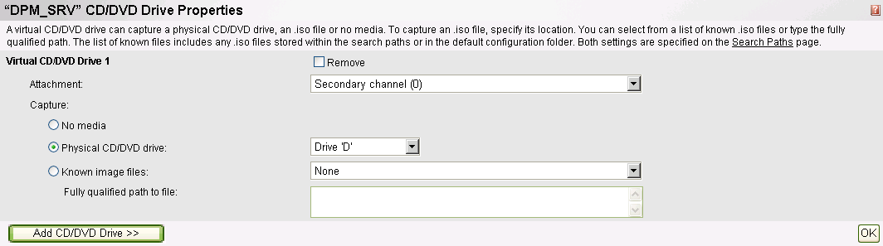
Figure 13 Protected_SRV virtual machine CD/DVD drive properties
Note: Accessing files on a remote computer requires constrained delegation and a software update to the host operating system of the local computer. For instructions, go to Allow Virtual Server to delegate the credentials of the logged-on user to another computer earlier in this guide.
- After you have performed one of these two actions, click OK.
- In the Status section for the virtual machine that you are configuring, point to the virtual machine name (Protected_SRV in this example), and then click Turn On.
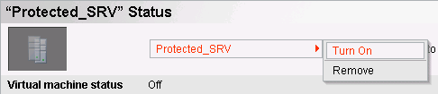
Figure 14 Turn on the Protected_SRV virtual machine
- When the virtual machine is turned on, point to the virtual machine name, and then click Remote Control.
- When you are connected to the virtual machine, follow the instructions provided by the operating system to complete the installation.

Install Virtual Machine Additions
Virtual Machine Additions is a very important component to running a virtual machine. Virtual Machine Additions improves mouse cursor tracking and control as well as greatly improving overall performance of the guest operating system on the virtual machine.
Note: Prior to installing Virtual Machine Additions, the mouse pointer may appear as a dot on the screen. The mouse still functions correctly; only the display of the pointer is affected.
- If it is not already open, open the Virtual Server Administration Website. On the desktop of the computer running the Virtual Server service, click Start > All Programs > Microsoft Virtual Server > Virtual Server Administration Website.
- In the navigation pane of the Virtual Server Administration Website, under Virtual Machines, point to Configure, and then click the appropriate virtual machine.
- In Status section for the virtual machine that you are configuring, point to the virtual machine name, and then click Turn On.
- When the virtual machine has started, point to the virtual machine name, and then click Remote Control.
- Log on to the virtual machine as an administrator or a member of the Administrators group.
- When the guest operating system is loaded, press the HOST KEY (by default, the RIGHT ALT key) to release the mouse pointer, and then in the lower-left corner, under Navigation, click Configure virtual_machine_name.
- In Configuration section, click Virtual Machine Additions, select the Install Virtual Machine Additions check box, and then click OK.
- In the Status section for the virtual machine that you are configuring, point to the virtual machine name, and then click Remote Control.
- Click in the Remote Control window to return to the guest operating system. The Virtual Machine Additions Installation Wizard will start. Proceed through the wizard.
- When the wizard is complete, you will be prompted to restart the virtual machine to complete the installation.

Allow the Virtual Server host computer to delegate a user's credentials to the Virtual Server service
Allowing this delegation permits users authorized in Active Directory to access the Virtual Server Administration Website from a remote workstation. While being able to do this is a minor issue in a test environment, it is will make your virtual machines easier to administer if you enable this in a production environment. In a test environment, this step will probably be unnecessary.
- On the domain controller for the physical server that will host the virtual machine, open Active Directory Users and Computers.
Note: This delegation is to facilitate your administration of a service (Virtual Server) running on a physical computer joined to your own domain.
- In the console tree, under DomainName, click Computers. In this case, DomainName refers to the domain to which the computer hosting the virtual machine is attached.
- Right-click the Web server (that is, the physical computer on which you installed Virtual Server), and then click Properties.
- On the Delegation tab, click Trust this computer for delegation to specified services only.
- Click Use any authentication protocol.
- Click Add, and then click Users and Computers.
- Type the name of the computer running the Virtual Server service, and then click OK.
- From the list of available services, hold down the CTRL key while clicking cifs and vssrvc, and then click OK.
- Repeat as necessary for any additional computers hosting Virtual Server-based virtual machines.

Section 2:
Install and Configure Data Protection Manager
You can install DPM directly from the installation media, an .iso file, or copy the setup files from a shared network location. A DPM installation involves installing the DPM prerequisite software and the DPM application. The DPM setup wizard guides you through the process of specifying the DPM installation settings, and automatically installs or provides links to install the prerequisite software as part of the integrated DPM installation process.
Steps covered in this section:
Install DPM prerequisites and DPM 24
The DPM installer gathers your input at the beginning of the setup process. In addition, the installer verifies prerequisites and installs dependent components that may not already be present, such as Internet Information Server.
Allocate storage for the DPM server 32
The storage pool consists of one or more dynamic disk volumes that are used exclusively by DPM to store replicas, recovery points, and logs. Any volumes you use must be dedicated to DPM, but you do not have to dedicate an entire disk to DPM.
Install the DPM agent on computers to be protected 34
A protection agent is software installed on a server that tracks changes to protected data and transfers the changes from the protected server to the DPM server. Before you can start protecting data, you must install a protection agent on each of the servers that contain data that you want to protect.

Install DPM prerequisites and DPM
The DPM installer has been optimized to gather all user input at the beginning of the setup process. When the interactive portion is complete, the installer verifies prerequisites and installs dependent components that may not already be present, such as Internet Information Server.
DPM includes Microsoft SQL Server 2005 and Microsoft SQL Server 2005 Reporting Services, allowing them to configure a dedicated SQL Server instance for their internal databases. However, if you already have a suitable SQL Server 2005 installation, you can configure the DPM installer to use your existing deployment.
- Log on to DPM_SRV. Be sure to use a domain user account that is a member of the domain administrators group.
Note: You can install DPM by using a local administrator account. However, most configuration tasks require domain user privileges. Microsoft recommends installing DPM by using a domain account that is a member of the local administrators group.
- Insert the Microsoft Data Protection Manager V2 Beta2 product DVD in the DVD-ROM drive. If the setup wizard does not start automatically, double-click Setup.exe in the root folder of the DVD.
- If you are installing DPM from a network share instead, navigate to the installation share, and then double-click Setup.exe in the root folder of the share. You can do this by clicking Start > Run, and then typing the location of the bits.
- On the Microsoft System Center Data Protection Manager V2 Beta2 screen, click Install Data Protection Manager.
- On the Microsoft Software License Terms page, review the license agreement. If you accept the terms, click I accept the license terms and conditions, and then click OK.
Note: DPM installs the Microsoft® .NET Framework version 2.0 if it has not already been installed.
- On the Welcome page, click Next. DPM begins a prerequisites check for all required hardware and software.
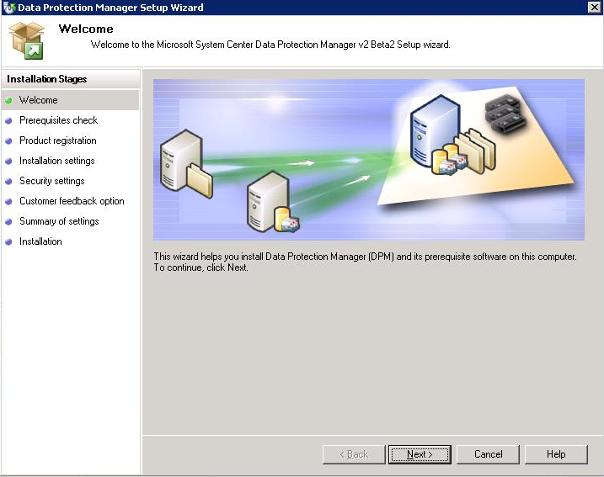
Figure 15 Data Protection Manager Setup Wizard, Welcome page
- On the Prerequisites Check page, wait while Setup checks the system to verify that it meets software and hardware requirements. If all required components are present, Setup displays a confirmation. Click Next to continue.
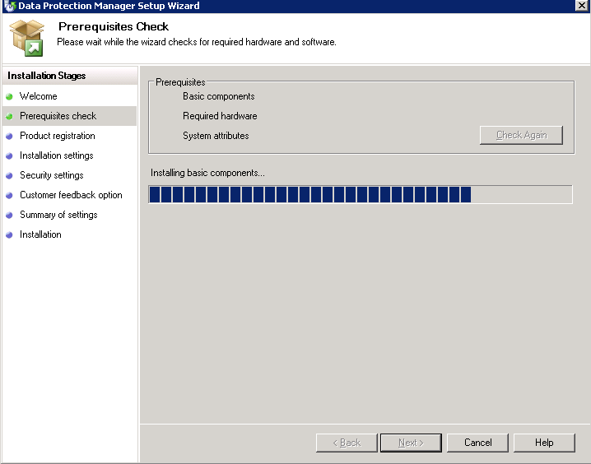
Figure 16 Data Protection Manager Setup Wizard, Prerequisites Check page
Note: If one or more required or recommended components are missing or noncompliant, Setup displays a warning or error message. A warning indicates that a recommended component is missing or noncompliant. Review the warning and determine whether to resolve the issue now or continue with the installation. If you choose to continue with the installation, plan to resolve the issue as soon as possible. An error indicates that a required component is missing or noncompliant. You must exit the wizard and resolve the error before you can continue with the installation.
- On the Product Registration page, enter your registration information, and then click Next.
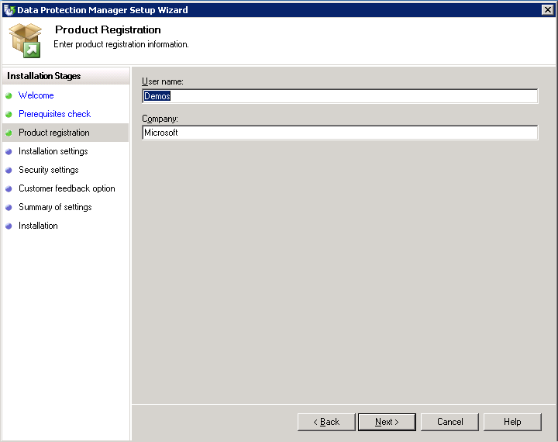
Figure 17 Data Protection Manager Setup Wizard, Product Registration page
- On the Installation Settings page, in the DPM Program Files section, accept the default folder, or browse to the folder in which you want to install DPM. In this example we will use the default folder. In the SQL server settings section, click Use the dedicated Microsoft$DPMv2Beta2$ instance of SQL Server (this will be installed to the DPM install location if required). Click Next.
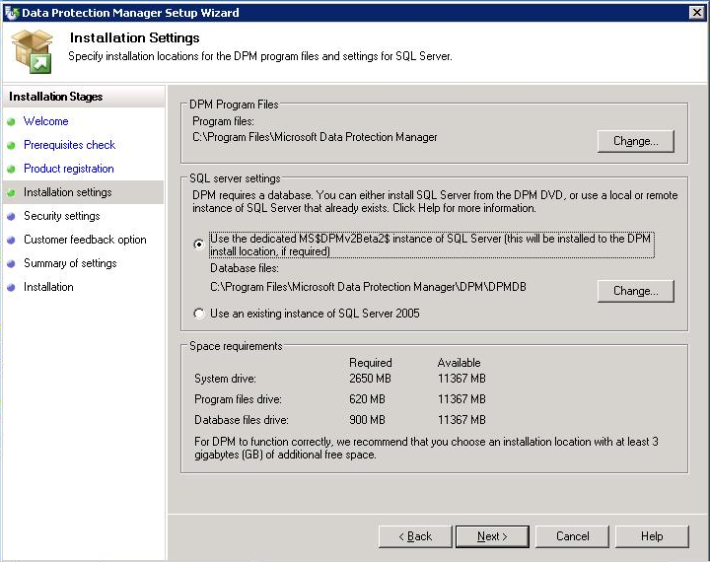
Figure 18 Data Protection Manager Setup Wizard, Installation Settings page
Note: You can install DPM only on a local drive, and cannot install it in read-only folders, hidden folders, or directly to local Windows folders, such as Documents and Settings, or Program Files. (DPM can be installed to a subfolder of the Program Files folder.)
Also, the installation partition must be formatted with the NT File System (NTFS). To simplify recovery in the event of system partition failure, install DPM to a partition that is separate from the system partition.
- The Space requirements section of the page displays space availability on the specified destination drives. If you choose to change the installation folders, verify that the selected drives have enough space for the installation. Accept the specified installation locations, and then click Next.
- On the Security Settings page, specify a strong password for the Microsoft$DPMWriter$ account, and then click Next.
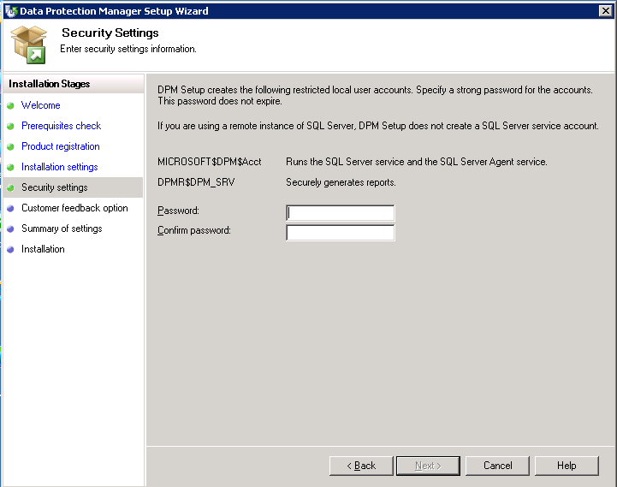
Figure 19 Data Protection Manager Setup Wizard, Security Settings page
Note: For security purposes, during installation, DPM Setup creates the Microsoft$DPMWriter$ account, which the DPM Writer service uses. DPM sets the system administrator (SA) password for SQL Server to the same password that you specify for the Microsoft$DPMWriter$ account.
A strong password is typically defined as a password that is at least six characters long, does not contain all or part of the user’s account name, and contains at least three of the following four categories of characters: uppercase characters, lowercase characters, base 10 digits, and symbols. The password that you specify for these accounts does not expire.
- On the Customer Experience Improvement Program page, if you want to provide Microsoft with information about your hardware and software configurations and usage patterns, click Yes, I want to participate anonymously in this program.
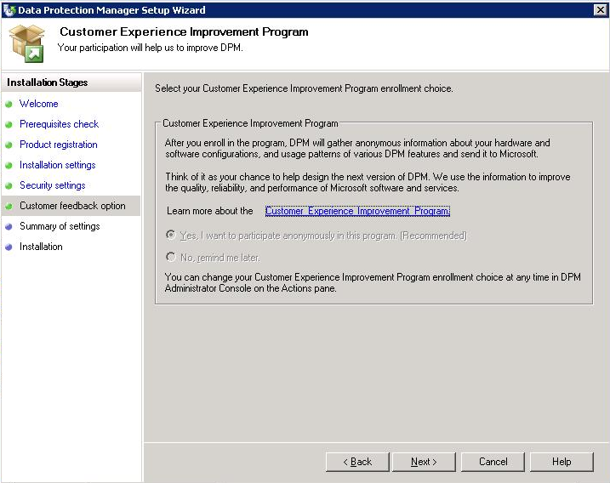
Figure 20 Data Protection Manager Setup Wizard,
Customer Experience Improvement Program page
Note: While participating in the DPM beta program, the only choice you can select is to participate in the Customer Improvement Program.
- On the Summary of Settings page, review the summary of installation settings. To install DPM by using the specified settings, click Install. To change the settings, click Back.
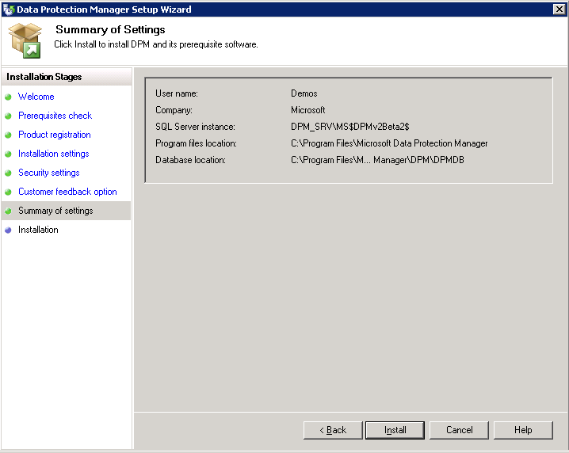
Figure 21 Data Protection Manager Setup Wizard, Summary of Settings page
- When prompted, insert the Windows Server 2003 product CD, and then click OK. Setup prompts for the Windows Server 2003 CD because IIS and SIS are not already installed on the DPM server.
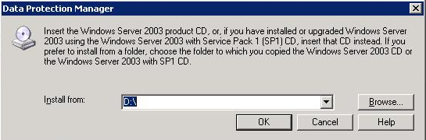
Figure 22 Insert CD
- When installation is complete, the Installation page displays the installation status. Click Close.
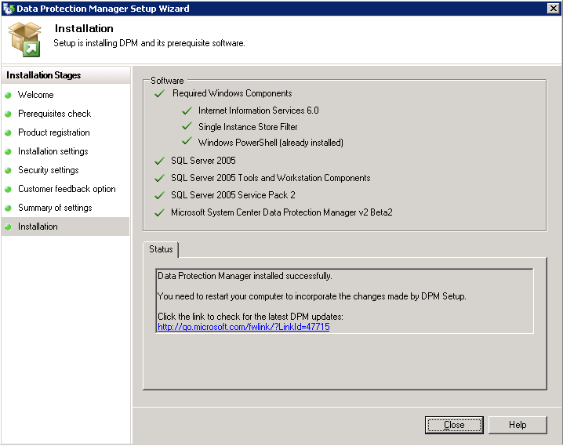
Figure 23 Data Protection Manager Setup Wizard, Installation page

Allocate storage for the DPM server
We will now allocate storage for DPM_SRV, the physical server hosting DPM. The next step in deploying DPM is to create the storage pool. Your storage pool consists of one or more dynamic disk volumes (that is, volumes on physical disks that are initialized for dynamic [as opposed to basic] storage) that are used exclusively by DPM to store replicas, recovery points, and logs. Any volumes you use must be dedicated to DPM, but you do not have to dedicate an entire disk to DPM.
You can add RAID volumes to your storage pool, but some common RAID configurations, such as RAID 5, are less suitable for use with DPM because of the characteristics of their write performance.
You can use three types of disk storage with DPM:
• Direct attached storage (DAS)
• Storage area networks (SAN)
• Windows-certified iSCSI devices
You can add RAID volumes to your storage pool, but some common RAID configurations, such as RAID 5, are less suitable for use with DPM because of the characteristics of their write performance. If you choose to use an iSCSI device, you will need to install an iSCSI initiator; see Appendix D for instructions.
- Open DPM Administrator Console (Start, All Programs, Microsoft System Center Data Protection Manager), click Management on the navigation bar, and then click the Disks tab.
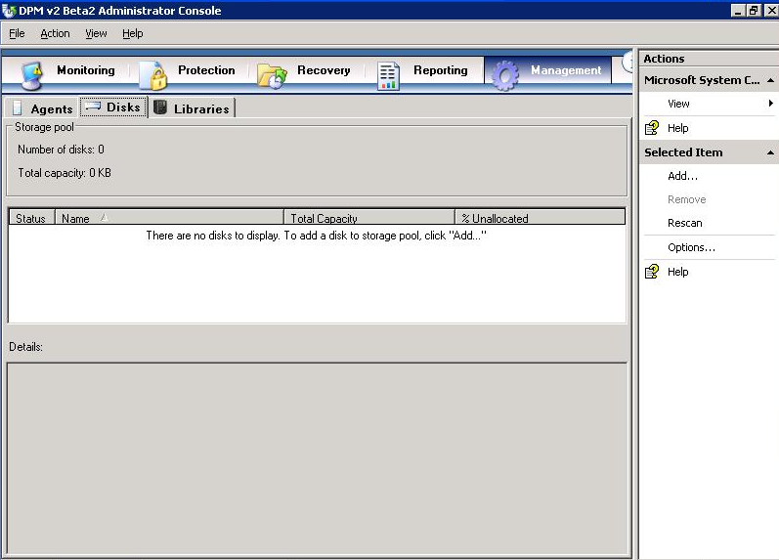
Figure 24 Administrator Console, Management tab
- To add disks to your DPM storage pool, click Add in the Actions pane.
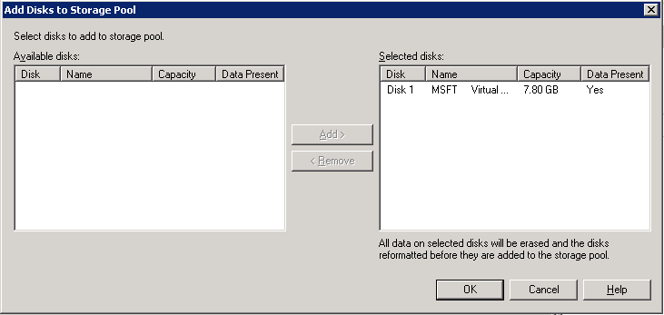
Figure 25 Add Disks
- In the Add Disks to Storage Pool window, you will see any available disks that are usable by DPM. Highlight one or more disks in the Available disks field, and then click Add to move them to the Selected disks field. When you have selected the desired disks, click OK to allocate these disks to the DPM storage pool. The available disks shown will vary depending on the characteristics of the storage that you chose.

Install the DPM agent on computers to be protected
A protection agent is software installed on a server that tracks changes to protected data and transfers the changes from the protected server to the DPM server. Before you can start protecting data, you must install a protection agent on each of the servers that contain data that you want to protect. After the protection agent is installed on a server, the server is referred to as an unprotected server in DPM Administrator Console in the Management task area. The data sources on the server are not protected until you add them to a protection group.
Note: The Beta 2 release of DPM 2007 provides the license for only one protection agent. This means that while using the beta version of DPM 2007, each DPM server can only protect one computer.
After installation, DPM will scan Active Directory to find servers that it can protect. Simply choose the servers that you want to protect from the list that is presented in the Protection Agent Installation Wizard. You will need to deploy the DPM protection agent on the servers to be protected. You can install the DPM protection agent through the DPM Administrator Console, Microsoft® System Center Configuration Manager 2007, Microsoft® Systems Management Server 2003, Active Directory Group Policy, or from the command line on the production server to be protected.
- Turn on and log on to the server on which you have installed DPM (DPM_SRV), if you have not already done so.
- Open DPM Administrator Console: Start > All Programs > Microsoft System Center Data Protection Manager.
- Click Management on the navigation bar, and then click the Agents tab. In the Actions pane, click Install. The Protection Agent Installation Wizard appears.
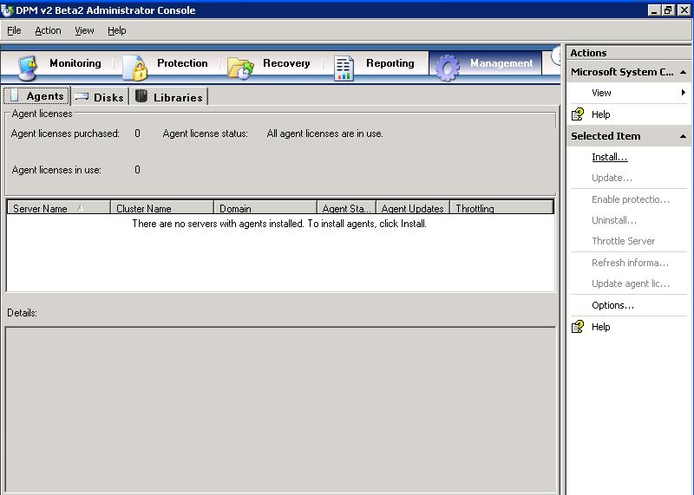
Figure 26 Administrator Console
- The first time that you use the wizard, DPM assembles a list of potential servers from Active Directory. The daily autodiscovery process creates a stored list of servers that is used for subsequent installations. On the Select Servers page, select up to the hard-coded number of servers (50), and then click Add. Here we will choose only PROTECTED_SRV. You can also specify a server by typing its name in the Server name box and clicking Add. When you are finished adding servers, click Next.
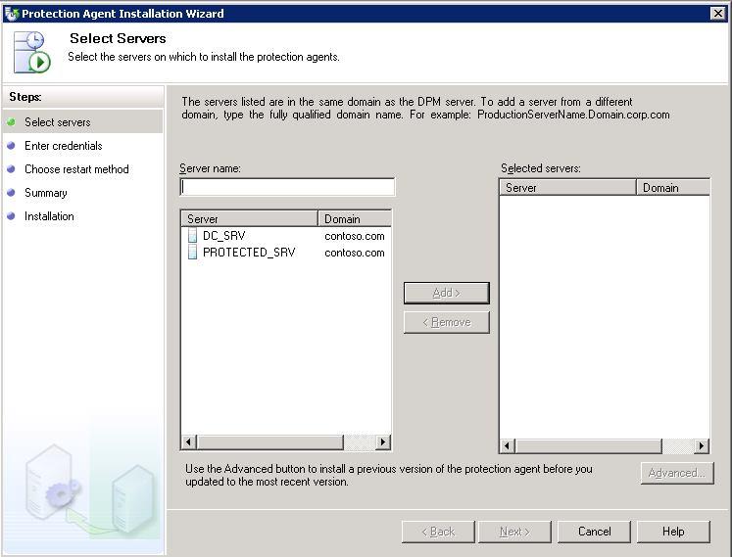
Figure 27 Protection Agent Installation Wizard, Select Servers page
Note: Windows Firewall® is included with all editions of Windows Server 2003 SP1 and later versions, as well as with SP2 for Windows XP and with the Windows Vista® operating system. If Windows Firewall is enabled on a computer that you want to protect, you must disable the firewall before you can install the DPM File Agent. After you have installed the file agent, configure Windows Firewall by opening port 135 to TCP traffic and then specifying the file agent (Data Protection Manager\DPM\bin\MsDpmFsAgentCA.exe) as an exception to the Windows Firewall policy. For more information, refer to the DPM Protocols and Ports section.
- On the Enter Credentials page, type the user name and password for the domain account to use during the agent installation. This account must be a member of the Domain Admins Group on all selected servers. Click Next.
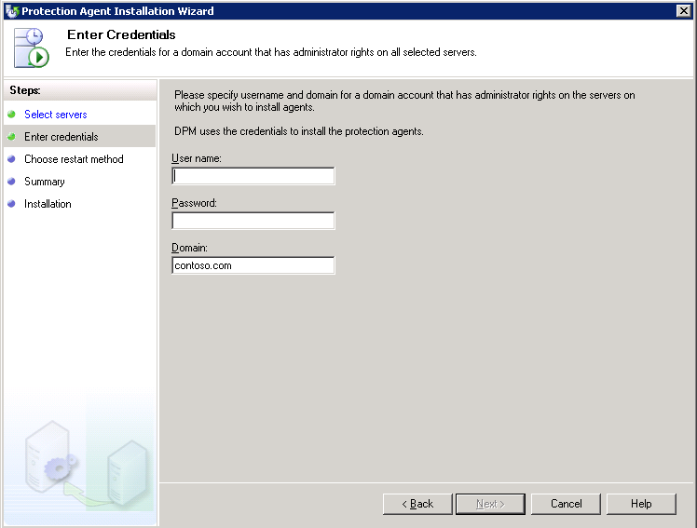
Figure 28 Protection Agent Installation Wizard, Enter Credentials page
- On the Choose Restart Method page, click the option indicating how you want the selected server to restart when the protection agent is installed. Nothing will be protected until you have restarted the machine. If you do not restart now, be sure to do so later. Click Next.
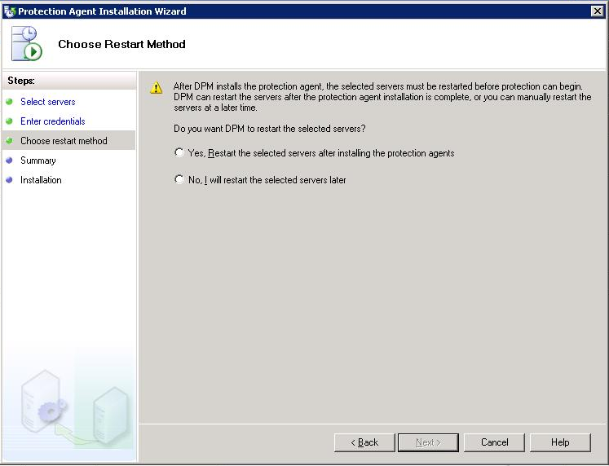
Figure 29 Protection Agent Installation Wizard, Choose Restart Method page
Note: If any of the servers that you selected are clustered servers, an additional Choose Restart Method page appears that enables you to select the method that you will use to restart the clustered servers. The servers must be restarted before you can start protecting data. This restart is necessary to ensure that the protection agent is installed correctly. Because of the time required to start services, it may take a few minutes after a restart is complete before DPM can contact the server. DPM will not restart a server that belongs to Microsoft Cluster Server or a Windows Server cluster. You must manually restart a server in clusters such as these.
- Click Next.
- On the Summary page, review the summary, and then click Install Agents to proceed with the installation.
- The results of the process appear on the Task tab of the wizard. You can monitor the installation progress in the Management task area on the Agents tab in DPM Administrator Console. If the installation is unsuccessful, you can view the alerts in the Monitoring task area on the Alerts tab.
- After the installation is complete, click Close.
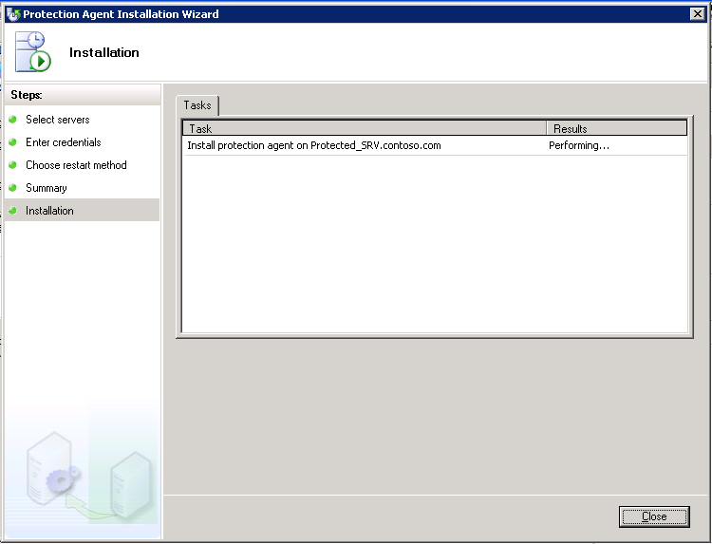
Figure 30 Protection Agent Installation Wizard, Installation page

Section 3:
Back Up Data
A protection group is a collection of data sources that share the same protection configuration. Data sources within a protection group are referred to as protection group members, or simply as members.
Not all data is created equal, even when it is of the same broad category. To efficiently use your storage and your bandwidth, you must work with your organization to design a set of recovery goals that takes into account the nature of each protected data source. To define these goals, you must first determine your organization’s desired synchronization frequency, recovery point schedule, and retention range.
The synchronization frequency determines how often the DPM agent will capture snapshots of your data and transmit the changes to the DPM server. This value reflects how much data you are willing to lose from this data source if there is an outage or disaster. Think of the synchronization frequency as how often you want incremental backups of your data.
The recovery point schedule determines how often DPM creates discrete recovery points for the protected data. The DPM recovery point schedule is conceptually similar to the opportunities that you have to recover your data by using a traditional backup application. If you perform a weekly full backup and a daily incremental backup, you will have seven unique points of recovery. In DPM, recovery points are created every time DPM performs a full backup, and also when data is synchronized by the DPM agent. Synchronizing every fifteen minutes throughout the day provides 96 recovery points per day (4 x 24 hours).
The retention range determines how long you need DPM to keep the protected data available for recovery. You may define both short-term and long-term protection policies to control recovery from both disk and tape. Short-term policies may use either disk or tape, while long-term policies are intended to provide control over your extended tape retention.
- Defining a short term to tape scenario implies using DPM as a traditional tape backup solution, intending to replace one’s existing backup solution.
- Defining short term to disk (only) is often used to provide a robust backup and recovery solution for Microsoft® Exchange Server and other workloads through DPM, and then enable a third-party “enterprise” tape solution to back up the DPM server for long-term compliance.
- Most DPM users, however, will choose short term to disk plus long term to tape, which provides a complete solution offering rapid and reliable disk-based protection and recovery, with a seamlessly integrated tape component for long-term data retention.
Steps covered in this section:
Create and configure protection groups 41
Your protection groups are collections of data sources that share the same protection configuration and schedule. When created and configured, you will manage your data protection through protection groups in DPM.
Set bandwidth throttling 51
Bandwidth throttling is a performance optimization in DPM that limits the percentage of network bandwidth that protection and recovery jobs can consume.
Optimize performance 52
DPM provides several ways to increase server performance expectations and optimize DPM performance. Among these, you can enable on-the-wire compression to decreases the size of data being transferred, stagger the start time of protection jobs, and schedule you consistency checks for off-peak hours.

Create and configure protection groups
In this section we will go through the various sections of the Create New Protection Group Wizard.

Start the Create New Protection Group Wizard
- In DPM Administrator Console, click Protection on the navigation bar.
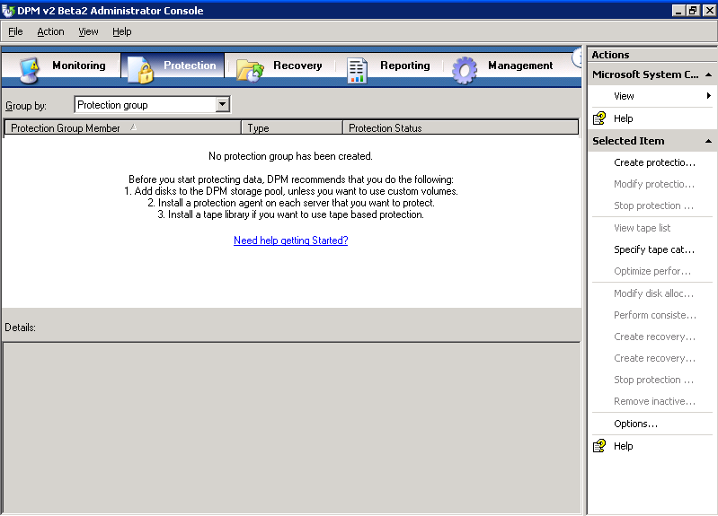
Figure 31 Administrator Console, Protection tab
- On the Actions pane, click Create. The Create New Protection Group Wizard appears.
- Review the Welcome page, and then click Next.
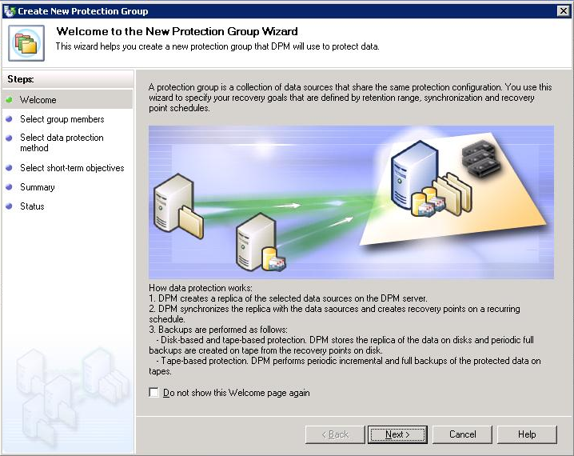
Figure 32 Create New Protection Group Wizard, Welcome page

Select members for the protection group
You can protect the following members by using DPM:
- File servers: Volumes, shares, and folders
- Computers running Exchange Server: Storage groups
- Computers running SQL Server: Databases
- On the Select Group Members page, verify that all servers that store data that you want to protect are displayed in the Available members box. If servers are missing, click Add Servers, and then follow the instructions for adding them.
- In the Available members box, expand the server nodes to display the available data sources on each server. If you have just installed the protection agent, you may experience a delay of several minutes before you can expand the node for the server and display its available data sources.
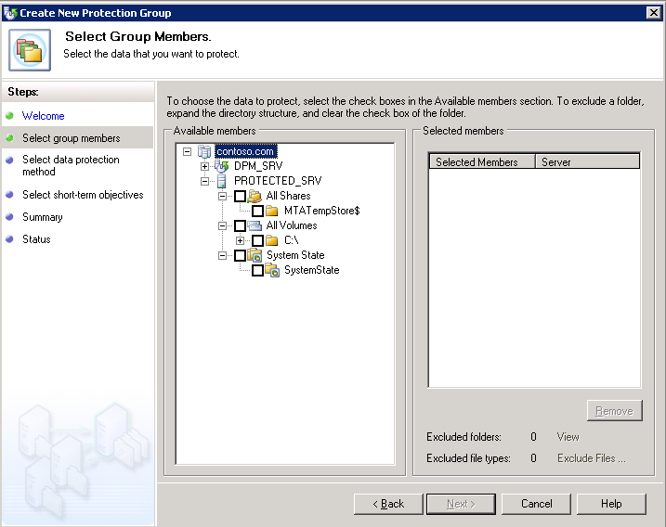
Figure 33 Create New Protection Group Wizard, Select Group Members page
- Place a check mark in the box next to each data source that you want to include in the protection group. As you select data sources, your selections appear in the Selected members box.
If you are following this cookbook in your test environment, select all of the data sources in PROTECTED_SRV and then click Next.
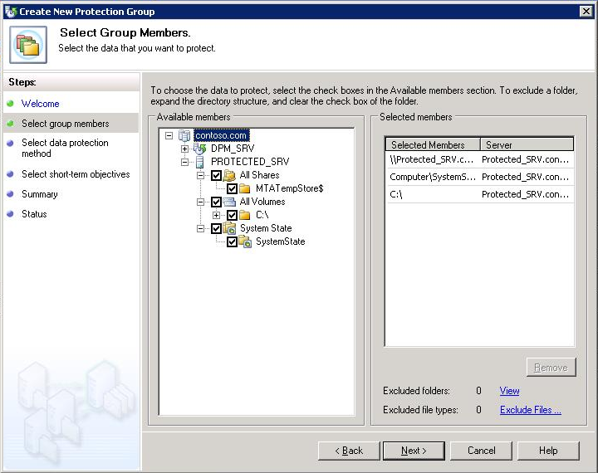
Figure 34 Create New Protection Group Wizard, Selected Members box
Note the following:
  - You cannot include data sources from the same volume in different protection groups.
  - You can include data sources from more than one volume in a protection group.
  - Data sources that are members of other protection groups and unprotected data sources that reside on a volume already protected by another protection group are displayed, but cannot be selected.
  - If a boot volume contains user data that you want to protect, Microsoft recommends that you protect the relevant folders or shares individually, rather than protecting the whole boot volume.
  - To exclude a folder, expand the directory structure, and then click to clear the check box of the folder that you want to exclude.
  - To exclude file types, click the Exclude File Types link. In the Exclude File Types dialog box, type the file types you want to exclude, and then click OK.
- After you have selected the members for the protection group, click Next.

Select a name and protection method for the protection group
After you select the data that you want to protect, you will select your protection method. You can select short-term protection by using either disk or tape, or long-term protection by using only tape.
- On the Select Data Protection Method page, in the Protection group name box, accept the default name, or type a new name for the protection group. In this example we will accept the default name.
In the Protection method section, select the I want short-term protection using check box, and then select Disk from the drop-down list.
For long-term protection, you can select I want long-term protection using tape if you have a tape-based storage device attached to the DPM server. Although tape is not required for this document, Data Protection Manager 2007 supports tape-based backup and can detect tape backup devices.
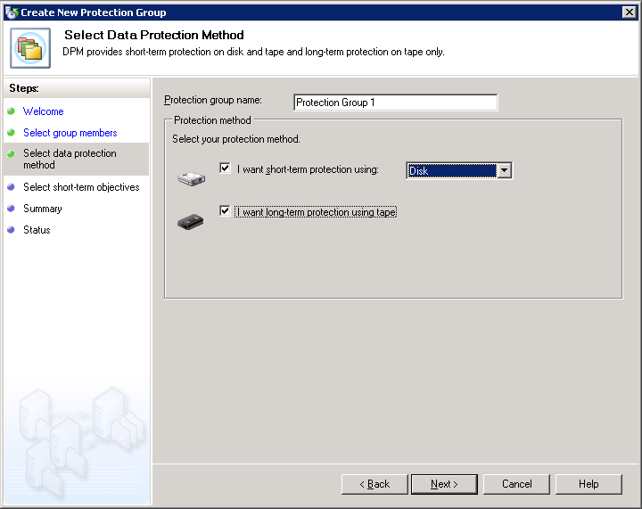
Figure 35 Create New Protection Group Wizard, Select Data Protection Method page
- Click Next.

Specify your short-term protection policy
You define your short-term protection policy by selecting a retention range for your data, specifying how frequently data should be synchronized, and scheduling the creation of your selected recovery points. A recovery point is a snapshot or point-in-time copy of the data sources that are protected by your DPM server.
- On the Specify Short-Term Goals page, in the Retention range box, select 5. In the Synchronization frequency section, click next to Every and choose 15 minutes. If you prefer, you may do one of the following:
In your production environment, choose one of the options:
  - Click Every, and then select the days and times for which you want recovery points created for file protection. The synchronization frequency determines the recovery point schedule for application data protection.
  - Click Just before a recovery point to replicate data just before a scheduled recovery point.
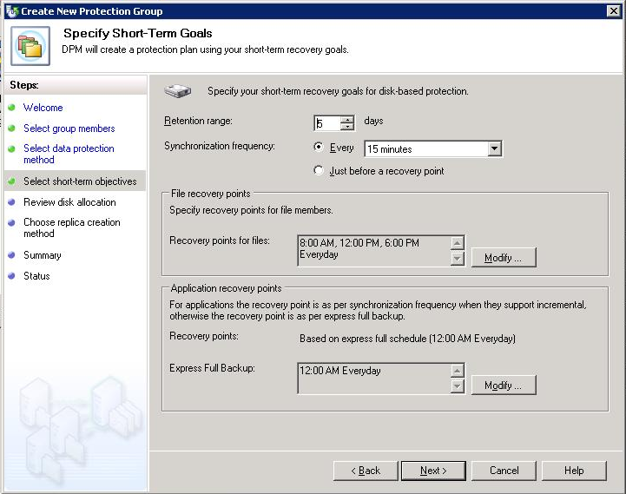
Figure 36 Create New Protection Group Wizard, Specify Short-Term Goals page
- To modify the recovery points, in the File recovery points section, click Modify next to the data source for which you want to change the recovery points. At this point, you do not need to modify any of the recovery points. On the Modify Recovery Points screen, select 8:00 AM, 12:00 PM, and 6:00 PM. Select all days of the week, and then click OK.
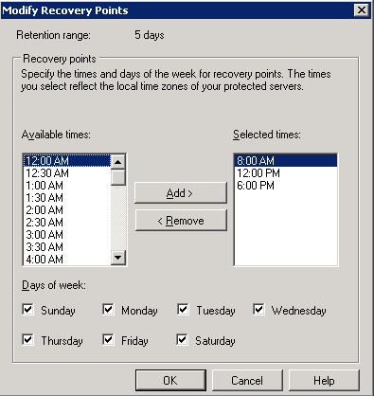
Figure 37 Modify Recovery Points screen
- On the Specify Short-term Recovery Objectives page, click Next.

Allocate space for the protection group
When you create a protection group, DPM recommends and allocates disk space for your protection group based on the size of the data to be protected. You can modify the disk space in the storage pool; however, there are guidelines that you must follow to increase or decrease the allocated disk space.
- On the Review Disk Allocation page, review the space allocations that DPM recommends for the protection group. DPM lists the disk space that is allocated for your protection group, based on the size of the selected data.
Accept default space allocations unless you are certain that they do not meet your needs. This will be affected by the type of storage you are using.
- On the Disk Allocation page, accept the recommended allocations, and then click Next.
- When you finish specifying the new allocations, click OK, and then click Next.

Specify your long-term protection plan
If you want long-term protection by using tape, you must specify your long-term protection plan. You define your long-term protection plan by selecting a retention range for your data and a long-term backup schedule. If you are following this document by using the example network topology, you will not be able to perform these steps, since tape was not a requirement in the prerequisites section.
- On the Specify Long-Term Protection page, in the Retention range box, select three weeks, which is the duration of time for which you want the data to be available for recovery from the drop-list box. In the Frequency of backup box, select the backup frequency of weekly from the choices of daily, weekly, or monthly from the drop-down list.
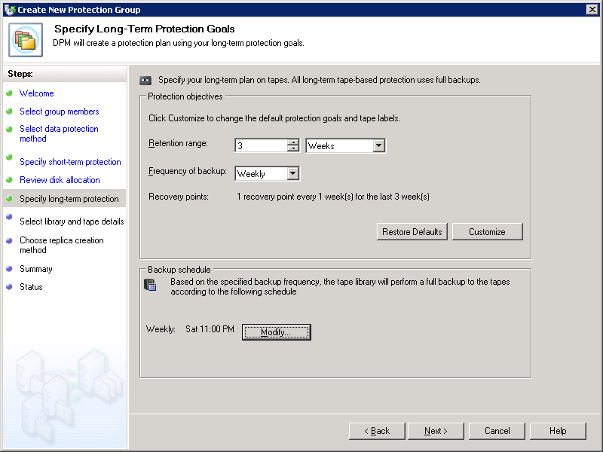
Figure 38 Create New Protection Group Wizard, Specify Long-Term Goals page
- You will not do this now, but in the future, to change the long-term backup schedule, click Modify under Backup schedule. In this dialog box, you can select the day of the week, month, or year that you want to back up your data, depending frequency of long-term backups that you select on the Specify Long-Term Goals page of the Create New Protection Group Wizard.
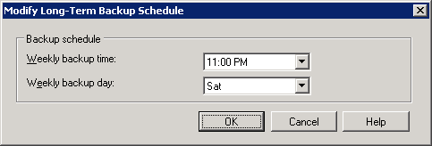
Figure 39 Modify Long-Term Backup Schedule dialog box
- Click OK
- On the Specify Long-term Protection Policy page, click Next.

Specify tape and library details
When you are protecting data for the long term, you must specify the number of copies that you need and how many tapes you want to allocate for long-term protection. You also specify whether you want DPM to encrypt and compress the data, and whether you want DPM to check the backup for data integrity.
- On the Select Tape and Library Details page, in the Library details section, in the Library box, select the backup library that you want from the drop-down list. The libraries listed in the drop-down list will depend on the tape libraries attached to your DPM server.
In the Drives allocated box, select how many drives you want to allocate from the drop-down list. This number will depend on the tape libraries attached to your DPM server.
In the Copy library box, select the tape copy library that you want from the drop-down list. The libraries listed in the drop-down list will depend on the tape libraries attached to your DPM server.
- For this example, in the Tape options for long-term protection section, leave Compress data selected.
In your production environment, you may choose to either not compress your data or to encrypt your data.
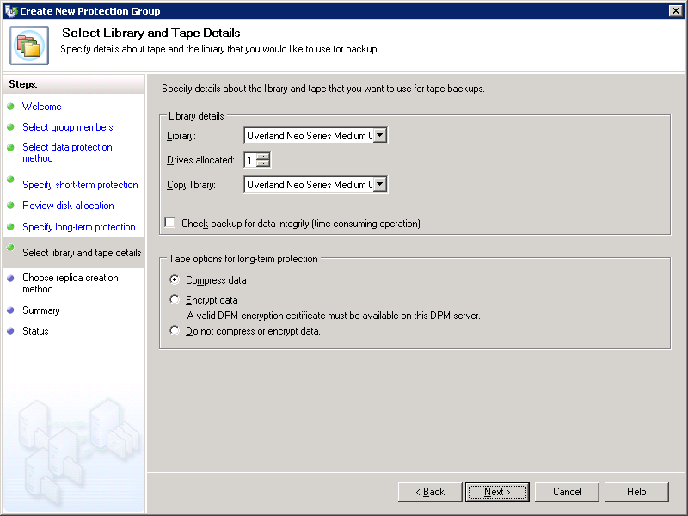
Figure 40 Create New Protection Group Wizard, Select Library and Tape Details page
- Click Next.

Choose a replica creation method
When you create a protection group, a replica is created for each protected volume in the protection group. In DPM, a replica is a complete copy of the protected data on a single volume, database, or storage group.
You can automatically perform synchronization at the times specified in your protection schedule, or you can manually synchronize a replica.
- On the Choose Replica Creation Method page, select Now for when you want DPM to replicate your data.
- Click Next.

Create the protection group
Before you create the protection group, you review the tasks that DPM is set to perform. These tasks are based on the options that you specified while performing the steps in the Create New Protection Group Wizard.
- On the Summary page, review the tasks that DPM is set to perform to create the protection group, and then click Create Group.
When the creation process is complete, DPM displays a confirmation page where you can view the results of creating the protection group task.
- On the Confirmation page, click Close.

Set bandwidth throttling
Bandwidth throttling will allow you to limit the amount of bandwidth used by DPM, set a maximum speed for data transfers from the file servers to the DPM server, compress data on the wire to decrease the size of the data transferred to make replicas, and/or stagger the starting times for protection jobs.
- In DPM Administrator Console, click Management on the navigation bar.
- Click the Agents tab, and select the server you want to throttle. In this example, right-click PROTECTED_SRV and select Throttle Server.
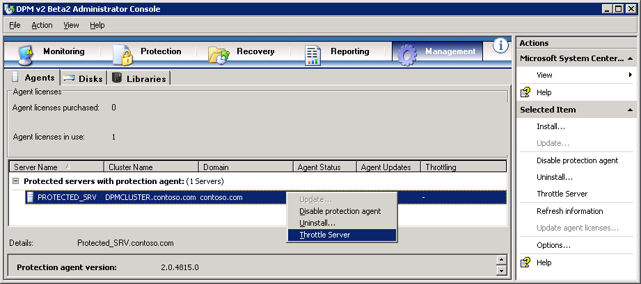
Figure 41 Administrator Console, Management tab
- In the Throttle dialog box, check Enable network bandwidth usage throttling. In this example, leave the default settings under Settings and Work Schedule. In production environment, set these to your desire settings.
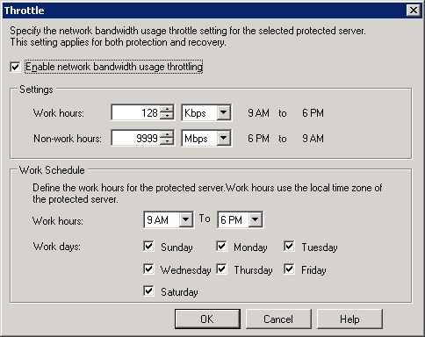
Figure 42 Network bandwidth throttling dialog box
- To apply your changes, click OK.

Optimize performance
DPM provides several ways to increase server performance expectations and optimize DPM performance. Among these, you can enable on-the-wire compression to decreases the size of data being transferred during replica creation and synchronization and allows more data throughput with less impact to network performance, stagger the start time of protection jobs to avoid performance degradation from starting too many jobs at once, and schedule you consistency checks for off-peak hours.
Note: Network speed, the performance characteristics of the protected server, the size of your protected data, and the rate at which the protected data changes can affect your actual results.
- In DPM Administrator Console, click Protection on the navigation bar.
- In the Display pane, right-click the protection group for which you want to modify performance options. In this example, right-click Protection Group 1 and select Optimize performance.
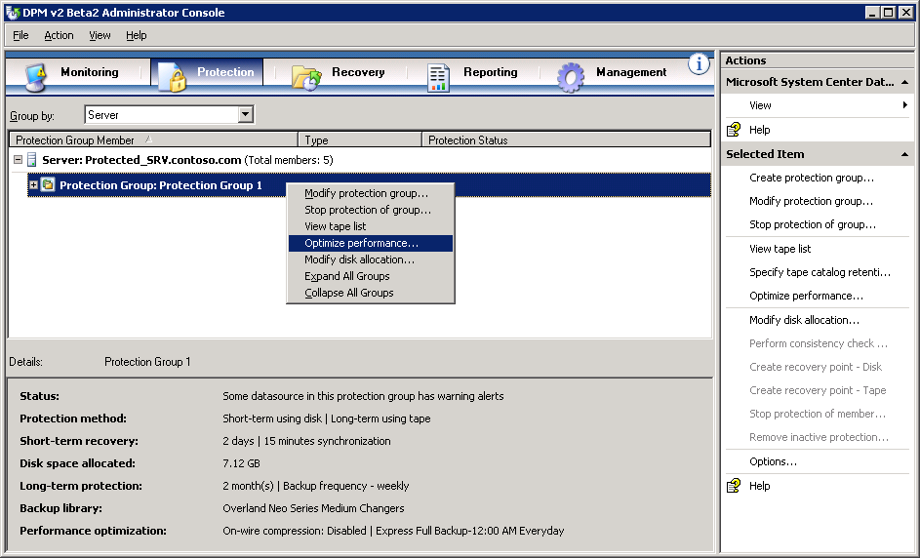
Figure 43 Administrator Console, Protection tab
- To enable on-the-wire compression, on the Network tab, check Enable on-the-wire compression.
To stagger the starting times for protection jobs, under Start protection jobs, specify the number of minutes after the hour to start synchronization and shadow copy jobs.
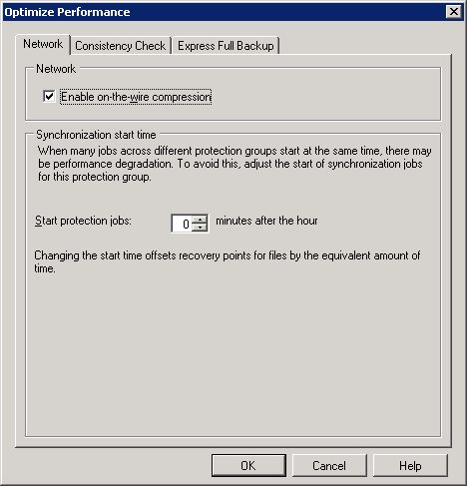
Figure 44 Optimize Performance dialog box, Network tab
- To ensure that your replica of your protected data does not become inconsistent due to problems on the protected server or the network, you can schedule consistency checks. To do this, check Schedule daily consistency check on the Consistency Check tab.
You do not need to do this in this example. If you do this in a production environment, optimize network performance and run the consistency check during off-peak hours.
- Express full backups allow DPM to provide quick recoveries to application data. In this example, leave the default settings on the Express Full Backup tab.
In you production environment, choose the settings the meet your customers’ data recovery time goals.
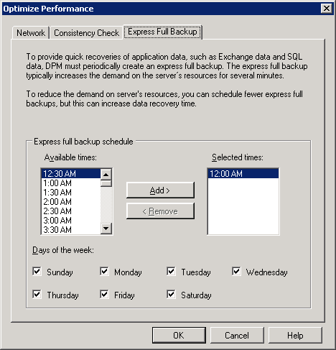
Figure 45 Optimize Performance dialog box, Network tab
- To apply your changes, click OK.

Section 4:
Monitor and Report
After you set up data protection, you should monitor DPM activity to verify that everything is working correctly and to troubleshoot any problems that occur. Monitoring is essential to give you an overview of what has already happened, what is currently happening, and what is scheduled to happen. By monitoring DPM, you will know that data protection activities are working as expected, and you can have confidence that errors and warnings will be brought to your attention when they occur.
DPM reporting provides both new and historical reports. In addition, you can subscribe to DPM reports. A new report is created dynamically, based on the options that you select when you set up the report. A historical report is created and saved for future reference only when you schedule a report. You choose the options that you want at the time that you schedule the report.
Steps covered in this section:
Monitor DPM alerts 56
DPM alerts enable you to monitor DPM activity, job status, and error conditions. Alerts form your first avenue of troubleshooting.
Monitor DPM jobs 57
You can directly monitor the status of all completed, scheduled, and running protection jobs, as well as all associated tasks.
Display a new DPM report 58
A report selected through DPM Administrator Console always opens as a Web page in Internet Explorer.
Schedule DPM reports 59
Schedule DPM reports to run one time, weekly, or monthly, and customize the way that data is organized within reports.
Subscribe to DPM reports 60
You can choose to send scheduled reports to subscribers through e-mail.

Monitor DPM alerts
By monitoring alerts, you can monitor data protection activity, job status, and error conditions in Data Protection Manager (DPM) and take action, when necessary, to resolve issues. In DPM, alerts are displayed in the Monitoring task area on the Alerts tab.
As a general rule, you should start troubleshooting an issue in DPM by reviewing the relevant alert details. For detailed information about a specific job related to the issue, review the job details.

Display details for an alert
- In the DPM Administrator Console, click Monitoring on the navigation bar, and then click the Alerts tab.
- Select the alert for which you want more details. The alert information is displayed in the Details pane.
When an alert is resolved, or when the conditions that generated the alert no longer apply, the alert becomes inactive. Inactive alerts are displayed for 30 days in the Alerts view of the Monitoring task area by default. After an alert has been inactive for 30 days, it is removed from the inactive alerts history and it can no longer be displayed. If you want to hide inactive alerts, you can disable the Show inactive alerts option.

Disable inactive alerts
- In DPM Administrator Console, click Monitoring on the navigation bar, and then select the Alerts tab.
- Clear the Show inactive alerts check box. This check box is located below the navigation bar and above the Display pane.

Monitor DPM jobs
Jobs are displayed in the Monitoring task area on the Jobs tab. On the Jobs tab, you can monitor the status of all completed, scheduled, and running jobs, and all associated tasks. Use the Group by drop-down list box to group the list of jobs by protection group, server, status, or type. Use the Time period drop-down list box to filter the list of jobs according to a selected time period. Select or clear the Show synchronization check box to include or exclude synchronization jobs in the list of jobs.
DPM provides both an Alerts view and a Jobs view so that you can easily access both summary and detailed information about data protection activity. The Alerts tab aggregates alerts, error conditions, and jobs to provide a summary view of what is happening across the entire system. The Jobs tab provides the operational details for each scheduled, completed, running, canceled, or failed job. For example, in response to multiple shadow copy job failures of the same replica, the Alerts view displays a single “shadow copy failure” alert; in contrast, the Jobs view displays an entry for each shadow copy job failure. In the Jobs view, you can also display completed shadow copy jobs for the past 30 days and scheduled shadow copy jobs for the next seven days.
As a general rule, you should start troubleshooting an issue in DPM by reviewing the relevant alert details. For detailed information about a specific job related to the issue, review the job details.

Check job status
- In DPM Administrator Console, click Monitoring on the navigation bar, and then click the Jobs tab.
- In the Group by list box, select Status.
- In the Time Period list box, select the time period that you want to review. The jobs for the selected time period are displayed, grouped by status.
- To review details for a specific job, select the job and refer to the information in the Details pane.

Display job details
- In DPM Administrator Console, click Monitoring on the navigation bar, and then click the Jobs tab.
- Select the job for which you want more details. The information for the job is displayed in the Details pane, in the lower part of the console.

Display a new DPM report
A report selected through DPM Administrator Console always opens as a Web page in Internet Explorer. New reports are not saved for future reference; they are deleted when closed.
- In DPM Administrator Console, click Reporting on the navigation bar.
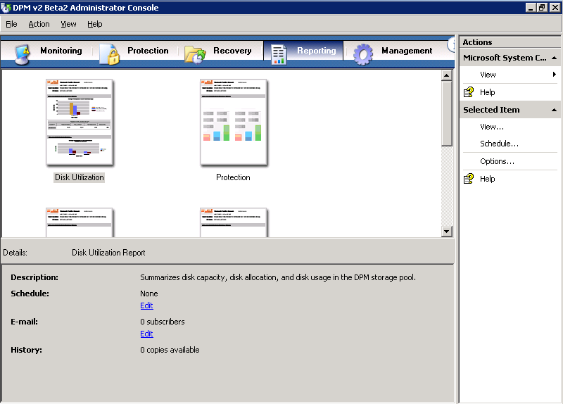
Figure 43 Administrator Console, Reporting tab
- Select a report, and then, on the Actions pane, click View. Alternatively, you can double-click or right-click a report in the Display pane, and then click View.
- Select display options for the report, and then click OK.

Schedule DPM reports
No reports are scheduled in DPM by default. To prompt DPM to start creating and saving historical reports, you must specify report creation schedules. Each of the standard reports operates on an independent schedule. You can schedule DPM reports to run one time, weekly, or monthly, and you can customize the way that data is organized within the report. When you schedule reports, you can also choose to send reports to specified recipients through e-mail.
- In DPM Administrator Console, click Reporting on the navigation bar.
- On the Display pane, select the report that you want to schedule.
- On the Actions pane, click Schedule. Alternatively, you can right-click the report icon, and then click Schedule.
- In the Schedule dialog box, click Enable Schedule.
- On the Schedule tab, select the Run the Disk Utilization report according to the schedule options check box, fill in the appropriate values, and then click OK.
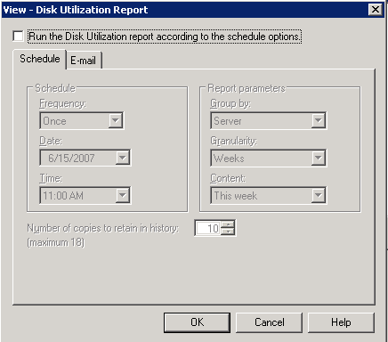
Figure 44 Reporting, schedule options
- Repeat steps 2 through 5 for each report that you want to schedule.

Subscribe to DPM reports
When you schedule reports, you can enable the option to send reports to subscribers through e-mail. Before you enable this option, you must specify the SMTP server that DPM will use to send reports. In order for this procedure to work, you will need an SMTP server. Also, make sure DPM_SRV can resolve the name of the SMTP server and that outbound access to TCP 25 is allowed from DPM_SRV to the SMTP server.

Configure the SMTP server
- In DPM Administrator Console, click the Action menu, and then click Options.
- The Options dialog box appears.
- On the SMTP Server tab, type the SMTP server name, the SMTP server port, and the e-mail address that you want to appear in the From box of the e-mail messages that DPM will send.
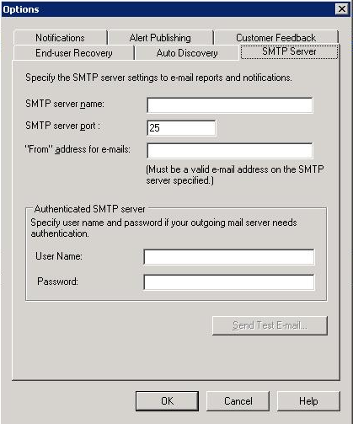
Figure 45 Options, SMTP Server tab
- To test the SMTP server settings, click Send Test E-mail, and type the e-mail address to which you want DPM to send the test message.
- Click OK.

Subscribe to reports
- In DPM Administrator Console, click Reporting on the navigation bar.
- On the Display pane, right-click the report to which you want to subscribe. On the Actions pane, click Schedule. Alternatively, you can right-click a report in the Display pane, and then click Schedule.
- On the E-mail tab, in the Recipients box, type the e-mail addresses of all the people or groups to whom DPM should send reports, and then click OK.
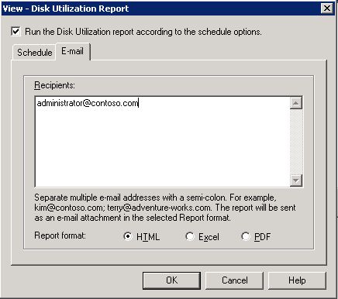
Figure 46 Reporting, E-mail tab
- Select the report format—HTML, Excel, or PDF—and then click OK.
- Repeat steps 2 through 4 for each type of report that you want to distribute through e-mail.

Add a subscriber to an existing subscription
- In DPM Administrator Console, click Reporting on the navigation bar.
- In the Display pane, right-click the report for which you want to add e-mail recipients, and then click Schedule.
- On the E-mail tab, in the Recipients box, add the subscriber to the list of recipients, separating it from the last entry by a semicolon, and then click OK.

Modify the report format for an existing subscription
- In DPM Administrator Console, click Reporting on the navigation bar.
- On the Display pane, right-click the report for which you want to modify the report format, and then click Schedule.
- On the E-mail tab, in the Report format box, select the report format for this report—HTML, Excel, or PDF—and then click OK.

Section 5:
Restore Data
After Microsoft System Center Data Protection Manager (DPM) is deployed in your environment, you will use DPM and its disk-based recovery functionality to handle most of your short-term data recovery needs. You can also continue to use tape for long-term data archiving and disaster recovery. DPM fits seamlessly into existing archiving solutions.
Archiving file server data from the replicas on the DPM server rather than from the file servers eliminates the problem of scheduling backups around file server availability. When you archive DPM to tape, you can, in case of disaster, restore archived data to file servers and rebuild the DPM server.
Note that if you would like to backup and restore a running virtual machine, you can find those steps in Section 6.
Steps covered in this section:
Recover data on the file server 62
Recovery in DPM is the process by which you restore previous versions of shares, volumes, folders, or files from the shadow copies to your computers from copies kept on the DPM server.
Support end-user restores 68
This feature of DPM enables end users to independently recover data by retrieving a shadow copy of their data.
Restore data from tape 72
The process of restoring data from long-term storage on tape is very similar in DPM to restoring data from disk.

Recover data on the file server
You can easily and quickly recover data by using the DPM Recovery Wizard. Recover your data by selecting a previous version of the data from a recovery point stored on the DPM server.
A recovery point, also referred to as a snapshot, is a point-in-time copy of the files and folders that are protected by the DPM server.

Create a recovery point
- Switch to DPM_SRV.
- In DPM Administrator Console, on the Protection tab, expand Protection Group: Protection Group 1, and then select the folder, Computer\SystemState, that you want to protect. In the Actions pane, click Create recovery point. You need to complete at least one full backup before you have the option to perform incremental backups
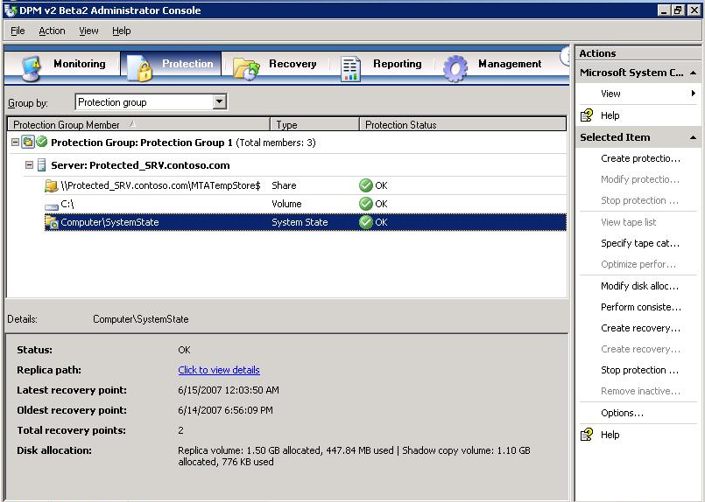
Figure 47 Administrator Console, Protection tab
- In the Create recovery point dialog box, click OK. The new recovery point appears in the recovery point list.
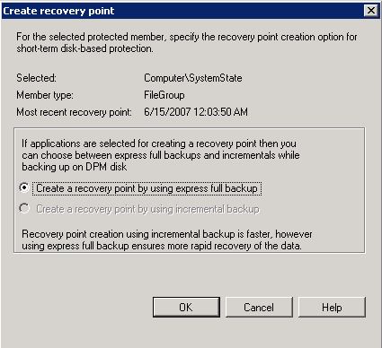
Figure 48 Create recovery point dialog box

Recover the data
- Switch to DPM_SRV.
- In DPM Administrator Console, on the navigation bar, click the Recovery tab. In the Protected data pane, navigate to PROTECTED_SRV, expand All Protected Volumes, and then select drive C:\. In the right pane, in the Recoverable Item list, choose a file that is in the root of C:\ In this example, we have picked a file called additions.log. On the calendar, select the latest recovery point for the folder. Available recovery points are indicated in bold.
Note: Additions.log is a file created when you install Virtual Machine Additions on PROTECTED_SRV. If you did not install Virtual Machine Additions on PROTECTED_SRV, select another file, such as boot.ini.
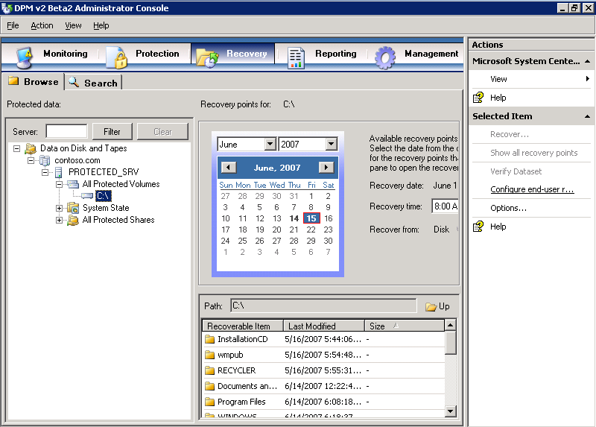
Figure 49 Administrator Console, Recovery tab
- In the Actions pane, click Recover. The Recovery Wizard appears.
- On the Review Recovery Selection page, verify that the file that you want to recover appears in the Recovery items list. Here we have chosen additions.log, but your choice may be different. Then click Next.
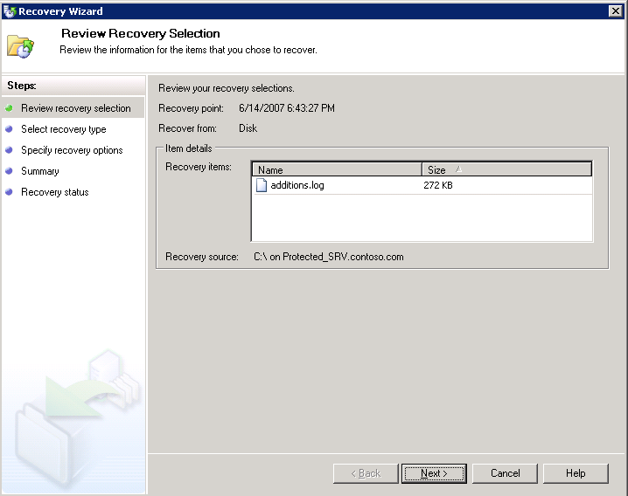
Figure 50 Recovery Wizard, Review Recovery Selection page
- On the Select Recovery Type page, select Recovery to the original location, and then click Next. Tape will be greyed out, unless DPM detects a physical tape backup device.
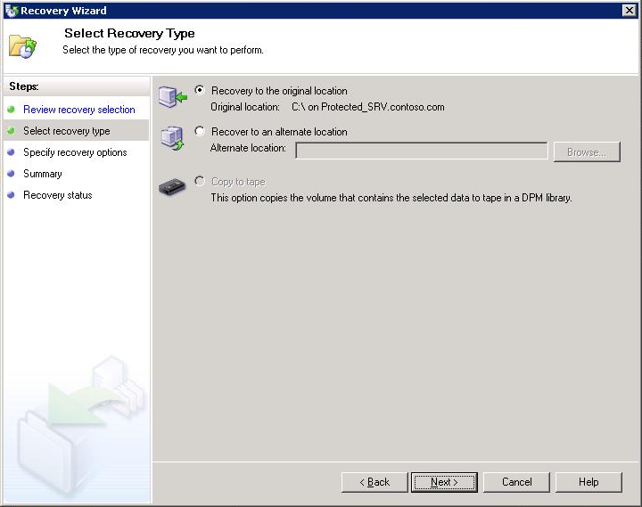
Figure 51 Recovery Wizard, Select Recovery Type page
- On the Specify Recovery Options page, in the Existing version recovery behavior section, click Create copy. This will create another copy of the file you are recovering in the event that DPM finds an existing version of that file.
If you choose Skip, DPM will do nothing to the existing version of the file. If you choose Overwrite, DPM will overwrite any existing versions of that file.
In the Restore security section, select Use security setting of the destination server and then click Next. This will cause the file being restored to inherit the current security settings of the server you are restoring it to.
Apply the security settings of the recovery point version will cause the file to be restored with the security attributes of the recovery point from which you are restoring the file.
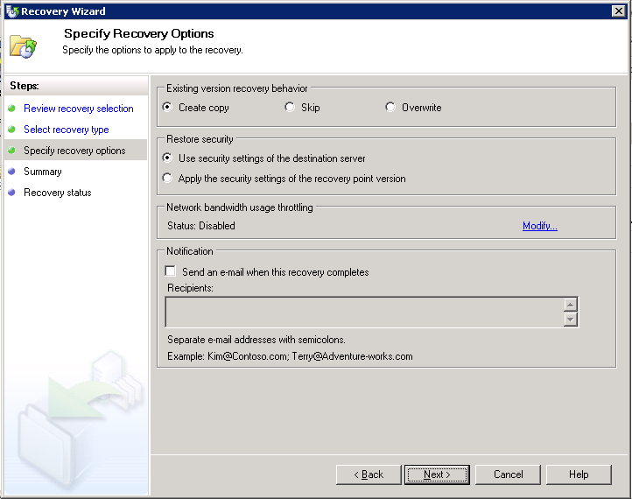
Figure 52 Recovery Wizard, Specify Recovery Options page
- On the Summary page, verify that the additions.log file appears in the Recovery Items list, and then click Recover.
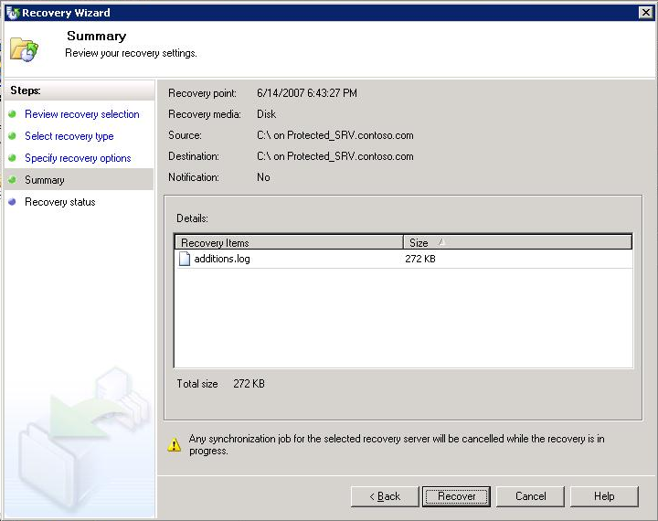
Figure 53 Recovery Wizard, Summary page
- On the Recovery Status page, after the recovery is complete, click Close.

Support end-user restores
End-user recovery enables your end users to independently recover data by retrieving the most recent copies of their files. End-user recovery is supported in Active Directory domains.

Enable end-user recovery
- Switch to the DPM server (DPM_SRV in your test environment).
- In DPM Administrator Console, from the Action menu, select Options. The Options dialog box appears. On the End-user Recovery tab, click Configure Active Directory.
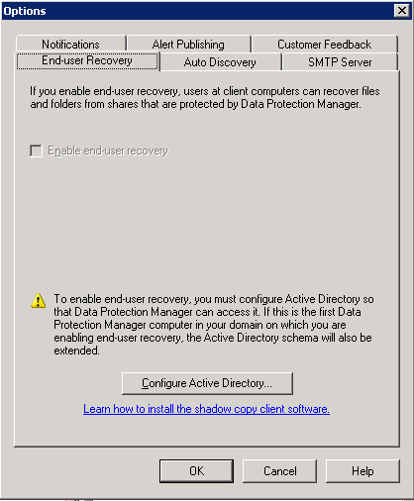
Figure 54 End-user Recovery Options
- In the Configure Active Directory dialog box, click Enter credentials. Fill in the User name and Password box with the user name and password of a user who has permission to make changes to the Active Directory. Typically this user is a member of the Domain Admins Security Group. Then click OK.
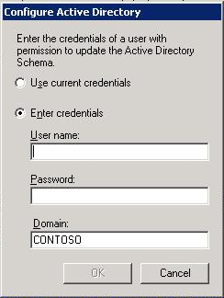
Figure 55 Configure Active Directory dialogue box
- On the Active Directory Configuration for Data Protection Manager dialog box, click Yes, and then click OK.
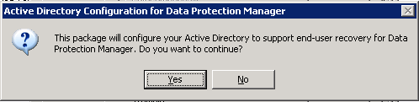
Figure 56 Active Directory Configuration dialogue box
- After configuration of Active Directory is complete, select the check box for Enable end-user recovery, and then click OK.
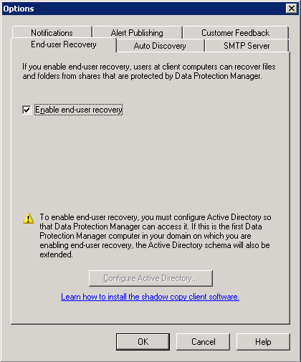
Figure 57 End-user recovery options
- In the Options dialog box, click OK.
Before your users can begin independently recovering previous versions of their files, the DPM shadow copy client software must be installed on their computers.

Install the shadow copy client software
- Install the client software located at http://go.microsoft.com/fwlink/?LinkId=46064 on the computers of your customers on which you want to enable end-user recovery. You can deploy this software package to your users by using Group Policy, or another method.

Perform an end-user restore
- On Protected_SRV, create a shared folder called Docs. Create a document in this folder called Important_Doc.doc.
- On the computer on which you have installed the shadow copy client software, click Start, Run, and type\\Protected_SRV\Docs\Important_Doc.doc. Open the document and make a change, then close the document.
- Right-click Important_Doc.doc, and then click Properties.
- In the dialog box, on the Previous Version tab, click the previous version of the file, and then click Restore. If you don’t see the Previous Version tab, go to the DPM Server and manually create a restore point, and then repeat steps 1-4.
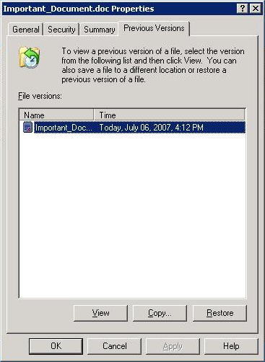
Figure 58 Previous version tab of the file properties dialog box
- Click Yes, and then, after the file has been successfully restored, click OK.
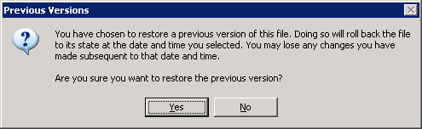
Figure 59 Previous Versions dialog

Restore data from tape
Restoring data from tape is very similar to restoring data from disk. If you are following this document by using the example network topology, you will not be able to perform these steps, since tape was not a requirement in the prerequisites section.
- On the Management page of the DPM Administrator Console, select the Libraries tab and then select the tape you want to restore from. In Figure 60, for example, Slot 4 houses the tape labeled ‘Protection Group 1-00000001,’ a tape image that can be used to restore from.
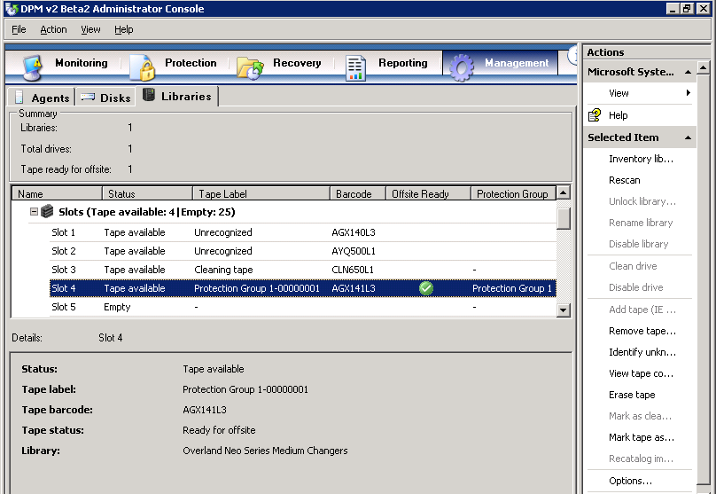
Figure 60 Tape library viewed in DPM Administrator Console
- On the Review Recovery Selection page of the Recovery Wizard, verify that you have selected the correct tape set for recovery in the Tape set for recovery drop-down menu. Click Next.
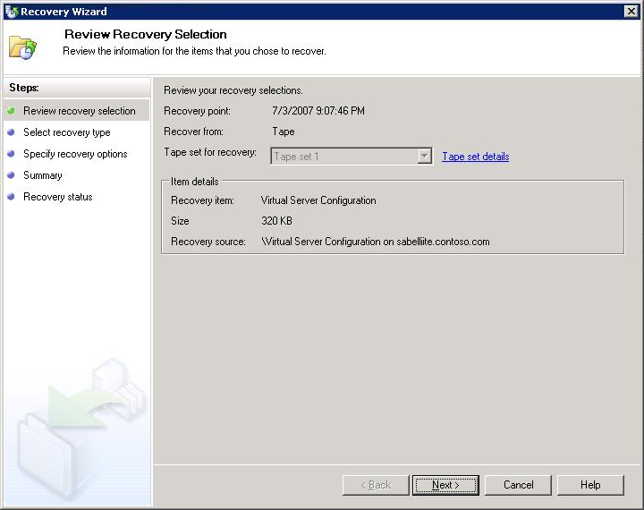
Figure 61 Review Recovery Selection page, Recovery Wizard
- On the Select Recovery Type page, select how you want to recover this data from tape. In Figure 62, Recover to original instance is selected. Click Next.
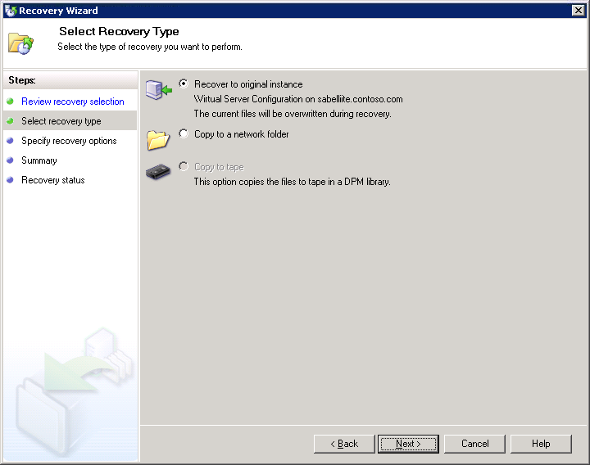
Figure 62 Select Recovery Type page, Recovery Wizard
- On the Specify Recovery Options page, you can set the final parameters for your recovery job, such as the name of the tape library to use, network bandwidth throttling, and recipients for e-mail notifications of the completion of the recovery. In the example in Figure 63, the default library, Overland Neo Series Medium Changers (the name of the specific tape device we used; your device may be different), is selected. The other parameters are left blank, the default setting for these. Click Next.
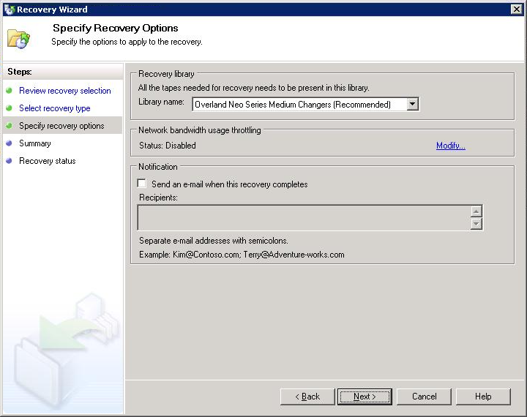
Figure 63 Specify Recovery Options page, Recovery Wizard
- Review your settings on the Summary page and then click Next. This will initiate your recovery.
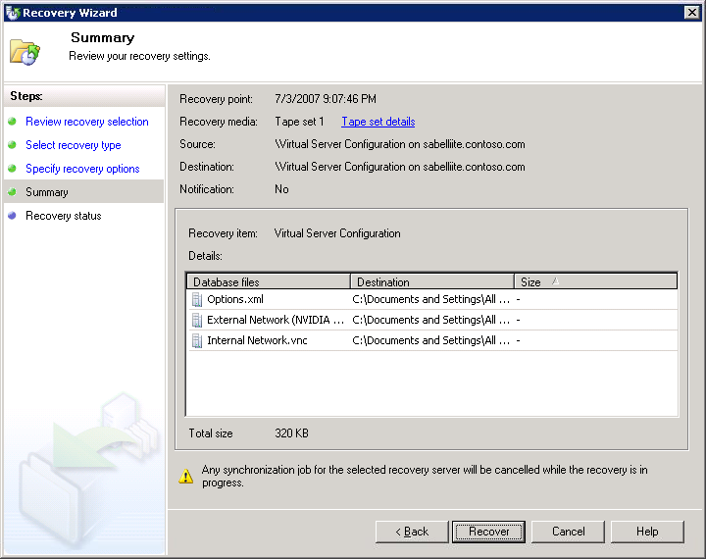
Figure 64 Summary page, Recovery Wizard
- When the recovery is complete, click Close on the Recovery Status page.
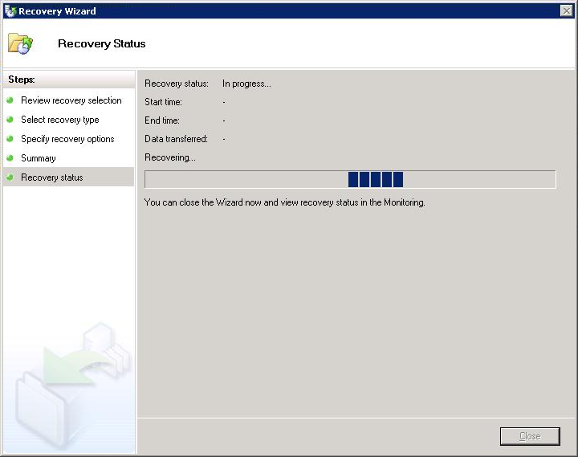
Figure 65 Recovery Status page, Recovery Wizard
- The files backed up to tape are now restored to their original location and have overwritten any subsequent versions of those files at that location.

Section 6:
Back Up and Restore Data to a Running Virtual Machine
Previous to the release of Service Pack 1 for Virtual Server 2005 R2, a Virtual Server-based virtual machine had to be stopped or shut down in order to be fully backed up by the Virtual Shadow Copy Service (VSS). Service Pack 1 provides a VSS writer to Virtual Server 2005 R2, thereby enabling VSS (which DPM uses to back up servers) to back up a running virtual machine. This means that you can provide the same protection for virtual machines that you do for their physical servers, without server downtime. In this scenario, we are backing up the entire virtual machine, not just files that exist within that virtual machine.
Steps covered in this section:
Back up a running virtual machine 78
Backing up a virtual machine without shutting it down requires capturing both the contents of a virtual hard drive and the virtual machines system state. This is made possible by Virtual Server 2005 R2 SP1.
Restore a backed up virtual machine 87
With Virtual Server 2005 R2 SP1, DPM can restore workloads to a virtual machines.

Back up a running virtual machine
Backing up a virtual machine without shutting it down requires capturing both the contents of a virtual hard drive and the virtual machines system state. Service Pack 1 for Virtual Server 2005 R2 allows DPM to back up both of these items so that you can back up workloads running on virtual machines without downtime.
- Make sure that the physical machine HOST_SRV, as well as your other machines, is joined to Contoso.com.
- Make sure that the DPM Backup Agent is installed on HOST_SRV.
- Create a protection group that contains HOST_SRV. In DPM Administrator Console, select the Protection tab.
- In the Action pane on the right side of the screen, click the Create New Protection Group link. This will launch the Create New Protection Group Wizard.
- In the Create New Protection Group Wizard, on the Select Group Members page, expand HOST_SRV. Select the check box next to Protected_SRV, and the check box next to Virtual Machine Configuration. Click Next. In this example we will enter Protection Group VM in the Protection group name text box.
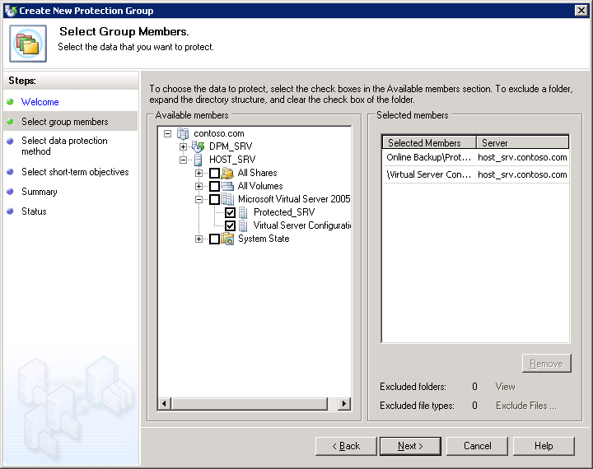
Figure 66 Create New Protection Group Wizard, Select Group Members page
- On the Select Data Protection Method page, give your protection group an appropriate name. Select the check box I want short-term protection, and then select Disk from the drop-down menu. Click Next.
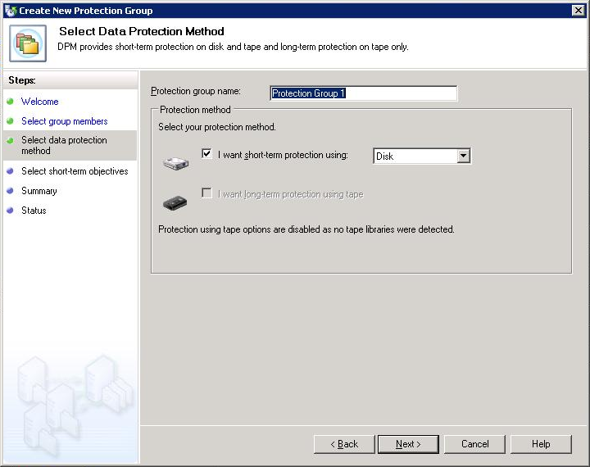
Figure 67 Create New Protection Group Wizard, Select Data Protection Method page
- On the Specify Short-Term Goals page, enter an appropriate number in the Retention range field. In this example we will enter 5 days. We will make no changes in the Recovery points (all members) section.
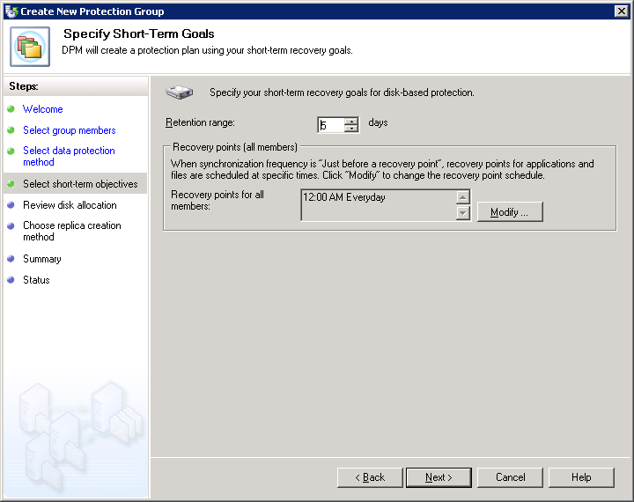
Figure 68 Create New Protection Group Wizard, Define Short-Term Goals page
- On the Review Disk Allocation page, make sure you have sufficient disk space allocated for your backup jobs. Adjust if necessary. Click Next.
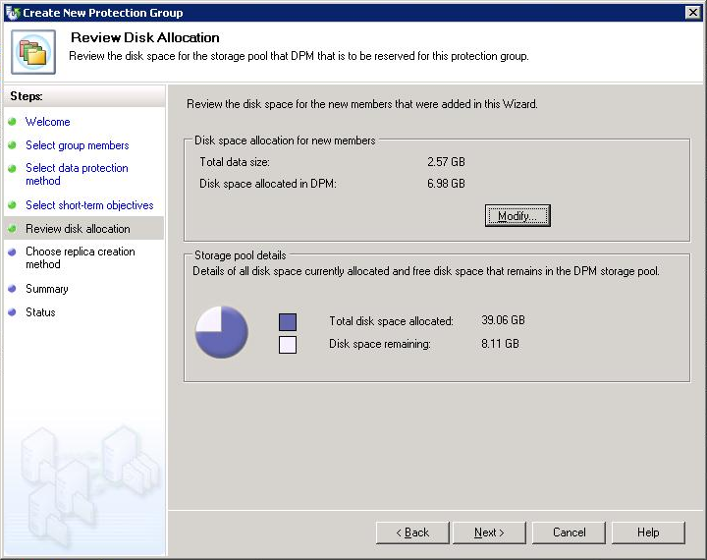
Figure 69 Create New Protection Group Wizard, Review Disk Allocation page
- On the Choose Replica Creation Method page, select the options that best suit your needs. In this example we will select the default option, which is Automatically and Now. This allows DPM to create a replica to copy the selected data to the DPM server automatically and immediately. Click Next.
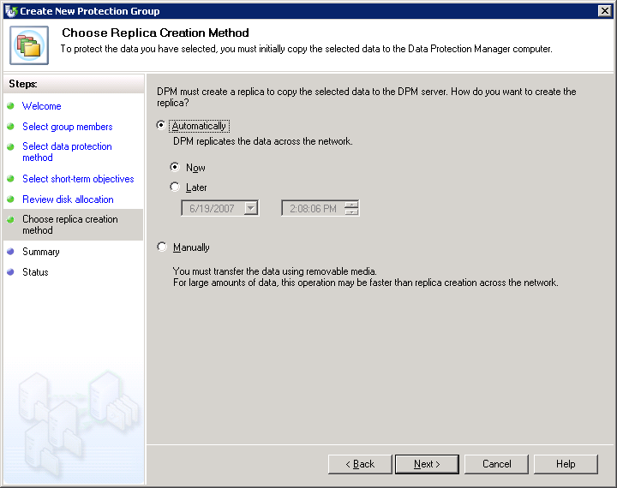
Figure 70 Create New Protection Group Wizard, Choose Replica Creation Method page
- On the Summary page, review the settings and confirm that all the information presented is accurate. Click Create Group.
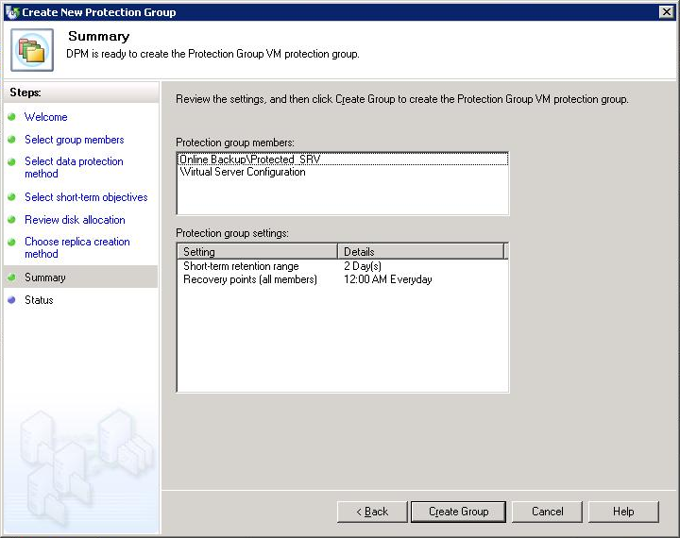
Figure 71 Create New Protection Group Wizard, Summary page
- Keep an eye on the Status page to track progress. When all tasks are finished, click Close.
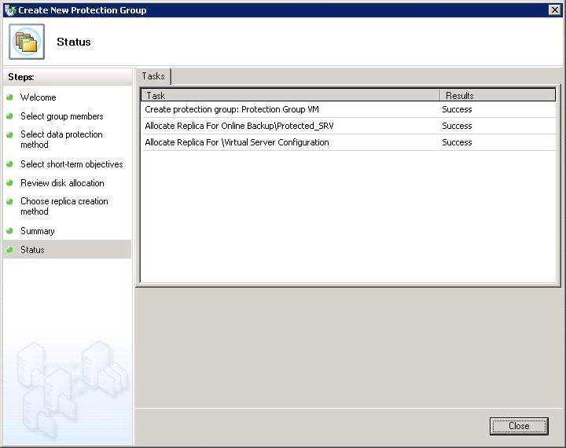
Figure 72 Create New Protection Group Wizard, Status page
- In DPM Administrator Console, select the Protection tab. Confirm that the Protection Status for your protection group members is OK.
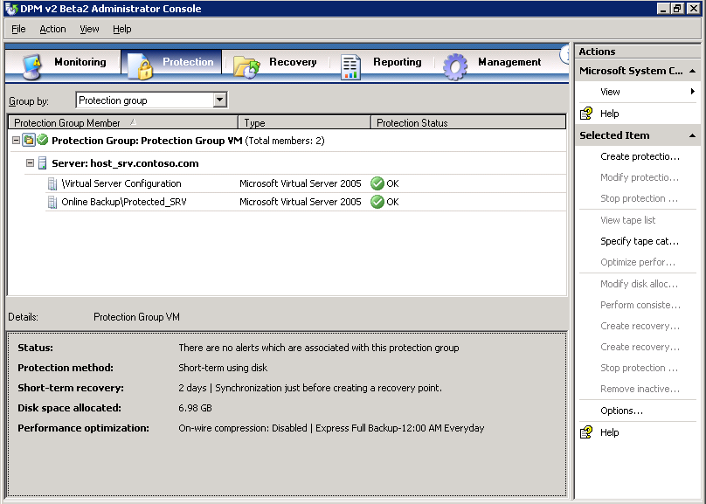
Figure 73 Successfully protected servers in protection group

Restore a backed up virtual machine
With Virtual Server 2005 R2 SP1, DPM can restore workloads to virtual machines
- In DPM Administrator Console, click the Recovery tab. Expand the tree on the left to navigate to Protected_SRV, and then click it.
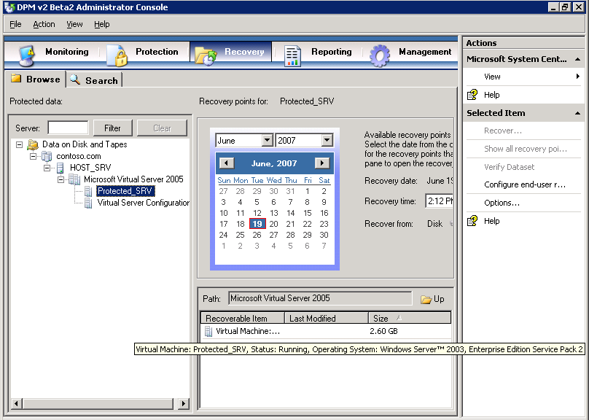
Figure 74 DPM Administrator Console, Recovery tab
- In the middle pane, right-click Protected_SRV, and then select Recover. This will launch the Recovery Wizard.
- On the Review Recovery Selection page, review the information presented for accuracy, and then click Next.
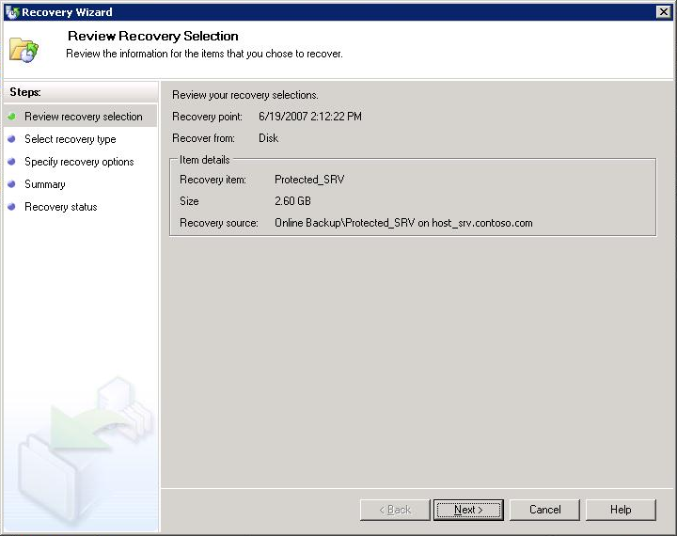
Figure 75 Recovery Wizard, Review Recovery Selection Page
- On the Select Recovery Type page, click Recover to original instance, and then click Next. This will return the protected machine to its original location. If you would like to choose a new location for the protected machine restore, choose Copy to a network folder.
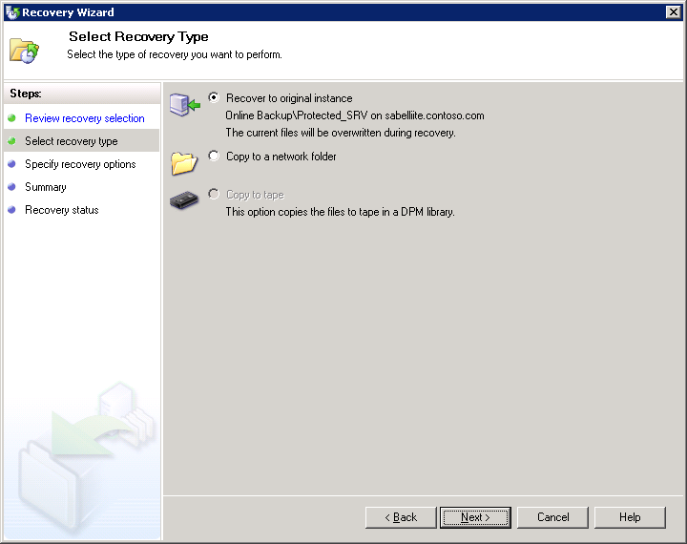
Figure 76 Recovery Wizard, Select Recovery Type page
- On the Specify Recovery Options page, you can choose to have an e-mail notification sent when the recovery completes. (This requires that you have already configured your DPM server for SMTP mail delivery). In this example we will not send e-mail. Click Next.
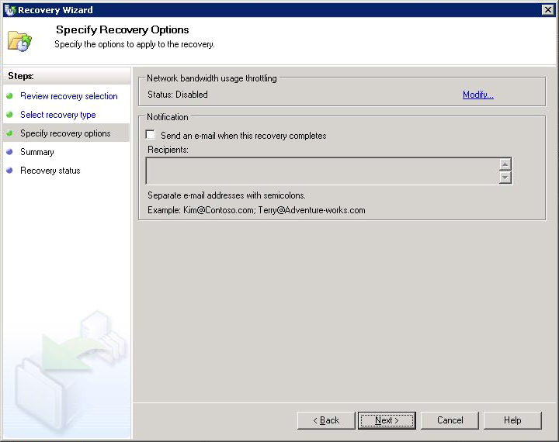
Figure 77 Recovery Wizard, Specify Recovery Options page
- On the Summary page, review the information presented for accuracy. Click Recover.
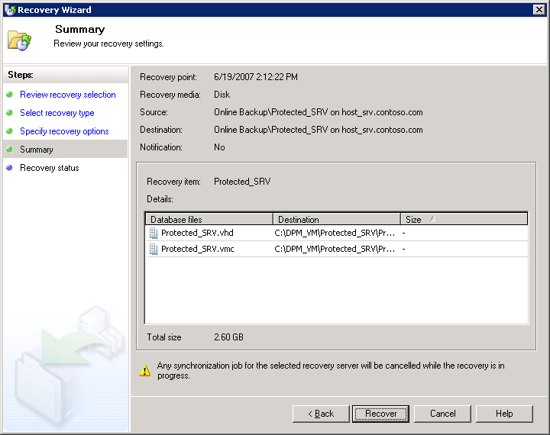
Figure 78 Recovery Wizard, Summary page
- Click Close.
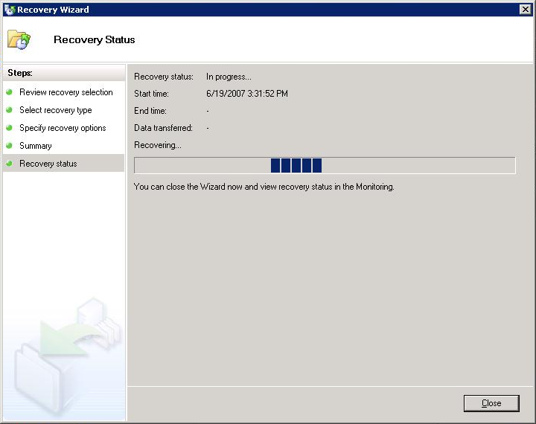
Figure 79 Recovery Wizard, Recovery Status page
- In the DPM Administrator Console, click the Monitoring tab, and then click the Jobs tab. Keep an eye on your job. When your Restore job completes successfully, a green check ball and a Completed status will appear next to it.
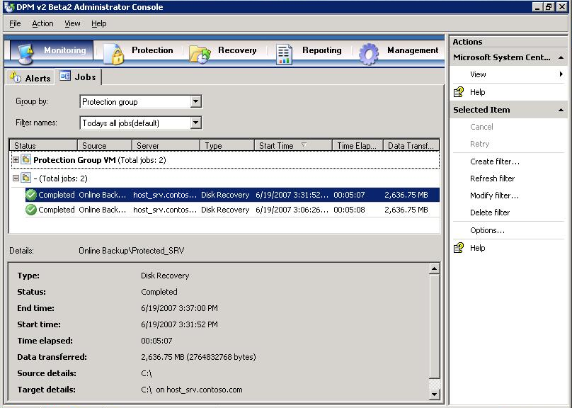
Figure 80 DPM Administrator Console, Monitoring page, Jobs tab
- Turn on your restored virtual machine. Your restoration is complete.

Appendix A:
DPM Protocols and Ports
If the computers that you want to protect reside behind a firewall, you must configure the firewall to allow communication across it.
Table 4 Protocols and ports used by DPM
Protocol | Port | Details
DCOM | 135/TCP  Dynamic | The DPM control protocol uses DCOM. DPM issues commands to the file agent by invoking DCOM calls on the agent. The file agent responds by invoking DCOM calls on the DPM server.  TCP port 135 is the Distributed Computing Environment (DCE) endpoint resolution point used by DCOM.
TCP | 3148/TCP  3149/TCP | The DPM data channel is based on TCP. Both DPM and the file server initiate connections to enable DPM operations such as synchronization and recovery.  DPM communicates with the agent coordinator on port 3148 and with the file agent on port 3149.
DNS | 53/UDP | Used between DPM and the domain controller, and between the file server and the domain controller, for host name resolution.
Kerberos | 88/UDP  88/TCP | Used between DPM and the domain controller, and between the file server and the domain controller, for authentication of the connection endpoint.
LDAP | 389/TCP  389/UDP | Used between DPM and the domain controller for Active Directory queries.
NetBIOS | 137/UDP  138/UDP  139/TCP | Used between DPM and the file server, between DPM and the domain controller, and between the file server and the domain controller, for miscellaneous operations.

Appendix B:
Install IIS via Control Panel
This alternate method for installing Internet Information Services is for installations of Virtual Server 2005 R2 SP1 on operating systems that do not have the Configure Your Server Wizard—for example, Windows XP Professional. Although Virtual Server 2005 R2 SP1 is supported on operating systems such as Windows XP Professional and Windows Small Business Server 2003, due to maximum supported memory and restrictions connected with operating systems other than the Windows Server family of operating systems, Microsoft does not recommend using such an operating system on the host machine running your virtual machines in a production environment.

Install IIS by using Control Panel
You must install the World Wide Web Service component of IIS so that you can use the Administration Website to manage Virtual Server.
- From the Start menu of the physical computer that will run the Virtual Server service, select Settings > Control Panel.
- Double-click Add or Remove Programs.
- In the left column, click Add/Remove Windows Components.
- In the Components list box, select the check box next to Application Server, and then click Details.
Note: On this page and on subsequent pages of the wizard, leave check boxes that are already selected.
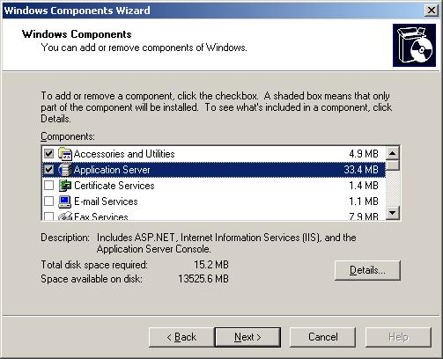
Figure 81 Windows Components Wizard, Windows Components page
- In the Subcomponents of Application Server list box, select the check box next to Internet Information Services Manager, and then click Details.
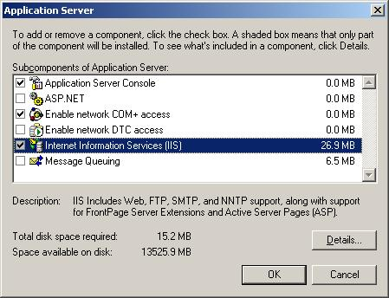
Figure 82 Application Server page
- In the Subcomponents of Application Server list box, select the check box next to World Wide Web Service, and then click Details.
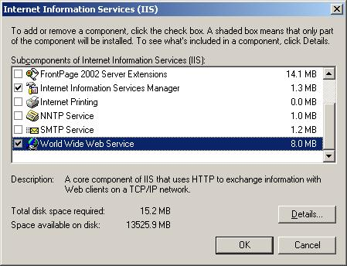
Figure 83 Internet Information Services (IIS) page
- Select the check box next to World Wide Web Service, and then click OK.
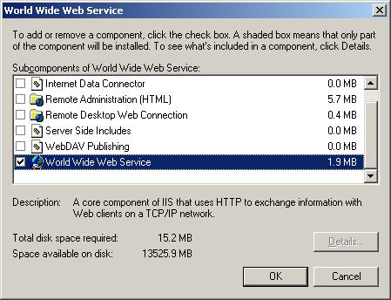
Figure 84 World Wide Web Service page
- On the Internet Information Services page, click OK.
- On the Application Server page, click OK.
- On the Windows Components page, click Next. You will need the installation medium (CD or network file) for the operating system of this computer to complete this step.
- Wait while the Windows Components Wizard configures these settings. Then, on the Completing the Windows Components Wizard page, click Finish.

Appendix C:
Virtual Server Security Considerations
Virtual Server has the following default configuration:
- The Virtual Machine Remote Control (VMRC) server is disabled.
- The VMRC server uses port 5900.
- Virtual Server uses Integrated Windows authentication.
- Only local administrators can access the Administration Website, configure Virtual Server, and create and configure virtual machines and virtual networks; other users must be granted the appropriate permissions manually. The Administration Website is a browser-based tool for configuring and managing Virtual Server and its associated virtual machines and virtual networks.
- Firewall and antivirus software running on the host operating system will not protect guest operating systems. To obtain this protection, you must install firewall and antivirus software directly on the guest operating systems.
- The two Virtual Server services run under security accounts that have low privileges: The Virtual Server service (Vssrvc.exe) runs under the Network Service account, which has limited access to the local computer and authenticated access (as the computer account) to network resources. The Virtual Machine Helper service (Vmh.exe) runs under the Local Service account. This account has limited access to the local computer and anonymous access to network resources.
- Only local administrators can configure Virtual Server or create and configure virtual machines. You can give other users the ability to create and configure virtual machines by changing file system security settings. Use care in giving such permissions to other users.
- Virtual machines run under the account of the user who started the virtual machine, unless you specify a different user account under which to run virtual machines and assign the user account to each virtual machine. Make sure that you specify a user account that has a low level of privileges.
Note: To provide a more secure file system, use NT File System (NTFS) on the server that will run the Virtual Server service.

Appendix D:
Install the iSCSI Initiator

- Download the Microsoft iSCSI Software Initiator version 2.04 software from http://www.microsoft.com/downloads/details.aspx?FamilyID=12cb3c1a-15d6-4585-b385-befd1319f825&DisplayLang=en. Save it to a location on your hard disk drive.
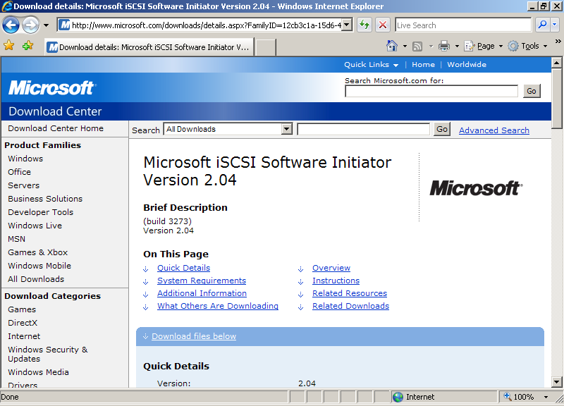
Figure 95 Download Center
- Double-click Initiator-2.04-build3273-x86fre.exe.
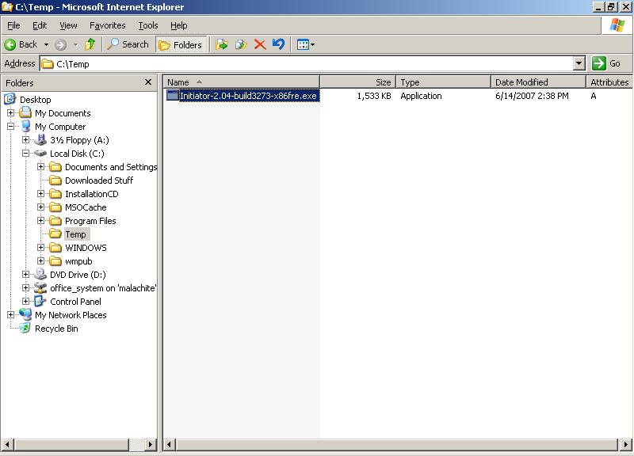
Figure 96 Download initiator
- When the Software Installation Update Wizard appears, click Next.
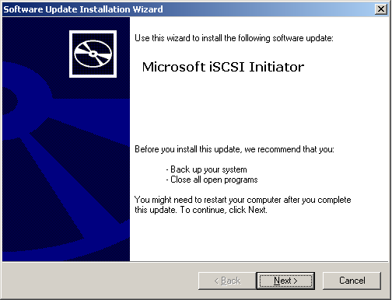
Figure 97 Microsoft iSCSI Initiator page
- Leave the default settings checked, and click Next.
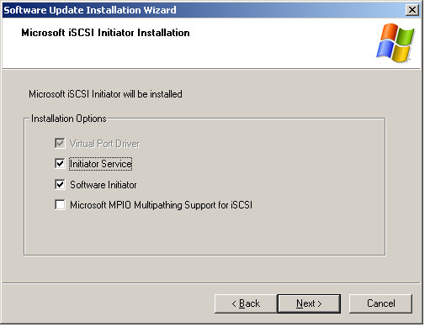
Figure 98 Microsoft iSCSI Initiator Installation page
- On the License Agreement page, read the license agreement, select I Agree, and then click Next.
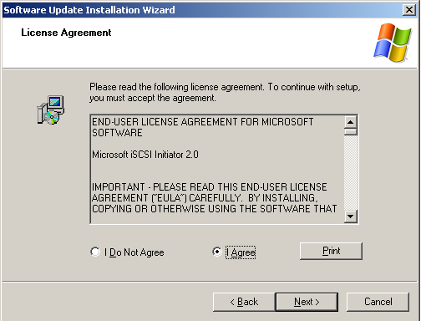
Figure 99 License Agreement page
- Wait while your system is updated.
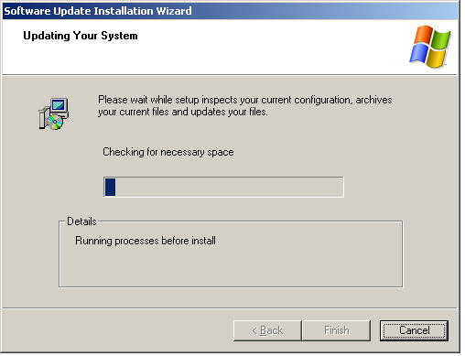
Figure 100 Updating Your System page
- When the installation process is complete, click Finish.
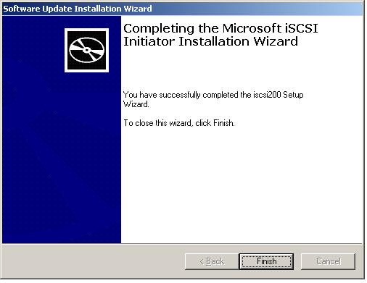
Figure 101 Completing the Microsoft iSCSI Initiator Installation Wizard
- Click Start > Control Panel, and double-click the iSCSI Initiator icon. The properties box will appear.
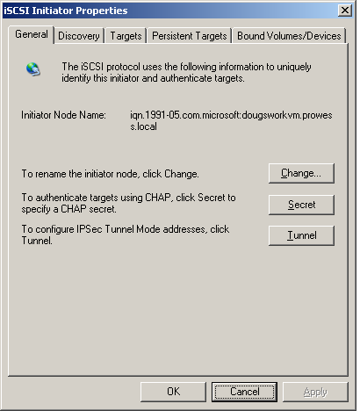
Figure 102 iSCSI Initiator Properties
- On the General tab, make note of your Initiator Node Name. This name is important, as it will be used by an iSCSI target device (SAN, tape device, or another type of storage device) to identify your computer.
- Click the Discovery tab.
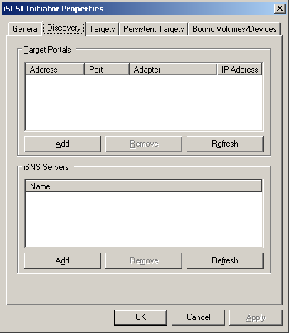
Figure 103 iSCSI Initiator Properties page, Discovery tab
- Under Target Portals, click Add.
- Type the name or IP address of the iSCSI target that you want to use. Click OK.
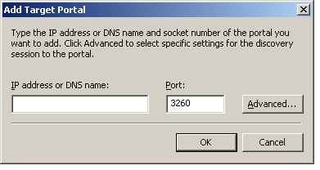
Figure 104 Add Target Portal
- You will now need to configure your iSCSI target device. See the documentation that came with your iSCSI target device for information.

Related Links
For more information about Microsoft System Center Data Protection Manager, visit the Data Protection Manager home page at: www.microsoft.com/systemcenter/dpm/default.mspx
For more information about Data Protection Manager 2007, visit: www.microsoft.com/systemcenter/dpm/beta/overview.mspx
For more information about Virtual Server 2005 R2 SP1, visit the Virtual Server 2005 R2 home page at:
www.microsoft.com/windowsserversystem/virtualserver/default.aspx
To download Virtual Server 2005 R2 or Service Pack 1, visit the Microsoft Virtual Server TechCenter page at:
www.microsoft.com/technet/virtualserver/default.mspx

Information in this document, including URL and other Internet Web site references, is subject to change without notice. Unless otherwise noted, the example companies, organizations, products, domain names, e-mail addresses, logos, people, places, and events depicted herein are fictitious, and no association with any real company, organization, product, domain name, e-mail address, logo, person, place, or event is intended or should be inferred. Complying with all applicable copyright laws is the responsibility of the user. Without limiting the rights under copyright, no part of this document may be reproduced, stored in or introduced into a retrieval system, or transmitted in any form or by any means (electronic, mechanical, photocopying, recording, or otherwise), or for any purpose, without the express written permission of Microsoft Corporation.
The names of manufacturers, products, or URLs are provided for informational purposes only and Microsoft makes no representations and warranties, either expressed, implied, or statutory, regarding these manufacturers or the use of the products with any Microsoft technologies. The inclusion of a manufacturer or product does not imply endorsement of Microsoft of the manufacturer or product. Links are provided to third-party sites. Such sites are not under the control of Microsoft and Microsoft is not responsible for the contents of any linked site or any link contained in a linked site, or any changes or updates to such sites. Microsoft is not responsible for webcasting or any other form of transmission received from any linked site. Microsoft is providing these links to you only as a convenience, and the inclusion of any link does not imply endorsement of Microsoft of the site or the products contained therein.
Microsoft may have patents, patent applications, trademarks, copyrights, or other intellectual property rights covering subject matter in this document. Except as expressly provided in any written license agreement from Microsoft, the furnishing of this document does not give you any license to these patents, trademarks, copyrights, or other intellectual property.
Copyright © 2007 Microsoft Corporation. All rights reserved.
Microsoft are either registered trademarks or trademarks of Microsoft Corporation in the United States and/or other countries.
<The publications specialist inserts mention of specific, contractually obligated to, third-party trademarks, provided by the copy editor>
The names of actual companies and products mentioned herein may be the trademarks of their respective owners.

