Microsoft Office Professional Plus 2007

Microsoft® Office Professional Plus 2007 will help you and your organization work more efficiently and effectively with a new set of powerful tools for creating, managing, analyzing, and sharing information. The Microsoft Office Fluent™ user interface in the 2007 Microsoft Office system makes programs easier to use, and the new graphics capability makes creating great-looking, high-impact documents a snap. Office Professional Plus 2007—it’s all about helping you deliver better results faster.

Deliver Better Results Faster
Office Professional Plus 2007 delivers a host of innovative new capabilities that make it easier to produce great results.
Get more out of the Microsoft Office system.
The Office Fluent user interface for Microsoft Office Word, Excel®, PowerPoint®, Outlook®, and Access has been introduced to help make program features easier to find and use. Commands are easier to find because they are organized into a set of easy-to-browse tabs that correspond more directly to the things you do in the Microsoft Office system. Larger, more informative ScreenTips help you discover new features to make your job easier. Formatting and page layout galleries take the place of complicated dialog boxes so you can simply pick and then click to get the effects you want. Live previewing streamlines editing and formatting operations so you can spend more time on the important stuff.
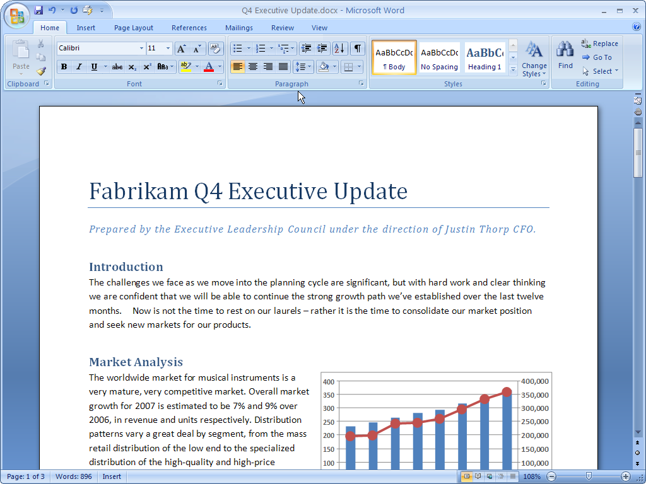
The new streamlined workspace and easy-to-browse tabs make program features easier to find and use.

Give your work greater impact.
Office Professional Plus 2007 brings a powerful new set of graphics capabilities to your desktop. New 3-D effects, shadows, reflection, glow, and surface texture tools make it easy to add highly professional-looking charts and diagrams to your work.
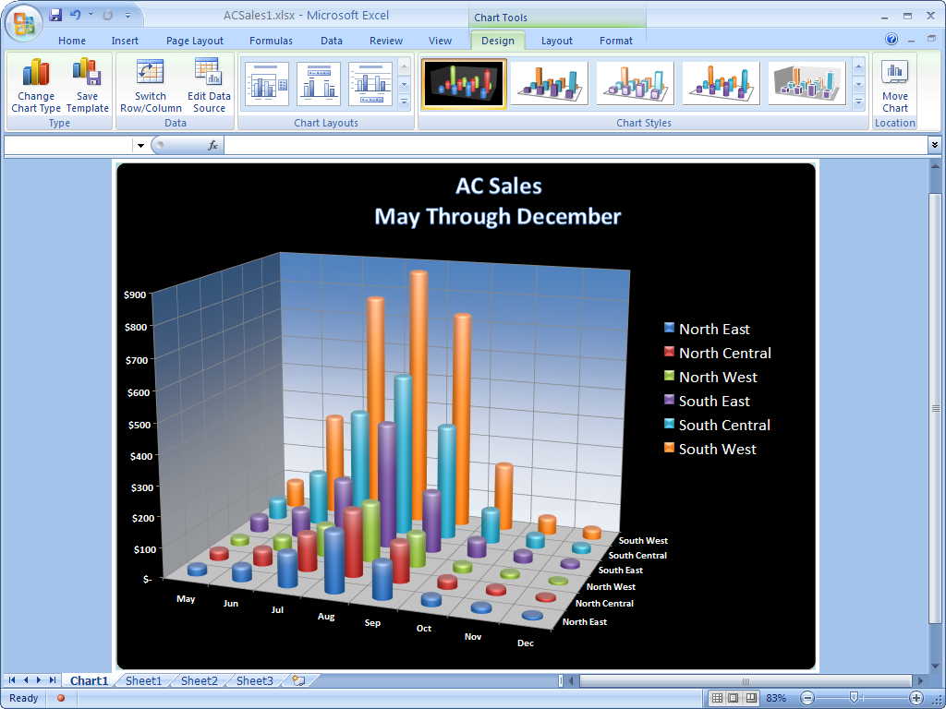
The new graphics capabilities make it easier to produce professional, high-impact charts in Office Excel 2007.
Manage your work with ease.
Office Outlook 2007 helps you keep your e-mail, commitments, and tasks more organized with the new To-Do Bar. This new feature gives you a consolidated view of upcoming appointments, tasks, and e-mail messages flagged for follow-up. Allocating time to work on tasks is as easy as dragging tasks onto your calendar.
Reuse document content with just a
few clicks.
Office Word 2007 introduces Building Blocks for adding frequently used content to your documents. You can now select from a predefined gallery of cover pages, pull quotes, headers, and footers to make your documents look more professional. You can even create your own Building Blocks to simplify the addition of custom text, such as legal disclaimer text or other frequently used materials.
Make sense of spreadsheet data in a flash.
New capabilities in Office Excel 2007 enable you to quickly make sense of your data using rich data visualization and conditional formatting schemes, such as multicolor gradients, value thresholds, and performance-indicating icons.
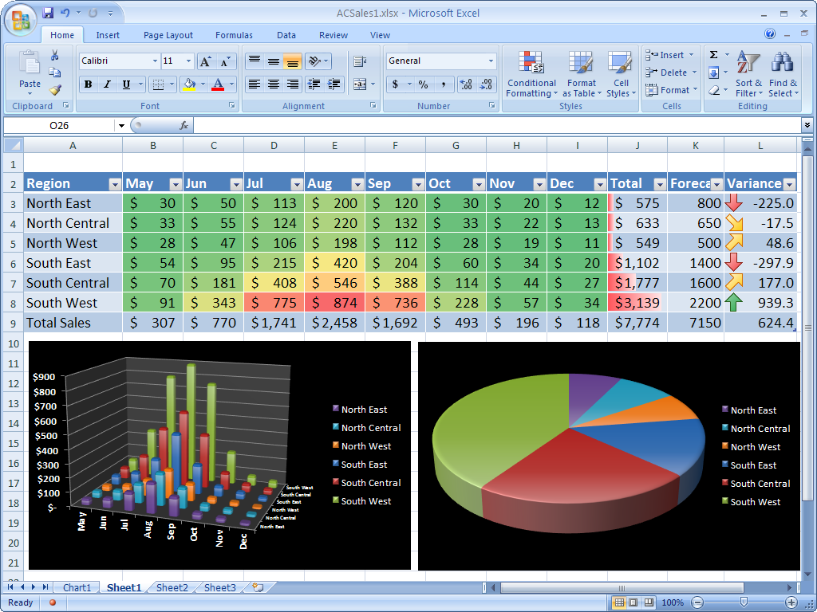
Apply conditional formatting using color gradients and icons to find exceptions and spot trends in your data.
Easily publish and reuse PowerPoint slides.
With PowerPoint slide libraries, you can publish presentations as individual slides on a site supported by Microsoft Office SharePoint® Server 2007, enabling others to easily access them later right from within Office PowerPoint 2007. Inserted slides remain synchronized with the server version, helping ensure that content is always up to date.
Create powerful, dynamic diagrams.
Office PowerPoint 2007 makes it easy to create dynamic relationship, workflow, or hierarchy diagrams that help you communicate your ideas more effectively. Convert bulleted lists into SmartArt™ diagrams with just a few clicks. Edit and modify your diagrams just as easily. The Office Fluent user interface makes it quick and easy to give your diagrams a highly professional appearance.
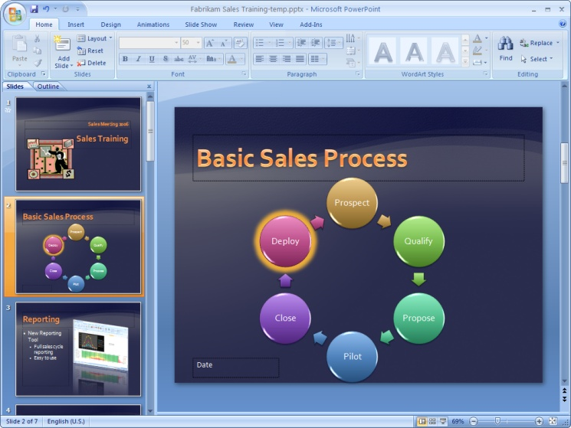
Use the new SmartArt graphics capabilities to create powerful, dynamic diagrams.

Work Together More Effectively
Office Professional Plus 2007 helps make sharing information and working together easier, safer, and more productive. Works smoothly with Microsoft collaboration and IT infrastructure technologies, which enables more efficient information sharing and collaboration out of the box.
Communicate more effectively with greater flexibility.
Microsoft Office Communicator 2007 makes communicating with colleagues in different locations or time zones easier while using a range of different communication options, including instant messaging (IM), voice, and video.
Coordinate schedules quickly and easily.
With Office Outlook 2007, scheduling meetings with colleagues outside your organization no longer requires extended rounds of phone tag. Reduce the time it takes to exchange scheduling information by sending a calendar snapshot in an e-mail message or publishing your calendar on Microsoft Office Online.
Collaborate with the greatest of ease.
Office Professional Plus 2007 delivers
out-of-the-box integration with the new Office SharePoint Server 2007, creating a powerful self-service collaboration environment that supports workflow-enabled document review, managed reports distribution, and structured information sharing.
Share documents with confidence.
The Document Inspector in Office Professional Plus 2007 makes it easy for you to remove “invisible” information such as comments, hidden text, and properties from documents, spreadsheets, and presentations.
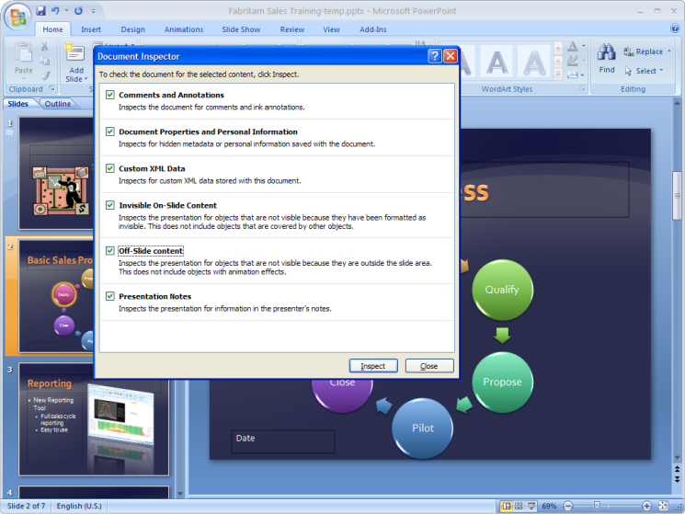
The Document Inspector finds and removes potentially sensitive “hidden” information from your documents, presentations, and spreadsheets.
Convert your documents and information to PDF or XPS.
Office Professional Plus 2007 enables you to share documents, spreadsheets, and presentations in Portable Document Format (PDF) and XML Paper Specification (XPS) format.

Get More Out of Your Information
Office Professional Plus 2007 makes it easier for you to find, analyze, and use information through a broad array of advanced information search, management, and analysis technologies that extend from the inbox to the data center.
Work with confidence.
New capabilities for data integration in Office Professional Plus 2007 help reduce the cost and complexity of connecting documents and spreadsheets to central data sources so you
can feel confident that you are working with consistent and accurate information.
Analyze data more efficiently.
Office Excel 2007 enhances your ability to analyze business information with streamlined access to corporate data sources; redesigned, easier-to-use PivotTable® dynamic views; and new data visualization capabilities.
Quickly start tracking information.
Office Access 2007 helps you keep track of information more productively with a redesigned Getting Started experience and WYSIWYG (what you see is what you get) report writer. It also works smoothly with Microsoft Windows® SharePoint Services. Extensive database experience is no longer required to start tracking information and creating reports to make more informed decisions.
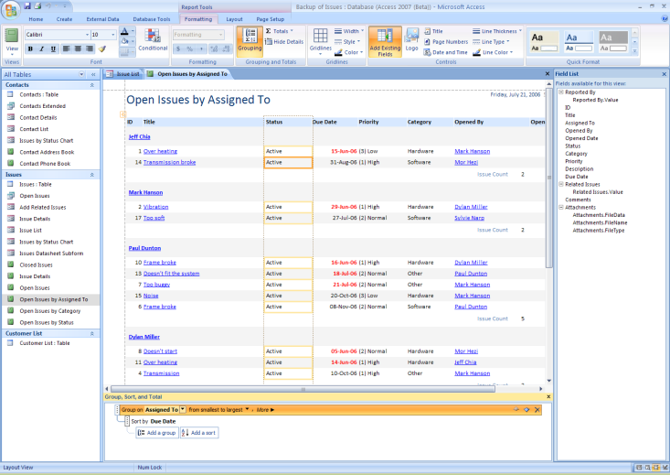
Create good-looking, print-ready reports with a true
WYSIWYG experience.
Keep information where you need it.
Office Outlook 2007 gives you new tools for making the information you need easily accessible whether you are online or off. Really Simple Syndication (RSS) feeds can now be stored directly in your inbox for easier access (an additional fee-based RSS subscription is required). Similarly, information stored on Windows SharePoint Services sites can be taken offline using Outlook folders, giving you the flexibility to work with this data whenever and wherever you choose.
Find it fast.
Office Outlook 2007 introduces a new, integrated Instant Search capability so you can quickly locate the information you need right from within Office Outlook 2007. Search by keyword or other criteria throughout all of your Outlook data, including e-mail, e-mail attachments, calendar items, RSS feeds, and Windows SharePoint Services information.
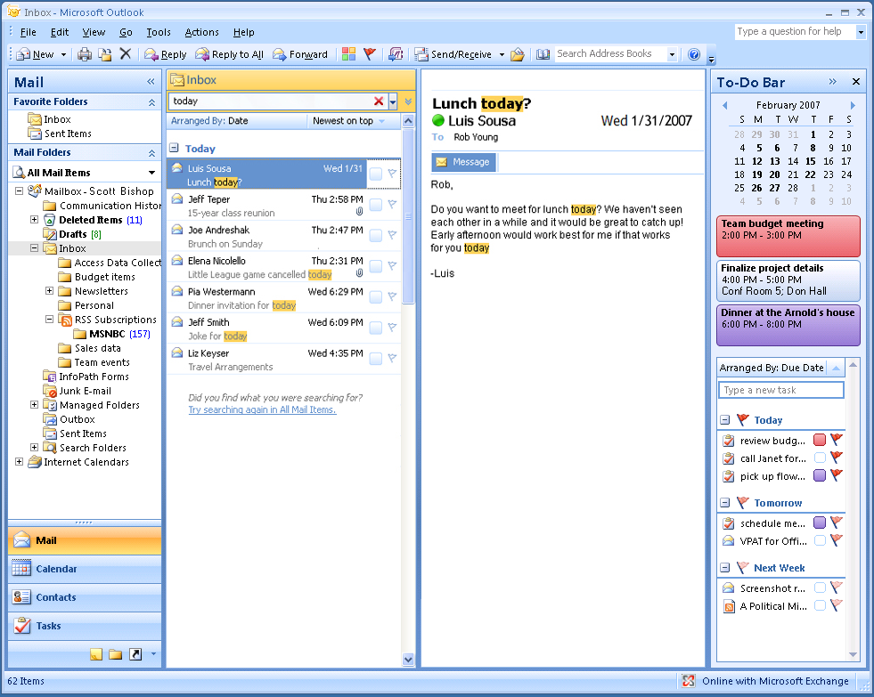
Search by keyword or other criteria throughout all of your Outlook data, including e-mail, e-mail attachments, calendar items, and more.

Control Content, Streamline Processes
Office Professional Plus 2007 helps organizations to lower the cost of executing business processes, including content production and management, through streamlined process automation using advanced electronic forms technologies.
Harness the power of electronic forms.
Advances in Microsoft Office InfoPath® 2007 enable you to deploy forms as Outlook e-mail messages so colleagues can complete them without leaving the familiar Outlook environment. After you’ve collected the information in Outlook, you can export it to an Excel spreadsheet or an Access database, or merge the data back to a single InfoPath form.
Extend the reach of your electronic forms.
Office InfoPath 2007 and InfoPath Forms Services make it easy to extend electronic forms solutions beyond your firewall by enabling forms to be completed using many different Web browsers and mobile devices.
Share with greater control.
Office Excel 2007 works with the new Office SharePoint Server 2007 to enable you to publish your spreadsheet reports and models with a full range of control over who can access them. Access options include full access with Office Excel 2007, limited (values only) access, browser access, and Web services access.
Work with less “busywork.”
Office Word 2007 works with the automated workflow services of the new Office SharePoint Server 2007 to help reduce the busywork you have to do when managing the process of reviewing and publishing content.
Go beyond documents.
Office Professional Plus 2007 introduces a new level of support for XML with the Ecma Office Open XML Formats. These new file formats enable smaller, more robust documents and deep integration with information systems and external data sources.
Microsoft Office Professional Plus 2007 includes:
- Microsoft Office Access 2007
- Microsoft Office Communicator 2007
- Microsoft Office Excel 2007
- Microsoft Office InfoPath 2007
- Microsoft Office Outlook 2007
- Microsoft Office PowerPoint 2007
- Microsoft Office Publisher 2007
- Microsoft Office Word 2007

Accelerate Performance with the
Power of Integrated Innovation
Office Professional Plus 2007 is part of the Microsoft Office system, an integrated collection of programs, servers, and services designed to work together to enable optimized information work. Office Professional Plus 2007, when combined with Office SharePoint Server 2007, delivers an expanded set of capabilities that make it easier to deliver better results faster across your organization. Key capabilities include:
Office PowerPoint 2007 slide libraries that make it easy to share presentation content.
Office Excel 2007 publishing capabilities that enable you to view spreadsheets by using a Web browser and Internet access.
Document management capabilities that streamline the process of creating, reviewing, and publishing content.
Electronic forms distribution capabilities that extend the use of Office InfoPath 2007 electronic forms beyond your firewall.

For More Information
Learn more about Microsoft Office Professional Plus 2007 and the Microsoft Office system at www.microsoft.com/office/suites/professionalplus.

For complete system requirements, visit www.microsoft.com/office/suites/professionalplus.

This document is for informational purposes only. MICROSOFT MAKES NO WARRANTIES, EXPRESS OR IMPLIED, IN THIS SUMMARY.

The example companies, organizations, products, domain names, e-mail addresses, logos, people, places, and events depicted herein are fictitious. No association with any real company, organization, product, domain name, e-mail address, logo, person, place, or event is intended or should be inferred.


© 2006 Microsoft Corporation. All rights reserved. Microsoft, Excel, InfoPath, the Office logo, Outlook, PivotTable, PowerPoint, SharePoint, SmartArt, Fluent and Windows are either registered trademarks or trademarks of Microsoft Corporation in the United States and/or other countries. All other trademarks are property of their respective owners.

You can save as a PDF or XPS file from a 2007 Microsoft Office system program only after you install an add-in. For more information, see Install and use a PDF or XPS add-in.
To enable full functionality of this feature on Microsoft Windows XP, users must download a search redistributable from Windows Update.

