
Microsoft Office SharePoint Server 2007
Evaluation Guide
February 2007

Abstract
This evaluation guide is designed to give you a solid understanding of the design goals and feature set for Microsoft® Office SharePoint® Server 2007 and a familiarity with the product implementation. It provides an overview of the solutions and benefits provided by Office SharePoint Server 2007, along with descriptions of new and improved features in the areas of portal, search, content management, business forms and integration, and business intelligence. It also provides a hands-on tour of the product’s main feature areas and concludes with useful information for administrators and developers.
The ultimate goal of this guide is to aid the reader in performing a thorough and effective evaluation of Office SharePoint Server 2007. This guide is intended for anyone who is interested in learning more about Office SharePoint Server 2007 and wants hands-on experience.
For the latest information about Office SharePoint Server 2007, go to the SharePoint Products and Technologies Web site. For other product information resources, refer to the “For More Information” section at the end of this guide.
Table of Contents
Abstract 1
Resources Available for Evaluating Office SharePoint Server 2007 6
SharePoint Products and Technologies 6
Windows SharePoint Services 3.0 6
Microsoft Office SharePoint Server 2007 7
There are also specialty SharePoint Products and Technologies for Search and Forms. 7
Microsoft Office SharePoint Server 2007 for Search 7
Microsoft Office Forms Server 2007 7
Windows SharePoint Services 3.0 8
Microsoft Office SharePoint Server 2007 Version Comparison 9
Office SharePoint Server 2007 Feature Areas 10
Collaboration 11
Portal 12
Personalization 13
User Profiles and the Profile Data Store 16
Navigation and the Site Directory 18
Audience Targeting 21
Web Parts to Make Content Easier to Find 22
Site Content and Structure 22
SharePoint Sites and Documents Roll-up Web Parts 23
Portal Site Templates 24
Enterprise Search 25
Relevance 27
People Search 28
Business Data Search 29
User Experience 30
Security 33
Search Extensibility 34
Search Manageability and Scalability 34
Content Management 35
Document Management 36
Records Management 42
Web Content Management 44
Web Content Authoring 48
Business Forms and Integration 51
Business Data Catalog 54
Business Intelligence 57
Web-Based Business Intelligence Using Excel Services 57
SharePoint Products and Technologies Interoperability 60
Interoperability 61
Web Services 62
Custom Development 63
Office SharePoint Server 2007 Architecture 64
Application and Services 65
Platform Services 66
Operating System Services 67
Shared Services 67
Installing an Evaluation Server 68
Hardware Requirements 68
Software Requirements 69
Database 70
Database Server 70
Operating System 71
Windows Components 71
Microsoft .NET Framework 3.0 72
Install and configure Office SharePoint Server 2007 with Microsoft SQL Server 2005 Express Edition 72
Post-Installation Steps 74
Product Walkthrough 76
Exercise 1 – Getting Started 76
Exercise 2 – Site Administration 79
Create a new group 79
Exercise 3 – Web Parts 81
Adding Web Parts 81
Exercise 4 – Web Parts for Common Information 83
Exercise 5 – Security 84
Item level security 84
Item version and history 85
Recycle Bin 88
Exercise 6 – Notifications 88
Alerts 88
E-Mail Notifications 89
RSS Feeds 91
Exercise 7 – Working with Microsoft Office Outlook 2007 92
Shared Calendars and Tasks 93
Exercise 8 – Audience Targeting 96
Exercise 9 – People Profile and My Sites 100
Social Networking 104
Exercise 10 – Create a SharePoint list to track reseller feedback from the Business Data Catalog 107
Create the Reseller Feedback list 108
Exercise 11 – Workflow 110
For More Information 112

Introduction
Welcome to the evaluation guide for Microsoft Office SharePoint Server 2007. The goal of this guide is to help you gain sufficient knowledge and understanding of Office SharePoint Server 2007 to evaluate this product from Microsoft.
Office SharePoint Server 2007 helps organizations gain better control and insight over their content, streamline their business processes, and access and share information. In addition, Office SharePoint Server 2007 gives IT professionals the tools they need for server administration along with application extensibility and interoperability.
Office SharePoint Server 2007 provides a single, integrated location where employees can efficiently find organizational resources, access corporate knowledge, and leverage business insight to make better-informed decisions.
Office SharePoint Server 2007 helps you to:
- Get more out of your information Make better-informed decisions through centralized access to information and improved abilities to locate relevant content; implement comprehensive control over the storage, security, distribution, reuse, and management of documents and other electronic content such as Web pages, PDF files, and e-mail messages; submit work from collaborative sites to portals by using tools that simplify content reuse and publishing; simplify management of multilingual content through document library templates designed to maintain a relationship between original and translated versions of documents; use slide libraries as an easy way to share and reuse Microsoft Office PowerPoint® 2007 slides.
- Streamline your business processes Accelerate internal and external shared business processes, share business information within and outside of your organization; make business process initiation, participation, tracking, and reporting easy and flexible by providing a simple, consistent user experience through familiar client applications; optimize the way people, content, and processes interact within and across organizations.
- Simplify the way people work together Simplify content reuse and information repurposing; take advantage of workflows to automate and gain more visibility into common business activities such as document review and approval, issue tracking, and signature collection; focus on strategic, value-added tasks instead of redundant activities; improve and extend team collaboration; enhance your relationships with customers, partners, and suppliers by making forms-based business processes easily accessible to them, even if they haven’t installed client software; have customized document management policies enable item-level access rights, retention periods, expiration actions, and document-auditing settings; see how policy integration with familiar client applications makes compliance transparent and easy for employees.
- Ease server administration, extensibility, and interoperability Use a single, integrated platform with a consistent administrative interface to manage intranet, extranet, and Internet applications; employ powerful programming APIs and XML Web services to extend the reach and functionality of your portal implementation.
The section below entitled “Office SharePoint Server 2007 Feature Areas” details the new and enhanced features for this release of Office SharePoint Server, including:
- Portals
- Search
- Content Management, including Documents, Records, and Web Content
- Business Forms and Integration
- Business Intelligence
With this knowledge, you will be able to properly evaluate these new features and readily describe their capabilities to your colleagues, clients, and business partners.
For more information about Microsoft Windows® SharePoint Services 3.0, go to the Windows SharePoint Services Technology Guide. You may choose to review that document if you wish to do a more-comprehensive evaluation of Microsoft Windows SharePoint Services 3.0. This paper will briefly cover Windows SharePoint Services 3.0 technology and move beyond that topic to introduce the many additional capabilities introduced in Office SharePoint Server 2007.
One other note before continuing: the full spectrum of functionality and business value contained within Office SharePoint Server 2007 is immense, and a detailed accounting of each feature is well beyond the scope of this document. This document focuses on evaluating the capabilities of Office SharePoint Server 2007 in a very broad way, highlighting the major functional areas that deliver the greatest business value. Many deeper features will become self-evident through the course of evaluating and using the software, while still other features demand deeper and more technical consideration. It is suggested that you review the resources listed in the next section for more information.

Resources Available for Evaluating Office SharePoint Server 2007
Many resources are available to help you evaluate Office SharePoint Server 2007, including the following:
- The Product Documentation will help you install Office SharePoint Server 2007.
- The SharePoint Products and Technologies Web site offers a variety of white papers and other resources.
- The MSDN® SharePoint Web site offers numerous technical resources from a developer’s perspective about Microsoft SharePoint Products and Technologies.
- The Microsoft TechNet Web site provides a clearinghouse of resources to help you deploy, maintain, and support Office SharePoint Server 2007.
- The Microsoft SharePoint Products and Technologies Team Blog is the official blog of the SharePoint Products and Technologies Group.
Microsoft encourages you to use these resources as aids in installing and evaluating Office SharePoint Server 2007.

SharePoint Products and Technologies
SharePoint Products and Technologies address a range of business needs for the delivery of flexible, adaptable, and powerful Web applications and solutions. These products and technologies can be assembled in a variety of configurations tailored to an organization’s specific Web application requirements.
The full range of capabilities of SharePoint Products and Technologies is delivered through the following products:

Windows SharePoint Services 3.0
Windows SharePoint Services 3.0 provides the solution platform for SharePoint Products and Technologies, delivering a wide range of functional capabilities that are exploited and extended by other SharePoint Products and Technologies. For a detailed description of Windows SharePoint Services 3.0, see the section below titled Windows SharePoint Services 3.0.

Microsoft Office SharePoint Server 2007
Microsoft Office SharePoint Server 2007 is an integrated suite of server capabilities that can help improve organizational effectiveness by providing comprehensive content management and Enterprise Search, accelerating shared business processes, and facilitating information sharing across boundaries for better business insight. Office SharePoint Server 2007 supports all intranet, extranet, and Web applications across an enterprise within one integrated platform, instead of relying on separate fragmented systems. Additionally, this collaboration and content management server provides IT professionals and developers with the platform and tools they need for server administration, application extensibility, and interoperability. The evaluation of Microsoft Office SharePoint Server 2007 is the focus of this document.

There are also specialty SharePoint Products and Technologies for Search and Forms.

Microsoft Office SharePoint Server 2007 for Search
The ability to search for information in enterprise Web sites is critical to the effective use and usability of those sites. Search in Office SharePoint Server 2007 is a shared service that provides extensive and extensible content gathering, indexing, and querying. This service supports full-text searching by using Structured Query Language (SQL)–based query syntax, and it provides new keyword syntax to support keyword searches. Search is covered in more detail elsewhere in this document, in the section titled Enterprise Search. You can also learn more about search functionality by consulting the Search in Microsoft Office SharePoint Server 2007 Evaluation Guide.

Microsoft Office Forms Server 2007
Microsoft Office Forms Server 2007 provides scalable, standards-based electronic forms solutions with enhanced security that can help an organization to extend the reach of forms-driven business processes to anyone with a Web browser. It is a stand-alone server that delivers new Microsoft Office InfoPath® Forms Services, which is also available in Microsoft Office SharePoint Server 2007. This new technology uses server-based electronic forms to streamline business processes and make data collection, distribution, and integration more cost-effective than with paper-based forms.
It is important to understand the licensing options for these various products. You can learn more about the packaging and licensing at How to Buy Microsoft Office SharePoint Server 2007. Please note that this product guide focuses on functionality provided by Microsoft Office SharePoint Server 2007 Client Access License (CAL), Enterprise Edition. Some of the functionality described in this guide — for example, Business Forms and Integration and Business Intelligence — is not available with only the Standard CAL.

Windows SharePoint Services 3.0
Microsoft Office SharePoint Server 2007 is built on and extends the functionality provided by Windows SharePoint Services 3.0.
Windows SharePoint Services 3.0 employs operating system and database services to support requirements ranging from a team site for a workgroup, to large enterprise portal solutions serving hundreds of thousands of employees and staff, to a corporate Internet portal supporting millions of users.
Microsoft Office SharePoint Server 2007 builds on top of Windows SharePoint Services 3.0 to provide a comprehensive solution with enterprise-scale capabilities to meet critical needs such as managing content and business processes, and simplifying how people find and share information across boundaries.
Windows SharePoint Services 3.0 provides the following security-enhanced, scalable, reliable, high-performance capabilities for site management:
- Storage Allowing content such as documents (Office documents, PDFs, custom binary files), Web pages, lists, and other types of information to reside in a common data repository (Microsoft SQL Server™) with full data management capabilities, version control, metadata, and site-level search.
- Security Providing the essential elements of comprehensive security management by employing a range of authentication providers (for example, Kerberos, NTLM, basic, the Active Directory® directory service, LDAP, ASP.NET forms and Web single sign-on authentication), policy management, group management, and permission levels ranging from individual items in list to entire sites.
- Management Enabling centralized and delegated administrative facilities for Windows SharePoint Services sites from operational and application perspectives, in addition to ongoing site monitoring.
- Deployment Providing an architecture that supports flexible, distributed, and scalable deployment architectures, across Web and database servers; enabling configuration and site feature management.
- Site Model Providing a template-based infrastructure for deployment of custom sites, providing automated navigation and a consistent user interface – while allowing for extensive and flexible customization of site formatting and layout.
- Extensibility Providing a comprehensive application programming interface (API) that allows custom applications to be built on the Windows SharePoint Services architecture, employing use of XML Web services and SOAP, providing event handlers for cross-integration with other applications, and providing methods for migrating content into Windows SharePoint Services sites.
From a business perspective, Windows SharePoint Services 3.0 provides the following foundational collaboration features:
- Document collaboration
- Wikis and blogs
- RSS support
- Discussion boards
- Project task management
- Contacts, calendars, and tasks
- E-mail integration
- Integration with the 2007 Office system client applications
- Offline support for SharePoint lists and document libraries, by using Office Outlook® 2007
These collaboration features are essential elements for building rich business productivity applications; Microsoft Office SharePoint Server 2007 employs and extends these features, while adding many more levels of capability in building rich business productivity solutions. It is these additional capabilities that are the primary focus of this paper. For a more detailed review and guidance on evaluation of Windows SharePoint Services 3.0, please refer to the Evaluation Guide.

Microsoft Office SharePoint Server 2007 Version Comparison
For a detailed comparison of the range of features available in different SharePoint Products and Technologies (including the capabilities included in the different licensing models available for Microsoft Office SharePoint Server 2007), there is a downloadable spreadsheet with this information.

Office SharePoint Server 2007 Feature Areas
When considering Microsoft Office SharePoint Server 2007 for enterprise Web solutions, there are six major feature areas to explore, as represented in the following figure:
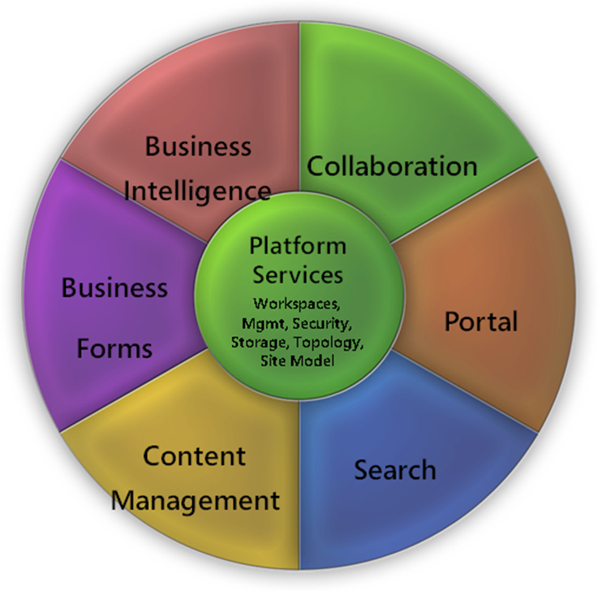
Figure 1 – Office SharePoint Server 2007 feature areas
The feature areas are as follows:
- Collaboration The enabling technologies that allow teams to work together effectively, providing intuitive, flexible, and secure mechanisms for sharing information through the use of wikis and blogs, collaborating on and publishing documents, maintaining task lists, conducting surveys, developing and maintaining site templates customized for specific business uses, and implementing workflows.
- Portal The facilities that provide the capabilities to personalize the user experience of an enterprise Web site, to target content to various audiences based on sets of rules, to automatically facilitate intuitive navigation through the Web site while tailoring the navigation to the individual rights of the user, to deliver comprehensive site content management and structural facilities, and more.
- Enterprise Search The critical ability to quickly and easily locate relevant content distributed across a wide range of sites, document libraries, business application data repositories, and other sources, including files shares, various Web sites, Microsoft Exchange public folders, and Lotus Notes Databases — and to find the appropriate people who can help answer questions or be involved in projects.
- Content Management The facilities for the creation, publication, and management of content, regardless of whether that content exists in discrete documents or is published as Web pages. Content management scenarios include document management, records management, and Web content management.
- Business Forms and Integration The ability to rapidly and effectively implement forms-based business processes, from design to publication to user access, by using standard Web browsers or a rich client application such as Microsoft Office InfoPath 2007. Also includes the ability to connect with structured systems such as databases and line-of-business applications, and the ability to access that information in a number of ways.
- Business Intelligence The ability to deliver information critical to business objectives through a wide range of mechanisms, from server-based spreadsheets accessing business data in real time and performing sophisticated analyses to the presentation of key performance indicators (KPIs) through enterprise Web sites.
In this section, we’ll review each of these functional areas.

Collaboration
Collaboration is one of the most vital and central requirements in the majority of enterprise portal implementations. The core collaborative functions in Office SharePoint Server 2007 are provided by the underlying technologies of Windows SharePoint Services 3.0. Enhancements in Windows SharePoint Services 3.0 make it easier than ever to share documents, track tasks, use e-mail effectively, and share ideas and information. All of the features and services provided by Windows SharePoint Services 3.0 are available in Office SharePoint Server 2007 installations.
For a more-detailed review and guidance on evaluation of Windows SharePoint Services 3.0, please refer to the Evaluation Guide.

Portal
A notable difference in the name of Microsoft Office SharePoint Server 2007 is the absence of the word “portal.” Office SharePoint Server 2007 is more than a portal solution providing rich features and functionality. The very term “portal” has a range of connotations for different people and organizations, and any solution that purports to deliver portal capabilities must by definition be extremely flexible and adaptable to each organization’s unique requirements. Office SharePoint Server 2007 is such a solution; it builds on top of the technologies in Windows SharePoint Services 3.0 to provide personalization and targeting capabilities that organizations need to build flexible solutions for a large user base.
As varied as the specific requirements may be, there are some common functional areas that tend to be required in enterprise portals. Office SharePoint Server has the following capabilities:
- Personalization The ability of enterprise content to be accessible and deliverable in customized ways, whether by the individual user or as content to be targeted to individuals or groups.
- User profiling The functionality to profile each individual user’s preferences, skills, and memberships within enterprise communities; this can be not only the method by which personalized content “finds” individuals, but also how those individuals are made visible by the enterprise.
- Navigation The capability of the portal to automatically present intuitive, comprehensive, and tailored navigation within the portal; the objective is to enable the user to navigate through potentially complex portal hierarchies with the greatest ease.
- Audience targeting The ability of an enterprise to make the appropriate content visible to the appropriate people; allowing the content to find its way to the individuals to whom it will be most relevant.
- Web Parts The existence of “mini applications” that can deliver content in highly customized ways, defined by application logic and/or user preferences, presented within a portal context alongside other content that the user requires.
- Site structure and content The ability for the user to explore the structure and contents of the portal and its subsites, in a manner that tailors the view to individual users based on security permissions.
- Site and library aggregation and roll-up The ability for individuals to contribute content to a wide range of areas within a portal — for example, various sites and subsites, document libraries, and event lists — and the ability for these individuals to be able to quickly locate that content, however widespread it is across the portal.
- Templates The ability for sites, subsites, libraries, and lists to be made available through a common collection of templates that ensure an interface consistency that maximizes the individual user’s capability to quickly utilize each area. A template-based approach ensures this; it also must provide the ability of non-IT users to quickly select a template from an available suite of templates that are intended for specific purposes, and that will integrate seamlessly into the portal infrastructure.
Each of these functional areas is covered in the following sections.

Personalization
Finding and targeting relevant content can be a tremendous challenge in large sites. Nowhere is this more true than within corporate intranets. The problem can be reduced by allowing users to personalize the site and to have the site personalize content for the users. Personalization represents the ability of content to be tailored to an individual user. If the site allows it, the user should be able to create his or her own custom sites, specify content preferences, and receive targeted content based on the user's interests or the subscribed online communities. If these capabilities are enabled and well-managed, the end result is more-effective delivery and use of information and applications on the Web site, and an improved ability for users to get quick access to the most relevant information and applications that will help them do their jobs.
Office SharePoint Server 2007 has extensive capabilities to enable and manage personalization. There are three important and distinct aspects to how this is achieved:
- User-maintained site customization ("By Me"):
The user creates his or her own site ("My Site") and personalizes it by selecting content relevant to the user’s occupation, position, skills, and interests; the view of this information may be further customized by applying filters to the content. The user can also access content through online communities, RSS Feeds, and custom searches. The site can also include a personal blog maintained by the user to which other users can subscribe. Web Parts may be enabled for optional selection to provide content or applications that the user may need, and these Web Parts can allow user customization to tailor the content contained within them.
Use case — Personalizing Blog Views: Dave Richards (Director of Marketing) has created a new blog on his personal Web site for information about marketing resources. Product Manager Jesse Merriam wants to have the most recent postings to this blog visible on her personal site. She finds Dave’s personal site, and on his personal home page sees the “blog” link. She copies the URL of Dave’s blog page and adds a new Recent Blog Posts Web Part to her page, and then she changes the URL of the Web Part to that of Dave’s new blog. Now the most recent posts to this blog will always be visible to her on her home page.
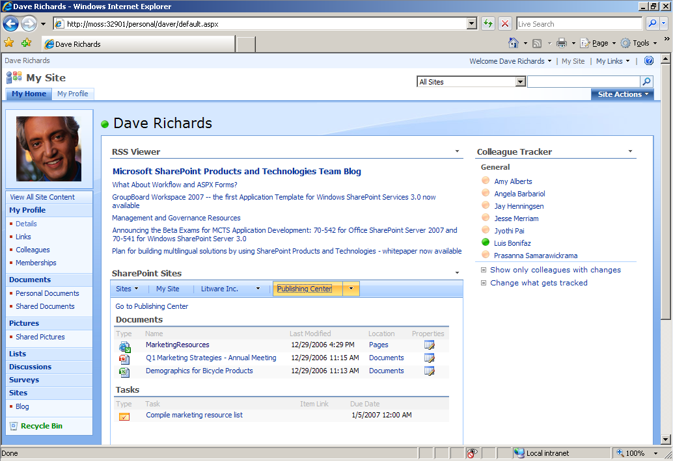
Figure 2 – Sample My Site page of Dave Richards’ personal Web site

- Information about the user ("About Me"):
This can include relevant metadata about the user based on their job description, department, membership in Active Directory directory service groups, subscription in online communities, or user-supplied information about specific interests or skills.
This information can be used to target content to the user, tailor site navigation to the user’s areas of interest, and enable more effective “people searching” (the ability to search for people on a site based on interests or abilities). Audience definitions can be built upon this information to allow rules-based content targeting.
User blogs can provide useful information to others within the organization by providing direct insight into the user’s abilities through their blogs, and the blog content can be indexed and searched.
Equally important to making user information available is the need to protect that information. For example, a user may want their phone number to be made available only to certain other people — such as the user’s manager.
Use case — Defining Personal Profile Data: Product Manager Jesse Merriam needs to update her profile information to make it easier for others within the organization to find her based on her skills. She navigates to her My Profile page and selects the Details link. She notes that the portal administrator has made many of the profile properties accessible to everyone in the organization (such as Name, Title, Picture, and Responsibilities), but has allowed users to selectively determine who can access the Skills information — “Only Me,” “My Manager,” “My Workgroup,” “My Colleagues,” or “Everyone.” She leaves the default “Everyone” value selected, inserts the text “Business Case Preparation, Live Presentations, Team Building, Technical Writing” into the Skills box, and saves her profile. As soon as an incremental search crawl runs against the personal sites, the data she entered will be available for others in the organization to search.
- Information targeted toward the user ("For Me"):
Content creators often need to target information to various users across an organization. Often, this is done along organizational lines — by division or department, for example. What is also frequently needed is the ability to target users by some other dimension, such as skill set or interests.
Content — documents, pages, Web Parts, or even entire Web sites — can be targeted to specific groups of people, to subscribers to online communities, to distribution lists, or on the basis of metadata.
Use case — Targeting a Web Part: A manager having the authority to edit a Web page wants to specify that a certain Web Part on that page should appear to specific audiences only. He navigates to the page, and from the Site Actions menu he selects the Edit Page option. From the Web Part’s Edit menu, he selects Modify Shared Web Part. In the Advanced group of settings for the Web Part, he specifies the audience name in the box labeled Target Audiences and clicks the OK button, then he saves the page. (There is no workflow associated with the page, so it is now published.) Now, only users who are members of the specified audience will see the Web Part when they browse this page.

User Profiles and the Profile Data Store
To realize the full potential of personalization, a user profile data store is required. This data store will contain user preference information, such as parameters for personalized Web Parts that are used in users’ personalization sites (“My Sites”). Additional information may also be stored, such as the users’ departments, divisions, memberships in Microsoft Exchange Server distribution lists and Microsoft Windows SharePoint Services 3.0 sites, and other information.
In Office SharePoint Server 2007, a user’s personalized site (“My Site”) will contain a profile page. This page shows a user’s colleagues and memberships, in addition to what’s common between the user and a user visiting the My Site of another user. It also shows an aggregated view of the user’s documents, Web logs (blogs), and privacy-sensitive profile properties. Office SharePoint Server 2007 enables administrators to set privacy policies on user profile properties, colleagues, and memberships, and to restrict who can access personal information. Subject to these policies, users can limit the visibility of properties, colleagues, links, and memberships to Only Me, My Manager, My Workgroup, My Colleagues, or Everyone.
An important aspect of user profile information is that it can be used as the basis for “people searches” — finding other individuals across the organization based on interests, skills, and other characteristics.
The initial definition of much of the user profile data will likely reside in other areas of the enterprise: the Active Directory directory service, LDAP directories, and/or enterprise applications. Active Directory data can be directly imported into the user profile data store; user information from LDAP directories can be imported as well.
After data is available in the user profile data store, users can update and supplement the information in their profiles. For organizations that support multiple languages, information can be supplied in as many languages as are implemented in the portal; for example, a user’s job title could be available in English, French, German, and Spanish — the value used would be dependent on the client language/culture settings of the user accessing the information.
The most immediately obvious use of user profile data is in the user’s personalized site (“My Site”). The user creates and configures a customized view of the portal, and the preferences defining this view are stored in the user profile data store. In addition to “My Site,” Office SharePoint Server 2007 enables the creation of “Personalization Sites” that provide personalized views of a site to the user. These sites use audience targeting to display personalized information such as “My HR” and ”My Sales.”
Office SharePoint Server 2007 automatically adds a user’s manager, peers, and direct reports as the user’s colleagues. In addition, Office SharePoint Server 2007 allows the addition of colleagues (people the user knows), allowing easy navigation to colleagues’ My Site public pages. Office SharePoint Server 2007 also provides a Colleague Tracker Web Part on My Site, which keeps the user informed about changes for the user’s colleagues. Also, when searching for people in the organization, results can be grouped by social distance so that colleagues are displayed first.
User profiling is further employed to implement the concept of “shared context” for individual users. When one user visits another’s profile page, Office SharePoint Server 2007 shows all the commonalities between the two users, such as:
- Their common manager
- The distribution lists and Windows SharePoint Services 3.0 sites of which they are both members
- The colleagues they have in common
User profiles provide the basis for audience targeting based on rules-based audiences, in addition to providing a search scope for people. Users can find people by name or by users’ public profile properties. The Enterprise Search feature in Office SharePoint Server 2007 supports property-based querying, social distance grouping, search refinement, and richer search results.

Use Case — Managing Personal Profile Information: Diane Tibbot wishes to make her most important skills more visible to the organization as a whole, while at the same time limiting access to some of the information about her to only those within her immediate team. From her My Site page, she clicks the My Profile tab, and she sees a representation of her position within the organization, a list of her most valued colleagues, her memberships in various distribution lists, and links to both internal and external sites that she wishes to share with her colleagues. She clicks the Details link in the “Quick Launch” navigation area, which takes her to the Edit Details page where she is able to maintain her profile information. She sees that she is unable to modify certain items, such as her name and position. Some fields, such as a personal portrait image of her, are available for her to modify, but administrative policies have been set that will allow everybody within the organization to view this image. She enters text in the Skills field: “Project Management, Conflict Resolution, Team Building.” She is then able to select, from a menu, the range of people who will be able to see this content. The menu allows Only Me, My Manager, My Workgroup, My Colleagues, or Everyone. For Skills she chooses Everyone. She also wishes to make her mobile phone number available to those members of her immediate workgroup, so she enters the number in the Mobile phone field and selects My Workgroup from the menu beside this field.

Navigation and the Site Directory
Naturally, navigation through a portal must facilitate quick, intuitive access to those areas both accessible and relevant to users of the site. Regardless of the portal’s structure, there will be certain “global” links to commonly used areas within the portal (for example, Help or Support), in addition to areas that are “global” in context for the individual user: My Site and My Links. Site-wide global links can be assigned by site administrators (typically represented as a navigation “tab” across the top of the page). In the templates supplied with Office SharePoint Server 2007, authenticated users will see a My Site link visible at the top of all pages, along with a My Links menu that the user can modify and maintain — enabling rapid access to the personalized view of the portal in addition to the sites (internal and external) that are most important to the user. The advantage of a portal-based My Links menu over the usual browser-based “Favorites” menu is that the My Links menu is available to authenticated users regardless of what computer they may access the portal from.
The next critical element in navigation is the dynamic presentation of links to sites to which the user has access. In the template designs supplied with Office SharePoint Server 2007, these links appear as tabs in the upper area of the browser window, and they include not only links to those sites that the user can access but those that have been targeted to the user.
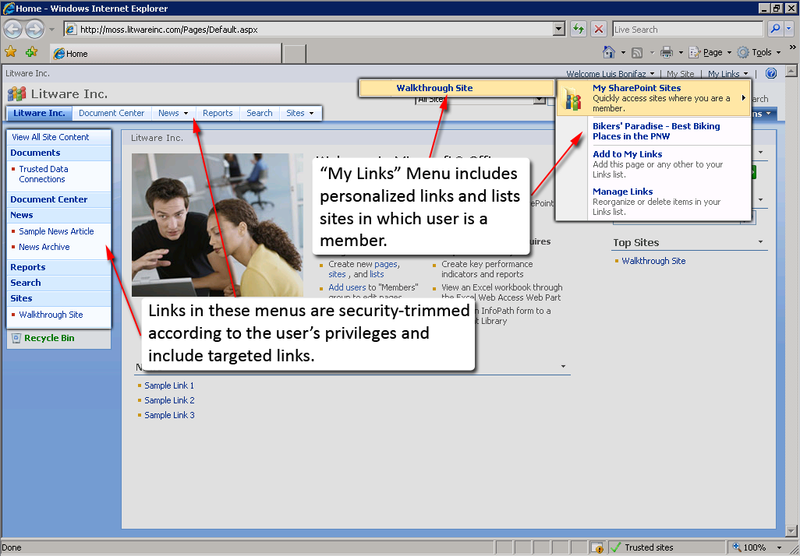
Figure 3 – Portal home page showing personalized navigation
In Office SharePoint Server 2007, site navigation controls use the ASP.NET provider model as a means to bind navigation controls to the underlying site hierarchy. The default controls are the Menu and Breadcrumb controls; they bind to the underlying PortalSiteMapProvider data source. The Menu control creates dynamic fly-out menus based on the site hierarchy; authored (“static”) links can also be added to the menu without writing any code. (In addition, the appearance and behavior of this menu is extensively customizable.) The Breadcrumb control renders a breadcrumb path from the top of the site map to the current location within the site.
For site designs that require completely unique navigation behaviors and appearances, a developer can implement custom navigation controls. The recommended approach is to use controls that can bind to an underlying site map provider as a data source, thereby separating the data and presentation layers in the Web application. The existing Office SharePoint Server 2007 navigation controls can be subclassed and modified for this purpose; in addition, the standard ASP.NET 2.0 Menu, TreeView, and SiteMapPath controls can be employed. These controls all support the provider model. And, of course, the developer is free to implement completely custom controls of unique design for the site; the Office SharePoint Server 2007 Software Development Kit (SDK) provides an extensive and comprehensive set of .NET classes that can be employed to create dynamic site navigation that will satisfy a virtually limitless range of varying requirements.

The Site Directory
An early step in building a portal is defining its overall site and subsite structure. Navigation helps guide the user to different sites and subsites in the portal; however, as the portal grows in size and complexity, traversing the hierarchical structure can pose practical challenges. There may be subsites that are commonly referenced by other subsites, and some sites may be completely external to the portal and their hierarchies not automatically discoverable by the portal’s default navigation. Large organizations typically need to define a number of categories to allow the presentation of information in the context of the organizational structure or lines of business.
Solving these problems is the role of the Site Directory in Office SharePoint Server 2007. Any site can be assigned to any number of different categories in the Site Directory. Sites may be internal or external; they do not need to be a physical part of the portal. The Site Directory can provide a quick view of the possible categorizations in the portal. Normally, the Site Directory becomes a part of the portal’s global navigation; a link to the Site Directory is always available wherever a user goes within the portal.

Use Case — Creating Multiple Categorizations for a Site: Director of Marketing Dave Richards has created a new site with information about a new set of service offerings that his company is targeting to customers and licensed retailers. He wishes to have this site categorized under both “Marketing Initiatives” and “Services.” (The portal administrator has already created these categories by navigating to the Sites Directory, selecting Edit Page, and clicking on the link labeled “Create New Category.”) From the home page of the corporate portal, Dave clicks the Sites tab across the top of the page. He now views the Site Directory. He selects the appropriate values under both the “Marketing Initiatives” and “Services” categories. Now, when users browse the Sites Directory and click either of these two category values, they will see Dave’s new site.

Audience Targeting
By using targeting, content can be targeted in the portal site for viewing by one or more specific audiences. Office SharePoint Server 2007 supports targeting based on rules-based audiences, Microsoft Windows SharePoint Services 3.0 groups, and distribution list memberships. These audiences can span one or more portal sites in a deployment. In addition, Office SharePoint Server 2007 provides the ability to target any list item, not just listings. This means that virtually any individual item within the portal — documents, events, custom list items, and even entire sites — may now be targeted to audiences.
Use Case — Targeting a Site to a SharePoint User Group: A site manager (with site management privileges) wishes to target an external site to specific user groups in the portal. He navigates to the home page of the site, and from the Site Actions menu he selects Site Settings and then Modify Site Navigation. He then clicks the Add Link… item, which opens the Navigation Link dialog box, where he can specify the URL and title of the site and can also select the user groups to which this link is targeted. After he has completed this definition, all users from the specified group will now see the external site listed in the navigation tabs wherever they navigate within the portal
Web Part content can be targeted in two different ways: 1) Web Parts can be targeted so that members of different audiences see different Web Parts on a page, and 2) by using Web Parts that recognize audience membership, items or links in a list can be targeted to one or more audiences, so that only members of those audiences can view the targeted items within the Web Parts. For example, in a default area called Human Resources, a site administrator or the manager of that area could add a news item within the News Web Part. This item could be targeted to an audience composed of all new employees, directing them to the New Employee Benefits site.
Audiences are created through the central administrative interface. They are defined by Shared Services Provider (SSP) administrators in the Application Management page for the core services of the server farm providing the Audiences Shared Service. The SharePoint Central Administration Web site interface presents a simple set of options for defining the rules that apply to the audience. For more complex rules, Office SharePoint Server 2007 provides the Audience Object Model, which can be accessed programmatically to create and modify audiences.

Web Parts to Make Content Easier to Find
Office SharePoint Server 2007 includes a variety of Web Parts that are designed to allow users to find content quickly and easily. Two of these Web Parts are highlighted here: the Site Aggregator Web Part and the Content Query Web Part.
The Site Aggregator Web Part is used on the personalized site (“My Site”) to enable a personalized menu that will allow navigation to sites frequently required by the user. More than just another “Favorites” menu, sites selected in the Site Aggregator Web Part are displayed in line in the user’s personalized page. These sites can be other portal sites or completely external sites.
The Content Query Web Part is a general Web Part designed to enable the configuration of specific queries for placement on portal pages. Queries can be customized to filter specific content types; any SharePoint list type can be used, such as documents and other list items. Other filters may be applied, and audience filtering may also be used; in this way, the Content Query Web Part can be used as a vehicle for content targeting.
Use Case — Adding a Custom Query for Wiki Pages with a Specific Keyword in the Title: A site designer wishes to add a Web Part to the right zone of a site page to show wiki pages that use a particular keyword in the titles. She selects Edit Page from the Site Actions menu, and in the right zone she clicks the Add a Web Part link. She selects the Content Query Web Part and is presented with the properties pane for that Web Part. Under the List Type property, she selects Wiki Page Library, and for the Content Type she selects Publishing Types and Pages. Under Additional Filters, she specifies that the Title should contain the keyword she requires. She clicks OK and publishes the new version of the page. Now, the results of this query will appear in the right zone of the page whenever anyone views this page.
There is a very comprehensive set of additional Web Parts that are suitable for a wide range of additional applications in areas such as business data access, RSS Feed monitoring, key performance indicators, summary links, and searches — to name only a few. For more details on the full complement of pre-built Web Parts, consult the documentation for Office SharePoint Server 2007.

Site Content and Structure
As a portal grows, the structure of its content becomes more complex and varied. Not only are there sites and subsites to manage, but within sites and subsites there may be a combination of document libraries, folders, documents, pages, tasks, meeting workspaces, blogs, wikis, and more. A coordinated structure to navigate through this heterogeneous hierarchy quickly and easily is essential.
Office SharePoint Server 2007 addresses this problem with the Site Content and Structure page, also known as the Site Manager. This page presents a view of the hierarchy in an intuitive format similar to Windows Explorer, allowing access to all levels of a site collection and all the objects contained within it. Each object will be selectable, and the actions available will be those applicable to the selected object’s type. For example, the following figure shows the action menu available for a selected page object:
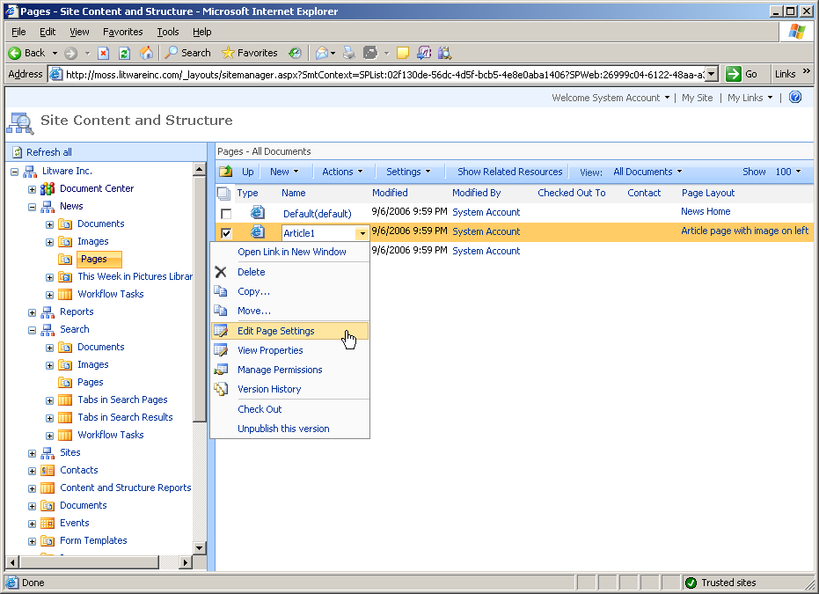
Figure 4 – Managing the site by using the Site Content and Structure page

SharePoint Sites and Documents Roll-up Web Parts
“My Site” is a personal site that provides users with a central place to manage the documents that they have created, opened, saved, or checked out on any Office SharePoint Server 2007 site across the portal. Users can view and work on their documents privately or share them on their public pages. They can also use their My Sites to view and access all of the tasks that are assigned to them in every site in the organization.
Users can easily access all of the documents they have saved and all of the tasks that are assigned to them by using the SharePoint Sites Web Part on their My Site pages. A user may want to add a site to the bar along the top of the Web Part, so that the user can quickly navigate to these sites with a single click.
The SharePoint Sites Web Part on a My Site page is useful for listing all of the documents a user has created, saved, or modified in any site in the organization. The SharePoint Sites Web Part automatically displays documents for five sites where the user is listed in the Site Name Member SharePoint group. The SharePoint Sites Web Part also lists any tasks that the user is assigned in any site. Users can add as many sites as they want to the SharePoint Sites Web Part.
The Documents Web Part on a user’s public page allows the user to share documents with other people. All documents the user has saved to every library in the organization (except for the user’s private document library) automatically appear in the list for other people to access. The user can change the permissions on list items and libraries to prevent them from appearing in the Documents Web Part.
Use Case — Finding a User’s Own Documents: An information architect, who is involved in several different projects, has published documents in different document libraries across the portal. She wishes to see a list of all of her documents in one location. In her My Site on the SharePoint Sites Web Part, she has added links to all of the sites of which she is a member. When she clicks the link for each site, under the Documents heading she will see all of her documents listed; she can access them directly from this location.

Portal Site Templates
Two key functional requirements for building portals quickly and effectively are: 1) that they should be based on templates that implement a consistent user experience and 2) that can be selected and implemented by business users who may have little or no expertise in technical Web site design or development.
Another key requirement is that the templates can be fully customized to deliver a customized look and feel, as determined by the organization’s requirements; these organizations should not be limited to design aspects inherent in the prototypes supplied with the software. This is particularly essential in the creation of public-facing sites, where organizational branding is critical to presenting and maintaining a unique Web identity to the public.
These requirements are fully addressed in Microsoft Office SharePoint Server 2007. In addition to a set of collaboration and meeting workspace templates (that are also included with Microsoft Windows SharePoint Services 3.0), Office SharePoint Server 2007 extends the suite of templates with two additional groups:
- Enterprise: Templates for general use in portal sites to be made available across an organization.
- Publishing: Templates for sites displaying published content, from both internal and public (external) perspectives.
The templates included are fully functional, enabling an organization to rapidly deploy a wide range of portal sites and functions. They can also be viewed as starting points for organizations that need to go beyond the functions of these templates.
Use Case — Creating a New Site: A site administrator wishes to create a new publishing site as a subsite to the main intranet site. From the main site’s Site Actions menu, he selects the Create Site link. On the New SharePoint Site page, he enters a site title and description, and specifies a URL. Under the Template Selection heading, he selects the Publishing template group tab. He then selects the Publishing Site with Workflow template. Accepting the defaults for permissions and navigation, he selects the categories to be assigned to this new site (as they will be displayed in the Sites Directory) and then clicks the Create button. The Operation in Progress page is displayed while the site is being created. After the operation is completed, the new site is displayed and ready for use.
As always, with SharePoint-based templates, the layout is fully customizable. As new sites are built by using these templates, the new site implementations can be saved back to the data repository to be used as new templates for further sites; these templates will include layout and functional elements, and can also include default content as well.

Enterprise Search
Note: For more details about Search in Microsoft Office SharePoint Server 2007, download the Evaluation Guide.
Office SharePoint Server 2007 is the flagship product for Enterprise Search. Search in Office SharePoint Server 2007 has undergone a dramatic evolution in this release, with an extensive new set of features that provides powerful and advanced search features across the portal with increased relevance.
The newest generation of Search functionality in Office SharePoint Server 2007 provides an intuitive and flexible user interface, improved relevance, and the ability to search unstructured and structured information such as databases and line-of-business applications. Search in Office SharePoint Server 2007 also includes powerful tools for performing advanced queries. Property-based searching can be accomplished through advanced searches (and — for the power user — direct input of property keywords in any search box) to allow extensive flexibility in forming search queries. “Did you mean?” functionality is included for handling unrecognized keywords that may have been misspelled. Advanced duplicate result handling is also built into the solution; not only are exact duplicates handled appropriately, but near-duplicates are handled as well. Duplicate search results are indicated by a “Duplicates” link under an individual search result; the user can review the duplicates by clicking on the link.
Search in Office SharePoint Server 2007 includes the ability to control the scope of queries (and, of course, make these controls available to end users), in addition to new abilities to index a wider range of content sources and types, including business data.
Search in Office SharePoint Server 2007 also delivers the ability to search for people, based on their knowledge and other factors (such as membership SharePoint-based audiences). The ability to quickly get in touch with the appropriate people who can answer a question or help with a set of problems will enable much more efficient business processes across the enterprise; employees will find smarter and better ways of working together as a result.
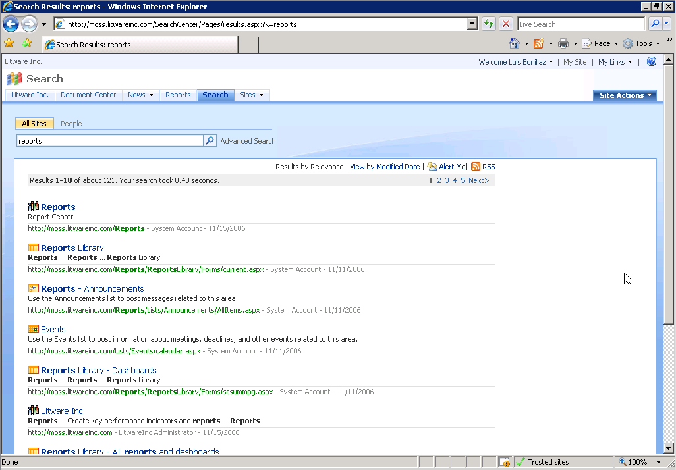
Figure 5 – Search Center Search Results page showing query keyword highlighting (bold characters)

Relevance
The relevance of search results is very important for finding the appropriate information and people and — ultimately — for user adoption. A wide range of attributes helps determine the relevance of information such as a document, a Web page, a business database, and other forms of content. Search in Office SharePoint Server 2007 takes into account these attributes to maximize the relevance of results. The search engine is specifically tuned for the unique requirements of searching enterprise content; these requirements include:
- Searching document content and line-of-business application data in addition to Web content.
- Producing high-relevance search results despite the lack of rich linking information available in document content and line-of-business application data.
- High security and content access controls.
Some elements of the new relevance algorithms include:
- Click distance A measure of the distance of a document from an authoritative home page
- Hyperlink anchor text The text used in a link that points to the document
- URL surf depth A measure of the depth within the site that the document’s URL represents
- Missing metadata creation Automation of the metadata from page content (for example, title)
- Automatic language detection Determination of the language in use on a page from its content
The most recent enhancements in Search in Office SharePoint Server 2007 create dramatically improved relevance of results across all queries, and even greater improvements in the case of common queries. Tests have shown that results are 100% better on all queries and 500% better on common queries when compared to the previous version.
Use Case — Doing Anecdotal Research: An analyst at a large legal firm is interested in studying the applicability of Force Majeure clauses in litigation cases that the firm has undertaken. Case historical documents at this firm have been indexed by using Office SharePoint Server 2007, and they are accessible from the firm’s Office SharePoint Server 2007 site. In the site’s Search Center, the analyst performs a search query on the keywords “force majeure litigation.” Without advanced relevance enhancements, simple search algorithms would typically give higher rankings to documents that simply contain all three keywords; for a large law firm, this would likely return a huge set of results, many (if not most) of which would not be relevant to her needs. The relevance features in Search in Office SharePoint Server 2007 are likely to give higher rankings to documents where Force Majeure is a key topic in the documents for specific litigation cases. With the most relevant search results listed first in the result set, the analyst is likely to spend significantly less time finding case histories that are relevant to her research.

People Search
A key to working effectively within any organization is knowing the appropriate people to get in touch with for expertise. Within a large organization, this can be a significant challenge. Search in Office SharePoint Server 2007 provides assistance:
People Search: Portal users can maintain information about themselves on their profile pages in their personal sites. This information can be indexed by Office SharePoint Server 2007 and used in queries. (For security and privacy reasons, the user may choose to restrict access to some information to only certain groups of people; security policies are set and managed by the site administrator.)
Often, the relevance of the results in people searches can be aided if the people contained within these results are grouped by “Social Distance” — the relationship of these individuals to the person performing the search. Social Distance categorizations include “My Colleagues,” “My Colleagues’ Colleagues,” and “Everyone Else.”
Use Case — Finding the Appropriate Project Manager: A business development manager within a large organization is in search of a project manager for a new application development project. He is particularly interested in finding someone who has extensive project management expertise, while also being familiar with the members of his own development team and the business issues handled by his department. In a people search query for “project management experience,” social distance will help him assess suitability of potential project managers; those more “distant” from his team may be less suitable than others who are closer. In addition, those who are closer to his group are more likely to understand his department’s primary business drivers.

Business Data Search
In many (if not most) common portal implementations, content indexing and search tend to be limited to Web pages (published pages, online discussion groups, and blogs) and documents. What is often missing in these search scenarios is the ability to search actual line-of-business application information along with the other common content types. This might often include data from enterprise resource planning (ERP) or customer relationship management (CRM) applications, but it might also include custom business applications. Microsoft Office SharePoint Server 2007 includes the ability to index content accessed through the Business Data Catalog (see the section titled “Business Data Catalog” elsewhere in this document), and to treat this data just like data from any other search source. Search in Office SharePoint Server 2007 can index Business Data Catalog data directly; there is no need to write code to access the data, and search pages can be extensively customized to use it.
Use Case — Searching Customer Data: A large sales organization utilizes a customer relationship management (CRM) system that contains information about the organization’s account management hierarchy in addition to customer contact information. People in this organization need to be able to search this information, just as they would search for people or content within the company. An application definition (an XML file that defines database connectivity and required entities) is created by using administration and development that maps the connection to the CRM database and data views contained within it. This application definition is imported as a Business Data Catalog application. In this Business Data Catalog entry, the required entities from the application are configured. The Business Data Catalog is then defined as a content source to Search in Office SharePoint Server 2007, which is then scheduled to crawl this data at regular intervals. The Search Center page is customized to add a “CRM” tab that enables the user to search this business data. Now, users can query CRM data through the same search page they use to locate content and people within the organization.

User Experience
Search in Office SharePoint Server 2007 represents a major overhaul of the user experience of search when compared with the search component in SharePoint Portal Server 2003. The end-user interface for search (the “Search Center”) has a new extensible tab metaphor, allowing the user to select custom search types — searching for general content, people, and business data. In addition, the customizability and extensibility of the end-user interface is more powerful than before, with many more Web Parts and features. The Advanced Search options include the ability to specify metadata values and ranges, and the search control allows the use of special keywords to specify additional search parameters.
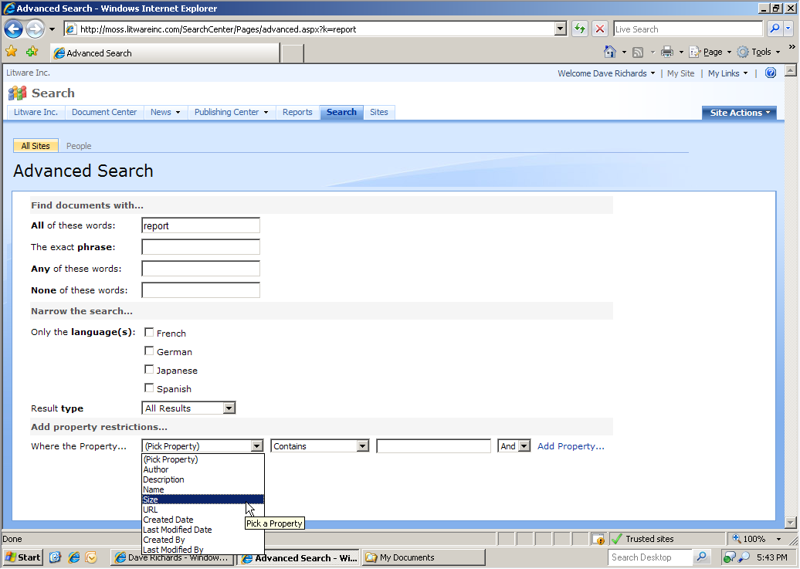
Figure 6 – Advanced Search in the Search Center, showing metadata property selection
Search Administration
The new administrative interface for Search in Office SharePoint Server 2007 presents a streamlined, clear, consolidated overview of search activities, crawl status, content sources, scopes, and relevance settings.
The search administrative interface has many new enhancements. One such enhancement is the ability to monitor the crawl logs while searches are in progress. Log events can also be filtered by time; URL or site; content source; status type (All, Success, Warning, Error); and last status message.
Through the search administrative interface, all metadata properties that are crawled can become “managed properties.” Managed properties allow an organization to have one global name for a specific property that might map to different properties in the various data sources crawled. For example, you can map “Customer Name” and “Organization” metadata from two different sources to the managed property “Name.” These managed properties can then be used to filter query results, or they can simply have their values displayed in the results. The user interface is simple and intuitive, and it can be applied to any defined content source.
For new content sources, such as Business Data Catalogs, the end-user search interface can be modified and extended simply by editing the search page and adding a new search results page. This can be done entirely from the browser within the portal. There are many new Search Web Parts that can be employed to customize the behavior and available options in the Search Center’s search results page.
Use Case — Adding a New Search Tab for Business Data: A site administrator wishes to add a new tab to the main search page that accesses a new Business Data Catalog entry, which has just been added to the system and crawled by Search in Office SharePoint Server 2007. From the Search page’s Site Actions menu, he selects Edit Page. To add the new tab, he simply clicks the Add New Tab link, and specifies a name for the new tab (for example, Customers) along with a page name (for example, Customers.aspx). He then clicks OK and publishes the page. Next, he selects Create Page from the Site Actions menu, specifies a title using the same URL Name (for example, Customers to match the Customers.aspx URL on the search results page), selects the Search Results Page layout, and clicks Create. When the page is created, the edit mode is displayed, where the administrator can modify or add Web Parts. Next, he modifies the Search Box Web Part to specify the URL of the search results (Customers.aspx in this example). He then edits the Search Core Results Web Part and, under the Results Query Options group, he clicks the ellipsis (…) button next to the Selected Columns text box; he can paste in XML that enumerates the columns from the Business Data Catalog data that he wishes to use in the query results. Next, under Data View Properties, he clicks the XSL Editor button where he places custom XSLT code to render the results by using the custom columns that he specified in the XML above. Finally, he needs to add a new search tab to this new page, in exactly the way that he added the tab to the main search page above (that is, Customers and Customers.aspx), and publish the page. Now, he has a new tab for searching the Business Data Catalog data and presenting results in a customized layout. (Note: XML and XSLT editing can be accomplished by using a text editor and the new Office SharePoint Designer 2007.)

Security
The main bulk of security management in Office SharePoint Server 2007 comes from the underlying security support contained within Windows SharePoint Services 3.0 and Internet Information Services (IIS). A new support feature is pluggable ASP.NET authentication — a provider-based authentication model that supports LDAP, Microsoft SQL Server 2005 database software, single-domain Active Directory directory service, and Active Directory Federation Services (ADFS, available in Windows Server® 2003 R2). (For a more-detailed discussion of these features, consult the Windows SharePoint Services 3.0 documentation.) The combined security management features in Office SharePoint Server 2007 have several benefits for search that are highlighted here.

Pluggable Authentication Support and Search Crawling
With the new Windows SharePoint Services 3.0 support for ASP.NET 2.0 pluggable authentication, Search in Office SharePoint Server 2007 is capable of completely crawling all required content across the portal while still ensuring that search results can be dynamically trimmed to match the user’s access rights.

Default Content Access Account — Full Read Only
In previous iterations of the search engine, the crawler required administrative privileges to ensure that all content could be successfully crawled. With Search in Office SharePoint Server 2007 for Search, this has been limited to Full Read Only; the crawler needs no administrative privileges to successfully complete a crawl.

Selective Removal of Single Items
Occasionally, it may happen that an item is indexed during a crawl that should not be there. The new version of the search function contains the ability to physically remove individual items from the index so that they will no longer appear in search results.

Query-Time Security Trimming
While navigating through an Office SharePoint Server 2007 portal, the collections of sites and items available for access by the user are always “trimmed” to include only those items that the user is authorized to access. This is also true of query results in searches. When viewing the results of a search, a user will never be able to see a link to an item that he or she cannot access. A new security feature with Office SharePoint Server 2007 is the ability to add a custom query-time security trimmer to enhance this process even further to address unique requirements.
Use Case — Utilizing Different User Views of Navigation: Two employees in an organization are in different divisions. The enterprise portal administrators have made several top-level sites available to all users in the organization. Divisional sites are also created at the top level of the portal, but these have been configured such that they are accessible only to employees of those respective divisions. When each employee opens his view of the enterprise portal home page in a browser, the tab navigation displays the top-level sites available to all employees. In addition, each user sees tabs for the divisional sites to which he belongs, but not for those sites for which he does not have access. Quick Launch navigation (that is, on the left side of each portal page) is similarly trimmed according to the areas to which each user has access. Even if one of the employees knows the URLs of the other divisional sites, he will not be able to access them without logging in with user credentials that have access to those sites.

Search Extensibility
Office SharePoint Server 2007 includes a comprehensive and powerful object model that can be employed in extending search configuration and functionality. The API includes interfaces to search administration in addition to invoking queries. When combined with the flexibility of access to virtually any content source, whether documents, Web pages, or business data, the integration opportunities are virtually limitless. Extensibility scenarios include:
- Taking advantage of the Search XML Web Service on a non-SharePoint site by accepting keywords in a text box and displaying the returned results.
- Building custom protocol handlers and iFilters to extend the indexing capability.
- Developing custom search applications that take advantage of the underlying engine and passing custom queries.

Search Manageability and Scalability
Search management and scalability have been dramatically improved in Office SharePoint Server 2007:
- Simplified Administration UI: As discussed earlier, enhancements to the administrative user interface provide considerable improvements to manageability. In Office SharePoint Server 2007, virtually every setting needed from an operational perspective is in one place. This provides a bird’s-eye view of what is happening with the search, with crawls, and with propagation.
- Indexing Management: The function for indexing management has been streamlined to give the administrator more control. There is now only one index, so there is no need to worry about managing discrete indexes. The new ability to define multiple start addresses within a content source helps to manage crawling.
- Query Reporting: The best way to improve search is to understand current usage. This can easily be done by using the new Usage Reporting to obtain information about such items as volume trends, top queries, click-through rates, or queries with zero results. In addition, report information can be exported into Microsoft Excel® for further analysis and reporting.
- Performance Improvements: Key new features make the crawls faster so the content is fresher. This is accomplished through more-efficient SharePoint sites crawling and continuous propagation of indexed content. A new Security Change Only Crawl feature saves time because the administrator does not have to perform a full crawl when there are only security changes.
- Scalability: In Office SharePoint Server 2007, scalability has been dramatically improved. There is no physical limit for the maximum number of documents in one index (although the recommended document limit is 50 million documents per indexer). This is also dependent on the hardware used.
- Troubleshooting: Features are built into Office SharePoint Server 2007 to make troubleshooting easy. Administrators can deploy a Microsoft Operations Manager (MOM) pack to monitor how the crawls are working and whether queries are responding, and to watch for common errors. Administrators can also look at the crawl logs or use the crawl log UI to see the content sources and the number of successes, warnings, and errors. It is also easy to use the log viewer to enter a specific path and see why someone can’t find a document. Was it crawled? Were there any errors or warnings?

Content Management
The scope of the term “content management” has expanded dramatically with the new generation of Office SharePoint Server 2007. Now, virtually any content that an organization wishes to publish on an intranet, extranet, or Web site — whether that content be individual documents, Web pages, forms or documents, or records with strict regulatory requirements — can be fully managed within the Office SharePoint Server architecture.
The content management capabilities in Office SharePoint Server 2007 fall into three main categories: document management, records management, and web content management.

Document Management
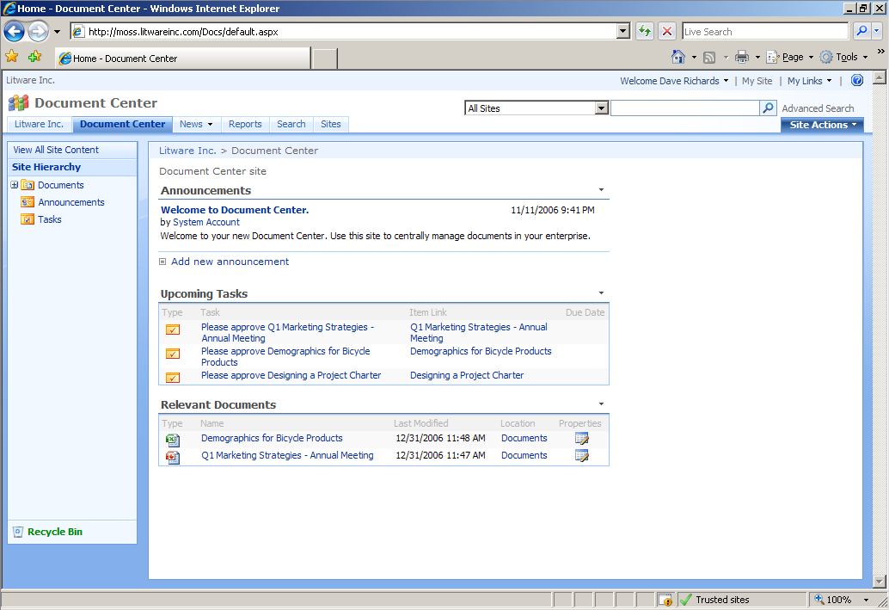
Figure 7 – Document management with the Document Center template, showing workflow tasks
Document management capabilities have been a fundamental part of Windows SharePoint Services from its original inception. The latest generation of this technology, Windows SharePoint Services 3.0, provides a host of enhancements to this document management, including the ability to check out documents locally, offline document library support in Outlook 2007, major and minor version numbering and tracking, support for multiple content types, policy enhancements, workflow integration, and tree view support. To learn more about these changes, consult the Windows SharePoint Services 3.0 documentation and product guide.
This wide-ranging set of enhancements provides a new and more powerful base on which the following Office SharePoint Server 2007 features are based:
- Document management site templates Office SharePoint Server 2007 includes enhanced document management site templates that can be used right away without further customization:
  - The managed document library site template defines large-scale document management sites.
  - The divisional library site template includes managed document libraries, dashboards, key performance indicators, and other reporting tools.
  - The Translation library site template helps organizations manage multiple translations of a document.
- Configurable workflow templates In many organizations, the ability to create and configure workflows that support governance processes is essential. Office SharePoint Server 2007 includes user-configurable workflow templates that can guide review and approval processes. The included workflows are:
  - Approval: Routes a document for approval. Approvers can approve or reject the document, reassign the approval task, or reject changes to the document.
  - Collect feedback: Routes a document for review. Reviewers can provide feedback, which is compiled and sent to the document owner when the workflow is completed.
  - Collect signatures: Gathers signatures needed to complete a Microsoft Office document (started from within an Office client application).
  - Disposition approval: Manages document expiration and retention by allowing participants to decide whether to retain or delete expired documents.
Developers can also use Microsoft Visual Studio® or Microsoft Office SharePoint Designer 2007 to define custom workflows, create document-handling processes, help users collaborate through portals and workspaces, and connect users to information in enterprise business systems.
- Metadata entry All documents in SharePoint libraries have associated metadata for documents that they contain, and they include some attributes that are automatically generated (for example, creation date) and some that may be provided by the author (for example, subject or keywords). The Metadata feature is fully customizable and extensible.
- Enterprise Search The ability to index and search for content is critical in enterprise content management. Search in Office SharePoint Server 2007 (see the section entitled “Enterprise Search” elsewhere in this document) provides an extensive and comprehensive solution to this requirement.
- Slide libraries Slide libraries allow Microsoft Office PowerPoint 2007 users to share individual slides from a presentation, reuse slides, track the history of a slide, compile individual slides into a presentation, and receive notifications when a slide in a presentation has changed. Users can publish slides to a slide library from Office PowerPoint 2007.

Workflows
Workflows are available in Office SharePoint Server 2007 for all libraries and lists, to control the publication of documents and other list items. These workflows can be defined to start automatically or manually, and multiple workflows can be assigned to a library or list according to the organization’s business needs. Workflows can trigger e-mail messages to workflow participants, and a user’s workflow tasks can be displayed on pages within the enterprise portal.
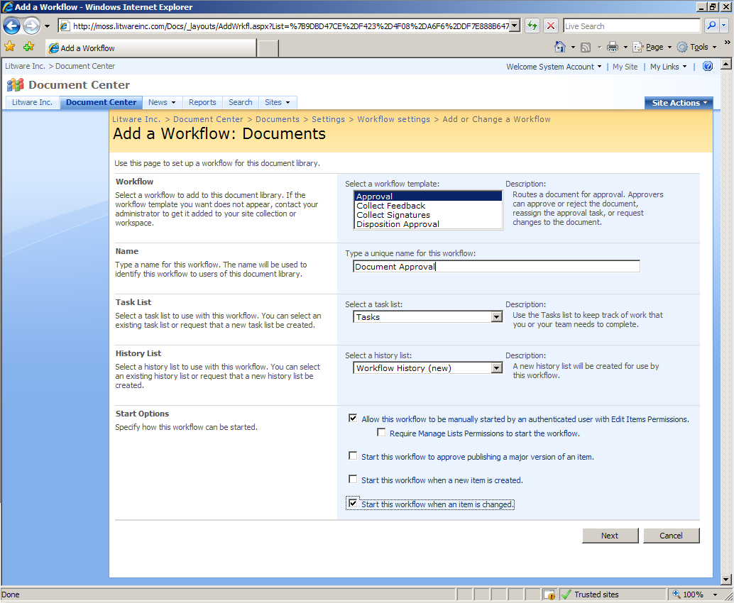
Figure 8 – Adding a workflow to a document library
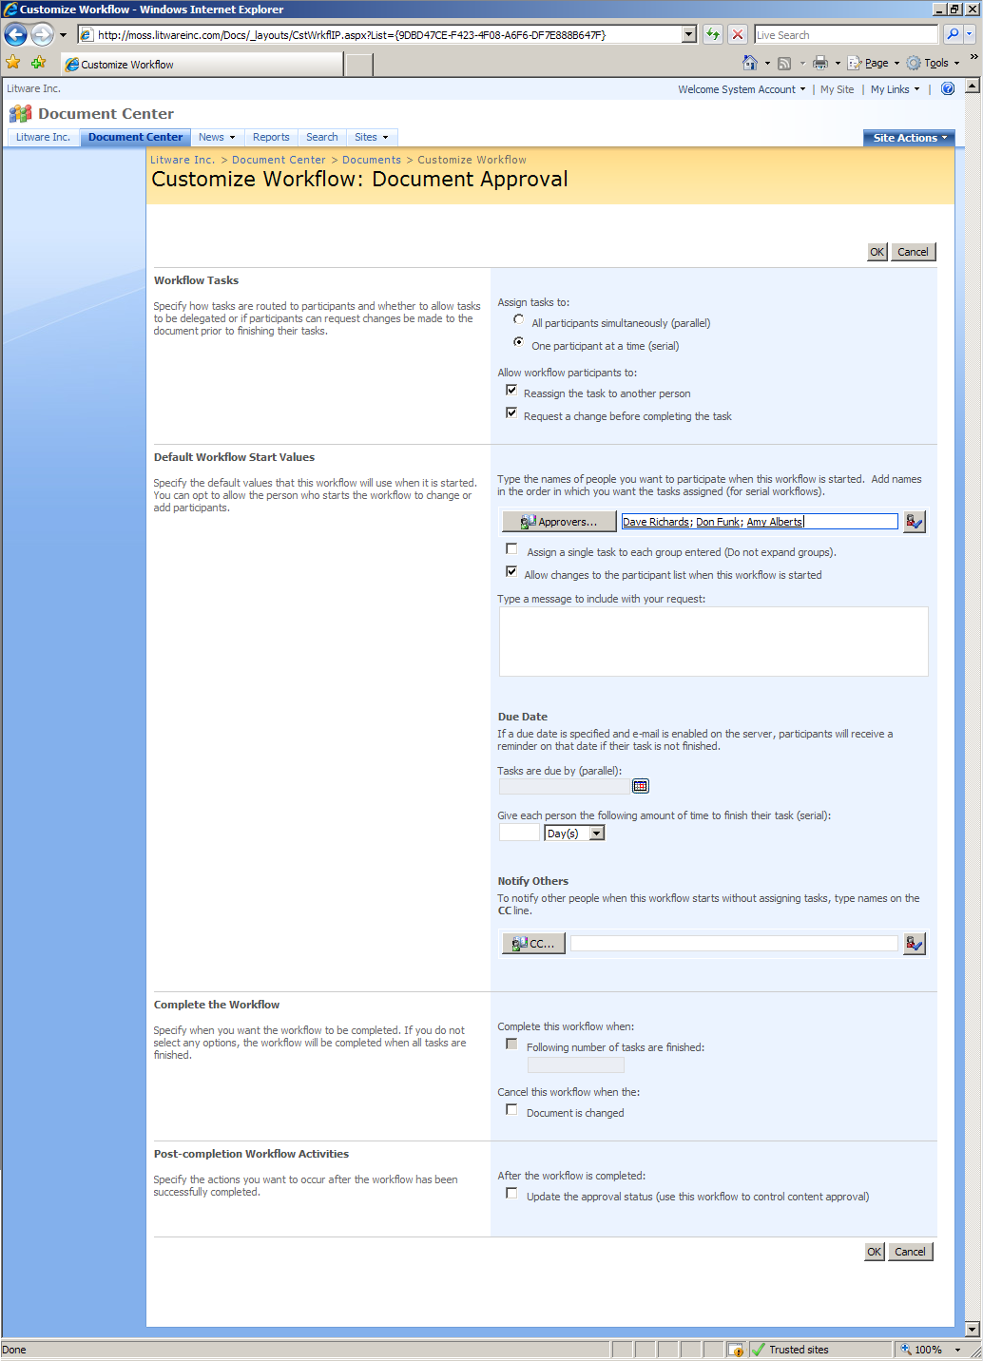
Figure 9 – Customizing a workflow
The workflow templates included with Office SharePoint Server 2007 can be applied and configured without any need for development. These pre-built workflow templates will satisfy common workflow needs in most organizations. They include options to configure the workflows in a number of ways, including the ability to specify whether a workflow is to be parallel or serial, and the ability to define the workflow participants, along with other settings.
Of course, it is anticipated that many organizations will have their own specific workflow requirements that may not be satisfied by the pre-built workflow templates. In these instances, site administrators have two options for creating their own custom workflows:
- Office SharePoint Designer 2007: The Office SharePoint Designer 2007 application can be used to visually design workflows with the assistance of the Workflow Design Wizard. This tool presents a code-free approach to designing workflows and is most suitable for site- and list-specific workflows.
- Visual Studio and Workflow SDK: Developers can implement custom-built workflows through the use of the Workflow Software Development Kit (SDK) and the visual workflow designer in Microsoft Visual Studio 2005. This is the most general environment for building organization-specific workflows that may need to be deployed across the portal.
For more information about workflow capabilities provided by the 2007 Office system, see the 2007 Office System Document: Understanding Workflow in Microsoft Windows SharePoint Services and the 2007 Microsoft Office System.
Use Case — Writing Documents and Managing Workflow: A marketing analyst is preparing an initial draft of a marketing strategy document for publication to her department’s Marketing Document Center. She completes her initial draft of the document by using Microsoft Office Word 2007 and saves the document to the main document library in the Marketing Document Center. Then she chooses to check in the document directly to the library from within the Office Word 2007 client, although she could also save the document to her desktop and upload the document to the library by using her Web browser. The document library has a serial approval workflow configured to start whenever a document is added to the library or modified, and a sequence of approvers is already configured; the analyst has the option to add new users to this sequence if needed. As she submits the document, she adds message text to the notification that will be received in the approvers’ e-mail inboxes regarding her submission; she also copies some of her colleagues on the notification e-mail so that they can view the document, although they will not be part of the review and approval workflow. The message includes a link to the document in the Marketing Document Center.
As the workflow proceeds through successive approvals, each user associated with this workflow receives an assigned task and e-mail alert to approve the document. They see these tasks when they view the home page for the Marketing Document Center, and they also see the tasks added in their Office Outlook 2007 client applications. After all members of the approval group have approved the document, it has published status, available to all who have rights to view it.

Records Management
Every organization, whether privately held, publicly traded, or not-for-profit, needs a disciplined approach to record keeping. Proper records management is vital to an organization’s knowledge management, legal defense, and regulatory compliance.
Records management is the process of collecting, managing, and disposing of corporate records (information deemed important for the history, knowledge, or legal defense of a company) in a consistent and uniform manner based on the company’s policies. These policies are shaped by the type of work the organization does, the kinds of legal risks it faces, and the laws and regulations that govern it.
Office SharePoint Server 2007 introduces a new set of features for creating and supporting formal records management capabilities in an organization:
- Policy and Auditing The Policy and Auditing features of Office SharePoint Server 2007 include:
  - Content-type and policy-based document retention and expiration schedules.
  - Auditing and reporting of policy-based actions.
  - Support for labeling and bar coding without physically modifying a document.
  - Integrated Windows Rights Management Services (RMS).
- Records repository The core of the records management implementation in Office SharePoint Server 2007 is a stable, scalable, and efficient repository built on Windows SharePoint Services. The Records Repository in Office SharePoint Server 2007 includes several important features:
  - Specialized Records Repository site templates.
  - A records vault with capabilities that help ensure the integrity of the files stored in the repository.
  - Information management policies that consistently and uniformly enforce the labeling, auditing, and expiration of records.
  - Hold capabilities that make it possible for IT staffers, lawyers, and records managers to apply one or more holds that suspend the records management policies on items to help ensure that they remain unchanged during litigation, audits, or other investigations.
  - Records Collection Interface that helps people and automated systems easily submit content to a records repository —supporting “write only” access without requiring direct access to the records in the repository.
  - Record routing that enables automated routing of content to its proper location within the records management system, based on its content type.
  - Extensibility for solutions requiring additional capabilities beyond those available in Office SharePoint Server 2007.
- E-mail content as records The Office SharePoint Server 2007 records management features include the ability for providing consistent, policy-based solutions for managing e-mail content across Microsoft Office Outlook® 2007, Microsoft Exchange Server 2007, and Office SharePoint Server 2007. This is accomplished through two new features:
  - Managed mail folders Office SharePoint Server 2007 is tightly integrated with Exchange 2007. This integration enables organizations to create managed e-mail folders in Exchange that are exposed to users in Office Outlook 2007. Users can also use these folders to send e-mail to a Records Center site that has been implemented in Office SharePoint Server 2007. Users can drag-and-drop e-mail records from their inbox into the appropriate managed e-mail folder.
  - Mail management policies Organizations can define information management policies for managed mail folders that specify things such as a retention period or a quota.
Use Case — Managing Contracts: A contract administrator for the Sales Group at a software company is drafting the Software License Terms with a new customer. The draft contract resides in the Sales Group’s License Terms Drafts Library, where documents are to reside while the company is in negotiation with the customer. The library is configured to handle a custom content type that the company has created for license terms documents. This document library is connected to a Records Repository for contracts.
When the contract administrator adds a new document to this library, an information management policy assigned to the library causes a notification to appear in Microsoft Office Word 2007, telling the analyst that agreement details are strictly confidential and can be discussed only with the involved customers, members of the Sales Group, senior management, and legal counsel.
Over the course of document creation, custom metadata fields that have been defined in the library as required fields are enforced to ensure that all necessary information relating to the agreement is captured (for example, the contract’s final effective date or the expiration date). When the license terms document is ready for review and approval, the contract administrator starts a custom workflow that has been assigned to the License Terms Drafts Library.
After all the required approvals are received for the specific license terms, the custom workflow sends the approved copy of the document to the Records Repository. When this is completed, the draft license terms are deleted from the License Terms Drafts Library.
The Repository has a record routing rule for Software License Terms that is invoked as a result of the custom content type associated with the new license terms. The document is stored in a license terms folder in the repository and is automatically assigned a retention period in the repository of the final effective date plus 10 years (as dictated by company policy). When the contract reaches its expiration date, a workflow has been configured for the repository that collects signatures from contracts administration to verify that the contract is no longer in effect.
Another company policy states that audit records are to be kept to indicate whenever the document is viewed. The Records Repository Auditing Options are configured to enable this feature.

Web Content Management
Office SharePoint Server 2007 has integrated Web content management capabilities allowing organizations to empower their business users to manage their own Web content. Some of the features include:
- Support for high-fidelity Web sites with consistent branding
- Navigation controls that automatically render site navigation links
- Browser-based Web authoring with a WYSIWYG Web content editor
- Content publishing and deployment with workflows
- Publishing site templates
- Multilingual site support
Office SharePoint Server 2007 includes many features that are useful for designing, deploying, and managing enterprise intranet portals, corporate Internet presence Web sites, and divisional portal sites. These features enable you to author and publish Web content in a timely manner and can ultimately reduce the cost and overhead of managing multiple sites. This is accomplished through the following features:
- Template-based Web pages By using the Web content management features in Office SharePoint Server 2007, you can create, edit, and manage template-based Web pages. To do this, you create page layouts. A page layout is a template that is used in conjunction with a master page to control the look, feel, and content of a page. A page layout serves as a wireframe that is designed by using Office SharePoint Designer 2007 by defining where and how authors can edit content on a page. All access to pages — in both authoring and viewing modes — is done by using these layouts. The content stored in the database is independent of the layouts, making site design changes possible by manipulating layouts without having to re-create content. For example, if there are 1,000 pages that are based on a particular Page Layout, their appearance can easily be changed by simply changing that single layout. In addition, making content independent of its layout enables dynamic rendering of content in different formats for different devices — for example, mobile devices versus desktop browsers.
- Publish site templates When you create a new Office SharePoint Server 2007 site, you can start by selecting one of several different kinds of site templates, including templates that support specific content publishing needs your organization may have. The site templates in the Publish group enable organizations to design, deploy, and manage enterprise intranet portals, corporate Internet presence Web sites, and divisional portal sites. The site templates in the Publish group all have publishing features enabled, including the page editing toolbar, content editor, and check-out. The following templates are included:
  - News site Select this site template when you want to create a site to deliver news articles and links to news articles quickly and easily. It includes sample news page layouts and an archive for storing older news items. It also features an easy-to-use layout for readers and news providers. This site template also includes two Web Parts that enable efficient news delivery: RSS Viewer and This Week in Pictures.
  - Publishing site with workflow Select this site template when you want to create a site for publishing Web pages on a schedule by using approval workflows. It includes document and image libraries for storing Web publishing assets. For example, you can create a site to display technical articles that must be reviewed by subject matter experts before they can be published.
  - Collaboration portal Select this site template if you want to create a starter site hierarchy for an intranet divisional portal. It includes a home page, a News site, a Site Directory, and a Search Center with Tabs. Typically, this site has nearly as many contributors as readers and is used to host team sites. This type of template can help when you want to create a divisional portal where employees can collaborate and publish documents and Web pages. This site template is available only if you are creating a site collection within Central Administration.
  - Publishing portal Select this site template if you want to create a starter site hierarchy for an Internet-facing site or a large intranet portal. This site can be customized easily with distinctive branding. It includes a home page, a sample press releases subsite, a Search Center, and a login page. Typically, this site has many more readers than contributors, and it is used to publish Web pages with approval workflows. By default, you can create only publishing subsites with workflow under sites that you create by using this site template. This site template is available only if you are creating a site collection within Central Administration.
- Integration with Office SharePoint Designer 2007 Office SharePoint Designer 2007 is a new product for creating and customizing Office SharePoint Server 2007 Web sites and building workflow-enabled applications based on SharePoint Products and Technologies. You can use Office SharePoint Designer 2007 to customize an Office SharePoint Server 2007 site. This enables you to design and extend portal sites or portal pages with more flexibility and power than ever before. For example, you can use state-of-the-art editing tools to edit cascading style sheet (CSS) files for SharePoint sites. Office SharePoint Designer 2007 is also used to create the Master Pages and Page Layouts that control the look and feel of your site.
- In-context Web page authoring You can create Web pages by using the rich-text editor that comes with Office SharePoint Server 2007. By simply switching to edit mode, you can type and edit page content on the page by using a browser. The experience is similar to Word where you get a WYSIWYG experience — for example, you can easily format text, check spelling, and create tables. You also have the option to switch to HTML-source editing mode, where you can type and edit page content by using standard HTML. Other features for Web authoring include:
  - A feature that lets you quickly create, organize, and format links.
  - A Web Part that lets you roll up content from across your site.
  - The ability to check the spelling of the content you author.
  - The ability to manage and edit boilerplate content, such as copyright statements, in a single location.
- Smart client authoring Office SharePoint Server 2007 also provides you with the ability to create Web pages by converting documents you create by using other applications such as Word and InfoPath. This has many advantages, depending on the application you use to create the original document. For example, you can use Office Word 2007 documents to create press releases that need to be published to the Web. Advantages to this approach include:
- Faster creation You can turn important Office Word 2007 documents — for example, white papers or status reports — directly into Web pages, instead of re-creating those documents for use on the Web.
- Working offline By using Office Word 2007 to create a Web page, you are free to work on the content with or without a connection to the Internet.
- Richer authoring feature set Office Word 2007 provides more word-processing features than are offered by Office SharePoint Server 2007 alone.
- Document flexibility You can use Office Word 2007 documents for other purposes too. For example, you can create a new product announcement by using Word, and then distribute that announcement in an e-mail message and on the Web.
- Site variations Audiences of Web sites can vary in many ways, including language, geographic region, browsing device, or company affiliation. The job of producing and maintaining variations of a site can be difficult and time consuming. In Office SharePoint Server 2007, the Variations feature allows site administrators to simplify the process of managing variations by maintaining customizable copies of the content from a source site in each target site. This feature is particularly useful for publishing multilingual sites. For example, you can identify a source (for example, Press Releases – English) and multiple target sites (for example, Press Releases – French, Press Releases – Japanese), and Office SharePoint Server 2007 will keep the target sites synchronized with the source site.

Web Content Authoring
Document creation and publishing is always subject to unique activities depending on the nature of the document. For example, the creation of an Office Excel 2007 document requires the use of the Office Excel 2007 client application, and its publication to an Office SharePoint Server 2007 site can be initiated from within the client or from the Web browser. After the document has been submitted, it can be immediately published or handled through workflows, depending on the configuration of the document library to which it has been submitted.
Web content authoring has its own unique aspects. One of the primary decisions to be made in publishing a page is the location — the “navigational context” — within the site. For this reason, the most common approach to page creation and publication is to perform this activity within the Web browser. In Office SharePoint Server 2007, the user experience in authoring and maintaining Web pages is implemented within the navigational context of the site. The content author simply uses the browser to navigate to the location within the site where the content is to be published, and creates a new page — or edits the existing page. (Alternatively, Office SharePoint Server 2007 also includes a feature known as Smart Client Authoring, which allows the creation of content in Office client applications and converts the content into a Web page on the Web site.)
Another primary decision in the creation of Web pages is choosing an appropriate layout for the page. The available layouts must satisfy the varying needs for content rendering, and must also deliver a consistent look and feel for the organization’s site. In Office SharePoint Server 2007, the author selects the page layouts from those made available by site designers for the particular site.
After the content author has selected the site location and page layout, page edit mode is invoked, which presents the user with an intuitive and rich environment where the page’s content can be created.
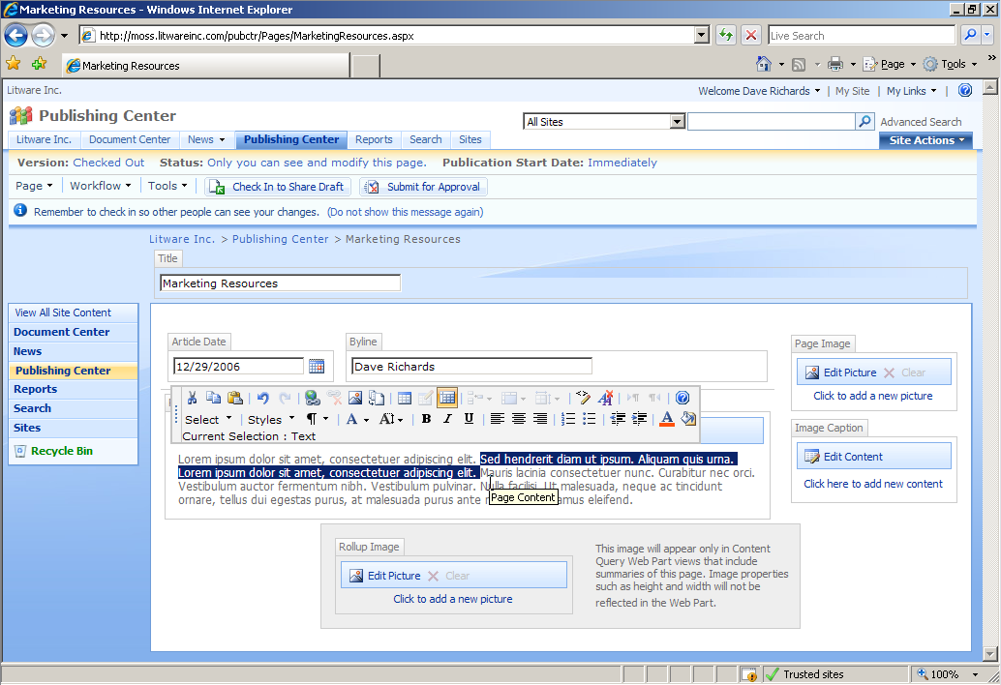
Figure 10 – Web page WYSIWYG edit mode
The Web designers who create the page layouts control the styles that are to be made available to content authors for formatting HTML content on the page; this ensures consistency in the branding and general site design.
In addition to the provision of visible Web content, authors can provide additional metadata for the page. This metadata can be used to enhance content indexing, and metadata field values can be enforced where required.
A very common requirement in Web content publishing is the ability to access reusable content on a page. Office SharePoint Server 2007 supports a feature named "Reusable Content" that enables the maintenance of these reusable content fragments in a centralized list for each site collection. Page authors can then reuse these content fragments in their Web pages. Items can be configured either to allow authors to edit or to prevent authors from editing the content in their pages. A similar approach is used to manage commonly required documents, images, or media objects through the use of the Site Collection Images and Site Collection Documents libraries that are automatically created by the Office SharePoint Server 2007 installation process.
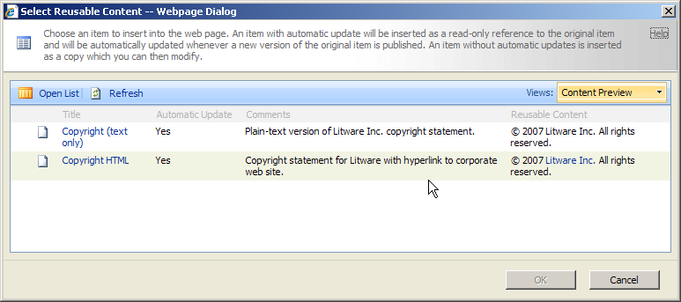
Figure 11 – Reusable content selection
When the author has completed work on the page and saved it, the Web page — like any other document in Office SharePoint Server 2007 — can be subject to workflows. By default, a parallel workflow process is immediately available; other workflows may be added. As with any workflow in Office SharePoint Server 2007, the workflows are configurable and customizable, and completely new workflows can be designed and added as required by the organization.
In addition to the rich-content editing capabilities of the HTML content editor, Office SharePoint Server 2007 provides additional content management capabilities, including:
- Image Controls: Controls that enable the user to select and format images from image libraries.
- Summary Link Controls: Controls that allow authors to create summary lists of links to other Web sites (both internal and external) and specify how those lists are formatted on the published page.
- Web Parts:
  - Summary links: Allows the quick authoring, formatting, and organization of links to other sites — similar to the summary link controls mentioned above, but with the added capabilities of Web Parts for customization and targeting.
  - Table of contents: Provides data-driven views of navigation.
  - Content query: Allows the embedding of dynamic queries of content on the page (for example, “Related articles” queries based on subject).
Use Case — Publishing a News Article: An analyst at a newspaper publisher needs to publish a news article with a photo on the organization’s public Web site. She navigates to the current news section of the site, and from the Site Actions menu she selects Create Page. In the Create Page dialog box, she specifies the page title, description, and URL (one is automatically created for her that she can change if desired). She selects the page layout to use in publishing the page (“Article page with image on right”), and then clicks the Create button.
Now in page edit mode, she inserts the main body of the article text in the field labeled “Page Content.” For the photo image, in the Page Image field she clicks the Click to add new picture link. In the Edit Image Properties dialog box, she clicks the Browse button next to the Selected Image field to open the Select an Image dialog box. From this location, she clicks the Upload button to upload her scanned photo into the current site’s Images library. After publishing the image, she returns to the Select an Image dialog box to refresh the list and selects the image, specifying additional information (such as alternate text, layout information, or size), and then she clicks OK. She completes a review of her content by clicking on the Check In to Share Draft button, which saves her content and closes page edit mode so that she can now see how the page will appear to a user browsing the site.
The page is not yet published. The site she has been working in is configured with workflow, so she must now submit the page for approval. She clicks the Submit for Approval button and is taken to the Start Workflow page, which has automatically selected a Parallel Approval workflow. On this page, she can type a message and optionally select other users to notify of this submission, and then she clicks the Start button. The workflow process notifies the editorial staff of the new submission. After the item has received approval, the news article is published.

Business Forms and Integration
One of the most common and essential feature requirements in enterprise Web applications is the ability to accommodate forms-driven business processes. This often involves a development-centric process to design and implement sophisticated forms solutions. Microsoft Office SharePoint Server 2007 provides Office InfoPath Forms Services, which enable the design of these forms by using Microsoft Office InfoPath 2007, in addition to deployment of these forms across internal and external Web sites by using Office SharePoint Server 2007. Users can access these forms through a browser or an HTML-enabled mobile device without requiring any custom client software or application components.
Office InfoPath Forms Services delivers the capability for centralized forms management and control through an administrator-controlled form solution catalog. This facility enables users to rapidly locate forms, minimizes form solution downtime when upgrades are required, and provides administrators with the tools to manage form solution security and accessibility.
The design and implementation of forms is greatly enhanced through a “Design Once” methodology. By using Office InfoPath 2007, sophisticated forms can be designed for use both within the rich environment of the InfoPath client and through Web browsers; upon publication, forms are automatically converted into ASP.NET Web forms with no additional work from the designer. For forms that don’t require managed code components, the Publish Wizard in Office InfoPath 2007 simplifies the process of publishing forms to a document library, while simultaneously making the form available as a browser-based form.
Form templates are published to an Office InfoPath 2007 form library. This library can be configured to default users to open the form in either the browser or in the Office InfoPath 2007 client. The form library can be configured to automatically start a workflow.
For users with Office InfoPath 2007, the advanced functionality of the application can be leveraged by defaulting users to open forms with the InfoPath client. If the form requires data access, the form can be configured in InfoPath Design mode to access trusted data sources on Office SharePoint Server 2007 sites. This access is performed via XML Web services in Office SharePoint Server 2007, thus simplifying the process of configuring data access. Forms accessed through the InfoPath client can take advantage of additional functionality not available through the browser interface. General forms management tasks will still be available through the form library — to access, view, analyze, and manage form workflows.
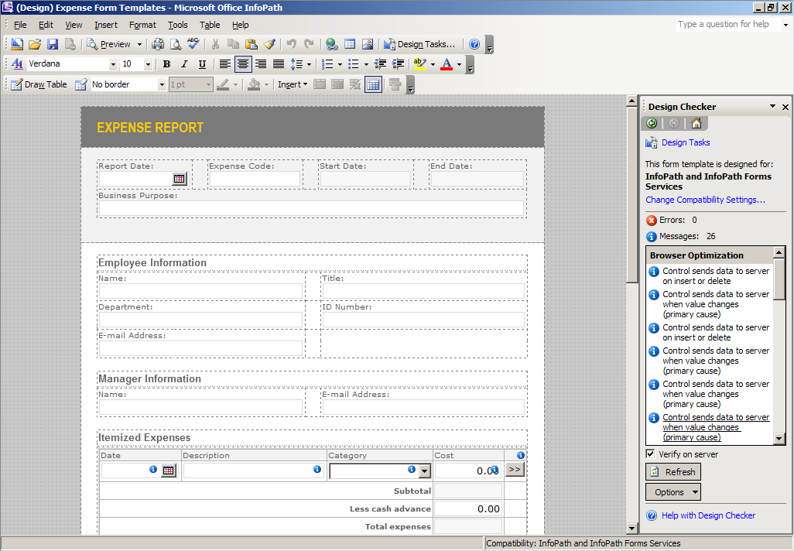
Figure 12 – Form design in Office InfoPath 2007 with Design Checker visible
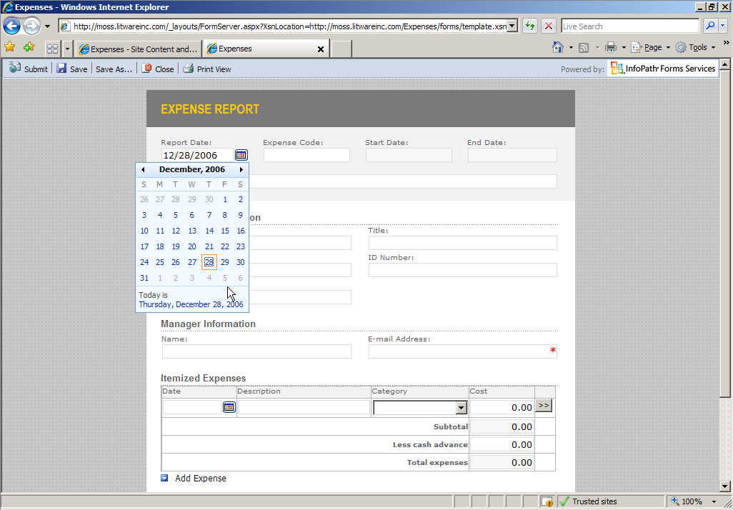
Figure 13 – Form access from the Web browser
For forms that have been designed in Office Excel or Office Word, the Form Import Wizard can be used to convert these forms into rich Office InfoPath 2007 forms. The wizard dynamically handles the conversion of form fields, repeating tables, rich text boxes, and other elements, and it generates the underlying XML structure for the new form.
Naturally, the compatibility of forms across a wide range of browsers is a primary concern when implementing forms-based solutions. The built-in Design Checker in Office InfoPath 2007 provides form designers with immediate compatibility feedback on features used within the form. Designers can thus design forms effectively for use both in the Office InfoPath 2007 client and through the Web browser.
Use Case — Implementing an Expense Form: A manager wishes to implement a departmental expense submission form on the corporate intranet, and to allow the form to be completed and submitted by using a Web browser. By using Office InfoPath 2007, he designs and tailors a form suited to his department’s requirements. As he works on the form, he needs to monitor the compatibility of his form with browser clients. In the InfoPath client, he enables the Design Checker tool and configures its options to connect to a SharePoint document library. The Design Checker shows any messages that would alert him to functional elements that will not be supported in the browser, in addition to messages that indicate browser optimizations that occur as he designs his form.
To publish his form to the site, he selects Publish from the InfoPath menu, starting the Publish Wizard. He specifies that the form is to be published to an Office SharePoint server, the URL of that server (ensuring that the form can be completed in a browser), and that the form is to be published as a template in a document library. Through the wizard, a new forms library will be created. Upon completion, the Publish Wizard presents an option to open the form in the browser. The form template is now available for the creation of new expense report submissions.
(Note: In this example, the form template was designed for use with a specific document library. The form template could also be saved as a new content type in the SharePoint site, which would allow expense form submissions to be created in document libraries across the site.)

Business Data Catalog
The Business Data Catalog tightly integrates business data into the Office SharePoint Server 2007 user experience, providing access to external data residing within back-end line-of-business applications. With the Business Data Catalog, organizations can expose information locked up in databases and line-of-business applications via Web Parts and Search in Office SharePoint Server 2007. Office SharePoint Server 2007 includes five Web Parts for use with the Business Data Catalog:
- Business Data List Web Part Displays a list of entity instances from a business application registered in the Business Data Catalog. For example, this Web Part could display a list of customers contained in a customer information table in a customer relationship management (CRM) application.
- Business Data Item Web Part Displays the details of an entity instance from a business application. For example, details for a specific customer could be displayed from data in a CRM application’s database.
- Business Data Item Builder Web Part Creates a business data item from parameters in the URL query string and connects it to other Web Parts. It is only visible when the page is in edit mode.
- Business Data Related List Web Part Displays a list of related entity instances from a business application. For example, a list of orders made by a specific customer could be displayed from CRM application data.
- Business Data Actions Web Part Displays a list of actions associated with an entity as defined in the Business Data Catalog. For example, the Web Part could display a list of all actions that an authorized portal user could perform on customer information (such as update or send e-mail).
Business Data Actions With no custom coding, the user can easily create actions that open Web pages, display the user interfaces of line-of-business applications, start InfoPath forms, and perform other common tasks. Use the convenient links that appear beside business objects returned from the Business Data Catalog.
Use Case — Adding a Custom Action: An administrator receives a request to add an action to allow the addition of new contact information in the Contact table of a customer relationship management (CRM) database. The CRM application administrator provides him with a URL that will open a Web page to add a new customer contact information entry. A Business Data Catalog has already been created that includes the Contact entity. The administrator opens Central Administration, and selects the Shared Services Provider (SSP) that includes the CRM Business Data Catalog definition. He views the entities in the Business Data Catalog and selects the Contact entity. From the View Entity page, he sees that there are currently no actions defined for Contacts, so he clicks the Add Action link on this page. From the Add Action page, he enters the Action name (“Add New Contact”), the URL to invoke this action, and an icon to associate with the action in menus. He clicks OK and the action is now associated with that entity. On pages in the corporate Web where the Contact entity is exposed through a Business Data List or a Business Data Actions Web Part, the Add New Contact action will be displayed.
The site administrator creates and maintains the available Business Data Catalog definitions. This begins with the creation of a Business Data Catalog Application Definition (an XML file that describes the business data source), which is then imported through Central Administration. The following figure shows an example of just such a definition:
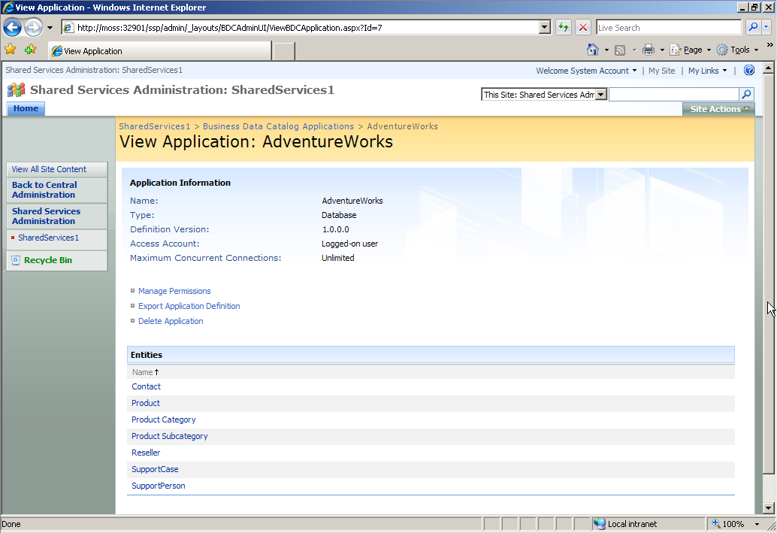
Figure 14 – View of sample Business Data Catalog application
For detailed information about creating Business Data Catalog application definitions, please refer to the Office SharePoint Server 2007 Software Development Kit. A sample Business Data Catalog application definition file that connects to the AdventureWorksDW SQL Server 2005 Analysis Services Project database is available through the installation of SQL Server 2005. If you have installed this database, you will need to modify the RdbConnection Data Source property in this file to point to the computer running SQL Server where the database is located.
(If you are using SQL Server 2000, then go to the AdventureWorks SQL Server 2000 Sample for instructions on the configuration of this database and the Business Data Catalog application definition.)

Business Intelligence
The preparation, deployment, and sharing of business intelligence presents challenges, particularly in large organizations. Office SharePoint Server 2007 introduces business intelligence capabilities, allowing information workers throughout an organization to make more informed decisions, analyze and view data, and share business data with others. It includes a host of capabilities and provides new features to extend the capacities of corporate Web sites in deploying business intelligence information.

Web-Based Business Intelligence Using Excel Services
Delivering advanced analytic capabilities for business intelligence applications from a centralized server usually requires considerable effort in server-based application development; this effort is often redundant for many analysts and knowledge workers who have the required business intelligence analysis contained within their own desktop environments that use Office Excel. Excel Services empowers these users to publish and run spreadsheets on the server, enabling users to access these spreadsheets through a Web browser without the need for any custom browser components. The server performs all data access and analytic functions, enabling efficient processing and ensuring that all views of shared documents are generated from a centralized source. Fully interactive, data-bound spreadsheets — including charts, tables, and PivotTable® views — can be created as part of a portal, dashboard, or business scorecard, without requiring any custom server development. As part of this experience, Office SharePoint Server integrates flexible spreadsheet publishing with Office Excel 2007. Office Excel 2007 enables a fully integrated publishing experience, enabling authors to determine the target locations for the publishing of their spreadsheets, from the desktop to the corporate Web. Knowledge workers and analysts can publish Excel spreadsheets directly to SharePoint libraries, with the following capabilities:
- Create a new document workspace If the author of the worksheet has the rights to do so, a new workspace can be created on the Office SharePoint Server 2007 to allow sharing and collaboration on the document.
- Save to a document library The document can be saved directly to an existing Excel document library that the author has rights to access.
- Specify Excel Services options The author can specify which parts of a spreadsheet are available for viewing and editing by other users.
The author has the ability to direct the publication of spreadsheets to the appropriate locations on the corporate Web, while exercising control over the documents — perhaps to control embedded logic, perhaps to protect sensitive information. These published documents can be accessed by authorized users via the Web browser or the full Office Excel 2007 client software. Modeling logic, proprietary information, and private data can be protected. The publishing process is tightly integrated into the Office Excel 2007 client.
An important business intelligence capability provided by Office SharePoint Server 2007 is data connection libraries. These are centralized SharePoint document libraries that store Office Data Connection files. Data connection files describe connections to external data. Centralizing these data connection files makes it easier to share, manage, and discover data connections that can be used by any Microsoft Office application. Common Office Data Connection files that connect to business intelligence data sources can be created and published to data connection libraries for easy shared access by knowledge workers, eliminating the need for those people to be concerned with data connectivity.
Additional business intelligence features of Office SharePoint Server 2007 include:
- Integrated business intelligence dashboards Office SharePoint Server 2007 enables the creation of rich, interactive business intelligence dashboards that assemble and display business information from disparate sources by using built-in Web Parts such as dynamic key performance indicators, Excel spreadsheets, Microsoft SQL Server Reporting Services reports, or a collection of business data connectivity Web Parts that can visualize information residing in back-end line-of-business applications.
- Report Center A site optimized for report access and management, including a report library, a data connection library, and a dashboard template. These sites, hosted by the new Report Center, provide consistent management of reports, spreadsheets, and data connections.
- Key performance indicators Key performance indicators (KPIs) communicate goals and status to drive results. By using the KPI Web Part, a user can create a KPI list within a Web Part page, without writing code. The KPI Web Part can display KPIs from Microsoft SQL Server Analysis Services, Excel spreadsheets, SharePoint lists, or manually entered data.
- Filter Web Parts Filters enable dashboards to be personalized by communicating shared parameters among Web Parts on a dashboard. The parameters passed can be automatically applied based on user profiles, SharePoint lists, the Business Data Catalog, manually entered information, and so forth.
Use Case — Publishing an Excel Workbook to a Sales Portal for Browser Access: A knowledge worker in a sales organization has prepared a workbook in Office Excel 2007 that analyzes sales information by region. The workbook includes a pivot table showing sales bookings by region and product, a summary table showing rankings of product sales versus quotas, and graphical charts showing the data in the pivot table and the summary table.
The worker wishes to publish the table to an Office SharePoint Server 2007 sales portal so that other members of the sales team can access this workbook from their browsers, even if they do not have the Office Excel 2007 client application installed.
From inside the Excel client application, the knowledge worker clicks the Office button and selects Publish and then Excel Services. He then clicks his Shared Documents folder, which points to a document library in Office SharePoint Server 2007. He selects the option labeled “Open in Excel Services” (below the File Name and Save as type boxes) and clicks the Save button.
The knowledge worker’s default Web browser is started and shows the server version of the workbook that he has just published. The rendering of the workbook in the browser shows a view almost indistinguishable from the Excel client application. He clicks pivot table menus to drill through the data and see that the chart driven from the pivot data is updated.
Now other sales team members have access to the knowledge worker’s new regional sales analysis workbook from a browser. Even when they are away from the office and their own computers, as long as they have a connection to the sales portal they can access the regional sales analysis workbook from a Web browser.
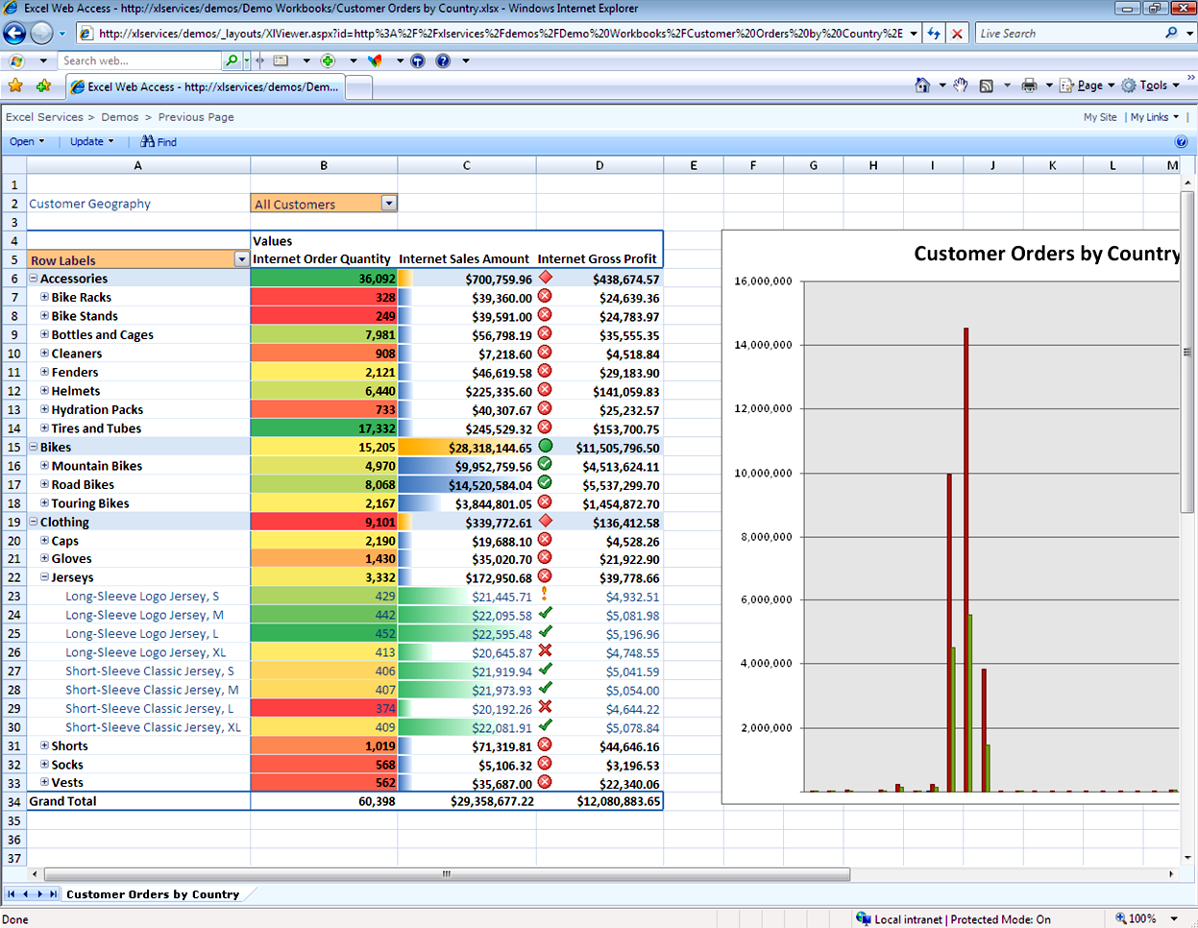
Figure 15 – Accessing an Excel workbook by using Excel Services and a Web browser

SharePoint Products and Technologies Interoperability
Application interoperability can take many forms in enterprise Web application architectures. The scope of this discussion can be immense. For our purposes here, we’ll consider the following concepts:
- Interoperability Features included in Office SharePoint Server 2007 that can allow access to information and applications that exist on other platforms and portals, without the need to create custom Web Parts or application components.
- Web services Services in Office SharePoint Server 2007 that can make information contained within the portal available to other applications.
- Custom development Features in Office SharePoint Server 2007 to facilitate the development of application components and services that act as producers or consumers of application data and enterprise portal information.

Interoperability
Perhaps the most common and general interoperability requirement for an enterprise portal application is the ability to access information in a wide range of locations, and possibly on a range of different application platforms. Most often, the access to content on these platforms requires custom authentication. Office SharePoint Server 2007 includes a number of features that can make such content immediately accessible through the portal:
- Single sign-on (SSO) A service provided by Office SharePoint Server 2007 for storage and mapping of credentials for use in connecting with third-party or back-end systems. For organizations that already maintain another single sign-on service, Office SharePoint Server 2007 provides a mechanism called pluggable SSO, allowing the specification of an alternate SSO provider to the standard SSO provider in Office SharePoint Server 2007.
Use Case — Connecting a Web Part to an Enterprise Resource Planning Application: A company has designed a custom employee Web Part that connects to the corporate enterprise resource planning (ERP) system displaying an employee’s current balance of available vacation days; the Web Part appears on every employee’s My Site. The ERP system employs its own authentication scheme. The Office SharePoint Server 2007 single sign-on service is configured to map the employee’s credentials to those necessary to obtain this information from the ERP system. The credentials are passed to the ERP application and the data connection required by the Web Part is established. The required data is obtained from the ERP and rendered as HTML in the Web Part on the user’s My Site home page.
- Business Data Catalog Data residing in other applications can be made directly available to the portal, both as searchable content and as data for Web Parts. Office SharePoint Server includes a number of ready-to-use Web Parts for accessing Business Data Catalog data. (For more information about this feature, refer to the section titled Business Data Catalog in this document.)
Use Case — Querying Product Information: A sales support analyst has a frequent need to query product and pricing information. The site administrator for the organization’s Sales Portal has imported a Business Data Catalog application definition that connects to the product information and pricing entities in the corporate product information database. The analyst adds a Business Data Item Builder Web Part to her My Site home page and uses the Web Part’s tool pane to connect it to the Business Data Catalog data, selecting the Product entity in the Business Data Catalog, an entity that contains product descriptions and pricing. The analyst saves the Web Part changes to the page. Now she can perform queries against the product and pricing information directly from her My Site.
- RSS Feeds Users can add the RSS Feed Web Part to their pages to access their favorite feeds directly from their own personal pages.
- WSRP (Web Services for Remote Portlets) Consumer This is a specification by an OASIS committee that enables “presentation-oriented Web services for use by aggregating intermediaries, such as portals.” More simply stated, it is a means by which blocks of HTML can be served from an XML Web service for display in portal components such as Web Parts. Office SharePoint Server 2007 includes a WSRP Consumer Web Part that will allow the display of content from trusted WSRP providers.
- SAP iView This is a component in SAP portals that is used to display information, documents, and application data in an SAP Portal. Office SharePoint Server 2007 includes an SAP iView Web Part that allows the display of content from trusted SAP portal iViews.

Web Services
In designing, building, and deploying enterprise Web applications, access to the application’s information and functionality enables a truly interoperable architecture. Office SharePoint Server 2007 includes a number of XML Web services that enable extensive and secure access to its capabilities, including the following:
- Official File Web Service: A service that enables the submission of files to a records repository.
- Published Links Web Service: A service enabling Microsoft Office clients and other applications to obtain the list of published links on the server that are targeted to the current user.
- Search Web Service: A service exposing Office SharePoint Server 2007 search functionalities through the Query Web Service. This allows the access to Enterprise Search results from client applications and Web applications outside of the context of a SharePoint site.
- User Profile Change Web Service: A service that enables the change of user profile information from outside of the context of a SharePoint site.
- User Profile Web Service: A service that provides a user profile interface for remote clients.
- Workflow Web Service: A service providing access to workflows within a SharePoint site.
- Publishing Web Services: XML Web service interfaces to publishing capabilities within a SharePoint site.
- Administration Web Services: Services to support SharePoint Server 2007 Administration.
Use Case — Developing a Custom-Designed Application to Send Documents to a SharePoint Document Library: An engineering firm has a visual design application that its engineers use to create technical design drawings for their projects. This application has the ability to incorporate programmed add-in functions. The firm’s IT department develops an add-in for this application to access the PublishingService Web Service (from the Microsoft.SharePoint.Publishing.WebServices namespace) that allows a user to publish the drawing document directly to the firm’s intranet portal site’s Document Center, where it can be processed by workflows for review and approval.

Custom Development
In many cases, the interoperability requirements for portals are sufficiently unique to an organization that custom development is required. For example, an organization may have a requirement to make content from an Office SharePoint Server 2007 implementation available to other portal implementations that support WSRP consumer Web Parts or portlets. In such a case, WSRP provider services must be built that provide the required access to content. Office SharePoint Server 2007 contains an extensive and comprehensive set of .NET namespaces that enable the development of custom applications and services that enable functionality that support requirements such as these. A complete reference to these namespaces and their classes is available online at the MSDN Library.
Use Case — Embedding Search in a Custom Client-Server Application: A book publishing company develops a .NET client-server application for its staff to provide quick search capabilities for all of its publications, utilizing custom menus that allow filtering of results by subject, catalog index numbers, and other data elements. The publications reside in an Office SharePoint Server 2007 Document Center, which is indexed by Search in Office SharePoint Server 2007. A custom server-based XML Web service is created for deployment on the Office SharePoint Server 2007 server that accesses publication document metadata and query services through classes in the Microsoft.Office.Server.Search namespace. A set of Web methods is defined for use by the desktop-based client application to populate menus and to process user-submitted queries to the Search Web service. The desktop client is designed to be quickly accessible through the system tray area, and it renders a pop-up window with menus determined by publication metadata, producing search results in a scrollable list within the pop-up window.

Office SharePoint Server 2007 Architecture
To effectively build and deploy enterprise Web solutions by using Office SharePoint Server 2007, it’s important to understand the architectural elements that provide this solution technology. This section presents a logical view of the architecture, and clarifies what aspects of the technology deliver the feature components that are available for enterprise Web solution delivery.
In building and customizing enterprise Web applications by using Office SharePoint Server 2007, integrators and developers can access all three logical layers within this architecture to address the specific requirements for any organization.
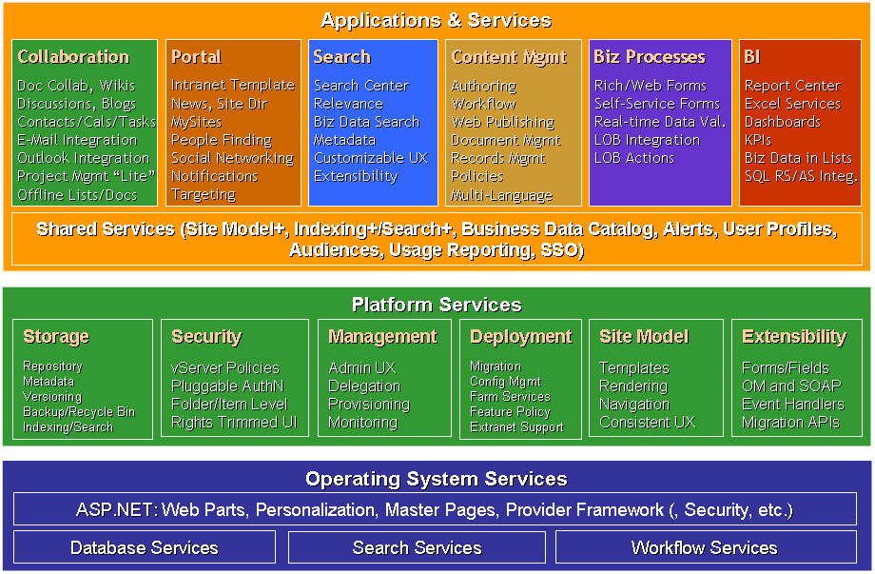
Figure 16 – Office SharePoint Server 2007 logical architecture

Application and Services
The top-level layer of the logical architecture in Office SharePoint Server 2007 is concerned with the delivery of applications and services in enterprise Web solutions. The bulk of this document’s content has been focused on the six major feature areas of Office SharePoint Server 2007: collaboration, portal, search, enterprise content management, business forms and data integration, and business intelligence. From a business solution design perspective, these are the most important elements to focus on and they are covered in the section entitled “Office SharePoint Server 2007 Feature Areas.”
A number of individual Microsoft technologies are employed in delivering the six major feature areas, including Microsoft Windows SharePoint Services 3.0, Office Forms Server 2007, Enterprise Search, and Excel Services. All of these technologies are delivered with Microsoft Office SharePoint Server 2007.
Another essential aspect to this top-level layer in the logical architecture is Shared Services. As the name so obviously implies, these are common facilities and functional elements that apply to all of the main feature areas in the logical architecture, including:
- The Site Model The creation and management of the overall site hierarchy and the configuration of the functional elements within the site collections that constitute the Web portal. The site model is managed through the Central Administration interfaces along with individual site actions and settings within the portal context.
- Indexing and Search The critical aspect of indexing and enabling the effective search for relevant content across the portal. In Office SharePoint Server 2007, these capabilities are delivered through Search in Office SharePoint Server 2007. Functional aspects to this capability are covered in the section of this document titled “Enterprise Search.”
- Business Data Catalog The capability to directly access business data within the context of the portal. The enabling of this functionality is done through Central Administration. This functionality is covered in more detail in the section titled “Business Data Catalog.”
- Alerts The way to keep everyone involved in content management, workflows, and other business processes in the portal aware of changes and processes by alerting them through e-mails and the assignment of tasks.
- User Profiles The management of user profiling that provides essential elements employed in personalization, targeting, and workflow.
- Audiences The definition and management of collections of users that drive the ability to target sites, Web Parts, and content to users across the portal.
- Usage Reporting The provision of detailed reporting and auditing capabilities within the portal environment — of particular importance in records management.
- Single Sign-On The capability to manage user authentication across multiple application environments across the portal, including the interface to other single sign-on solutions through pluggable SSO technology.

Platform Services
This layer in the logical architecture of Office SharePoint Server 2007 is delivered through the technologies in Windows SharePoint Services 3.0. Please refer to that section of this document for more information about the roles that these technologies fill in the delivery of enterprise Web portal applications.

Operating System Services
The bottom layer in the logical architecture of Office SharePoint Server 2007 provides many of the fundamental and granular functions that are required in building and delivering enterprise Web applications. The services at this layer are provided by Windows Server 2003, SQL Server 2005 (or 2000), the Windows Workflow Foundation, and ASP.NET 2.0.

Shared Services
Conceptually similar to shared services in SharePoint Portal Server 2003, the shared services component in Office SharePoint Server 2007 has been completely restructured and redesigned by using a new services provider model.
The services of Office SharePoint Server 2007 include a key set of services that can be shared across Web applications. By default, these services are shared across all sites within a server farm. Using shared services greatly reduces the resources required to provide these services across multiple portal sites. These services include:
- Search and Alerts Includes the search and indexing services, and the databases or related files that support search services. A search scope is created to include all portals and sites that consume this shared service.
- User Profiles and My Sites Maintains people profiles from various data sources (directory, user-entered, and business systems). Synchronizes information from the profile store to individual sites. Provides My Sites for collaboration and sharing.
- Audiences Provides content targeting based on user audiences. Audiences can be defined based on a user’s role or affiliation within an organization.
- Business Data Catalog Connects to external databases and Web services, allowing you to integrate line-of-business application data into your Office SharePoint Server solution. After you register an external data source in the Business Data Catalog, you can include the data in lists, Web Parts, search, and user profiles.
- Portal Usage Reporting Reports site usage data to site owners, including the number of page requests, the most popular pages, the number of unique users, the most active users, top referring pages, and top destination pages.
- Excel Services Settings Provides server-side calculation and thin rendering of Excel workbooks. It also enables server-side refresh of external data in workbooks.
The Shared Services Provider (SSP) architecture provides a greater range of deployment and configuration alternatives, in addition to a means of delegating functional aspects of enterprise Web application administration.

Installing an Evaluation Server
This section covers the requirements and steps for installing an evaluation environment for Office SharePoint Server 2007 on a stand-alone single server. (These instructions are also available online in the article Install Office SharePoint Server 2007 on a stand-alone computer.
You can quickly publish a SharePoint site by deploying Office SharePoint Server 2007 on a single server. A stand-alone configuration is useful if you want to evaluate Office SharePoint Server 2007 features and capabilities, such as collaboration, document management, and search. A stand-alone configuration is also useful if you are deploying a small number of Web sites and you want to minimize administrative overhead. When you deploy Office SharePoint Server 2007 on a single server by using the default settings, the Setup program automatically installs Microsoft SQL Server 2005 Express Edition and uses it to create the configuration database and content database for your SharePoint sites. In addition, the Setup program creates a Shared Services Provider (SSP), installs the SharePoint Central Administration Web site, and creates your first SharePoint site collection and site.
Note: There is no direct upgrade from a stand-alone installation to a farm installation.
You can install Office SharePoint Server 2007 on a single computer by using either of the following methods:
- By selecting Basic.
- By selecting Advanced, and then selecting Stand-alone in Office SharePoint Server 2007 Setup.

Hardware Requirements
The following table lists the minimum and recommended hardware requirements for deploying Office SharePoint Server 2007, including the deployment of SQL Server 2005 Express Edition, for a stand-alone installation:
Component | Minimum | Recommended
Processor | 2.5 gigahertz (GHz) | Dual processors that are each 3 GHz or faster
RAM | 1 gigabyte (GB) | 2 GB
Disk | NTFS file system–formatted partition with a minimum of 3 GB of free space | NTFS file system–formatted partition with 3 GB of free space plus adequate free space for your Web sites
Drive | DVD drive | DVD drive or the source copied to a local or network-accessible drive
Display | 1024 × 768 | 1024 × 768 or higher resolution monitor
Network | 56 kilobits per second (Kbps) connection between client computers and server | 56 Kbps or faster connection between client computers and server

Software Requirements
Office SharePoint Server 2007 is built on the technologies and services provided by Microsoft Windows Server 2003 Service Pack 1 (SP1) and SQL Server 2005 (in addition to SQL Server 2000).
The core and development-platform operating system services include:
  - Microsoft .NET 2.0 Framework, including:
    - ASP.NET 2.0 master pages, content pages, and Web Parts
    - Pluggable service-provider models for personalization, membership, navigation, and enhanced security
  - Database access services
  - Internet Information Services
  - Windows Workflow Foundation
  - Windows desktop indexing and search services
SQL Server 2005 is the relational database used for storing all content, data, and configuration information used by Office SharePoint Server 2007. SQL Server 2005 is recommended; SQL Server 2005 Express Edition is included as a default part of the installation. SQL Server 2000 can be used as an alternative.
Because Office SharePoint Server 2007 is built on Microsoft Windows SharePoint Services 3.0, the requirements that apply to Windows SharePoint Services 3.0 also apply to Office SharePoint Server 2007.
Note: Because the Office SharePoint Server 2007 installation and configuration wizard marshals many components, if you uninstall Office SharePoint Server 2007 and then later install Office SharePoint Server 2007 on the same computer, the Setup program could fail when creating the configuration database, which would cause the entire installation process to fail. You can prevent this failure by deleting the existing configuration database or by using the psconfig command to create a new configuration database.
The 2007 Microsoft Office system uses a common installer, and the features that are available in your Office SharePoint Server 2007 installation depend on the product identification (PID) key that you specify during installation. This means that, even with the same installation source, if you specify a different PID key (for example, a PID key for a different Office SharePoint Server 2007 edition), a different feature set will be available for installation.

Database
When you perform a Basic installation, SQL Server 2005 Express Edition is automatically installed. When you perform an Advanced installation on a stand-alone computer that already has SQL Server installed, ensure that the computer meets the hardware and software requirements for a database server.
Because of Windows licensing restrictions, if you are using Windows Server 2003 Web Edition in a single-server environment, you can only perform a Basic installation. This is because the full SQL Server editions cannot be installed on Windows Server 2003 Web Edition. However, you can install SQL Server 2005 Express Edition or SQL Server 2000 Desktop Engine (Windows) (WMSDE).

Database Server
The computer that hosts the database server role must have SQL Server 2000 with the most recent service pack or Microsoft SQL Server 2005 with the most recent service pack. Some advanced features require SQL Server 2005 Analysis Services with the most recent service pack. For more information about the hardware and software required to deploy a database server, see SQL Server 2005 System Requirements.
Because of Windows licensing restrictions, if you are using Windows Server 2003 Web Edition in a single-server environment, you can only perform a Basic installation. This is because the full SQL Server editions cannot be installed on Windows Server 2003 Web Edition. However, you can install SQL Server 2005 Express Edition or SQL Server 2000 Desktop Engine (Windows) (WMSDE).

Operating System
Office SharePoint Server 2007 runs on Windows Server 2003 with the most recent service pack. We recommend that you apply all critical updates. You can use the following Windows Server 2003 editions:
- Windows Server 2003, Standard Edition
- Windows Server 2003, Enterprise Edition
- Windows Server 2003, Datacenter Edition
- Windows Server 2003, Web Edition
Because of Windows licensing restrictions, if you are using Windows Server 2003 Web Edition in a single-server environment, you can only perform a Basic installation. This is because the full SQL Server editions cannot be installed on Windows Server 2003 Web Edition. However, you can install SQL Server 2005 Express Edition or SQL Server 2000 Desktop Engine (Windows) (WMSDE).
Office SharePoint Server 2007 administration functions require Microsoft Internet Explorer 6.0 with the most recent service packs or Internet Explorer 7.0.

Windows Components
After you have installed the operating system and applied all critical updates, you must configure the computer to be a Web server by enabling Internet Information Services (IIS) 6.0, including:
  - Common files
  - WWW
  - Simple Mail Transfer Protocol (SMTP)
You must configure the server to use IIS 6.0 worker process isolation mode. This is the default setting in new installations. However, if you have upgraded from IIS 5.0 on Windows Server 2000, Run WWW in IIS 5.0 isolation mode is enabled, and you must change this setting to use IIS 6.0 worker process isolation mode.
To enable e-mail notifications, you need to configure incoming and outgoing e-mail settings. To configure sending e-mail alerts and notifications, you must specify an SMTP e-mail server. To configure your installation so that your SharePoint sites can accept and archive incoming e-mail messages, you must install the IIS SMTP service.

Microsoft .NET Framework 3.0
Before installing Office SharePoint Server 2007, you must install the Microsoft .NET Framework version 3.0 and then ensure that ASP.NET 2.0 is enabled.
To enable ASP.NET 2.0, open the Web service extension in the IIS snap-in on the Microsoft Management Console (MMC). If ASP.NET 2.0 is installed on the computer before IIS is enabled, you must enable ASP.NET 2.0 by running the command aspnet_regiis -i.

Install and configure Office SharePoint Server 2007 with Microsoft SQL Server 2005 Express Edition
When you install Office SharePoint Server 2007 on a single server, run the Setup program by using the Basic option. This option uses the Setup program’s default parameters to install Office SharePoint Server 2007 and SQL Server 2005 Express Edition.
Note: If you uninstall Office SharePoint Server 2007 and then later install Office SharePoint Server 2007 on the same computer, the Setup program could fail when creating the configuration database, causing the entire installation process to fail. You can prevent this failure by either deleting all the existing Office SharePoint Server 2007 databases on the computer or by creating a new configuration database. You can create a new configuration database by running the following command:
psconfig -cmd configdb -create -database <uniquename>

Run Setup
- From the product disc, run Setup.exe, or from the product download, run Officeserver.exe.
- On the Enter your Product Key page, enter your product key, and then click Continue.
Note: Setup automatically verifies the product key, places a green check mark next to the text box, and enables the Continue button after it validates the key. If the key is not valid, Setup places a red circle next to the text box and displays a message that the key is incorrect.
- On the Read the Microsoft Software License Terms page, review the license terms, select the I accept the terms of this agreement check box, and then click Continue.
- On the Choose the installation you want page, click Basic to install to the default location. To install to a different location, click Advanced, and then on the File Location tab, specify the location you want to install to and finish the installation.
- When Setup finishes, a dialog box prompts you to complete the configuration of your server. Be sure that the Run the SharePoint Products and Technologies Configuration Wizard now check box is selected.
- Click Close to start the configuration wizard.

Run the SharePoint Products and Technologies Configuration Wizard
- On the Welcome to SharePoint Products and Technologies page, click Next.
- In the dialog box that notifies you that some services might need to be restarted or reset during configuration, click Yes.
- On the Configuration Successful page, click Finish. Your new SharePoint site opens.
Note: If you are prompted for your user name and password, you might need to add the SharePoint site to the list of trusted sites and configure user authentication settings in Internet Explorer. Instructions for configuring these settings are provided in the following procedure.

Add the SharePoint Site to the List of Trusted Sites
- In Internet Explorer, on the Tools menu, click Internet Options.
- On the Security tab, in the Select a Web content zone to specify its security settings box, click Trusted Sites, and then click Sites.
- Clear the Require server verification (https:) for all sites in this zone check box.
- In the Add this Web site to the zone box, type the URL to your site, and then click Add.
- Click Close to close the Trusted Sites dialog box.
- Click OK to close the Internet Options dialog box.
If you are using a proxy server in your organization, use the following steps to configure Internet Explorer to bypass the proxy server for local addresses.
Note: If you see a proxy server error message, you might need to configure your proxy server settings so that local addresses bypass the proxy server. Instructions for configuring proxy server settings are provided later in this section.

Configure proxy server settings to bypass the proxy server for local addresses
- In Internet Explorer, on the Tools menu, click Internet Options.
- On the Connections tab, in the Local Area Network (LAN) settings area, click LAN Settings.
- In the Automatic configuration section, clear the Automatically detect settings check box.
- In the Proxy Server section, select the Use a proxy server for your LAN check box.
- Type the address of the proxy server in the Address box.
- Type the port number of the proxy server in the Port box.
- Select the Bypass proxy server for local addresses check box.
- Click OK to close the Local Area Network (LAN) Settings dialog box.
- Click OK to close the Internet Options dialog box.

Post-Installation Steps
After Setup finishes, your browser window opens to the home page of your new SharePoint site. Although you can immediately start adding content to the site or customizing the site, we recommend that you perform the following administrative tasks by using Central Administration.
- Create SharePoint sites: When Setup finishes, you have a single Web application that contains a single SharePoint site collection that hosts a SharePoint site. You can create more SharePoint site collections, sites, and Web applications if your site design requires multiple sites or multiple Web applications.
Note: In the Product Walkthrough section of this document, you will need to create a walkthrough site. That section assumes that you have a site collection created by using the Collaboration Portal site template (available from the Publishing group in the site template selection box on the Create Site Collection page following the creation of your Web Application).
- Configure incoming e-mail settings: You can configure incoming e-mail settings so that SharePoint sites accept and archive incoming e-mail. You can also configure incoming e-mail settings so that SharePoint sites can archive e-mail discussions as they happen, save e-mailed documents, and show e-mailed meetings on site calendars. In addition, you can configure the Directory Management Service to provide support for e-mail distribution list creation and management. For more information, see Configure incoming e-mail settings.
- Configure outgoing e-mail settings: You can configure outgoing e-mail settings so that your Simple Mail Transfer Protocol (SMTP) server sends e-mail alerts to site users and notifications to site administrators. You can configure both the “From” e-mail address and the “Reply” e-mail address that appear in outgoing alerts. For more information, see Configure outgoing e-mail settings.
- Configure Workflow settings: Specify whether users can assemble new workflows, and if participants without site access should be sent documents in e-mail attachments so they can participate in document workflows. For more information, see Configure workflow settings.
- Configure diagnostic logging settings: You can configure several diagnostic logging settings to help with troubleshooting. This includes enabling and configuring trace logs, event messages, user-mode error messages, and Customer Experience Improvement Program events. For more information, see Configure diagnostic logging settings.
- Configure antivirus protection settings: You can configure several antivirus settings if you have installed an antivirus software program that is designed for Office SharePoint Server 2007. Antivirus settings enable you to control whether documents are scanned at upload or download, and whether users can download infected documents. You can also specify how long you want the antivirus software program to run before it times out, and you can specify how many execution threads the antivirus software program can use on the server. For more information, see Configure antivirus protection.
- Configure search: You can configure several search and index settings to customize how Office SharePoint Server 2007 crawls your site content or external content. For more information, see Configure the Office SharePoint Server Search service.
- Configure Excel Services: Before you can use Excel Services, you must start the service and add at least one trusted location. For more information, see Configure Excel Services.

Perform Administrator Tasks by Using the Central Administration Site
- Click Start, point to All Programs, point to Microsoft Office Server, and then click SharePoint Central Administration.
- On the Central Administration home page, under Administrator Tasks, click the task you want to perform.
- On the Administrator Tasks page, next to Action, click the task.

Product Walkthrough
This section provides a functional walkthrough of a basic site in Office SharePoint Server 2007. Please note that this is not a comprehensive walkthrough. It provides a high-level overview, mainly of the collaboration and portal feature areas.

Exercise 1 – Getting Started
This exercise gives an overview of several of the key navigational elements for sites within Office SharePoint Server 2007.
- Site creation
- Navigation
  - Common navigation
  - Flexible top and left navigation bars
  - Fly-out menus
- Log in to your server environment by using administrator credentials.
- Open an Internet Explorer browser.
- Browse to the URL for your newly created site collection.
- Click Sites in the top navigation to open the Site Directory page.

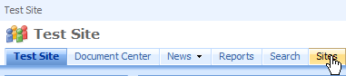

- Notice that the “global” breadcrumb lists the portal name (in this example, “Test Site”).
- Notice the “site” breadcrumb shows the complete path from the portal home page.
- Use the Site Actions drop-down menu, and notice the fly-out menu options for the View Reports and Site Settings menu options.

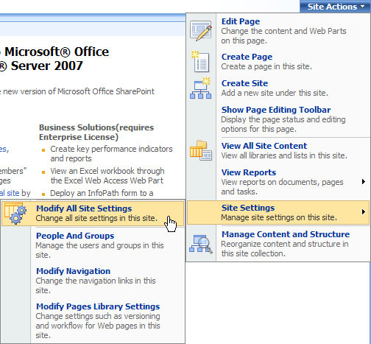

The global navigation breadcrumb is located at the top of the Web page. This is automatically updated throughout SharePoint site hierarchies and it displays the location of the current site.
The site navigation breadcrumb is located just above the list title. This breadcrumb displays the current location within the site hierarchy to simplify navigation and to provide context.
- Click the Sites navigation tab.
- From the Site Actions menu, select Site Settings and Modify All Site Settings.
- Under Look and Feel, click Navigation.
- Under Subsites and Pages, select the check box labeled Show subsites and click OK.
- Click the Create Site link.
- On the New SharePoint Site page, enter the following information:
  - For Title, enter “Walkthrough Site”.
  - For Description, enter “Sample site for walkthrough of Office SharePoint Server 2007”.
  - In the URL Name box, enter “walkthrough”.
  - For Template Selection, select Document Center from the Enterprise group of templates.

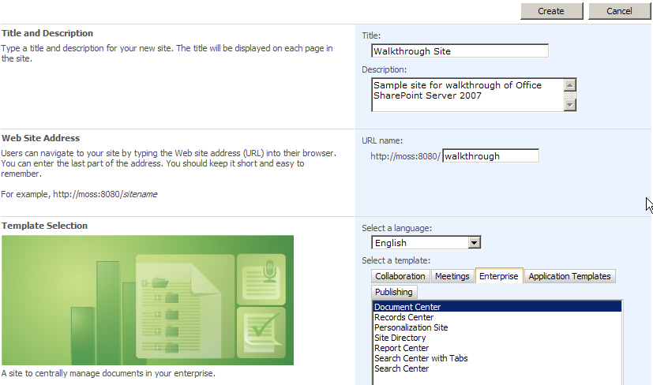
  - Under Site Categories (scroll to the bottom of the page), select the List this new site in the Site Directory check box.
- Click the Create button and wait for the site to be created.
- Rest your mouse on Sites in the top navigation bar and select the Walkthrough Site.
- Click the Tasks link in the left navigation.
- Notice the Site Navigation breadcrumb above the Tasks header; this is the path within the current site from the top of the site hierarchy.

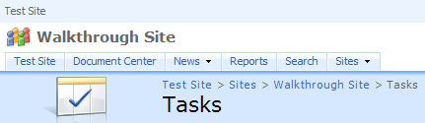

- Return to the site home page by using the Walkthrough Site link in the site breadcrumb.

Exercise 2 – Site Administration
This exercise will take you through the administration UI for adding new groups and users to the site.
Note: This exercise requires that you have additional users in your directory that you can add to user groups in Office SharePoint Server 2007. You may wish to create some test accounts for this purpose.

Create a new group
- On the Walkthrough Site from Exercise 1, choose Site Settings from the Site Actions menu.

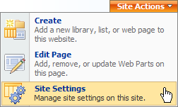

- Under the Users and Permissions section, select People and groups.

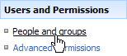

- On the toolbar, click the New menu and select New Group.

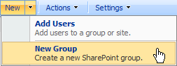

- Set the Name to “Walkthrough Group”.
- Click “Create”.
- Click the New menu on the toolbar and select “Add Users”.
- Use the new “People Picker” feature to add another user to the group.
- Click the Browse button next to the “Users” field.

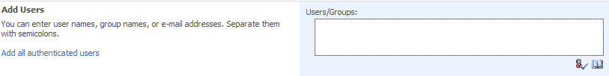

- Type the first name of a user into the search field and click the Search button. The “People Picker” will search for the name and fill in the search results box.
- Select the user you wish to add from the results box, then click Add and OK.

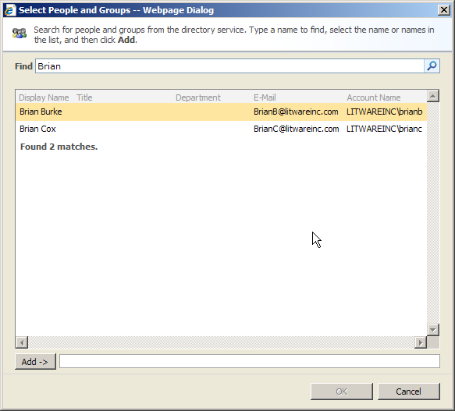

- Click OK to complete the user addition. You have just added a new, lower-permission user to the site. You can use the People and Groups page for flexible, easy control over your site’s visitors.
- Now, click the Walkthrough Site from the breadcrumb.

Exercise 3 – Web Parts
This exercise will demonstrate how to add Web Parts to a page in Office SharePoint Server 2007.

Adding Web Parts
- On the home page of the Walkthrough Site, click Site Actions and select “Edit Page”.

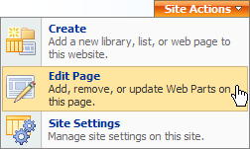

- In the Left Web Part Zone, click the “Add a Web Part” button.

- Select the “Tasks” list Web Part, and then click the Add button.

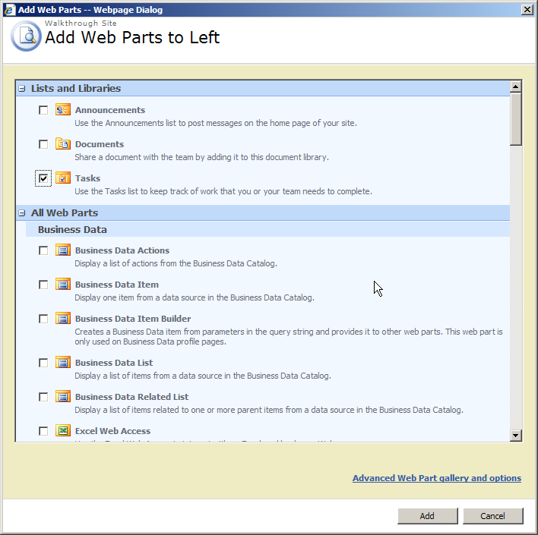

- Click Exit Edit Mode below the “Site Actions” menu.



- The “Tasks” list now displays in the left Web Part zone of your home page.

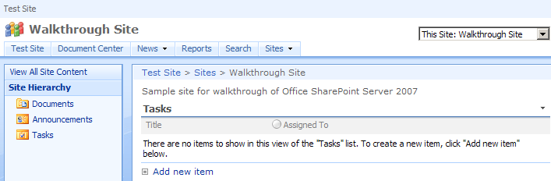

Exercise 4 – Web Parts for Common Information
This exercise demonstrates some Web Parts included with Office SharePoint Server 2007 for common informational use:
- Highlight/News of the day
- News
- Top sites
- Calendar

- Go to the home page of your test site.
- Notice the large content area in the center of the page; this is the “Highlight” section, by default containing information for new users.

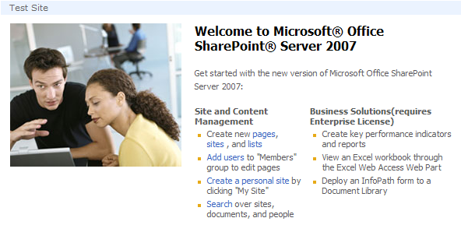

- Notice the News section directly below the highlight; this is populated based on articles in the News area. The News area is now a publishing site with the features previously included in Microsoft Content Management Server 2002. For more information, see the separate Content Management lab.



- Notice the Top Sites section; this is a list of sites from the Sites Directory that can be filtered based on rules set in the Web Part.



Exercise 5 – Security
This exercise will provide an overview of the improved security model in addition to the new Recycle Bin functionality.

Note: This exercise requires that you have additional users in your directory that you can add to user groups in Office SharePoint Server 2007. You may wish to create some test accounts for this purpose.

Item level security
- Click the Tasks link in the Tree View left navigation.
- Create a new Task:
  - Title: Important
  - Priority: (1) High
  - Assigned to: (Assign to a user in your directory)
- Create another new Task:
- Title: Common
- Assigned to: (Assign to the same user in your directory)
- Rest your mouse on the title of the “Important” task. You’ll notice a drop-down menu highlight around the title. Click the drop-down arrow to expand this menu, and select the Manage Permissions command.

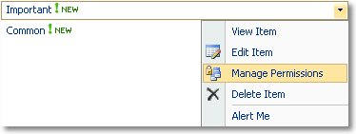

- On the Manage Permissions page, choose “Edit Permissions” from the “Actions” menu. Read the warning prompt and click OK.

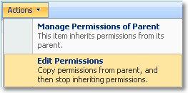

- Select the check box for “Walkthrough Group” and choose “Remove User Permissions” from the Actions menu.
- Click OK on the pop-up prompt.

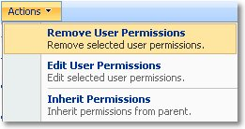

- Click “Tasks” from the Site breadcrumb to return to the Tasks list page.



- Click the arrow next to the “Welcome” message on the top right of the page and select “Sign in as Different User”.

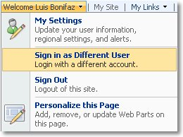

- Sign in with another user’s credentials.
- Notice that, as this other user, you cannot see the “Important” task after the previous user’s permission change.
- Choose “Sign Out” from the Welcome menu and “No” from the pop-up to revert to Luis Bonifaz.
- Click “Go back to site” to return to the Walkthrough Site.

Item version and history
- Choose Tasks from the left navigation menu.
- In the Tasks list, click the Settings menu on the list toolbar, then click List Settings.

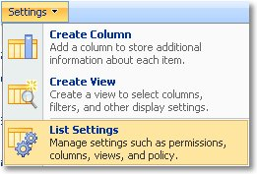

- Like the Site Settings page, the Customize List page has been updated with categories and a new layout to aid navigation.
- Click “Versioning settings” under the “General Settings” category.

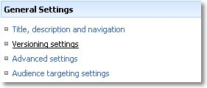

- In the Item Version History section, set the “Create a version each time you edit an item in this list?” radio button to “Yes”. Then click OK.

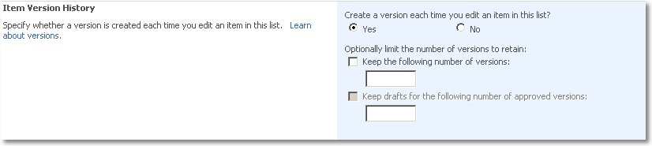

- Click “Tasks” in the site breadcrumb.



- Rest your mouse on the “Common” task to display the drop-down menu and choose “Edit Item”.

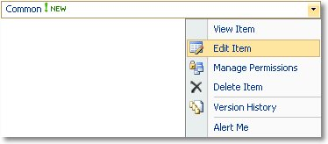

- Change the value of Status to Completed and click OK.

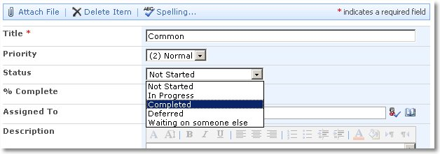

- Rest your mouse on the “Common” task to display the drop-down menu and choose “Version History”.

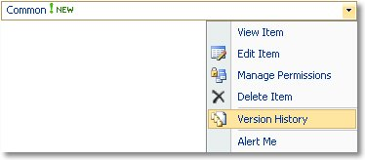

- Delete version 1.0 by clicking Delete on the item’s drop-down menu, which appears when the mouse rests on the “Modified” date field. Then click OK to confirm the information.

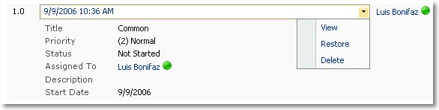

- Click Walkthrough Site on the site breadcrumb to return to the home page.



Recycle Bin
- Scroll to the bottom of the home page, and click Recycle Bin from the left navigation.



- You’ll see the 1.0 version of the “Common” item, plus details about its original location, deletion date, and disk size.
- Click the check box for the “Common (1.0)” item, then click “Restore Selection” on the toolbar. Click OK to confirm the information.

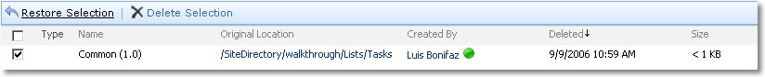

- Had you chosen to delete the item, it would have been sent to a second-stage administrator Recycle Bin. From there, the data can be restored in an emergency.
- Click “Walkthrough Site” in the site breadcrumb to return to the home page.

Exercise 6 – Notifications
This exercise gives an overview of the changes made to alerts, e-mail notifications for task lists, and RSS Feeds.

Alerts
- Return to the “Tasks” list by clicking the Tasks link on the left navigation.
- Click the Actions menu on the list toolbar and select Alert Me.

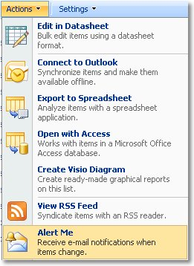

- Browse through the New Alert page and notice that the configuration includes sending e-mails to other users, new event criteria such as “A task is assigned to me” and “A high priority task changes”, and an option to specify the delivery time for your alerts.
- Choose “A high priority task changes” from the “Send Alerts for These Changes” section.

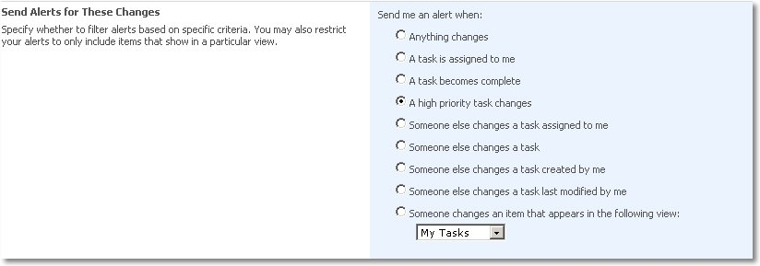

- Click OK.

E-Mail Notifications
- Click the “Settings” menu and select “List Settings”.

- Click “Advanced settings” from the “General Settings” category on the “Customize Tasks” page.

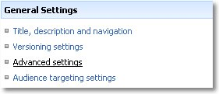

- Scroll down to the “E-Mail Notification” section and confirm that “Yes” is chosen to enable e-mail notification for Task items. Click OK.

- This “Tasks” list will send e-mail messages to users who have been assigned new tasks. This requires that outgoing e-mail has been configured on the server.
- Click “Tasks” in the site breadcrumb.
- Choose “Edit Item” from the pull-down menu on the “Important” task.
- Set the value for “Status” to “Completed” and click OK.
- Open Microsoft Office Outlook 2007. View the e-mail regarding the change to the “Important” task. It may take up to five minutes for the e-mail to appear.

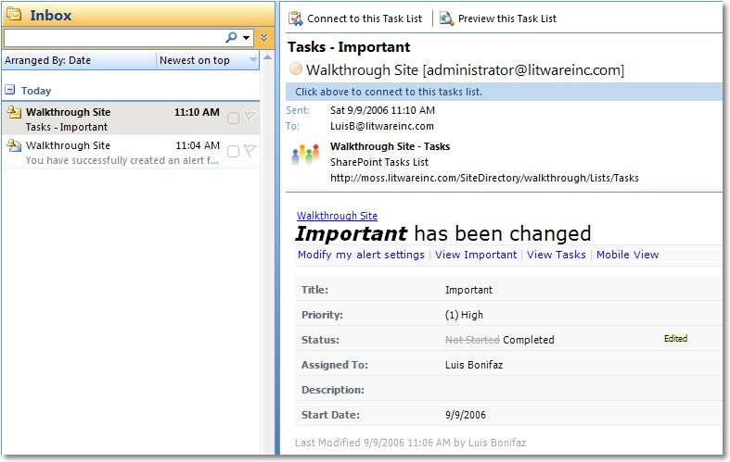

RSS Feeds
- Return to your browser.
- Choose “View RSS Feed” from the “Actions” menu for the Tasks list.

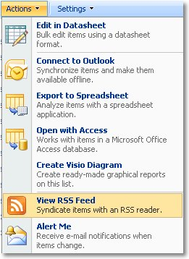

- RSS Feeds have a link near the top of the page that simplifies subscription with a single click, as demonstrated below. Click the “Subscribe to this feed” link.

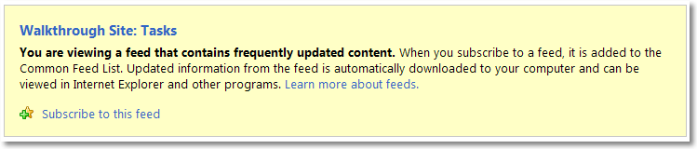

- If your default RSS aggregator is Internet Explorer 7.0 (as shown here), it opens and gives you the option to set any advanced settings for the feed. Click Subscribe in the Internet Explorer dialog box (the options will vary depending on your RSS Feed aggregator application).

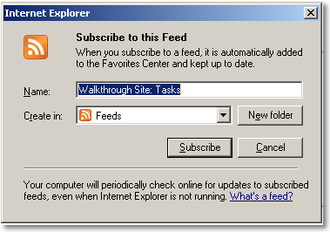

- Click the View my feeds link.
- Notice the list feed has been added and the list items are synchronized to your RSS viewer.
- Open Outlook 2007, expand RSS Feeds in the folder tree, and choose Walkthrough Site: Tasks.
- See that the feed is automatically synchronized with the Outlook 2007 RSS viewer as well.
- Return to your browser.
- Click the Walkthrough Site: Tasks link to return to the default view of the tasks list.
- Click Walkthrough Site in the site breadcrumb to return to the site home page.

Exercise 7 – Working with Microsoft Office Outlook 2007
This exercise gives an overview of the new Outlook 2007 features that integrate with the Office SharePoint Server 2007 platform.

Shared Calendars and Tasks
Note: This exercise requires that you access the Office SharePoint Server 2007 environment from a computer with Office Outlook 2007 installed.
- From the home page of the Walkthrough Site, select Edit Page from the Site Actions menu.

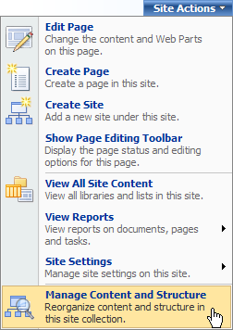
- Locate the Walkthrough Site in the tree and click it.

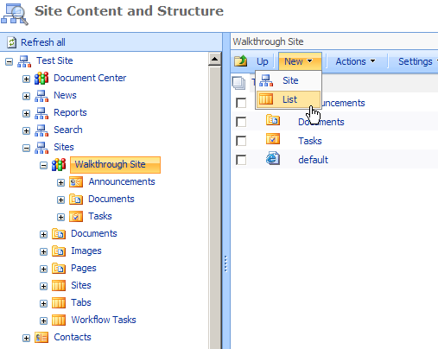
- In the right pane, click New and then List.
- From the Create page, under Tracking, click Calendar.
- From the New page, in the Name box simply enter “Calendar” and click the Create button.
- You will now be on the Calendar page.
- Create a new Calendar item titled “Walkthrough”.
- Click OK.
- Scroll down the Calendar page, if necessary, to see your new entry.
- Now, scroll to the top of the page, click Actions, then “Connect to Outlook”.

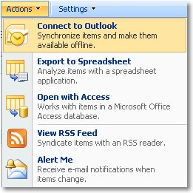

- Click Yes in the Outlook 2007 dialog box.

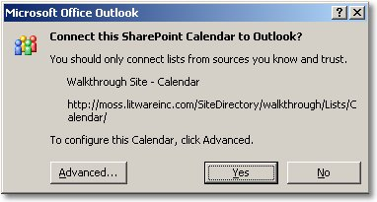

- The SharePoint-based event now shows up in Outlook 2007 (you may need to scroll down in the Outlook calendar display).
- Add a new calendar entry to the Walkthrough Site calendar at a few hours after “Walkthrough” and name it “New Item”.

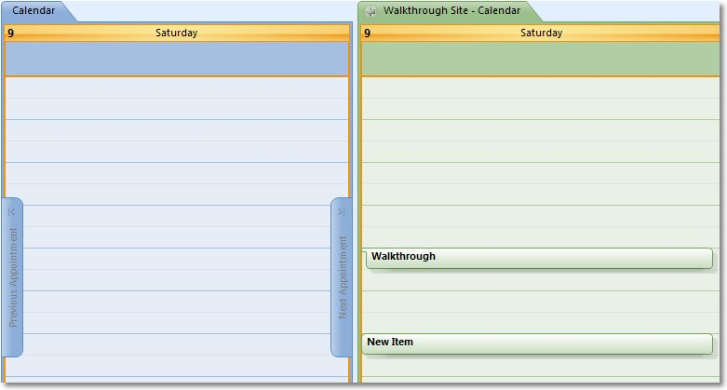

- Press F9 to do a Send/Receive and push the data back to the server.
- Return to your browser, use the Refresh browser menu item, and you’ll see that the Outlook 2007 item now appears.

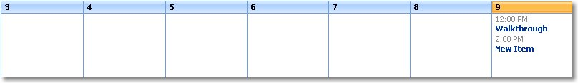

Exercise 8 – Audience Targeting
Note 1: This exercise assumes a configuration where SharePoint-based audiences are managed within a Shared Services Provider named SharedServices1. If you have named your SSP differently, use your SSP name wherever “SharedServices1” is used below.
Note 2: This exercise also assumes that you have access to one or more user login accounts with the word “Manager” in their titles. If this is not the case, substitute another value for Manager where this value is used in this exercise.
Office SharePoint Server 2007 also includes improved audience targeting with better scale, depth, and usability.
- Audience targeting allows content contributors to highlight certain content and present it to users who may find it useful.
- Targeting is used as an additional attribute on content items to target them more accurately within the portal user community.
- A user base can be chosen based on a person’s role or affiliation within the organization and it can be applied to discussion groups and SharePoint groups.
- Targeting is available for Enterprise Information Sites, Business Application Sites, and Collaboration/Community Sites.

There are two ways to target content to users:
- Web Parts A user in a particular audience will see Web Parts that are relevant to him.
- Listings A summarization and aggregation list provides a rich summary on a particular resource, annotated with audience information.

In this case, you will create an audience and target a Web Part in the new Windows SharePoint Services Test site. Targeting Web Parts themselves and doing so in Windows SharePoint Services sites are both new capabilities in Microsoft Office 2007.

- Close all Web browsers.
- Open SharePoint Central Administration from the Start menu Program Files Administrative Tools.

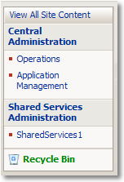
- Click the SharedServices1 link in the left navigation.
- Click the Sign in as a different user link.
- Sign in with Administrator credentials.
- In the Audiences section, click Audiences to open the Manage Audiences page.
- Click the Create Audience link.
- Give the new audience a name of Managers and click OK.
- In the Add Audience Rule page, use the following values and click OK.
Property: Title
Operator: Contains
Value: Manager

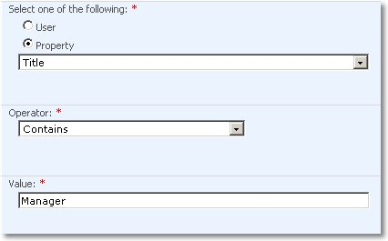

- Click Manage Audiences from the site breadcrumb.

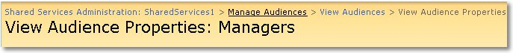

- Click Start compilation.

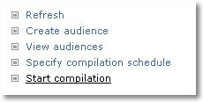

- Click the browser home button to return to the portal home page.
- Click Walkthrough Site in the drop-down menu under Sites in the top navigation bar.

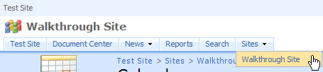

- Click the down arrow on the right side of the Announcements Web Part header and choose Modify Shared Web Part.
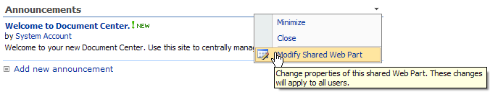
- The Web Part Properties pane appears. Expand the Advanced section.
- Scroll to the bottom, and click the Browse button in the Target Audiences section.

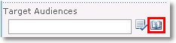

- The Select Audience pop-up appears.
- Click to highlight Managers in the return list, then click Add and OK.

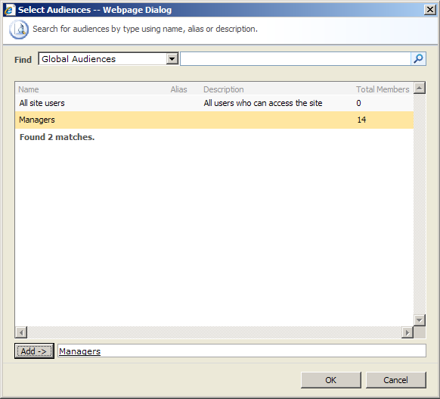

- Click OK to apply the Web Part changes, and close the property pane.

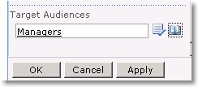

- Log in as a user who does not have the word “Manager” in her title.
- Notice that the Announcements Web Part is hidden, as this user is not a member of the audience.
- Choose Sign In as Different User from the Welcome <user name> item at the top of the browser window.

Exercise 9 – People Profile and My Sites
Note: This exercise assumes that you have additional users in your directory that you can add to user groups in Office SharePoint Server 2007, and that these users have configured their own My Site pages. If this has not yet been done, you should log in as each of these users and click their “My Site” links to initialize their personal pages. The illustrations below use names of individuals in a fictitious organization.
One of the core benefits of “My Site” personal views is the ability to look at all the items that are created by, assigned to, and modified by the user. There are a number of places in the corporation where information is stored, and rolling them up into a single view personalized for a specific user is one of the most critical productivity enhancing features.
Office SharePoint Server 2007 has improved “My Site” personal sites with the following:
Richer information
- SharePoint sites roll-up
- Documents and tasks
- Colleagues (and what has changed)
- Self-configuring OWA parts

Your own site
- Add your own Web Parts
- Granular privacy control over profile and content
- Customize in Office SharePoint Designer 2007

Leverage all Windows SharePoint Services features
- Offline documents and calendar in Outlook 2007
- Personal blog
- RSS Feed

- Click My Site in the upper right corner of the browser page.

- Notice the SharePoint Sites roll-up Web Part. This Web Part displays tabs for each site where documents were created or tasks were assigned to Luis Bonifaz.
- The SharePoint Sites roll-up Web Part can be used to find documents that you have authored on the portal. Click the Find all documents by Luis Bonifaz link.
- Click the Back button on the browser to return to My Home.
- The roll-up Web Part can also have a quick view of a site configured. Click the Walkthrough Site tab.

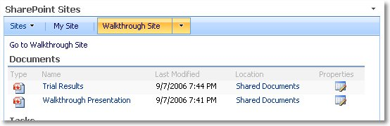

- Notice the Colleagues Web Part.

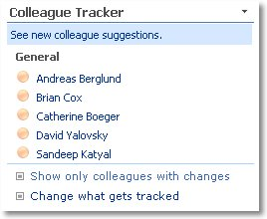

- You can add additional colleagues at any time by clicking on Colleagues under My Profile in the left navigation.

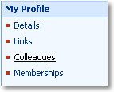

- Notice the My Colleagues page, which lists existing colleagues with information about them and options for editing.

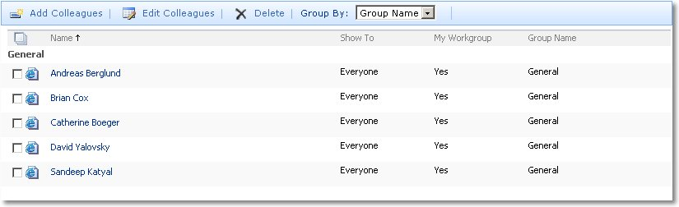

- Click Add Colleagues.
- Notice the ability to add new colleagues, including suggestions based on e-mail and IM communication.

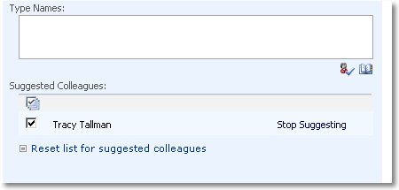

- Also notice the Privacy and Grouping section, which has options for grouping colleagues and for how your colleagues are displayed on your public My Site.

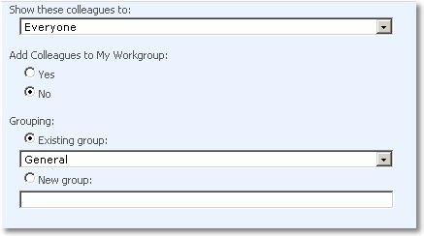

- Click My Site in the upper right corner to return to Luis’ My Site.
- In the left navigation, click Details under My Profile.

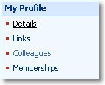

- Scroll down the page and notice the drop-down menus in the Show To column. This controls who is able to see this information on your public My Site.

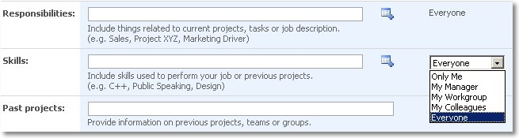

- Notice the ability to pick a picture for your profile.



- Fill in some information in the Interests, Skills, and Responsibilities sections.
- Click Save and Close.

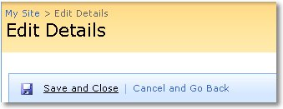

Office SharePoint Server 2007 has added additional functionality to make social networking connections between employees easier to discover. Public “My Site” pages now include additions such as:

Social Networking
- Use organization, community, and communication to recommend colleagues
- Better search results
- Make a personal connection by viewing who you have in common with other users

Richer implicit information
- People you work with
- Documents written by you
- Distribution lists and SharePoint site memberships

Declared information
- Responsibility and skills
- Import from business systems

- Click the My Profile tab; this displays the user’s public My Site.

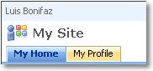

- Notice the improved Organization Hierarchy Web Part. This information is derived from the manager property of the imported user profile.

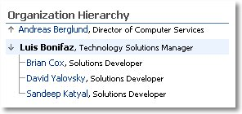

- Notice the In Common with You Web Part.

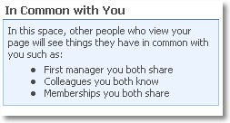

- Click the name of another user from the Colleagues Web Part.

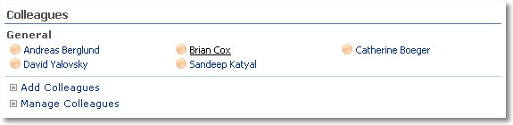

- Note the other user’s public My Site the In Common with <user name> and its contents (your results will likely vary).

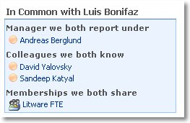

- Return to your My Profile page by clicking on the My Site link and then selecting the My Profile tab.

Office SharePoint Server 2007 has added additional functionality to control the visibility of information on your public My Site, including:
- Show to “My Manager”, “My workgroup”, “My colleagues” and “Everyone”
- Control colleagues, memberships, property values

- Notice the information you had previously added is displayed in the Contact Information Web Part.

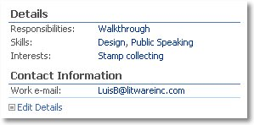

- Click the drop-down menu As seen by (Top right of page): and notice the values. This allows you to preview your My Profile and see what appears for each group.

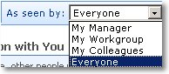

- Click Edit Details under Contact Information.
- Change the Show to drop-down value for Skills to My Work Group.
- Choose Save and Close.
- Notice that Skills disappears from the Details section.

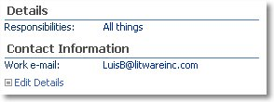

- Change the value of the As seen by: drop-down menu to My Work Group and notice that Skills reappears.

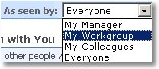

- Notice the Memberships Web Part, which displays your group memberships.

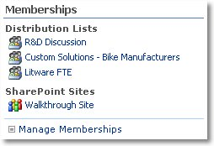

- Notice the Colleagues Web Part, which displays all of your colleagues.

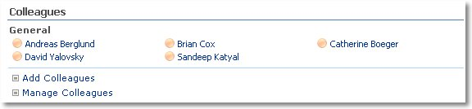

- Click the Manage Colleagues link.
- Select the check box next to a colleague and click Edit Colleagues on the toolbar.

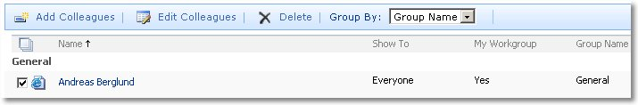

- Notice the options to set visibility and grouping for this colleague.

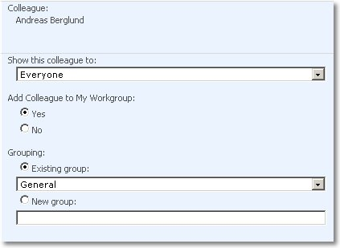

- Click Cancel to return to the My Colleagues page.

Exercise 10 – Create a SharePoint list to track reseller feedback from the Business Data Catalog

Note: This exercise assumes that you have a sample Business Data Catalog application definition called AdventureWorks. The Business Data Catalog section of this document refers to this Business Data Catalog application and also includes a link to a location where you can access a business application definition file that can be used to create the Business Data Catalog entry.
Windows SharePoint Services 3.0 allows you to create custom field types. Office SharePoint Server 2007 uses this feature to provide a new field type called Business Data that is available to all lists. The Business Data field type enables users to add data from business applications registered in the Business Data Catalog to lists.
This topic shows how you can add a Reseller column to a SharePoint list.

Create the Reseller Feedback list
- In Internet Explorer, return to the home page of your test portal site.
- Navigate to the Walkthrough Site by using the top navigation Sites drop-down menu.
- Click Create in the Site Actions menu at the top right. The Create Page appears.

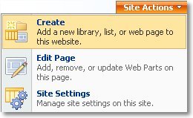

- Click Custom List in the Custom Lists section. The New page appears.

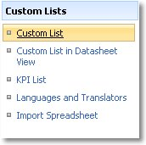

- Type Reseller Feedback in the Name field and click Create. The Reseller Feedback list appears.
- Click Settings on the list toolbar and select Create Column. The New Column page appears.

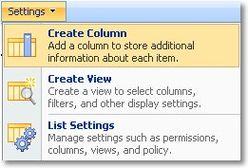

- Use the following values:
  - Column name: Reseller
  - The type of information in this column is: Business data
  - Under Additional Column Settings in the Type field: Reseller (then click the “Check Types” icon: )
  - Add a column to show each of these additional fields: Number
- Click OK. You return to the list, which now contains the Reseller and the related Reseller: Number columns.
- Click New on the list toolbar and select New Item. The New Item page appears.
- Use the following values:
  - Title: Can’t withstand rainy Seattle winter
  - Reseller: Volume Bike Sellers chosen in one of these ways:
    - Type Bike in the Reseller field and click the Check Names icon. bike is underlined in red and a message is displayed: No exact match was found. Click bike and choose the reseller.
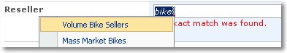
    - Click the Browse icon, choose Name in the search drop-down menu, type bike in the search box, and click the magnifying glass button. Select the reseller from the search results box.
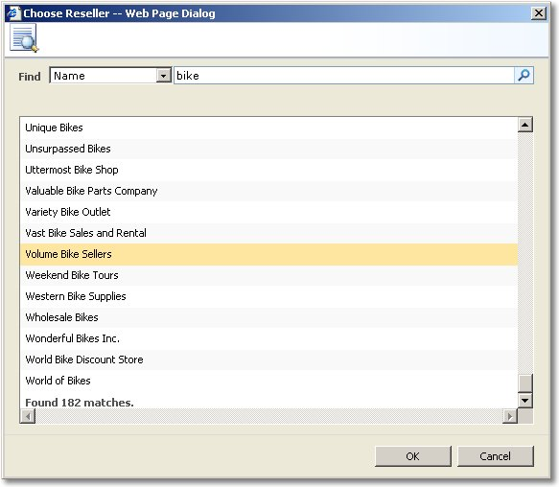

- Click OK. The new list item appears with the reseller name and number. The reseller name item also includes the drop-down menu of all the available Business Data Catalog actions for the reseller entity.

Exercise 11 – Workflow

Office SharePoint Server 2007 streamlines document collaboration with the provided workflows. Custom workflows can also be defined by using tools such as Microsoft Office SharePoint Designer 2007 and Visual Studio.NET 2005 and the Workflow SDK.
The workflow tasks show up as a familiar SharePoint list, showing the status of all assigned tasks.
- From the home page of your test portal, click the Document Center tab.
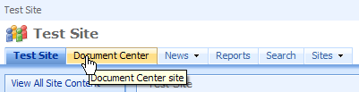
- Click the Documents list in the Quick Launch.
- Upload a new document to the library by clicking Upload and Upload Document.

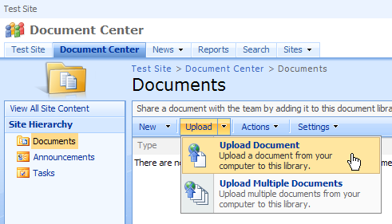
- From the Upload Document page, select a document from your desktop and upload it to the library (Check In the document when you are prompted to do so).
- You may start a workflow in a number of different ways:
  - By using the Office 2007 client user interface
    - First, from the browser, rest your mouse on the document and click the down arrow to the right side of the document
    - Select Edit in Microsoft Office <Word, Excel, or PowerPoint>
    - Under the “Office Button” menu, select “Workflows”, and click the “Start” button next to the desired workflow (check in the document if prompted)
    - 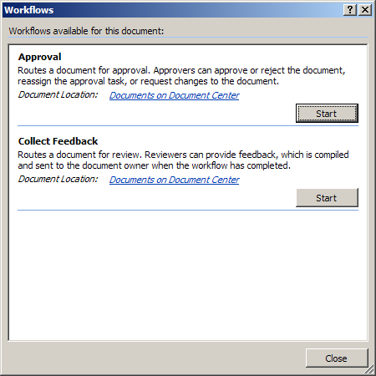
  - By using the Office SharePoint Server 2007 user interface
    - Rest your mouse on the Walkthrough Presentation and click to pull down the drop-down menu, and then select Workflows
    - Click the Document Review link and then click the Start button to start the workflow
- After the workflow has been started, you will notice a Workflow Task option appear. You may interact with your workflow tasks through the Office client user interface or by using the interface.
- Return to your browser.
- Click the Tasks list in the Quick Launch to view the assigned tasks.
- Notice the new workflow-related tasks.
- Return to the document library.
- Notice the workflow status field next to the document in the Document Review metadata column.

For More Information
- Visit Microsoft Office Online. This Web site features the latest news and information about the 2007 Microsoft Office system, including product information, case studies, white papers, information about related technologies, and more.

The information contained in this document represents the current view of Microsoft Corporation on the issues discussed as of the date of publication. Because Microsoft must respond to changing market conditions, this document should not be interpreted to be a commitment on the part of Microsoft, and Microsoft cannot guarantee the accuracy of any information presented after the date of publication. The information represents the product at the time this document was printed and should be used for planning purposes only. Information is subject to change at any time without prior notice.

This document is for informational purposes only. MICROSOFT MAKES NO WARRANTIES, EXPRESS OR IMPLIED, IN THIS DOCUMENT.

© 2007 Microsoft Corporation. All rights reserved.

Microsoft, Active Directory, Excel, InfoPath, Microsoft Press, MSDN, the Office logo, Outlook, PivotChart, PivotTable, PowerPoint, SharePoint, SQL Server, Visual Studio, Windows, Windows Server, and Windows Vista are either registered trademarks or trademarks of Microsoft Corporation in the United States and/or other countries. All other trademarks are the property of their respective owners.

