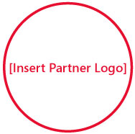

Solutions for Small Business
[Insert Partner Copyright Notice or Trademark Notice]
[Insert Partner Legal and/or Privacy Information]

So you heard about me from your mom’s doctor’s golfing buddy?

Want to get new customers without it being a hassle? Build on the information you’ve gathered at this event by taking the next step.

Visit http://mslocalbiz.com to view special offers, access small business resources, and learn about other events in your local area.

