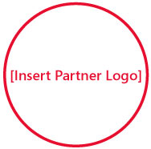

Solutions for Small Business

[Insert Partner Copyright Notice or Trademark Notice]
[Insert Partner Legal and/or Privacy Information]
Visit http://mslocalbiz.com to view special offers, access small business resources, and learn about other events in your local area.
So you heard about me
from your mom’s doctor’s golfing buddy?

