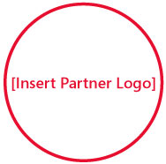

Solutions for Small Business
[Insert Partner Copyright Notice or Trademark Notice]
[Insert Partner Legal and/or Privacy Information]
Want to use the Internet to drive your business? Build on the information you’ve gathered at this event by taking the next step.

Visit http://mslocalbiz.com to view special offers, access small business resources, and learn about other events in your local area.
My 5th grader has a better web site than you!

