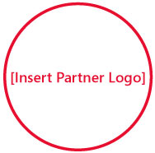

Solutions for Small Business
Event info:
[Month dd, 2008]
[12:00am-12:00pm]
[Location Name]
[Street Address]
[City, State]

Don’t miss this opportunity to meet other local business people, share experiences, and learn how to more effectively use the Internet to drive business.

Please join us! Go to [Insert Partner Registration URL] to register today. Visit http://mslocalbiz.com to discover special offers for small business.
[Insert Partner Copyright Notice or Trademark Notice]
[Insert Partner Legal and/or Privacy Information]

My 5th grader has a better
web site than you!

