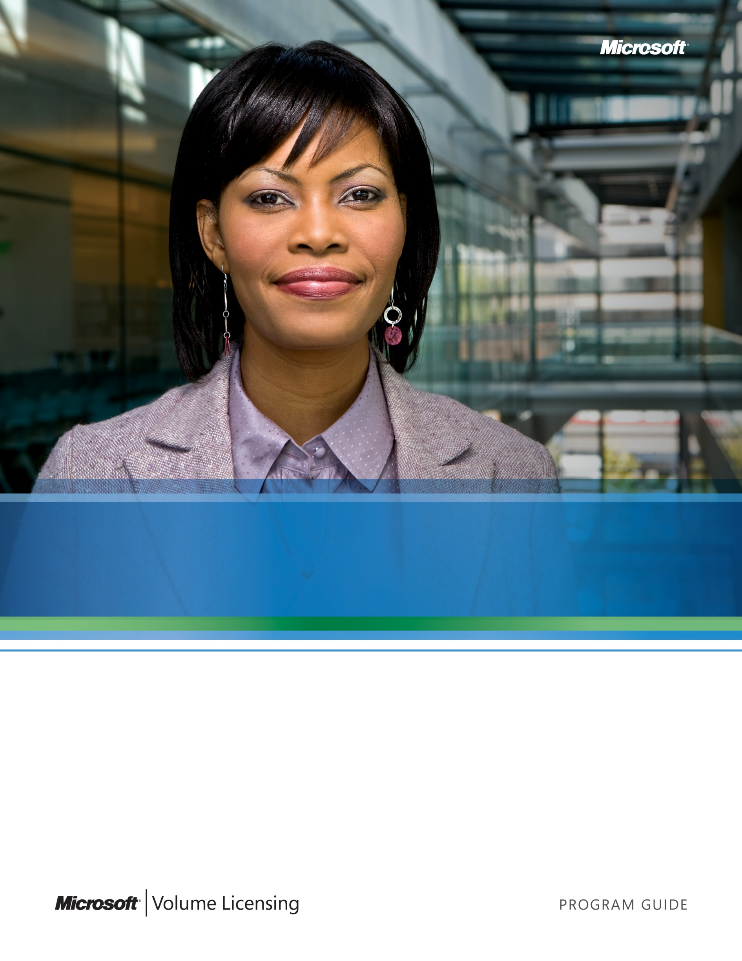Microsoft Product Use Rights Explained
A Guide to the Microsoft® Volume Licensing Product Use Rights (PUR)

© 2009 Microsoft Corporation. All rights reserved.
This document is for informational purposes only. MICROSOFT MAKES NO WARRANTIES, EXPRESS OR IMPLIED, IN THIS DOCUMENT.
The example companies, organizations, products, domain names, e-mail addresses, logos, people, places, and events depicted herein are fictitious. No association with any real company, organization, product, domain name, e-mail address, logo, person, places, or events is intended or should be inferred.
Microsoft provides this material solely for informational and marketing purposes. Customers should refer to their agreements for a full understanding of their rights and obligations under Microsoft’s Volume Licensing programs. Microsoft software is licensed not sold. The value and benefit gained through use of Microsoft software and services may vary by customer. Customers with questions about differences between this material and the agreements should contact their reseller or Microsoft account manager. Microsoft does not set final prices or payment terms for licenses acquired through resellers. Final prices and payment terms are determined by agreement between the customer and its reseller. Eligibility for Software Assurance benefits varies by offering and region and is subject to change. The Terms and Conditions of your Volume Licensing Agreement and the Terms and Conditions under which any specific Software Assurance benefits are offered will take precedence in the case of any conflict with the information provided here. For eligibility criteria and current benefit program rules, see the Microsoft Product List.
0909
Table of Contents
Introduction 5
Overview 5
Using This Guide 5
Key Terms and Acronyms 6
Licensing Basics 7
What Is Intellectual Property? 7
What Is a License? 7
What Is Microsoft Volume Licensing? 7
What Is Software Assurance? 8
What Is a License Agreement? 8
License Life Span 8
Introduction to the Microsoft Volume Licensing Product Use RIghts 9
What Is the PUR? 9
How to Find License Terms for Specific Products 9
Accessing the Current PUR or Creating a Custom PUR 9
Licensing Models used in Volume Licensing 10
Why Does Microsoft Use Several Licensing Models? 10
A Customer’s Journey 11
Initiative 1: Desktop Hardware Refresh 11
Initiative 2: File and Print Sharing 13
Initiative 3: Development and Testing 15
Initiative 4: Enterprise E-mail and Calendaring 16
Initiative 5: Collaboration Portal 17
Initiative 6: IT Protection 20
Initiative 7: IT Management 21
Initiative 8: Company Web Site 23
Additional Resources 25

Introduction

Overview
Microsoft makes hundreds of products that help businesses operate. Considering this, it’s no surprise that understanding your options as a business customer for licensing a particular product can feel like a challenge. If you would like to better understand the ways in which Microsoft® products are licensed through Microsoft Volume Licensing programs, this guide is a great place to begin.
Here you will find information about licensing basics and why Microsoft uses different models for licensing its products. These models are described in detail in the Microsoft Volume Licensing Product Use Rights (PUR) document. While the PUR is a vital legal document and part of your Microsoft Volume Licensing agreement, we understand if you feel it’s more than just casual reading! To help you, we have created a licensing story that walks you through examples of how the Microsoft licensing models are applied when using various “real-world” technology solutions. We invite you to follow the director of IT for a midsize company as she finds the best way to license the Microsoft products and services her company needs for a series of IT initiatives.

Using This Guide
Use this guide to improve your understanding of the models and rules for licensing Microsoft products through Microsoft Volume Licensing programs. It is not intended to guide you in choosing Microsoft products and services. The examples presented in this guide are illustrative and to help focus on the licensing concepts we have simplified product names. For help determining the right technology solution for your organization, talk to your Microsoft reseller and/or Microsoft account team. If you are unsure about the license requirements for a specific product or scenario, consult with your Microsoft reseller, your Microsoft account team, or the licensing support contact for your region. You can also visit http://www.microsoft.com/licensing/worldwide.aspx to find your local Microsoft Volume Licensing Web site.
This guide does not supersede or replace any of the legal documentation covering use rights for Microsoft products. Specific product license terms are detailed in the Microsoft Volume Licensing Product Use Rights document, which is available at http://www.microsoft.com/licensing/userights/.

Key Terms and Acronyms
Please take a moment to review these key terms and acronyms that are in this guide:
CAL: Client Access License permitting access to software running on a server
Device: Desktop PC, server, mobile phone, or any other machine on which the software is run or accessed
Instance: An installed copy of the software
L&SA: License and Software Assurance Pack used to acquire both a license and Software Assurance coverage for the license
ML: Management License permitting operating system environments to be managed by a management server
MDOP: Microsoft Desktop Optimization Pack
Operating system environment (OSE): The computing environment on the physical machine (physical OSE) or virtual machine (virtual OSE) where the operating system and applications run
Physical machine: An actual hardware device, such as a desktop PC, mobile phone, or server
Processor: A complete computation engine that is fabricated on a single chip and performs the “work” of the computer (also referred to as a “microprocessor” or “CPU” (central processing unit)
Product List: Monthly publication that includes a list of products and services available through Microsoft Volume Licensing programs, plus other important information such as which products qualify for the Windows® Upgrade license, available products to downgrade, and Software Assurance migration paths and acquisition rules. The Product List is available at http://www.microsoft.com/licensing/userights/.
Product Use Rights (PUR): A document that contains use rights for licenses acquired through Microsoft Volume Licensing. The PUR is available at http://www.microsoft.com//licensing/userights/.
Run: To copy, install, use, access, display, run, or otherwise interact with the software
User: Person using the software product or service
SL: Subscription License used to license access to certain Microsoft online services
VECD: Windows Virtual Enterprise Centralized Desktop
Virtual machine (VM): An emulated software version of a computer that executes programs like a separate physical computer
Virtual processor: Processor execution unit supporting a virtual machine
Virtualization: Running software in a virtual operating system environment

Licensing Basics

What Is Intellectual Property?
People tend to think of software as a commodity—something you buy off the shelf from a retailer, like a computer or a television. When you buy a commodity, you own the physical object, and all or most of the commodity’s value is intrinsic to that object. But with software, you license not purchase it. When you license software, the primary value comes not from an object (such as the disk it is stored on) but from the knowledge of the people who wrote the software. You do not own that knowledge; you are merely acquiring a limited right to use it. In other words, software is an intellectual property, much like the words in a book or musical notes on a song sheet.
Intellectual property includes ideas and creative expressions that may have commercial value. These items are intangible and not easily defined or identified by their physical parameters. As a result, they are copyrighted. A copyright is an Intellectual Property Right (IPR) and is protected by international copyright laws. Intellectual Property Rights include copyrights, trademarks, and patents. These laws enable the owners of the intellectual property to decide who may access and use their property, and to protect it from unauthorized use.

What Is a License?
A software license provides the legal right to install, use, access, display, run, or otherwise interact with a software program. A license does not necessarily include the rights to media, manuals, or support. The way in which the software may be used is determined by the software license terms. When you acquire a software license, to use the software you must agree to those terms. Some companies refer to those terms of use as an End User License Agreement (EULA). At Microsoft, we refer to them as software license terms.
License enforcement and compliance protects a software developer’s investment in his or her intellectual property. As a user, proper compliance ensures you that your use of the software is covered by the terms of the license. Proper compliance also protects you from pirated and potentially corrupted or malfunctioning software. In addition, with the acquisition of your license, you often have the option of receiving technical services and support to maximize your investment.

What Is Microsoft Volume Licensing?
Simply stated, licensing software in volume makes it easier and more affordable to run software on multiple computers within a single licensing organization.
By acquiring software licenses through Microsoft Volume Licensing programs, you only pay for the software license. Boxed software, on the other hand, includes media (the CD-ROM or DVD), a user's guide, and other packaging items. Eliminating these physical costs and purchasing licenses in volume often reduces cost and provides more customized licensing options and improved software management. Depending on the Volume Licensing program you choose, you may receive media, and you have the option to acquire media (or supplemental media), documentation, and product support separately as needed.

What Is Software Assurance?
Software Assurance is a comprehensive maintenance offering from Microsoft that can help you get the most out of your software investment. It combines the latest software with benefits such as phone support, partner services, training, and IT tools. You can choose to include Software Assurance with your license at the time that you purchase the license and begin using your benefits immediately for the term of your coverage.

What Is a License Agreement?
When you participate in a Microsoft Volume Licensing program, you are required to accept a license agreement between your organization and Microsoft. This license agreement defines the software license terms. For instance, it determines whether the software can be installed on more than one PC or other device and for how long it can be used. When you acquire and install new software, you must accept the license agreement to legally use that software. It’s important to understand the content of license agreements and the differences between specific licensing programs.

License Life Span
Licenses can have different life spans. They can be either “perpetual” or “nonperpetual.”
- Perpetual licenses are everlasting and valid if the software is being used according to the license agreement and software license terms.
- Nonperpetual licenses, or subscription licenses, are temporary and provide the right to use a particular licensed product as described in the license agreement (e.g. until the end of the term of that agreement or until the anniversary of the effective date of that agreement) if the software is being used in accordance with the license agreement and software license terms. They are available only through certain comprehensive Microsoft Volume Licensing programs or available for certain products such as Microsoft Online Services, Microsoft Desktop Optimization Pack (MDOP), and Windows Virtual Enterprise Centralized Desktop (VECD).

Introduction to the Microsoft Volume Licensing Product Use RIghts

What Is the PUR?
The Microsoft Volume Licensing Product Use Rights document, commonly referred to as “the PUR” (pronounced “per”), is part of your Microsoft Volume Licensing agreement. When you need to know how to license a particular product or the specifics of what you may do with that product under the terms of your license agreement, generally, the PUR has the information you need.
The PUR details use rights for specific products, as well as rights that apply to all software licensed through Microsoft Volume Licensing. In addition, the PUR outlines the licensing models used for similar products in Volume Licensing, and the use rights associated with each licensing model. Some products have logical deployment scenarios that may necessitate special use rights or exceptions. These are also outlined in the PUR. The number of licenses required for a particular Microsoft product is determined by the licensing model used for that particular product and how you plan on deploying that product.

How to Find License Terms for Specific Products
When you use the PUR to find the license terms for a specific product, be sure to review the following three terms:
- The Universal License Terms. These terms apply to all products licensed through Microsoft Volume Licensing. You’ll find them near the beginning of the PUR.
- The General License Terms. These terms apply to all products that use a particular licensing model. Each licensing model section includes a list of products that use that particular model. (More on licensing models below.)
- The Exceptions and Additional Terms for the product. Any additional product-specific terms are listed by product at the end of the applicable licensing model section.

Accessing the Current PUR or Creating a Custom PUR
You can download the current PUR or create a customized PUR that includes only the product(s) you select by visiting http://www.microsoft.com/licensing/userights/.

Licensing Models used in Volume Licensing
Different models are used for licensing products through Microsoft Volume Licensing. These programs are outlined in the PUR.

Why Does Microsoft Use Different Licensing Models?
When determining how best to license a specific Microsoft product, consider a number of factors. Some factors are product-specific:
- How will the product be used?
- How will it be accessed?
- How many people or devices will access it?
- Will it run on a client device (PC, Smartphone, etc.) or on a server?
- Are there additional products that are required to run it?
Other factors may be Microsoft-specific or solution-specific, thus requiring the need to strike a balance between competing licensing priorities. Examples include:
- Simplicity versus flexibility. While it might be simpler for every product to use the same licensing model, that would remove the flexibility to match the model to the typical use scenarios.
- Predictability versus adaptability. We know from talking to our customers and partners that adding or changing licensing models can cause some disruption. At the same time, sometimes it makes sense to adapt the way a product is licensed based on changes to how it is used—such as virtualization or other new, emerging use scenarios—so that the model works better for more people.
Ultimately, Microsoft strives to find the right balance between these and a number of other priorities to find licensing models that work best for everyone.

A Customer’s Journey

Meet Wendy Wheeler. Wendy is the Director of IT for Trey Research, a growing firm that helps clients implement a research-based approach to online marketing. As part of a strategic planning process, Wendy and a team of Trey Research executives outlined eight IT initiatives aimed at building a core IT infrastructure that will help their employees provide the best service to their clients.
Wendy is responsible for guiding the eight IT initiatives through to completion—on time and within budget. To do so, Wendy chooses her technology vendors carefully and pays close attention to how Trey Research procures its hardware and software so that they maximize their return on investment (ROI).
Microsoft is a key vendor for Trey Research, and Wendy makes it a priority to understand the options the company has for acquiring its Microsoft software licenses so that they are getting all of the licenses they need in the most cost-effective way. When it comes to procuring software licenses, Wendy puts a high priority on total cost of ownership (TCO) and long-term value. That’s one of the reasons she includes Microsoft Software Assurance with all of Trey Research’s Microsoft licenses. She believes the benefits of Software Assurance provide significant added value that saves the company money in the long term.
We can learn a lot from Wendy’s experience. Let’s follow her as she acquires licenses for various IT initiatives that use Microsoft software and services.

Initiative 1: Desktop Hardware Refresh
Licensing Model Summary:
Desktop Applications
One license is required for each physical device running or accessing the application. This includes situations where you run the software on your local device or access the software on another device like a server. Additional licenses are not required for running the application on any virtual machines running on the licensed physical device.
Like many organizations, Trey Research refreshes their personal computers on a revolving schedule. Older PCs are retired and new PCs are added. For this refresh cycle, Trey Research is replacing 50 of their PCs. On each PC, they need an operating system and also want a suite of desktop PC productivity applications.
For the operating system on their new PCs, Wendy has selected the Windows 7 Professional operating system. She also wants to be ready to upgrade the PCs to the next Windows operating system when it releases in the future.
Desktop PC applications are typically software programs that one user uses to perform a task on their PC. For example, you may use Microsoft Office Word to draft a business letter or the Microsoft Office PowerPoint® presentation graphics program to create a sales presentation. Desktop PC applications are installed on devices, which can be anything from desktop PCs to laptops to netbooks to mobile phones. They may even be installed on servers so that a user can access them from their PC.
Licensing Model Summary:
Desktop Operating Systems
One license is required for each device on which you access and use the software, whether the software is running directly on the device or running on another device (such as a server) and accessed remotely.
For desktop PC applications, Trey Research uses Microsoft Office, which has all of the familiar applications they need. Wendy has chosen Microsoft Office Professional Plus 2007 as the desktop PC application suite for the new PCs.

License Requirements:
Quick Facts: License SKU Types

Five main stock-keeping unit (SKU) types are sold through Microsoft Volume Licensing. They are:

License: Used to license a specific version and edition of the software.

Software Assurance: Used only to renew/extend Software Assurance coverage or to enroll qualifying OEM or full-package product (FPP) licenses in Software Assurance within 90 days of the license purchase. In addition to other benefits, it permits you to upgrade to new releases of the software made available during the Software Assurance term.

License and Software Assurance Pack (L&SA): Used to acquire both a license and Software Assurance coverage for the license.

Monthly Subscription: Used to license products and services offered on a monthly subscription basis through Volume Licensing.

Software Assurance-Step Up: Used to migrate from a lower edition of a qualifying product (such as Windows Server Standard) that is covered by Software Assurance to a later edition (such as Windows Server Enterprise).

Windows 7 Professional
Trey Research needs a full license for Windows 7 Professional for each new PC. Because full base licenses are not available in Volume Licensing for Windows desktop PC operating systems, the most cost-effective way to get the full license is by having the PC manufacturer (the “original equipment manufacturer” or “OEM”) license and preinstall Windows 7 Professional on each PC.
Trey Research also acquires 50 units of Software Assurance for the Windows 7 Professional through Microsoft Volume Licensing. Because one of the benefits of Software Assurance is access to the most recent version of the software, they can upgrade to the next version of Windows when it releases without having to acquire new Windows licenses. They also receive additional benefits, such as training, support, and deployment assistance.
Microsoft Office Professional Plus 2007
In general, no matter what the device, if Trey Research wants to use a Microsoft desktop PC application on it, they need to license the device for that application. This is true whether the software is installed on the device that the user uses or on the device from which the user accesses the application. Once the device is licensed, they can install as many copies of the application (or a prior version of the application) on the device as they want.
In this case, Trey Research orders one License and Software Assurance Pack for Office Professional Plus 2007 through Microsoft Volume Licensing for each new PC.
Figure 1
Quick Facts: Acquiring Software Assurance for OEM or Retail Licenses

When you acquire licenses for certain products (such as Windows 7) through the OEM or retail boxed product channels, you may purchase Software Assurance for those licenses through certain Microsoft Volume Licensing programs within 90 days of the licensing purchase date. Details on eligibility are included in the Product List at http://www.microsoft.com/licensing/userights
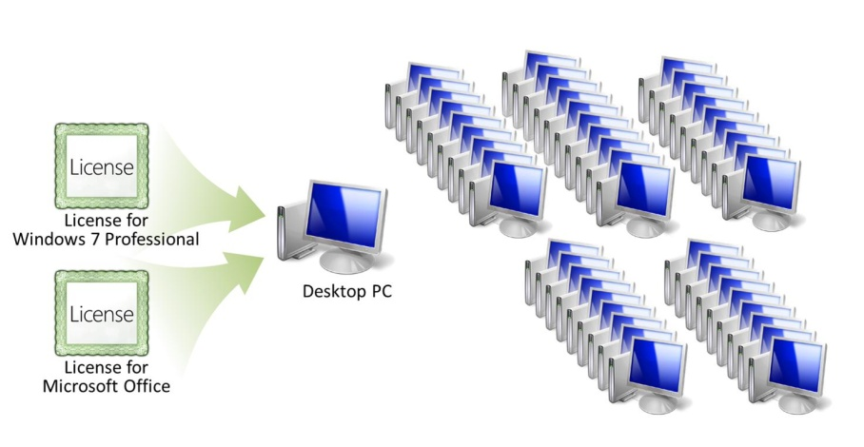

License Order Summary:
Product | Quantity | Ordered Through
Windows 7 Professional | 50 | OEM (Preinstalled)
Windows 7 Professional Upgrade (Software Assurance Only) | 50 | Microsoft Volume Licensing
Office Professional Plus (L&SA) | 50 | Microsoft Volume Licensing

Initiative 2: File and Print Sharing
The next IT initiative for Trey Research is to network their PCs for sharing files and printers. To do this, they will buy a new server with Windows Server® Standard.
Licensing Model Summary:
Server Operating Systems

One server license is required for each instance of the server software running at the same time. A Client Access License (CAL) is required for each user or device that accesses the server software. An optional External Connector license replaces CALs for non-employees, requiring external access to the server.
As Windows 7 is to a PC, so is Windows Server to a server device—it’s the operating system that provides the basis for interacting with the server. Microsoft Server Operating System products (which include most Windows Server editions) are licensed using a Server/Client Access License (CAL) model (the only exception is Windows Server Datacenter which is licensed using a Processor/CAL model). This means they need a license for each instance of the server software that runs at the same time, plus a CAL for each user or device accessing the server.
Figure 2

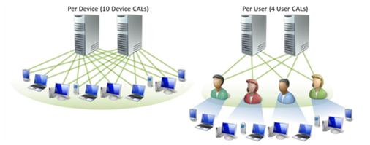

License Requirements:
Windows Server Standard
Wendy purchases the new server hardware from the OEM, but purchases the Windows Server Standard License and Software Assurance Pack through Microsoft Volume Licensing.
Windows Server CALs
Next, they need to figure out how many CALs they need. They can choose user CALs or device CALs, and Wendy wants to make sure they are making the most cost-effective choice. In their case, each of the 120 employees has a PC and Smartphone that can connect to the server. Because they have fewer people than devices, Wendy decides to go with user CALs. She orders 120 Windows Server user CALs with Software Assurance through Microsoft Volume Licensing.
Figure 3
Quick Facts: CALs

- A CAL is not software; it’s a license granting access to the server software.
- CALs are available on a per-user or per-device basis.
- CALs must be for the same or a later version of the server software. (For example, to access Windows Server 2003, you need a Windows Server 2003 CAL or a Windows Server 2008 CAL.)
- Any given user or device only needs one CAL to access any instance of the server software running across the organization.
    - CALs must be assigned to a device or user for at least 90 days before they may be reassigned. You can temporarily reassign your device CAL to a loaner device while the first device is out of service or your user CAL to a temporary worker while the user is absent.
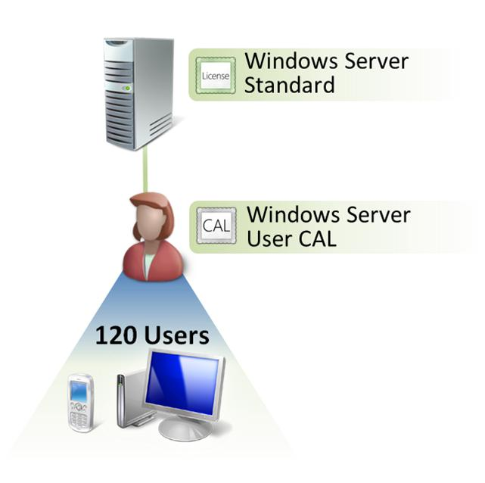
License Order Summary:
Product | Quantity | Ordered Through
Windows Server Standard (L&SA) | 1 | Microsoft Volume Licensing
Windows Server User CAL (L&SA) | 120 | Microsoft Volume Licensing

Initiative 3: Development and Testing

A group of developers and testers at Trey Research is planning to build a new custom application that will help their account managers track and report Web traffic statistics and other key performance indicators (KPIs) for individual clients. Trey Research has three developers and six testers. To provide them with the tools they need for this project (and future projects), the developers will be licensed for Microsoft Visual Studio® Team System Development Edition with MSDN Premium, and the testers will be licensed with Visual Studio Team System Test Edition with MSDN Premium. MSDN Premium provides access to most Microsoft software for design, development, testing, and demonstration purposes, as well as other benefits that help the developers and testers in their application building process.
Licensing Model Summary:
Developer Tools
One license is required for each person that accesses or uses the software. As long as only licensed users have access to the software, you can install as many copies of the software on as many devices as you like.
The software may be used for design development, testing, and demonstration purposes only.

These products are licensed using the Developer Tools model, which is a per-user model. You need a license for each person that accesses or uses the software. As long as only licensed users have access to the software, you can install as many copies of the software on as many devices as you like. This is significant, because it allows the developers and testers to run the software on multiple devices (such as for testing purposes) without having to license each device.

Requirements:
Visual Studio Team System Development Edition with MSDN Premium
Wendy orders three License and Software Assurance Packs for Visual Studio Team System Development Edition with MSDN Premium—one for each developer.
Visual Studio Team System Test Edition with MSDN Premium
Wendy orders six License and Software Assurance Packs for Visual Studio Team System Test Edition with MSDN Premium—one for each tester.
License Order Summary:
Product | Quantity | Ordered Through
Visual Studio Team System Development Edition with MSDN Premium (L&SA) | 3 | Microsoft Volume Licensing
Visual Studio Team System Test Edition with MSDN Premium (L&SA) | 6 | Microsoft Volume Licensing

Initiative 4: Enterprise E-mail and Calendaring
With their new PCs and file and print network setup, Wendy is ready to improve the way employees at Trey Research communicate both in the office and in the field by upgrading their e-mail platform from accounts hosted off of their Web domain to a more powerful, enterprise solution based on Microsoft Exchange Server. The solution runs on the same server they are using for file and print sharing.
Licensing Model Summary:
Server/CAL
One server license is required for each instance of the server software running at the same time. A CAL is required for each user or device that accesses the server software. An optional External Connector license replaces CALs for non-employees requiring external access to the server.
Exchange Server is licensed using a Server/CAL model, which is a good fit for Trey Research. “What I like about the Server/CAL model is that once we make the initial investment in the server license and hardware, we can scale out the solution to more and more employees without incurring big costs, because all we need to do is buy more CALs,” she says.
To provide a comprehensive solution for managing time and information, Exchange Server integrates with the Microsoft Office Outlook® messaging and collaboration client. Outlook is included with the Microsoft Office suite licenses they already have, so they do not need to acquire separate licenses for Office Outlook.

License Requirements:
Exchange Server Standard
Quick Facts: Assigning Licenses

Assigning licenses to a device (such as assigning an Exchange Server license to a server) is not a formal process. It means you need to track your licenses so that you know that you have the appropriate license for a given device.
To meet their server license requirement, Wendy orders one Exchange Server Standard License and Software Assurance Pack through Microsoft Volume Licensing and assigns it to the server.
Exchange Server CALs
CALs are required for every user or device accessing the Exchange Server software. Having already learned about user CALs and device CALs for Windows Server, it was easy for Wendy to choose between user CALs and device CALs for Exchange Server. Each of the 120 employees needs to be licensed for two devices: their desktop PC and their Smartphone, so user CALs are the most cost-effective. They order 120 Exchange Server Standard User CALs with Software Assurance.
In addition to the “base” CAL, some products offer “additive” CALs that provide access to incremental functionality. Wendy has identified 10 employees who require the additional functionality of Managed E-mail Folders (Custom Folders), and so Wendy orders 10 Exchange Server Enterprise CALs with Software Assurance for those users. Users who need additive functionality need both the Standard CAL (base) and the Enterprise CAL (additive).
Figure 4
Quick Facts: Base and Additive CALs

Server software that requires CALs offers one base CAL and may offer one or more additive CALs. Base CALs license access to basic server functionality. Additive CALs license access to advanced server functionality and must be licensed in addition to the corresponding base CAL.
For details see the Volume Licensing brief titled “Base and Additive Client Access Licenses: An Explanation” at http://www.microsoft.com/licensing/about-licensing/volume-licensing-briefs.aspx.

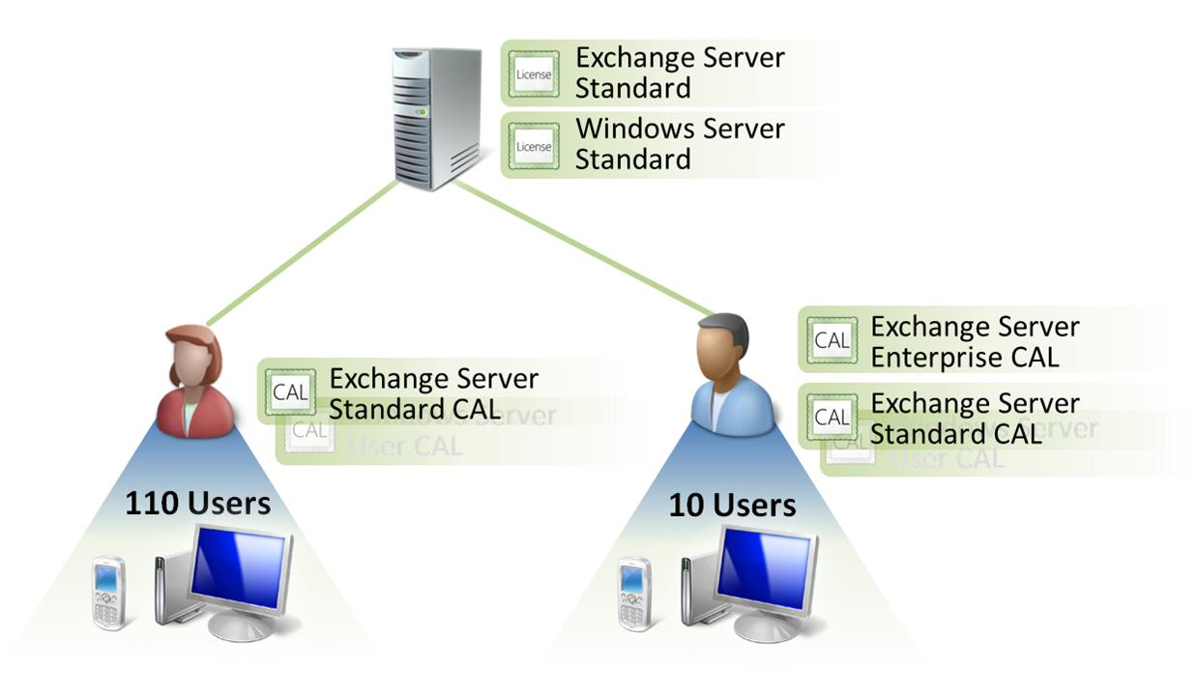
License Order Summary:
Product | Quantity | Ordered Through
Exchange Server Standard (L&SA) | 1 | Microsoft Volume Licensing
Exchange Server Standard User CAL (L&SA) | 120 | Microsoft Volume Licensing
Exchange Server Enterprise User CAL (L&SA) | 10 | Microsoft Volume Licensing

Initiative 5: Collaboration Portal
Executives at Trey Research understand that the ways in which people communicate and collaborate are changing. To keep pace with this changing world of work—and to take advantage of the efficiencies it offers—they want their employees to have self-service access to the information they need when they need it. That is why they have directed Wendy to establish a new collaboration portal—where employees can share and access business intelligence (BI) data, calendars, documents, scorecards, and more—her next IT initiative.
For a collaboration portal platform, Wendy chooses Microsoft Office SharePoint® Server. SharePoint Server, like Exchange Server, is licensed on a Server/CAL basis. SharePoint Server Standard CAL provides access to the portal and its content management and search capabilites. SharePoint Server Enterprise CAL is an additive CAL that provides additional functionality, allowing access to BI and business process and tools functionality. Wendy will add a new server for running SharePoint Server, knowing that she can likely also use some of its resources for future solutions.
SharePoint Server uses Microsoft SQL Server® as an enabling technology. SQL Server provides the back-end database engine that allows Trey Research to centralize data from various sources and deliver BI information through the user friendly interface of SharePoint Server and Microsoft Office. To prepare for the increased workloads that are required of the server running SQL Server as new inititatives are rolled out, Wendy decides to add a separate server for SQL Server.
Licensing Model Summary:
Per Processor
One processor license is required for each processor on a server that the software uses. Separate CALs or External Connector licenses are not required.
SQL Server is unique in that it can be licensed in two ways:
1. Server/CAL
2. Per Processor

Wendy is very familiar now with the Server/CAL model, so she looks more closely at the per-processor model. Under the per-processor model, instead of licensing the server and the access by users and devices separately, she can buy a processor license for every processor in the server and then gain access for an unlimited number of users and devices. Processor licenses cost more than server licenses, so the deciding factor between the two models is often how many CALs are required for the Server/CAL model.

License Requirements:
Windows Server Standard
Wendy will stick with Windows Server Standard as the operating system for the two new servers, so she orders two licenses with Software Assurance for Windows Server Standard through Microsoft Volume Licensing. Her users are already covered by Windows Server CALs, so she just needs the server licenses.
SharePoint Server
To meet their server license requirement, Wendy orders one SharePoint Server License and Software Assurance Pack through Microsoft Volume Licensing and assigns the license to the server.
SharePoint Server Standard CALs
Wendy orders SharePoint Server Standard CALs with Software Assurance for each of their 120 users.
SharePoint Server Enterprise CALs
Because Trey Research executives are committed to providing BI across the organization, they buy SharePoint Server Enterprise User CALs with Software Assurance for all 120 users in addition to the required SharePoint Server Standard CALs.
Quick Facts: Multi-Core Processors and Per Processor Licensing

Multi-core processors, which consist of multiple processing execution units or “cores” on one chip, are seen as a promising way to boost computing power. For processor licenses, Microsoft charges by the processor, not by the core.

Each of these physical processors would require a single processor license:

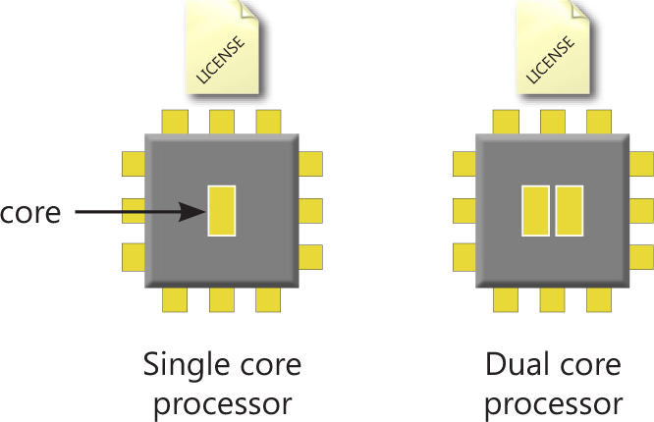

For details see the Volume Licensing brief titled “Multiplexing—CAL Requirements” at http://www.microsoft.com/licensing/about-licensing/volume-licensing-briefs.aspx.

SQL Server Standard
Wendy has her Microsoft reseller quote the price of two SQL Server Standard processor licenses (one for each processor in the server device) compared to one SQL Server Standard server license plus 120 SQL Server User CALs. As it turns out, the cost for two processor licenses is more than the cost for one server license plus 120 CALs. Considering this, you might expect her to choose the Server/CAL model. This is where Wendy’s involvement in the other IT initiatives on her list pays off. Once they add an external Web site, Trey Research will have hundreds of external users and devices accessing SQL Server data, so they will need to license SQL Server on a per-processor basis. Knowing this, she decides to purchase the two SQL Server Standard processor licenses with Software Assurance now, which can help save the company money in the long term.
Figure 5
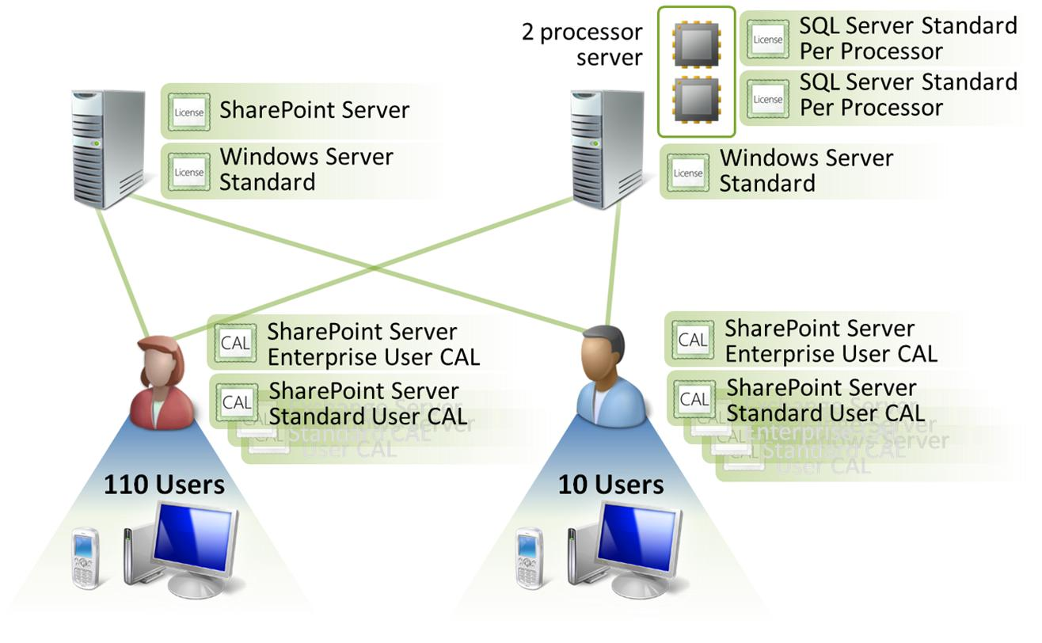
License Order Summary:
Product | Quantity | Ordered Through
Windows Server Standard (L&SA)  Licensing Model Summary:  Online Services  Online Services are subscription-based and provide access to software and services. Licensing under this model consists of one or more of the following:  - User or Device Subscription License (USL or DSL):  For offerings that require these, USLs or DSLs are needed for each user or device that accesses the online service.  - Services Subscription License (SSL):  Generally, for offerings that require these, this license applies to the entire organization’s use of the online service. User, Device SLs, or Add-on SLs may also be required, depending on the service offering.  - Add-On Subscription License (Add-on SL): This license sometimes is used instead of or in addition to USLs, DSLs, and SSLs, depending on the particular online service. For example, it can apply to a specified number of consumed units, such as gigabytes of storage, or it can apply to a single server accessed by external users. Add-on subscription licenses are not always required. | 2 | Microsoft Volume Licensing
SharePoint Server (L&SA) | 1 | Microsoft Volume Licensing
SharePoint Server Standard User CAL (L&SA) | 120 | Microsoft Volume Licensing
SharePoint Server Enterprise User CAL (L&SA) | 120 | Microsoft Volume Licensing
SQL Server Standard Per Processor (L&SA) | 2 | Microsoft Volume Licensing

Initiative 6: IT Protection
With the collaboration portal and enterprise e-mail getting widespread use across the company, Wendy wants to help secure the IT infrastructure and data by adding comprehensive protection from viruses, malware, and other threats. She finds an easy way to get the protection they desire, which is to order Microsoft Forefront™ Security Suite. The suite includes Forefront Client Security, Forefront Security for Exchange Server, Forefront Security for SharePoint, Forefront Security for Office Communications Server, and Forefront Online Security for Exchange.
Forefront Security Suite is one of the Microsoft Online Services offerings and is licensed on a per-user or per-device monthly subscription basis.

License Requirements:
Forefront Security Suite
Because they have more devices than users, Wendy chooses to license the subscription on a per-user basis. She purchases 120 Forefront Security Suite User Subscription Licenses (USLs) through Microsoft Volume Licensing. (She also needs an SSL to license the server on which the software is running.)
License Order Summary:
Product | Quantity | Ordered Through
Forefront Security Suite USL | 120 | Microsoft Volume Licensing

Initiative 7: IT Management
Now that the employees of Trey Research have a lot of foundational technology to help them be more efficient and successful, Wendy is researching how to best ensure that their devices stay up-to-date, healthy, and manageable. Naturally, she considers how technology can help—starting with finding the right tools to centrally manage their IT infrastructure. Microsoft System Center Configuration Manager fits the bill. It provides a comprehensive solution to assess, deploy, and update Windows clients, servers, and devices across their IT environment.
To license System Center Configuration Manager, which is under the Management Servers licensing model, you need a server license for each instance of the server software that manages the devices. You also need a Management License (ML) for each OSE that the System Center server software manages.
Quick Facts: OSEs
An OSE (operating system environment) is the computing environment on the physical machine (physical OSE) or virtual machine (virtual OSE) where the operating system and applications run.
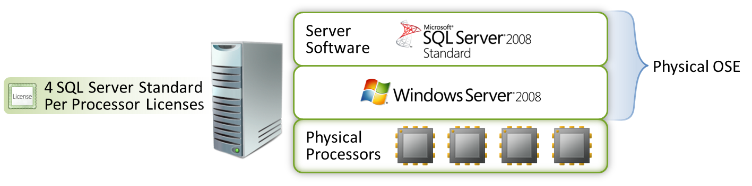

Soetimes organizations develop network scenarios that use various forms of hardware or software (often called “multiplexing” or “pooling” hardware or software) that reduce the number of devices or users that directly access or use the software on a p another option is to license the devices using the Microsoft Core CAL or Enterprise CAL suites. Devices covered by Core CAL or Enterprise CAL do not need separate MLs.
Particular server, Use of multiplexing or pooling hardware and/or software does not reduce the number of CALs required.

In the case of Trey Research, even though users will connect to SQL Server data indirectly through the SharePoint Server portal, they still need SQL Server CALs.

Remember: If licensing SQL Server under the Per Processor model, SQL Server CALs are not required—even in multiplexing scenarios.
When managing OSEs of the server type, such as Windows Server, you need a Server Management License (Server ML) for each managed OSE on a device.
When managing OSEs of a non-server type, such as Windows 7, you need a client ML for each managed OSE on a device. Two types of client MLs are available: OSE MLs and User MLs:
- OSE MLs. You need one client OSE ML for each OSE that you want to manage. If you use client OSE MLs, you don’t need to worry about who is using the device on which the OSE resides.
- User MLs are used to license the management of any number of client OSEs a person uses. If you manage the client OSEs by user, then any user who accesses the managed OSEs needs a user client ML.
Quick Facts: Alternatives to MLs
As an alternative to Server MLs, you can acquire a Management Suite. The Server Management Suite Enterprise (SMSE) permits managing up to four server OSEs on a licensed device and the Server Management Suite Datacenter (SMSD) permits managing any number of server OSEs on a licensed device.
Also, the Core CAL Suite includes a System Center Configuration Manager client ML. Finally, the Enterprise CAL Suite includes the System Center Configuration Manager and the System Center Operations Manager client MLs.

Sometimes organizations develop network scenarios that use various forms of hardware or software (often called “multiplexing” or “pooling” hardware or software) that reduce the number of devices or users that directly access or use the software on a p another option is to license the devices using the Microsoft Core CAL or Enterprise CAL suites. Devices covered by Core CAL or Enterprise CAL do not need separate MLs.
Particular server, Use of multiplexing or pooling hardware and/or software does not reduce the number of CALs required.

In the case of Trey Research, even though users will connect to SQL Server data indirectly through the SharePoint Server portal, they still need SQL Server CALs.

Remember: If licensing SQL Server under the Per Processor model, SQL Server CALs are not required—even in multiplexing scenarios.
Budgets are tight, and Wendy’s top priority is for her IT staff to centrally manage the employee’s PCs and Smartphones. She decides to not include management of their server OSEs at this point knowing that she can add server management later by ordering Server MLs.

License Requirements:
Windows Server Standard
Wendy orders new server hardware for IT management from the OEM and orders one Windows Server Standard License and Software Assurance Pack through Microsoft Volume Licensing.

System Center Configuration Manager
One License and Software Assurance Pack for System Center Configuration Manager, ordered through Microsoft Volume Licensing, takes care of licensing the instance of the software running on the server that performs the management.
Licensing Model Summary:
Management Servers
You need a server license for each instance of the management server software running at the same time and a Management License for each managed OSE.
System Center Configuration Manager Client ML
Much like when deciding between device CALs and user CALs, Wendy decides to go with Client User MLs with Software Assurance for each employee because there are fewer users than devices. This permits managing any client OSE on any device Trey Research’s employees are using.
Figure 6
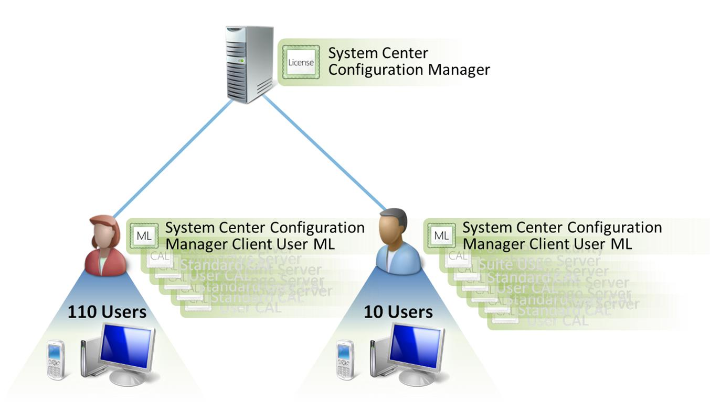

License Order Summary:
Product | Quantity | Ordered Through
Windows Server Standard (L&SA) | 1 | Microsoft Volume Licensing
System Center Configuration Manager (L&SA) | 1 | Microsoft Volume Licensing
System Center Configuration Manager Client User ML (L&SA) | 120 | Microsoft Volume Licensing

Initiative 8: Company Web Site
Now that Trey Research has built the foundation for an IT infrastructure that can grow and adapt to their needs, Wendy has one more IT initiative in their strategic plan to deliver—establishing a new company Web site. In addition to providing general information about the company and its services, the Web site will also provide a way for clients to access files and data specific to their project and track and manage orders.
The Web site will be built on a new server running Windows Server Standard and SharePoint Server for Internet Sites. SharePoint Server for Internet Sites is an edition of SharePoint Server that is exclusively for external-facing sites. The requirement that all of the server’s content be externally facing is an exception for this specific product. Product-specific terms such as these are listed in the Product Use Rights under “Exceptions and Additional Terms.” SharePoint Server for Internet Sites is under the Specialty Servers licensing model and so does not require CALs.
Licensing Model Summary:
Specialty Servers
You need a server license for each instance of the server software running at one time.
Wendy understands that SharePoint Server for Internet Sites relies on Windows Server and SQL Server. They will use their existing server already running SQL Server, and because Wendy had the foresight to license SQL Server on a per-processor basis, no additional SQL Server licenses are required for the new Web site solution.

License Requirements:
Windows Server Standard
Wendy orders new server hardware for the Web site from the OEM and orders one Windows Server Standard License and Software Assurance Pack through Microsoft Volume Licensing.
Windows Server External Connector
Because customers can access information specific to their account through the Web site, user authentication by Windows Server is required. This means Trey Research needs to license those external users for connecting to Windows Server. Because they cannot count the number of users and devices that will connect to the server, ordering a specific number of CALs won’t work.
The solution is the Windows Server External Connector license, which allows any number of external users the right to access Windows Server as long as that access is for the benefit of the licensee. Wendy orders one Windows Server External Connector License and Software Assurance Pack through Microsoft Volume Licensing and assigns it to the new Windows Server device.
Since these users will also indirectly access the SQL Server, Wendy knows that she needs to also buy a Windows Server External Connector for the server running SQL Server.
Quick Facts: External Connectors

An External Connector (EC) license is an alternative to CALs for servers that external users (such as customers or vendors) can access. An EC license assigned to a server permits access by any number of external users as long as that access is for the benefit of the licensee and not the external user. Each physical server that external users access requires only one EC license.
SharePoint Server for Internet Sites
SharePoint Server for Internet Sites is under the Specialty Server licensing model. Servers under this model require one server license for each running instance of the server software. Wendy orders one License and Software Assurance Pack for SharePoint Server for Internet Sites through Microsoft Volume Licensing.
Figure 7
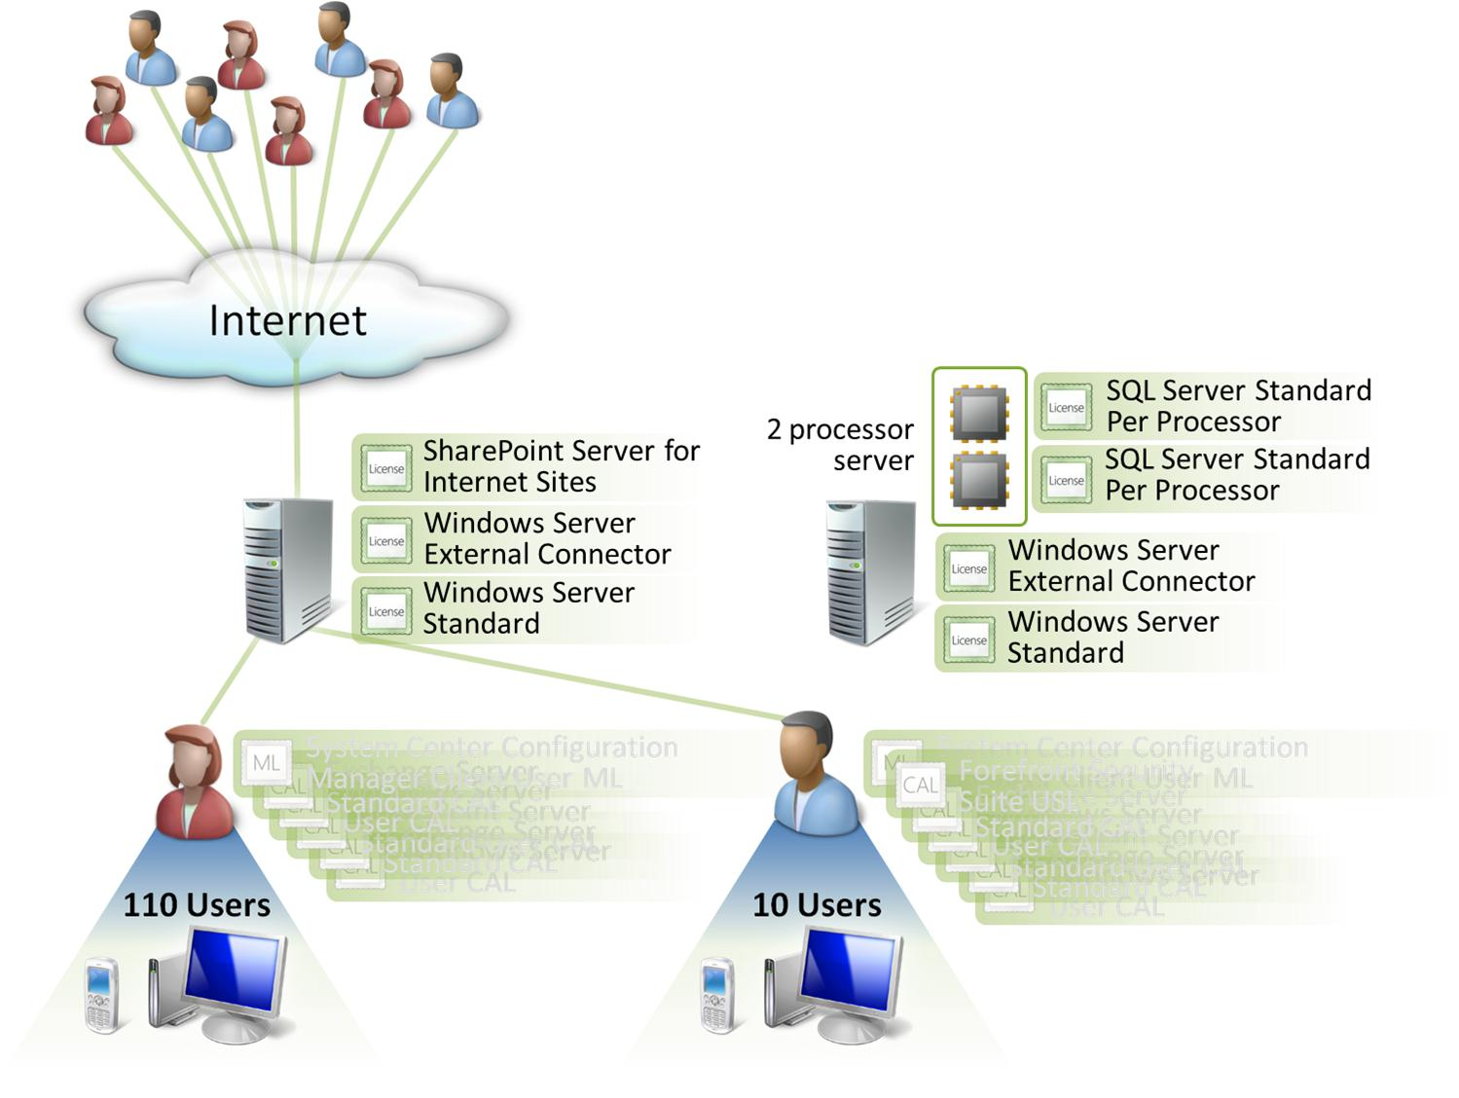

License Order Summary:
Product | Quantity | Ordered Through
Windows Server Standard (L&SA) | 1 | Microsoft Volume Licensing
Windows Server External Connector (L&SA) | 2 | Microsoft Volume Licensing
SharePoint Server for Internet Sites (L&SA) | 1 | Microsoft Volume Licensing

As you can see, by investing some time in understanding their options, Wendy found the flexibility needed in the various Microsoft licensing models to meet Trey Research’s current—and future—technology needs.

Additional Resources

Microsoft Volume Licensing Web Site: Learn about your options for acquiring licenses and Software Assurance through Microsoft Volume Licensing. www.microsoft.com/licensing

Microsoft Product Licensing Web Site: Get product licensing details and briefs, and download the current Microsoft Volume Licensing Product Use Rights (PUR) and Product List documents. http://www.microsoft.com/licensing/about-licensing/product-licensing.aspx

Microsoft Volume Licensing Service Center: Track license orders, activate Software Assurance benefits, and download licensed software. https://www.microsoft.com/licensing/servicecenter/home.aspx

CAL Guide: Learn more about Client Access Licenses. http://www.microsoft.com/resources/sam/lic_cal.mspx



