

Predictive Analytics for the Retail Industry
SQL Server Technical Article

Writer: Matt Adams
Technical Reviewer: Roni Karassik

Published: May 2008
Applies To: SQL Server 2008, Microsoft Office Excel 2007

Summary: To stay competitive, retailers must understand not only current consumer behavior, but must also be able to predict future consumer behavior. Accurate prediction and an understanding of customer behavior can help retailers keep customers, improve sales, and extend the relationship with their customers. SQL Server 2008 offers predictive analysis through data mining, empowering users with actionable insight across the organization. SQL Server 2008 and Microsoft Office Excel 2007 offer data mining capabilities that can help retailers make informed decisions. This white paper explores examples that include churn analysis to estimate the number of customers in danger of being lost, market analysis to show how customers are distributed between high and low value segments, and market basket analysis to determine those products that customers are more likely to buy together.

Copyright

This is a preliminary document and may be changed substantially prior to final commercial release of the software described herein.

The information contained in this document represents the current view of Microsoft Corporation on the issues discussed as of the date of publication. Because Microsoft must respond to changing market conditions, it should not be interpreted to be a commitment on the part of Microsoft, and Microsoft cannot guarantee the accuracy of any information presented after the date of publication.

This White Paper is for informational purposes only. MICROSOFT MAKES NO WARRANTIES, EXPRESS, IMPLIED OR STATUTORY, AS TO THE INFORMATION IN THIS DOCUMENT.

Complying with all applicable copyright laws is the responsibility of the user. Without limiting the rights under copyright, no part of this document may be reproduced, stored in or introduced into a retrieval system, or transmitted in any form or by any means (electronic, mechanical, photocopying, recording, or otherwise), or for any purpose, without the express written permission of Microsoft Corporation.

Microsoft may have patents, patent applications, trademarks, copyrights, or other intellectual property rights covering subject matter in this document. Except as expressly provided in any written license agreement from Microsoft, the furnishing of this document does not give you any license to these patents, trademarks, copyrights, or other intellectual property.

Unless otherwise noted, the example companies, organizations, products, domain names, e-mail addresses, logos, people, places and events depicted herein are fictitious, and no association with any real company, organization, product, domain name, email address, logo, person, place or event is intended or should be inferred.

© 2008 Microsoft Corporation. All rights reserved.

Microsoft, Excel, and SQL Server are either registered trademarks or trademarks of Microsoft Corporation in the United States and/or other countries.

The names of actual companies and products mentioned herein may be the trademarks of their respective owners.

Table of Contents
Introduction 1
Predictive Analysis 1
Data Mining Models 2
Define the Business Problem 2
Explore the Data 3
Clean the Data 4
Partition the Data 5
Generate a Model 5
Validate the Model 6
Put the Model into Production 6
Data Mining in Retail 7
Marketing Campaign Effectiveness 7
Market Segmentation 10
Shopping Basket Analysis 15
Demand Planning 19
Conclusion 22

Introduction
Retail is an industry that is in a constant state of change. Increasing competition, a wide array of product offerings, increasing customer sophistication, multiple touch points to the customer, and consumer complexity are just a few of the many examples that constitute a dynamic and constant state of change in the area of retail sales. As the population continues to increase and consumers are presented with more choices, the numerous challenges that a retailer faces become more pervasive. To stay competitive, retailers must take an analytical, guided, and prescriptive approach to better understand their business and anticipate customer behavior.
Predictive analysis can help. For years data mining has been suitable only for a limited audience with expertise in statistics and math. However, Microsoft® SQL Server® 2008 provides simplified tools that bring data mining to knowledge workers.
Microsoft predictive analysis enables all business users in a retail organization to take advantage of powerful analytical tools in a presentation layer that is easy to understand. This is accomplished through Microsoft Office Excel® 2007 and SQL Server 2008. By taking advantage of the capabilities of Microsoft data mining, retailers can more easily acquire and retain customers, optimize merchandising assortments, and better understand the true demand for their products. Retailers can then identify those variables that have the most significant impact on business performance and customer behavior.
This paper discusses many of the problems faced by retailers and how they can be resolved with predictive analysis solutions delivered by SQL Server 2008.

Predictive Analysis
Predictive analysis solutions are delivered by using data mining technologies that use analytical models to discover hidden patterns and apply them to predict future trends and behaviors. Interest in predictive analysis within retail organizations is increasing. However, the adoption of data mining technologies in most retail organizations is limited. Data mining has many components, but the most significant components that are required to ensure meaningful and actionable insight are the following:
- Define the business problem.
- Explore the data.
- Create predictive models.
- Test the models.
- Apply one or more models to an identified population to predict behavior.
Typically, the complete data mining process is not followed—consequently, the results that are produced are not predictive and only limited insight into the business is gained. Furthermore, organizations may not have all the resources or information necessary to facilitate the data mining environment because traditionally, the focus has been on retrospective analysis rather than predictive analysis. Microsoft SQL Server 2008 Data Mining Add-Ins for Office 2007 make predictive analysis intuitive and simple, making predictive analysis appealing to all business analysts and decision makers.
The terms data mining and predictive analysis are not new concepts. Traditional statistical techniques have been used for years to model consumer behavior, predict stock prices, assess labor needs, model exchange rates, and so forth. With the introduction of commercially available data mining software, predictive analysis is becoming more integrated into business decisions and processes. However, data mining and statistical analysis is sometimes avoided because these types of analysis occur in unfamiliar user environments and require statistical understanding and/or programming skills.
Microsoft, through the Data Mining Add-Ins for Office 2007 is changing the way retailers view predictive analysis. With intuitive tools in a familiar user environment, organizations can now take advantage of a complete data mining platform directly at the desktop, introducing insight to every business decision.
What is predictive analysis? In the context of this paper, it is the process of selecting, exploring, analyzing, and modeling data to create better business outcomes. Successful predictive analysis takes into consideration where data is located, the state of the data (redundant, old, dirty), and how accessible it is. An important aspect of predictive analysis is how the data should be structured to align with business objectives and to reflect the reality within which the business operates.
The Data Mining Add-Ins for the 2007 Office System create an environment where predictive analysis solutions can be delivered seamlessly and intuitively. The next section explores the process of building successful predictive analysis solutions.

Data Mining Models
A successful data mining project requires a clear process. The process described in this paper is not the only suggested methodology, but it will ensure that meaningful results are returned that will provide insight that can be used for business decisions.

Define the Business Problem
A data mining project starts with a defined business problem. In the most successful data mining projects, the problem is defined quantitatively. Example problem definitions are:
- We want to find the top 10 percent of our customer base that is most likely to churn.
- Who are my high margin customers?
Without a defined business problem or if the business problem lacks a metric, a data mining project will not deliver useful results because the user does not have a specific measure for success.
A data mining project also includes information about the data that will be used. The problem definition could include additional specifications such as one or more of the following:
- Where is the data?
- Who is responsible for the data?
- How do I get access to the data?
- How much data is available?
- Does the data satisfy my business problem?
- Do I have enough data?
- Is the data clean?
- Where can I process this data?
It is quite common for the data sources to be in multiple locations, exist in different file formats, and have different underlying structures. For example, in a data mining project for a customer relationship management initiative, you might obtain the data from multiple transactional systems, third-party data, feeds from Web logs, and response information from mobile text ads. Both the business problem and the data that is going to support the solution require thought and planning.
SQL Server 2008 delivers many technologies to simplify and automate the tasks to obtain the data that support the business problem. SQL Server Integration Services (SSIS) enables you to pull data from various sources, clean the data, transform it into the appropriate format, and then load it into an easily accessible destination with enterprise grade security, performance, and scale, truly making any type of data available, for any type of analysis.

Explore the Data
Data exploration is the process of looking at the shape, health, distribution, and overall state of the data. Patterns and anomalies identified at this step can help improve overall understanding of business processes. When exploring data for a data mining project, it is quite common that you will find missing values, outliers, abnormal distributions, or unique patterns within the underlying data structure of a data source. For example, if there are tremendous amounts of missing values in the data, it is possible that customer service is inaccurately entering customer information. Some anomalies may uncover a real problem, such as an issue with product delivery for a specific brand. In this case, the abnormal behavior describes a real business problem rather than errors in data entry.
By exploring data through a technique called clustering, patterns begin to emerge that may not have been immediately evident. For example, if a retail store has created four segments of consumer behavior for a particular store location, they may create better customer loyalty by optimizing their merchandise assortment specifically for identified segments of customers, each of which demonstrate similarity in purchasing behavior. Exploring your data gives you tremendous insight into the structure of your data, and could potentially have profound impact on business operations.
The Data Mining Add-Ins for Office 2007 enable data exploration through Table Analysis Tools for Excel and Data Mining Client for Excel.
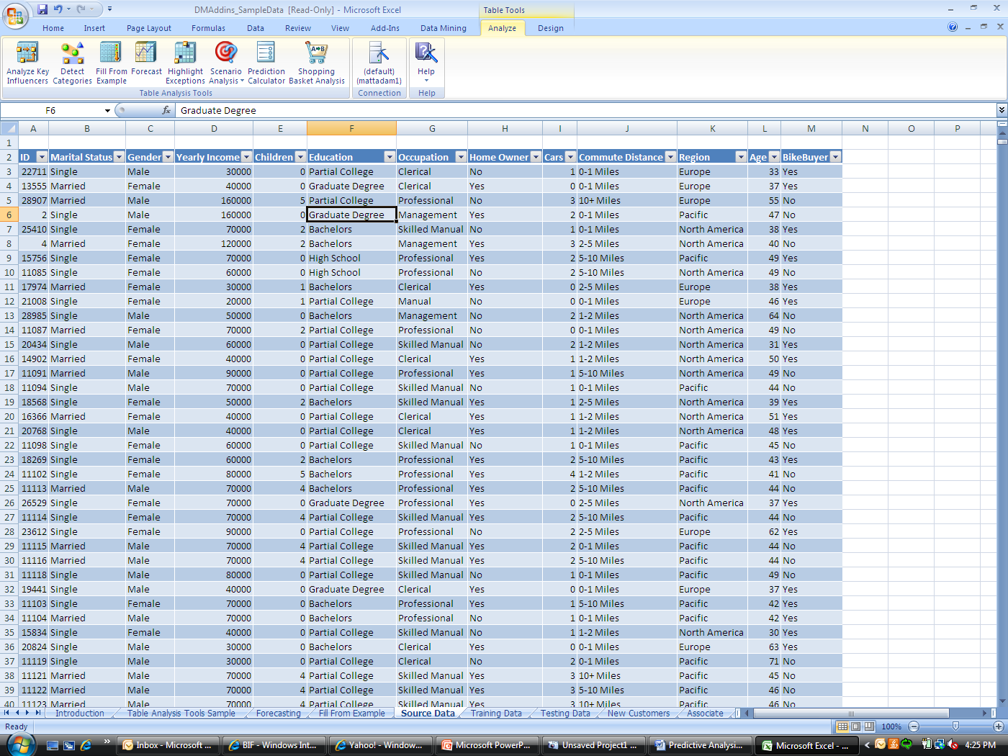
Figure 1: Table Analysis Tools for Excel

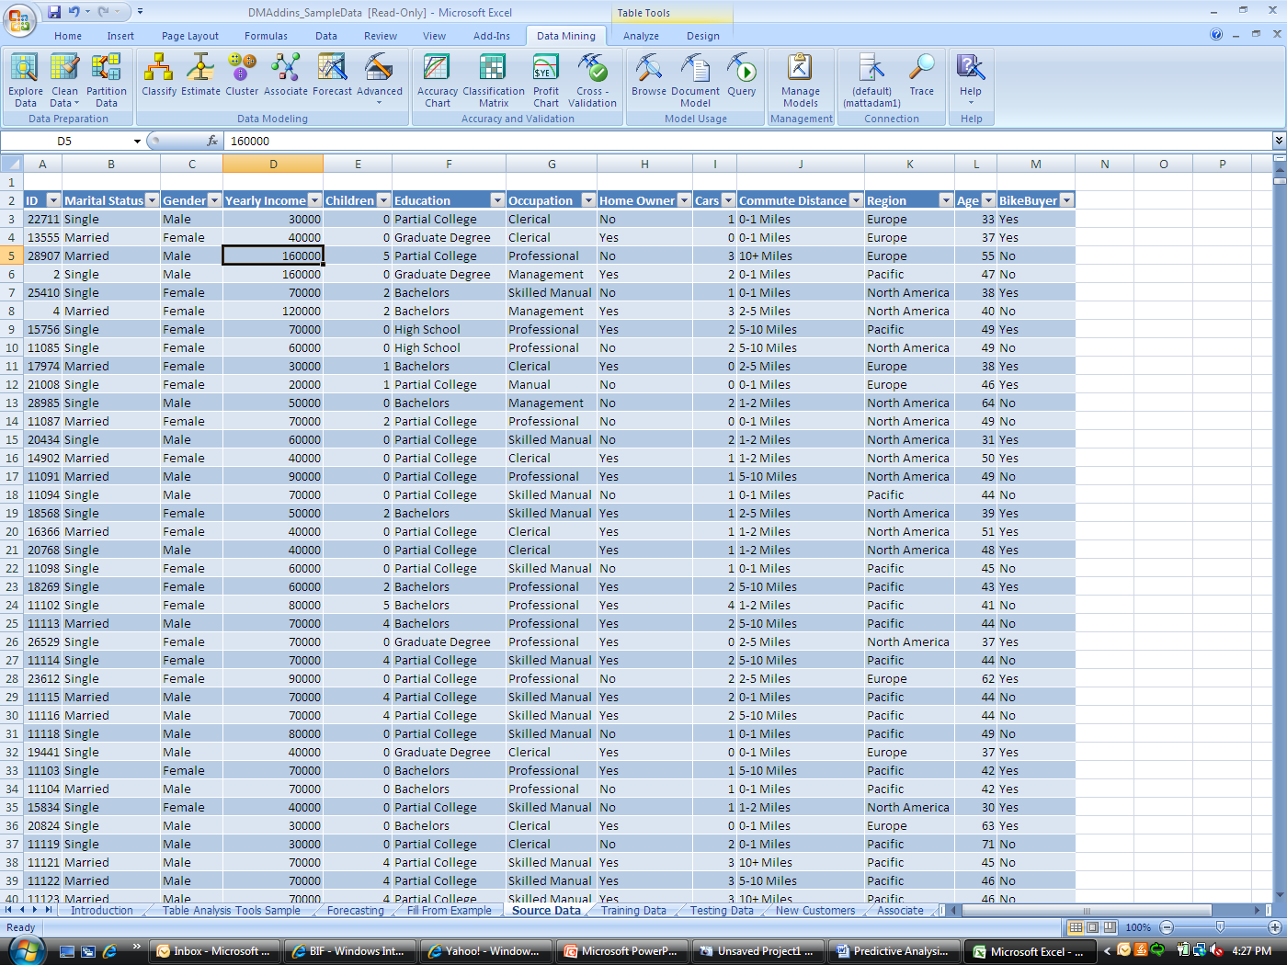
Figure 2: Data Mining Client for Excel

Clean the Data
Cleaning the data can require multiple iterations until the appropriate data mining set has been generated to solve the business problem. The Data Mining Add-ins for Office 2007 alleviate a tremendous amount of the burden associated with data preparation. The following figure shows the option to replace outliers when performing a data cleansing routine. Not only can you detect outliers, but you can relabel data values as well. This enables you to replace values such as substituting null values with an appropriate label. Furthermore, visualizations in the user interface of the add-ins help you to clearly identify exceptions and intuitively take action to resolve them.
The cleansed data can be incorporated directly back into the original set of working data, allowing for great flexibility and self service.
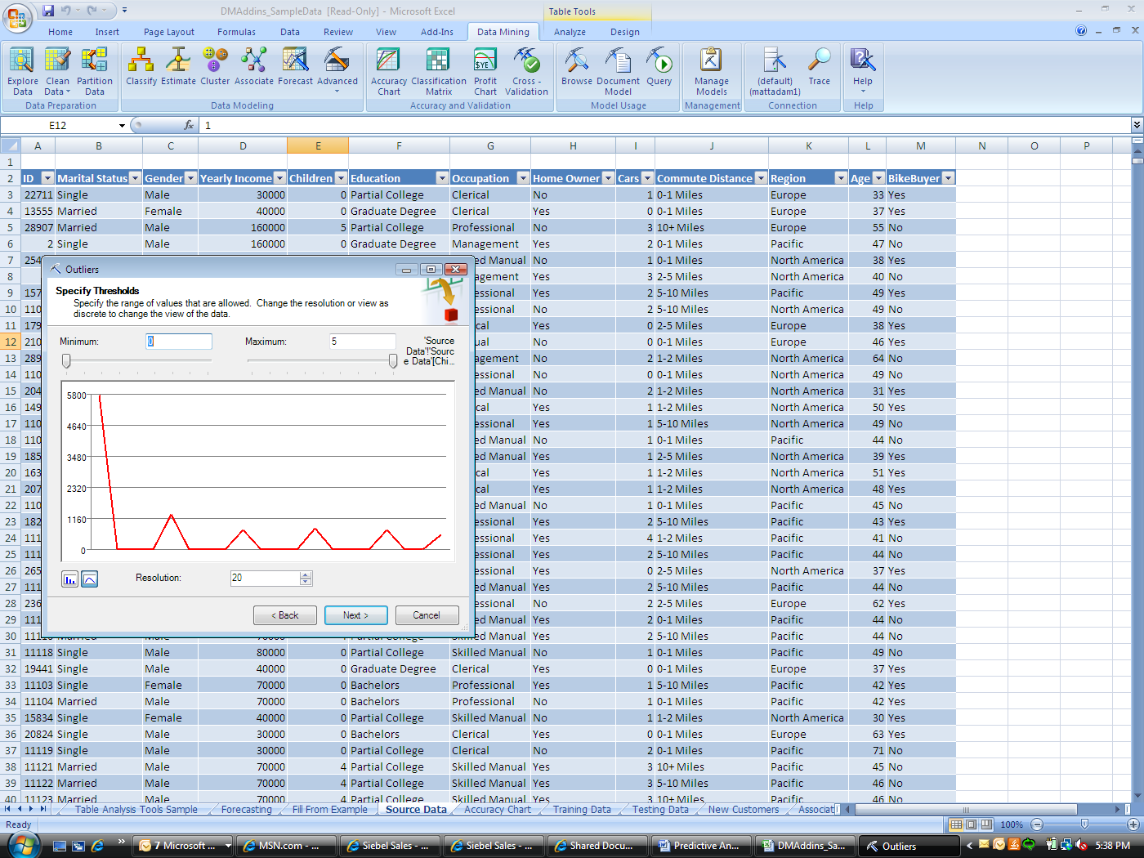
Figure 3: Locating data outliers
Quite often the underlying data can take on many values (the data is noisy), values are missing, or there are data points that are clearly out of range of the norm. It is highly possible that an anomalous value could actually be a valid value. For example, a certain customer group could represent unique high spending or low spending behavior, but the frequency of that behavior could be extremely often or extremely infrequent. Still, this is valid data. Careful attention must be paid to how the data will be cleaned because exceptions are defined by patterns within the existing dataset and may not be unique in absolute terms.

Partition the Data
Data partitioning is the process of creating training and testing groups for the model generation process. The training group is a selected group of data that is used to inform the model about patterns and influences. The testing group is used to assess the validity of the model, comparing predictive values with actual data. The training group is used to generate the first series of models, and the testing group is used to answer the question, “Did the generated model behave as expected?” This method is referred to as a check and balance.
The Data-Mining Add-Ins for Office 2007 enable the end user to perform many of the tasks that are associated with the data partitioning stage. You can choose from among multiple sampling techniques to create the training and testing groups. For example, you can oversample underrepresented populations. You can force an equal representation of males and females in the analysis when this may not be true in the underlying data. This would guarantee that the resulting data set has an equal number of cases of males and females. When we have rare cases in our data, oversampling enables us to understand the behavior of the rare cases. This might not be the case if we were to perform traditional sampling. Oversampling balances the population as shown in Figure 4.
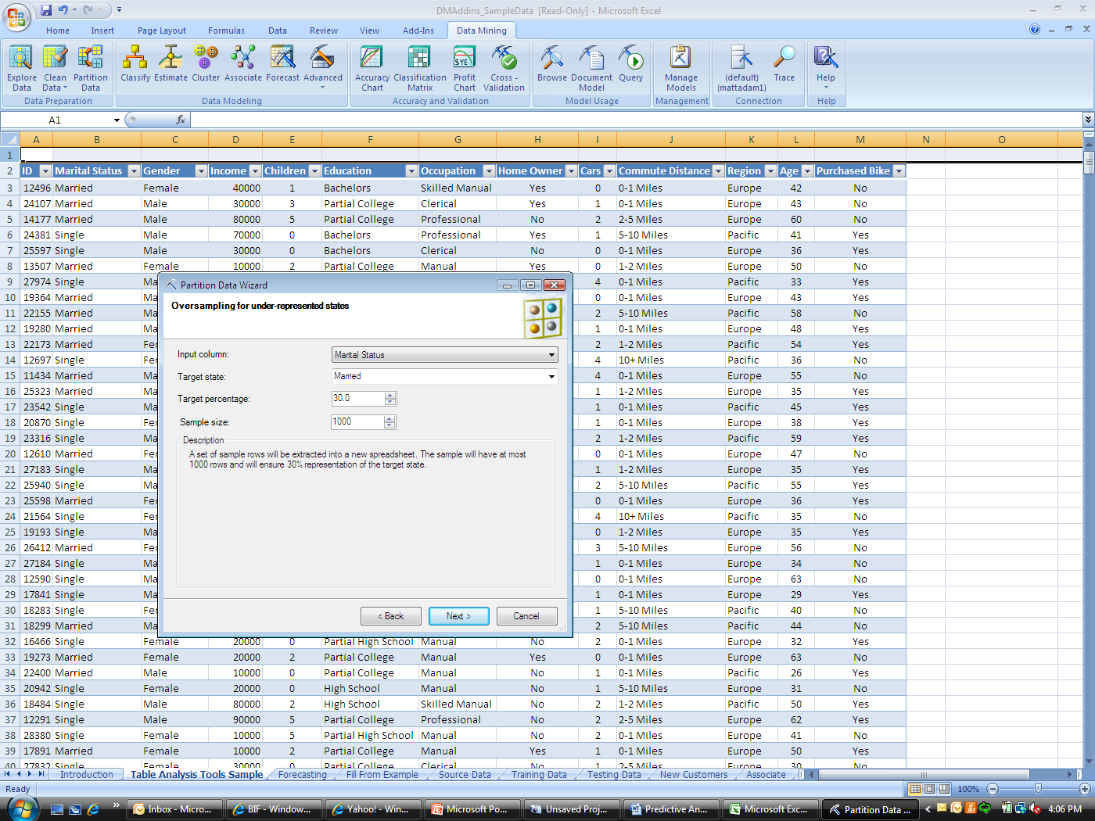
Figure 4: Oversampling an under-represented customer segment

Generate a Model
Microsoft has created a very simple, powerful, easy-to-use and results-oriented data mining environment. Think of a model as an intelligent application or process that is applied to historical data, to detect significant patterns and trends that are key influencers to business measures. These patterns and trends can then be applied to predict probable outcomes, empowering the business to take preemptive action and potentially have an impact on future results. For example, if trying to solve the problem of customer churn by identifying customers within the customer base who are most likely to attrite, a model can be applied to customers on an ongoing basis, to proactively identify those more likely to leave. These customers can either be contacted with a promotion that will extend the relationship or you can exclude them from other promotions to improve response rates.
Think of a model as an automated process that identifies patterns and trends to generate business rules. When applied to business cases, the model provides the opportunity to proactively avoid or solve problems.
SQL Server 2008 enables you to create multiple types of data mining models, assess the validity of each model, and apply models to business cases. It is not necessary to be a statistician to take advantage of these modeling capabilities. Microsoft offers a complete array of modeling techniques that enable analysts to create reliable and robust data mining models.

Validate the Model
After models are generated, it is imperative to assess how well they perform against known data. You can create multiple models, but it is almost impossible to manage multiple models to solve a business problem. In most situations, you create multiple models, assess how well each model performs, and then use the model that is most accurate.
It is important to understand that the accuracy of a model is relative to the data—data mining is an iterative process where you constantly measure and compare models as new data is introduced. With SQL Server 2008, the Data Mining Client for Excel offers a number of techniques to assess model performance as shown in Figure 5.
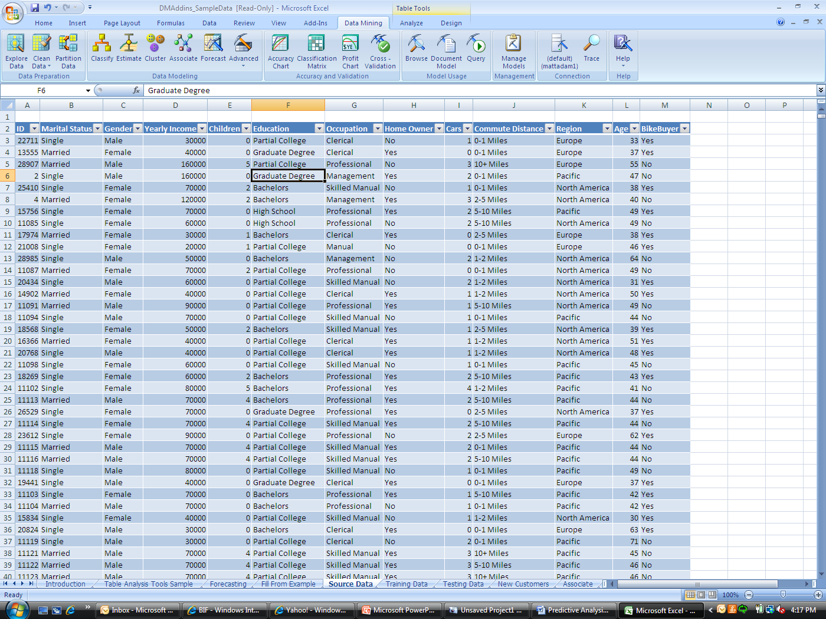
Figure 5: Data mining techniques in the Data Mining Client for Excel

Put the Model into Production
SQL Server data mining technologies enable you to publish a model in multiple ways. For example, you can score data from your desktop computer by using Excel 2007, or you can put the model into a batch in SQL Server and have batch scoring performed against the data. Alternatively, the model can be applied in a live scoring environment through SOA (Services Oriented Architecture).
Data mining can be embedded within organizational processes. An example might be real-time fraud detection at the time of transaction in a retail store. By using a data mining model, a customer or employee can be measured for fraudulent behavior by measures such as number of transactions, length of checkout time, or total dollar amount of the transaction. A predictive analysis model could be running in the store environment, processing transactions in real time, looking for fraudulent behavior. If fraudulent behavior is suggested, SQL Server 2008 can be configured to send an alert to the store manager, notifying him or her that fraud might be occurring.
Another example of using data mining in retail operations is for employee screening. Predictive models can be applied to candidates during the job screening process to help segment them and determine whether they are good candidates, and if so, where they would be best placed within the organization. For example, this type of logic might be used in a restaurant environment to help determine through the screening process whether a particular person is a good fit for certain shifts, such as in the morning when operations tend to be faster and the goal is to process the customer quickly.

Data Mining in Retail
Data mining within the retail industry can be used for many business objectives. For instance, data mining can be used to better understand the purchasing behaviors of your customers, to help you understand your high- and low-margin customers, to help you understand which customers are most likely to respond to a marketing campaign, or to help you identify which customers are likely to leave. Data mining can enhance and amplify the knowledge of all of your assets, from customers to suppliers to employees, and even the presentation of merchandise within the store.
This section demonstrates how Data Mining Add-Ins for Office 2007, through either the Data Mining Client for Excel (Figure 6) or the data mining capabilities within the Table Analysis Tools for Excel (see Figure 7) can solve retail business problems, such as marketing campaign effectiveness, customer segmentation, market basket analysis, demand planning, and inventory prediction.
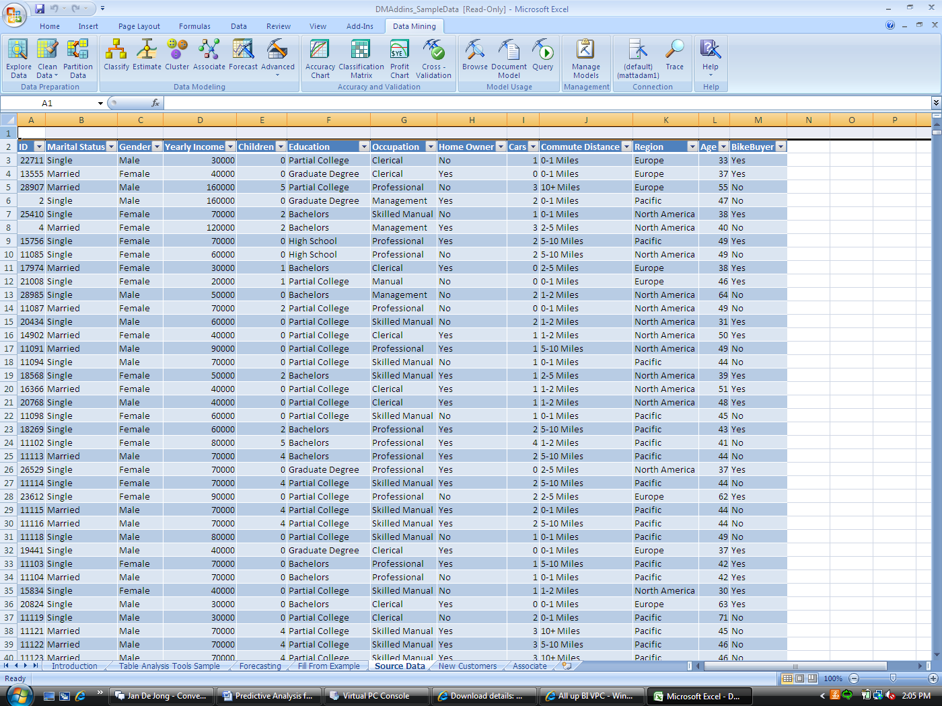
Figure 6: Data Mining Client for Excel
The Data Mining Client for Excel is an end-to-end data mining environment, delivering tools for a full data mining development life cycle. It follows the processes mentioned previously for data exploration, data cleansing, data partitioning, model generation, and model assessment.
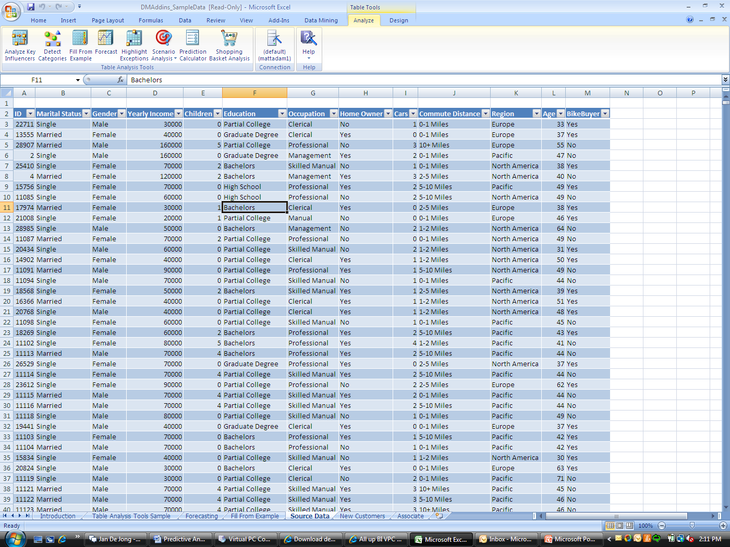
Figure 7: Table Tools in the Data Mining Client
The Data Mining Add-ins for Office 2007 include task-based tools for quick and powerful data mining with the Table Analysis Tools for Excel within Excel.

Marketing Campaign Effectiveness
As the channels by which consumers shop evolve, retailers are faced with multiple dilemmas on how to target customers. With the progression of Web shopping and shopping mobility, traditional marketing campaigns such as mailers, flyers, and catalogs do not always reach their intended audience. The same can be true for a traditional brick-and-mortar shopper; because catalogs and mailers traditionally send this customer segment to the store, Web-based ads should be carefully selected for this population. This marketing problem could be defined as:
- Who will receive the ad?
- In what format is the ad going to be rendered?
- How likely is it that the recipient will respond to the ad?
- How frequently is the person going to be receiving direct offers—traditional, Web, or mobile?
- What is the potential value of revenue if the customer does respond to the ad?
These are questions that retailers constantly ask. As budgets become tighter, competition continues to grow and margins become increasingly smaller, retailers must be judicious about to whom and how they target campaigns.
The use of data mining for this type of initiative can assist in targeting the appropriate customer, increase response rates for the campaign, reduce associated costs, and increase customer satisfaction. Customers do not want to be inundated with senseless marketing. With data mining, an organization can wisely target the correct customers with the correct offering.
The sample data in Figure 8, which is from an historical marketing campaign, tells us who responded to a particular campaign and who did not. This information can be used to create a data mining model that predicts who is likely to respond to a similar future campaign. We want to generate a model from this data that can be applied to a group of customers so that we can predict future behavior. Using the Data Mining Client for Excel, we follow the steps previously outlined—exploring, cleaning, and partitioning the data, and then generating a model.
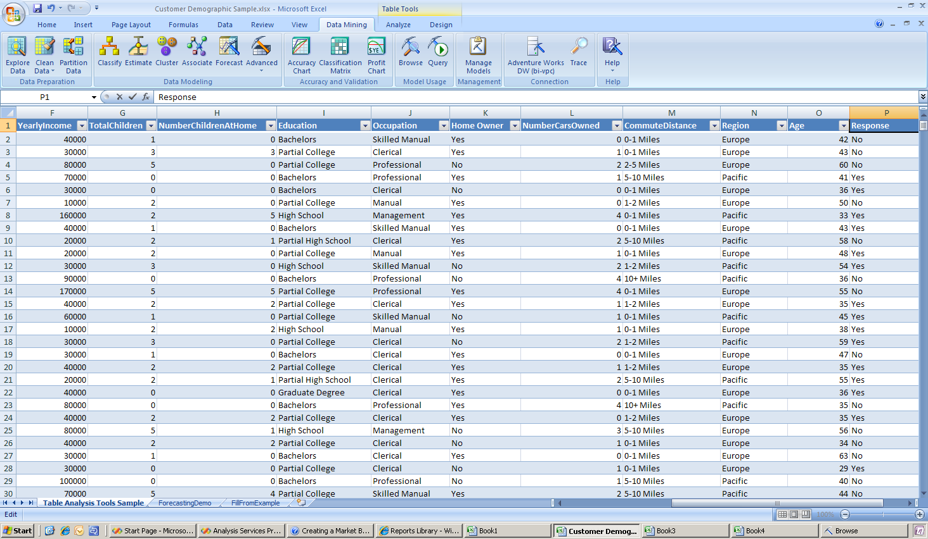
Figure 8: Sample of historical campaign data

After that process is completed, we can assess the performance of the model. Figure 9 tells us the response rate we can expect if we apply a predictive model to a marketing campaign. In this instance, we see that by using a predictive model, we can achieve about an 80 percent return in response rate by targeting only 60 percent of our customer population. We can use this information in a future campaign.

Figure 9: Assessing model performance
We can apply the information that is generated from the model to a group of people to assess the likelihood that they will respond to a campaign.
By using the Query tool within Model Usage in the add-in, you can apply a model to obtain a list of customers and assess if they should be targeted for a particular marketing campaign. The set of data shown in Figure 10 contains a list of potential customers. After applying a model to the data, the last column shows who is most likely to respond to the campaign. This column is autogenerated by the data mining tool. This information provides the predictive power to make better business and financial decisions. Because we are in the Excel environment, we can easily switch between discovery and exploration and filter customers by the expected outcome, review those who are more likely to respond, and perhaps export the list for action
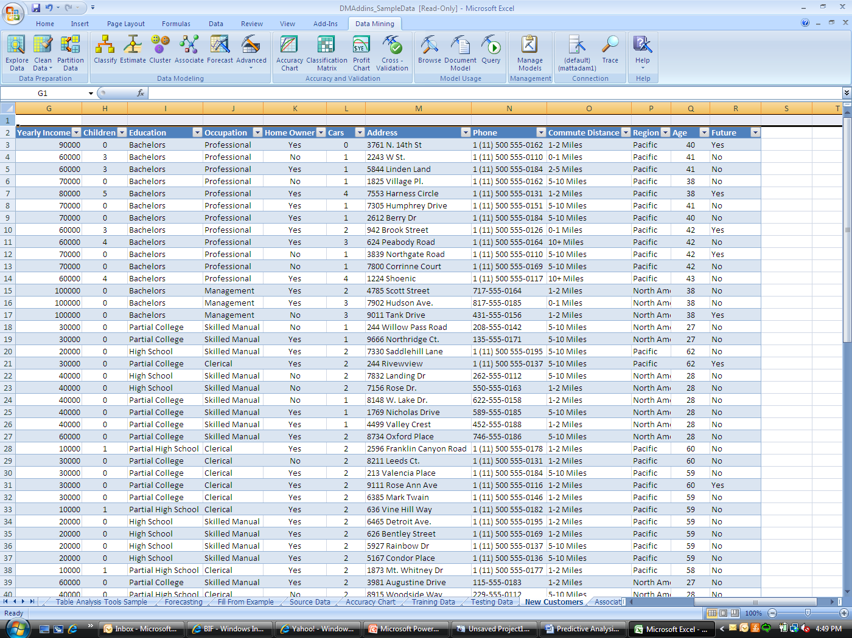
Figure 10: Viewing predicted campaign responses
The financial ramifications of this type of knowledge are profound. It can be used to determine the frequency of campaigns, which type of campaign will be most effective, and to a multichannel campaign strategy.

Market Segmentation
Segmentation is available by clustering, which offers the capability to categorize unstructured data into groups with similar characteristics, properties, or attributes. In retail environments, this is commonly done with customer data to create segments that define customers or stores that share similar or unique patterns and behaviors. For example, clustering can be used to divide customers into high spend, medium spend and low spend customer segments. It can also be used to identity product purchasing trends in the store. This would then have an impact on how stores are furnished with merchandise or how marketers speak to customers.
Segmentation can be used to help retailers better understand the spending patterns, communication preferences, and merchandising preferences of their customers, and to group customers uniquely by these characteristics. These same principles can be used to segment stores, partners, and vendors. This knowledge helps you drive promotions, pricing strategies, and marketing campaigns, and achieve a better relationship with customers, vendors, and partners. Retailers cannot afford to treat each store or channel as the same. By creating segments, the retailer has a better perspective on consumer behavior and can strive for greater loyalty by speaking appropriately to the defined segment. The Table Analysis Tools for Excel enable the business analyst to create identifiable and understandable segments that represent their customers.
The sample data in Figure 11 is customer demographic data for those customers who historically have made a bike purchase. If we were to segment these customers, we could get a better understanding of the different groups of customers who are likely to purchase a bike. With this information, we can send them a campaign for potential cross selling. We can better understand how likely they are to spend, and we can better understand where we need to invest more resources in advertising.

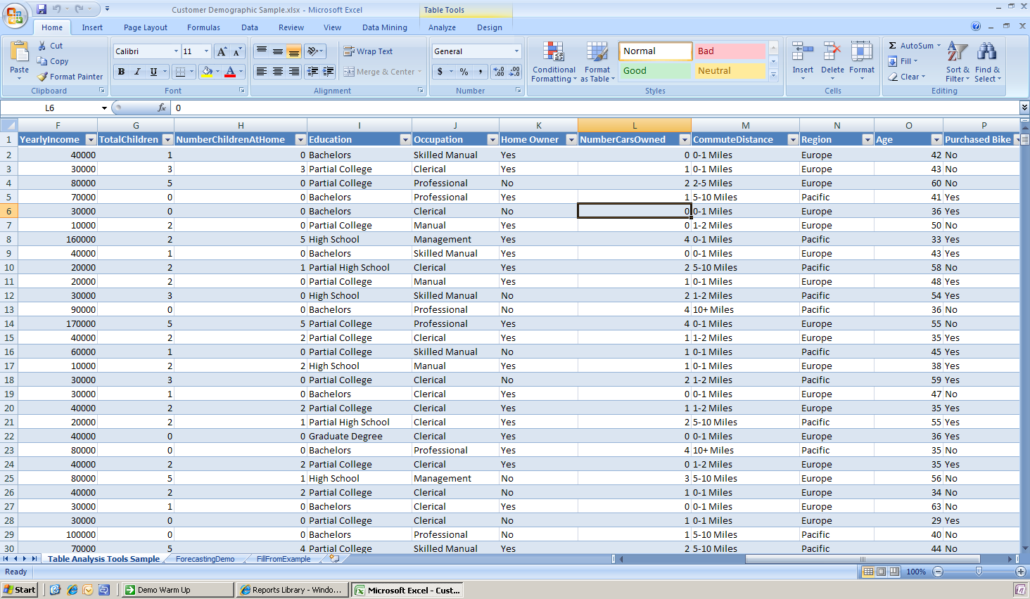
Figure 11: Sample of demographic data for segmentation analysis
The Table Analysis Tools for Excel enable the business user to quickly and easily create reliable customer segments with ease. The following figure shows the Table Analysis Tools.
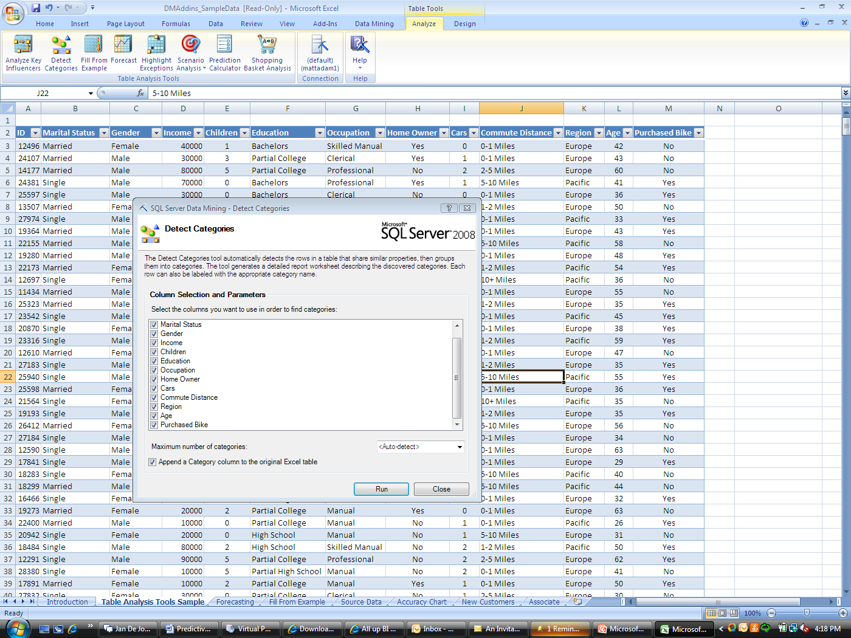
Figure 12: Detect categories enables the creation of unique segments
By using the Table Analysis Tools, we can quickly build our segments with the Detect Categories task. The chart in Figure 13 is an example of the results for clustering.
The following chart shows the results of performing a category analysis (cluster analysis) by using the Table Analysis Tool for Excel. As a result, six categories were automatically created. The tool includes an option to either automatically define the number of categories or have the end user define the number of categories. After the categories have been created, the end user can explore the category for the meaningful information that the category encapsulates. Since we are most interested in those customers who have or who have not purchased a bike, we will explore the category(s) that either tend to favor or not favor the purchase of a bike.
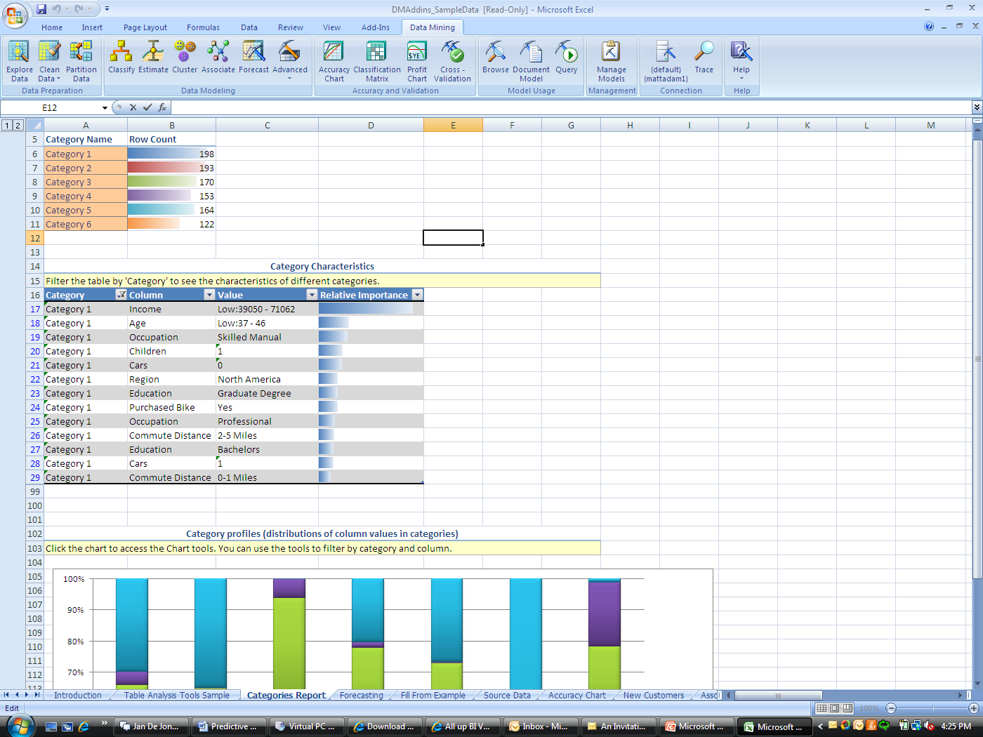
Figure 13: Initial results from the detect category analysis
Figure 14 shows a more detailed and a segmented look at customers who have made a bike purchase. As the graph suggests, Category 1, Category 3, and Category 4 are all highly represented with customers who purchased a bike. We would then explore the generated customer segments in further detail to better understand the overall attributes of customers who belong to these categories. We would want to look at the associated demographic data that went in the creation of the segments. This intelligence helps us target new customers or better understand why certain store locations are not performing well. We can easily explore the identified segment within the results of the detect categories output. Figure 15 shows some of the details that describe Category 3.

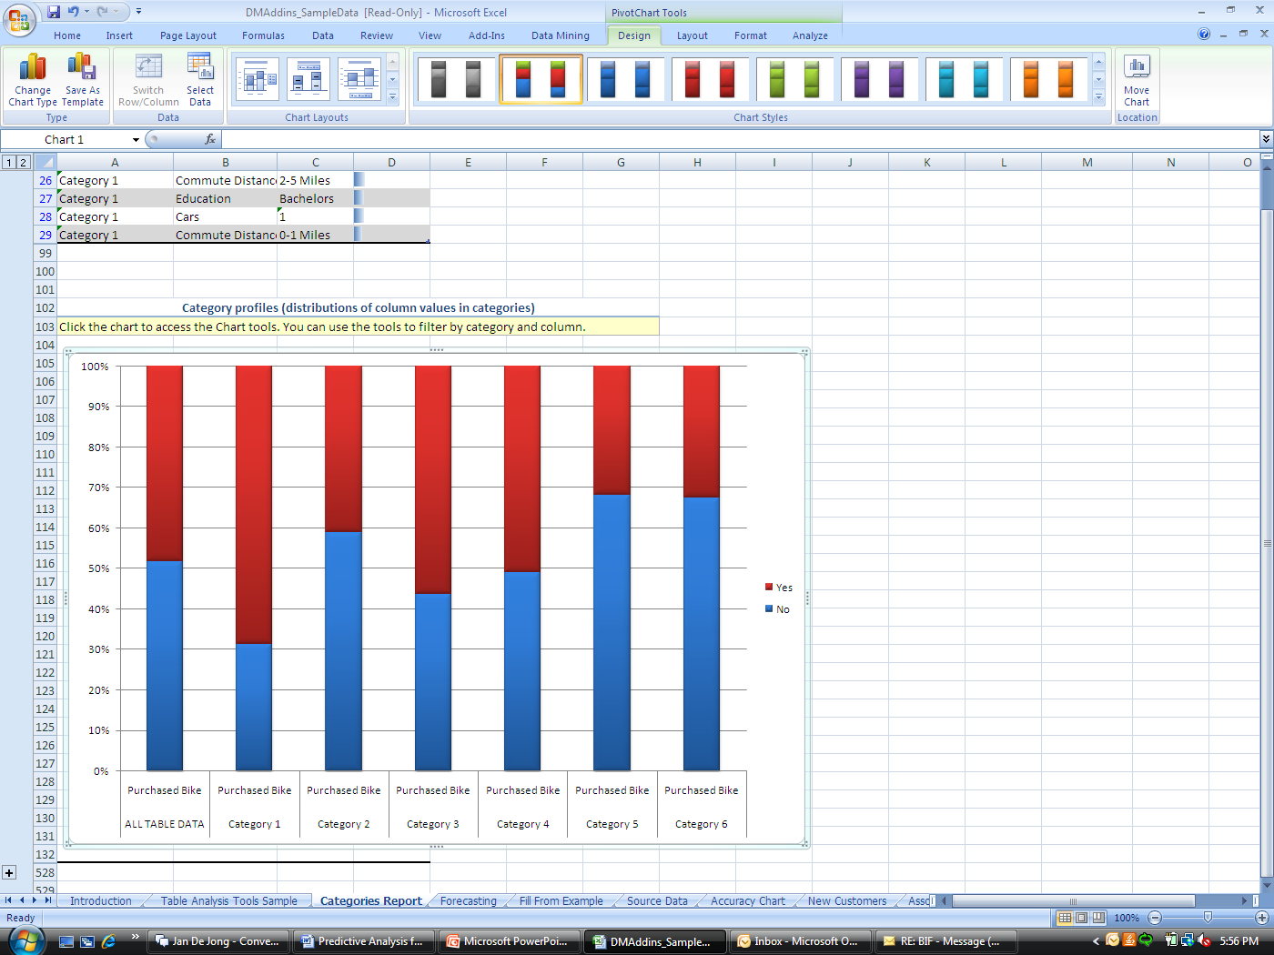
Figure 14: A detailed look at the detect categories results
The Table Analysis Tools for Excel deliver rich visualization that provide clear and intuitive results. The Excel environment enables you to explore the data for a deeper understanding. Figure 15 shows the demographics that went into defining Category 3—customers in this category are managers with a relatively high income, live in the Pacific region, have more than four children, and have advanced scholastic degrees. This information is useful for creating campaigns or establishing a retail store in a particular area. With these demographics and an understanding of the lifestyle associated with the high likelihood of a bike purchase, you can make informed decisions about investments to target this population.

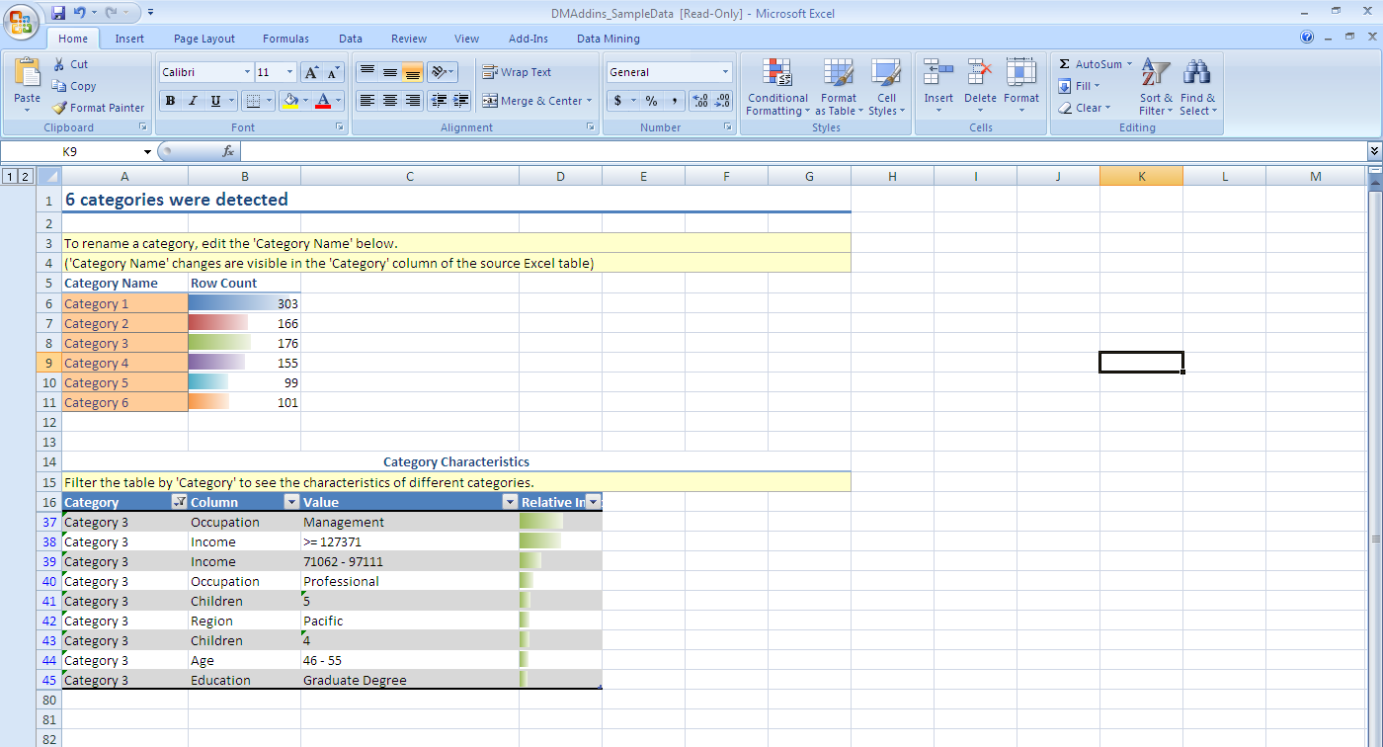
Figure 15: Detailed analysis of category 3
Segmentation enables a retailer to have a better understanding of customers. Since customers tend to change behaviors over time, segments change over time as well. Therefore, a segmentation analysis should be recalculated to check for correctness. The ease of use and flexibility of Microsoft software data mining capabilities make this relatively easy.

Shopping Basket Analysis
Shopping basket analysis is the ability to understand, on average, what products constitute a customer’s order or “shopping basket.” Shopping basket analysis is commonly used in retail and grocery environments to better understand customer purchasing preferences. This type of analysis is commonly referred to as market basket analysis. The information gathered from a shopping basket analysis can be used to cross-sell, bundle products that are frequently purchased together to increase customer satisfaction as well as up-sell, and offer products with higher margins alongside products with high demand to increase revenues. Businesses can leverage the insights gained from a shopping basket analysis to optimize assortment planning and validate promotions. The results of a shopping basket analysis can also be incorporated into a real-time marketing offer environment at check out. When a customer makes their purchase at check out, your company can offer the appropriate marketing ad or product recommendation for future purchases on the customer receipt, which can potentially affect sales and customer satisfaction.
The Table Analysis Tools for Excel include the Shopping Basket Analysis task. The results of this analysis deliver an understanding of existing purchasing behavior in addition to effective recommendations for future purchases based on current purchasing behavior.
The data in Figure 16 represents the traditional data requirements to perform a market basket analysis. You must have a variable that represents the transaction, a variable that represents the products that were purchased in the transaction, and optionally, a value associated with the transaction (this could represent either profit or cost, depending on the problem definition).
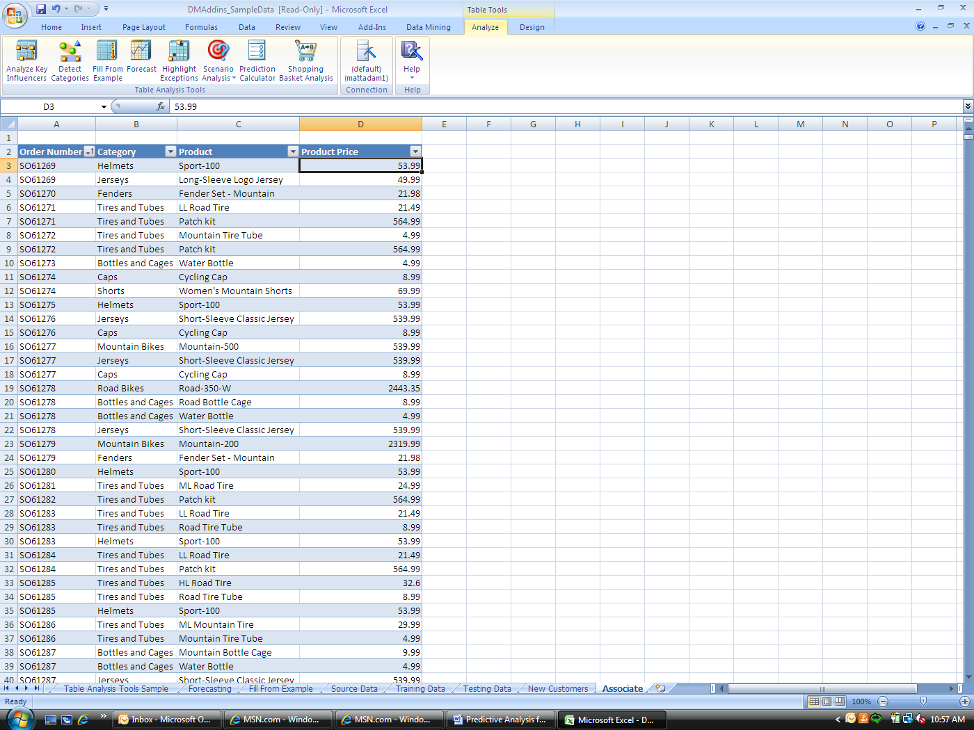
Figure 16: Detail data to perform a shopping basket analysis

An intuitive Excel wizard steps you through creating the shopping basket analysis.
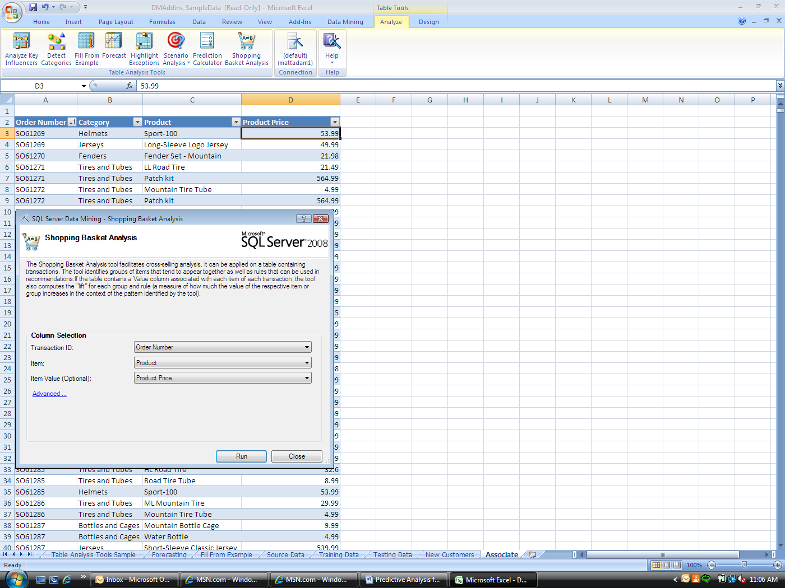
Figure 17: Shopping Basket Analysis wizard
After you run the wizard, two reports are presented—the shopping basket bundled items, and customer purchasing behavior, as shown in Figure 18.
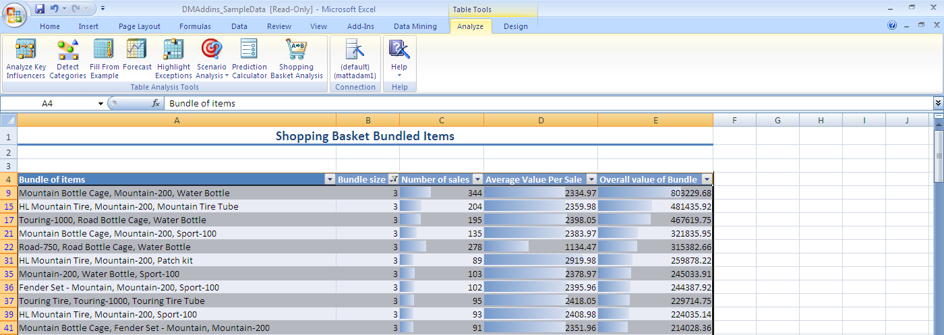
Figure 18: Initial shopping basket analysis results
The chart shows which items tend to be sold or bundled together, as well as the number of associated sales with the overall value of the bundle. This information is useful for making decisions about promotions, pricing strategies, and merchandising efforts. For example, in Figure 18, the Road-750 bike, along with the Road Bottle Cage and the Water Bottle were purchased 278 times, selling for $1,113.47, and generating $315,382.66 in sales.
The second report, in Figure 19, delivers recommendations. This information is useful for determining which products to recommend to a customer, and how each recommendation can have an impact on the total value of a purchase. For example, when the Half Finger Gloves are purchased, recommending the Sport 100 is a good decision. There were 849 sales of the Half Finger Gloves and these sales result in 352 purchases of the Sport 100. The combined value of the recommendation is $19,004.48.
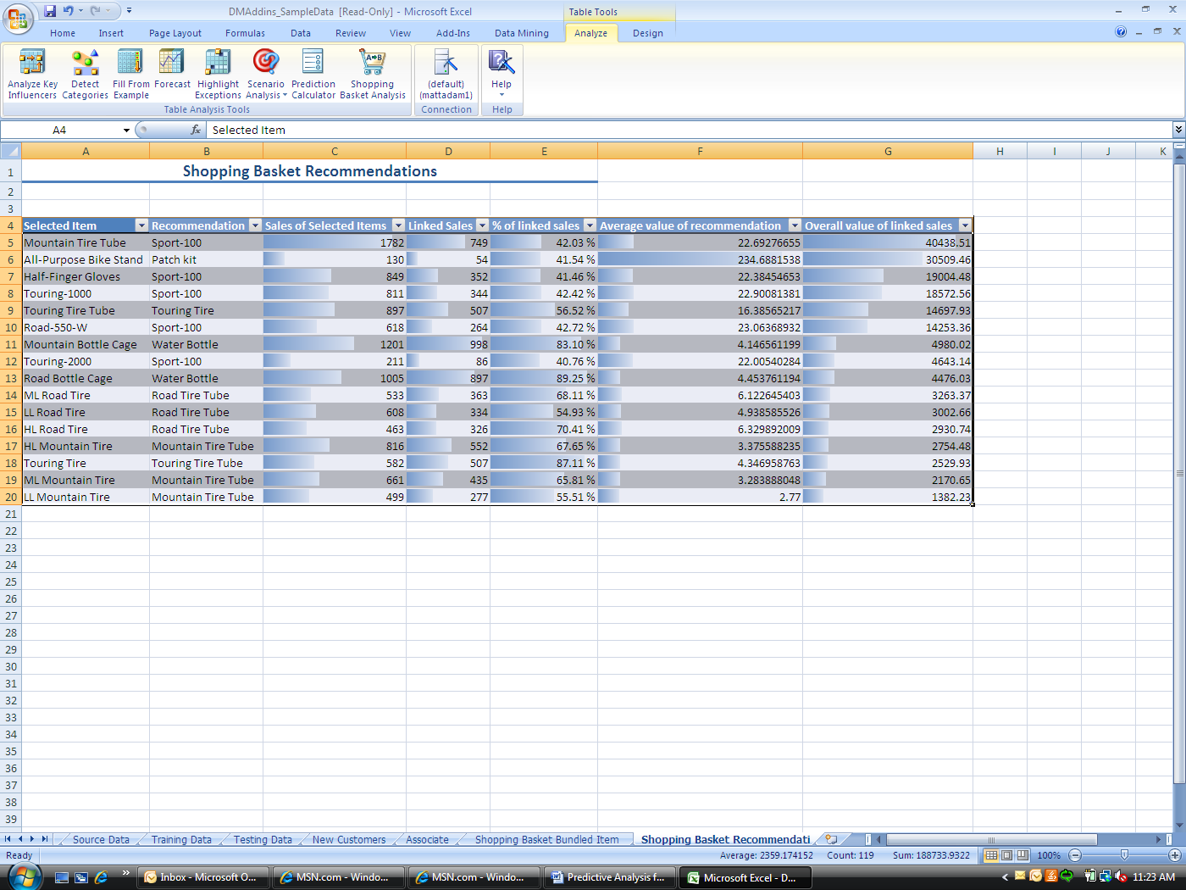
Figure 19: Suggested recommendations from shopping basket analysis
Shopping basket analysis is a powerful analytical tool that enables the retailer to better understand how their customers purchase items. This information can improve merchandising efforts, increase customer satisfaction, and increase store profits.

Demand Planning
Accurate demand planning has a tremendous impact on customer satisfaction, store operating costs, relationships with suppliers, and much more. A stock out occurs when a store is out of stock on a particular item. This causes not only a loss in sales, but potentially a decline in customer satisfaction. On the other hand, over stocking a store with too many of a particular item suggests that the retail store does not understand their customer base. Over stocking is costly because items sit on shelves and are not moving. Also, the retailer has paid the supplier for unnecessary merchandise. Both being out of stock and over stocking are to be avoided. Integrating demand planning into the merchandising, operational, and store processes helps to create a much more efficient process. Because you cannot assume that all stores and all customers behave the same, using demand planning enables the store to run much more efficiently.
Demand planning is different from traditional data mining because includes a time series component. Other modeling techniques do not take time into consideration. Demand planning with SQL Server 2008 empowers users to understand fluctuations and variability over time, and takes these components into consideration when creating the model and forecast.
Figure 20 shows historical sales data from multiple global regions. The time series dimension is provided by the first column, which contains a year/month timestamp for every sales entry. The illustration shows the sales amount for Europe, North America, and Pacific according to the time variable, which is monthly by year.
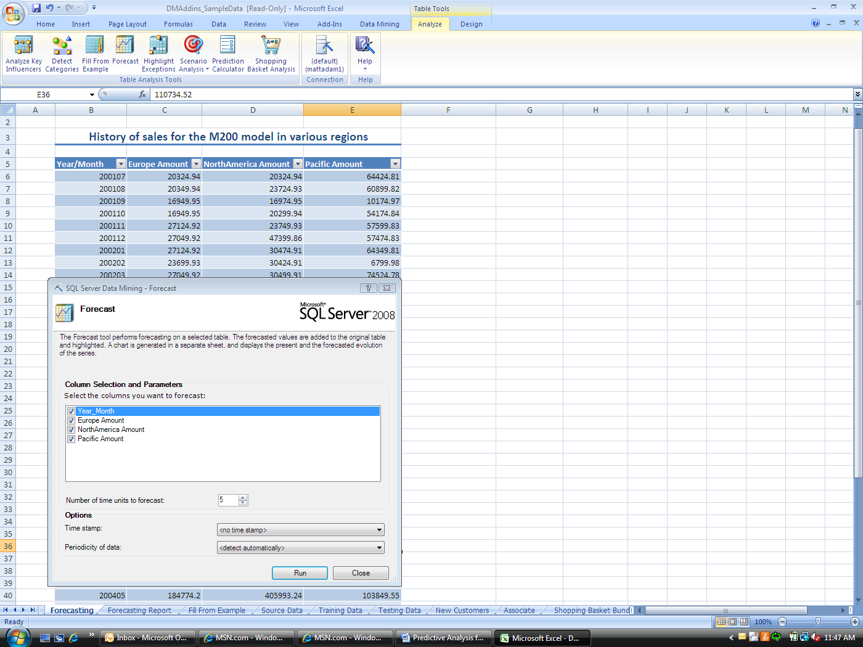
Figure 20: Forecasting wizard with Microsoft data mining
By applying the forecasting capabilities of SQL Server 2008 to this data, you can predict sales for a specified number of months. Figure 21 shows a chart with the forecasted values.

Figure 21: Visual display for forecasted values
You can define the length of the forecasting period. In the example, we forecast sales for the next 12 months.
Not only are we given a visual representation of the forecasted values (the dotted lines), but the forecasted values are also written back to the original Excel worksheet as shown in Figure 22. In the illustration, the predicted data is highlighted. This enables the analyst to easily switch between discovery and exploration, so that he or she can provide predictions to incorporate into business decisions.
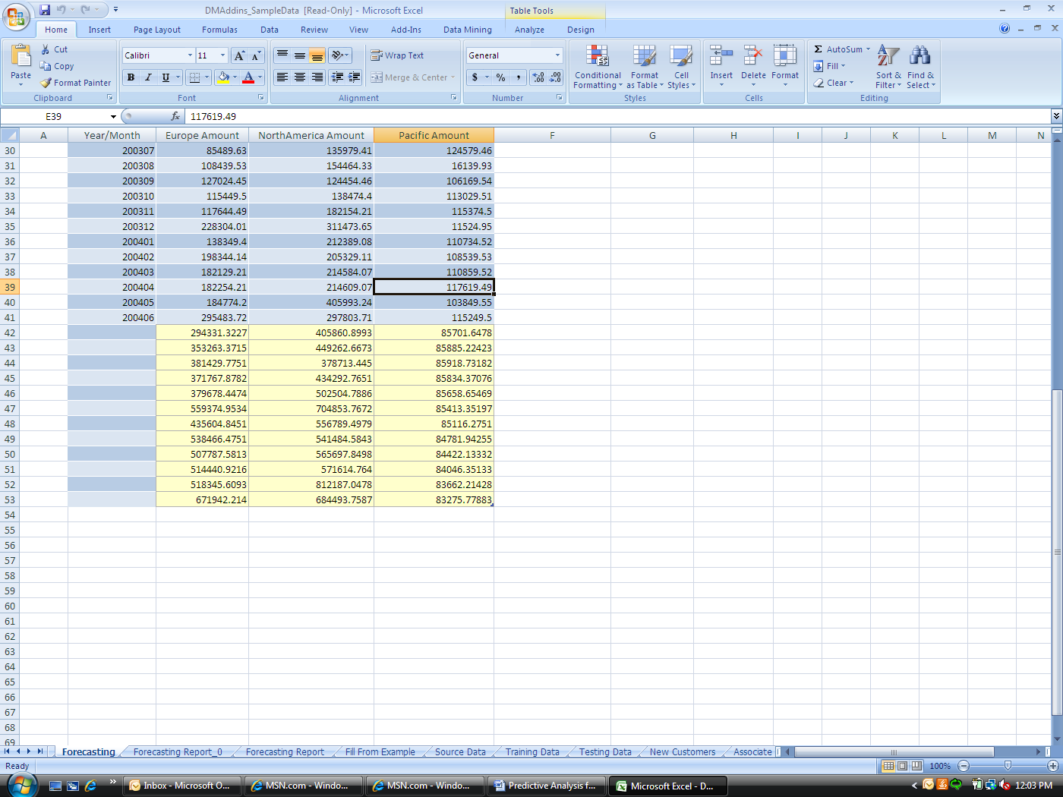
Figure 22: Forecasted values written back to excel
The impact that demand planning has on a retail organization affects not only sales or products—it can also affect staffing of personnel, help you understand peak times of store activity, and help you take into consideration store preparations during times of catastrophic weather, allowing for preemptive actions that empower the business to run more smoothly and operate more efficiently, creating better internal and external relationships with customers and suppliers.

Conclusion
The Data Mining Add-Ins for Office 2007 can be used to solve multiple business problems. The examples used in this paper describe the retail environment, but these methods are not exclusive to retail organizations. Most industries can use the concepts described in this paper to better understand both their businesses and their customers. There is an array of opportunities to apply predictive analysis to your organization. This article discussed a few salient topics, but predictive analysis can be used for many other applications, such as price and promotional analysis, logistics optimization, and customer life time value.
The Data Mining Add-Ins for Office 2007 offer end-user flexibility, complete ease of use, and a familiar and intuitive environment for predictive analysis. The add-ins build upon the scalability of SQL Server 2008 and the familiarity of Microsoft Office. Microsoft data mining offers a complete self-service predictive analysis environment for you to better understand your business.

For more information:
SQL Server Web site: http://www.microsoft.com/sql/technologies/dm/default.mspx
SQL Server TechCenter: http://technet.microsoft.com/en-us/sqlserver/default.aspx
SQL Server DevCenter: http://msdn2.microsoft.com/en-us/sqlserver/default.aspx

Did this paper help you? Please give us your feedback. Tell us on a scale of 1 (poor) to 5 (excellent), how would you rate this paper and why have you given it this rating? For example:
- Are you rating it high due to having good examples, excellent screenshots, clear writing, or another reason?
- Are you rating it low due to poor examples, fuzzy screenshots, unclear writing?
This feedback will help us improve the quality of white papers we release. Send feedback.

