


Predictive Analysis with SQL Server 2008
White Paper

Published: November 2007
Updated: July 2008

Summary: Microsoft SQL Server 2008 offers predictive analysis through a complete and intuitive set of data mining tools. Seamless integration with the Microsoft Business Intelligence platform provides rich insight at every step of the data lifecycle. Furthermore, the flexible platform empowers you to extend prediction into any application.

For the latest information, see Microsoft SQL Server 2008.

Contents
Introduction 1
Predictive Analysis for All Users 2
Pervasive Delivery through Microsoft Office 2
Comprehensive Development Environment 4
Insight at Every Step of the Data Lifecycle 8
Native Reporting Integration 8
In-Flight Data Mining During Data Integration 10
Insightful Analysis 12
Predictive KPIs 13
Data Mining Awareness in Every Application 14
Predictive Programming 14
Plug-In Algorithms and Custom Visualizations 14
Conclusion 15

Introduction
One of the most valuable assets of any company is the large volume of business data in various applications and systems throughout the organization. This data has the potential to provide previously unimagined insights into the business and to form a reliable basis for effective decision-making and accurate forecasting that can drive a company forward to success. Unfortunately, all too often the data is collected by the various computer systems and left dormant in isolated data stores. Some organizations may generate historical reports from this data, and some may even measure the company’s performance against key performance indicators (KPIs); but surprisingly few organizations realize the benefits of mining their historical data to detect patterns and trends, and even fewer embed predictive analysis into their day-to-day business processes to make decisions and predictions and to improve the overall agility of the company.
Over the past few releases, Microsoft has refined the reporting and analytical capabilities in Microsoft® SQL Server® to create a comprehensive Business Intelligence (BI) platform that can be integrated into everyday business activity and used effectively by employees throughout the organization instead of only by a few specialized analysts. Many organizations that previously would have found BI solutions too expensive or complex to implement are now taking advantage of the comprehensive report authoring, rendering, and delivery capabilities of SQL Server Reporting Services and the powerful online analytical processing (OLAP) services provided by SQL Server Analysis Services. The close integration between these BI server products and the ubiquitous Microsoft Office system has brought business analysis to the masses and promoted the evolution of a new kind of information worker who can gain a deeper insight into the business and operate more effectively.
While this proliferation of reporting and multidimensional analytics has greatly benefited many organizations of all sizes, the next step in promoting business agility and operational efficiency is to make the leap from retrospective analysis of historical data to proactive actions based on predictive analysis of business data, and to embed intelligent, fact-based decision-making into business processes. The key to accomplishing this is to use powerful data mining algorithms to analyze data sets, compare new data to historical facts and behaviors, identify classifications and relationships between business entities and attributes, and to deliver accurate predictive insights to all of the systems and users who make business decisions. As with OLAP technologies, data mining was once considered a highly specialized field that required expensive software and rare expertise to implement. However, by including comprehensive data mining technologies in SQL Server Analysis Services, and through integration with the 2007 Microsoft Office system, Microsoft has delivered a cost-effective solution that can extend the power of data mining to everyone and provide the insights that are critical to success while taking advantage of the enterprise-scale capabilities of SQL Server Analysis Services.

Predictive Analysis for All Users
A predictive analysis solution is most effective when it is pervasive throughout the organization and helps to drive day-to-day decisions across the business with its scale and enterprise-level performance. Furthermore, providing a way to implement comprehensive predictive analysis intuitively enables self-service data mining for users, which in turn enables the business to gain actionable insight promptly. The data mining technology in SQL Server 2008 meets these requirements through close integration with the 2007 Office system, a comprehensive development environment, enterprise-grade capabilities, and an extensible set of rich and innovative data mining algorithms that are designed to meet common business problems.

Pervasive Delivery through Microsoft Office
Traditionally, predictive analysis was limited to only a fraction of employees who were statistically trained experts. Microsoft SQL Server 2008 Data Mining Add-Ins for the 2007 Office System, shown in Figure 1, extend insight and prediction to a wider audience by enabling information workers to harness the highly sophisticated data mining technology within a familiar spreadsheet environment. The array of tools empowers users to inform everyday decisions in a few simple steps by providing prompt and actionable recommendations. The Table Analysis Tools for Microsoft Office Excel® 2007 hide the complexity of data mining behind intuitive tasks, delivering a seamless experience that enables users to transition easily between exploration and discovery. The Data Mining Client for Excel 2007 offers a complete data mining development lifecycle, which empowers advanced users with more information, validation, and control. Furthermore, the Data Mining Templates for Visio enable users to render annotatable graphical visualizations of the data mining models. Altogether, the integration between SQL Server 2008 data mining and the 2007 Office System provides a comprehensive, intuitive, and collaborative business ecosystem that extends the insight of predictive analysis to inform business decisions throughout the organization.
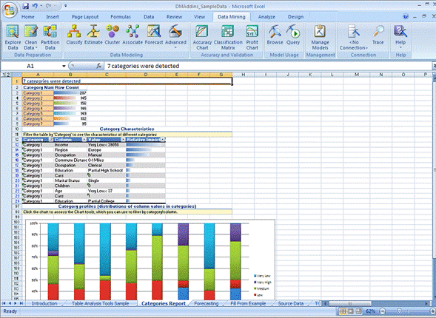
Figure 1: Data Mining Add-Ins for Microsoft Office Excel 2007
The Data Mining Add-Ins for the 2007 Office system delivers the following benefits:
- Comprehensive: Provide a wide range of tools to fit many needs.
Data Mining Add-Ins for the 2007 Office System are designed to offer a remarkably broad and reliable set of data mining tools. The availability of these tools at the desktop enables all users to explore data and discover hidden trends and relationships between products, customers, markets, employees, and other factors; empowering them to anticipate needs, understand behaviors and discover hidden opportunities that can improve business processes and directly impact profitability.
- Intuitive: Deliver actionable insight to every user.
Access to predictive analysis within the familiar Microsoft Office environment helps users to easily incorporate prediction into everyday processes. The automated tasks provided in the Table Analysis Tools for Excel 2007 deliver clear and actionable insights promptly, in three simple steps:
- Define your data.
Identify the data that is necessary to inform the solution and create a table in an Excel 2007 spreadsheet that defines the data to be analyzed.
- Identify the task.
Select the appropriate data mining task to perform on the data from the Data Mining or Table Analysis ribbon.
- Get results.
Examine the output from the task delivered through clear and intuitive visualizations directly in the Excel 2007 environment.
The automated tasks provided in the Data Mining Add-Ins for Excel 2007 include:
- Analyze Key Influencers - Detects the key characteristics that influence a certain outcome. A detailed report that ranks the key influencers based on importance is generated, enabling users to compare key factors for each set of distinct values.
- Detect Categories - Helps users to identify and segment data based on common properties. A detailed report describing the discovered categories is generated, enabling re-labeling of categories with meaningful naming for further analysis.
- Fill From Example - Helps users to complete a partially populated column automatically based on patterns in the table. A report explaining the detected patterns is generated, enabling users to re-analyze the data and refine patterns as more knowledge is acquired.
- Forecast - Enables users to predict future values based on trends in the data set. The forecast values are added to the original table and charts displaying past and forecast evolution of the series are generated.
- Highlight Exceptions - Enables users to detect cases in the data set that include values outside the expected range. The rows containing the exceptions are highlighted and the actual column likely to cause the exception is emphasized.
- Scenario Analysis: What If - Enables users to gain insight into the impact of a potential change that is applied to one value on other values of the data set.
- Scenario Analysis: Goal Seeking - Enables users to better understand the underlying factors that need to be changed to achieve a desired value in a certain target column (complementary to the What-If tool).
- Prediction Calculator - Related to the Analyze Key Influencers task, the Prediction Calculator generates an interactive form for scoring new cases. The influence of each attribute is translated into a set of scores. A summary of a combination of attributes, which apply to a new case, predicts probable future behaviors.
- Shopping Basket Analysis - Enables users to detect the relationship between items frequently purchased together. A report explaining the relationships can provide a better understanding of the financial significance, providing insight into bundling offerings or improved product placement.
- The easy to understand, graphical output from these tools provides a seamless transition between exploration and discovery, and empowers users with rich prediction and insight that clearly translates into recommendations and actions.
- Collaborative: Share insights throughout the organization - Having performed predictive analysis in Excel 2007, users can use the powerful publishing tools of the 2007 Office System to share findings and inform business decisions throughout the organization. For example, users can share analysis through interactive graphical visualizations in Office Visio® 2007 diagrams, or they can share tables, reports, and diagrams through Microsoft Office SharePoint® Server 2007.

Comprehensive Development Environment
The 2007 Office System is an ideal desktop tool for information workers, but for BI developers who deploy solutions throughout the enterprise, SQL Server Business Intelligence Development Studio is the environment of choice because it has a project-based environment, complete with debugging and source control integration that you can use to create end-to-end BI solutions.
Of course, pervasive delivery of data mining functionality is only useful if developers can build data mining solutions that meet the needs of the business quickly and easily. SQL Server Business Intelligence Development Studio provides a comprehensive development environment that is based on the Microsoft Visual Studio® development system. With Business Intelligence Development Studio, developers can create data mining structures, which identify the tables and columns to be included in the analysis, and add multiple data mining models that apply data mining algorithms to the data in those tables. The Analysis Services project template in Business Intelligence Development Studio, shown in Figure 2, includes an intuitive Data Mining Designer for creating and viewing data mining models, and provides cross-validation, lift charts, and profit charts to compare and contrast the quality of models visually and through statistical scores of error and accuracy before deploying them.
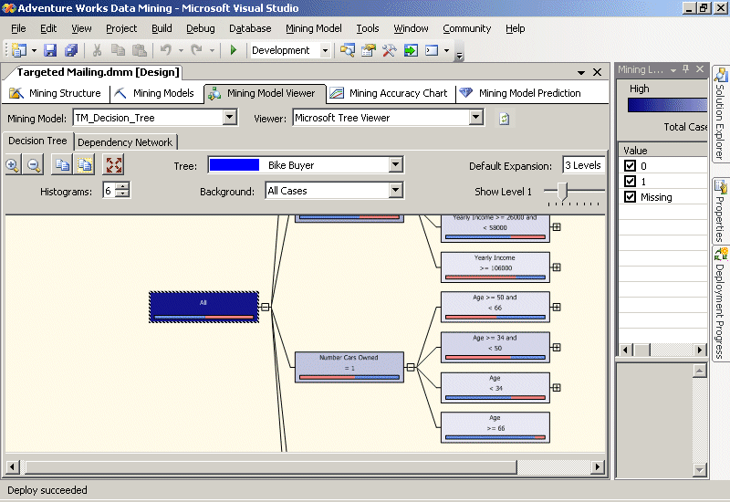
Figure 2: Data Mining Designer in Business Intelligence Development Studio
SQL Server 2008 introduces a number of enhancements to the already comprehensive development environment of SQL Server 2005, including the ability to:
- Split data into training and testing partitions more effectively. Partitioning is available within the process of creating the data mining model. Developers can identify a portion of the training dataset to be randomly selected for testing.
- Build models over filtered data. Data filtering enables the creation of mining models that use subsets of data in a mining structure. Filtering provides flexibility for designing mining structures and data sources, because developers can create a single mining structure, based on a comprehensive data source view, and then apply filters to use only a part of that data for training and testing a variety of models, instead of building a different structure and related model for each subset of data. For example, a developer could define the data source view on the Customers table and related tables, build a single mining structure that includes all of the required fields, and then create a model that is filtered on a particular customer attribute, such as Region. The developer can then easily make a copy of that model, and change the filter condition to generate a new model based on a different region. By applying filters to data models, you can:
- Create separate models for discrete values. For example, a clothing store might use customer demographics to build separate models by gender, even though the sales data comes from a single data source for all customers.
- Experiment with models by creating and then testing multiple groupings of the same data, such as ages 20-30 versus ages 20-40 versus ages 20-25.
- Specify complex filters on nested table contents, such as requiring that a case be included in the model only if the customer has purchased at least two of a particular item.
- Build incompatible models within the same structure. Models using continuous or discretized versions of the same column can co-exist in a single structure with the new aliasing ability in the Mining Model Editor in Business Intelligence Development Studio.
- Test multiple models simultaneously with cross-validation. The models created by data mining algorithms have various applications that require different accuracy and stability measurements. Depending on the application, users demand these measurements. Additionally these measurements assist in ensuring that various settings result in the best model for a current data set and a given application. SQL Server 2008 offers a robust cross-validation feature that can test all of the models in a structure simultaneously by using a folding technique. This enables users to test a variety of settings on a subset of data before committing to an expensive processing step. Cross-validation results also tell users if the model results are stable or if the results would change given more or less data. Figure 3 shows a cross-validation report in the Data Mining Designer.
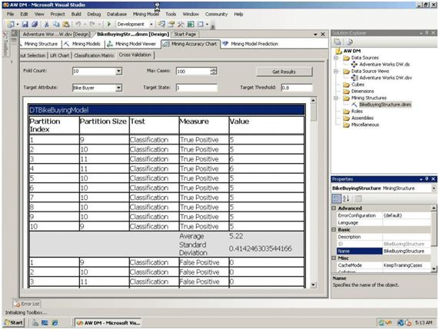
Figure 3: Cross-validation

Enterprise-Grade Capabilities
SQL Server Predictive Analysis is part of SQL Server Analysis Services, which provides enterprise-class server advantages: rapid development, high availability, superior performance and scalability, robust security, and enhanced manageability through SQL Server Management Studio. This enterprise-level capability means that the data mining technologies enabling predictive analysis can grow with the business and provide a high performance, scalable solution for any size of organization.

Rich and Innovative Algorithms
Different businesses have different goals and need to make different decisions. For this reason, any data mining technology must support a comprehensive set of capabilities and algorithms to meet a diverse range of business needs. SQL Server 2008 Analysis Services includes data mining technologies that support many rich and innovative algorithms, most of them designed by Microsoft Research to solve common business problems. Additionally, the data mining technologies of SQL Server Analysis Services are extensible, enabling you to add plug-in algorithms that meet uncommon analytical needs that are more specific to an individual business. The following table shows some of the tasks that SQL Server data mining can be used to perform.
Data Mining Tasks
Task | Description | Algorithms
Market Basket Analysis | Discover items sold together to create recommendations on-the-fly and to determine how product placement can directly contribute to your bottom line. | Association  Decision Trees
Churn Analysis | Anticipate customers who may be considering canceling their service and identify the benefits that will keep them from leaving. | Decision Trees  Linear Regression  Logistic Regression
Market Analysis | Define market segments by automatically grouping similar customers together. Use these segments to seek profitable customers. | Clustering  Sequence Clustering
Forecasting | Predict sales and inventory amounts and learn how they are interrelated to foresee bottlenecks and improve performance. | Decision Trees  Time Series
Data Exploration | Analyze profitability across customers, or compare customers that prefer different brands of the same product to discover new opportunities. | Neural Network
Unsupervised Learning | Identify previously unknown relationships between various elements of your business to inform your decisions. | Neural Network
Web Site Analysis | Understand how people use your Web site and group similar usage patterns to offer a better experience. | Sequence Clustering
Campaign Analysis | Spend marketing funds more effectively by targeting the customers most likely to respond to a promotion. | Decision Trees  Naïve Bayes  Clustering
Information Quality | Identify and handle anomalies during data entry or data loading to improve the quality of information. | Linear Regression  Logistic Regression
Text Analysis | Analyze feedback to find common themes and trends that concern your customers or employees, informing decisions with unstructured input. | Text Mining

Insight at Every Step of the Data Lifecycle
Whether consuming, analyzing, monitoring, planning, exploring, or reporting on business data, predictive analysis can add rich insight to expose new avenues for growth. SQL Server 2008 is part of a family of business intelligence technologies, all working together to deliver a comprehensive platform that enables organizations to incorporate predictive analysis into every stage of the data life cycle.

Native Reporting Integration
Reporting is a fundamental activity in most businesses, and SQL Server 2008 Reporting Services provides a comprehensive solution for creating, rendering, and deploying reports throughout the enterprise. SQL Server Reporting Services can render reports directly from a data mining model by using a data mining extensions (DMX) query. This enables users to visualize the content of data mining models for optimized data representation. Furthermore, the ability to query directly against the data mining structure enables users to easily include attributes beyond the scope of the mining model requirements, presenting complete and meaningful information. Figure 4 shows the DMX query editor for Reporting Services.
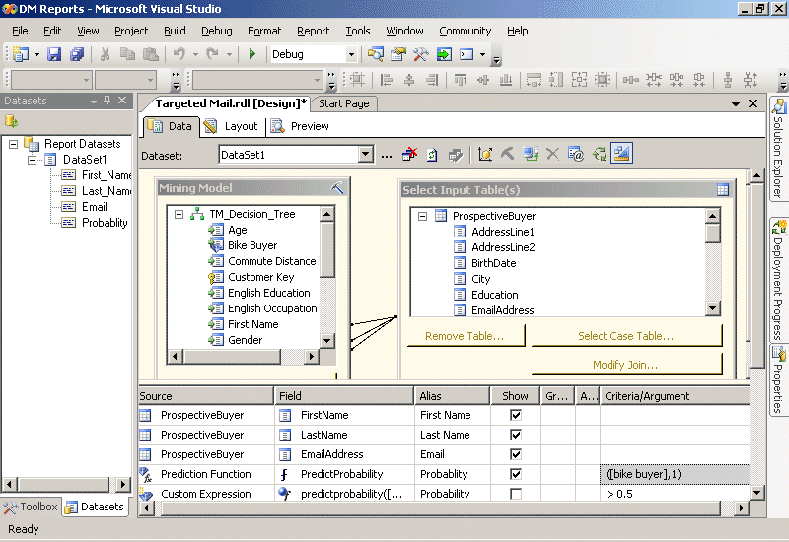
Figure 4: The DMX query editor for SQL Server Reporting Services
SQL Server Reporting Services provides the ability to generate parameter-driven reports based on predictive probability. For example, the query shown in Figure 4 analyzes a list of prospective customers for the hypothetical Adventure Works cycle company and uses a data mining model to assess the probability of those customers buying a bicycle. The query is filtered to return only prospects that are more than 50% likely to make a purchase. Figure 5 shows the resulting report, which the company could use as the basis for a marketing campaign that targets only the customers most likely to make a purchase, significantly improving the effectiveness of the campaign and its return on investment.
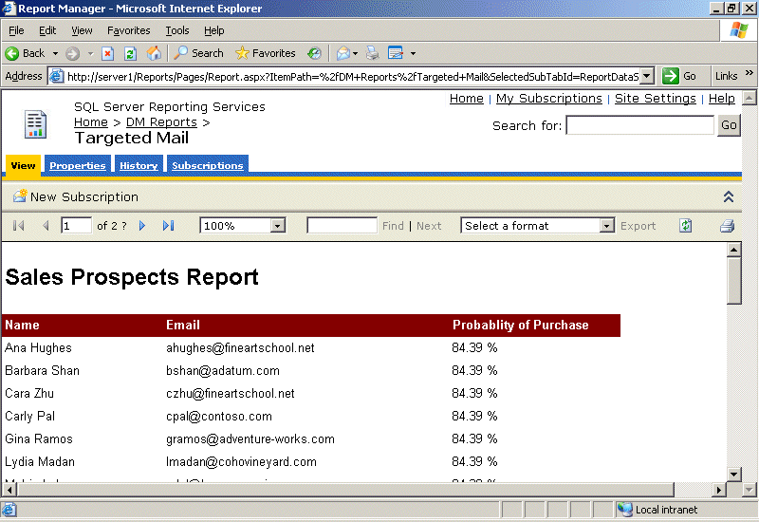
Figure 5: A predictive analysis report

In-Flight Data Mining During Data Integration
As Business Intelligence becomes more pervasive, businesses are increasingly implementing extract, transform, and load (ETL) solutions to consolidate data from around the organization into a data warehouse for reporting and analysis. However, the source data for these operations can often be incomplete, or in some cases business entities, such as customers, might need to be classified into categories based on common profile characteristics.
Microsoft SQL Server 2008 Integration Services provides a powerful, extensible ETL platform that Business Intelligence solution developers can use to implement ETL operations that cleanse and transform data in-flight. SQL Server Integration Services includes a Data Mining Model Training destination for training data mining models, and a Data Mining Query transformation that can be used to perform predictive analysis on data as it is passed through the data flow. Integrating predictive analysis with SQL Server Integration Services enables organizations to flag unusual data, classify business entities, perform text mining, and fill-in missing values on the fly based on the power and insight of the data mining algorithms. For example, an ETL process might extract customer data from one or more source systems for inclusion in a data warehouse. Traditionally, data mining would be used after the data warehouse is loaded, to classify customers for predicted purchasing behavior or other campaign management tasks. However, with SQL Server Integration Services, the Data Mining Query Transformation can apply a data mining model during the ETL process, resulting in a data warehouse that is populated with classified data at load time. This reduces the work that must be done on the warehouse server, and ensures that the data available for analysis is always up-to-date and consistently classified. Moreover, classification during the ETL process may also be used to filter out customer records that do not fit any known classification. These records may be the result of poor data quality, or may represent a new classification not yet captured in the campaign management process. In either case, SQL Server Integration Services can detect these records by using data mining and redirect them for manual or automated review.
Figure 6 shows a SQL Server Integration Services data flow that includes a Data Mining Query transformation.
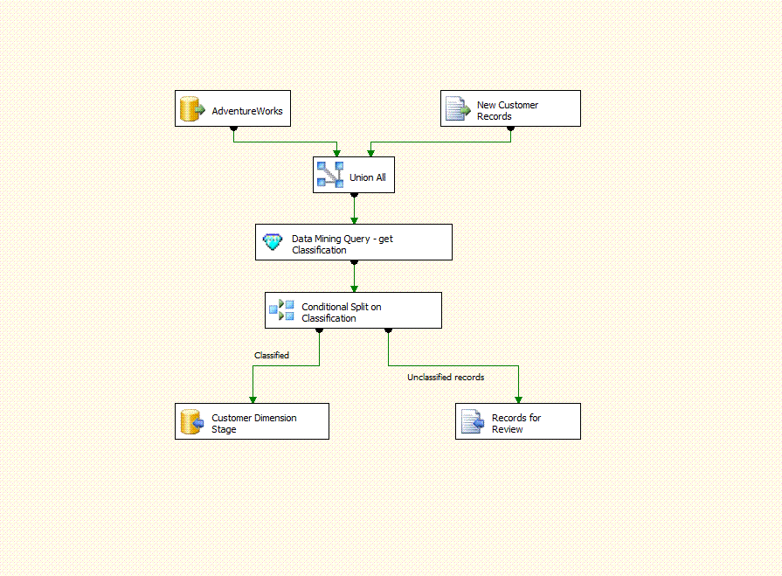
Figure 6: Data mining in SQL Server Integration Services

Insightful Analysis
SQL Server 2008 Analysis Services provides a highly scalable platform for multidimensional OLAP analysis. Many customers are already reaping the benefits of creating a unified dimensional model (UDM) in Analysis Services and using it to slice and dice business measures by multiple dimensions. Predictive analysis, being part of SQL Server 2008 Analysis Services provides a richer OLAP experience, featuring data mining dimensions that slice your data by the hidden patterns within. For example, a sales and marketing department can create a data mining structure that is based on an existing Customer OLAP dimension and use it to classify customers into clusters that exhibit similar characteristics. They can then use that data mining structure to generate a new data mining dimension and use it to analyze sales information based on the customer clusters that have been identified. Figure 7 shows a data mining dimension in an OLAP cube.
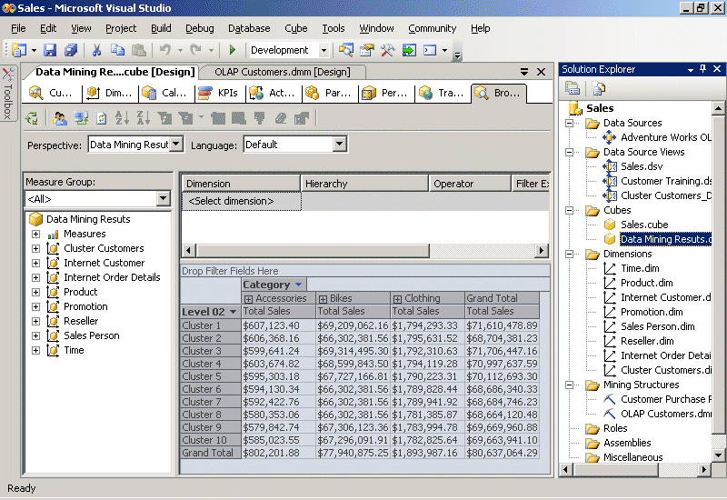
Figure 7: A data mining dimension in an OLAP cube
In addition to incorporating the results of data mining into OLAP dimensions, SQL Server 2008 enables you to incorporate predictive functions based on data mining models into calculations and KPIs.

Predictive KPIs
Many businesses use KPIs to evaluate critical business metrics against targets. SQL Server 2008 Analysis Services provides a centralized platform for KPIs across the organization, and integration with Microsoft Office PerformancePoint® Server 2007 enables decision makers to build business dashboards from which they can monitor the company’s performance. KPIs are traditionally retrospective, for example showing last month’s sales total compared to the sales target. However, with the insights made possible through data mining, organizations can build predictive KPIs that forecast future performance against targets, giving the business an opportunity to detect and resolve potential problems proactively. Figure 8 shows a KPI that displays the anticipated number of orders that are predicted to be placed.
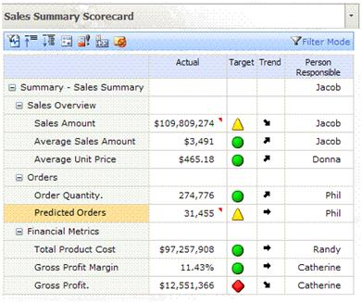
Figure 8: Microsoft Office PerformancePoint Server 2007
Additionally, predictive analysis can detect attributes that influence KPIs. Together with Office PerformancePoint Server 2007, users can monitor trends in key influencers to recognize those attributes that have a sustained effect, for example identifying whether price discount on a competing product has a lasting impact on sales or only generates a short-term interference. Such insights enable businesses to inform and improve their response strategy.

Data Mining Awareness in Every Application
As you have seen in this whitepaper so far, SQL Server 2008 provides a comprehensive data mining solution, and the tight integration with the Microsoft Business Intelligence platform makes it easy to provide predictive analysis to users and automated processes across the enterprise. However, there may still be occasions where organizations need to embed data mining functionality into an application, to introduce intelligence into an existing business process, or to extend data mining technologies to meet a specific business problem. For this purpose, SQL Server offers a flexible and extensible programming platform for seamlessly incorporating prediction and insight into line-of-business applications.

Predictive Programming
SQL Server 2008 data mining supports a number of application programming interfaces (APIs) that developers can use to build custom solutions that take advantage of the predictive analysis capabilities in SQL Server. DMX, XMLA, OLEDB and ADOMD.NET, and Analysis Management Objects (AMO) offer a rich, fully documented development platform, empowering developers to build data mining aware applications and providing real-time discovery and recommendation through familiar tools.
This extensibility creates an opportunity for business organizations and independent software vendors (ISVs) to embed predictive analysis into line-of-business applications, introducing insight and forecasting that inform business decisions and processes. For example, the Analytics Foundation adds predictive scoring to Microsoft Dynamics® CRM, to enable information workers across sales, marketing, and service organizations to identify attainable opportunities that are more likely to lead to a sale, increasing efficiency and improving productivity (for more information, see the Microsoft Dynamics site).

Plug-In Algorithms and Custom Visualizations
The SQL Server data mining toolset is fully extensible through Microsoft .NET–stored procedures, plug-in algorithms, custom visualizations and PMML. This enables developers to extend the out-of-the-box data mining technologies of SQL Server 2008 to meet uncommon business needs that are specific to the organization by:
- Creating custom data mining algorithms to solve business-specific analytical problems.
- Using data mining algorithms from other software vendors.
- Creating custom visualizations of data mining models through plug-in viewer APIs.

Conclusion
SQL Server 2008 Analysis Services provides a complete data mining platform that organizations can use to infuse insight and prediction into everyday business decisions. Pervasive delivery through the Data Mining Add-Ins for the 2007 Office system delivers predictive analysis capabilities with intuitive tools and clear results that are available throughout the enterprise at the desktop. The comprehensive development environment and extensible range of innovative data mining algorithms combined with the enterprise-level scalability and manageability of SQL Server Analysis Services makes SQL Server 2008 an ideal way to bring the benefits of predictive analysis to your business.
Because the predictive analysis capabilities of SQL Server 2008, as part of the Microsoft BI platform, are closely integrated into every stage of the data life cycle, they incorporate intelligence into reporting, data integration, OLAP analysis, and business performance monitoring. This helps organizations increase business agility and creates a tangible competitive advantage.
Although the data mining functionality provided with SQL Server 2008 is comprehensive enough to meet the needs of a wide range of business scenarios, its extensibility ensures that it can be used to solve virtually any predictive problem. The ability to extend the data mining technologies of SQL Server through custom algorithms and visualizations, together with the ability to embed predictive functionality into line-of-business applications makes SQL Server 2008 a powerful platform for introducing predictive analysis into existing business processes to add insight and recommendations into everyday operations.
For more information:
Microsoft SQL Server 2008
http://www.microsoft.com/sqlserver/2008/en/us/default.aspx
SQL Server Developer Center
http://msdn2.microsoft.com/sqlserver
SQL Server TechCenter
http://technet.microsoft.com/sqlserver

Please give us your feedback:
Did this paper help you? Tell us on a scale of 1 (poor) to 5 (excellent), how would you rate this paper and why have you given it this rating? For example:
- Are you giving it a high rating because it has good examples, excellent screenshots, clear writing, or another reason?
- Are you giving it a low rating because it has poor examples, fuzzy screenshots, unclear writing?

This feedback will help us improve the quality of white papers we release. Send feedback.

