Microsoft is providing products, technologies and offerings, based on the concept of being highly virtualized, managed in a consistent manner, dynamic and elastic scalability, and focused on the delivery of services to the user.
Cloud Computing Infrastructure

Microsoft’s cloud computing infrastructure
Microsoft has outlined a vision for cloud computing infrastructure that is an evolution of the multi-year, multi-product Dynamic IT vision outlined six years ago. Microsoft is now providing products, technologies and offerings around 2 types of clouds, each based on the concepts of being highly virtualized, managed in a consistent manner, dynamic and elastic scalability, and focused on the delivery of services to the user:

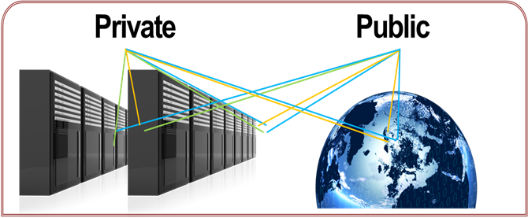
Private Cloud - an internal service-oriented environment optimized for performance and cost that is deployed inside a customer’s datacenter. Powered by packaged server products including Windows Server® and Microsoft® System Center family of products, private cloud provides compatibility with existing applications.

Public Cloud - provided by service providers and offering customers the ability to deploy and consume services. In this category, Azure is a highly scalable services platform providing pay–as-you-go flexibility delivered from Microsoft’s datacenters.

What are the key benefits of cloud computing?
As we enable our customers on this path, Microsoft will deliver the technology that allows enterprises to build a private cloud within their datacenters based on enhancements to Windows Server and System Center. This portfolio represents infrastructure, service and application development tools for clouds that offer:
- A flexible and familiar infrastructure with a common Windows-based platform to build and deploy applications across clouds, and reduce development and deployment time on new services.
- Integrated resource fabrics that enable federated services across clouds, helping ensure capacity and resources needed to achieve business requirements. Ideal for allowing overdraft protection for application services into a public cloud.
- The agility to develop applications and services once, deploy them in, and across any cloud environment, enabling rapid response to changing business needs.

What is unique about Microsoft’s cloud strategy?
With Microsoft’s cloud strategy, a complete set of components to deliver datacenter services; infrastructure, applications, management, and security, are combined with best practices to enable a service oriented infrastructure today. This allows customers to maximize returns on their existing applications as they transition to a cloud computing paradigm while providing opportunities to take advantage of new approaches for application and service development.

Microsoft is uniquely positioned to deliver a range of capabilities that provide customers with:

- Virtualized infrastructure
- Automated and service-oriented management environment
- Common application platform & development tools
- Integrated identity, protection, and access technologies
- Physical and virtual management

Get Started Quickly
Microsoft is offering customers and hosting partners solution accelerators to help build the foundation for a cloud infrastructure:

- Dynamic Datacenter Toolkit for Hosters – Available today!
- Dynamic Datacenter Toolkit for Enterprises – Available Q4 2009

Both solution accelerators will be available from Microsoft at no charge. These toolkits will provide customers and hosting partners with the reference architecture, deployment guidance, and best practices for enabling the foundation for a cloud infrastructure today and help them move toward dynamic IT environment. These offerings work with Windows Server and System Center family of products to utilize and help extend existing investments in Microsoft technologies.

For more information, visit www.microsoft.com/privatecloud

This document is for informational purposes only. MICROSOFT MAKES NO WARRANTIES, EXPRESS, IMPLIED OR STATUTORY, AS TO THE INFORMATION IN THIS DOCUMENT.
© 2009 Microsoft Corporation. All rights reserved.
Microsoft, Windows, System Center, and Azure are either registered trademarks or trademarks of Microsoft Corporation in the United States and/or other countries. The names of actual companies and products mentioned herein may be the trademarks of their respective owners.

