Business Intelligence and Reporting
With an immense amount of data located in a variety of systems, one of the great challenges organizations face is how to collect, categorize, understand, and make decisions about project data. Conventional reporting offers tools and methods for collecting, aggregating, displaying, and communicating data. Business Intelligence (BI) takes that concept to the next level by providing visibility and helping organizations with decision support for proactive work management.
BI is a rapidly evolving discipline. Its effectiveness depends on an organization’s ability to pull together accurate information in real time that it is standardized and tailored to the needs of the audience.
Organizations face many challenges in obtaining the right tools and data to meet their business intelligence and reporting needs, including the following:
- Lack of standard metrics for measuring performance. Organizations require standardized metrics to proactively monitor and address problems by using key performance indicators (KPIs). Without standardized metrics it becomes difficult to compare projects, recognize problems, roll up key data to the program or portfolio level, and provide cohesive reporting to executive management.
- Time-consuming, manual report generation. Automating the reporting process means that project management offices (PMOs) and project managers will not spend valuable time gathering and assembling up-to-date project progress data and manually preparing project and portfolio reports.
- Specialized skill sets are required to build reports. The problem with many reporting solutions is that they are difficult to use and require highly specialized, technical resources. This creates a strong dependency on certain resources being available and requires sufficient planning, which can lead to delays and bottlenecks.
- It’s difficult to create on-demand reports. PMOs often have to accommodate and react to fire drills and, as a result, need powerful reporting tools to effectively mine data and easily produce and distribute reports as required.
- Lack of reusable reports and best practices. Organizations need to be able to generate, share, and reuse best-practice template reports. Selecting from the same set of best-practice reports promotes efficiency and the ability to adapt common formats into reusable templates at any level—individual, team, department, and enterprise.
By standardizing the collection of data and performance metrics in a central repository, PMOs can more easily facilitate enterprise reporting. Microsoft® Project Server 2010 includes a variety of online views, such as Project Center, Resource Center, and Portfolio Analysis, in addition to powerful BI and reporting services to help organizations gain insight, visibility, and control across all project portfolios. Because Project Server 2010 is built on Microsoft® SharePoint® Server 2010, users can take advantage of all the tools included in the Microsoft BI platform, such as Excel Services, PerformancePoint® Services, Visio® Services, PowerPivot for Excel, SQL Reporting Services, and more. The flexible Microsoft BI solution provides nontechnical resources with familiar tools to easily create reports and configure powerful dashboards, while providing technical resources with more sophisticated capabilities to create complex views.
Project Server 2010 includes a dedicated reporting database that stores project and portfolio data to ensure access to up-to-date information. PMOs can satisfy line-of-business (LOB) reporting requirements by using departmental cubes, so decision makers can focus on their data, eliminate unnecessary clutter, and ensure faster build times. The improved Business Intelligence Center in Project Server 2010 includes a library of preconfigured best-practice template reports. Nontechnical resources can get started quickly by customizing the templates in a familiar Excel editor and then simply publish the report using Excel Services to be incorporated into dashboard views. PMOs can create intuitive audience-based dashboards to ensure that managers receive relevant and useful information. Resources who are more technical can use more sophisticated tools, such as SQL Server® Reporting Services, to create complex reports—for example, monthly reporting packs—to meet the organization’s unique requirements.

Project Controls and Performance Measurement
Powerful BI solutions quickly become redundant if the required data is not available or if the accuracy of the information is questionable. Without first standardizing the collection of data and metrics, it becomes difficult to effectively measure project and portfolio performance and to facilitate enterprise reporting. Automating the collection of accurate status information helps organizations focus on delivering projects on time and within budget, rather than engaging in manual, time-consuming efforts to gather data to drive status reports.
Project Server 2010 helps organizations standardize data collection and performance metrics across the enterprise and streamlines status reporting through easy-to-use Web-based tools. Automating and standardizing data collection ensures the availability of up-to-date and accurate information to drive enterprise reporting and controls.
Project Server 2010 ensures that PMOs can define consistent KPIs using custom enterprise fields to measure the overall health of initiatives. Depending on the culture of the organization, the color of the indicators—red, amber, and green—can be derived through formulas or be manually selected by the project manager. Common indicators include overall health, budget, resource, schedule, quality scope, and risk. Performance indicators can be displayed in the project schedule or in the configurable scorecard views to provide stakeholders with an overview of portfolio- and project-level performance (see Figure 1).
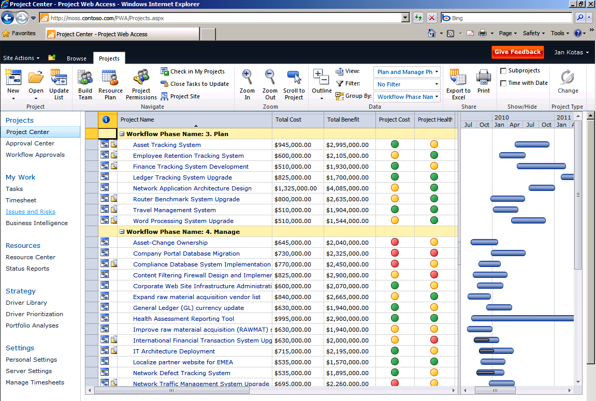
Figure 1. Project Server 2010 – Configurable Project Center view
Organizations often face the challenge of not having real-time information at hand with which to make appropriate decisions and the need to react quickly to certain situations or events. To help address this need, Project Server 2010 offers automated methods of time, task, and status reporting so team members can provide project managers with real-time progress data. With Project Server 2010 project managers can create custom status reports to collect and combine progress updates from team members (see Figure 2). The project manager can define the recurrence of the status report—weekly, monthly, annually, and so on—select the resources, and define the categories—for example, Major Accomplishments, Objectives for Next Period, and Hot Issues—that need to be included in the report. This approach sets clear expectations and responsibilities within the project team, in addition to automating status collection for the project manager. Using status reporting tools, project managers can exercise a “no surprises” approach to project execution and keep sponsors and executive leadership always up to date. For more information about time and task reporting, see the Time and Task Management page.
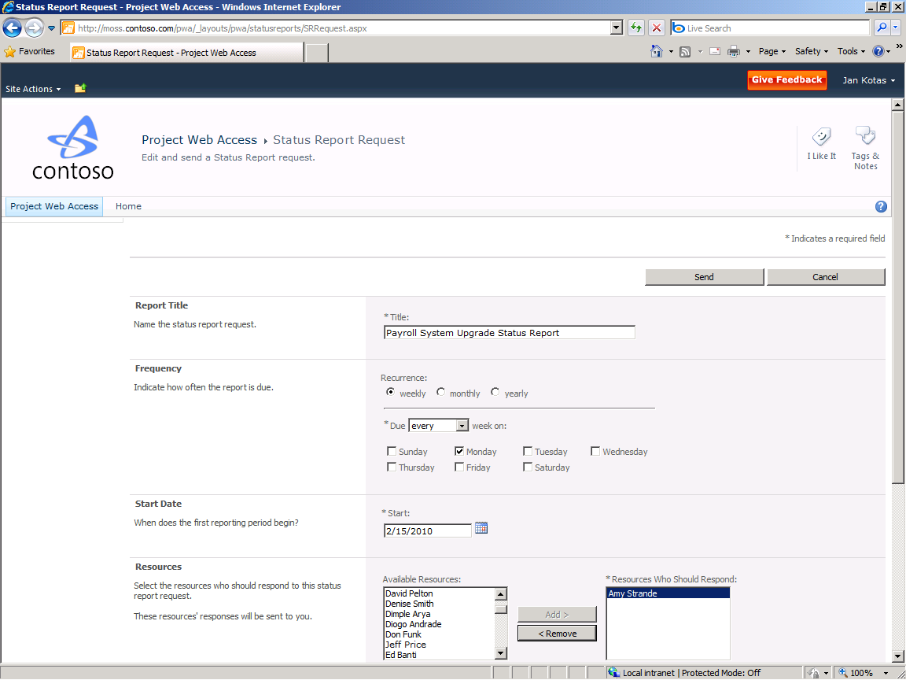
Figure 2. Custom Status Report created by the project manager

Easily Create Reports and Build Powerful Dashboards
Project Server 2010 includes powerful BI and reporting services to help organizations gain insight, visibility, and control across all project portfolios. Because Project Server 2010 is built on SharePoint Server 2010, organizations can take advantage of all the tools included in the Microsoft BI platform, such as Excel Services, PerformancePoint Services, Visio Services, the PowerPivot Excel add-in, and SQL Server Reporting Services. This flexible BI solution provides nontechnical and technical resources with familiar tools to intuitively create reports and easily configure powerful dashboards.
The new Project Server 2010 Business Intelligence Center includes a Reports Library with preconfigured best-practice report templates, so it is easier to get started (see Figure 3). The best-practice templates include common reports such as Issues and Risks, Timesheet Actuals, Simple Project List, Resource, Deliverables, and more. Using the Report Library, PMOs can easily add new report templates, and share and reuse best-practice report templates across the enterprise.

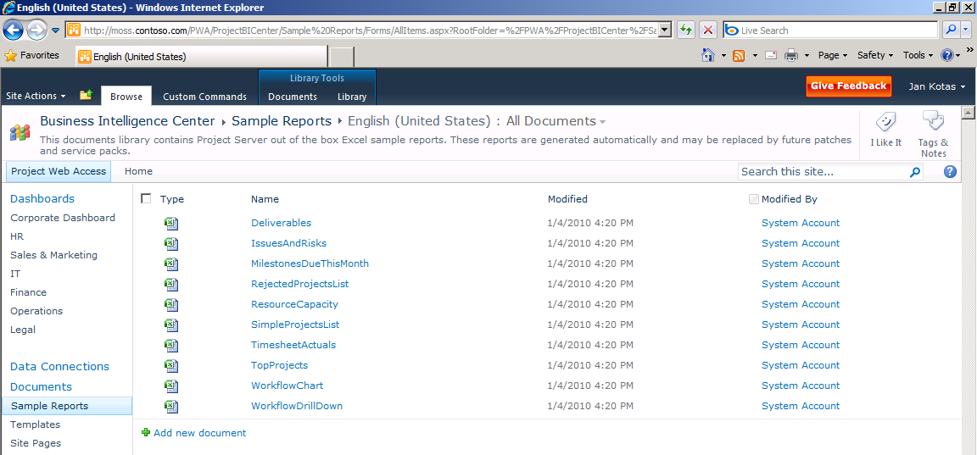
Figure 3. Project Server 2010 – Business Intelligence Center (sample reports)
Users can simply click and open the required report template in a familiar Excel editor. Because data connections are already established, the user can intuitively customize the report by selecting and arranging the required data and using the PivotTable field list in Excel.
Updated reports can be saved in the Reports Library, published using Excel Services, and made available as a Web part to be integrated into various dashboard views. Users with appropriate permissions can build powerful dashboards by selecting and arranging the required Web parts within configurable dashboard views (see Figure 4).
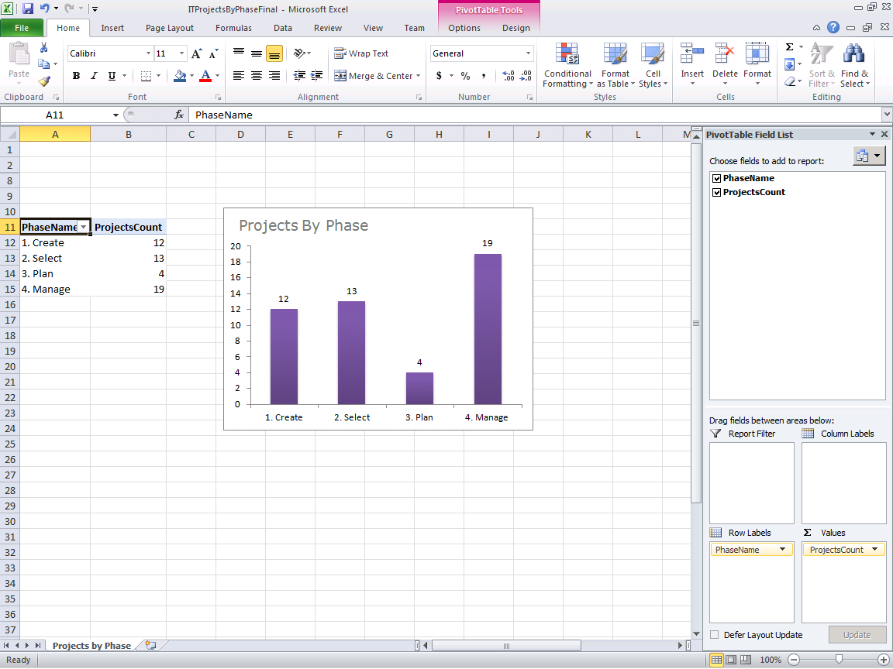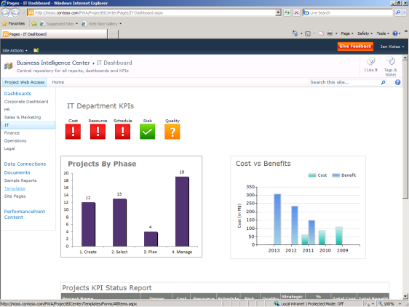
Figure 4. Project Server 2010 – Easily create reports and build powerful dashboards
The Project Server 2010 BI capabilities help PMOs create powerful dashboards that provide executives with an at-a-glance summary across the organization. Managers can use KPIs to highlight areas of concern and executives can examine details at the department, program, and project level to identify root causes and take corrective action.
In addition, Project Server 2010 offers the flexibility to filter content based on a specific user or role. Audience-based Web parts and dynamic content filtering make it easy to discover and share relevant information with people based on their role within the organization. For example, a CIO could view IT-specific information by default, whereas departmental managers may want to see a dashboard that displays project metrics for their lines of business.

Effectively Mine Data and Create Sophisticated Reports
Project Server 2010 BI capabilities not only make it easier for nontechnical resources to build reports, but also provide sophisticated tools to meet an organization’s custom reporting requirements. PMOs often have to react to fire drills and quickly access up-to-date data to provide complex reports to key executives.
Project Server 2010 provides access to up-to-date data by storing both project and portfolio information, including business case metrics and custom fields, task, resource, and timesheet data in a dedicated reporting database. Administrators can create Office Data Connections (.odc) files that aggregate data from the reporting database and from LOB systems to ensure that real-time and accurate data is available to drive enterprise reporting.
By simplifying access to the right data, Project Server 2010 makes it easier to generate on-demand reports without engaging specialized and highly technical skill sets to build the right reports. PMOs, department leads, and project managers can rapidly respond to business needs using the Project Server 2010 reporting infrastructure to create a variety of project and portfolio reports.
IT pros can continue to use tools like SQL Server Reporting Services to meet complex reporting requirements. Reporting Services is ideal for creating scheduled reports, such as monthly reporting packs for executives, and for sending e-mail reports to relevant stakeholders.
The new departmental cubes in Project Server 2010 help PMOs better satisfy LOB reporting requirements. Managers can use Departmental fields to filter project data and resources by LOB so decision makers can focus on their data, eliminate unnecessary clutter, and provide better performance and build times.

