

WHAT IS THE BIZTALK® ADAPTER PACK?
As part of our continuing commitment to simplify interoperability, Microsoft has released the BizTalk® Adapter Pack 1.0, a set of adapters based on the Windows Communication Foundation (WCF) programming model. The BizTalk® Adapter Pack provides a single solution to easily and securely connect to Line of Business (LOB) data from any custom-developed .NET application, SQL Server-based business intelligence solution, or an Office Business Application (OBA).

The BizTalk® Adapter Pack 1.0 includes adapters for SAP, Siebel and the Oracle Database. Key benefits include:
- Single infrastructure for connectivity. Whether you are connecting to LOB systems from custom-developed applications, SQL Server, or rich Office applications, you can use a consistent approach to connectivity. This enables a simplified approach to interoperability that lowers total cost of ownership and reduces training requirements.
- Simple to learn. Built on top of the WCF programming model, the BizTalk® Adapter Pack is easy for .NET trained developer to begin using and building connected applications. The BizTalk Adapter Pack provides enhanced extensions to WCF that enable dynamic metadata discovery and generation –making it fast and easy to access data in corporate systems.
- Secure and reliable. The BizTalk Adapter Pack tightly integrates with the security models provided by the individual business applications, ensuring that users have access only to data which they are permitted to see.
- Improves real-time visibility to your business data. The BizTalk® Adapter Pack allows you to access valuable corporate information when and where you can use it most productively, increasing visibility and enabling faster, better informed decision making.

The BizTalk® Adapter Pack is offered separately from BizTalk Server, and does not require deployment of a middle-tier SOA or BPM infrastructure to connect to LOB applications. This lets you begin with a focused solution to meet your initial needs.

As your solution evolves and you need more extensive business process orchestration or scale, adapters can be easily migrated to a full BizTalk® Server implementation due to shared use of the WCF programming model.

BizTalk® Adapter Pack Architecture
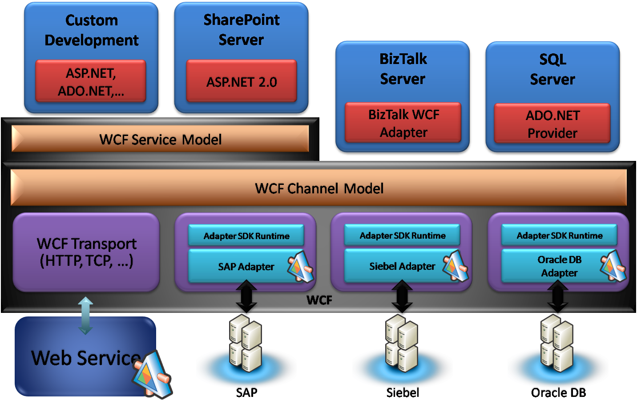
HOW CAN I LEARN MORE?
Visit the BizTalk ® Adapter website at: http://www.microsoft.com/biztalk/evaluation/adapter/default.mspx
Download information about the BizTalk® Adapter Pack Office Developer Program: http://www.microsoft.com/biztalk/evaluation/adapter/default.mspx
Learn more about developing adapters using the Microsoft Windows Communication Foundation (WCF) Line-of-Business (LOB) Adapter SDK at:
http://msdn2.microsoft.com/en-us/biztalk/bb905478.aspx

© 2008 Microsoft Corporation. All rights reserved. The information contained in this document represents the current view of Microsoft Corporation on the issues discussed as of the date of publication. Because Microsoft must respond to changing market conditions, it should not be interpreted to be a commitment on the part of Microsoft, and Microsoft cannot guarantee the accuracy of any information presented after the date of publication. This document is for informational purposes only. MICROSOFT MAKES NO WARRANTIES, EXPRESS, IMPLIED, OR STATUTORY, AS TO THE INFORMATION IN THIS DOCUMENT. Microsoft, BizTalk, Microsoft Dynamics, MSDN, SharePoint, Visual Studio, Windows, Windows Server, Windows Server System, and Windows Vista are trademarks of the Microsoft group of companies. All other trademarks are property of their respective owners.

© 2008 Microsoft Corporation. All rights reserved. The information contained in this document represents the current view of Microsoft Corporation on the issues discussed as of the date of publication. Because Microsoft must respond to changing market conditions, it should not be interpreted to be a commitment on the part of Microsoft, and Microsoft cannot guarantee the accuracy of any information presented after the date of publication. This document is for informational purposes only. MICROSOFT MAKES NO WARRANTIES, EXPRESS, IMPLIED, OR STATUTORY, AS TO THE INFORMATION IN THIS DOCUMENT. Microsoft, BizTalk, Microsoft Dynamics, MSDN, SharePoint, Visual Studio, Windows, Windows Server, Windows Server System, and Windows Vista are trademarks of the Microsoft group of companies. All other trademarks are property of their respective owners.

