Communicator Mobile for Nokia 1.0
Installing Communicator on your phone
Install Microsoft® Communicator for Nokia 1.0 on your device by downloading the application from the Ovi Store, found at Ovi.com. You need to create an Ovi account and sign in to it before downloading the application.
You can access Ovi Store
- On your computer Go to Ovi.com, sign in to your account, click the Ovi Store icon, locate the Communicator application, and send a link to your phone. Open the link on your device and follow the instructions to install the application.
- On your phone There are two ways to access the Ovi Store on your device. Once you have opened Ovi Store, locate Communicator, and then download and install it on your device.
To access Ovi Store on your phone, do one of the following:
  - Click Menu, select Ovi Store, and then click the middle navigation key.
  - Open your mobile browser, launch Ovi.mobi, and then click the Visit Ovi Store link.
Setting up Communicator on your phone
The Settings screen has two tabs: Required and General.
- Required: you must set your User Name, Password, Server URL, and Network connection. You can also change the default settings for roaming connection, and sign in preferences. Your Server URL is the same Web address used for Communicator. Your support team can provide this information.
- General: you can add a Unified Messaging voice mail number and logging tracking. Logging is used for troubleshooting.
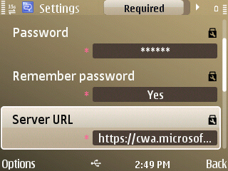
To set up Communicator
- On the home screen, select Set up Communicator, and then click the middle navigation key.
- If Communicator is not available on your home screen, click Menu, select Applications, then select Communicator, and then click the middle navigation key.
- Using the middle navigation key, scroll left or right to select either the Required or General tab.
- Select the setting, and then click the middle navigation key to open. Or, you can click Options, select Open, and then click the middle navigation key.
- On the setting screen, select the appropriate option button or, in the text box, type the necessary information, and then click OK.
- To save your changes and exit the Settings screen, click Back.
Note After setting up Communicator, you must sign out of Communicator and then sign in again before your Contacts are added.
Using Communicator
Signing in to and out of Communicator
To sign in to Communicator
- On the home screen, select Communicator Contacts, and then click the middle navigation key.
If Communicator is not available on your home screen, click Menu, select Applications, then select Communicator, and then click the middle navigation key.
- On the Contacts screen, click Options, select Open, and then click the middle navigation key.
To sign out of Communicator
- In Communicator, click Options, select Sign Out, and then click the middle navigation key.
Finding Contacts
Contacts that are added to Communicator on your computer are automatically updated on your phone every time that you sign in. You can also search for contacts in your Work Directory.
Contact information is found on two tabs within Communicator:
- Contacts: All contacts in your Communicator Contacts and Group lists.
- Groups: Contacts grouped together according to your Communicator Groups list.
To search for contacts in the Contact List
- On the Communicator and Contacts screen, in the search text box at the bottom of the screen, start to type the name of the contact you are searching for. Contacts are automatically filtered according to each letter that you type. Once the contact is displayed, select it, and then click the middle navigation key.
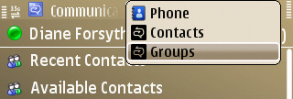
To search for contacts in a Group List
- On the Communicator screen, scroll left with the middle navigation key, select Groups, select the group you want to search in, and then click the middle navigation key.
- In the search text box, type the name of the contact and then click the middle navigation key to open the contact card.

To search for contacts in the Work Directory
- On the Communicator screen, click Options, select Search Work Directory, and then click the middle navigation key to open.
- On the Work Directory screen, select Search by, and then click the middle navigation key.
- Select one of the following, Display Name, First Name, Last Name, or E-mail, and then click OK.
- Select Type a name or e-mail address, and then click the middle navigation key.
- In the Name or E-mail text box, type a name or e-mail address, and then click OK.
- On the Work Directory screen, click Options, select Search, and then click the middle navigation key.
To view contact information
- To view a person’s contact card, select that person’s name, and then click the middle navigation key.
Sending instant messages
Communicator lets you send instant messages to one or more people.
To send an instant message to a Contact
- On the Communicator screen, using the middle navigation key, select the contact you want to send an instant message to, and then click the middle navigation key. The information screen for the Contact opens.
- To send an instant message to someone not in your Contacts list, see the section “To search for contacts in the Work directory.”
- On the next screen, use the middle navigation key to select IM, if it is not already selected, and then click it to open an IM screen.
- On the Conversation screen, type your message, and then click the middle navigation key to send.
To send an instant message to more than one Contact
- On the Communicator screen, using the middle navigation key, select the contact you want to send an instant message to, and then click the middle navigation key.
- On the next screen, use the middle navigation key to select IM, and then click it to open an IM screen.
- On the Conversation screen, select Options, select Invite Someone, select either From Contacts or From Work Directory, and then click the middle navigation key.
- On the Invite Someone screen, select a contact name, and then click Add. Repeat the above step to add more Contacts to the conversation.
PRINT SETTINGS For best results, set printer options to: Paper Size: Letter (8.5x11”); Orientation: Landscape; 2-sided printing options: Two-sided, flip on short side.
© 2010 Microsoft. All Rights Reserved
- To search for contacts not listed in your Contacts list, see the section “To search for contacts in the Work directory.”
- On the Conversation screen, type your message, and then click the middle navigation key to send.
Managing conversations
To find and resume an ongoing conversation
- On the Communicator screen, click Options.
- On the Options screen, click Conversations. A screen with all ongoing conversations appears.
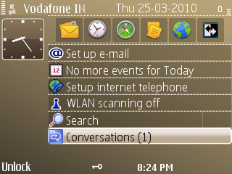
- Select the conversation you want to resume, and then click the middle navigation key.
To find a missed conversation
Missed instant messages are shown on the following screens.
- On the home screen.
- On the Conversations screens.
To end conversations
- To end the current conversation, on the Conversation screen, click Options, select End Conversation, and then click the middle navigation key.
- To end all conversations, on a Conversation screen or on the Conversations screen, click Options, select End All Conversations, and then click the middle navigation key.
Changing your status
To change My Status
You can view your status on the Communications screen.
- On the Communicator screen, click Options, select Change My Status, and then click the middle navigation key.
- Select a status option, and then click the middle navigation key.

