Overview  Country or Region: Austria  Industry: Professional services  Customer Profile  SIS provides information technology products and services to medium-sized and large companies in Austria and Germany. The company has 140 employees and is based in Vienna, Austria.  Business Situation  SIS had to help a client migrate its internally developed, Visual Basic® 6.0–based enterprise resource planning (ERP) system to newer technology.  Solution  The company used VB Migration Partner together with Microsoft® Visual Studio® Team System 2008 to migrate nearly 1 million lines of Visual Basic 6.0 code to the Microsoft .NET Framework.  Benefits  - Functional equivalence of the migrated application  - Rapid implementation  - Minimal costs |  |  | “We couldn’t have met all of our client’s needs so quickly and cost-effectively without VB Migration Partner.”  Otto Wiegele, Chief Executive Officer, SIS
 |  |  | Technology consulting company SIS had to find a fast, cost-effective way to help a client update its internally developed, Visual Basic® 6.0–based enterprise resource planning (ERP) system to newer technology. The company used VB Migration Partner—conversion software from Code Architects—together with Microsoft® Visual Studio® Team System 2008 to migrate nearly a million lines of code to the .NET Framework, achieving functional equivalence of the migrated application and completing the project in less than half the time and at a fraction of what it would have cost to implement a commercially available ERP system.
 |  |  | 

Situation
Established in 1976, SIS provides information technology products and services to medium-sized and large companies in Austria and Germany. In early 2008, a global manufacturing company came to SIS with a challenge: Over the past 10 years, the company had built its own highly optimized enterprise resource planning (ERP) system, consisting of 33 applications to manage virtually all business processes. It now had to address the fact that mainstream support for the Microsoft® Visual Basic® 6.0 development technology on which the solution was based would soon be discontinued.
“It took 2.5 hours to get a project that would compile and run using VB Migration Partner, and 13 hours with the closest competitor.”
Otto Wiegele, Chief Executive Officer, SIS

Two options were immediately evident: Rewrite the application on the Microsoft .NET Framework, or implement a commercial ERP system and perform the required system integration. “Needless to say, the thought of rewriting 950,000 lines of code by hand was not attractive to the client,” says Otto Wiegele, Chief Executive Officer at SIS. “However, finding a commercial solution turned out to be just as unattractive. Total implementation costs were estimated at 3 to 5 million euros, the project would have taken at least two years, and none of the ERP vendors were willing to guarantee that we could duplicate all the functionality of the existing application.”

Solution
SIS used VB Migration Partner—conversion software from Microsoft Visual Studio® Industry Partner Code Architects—together with the Microsoft Visual Studio Team System 2008 development system to perform an automated migration of the client’s ERP system to the .NET Framework. “Costs were far lower with this approach, with an estimated project duration of 12 months or less,” says Wiegele. “Just as important, we could guarantee functional equivalence with the existing application.”
SIS evaluated six products before choosing VB Migration Partner. To ensure an automated migration to the greatest possible extent, SIS conducted an inventory of the existing code base, identified critical and “difficult” functions, and identified 25,000 lines of code to run through each conversion tool. “It took 2.5 hours to get a project that would compile and run using VB Migration Partner, and 13 hours with the closest competitor,” says Wiegele. “VB Migration Partner also required 50 percent less rework to precisely duplicate the UI of the old application.”

“While VB Migration Partner can be customized for even greater levels of efficiency, it’s noteworthy that SIS achieved its results using a standard, noncustomized copy of our software,” says Francesco Balena, Chief Executive Officer at Code Architects. “Thanks to our extensive online documentation and knowledge base, the only technical support SIS required was handled through a half-dozen e-mails.”

SIS also chose VB Migration Partner because of its support for migration pragmas, which are special remarks that can be added to the original Visual Basic 6.0 code to give the VB Migration Partner conversion engine directions for translating a given portion of code when multiple alternatives exist. Finally, SIS liked the product’s strong integration with Microsoft Visual Studio Team System 2008 Team Foundation Server for source-code control and bug tracking—features that would be required to support the planned convert-test-fix project methodology.

Successful migration of the 25,000-line prototype was completed in September 2008, and the client decided to proceed with a full migration to the .NET Framework. SIS migrated the entire ERP application over the following nine months, during which developers improved performance and software quality through extensive refactoring. New code was put into production using a phased approach, with new modules running alongside still-to-be-migrated modules to avoid downtime.

The effort required for the project included 3,650 developer-hours to migrate the code, 3,400 hours for code review and refactoring, and 1,300 hours for testing. “Code review and refactoring weren’t necessary to achieve the primary goal of technical migration,” says Wiegele. “The reason we did a 100 percent code review after technical migration is that the client will use the migrated code as the basis for future enhancements, which are estimated at 2,000 or more developer-hours for each of the next 3 to 5 years.”
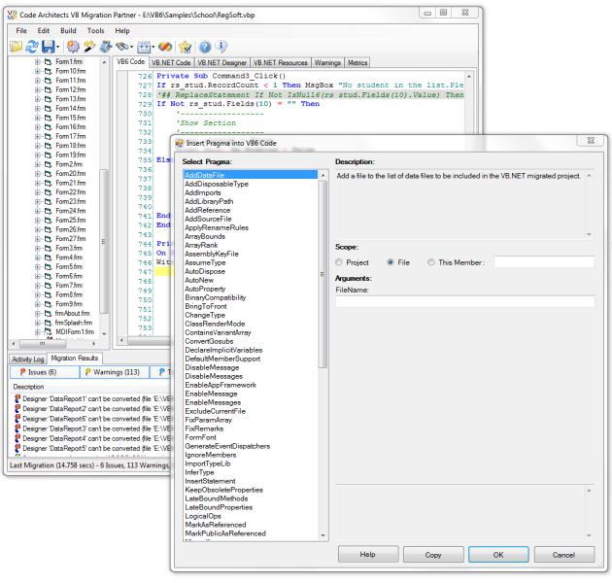
Figure 1. VB Migration Partner allows developers to finely control every detail of the conversion by means of special comments that can be added to the original Visual Basic 6.0 code.

Wiegele explains, “Considering that the original code base had been developed over a period of 10 years by more than 15 developers, and that none of the lead developers were still employed by our client, a full code review was a reasonable way to build expertise, improve code quality, and lay a solid foundation for future development and enhancements. The code review wouldn’t have been necessary for a basic technical migration, and the effort would have been significantly less if at least one of the original lead developers had still been on the team.”

Benefits
Through its use of Visual Studio 2008 and VB Migration Partner, SIS helped a major client preserve its significant investment in a highly optimized ERP system, delivering a solution to the client’s business challenge faster and less expensively than possible with any other option. Benefits of the approach included:
“The total effort including product evaluation was less than a year—roughly half of the two years that it would have taken to implement an off-the-shelf ERP system.”
Otto Wiegele, Chief Executive Officer, SIS

- Functional equivalence. SIS was able to ensure that all Visual Basic–related methods and controls work identically in the new application. VB Migration Partner prevented the incidental introduction of subtle differences in the application’s look and feel, enabling the client to minimize retraining of the system’s 350 users.

- Rapid implementation. Three SIS developers migrated all 950,000 lines of Visual Basic 6.0 code to the .NET Framework in only nine months—including the time it took for code migration, code review and refactoring, and testing. “The total effort including product evaluation was less than a year—roughly half of the two years that it would have taken to implement an off-the-shelf ERP system,” says Wiegele.

- Minimal costs. SIS converted the entire application to run on the .NET Framework at a total cost to its client of 750,000 euros—including proof of concept, migration, refactoring, testing, documentation, and project management. This was a small fraction of the estimated 3 to 5 million Euros that it would have cost to implement a commercial ERP system.

“The entire project went very smoothly, and our client is quite happy with its new solution,” says Wiegele. “We couldn’t have met all of our client’s needs so quickly and cost-effectively without VB Migration Partner.”

Microsoft Visual Studio 2008
Software and Services  - Microsoft Visual Studio  - Microsoft Visual Studio Team System 2008  - VB Migration Partner from Code Architects | Partners  - Code Architects

This case study is for informational purposes only. MICROSOFT MAKES NO WARRANTIES, EXPRESS OR IMPLIED, IN THIS SUMMARY.

Document published July 2009

For More Information
For more information about Microsoft products and services, call the Microsoft Sales Information Center at (800) 426-9400. In Canada, call the Microsoft Canada Information Centre at (877) 568-2495. Customers who are deaf or hard-of-hearing can reach Microsoft text telephone (TTY/TDD) services at (800) 892-5234 in the United States or (905) 568-9641 in Canada. Outside the 50 United States and Canada, please contact your local Microsoft subsidiary. To access information using the World Wide Web, go to:
www.microsoft.com

For more information about Code Architects, visit the Web site at:
http://www.codearchitects.com/
defaulten.aspx

For more information about VB Migration Partner, visit the Web site at:
www.vbmigration.com

For more information about SIS, visit the Web site at:
www.sisworld.com

Microsoft Visual Studio 2008 is the world’s most popular development environment for designing, developing, and testing next-generation Windows®-based solutions and Web applications and services. By improving the development experience for Windows, the Web, mobile devices, and Microsoft Office, Visual Studio 2008 helps organizations deliver a variety of solutions more productively than ever before. Visual Studio Team System expands the product line with new software tools that enable greater communication and collaboration throughout the development life cycle. Interaction between developers and designers is enhanced through the use of Visual Studio 2008 and Microsoft Expression® Studio. With Visual Studio 2008, businesses can deliver modern service-oriented solutions more efficiently.

For more information about Visual Studio 2008, go to:
msdn.microsoft.com/vstudio

