

Microsoft® Office 2003 Editions: Overview of Developer Technologies
White Paper

Published: September 2004
Updated: June 2007
This document supports a preliminary release of a software product that may be changed substantially prior to final commercial release. This document is provided for informational purposes only and Microsoft makes no warranties, either express or implied, in this document. Information in this document, including URL and other Internet Web site references, is subject to change without notice. The entire risk of the use or the results from the use of this document remains with the user. Unless otherwise noted, the example companies, organizations, products, domain names, e-mail addresses, logos, people, places, and events depicted herein are fictitious, and no association with any real company, organization, product, domain name, e-mail address, logo, person, place, or event is intended or should be inferred. Complying with all applicable copyright laws is the responsibility of the user. Without limiting the rights under copyright, no part of this document may be reproduced, stored in or introduced into a retrieval system, or transmitted in any form or by any means (electronic, mechanical, photocopying, recording, or otherwise), or for any purpose, without the express written permission of Microsoft Corporation.
Microsoft may have patents, patent applications, trademarks, copyrights, or other intellectual property rights covering subject matter in this document. Except as expressly provided in any written license agreement from Microsoft, the furnishing of this document does not give you any license to these patents, trademarks, copyrights, or other intellectual property.
© 2007 Microsoft Corporation. All rights reserved.
Microsoft, MS-DOS, Windows, Windows NT, Windows Server, ActiveX, Excel, FrontPage, InfoPath, IntelliSense, JScript, OneNote, Outlook, PivotChart, PivotTable, PowerPoint, SharePoint, ShapeSheet, Visual Basic, Visual C++, Visual C#, Visual Studio, Visual Web Developer, Visio are either registered trademarks or trademarks of Microsoft Corporation in the United States and/or other countries.
All other trademarks are property of their respective owners.
License Agreement

Microsoft® Office 2003 Editions: Overview of Developer Technologies
White Paper

Published: September 2004
For the latest information, please see http://msdn.microsoft.com/office/

Introduction
This overview of developer technologies describes the newer tools and technologies that help enable solution developers to build custom solutions incorporating programs from Microsoft® Office 2003 Editions. The goal of this document is to allow developers who incorporate Office 2003 Editions within custom solutions to begin to understand the new development technologies and techniques around Office 2003 Editions and the types of solutions they can create with them.

Solution Development for Microsoft Office 2003 Editions
Microsoft Office 2003 Editions preserves all the development capabilities that existed in previous versions, giving you the comfort of knowing you can always rely on your existing base of knowledge while learning new solution techniques. The solutions that you can create with the new capabilities continue to use the familiar and consistent user interface (UI) that current Office users know, thereby minimizing training.
You can loosely group the new investment areas for Office 2003 Editions into the following three areas.
Simplifying creation of connected systems. Office 2003 Editions enables you to build solutions that use Extensible Markup Language (XML) and Web services to allow users using Office to easily interact with enterprise-wide business processes and data. These solutions can help improve the flow of information, efficiency of handling documents, and quality of decision making throughout an organization.
Furthering the robust foundation of Office functionality. The solid base of Office technology is significantly enhanced through improving existing technologies and innovating with new technologies. This investment helps you employ proven and specialized software and technology in Office 2003 Editions, allowing you to rapidly build solid, extensible solutions, decreasing the time to market while retaining flexibility to meet changing business requirements.
Productive developer tools. This focus enables secure, robust solution development with efficient and friendly developer tools and software. Developers can implement solutions with their existing developer skills while also growing in new areas, e.g. by increasingly adopting W3C standards and .NET Framework technologies.
Many of the tools and techniques described in this document are available only in Microsoft Office Professional Edition 2003, Microsoft Office Professional Enterprise Edition 2003, and the individual versions of each program. This means that both from a development perspective as well as from a user’s perspective, solutions using these specific capabilities do not work without one of these versions. Those features that are available in all Office 2003 Editions are as follows:
XML reference schemas for documents and templates.
Note Microsoft Office InfoPath™ 2003 is available only in Office Professional Enterprise Edition 2003.
Research task pane
Smart tags
Primary interop assemblies (PIAs)
Support for Web services
Note Support for use with Microsoft Visual Studio® Tools for the Microsoft Office System or Microsoft Office Information Bridge Framework is available only with Office Professional Edition 2003.
Microsoft Office 2003 Editions are highly extensible. They offer efficient and effective development techniques and allow you to build solutions to address today’s challenges around people, business processes and information. Building custom solutions to solve some of these challenges can provide a host of benefits, not only to users and developers, but to entire organizations and beyond.

Development Technologies

XML at the Desktop
XML is a public and widely accepted standard that enables exchange of information between disparate systems. XML provides a flexible meta-language for creating text-based tags and relationships that you can use to define and distinguish document structure or presentation and content. This separation of content from presentation allows you to manipulate document content more easily in a meaningful way. But even though many businesses rely on XML for data exchange and transaction processing, and even though the necessary servers and architecture are in place on the Internet and at the enterprise level, XML is not fully exploited in solutions involving user interaction. Previously, it was difficult to separate document data from structure and formatting information. The enhanced XML support in many of the productivity applications in the Office 2003 Editions makes this much easier, thereby enabling rich solutions that bring the power of XML to the desktop.
You can use XML support in Office Professional Edition 2003 in two significant ways. First, Microsoft defined W3C-compliant XML schemas (XSDs) to represent the structure of Word documents, Excel spreadsheets and InfoPath form templates. These fully documented and published schemas enable you to understand and manipulate documents using any software that can process industry standard XML, without using programs in Office 2003 Editions. The second XML feature area is the support for custom-defined XML schema. This feature allows you to define any schema that represents your business information and use that schema and the associated data within Office Professional Edition 2003. Each of these capabilities is discussed in detail in subsequent sections.

Suggested Next Steps
Read more about the importance of XML with Office 2003 Editions and a few scenarios: http://msdn.microsoft.com/office/understanding/xmloffice/gettingstarted/default.aspx?pull=/library/en-us/dno2k3ta/html/odc_ofofficesysxmlinaction.asp.
View technical articles about XML in Office 2003 Editions on the MSDN® Office Developer Center: http://msdn.microsoft.com/office/understanding/xmloffice/articles/default.aspx.

XML Reference Schemas for Documents and Templates
XML Schema is a standard recommended by the World Wide Web Consortium (W3C). An XML schema defines the set of tags in an XML document and the rules for applying them. Schemas define the structure and type of data that each data element in a document can contain. Anyone can create a schema to define and qualify the content for their application; Microsoft defined schemas that abide by the XML Schema 1.0 recommendation for Word documents, Excel spreadsheets and InfoPath form templates. For Microsoft Office Word 2003 and Microsoft Office Excel 2003, you can view these schemas as alternative file formats to the well-known binary (.doc and .xls) formats. The schema for Microsoft Office InfoPath 2003 defines the structure for InfoPath forms.

XML Reference Schema Benefits
In the past, when working with the binary file formats for Office 2003 Editions, it was difficult to interpret content without starting the appropriate Office program and automating it through its object model. Not only is it inefficient for any Office program to begin, but the Office programs were not written and are not supported to be run on a server. This restricted how you could use document content.
The advent of an XML file format changes this restriction. XML is text-based and can be read and manipulated outside of the Office programs by using any tools and techniques that support the XML standards. This opens up a number of interesting and beneficial scenarios for developers:
Creating a document on a server. You can assemble XML on a server to create a Word document, Excel spreadsheet or InfoPath form template fully. For Word and Excel, you can accomplish this by retrieving information from a database or Web service and applying an XML transform (XSLT) that adds formatting and structure to result in a rich document. This is a useful technique for the automated creation of any type of document. You can use this technique, for example, to create a report periodically such as an on demand, customized report, or a document with customized information specific to many individuals, e.g. thousands or millions of customers.
Reuse, indexing, and searching of document data. When documents are created, they often need information copied from existing documents, particularly those created from the same template. For example, sales proposals are created repetitiously. Previously created information is reused when pulling together proposals to customers from similar types of companies.
In the past, it was difficult for a user to find the right document with the most appropriate related information, and if found, users copied information manually into the new document. It also was difficult for a developer to build a solution to help the user since information was difficult to access from the binary file formats. With the XML file formats, Office 2003 Editions save documents as text files. Consequently, you can process them using many standard XML processing techniques to find needed information efficiently and then extract just the desired section from an existing document. XML helps you build such a solution in much less time than it took previously. The XML-based solution allows the user to complete a task more efficiently without having to know anything about XML.
Sharing data across heterogeneous systems. XML is used today as a means of data interchange for the reasons mentioned previously. Since it is text-based, you can read XML documents on all platforms. Sharing binary documents is not as easy since they are captive to platform issues such as storage formats and byte order. Information can’t be easily extracted from a binary file without sharing a low-level programming protocol to read the file. With XML, cross-platform computer-based processing is possible. This enables documents to have an acceptable transfer format for document-centric solutions.
Formatting information being inserted. Formatting in a Word document is always an important aspect of the presentation of information. However, many documents need content from databases which is in a raw format with no related display information. You can use XML transforms to associate XML data streams with specific formatting so that when the transformed XML data arrives in Word, it appears formatted as needed to fit that document solution. XML makes it easier for you to provide this capability. The capability simplifies routine formatting work an information worker would otherwise spend (unproductive) time performing.

XML Reference Schema Technology
The next sections highlight the XML reference schema capability in each application in Office 2003 Editions.
Microsoft Office Word 2003. The Word 2003 XML format or schema, called WordprocessingML, is available in all versions of Word 2003. This format is an alternative file format to the well-known .doc binary format and saves all of the same information that is saved in the Word binary format. This means that if you saved a document as WordprocessingML and reopened it, Word retains every document feature. Word saves the WordprocessingML file with a processing instruction at the top of the file so that when a user opens a WordprocessingML file from Microsoft Windows® Explorer or Microsoft Internet Explorer, Windows opens the XML file directly in Word. Organizations or individuals can configure Word or specific templates in Word to save in the WordprocessingML format by default.
Saving a full Word document as XML results in a detailed XML file with several namespaces. However, the structure of WordprocessingML is not complex. The simplest WordprocessingML document consists of just five elements and one namespace:
<?xml version="1.0"?>
<w:wordDocument
xmlns:w="http://schemas.microsoft.com/office/word/2003/wordml">
<w:body>
<w:p>
<w:r>
<w:t>Hello, World.</w:t>
</w:r>
</w:p>
</w:body>
</w:wordDocument>
Although Word saves all of the document information in the XML file, several types of information are saved in a “binary” format through base-64 encoding (a standard technique for XML). Word saves all the details to which it has access as text. Base-64 encoding is needed for items such as images (which are binary), Microsoft ActiveX® controls (which don’t support a protocol for saving in an XML format) and Microsoft Visual Basic® for Application (VBA) projects (which don’t provide a mechanism for Word to save as text).
Although XML provides for greater interoperability with heterogeneous systems, WordprocessingML files are not recognized by previous versions of Word, which treats them as XML files of an unknown type.
Microsoft Office Excel 2003. The Excel 2003 XML format or schema, called SpreadsheetML, is available in all versions of Excel 2003. This format saves spreadsheet content and information about workbooks, worksheets, formulas, formatting, Microsoft Office PivotTable® dynamic views and much more. However, unlike the Word XML format, SpreadsheetML does not save all details associated with a workbook. You can find a list of items that are not saved on Office Online under the (search) topic, “Features and limitations of XML Spreadsheet format in Excel.” Excel saves the SpreadsheetML file with a processing instruction at the top of the file so that when a user opens a SpreadsheetML file from Windows Explorer or Internet Explorer, Windows opens the XML file directly in Excel 2003. Microsoft Office XP and Microsoft Excel 2002 also supported SpreadsheetML. Excel 2003 adds new features by using a new namespace: “urn:schemas-microsoft-com:office:excel2”.
Microsoft Office InfoPath 2003. Unlike Word and Excel, InfoPath does not define a file format since information captured through InfoPath is saved in the XML format defined by the developer of an InfoPath solution. Instead, InfoPath uses an XML schema, called FormTemplate which is saved with a file extension of .xsf, to define the layout for InfoPath forms. FormTemplate defines information about all other files and components used within an InfoPath form, including UI customizations, XML schemas, views, business logic, events, and deployment settings. The .xsf file holds information about how the form is constructed, used, and deployed. When the InfoPath designer creates a solution, InfoPath creates and manages this file automatically. While you do not usually need to modify this file, directly editing the .xsf file does enable you to extend form functionality in some ways that are not possible through the designer UI.

Suggested Next Steps
Download the Office 2003 XML Reference Schemas: http://www.microsoft.com/downloads/details.aspx?FamilyID=fe118952-3547-420a-a412-00a2662442d9&DisplayLang=en
Learn to generate Excel 2003 workbooks with XML: http://msdn.microsoft.com/office/understanding/xmloffice/articles/default.aspx?pull=/library/en-us/odc_xl2003_ta/html/odc_xlxmlhowto_.asp

Custom-defined XML Schema Support
Schemas define the structure and type of data that each element in an XML document can contain. You can use a schema to define the format of information needed for a particular application and then use the schema to ensure that the solution captures and manipulates valid XML data. Word 2003, Excel 2003 and Microsoft Office Access 2003 have many new features to support custom schemas that adhere to the W3C 1.0 recommendation for XML Schema, allowing you to work with information more easily in a familiar, specific format rather than navigating various aspects of specific object models for individual Office applications.
Note Custom-defined XML schema support is available only in Microsoft Office Professional Edition 2003, Microsoft Office Professional Enterprise Edition, and the standalone versions of each individual product.

Custom-defined XML Schema Benefits
All data has meaning within the context of a business. The custom-defined XML schema support in Office 2003 Editions allows you to work with data that is marked according to a business-defined schema more often than unlabeled text items in Office documents. For example, purchase orders contain data such as prices and item numbers. Before Office 2003 Editions and custom XML schema support, these data existed as simply numbers displayed in the cells of a spreadsheet or somewhere within a Word document range. You were required to know the structure of the document (e.g. spreadsheet cell reference, named range, Word structure or bookmark) in order to read or set the value. If you moved the item to another position in the document, you had to find and change every line of code that accessed the value. With an XML schema mapped to the document, you can read or set the value by referring to an XPath statement based on the schema. This method of access is independent of where the data appears in the document because it references the XML structure. The following example shows how to set a value to XML-mapped data in Word using an XPath expression. This both simplifies the code by requiring only one statement and makes the solution more robust by separating the access method to the data from the document layout or formatting.
Sample schema:
<?xml version="1.0"?>
<xs:schema xmlns:xs="http://www.w3.org/2001/XMLSchema"
targetNamespace="uri:myNS"
xmlns="uri:myNS"
elementFormDefault="qualified">
<xs:element name="PurchaseOrder">
<xs:complexType>
<xs:sequence>
<xs:element name="Company" type="xs:string"/>
<xs:element name="NumberItems" type="xs:integer"/>
</xs:sequence>
</xs:complexType>
</xs:element>
</xs:schema>

This XPath statement refers to the <Company> element:

/PurchaseOrder/Company

This statement is one way to set the value of the data in the Word document associated with the <Company> element using an XPath statement in Visual Basic:
ActiveDocument.XMLNodes(1).SelectSingleNode( "/n:PurchaseOrder/n:Company ", "xmlns:n='uri:myNS'" ).Text = “NewValue”

This ease of working with XML schemas applies to how to access data in documents programmatically, how to format data, how to incorporate data from external sources, and how to extract data from a document or file. In addition, Word and Excel provide events relating to the custom XML structure in a document to facilitate the creation of more intelligent solutions, such as the smart document solution model described subsequently in this document. Although some capabilities enabled by XML schemas could have been implemented previously with clever and extensive coding, those solutions were fragile and difficult to create.
Using XML and custom XML schema also simplifies the integration of a document with corporate data and business processes. Word and Excel-based solutions can more directly exchange information with any Web service or other XML interfaces, such as those built into popular products such as Microsoft SQL Server 2000 and Microsoft BizTalk® Server. XML exchange is often handled through loosely coupled connections, such as Web services, which allow you to orchestrate software components and reuse them in a more flexible architecture.
Custom XML schema support simplifies the development of data-centric document solutions allowing you to work with data in a form that matches business needs while adhering to accepted industry standards. The following sections discuss specific Office support for XML in each application.

Custom-defined XML Schema Technology
In Office 2003 Editions, you can visually map data elements from a schema to regions in Word and Excel documents through new UI and to controls in InfoPath forms. In general, you can make the XML tags invisible to the end user of the solution. Although many XML features are designed through the UI, you also have access to XML features through object model support. Office retains the custom XML schema information in the XML document formats allowing subsequent processing to be specific to the custom XML data.
Microsoft Office Word 2003. Word with custom XML tags is still Word. You should consider using a custom XML schema as part of a Word solution in order to create a solution that is more intelligent, that allows for capture of structured and semi-structured content, or that is more robust and more easily updated. XML adds structure to a Word document but doesn’t affect the user’s ability to use all the rich editing features that they expect, including spell check, change-tracking, AutoCorrect and more. Word 2003 is not intended to be an XML editor where the sole purpose is to manipulate XML tags and attributes, and as such does not provide a streamlined out-of-the-box experience for end users to manipulate XML tags directly.
You can use the task pane to map schema elements to ranges in a Word document or template. The document becomes effectively marked with tags that reveal locations of the XML elements, as seen in Figure 1. You can toggle between the tagged view and normal view to compare the structure against the intended view while editing the document. Word requires that the elements exist in the same order in the document as they are in the schema. If you wish to use a schema which doesn’t have the structure as the desired document layout, you should create a schema to match the document layout, and use XSLT transforms to change the format of the data when bringing it in or sending it out of the document. Word performs real-time validation of the document data against the attached schema as it is entered or edited and flags the errors with a subtle UI while raising validation error events.
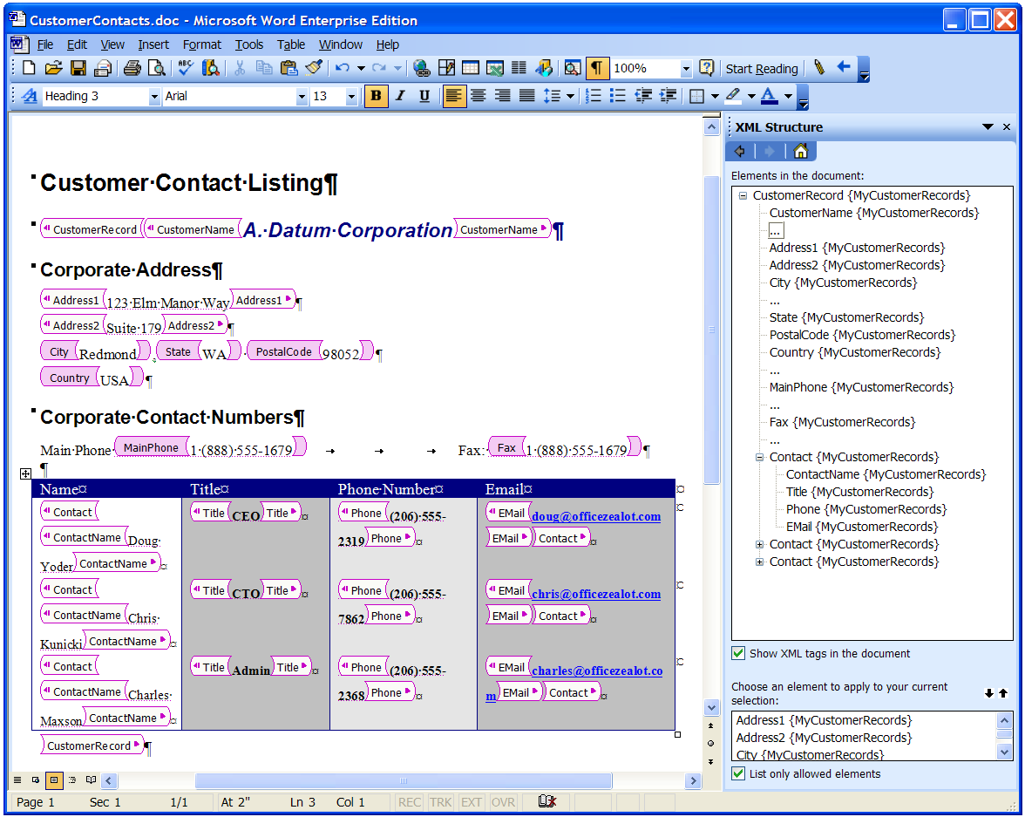
Figure 1. Customer-defined XML in Word 2003
To insert formatted information in Word, you can transform an input data stream to become valid WordprocessingML. You can insert this WordprocessingML in a document with any valid Word formatting characteristics. To insert just data into an existing Word template with custom XML tags, you can either transform the XML to WordprocessingML and replace a selection or copy the XML data element by element.
You can save documents that use a custom-defined schema as “data-only” which means that Word saves only the XML data in a file according to the custom schema’s structure. Conversely, you can save documents using the full Word XML schema (WordprocessingML). The WordprocessingML format incorporates all custom XML elements, allowing you to use standard XML techniques against the saved XML file to access and change any of the WordprocessingML or custom XML markup at will.
Word allows you to manage multiple custom schemas on a computer by using the Schema Library. The Schema Library organizes schemas according to namespaces and provides a mechanism to associate transforms (XSLT files) and solutions (smart documents) with a namespace. This allows you to configure Word to process raw XML using a custom default behavior of applying a transform or prompting the user for related solutions.
The custom XML schema support in Word enables you to build powerful solutions using XML to build those solutions more easily and in a way that yields document content that you can easily reuse.
Microsoft Office Excel 2003. Excel with a mapped custom XML schema is still Excel. XML makes it easier to build Excel solutions that aggregate data and provide analytical capabilities. Excel allows you to map the elements of any custom W3C-compliant XML schema within the structure of one or more spreadsheets. Excel also provides a visual data-mapping tool in a task pane (as shown in Figure 2. Unlike the visual inline XML tags that surround words or ranges in a Word document, Excel designates mapped elements with blue, nonprinting cell borders. Excel maps individual elements as defined by the schema to single cells; and maps repeating cells to the new List feature. Although geared toward end-user scenarios, you can access Excel Lists programmatically by using the object model. Lists also offer direct read/write connectivity to lists in Microsoft Windows SharePoint® Services. Excel does not have a capability to work with XML easily that includes repeating elements within other repeating elements.
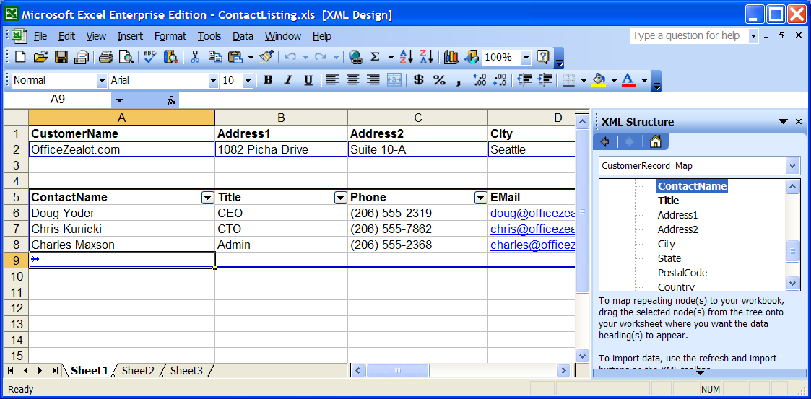
Figure 2. Custom-defined XML schema mapping in Excel
You can map multiple schemas to a workbook although you cannot map multiple elements to the same cell location. Often you may use one schema to bring in data and another for exporting data. Excel makes it very easy to bring XML data into a schema map, or to export it. If you open an XML file in Excel without a reference to a schema, Excel offers to infer a schema from the XML data and structure. If you save a workbook as SpreadsheetML, Excel saves the map details in the file format and also saves complete copies of the respective schemas.
Excel does not do real-time validation against any attached schemas since with the two-dimensional layout of a spreadsheet it is difficult for you to know where the user last worked. However, you can request a validation at any time in order to notify a user of any errors at specific stages of a solution.
Although Excel doesn’t provide native support for Web services, since the XML map in a worksheet acts like a display transform, it is fairly easy to use code in Microsoft Visual Studio .NET to receive data from a Web service and then use the Excel object model to place the data directly into a map using one method. This is a significant productivity boost from previously available data manipulation techniques.
Microsoft Office InfoPath 2003. A custom XML schema is at the core of every InfoPath form solution. Controls on InfoPath forms map to XML elements defined by the schema, and InfoPath enforces the validity of the captured information according to the schema. The result of information captured in InfoPath is an XML file in the format of the custom XML schema; InfoPath has no special file format. You can only use one schema as the basis for a form.
When designing a form from a custom schema, InfoPath provides suggested controls based on the data type specified by the schema, e.g. a single line text control is suggested for the XSD string type; a date control is suggested for the XSD date type.
When InfoPath forms save captured information as XML, it includes a PI (XML processing instruction) at the top of the document that identifies the corresponding template solution so that the document is always connected with that specific form template. In the same way, you can open any XML of that namespace with that InfoPath form template.
For more information, see InfoPath 2003.
Microsoft Office Access 2003. Access uses custom XML schema primarily for importing and exporting data for greater ease of data exchange with other systems. You can also apply XSL transforms during an import or export, providing you with more flexibility over the shapes of XML that you can use.
When importing XML data, if the XML refers to an accompanying schema, Access recognizes data types based on the schema definition. However, importing XML data into Access does not require a schema. If there is no schema reference, Access infers a structure from the incoming data.
Access also offers more flexibility than previous versions of Access for exporting data as XML. You can limit an export to only data selected with respect to current Filter and Sort views. Access can also export related tables as XML. This way, you can include hierarchical data in one standard XML file for consumption in other systems.
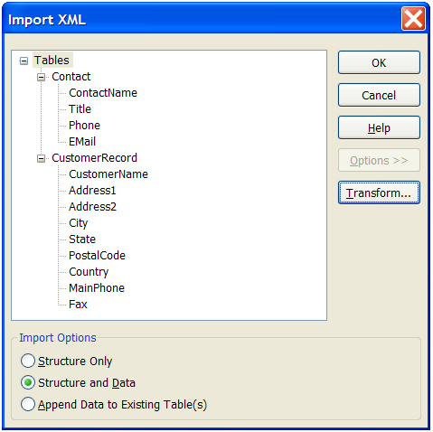
Figure 3. Import XML options UI in Access 2003
All support for importing and exporting XML is available through UI objects as well as programmatically. Figure 3 shows the available dialog to import XML. To enable this, there are enhancements to the XML object model, including a new TransformXML method and additional parameters for the ExportXML method.

Suggested Next Steps
Learn more about the XML schema standard: http://msdn.microsoft.com/library/default.asp?url=/library/en-us/dnxml/html/understandxsd.asp
Word
Follow a basic walk-through using custom XML with Word: http://msdn.microsoft.com/office/understanding/word/articles/default.aspx?pull=/library/en-us/odc_wd2003_ta/html/odc_wd11xml.asp
Read a technical article on the new Word XML features: http://msdn.microsoft.com/office/understanding/xmloffice/gettingstarted/default.aspx?pull=/library/en-us/odc_wd2003_ta/html/odc_wdnew2k3xmlom.asp
Download the Word XML Toolbox to help with Word XML development: http://msdn.microsoft.com/library/default.asp?url=/library/en-us/dnofftalk/html/odc_office01012004.asp
Excel
Follow a basic walk-through using custom XML with Excel: http://msdn.microsoft.com/office/understanding/xmloffice/articles/default.aspx?pull=/library/en-us/odc_xl2003_ta/html/odc_xlexpen.asp
Learn how Excel makes importing data easier with XML: http://msdn.microsoft.com/office/understanding/xmloffice/articles/default.aspx?pull=/library/en-us/odc_xl2003_ta/html/odc_xmllists.asp
Read a technical article on the new Excel XML features: http://msdn.microsoft.com/office/understanding/xmloffice/articles/default.aspx?pull=/library/en-us/odc_xl2003_ta/html/odc_xl_excel2003xmlintro.asp
Access
Learn how to import and export data using schemas with Access 2003: http://msdn.microsoft.com/office/understanding/access/techarticles/default.aspx?pull=/library/en-us/odc_ac2003_ta/html/odc_ac_xsd.asp
Read one way to transfer XML data from Access 2003 to Excel 2003: http://msdn.microsoft.com/office/understanding/xmloffice/articles/default.aspx?pull=/library/en-us/odc_xl2003_ta/html/odc_xltransferxmltoxlwvb.asp
InfoPath
Learn how XML standards are used in InfoPath 2003: http://msdn.microsoft.com/office/understanding/xmloffice/articles/default.aspx?pull=/library/en-us/odc_ip2003_ta/html/odc_inxmls.asp

Smart Documents
A smart document is a document-based solution which provides a user with help information, auxiliary data, available actions and custom tools that are pertinent to where a user is working in the document. These items are presented dynamically when a user enters that region of the document. With this type of solution, it is easier for someone to work with the document because the solution can guide them and provide supporting information. Smart document solutions are supported in Word 2003 and Excel 2003. Smart document solutions build off the custom XML schema capabilities in those products. Figure 4 shows a smart document solution using Excel with task-specific guidance and tools that help perform a budgetary analysis through the right-hand task pane. Smart document scenarios can include such varying tasks as streamlining a financial analysis or numerical aggregation in Excel, or managing a sales proposal or a legal compliance form in Word.
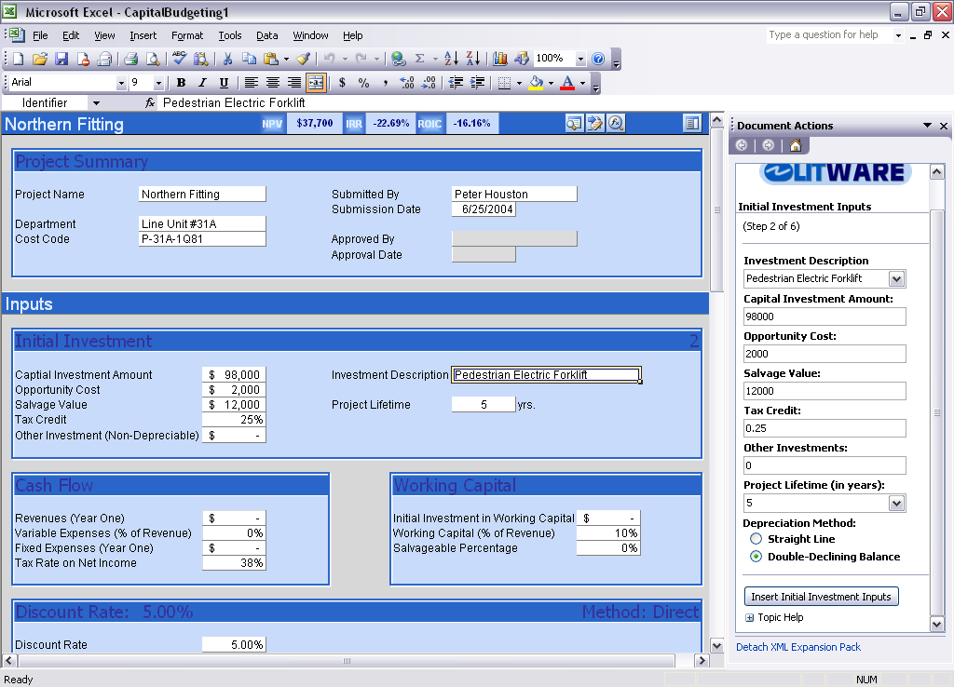
Figure 4. Smart document solution in Excel

Smart Document Benefits
Users become more productive with smart documents because content is presented in the task pane as they navigate through a document, reducing the time spent searching for or filling in data, or looking for help. At the same time, users continue to enjoy the familiarity of working with Word and Excel.
You can enable this enhanced UI through a programmable task pane that can contain any variation of data, help, and common controls— such as buttons, check boxes, option buttons, and list boxes— hyperlinks, images, free text, and more. This allows you to create solutions that offer a richer UI, provide content that is relevant to the specific task a user needs to perform within a specific section of a document, and extend documents to seamlessly integrate with other processes and systems. You can also manage task pane events to perform actions on behalf of the user. All of this allows an organization to manage its information with a higher level of integrity.
You can deploy smart document solutions using a new mechanism that enables installation when a user simply opens a document that was obtained by using e-mail or downloaded from a Web server or file server. These solutions implement a high standard of security that is subject to Office security settings, demands trusted servers for deployment sites, and requires all solution code to be signed. Smart documents also can automatically update themselves from a trusted server location, making solution upgrades easier. You need not install or manage the client-side code directly.

Smart Document Technology
You can use an existing document or start from scratch to build a smart document solution. To do so, you must attach the document to an underlying XML schema. For more information, see Custom-defined XML Schema Support. The solution then uses the schema as the basis for marking it with corresponding XML elements. You write code to respond to events that are fired when the user’s insertion point enters a document range mapped to an XML element. The custom code should provide the user with specialized UI in the task pane.
There are a number of techniques available to create smart documents, including the ISmartDocument interface, "Visual Studio Tools for Office version 2005 (Beta)" and Information Bridge Framework. Each provides a different flavor of technology and suits a different type of solution’s needs. Note that you cannot use Microsoft Visual Studio Tools for the Microsoft Office System version 2003 to create smart document solutions because it does not provide programmability access to the task pane.
IMPORTANT: Information Bridge Framework has been deprecated with the release of the 2007 Microsoft Office system. For information about Office Developer Platform and Business Application strategy, see the OBA Development Portal on the Microsoft Office Developer Center.
If you have been working with Information Bridge Framework 1.5 and are experiencing compatibility issues with the 2007 Microsoft Office system or .NET Framework 2.0, see Knowledge Base article 926348.
The following table provides the major decisions factors for each technology. The paragraphs which follow describe the underlying technologies.
Table 1. Smart Document Development Technology Options
Solution | Expected rollout of your solution | Technology | Other considerations
"Visual Studio Tools for Office version 2005 (Beta)" | 2005 | .NET-based | Most flexible
ISmartDocument interface | 2004 + | COM-based  .NET-based with PIAs or Vertigo Managed Smart Document Wrapper | Restricted task pane layout
Information Bridge Framework | 2004 + | .NET-based with declarative programming; requires infrastructure investment | Better for less document interaction, focus on exposing business system data/functionality, committed to multiple solutions

ISmartDocument interface. As mentioned previously, a smart document solution needs a document with an underlying XML structure. Then, you can use the COM-based ISmartDocument interface to build the automation that drives the solution. The code you write manipulates the document directly, presents information in the task pane and interacts with server-side processes, such as retrieving data, routing the document or its contents to a business system to complete the solution.
You can create a DLL to implement the ISmartDocument interface using COM-based or .NET-based technologies and thereby use your language of choice. For implementations using the .NET Framework, Office 2003 Editions includes a PIA to simplify the task of creating .NET-based code that interacts with the COM-based ISmartDocument interface.
To connect the Word or Excel document template that a user accesses to all the supporting files (such as DLL, XSD or XSL) associated with a smart document solution, you must create an XML file called a manifest. The manifest file identifies all the solution components, their versions and how they should be installed for the solution to work (such as on the server, on the client, in a particular directory). You place the solution files with the manifest file on a trusted server. When the user opens this type of smart document, the manifest technology in Office 2003 Editions checks the document’s internal metadata, specified as custom document properties when you create the solution, to locate the assigned manifest. It inspects the manifest to ensure that the entire solution is available, operational and secure, and that any new files are downloaded as needed. This dramatically simplifies deployment and maintenance for you because the document or template and the code that drives the solution exist independently of each other. You can version and update them separately.
Implementing the ISmartDocument interface with code for the .NET Framework can be a challenge due to the difficulty of getting all the references, code requirements and security issues set up correctly. Although a number of examples are provided through MSDN, a very usable option is to use a “wrapper” interface such as that built by Vertigo Software, called the Managed Smart Documents Wrapper. It provides an abstraction of the ISmartDocument interface that makes it easier for you to build and deploy a smart document solution using .NET-based technologies now and then migrate your code to "Visual Studio Tools for Office version 2005 (beta)" when the final version is available.
"Visual Studio Tools for Office version 2005 (beta)." Amongst many uses, these tools improve how you can implement smart document solutions by providing .NET-based events off XML elements, data-binding to the XML structure and a greater flexibility by allowing custom-defined Windows Forms user controls in the task pane. The resulting solutions benefit from the .NET Framework security model. "Visual Studio Tools for Office version 2005 (beta)" is scheduled for release sometime in 2005 around the time that Visual Studio 2005 is available (http://msdn.microsoft.com/vstudio/whidbey/default.aspx).
Information Bridge Framework. You can use the Information Bridge Framework to build smart documents as well. However, solutions built using the Information Bridge Framework require a significant upfront investment in enterprise Web services and metadata design. Given this, if an organization is (1) investing in an Information Bridge Framework infrastructure for tying together information coming from multiple back-end systems, (2) considering multiple solutions that can use an Information Bridge Framework infrastructure, and/or (3) wants to use a declarative programming model, Information Bridge Framework technologies make sense.
IMPORTANT: Information Bridge Framework has been deprecated with the release of the 2007 Microsoft Office system. For information about Office Developer Platform and Business Application strategy, see the OBA Development Portal on the Microsoft Office Developer Center.
If you have been working with Information Bridge Framework 1.5 and are experiencing compatibility issues with the 2007 Microsoft Office system or .NET Framework 2.0, see Knowledge Base article 926348.

Suggested Next Steps
See the following resources:

ISmartDocument
Download and begin using the Office 2003 Smart Document Software Development Kit (SDK): http://www.microsoft.com/downloads/details.aspx?FamilyId=24A557F7-EB06-4A2C-8F6C-2767B174126F&displaylang=en
Follow a "Hello World" managed smart document tutorial: http://msdn.microsoft.com/office/understanding/smarttags/gettingstarted/default.aspx?pull=/library/en-us/dnofftalk/html/office09042003.asp
Easier managed smart documents using the Vertigo Managed Smart Documents Wrapper: http://msdn.microsoft.com/office/default.aspx?pull=/library/en-us/dno2k3ta/html/odc_SmartDocsWrapper.asp

"Visual Studio Tools for Office version 2005 (beta)"
For more information, see "Visual Studio Tools for Office version 2005 (beta)".

Information Bridge Framework
For more information, see Information Bridge Framework.

Research Task Pane
The Research task pane is new task pane introduced with Office 2003 Editions that allows users of Office applications to search for a word or phrase in any of a number of information sources without leaving the context of the Office application. Two examples of the Research task pane are shown in Figure 5, one searching default information sources provided with Office 2003 Editions and one searching a custom research service.
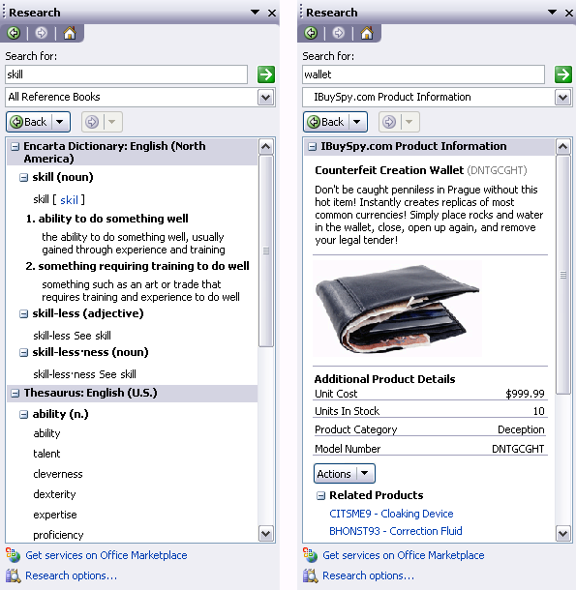
Figure 5. Default and custom research task panes

Research Task Pane Benefits
With this feature being available in most Office programs, users don't have to navigate among separate windows in order to perform a quick lookup of information (for example, to perform a search through a browser). Users have one convenient way to look up terms within the context of their document. Through search results, users may also have a set of features available to them to incorporate the information into their documents.
Developers and organizations benefit through the ease of making corporate information available to all (or select) users in the task pane by implementing a straightforward, industry standard Web service that exposes the information. The services available to users can be configured and updated from a server or through policy.

Research Task Pane Technology
The Research task pane is available in Word, Excel, Microsoft Office Outlook® 2003, Microsoft Office PowerPoint® 2003, Microsoft Office Publisher 2003, Microsoft Office OneNote® 2003, Microsoft Office Visio® 2003 and Internet Explorer (when an Office program is installed). Search options that come with Office 2003 Editions include basic resources such as thesauruses and dictionaries in multiple languages, language translation, an online encyclopedia, and Web searching. There is also a simple Web service URL that you can activate to initiate a search against SharePoint sites.
To expose information in the Research task pane, you implement an industry standard Web service using the method names and schemas expected by the Research task pane. The schemas describe the expected query and result XML streams. You can set up searches to access local and remote data sources, both behind a corporate firewall and on the Internet. Security can use Windows Authentication or Internet passwords. The Research task pane shares cookies and caching with Internet Explorer. The Research task pane can be controlled by administrators at a corporate level, automatically rolling out services or broadcasting their availability using a Discovery Web service for research services.
For basic features such as displaying results and copying items to the clipboard, a Research service does not require any client-side code beyond an Office installation. However, you can customize a research service to contain smart tag actions for extended document interactions. Smart tags require that you install a DLL locally. Though once installed, you can make smart tag actions with full client-side functionality available through menus in research service results.

Suggested Next Steps
Download and begin using the Office 2003 Research Service SDK: http://www.microsoft.com/downloads/details.aspx?FamilyId=D3FC8129-63F7-43B5-8D99-DE4058ADE0EC&displaylang=en
Download and begin using the Research Services Development Extras (coming September 2004 on MSDN)
View a Web seminar on building research services: http://www.microsoft.com/seminar/shared/asp/view.asp?url=/seminar/en/20031201devt1-82/manifest.xml&wmpver=9.0.0.3075
Follow a "Hello World" tutorial to build a custom research service: http://msdn.microsoft.com/office/understanding/research/gettingstarted/default.aspx?pull=/library/en-us/dnofftalk/html/office11062003.asp
Learn how to use smart tags with research services: http://msdn.microsoft.com/office/understanding/smarttags/articles/default.aspx?pull=/library/en-us/dno2k3ta/html/odc_of2003usingsmarttagsresearchservices.asp
Walk-through building a research service to search Google.com: http://msdn.microsoft.com/office/understanding/research/gettingstarted/default.aspx?pull=/library/en-us/dnofftalk/html/office03062003.asp

Smart Tags
Smart tags are programmed to identify terms and regions in a document that are of interest to those working with the document. They nominally appear as a dotted underline near which a menu icon appears when the user’s mouse cursor clicks in or hovers over the marked region. The context-specific menus for smart tags present users with actions related to the text, cells or regions of a document where they appear. Figure 6 shows a basic smart tag underline with the smart tag icon in the left picture and the resulting menu in the right picture.
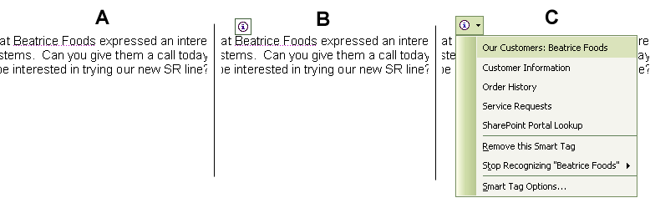
Figure 6. –Selecting a smart tag
A. Words marked by a smart tag
B. Icon when mouse hovers over
C. Custom menu appears upon clicking

Smart Tag Benefits
You can build smart tags to recognize key data terms inside documents and e-mail messages, allowing users to efficiently perform custom actions associated with the specific data elements directly from their document. Smart tags can link users to relevant corporate data, streamline cumbersome tasks, or perform any number of operations that are sensibly associated with the tagged data.

Smart Tag Technology
Smart tags were introduced in Office XP and improved in Office 2003 Editions based on feedback from users and developers. Within Office 2003 Editions, smart tag functionality is available in Word, Excel, Outlook when using Word 2003 as the e-mail editor, Access and PowerPoint. You can also use smart tags with people names using the persona menu in Outlook, all task panes in Office 2003 Editions, and with Microsoft SharePoint Products and Technologies. You can also use smart tag actions in Microsoft Internet Explorer for smart tags that are embedded in Web pages.
Implementing smart tags involves two primary interfaces, one for recognizing and marking text, ISmartTagRecognizer, and one for executing actions, ISmartTagAction. Office 2003 Editions offer new functionality by using the extended interfaces of ISmartTagRecognizer2 and ISmartTagAction2. You nominally build COM DLLs to implement these interfaces, although PIAs are available so that you can implement smart tags using Visual Studio .NET. "Visual Studio Tools for Office version 2005 (Beta)" also offers a capability for creating managed smart tags, though specifically for Word and Excel document-based solutions. Another option is to implement simpler smart tags through XML files using Microsoft Office Smart Tag Lists (MOSTL). Recognizers and actions are connected through a type identifier and you can even implement them using a combination of these technologies.
Smart tags in Office 2003 Editions include the following improvements:
The ability to alter smart tag action menus at run time, including eliminating individual menu items. This facilitates more solution flexibility.
Support for cascading action menus, so you can logically group actions by hierarchy. This can help users find related actions, help shorten the overall menu length or simply consolidate actions so they are separated from other action handlers.
The ability to register smart tags at a computer level and not just for individual users.
Improved tokenization and pattern matching using regular expressions to simplify writing recognizers.
New smart tag characteristics, such as smart tags that expire and those that can’t be saved in documents.
As one technology for building smart tag actions, the Information Bridge Framework provides a declarative model for exposing information and actions from business systems that relate to phrases recognized by smart tags.

Suggested Next Steps
Download and begin using the Office 2003: Smart Tag SDK: http://www.microsoft.com/downloads/details.aspx?familyid=c6189658-d915-4140-908a-9a0114953721&displaylang=en
Learn how to use regular expressions with smart tag lists: http://msdn.microsoft.com/office/understanding/word/articles/default.aspx?pull=/library/en-us/dno2k3ta/html/odc_regex_smarttags_2003.asp
Learn how to use smart tags with Access 2003: http://msdn.microsoft.com/office/understanding/access/gettingstarted/default.aspx?pull=/library/en-us/odc_ac2003_ta/html/odc_ac11st.asp
Learn how to use smart tags with research services: http://msdn.microsoft.com/office/understanding/smarttags/articles/default.aspx?pull=/library/en-us/dno2k3ta/html/odc_of2003usingsmarttagsresearchservices.asp
Walk-through an example of using smart tags to enable data drill-down in Excel: http://msdn.microsoft.com/office/understanding/smarttags/articles/default.aspx?pull=/library/en-us/odc_xl2003_ta/html/odc_xldatadrill.asp

Web Services Support
Web services are an industry standard for enabling the exchange of data and the remote invocation of application logic using XML messaging and Internet technologies to move data through firewalls and between heterogeneous systems. Although remote access of data and application logic is not a new concept, doing so in the loosely coupled fashion of Internet protocols is. The only assumption between the client and the Web service is that recipients understand the messages they receive. As a result, programs written in any language, using any component model, and running on any operating system can access Web services.

Web Services Support Benefits
Web services make it easier for you to expose data from legacy systems to authorized users around the company. Often these targeted users are those who previously needed the data but, until the advent of solutions using Web services, had no simple way of accessing it.

Web Services Support Technology
The recommended way to connect programs in Office 2003 Editions with Web services is to use Visual Studio .NET. With Visual Studio, you can more easily take advantage of the latest Web service standards with minimal code and have a host of rich objects available with which to manipulate the XML payloads. You can then integrate the XML from Web services into the custom-defined schema capabilities of Office programs, and vice-versa.
For integrating Word and Excel document solutions with Web services, Visual Studio Tools for Office is a natural development tool. In addition, the Information Bridge Framework helps you create relationships between multiple business systems using Web services and associated metadata which you can then incorporate into Office solutions.
If you need to access Web services from VBA (or Visual Basic 6), you can download the free Microsoft Office 2003 Editions Web Services Toolkit which helps create the code necessary to interface with basic Web services. Note that this toolkit is provided on an "as-is" basis and support is only available through a peer-to-peer newsgroup. Other developers could interoperate with Web services in any environment by manually interpreting the SOAP messages.

Suggested Next Steps
Learn how to access Web services in Excel using Visual Studio Tools for Office version 2003 : http://msdn.microsoft.com/office/understanding/vsto/articles/default.aspx?pull=/library/en-us/odc_vsto2003_ta/html/odc_vstexlweb.asp

Primary Interop Assemblies
Developers increasingly seek to build solutions using code that runs on the .NET Framework, called managed code, because of increased security, robustness and productivity. In order for managed code to interoperate with COM interfaces, such as the Office object models, developers need to use a managed assembly that describes the COM interface types. This type of managed assembly is called a Primary Interop Assembly, allows managed applications to bind to the COM types at compile time and provides a run time interface for the .NET Framework.
Microsoft includes Primary Interop Assemblies with Office 2003 Editions to make it easier for developers to write code using Visual Studio .NET to automate Office applications. Primary Interop Assemblies are also available for the smart tag and ISmartDocument interfaces.

Primary Interop Assemblies Benefits
Primary Interop Assemblies (PIAs) allow you to build solutions for Office 2003 Editions using managed code. This means you can take advantage of the benefits of Visual Studio .NET and the .NET Framework when developing and deploying Office solutions.

Primary Interop Assemblies Technology
The Office 2003 PIAs are available when you install the Office 2003 Editions as optional items called .NET Programmability Support. You can choose to install .NET Programmability Support for Access, PowerPoint, Outlook, Publisher, Word, and Excel. Under Office Tools, you can also install the Smart Tag .NET Programmability Support to add the PIAs for smart tags and smart documents and Microsoft Forms 2.0 .NET Programmability Support to install the PIAs for forms and graphs. We recommend you install all of them so that you have the appropriate interface for any custom managed Office solution you choose to create.
Both Visual Studio Tools for Office version 2003 and "Visual Studio Tools for Office version 2005 (Beta)" require that you install these options for developing managed code solutions for Word and Excel.

Suggested Next Steps
Understand more about PIAs: http://msdn.microsoft.com/library/default.asp?url=/library/en-us/dndotnet/html/whypriinterop.asp
Learn about Visual Studio and Visual Studio Tools for Office version 2003.

Network Deployment and Updating Models
With Office 2003 Editions, there are several types of solutions that you can deploy, manage and update from a server. This is a dramatic departure from the previous options available to developers that invariably required you to register COM DLLs manually on desktop computers.

Network Deployment Benefits
Being able to deploy the code for a solution from a network server enables you to deploy and manage it more easily. This is a primary reason why Web-based solutions are so popular. Until the advent of the .NET Framework and the new options for Office 2003 Editions solutions, deploying client-side code was particularly problematic. Managing a solution is also easier from a server as you can publish a newer version on the server and the solution automatically updates itself.
Server-based deployments also improve the security of desktop solution code by managing more of the application and data access privileges from a centralized server within a trusted zone. Assemblies built with managed code can also follow robust .NET security protocols.

Network Deployment Technology
With Office 2003 Editions, there are two technologies available for deploying solution code from a network. The first technology is for smart document solutions built using the ISmartDocument interface with an XML solution manifest. The second is for solutions built using the Visual Studio Tools for Office. Both only support document-based solutions for Word and Excel.
In each case the deployment works by placing the solution code on a trusted server and giving the user the document or template for the solution. When the user opens the document, assuming they have a network connection, appropriate security checks are made. If all security checks pass, the custom code is downloaded to the local computer. Periodically when the user opens the document, the solution checks the server location for updates making solution maintenance easier.
Smart document solutions using the ISmartDocument interface. For this type of solution, the document contains a custom document property that points to the XML manifest file. When the document is opened, Office 2003 Editions verifies that the manifest file is digitally signed, and second, Office 2003 Editions verifies that the code components included with the smart document are also signed. The code must also exist on a trusted server location. This type of smart document solution, if built with managed code, also undergoes .NET-based security checks. For more details about smart document security, see the Office 2003 Smart Document SDK.
If security checks pass, you can choose to install the solution code locally or keep it on the server, depending on how you configure the solution. If you configure the solution to install all solution files locally and the solution does not need other network resources, the solution can work offline. Solution updates occur based on version numbers for each individual file in the manifest. The solution contains an XML element that signifies how often to check for updates.
Visual Studio Tools for Office version 2003 and "Visual Studio Tools for Office version 2005 (Beta)". For this type of solution, the document also contains a custom document property that points, in this case, to the main interfacing assembly. The solution does not run unless it has full trust according to .NET-based code access security. If security checks pass, the solution code is downloaded into the Internet Explorer cache for the solution to run. As long as the solution code remains in the cache, the solution can work offline. When connected and when a new version is placed on the server, the new version is downloaded to update the local cached copy.

Suggested Next Steps
Learn about smart documents, InfoPath 2003 and Visual Studio Tools for Office.

Access 2003 Runtime
Access provides a rich platform for developing database management solutions. To distribute those Access solutions so that they run without requiring a full installation of Access, you can package and distribute your application with the Access 2003 Runtime. The Access 2003 Runtime is essentially a full version of Access 2003, but with certain design-time features disabled.

Access 2003 Runtime Benefits
The Access 2003 Runtime allows you to build powerful, Access-based solutions and use the royalty-free Runtime to distribute them without customers needing to purchase additional licenses of Access software. Besides the obvious benefit of cost efficiency for the customer and maximizing profit for the developer, Access Runtime solutions are easier for you to deploy and update since you can manage your solution without being concerned about what version of Office a customer may have.

Access 2003 Runtime Technology
The Access 2003 Runtime license allowing royalty-free distribution comes with the Microsoft Office Access 2003 Developer Extensions, which is a component of Visual Studio Tools for Office version 2003. A developer who is licensed for this product can bundle a solution (.mdb files and any other support files) with the Access 2003 Runtime and distribute it to as many users as necessary. There is no limit to the number of distributions or the number of Access Runtime solutions that you can create using one license. The physical runtime files are included with Microsoft Office 2003 Professional Edition or Microsoft Office Access 2003, so you must also own a copy of one of these products, although this is not a requirement for the end customer. The Package Wizard which comes with the Access 2003 Developer Extensions helps you create a professional installation package for the solution.
The Access 2003 Runtime is, in essence, Microsoft Office Access 2003, but with a few key features disabled. A user with an Access 2003 Runtime solution installed instead of full Access can open and run the solution (either an .mdb file or, with a few extra steps, a SQL Server back-end database) but does not see the Database Window and cannot switch the view of any Access object to the Design view.

Suggested Next Steps
Learn the basics for building Access 2003 Runtime-based solutions: http://msdn.microsoft.com/office/understanding/access/techarticles/default.aspx?pull=/library/en-us/odc_ac2003_ta/html/odc_acbasicsofruntime.asp
Understand how to obtain and deploy the Access 2003 runtime: http://office.microsoft.com/assistance/preview.aspx?AssetID=HA011208861033&CTT=4&Origin=CH011228281033

New Developer Tools and Programs
Microsoft has a long history of innovation with regard to delivering tools for developers to build custom solutions that extend Office. As previous Office technologies have made developers more productive, Microsoft continues to focus on ensuring that Office is a leading-edge solutions platform for professional developers of all levels and skills. Microsoft advances that commitment with Office 2003 Editions, enabling you to use it across the enterprise by exposing new interfaces, extending support for open standard technologies, and allowing you to make choices with regard to tool sets, languages and application architectures.

InfoPath 2003
InfoPath 2003 is a new program in the Microsoft Office System that allows developers to easily build rich, dynamic forms with which organizations can capture information in an industry standard XML format. An example is shown in Figure 7. The collected information can be integrated with a broad range of business processes and business systems because InfoPath supports any customer-defined XML schema and integrates with Web services. InfoPath provides a WYSIWYG design environment that builds off an XML schema or data source to simplify the form layout. InfoPath forms can include data and business rule validation, conditional formatting, rich text fields, optional and repeating elements, ActiveX controls, and custom code developed with Visual Studio .NET. InfoPath forms can be deployed by using a shared network folder or Web server, integrated with a Windows SharePoint Services form library, or sent by e-mail. Solutions can be kept up-to-date using silent and automatic downloads. Users of InfoPath solutions must have InfoPath on their desktops, and InfoPath forms can be used off-line, unlike Web forms.
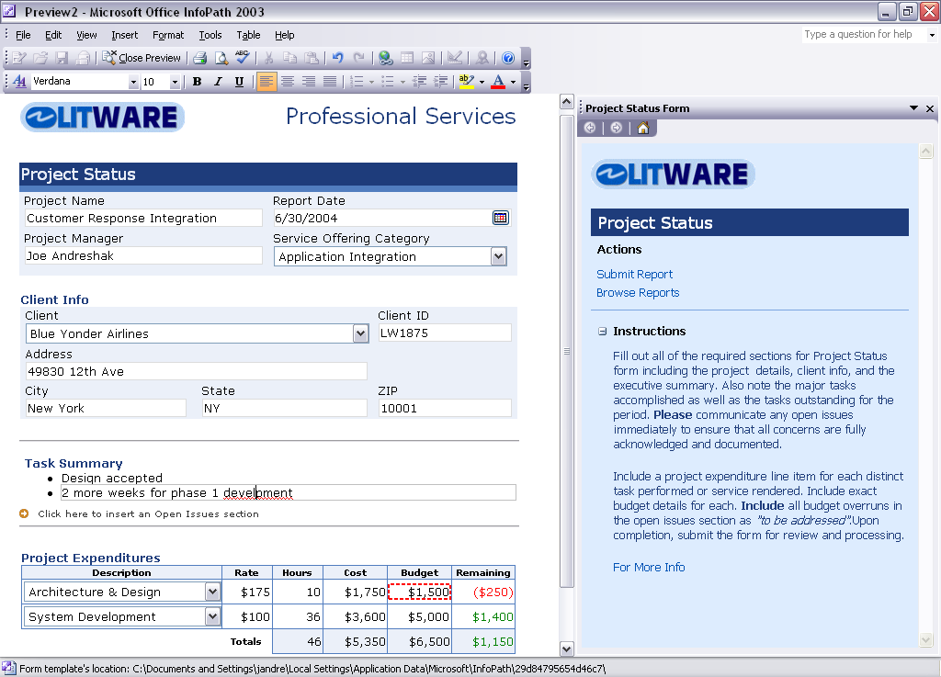
Figure 7. A sample InfoPath 2003 form being filled out

InfoPath 2003 Benefits
For users, InfoPath forms have the familiar feel of an Office interface, including rich interactive controls and authoring features like the spelling checker, font formatting, and other familiar tools. Forms are dynamic, allowing optional sections and repeating structures that allow users to efficiently enter information that needs to be captured. Organizations can be sure that captured information is valid through enforced data types and business rules. InfoPath forms can save data offline allowing users to conveniently fill out more complex forms on their computer, over time, and submit them to a process when connected.
Developers can easily build InfoPath forms based on existing data sources such as a custom XML schema using a WYSIWYG form designer. Straightforward wizards make it easy to add rules and customized formatting to a form to create a good user experience and ensure data is captured as needed. Developers can deploy InfoPath solutions from a server providing silent and automatic downloads to be sure that users always have the most up-to-date form. Rich programmability with Visual Studio .NET allows robust enterprise solutions to be built to use the benefits of the .NET Framework.

InfoPath 2003 Technology
InfoPath 2003 is a desktop program for creating rich forms-based solutions for capturing information. InfoPath contains a design and runtime environment. You must install it on the desktop of those who will use the forms. InfoPath 2003 Service Pack 1 (SP 1, released July 2004) adds a number of key development features, some of which are described in this section.
You can design InfoPath forms based on custom-defined XML schema, an XML data file, an industry standard Web service or ADO record sets from Access or SQL Server. InfoPath automatically applies data-type and structural validation based on whatever schema information it has. You can also begin with a blank form and insert controls as needed. In this case, InfoPath automatically creates a schema in the background that you can modify later, if necessary. InfoPath does not have its own file format. Data entered in InfoPath forms is saved as XML in the schema that was used to create the form.
InfoPath provides an easy-to-use WYSIWYG design mode that lets form developers design or modify form templates without writing any code. InfoPath supports a rich set of controls and layout capabilities and provides default suggestions based on the underlying schema data types.
You can customize InfoPath form solutions programmatically using the Microsoft Office InfoPath 2003 Toolkit for Microsoft Visual Studio .NET. The toolkit provides language support for writing managed code including C, Microsoft Visual C#®, Microsoft Visual C++® and Visual Basic .NET, or using the Microsoft Script Editor with the Microsoft JScript® and Microsoft Visual Basic Script (VBScript) languages. InfoPath includes a robust object model that you can use to interact with the application, its forms, and the data that the forms contain. InfoPath also implements a number of events that you can use to respond to an application state, to user-initiated action or to changes in a form's underlying XML document.
A complete InfoPath solution consist of a number of files, including XML schemas, XML templates and files for view, presentation, script, and custom business logic. All these files are packed into a CAB file with an .xsn extension. One of the files is an XML file called the form definition file that serves as a manifest to describe how to construct, use, and deploy the form. This manifest is automatically created by InfoPath when you design a form, but you can also modify it manually for additional control over the solution behavior.
An InfoPath form solution is tied to a particular XML schema and you can use it to open any XML document that complies with that schema. Saved XML documents include a PI (XML processing instruction) that identifies the corresponding template solution so that you can move the document around and you can still open it with that same form template.
For processing the captured information, InfoPath interoperates with any server that is accessible through Web services, including those using ADO.NET. InfoPath also has built-in support for Access and SQL Server databases using ADO and for submitting XML data over HTTP. In addition to built-in features, you can write custom code to retrieve and submit XML data. Additionally, you can use InfoPath with form libraries in Microsoft Windows SharePoint Services for enhanced workgroup collaboration, or just save an InfoPath XML file to the local computer.
The native support in InfoPath for generic XML documents makes it easy for companies to integrate InfoPath forms into workflow processes. Microsoft BizTalk Server is a natural choice for integration because both use XML as their basis. You can post data to BizTalk using built-in support for saving XML data through HTTP, Web services, and e-mail. You can likewise easily retrieve data from BizTalk in a number of ways. InfoPath includes support for using BizTalk Server 2004 - Human Workflow Services in the InfoPath design environment to encode workflow rules based on user roles.
You can deploy InfoPath solutions as "sandboxed" solutions or trusted solutions. "Sandboxed" InfoPath solutions don’t have access to any resources of the local computer since they follow the same security model as Web pages in Internet Explorer. They are identified by URL and saved locally in an InfoPath cache. If the sandboxed solution needed for a form is not installed, it is downloaded silently in the background. Trusted solutions require a client install, are identified by URN and require explicit upgrades.
InfoPath also provides rich digital signature support for XML documents using the XML DSIG standard from W3C. When adding a digital signature to an InfoPath form, the user is prompted to select from the digital certificates that are available for signing. InfoPath supports verifiable, non-repudiable signing, partial signing, co-signing and counter-signing. Users can sign separate sub-sections of the form and verify signatures upon opening an InfoPath form.

Suggested Next Steps
Download and begin using the InfoPath 2003 SDK: http://www.microsoft.com/downloads/details.aspx?FamilyId=351F0616-93AA-4FE8-9238-D702F1BFBAB4&displaylang=en
Download and begin using the InfoPath Toolkit for Visual Studio: http://www.microsoft.com/downloads/details.aspx?familyid=7E9EBC57-E115-4CAC-9986-A712E22879BB&displaylang=en
Learn more about the basic InfoPath 2003 design process: http://msdn.microsoft.com/office/understanding/xmloffice/articles/default.aspx?pull=/msdnmag/issues/03/09/infopath/toc.asp
Learn how XML standards are used in InfoPath 2003: http://msdn.microsoft.com/office/understanding/xmloffice/articles/default.aspx?pull=/library/en-us/odc_ip2003_ta/html/odc_inxmls.asp
Understand the architecture of InfoPath 2003: http://msdn.microsoft.com/office/understanding/xmloffice/articles/default.aspx?pull=/library/en-us/odc_ip2003_ta/html/odc_inarch.asp

Visual Studio
Visual Studio is a complete set of development tools for building desktop applications, Web services, ASP.NET Web applications and mobile applications. Visual Basic, Visual C++, C#, and Visual J# all use the same integrated development environment (IDE), which allows them to share tools and facilitates in the creation of mixed-language solutions. In addition, these languages use the functionality of the .NET Framework, which provides access to key technologies that simplify the development of applications and Web services.
You can use Visual Studio to build solutions with Office 2003 Editions, benefiting fully from the streamlined and productive development environment that Visual Studio provides. The Office-related solutions can also accrue benefits from the .NET Framework. To facilitate this development, Office 2003 Editions include primary interop assemblies (PIAs) for all Office programs as described previously. For Word and Excel development specifically, Visual Studio Tools for Office, described in the next section, further streamlines the development process and provides more advanced development capabilities. For InfoPath solutions, .NET-based programmability is available through the InfoPath 2003 Toolkit for Visual Studio .NET with language support for writing managed code including C, C#, C++ and Visual Basic .NET. This toolkit will be included as part of “Visual Studio Tools for Office v2005 (Beta)” when it is released as a formal product. InfoPath development, including the use of this toolkit, is described in the previous section.

Suggested Next Steps
Read the MSDN article "Understanding the Word Object Model from a .NET Developer's Perspective": http://msdn.microsoft.com/office/understanding/word/gettingstarted/default.aspx?pull=/library/en-us/odc_vsto2003_ta/html/wordobject.asp
Read the MSDN article "Understanding the Excel Object Model from a .NET Developer's Perspective": http://msdn.microsoft.com/office/understanding/excel/gettingstarted/default.aspx?pull=/library/en-us/odc_vsto2003_ta/html/excelobj.asp
Download and begin using the InfoPath 2003 Toolkit for Visual Studio .NET: http://www.microsoft.com/downloads/details.aspx?familyid=7E9EBC57-E115-4CAC-9986-A712E22879BB&displaylang=en
Learn to use XML functionality in Excel with Visual Basic .NET: http://msdn.microsoft.com/office/understanding/xmloffice/articles/default.aspx?pull=/library/en-us/odc_xl2003_ta/html/odc_xlxmlxfer.asp
Learn how to consume ADO.NET Datasets in Office from Visual Studio: http://msdn.microsoft.com/office/understanding/vsto/articles/default.aspx?pull=/library/en-us/dno2k3ta/html/odc_office2003adonet.asp

Visual Studio Tools for the Microsoft Office System
Microsoft Visual Studio Tools for the Microsoft Office System is a new technology that brings the power and productivity of Visual Studio .NET and the Microsoft .NET Framework to business solutions built on Word and Excel. With this technology, using Visual Studio .NET 2003 and "Visual Studio 2005 (Beta)", you can use Visual Basic .NET and C# to write code behind Word and Excel documents. The following two sections review Visual Studio Tools for Office version 2003 and "Visual Studio Tools for Office version 2005 (beta)".

Visual Studio Tools for Office version 2003
You can use Visual Studio .NET and Visual Studio Tools for Office version 2003 to address any number of business scenarios requiring code to execute behind Word and Excel documents. These could involve business logic that manages budget figures in an Excel spreadsheet, or populating a table in a Word document with sales figures obtained using a Web service.

Benefits
Businesses and developers have long benefited from the ability to use VBA to customize Office applications and integrate them with existing data and systems. While VBA continues to be an important part of Office development and benefits from the new features of Office 2003 Editions, Visual Studio Tools for Office version 2003 provides significant advances in the areas of language choice and innovation, security, deployment, and an integrated development environment (IDE).
With a Visual Studio Tools for Office version 2003 solution, the end-user receives rich, integrated functionality to use with their Word or Excel document. Although the feel of a Visual Studio Tools for Office version 2003 solution may be comparable to that of a Visual Basic for Applications (VBA) solution, the network deployment capability and security model help ensure that the end-user's desktop is secure and that the latest version of the solution is always used.

Technology
Visual Studio Tools for Office version 2003 allows you to build solutions using Visual Studio .NET 2003 that targets Word or Excel documents and templates in Office 2003 Editions. Visual Studio Tools for Office version 2003 provides full access to the Word and Excel object models, as well as the benefit of Microsoft IntelliSense® statement completion when you write code against these object models. You can compose code in Visual Basic .NET or C# that runs from the document or workbook and uses all areas of Visual Studio .NET, including the Server Explorer, Microsoft Windows Forms, ADO.NET data access, and Dynamic Help. Visual Studio Tools for Office version 2003 solutions are tied to documents or templates; you cannot use this technology to build program-specific code, for example a Word add-in. However, you can use it to provide custom menus and toolbars for use with the associated document.
When you want to test an application, t click Start on the Visual Studio .NET toolbar. This starts the Word document or Excel workbook and runs the custom code. Then, you can view the Word or Excel solution and observe the results of the running code. You can also set break points in the code and return to Visual Studio .NET for debugging purposes.
The code that you write is built as a dynamic-link library (DLL) file, which you can deploy to any number of places depending on the specific needs of the solution – a local hard disk, a network share on a corporate intranet, or on a secured Internet site. Code written with Visual Studio Tools for Office version 2003 is managed code, and uses the built-in security features of the .NET Framework. Indeed, .NET security for Visual Studio Tools for Office version 2003 solutions is aggressively locked down so that you must use explicit security policy to control whether or not the code is trusted.
You can choose to use the No-Touch Deployment feature of the .NET Framework to facilitate easier deployment and maintenance. If the security checks are in order, when a user opens the Word or Excel file, the computer downloads the DLL from the deployment location to the user's computer and the solution runs. After you deploy a new DLL to the location, the next time a user opens the Word or Excel file, the computer detects that the DLL is updated and downloads and runs the new code automatically. No intervention is required by either you or administrator and the user does not need to download a new version of the file.

Suggested Next Steps
View online demonstrations: http://msdn.microsoft.com/office/understanding/vsto/multimedia/default.aspx
Compare VBA and Visual Studio Tools for Office version 2003: http://msdn.microsoft.com/office/understanding/vsto/articles/default.aspx?pull=/library/en-us/dno2k3ta/html/odc_ofcomparevba6andvsto.asp
Learn how to migrate Word VBA solutions to Visual Studio Tools for Office version 2003: http://msdn.microsoft.com/office/understanding/vsto/articles/default.aspx?pull=/library/en-us/odc_vsto2003_ta/html/odc_vstvbatovsto.asp
Walk-through Visual Studio Tools for Office version 2003 training labs: http://msdn.microsoft.com/library/default.asp?url=/library/en-us/odc_2003_ta/html/odc_landvsto03_tr.asp
Understand Visual Studio Tools for Office version 2003 project templates: http://msdn.microsoft.com/office/understanding/vsto/articles/default.aspx?pull=/library/en-us/odc_vsto2003_ta/html/vstointro.asp
Learn how to access Web services in Excel using Visual Studio Tools for Office version 2003: http://msdn.microsoft.com/office/understanding/vsto/articles/default.aspx?pull=/library/en-us/odc_vsto2003_ta/html/odc_vstexlweb.asp
Read the Visual Studio Tools for Office version 2003 blog: http://weblogs.asp.net/vsto

"Visual Studio Tools for Office version 2005 (beta)"
"Visual Studio Tools for Office version 2005 (beta)" builds upon the capabilities introduced in Visual Studio Tools for Office version 2003 to help address some of the biggest challenges facing Office solution developers. "Visual Studio Tools for Office version 2005 (beta)" brings significant enhancements to development areas including the separation of data and view elements, deployment of Office solution assemblies, server-side and offline scenarios, and seamless integration with the Visual Studio toolset. "Visual Studio Tools for Office version 2005 (Beta)"will also include the InfoPath 2003 Toolkit for Visual Studio 2005 which is discussed in the section on InfoPath development.

Benefits
"Visual Studio Tools for Office version 2005 (beta)" significantly increases your ability to develop and deploy Word and Excel solutions. By hosting Excel spreadsheets and Word documents within the Visual Studio IDE (see Figure 8), "Visual Studio Tools for Office version 2005 (beta)" gives you a streamlined and consolidated environment for building solutions with Word and Excel.
The integration goes deeper, for example, by exposing Office objects as .NET-based controls, listing worksheets in the Solution Explorer, enabling data binding into documents and elevating object model properties through the Properties Window. These features allow professional Visual Studio developers to construct Office solutions more easily by using their existing Visual Studio .NET skills.
"Visual Studio Tools for Office version 2005 (beta)" also improves many popular scenarios, such as those using the task pane, and introduces a few new solution scenarios that were previously impossible or simply unsupported. For example, by enabling the concept of a data cache in documents, you can pre-populate documents and reports on a server with timely or personalized information before the user accesses a document.
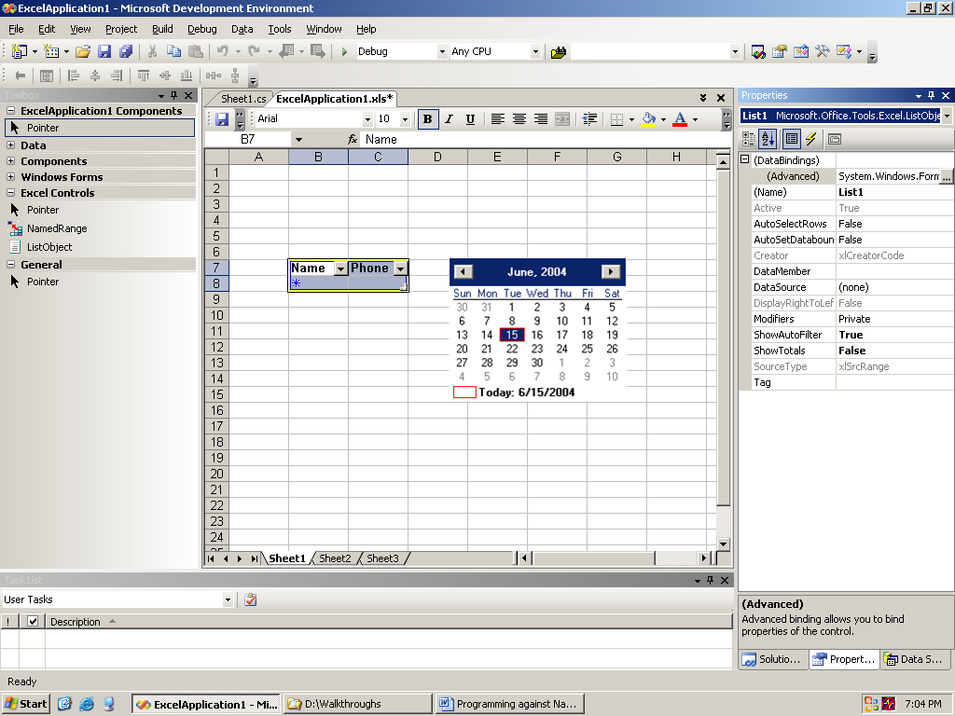
Figure 8. Excel 2003 as a design surface in Visual Studio using "Visual Studio Tools for Office version 2005 (beta)"

Technology
In "Visual Studio Tools for Office version 2005 (beta)", the IDE hosts Excel and Word as designers (see Figure 8). You can design Office documents within the Visual Studio environment using the full collection of Windows Forms controls in Excel and Word by simply dragging and dropping managed controls, including third-party controls, from the Toolbox onto the Word or Excel document surface. Double-clicking a managed control in Excel or Word invokes the code view in which you can write customizations inside the auto-generated event handler for that control.
Programming the task pane gives you a way to provide content, tools and information to supplement the document being created or used. "Visual Studio Tools for Office version 2005 (Beta)" allows you to instantiate an ActionsPane class which you can then populate with custom Windows Forms user controls. The layout, visibility and behavior of controls on this task pane are entirely up to you, allowing an extraordinary level of flexibility. Smart document solutions that display content specifically relevant to a user's position within a document are also programmable through the ActionsPane class.
"Visual Studio Tools for Office version 2005 (beta)" creates a data-view separation by enabling you to embed data as an XML data island in the document. Some of the data may be viewable in the document; some of it may be hidden. You can update the data directly without having to write code to describe how to format the data in the document. Typed data sets provide a schema-oriented programming model for interacting with the data island, ensuring IntelliSense support for the managed code you write. Data binding between the data island and the view keep the two entities in sync. You can also add validation code to the data that is independent from the document’s view components.
"Visual Studio Tools for Office version 2005 (beta)" has a runtime capability to open the data island by using a server process without the need to run Excel or Word. You can then manipulate the data island in a document through a lightweight object model from server-side code. You can then read or update the data in the island, including that which is bound to the document view. When the user opens an Office document for which the data bound to the document is changed, the view re-synchronizes with the data island and the user is automatically presented with the updated data. In this model, Excel and Word are not needed to write to the data on the server, but rather only to view it on the client. This update model provides scalability and enables high performance batch processing of documents containing data islands on the server.
Storing data in the data island also provides a mechanism for enabling robust offline scenarios. When a document is first requested from the server or first opened by the user, you can fill the data island with the most recent data. Then, you can cache the data island in the document and make it available offline. The user or custom code can manipulate the data without a live connection. When the user reconnects, you can propagate the changes to the data back to a server data repository.
"Visual Studio Tools for Office version 2005 (beta)" also introduces enhancements to the way you programmatically access UI, or view, elements. Elements, such as ranges, lists, bookmarks and mapped XML schema elements become first class controls that you can easily access in code. You can uniquely identify each control. The controls support data binding and provide a more complete event model.

Suggested Next Steps
Download and begin using "Visual Studio Tools for Office version 2005 (beta)" which includes Visual Studio Tools for Office version 2003: http://lab.msdn.microsoft.com/vs2005/
Read the "Visual Studio Tools for Office version 2005 (beta)" blog: http://weblogs.asp.net/vsto2

Information Bridge Framework
The Microsoft Office Information Bridge Framework is a set of tools and technologies that help you use XML and Web services to connect information in documents in Office 2003 Editions to line-of-business systems. It enables you to build solutions providing live, direct connections to enterprise business information that users can employ to make and implement decisions. Information Bridge Framework relies on metadata coming from Web services and a metadata server that feeds into a custom Office 2003 add-in which presents rich, interactive views of information to users. You can retrieve and present information through the Information Bridge Framework when users interact with specific smart tag menus or move amongst document regions marked by a custom XML tags.

Benefits
Employees in an organization generally need to view, retrieve, and act on line-of-business data and operational information to work efficiently and make the best decisions. However, employees often may not have access to the information or are required to switch contexts and navigate a separate application to get what they need. Moreover, the documents with which they interact contain important business data but do not help them bring up any related content. As a result, users lose time searching and then copying and pasting information in different formats between different applications, without any efficient way to access or reuse information.
With the Information Bridge Framework, data in documents become business objects that are connected to related information and data in business systems. Users can more efficiently bring up related information and perform actions on it without leaving the context of their current work. Users can also establish dynamic links between Office document text and the company’s enterprise business objects, making it easier for the next user of the document information to access further content if they need.
Using the Information Bridge Framework, you can build a Web services infrastructure around business systems to expose information in a meaningful and reusable way using metadata to define business objects, relationships between information, related actions and solution views. This declarative solution model allows an organization to segment solution development between those focused on building a reusable Web services infrastructure and those focused on the domain-specific work of building a business solution.

Technology
The Microsoft Office Information Bridge Framework is a set of software components, tools and prescriptive guidance that enable you to create solutions that connect programs in the Office 2003 Editions to enterprise systems or applications. You can build Information Bridge Framework-based solutions for Word, Excel, and Outlook.
The Information Bridge Framework architecture uses metadata to express the relationships between Web services, business entities and views, operations, and user-interface elements. Metadata is information or data that is created as line-of-business applications expose their information as Web services. After metadata is described through XML, a solution developer can use specialized designer tools to create customized Office solutions that present back-end information in custom usable ways directly in an application in Office 2003 Editions.
The components of Information Bridge Framework are as follows:
Prescriptive design guidelines for building Web services and defining metadata. You can reuse existing Web services or build new ones. The Web service guidelines describe how you can add metadata to Web services and how you can design Web services to be more effective providers of content to Information Bridge Framework solutions. The metadata allows multiple Web services to expose data, views and actions embodied by line-of-business applications as a unified model and in a standardized way. It effectively describes a particular solution’s views and actions.
Metadata Designer. A plug-in for Microsoft Visual Studio .NET that creates and manages solution metadata. The Metadata Designer also allows solution creators to configure how enterprise data and operations appear to the user through transforms to HTML or custom Windows Forms.
Metadata Service. Provides the metadata from a metadata database in SQL Server 2000 to the client-side engine.
Client component. Orchestrates the custom solution by interacting with Microsoft Office programs, calling Web services and displaying the data returned by these Web services.
A request for displaying information is initiated either manually by the user selecting smart tags or automatically as the user enters a predefined, XML-tagged region. The client engine retrieves and interprets metadata for the request from its local cache, or through a request to the Metadata Service to determine what operations need to occur. The engine then retrieves needed information or executes actions using one or more Web services, creates a view including context-specific actions and navigational elements for retrieved information and displays the result. The resulting display is presented to the user through a programmable task pane or a pop-up Windows Forms window.
You can control both the available views and available actions based on the user’s role or authentication credentials through integration with the Microsoft Active Directory® directory service. In this way, you can tailor solutions to align with a company’s unique data structures, computing environment and business processes.

Suggested Next Steps
Understand the business value of building Information Bridge Framework solutions: http://msdn.microsoft.com/office/understanding/ibframework/gettingstarted/default.aspx?pull=/library/en-us/odc_ibf2003_ta/html/ODC_ibfintro.asp
Read a technical overview of the Information Bridge Framework: http://msdn.microsoft.com/office/understanding/ibframework/gettingstarted/default.aspx?pull=/library/en-us/odc_ibf2003_ta/html/odc_ibftechoverview.asp
View an online demonstration: http://www.microsoft.com/office/ibframework/demo.mspx
Download and begin using the Information Bridge Framework: http://www.microsoft.com/downloads/details.aspx?FamilyId=2833D4A7-9856-4E25-B7D6-E0C68872AF83&displaylang=en
Understand how to approach solutions with the Information Bridge Framework: http://msdn.microsoft.com/office/understanding/ibframework/gettingstarted/default.aspx?pull=/library/en-us/odc_ibf2003_ta/html/odc_ibfsolutionswibf.asp

Access 2003 Developer Extensions
Microsoft Office Access 2003 is a powerful platform for developing robust database solutions. In addition to the new development features in Access, the Access 2003 Developer Extensions provide additional tools and resources to help you more quickly and easily create, test, and deploy Access solutions. Access 2003 Developer Extensions are part of the new Visual Studio Tools for the Microsoft Office System software package.

Access 2003 Developer Extensions Benefits
New tools for packaging and deployment facilitate the process, while licensing and distribution agreements make it easier for you to bring solutions to market, whether to a small business or a large enterprise, as a third party or internal developer.
The Access 2003 Developer Extensions licensing allows for royalty-free distribution of Access Runtime solutions and Access Data Projects, and free use and distribution of portions of the tools source code as part of your solutions.
Access 2003 Developer Extensions provide a set of tools for Access solution developers that can reduce the amount of tedious work required in building Access solutions and streamline the production environment. The features described help reduce testing obstacles and produce higher-quality solutions.

Access 2003 Developer Extensions Technology
Access 2003 Developer Extensions include the Package Wizard that helps you create professional setup routines for Access solutions. The wizard automatically includes the Access Runtime files, if selected, along with the Access 2003 solution files that make up the solution. The resulting setup uses the standard Windows Installer (MSI) for the installation routine and can create shortcuts for the solution that use the appropriate Access .exe file in cases where two different versions of Access are installed. You can easily customize setup routines created with the Package Wizard through the Windows Installer scripting language and by using any third-party tools that support Windows Installer files.
A common, tedious task when developing a solution can be the need to change the name of a feature or UI object that cascades throughout the solution. The Property Scanner Add-In allows you to search globally throughout an Access solution for custom strings. The tool searches all the properties or code in tables, queries, forms, reports, and modules—nearly all objects within Access are searched. When the search completes, the Property Scanner Add-In provides a search results list and enables you to jump directly to the object in which the custom string is located.
To prepare for packaging, the Custom Startup Wizard helps you create an MDE file, which is an Access solution (MDB file) that is stripped of all source code. MDE files provide a secure solution that you can then distribute among one or more customers. To use this tool, you simply need to specify the original solution, the destination database, and ay additional options and startup settings. Everything else is automatic, saving you much time at the end of a development cycle.
Access 2003 Developer Extensions include the complete source code for the tools included in the product, such as the Property Scanner Add-In, Custom Startup Wizard, and the Package Wizard. Each of these tools is written in Microsoft Visual Basic for Applications (VBA). You can create customized versions of these tools for your own benefit or to meet the needs of their enterprises.

Suggested Next Steps
Learn more information about the Access 2003 Developer Extensions: http://msdn.microsoft.com/office/technologyinfo/devtools/accessextensions/default.aspx

Summary
Microsoft Office 2003 Editions offers the latest innovations for delivering rich solutions targeted at one of the world’s most popular software programs. Through the use of XML and Web services, Office 2003 Editions becomes a highly connected platform to share data between applications, among processes, across enterprises and beyond. With intelligent and extensible technologies including Smart Documents, smart tags, programmable task panes and a suite-wide research library, Office continues to equip you to build applications for any audience of users that satisfy a wide range of business needs.
Finally, Office 2003 Editions offer a professional development environment that builds on your knowledge and skills; simplifies deployment and management; and provides rich functionality, options, and choices. Office 2003 Editions offers innovative tools for building intelligent business applications.

Appendix 1. Solution Guidance
This section provides guidance as to which technologies may be more appropriate for specific development scenarios. Some information is directional though there is no commitment that Microsoft deliver such functionality or in the form described.

Scenarios included
Allow user to query corporate information sources at will while using Office
Allow user to use terms marked as smart tags in an Office document to bring up relevant views of corporate information and execute related actions
Pull information from any Web service into an Office document
Build a smart document solution with Word or Excel
Creating a rich, dynamic Word or Excel report
Creating a Word or Excel report on a server
Place custom UI elements on a document
Build a custom task pane to display content
Capture XML information using an Office application
Build a solution that can work with an offline
Build custom Excel worksheet functions
Roadmap for future VBA migration
Table 2. Scenario-based solutions
Scenario | Recommendation
Allow user to search corporate information sources while using Office | When using Word, Excel, Outlook, PowerPoint  Recommend Research Services. For informational or copy/paste purposes primarily. It is a simple, yet elegant Web service implementation, accessible by the user at any time through the task pane.  If there is a need to tie information together from multiple back-end systems, you can use Information Bridge Framework to aggregate the information. Then, you can build a Research service as a front-end service to these Information Bridge Framework Web services.  When using Word, Excel, Outlook  Recommend Information Bridge Framework, if an organization is:  Already investing in an Information Bridge Framework infrastructure  Interested in giving users actions to execute against back-end data  Interested in presenting a unified view of information coming from multiple back-end systems.
Allow user to use terms marked as smart tags in an Office document to bring up relevant views of corporate information and execute related actions | When using Word, Excel, Outlook  Recommend Information Bridge Framework. It provides the user with a capability to navigate to the information they need using a Windows Form or HTML UI in the default task pane or a popup window. If needed, Information Bridge Framework also helps you create relationships between information from multiple back-end systems for presenting a unified data view.  When using Access, PowerPoint  Use the ISmartTagAction interface in a smart tag DLL. You can access and present data by using .NET-based PIAs or COM-based code when implementing the ISmartTagAction interface in a smart tag DLL.
Pull information from any Web service into an Office document | When using Word, Excel  Recommend Visual Studio Tools for Office version 2003 with Visual Studio .NET 2003. Visual Studio .NET 2003 allows you to connect to industry standard Web services easily and manipulate the data in a variety of ways once retrieved. Visual Studio Tools for Office version 2003 makes it easy to create .NET-based code for Word and Excel document solutions. The code retrieves the Web service content as XML and then presents it in a document using the Office object model functionality.  -OR-  Recommend "Visual Studio Tools for Office version 2005 (beta)" with Information Bridge Framework. The use of "Visual Studio Tools for Office version 2005 (beta)" allows you to use the latest Web service standards and manipulate the data in a variety of ways once retrieved. "Visual Studio Tools for Office version 2005 (beta)" has a number of advanced data manipulation techniques and UI capabilities that give you greater control over how to insert the data in a document.  Coupling "Visual Studio Tools for Office version 2005 (beta)" with the next version of Information Bridge Framework Web services is appropriate when  An organization is already investing in an Information Bridge Framework infrastructure  You prefer to work with back-end data as "business objects" rather than individual data fields  The solution needs to present a unified view of information coming from multiple back-end systems.  This approach takes advantage of both Information Bridge Framework’s efficient meta-data and Web services architecture, and data binding and manipulation in "Visual Studio Tools for Office version 2005 (beta)".  When using InfoPath  Recommend using Visual Studio and InfoPath UI. Use Visual Studio to develop code that populates data in a form the latest Web service standards, and use InfoPath UI to provide out-of-the-box connectivity for secondary data sources.  When using Outlook, PowerPoint  Recommend using Visual Studio with the Office 2003 Editions PIAs to develop a custom solution. This allows you to benefit from Visual Studio’s capabilities to connect to Web services and manipulate XML data. Web service capabilitiess in the next version of Information Bridge Framework will help you if:  Data from multiple business systems is needed  An organization is already investing in an Information Bridge Framework infrastructure.
Build a smart document solution with Word or Excel  A smart document is a Microsoft Office Word 2003 or Microsoft Office Excel 2003 document mapped to an underlying XML structure, which can be programmed to automatically deliver context-sensitive help information, auxiliary data, actions and custom tools as the user moves through the XML structure in the document. This helps information workers more efficiently work with the document.) | When using Word, Excel  Recommend "Visual Studio Tools for Office version 2005 (beta)". The new action pane tools coming in "Visual Studio Tools for Office version 2005 (beta)" provide an efficient way to create managed code solutions that use the task pane and a document’s XML structure. With these tools, you have the most flexibility regarding the complexity and formatting of task panes that you can build and how tightly they connect to document manipulation. If you intend to pull information from back-end systems for integration in the task pane or document, "Visual Studio Tools for Office version 2005 (beta)" UI can pull through Web services using the next version of Information Bridge Framework, giving you the advantages of referencing logical business objects optionally across multiple data sources.  Recommend ISmartDocument interface for COM-based scenarios.  Recommend the Vertigo managed smart document wrapper for building a solution with managed code until "Visual Studio Tools for Office version 2005 (beta)" is released as a final product. Its abstraction of the ISmartDocument interface makes it easier for you to build a solution and deploy a solution. This implementation will also help you migrate your solution to "Visual Studio Tools for Office version 2005 (beta)" when the final version is released.  Recommend Information Bridge Framework. If an organization is:  Investing in an Information Bridge Framework infrastructure for tying together information coming from multiple back-end systems.  Considering multiple solutions to use an Information Bridge Framework infrastructure  Interested in using a declarative programming model.  You can use Information Bridge Framework technologies to create a smart document. However, this is not viewed as a key scenario for this technology.
Create a rich, dynamic Word or Excel report using a document or template that updates upon opening, or on request | When using Word, Excel  Recommend Visual Studio Tool for Office version 2003 until “Visual Studio Tools for Office version 2005 (beta)" is released as a product. You can use Visual Studio Tools for Office version 2003 to pull in and format information using standard Office UI. This allows you to benefit from the rich programming, data manipulation and security features of Visual Studio .NET 2003 and the .NET Framework.  Recommend "Visual Studio Tools for Office version 2005 (beta)" for most features, optionally with Information Bridge Framework. "Visual Studio Tools for Office version 2005 (beta)" gives you the greatest power and control over the report features that you can create. Advanced tools include data-binding to XML and UI elements, placing managed controls on the document and incorporating an accompanying rich task pane.  Supplementing "Visual Studio Tools for Office version 2005 (beta)" with Information Bridge Framework is appropriate when an organization needs a report to pull information from multiple business systems or has already invested in an Information Bridge Framework infrastructure that provides information for the report.  Here are various report features that you can include using "Visual Studio Tools for Office version 2005 (beta)":  Dynamic display. Many reports are static views whereas some reports are more valuable when the viewer has some control over the data presented. You can use UI elements on document and task panes to give the user various selection options.  Supplementary tools/information. A report could be a solution with complementary content that is presented through a programmable task pane.  Related business actions. The content in a report could lead the user to bring up other reports or want to access related data. This capability is best handled by marking important terms in the report with either smart tags or XML elements. The report could have smart tags and XML elements built in or use smart tags for dynamic labeling. Assuming corporate information coming from a Web service (rather than local desktop storage), Information Bridge Framework is best used to access and present auxiliary enterprise business information (in a task pane or pop-up WinForm window). Using "Visual Studio Tools for Office version 2005 (beta)" you can create a task pane view which retrieves the appropriate data from Information Bridge Framework Web services.  When using Excel and SQL Server 2000  Recommend SQL Server 2000 Reporting Services. Reporting Services provides Visual Studio-based tools to create a sophisticated, dynamic report from SQL Server data easily.  When using Excel  Recommend Web Query and Database Query in Excel for quick, lightweight reports. You can build quick, lightweight reports using the Web Query and Database Query capabilities of Excel to pull data into a report. The Web Query has the advantage of allowing you to pull in data through a loosely coupled connection using URL addressing.
Creating a Word or Excel report on a server | When using Word, Excel  There are two ways to handle this task.  Recommend using XML. Using the XML file formats for Word and Excel, you can pull information from a business system and transform it using XSLT into a rich document. With this technique, you can pull separate data sets and apply appropriate formatting to each data set before putting them together into one full document. BizTalk server is recommended for complex XML manipulation and aggregation scenarios.  Note There is a limitation to doing this using Excel, because the Excel XML file format does not support all Excel features, such as charts and images.  Recommend "Visual Studio Tools for Office version 2005 (beta)". With "Visual Studio Tools for Office version 2005 (beta)", you can create a document or template with an associated data cache that you can bind to displayed data locations in the document. "Visual Studio Tools for Office version 2005 (beta)" provides a lightweight object model with which you can replace the data in this cache, thereby creating a report customized to a specific date, or customer, etc. This allows an organization to have a server-side process to populate periodic, customized reports that does not require Office 2003 to be installed on the server. Note that the end user of the report needs Office 2003 Professional Edition and the .NET Framework installed to open the newly populated report.
Place custom UI elements on a document | When using Word, Excel  Recommend "Visual Studio Tools for Office version 2005 (beta)". It gives you the greatest power and control for using managed user controls and binding them to data sources, if needed.  When using InfoPath, PowerPoint  Recommend ActiveX. Use standard ActiveX controls.
Build a custom task pane to display content | There are several approaches that you can take to build custom task panes. As to the specific options available, it depends on what you want to accomplish. The following are two common scenarios for using the task pane. Between them, they incorporate all of the technologies available for customizing the task pane.
Task pane scenario 1.  Create a task pane that is independent of a specific Office program, and allows users to access information when using any document | Choose the solution technique below according to the applications in use in the scenario, the UI programming model, other needed functionality, location of users and existing organizational infrastructure. In each case, build Web services as the mechanism for connecting the information source to Office.  When using Word, Excel, Outlook, PowerPoint  Recommend Research Services and the Research task pane.  Defines XML schema for how the data and UI layout are represented on the task pane  Supports additional functionality through client-side smart tag actions  Works well for Internet and intranet scenarios  When using Word, Excel, Outlook  Recommend the Information Bridge Framework.  Defines UI through HTML or Windows Forms  Supports additional functionality through HTML or Windows Forms programming  Better to use for intranet scenarios as it requires you to deploy a client-side runtime
Task pane scenario 2.  Create a task pane with specific content to complement the construction or use of an Office document | When using Word, Excel  Recommend a smart document solution. Technology is only available for use with Word and Excel documents. Create a document-specific task pane to act as a smart document, where it changes content as a user moves through a document, or to serve as a (relatively) more static palette of tools and information. This latter case is enabled by using the "Visual Studio Tools for Office version 2005 (beta)".
Capture XML information using an Office application | There are several approaches that can be taken to capture information in an XML format by using an Office program. Choose a solution according to the type of information being captured and the expected subsequent use of it. Although you could use Access interfaces to capture information which is then subsequently exported as XML, this section focuses on Word, Excel and InfoPath.  Recommend using Word. Use Word to capture XML when the XML capture is an incidental part of creating a document. The creation of a document should be the focus. XML provides structure to Word documents to assist you in creating a robust document-based solution and allows for easier subsequent reuse of the document information through the XML file format. If the captured information is solely intended for a database or to be submitted to a business process or Web service in the form of a custom-defined schema, InfoPath provides better control over data validation and offers quicker form construction to capture information than Word. There are also a number of Word structures, such as controls, that you cannot easily map to XML elements without writing code to construct the desired XML.  Recommend using Excel. Use Excel to capture XML when the information being captured is part of a numerical data aggregation or analysis project. A typical use is for peer groups to use a common Excel template for entering periodic information (e.g. monthly financials) which is rolled up into an overall analysis. An Excel template allows multiple users to use the power of Excel to consolidate and calculate the appropriate numbers to submit as a simple XML file; the common schema allows you to each XML results file in Excel. If calculations or numerical relationships are not necessary in the capture process, consider using InfoPath. The result of an InfoPath form is an XML file that you can merge and analyze using Excel.  Recommend using InfoPath. InfoPath provides rich form-like capabilities to capture information in an XML format. Any time you can consider a form as a mechanism to capture data easily, whether on-line or off-line, you should consider InfoPath. Due to the requirement that all users require InfoPath to fill out the forms, do not consider InfoPath for extranet scenarios where you are solely capturing a limited set of data within one session by a user. Web technologies are better for that scenario. However, InfoPath does provide the capability to fill out a form off-line which can provide a better experience for some extranet users when the filling out forms that require a lot of data, or require more time than a single sitting to complete. Or for scenarios that include collaboration and reviews before submission.  If high fidelity printing of the form is important, then consider Word. However, if it is better for the form to use many different controls, such as checkboxes and drop-down lists, InfoPath is still a better choice.  If the form should allow the user to have significant freedom in formatting information, such as creating their own tables or inserting images using the full range of accepted Word features, then consider Word as InfoPath doesn’t provide the same level of flexibility.  You can use InfoPath to capture information that is used to generate or pre-populate a Word document or Excel spreadsheet. InfoPath forms are also easy to integrate with SharePoint form libraries to allow teams to share captured information.
Build a solution that can work offline | Recommend Smart Client Offline Application Block. Writing solutions that use client-side code has an advantage over Web applications in that they can be made to work offline. As a base level of functionality, Office programs allow users to save their intermediate work in a variety of file formats offline. The challenge for developers comes when secondary data sources need to be accessed offline, or when you need to submit data to a business process while offline.  To download the Smart Client Offline Application Block: http://msdn.microsoft.com/library/en-us/dnpag/html/offline.asp  For more information about occasionally connected smart clients, see Chapter 4 — Occasionally Connected Smart Clients: http://msdn.microsoft.com/library/en-us/dnpag/html/SCAG-CH04.asp  Using Word, Excel  Recommend "Visual Studio Tools for Office version 2005 (beta)". If you are building a document-specific solution around Word or Excel and you need to access a finite set of data through the solution interface, use "Visual Studio Tools for Office version 2005 (beta)". It provides an in-document data cache into which you can place any data. For example, you could use this with an Excel spreadsheet to hold additional data for analysis rather than storing the data in a hidden worksheet. This technique is not feasible for very large data sets since the data in the cache adds onto the size of the document file.
Build custom Excel worksheet functions | If using COM, build Automation Add-ins.  If using .NET, build managed COM Add-ins and add registry keys to expose the solution as an automation add-in.  Read more about COM Add-ins and Automation Add-ins: http://support.microsoft.com/default.aspx?scid=kb;en-us;291392
Roadmap for future VBA migration | Microsoft plans to continue supporting VBA for the near future. However, you should consider taking advantage of the power and rich features of the .NET Framework and class library, plus sophisticated developer experience, security and deployment.  New document-centric solutions that in the past you built using VBA, you should now consider building with Visual Studio Tools for Office version 2003.

Appendix 2. List of References
This section reviews the additional resources recommended throughout this document.

XML at the Desktop
Read more about the importance of XML with Office and a few scenarios: http://msdn.microsoft.com/office/understanding/xmloffice/gettingstarted/default.aspx?pull=/library/en-us/dno2k3ta/html/odc_ofofficesysxmlinaction.asp
View technical articles about XML with Office on MSDN: http://msdn.microsoft.com/office/understanding/xmloffice/articles/default.aspx

XML Reference Schemas for Documents and Templates
Download the Office 2003 XML reference schemas and documentation: http://www.microsoft.com/downloads/details.aspx?FamilyId=FE118952-3547-420A-A412-00A2662442D9&displaylang=en
Learn to generate Excel 2003 workbooks with XML: http://msdn.microsoft.com/office/understanding/xmloffice/articles/default.aspx?pull=/library/en-us/odc_xl2003_ta/html/odc_xlxmlhowto_.asp

Custom-defined XML Schema Support
Learn more about the XML schema standard: http://msdn.microsoft.com/library/default.asp?url=/library/en-us/dnxml/html/understandxsd.asp

Word
Follow a basic walk-through using custom XML with Word: http://msdn.microsoft.com/office/understanding/word/articles/default.aspx?pull=/library/en-us/odc_wd2003_ta/html/odc_wd11xml.asp
Read a technical article on the new Word XML features: http://msdn.microsoft.com/office/understanding/xmloffice/gettingstarted/default.aspx?pull=/library/en-us/odc_wd2003_ta/html/odc_wdnew2k3xmlom.asp
Download the Word XML Toolbox to help with Word XML development: http://msdn.microsoft.com/library/default.asp?url=/library/en-us/dnofftalk/html/odc_office01012004.asp

Excel
Follow a basic walk-through using custom XML with Excel: http://msdn.microsoft.com/office/understanding/xmloffice/articles/default.aspx?pull=/library/en-us/odc_xl2003_ta/html/odc_xlexpen.asp
Learn how Excel makes importing data easier with XML: http://msdn.microsoft.com/office/understanding/xmloffice/articles/default.aspx?pull=/library/en-us/odc_xl2003_ta/html/odc_xmllists.asp
Read a technical article on the new Excel XML features: http://msdn.microsoft.com/office/understanding/xmloffice/articles/default.aspx?pull=/library/en-us/odc_xl2003_ta/html/odc_xl_excel2003xmlintro.asp

Access
Learn how to import and export data using schemas with Access 2003: http://msdn.microsoft.com/office/understanding/access/techarticles/default.aspx?pull=/library/en-us/odc_ac2003_ta/html/odc_ac_xsd.asp
Read one way to transfer XML data from Access 2003 to Excel 2003: http://msdn.microsoft.com/office/understanding/xmloffice/articles/default.aspx?pull=/library/en-us/odc_xl2003_ta/html/odc_xltransferxmltoxlwvb.asp

InfoPath
Learn how XML standards are used in InfoPath 2003: http://msdn.microsoft.com/office/understanding/xmloffice/articles/default.aspx?pull=/library/en-us/odc_ip2003_ta/html/odc_inxmls.asp

Smart Documents

ISmartDocument
Download and begin using the smart document SDK: http://www.microsoft.com/downloads/details.aspx?FamilyId=24A557F7-EB06-4A2C-8F6C-2767B174126F&displaylang=en
Follow a "Hello World" managed smart document tutorial: http://msdn.microsoft.com/office/understanding/smarttags/gettingstarted/default.aspx?pull=/library/en-us/dnofftalk/html/office09042003.asp
Easier managed smart documents using the Vertigo Managed Smart Documents Wrapper: http://msdn.microsoft.com/office/default.aspx?pull=/library/en-us/dno2k3ta/html/odc_SmartDocsWrapper.asp

"Visual Studio Tools for Office version 2005 (beta)"
Learn about "Visual Studio Tools for Office version 2005 (beta)".

Information Bridge Framework
Learn about Information Bridge Framework.

Research Services
Learn about the Research Task Pane: http://msdn.microsoft.com/office/understanding/research/gettingstarted/default.aspx
Download and begin using the research services SDK: http://www.microsoft.com/downloads/details.aspx?FamilyId=D3FC8129-63F7-43B5-8D99-DE4058ADE0EC&displaylang=en
Download and begin using the Office 2003 Toolkit: Research Service Development Extras: (Coming September 2004) http://msdn.microsoft.com/office/understanding/research/
View a Web seminar on building research services: http://www.microsoft.com/seminar/shared/asp/view.asp?url=/seminar/en/20031201devt1-82/manifest.xml&wmpver=9.0.0.3075
Follow a "Hello World" tutorial to build a custom research service: http://msdn.microsoft.com/office/understanding/research/gettingstarted/default.aspx?pull=/library/en-us/dnofftalk/html/office11062003.asp
Learn how to use smart tags with research services: http://msdn.microsoft.com/office/understanding/smarttags/articles/default.aspx?pull=/library/en-us/dno2k3ta/html/odc_of2003usingsmarttagsresearchservices.asp
Walk-through building a research service to search Google.com: http://msdn.microsoft.com/office/understanding/research/gettingstarted/default.aspx?pull=/library/en-us/dnofftalk/html/office03062003.asp

Smart Tags
Download and begin using the Office 2003 Smart Tag SDK: http://www.microsoft.com/downloads/details.aspx?familyid=c6189658-d915-4140-908a-9a0114953721&displaylang=en
Learn how to use regular expressions with smart tag lists: http://msdn.microsoft.com/office/understanding/word/articles/default.aspx?pull=/library/en-us/dno2k3ta/html/odc_regex_smarttags_2003.asp
Learn how to use smart tags with Access 2003: http://msdn.microsoft.com/office/understanding/access/gettingstarted/default.aspx?pull=/library/en-us/odc_ac2003_ta/html/odc_ac11st.asp
Learn how to use smart tags with research services: http://msdn.microsoft.com/office/understanding/smarttags/articles/default.aspx?pull=/library/en-us/dno2k3ta/html/odc_of2003usingsmarttagsresearchservices.asp
Walk-through an example of using smart tags to enable data drill-down in Excel: http://msdn.microsoft.com/office/understanding/smarttags/articles/default.aspx?pull=/library/en-us/odc_xl2003_ta/html/odc_xldatadrill.asp

Web Services Support
Learn how to access Web services in Excel using Visual Studio Tools for Office version 2003: http://msdn.microsoft.com/office/understanding/vsto/articles/default.aspx?pull=/library/en-us/odc_vsto2003_ta/html/odc_vstexlweb.asp

Primary Interop Assemblies
Understand more about PIAs: http://msdn.microsoft.com/library/default.asp?url=/library/en-us/dndotnet/html/whypriinterop.asp
Learn about Visual Studio and Visual Studio Tools for Office version 2003: http://msdn.microsoft.com/office/understanding/vsto/default.aspx

Network Deployment and Updating Models
Learn about smart documents, InfoPath 2003 and Visual Studio Tools for Office version 2003.

Access 2003 Runtime
Learn the basics for building Access 2003 Runtime-based solutions: http://msdn.microsoft.com/office/understanding/access/techarticles/default.aspx?pull=/library/en-us/odc_ac2003_ta/html/odc_acbasicsofruntime.asp
Understand how to obtain and deploy the Access 2003 runtime: http://office.microsoft.com/assistance/preview.aspx?AssetID=HA011208861033&CTT=4&Origin=CH011228281033

InfoPath 2003
Download and begin using the InfoPath 2003 SDK: http://www.microsoft.com/downloads/details.aspx?FamilyId=351F0616-93AA-4FE8-9238-D702F1BFBAB4&displaylang=en
Download and begin using the InfoPath Toolkit for Visual Studio: http://www.microsoft.com/downloads/details.aspx?familyid=7E9EBC57-E115-4CAC-9986-A712E22879BB&displaylang=en
Learn more about the basic InfoPath 2003 design process: http://msdn.microsoft.com/office/understanding/xmloffice/articles/default.aspx?pull=/msdnmag/issues/03/09/infopath/toc.asp
Learn how XML standards are used in InfoPath 2003: http://msdn.microsoft.com/office/understanding/xmloffice/articles/default.aspx?pull=/library/en-us/odc_ip2003_ta/html/odc_inxmls.asp
Understand the architecture of InfoPath 2003: http://msdn.microsoft.com/office/understanding/xmloffice/articles/default.aspx?pull=/library/en-us/odc_ip2003_ta/html/odc_inarch.asp

Visual Studio
Understanding the Word object model from a .NET developer's perspective: http://msdn.microsoft.com/office/understanding/word/gettingstarted/default.aspx?pull=/library/en-us/odc_vsto2003_ta/html/wordobject.asp
Understanding the Excel object model from a .NET developer's perspective: http://msdn.microsoft.com/office/understanding/excel/gettingstarted/default.aspx?pull=/library/en-us/odc_vsto2003_ta/html/excelobj.asp
Download and begin using the InfoPath Toolkit for Visual Studio: http://www.microsoft.com/downloads/details.aspx?familyid=7E9EBC57-E115-4CAC-9986-A712E22879BB&displaylang=en
Learn to use XML functionality in Excel with Visual Basic .NET: http://msdn.microsoft.com/office/understanding/xmloffice/articles/default.aspx?pull=/library/en-us/odc_xl2003_ta/html/odc_xlxmlxfer.asp
Learn how to consume ADO.NET Datasets in Office from Visual Studio: http://msdn.microsoft.com/office/understanding/vsto/articles/default.aspx?pull=/library/en-us/dno2k3ta/html/odc_office2003adonet.asp

Visual Studio Tools for Office version 2003
View online demonstrations: http://msdn.microsoft.com/office/understanding/vsto/multimedia/default.aspx
Compare VBA and Visual Studio Tools for Office version 2003: http://msdn.microsoft.com/office/understanding/vsto/articles/default.aspx?pull=/library/en-us/dno2k3ta/html/odc_ofcomparevba6andvsto.asp
Learn how to migrate Word VBA solutions to Visual Studio Tools for Office version 2003: http://msdn.microsoft.com/office/understanding/vsto/articles/default.aspx?pull=/library/en-us/odc_vsto2003_ta/html/odc_vstvbatovsto.asp
Walk-through Visual Studio Tools for Office version 2003 training labs: http://msdn.microsoft.com/library/default.asp?url=/library/en-us/odc_2003_ta/html/odc_landvsto03_tr.asp
Understand Visual Studio Tools for Office version 2003 project templates: http://msdn.microsoft.com/office/understanding/vsto/articles/default.aspx?pull=/library/en-us/odc_vsto2003_ta/html/vstointro.asp
Learn how to access Web services in Excel using Visual Studio Tools for Office version 2003: http://msdn.microsoft.com/office/understanding/vsto/articles/default.aspx?pull=/library/en-us/odc_vsto2003_ta/html/odc_vstexlweb.asp
Read the Visual Studio Tools for Office version 2003 v2003 blog: http://weblogs.asp.net/vsto

“Visual Studio Tools for Office version 2005 (beta)”
Download and begin using the "Visual Studio Tools for Office version 2005 (beta)" which includes Visual Studio Tools for Office version 2003: http://lab.msdn.microsoft.com/vs2005/
Read the "Visual Studio Tools for Office version 2005 (beta)" blog: http://weblogs.asp.net/vsto2

Information Bridge Framework
Understand the business value of building Information Bridge Framework solutions: http://msdn.microsoft.com/office/understanding/ibframework/gettingstarted/default.aspx?pull=/library/en-us/odc_ibf2003_ta/html/ODC_ibfintro.asp
Read a technical overview of the Information Bridge Framework: http://msdn.microsoft.com/office/understanding/ibframework/gettingstarted/default.aspx?pull=/library/en-us/odc_ibf2003_ta/html/odc_ibftechoverview.asp
View an online demonstration: http://www.microsoft.com/office/ibframework/demo.mspx
Download and begin using the Information Bridge Framework: http://www.microsoft.com/downloads/details.aspx?FamilyId=2833D4A7-9856-4E25-B7D6-E0C68872AF83&displaylang=en
Understand how to approach solutions with the Information Bridge Framework: http://msdn.microsoft.com/office/understanding/ibframework/gettingstarted/default.aspx?pull=/library/en-us/odc_ibf2003_ta/html/odc_ibfsolutionswibf.asp

Access 2003 Developer Extensions
Learn more information about the Access 2003 Developer Extensions: http://msdn.microsoft.com/office/technologyinfo/devtools/accessextensions/default.aspx

From Appendix 1
Get the Smart Client Offline Application Block: http://msdn.microsoft.com/library/en-us/dnpag/html/offline.asp
Read about Occasionally Connected Smart Clients: http://msdn.microsoft.com/library/en-us/dnpag/html/SCAG-CH04.asp
Read more about COM Add-ins and Automation Add-ins: http://support.microsoft.com/default.aspx?scid=kb;en-us;291392

For more information: http://msdn.microsoft.com/office/


The information contained in this document represents the current view of Microsoft Corporation on the issues discussed as of the date of publication. Because Microsoft must respond to changing market conditions, it should not be interpreted to be a commitment on the part of Microsoft, and Microsoft cannot guarantee the accuracy of any information presented after the date of publication.

This document is for informational purposes only. MICROSOFT MAKES NO WARRANTIES, EXPRESS, IMPLIED OR STATUTORY, AS TO THE INFORMATION IN THIS DOCUMENT.

Microsoft may have patents, patent applications, trademarks, copyrights, or other intellectual property rights covering this document or the subject matter included in this document. The furnishing of this document does not give you any license to these patents, trademarks, copyrights, or other intellectual property.

© 2006 Microsoft Corporation. All rights reserved.

