

Optimizing Your SharePoint Environment: Ensuring Services and Data Availability

Using Microsoft® System Center
Published: October 2008
For the latest information, please see http://www.microsoft.com/systemcenter
Contents
Introduction 1
Understanding SharePoint Management Options 3
Managing and Protecting SharePoint Services with System Center 6
System Center Operations Manager 6
System Center Configuration Manager 6
System Center Data Protection Manager 7
System Center Virtual Machine Manager 7
System Center Essentials 7
Management Packs 7
Monitoring SharePoint 8
Assuring the Desired Configuration of SharePoint 11
Protecting Your SharePoint Data 12
Managing the Virtual SharePoint Environment 13
SharePoint Management Scenario 14
Summary 14

Introduction
Many organizations would argue that collaboration is key to success. And, with increased collaboration comes the growing need for solutions that facilitate higher levels of social computing. Organizations are searching for ways to manage shared content, implement business processes and supply secure internal and external access to information that is essential to organizational goals.

Microsoft® Office SharePoint® Server (MOSS) 2007 provides that single, integrated location where employees and external users can efficiently collaborate. Users can find organizational resources, search for expert and corporate information, manage content and workflow and leverage business insight to make informed decisions. SharePoint is the fastest growing product in Microsoft’s volume-licensing history and is a key part of the strategy companies are using to connect people.

One of the key reasons for SharePoint’s rapid growth and success is its ease of use. In many organizations, SharePoint is first deployed at the departmental level – and frequently without the IT team’s knowledge. Consequently, its growth is not initially monitored. For example, with its graphical user interface, employees can easily create their own SharePoint sites without the need for IT involvement. This may work for a while, usually until the inevitable happens – the SharePoint deployment runs out of space, a file is deleted or the server becomes unavailable. In response, users will typically contact IT to help resolve the problem. This ultimately places IT into a reactive position rather than a supportive one.

Due to a downturn in U.S. automobile sales, auto glass manufacturer AGC Automotive needed to cut costs and make its IT staff more productive. Using System Center’s integrated suite of management programs to manage their Exchange, SharePoint and SQL environments, AGC has been able to reduce the time they spend on systems management tasks by 50 percent.

“We don’t have to rely on user feedback, as we did before. This enables us to be more proactive and quickly pinpoint problems. Before, we were in reactionary mode.”
– AGC Automotive Group

For those organizations where IT is engaged in SharePoint deployments, many are looking to evolve their solutions to leverage the numerous benefits of running their SharePoint environment on virtual servers. Running SharePoint virtually allows organizations to reduce costs through server consolidation, increase high availability and recoverability and drive agility by quickly and efficiently deploying new SharePoint servers into the farm. While there are many powerful reasons to virtualize a SharePoint environment, the more virtualized it becomes, the more care is needed to manage and protect the deployment.

Without a doubt, SharePoint is becoming increasingly important for many organizations as a strategic collaborating tool for employees and their partners; however, for organizations to collaborate effectively they must have a strategy for growing and managing their SharePoint environments.

This paper presents the key areas of focus needed to maintain the health and integrity of a physical and virtual SharePoint deployment. The health and availability aspects of SharePoint are outlined here with specific emphasis on the best tools for monitoring the SharePoint services and backing up critical SharePoint components. The reader will gain an understanding of how Microsoft System Center, along with freely downloadable knowledge about SharePoint technologies and products, optimizes your SharePoint deployments.

The Business Case for Better Management
Your organization may have already reached the point where it depends on SharePoint to drive business collaboration, implement new business processes, host applications as well as address a multitude of other business needs. However, deploying SharePoint is only part of the answer. Organizations that depend on SharePoint are challenged to manage those environments; deploying SharePoint without proper management tools introduces a number of realities:
- Increasing downtime expense – As organizations become more dependent on IT technologies as part of their business processes, the cost of unplanned outages continues to increase. Many companies can suffer direct financial losses as a result of the unplanned downtime of their SharePoint systems. Whether SharePoint is a core component of an external facing Web strategy, or the platform for a critical business application, unplanned downtime degrades the ability to carry out normal business operations and results in lost productivity. When IT is in reactive mode, the potential for unplanned downtime of the collaboration environment is nearly five times as high as their managed counterparts.
- Limited tolerance for data loss – Companies of all sizes face the challenge of managing data explosion. According to a user study released in 2007, Fortune 1,000 companies have, on average, seen their data grow from 190TB to 1 petabyte (1 million gigabytes). Data at America's 9,000 midsize companies has grown from 2TB to 100TB during the same period. Further, through 2010 the world’s data is expected to continue its explosive increase, growing at a rate of six fold annually. With growth rates of this magnitude, near-continuous data protection (particularly that of systems housing key corporate intellectual property like SharePoint) is required to limit the window of opportunity for data loss.
- The importance of cost controls – Even with rising requirements for new and improved services, managers in North America expect IT budgets to be flat at best in 2009 and 2010 according to a 2008 survey. Containing and reducing costs remains high on the perpetual priority list for CIOs. Automation of routine tasks is best practice for reducing management labor costs. Further, companies are starting to approach cost controls through virtualization and server consolidation. Virtualization reduces the cost of physical equipment and automates time-consuming tasks such as provisioning and patch management.
High availability, limited tolerance for data loss, and cost management mean an IT organization must employ the very best tools for managing its SharePoint environment. For the IT professional looking to drive a reliable SharePoint user experience, Microsoft System Center is the management solution that ensures maximum services availability – up to 99.94 percent. System Center limits the window of liability for data loss for a single file, a single server or the entire site by 98 percent while reducing key labor costs. System Center, out-of-the-box, builds its foundation on deep domain knowledge of the physical and virtual SharePoint environment, driving a faster time to value for your enterprise and its users.

Understanding SharePoint Management Options
Because of SharePoint’s ease of use and flexibility many deployments have become widely dispersed and complex. Ensuring the health and integrity of these systems has been a challenge for many network administrators. System uptime of a SharePoint farm is extremely important in order to maintain user trust and overall usefulness of the collaborative solution. A SharePoint solution that is unstable or prone to disruptions may cause users to revert to less efficient, but proven, methods of communication such as “old fashioned” standalone email or unsecured folders for sharing documents on a corporate server.

The first step to supporting and managing a SharePoint deployment is to have an understanding of the available tools and how they can be used to support the deployment. The foundation of SharePoint is Windows® SharePoint Services (WSS) 3.0, which builds on the Windows operating system and SQL database services. The WSS 3.0 platform provides storage (SQL databases), management, deployment, site modeling and extensibility. WSS, in and of itself, is a powerful application set and is the core foundation for the collaboration features found in MOSS 2007. Effective management, including backing up critical WSS components, is primary to ensuring the health and availability of the SharePoint environment.
Improving SharePoint Availability
A 2008 study conducted by Microsoft with enterprise SharePoint customers shows that customers who employ technology to perform daily monitoring of the basic thresholds in the SharePoint environment experience nearly five times less downtime than their counterparts who do not monitor.
Having consistent backup procedures in place raises user confidence in the SharePoint deployment. WSS allows backing up and restoring of individual Web sites that are hosted on a server or on a server farm. This allows for quick restoration if a site is corrupted or contains changes that must be rolled back to a previous version. A recycle bin also allows users to restore a document directly from the user interface.

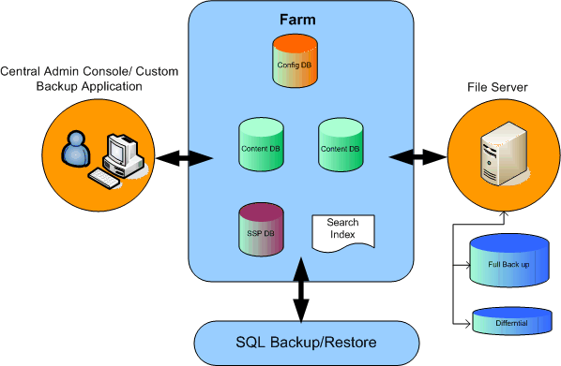
Figure 1 - Backing up a SharePoint environment.
When using the built-in backup functionality for SharePoint, critical components and data are backed up at once including Web pages within a Web site, files in document libraries or in lists, security and permission settings, and feature settings. After a Web site is backed up, it can be restored to either the same location or a new one. Selection of the right backup tools depends on the size of your environment and the experience level of the IT administrator. Specifically, the following areas of your SharePoint deployment need to be backed up regardless of the methods chosen:
- All Servers and all drives in the SharePoint farm including system state. This includes the metabase, system state, home directories, Web configurations, install path, custom assemblies, binaries and code, customizations, site definitions, list definitions, IIS logs, event logs, etc.
- SQL databases. The SQL database stores all data and nearly all configuration components, so a reliable backup is vital.
- Index. The index is propagated to the query servers, but cannot be recovered from there if there is a system failure, drive, sector or file corruption. Two ways to back up the index manually are via the Stsadm utility and via the Central Administration application. These two tools can be used interchangeably and are discussed in detail below.
While there are many methods and tools to perform a SharePoint backup, they do not all scale equally. Some SharePoint backup tools are best used in small SharePoint environments while others are designed for larger scale SharePoint deployments and provide additional functionality across multiple servers. As an IT professional, you may wish to employ the tools shown in the table below. However, one of the best administrator tools for comprehensive backup and restoration of the SharePoint environment is System Center Data Protection Manager (DPM) 2007, which we will discuss later in the paper.

The following table is a comprehensive list of the backup options available to you through Windows and SharePoint services:
SharePoint Utility | Description
Volume Shadow Copy Service | Used to define and create point-in-time copies of storage data. VSS is one of the better ways to provide continuous live backup for SharePoint and is essentially a “hands-off” solution. DPM 2007 uses VSS to back up SharePoint and its databases.
Native SQL Server Backup & Restore | Used to back up all SQL databases. Since the bulk of SharePoint data is stored in SQL this should already be a step in your overall backup process. However, if a different team in your company handles SQL backups, you may rely on that team for the SQL restore. Note that if SQL only is restored, there is a chance that other files essential to the SharePoint deployment will not be restored.
SQL Database Mirroring | Provides redundancy by mirroring data in another location. Used to provide location, data and hardware fault tolerance. Not truly a backup mechanism because it does not present “point-in-time” backup. It is good for fault tolerance and should be considered in terms of providing availability of the SharePoint system.
SharePoint Backup and Restore (Central Admin) | A UI-based backup for server farms including services like Index, which includes full and differential backup. This is a bare minimum capability provided by SharePoint for backup and restore. For increased protection and more sophisticated backup capability, System Center using VSS (discussed below) should be used.
Stsadm Utility – (Stsadm –o backup/restore, Stsadm –o export/import) | Provides full, differential and partial backups of services or individual Web apps, site collections and sites. Does not require Microsoft SQL Server 2000 or SQL Server 2005 tools. There must still be an administrator on the local server computer that is hosting Central Administration in order to perform this method of backup and restore. If you have multiple and dispersed SharePoint servers you’ll need security access to each one in order to use this utility.
SharePoint Designer | An end-user means of backing up a site or site collection. It is good for very small environments, but does not scale as well for SharePoint management environments that are widely dispersed across multiple departments.
Recycle Bin | Available out of the box and when a Web app is created. Files, lists, and list items are retained for 30 days (configurable) before deletion. The second stage, called the “site collection admin stage”, allows you to recover documents deleted by users.

Managing and Protecting SharePoint Services with System Center
The best approach to monitoring and safeguarding a SharePoint deployment is through System Center. System Center is a family of leading IT management solutions that helps IT departments proactively plan, deploy, manage, and optimize an IT environment. In addition to SharePoint, System Center solutions manage systems and applications your company already has implemented, including Microsoft SQL Server, Microsoft Exchange Server, the Microsoft Office system, and the Microsoft .NET Framework.

The System Center management solution includes a comprehensive set of tools that provide seamless support for both virtual and non-virtual environments. For enterprise or departmental environments, Microsoft offers the Server Management Suite Enterprise—a license that brings together all of the capabilities needed for complete comprehensive, life-cycle management of the SharePoint environment. For small to midsize organizations, Microsoft offers System Center Essentials, which provides the basic elements of the System Center suite.

The following sections provide an overview of the System Center components:

System Center Operations Manager
Operations Manager helps you solve the end-to-end SharePoint service management challenge. Operations Manager provides easy integration with Microsoft software and applications and intelligent monitoring and reporting, helping you increase efficiency while enabling greater control of your SharePoint environment. SharePoint Management Packs are available to extend Operations Manager with best practice knowledge to discover, monitor, troubleshoot, report on, and resolve problems for SharePoint Server and end-to-end SharePoint services.

System Center Configuration Manager
Configuration Manager drives IT productivity and efficiency by reducing manual tasks and by enabling secure and scalable operating system and application deployment. This tool provides configuration management capabilities for SharePoint environments, enhanced system security, and comprehensive asset management of servers, desktops and mobile devices. Since proper configuration of the SharePoint server is key to continued availability, Configuration Manager is a critical foundational component for configuring SharePoint deployments.

System Center Data Protection Manager
Data Protection Manager (DPM) continually protects and reliably recovers data on Microsoft application and file servers, and delivers full data protection for your SharePoint deployments. DPM presents data to the administrator for protection in their native format. For example, file servers can be protected by choosing server shares, SQL servers can be protected by choosing SQL instances and databases, and Exchange servers can be protected by choosing storage groups. A SharePoint administrator simply selects the SharePoint Farm as a single root object, along with the Index object. DPM then identifies all of the data components and servers necessary for protection. Therefore, an administrator with limited technical background can back up and restore their SharePoint environments with greater confidence.

System Center Virtual Machine Manager
Administrators can use Virtual Machine Manager (VMM) to centrally manage the entire SharePoint virtual server environment. Customers, like DigiTurk, have shown that VMM reduces managerial load by up to 50 percent. VMM provides unified management of physical and virtual machines and consolidation of underutilized physical resources. With VMM, SharePoint farms can be deployed quickly while maintaining configurations and providing virtual snapshots for fast recovery. VMM is the ideal management tool for SharePoint administrators tasked with the maintenance of virtualized SharePoint farms, as it provides valuable tools that allow for rapid provisioning of new SharePoint front-end servers, conversion of physical servers to Hyper-V guests and other management tasks. VMM can manage both Hyper-V guests and VMware Virtual Infrastructure 3.

System Center Essentials
Essentials is designed to help IT professionals in small and midsize organizations (up to 500 PCs and 30 servers) efficiently secure, update, monitor, and troubleshoot their IT environments. Essentials is a unified management solution that helps optimize a broad set of tasks across an IT environment. It provides a single console from which administrators can view and manage all servers, clients, hardware, software, and IT services and helps administrators proactively monitor their IT environment, simplifies complex management tasks, and automates system updates and data collection.

Management Packs
Management packs for System Center are the building blocks that extend management capabilities to operating systems, applications, and other technology components. A management pack contains best practice knowledge to discover, monitor, troubleshoot report on, and resolve problems for a specific technology component. Management packs include health models to analyze the performance, availability, configuration and security inputs, as well as the status of related components, helping administrators determine the overall status of components. The management packs are developed by the same teams who develop the products, so the expertise and knowledge included comes from the most knowledgeable source.
Microsoft recently introduced two management packs for SharePoint: the Microsoft Windows SharePoint Services 3.0 Management Pack and the Microsoft Office SharePoint Server 2007 Management Pack.
Managing SharePoint Using Models
Management packs, available as a download to System Center customers, contain best-practice knowledge to proactively discover, monitor, troubleshoot, report on and resolve problems. When the SharePoint Management Pack detects issues that may cause service or performance degradation, it alerts systems administrators and facilitates diagnosis and corrective action. Through comprehensive, rollup reporting, the SharePoint Management Pack quickly brings any failures or configuration problems to the attention of IT administrators.
These management packs, discussed in greater detail in the next section, extend System Center Operations Manager and System Center Essentials to give administrators greater visibility into the health of a SharePoint environment. This increased monitoring allows them to more accurately pinpoint potential failures and maintain greater stability of the system.

Monitoring SharePoint
Assuring peak performance and availability of your SharePoint environment requires that all the servers and applications providing the SharePoint service are operating as expected and that there are no situations that may quickly (or slowly) evolve into critical incidents. For example, simply checking to see that the SharePoint server is running won’t tell you that the Index server isn’t operating as expected and that new files are not being indexed. Comprehensive monitoring of the end-to-end SharePoint service is required.
Through its model-based monitoring capabilities, Operations Manager delivers best-of-breed monitoring and management of Microsoft-based environments and applications. When coupled with the SharePoint Management Packs, administrators are able to monitor their SharePoint deployments with greater ease and accuracy, helping to ensure that SharePoint health and performance is maintained. As described above, small to midsize organizations can also use the SharePoint Management Packs with their Essentials deployment.
The SharePoint Monitoring Toolkit is a solution accelerator that contains the management packs for Operations Manager and Essentials to facilitate the management of SharePoint environments of all sizes. The SharePoint Management Pack can also be downloaded from Microsoft as a standalone pack and not as part of the SharePoint Monitoring Toolkit.

The SharePoint Management Packs have been architected with the following enhancements:
- Extended rules for gathering SharePoint data
- New and improved reports with little or no configuration required
- Additional actions based on expanded rules
- New views of critical SharePoint functionality
- Elimination of backward compatibility dependencies
- Increased reliability of the overall reporting and monitoring system
- Thoroughly tested compatibility of management packs with System Center Operations Manager 2007, System Center Essentials, and Microsoft Office SharePoint Server 2007 SP1
The management packs monitor the health state of the components in your SharePoint environment that affect performance and availability. When an issue arises that may cause service or performance degradation, Operations Manager uses the management packs to detect the issue, alert you about the issue and facilitate diagnosis to take corrective action. This is accomplished through a process known as roll-up reporting where lower level alerts are passed up the hierarchy and are clearly visible in the Operations Manager consoles.

You can monitor the following applications with the SharePoint Management Packs:
- Windows SharePoint Services 3.0 related services (timer, tracing and search)
- Windows SharePoint Services 3.0 related events
- Web server applications such as Internet Information Services (IIS)
- IIS-related events
- Microsoft SQL Server database-related events
- WSS Server performance
The management packs also provide the knowledge and expertise you need to monitor MOSS 2007, quickly bringing any failures or configuration problems to your attention. This increases the availability and performance of your SharePoint environment by alerting you of the following conditions:

- Shared Services Provider (SSP) provisioning failed
- Site directory scan job failed
- Enabling features failed on some sites
- Administration site for the SSP is missing
- Enabling features on existing sites failed
- The Office SharePoint Server Search Service is not running
- The Microsoft Single Sign-on service is not running
- The Office Document Conversions Launcher service is not running
- Failed to connect to parent server farm
- SSP synchronization failed
- The Office Document Conversions Load Balancer service is not running
- Failures in content deployment jobs
- Poor cache performance
- Error during document copy or move operations
- Errors with the Information Rights Management (IRM) features
- Failures in the Document Conversion feature
- Out of Memory exceptions coming from business logic
- Denial of Service scenarios
- Failures during form processing or while loading business logic assemblies

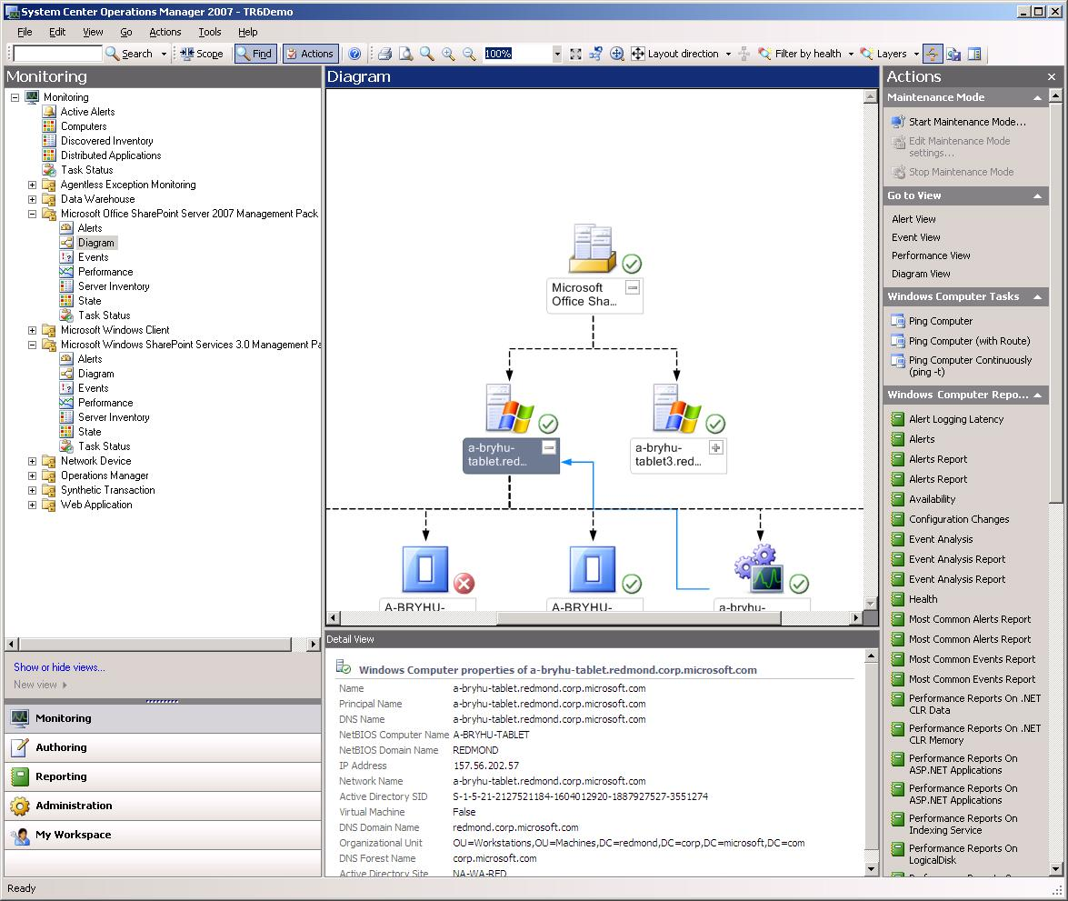
Figure 2 - Monitoring SharePoint with System Center Operations Manager.
The critical conditions that the SharePoint Management Pack monitors are summarized in the following reports that can be easily viewed through the System Center reporting console. Rules can be defined to alter how and when data is gathered, influencing the contents of these reports.

- Alerts Report
- Most Common Alerts Report
- Event Analysis Report
- Most Common Events Report
- .NET CLR Data Performance Report
- .NET CLR Memory Performance Report
- ASP .NET Applications Performance Report
- Indexing Service Performance Report
- Logical Disk Performance Report
- Memory Performance Report
- MOSS Search Performance Report
- Network Interface Performance Report
- Paging File Performance Report
- Physical Disk Performance Report
- Process Performance Report
- Processor Performance Report
- System Performance Report
- Web Service Performance Report across your SharePoint environments.

To help SharePoint teams meet and report on service level targets, the Service Level Dashboard for Operations Manager, a solution accelerator available as a download, provides the ability to monitor availability and performance for the entire SharePoint service from both the user’s perspective and from a backend perspective. Top-level views and drill down capabilities let administrators investigate and resolve problems before they affect service levels.

Assuring the Desired Configuration of SharePoint
Configuration Manager delivers the ability to assess, deploy and update configurations across your Microsoft-based servers and applications. Through configuration packs imported into Configuration Manager, the configuration items detailed within the configuration pack can be targeted to collections of systems. These systems are then audited for compliance with the recommended configurations. When settings are detected to be out of compliance, events will be generated and sent to the Configuration Manager server where the data is available for reporting. Alerts can also be forwarded to the Operations Manager console through the respective management pack for System Center Configuration Manager 2007. This enables early detection of potentially detrimental configuration settings and allows administrators to correct them before they cause downtime or security incidents.

To aid administrators in determining best practices for configuring the SharePoint environment, configuration packs were created for both Microsoft SharePoint Portal Server 2003 and Microsoft SharePoint Server 2003. These configuration packs define recommended configurations based on a substantial number of settings affecting the configuration of the SharePoint environment within Microsoft. A partial list of the included configuration items is made available through the Basic Configuration Pack, with more extensive configuration items and settings being available through the intermediate version of the configuration pack.

While these configuration packs for SharePoint deliver best-practice configuration information, administrators can modify the configuration pack by changing the value(s) for given settings-based configuration items, or by adding or removing configuration items from the model. The Microsoft SharePoint Portal Server 2003 MSIT Intermediate Configuration Pack includes configuration items for the following:
- SharePoint Core
- Core MidMarket Server (MMS)
- Core SharePoint Portal Server (SPS)
- Internet Information Services (IIS)
- Indexer
- Searcher
- SharePoint Portal Server (SPS)
The Microsoft Office SharePoint Server (MOSS) 2007 MSIT Basic Configuration Pack includes configuration items for the following:

- MOSS Core
- MOSS HealthCheck
- MOSS Index
- MOSS Web Front End (WFE)
- WSS Core
With Configuration Manager, organizations can ensure that all systems in the SharePoint environment comply with desired configuration states to improve systems availability, security, and performance.

Protecting Your SharePoint Data
Microsoft recognized the need to simplify the backup and restore process for a SharePoint administrator. One of the best tools for performing backups of a SharePoint network is Data Protection Manager 2007. DPM understands the advanced and distributed architectures of SharePoint that often cause other data protection tools to fail. DPM provides flexibility for an ever-changing environment through the following capabilities:
- Adding/Deleting SharePoint Content. DPM utilizes the Volume Shadowcopy Service (VSS) writer to alert the administrator console whenever content databases on an SQL server are added or deleted. The administrator acknowledges the notification within DPM and a new server is protected at the next backup cycle.

- Protecting all pertinent SharePoint data. When DPM is used, all SharePoint data (including SQL Server databases, metadata with Web servers, farm configuration servers, files and indexes for search) are backed up. There is no need for an administrator to remember what specific components need backing up. The wizard-driven interface allows point-and-click configuration. The backup of specific SharePoint components is automatically handled in the background.

- Protecting SharePoint 2003 and Windows SharePoint Services 2.0. Although these products do not provide a native VSS writer, DPM can still protect the underlying SQL Server databases and the metadata that comprises the SharePoint solution making the administration of these applications much easier.

DPM presents the data to be protected in the same context as users access it and allows platform owners to manage backups from the perspective of the application. For example, SharePoint administrators simply select the farm to be protected and DPM understands what components need to be backed up. Similarly, SQL Server administrators choose SQL databases, Exchange administrators select storage groups, managers of virtual environments choose virtual machines and file server owners choose file shares.

The limitations of Windrush’s existing data backup solution put the company at serious risk for significant data loss should an error occur. As the business moved toward becoming a 24-hour operation, the downtime required for daily backup was becoming an issue. With System Center Data Protection Manager, Windrush was able to decrease the time required to perform backups by 50% and limit their data loss window of liability by 98% from 24 hours to just 15 minutes.

“It really made sense to us to deploy a backup solution that was built specifically for those products.”
– Windrush Frozen Foods
DPM continuously protects the core Microsoft server workloads to a DPM server, which then provides disk-based recovery and tape-based, long-term archival storage for a complete data protection and recovery solution.

After an initial baseline copy of SharePoint data, DPM utilizes the SharePoint VSS writer and underlying component VSS writers to identify changes in the entire production farm and content databases – and only sends the updated blocks to be backed up. This provides a complete and consistent image of the data files on the DPM server or appliance. DPM maintains up to 512 shadow copies containing only the granular changes between one SharePoint backup and the next.

Managing the Virtual SharePoint Environment
More and more organizations are taking advantage of virtualization to deploy SharePoint environments. Microsoft System Center Virtual Machine Manager (VMM) is a cost-effective solution for IT professionals to manage and deploy their virtual infrastructure. VMM provides unified management of both physical and virtual machines and allows rapid provisioning through the use of templates. Organizations can roll out a new SharePoint farm on-the-fly with consistent configurations for test and QA, for example. VMM can also assist in performing a physical to virtual conversion allowing organizations to transition their physical servers to a virtualized solution.

VMM and DPM together can provide an effective disaster recovery solution. With the creation of a SharePoint server template in VMM, new servers can be quickly added to existing farms or a server can be created on the fly, which can be used to create a disaster recovery farm for the SharePoint environment. In a disaster recovery scenario, this provides significant time to recovery benefits over traditional physical server build models. DPM then provides a robust protection mechanism of the entire SharePoint infrastructure and enables restoration to a recovery farm. With DPM’s near continuous protection, your window for data loss minimizes to as little as 15 minutes.

SharePoint Management Scenario
To best illustrate the capabilities of System Center, the following scenario shows how a company with a geographically dispersed SharePoint deployment utilized some of the key alerts found in the SharePoint Management Pack. This company uses System Center Operations Manager to monitor their entire network. They have also installed the Management Pack for MOSS 2007. The deployment of these tools allows the company to monitor critical functions such as the health of SQL and IIS – two backbones of SharePoint deployments.

Through roll up reporting and the graphical console, the IT administrator can monitor all services and applications running on their network. When an alert is discovered, it is shown on one of the console servers and is easily identified. The network administrator clicks on the icon to gather further information about the alert. Event logs will display critical troubleshooting data such as Event IDs, Event Source, Event Description and Alert Types (Error, Warning, and Informational). A knowledgebase also provides additional information on problem resolution and causes. The administrator also takes a few minutes to review the “Most Common Alerts” report in the Reports tab to see when the alert occurred and how many times it has occurred over a specific duration of time.
Disaster Recovery for SharePoint
Server virtualization can be used to enable accelerated disaster recovery capability –
without the need for staging expensive similar hardware at an alternate location –
and streamlining provisioning and data restoration processes. Using VMM, you can create virtual copies of your physical servers and then recover your key physical servers through virtualization without the need for similar hardware.

After review, the administrator determines that the Single Sign-On service has shut down, causing users difficulties in accessing the SharePoint system. Since the service is shut down, the administrator’s first step is to start up the service again. The administrator will perform the task “Start MOSS SSO Service” which starts the service. After a minute or so, the administrator can check the task status to see that the service has been properly restored.

Summary
As SharePoint deployments proliferate, administrators are seeking better tools to manage the health and availability of their deployments. With a need to ensure services and data availability, determining that frequent and routine backups occur, and that the service is monitored end-to-end is critical to managing the health of a SharePoint network.

- There are many tools to provide SharePoint backups each with strengths and weaknesses. Data Protection Manager is the most comprehensive backup and restore application available for SharePoint. DPM provides the strengths of continuous data protection along with a wizard-driven interface to quickly select the applications for backup. DPM takes the guesswork out of performing SharePoint backups and allows an administrator to focus on other aspects of their SharePoint deployments such as Web development and content access. Acting together with Virtual Machine Manager, DPM provides an efficient and effective solution for SharePoint disaster recovery.

System Center is the best solution available for monitoring and managing SharePoint environments The SharePoint Management Packs extend System Center Operations Manager and System Center Essentials to the specific applications supporting the SharePoint service including IIS and SQL. These management packs provide critical health data and alerts for the core components of SharePoint. Through configuration packs, Microsoft System Center Configuration Manager allows you to assess, deploy and update SharePoint server configurations.

Microsoft’s System Center is the management solution that ensures maximum services availability for SharePoint services. System Center limits the window of liability for data loss for a single file, a single server or the entire site by 98 percent. System Center provides unified management of both physical and virtual machines and allows rapid provisioning through the use of templates. Out-of-the-box, System Center builds its foundation on deep domain knowledge of the SharePoint environment, driving a faster time to value for your enterprise and its users.

The information contained in this document represents the current view of Microsoft Corporation on the issues discussed as of the date of publication. Because Microsoft must respond to changing market conditions, it should not be interpreted to be a commitment on the part of Microsoft, and Microsoft cannot guarantee the accuracy of any information presented after the date of publication.
This white paper is for informational purposes only. MICROSOFT MAKES NO WARRANTIES, EXPRESS OR IMPLIED, IN THIS
DOCUMENT.
Complying with all applicable copyright laws is the responsibility of the user. Without limiting the rights under copyright, no part of this document may be reproduced, stored in, or introduced into a retrieval system, or transmitted in any form or by any means (electronic, mechanical, photocopying, recording, or otherwise), or for any purpose, without the express written permission of Microsoft Corporation.
Microsoft may have patents, patent applications, trademarks, copyrights, or other intellectual property rights covering subject matter in this document. Except as expressly provided in any written license agreement from Microsoft, the furnishing of this document does not give you any license to these patents, trademarks, copyrights, or other intellectual property.
© 2001 Microsoft Corporation. All rights reserved.
Microsoft, Windows, Office, and SharePoint, are either registered trademarks or trademarks of Microsoft Corporation in the United States and/or other countries.
The names of actual companies and products mentioned herein may be the trademarks of their respective owners.

War on Cost Survey, June 2008
The MP guides for the Operations Management Packs for SharePoint can be downloaded from the System Center Catalog, available at http://www.microsoft.com/technet/prodtechnol/scp/opsmgr07.aspx.

