Get to the right information quickly in Excel 2010
Microsoft® Excel® 2010 delivers new tools that help you search and display information faster and easier. With search in tables and PivotTables® and filter capability directly in PivotCharts®, finding the right data and visual for your analysis is a snap.
 | - Create and Filter in PivotCharts  PivotCharts provide dynamic views for visual analysis and reporting. Excel 2010 adds interactive buttons to the PivotChart so you can filter directly on the chart without having to go back and forth between the chart and the PivotTable.  Step by Step:  1. On the Insert tab, in the Tables group, click PivotTable, and then select PivotChart.  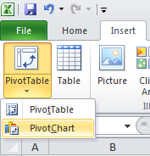  2. In the Create PivotTable with PivotChart dialog box, enter your data range and location where you want your PivotTable and PivotChart to appear, and then click OK.  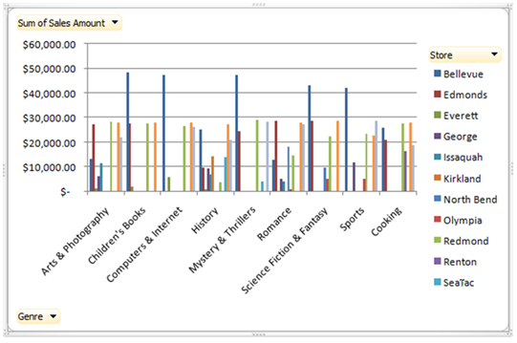  3. In your PivotChart, click one of the interactive buttons (Field Button arrows ), then check or uncheck the check boxes to customize what you’d like to display.
  - Search by Value
  When working with a large number of data, up to thousands – even millions* – of items, the new search feature can help you locate that one important entry quickly.
  Step by Step:
  - Select your PivotTable or table. When searching in tables, make sure your filter is turned on by clicking on the Filter command under the Data tab.
  - Select the downarrow button to the right of the row label heading. In the Search text box, enter the value for which you want to search. For example, you have a PivotTable that shows revenue for all your stores but you only want to look at the revenue from the Redmond Way store. You’d enter “Redmond Way” as the value.
  - Click OK. The resulting PivotTable report will show
  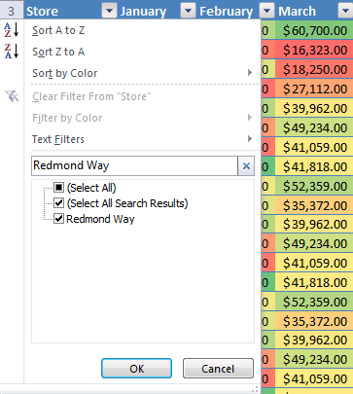
  just the Redmond Way store revenue.
  

