

Service Description For
Exchange Hosted Archive
Version 9.2

Published: July 2010

This document contains sensitive confidential and proprietary information and intellectual property of Microsoft. Review, use, and reproduction is only permitted by you solely as necessary for the purposes for which it was given to you, and solely subject to the terms of your non-disclosure agreement with Microsoft. No further distribution to third parties is permitted.
The information contained in this document represents the current view of Microsoft Corporation on the issues discussed as of the date of publication and is subject to change at any time without notice to you. This document and its contents are provided AS IS without warranty of any kind, and should not be interpreted as an offer or commitment on the part of Microsoft, and Microsoft cannot guarantee the accuracy of any information presented. MICROSOFT MAKES NO WARRANTIES, EXPRESS OR IMPLIED, IN THIS DOCUMENT.
The descriptions of other companies’ products in this document, if any, are provided only as a convenience to you. Any such references should not be considered an endorsement or support by Microsoft. Microsoft cannot guarantee their accuracy, and the products may change over time. Also, the descriptions are intended as brief highlights to aid understanding, rather than as thorough coverage. For authoritative descriptions of these products, please consult their respective manufacturers.
All trademarks are the property of their respective companies.
©2010 Microsoft Corporation. All rights reserved.
Microsoft, Active Directory, Azure, Forefront, Outlook and Windows are either registered trademarks or trademarks of Microsoft Corporation in the United States and/or other countries.
The names of actual companies and products mentioned herein may be the trademarks of their respective owners.

Contents
Microsoft Exchange Hosted Archive Overview and Benefits 5
Enterprise Class Reliability and Security 5
Simplified Management 5
Accelerate Time to Value 5
Introduction 5
Protect 6
Hosted Services Security 6
Network and Infrastructure 7
Data Centers 7
Administration 8
Roles 8
Directory Synchronization 10
Additional Administrative and Security Features 10
Preserve 11
Capture Messages and Content Types 11
Storage 13
Retention and Disposition 14
Data Imports 15
Discover 16
Search and Export 16
Search 16
Export 17
Restore 18
Interface 18
Supervision and Review 19
Prove 21
Reports 21
Logging and Auditing 22
Additional Services 23
Support 23
Related Links 23

Microsoft Exchange Hosted Archive Overview and Benefits
Microsoft® Exchange Hosted Archive (EHA) is a Microsoft Online Service and is available as an optional service in conjunction with your Microsoft Exchange or Exchange Online implementation. Exchange Hosted Archive provides an enterprise-class service to assist businesses with their compliance, regulatory and e-discovery challenges while simplifying a company’s environment, enabling cost savings and easing the burden on IT.

Enterprise Class Reliability and Security
Help organizations to implement security requirements for business critical data by using multiple methods to help organizations protect and control data. Additionally, skilled administrative and operations teams can leverage some of the latest security tools, processes and technologies to help protect the reliability and security of your data.

Simplified Management
Free up IT. One of the core benefits of a service hosted by Microsoft is that skilled teams are in charge of operations, security performance, monitoring and capacity planning. Your business can have access to years of knowledge through 24x7 support teams, administrative guides and training materials. An in-the-cloud service backed by service level agreements can help simplify your IT environment and free up your IT personnel to focus on strategic projects and business core competencies. Exchange Hosted Archive can help further reduce the burden on IT staff by providing role-based self-service access to EHA’s centralized data repository so HR, legal, compliance contacts and end users can have direct access to EHA for message search, retrieval and restoration purposes.

Administer systems with ease. Exchange Hosted Archive provides an easy-to-use interface and simple workflows to help maximize the use of features and functionality with less training time. Easy-to-use interfaces and workflows help your IT administrators to easily manage a complex, centralized and multi-functional archive.

Accelerate Time to Value
Simplify on-boarding from months to minutes. Exchange Hosted Archive is typically simple and fast to deploy without requiring design work or expensive consulting services. EHA provides support and deployment experts to provide documentation and materials to help your business get up and running quickly. EHA also has an intuitive and friendly interface which can reduce training times for both your IT personnel and end users.

No capital investment. EHA requires no additional hardware or software purchase* and no implementation or deployment fees**. You can sign up for services without worrying about data center space allocation, capacity planning or asset management for your e-mail archive.
Stay up-to-date. Currently, with an Exchange Hosted Archive subscription you will have access to future versions of EHA as a free upgrade. Microsoft manages hot fixes and upgrades which helps to reduce the complexity of migrations, trials and upgrade project management. Your IT can spend less time on maintenance of existing technology and focus on enabling new capabilities for your business.
* Hardware and software upgrades may be necessary. Please see the technical requirements list at the bottom of the following webpage: http://www.microsoft.com/online/exchange-hosted-services/archive.mspx
** Fees to import legacy data may apply.

Introduction
Message retention has become a way of business life, increasingly crossing different corporate initiatives. IT walks a tightrope between optimizing the messaging environment and allowing users to save additional e-mail. Departments such as Legal and Human Resources increasingly need to retrieve messages related to an investigation. Industry related regulations and corporate governance policies often include guidelines or mandates for message retention.

There are many overlapping forces that can make understanding general IT requirements difficult to break down. The sets of laws that affect the way an organization is directed, the processes and policies driven by business requirements and the corresponding challenges can be viewed in a way which can be described as Organizational Governance; this model consists of four themes: protect, preserve, discover and prove.

Fig. 1

- Protect encompasses policy, administrative and security requirements to help prevent businesses from falling out of compliance.
- The Preserve pillar describes typical security requirements for keeping information that organizations need to keep for business or legal reasons for specified time periods.
- Discover illustrates finding information that has been kept to take action upon it at some point such as for litigation, regulatory audits or internal investigations.
- Prove spans across all three other pillars and depicts being able to track and monitor actions to prove organizations did what they are supposed to do for auditing purposes.

Today’s business demands the need for a centralized, easily accessible and multi-functioning message repository. Microsoft Exchange Hosted Archive (EHA) can assist with this enterprise goal: explore how using the Organizational Governance model.

Protect
The Exchange Hosted Archive (EHA) takes a multi-faceted approach to helping organizations protect their business and customer data from the physical infrastructure aspect, to highly developed processes behind the services and administrative features within the software available to an organization’s IT administrators.

Hosted Services Security
A key tenet of Microsoft’s Online Services model is provision of security technologies. Microsoft Online Services including Exchange Hosted Archive incorporate many layers of security features including physical, access, logical, network and product security. Microsoft utilizes some of the latest and most efficient tools, technologies and processes run by skilled administrative and operations teams in order to provide a security-enhanced environment.

Some key practices are:

- Regular penetration testing: Provides an additional level of feedback to administrators.
- Using the Microsoft Trustworthy Computing Security Development Lifecycle (SDL) to develop software
- Approaching security and privacy as an ongoing effort that combines experienced and qualified personnel software and hardware technologies; and robust processes to design, build, deploy, operate, and support the service
- Applying risk management best practices based on Microsoft Operations and Solutions Frameworks

Microsoft Online Services including EHA encompasses the best practices from years of experience gained by Microsoft and its partners in designing, building and deploying Web-based platforms for hosting services.

Detailed information on how Microsoft Online Services approach security can be found within the Exchange Hosted Services Network Security document, the Microsoft Online Security Whitepaper and MSDN.

Network and Infrastructure
The Microsoft Exchange Hosted Archive uses the Forefront Online Protection for Exchange (FOPE) Network which is powered by a global network of data centers based on a fault-tolerant and redundant architecture. Figure 2 shows the physical location of the data centers that make up the global network. If a data center is suddenly unavailable, traffic is automatically routed to another data center without interruption to service. Multiple Microsoft servers in each data center accept e-mail on the customers’ behalf, providing a layer of separation between their servers and the Internet. Furthermore, Microsoft algorithms analyze and route message traffic between data centers to ensure the most timely and efficient delivery. Unwanted and potentially damaging e-mail is blocked or quarantined, and e-mail marked as legitimate is forwarded directly to customers’ email servers. On average, Microsoft receives scans and delivers e-mail to customers’ e-mail servers in a fraction of a second.

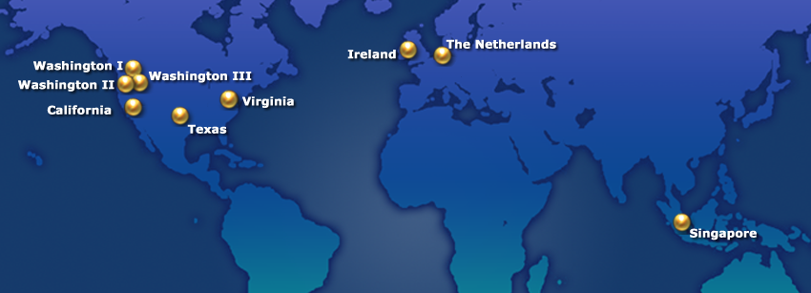
Fig. 2

This approach, built on a distributed server and software model, has proven successful in helping customer’s protect their corporate networks and e-mail servers from common threats, such as damaging worms, denial-of-service assaults, directory harvest and dictionary attacks, and other forms of e-mail abuse.

IT resources can increase security and compliance benefits by combining Forefront Onilne Protection for Exchange with its powerful filtering capabilities and the Exchange Hosted Archive, which is embedded within the network.

Data Centers

Microsoft Online Services including the Exchange Hosted Archive are delivered to customers through a network of global data centers, each designed to run 24 x 7 with N+1 redundancy and employing various measures to help protect them from power failure, physical intrusion and network outages. These data centers comply with leading industry standards for physical security and reliability and are managed, monitored and administered by Microsoft operations staff. The Exchange Hosted Archive storage datacenters are located in Washington, Texas, Ireland and the Netherlands.

Microsoft uses restricted access mechanisms which are limited to a very small amount of operations personnel who must regularly change their administrator passwords. Physical security measures include but are not limited to 24 x 7 guard service, biometric access controls, video surveillance and restrictive access control lists. More information can be found in the Network and Security Overview and Microsoft Online Security Whitepaper.

Administration
Having proper administrative policies and access controls is one key method to helping to protect data. Exchange Hosted Archive contains rich administrative capabilities including a roles-based permissions model, directory services and other functionality to help your business maintain and protect its critical business data located within the archive.

EHA can help simplify the administrative process with a unified Administration Center for all Exchange Hosted Services including Forefront Onilne Protection for Exchange and the Exchange Hosted Archive.

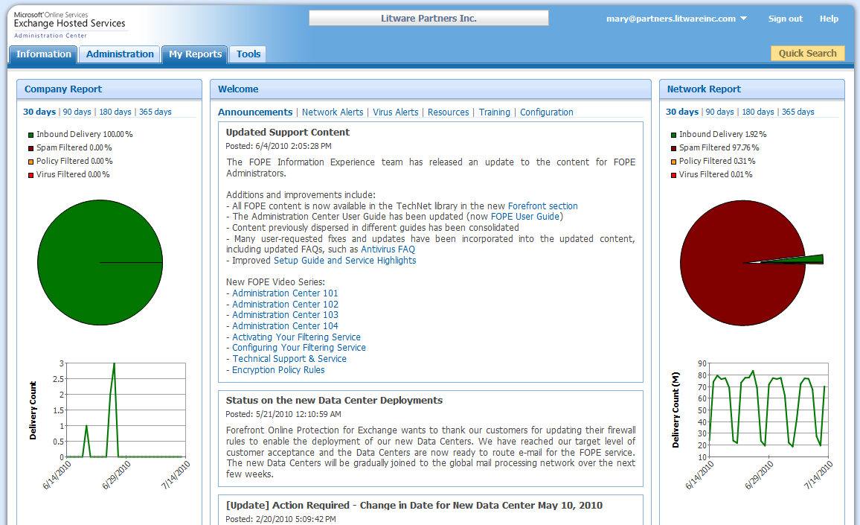
Fig. 3

Roles
Access permissions in the Web-based interface are governed by assigned roles. One or more roles can be assigned to one person, or each role can be assigned to a different person as shown in figure 3. Exchange Hosted Archive also has the flexibility for your organization to create custom roles with certain permissions that can be applied. Custom roles can be created using an existing role with associated permissions as a starting template; this is shown in figure 4. Default roles are listed below.

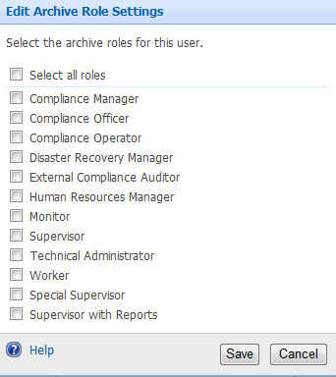Fig. 3 Fig. 4

Roles | Description
Compliance Manager | A compliance manager can view all user e-mail messages and use all Archive Viewer functions.
Compliance Officer | A compliance officer can be assigned supervisors. Like the compliance manager, the compliance officer has the authority to review and clear escalated messages, but only for the assigned supervisors.
Compliance Operator | A compliance operator has most of the rights of the Compliance Manager, but cannot view contents of messages other than their own or messages shared to them.
Disaster Recovery Manager | A disaster recovery manager can view and restore their own messages, send emergency notifications, and run some disaster discovery related reports. You can create a custom role to allow a Disaster Recovery Manager to restore messages for all users.
External Compliance Auditor | An external compliance auditor is an external individual who has access to folders and messages specifically shared to him/her.
Technical Administrator | Technical administrators can run most reports in addition to having access to their own messages.
Monitor | A monitor can access the Review tab in the Archive Viewer to review the messages of the people they supervise.
Monitor Operator | A monitor operator has limited access to user e-mail messages, for the primary purpose of helping to search for messages. A monitor operator cannot view the body of messages. People in this role can, however, tag message results for another person or share the results in a folder with another user.
Supervisor | A supervisor can view and review messages of assigned subordinates, and can annotate and escalate messages for further review.
HR Manager | An HR manager can view their own messages and messages shared to them, and view their own folders and folders shared to them.
Worker | A worker can view and search their own messages, send and receive messages, restore their own messages, create folders for their messages, and export their messages.

EHA’s comprehensive roles-based permission model and ability to create custom roles helps aid your organization in protecting your environment and sensitive data by enabling your administrators to assign users with only the exact level of access they need. This functionality can be an important aspect of your policy and process in order to help reduce your organization’s risk of negative exposure.

Directory Synchronization
The Directory Synchronization Tool (DST) works with Active Directory® synchronization features in the EHA service to keep the archive service up-to-date with respect to new and existing users found within a company’s Active Directory. Synchronization of this information occurs once every 24 hours. This can help you with the administration of the environment since the tool deactivates the accounts for end users who are no longer with the company and are no longer within the AD. These users will no longer be able to access the archive although e-mail that was sent or received to their e-mail address will remain in EHA for the duration of their specified retention period.

Additional Administrative and Security Features
EHA provides many other related features that can allow you to:

- Restrict access to EHA by allowing users to log on only from a specific IP address or any IP address
- Set and enforce password policies
- Reset passwords
- Manage accounts in EHA

Other administrative features such as these can help you protect your archived business data according to your data protection controls and policies.

Preserve
Preserve is another important part of Organizational Governance; in the context of messaging, this can refer to keeping messages that are needed to meet business requirements for a specified period of time. Microsoft Exchange Hosted Archive has functionality which enables your business to capture messages and preserve them until they are no longer required as defined by your corporate policies and automatically delete them at the end of their lifecycle.

Capture Messages and Content Types

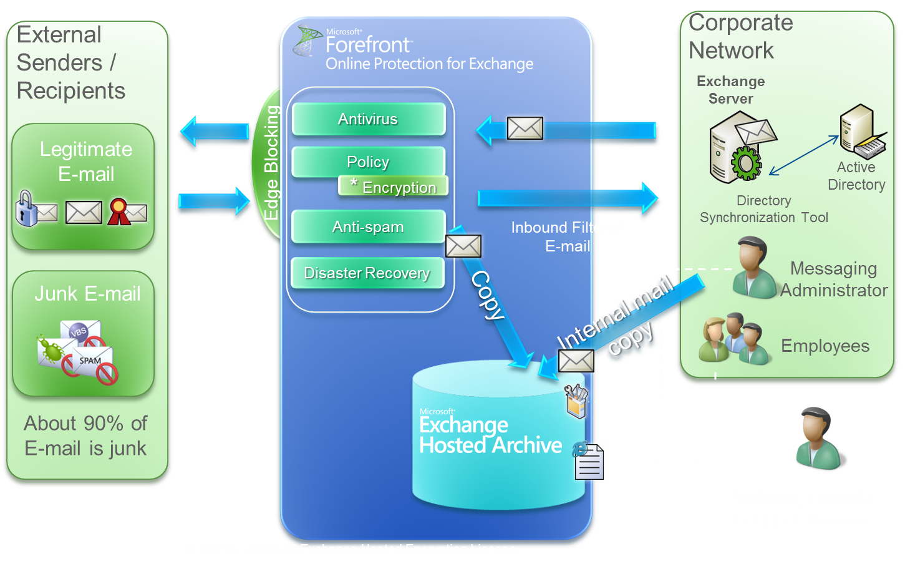
*Requires additional Exchange Hosted Encryption License
Fig. 5

The Exchange Hosted Archive solution is embedded in the Microsoft Online Services network and with both Forefront Online Protection for Exchange and archive subscriptions in place, the online repository benefits from the edge based spam and virus protection features. FOPE receives messages via an MX record redirect, and after being filtered, clean messages are delivered to the corporate mail server. A copy is made and stored in a security-enhanced online message repository. Filtering e-mail before it is archived can help your organization preserve only business e-mail instead of spam and virus infected messages. Keeping only legitimate mail also allows you keep your archive and result sets smaller when you need to search messages for investigative purposes.

Please Note: As of version 9.2, only messages for explicitly provisioned accounts will be archived. If an e-mail message is sent to an e-mail address that is not provisioned in EHA, it will not be archived. Organizations under contract for EHA prior to the 9.2 release will not be shown this behavior. All e-mails to specified domains will be archived unless explicitly changed or contract renewal and will continue to receive unattached/unassociated messages.
Exchange Hosted Archive is optimized to support Exchange environments. The system can support feeds from multiple versions of Exchange to a single repository and also supports both on-premises and hosted versions of Exchange including Microsoft Exchange Online. EHA also supports capture of messages from other messaging systems via customized configuration in which internal messages are sent out to the internet before delivery.

Internal mail can be copied directly from the corporate mail server to the online archive using the journaling function of Microsoft Exchange Server 2000, 2003, 2007 and 2010. In addition, envelope journaling allows BCC recipients of messages to be captured. Additional information on journaling can be found on TechNet.

The flow of the data is illustrated in figure 5. No additional software needs to be installed on your Microsoft Exchange Server environments in order to capture and process e-mail. The following Exchange platforms are supported:

- Exchange Server 2000 SP3 or higher
- Exchange Server 2003 SP1 or higher
- Exchange Server 2007 or higher
- Exchange Server 2010
- Exchange Online

A centralized archive repository for communications allows your business to conduct archiving-related activities, such as searching and monitoring, in a single interface to help streamline your workflow and reduce the time required to perform these tasks.

A variety of instant message (IM) solutions and Bloomberg messaging are compatible with EHA, so that IM conversations can also be archived to the same system. Supported IM systems can be configured to send copies of IM conversations via Simple Mail Transfer Protocol (SMTP). A unique SMTP copy address is issued per customer and those IM sessions are sent to the archive via SMTP. For some certain appliance and IM applications, EHA can present the IM in native IM view but please note that IM messages that cannot be processed this way are captured in the Hosted Archive as a normal e-mail message.

The following platforms are supported along with required format type:

IM Vendor | Format/Version
MessageLabs EIM (Omnipod) | XML v.2
Parlano MindAlign | XML
FaceTime | XML v.2 and text
Symantec IM Manager (IM Logic) | XML
Akonix | Text

EHA also supports Bloomberg E-mail version 1.6 and Instant Bloomberg 1.3. The supported Bloomberg XML formats are:
- Bloomberg Messages
- Bloomberg Attachments
- Bloomberg Disclaimers
- Internet Messages
- Internet Attachments
- Internet Disclaimers
- Instant Bloomberg

Please note: EHA currently does not support the Bloomberg Self Service Retrieval Tool. EHA archives Bloomberg messages that are blind carbon copied to the archive user (BCC) but such messages are archived as e-mail and are not associated as native Bloomberg content. For additional information on Bloomberg please refer to: ftp://Notices:Welcome@ftpcom1.bloomberg.com

EHA can capture RIM BlackBerry messages that pass through an organization’s Exchange Server using BlackBerry Enterprise Server. The BlackBerry Messenger IM service is not currently compatible with the EHA web-based interface. PIN to PIN messages that bypass the Exchange Server environment are currently not captured as well.

The system supports the archiving (for example, capture and storage) of all file types for provisioned accounts so data is not lost or left out, which can lead a business exposed. The archive indexing function handles a variety of commonly-used file attachment types for easy search and retrieval. Encrypted or Rights-Protected messages are stored encrypted so full-text indexing cannot be applied. If a file type cannot be indexed, the e-mail can still be discovered by searching for metadata such as date, sender and recipient, and the e-mail can be restored to its native format. The system will capture and maintain file types such as voice mail messages, so long as they are encapsulated in an e-mail such as Exchange Server 2007 UM voice mail.

All data is captured natively and users can view messages containing foreign characters when restored since EHA preserves the message encoding.

Please note: to display the foreign language character set, the computer must have the appropriate language pack installed. Read about language pack installation at www.support.microsoft.com/kb/283807/en-us

Storage
Exchange Hosted Archive utilizes the same platform as Microsoft SQL Azure, a building block service of the Windows® Azure™ Platform. The archive is a centralized repository which allows you to access all of your archived messages from one service to simplify compliance, e-discovery and investigative tasks. All customer data is logically segmented with stringent controls so customers do not have access to other customers’ data.

All content, including message bodies and attachment data is single-instanced in the EHA repository. A detailed de-duplication process in the service eliminates duplicates, allowing for a model that maximizes storage optimization. A primary copy of all company data is stored and can be accessed by users with the appropriate permissions to view. As an example, if an e-mail is sent to seven recipients with an attachment, only one copy of that e-mail and one copy of the attachment are stored; the seven original recipients and the sender have access to that same message within EHA if they have default Worker role permissions. As messages are archived, each one is fully indexed and serialized with the metadata and message bodies stored in a relational database management system. Attachments are also indexed and serialized as their corresponding messages.. Message indexing enables fast retrieval of items and attachments for e-discovery events, investigative efforts and for emergency e-mail access.

As messages are received, they are also simultaneously sent to a secondary, geographically-distributed datacenter for data redundancy purposes. The datacenters essentially have copies of the same sets of messages since the messages are not copied from one datacenter to the other but are forked to both datacenters for faster failover and data recovery purposes.

Non-tamperable storage is provided by a proprietary combination of hardware and software; the data in the system is read-only. This is especially important for compliance purposes since it is required by many regulations such as the SEC: http://www.sec.gov/rules/interp/34-47806.htm

EHA also contains auditing and reporting functionality to log user and administrative actions for an audit trail of all transactions. More information can be found within the Reports section of this document.

For additional information on how Exchange Hosted Archive is built on the SQL Azure platform, please read the case study.

Retention and Disposition
Exchange Hosted Archive provides flexibility that allows you to select multiple retention periods to help meet your retention needs, which can differ depending on your policies, roles and departments. Multiple retention periods can be established in EHA by your IT administrator to preserve messages for a specified period of time. When your organization is provisioned with EHA, a default retention period must be specified and is recorded in the system as such. Additional retention periods can be added to your company profile. Newly-added user accounts or groups of accounts will fall under the default retention period unless another one of the retention periods is explicitly specified.

The Exchange Hosted Archive supports retention periods set in increments of days, months or years between 1 day and 10 years. The figure below shows how retention policies are configured.

Fig. 6

Individual retention periods apply to the e-mail and Bloomberg XML message streams only – multiple retention periods do not impact any archived Instant Messaging content. All Instant Message content streams will use the default retention period for your organization.

The system automatically tracks message lifecycle and can delete messages according to the specified retention policy. In real time, and based on the message capture timestamp, each message is assigned a set of properties, including an expiration date based on the retention period and a serialized, unique message ID. Destruction of messages and attachments occurs naturally in the system via an automated daily process. This programmatic process is based on capture date and retention period of the message, respecting any legal holds. Legal holds can be applied to the entire organization, domain-wide or on a per user basis to allow messages to be held indefinitely outside of the retention period for litigation and investigation purposes.

When multiple retention periods apply, a message will be retained in EHA by default for the longest of all of the retention periods that may apply.

You can also set a “tombstone” policy to track statistics on messages that have been removed from the system after their expiration period has been reached. The term “tombstone” indicates whether full headers, partial header information or no information is retained after messages have expired and have been destroyed. You can configure a retention period for these tombstones as well. Minimal headers should be selected in order for the Message Destruction Report to provide meaningful statistics. Even if you decide to have a tombstone policy, messages cannot be retrieved from the system once it has been destroyed since only the header information is retained. See figure 6 for how this is configured.

Retention is a key aspect of many corporate data policies and EHA assists businesses such as yours in meeting needs by helping to enforce retention and disposition processes automatically and seamlessly.

Data Imports
Microsoft Exchange Hosted Archive supports the import of existing e-mail to aid businesses in ensuring all of their relevant e-mails can be stored and accessed in a centralized system to simplify the discovery process – whether they are captured and stored in real time or were previously stored in another system. EHA supports this import of existing or legacy data into the EHA repository as an optional service. This import process is limited to e-mail only.

This process is performed by Microsoft support and operations staff. The historical data files must be submitted on an external hard drive or USB memory stick. For small amounts of data, a secure FTP site can be provided. Data must be submitted in .PST file format.

The rate of import varies based on e-mail size, content, attachments and how quickly the data is received. Microsoft support can help estimate how long an import may take after receiving the request and gathering some information from you.

The timestamps used for the imported messages are taken from the “Received:” line of the message header to calculate the expiration date of the message. If data does not contain the original header information, the message will have the following information appended related to the date/time:

- The sent date used will be the “Date:” field of the message, if this exists within the message
- If neither a “Received:” or “Date:” field exists within the submitted message, the date the message is imported will be appended as the “Date:” portion of the message.

Detailed information and instructions on the process can be found in the Upload Historical Data document.

Preserving historical data to its relevant retention period is important to businesses and Exchange Hosted Archive can assist with this to help companies meet their data handling policy goals.

Discover
Once items are preserved, they may be discoverable for purposes such as litigation, external audits, and message restoration due to accidental deletions and internal investigations. All captured messages can be searched within a centralized repository using Exchange Hosted Archive which simplifies the investigative process for IT administrators and related compliance, legal or HR teams. EHA provides the permissions model, user interface and functionality that can empower your business and can significantly reduce the impact to your IT personnel.

Search and Export

Search
Simple and advanced search capabilities help you to respond quickly to business needs whether that means e-discovery requests, message retrievals to recover business data or for internal investigations. Because the Exchange Hosted Archive is on the same platform as Microsoft SQL Azure, you get the benefit of a scalable service with fast search performance in the cloud.

Using this platform allows for faster ingestion of messages so they are quickly indexed using Microsoft SQL’s full-text indexing engine and inserted in the cloud database to enable you to find messages sooner. Messages are captured and indexed in many languages. Metadata and nested files are also indexed; however, messages with nesting levels greater than 50 are only indexed down to 50 nested levels.

Searching for data is also fast; queries are distributed across multiple databases in parallel in the SQL Azure platform and responses are aggregated, which is often referred to as fanning out. This feature allows for fast search responses which is particularly helpful for more complex queries.

Basic searches can include dates, date ranges, keywords in the subject, body and attachments and be limited to specific message size or file type attachments, single or multiple sender/recipient e-mail addresses, domains or names. Figure 7 below shows the search interface for EHA. The system also contains advanced operator functionality for conducting complex searches and proximity searches. The scope of search results shown is also dependent upon assigned roles; for example, an end user assigned the Worker role can only search across his or her own archive and see messages sent and received by him or her.

Fig. 7

You can save search results or selected messages to folders that you create within the archive for easy organization of legal cases or investigations. You can scope a search to a particular folder to further refine your result set. You can also share these folders with others in the scenario where members of a team are working on an investigation together and wish to share and double-check data as shown in figure 8. You can even create an account within the archive for an external user such as external counsel or an outside auditor and share only the data organized within a folder to them to limit the scope of what they have access to and reduce the size of messages they would need to review. This combination of saving search results to folders and folder sharing can facilitate a simple investigative workflow.

Fig. 8

Export
The system can export messages in two formats: a ZIP file containing individual .EML files, or a .PST file. You can select individual messages or select all results from a search or folder to be exported. Once the file is rendered, you can easily download the export to a share or copied to other media, according to your policies as shown in figure 9 below.

Fig. 9

Restore
One or more messages can also be restored to their original internal recipients and the individual conducting a search via SMTP. Restore functionality always delivers a copy of the selected messages to the original internal recipient, even if they are restored to another mailbox. This functionality can be beneficial in the case an end user had deleted an important e-mail out of their mailbox and would like it restored quickly as shown in figure 10. This does not require restoration of a message from backups and can save your end users, support teams and administrators valuable time. More information on this can be found in the Emergency E-mail section of the document.
Fig. 10

Interface
Exchange Hosted Archive utilizes an intuitive, user-friendly web-based interface which helps minimize the need for extensive end user training.

Fig. 11

It is also easy to access the interface within Microsoft Outlook® with Folder Home Pages. This can be accomplished by creating a folder, setting its home page properties to the archive URL and selecting the option to show the home page by default for the folder. Users can simply click on a folder within Outlook to search their archive and restore e-mail within the same tool used for e-mail. IT administrators can set this up for their users automatically via Group Policy, configuration management tools such as System Center Configuration Manager or however the IT administrator would normally push out software or configuration updates.

EHA’s discovery functionality enables businesses to find data quickly, export and retrieve that data, streamline processes by simplifying the capture of different data streams such as e-mail and IM into a single archive and eases the burden on IT by providing functionality for HR, legal and business teams to have self-service access to the information via an intuitive web interface.

Supervision and Review
The Exchange Hosted Archive contains functionality that allows you to monitor your ongoing business communications periodically to help enforce your compliance or quality control policies. Many U.S.-based financial services companies fall within the regulatory arm of FINRA and the SEC; one of these mandates under the FINRA (formerly NASD) rule 3010 is for businesses to review their employee’s business communications to help ensure compliance with regulations. Human Resources, Compliance Offices and other business groups may also utilize this functionality to help ensure departments and employees are adhering to internal corporate governance policies such as those around hiring practices and general business conduct. Organizations may also want to monitor customer service teams’ e-mails to customers to assist with quality assurance.

EHA’s supervision feature allows you to establish supervisor and subordinate relationships and enable a workflow for messages to be monitored and reviewed by supervisors after they are sent. EHA provides the following mechanisms for capturing messages for reviewing:

- Matching keywords/phrases within e-mail, instant messages and Bloomberg messages
- Random sampling of messages based on a specified percentage
- Both keyword and random sampling

Your organization can create custom dictionaries for different business needs, include additional lists and add new keywords in order to capture matching messages. You can also set different sampling percentage rates for inbound and outbound e-mail, instant messages and Bloomberg messages for individuals. You can even perform test compliance searches to help determine if proposed sampling criteria provides expected results or conduct an ad-hoc compliance search as shown in figure 12.

Fig. 12

Messages indicate if they were sampled by keyword match or random sampling; you can highlight keywords when reviewing a message that contains sampled keywords as indicated in figure 13.

This functionality also has associated reports that are useful for audits such as the Supervisory Review Evidentiary Report to determine if your supervisors are reviewing their set of messages in a timely manner. More information can be found in the Reports section of this document.

Fig. 13

Microsoft has the expertise to design, deploy and operate a secure service in a scalable manner with sophisticated administrative functionality to help customers protect their corporate data. Organizations can benefit from the years of Microsoft’s experience around administrative and security practices from developing, testing deploying and operating software as a service worldwide.

Prove
One overarching theme for Organizational Governance is to be able to audit actions taken on and within the archive including sophisticated logging, monitoring and reporting functionality. EHA provides very detailed, granular reporting and auditing capabilities which can be a crucial aspect of security and compliance policies. These tools can aid businesses with their internal or external investigations and play a significant role in audits.

Reports
Fig. 14

Compliance managers, technical administrators and supervisors can choose from a wide selection of reports from e-mail volume and attachment statistics to lists of messages that have reached the end of their retention period and have been destroyed. These reports can be scheduled at regular intervals or run on an ad hoc basis. Some of the available reports are shown in figure 14. Reports are available in multiple formats such as PDF format with Adobe Acrobat 5.0 or higher with PDF inline viewing enabled, Web page (HTML) or Microsoft Excel (XLS).
Once you select a report, you can see a description of the report and can choose from report options as show in figure 15. Figure 16 is a sample of the Activity Summary report which can provide your service management team with a high-level view of messages that are being archived.

Fig. 15
Fig. 16

Logging and Auditing
The archive captures actions taken within the Exchange Hosted Archive’s web-based interface for auditing and monitoring purposes. Within reports, Audit Events enable query-based reports that can track every user’s actions taken within EHA; some of these events are shown in figure 17 below. The resulting tracking report can be used as an audit of actions taken during a specified period of time. Queries can be constructed based on many fields within the interface but the types of events that are available are:

- Access Events
- Customer Events
- Customer Maintenance
- Customer Transaction
- Message Events
- User Administration

These advanced tools assist businesses with a crucial, overarching need for detailed auditing and reporting. IT managers can use this information for decision making, investigations and to help prove adherence to policies.

Fig. 17

Additional Services

Support

Get Help with Technical Support
Microsoft Online Services live technical support staff is ready to deliver solutions quickly and clearly and can be reached with ease; they are available by phone, web form or e-mail 24 hours a day, 7 days a week. The technical support team stays in close contact with you and provides regular updates on issues until all questions have been resolved. Microsoft Online Services technical support will issue a support incident to assist with follow up communication. Additionally, we offer support for customers in Japan with Japanese speaking support staff from 10:00 to 6:00pm local time and you can also use translation services to receive phone support for the following languages: French, German, Korean, Mandarin and Spanish. Native language support in French, German and Spanish will be available starting in 2010.

Assistance at Your Fingertips
Microsoft Exchange Hosted Archive also provides online support tools, including FAQs and step-by-step guides, and comprehensive service tutorials. These documents are available in various languages.

Announcements and Notifications
As an enterprise-class service, Exchange Hosted Archive provides proactive, detailed and regular communications so you and your IT staff are well informed. Announcements, alerts and other notifications such as configuration updates are posted to the Information page of the Administration Center as well as pushed via RSS feeds which you can subscribe to.

Accelerate Time to Value with Implementation Project Managers
Implementation Project Managers (IPMs) are product specialists who are available for qualifying accounts for the first 90 days after service purchase to answer deployment, security, and configuration questions, and to ensure that you benefit from the best service experience and successful implementation. IPMs can work closely with you to manage the initial deployment for your organization and to represent your needs. They provide an additional layer of support and can facilitate supplementary training with your administrative team as needed.

Leverage Microsoft Premier Support
Premier Support for Microsoft Online Services extends the Premier Support framework beyond on-premises products to online services to provide you with a unified support experience across all products and services. This service helps ensure that you can resolve issues quickly and it simplifies the task of managing support for different components of an IT infrastructure.

Microsoft Online Services customers who have a Microsoft Premier Support contract can also obtain support for their services through the normal Microsoft Premier Support channels. This integration allows existing and new Premier customers to receive access to all processes and resources available to Premier Support customers, such as a Premier Technical Account Manager (TAM) and case submission.

Related Links
See the following resources for further information:

- Microsoft Online Services at http://www.microsoft.com/online
- Microsoft Exchange Hosted Services at http://www.microsoft.com/online/exchange-hosted-services
- Microsoft Exchange Hosted Archive Demo Video at http://www.microsoft.com/online/exchange-hosted-services/archive/demo.aspx
- Microsoft Exchange hosted Archive SLAs at http://go.microsoft.com/fwlink/?LinkID=157373
- Microsoft Exchange Server at http://www.microsoft.com/exchange
- Microsoft Online Services Online Training http://go.microsoft.com/fwlink/?LinkID=137241

