
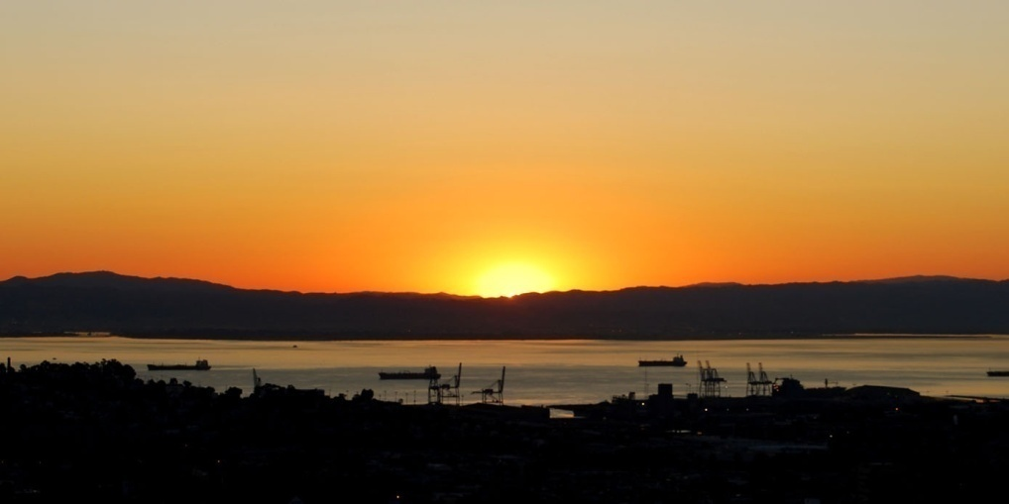

<--- Insert your own image
(2.31″ x 4.36″).

Use grayscale to
save colour ink.
Vacation photos
Backup: June 6, 2008

Europe 2005, California 2007, family reunion back home
Budget, work files, taxes 2002 – 07, insurance list
Backup files
October 17, 2008
Disc: 1 of 2

