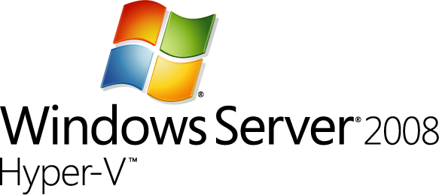 Provisioning Hyper-V Virtual Machine in Hosting Environment

Prepared by

Microsoft Consulting Services
Tuesday, 8 July 2008

Version 0.9

Prepared by

Gang Pan, AcutePath, Inc.

Contributors

Mannan Mohammed, Sr. Architect

Mark Stevenson, Senior Consulltant II

This file does not collect any personal information.
The information contained in this document represents the current view of Microsoft Corporation on the issues discussed as of the date of publication. Because Microsoft must respond to changing market conditions, it should not be interpreted to be a commitment on the part of Microsoft, and Microsoft cannot guarantee the accuracy of any information presented after the date of publication.
This White Paper is for informational purposes only. MICROSOFT MAKES NO WARRANTIES, EXPRESS, IMPLIED OR STATUTORY, AS TO THE INFORMATION IN THIS DOCUMENT.
Complying with all applicable copyright laws is the responsibility of the user. Without limiting the rights under copyright, no part of this document may be reproduced, stored in or introduced into a retrieval system, or transmitted in any form or by any means (electronic, mechanical, photocopying, recording, or otherwise), or for any purpose, without the express written permission of Microsoft Corporation.
Microsoft may have patents, patent applications, trademarks, copyrights, or other intellectual property rights covering subject matter in this document. Except as expressly provided in any written license agreement from Microsoft, the furnishing of this document does not give you any license to these patents, trademarks, copyrights, or other intellectual property.
Unless otherwise noted, the example companies, organizations, products, domain names, e-mail addresses, logos, people, places and events depicted herein are fictitious, and no association with any real company, organization, product, domain name, email address, logo, person, place or event is intended or should be inferred.
© 2007 Microsoft Corporation. All rights reserved.
Microsoft, Outlook, SharePoint, Windows, and Windows Server are either registered trademarks or trademarks of Microsoft Corporation in the United States and/or other countries.
The names of actual companies and products mentioned herein may be the trademarks of their respective owners.

Table of Contents
1 Introduction 1
2 Hosting Scenarios Using Microsoft Hyper-V 1
3 Plan and Design Hyper-V Hosting Environment 2
3.1 Microsoft Hyper-V Architecture 3
3.2 Microsoft Hyper-V Capabilities 4
3.2.1 Supported Host Operating Systems 4
3.2.2 Host Hardware Requirements 4
3.2.3 Hyper-V Virtual Machine Capability 5
3.2.4 Supported Guest Operating Systems 5
3.3 Host Server Hardware Selection 6
3.3.1 Processor 6
3.3.2 Memory 7
3.3.3 Networking 7
3.3.4 Storage 8
3.4 Host Operating System Selection 9
3.5 Virtual Machine Architecture Selection 10
3.5.1 Guest Operating Systems 10
3.5.2 Virtual Machine Processor 10
3.5.3 Virtual Machine Memory 12
3.5.4 Virtual Machine Storage 13
3.5.5 Virtual Networking 3
3.6 Benchmark Hyper-V Hosting Environment 7
3.7 Host Server Capacity Planning 7
3.8 Security Consideration 8
4 Hyper-V Hosting Architecture Models 11
4.1 Sandalone Hyper-V Host Server Architecture 11
4.2 Two-Nodes Failover Hyper-V Cluster 11
4.2.1 Parent-based Failover Clustering with Two Physical Servers 12
4.2.2 Child-based FailoverClustering with Tow Physical Servers 14
4.2.3 Mixed Physical and Virtual Failover Clustering 15
4.2.4 Failover Clustering with Two Child Partitions on One Physical Server 16
4.3 Hyper-V Host Server Farm 18
5 Options for Provisioning and Managing Hyper-V Virtual Machine 18
5.1 Hyper-V Manager 19
5.2 Microsoft System Center Virtual Machine Manager 2008 19
5.3 Custom Solutions 21
5.3.1 Hypercall Interface 21
5.3.2 Hyper-V WMI Provider 21
5.3.3 System Center Virtual Machine Manager 2008 Components and Web Services 22
6 Automate Guest Operationg System Provisioning 23
6.1 Using ISO Image 23
6.2 Using Syspreped Virtual Hard Disk 24
6.3 Using WIM/ImageX 25
6.4 Using Microsoft Deployment Toolkit 26
6.5 Using SCVMM 2008 26
7 Sample of Automated Hyper-V Virtual Machine Provisioning and Management 27
7.1 Sample Code for Commonly Used Commands and Tasks 27
7.1.1 Commands for Configuring iSCSI Storage 27
7.1.2 VHD Creation Using Powershell 28
7.1.3 Creating Virtual Switch/Networks Using Powershell 28
7.1.4 Create Virtual Machine Using Powershell 29
7.1.5 List Virtual Machine Using C# 31
7.1.6 Get Virtual Machine Thumbnail Image Using C# 32
7.1.7 Change Virtual Machine Memory Setting 33
7.2 SolutionKit Sample Application 34
8 Summary 37
9 References 37

Introduction
This whitepaper will discuss different approaches to provision and manage Microsoft Hyper-V virtual machine in hosting environment, especially focus on approaches for automating the processes of provisioning and management perspective, so hosting companies could construct their Hyper-V offers quickly and integrate with their existing environment.
This whitepaper is targeted towards hosting companies that are offering or planning to offer virtualization hosting solutions using newly released Microsoft Hyper-V technology.

Hosting Scenarios Using Microsoft Hyper-V
Today there is more pressure than ever on hosters to provide greater levels of feature and functionality at ever-reducing price points. There is also demand for provisioning of service over a reduced period in order to fulfill a specific short-term requirement, whether at be as a test-bed for development, a web-site for a marketing promotion, or as the central point for a virtual project team.
Virtualization as a technology can address the requirements for shorter term and lower costs dedicated environments and still enable hoster to derive a good return on their hardware investment.
The use of Virtualization technology in the hosting industry can take many forms. One of the more prevalent scenarios is using virtualization to divide up a physical server into multiple virtual dedicated instances. This is often termed
VPS” or Virtual Private Server hosting. The common scenario in dedicated hosting is to provide a physical server of a certain specification that is connected to the internet. Management (typical via terminal services) is the responsibility of the subscriber. In virtual dedicated scenarios, the physical server is replaced with an “instance” of a virtual machine. The service provider typically provides a base OS configuration and the subscriber is responsible for management and operation remotely via terminal services. Hosters could also leverage
Hosting companies could leverage Microsoft Hyper-V in the following possible scenarios:
- Business continuity management
IT administrators are always trying to find ways to reduce or eliminate downtime from their environment. Windows Server virtualization will provide capabilities for efficient disaster recovery to eliminate downtime. The robust and flexible virtualization environment created by Windows Server virtualization minimizes the impact of scheduled and unscheduled downtime.
- Low-cost dedicated servers
Hosting customers require the levels of control over their environment gained through a dedicated server, but demand a lower price point for the facilities. Hyper-V allows the hoster to provide the ownership of a dedicted server to the customer at very attractive price point.
- Server consolidation
Hosting companies could consolidate their low-end web hosting physical servers onto fewer physical servers using Hyper-V to reduce maintenance costs and still meet performance and service level requested by their customers.
- Proof-of-concept deployments
The customer needs to deliver a proof-of-concept for a product or solution without the overhead of hardware purchase. The use of virtualization enables the hoster to provide a fully configured network environment on a single server at no capital cost to the customer
- Software test and deployment
One of the biggest areas where virtualization technology will continue to be relevant is the software test and development area to create automated and consolidated environments that are agile enough to accommodate the constantly changing requirements. Windows Server virtualization helps minimize test hardware, improve lifecycle management, and improves test coverage.
In the following sections, we will discuss few hosting architecture pattens using Microsoft Hyper-V to serve those business scenarios.

Plan and Design Hyper-V Hosting Environment
Microsoft Hyper-V is the new virtualization server role in the Windows Server 2008. Virtualization servers can host multiple virtual machines (VMs), which are isolated from each other but share the underlying hardwar resources by virtualizing the processors, memory, and I/O devices. By consolidating servers into a single machine, virtualization can improve resource usage and power efficiency and reduce the operational and maintenance costs of servers. In addition, VMs an the management APIs offer more flexibility for managing resources, balancing work loads, and provisioning systems.
This section describes the design, hardware, software and support considerations that should be taken into considerations when planning and designing the virtualized hosting environment using Microsoft Hyper-V and suggests best practices that yield increased performance on Microsoft Hyper-V servers.

Microsoft Hyper-V Architecture
Hyper-V features a hypervisor-based architecture that is shown in Figure 1. The hypervisor virtualizes processors and memory, and provides mechanisms for the virtualization stack in the root partition to manage child partitions (Virtual Machines) and expose services such as I/O devices to the virtual machines. The root partition owns and has direct access to the physical I/O devices. The virtualization stack in the root partition provides a memory manager for VMs, management APIs, and virtualized I/O devices. It also implements emulated devices such as Integrated Device Electronics (IDE) and PS/2 but supports synthetic devices for increased performance and reduce overhead.
Root Partition
I/O
Stack
Drivers
Child Partition
I/O
Stack
VSCs
Server
Child Partition
I/O
Stack
VSCs
Server
Hypervisor
Devices
Processors
Memory
VMBus
VMBus
VMBus
Shared Memory
VSPs
VSPs
OS Kernel Enlightenments (WS08+)
Figure 1. Hyper-V Hypervisor-Based Architecture Diagram
The synthetic I/O architecture consists of VSPs (Virtualization Service Provider, which is a provider exposed by the virtualization stack that provides resources or service such as I/O to a child partition.) in the root partition and VSCs (Virtualization Service Client, a software module that a guest loads to consume a resource or service. For I/O devices, the virtualization service client can be a device that the operating system kernel loads.) in the child partition. Each service is exposed as a device over VMBus, which acts as an I/O bus and enables high-performance communication between VMs that use mechanisms such as shared memory. Plug and Play enumerates these devices, including VMBus, and loads the appropriate device drivers (VSCs). Services other than I/O are also exposed through this architecture.
Windows Server 2008 features enlightments (an optimization to a guest operating system to make it aware of VM environments an tune its behavior for VMs). To the operating system to optimize it behavior when it is running in VMs. The benefits include reducing the cost of memory virtualization, improving multiprocessor scalability, and decreasing the background CPU usage of the guest operating system.

Microsoft Hyper-V Capabilities
This section describes the software and hardware requirements and capabilities of Microsoft Hyper-V.

Supported Host Operating Systems
Microsoft Hyper-V is supported in the following operating systems:
- Windows Server 2008 Standard Edition x64 with Hyper-V
- Windows Server 2008 Enterprise Edition x64 with Hyper-V
- Windows Server 2008 DataCenter Edition x64 with Hyper-V
In addition, Windows Server 2008 features the Server Core Installtion option. Server Core offers a minimal environment for hosting a select set of server roles including Hyper-V. It features a smaller disk, memory profile, and attack surface. Therefore, we highly recommend that Hyper-V virtualization servers use the Server Core Installation option. Using Server Core in the root partition leaves additional memory for the VMs to use (approximately 80MB for commit charge on 64-bit Windows).
ServerCore offers a console window only when the user is logged on, but Hyper-V exposes management features through WMI so administrators can manage it remotely. System Center Virtual Machine Manager 2008 also supports Hyper-V in Server Core installation option.

Host Hardware Requirements
Microsoft Hyper-V is leveraging processor level virtualization capability. The following types of processors are required:
- Intel Processor:
  - X64 Processor Architecture
  - Support for Hardware Execute Disable
  - Intel VT Hardware Virtualization
- AMD Processor Requirements
  - X64 Processor Architecture
  - Support for Hardware Execute Disable
  - AMD-V Hardware Virtualization

Host machine running Microsoft Hyper-V also the following minimum hardware requirements:
- CPU Speed: Minimum 1.4 GHz
- Memory: Minimum of 512MB of RAM
- Disk Space: 10GB available hard disk space. Note: Computers with more than 16GB of RAM will require more disk space for paging and dump files.

Hyper-V Virtual Machine Capability
Hyper-V greatly increases the scalability of guest virtual machines in comparison to Virtual Server 2006. Hyper-V guests, when utilizing a supported operating system, are able to support the following options:
- X86 or X64 operating systems
- Up to 4 virtual processors
- Up to 64GB of RAM per guest
- Up to 4 IDE devices
- Up to 4 SCSI controllers supporting up to 64 disks each SCSI controller
- Up to 4 legacy network adaptors
- Up to 8 synthetic network adaptors
Since Hyper-V supports such large guest virtual machines, there is a much larger set of viable workloads that can be consolidated including multi-processor multi-core servers, servers with large disk or I/O requirements etc.
While Hyper-V can support large guest virtual machines, in general it is prudent to only configure each guest with the resources needed. This ensures that resources are available to other guests or future expansion. In the following sections, we will discuss virtual machine storage and networks configuration in details.

Supported Guest Operating Systems
Microsoft Hyper-V supports the following guest operating systems. In particularly, Hyper-V has been tuned for both 32-bit and 64-bit versions of Windows Server 2008 and Windows Server 2003 (SP2 or later versions required) as guest operating system. The VM integration services, which significantly improve performance, might not work on unsupported guest operating systems.

- Windows Server 2008 (both x64 and x86)
  - Up to 4 virtual processors (1, 2 or 4 virtual processors)
  - Standard/Enterprise/Datacenter Editions with or without Hyper-V
  - Web Server
- Windows HPC Server 2008 (x64 only)
  - Up to 4 virtual processors (1, 2 or 4 virtual processors)
- Windows Vista (both x64 and x86)
  - Up to 2 virtual processors (1 or 2 virtual processors)
  - Business, Enterprise and Ultimate Editions
  - Minimum service pack: SP1
- Windows Server 2003 (x64)
  - Up to 2 virtual processors (1 or 2 virtual processors)
  - Standard, Enterprise and Datacenter Editions with or without R2 update
  - Minimum servie pack: SP2
- Windows Server 2003 (x86)
  - Up to 2 virtual processors (1 or 2 virtual processors)
  - Standard, Enterprise, Datacenter and Web Editions with or without R2 update
  - Minimum servie pack: SP2
- Windows XP Professional (x86)
  - 1 virtual processor with SP2
  - Up to 2 virtual processors with SP3 (1 or 2 virtual processors)
  - Minimum service pack: SP2
- Windows XP Professional (x64)
  - Up to 2 virtual processors (1 or 2 virtual processors)
  - Minimum service pack: SP2
- SUSE Linux Enterprise Server 10 (both x64 and x86)
  - 1 virtual processor
  - Service pack 1 or 2
In additional, the operating system kernel in Windows Vista SP1, Windows Server 2008, and later releases features enlightenments that optimize its operation for VMs. For best performance, we recommend that you use Windows Server 2008 as a guest operating system. The enlightenments decrease the CPU overhead of Windows that runs in a VM. The integration services provide additional enlightenments for I/O.

Host Server Hardware Selection
The host server hardware configuration is a critical component of the virtual infrastructure as well as a key variable in the capacity planning and cost analysis. The ability of the host server to handle the workload of a large number of VPS increases the density and helps provide attractive price point of hosting offers. This section outline the major host server hardware selection considerations.

Processor
Windows Server 2008 with Hyper-V requires an x64 processor architecture from Intel or AMD as well as support for hardware execute disable and hardware virtualization such as Intel VT or AMD-V.
Both Intel and AMD provide a wide range of processors that are appropriate for host servers. The industry competition between the two is very tight and at any one time one may have a performance advantage over the other. Regardless of which manufacturer is chosen, several performance characteristics are important.
The number of processor cores is a key performance characteristic. Windows Server 2008 and Hyper-V make excellent use of multi-core processors so the more cores the better. Also important to note is the processor clock speed which is the speed at which all cores in the processor will operate. The clock speed is important because that will be the clock speed of all of the guest virtual machines. This is a key variable in the consolidation ratio since it impacts the amount of candidates the host server can handle AND the speed at which those guests will operate. As an example, choosing 2 GHz processor rather than a 3 GHz processor on a server that will host 20 guests means that all of those guests will run only at 2 GHz.
At lower level of detail, the server processor architectures make design choices in terms of the type and quantity of processor cache, memory controller architecture, and bus/transport architecture. A detailed analysis of these factors is beyond the scope of this document.
Hyper-V in Windows Server 2008 supports up to 16 logical processors and can use all logical processors if the number of active virtual processors matches that of logical processors. This can reduce the rate of context switching between virtual processors and can yield better performance overall.
Hyper-V can benefit from larger processor caches, especially for loads that have a large working set in memory and in VM configurations in which the ratio of virtual processors to logical processors is high.

Memory
The memory architecture choices that remain are typically quantity, speed, and latency. For Hyper-V, the most important memory architecture choice is the quantity of RAM. Most consolidated workloads (i.e. individual guest virtual machines) will require at least 512 MB to 1 GB of RAM or more. Since most commodity four socket servers can only cost effectively support between 32 and 128 GB of RAM, this is frequently the limiting factor in host server capacity.
The quantity or RAM is a more important factor than RAM speed or latency. Once the maximum amount of RAM that is cost effective is determined, if there is a remaining choice between speed and latency, choosing the memory with lower latency is recommended.

The physical server requires sufficient memory for the root and child partitions. Hyper-V first allocates the memory for child partitions, which should be sized based on the needs of the expected server load for each VM. The root partition should have sufficient available memory to efficiently perform I/Os on behalf of the VMs and operations such as a VM snapshot.

Networking
The network architecture of the host server is a frequently overlooked topic in host server sizing since Gigabit Ethernet NICs are now very inexpensive and most servers have at least two built in. The topic is important however because it is directly impacted by host server architecture pattern selected. If one of the two host server cluster patterns is selected, a dedicated NIC per server is required for the cluster private (heartbeat) network. As mentioned previously, if an iSCSI storage architecture is being utilized, NICs will need to be dedicated to storage I/O traffic. Gigabit Ethernet is a high speed network transport, though a host server with a large number of guests may require greater than Gigabit speed thus requiring additional NICs. Finally, it is recommended that each host server have a NIC dedicated to the host itself for network I/O and management.
As illustrated above, a fairly large number of NICs per host server may be required. This is the one factor that can mitigate against blade servers in some instances. Recently, 10-Gigabit Ethernet has become commonly available and is starting to drift lower in price similar to the way Gigabit Ethernet has done over the years. The ability for servers to utilize 10-Gigabit Ethernet NICs is a significant factor in increasing the consolidation ratio.
If the expected loads are network intensive, the virtualization server can benefit from having multiple network adapters or multiport network adapters. VMs can be distributed among the adapters for better overall performance. To reduce the CPU usage of network I/Os from VMs, Hyper-V can use hardware offloads such as Large Send Offload (LSOv1) and TCPv4 checksum offload.
When considering networking configurations for host server, we recommend the followings:
- Use multiple NICs and multi-port NICs on each host server.
- Dedicate one NIC/Port on each host server for network I/O and management of the host itself and do not create a virtual switch using that NIC.
- Dedicate one NIC/Port on each host server to the private (heartbeat) network if the host is part of a server cluster.
- Dedicate at least two NICs/Ports on each host server to the iSCSI network if an iSCSI storage architecture is being utilized.
- Dedicate at least one NIC/Port on each host server for guest virtual machine network I/O. For maximum consolidation ration, utilize one or more 10-Gigabit Ethernet NICs to virtual machine network I/O.

Storage
The disk storage for all guest virtual machines is one or more VHD files housed on the storage system utilized by the host server. Host storage I/O, in addition to the system, processor, memory, and network architectures previously discussed is the final major component of host server sizing. Hyper-V I/O is comprised of a large number of read and write IOPS to the storage system due to the large number of guests running on each server and their various workloads.

The storage hardware should have sufficient I/O bandwidth and capacity to meet current and future needs of the VMs that the physical server hosts. Consider these requirements when you select storage controllers and disks and choose the RAID configuration. Placing VMs with highly disk-intensive workloads on different physical disks will likely improve overall performance. For example, if four VMs share a single disk and actively use it, each VM can yield only 25 percent of the bandwidth of that disk.
If direct attached storage is being utilized, a SATA II or SAS RAID controller internal to the server is recommended as previously discussed. If a storage array and SAN are being utilized, host bus adapters (HBAs) are required in the host server. The HBA provides access to the storage array from the host server. The storage connectivity is a critical component for high availability and performance.
Windows Server 2008 and Hyper-V host servers benefit from many of the same disk I/O performance tuning techniques as SQL or Exchange servers. Dedicating a high speed LUN to the operating system, dedicating a high speed LUN for the page file, and placing virtual hard disk files (.VHDs) and virtual machine configuration files on separate high speed LUNs are recommended. If using the Two-Node or Host Server Farm patterns, the VHD files must reside on shared storage such as a SAN or iSCSI array. Utilize NTFS for all host server volumes.
Hyper-V also provides the option to use pass-through disks which provide the guest with direct access to a LUN without the disk being presented to the host. This feature can be used with the Two-Node or Host Server Farm patterns to avoid the 26 drive letter limitation on a single cluster.
If using a storage array, confirm with your storage vendor the appropriate track and sector values for your storage system and use the Diskpart.exe tool to verify that your disk tracks are sector-aligned. In most cases with Windows Server 2008 this is not necessary but should be verified with your storage vendor.
Periodically defragmenting, pre-compacting, and compacting the VHD files on the guest and defragmenting the volumes on the host will help ensure optimal disk I/O performance.

Host Operating System Selection
The choice of operating system for the Hyper-V hosts is important from a support and performance perspective as well as an overall cost perspective. As mentioned previously, in all scenarios an x64 version of Windows Server is required.
Another consideration when choosing the operating system version is virtualization use rights. Certain versions of Windows Server 2008 (namely Standard, Enterprise, and Datacenter editions) include “virtualization use rights” which is the right and license to run a specified number of Windows virtual machines. Windows Server 2008 Standard edition includes use rights for one running virtual machine. Windows Server 2008 Enterprise Edition includes use rights for up to four virtual machines. This does not limit the number of guests that the host can run, it means that licenses for four Windows guests are included. To run more than four you simply need to ensure you have valid Windows Server licenses for the additional virtual machines.
Windows Server 2008 Datacenter Edition includes unlimited virtualization use rights allowing you to run as many guests as you like on the physical server running windows Server 2008 Datacenter edition.
Windows Server 2008 features the Server Core installation option. Server Core offers a minimal environment for hosting a select set of server roles including Hyper-V. It features a smaller disk, memory profile, and attack surface. Therefore, we highly recommend that Hyper-V virtualization servers use the Server Core installation option. Using Server Core in the root partition leaves additional memory for the VMs to use (approximately 80 MB for commit charge on 64-bit Windows).
Server Core offers a console window only when the user is logged on, but Hyper-V exposes management features through WMI so administrators can manage it remotely.
The root partition should be dedicated to the virtualization server role. Additional server roles can adversely affect the performance of the virtualization server, especially if they consume significant CPU, memory, or I/O bandwidth. Minimizing the server roles in the root partition has additional benefits such as reducing the attack surface and the frequency of updates.
System administrators should consider carefully what software is installed in the root partition because some software can adversely affect the overall performance of the virtualization server.

Virtual Machine Architecture Selection
As discussed in previous section, Hyper-V greatly increases the scalability of guest virtual machines in comparison to Virtual Server 2005. While Hyper-V can support large guests, in general it is prudent to only configure each guest with the resources needed. This ensures that resources are available for other guests or future expansion. As an example, it is not recommended to make all guests utilize four logical processors if that is not specifically needed for the guests. Additional resources such as processors, RAM, etc can easily be added if needed.

Guest Operating Systems
Hyper-V supports and has been tuned for both 32-bit and 64-bit versions of Windows Server 2008 and Windows Server 2003 (SP2 or later versions required) as guest operating systems. The number of virtual processors that are supported per guest depends on the guest operating system. Windows Server 2008 is supported with 1P, 2P, and 4P VMs, and Windows Server 2003 SP2 is supported with 1P and 2P VMs. For the list of other supported guest operating systems, see the documentation that is provided with the Hyper-V installation.
The VM integration services, which significantly improve performance, might not work on unsupported guest operating systems.

Virtual Machine Processor
The hypervisor virtualizes the physical processors by time-slicing between the virtual processors. To perform the required emulation, certain instructions and operations require the hypervisor and virtualization stack to run. Migrating a workload into a VM increases the CPU usage, but this guide describes best practices for minimizing that overhead.
- Integration Services
The VM integration services include enlightened drivers for the synthetic I/O devices, which significantly reduces CPU overhead for I/O than for emulated devices. The latest version should be installed in every supported guest. The services decrease the CPU usage of the guests, from idle guests to heavily used guests, and improve the I/O throughput. This is the first step in tuning a Hyper-V server for performance.
- Enlightened Guests
The operating system kernel in Windows Vista SP1, Windows Server 2008, and later releases features enlightenments that optimize its operation for VMs. For best performance, we recommend that you use Windows Server 2008 as a guest operating system. The enlightenments decrease the CPU overhead of Windows that runs in a VM. The integration services provide additional enlightenments for I/O. Depending on the server load, it can be appropriate to host a server application in a Windows Server 2008 guest for better performance.
- Virtual Processors
Hyper-V in Windows Server 2008 supports a maximum of four virtual processors per VM. VMs that have loads that are not CPU intensive should be configured by using one virtual processor. This is because of the additional overhead that is associated with multiple virtual processors, such as additional synchronization costs in the guest operating system. More CPU-intensive loads should be placed in 2P or 4P VMs if the VM requires more than one CPU of processing under peak load.
Hyper-V supports Windows Server 2008 guests in 1P, 2P, or 4P VMs, and Windows Server 2003 supports SP2 guests in 1P and 2P VMs. Windows Server 2008 features enlightenments to the core operating system that improves scalability in multiprocessor VMs. Your workloads can benefit from the scalability improvements in Windows Server 2008 if they must run 2P and 4P VMs.
- Background Activity
Minimizing the background activity in idle VMs releases CPU cycles that can be used elsewhere by other VMs or saved to reduce power consumption. Windows guests typically use less than 1 percent of one CPU when they are idle. The following are several best practices for minimizing the background CPU usage of a VM:
  - Install the latest version of VM integration services.
  - Remove the emulated network adapter through the VM settings dialog box (use a synthetic adapter).
  - Disable the screen saver or select a blank screen saver.
  - Remove unused devices such as the CD-ROM and COM port, or disconnect their media.
  - Keep the Windows guest at the logon screen when it is not being used (and disable its screen saver).
  - Use Windows Server 2008 for the guest operating system.
  - Disable, throttle, or stagger periodic activity such as backup and defragmentation if appropriate.
  - Review scheduled tasks and services enabled by default.
  - Improve server applications to reduce periodic activity (such as timers).

The following are additional best practices for configuring a client version of Windows in a VM to reduce the overall CPU usage:
  - Disable background services such as SuperFetch and Windows Search.
  - Disable scheduled tasks such as Scheduled Defrag.
  - Disable AeroGlass and other user interface effects (through the System application in Control Panel).
- Weights and Reserves
Hyper-V supports setting the weight of a virtual processor to grant it a larger or smaller share of CPU cycles than average and specifying the reserve of a virtual processor to make sure that it gets a minimal percentage of CPU cycles. The CPU that a virtual processor consumes can also be limited by specifying usage limits. System administrators can use these features to prioritize specific VMs, but we recommend the default values unless you have a compelling reason to alter them.
Weights and reserves prioritize or de-prioritize specific VMs if CPU resources are overcommitted. This makes sure that those VMs receive a larger or smaller share of the CPU. Highly intensive loads can benefit from adding more virtual processors instead, especially when they are close to saturating an entire physical CPU.

Virtual Machine Memory
The hypervisor virtualizes the guest physical memory to isolate VMs from each other and provide a contiguous, zero-based memory space for each guest operating system. Memory virtualization can increase the CPU cost of accessing memory, especially when applications frequently modify the virtual address space in the guest operating system because of frequent allocations and deallocations.
- Enlightened Guests
Windows Server 2008 includes kernel enlightenments and optimizations to the memory manager to reduce the CPU overhead from Hyper-V memory virtualization. Workloads that have a large working set in memory can benefit from using Windows Server 2008 as a guest. These enlightenments reduce the CPU cost of context switching between processes and accessing memory. Additionally, they improve the multiprocessor (MP) scalability of Windows Server 2008 guests.
- Correct Memory Sizing
You should size VM memory as you typically do for server applications on a physical machine. You must size it to reasonably handle the expected load at ordinary and peak times because insufficient memory can significantly increase response times and CPU or I/O usage. In addition, the root partition must have sufficient memory (leave at least 512 MB available) to provide services such as I/O virtualization, snapshot, and management to support the child partitions.
A good standard for the memory overhead of each VM is 32 MB for the first 1 GB of virtual RAM plus another 8 MB for each additional GB of virtual RAM. This should be factored in the calculations of how many VMs to host on a physical server. The memory overhead varies depending on the actual load and amount of memory that is assigned to each VM.

Virtual Machine Storage
Hyper-V supports synthetic and emulated storage devices in VMs, but the synthetic devices generally can offer significantly better throughput and response times and reduced CPU overhead. The exception is if a filter driver can be loaded and reroutes I/Os to the synthetic storage device. Virtual hard disks (VHDs) can be backed by three types of VHD files or raw disks. This section describes the different options and considerations for tuning storage I/O performance.

Virtual Hard Disks
Virtual hard disks encapsulate a guest’s hard disk inside of a VHD file which is placed on storage accessible to the host server. Utilizing virtual hard disks provides benefits such as the ability to dynamically expand the disk, the ability to take snapshots of the disk, portability in terms of moving the disk to a different server, etc. There are three forms of virtual hard disks, We recommend that production servers use fixed-sized VHD files for better performance and also to make sure that the virtualization server has sufficient disk space for expanding the VHD file at run time.
- Dynamically expanding VHD.
Space for the VHD is allocated on demand. The blocks in the disk start as zeroed blocks but are not backed by any actual space in the file. Reads from such blocks return a block of zeros. When a block is first written to, the virtualization stack must allocate space within the VHD file for the block and then update the metadata. This increases the number of necessary disk I/Os for the write and causes an increased CPU usage. Reads and writes to existing blocks incur both disk access and CPU overhead when looking up the blocks’ mapping in the metadata.
- Fixed-size VHD.
Space for the VHD is first allocated when the VHD file is created. This type of VHD is less apt to fragment, which reduces the I/O throughput when a single I/O is split into multiple I/Os. It has the lowest CPU overhead of the three VHD types because reads and writes do not need to look up the mapping of the block.
- Differencing VHD.
The VHD points to a parent VHD file. Any writes to blocks never written to before result in space being allocated in the VHD file, as with a dynamically expanding VHD. Reads are serviced from the VHD file if the block has been written to. Otherwise, they are serviced from the parent VHD file. In both cases, the metadata is read to determine the mapping of the block. Reads and writes to this VHD can consume more CPU and result in more I/Os than a fixed-sized VHD.

Snapshots of a VM create a differencing VHD to store the writes to the disks since the snapshot was taken. Having only a few snapshots can elevate the CPU usage of storage I/Os, but might not noticeably affect performance except in highly I/O-intensive server workloads.
However, having a large chain of snapshots can noticeably affect performance because reading from the VHD can require checking for the requested blocks in many differencing VHDs. Keeping snapshot chains short is important for maintaining good disk I/O performance.

Pass-thru Disks
The VHD in a VM can be mapped directly to a physical disk or logical unit number (LUN), instead of a VHD file. The benefit is that this configuration bypasses the file system (NTFS) in the root partition, which reduces the CPU usage of storage I/O. The risk is that physical disk or LUNs can be more difficult to move between machines than VHD files.
Large data drives can be prime candidates for passthrough disks, especially if they are I/O intensive. VMs that can be migrated between virtualization servers (such as quick migration) must also use drives that reside on a LUN of a shared storage device.
The primary benefit of a pass-through disk is in high availability scenarios where the host servers are clustered. Since pass-through disks do not require a mounted volume with a drive letter on the host, they do not consume any of the 26 allowed drive letters on the hosts. This enables the Hyper-V cluster to present a nearly unlimited number of pass-through disks to virtual machine guests. When utilizing pass-through disks, the Hyper-V snapshot capability is not available.
Use pass-through disks in cases where absolute maximum performance is required and the loss of features such as snapshots and portability is acceptable. Use pass-through disks for large host clusters where are a large number (greater than 26) of disks are required and which would exceed the available drive letter limitations

Disk Access Options
Virtual machines guests can access storage utilizing three mechanisms: IDE, SCSI, and iSCSI. When configuring IDE or SCSI disks for a guest, you can choose either a VHD or pass-through disk configuration utilizing any storage connected to the host server (ie. Disks direct attached to the host, SAN LUNs presented to the host, or iSCSI LUNs presented to the host)
While diagrammed separately, the various options can be combined and used together.
In each of the diagrams, the blue disks represent storage mounted by the host which hold VHD files used by the guests. The orange disks represent storage accessed directly by the guests using either pass-through disks (using either IDE or SCSI virtual controllers) or directly connecting to iSCSI LUNs presented to the guest.
In this diagram, direct attached storage such as SAS, SCSI, or SATA disks are utilized:
In this diagram, FibreChannel SAN based storage is utilized:
Hyper-V guests can only boot from IDE disks. The Hyper-V guest BIOS supports two IDE controllers each supporting up to two disks for a maximum of four IDE disk per guest.
Hyper-V guests support up to four SCSI controllers, each supporting up to 64 disks for a total of up to 256 SCSI disks per guest.
The synthetic storage controller provides significantly better performance on storage I/Os with reduced CPU overhead than the emulated IDE device. The VM integration services include the enlightened driver for this storage device and are required for the guest operating system to detect it. The operating system disk must be mounted on the IDE device for the operating system to boot correctly, but the VM integration services load a filter driver that reroutes IDE device I/Os to the synthetic storage device.
We strongly recommend that you mount the data drives directly to the synthetic SCSI controller because that configuration has reduced CPU overhead. You should also mount log files and the operating system paging file directly to the synthetic SCSI controller if their expected I/O rate is high.
For highly intensive storage I/O workloads that span multiple data drives, each VHD should be attached to a separate synthetic SCSI controller for better overall performance. In addition, each VHD should be stored on separate physical disks.

Hyper-V can also utilize iSCSI storage by directly connecting to iSCSI LUNs utilizing the guest’s virtual network interface cards. Guests cannot boot from iSCSI LUNs accessed through the virtual NICs without utilizing a 3d party iSCSI initiator.
In this diagram iSCSI storage is utilized. With iSCSI, a third access scenario is added which is direct iSCSI access utilizing the network connectivity of the guest.
If using iSCSI, ensure that a separate physical and virtual network is utilized for access to the iSCSI storage to obtain acceptable performance.
If utilizing iSCSI LUNs presented to the host, this means having dedicated physical NIC(s) for connectivity to the iSCSI storage.
If utilizing iSCSI LUNs directly presented to the guests, this means having dedicated Physical NIC(s) connected to the host, dedicated virtual switch(es) bound to the iSCSI physical NIC(s) and dedicated virtual NIC(s) in the guests bound to the iSCSI virtual switch. The end result would be a guest with two or more virtual NICs configured, one for LAN connectivity and one or more for iSCSI connectivity.
The following table provides details on the various combinations of disk connectivity, configuration, and features.

Scenario | 1 | 2 | 3 | 4 | 5 | 6 | 7 | 8 | 9
 | IDE VHD Local | SCSI VHD Local | IDE Passthru Local | SCSI Passthru Local | IDE VHD Remote | SCSI VHD Remote | IDE Passthru Remote | SCSI Passthru Remote | Guest iSCSI
Storage type | DAS | DAS | DAS | DAS | SAN, FC/iSCSI | SAN, FC/iSCSI | SAN, FC/iSCSI | SAN, FC/iSCSI | SAN, iSCSI
Exposed to host as | VHD on NTFS | VHD on NTFS | Passthrough disk | Passthrough disk | VHD on NTFS | VHD on NTFS | Passthru disk | Passthru disk | Not exposed
Exposed to guest as | IDE | SCSI | IDE | SCSI | IDE | SCSI | IDE | SCSI | iSCSI LUN
Guest driver is “synthetic” | No (a) | Yes | No (a) | Yes | No (a) | Yes | No (a) | Yes | No (b)
Guest boot from disk | Yes | No | Yes | No | Yes | No | Yes | No | No (i)
Guest max disks | 4 | 256 | 4 | 256 | 4 | 256 | 4 | 256 | 128
Guest max disk size | ~2 TB (c) | ~2 TB (c) | Limit imposed by guest (d) | Limit imposed by guest (d) | ~2 TB (c) | ~2 TB (c) | Limit imposed by guest (d) (e) | Limit imposed by guest (d) (e) | (d) (e)
Hyper-V VHD snapshots | Yes | Yes | No | No | Yes | Yes | No | No | No
Dynamically expanding VHD | Yes | Yes | No | No | Yes | Yes | No | No | No
Differencing VHD | Yes | Yes | No | No | Yes | Yes | No | No | No
Guest hot add disk | No | No | No | No | No | No | No | No | Yes
SCSI-3 PR for guests on two hosts (WSFC) | No | No | No | No | No | No | No | No | Yes
Guest hardware snapshot on SAN | N/A | N/A | N/A | N/A | No | No | No | No | Yes
P2V migration without moving SAN data | N/A | N/A | N/A | N/A | No | No | Yes (f) | Yes (f) | Yes (g)
VM migration without moving SAN data | N/A | N/A | N/A | N/A | Yes (h) | Yes (h) | Yes (f) | Yes (f) | Yes (g)
(a) Works as legacy IDE but will perform better if Integration Components are present.
(b) Works as legacy network but will perform better if Integration Components are present.
(c) Hyper-V maximum VHD size is 2040 GB (8 GB short of 2 TB).
(d) Not limited by Hyper-V. NTFS maximum volume size is 256 TB.
(e) Microsoft iSCSI Software Target maximum VHD size is 16 TB.
(f) Requires SAN reconfiguration or NPIV support.
(g) For data volumes only (cannot be used for boot/system disks).
(h) Requires SAN reconfiguration or NPIV support. All VHDs on the same LUN must be moved together.
(i) Requires third-party product like WinBoot/i from EmBoot.
http://blogs.technet.com/josebda/archive/2008/02/14/storage-options-for-windows-server-2008-s-hyper-v.aspx

Other Performance Tuning Considerations
In additional to selecting right disk type and disk access option, you should consider the following options for tuning your virtual machine storage I/O:
- Disabling File Last Access Time Check
Windows Server 2003 and earlier Windows operating systems update the last-accessed time of a file when applications open, read, or write to the file. This increases the number of disk I/Os, which further increases the CPU overhead of virtualization. If applications do not use the last-accessed time on a server, system administrators should consider setting this registry key to disable these updates.
NTFSDisableLastAccessUpdate
HKLM\System\CurrentControlSet\Control\FileSystem\ (REG_DWORD)
By default, both Windows Vista and Windows Server 2008 disable the last-access time updates.
- Physical Disk Topology
VHDs that I/O-intensive VMs use generally should not be placed on the same physical disks because the disks can otherwise become a bottleneck. If possible, they should also not be placed on the same physical disks that the root partition usesVirtual Networking.
- I/O Balancer Controls
The virtualization stack balances storage I/O streams from different VMs so that each VM has similar I/O response times when the system’s I/O bandwidth is saturated. The following registry keys can be used to adjust the balancing algorithm, but the virtualization stack tries to fully use the I/O device’s throughput while providing reasonable balance. The first path should be used for storage scenarios, and the second path should be used for networking scenarios:
HKLM\System\CurrentControlSet\Services\StorVsp\<Key> = (REG_DWORD)
HKLM\System\CurrentControlSet\Services\VmSwitch\<Key> = (REG_DWORD)
Both storage and networking have three registry keys at the preceding StorVsp and VmSwitch paths, respectively. Each value is a DWORD and operates as follows. We do not recommend this advanced tuning option unless you have a specific reason to use it. Note that these registry keys might be removed in future releases:
  - IOBalance_Enabled
The balancer is enabled when set to a nonzero value and disabled when set to 0. The default is enabled for storage and disabled for networking. Enabling the balancing for networking can add significant CPU overhead in some scenarios.
- IOBalance_KeepHwBusyLatencyTarget_Microseconds
This controls how much work, represented by a latency value, the balancer allows to be issued to the hardware before throttling to provide better balance. The default is 83 ms for storage and 2 ms for networking. Lowering this value can improve balance but will reduce some throughput. Lowering it too much significantly affects overall throughput. Storage systems with high throughput and high latencies can show added overall throughput with a higher value for this parameter.
- IOBalance_AllowedPercentOverheadDueToFlowSwitching
This controls how much work the balancer issues from a VM before switching to another VM. This setting is primarily for storage where finely interleaving I/Os from different VMs can increase the number of disk seeks. The default is 8 percent for both storage and networking.

Virtual Networking
You can create many virtual networks on the server running Hyper-V to provide a variety of communications channels. For example, you can create networks to provide the following:
- Communications between virtual machines only. This type of virtual network is called a private network.
- Communications between the virtualization server and virtual machines. This type of virtual network is called an internal network.
- Communications between a virtual machine and a physical network by creating an association to a physical network adapter on the host server. This type of virtual network is called an external network.
You can use Virtual Network Manager to add, remove, and modify the virtual networks. Virtual Network Manager is available from Hyper-V Manager MMC. The network types are illustrated below.

When creating an External network in Hyper-V, a virtual network switch is created and bound to the selected physical adapter. A new virtual network adapter is created in the parent partition and connected to the virtual network switch. Child partitions can be bound to the virtual network switch by using virtual network adapters. The diagram below illustrates the architecture.

In addition to the above scenarios, Hyper-V also supports the use of VLANs and VLAN IDs with the virtual network switch and virtual network adapters. Hyper-V leverages 802.1q VLAN trunking to achieve this objective. It provides significantly better network performance if the physical network adapter supports NDIS_ENCAPSULATION_IEEE_802_3_P_AND_Q_IN_OOB encapsulation for both large send and checksum offload. Without this support, Hyper-V cannot use hardware offload for packets that require VLAN tagging and network performance can be decreased. To utilize this functionality, a virtual network switch must be created on the host and bound to a physical network adapter that supports 802.1q VLAN tagging. VLAN IDs are configured in two places:
- The virtual network switch itself which sets the VLAN ID the parent partition’s virtual network adapter will use
- The virtual network adapter of each guest which will sets the VLAN ID the guest will use

The diagram below illustrates an example of using a single physical NIC in the host which is connected to an 802.1q trunk on the physical network carrying three VLANs (5, 10, 20). The design objective in this example are:
- An 802.1q trunk carrying 3 VLANs (5, 10, 20) is connected to a physical adapter in the host
- A single virtual switch is created and bound to the physical adapter
- The VLAN ID of the virtual switch is configured to 5 which would allow the virtual NIC in the parent to communicate on VLAN 5
- The VLAN ID of the virtual NIC in Child Partition #1 is set to 10 allowing it to communicate on VLAN 10
- The VLAN ID of the virtual NIC in Child Partition #2 is set to 20 allowing it to communicate on VLAN 20

The expected behavior is that there is a single virtual switch, the parent and two children can only talk on their respective VLANs, and they can’t talk to eachother.

Hyper-V features a synthetic network adapter that is designed specifically for VMs to achieve significantly reduced CPU overhead on network I/O when it is compared to the emulated network adapter that mimics existing hardware. The synthetic network adapter communicates between the child and root partitions over VMBus by using shared memory for more efficient data transfer.
The emulated network adapter should be removed through the VM settings dialog box and replaced with a synthetic network adapter. The guest requires that the VM integration services be installed.
As with the native scenario, offload capabilities in the physical network adapter reduce the CPU usage of network I/Os in VM scenarios. Hyper-V currently uses LSOv1 and TCPv4 checksum offload. The offload capabilities must be enabled in the driver for the physical network adapter in the root partition.
Drivers for certain network adapters disable LSOv1 but enable LSOv2 by default. System administrators must explicitly enable LSOv1 by using the driver Properties dialog box in Device Manager.
Under certain workloads, binding the device interrupts for a single network adapter to a single logical processor can improve performance for Hyper-V. We recommend this advanced tuning only to address specific problems in fully using network bandwidth. System administrators can use the IntPolicy tool to bind device interrupts to specific processors.

Benchmark Hyper-V Hosting Environment
Once the host serer architectures have been selected, Hosters should benchmark server’s maximum sustained CPU, RAM, Disk I/O, and network I/O. Benchmarking provides much more accurate numbers to facilitate monitoring, management and capacity planning of your Hyper-V hosting environment.
Benchmarking of a astandard guest or set of guests can be utilized to ensure that the actual performance of the virtual machine guests matches the expectations. By properly benchmarking the host and guest combinations you can be confident that the performance of the virtualized infrastructure will meet or exceed expectations. Failure to properly benchmark and confirm the calculations and sizing methodology utilized can result in poor performance.

Host Server Capacity Planning
The following equations could be used to divide the host sever resources by planned virtual machine resource requirements.

If possible, hosters should collect performance data during the benchmarking of customer hosted virtual machines. The following formula could be used to calculate resource requirements.

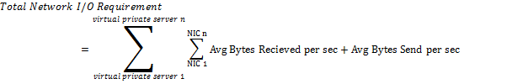

Security Consideration
We recommend using Active Directory to secure both host server and guest virtual machines if possible. Please refer to “Securing Virtual machines in a Hosting Environment” whitepaper for details .
Hyper-V uses the new authorization management framework in Windows to allow you to configure what users can and cannot do with virtual machines. The authorization management framework consists of the following objects:
- Operation
This is the basic building block of authorization manager - and represents some action that the user can perform. Some operations that exist in our authorization store include op_Create_VM (the act of creating a new virtual machine) or op_Start_VM (the act of starting a virtual machine).
- Task
A task is a grouping of operations. We do not create any tasks by default - but you could create a task that was labeled 'control_VM' and then add the operations for starting, stopping, pausing and restarting a virtual machine to that task.
- Role
A role defines a job / position / responsibility that is held by a user. For instance, you might have a role called 'Virtual_Network_Admin'. This role would have all the tasks and operations that relate to virtual networks. Users are then assigned to roles as needed.
- Scope
A scope allows you to define which objects are owned by which roles. If you had a system where you wanted to grant administrative access to a subset of the virtual machines to a specific user - you would create a scope for those virtual machines and apply your configuration change to only that scope.
- Default Scope
The default scope is where virtual machines are stored by default. It is the equivalent of having no scope defined.
Hyper-V can be configured to store it's authorization configuration in Active Directory or in a local XML file. After initial installation it will always be configured to use a local XML file located at \programdata\Microsoft\Windows\Hyper-V\InitialStore.xml on the system partition. To edit this file you will need to:
- Open the Run dialog (launch it from the Start menu or press Windows Key + R).
- Start mmc.exe
- Open the File menu and select Add/Remove Snap-in...
- From the Available snap-ins list select Authorization Manager.
- Click Add > and then click OK.
- Click on the new Authorization Manager node in the left panel.
- Open the Action menu and select Open Authorization Store...
- Choose XML file for the Select the authorization store type: option and then use the Browse... to open \programdata\Microsoft\Windows\Hyper-V\InitialStore.xml on the system partition (programdata is a hidden directory so you will need to type it in first).
- Click OK.
- Expand InitialStore.xml then Microsoft Hyper-V services then Role Assignments and finally select Administrator.
- Open the Action menu and select Assign Users and Groups then From Windows and Active Directory...
- Enter the name of the user that you want to be able to control Hyper-V and click OK.
- Close the MMC window (you can save or discard your changes to Console 1 - this does not affect the authorization manager changes that you just made).
If you are planning to use Hyper-V WMI interface to remote manage and control the virtual machines on Hyper-V server, in additional to enabling the firewall rules on the server for WMI, which you execute the following command in an elevated command prompt:
netsh advfirewall firewall set rule group="Windows Management Instrumentation (WMI)" new enable=yes
you also need to grant appropriate WMI permission to the user(s) who are remoting connecting. You need to grant access to two WMI namespaces: Root\CIMV2 and Root\virtualization
Open Computer Management under Start/Administrative Tools, expanding the tree down through Services and Applications\WMI Control. Select WMI Control:
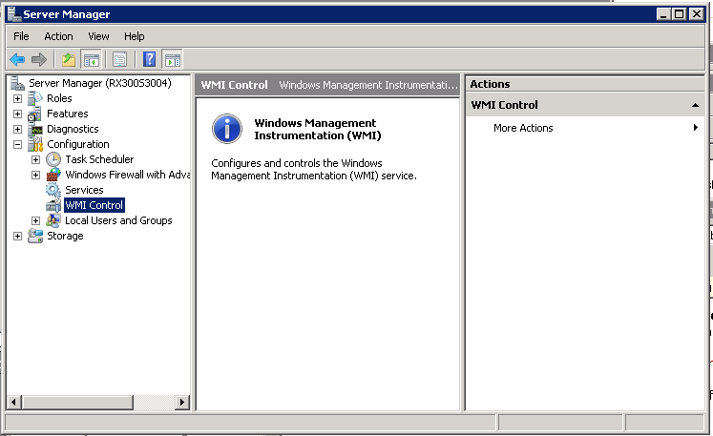
Right-click on WMI Control and select properties. Then switch to the Security tab. Select the Root\CIMV2 namespace node.
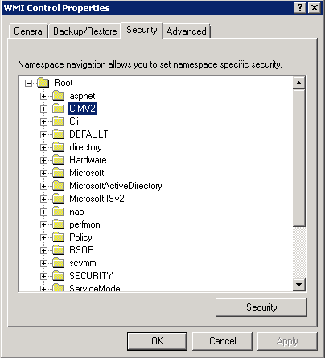
Click the Security button. If the appropriate user or group does not already appear, use “Add…”, then select the user and click the Advanced button below the “Permissions for <user>” area. Again, make sure the user/group is selected and click Edit, You need to make three changes here:
In the “Apply to:” drop-down, select “This namespace and subnamespaces”
In the Allow column, select Remote Enable
Check “Apply these permissions to objects and/or containers within this container only”

Hyper-V Hosting Architecture Models
This section summarizes few commonly used Hyper-V hosting architecture models. Each model will fit into various hosting business scenarios we discussed in section 2.

Sandalone Hyper-V Host Server Architecture
The single host server architecture mdoel is illustrated below. The architecture consists of a single host server running Windows Server 2008 with Hyper-V that runs a number of virtual machine guests. This model provides server consolidation but does not provide high availability. The host server is a single point of failure and this architecture will necessitate a Save State or Power Off of the virtual machine guests should the host server require maintenance or reboot. This model is appropriate for low-end virtual private server hosting where the limitations mentioned above are acceptable.

Two-Nodes Failover Hyper-V Cluster
The two-nodes host cluster architecture model is illustrated below. The architecture consists of a two-node Windows Server 2008 cluster leveraging a shared storage system such as an iSCSI or Fibre Channel storage area network (SAN) and storage array. Each node of the cluster runs Windows Server 2008 with Hyper-V. The virtual machine guests consist of configuration files and virtual hard disk files which are stored on the SAN. Virtual machines can run on any node of the cluster and in the event of a node failure or planned outage, the virtual machines will be failed over to the second node.
The two-nodes host cluster model provides a significant increase in overall availability of the consolidated workloads and reduces the risks of consolidating a large number of servers to a single virtual server host.
In addition, there are many ways to implement Windows Server Failover clustering with Hyper-V (http://blogs.technet.com/josebda/archive/2008/06/17/windows-server-2008-hyper-v-failover-clustering-options.aspx) as illustrated in the following sections. Hosting companies could select the appropriate options creating right offers with appropriate price point to meet their customer needs:

Parent-based Failover Clustering with Two Physical Servers
In this scenario, probably the most common one, you implement Windows Server Failover Clustering at the Hyper-V Parent (Host) level. As mentioned above, a shared storage, such as a Fiber-Channel or iSCSI SAN is required.
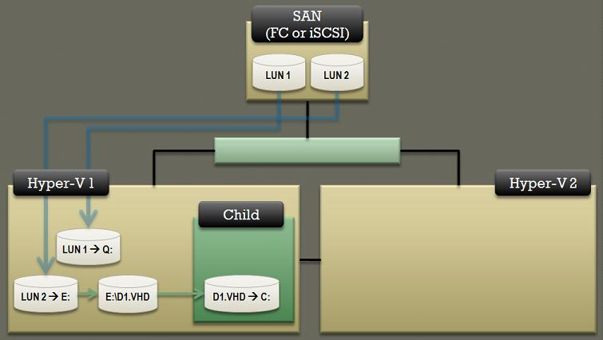
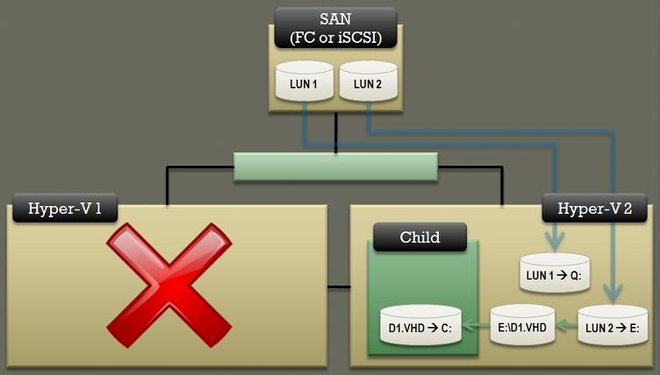
Figure . After failed over
As described earlier, this scenario can survive the failure of one of the physical server.

Child-based FailoverClustering with Tow Physical Servers
In this scenario, Windows Server 2008 Failover Clustering is implemented at the Hyper-V Child (Guest) level. In this case, the shared storage must be an iSCSI SAN.
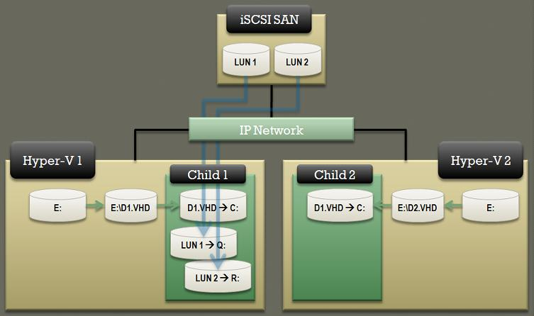

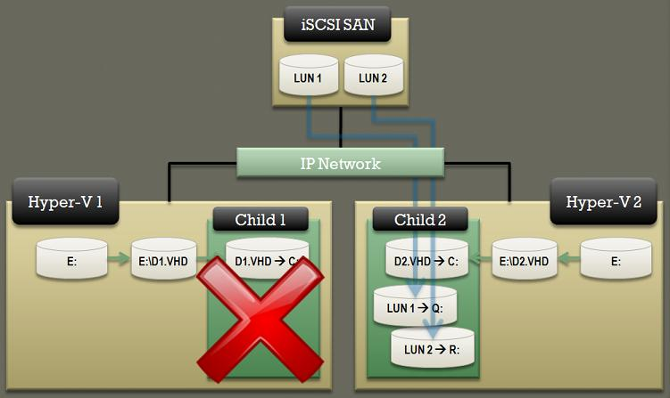

Mixed Physical and Virtual Failover Clustering
This scenario is using a physical server clustered with a virtual machine. If the physical server fails, the virtual instance will take over the workload. This scenario uses disimilar hardware with Failover Clustering, but if this is running Windows Server 2008, you could like make it work. Just make sure you run the Failover Clustering Validation Wizard to confirm this is supported in your specific configuration. In this case, since you need to expose the LUNs directly to the virtual machine, the shared storage must be an iSCSI SAN.
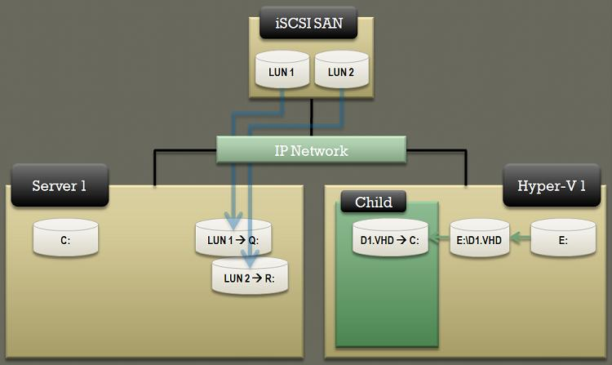

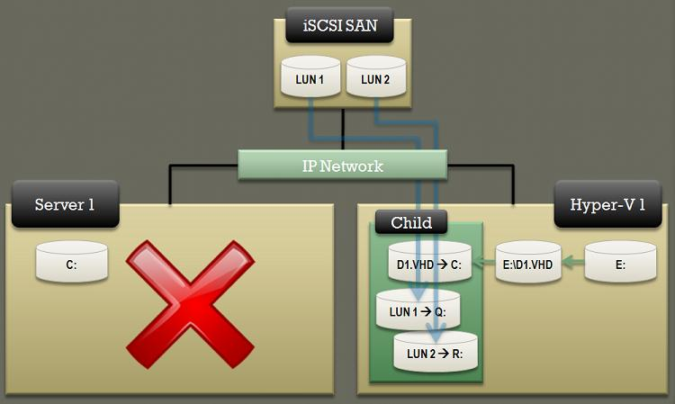

Failover Clustering with Two Child Partitions on One Physical Server
This scenario is also common. A single physical server running Hyper-V and two child partitions where you run Failover Clustering. If the physical server fails, both (virtual) cluster nodes will fail. Obviously, this is not true high availabilit, but could be interesting for testing, low end managed hosting solution, or customer with dedicated physical server creating virtualized redundancy/failover. In this case, the shared storage must be an iSCSI SAN.
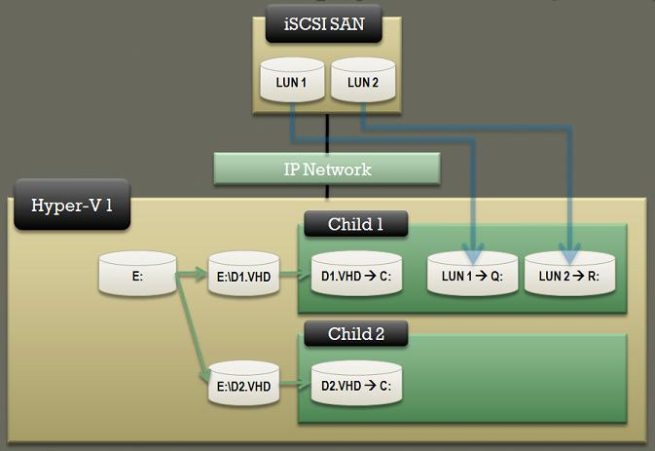

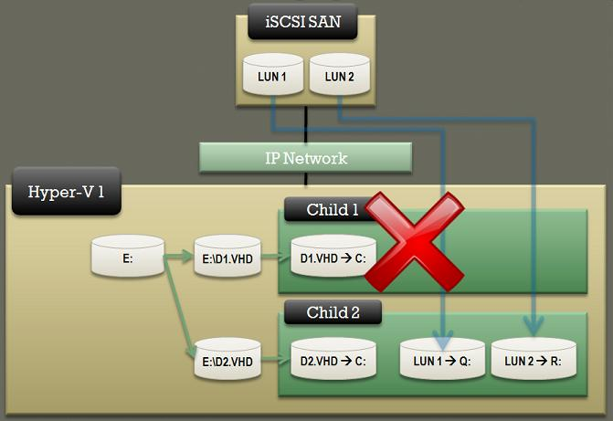

Hyper-V Host Server Farm
The Host Server Farm architecture model is illustration below. The architecture consists of a multi-node Windows Server 2008 cluster leveraging a shared storage system such as an iSCSI or Fibre Channel storage area network (SAN) and storage array. Each node of the cluster runs Windows Server 2008 with Hyper-V. Up to 16 nodes in a single cluster are supported. Similar to the two-node model, each active node in the multi-node pattern runs the virtual machines. In the event of a failure of one of the nodes or planned maintenance, cluster failover occurs. The virtual machine guest(s) are failed over to the remaining nodes.
The Host Server Farm model provides even higher availability than the two-node pattern as well as better use of hardware since a single physical host can serve a passive node for up to 15 active nodes. Careful capacity planning is required for multi-node clusters. The key capacity planning rule for multi-node clusters is to ensure that the passive node is sized such that it can take on the entire load of the most heavily utilized active node. If resiliency against the failure of two active nodes is desired then the passive node must be able to take on the entire load of the two most heavily utilized active nodes. The recommended approach is to have each node be physically identical and size the load on each node such that it achieves the above rules.

Options for Provisioning and Managing Hyper-V Virtual Machine
This section discusses different tools/options for provisioning and managing Hyper-V virtualization environment. We will also discuss various options to integrate Hyper-V provisioning and management functionality into hosting companies’ existing management infrastructures.

Hyper-V Manager
Hyper-V offers an out-of-box Hyper Manager as a MMC snapin, and remote management client application, which is only available on Windows Server 2008 and Windows Vista with SP1.
Hyper-V manager provides some basic management functionality for provisioning and managing Hyper-V based virtual environment. But it lacks the supports for managing clustered Hyper-V environment and capabilities of P2V, V2V migration and base image management, and it can’t manage remote server with server core installation option.
It offers wizard-based user interface for provisioning virtual machine, virtual network, and other configurations and management. It is simple and straightforward to use to perform basic management functionality.
It also has built-in delegated management functionality for securing access permissions.
It doesn’t offer any scripting capabilities to automate the operations. It can be used in small Hyper-V virtualization environment, such as dedicated hosting scenario, end customers can use it to manage their own Hyper-V environment within the dedicated server.

Microsoft System Center Virtual Machine Manager 2008
System Center Virtual Machine Manager (SCVMM) 2008 not only incorporates the enterprise level functionality of its predecessor, System Center Virtual Machine Manager (SCVMM) 2007, but it adds some new and exciting features that make it a highly desirable upgrade. Here is a short list of some of the major benefits of upgrading to System Center Virtual Machine Manger (SCVMM) 2008.
- Designed for virtual machines running on Windows Server® 2008 and Microsoft Hyper-V™ Server
VMM is designed to take full advantage of these foundational benefits through a powerful yet easy-to-use console which streamlines many of the tasks necessary to manage virtualized infrastructure. Even better, administrators can manage their traditional physical servers right alongside their virtual resources through one unified console.
- Support for Microsoft Virtual Server and VMware ESX
SCVMM 2008 can now manage a VMware ESX virtualized infrastructure in conjunction with the Virtual Center product. Now administrators running multiple virtualization platforms can rely on one tool to manage virtually everything. With its compatibility with VMware VI3 (through Virtual Center), SCVMM now supports features such as VMotion and can also provide VMM-specific features like Intelligent Placement to VMware servers
- Performance and Resource Optimization (PRO)
The Performance and Resource Optimization (PRO) feature enables the dynamic management of virtual resources though Management Packs that are PRO enabled. Utilizing the deep monitoring capabilities of System Center Operations Manager 2007, PRO enables administrators to establish remedial actions for SCVMM to execute if poor performance or pending hardware failures are identified in hardware, operating systems or applications. As an open and extensible platform, PRO encourages partners to design custom management packs that promote compatibility of their products and solutions with PRO’s powerful management capabilities.
- Maximize datacenter resources through consolidation
A typical physical server in the datacenter operates at only 5 to 15 percent CPU capacity. SCVMM can assess and then consolidate suitable server workloads onto a virtual machine host infrastructure thus freeing up physical resources for repurposing or hardware retirement. Through physical server consolidation, continued datacenter growth is less constrained by space, electrical and cooling requirements.
- Machine conversions are a snap
Converting a physical machine to a virtual one can be a daunting undertaking – slow, problematic and typically requiring you to halt the physical server. But thanks to the enhanced Physical-to-Virtual (P2V) conversion in SCVMM, P2V conversions will become routine. Similarly, SCVMM also provides a straightforward wizard that can convert VMware virtual machines to VHDs through an easy and speedy Virtual-to-Virtual (V2V) transfer process.
- Quick provisioning of new machines
In response to new server requests, a truly agile IT Department delivers new servers to its business clients anywhere in the network infrastructure with a very quick turnaround. SCVMM enables this agility by providing IT administrators with the ability to deploy virtual machines in a fraction of the time it would take to deploy a physical server. Through one console, SCVMM allows administrators to manage and monitor virtual machines and hosts to ensure they are meeting the needs of business groups within the organization.
- Intelligent Placement minimizes virtual machine guesswork in deployment
SCVMM does extensive data analysis of a number of factors before recommending which physical server should host a given virtual workload. This is especially critical when administrators are determining how to place several virtual workloads on the same host machine. With access to historical data -- provided by System Center Operations Manager 2007 – the Intelligent Placement process is able to factor in past performance characteristics to ensure the best possible match between the virtual machine and its host hardware.
- Delegated virtual machine management
Virtual infrastructures are commonly used in Test and Development environments, where there is constant provisioning and tear down of virtual machines for testing purposes. This latest version of SCVMM features a thoroughly reworked and improved self-service web portal, through which administrators can delegate this provisioning role to authorized users while maintaining precise control over the management of virtual machines.
- Organizing virtual machine components
To keep a data center’s virtual house in order, SCVMM provides a centralized library to store various virtual machine “building blocks”-- off-line machines and other virtualization components. With the library’s easy-to-use, structured format, IT administrators can quickly find and reuse specific components thus remaining highly productive and responsive to new server requests and modifications. Additionally, multiple library servers can be deployed throughout the organization.
- Windows PowerShell™ provides rich management and scripting environment
The entire SCVMM application is built on the command line and scripting environment provided by Windows PowerShell. This version of SCVMM adds additional PowerShell commandlets and “view script” controls which allow administrators to exploit customizing or automating operations at an unprecedented level.

Custom Solutions
Many hosting companies already have their existing management infrastructure for managing their environment, especially web front (control panel) offering e-commerce and end user management functionality. Therefore, integrating their existing environment with Hyper-V is also required. In this section we will discuss few options hosting companies can build their own integration points with their existing infrastructure. Microsoft Hyper-V provides few programming APIs which enable developers, and too vendors to extend and integrate with Hyper-V platform.

Hypercall Interface
The hypercall interface is an assembly-language interface that partitions use to access the hypervisor. Microsoft Hyper-V provides a set of Hypervisor C-Language Functions as a guide to understanding how to make calls to the hypervisor native interface, which can be used by any operating system. You can refer to Hypervisor C-Language Functions (http://msdn.microsoft.com/en-us/library/bb969818.aspx) for more details. In general, hypercall interface is a set of lower level APIs, is not recommended for managing Hyper-V instead Hyper-V WMI APIs should be used for that.

Hyper-V WMI Provider
Along Hyper-V, a WMI provider for virtualization has been provided that enables developers, and scripters to quickly build custom tools, utilities and enhancements for Microsoft Hyper-V platform. The WMI interfaces can manage all aspects of the virtualization services. Please refer to Hyper-V WMI Provider documentation for more details. (http://msdn.microsoft.com/en-us/library/cc136992(VS.85).aspx).
There are many programming options to consume Hyper-V WMI provider, we list few here:
- .Net Framework: .Net Framework has builtin class library for interacting with WMI provider. You can use C#, VB.Net or any other .Net languages to build your solutions. As part of Hyper-V GoLive for Hosters program, we wrapped Hyper-V WMI APIs as a set of WCF services for manging Hyper-V, which can be consumed in different platforms and configurations further extended available options for building your custom solutions.
- PowerShell Script: Windows PowerShell is a new command line shell and task-based scripting technology that provides information technology (IT) administrators comprehensive control and automation of system administration tasks, increasing administrator productivity. Windows PowerShell includes numerous system administration utilities, consistent syntax and naming conventions, and improved navigation of common management data such as the registry, certificate store, or Windows Management Instrumentation (WMI). Windows PowerShell also includes an intuitive scripting language specifically designed for IT administration. Windows Powershell is included as part of Windows Server 2008. Keeping in mind, Powershell requires .Net framework 2.0, so it is not available in server core installation option.
There are many resources available for Powersehll, particularly there is a open source library of powershell scripts for Hyper-V at http://www.codeplex.com/PSHyperv/Release/ProjectReleases.aspx?ReleaseId=14374 .

System Center Virtual Machine Manager 2008 Components and Web Services
If SCVMM 2008 has been selected as end-end virtualization management solution in your environment. You also can leverage either PowerShell scripting library or Web Services builtin with SCVMM 2008.
You can find detailed descriptions of available PowerShell cmdlets within SCVMM by checking the xml help file: Microsoft.SystemCenter.VirtualMachineManager.dll-Help.xml stored under “C:\Program Files\Microsoft System Center Virtual Machine Manager 2008\bin”.
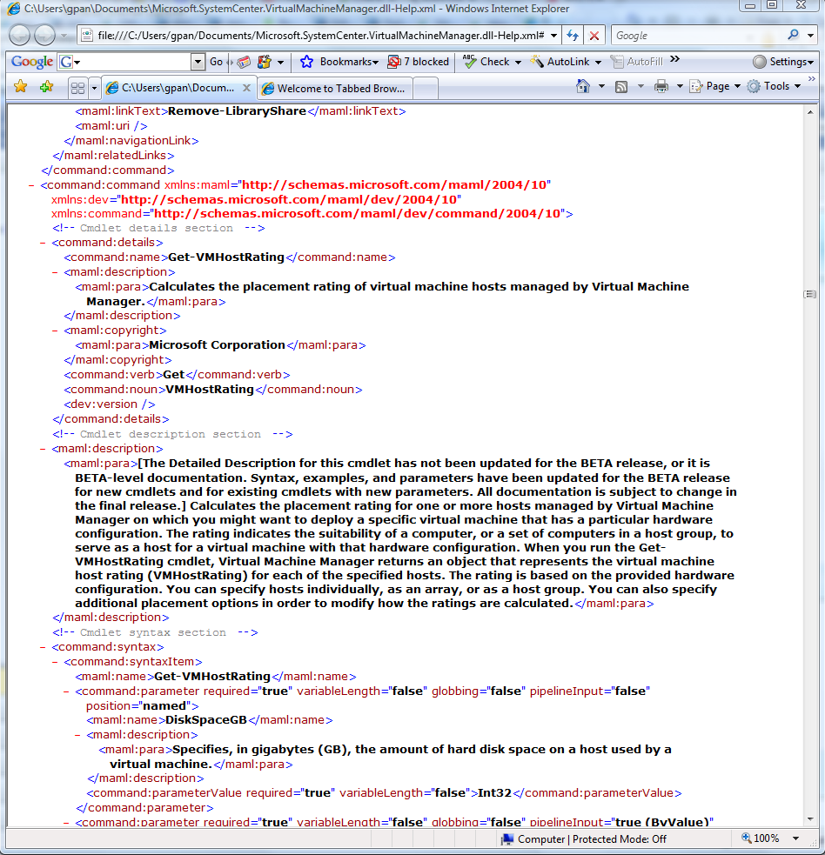
Beside Powershell script library within SCVMM 2008, it also has a set WCF services available you could consume for integrating your custom solution with SCVMM 2008.

Automate Guest Operationg System Provisioning
Within the process of provisioning Hyper-V virtual machine, provisioning guest operating system is a critical step. And this step needs to be flexible to reflect end customer’s specific configuration requirements, there are different ways to deploy guest operating systems into virtual machine. We will only discuss various options for provisioning Windows Opeating Systems focusing on how to automate the guest operating system deployment process.

Using ISO Image
After a virtual machine is defined, you could mount an ISO image containing appropriate guest operating system as CD/DVD drive, when the virtual machine starts, it will boot from the CD/DVD drive, the guest OS installation will walk you thru the steps for deploying the operating system. This option is a manual process, it will not meet the goal of automating the guest operating system. Please note in Hyper-V you can’t mount ISO image from a remote network location, it has to be stored locally.

Using Syspreped Virtual Hard Disk
You can use prebuild virtual hard disk with appropriate guest operating system as your image template to provision your new virtual machine. Just perform the base guest operating system installation like normal virtual machine, after you complete installations of all required component, run the System Preparation tool, Sysprep.exe with generalize option, which will remove unique information from your Windows Installation and enable you to reuse that image on different computers. For sysprep command line tool, please refer to http://technet2.microsoft.com/WindowsVista/en/library/72cc64e2-a0f3-4516-84fc-097577127fc91033.mspx?mfr=true for more details. You can use an answer file with Sysprep to configure unattended Setup settings.
When new virtual machine is provisioned, make a copy of the syspreped virtual hard disk, and mount the vhd as local drive by calling Hyper-V WMI provider. The vhd will be available to host server. Then you can run diskpart tool to bring the mounted drive online, and insert dynamically generated unattend.xml file into the drive. After inserting the unattend.xml reflecting specific configuration settings for the new virtual machine, such as computer name, network configurations, etc., you can unmount the drive, in turn you will have a customized virtual hard disk with appropriate configuration settings. After preparing the virtual hard disk, just follow the normal process to create the virtual machine with appropriate configurations for processor, memory and network adapter using the newly created virtual hard disk. After the virtual machine starts, it will go thru the initial setup process to build the guest operating system.
The following sample code demonstrates how to mount and unmount virtual hard disk to local drive.
public static bool MountVhd(string vhdPath, string serverName, string domainName, string userName, string password)
{
try
{
NetworkCredential credential = new NetworkCredential();
credential.Domain = domainName;
credential.UserName = userName;
credential.Password = password;

VirtualizationServer server = VirtualizationServer.Connect(serverName, credential, ManagementOptions.InfiniteTimeout);
server.GetImageManagementService().MountVirtualHardDisk(vhdPath);
return true;
}
catch (Exception ex)
{
throw new HostingManagementException(ex.Message, ex);
}
}

public static bool UnMountVhd(string vhdPath, string serverName, string domainName, string userName, string password)
{
try
{
NetworkCredential credential = new NetworkCredential();
credential.Domain = domainName;
credential.UserName = userName;
credential.Password = password;

VirtualizationServer server = VirtualizationServer.Connect(serverName, credential, ManagementOptions.InfiniteTimeout);
server.GetImageManagementService().UnmountVirtualHardDisk(vhdPath);
return true;
}
catch (Exception ex)
{
throw new HostingManagementException(ex.Message, ex);
}
}

Diskpart commands for bring mounted vhd online so you can insert unattend.xml file.
select disk 1 Note: disk number is dynamically assigned based on number of disks on your system, you can obtain the number by checking the job object returned by mount operation.
online disk noerr
attributes disk clear readonly

Please note not all server roles support Systeprep. Please refer to http://technet2.microsoft.com/WindowsVista/en/library/72cc64e2-a0f3-4516-84fc-097577127fc91033.mspx?mfr=true for details.

Using WIM/ImageX
Since Windows Vista and Windows Server 2008, a new Windows Imaging file format has been introduced, it will be the imaging format for future Windows release as well. For more details, please refer to http://technet2.microsoft.com/WindowsVista/en/library/72cc64e2-a0f3-4516-84fc-097577127fc91033.mspx?mfr=true.

As part of The Windows Automated Installation Kit, a number of tools have been provided to help customer to deploy Windows Operating System. For details, please refer to http://technet2.microsoft.com/WindowsVista/en/library/72cc64e2-a0f3-4516-84fc-097577127fc91033.mspx?mfr=true.

ImageX is a command-line tool that enables original equipment manufacturers (OEMs) and corporations to capture, to modify, and to apply file-based disk images for rapid deployment. ImageX works with Windows image (.wim) files for copying to a network, or it can work with other technologies that use .wim images, such as Windows Setup, Windows Deployment Services (Windows DS), and the System Management Server (SMS) Operating System Feature Deployment Pack. For details, please refer to http://technet2.microsoft.com/WindowsVista/en/library/72cc64e2-a0f3-4516-84fc-097577127fc91033.mspx?mfr=true.

Using WIM/ImageX to provision guest operating system, you could perform the following steps:
- Create a blank virtual hard disk
- Mount the virtual hard disk as local drive as described above
- Use diskpart command line tool to bring the mounted drive online
- Use ImageX command line tool to apply the customized wim file to your mounted drive.
- Prepare your unattend.xml file reflecting specific configurations
- Copy the unattend.xml to the mounted virtual hard disk
- Use BCDEdit command line tool to make VHD bootable. Please refer to http://www.microsoft.com/whdc/system/platform/firmware/bcdedit_reff.mspx for more details about the tool.
- Unmount the vhd.
- Create a virtual machine using the newly created VHD as bootable drive, and then starts the virtual machine, it will initiate the installation process to build your guest operating system.
Please note WIM/ImageX is only available for Windows Vista and Windows Server 2008.

Using Microsoft Deployment Toolkit
Microsoft Deployment is the next version of Business Desktop Deployment (BDD) 2007. Windows Deploy Toolkit is also WIM file based. Currently, the process to deploy a server is performed in one of two fashions, Lite touch or Zero touch. Lite touch meaning that you need to either pop in a CD/DVD or boot to PXE to start the deployment. Zero touch utilizes System Center Operations Manager 2007 to automate the process completely. For more details on how to leverage this approach to provision your guest operating system, please refer to http://technet.microsoft.com/en-us/library/bb978373(TechNet.10).aspx.

Using SCVMM 2008
Microsoft® System Center Virtual Machine Manager 2008 is a comprehensive management solution for the virtualized datacenter, enabling increased physical server utilization, centralized management of virtual machine infrastructure and rapid provisioning of new virtual machines by the administrator and authorized end-users. Following is an overview of the new features included in Virtual Machine Manager 2008.
Virtual Machine Manager 2008 has added management support for Windows Server 2008 Failover Clusters for Hyper-V. Virtual Machine Manager 2008 is cluster-aware when adding hosts, meaning you can discover what clusters are available through Active Directory. Additionally, you can easily create highly available virtual machines that run on a Windows Server 2008 cluster. SCVMM 2008 also supports intelligent placement while provisioning virtual machine to ensure the most appropriate host is selected for placement.
In addition SCVMM 2008 supports various different options for provisioning virtual machines. By leveraging its builtin Powershell script library, you could automate entire provisioning process with ease. Please refer to SCVMM 2008 documentations for more details.

Sample of Automated Hyper-V Virtual Machine Provisioning and Management
This section will describe some sample code snippets to demonstrate some common tasks for provisioning and managing Hyper-V virtualization environment. As part of Hyper-V GoLive for Hosters, we built a set of components/services to illustrate certain options to build custom solutions by leveraging Hyper-V WMI APIs and SCVMM components.

Sample Code for Commonly Used Commands and Tasks

Commands for Configuring iSCSI Storage
- Set MS iSCSI Initiator service to automatic and start
sc config msiSCSI start= auto (Note: the space between the = and auto is required)
net start msiSCSI

- Enable iSCSI service firewall exception
netsh advfirewall firewall set rule name="iSCSI Service (TCP-Out)" new enable=yes
- Add an iSCSI target portal
iSCSIcli QAddTargetPortal <Target Portal IP Address>
- Add iSCSI Targets (Cluster Witness Disk LUN, Data LUN(s))
iSCSIcli qaddtarget <Target IQN> <Target Portal IP Address>

- Login to iSCSI Targets
iSCSIcli qlogintarget <Target IQN> <username> <password>

- Set persistent Login to iSCSI Targets (this ensures the LUNs are persistent after reboots)

iSCSIcli persistentlogintarget <Target IQN> T * * * * * * * * * * * * * * * 0
- List persistent targets to verify
iSCSIcli listpersistenttargets
- Partition the iSCSI LUNs
diskpart
list disk
diskpart select disk 1
attribute disk clear readonly
online disk
create part primary
select part 1
assign letter=X
exit

VHD Creation Using Powershell
PS D:\> $VHDService = get-wmiobject -class "Msvm_ImageManagementService" -namespace "root\virtualization"
PS D:\> $VHDService.CreateDynamicVirtualHardDisk("D:\vhds\TestVhd1.vhd", 20GB)
__GENUS : 2
__CLASS : __PARAMETERS
__SUPERCLASS :
__DYNASTY : __PARAMETERS
__RELPATH :
__PROPERTY_COUNT : 2
__DERIVATION : {}
__SERVER :
__NAMESPACE :
__PATH :
Job : \\TAYLORB-DP490\root\virtualization:Msvm_StorageJob.InstanceID='Microsoft:Msvm_{B5A1A0EC-6A86-4CB0-AF7A-B336CBA2DCFF}'
ReturnValue : 4096

Creating Virtual Switch/Networks Using Powershell
$VirtualSwitchService = get-wmiobject -class "Msvm_VirtualSwitchManagementService" -namespace "root\virtualization"
$ReturnObject = $VirtualSwitchService.CreateSwitch([guid]::NewGuid().ToString(), "New External Switch", "1024","")
#Create New Virtual Switch
$CreatedSwitch = [WMI]$ReturnObject.CreatedVirtualSwitch
#Create Internal Switch Port
$ReturnObject = $VirtualSwitchService.CreateSwitchPort($CreatedSwitch, [guid]::NewGuid().ToString(), "InternalSwitchPort", "")
$InternalSwitchPort = [WMI]$ReturnObject.CreatedSwitchPort
#Create External Switch Port
$ReturnObject = $VirtualSwitchService.CreateSwitchPort($CreatedSwitch, [guid]::NewGuid().ToString(), "ExternalSwitchPort", "")
$ExternalSwitchPort = [WMI]$ReturnObject.CreatedSwitchPort
$ExternalNic = get-wmiobject -namespace "root\virtualization" -Query "Select * From Msvm_ExternalEthernetPort WHERE IsBound=False"
#Call SetupSwitch
$Job = $VirtualSwitchService.SetupSwitch($ExternalSwitchPort, $InternalSwitchPort, $ExternalNic, [guid]::NewGuid().ToString(), "InternalEthernetPort")
while (([WMI]$Job.Job.JobState -eq 2) -or ([WMI]$Job.Job.JobState -eq 3) -or ([WMI]$Job.Job.JobState -eq 4)) {Start-Sleep -m 100}
[WMI]$Job.Job

Create Virtual Machine Using Powershell
# Prompt for the Hyper-V Server to use
$HyperVServer = Read-Host "Specify the Hyper-V Server to create the virtual machine on"

# Get name for new VM
$VMName = Read-Host "Specify the name for the new virtual machine"

# Create new MSVM_VirtualSystemGlobalSettingData object
$wmiClassString = "\\" + $HyperVServer + "\root\virtualization:Msvm_VirtualSystemGlobalSettingData"
$wmiClass = [WMIClass]$wmiClassString
$newVSGlobalSettingData = $wmiClass.CreateInstance()

# wait for the new object to be populated
while ($newVSGlobalSettingData.psbase.Properties -eq $null) {}

# Set the VM name
$newVSGlobalSettingData.psbase.Properties.Item("ElementName").value = $VMName

# Get the VirtualSystemManagementService object
$VSManagementService = gwmi MSVM_VirtualSystemManagementService -namespace "root\virtualization" -computername $HyperVServer

# Create the VM
$result = $VSManagementService.DefineVirtualSystem($newVSGlobalSettingData.psbase.GetText(1))

#Return success if the return value is "0"
if ($Result.ReturnValue -eq 0)
{write-host "Virtual machine created."}

#If the return value is not "0" or "4096" then the operation failed
ElseIf ($Result.ReturnValue -ne 4096)
{write-host "Failed to create virtual machine"}

Else
{#Get the job object
$job=[WMI]$Result.job

#Provide updates if the jobstate is "3" (starting) or "4" (running)
while ($job.JobState -eq 3 -or $job.JobState -eq 4)
{write-host $job.PercentComplete
start-sleep 1

#Refresh the job object
$job=[WMI]$Result.job}

#A jobstate of "7" means success
if ($job.JobState -eq 7)
{write-host "Virtual machine created."}
Else
{write-host "Failed to create virtual machine"
write-host "ErrorCode:" $job.ErrorCode
write-host "ErrorDescription" $job.ErrorDescription}
}

List Virtual Machine Using C#
public static Collection<VirtualComputerSystemInfo> GetVirtualSystems(string serverName, string domainName, string userName, string password)
{
try
{
NetworkCredential credential = new NetworkCredential();
credential.Domain = domainName;
credential.UserName = userName;
credential.Password = password;

VirtualizationServer server = VirtualizationServer.Connect(serverName, credential, ManagementOptions.InfiniteTimeout);
Collection<VirtualComputerSystemInfo> virtualSystems = new Collection<VirtualComputerSystemInfo>();
foreach (MsvmComputerSystem system in server.GetVirtualSystems())
{
VirtualComputerSystemInfo virtualSystem = new VirtualComputerSystemInfo();
MsvmSummaryInformation summaryInfo = server.GetVirtualSystemManagementService().GetSummaryInformation(system.VirtualSystemSetting);
virtualSystem.CreationTime = summaryInfo.CreationTime;
virtualSystem.HealthState = summaryInfo.HealthState;
virtualSystem.HostServerName = system.Provider.ServerName;
virtualSystem.VirtualMachineName = summaryInfo.ElementName;
virtualSystem.InstanceId = summaryInfo.InstanceId;
virtualSystem.MemoryUsage = summaryInfo.MemoryUsage;
virtualSystem.Notes = summaryInfo.Notes;
virtualSystem.ProcessorLoad = summaryInfo.ProcessorLoad;
virtualSystem.State = summaryInfo.State;
virtualSystem.UpTime = summaryInfo.UpTime;
Collection<VirtualComputerSystemSettingInfo> snapshots = new Collection<VirtualComputerSystemSettingInfo>();
foreach (MsvmVirtualSystemSettingData snapshot in summaryInfo.Snapshots)
{
VirtualComputerSystemSettingInfo snap = new VirtualComputerSystemSettingInfo();
snap.BootOrder = snapshot.BootOrder;
snap.BiosNumLock = snapshot.BiosNumLock;
snap.CreationTime = snapshot.CreationTime;
snap.InstanceId = snapshot.InstanceId;
snap.Notes = snapshot.Notes;
if (snapshot.ParentSnapshot != null)
{
VirtualComputerSystemSettingInfo parent = new VirtualComputerSystemSettingInfo();
parent.BiosNumLock = snapshot.ParentSnapshot.BiosNumLock;
parent.BootOrder = snapshot.ParentSnapshot.BootOrder;
parent.CreationTime = snapshot.ParentSnapshot.CreationTime;
parent.InstanceId = snapshot.ParentSnapshot.InstanceId;
parent.Notes = snapshot.ParentSnapshot.Notes;
snap.ParentSnapshot = parent;
}
snapshots.Add(snap);
}
virtualSystem.Snapshots = snapshots;

VirtualComputerSystemSettingInfo systemSetting = new VirtualComputerSystemSettingInfo();
systemSetting.BiosNumLock = system.VirtualSystemSetting.BiosNumLock;
systemSetting.BootOrder = system.VirtualSystemSetting.BootOrder;
systemSetting.Notes = system.VirtualSystemSetting.Notes;
virtualSystem.SystemSetting = systemSetting;

MemorySettingInfo memorySetting = new MemorySettingInfo();
memorySetting.AllocatedRAM = system.MemorySetting.AllocatedRAM;
memorySetting.DeviceType = system.MemorySetting.DeviceType;
virtualSystem.MemorySetting = memorySetting;

ProcessorSettingInfo processorSetting = new ProcessorSettingInfo();
processorSetting.Limit = system.ProcessorSetting.Limit;
processorSetting.ProcessorPerSocket = system.ProcessorSetting.ProcessorPerSocket;
processorSetting.Reservation = system.ProcessorSetting.Reservation;
processorSetting.VirtualQuantity = system.ProcessorSetting.VirtualQuantity;
processorSetting.Weight = system.ProcessorSetting.Weight;
processorSetting.SocketCount = system.ProcessorSetting.SocketCount;
virtualSystem.ProcessorSetting = processorSetting;
virtualSystems.Add(virtualSystem);
}
return virtualSystems;
}
catch (Exception ex)
{
throw new HostingManagementException(ex.Message, ex);
}
}

Get Virtual Machine Thumbnail Image Using C#
public static byte[] GetVirtualSystemThumbnailImage(int imgWidth, int imgHeight, string systemName, string serverName, string domainName, string userName, string password)
{
try
{
NetworkCredential credential = new NetworkCredential();
credential.Domain = domainName;
credential.UserName = userName;
credential.Password = password;

VirtualizationServer server = VirtualizationServer.Connect(serverName, credential, ManagementOptions.InfiniteTimeout);
MsvmComputerSystem system = server.GetVirtualSystem(systemName);
if (system != null)
{
return server.GetVirtualSystemManagementService().GetVirtualSystemThumbnailImage(system.VirtualSystemSetting, imgWidth, imgHeight);
}
return null;
}
catch (Exception ex)
{
throw new HostingManagementException(ex.Message, ex);
}
}

Change Virtual Machine Memory Setting
public static bool ChangeVirtualSystemMemorySetting(string systemName, string serverName, MemorySettingInfo setting,string domainName, string userName, string password)
{
try
{
NetworkCredential credential = new NetworkCredential();
credential.Domain = domainName;
credential.UserName = userName;
credential.Password = password;

VirtualizationServer server = VirtualizationServer.Connect(serverName, credential, ManagementOptions.InfiniteTimeout);
MsvmComputerSystem system = server.GetVirtualSystem(systemName);
if (system != null)
{
MsvmMemorySettingData memSetting = system.MemorySetting;
memSetting.AllocatedRAM = setting.AllocatedRAM;
string instance = memSetting.Provider.EmbeddedInstance;
return server.GetVirtualSystemManagementService().ModifyVirtualSystemResources(system, instance);
}
return false;
}
catch (Exception ex)
{
throw new HostingManagementException(ex.Message, ex);
}
}

SolutionKit Sample Application
To help hosters accelerate building Hyper-V hosting offers, we built a sample web application simulating some scenarios as hosters could build to enable their customer purchase Hyper-V virtual private server online, and manage their virtual private server thru web interface.

The following screenshots demonstrate some functionality provided in this sample application.

This sample web application is leveraging the WCF service layer we wrapped around Hyper-V WMI provider. You can download the source code at connect site for Hyper-V GoLive for Hosters.
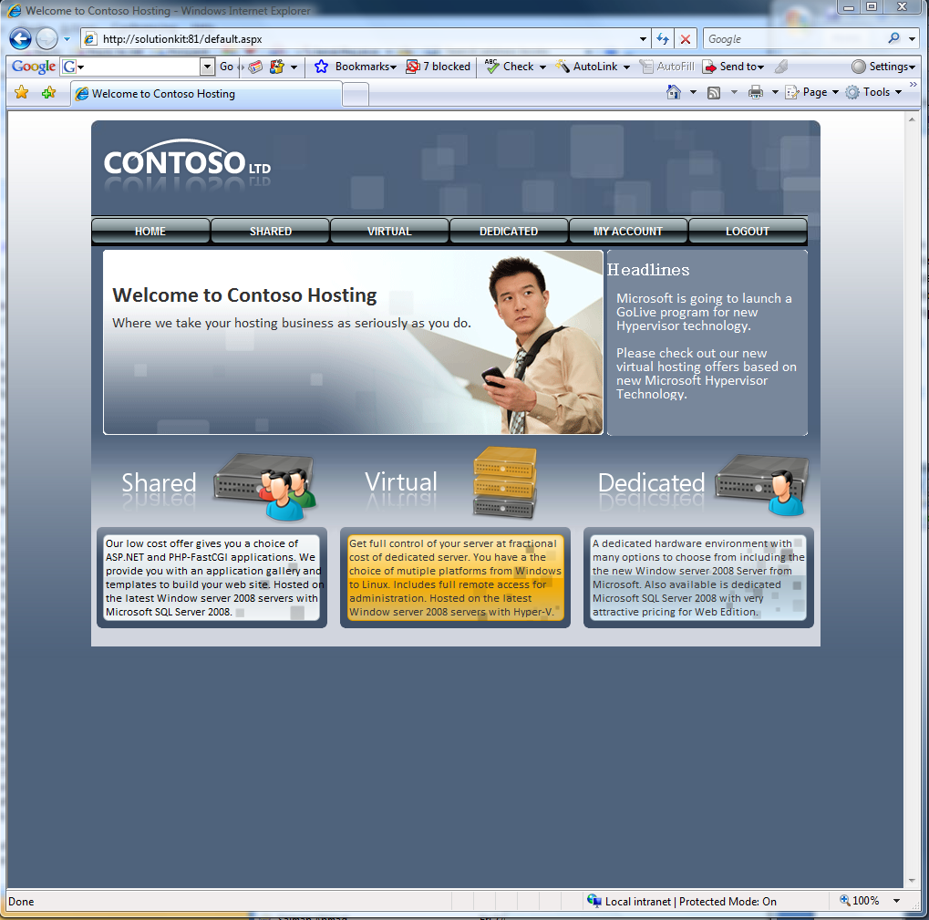

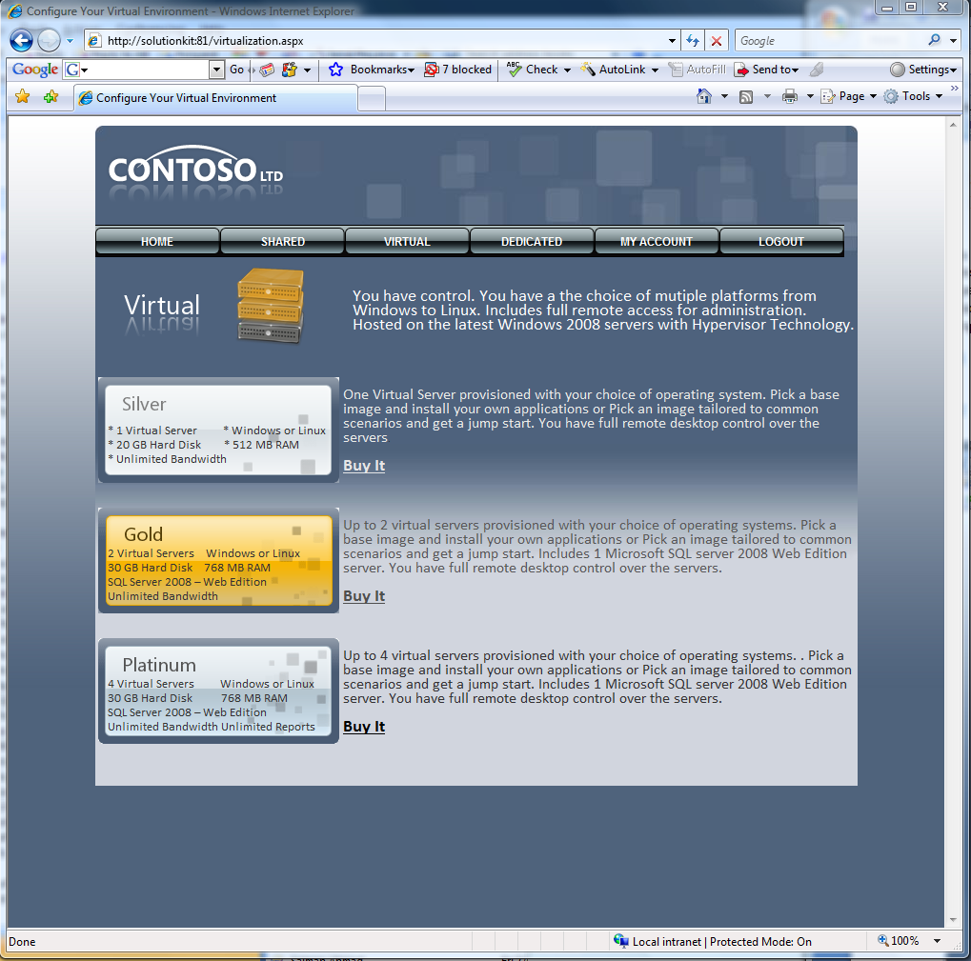

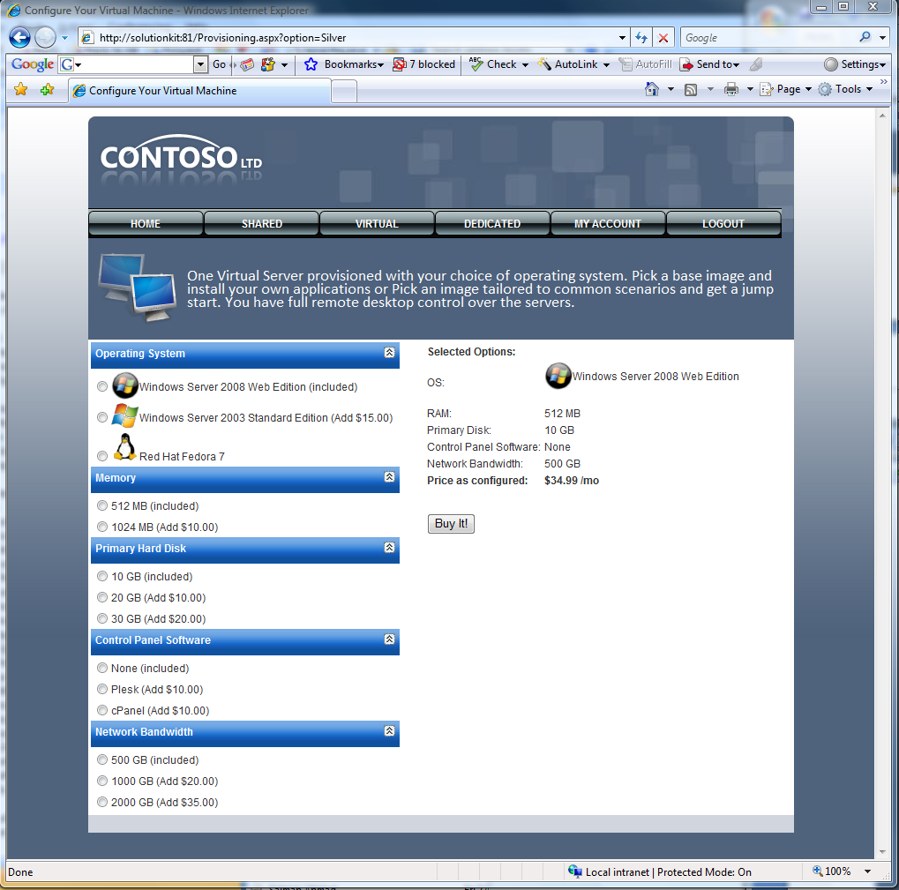

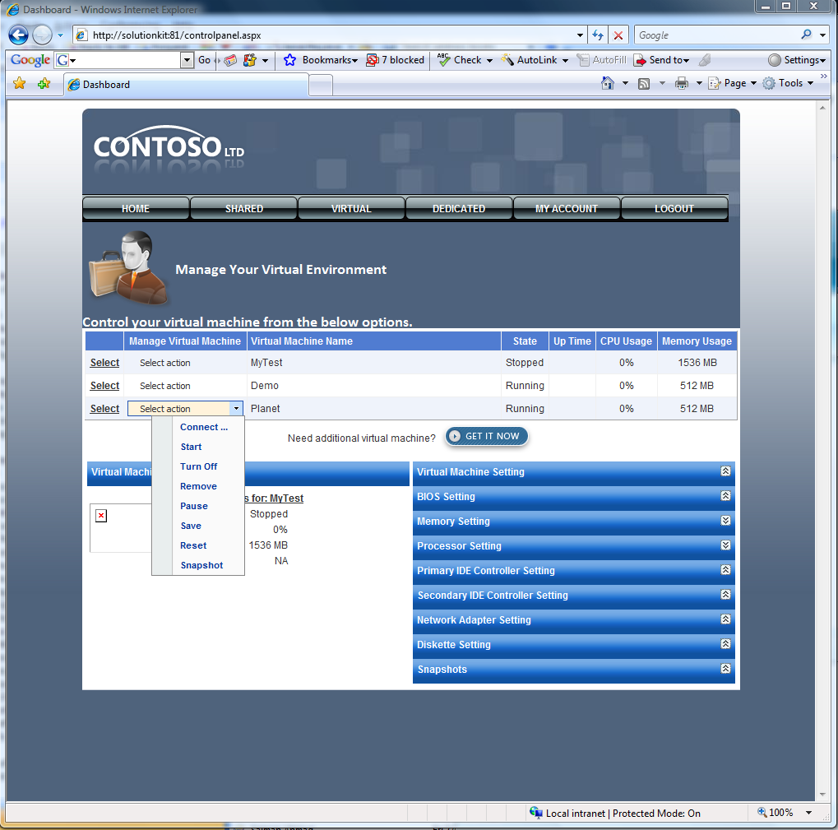
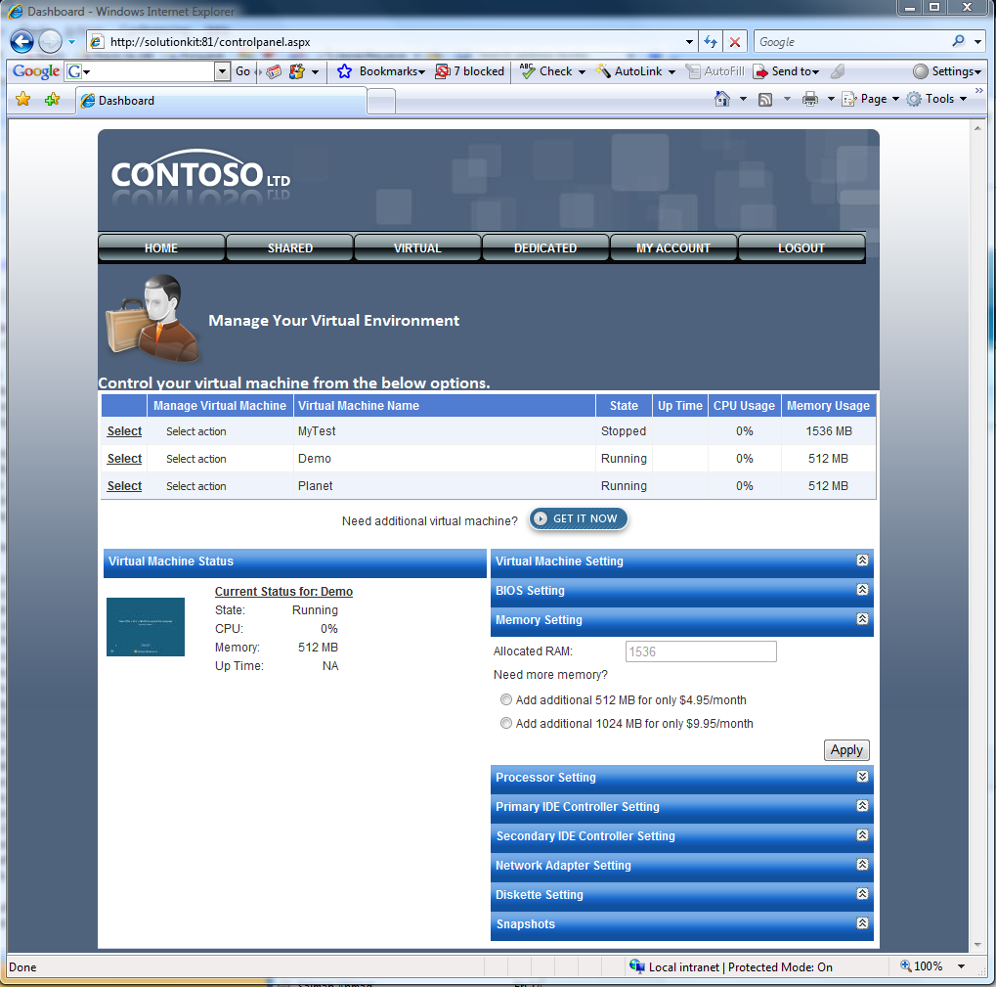

Summary
This whitepaper discussed various guidances, options and considerations for provisioning and managing Hyper-V based virtualization hosting environment. It also discussed different possible options for hosters to extend and integrate Hyper-V with their existing hosting environment. We hope this whitepaper could help hosters build better hosting solutions by leveraging Microsoft Hyper-V virtualization platform.

References
Hypervisor Functional Specification: http://www.microsoft.com/downloads/details.aspx?FamilyId=91E2E518-C62C-4FF2-8E50-3A37EA4100F5&displaylang=en
Virtualization WMI Provider: http://msdn.microsoft.com/en-us/library/cc136992(VS.85).aspx
Storage Options for Windows 2008 Hyper-V: http://blogs.technet.com/josebda/archive/2008/02/14/storage-options-for-windows-server-2008-s-hyper-v.aspx
Virtual Disk Service Programming Guide: http://msdn.microsoft.com/en-us/library/bb986750(VS.85).aspx
Understanding network with Hyper-V: http://blogs.msdn.com/virtual_pc_guy/archive/2008/01/08/understanding-networking-with-hyper-v.aspx
Windows Server 2008 Hyper-V Failover Clustering Options: http://blogs.technet.com/josebda/archive/2008/06/17/windows-server-2008-hyper-v-failover-clustering-options.aspx
Windows PowerShell: http://www.microsoft.com/windowsserver2003/technologies/management/powershell/default.mspx
PowerGUI: http://www.powergui.org/index.jspa
PowerShell Management Library for Hyper-V: http://www.codeplex.com/PSHyperv
Windows Automated Installation Kit: http://technet2.microsoft.com/WindowsVista/en/library/a8848521-b3ca-4c6c-81f0-6954f671cfe01033.mspx?mfr=true
Windows Deployment Services: http://technet2.microsoft.com/windowsserver2008/en/servermanager/windowsdeploymentservices.mspx
Windows Deployment Toolkit 2008: http://www.microsoft.com/downloads/details.aspx?FamilyId=3BD8561F-77AC-4400-A0C1-FE871C461A89&displaylang=en
Microsoft Deployment Toolkit Team Blog: http://blogs.technet.com/msdeployment/default.aspx
Performance Tuning Guidelines for Windows Server 2008: http://www.microsoft.com/whdc/system/sysperf/Perf_tun_srv.mspx
Hyper-V Performance FAQ: http://blogs.msdn.com/tvoellm/archive/2008/06/06/hyper-v-performance-faq.aspx
Hyper-V Performance Counters: http://blogs.msdn.com/tvoellm/archive/2008/05/04/hyper-v-performance-counters-part-one-of-many.aspx
http://blogs.msdn.com/tvoellm/archive/2008/05/09/hyper-v-performance-counters-part-two-of-many-hyper-v-hypervisor-counter-set.aspx
http://blogs.msdn.com/tvoellm/archive/2008/05/09/hyper-v-performance-counters-part-three-of-many-hyper-v-logical-processors-counter-set.aspx
http://blogs.msdn.com/tvoellm/archive/2008/05/12/hyper-v-performance-counters-part-four-of-many-hyper-v-hypervisor-virtual-processor-and-hyper-v-hypervisor-root-virtual-processor-counter-set.aspx
Hyper-V: Integration Components and Enlightenments: http://blogs.msdn.com/tvoellm/archive/2008/01/02/hyper-v-integration-components-and-enlightenments.aspx
Hyper-V: How to get the most from your virtualized disk performance: http://blogs.msdn.com/tvoellm/archive/2007/12/12/which-is-better-ide-or-scsi-windows-server-virtualization-08-code-name-viridian-controller-performance.aspx
Which Windows Server Virtualization Storage is best for you: http://blogs.msdn.com/tvoellm/archive/2007/12/12/which-is-better-ide-or-scsi-windows-server-virtualization-08-code-name-viridian-controller-performance.aspx
What you need to know about Windows Server Virtualization Snapshot Performance: http://blogs.msdn.com/tvoellm/archive/2007/09/28/what-you-need-to-know-about-windows-server-virtualization-o8-code-named-viridian-snapshot-performance.aspx
Hyper-V: SCSI vs IDE – Do you really need and IDE and SCSI drive for best performance: http://blogs.msdn.com/tvoellm/archive/2008/01/02/hyper-v-scsi-vs-ide-do-you-really-need-an-ide-and-scsi-drive-for-best-performance.aspx
Microsoft System Center Virtual Machine Manager 2008 Beta: http://www.microsoft.com/systemcenter/virtualmachinemanager/en/us/default.aspx

