Design Guidelines and Considerations for Building Windows Certified Network Media Devices
November 5, 2008
Abstract
This paper describes requirements and recommendations for building Network Media Devices that work well with the Windows® 7 operating system. This document is intended to be used as an informational guide to the Windows logo requirements.
This information applies for the Windows 7 operating system.
References and resources discussed here are listed at the end of this paper.
For the latest information, see:
http://www.microsoft.com/whdc/device/media/NetMediaDevices_Cert.mspx

Disclaimer: This is a preliminary document and may be changed substantially prior to final commercial release of the software described herein.

The information contained in this document represents the current view of Microsoft Corporation on the issues discussed as of the date of publication. Because Microsoft must respond to changing market conditions, it should not be interpreted to be a commitment on the part of Microsoft, and Microsoft cannot guarantee the accuracy of any information presented after the date of publication.

This White Paper is for informational purposes only. MICROSOFT MAKES NO WARRANTIES, EXPRESS, IMPLIED OR STATUTORY, AS TO THE INFORMATION IN THIS DOCUMENT.

Complying with all applicable copyright laws is the responsibility of the user. Without limiting the rights under copyright, no part of this document may be reproduced, stored in or introduced into a retrieval system, or transmitted in any form or by any means (electronic, mechanical, photocopying, recording, or otherwise), or for any purpose, without the express written permission of Microsoft Corporation.

Microsoft may have patents, patent applications, trademarks, copyrights, or other intellectual property rights covering subject matter in this document. Except as expressly provided in any written license agreement from Microsoft, the furnishing of this document does not give you any license to these patents, trademarks, copyrights, or other intellectual property.

Unless otherwise noted, the example companies, organizations, products, domain names, e-mail addresses, logos, people, places and events depicted herein are fictitious, and no association with any real company, organization, product, domain name, email address, logo, person, place or event is intended or should be inferred.

© 2008 Microsoft Corporation. All rights reserved.

Microsoft, Rally, Windows, Windows Media, and Windows Vista are either registered trademarks or trademarks of Microsoft Corporation in the United States and/or other countries.

The names of actual companies and products mentioned herein may be the trademarks of their respective owners.
Document History
Date | Change
November 5, 2008 | First publication

Contents
Introduction 5
A Brief History of Home Media Entertainment 5
Scenarios 7
Overview of Networked Media Device Roles for Windows 7 9
Digital Media Server 9
Supported Formats 14
Music /Audio 14
Photos / Pictures 15
Video 15
Recorded TV 15
Playlists 15
Additional Formats 16
Supported Streaming Protocols 16
Format Transcoding 16
Multiple Resolutions 17
Digital Media Renderers 17
Digital Media Players 20
Digital Media Controllers 23
Building a Great Network Media Device 24
Initial Network Media Device Discovery and Installation 24
Internet Protocol Addressing 26
Staying Connected and Troubleshooting 26
PnP-X Metadata 26
Device Announcement and Communication 28
Additional Metadata Requirements 29
Simple Service Discovery Protocol 31
Same Subnet 32
Device Performance 32
Device Startup Performance 32
Audio Latency 32
Track-to-Track Audio Latency 32
Gapless playback 32
Video Latency 32
Track-to-Track Video Latency 32
Building a Great Digital Media Renderer 33
Codec and Digital Rights Management Support 33
Support for Windows Media Codecs 33
Playing the Correct RES Element 34
Digital Rights Management 34
Playback Requirements 34
Seek Requirements 35
Pause Requirements 35
Volume Control Requirements 35
Playback Recommendations 35
Choosing the Optimal RES Element 35
Fast Forward and Fast Rewind 36
Search Requirements 36
Robustness Requirements 36
Robustness Recommendations 36
Wake on LAN Requirements 36
Wake on LAN Recommendations 36
Metadata Update Requirements 37
User Experience Recommendations 37
Building a Great Digital Media Server 37
Codec Support 37
Support for Windows Media Codecs 38
Playback 38
Seek 38
Trick Modes (Fast Forward/Fast Rewind) 38
Search 39
Robustness 39
Wake on LAN 39
User Experience 40
Album Art 40
Thumbnails 40
Metadata 40
Building a Great Digital Media Controller 40
Recommended Digital Media Controller Features 41
User Experience: Playback 41
User Experience: Browse 42
Glossary of Acronyms 43
Resources 44
Windows Logo Resources 44
Windows Media Resources 44
Rally Technologies 44
Windows Driver and Metadata Resources 44
Industry Resources 44
Appendixes 45
Appendix 1: Sample Simple Service Discovery Protocol Announcement Messages 45
Appendix 2: Resource Elements for Transcoded Content 47

Introduction
Consumers want their personal media collections available throughout their homes. This paper highlights the instrumental role that Windows® PCs play in enabling the home media ecosystem. To enable consumers to unlock the potential of their Windows PCs and enjoy widespread media access, personal and premium content must flow smoothly between Windows PCs and networked media devices.
This paper describes the Media Sharing functionality in Windows 7, and the Windows logo requirements that are associated with network media devices, so that manufacturers of networked media devices can develop products that are highly interoperable with Windows. Concepts and techniques discussed in this paper include the following:
- A brief history of home media entertainment.
- Baseline technologies, Windows scenarios, general architecture, and supported formats.
- Windows logo requirements for network media devices.
- What makes a good digital media controller, digital media renderer, and digital media server.

A Brief History of Home Media Entertainment
Since the 1920s when radio stations started regular broadcasting in the U.S., the home is a place of entertainment where media has played an important role. Recent Nielsen reports show that the average user watches television approximately 4 hours and 30 minutes per day. If we add other forms of entertainment such as DVDs, CDs, gaming, and Internet, we realize that media entertainment has become a primary activity for home users.
Media has experienced a transformation. Media existed as analog waves that were transmitted over radio and television broadcasting systems, or stored in vinyl records and magnetic tapes. Radio and television are moving to digital formats, and digital media in the form of pictures, music, and videos are kept in computers and other storage devices such as PCs, network-attached storage (NAS) devices, or digital video recorders (DVRs). Users have embraced digital media technologies at a fast pace. The 32-mm camera was invented in 1936. Starting around 1995, casual users have replaced their analog cameras with digital cameras. It is not unusual to find users who have thousands of digitized pictures that are stored in PCs, iPods, network-attached storage devices, and other home devices.
Since the advent of MP3 players, users are accumulating digital music at an equally fast pace. Many families have converted all their CDs to digital music to use it in MP3 players and iPods. Personal video is digital, easy to access, and an important social component, as Web sites such as YouTube show. Most digital cameras record directly in digital formats, which means that users can add hundreds of video files to their content libraries.
Because users keep media libraries with hundreds of pictures, music, and videos in storage devices at home, it is important to provide the means to access content easily and conveniently. For example, a user who tries to view a video that is stored in a PC might prefer to see the video on the large-screen living room television. Fortunately, together with the developments in digital media, home networking technology is making inroads into the home.
The 802.11 standard was finalized in 1997, and its adoption and use have grown exponentially since its introduction. Market research reports indicate that home network equipment sales grew by 15 percent between 2006 and 2007. It is estimated that by the end of 2008, the number of installed home networks worldwide will reach 200 million.
Home networks are used primarily for family members to share Internet access and printers, but they are migrating into a new function: connecting all media devices in the home to improve the quality of home-based entertainment activities.
There are many technological alternatives to develop a network platform for media devices. Home media devices are manufactured by many recognized vendors. Users enjoy the diversity of prices, quality, and features that the consumer electronics companies provide for media devices, but they also expect uniform usage scenarios and experiences. Therefore, a model for developing a network connectivity platform is to create a suite of baseline standards that provide a connectivity infrastructure but leave room for innovative products. In this way, vendors from heterogeneous industries—for example, consumer electronics, computers, and communication—can design products that interconnect well but that can be differentiated in the market.
The Digital Living Network Alliance (DLNA) has developed a suite of standards that provide a balanced approach to network connectivity for media devices. The standards are based on the following interconnection technologies:
- 802.11 a/b/g and Ethernet for physical connectivity.
- TCP/IP for network connectivity.
- UPnP for device discovery and communications.
- HTTP for the transfer of control messages and the transfer of content.
- MPEG-2 and MPEG-4 for media formats.

DLNA also recognizes optional components that add significant value to the platform: additional media formats such as Windows Media Audio (WMA) and Windows Media Video (WMV), Real-Time Transfer Protocol (RTP) as a secondary streaming protocol, non-streaming scenarios such as upload and download, and other alternatives.
The DLNA architecture categorizes devices according to their roles in the network. Windows 7 is designed to interact with many of the device classes that DLNA introduced. Specifically, Windows 7 interoperates with the following device classes:
- Digital media servers—devices that act as the sources of content in the network.
- Digital media players—devices that can browse, select, and play content from digital media server (DMS) devices in the network.
- Digital media renderers—devices that can receive control actions and play content from DMS devices in the network.
- Digital media controllers—devices that can browse and select content from any DMS, and then send control actions and play requests to any digital media renderer (DMR).

Some device classes in this list have a mobile equivalent. The mobile equivalent for a DMS is an M-DMS. Similarly, the mobile equivalent for a digital media player (DMP) is an M-DMP, and for a digital media controller (DMC) is an M-DMC. There is no mobile equivalent for a DMR. The important difference between home devices and their mobile equivalents is in the supported media formats. Although home devices support formats such as Motion Picture Experts Group (MPEG-2) and Linear Pulse Code Modulation (LPCM), mobile devices support formats such as MPEG-4 (Part 10), advanced audio coding (AAC), and MP3. Windows 7 computers support media formats for both home and mobile devices. Therefore, this paper makes no difference between home devices and mobile equivalents.
Windows media device connectivity in the home started with the release of a Windows XP application named Windows Media Connect (WMC). This application implemented a UPnP Media Server and used standard HTTP protocols for streaming. Devices that implemented UPnP media renderers, and were Plays for Sure certified, interoperated with WMC. This application became a component of Windows Media® Player with the release of Windows Media Player 11 named Network Sharing Services (NSS) that incorporates most elements that are necessary to interact with the first version of DLNA digital media players. Although WMC and Windows Media Player NSS implement mostly a media server component, the new NSS version in Windows 7 includes DMS, DMR, DMP, and DMC functionality. Furthermore, the new version includes a rich list of optional DLNA features, including transcoding, support for multiple new media formats, and download support.
With the expanded scope of the Windows 7 platform, the PC becomes a comprehensive networked media device that can interoperate seamlessly with DLNA devices and with many popular non-DLNA devices. Furthermore, the Windows 7 PC is versatile because of the large number of supported media formats and its powerful hardware accelerated transcoding engine. With these advances, we hope to bring a premier media-sharing experience to users who embrace the new era of digital living.

Scenarios
In Windows 7, computers can interact with devices in the home network by using one of the following scenarios:
- Scenario 1: The PC acts as the source of content for networked devices.
- Scenario 2: The PC acts as the receiver of content from networked devices.
- Scenario 3: The PC acts as a media manager and selects content from sources and sends content to receivers.

In Scenario 1, users keep a large collection of media in their PCs and make the content available to other devices that are connected to the home network by sharing their media libraries. The PC acts as a media server when it is connected to the network. Windows 7 improves the interoperability of this scenario by adding support for media players and media controllers that follow DLNA standards.
In Scenario 2, users store content in different storage devices such as NAS, DVR, and cameras, and use a PC to browse, search, and play the stored content. In this scenario, the receiving PC acts as a media player when it is connected to the network. Windows 7 improves the interoperability of this scenario by adding support for media servers that are based on DLNA standards, in addition to shared libraries from Windows PCs and Windows Home Server.
Figure 1 shows the three scenarios.
Figure 1. The three main scenarios for connecting devices with Windows 7 PCs
A second way exists to use a PC as a receiver. Some devices in the network include the ability to push content. In this case, the user browses content that is stored on the device itself by using the device user interface (UI), and then instructs a receiving PC to play the content. The PC acts as a media renderer when it is connected to the network.
In Scenario 3, a user discovers media servers and media renderers that are available in the network. The PC UI differentiates between content that exists in the local media library and content that exists in other media servers on the network. The user can search and browse the content and examine all the information that is available for each content item. The user can select content from any media server and push it to any media receiver. The PC acts as a media controller when the user selects content from a shared library on a media server; it acts as a push controller when the user selects content from the local media library.

Overview of Networked Media Device Roles for Windows 7
Windows 7 natively implements and interoperates with network media devices that perform the following roles:
- Digital media server (DMS)
- Digital media renderer (DMR)
- Digital media player (DMP)
- Digital media controller (DMC)

Digital Media Server
A user who opens Windows Media Player or Windows Media Center (from the PC or from an Extender for Windows Media Center) can browse, interact with, and play content from any device that implements the DMS role in the home network. A DMS is a DLNA-defined networked device role. A DMS exposes content to the network and, when content is requested, it transfers that content to the requesting device. Exposing and transferring content are the two fundamental functions that this device performs. A DMS exposes content to the network by using a UPnP service called a content directory service. The content directory service defines a protocol to query the DMS database and to describe the media in the database. A DMS transfers content to the network by using the HTTP protocol with extensions to support trick modes such as fast forward and fast rewind, transfer modes such as stream or download, and so on.
In Windows 7, discovery of media servers on the network is automatic and requires no configuration. In Windows Media Player, media servers are known as Other Libraries and are prominently displayed in the navigation pane. Figure 2 shows the automatic discovery of a digital media server named Karen (desktop) under Other Libraries in the navigation pane of Windows Media Player.

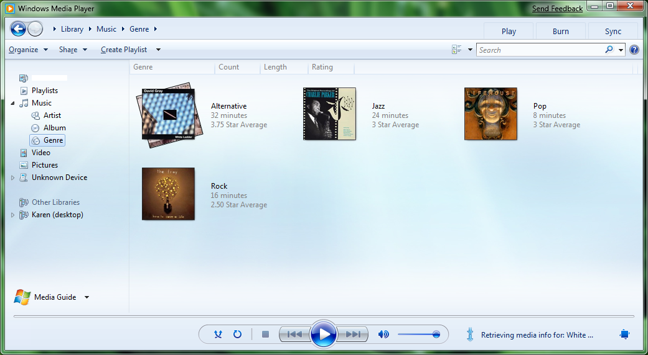
Figure 2. Windows 7 displaying shared libraries in Windows Media Player
In Windows Media Center, media servers can be browsed in the new shared pivot view of all libraries: music, pictures, videos, and recorded TV. The shared pivot is available from each music, pictures, video, and recorded TV media library. Figure 3 shows the discovery of media servers in the new shared pivot view of Windows Media Center.
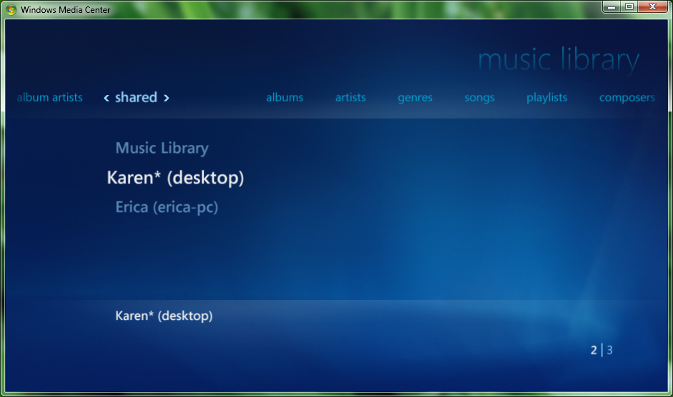
Figure 3. Windows Media Center automatically discovering the shared music library
In addition to automatic DMS discovery in Windows Media Player and Windows Media Center, media servers are automatically discovered in Network Explorer. Network Explorer is available from the navigation pane of Windows Explorer. By selecting a media server in Network Explorer, Windows Media Player is started to interact with the shared media library. Figure 4 shows the discovery of media servers, media players, and media renderers in Network Explorer.
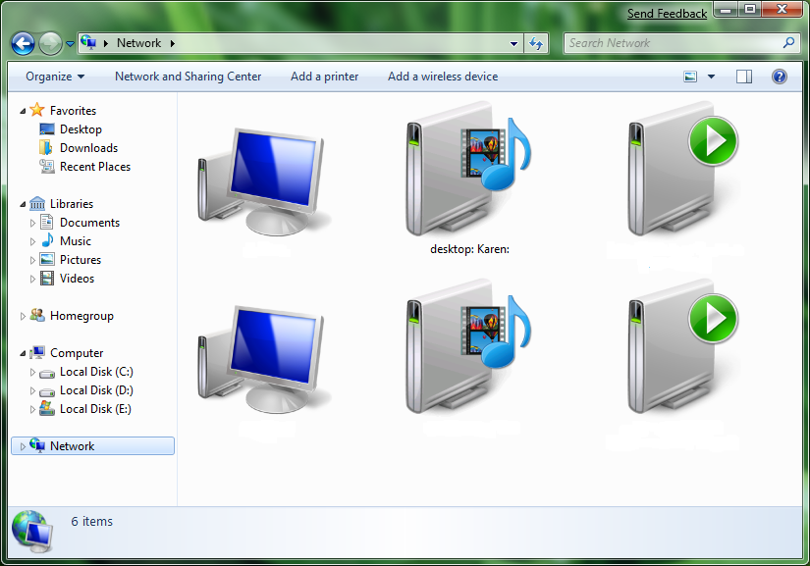
Figure 4. Network Explorer discovering available devices and services on the network
In addition to automatically discovering network media devices that implement the DMS role on the network, Windows 7 also performs the DMS role through the Windows Media Player NSS. Users can enable this functionality from the Advanced Sharing Settings in Control Panel or in Windows Media Player from the Share menu. Both methods open Share with Media Devices in Control Panel, which enables users to configure media sharing, including the ability to allow or block users and devices from accessing the shared media library. Figures 5 and 6 show the Share menu in Windows Media Player and the resultant Control Panel, which provides the option to enable sharing with media devices.

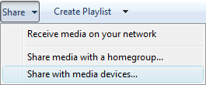
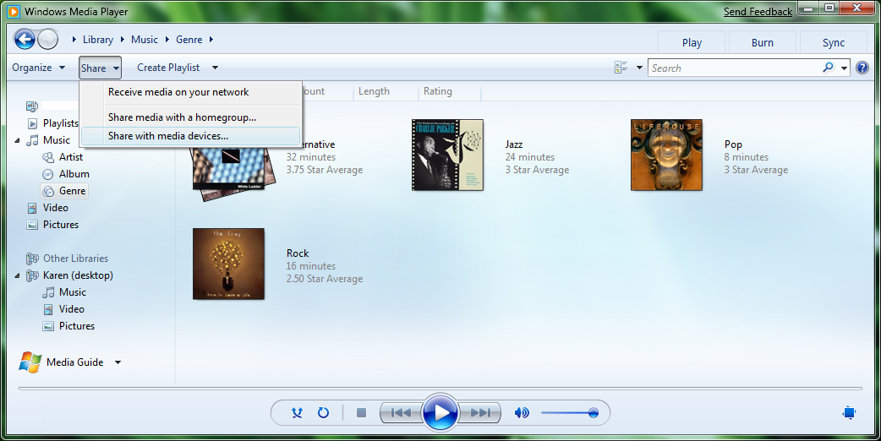
Figure 5. Windows Media Player displaying media-sharing features
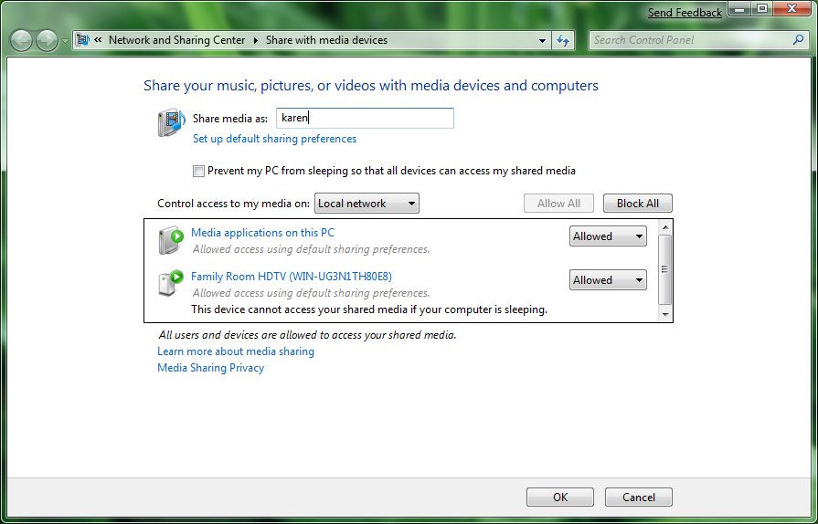
Figure 6: The Share with Media Devices application in Control Panel displaying available media player and rendering devices
After they choose to share with media devices, other Windows PCs, media player devices, and media controllers (described in further detail later in this paper) can automatically discover the DMS and play content from the media library.
Figure 7 shows the protocol layers in a digital media server. DMS devices support Wi-Fi or Ethernet for connectivity. DMS devices implement Transmission Control Protocol/Internet Protocol (TCP/IP),User Datagram Protocol (UDP)/IP, and HTTP. DMS devices implement HTTP and extensions to transfer content to other devices in the network. Some DMS devices use RTP for transfer. DMS devices implement the UPnP MediaServer functionality that includes two services:
- Content directory service (CDS)
- Connection manager service (CMS)

Figure 7: Protocol stack for a digital media server
To expose media through the CDS from the Windows 7 NSS, the files must be added to the Windows Media Player library. Windows 7 and Windows Media Player provide a simple interface to identify which folders contain files to be shared as a library. Music, pictures, videos, and recorded TV that are added to the Windows 7 library are automatically added to the Windows Media Player library and shared, if media sharing is enabled. Only content that is supported for playback by Windows Media Player is shared. Figure 8 shows Windows 7 libraries. Media files or folders that are added to a library are added to Windows Media Player and can be shared by the NSS.
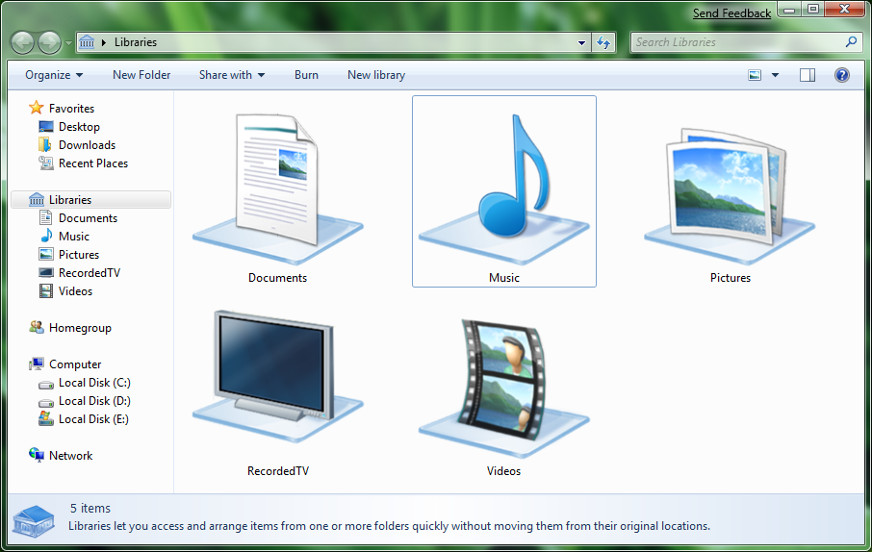
Figure 8. Windows 7 library view from Windows Explorer

Supported Formats
The following sections describe the formats that are supported for each content type, including the associated file name extension and Multipurpose Internet Mail Extensions (MIME) type. The NSS does not expose content for which the MIME type cannot be determined. For a device to play a format that NSS supports, the device must also support the codec that is appropriate for the format. Note that various codecs can be used for some formats such as WAV, MPEG-4, and audio video interleave (AVI).

Music /Audio
The Windows 7 Network Sharing Service supports audio formats shown in Table 1.
Table 1. Supported Audio Formats
Format | File name extension | MIME type
WMA | .wma | audio/x-ms-wma
MPEG-1 Layer 3 | .mp3 | audio/mpeg
WAV | .wav | audio/wav
PCM | Not applicable | audio/L16
AAC | .AAC | Audio/vnd.dlna.adts
M4A | .M4A | Audio/mp4

Photos / Pictures
The Windows 7 NSS supports the picture formats shown in Table 2.
Table 2. Supported Picture Formats
Format | File name extension | MIME type
Joint Photographic Experts Group (JPEG) | .jpg | image/jpeg
Portable network graphics (PNG) | .png | image/png
RAW | (codec specific) | (codec specific)

For more information about RAW format support, see “Additional Formats” later in this paper.

Video
The Windows 7 NSS supports the video formats shown in Table 3.
Table 3. Supported Video Formats
Format | File name extension | MIME type
WMV | .wmv | video/x-ms-wmv
MPEG-2 | .mpeg, .mpg | video/mpeg
MPEG-1 | .mpeg, .mpg | video/mpeg
AVI | .avi | video/avi
MPEG2 TS | .TS, .TTS | video/vnd.dlna.mpeg-tts
MPEG 4 Video | .MP4, .M4V, .MP4V, | Video/mp4

Recorded TV
The Windows 7 NSS also supports the following video formats of recorded TV shown in Table 4.
Table 4. Supported Recorded TV Formats
Format | File name extension | MIME type
Digital video recorder-Microsoft (DVR-MS) | .dvr-ms | Video/x-ms-dvr
Windows TV (WTV) | .wtv | Video/wtv

Playlists
The Windows 7 NSS supports the playlist formats shown in Table 5.
Table 5. Supported Playlist Formats
Format | File name extension | MIME type
Windows Media Playlist | .wpl, .asx | Not applicable
M3U | .m3u | Not applicable

Additional Formats
Format support in Windows Media Player is extensible. You can add media formats to Windows Media Player by installing the appropriate codec and creating the appropriate registry keys on the system that is running Windows Media Player. Formats that are supported in Windows Media Player are also supported by the Windows 7 NSS. For more information, see “Resources” at the end of this paper.

Supported Streaming Protocols
The NSS in Windows 7 and Windows Vista® supports HTTP and Real-Time Streaming Protocol (RTSP)/RTP protocols for delivering content to devices. The NSS in Windows XP supports streaming only over HTTP.

Format Transcoding
The Windows 7 NSS uses the Media Delivery Engine to deliver transcoded media content—content that is converted from one format to another—to the requesting device.
When the Windows 7 NSS exposes a media file to a device, it provides multiple resource elements for the content. One resource element specifies a URL for the content in its original format. The subsequent resource elements each specify a URL for a transcoded version of the content. A device can choose a resource element for which it has a codec to play back, and the NSS automatically transcodes the original format to the requested format. Formats supported for transcode by the Windows 7 NSS are listed in Table 6.
For an example showing multiple resource elements for transcoded content, see Appendix 2.
Table 6. Supported Transcoding Formats by Content Type
Content type | Destination format
Music / Audio | PCM  WMA  MP3
Photos / Pictures | YUV  JPG
Video | MPEG2 (phase alternating line—PAL)  MPEG2 (National Television System Committee—NTSC)  WMV

As mentioned earlier, Windows Media Player supports transcoding most supported input media formats to the preceding destination formats. This support means that digital media devices that implement the DMP and DMR role are not required to support all codecs to deliver a great playback experience. For example, if a user has video files that are all XVID, the Windows 7 NSS exposes the native XVID file to DMPs and DMRs, and also exposes a transcoded WMV and MPEG2 stream. This means that, even though the DMP and DMR do not support XVID, they still can provide a great playback experience for the consumer by requesting the WMV or MPEG2 format, where Windows automatically transcodes the XVID content.

Multiple Resolutions
The Windows 7 NSS provides multiple transcoded streams that use different codecs, and transcoded resource elements at different resolutions and bit rates. This option lets devices choose the stream that best meets their characteristics and bandwidth limitations. An example of this is a portable network device such as a Wi-Fi–capable mobile phone.

Digital Media Renderers
In Windows 7, users choose DMR devices in the network from a list that is provided by Windows Media Player or Windows Explorer and send content from PCs to the DMRs for playback. A DMR is a DLNA-defined networked device role. The DMR is the device in the network that plays content. The DMR implements the following three UPnP services:
- Connection manager service, which lists all the media formats that the DMR supports.
- AV transport service, which provides basic playback functions such as play, stop, and seek.
- Rendering control service, which provides basic output control functions such as volume and brightness.

Figures 9 through 12 show the Windows 7 Play To feature that is available on the shortcut menu in Windows Media Player and Windows Explorer when one or more media items are selected. Media items can be selected in the local library or in other libraries. The Play To feature is also available from the playlist area of Windows Media Player. All media items that are dropped into the playlist area are sent to the selected DMR for playback.
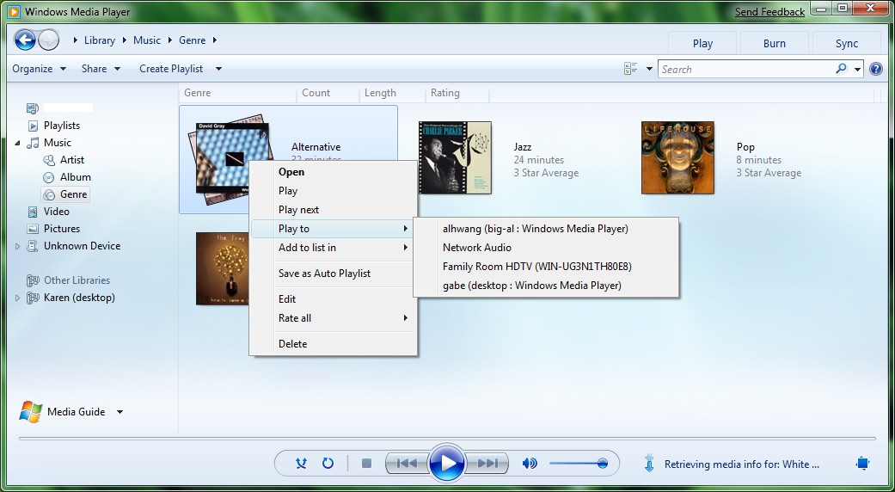
Figure 9. The Play To feature on the shortcut menu in Windows Media Player showing multiple DMR devices available on the network

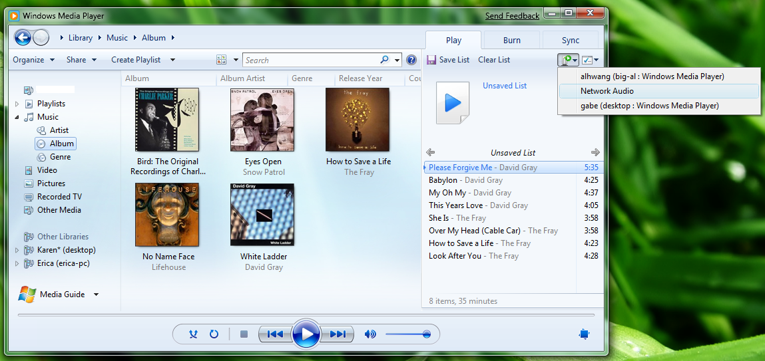
Figure 10. The Play To feature from the playlist area in Windows Media Player

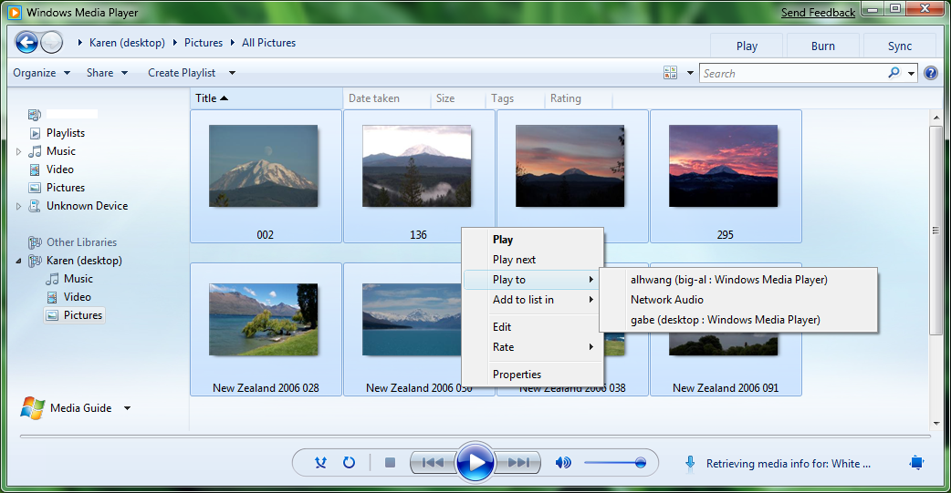
Figure 11. The Play To feature on the shortcut menu of a group of media items from Karen's shared media library in Windows Media Player showing multiple DMR devices available on the network

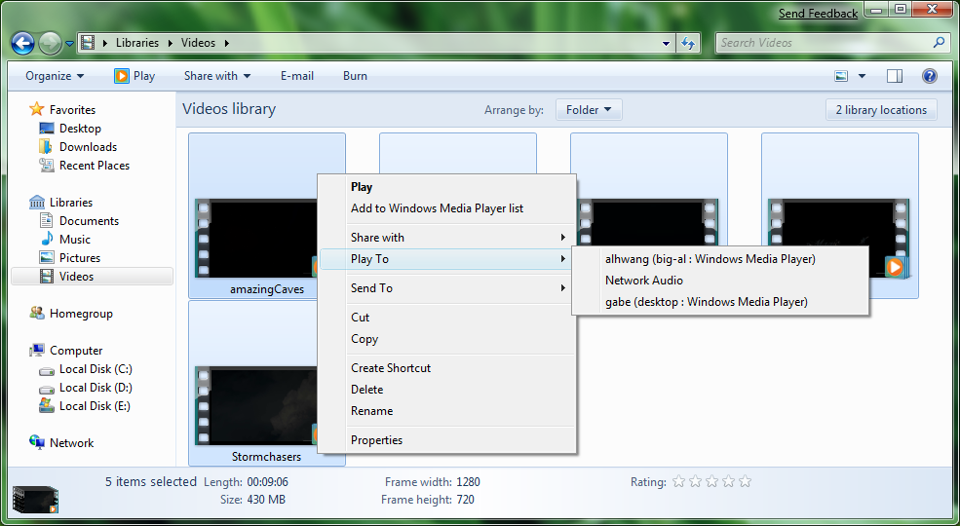
Figure 12: The Play To feature on the shortcut menu of a group of media items in Windows Explorer showing multiple DMR devices available on the network
Content that is sourced from a shared Windows 7 media library is delivered to a DMR in a format that the device can play because of a hardware-accelerated transcoding engine. The Windows 7 transcoding ability includes audio and video for many new formats.
Windows 7 PCs interact with the connection manager service, AV transport service, and rendering control service to provide an end-to-end experience for media enthusiasts. A user selects content in a media library, selects a target DMR, and then plays the content. Windows 7 also performs the DMR role.
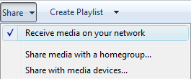
Figure 13 shows how users can enable this functionality in Windows Media Player from the prominently displayed Share menu. After enabling Windows Media Player to receive media on your network, other Windows 7 PCs and media controllers can discover the DMR and send content to the Player.

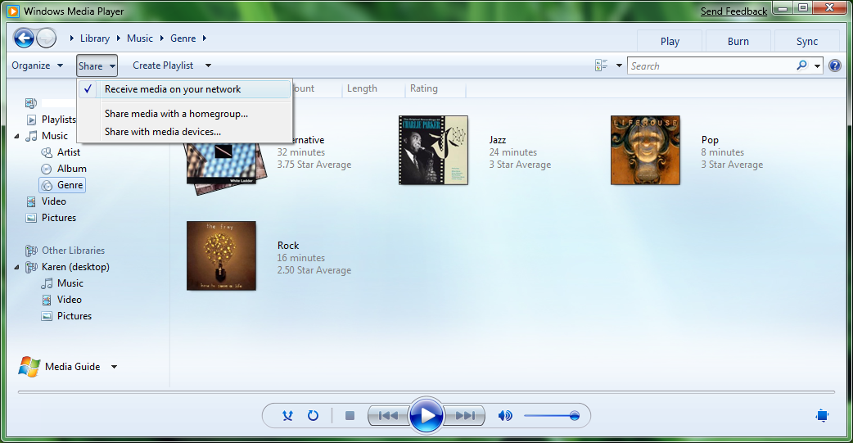
Figure 13. Windows Media Player displaying media-sharing features that let it act as a media renderer to receive content from other Windows 7 PCs and devices
Figure 14 shows the protocol layers in a DMR device. DMR devices support Wi-Fi or Ethernet for connectivity. They implement TCP/IP, UDP/IP, and HTTP, and implement the UPnP MediaRenderer functionality that includes the three services discussed earlier (connection manager, AV transport, and rendering control). DMR devices implement HTTP and extensions to receive content from a DMS in the network, and some use RTP for transfer.

Figure 14. Protocol stack for a digital media renderer

Digital Media Players
Users who have a DMP device can browse and request content from a Windows PC that is acting as a DMS for playback in the DMP. The functionality in Windows Vista was expanded by adding support for new formats and by including support for transcoding operations.
Windows 7 also performs the DMP role. Figures 15 and 16 show Windows Media Player and Windows Media Center acting as a media player. Whenever a media item is selected from the shared library of a media server and played, Windows Media Player and Windows Media Center are acting as a DMP.
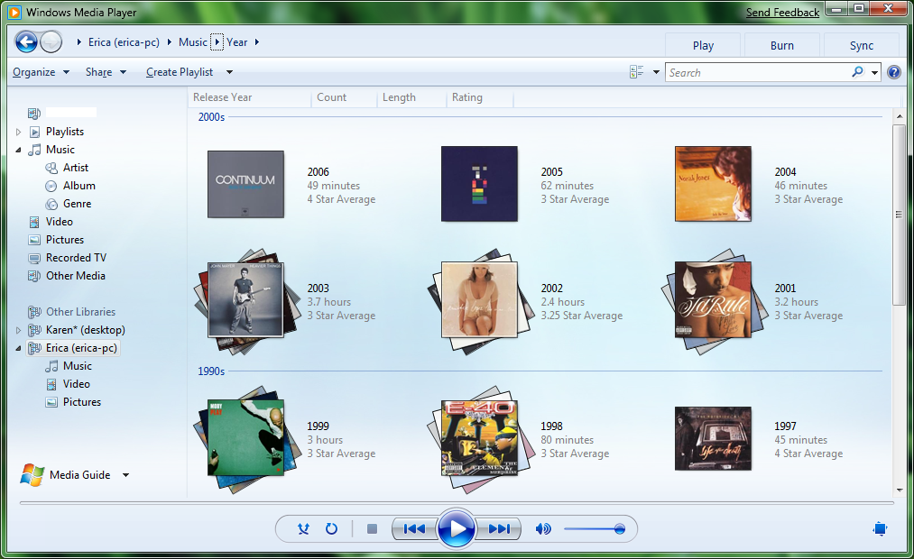
Figure 15: Browsing Erica’s shared music library for playback in Windows Media Player

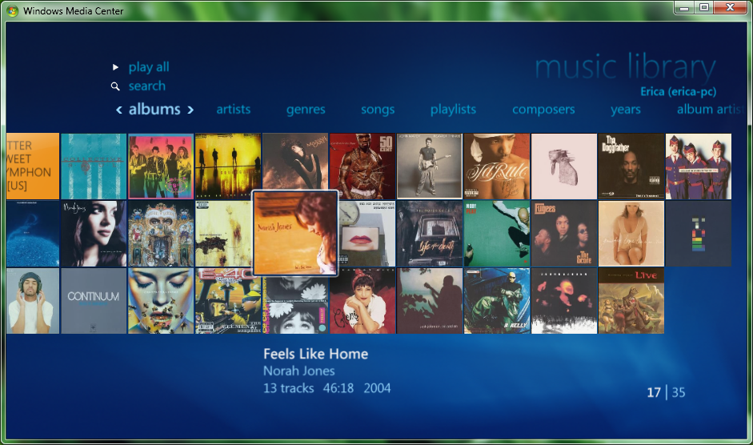
Figure 16: Browsing Erica’s shared music library for playback in Windows Media Center from the shared library pivot
DMP devices are fundamental for advancing the ecosystem of networked devices in the home. However, the new Windows Logo Program (WLP) will not certify devices that implement only the DMP role. We encourage companies to continue building devices with DMP functionality. In addition, we require the inclusion of the DMR role to interoperate with the Windows 7 Play To feature, as described in the preceding scenarios.
The rationale for this decision is simple. Families are storing several thousand pictures, audio files, and video files on PCs and other storage devices on their home networks. Managing this media content for one or more media libraries is an activity that is suited to the information management functions of a computer. Large media databases make it challenging to find items. Windows 7 addresses this problem through integrated search, tagging, and unified metadata across media applications and Windows Explorer. Searching for a song from a particular artist or searching for a family vacation photo is fast compared to browsing a file structure. By including the DMR role in devices, users can take full advantage of Windows capabilities for interacting with and searching media, while playing the content to the selected network media device by using the Windows 7 Play To feature.
Figure 17 shows the protocol layers in a digital media player. DMP devices support Wi-Fi or Ethernet for connectivity. DMP devices implement TCP/IP, UDP/IP, and HTTP. They implement the UPnP Media Server Control Point functionality to browse the media library in any networked DMS. DMR devices implement HTTP and extensions to receive content from a DMS. Some use RTP for transfer.

Figure 17. Protocol stack for a digital media player

Digital Media Controllers
Users who have DMC devices can browse content from any Windows PC and play that content in any other Windows PC or device that is connected to the home network and that implements the DMR role. Windows 7 implements a DMC, which is necessary to the Play To feature that was described earlier. After a DMR is selected for playback, the media controller is started to remotely control the playback experience. A user can have multiple media controllers open at any time and controlling playback to an equal number of DMRs in the network. Figure 18 shows this media controller, from which the following playback controls are available: Play, Pause, Stop, Mute, Volume, Next Item, Previous Item, Seek Forward, and Seek Backward.

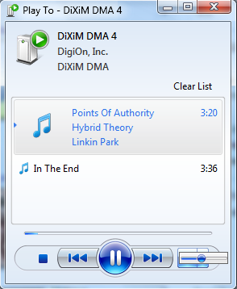
Figure 18. Windows 7 DMC controlling playback when the Play To feature is used in Windows Media Player and Windows Explorer
For example, a user can have network media devices that implement the DMR role in every room of the home. The family room DMR is an HDTV that supports playback of video, music, and pictures, and the bedroom DMR is a digital picture frame. The DMR for the kitchen and den is a network radio that supports only audio. From a Windows 7 PC, a user can concurrently send pictures to the bedroom digital picture frame, video to the family room HDTV, jazz music to the kitchen, and rock music to the den.
Figure 19 shows the protocol layers in a digital media controller. DMC devices support Wi-Fi or Ethernet for connectivity. DMC devices implement TCP/IP, UDP/IP, and HTTP. They implement the UPnP control point functionality that includes a media server control point and a media renderer control point.

Figure 19. Protocol stack for a DMC

Building a Great Network Media Device
A great network media device must meet the expectations of today’s users: discoverability, ease of installation and configuration, quick startup, and outstanding rendering that is free from delays.

Initial Network Media Device Discovery and Installation
Before the user can configure a media device, Windows 7 must discover the device and give the user a configuration interface. This initial device discovery and the subsequent configuration must continue smoothly and easily so that the user does not become frustrated, or worse, return the device. Network media devices must provide a great out-of-box experience for consumers.
In the past, it was fairly easy to set up a wired device, but rather challenging to set up a wireless device. The wireless technology got in the way of a great user experience. In Windows 7, the experience of setting up network devices is greatly improved because of new mechanisms for uniformly discovering and installing both wired and wireless devices.
To take advantage of the new discovery and installation features in Windows 7, device manufacturers must include device description document metadata for Plug and Play Extensions (PnP-X). This metadata is required by the NETMEDIA-0008, 0009, and 0010 network media device requirements. If a wireless interface is present, implement Wi-Fi Protected Setup (WPS) as required by the Connect-0099 Rally program requirements to receive a Windows logo. These capabilities enable Windows 7 to discover a device even if it has not associated with the wireless network (meaning that it does not yet have an IP address) and provide a simplified experience of configuration and installation directly from the Windows PC. The user out-of-box experience for a new network media device is as follows:
1. Remove the device from its package and plug it into a power outlet.
2. Connect audio and video cables if available.
3. From the Windows 7 PC Control Panel, under Hardware and Sound, choose Add a device.
4. Select the newly discovered network media device from a list of new devices and follow the wizard to install and configure the device.

Figure 20 shows the Windows 7 experience for adding and configuring a device.
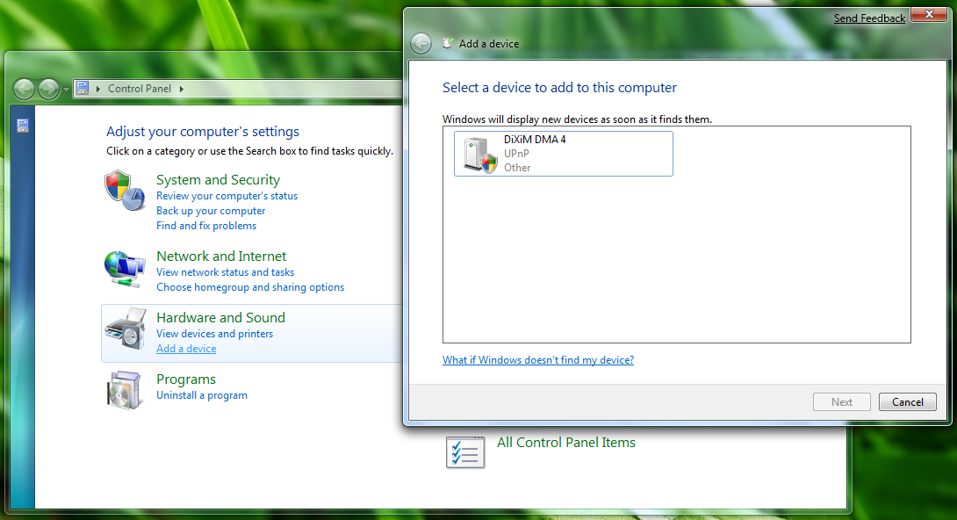
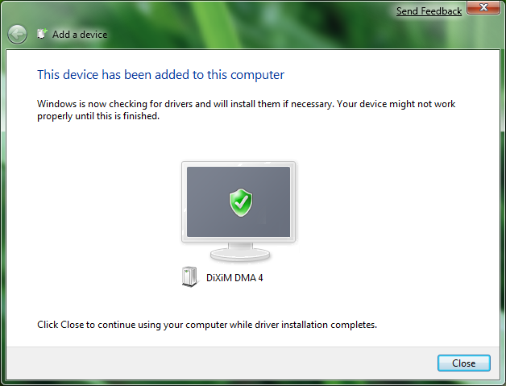
Figure 20. Adding a new network media device in Windows 7
This single process:
- Associates the wireless media device with the network by letting the user create a wireless profile or to specify an existing profile.
- Retrieves available drivers from Windows Update, based on the identifying information that is specified in the device description document PnP-X metadata. It also retrieves a metadata package that provides a photorealistic icon and other manufacturer-specific details for display in Windows.
- Installs the device and starts any associated software installations that are specified in the retrieved driver package.

Windows 7 provides a baseline installation experience that uses a simple driver package and default icons for each network media device class. However, manufacturers have lots of flexibility to brand their devices in Windows by submitting driver and metadata packages for their devices.

Internet Protocol Addressing
Network media devices must provide support for obtaining IP addresses without requiring user intervention. According to guidelines provided by DLNA, network media devices should be able to obtain an IP address by using either Dynamic Host Configuration Protocol (DHCP) or Automatic Internet Protocol (AutoIP) addressing. The expectation is that a home network has a router that acts as a DHCP server, but devices can use AutoIP to remain connected if the DHCP server fails.

Staying Connected and Troubleshooting
Network media devices must implement Link Layer Topology Discovery (LLTD) as specified in the Connect-0098 Rally program requirement. Any device that implements LLTD appears on the Windows Network Map as an icon that represents the device. This enables one-click access to the device's Web UI for troubleshooting and changing the device friendly name as required by NETMEDIA-0017 and 0018.
Support for LLTD is required for non-mobile DMRs and DMS. For more details, see the LLTD specification at “LLTD and QoS for Media Experiences” on the WHDC Web site.

PnP-X Metadata
To achieve the device discovery and installation experience, the manufacturer of a network media device must provide a UPnP device description document that contains at least the pnpx:X_deviceCategory and pnpx:X_compatibleId metadata elements. Windows 7 uses these metadata elements to discover DMR devices and DMS devices that are available for installation and to display appropriate icons and manufacturer-specific metadata for the device.

Digital Media Renderer Requirement NETMEDIA-0009
A DMR device must provide the following information in the device description document, unless the device specifies its own unique pnpx:X_compatibleId and associated pnpx:X_hardwareId for associating a custom driver and metadata package:
<device>
<pnpx:X_compatibleId
xmlns:pnpx="http://schemas.microsoft.com/windows/pnpx/2005/11">
MS_DigitalMediaDeviceClass_V001
</pnpx:X_compatibleId>
<pnpx:X_deviceCategory
xmlns:pnpx="http://schemas.microsoft.com/windows/pnpx/2005/11">
MediaDevice.DMR
</pnpx:X_deviceCategory>
</device>

The DMR role is typically one of many that a network media device implements, so we encourage device manufacturers to specify more than one pnpx:X_deviceCategory, where the first category that is specified represents the actual product form-factor of the device instead of the logical DMR role.
For example, a digital picture frame that implements the DMR role could specify the following device categories:
<device>
…
<pnpx:X_deviceCategory
xmlns:pnpx="http://schemas.microsoft.com/windows/pnpx/2005/11">
Display.PictureFrame
</pnpx:X_deviceCategory>
<pnpx:X_deviceCategory
xmlns:pnpx="http://schemas.microsoft.com/windows/pnpx/2005/11">
MediaDevice.DMR
</pnpx:X_deviceCategory>
…
</device>

A network radio that implements the DMR role could specify the following device category:
<device>
…
<pnpx:X_deviceCategory
xmlns:pnpx="http://schemas.microsoft.com/windows/pnpx/2005/11">
Audio.Speakers
</pnpx:X_deviceCategory>
<pnpx:X_deviceCategory
xmlns:pnpx="http://schemas.microsoft.com/windows/pnpx/2005/11">
MediaDevice.DMR
</pnpx:X_deviceCategory>
…
</device>

Digital Media Server Requirement NETMEDIA-0008
A DMS device must provide the following information in the device description document, unless the device specifies its own unique pnpx:X_compatibleId and associated pnpx:X_hardwareId for associating a custom driver and metadata package:
<device>
<pnpx:X_compatibleId
xmlns:pnpx="http://schemas.microsoft.com/windows/pnpx/2005/11">
MS_DigitalMediaDeviceClass_V001
</pnpx:X_compatibleId>
<pnpx:X_deviceCategory
xmlns:pnpx="http://schemas.microsoft.com/windows/pnpx/2005/11">
MediaDevice.DMS
</pnpx:X_deviceCategory>
</device>

The DMS role is typically one of many that a network media device implements, so we encourage device manufacturers to specify more than one pnpx:X_deviceCategory, where the first category that is specified represents the actual product form-factor of the device instead of the logical DMR role. For example, a network-attached storage that implements the DMR role might specify the following device categories:
<device>
…
<pnpx:X_deviceCategory
xmlns:pnpx="http://schemas.microsoft.com/windows/pnpx/2005/11">
Storage.NAS
</pnpx:X_deviceCategory>
<pnpx:X_deviceCategory
xmlns:pnpx="http://schemas.microsoft.com/windows/pnpx/2005/11">
MediaDevice.DMS
</pnpx:X_deviceCategory>
…
</device>

Customized PnP-X metadata
A device manufacturer can customize the user experience by specifying its own unique pnpx:X_compatibleId instead of the default MS_DigitalMediaDeviceClass_V001. If the manufacture chooses to specify its own compatible ID, it must also include a globally unique identifier (GUID) pnpx:X_hardwareId element in the device description document. The manufacturer must submit to Microsoft any metadata or driver packages that are associated with customizing the user experience. For details on how to create a customized experience, see ”Creating and submitting a device driver package” and “Creating and submitting a device metadata package” in “Resources” at the end of this document.

Device Announcement and Communication
After a network media device is discovered by Windows 7 and configured by the user, the device must be able to communicate with other devices on the network. To communicate effectively, a network device must comply with all UPnP protocols as specified in the DLNA 1.5 specification. The device description document must include the required device and service identifiers specified by DLNA. Specific network media device requirements can be found at the UPnP Web site.

Additional Metadata Requirements
To ensure that a network of several media devices provides the user with a great experience, Windows 7 requires some information in the device description document in addition to what DLNA requires. The additional elements enable the user to change the friendly name of the device and an indication of the device support for Wake on LAN (WoL).

FriendlyName
The device description document for a network media device exposes a friendly name for the device. For the friendly name to be useful, the user must be able to change it. For example, the user might change the friendly name of a device to Living Room Player.
Under Windows 7, a user must be able to change the friendly name of a device by using a Web page that the device manufacturer provides. The URL of that Web page is specified in the presentationURL element of the device description document. The use of a presentationURL element to expose an HTML presentation page is described in the UPnP Device Architecture specification. The presentation page must be written in such a way that it can be parsed and displayed correctly by Windows Internet Explorer 7 or later versions.

Wake on LAN Support
Windows 7 requires that a network media device declare its support for WoL in the device description document. Windows uses magic packets to wake devices that are sleeping on the network. In addition, Windows uses this information to inform the user whether a device can be awakened.
Figure 21 shows how a user can determine whether a DMP or a DMR in the network supports waking the PC. If a network media device does not specify the magicPacketSendSupported capability in its device description document, the following informational text appears under the device listing: “This device cannot access your shared media if your computer is sleeping.”
Figure 21: The Share with Media Devices application in Control Panel indicating whether the device can access a sleeping PC
By knowing which network media devices cannot wake the Windows 7 PC when it idles to sleep, a user can determine which option to select in the Share with Media Devices application in Control Panel to Prevent my PC from sleeping so that all devices can access my shared media.
A device that supports being awakened by magic packets must include the following element in its device description document:
<microsoft:X_magicPacketWakeSupported xmlns:microsoft="urn:schemas-microsoft-com:WMPNSS-1-0">
1
</ microsoft:X_magicPacketWakeSupported>

A device that does not support being awakened by magic packets must include the following element in its device description document:
<microsoft:X_magicPacketWakeSupported xmlns:microsoft="urn:schemas-microsoft-com:WMPNSS-1-0">
0
</ microsoft:X_magicPacketWakeSupported>

A device that supports sending magic packets to wake a sleeping Windows PC must include the following element in its device description document:
<microsoft:X_magicPacketSendSupported xmlns:microsoft="urn:schemas-microsoft-com:WMPNSS-1-0">
1
</ microsoft:X_magicPacketSendSupported>

A device that does not support sending magic packets to wake a sleeping Windows PC must include the following element in its device description document:
<microsoft:X_magicPacketSendSupported xmlns:microsoft="urn:schemas-microsoft-com:WMPNSS-1-0">
0
</ microsoft:X_magicPacketSendSupported>

Simple Service Discovery Protocol
UPnP devices announce their presence and find other devices by using the Simple Service Discovery Protocol (SSDP).
The Windows 7 NSS announces itself as a UPnP MediaServer device by sending out two SSDP NOTIFY messages every 15 minutes. The NSS responds to any correctly formatted M-SEARCH action by searching for a UPnP MediaServer. Sample SSDP NOTIFY messages are shown in Appendix 1.
The NSS provides a manufacturer name, model name, and model number in its device description document. The model number for Windows Media Player differs, depending on the operating system. In Windows 7, the model number for Windows Media Player is 12.0, the manufacturer name is Microsoft Corporation, and the model name is Windows Media Player Sharing.
The NSS tries to discover compatible devices on the network by examining UPnP SSDP NOTIFY announcements or responses to M-SEARCH actions. For a device to be discovered, it must implement the UPnP MediaRenderer:1 device class. Compatible devices include the following:
- UPnP MediaRenderers
- UPnP MediaServers
- UPnP Control Points

UPnP MediaRenderers are recognized by a combination of their media access control (MAC) address and a unique device name (UDN). When the NSS discovers a UPnP MediaRenderer device, the MAC/UDN pair of the device is compared to a stored list. If the MAC/UDN pair is not in this list, the NSS stores the MAC/UDN pair in the list and presents the device as a new device.
UPnP control points are recognized only by the MAC address. When the NSS discovers a control point device, the MAC address of the device is compared to a stored list. If the MAC address is not in this list, the NSS stores the MAC address for this device in the list but does not announce the device as a new device.
A network media device must a supply a unique device name (Udn0). A valid UDN value starts with the identifier uuid: followed by a 128-bit value in hexadecimal form. The ABNF syntax for the unique device name is defined as follows:
uuid-value = 8HEXDIG "-" 4HEXDIG "-" 4HEXDIG "-" 4HEXDIG "-" 12HEXDIG
UDN = "uuid:" uuid-value

According to this definition, the following is a valid UDN:
uuid:11223344-1122-1122-1122-123456789ABC

After a network media device is authorized, the device is automatically unauthorized if the MAC address for that device changes.

Same Subnet
The Windows 7 NSS communicates only with devices on the same subnet as the computer on which NSS is running. If the IP subnet of the Windows 7 PC and the device are not the same, the device cannot browse, search, or play content.
Devices can check the source IP address of incoming SSDP announcements from the NSS to confirm that the device and the computer are on the same subnet and to warn the user if they are not.

Device Performance
A great network media device must have a short boot time and respond to the user’s actions. To ensure that network media devices meet the expectations of today’s users, we make the following performance recommendations.

Device Startup Performance
For all network media devices, the time between turning on the device and the point at which the user can interact with the device should be less than 60 seconds.

Audio Latency
When the device is playing non-transcoded, unprotected audio content, the elapsed time from the device playback start until the first sound is heard should be no more than 1 second. Transcoded audio should take no more than 3 seconds.

Track-to-Track Audio Latency
When the device is playing non-transcoded, unprotected audio content, the elapsed time from the last sound on one track to the first sound on the next track must be no more than 1 second. When the device is playing transcoded, unprotected audio content, or protected content, the elapsed time from the last sound on one track to the first sound on the next track must be no more than 3 seconds.

Gapless playback
A great network media device should support gapless playback. Gapless playback means that tracks are played with no noticeable break between the tracks, so that an album plays continuously even though the CD is divided into tracks. The latency should be indiscernible by the human ear. This feature is important for listening to classical music, progressive rock, and electronic music.

Video Latency
When the device is playing unprotected video content, the elapsed time from the device playback start until the first video is displayed should be no more than 3 seconds. When the device is playing protected video content, the elapsed time from the device playback start until the first video is displayed should be no more than 8 seconds.

Track-to-Track Video Latency
When the device is playing unprotected video content, the elapsed time from the last video on one track to the first video on the next track must be no more than 3 seconds. When the device is playing protected video content, the time elapsed from the last video on one track to the first video on the next track must be no more than 6 seconds.

Building a Great Digital Media Renderer
Windows 7 has embraced the DLNA 1.5 specification for devices. As shown in scenario 3 in Figure 1, Windows lets users browse content on servers and send the content to digital media renderers. The DLNA requirements for DMR devices ensure good interoperability between DMR devices and the rest of the DLNA environment. In addition to the requirements that DLNA specifies, Windows has some requirements and recommendations to help device partners create great DMR devices.

Codec and Digital Rights Management Support
DLNA clearly defines the minimal set of codecs that are required for interoperability. Unfortunately, users’ libraries often consist of many different codecs that the device might not support. To address the growing number of codecs, Windows 7 NSS transcodes source content to several different profiles for better interoperability. The DMR device should support Windows Media codecs and specify the correct resource (RES) element for a format and bit rate the device supports.

Support for Windows Media Codecs
Windows Media Format codecs are publically available and are an optional format in the DLNA specification.

Windows Media Audio Support
If a DMR supports audio, the DMR should support the following WMA profiles as specified in the DLNA 1.5 Media Formats specification (NETMEDIA-0024):
- WMABASE
- WMAFULL

Windows Media Video Support
If a DMR supports video, the DMR should support the following WMV profiles, as specified in the DLNA 1.5 Media Formats specification (NETMEDIA-0023):
- WMVMED_BASE
- WMVMED_FULL
- WMVSPLL_BASE
- WMVSPML_BASE
- WMVHIGH_FULL

Windows Media Audio and Windows Media Video Certified Codecs
If WMA and WMV are implemented, a DMR must use WMA and WMV decoders that have passed the Microsoft integrated circuit (IC) test (NETMEDIA-0001).

Playing the Correct RES Element
The Windows 7 NSS transcodes source content into different RES elements. A DMR must choose a RES element that the DMR device can display (NETMEDIA-0025). The DMR device should select any RES element that can be rendered without requiring a transcode operation. If the device can play RES element #1, the device should prefer that element over a transcoded element.
Tips:
- Some devices choose MPEG over other formats they support. This can create a poor experience if the user must endure a transcode even though the device supports the source media natively.
- Devices should not choose to play or evaluate support for the media based only on the first returned RES element, even though Windows could provide the media to the device in a supported codec.
- With Windows 7 transcode support, the DMR device is not required to support as many decoders.

Digital Rights Management
Windows Media Digital Rights Management (DRM) has been part of the Windows ecosystem since before the beta release of Windows Media Player 7 in 2000. Windows users have millions of protected files that must play in this ecosystem. Therefore, we highly recommend that digital media renderers support Windows Media DRM-ND (NETMEDIA-0020).

Playback Requirements
Digital media renderer devices must meet two criteria:
- DMR devices must not block during errors.
- DMR devices must be ready to accept input.

The DMR might not be in the same room as the DMC. Therefore, when an error occurs, it is often the best user experience to move past the error and continue to play the next item. The Windows 7 logo requires that when a DMR receives an error, it must go into a STOPPED state and await instructions from the DMC. If the DMC provides another resource, then the DMR must suppress any error and begin playback of the next stream (NETMEDIA-0041).
When a DMR announces itself on the network, it must be able to display streams that are received from a DMC without any additional user input (NETMEDIA-0042). It is unacceptable for a device to announce itself as a DMR and then refuse to play back because the hardware is not set up to receive content. If the device has multiple modes and it can act as a DMR only in certain modes, then it must not broadcast itself as a DMR when in one of those competing modes.

Seek Requirements
Most users today are accustomed to operating VCRs and DVRs. There is an expectation that the device should enable the user to seek to a location in the audio or video stream. Minimally, Windows 7 logo requirements state that a DMR device must support time-based seeking for WMA and WMV content with ProfileIDs that are defined in NETMEDIA-0023 and NETMEDIA-0024. Support for seeking can be done locally by using cached content, through HTTP requests against the server or a combination of both (NETMEDIA-0070).
The time-based seek protocol for DMR devices and DMC device interactions is described in DLNA document CR13 (under the name ”controller-time seek operations”). CR13 will be published as Errata #3 to the DLNA 1.5 Guidelines. DMRs must follow the requirements for controller-time seek operations that are defined in CR13.
The Windows 7 NSS supports seeking to use a conventional HTTP range request as defined in section 14.35 of the HTTP 1.1 specification. It also supports the DLNA-defined HTTP extension header, TimeSeekRange.DLNA.org. Depending on the content type, the NSS provides none, one of the two, or both seek methods. The DMR must verify the appropriate seek method before it tries to seek within the content item.
Although the Windows 7 logo requirements require seek support for WMA and WMV profiles, for other profiles, DMR devices should support time-based seeking.

Pause Requirements
DLNA requires that DMRs be able to play and stop streams. Windows 7 logo requirements require that DMRs be able to pause as specified in the UPnP AVTransport specification (NETMEDIA-0071).

Volume Control Requirements
With digital media controllers controlling the playback experience, Windows 7 logo requirements state that it is mandatory that a DMR that can render audio must support volume control and conform with DLNA requirement 7.3.108 MM Renderer Volume Control (NETMEDIA-0072).

Playback Recommendations
The baseline playback requirements provide a good user experience. To foster a great user experience, we advocate that DMR devices implement the following features in addition to the baseline requirements.

Choosing the Optimal RES Element
The Windows 7 NSS provides a DMR device with multiple RES elements, and the Windows 7 requirements state that the DMR must choose the RES element that it can play. Additionally, the DMR should select the RES element that provides the best playback experience. The DMR should weigh Quality of Service (QoS) into the selection criteria and determine the bit rate that best meets the client’s needs.

Fast Forward and Fast Rewind
Consumers are accustomed to being able to fast-forward and fast-rewind both audio and video content. Therefore, we recommend that DMR devices support ”trick modes.” Minimally, a DMR should support positive 2 and negative 2 play speed control of WMA and WMV content.

Search Requirements
Some DMR devices enable more than just DMR functionality. If a DMR implements a media server control point (MSCP), then the DMR must either support search locally or support sending search requests in response to user action (NETMEDIA-0027). For example, if the DMR does not support local search, then the MSCP must also support sending CDS:Search requests in response to the user action. Search queries must support the following metadata properties:
- dc:title
- dc:creator
- upnp:actor
- upnp:album
- upnp:genre

For each property, the following operators must be supported:
- Contains
- Equal
- Exist

Robustness Requirements
DMR devices as consumer electronic devices should have the same robustness that the user experiences with a CD player. At a minimum, the DMR device must be able to play back its supported media type continuously for a 24-hour period without requiring user intervention (NETMEDIA-0048).

Robustness Recommendations
If the DMR device experiences a network glitch during playback, the DMR device should try to reconnect the stream and continue to play. If it cannot continue to play, then it must go into STOP mode.

Wake on LAN Requirements
As previously stated, a DMR device must provide device description document metadata that indicates whether the device supports WoL. In addition to this requirement, if a DMR device implements one or more low-power modes of operation, the DMR device must support WoL (NETMEDIA-0076).

Wake on LAN Recommendations
Although DMR devices are not required to support WoL, we recommend that device manufacturers be proactive and implement WoL in all devices.

Metadata Update Requirements
Windows 7 allows devices to modify the user’s ratings for a media item and to update the information on the server. If a DMR device allows editing the microsoft:userRatingInStars metadata attribute, then the DMR device must be able to notify digital media servers of the updated metadata by calling the UpdateObject method that the ContentDirectory service implements. The DMR device must call UpdateObject within 0.5 second of receiving approval of the change from the consumer.

User Experience Recommendations
The best user experience during playback includes displaying metadata that the user finds interesting about the currently playing item. The metadata for music should include the following:
- Album Art
- Artist
- Title
- Album Title
- Genre
- Year
- Star Rating

During music playback, a DMR device should visually expose album art and metadata to the user.
If a DMR device includes a control point that allows for browsing files, then the DMR device should meet the recommendations that are described later in this document for digital media controllers.

Building a Great Digital Media Server
Windows 7 has embraced the DLNA 1.5 specification for devices. This means that the DLNA 1.5 DMS can interact with Windows Media Player as a DMP and Windows Media Player as a DMR.
For a DMS to work with Windows, it must comply with DLNA. A set of rules must be followed so that Windows can discover DLNA 1.5 servers and make them available to the consumer.
In DLNA, DMS devices are divided into two categories: mobile devices (M-DMS) and home DMSs. The Windows 7 logo requirements are relaxed for M-DMS devices because of mobile device memory constraints. In the future, manufacturers of M-DMS devices should enable the High Definition Media Server (HDMS) requirements, as they improve the user experience.

Codec Support
DLNA clearly defines a minimal set of codecs that are required for interoperability and must be supported by a DMS. Because a DMS is used to store the consumer’s media files, it is essential to provide support for the various profiles that the consumer owns. For better interoperability, we recommend that a DMS provide support for WMV and WMA files.

Support for Windows Media Codecs
Windows Media Format codecs have been publically available for years and are an optional format in the DLNA specification.

Windows Media Audio Support
A DMS should support the following WMA profiles as specified in the DLNA 1.5 Media Formats specification (NETMEDIA-0022):
- WMABASE
- WMAFULL

Windows Media Video Support
A DMS must support the following WMV profiles as specified in the DLNA 1.5 Media Formats specification (NETMEDIA-0021):
- WMVMED_BASE
- WMVMED_FULL
- WMVSPLL_BASE
- WMVSPML_BASE
- WMVHIGH_FULL

Playback
The WLP has few specific playback requirements for DMS devices that exceed the support that DLNA requires. Beyond basic SEEK support, Windows does make some recommendations.

Seek
Seeking to a specific location in a media file is a basic task for consumers. A DMS device must support DLNA HTTP time-seek requests from any media content in storage with ProfileIDs that belong to the sets that are defined in NETMEDIA-0021 and NETMEDIA-0022. A DMS device must support HTTP range requests (byte-based seeking) for all files in storage.

Trick Modes (Fast Forward/Fast Rewind)
A DMS device should support trick modes for Windows Media and other media formats. To do this, the DMS device should support different values of play speeds (advertised in the DNLA.ORG_PS parameter of the fourth field of protocolInfo). The Server-Side Playspeeds parameter is specified in the 7.3.35 MM ps-param (Server-Side PlaySpeeds Parameter) section of the DLNA 1.5 Specification.

Search
Most users use Windows Media Player to filter their content quickly. For a DMS device to integrate with Windows 7, it is important that the DMS device exposes DLNA-defined search capabilities (NETMEDIA-0026) that use the following attributes:
- dc:title
- dc:creator
- upnp:actor
- upnp:album
- upnp:author
- upnp:genre

For each attribute, the following operators must be supported:
- Contains
- Equal
- Exist

Robustness
DMSs are the backbone for connected media home networks. If users cannot access their content, the system fails. Microsoft We have defined the minimum requirements for the robustness of a DMS. A DMS device must be able to stream the supported media files continuously for 24 hours without requiring user intervention or degradation of quality of experience (NETMEDIA-0047). The DMS device should be able to stream for much longer periods of time, and future requirements will dictate that.
A DMS must be able to stream HD content. Although this requirement may be taxing to mobile devices, the reality is that more content is moving to HD (NETMEDIA-0053).
A good digital media server should be able to source at least 10 connections at the same time. The Windows 7 Logo Program requires that the server support at least two concurrent connections. This is especially important as users play content and download album art and other metadata at the same time (NETMEDIA-0054)

Wake on LAN
Similar to the DMR requirement, we recommend that a DMS device support a low-power mode of operation and WoL. Allowing a server to enter a low-power mode and awaken only when content is required is a smart, ecologically friendly design. As mentioned earlier, a DMS device must provide information in the device description document that states its support for WoL.
The WLP requires that a DMS device that implements one or more low-power modes must be able to resume to normal-power mode operation in response to receiving a broadcast Magic Packet. It is not a current requirement that the DMS device support a low-power mode of operation (NETMEDIA-0011).

User Experience
To foster an improved user experience, the WLP requires that DMS devices implement the following features.

Album Art
Most users’ music collections include album art with the media files. When user browse a library of music, they expect to see album art associated with their media files. Therefore, the Windows logo requirement NETMEDIA-0059 states that if album art is available for the music file, the DMS device must provide it.
In addition, the WLP requires that DMS devices filter album art from the queries for images (NETMEDIA-0029). Otherwise, users browsing their photo libraries are inundated with album art.

Thumbnails
Users of Windows and Windows Media Player expect to browse through their libraries of content in thumbnail view. That means that thumbnails of videos and images appear in the library while the user is browsing. The WLP requires that if thumbnails are available, the server provide them to the client for videos and images (NETMEDIA-0060 and NETMEDIA-0061).

Metadata
In addition to album art, users expect to see the metadata that is associated with their files. The WLP requires that a DMS device provide the common metadata attributes for music, video, and pictures (NETMEDIA-0032).
For improved functionality and searching, a DMS device should also provide support for these additional Microsoft attributes that are specified in the Windows Media Player compatibility document:
- microsoft:artistAlbumArtist
- microsoft:artistConductor
- microsoft:artistPerformer
- microsoft:authorComposer
- microsoft:authorOriginalLyricist
- microsoft:authorWriter
- microsoft:userRatingInStars

Building a Great Digital Media Controller
One of the more exciting parts of the model that was illustrated previously in Scenario 3 is the DMC. The DMC lets the user find the content on the server and send it to the DMR device within the home ecosystem.
Although this is one of the more important elements of the system, the actual Windows requirements for these devices are fairly limited. A DMC device must comply with DLNA and support Microsoft® Rally™ technologies.
In addition to the requirements that DLNA specifies, the WLP requires DMC devices to be able to wake up other devices. The DMC device controls the servers and the renderers, so if those devices are in sleep mode, the DMC device must be able to send magic packets to wake them up (NETMEDIA-0074).

Recommended Digital Media Controller Features
With so few requirements on DMC devices, OEMs can differentiate their DMCs by implementing suggested features. The following is a list of recommendations to consider.

User Experience: Playback

Displaying Metadata
DMC devices should provide feedback to the user about the currently playing file. The feedback should include the following information:

Music Tracks (object.item.audioItem)
dc:creator
upnp:album
upnp:genre
res@duration
res@size

Images (object.item.imageItem)
dc:date
res@resolution
res@size

Images (object.item.videoItem)
dc:creator
upnp:genre
dc:date
res@duration
res@size

Music Album (object.container.album.musicAlbum)
dc:creator
upnp:genre
@childCount

Displaying Album Art
During playback of a music track, great DMC devices give the user the option of viewing the associated album art.

Controls
In Scenario 3, DMC devices are designed to control the user experience, so it is important that the user is provided with the same type of controls as other consumer electronic devices. For example, the DMC should lets users play, pause, stop, fast forward, rewind, mute, and adjust the volume of the media they are consuming.

Volume
A great DMC device should let the user adjust and modify the volume of supported media renderers. The volume support should include MUTE and a slider for more detail. If the DMR does not support the volume control, the UI for this feature should be disabled.

Play / Pause / Stop
A DMC device should provide play, pause, and stop controls for all media types. The DMC device should enable the user to pause or stop the currently playing stream. In addition to providing the UI elements, the DMC device should forward the pause, stop, and play requests to the digital media renderer.

Seek
A DMC device that is acting as an MSCP should let the user navigate to a specific position in a media stream. The DMC device should enable the user to seek into a specified time position for audio and video types. In addition to providing the UI elements, the DMC device should forward the seek requests to the digital media renderer.

Fast Forward/Fast Rewind
A great DMC device should include trick mode support. If a DMR device indicates its ability to (fast/slow) forward or (fast/slow) rewind a stream, the DMC should enable the user to forward and rewind the currently playing stream. In addition to providing the UI elements, the DMC must forward the appropriate metadata and trick mode requests to the digital media renderer. The DMC should forward the Server-Side Playspeeds parameter to the DMR device as part of the transferred metadata in the SetAVTransportURI action. Forwarding this information to the DMR enables the DMR device to request those play speeds from the DMS device.

User Experience: Browse
Another key user experience is locating the files to stream. To provide a great user experience, a DMC device should enable the user to browse libraries, based on album art, video thumbnails, or image thumbnails. The visual hierarchy allows consumers to quickly navigate and find the files they are looking for.

Metadata and Ratings Update
In addition to displaying album art and thumbnails to the user, a DMC device should expose metadata for each media item. This should include the metadata that is mentioned in the playback experience and additional Microsoft specific metadata:
- microsoft:artistAlbumArtist
- microsoft:artistConductor
- microsoft:artistPerformer
- microsoft:authorComposer
- microsoft:authorOriginalLyricist
- microsoft:authorWriter
- microsoft:userRatingInStars

A DMC should also let the user change the userRatingsInStars. When the user makes a change to this field, the DMC should push this change back to the DMS by using the UPnP UpdateObject. This lets users change queries that are based on their preferences.

Glossary of Acronyms
The following table lists the acronyms used in this white paper.
Acronym | Description
AAC | advanced audio coding
AutoIP | Automatic Internet Protocol
AVI | audio video interleave
CDS | content directory service
CMS | connection manager service
DHCP | Dynamic Host Configuration Protocol
DLNA | Digital Living Networking Alliance
DMC | digital media controller
DMP | digital media player
DMR | digital media renderer
DMS | digital media server
DRM | Digital Rights Management
DVR | digital video recorder
DVR-MS | digital video recorder – Microsoft
GUID | globally unique identifier
HDMS | High Definition Media Server
IC | integrated circuit
JPEG | Joint Photographic Experts Group
LLTD | Link Layer Topology Discovery
LPCM | Linear Pulse Code Modulation
MAC | media access control
MIME | Multipurpose Internet Mail Extensions
MPEG | Motion Picture Experts Group
MSCP | media server control point
NAS | network-attached storage
NSS | Network Sharing Services
NTSC | National Television System Committee
PAL | phase alternating line
PNG | portable network graphics
PnP-X | Plug and Play Extensions
QoS | Quality of Service
RTP | Real-Time Transfer Protocol
RTSP | Real-Time Streaming Protocol
SSDP | Simple Service Discovery Protocol
TCP/IP | Transmission Control Protocol/Internet Protocol
UDN | unique device name
UDP | User Datagram Protocol
UI | user interface
WMA | Windows Media Audio
WMC | Windows Media Connect
WMV | Windows Media Video
WoL | Wake on LAN
WPS | Wi-Fi Protected Setup
WSP | Windows Logo Program
WTV | Windows TV

Resources

Windows Logo Resources
Windows Logo Program information
http://winqual.microsoft.com/
Windows Logo requirements and policies
http://www.microsoft.com/whdc/winlogo/hwrequirements.mspx

Windows Media Resources
Building a Network Device Compatible with Microsoft Windows Media Player 11
http://go.microsoft.com/fwlink/?LinkId=87957
A Technical Overview of Windows Media DRM 10 for Devices
http://go.microsoft.com/fwlink/?LinkId=28570
Windows Media Licensing Program
http://www.microsoft.com/windows/windowsmedia/licensing/default.mspx
Windows Media Player SDK on MSDN
http://go.microsoft.com/fwlink/?LinkID=130978
Windows 7 Codec Support
http://go.microsoft.com/fwlink/?LinkId=130993

Rally Technologies
Windows Connect Now
http://go.microsoft.com/fwlink/?LinkId=130992
LLTD and QoS for Media Experience
http://go.microsoft.com/fwlink/?LinkId=129540

Windows Driver and Metadata Resources
Creating and submitting a device driver package
http://go.microsoft.com/fwlink/?LinkId=131005
Creating and submitting a device metadata package
http://go.microsoft.com/fwlink/?LinkId=129543

Industry Resources
UPnP MediaServer and MediaRenderer-related specifications
http://www.upnp.org/standardizeddcps/mediaserver.asp
Digital Living Network Alliance (DLNA) Guidelines
http://www.dlna.org

Appendixes

Appendix 1: Sample Simple Service Discovery Protocol Announcement Messages
The following examples show sample NOTIFY messages sent by the Windows 7 NSS. Depending on the computer that is hosting NSS, some fields might have different values:
NOTIFY * HTTP/1.1\r\n
Host:239.255.255.250:1900\r\n
NT:urn:schemas-upnp-org:service:ConnectionManager:1\r\n
NTS:ssdp:alive\r\n
Location:http://192.168.1.100:2869/upnphost/udhisapi.dll?content=uuid:224e2bb9-6961-4d79-b05f-f72cb415dc6c\r\ns
USN:uuid:224e2bb9-6961-4d79-b05f-f72cb415dc6c::urn:schemas-upnp-org:service:ConnectionManager:1\r\n
Cache-Control:max-age=1800\r\n
Server:Microsoft-Windows-NT/5.1 UPnP/1.0 UPnP-Device-Host/1.0\r\n
\r\n

NOTIFY * HTTP/1.1\r\n
Host:239.255.255.250:1900\r\n
NT:urn:schemas-upnp-org:service:ContentDirectory:1\r\n
NTS:ssdp:alive\r\n Location:http://192.168.1.100:2869/upnphost/udhisapi.dll?content=uuid:224e2bb9-6961-4d79-b05f-f72cb415dc6c\r\n
USN:uuid:224e2bb9-6961-4d79-b05f-f72cb415dc6c::urn:schemas-upnp-org:service:ContentDirectory:1\r\n
Cache-Control:max-age=1800\r\n
Server:Microsoft-Windows-NT/5.1 UPnP/1.0 UPnP-Device-Host/1.0\r\n
\r\n

NOTIFY * HTTP/1.1\r\n
Host:239.255.255.250:1900\r\n
NT:urn:schemas-upnp-org:device:MediaServer:1\r\n
NTS:ssdp:alive\r\n Location:http://192.168.1.100:2869/upnphost/udhisapi.dll?content=uuid:224e2bb9-6961-4d79-b05f-f72cb415dc6c\r\n
USN:uuid:224e2bb9-6961-4d79-b05f-f72cb415dc6c::urn:schemas-upnp-org:device:MediaServer:1\r\n
Cache-Control:max-age=1800\r\n
Server:Microsoft-Windows-NT/5.1 UPnP/1.0 UPnP-Device-Host/1.0\r\n
\r\n

NOTIFY * HTTP/1.1\r\n
Host:239.255.255.250:1900\r\n
NT:upnp:rootdevice\r\n
NTS:ssdp:alive\r\n
Location:http://192.168.1.100:2869/upnphost/udhisapi.dll?content=uuid:224e2bb9-6961-4d79-b05f-f72cb415dc6c\r\n
USN:uuid:224e2bb9-6961-4d79-b05f-f72cb415dc6c::upnp:rootdevice\r\n
Cache-Control:max-age=1800\r\n
Server:Microsoft-Windows-NT/5.1 UPnP/1.0 UPnP-Device-Host/1.0\r\n
\r\n

The following example shows a UPnP M-SEARCH message response by NSS:
M-SEARCH * HTTP/1.1\r\n
Host:239.255.255.250:1900\r\n
ST:urn:schemas-upnp-org:device:MediaServer:1\r\n
Man:"ssdp:discover"\r\n
MX:3\r\n
\r\n

The following example shows a sample SSDP announcement from a UPnP MediaRenderer:
NOTIFY * HTTP/1.1\r\n
HOST: 239.255.255.250:1900\r\n
CACHE-CONTROL: max-age=1800\r\n
LOCATION: http://192.168.1.100:80/description.xml\r\n
NT: urn:schemas-upnp-org:device:MediaRenderer:1\r\n
NTS: ssdp:alive\r\n
SERVER: NetDeviceOS/5.4 UPnP/1.0 DMP/5.0\r\n
USN: uuid: 224e2bb9-6961-4d79-b05f-f72cb415dc6c::urn:schemas-upnp-org:device:MediaRenderer:1\r\n
\r\n

Appendix 2: Resource Elements for Transcoded Content
The following example shows multiple resource elements exposed for the testImage.jpg file.
In each resource element, the name of the file in the root URL is intentionally shortened for brevity and clarity.
<item id="000000000000033F" parentID="B" restricted="1">
<dc:title>testImage</dc:title>
<upnp:class>object.item.imageItem.photo</upnp:class>
<upnp:album>[No Keywords]</upnp:album>
<dc:date>2002-03-04</dc:date>
<upnp:albumArtURI>http://192.168.1.111:10243/WMPNSSv4/1234/{name}.jpg?
albumArt=true</upnp:albumArtURI>
<res size="544643" resolution="3000x1968"
protocolInfo="http-get:*:image/jpeg:*" colorDepth="24">
http://192.168.1.111:10243/WMPNSSv4/1234/{name}.jpg</res>
<res resolution="160x104" protocolInfo="http-get:*:image/jpeg:*" colorDepth="24">http://192.168.1.111:10243/WMPNSSv4/1234/{name}.jpg?formatID=23,width=160,height=104</res>
<res resolution="640x419" protocolInfo="http-get:*:image/jpeg:*" colorDepth="24">http://192.168.1.111:10243/WMPNSSv4/1234/{name}.jpg?formatID=23,width=640,height=419</res>
<res resolution="1024x671" protocolInfo="http-get:*:image/jpeg:*" colorDepth="24">http://192.168.1.111:10243/WMPNSSv4/1234/{name}.?formatID=23,width=1024,height=671</res>
<res resolution="136x90" protocolInfo="http-get:*:image/x-ycbcr-yuv420:*" colorDepth="24">http://192.168.1.111:10243/WMPNSSv4/1234/{name}.jpg?formatID=24,width=136,height=90,thumbnail=false,aspectRatio=9:8,rFill=20,gFill=20,bFill=20</res>
<res resolution="684x456" protocolInfo="http-get:*:image/x-ycbcr-yuv420:*" colorDepth="24">http://192.168.1.111:10243/WMPNSSv4/1234/{name}.jpg?formatID=24,width=684,height=456,thumbnail=false,aspectRatio=9:8,rFill=20,gFill=20,bFill=20</res>
<res resolution="3000x1968"
protocolInfo="http-get:*:image/x-ycbcr-yuv420:*" colorDepth="24">
http://192.168.1.111:10243/WMPNSSv4/1234/{name}.jpg?formatID=24,width=3000,height=1968,thumbnail=false,aspectRatio=1:1,rFill=20,gFill=20,bFill=20</res>

