Developer Enhancements to Windows Touch and Tablet PC
December 18, 2008
Abstract
This paper provides guidelines for developers to understand the new Windows® Touch and Tablet PC developer enhancements to the Windows family of operating systems.
This information applies for the following operating systems:
Windows 7
Windows Server® 2008 R2
References and resources discussed here are listed at the end of this paper.
For the latest information, see:
http://www.microsoft.com/whdc/device/input/touch_tab_enhance.mspx

Disclaimer: This is a preliminary document and may be changed substantially prior to final commercial release of the software described herein.

The information contained in this document represents the current view of Microsoft Corporation on the issues discussed as of the date of publication. Because Microsoft must respond to changing market conditions, it should not be interpreted to be a commitment on the part of Microsoft, and Microsoft cannot guarantee the accuracy of any information presented after the date of publication.

This White Paper is for informational purposes only. MICROSOFT MAKES NO WARRANTIES, EXPRESS, IMPLIED OR STATUTORY, AS TO THE INFORMATION IN THIS DOCUMENT.

Complying with all applicable copyright laws is the responsibility of the user. Without limiting the rights under copyright, no part of this document may be reproduced, stored in or introduced into a retrieval system, or transmitted in any form or by any means (electronic, mechanical, photocopying, recording, or otherwise), or for any purpose, without the express written permission of Microsoft Corporation.

Microsoft may have patents, patent applications, trademarks, copyrights, or other intellectual property rights covering subject matter in this document. Except as expressly provided in any written license agreement from Microsoft, the furnishing of this document does not give you any license to these patents, trademarks, copyrights, or other intellectual property.

Unless otherwise noted, the example companies, organizations, products, domain names, e-mail addresses, logos, people, places and events depicted herein are fictitious, and no association with any real company, organization, product, domain name, email address, logo, person, place or event is intended or should be inferred.

© 2008 Microsoft Corporation. All rights reserved.

Microsoft, Silverlight, Windows, and Windows Server are either registered trademarks or trademarks of Microsoft Corporation in the United States and/or other countries.

The names of actual companies and products mentioned herein may be the trademarks of their respective owners.
Document History
Date | Change
December 18, 2008 | Originally titled “Developer Enhancements to Windows for Touch and Tablet.”  Clarified that the Math Input Control does not ship in Windows Server 2008 R2.
November 5, 2008 | First publication

Contents
Introduction 4
The Math Input Control 4
Creating the Math Input Control 5
Include Headers and Libraries for the Math Input Control 5
Declare and Initialize the Control Pointer 6
Show the Control 6
Customizing the Math Input Control 7
Changing the Displayed Buttons 7
Changing the Control Caption 8
Changing the Control's Preview-Area Size 8
Multitouch for Windows 7 9
Creating Custom Dictionaries for Handwriting Recognition 10
Compiling a Word List 10
Explanation of Options 10
Defaults 11
Examples 12
Installing a Compiled Custom Dictionary 12
Running HwrReg.exe in Check/Install Mode 12
Running HwrReg.exe in List/Remove Mode 13
General Notes on Custom Dictionaries 14
Server-Side Recognition 14
Resources 15

Introduction
The Windows® 7 operating system operating system introduces additional language support, the math input control, custom dictionaries, and multitouch support to Windows operating systems. Windows Server® 2008 R2 introduces support for additional languages, custom dictionaries, and server-side recognition. These features enhance Tablet PC functionality and let developers deliver new applications that support practical scenarios for end users:
- The math input control allows input of math formulas and functions from handwritten text in Windows 7.
- To improve text recognition, Windows 7 and Windows Server 2008 R2 support custom dictionaries, so that administrators can directly enable support for word lists.
- Multitouch supports input from multiple touch sources through new window messages, plus a gesture-recognition API that supports panning, zooming, and rotating.

Windows Server 2008 R2 supports server-side recognition of form input, and custom dictionaries for server-side recognition. With the addition of these features, developers and administrators can create and customize powerful applications that support handwriting recognition from the server side.

The Math Input Control
The Windows 7 operating system supports math input from the math input panel (MIP), the new math-specific equivalent of the text input panel. Note that Windows Server 2008 R2 does not include support for the math input panel or math input control. Many applications—even legacy applications—can take advantage of the MIP without modification, because users can directly trigger this input application from Windows 7. The following image illustrates one scenario of usage for the math input control, in which a user takes notes, inks them into a pen-enabled document, and then copies them into another application as symbolic input.
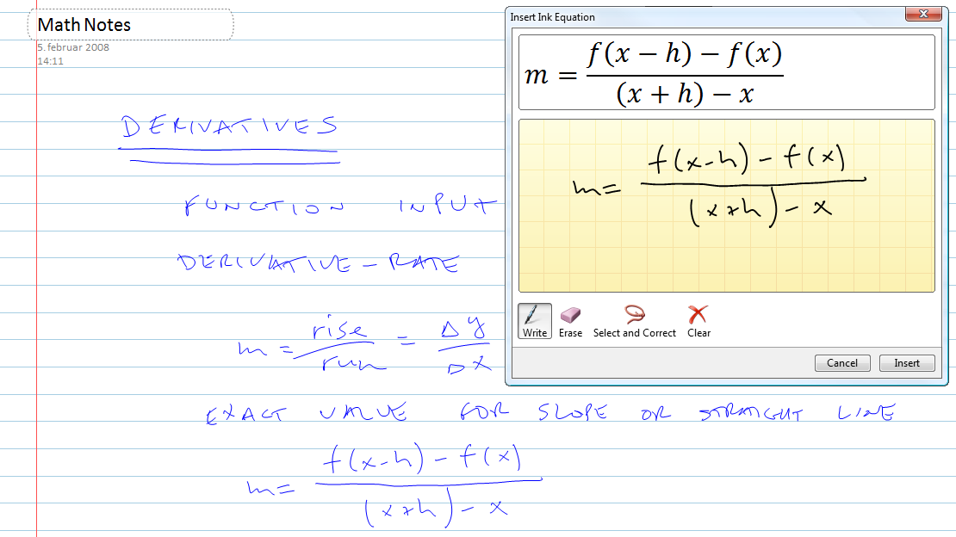
The math input control lets developers integrate the functionality of the MIP much more directly within their applications. Compared to data input with traditional methods—such as browsing through symbol menus or memorizing keyboard shortcuts—entering data by using the math input control is much more intuitive and natural. Because the math input control is well integrated into applications, users should notice the improved experience.
Developing applications that take advantage of the math input control is very easy in Windows 7. This section gives a few examples of typical tasks that Windows 7 developers may want to perform when they integrate the math input control into their applications.

Creating the Math Input Control
In this section, you will learn how to create the math input control from application code. This creation procedure is typically performed when the programmer expects a user to enter formulaic data.
To create the math input control
1. Include the headers and libraries for the math input control.
2. Declare and initialize the control pointer.
3. Show the control.

Include Headers and Libraries for the Math Input Control
Place the following at the top of code that uses the math input control:
// includes for implementation
#include "micaut.h"
#include "micaut_i.c"

This code adds support for the math input control to your application.

Declare and Initialize the Control Pointer
After you have included the headers for your control, you can declare the control pointer and initialize it with a call to the CoInitialize function. This call creates a handle to the math input control interface. The following code can be placed in a class or as a global variable in your application's implementation:
CComPtr<IMathInputControl> g_spMIC; // Math Input Control

The following code shows how to call CoInitialize on the control pointer:
HRESULT hr = CoInitialize(NULL);
hr = g_spMIC.CoCreateInstance(CLSID_MathInputControl);

After calling CoInitialize on the control pointer, you have a reference to the control and can access the control's methods. For example, you could enable the extended set of controls as shown in the following code:
hr = g_spMIC->EnableExtendedButtons(VARIANT_TRUE);

Show the Control
The control does not automatically appear after you create it. To show the control, call the Show method on the control reference that you created in the previous step. The following code demonstrates how the Show method can be called:
hr = g_spMIC->Show();

After the control shows, it looks something like the following image.
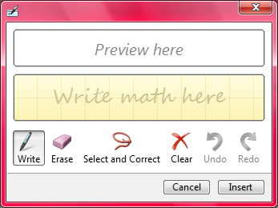
Note that the extended set of buttons is enabled, so that Redo and Undo are available. They appear dimmed in this image because the user has not yet done anything to undo or redo.

Customizing the Math Input Control
This section explains three ways of customizing the math input control's appearance to better suit your application:
- Changing the displayed buttons.
- Changing the control caption.
- Changing the control's preview-area size.

Changing the Displayed Buttons
You can change the buttons that are displayed on the math input control so that the control has extended functionality or appears smaller on the screen. Enabling the extended button set shows the Redo and Undo buttons. The following code shows how to enable the extended button set:
void CMath_Input_Control_testDlg::OnBnClickedToggleBtns()
{
static bool enabled = true;
HRESULT hr = S_OK;

hr = g_spMIC->Hide();
if(!enabled){
if (SUCCEEDED(hr)){
hr = g_spMIC->EnableExtendedButtons(VARIANT_TRUE);
enabled = true;
}
}else{
if (SUCCEEDED(hr)){
hr = g_spMIC->EnableExtendedButtons(VARIANT_FALSE);
enabled = false;
}
}
if (SUCCEEDED(hr)){
hr = g_spMIC->Show();
}
}

The following images show the control with the extended set of buttons (on the left) and without the extended set of buttons (on the right). (The different color schemes occur because the screen shots are from two different computers.)
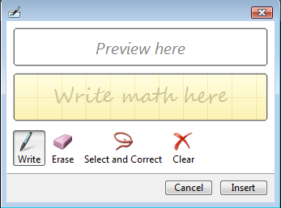

Changing the Control Caption
You can change the control caption for the math input control, to set the caption on the math input control's window. The following code shows how to set the caption:
void CMath_Input_Control_testDlg::OnBnClickedSetCaption()
{
g_spMIC->Hide();
CComBSTR cap1(L"Some Caption Text");
g_spMIC->SetCaptionText((BSTR)cap1);
g_spMIC->Show();
}

The following image shows the control after the caption has been set.
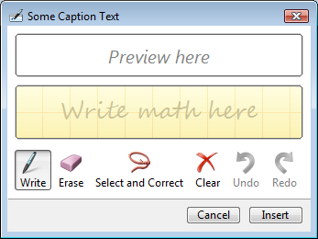

Changing the Control's Preview-Area Size
You can customize the math input control so that the control explicitly sets its preview-area size. This creates a larger area in which the math formulas appear. The following code shows how to set the preview-area size:
void CMath_Input_Control_testDlg::OnBnClickedSetPreviewAreaSize()
{
LONG height = 200;
HRESULT hr = S_OK;
hr = g_spMIC->SetPreviewHeight(height);
}

The following images show a control with differently sized preview areas.
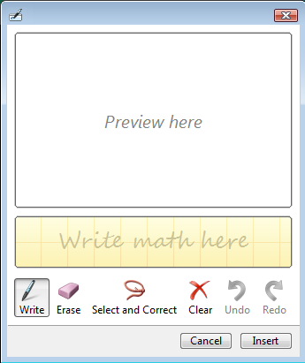

Multitouch for Windows 7
New hardware and API elements in the Windows 7 operating system allow applications to receive multitouch input. This ability lets an application detect and respond to multiple simultaneous touch points on the application’s visible surface. Functionality for this feature in Windows 7 is provided by a new set of dedicated window messages that report touch-down, touch-up, and touch-move actions. The new messages report the action and position of touch points, with unique identification of simultaneous touch points.
The messages are generated by pen or touch raw-input processing, which is currently performed by the Tablet platform's Windows Ink Service Platform Tablet Input Subsystem (WISPTIS) process and which is delivered to a target application.
In addition to the new input messages, multitouch gesture messages are added to the existing list of window messages. Messaging support for multitouch and multitouch gestures function through new window messages. Those messages are sent or posted by the Tablet WISPTIS process to appropriate application windows when user input is recognized as a gesture. Dedicated API functions encapsulate the details for creation and consumption of these messages. This is done so that the information that is associated with the message can change in the future without requiring developers to update applications that already consume this message.
By applying the new multitouch functionality available in Windows 7, developers can create applications that we see falling into three tiers of specialization:
- Applications in the first tier have no optimized support for multitouch. These applications use generic handlers for gesture input and translate those messages into window automation.
- Applications in the second tier have some optimization for specific messages. For example, these applications use the center point of a pinch or zoom gesture, rather than zoom directly to the center of a picture.
- Applications in the third tier are full multitouch applications. These applications are designed specifically for use only on multitouch hardware; for example, a multitouch game where multitouch gestures and multiple input points are used to manipulate objects on screen.

The Windows 7 Software Development Kit (SDK) includes documentation with more information about this new functionality.

Creating Custom Dictionaries for Handwriting Recognition
In the Windows 7 and Windows Server® 2008 R2 operating systems, the accuracy of handwriting recognition can be significantly improved through the use of custom dictionaries. These dictionaries supplement or replace system dictionaries that are used for handwriting.
Note that custom dictionaries can be installed for a language only if the handwriting recognizer for that language is installed.
There are two basic steps to setting up a custom dictionary for handwriting:
- Compile a word list. The compilation creates a compiled custom-dictionary (.hwrdict) file.
- Install the compiled custom dictionary.

Compiling a Word List
The word list to be compiled must be in plain-text format and should be saved by using a Unicode encoding. Other encodings do not work. Each line of the text file is considered a single entry in the dictionary. Multiword units—entries that contain one or more spaces—are allowed. Spaces at the beginning or end of a line are ignored.
A custom dictionary is compiled from a command line. To compile a dictionary, open a command window, navigate to the folder that contains the word list, and then run HwrComp.exe with the desired command-line options.
The following shows the usage syntax for the command-line options:
Usage: hwrcomp [-lang <localename>] [-type <type>]
[-comment <comment>]
[-o <dictfile.hwrdict>]
<inputfile>

Explanation of Options
-lang <localename>
The specified locale name is assigned to the compiled custom-dictionary file. The argument <localename> has the form language-REGION. An example of this is en-US, which signifies the English language in the United States region. You can find examples of this form in “Locale Identifier Constants and Strings” on the MSDN Web site.
-type <type>
The option argument <type> is a single-string concatenation of the resource's use—as either the main word list (PRIMARY) or as a supplement to the main word list (SECONDARY)—followed by the actual word-list name to which the resource is applied (such as DICTIONARY or SURNAME).
The following are possible type values:
PRIMARY-CITYNAME-LIST
PRIMARY-COUNTRYNAME-LIST
PRIMARY-COUNTRYSHORTNAME-LIST
PRIMARY-DICTIONARY
PRIMARY-GIVENNAME-LIST
PRIMARY-STATEORPROVINCE-LIST
PRIMARY-STREETNAME-LIST
PRIMARY-SURNAME-LIST
SECONDARY-CITYNAME-LIST
SECONDARY-COUNTRYNAME-LIST
SECONDARY-COUNTRYSHORTNAME-LIST
SECONDARY-DICTIONARY
SECONDARY-EMAILSMTP-LIST
SECONDARY-EMAILUSERNAME-LIST
SECONDARY-GIVENNAME-LIST
SECONDARY-STATEORPROVINCE-LIST
SECONDARY-STREETNAME-LIST
SECONDARY-SURNAME-LIST
SECONDARY-URL-LIST

If a type value starts with the prefix PRIMARY, the compiled dictionary, once installed, replaces the system dictionary. The value PRIMARY-DICTIONARY represents the main system dictionary for the given language. Note that replacing a system dictionary does nothing to the original system-dictionary content, because the replacement is in effect only until the custom dictionary has been removed.
If a type value starts with the prefix SECONDARY, the compiled dictionary supplements the system dictionary without replacing it.
-comment <comment>
The specified comment is compiled into the dictionary file. The comment must be a single string and no longer than 64 characters.
-o <dictfile.hwrdict>
Output is written to the file name that is specified by <dictfile.hwrdict>.
If this option is missing, the output file name is derived from the original input file name, with the input-file extension replaced by .hwrdict.

Defaults
If no parameters are specified, the following are the default option values:
-lang <current input language> -type SECONDARY-DICTIONARY

Examples
The following compiles the input file Mylist1.txt, applies the default option values, and creates the output file Mylist1.hwrdict:
hwrcomp mylist1.txt

In contrast, the following compiles Mylist1.txt into Myrsrc1.hwrdict, but assigns ”English (US)” (en-US) as the language and SECONDARY-DICTIONARY as the type:
hwrcomp –lang en-US –type SECONDARY-DICTIONARY –o myrsrc1 mylist1.txt

Installing a Compiled Custom Dictionary
HwrComp.exe creates a .hwrdict file, which is in a binary format that is usable by a handwriting recognizer. This file can be installed on any computer that is running Windows 7 or Windows Server 2008 R2 and supports handwriting recognition. A dictionary is installed either for just the current user or for all users on a machine.
A compiled custom-dictionary file can be installed from the command line by using the HwrReg.exe tool. This tool is useful if you want to override configuration values that either are compiled into the file or are the default values. There are two ways to run HwrReg.exe: in check/install mode and in list/remove mode.

Running HwrReg.exe in Check/Install Mode
This mode is for custom dictionary files that have not yet been installed. The following shows the usage syntax for the command-line options:
Usage: hwrreg [-check]
[-lang <localename>]
[-scope {all|me}]
[-noprompt]
<dictfile.hwrdict>

Explanation of Options
-check
The dictionary file is verified without being installed. The –check option displays the file’s comment, plus the registration information that is used to install the file. This option is useful for verifying registration information before the installation is performed.
If this option is missing, HwrReg.exe installs the custom dictionary.
-lang <localename>
The specified locale name is applied to the custom dictionary. This effectively ignores the locale name specified during compilation with HwrComp.exe. The argument <localename> has the form language-REGION. You can find examples of this form in “Locale Identifier Constants and Strings” on the MSDN Web site.
If this option is missing, the language that is specified during compilation is used.
-scope {all|me}
The custom dictionary is installed either for all users (–scope all) or for just the current user (-scope me). Installing with –scope all requires the command to be run in an elevated command prompt; otherwise, an error code is returned.
If this option is missing, the installation is scoped to just the current user.
-noprompt
HwrReg.exe does not prompt for confirmation. This can be useful when running hwrReg.exe from a script.

Example
The following example installs the custom dictionary Myrsrc1.hwrdict for language ”Danish (Denmark)” (da-DK), with the default scope of just the current user:
hwrreg –lang da-DK myrsrc1.hwrdict

Running HwrReg.exe in List/Remove Mode
This mode either lists or removes installed custom dictionaries. The following code shows the usage syntax for the command-line options:
Usage: hwrreg [-lang <localename>]
[-scope {all|me}]
[-type <type>]
-list | -remove

Explanation of Options
-lang <localename>
The dictionaries that are registered for only this locale name are listed or removed. The argument <localename> has the form language-REGION. You can find examples of this form, in “Locale Identifier Constants and Strings” on the MSDN Web site.
If this option is missing, dictionaries for all languages are listed or removed.
-scope {all|me}
Dictionaries are listed or removed either for all users (-scope all) or for just the current user (-scope me). Running with –scope all requires the command to be run in an elevated command prompt; otherwise, an error code is returned.
If this option is missing, the listing or removal is scoped to just the current user.
-type <type>
This option lists or removes only dictionaries that are registered with the specified type.
If this option is missing, all dictionaries type are listed or removed.
-list
This option lists all installed dictionaries that match the other options.
If this option is missing, the option –remove must be specified.
-remove
This option prompts for removal of any dictionary that matches the other options.
If this option is missing, the option –list must be specified.

Examples
The following code lists dictionaries that have language ”English (US)” (en-US) and type PRIMARY-DICTIONARY and that are installed for just the current user:
hwrreg –list –lang en-US –type PRIMARY-DICTIONARY

Similarly, the following code removes dictionaries that match the same criteria:
hwrreg –remove –lang en-US –type PRIMARY-DICTIONARY

General Notes on Custom Dictionaries
- If you install two custom dictionaries that have the same type, language, and scope, the second installation overwrites the first.
- If you install two custom dictionaries that have the same type and language, but with different scopes—one for all users, and one for the current user—the dictionary installed for the current user take precedence and the dictionary installed for all users is ignored.
- The only way to specify a non-default type is at compilation time by using the HwrComp.exe program.
- Only files that are compiled by using HwrComp.exe should be registered. Forcing registration of any other file may disable or otherwise disrupt handwriting recognition.
- The type that corresponds to the main system dictionary (PRIMARY-DICTIONARY) comprises several other types. Installing a custom dictionary of another type (such as PRIMARY-COUNTRYNAME-LIST) affects handwriting recognition in all contexts.
- Custom dictionaries in Windows 7 and Windows Server 2008 R2 are incompatible with the approach to customization that is outlined in “Creating Portable Encoded Custom Dictionaries That Improve Handwriting Recognition Results” on the MSDN Web site. If you have used that approach, we strongly encourage you to reinstall your word list as a custom dictionary for Windows 7 or Windows Server 2008 R2.
- Custom dictionaries in Windows Server 2008 R2 can be installed only for all machine (-scope all).

Server-Side Recognition
The Windows Server 2008 R2 operating system supports server-side recognition. Server-side recognition lets a server recognize content that is typed into a Microsoft® Silverlight™ form. This is particularly useful when users on a network specify terms that are interpreted by using a custom dictionary. For example, if you had a medical application that queried a server database for patient names, those names could be added to another database that would be cross-referenced when you perform searches from a handwritten Silverlight form.
Windows Server 2008 R2 includes an example application, SilverLiveSearch, to demonstrate server-side recognition.

Resources

MSDN Web site
Locale Identifier Constants and Strings
http://go.microsoft.com/fwlink/?LinkId=129137
Creating Portable Encoded Custom Dictionaries That Improve Handwriting Recognition Results
http://go.microsoft.com/fwlink/?LinkId=129140

