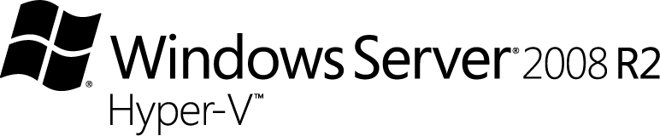

Windows Server 2008 R2 Hyper-V Benefits to the SMB

Table of Contents
Introduction 3
Windows Server 2008 R2 Hyper-V 3
Live Migration 3
Cluster Shared Volumes 3
Processor Compatibility Mode 4
Increased Processor and Memory Support 4
VDI and Terminal Server Integration 4
Performance Features 5
Hot add/remove of storage 5
System Center Essentials and Virtual Machine Manager 5
SMB Challenges 6
Sample Scenario: Virtualizing Woodgrove Bank 6
The Existing Environment 7
Needs Analysis 7
Virtualization Implementation 8
Approach A: 9
Approach B: 9
Virtualization Savings and Benefits 10
Summary 12

Introduction
Small and Medium Business (SMB) IT Departments face numerous challenges. They must often operate a significant number of servers on a limited budget. Even small businesses can experience server sprawl and the associated electricity and management costs. SMBs must often expend significant effort supporting a diverse range of server operating systems and applications. And with limited resources, the task of providing great server uptime and data redundancy to users can be significant challenges.
Microsoft® Windows Server® 2008 R2 Hyper-V combined with Microsoft System Center can be a powerful tool to help SMBs lower total cost of ownership (TCO), ease management of both virtual and physical servers, and increase availability of applications during planned and unplanned downtime.

Windows Server 2008 R2 Hyper-V
The original release of Hyper-V offered cost-effective server virtualization that was easily managed with familiar Windows tools. Windows Server 2008 R2 includes the updated Hyper-V server role. This second release of Hyper-V includes numerous new capabilities that bring tremendous value and Return on Investment (ROI) to both small and large businesses. These new capabilities, described below, make it easier than ever to implement a dynamic, highly-available virtualization platform in any business environment.

Live Migration
Hyper-V live migration is integrated with Windows Server 2008 R2 Hyper-V. With it you can move running VMs from one Hyper-V R2 physical host to another without any disruption of service or perceived downtime.
The live migration feature ships with Hyper-V R2 and no separate licensing or product installation is involved. In fact, any configuration that works with Quick Migration and also includes processors of the same family will support live migration.

Cluster Shared Volumes
Cluster Shared Volumes (CSV) is a new feature in Windows Server 2008 R2 that allows all nodes in a cluster concurrent access to data on each CSV-enabled shared disk. CSV provides additional high availability for Virtual Machines (VMs) stored on CSV-enabled storage and simplifies SAN management by reducing the number of Logical Unit Numbers (LUNs) required to achieve maximum VM flexibility. This feature is particularly valuable in environments where the additional overhead of SAN management adds to an already challenging technology management workload.

Processor Compatibility Mode
Processor Compatibility Mode brings the benefits of live migration, Quick Migration, and Failover Clustering to scenarios where cluster hardware cannot be completely standardized by using identical processor types on all cluster members. For instance, if a cluster is created and then later expanded by adding new hardware, the cluster may not have identical processor types. Processor Compatibility Mode allows a SMB to use failover clustering and live migration in this scenario provided the processors are from the same processor vendor.

Increased Processor and Virtual Machine Guest Support
Processor power on servers has continued to grow exponentially. Within the Windows Server 2008 lifecycle, 64 logical processor servers will become common. For example, a server with 8 processor sockets populated by 8-core processors offers 64 logical processors. While this is more processing power than many applications can efficiently use, Hyper-V R2 has expanded processor support for servers with up to 64 logical processors.
Hyper-V R2 has also increased the number of VMs supported. Hyper-V R2 supports numerous guest operating systems and can support up to 64GB of RAM and up to 4 virtual processors for specific supported guest operating systems. Additionally, Hyper-V R2 supports up to 384 virtual machines or 512 virtual processors per Hyper-V R2 system allowing Hyper-V R2 to take advantage of the more powerful systems available today.

VDI and Terminal Server Integration
VDI can be used to address many challenges that exist in the SMB environment. Desktop management, deployment, and maintenance can be a significant cost. By running desktop operating systems in VMs, the management and cost benefits of virtualization can extend to desktops as well. In addition, ongoing desktop maintenance and new desktop deployments can be simplified by hosting desktop operating systems on VMs and using Windows Remote Desktop Services to provide access to these virtualized desktops.
Remote Desktop Connection Broker extends the Terminal Server Session Broker capabilities included in Windows Server 2008 R2 by creating a unified administrative experience for both traditional session-based remote desktops and virtual machine-based remote desktops. Both Windows Server 2008 R2 Hyper-V and Microsoft Hyper-V Server can be used together with the Remote Desktop Connection Broker to create a Virtual Desktop Infrastructure (VDI) solution.
VDI leverages machine virtualization technologies to allow a single Hyper-V R2 server to run many virtual machines. With VDI, organizations can run multiple desktops, each in a virtual machine, on the same server in a datacenter and use remote desktop protocols to allow a user to access their personal desktop from any authorized device, thereby improving desktop flexibility. IT departments can take advantage of all the benefits of centralization, including centralized management of desktop workloads and improved business continuity.
Hyper-V R2 makes a great virtualization platform for a VDI solution. The reliable and scalable hypervisor and integration with management tools combine to ease VDI implementation. New Hyper-V R2 features like live migration provide greater flexibility for VDI implementations.
Hyper-V R2 integrates with the Windows Remote Desktop Services Session Broker. The Session Broker manages the connections between a user’s device and the remote desktops that are running on the Hyper-V R2 server. It also helps dynamically provision remote desktops, by combining a pristine desktop image with a user’s profile and personal settings at runtime, and delivering a personalized desktop to the end user.

Performance Features
In addition to expanded support for memory size and processor count, Hyper-V R2 contains several performance improvements. Second-Level Address Translation (SLAT) and Timer Coalescing reduce the overhead inherent in virtualizing operating systems. CPU Core Parking supports power savings. Support for jumbo frames, TCP Chimney, Virtual Machine Queues, and enhanced VHD performance all contribute to greater throughput from VMs to physical hardware.

Hot add/remove of storage
Hyper-V R2 supports hot plug-in and hot removal of storage into the guest virtual machine. By supporting the addition or removal of Virtual Hard Drive (VHD) files and pass-through disks while a VM is running, Hyper-V R2 makes it possible to reconfigure VMs quickly to meet changing workload requirements.
Enhanced Guest Operating System Support
Hyper-V R2 adds support for the latest Microsoft operating system releases, Microsoft Windows Server 2008 R2 and Windows 7. Hyper-V R2 also adds support for SUSE Linux Enterprise Server 11 and Red Hat Enterprise Linux (RHEL) 5.2 and 5.3, 32-bit and 64-bit editions. In addition, device drivers that enhance the performance of the Linux operating system when run in a Hyper-V VM have been released to the Linux community under GPLv2.
For a complete list of Hyper-V R2 features, see http://www.microsoft.com/windowsserver2008/en/us/hyperv-r2.aspx

System Center Essentials and Virtual Machine Manager
System Center Essentials (SCE) and System Center Virtual Machine Manager (VMM) Workgroup Edition, provide an integrated solution for virtualizing and managing physical and virtual assets. SCE and VMM provide the following management capabilities:
- Complete management of up to 5 virtualization hosts
- Proactive monitoring and troubleshooting diagnostics for Windows-based servers, Windows-based clients, applications and network devices.
- Update management for Microsoft and third-party applications and devices.
- Software deployment of MSI and EXE installed software packages, including third-party applications, and Office 2007.
- Hardware and software inventory with 30+ attributes collected for things like available disk space, RAM, and installed applications with version number.
- Integrated reporting including 50+ reports for things like inventory, update deployment status, and automated daily health status reports for your IT environment.

SCE and VMM provide more functionality delivered at a lower cost than competing solutions, making SCE+VMM the logical midmarket systems management solution.

SMB Challenges
SMBs face numerous challenges related to providing IT services. They must often purchase and operate multiple servers on a limited budget. Best practices for Line of Business (LOB) applications often recommend dedicated servers for each application, so even small businesses can experience server sprawl. Server sprawl increases power, cooling, and management costs associated with providing necessary IT services.
When it comes to providing a wide range of IT services, SMBs often face the same challenges as larger businesses. They may support a relatively diverse range of server operating systems and applications. In this environment, server management can be a significant cost, both in terms of software costs and in terms of IT staff time.
With limited resources, many SMBs are challenged by the task of providing great server uptime and data redundancy to users.
Together, all of these challenges make it difficult for SMB IT staff to operate at full efficiency. They are often busy putting out fires. Responding effectively to changing business requirements and the constant need for innovation becomes even more difficult in the face of the typical SMB IT challenges.

Sample Scenario: Virtualizing Woodgrove Bank
Microsoft offers a complete virtualization solution that manages virtualized IT assets and physical IT assets in the same management console. In addition, Microsoft Hyper-V offers a 4X to 12X lower TCO than competitive solutions for comparable deployments. For more information on Hyper-V cost comparisons with other virtualization solutions, see: http://www.microsoft.com/virtualization/compare/vmware-cost-comparisons.mspx Because Hyper-V is a role of the Windows operating system, customers can apply existing tools, staff skills, processes, available hardware, and application architectures to transition from physical to virtual infrastructure.
There is a great deal of information available on virtualization, and it is difficult for many SMBs to conceptualize exactly how they would implement virtualization in their environment. Below is a walkthrough of the process of applying Microsoft’s virtualization technologies in an example SMB environment.

The Existing Environment
Like many SMBs, Woodgrove Bank has multiple physical servers and applications. The Woodgrove Bank IT department supports 500 users, and 25% of those users require mobile access. The following table describes the servers currently in use:
Physical Server Description | Services Provided
Dual-core 2.4 GHz, 4GB of RAM, 500 GB of HD storage | Active Directory Domain Services (ADDS)
Two quad-core 2.6GHz processors, 8GB of RAM, 2TB of RAID5 storage | Exchange Server
Two quad-core 2.6GHz processors, 8GB of RAM, 2TB of RAID5 storage | LOB Application #1
Two quad-core 2.6GHz processors, 8GB of RAM, 2TB of RAID5 storage | SQL Server #1
Two quad-core 2.6GHz processors, 8GB of RAM, 2TB of RAID5 storage | SQL Server #2
Dual-core 2.4 GHz, 4GB of RAM, 500 GB of HD storage | Intranet IIS Server
Dual-core 2.4 GHz, 3TB of RAID5 storage | File Server #1
Dual-core 2.4 GHz, 3TB of RAID5 storage | File Server #2
Two quad-core 2.6GHz processors, 8GB of RAM, 500GB of HD storage | Terminal Services Server

Needs Analysis
Before selecting specific product SKUs, a SMB should conduct a needs analysis to determine how best to implement virtualization in their environment. There are several important considerations for this needs analysis:
Consideration | Implications for Woodgrove Bank
Determine the goal of the virtualization project.  Is the goal to virtualize specific servers to increase manageability, or is the goal a more broad-based virtualization of many physical servers? | The goal is to increase efficiency and lower operating cost. This suggests that a broad virtualization effort is ideal. Every existing and new server is a candidate for virtualization unless there is a reason to provision a particular server as a physical server.
What consolidation ratio will be acceptable?  This decision is based on many factors, including the current workload of physical servers, the cyclical load variations expected for virtualized servers, and high availability considerations. | Servers at Woodgrove Bank have very dynamic loads, and high availability for VMs is an important requirement. For this reason, a medium consolidation ratio will be used, along with a physical server configuration that supports Hyper-V live migration.
Does the SMB currently use a comprehensive IT management solution (integrated server, desktop and hardware device management)? | Woodgrove Bank currently does not use a comprehensive IT management solution.
How many virtual and physical servers will the SMB need to monitor? | Woodgrove Bank has high uptime and service level requirements, so they would like to monitor all virtual and physical servers.
Will VDI be a part of the virtualization solution?  If so, Microsoft Hyper-V Server may be the preferred virtualization platform for hosting virtual desktop operating systems. | Woodgrove Bank relies on a legacy LOB application that is only supported on Windows XP. In order to lower the cost of using this application, Woodgrove Bank will create a small VDI deployment for this application. At any one time, 20 Woodgrove Bank users may require use of this LOB application.
Do mobile users need access from remote locations? | Woodgrove Bank needs to provide secure access so that mobile users can use selected applications from remote locations. For this reason, Woodgrove Bank will use Remote Desktop Services (RDS). RDS will support both the VDI implementation and the specific applications that remote users require access to.

Virtualization Implementation
Based on this needs analysis, Woodgrove Bank cab take one of the following two approaches with virtualizing their infrastructure:

Approach A:
- Purchase and install one new 64-bit server for management and active directory (or re-purpose an existing server for this role)
- Purchase three to four new 64-bit servers for Hyper-V hosts
- Purchase and install a SAN that will support up to 300 TB of storage, but is currently equipped with 30 TB of storage.
- Purchase and install Windows Server 2008 R2 Enterprise Edition on the management server
- Install System Center Essentials on the management server and VMM
- Purchase and install Windows Server 2008 R2 Datacenter Edition on the new servers. This provides virtualization use rights for unlimited instances of Windows Server 2008 R2.
- Configure the new Hyper-V servers and SAN storage as a failovercluster using Windows Failover Clustering.
  - Deploy Windows Server 2008 R2 in VMs and migrate existing users, data, and settings
OR
  - Use the System Center Virtual Machine Manager (SCVMM) Physical to Virtual conversion wizard to convert existing physical servers to VMs.
- Configure 20 Windows XP VMs for VDI use on the Hyper-V hosts.
Note: See http://www.microsoft.com/windows/enterprise/solutions/virtualization/improve-flexibility.aspx for more information on special VDI licensing packages.
- Configure Windows Server 2008 R2 Remote Desktop Services to support the VDI deployment and remote application access.

Approach B:
- Purchase and install one new 64-bit server for management and active directory (or repurpose and existing server for this role)
- Purchase four new 64-bit servers for Hyper-V hosts
- Purchase and install a SAN that will support up to 300 TB of storage, but is currently equipped with 30 TB of storage.
- Purchase and install Windows Server 2008 R2 Enterprise Edition on the management server
- Install System Center Essentials on the management server and VMM
- Purchase and install two copies of Windows Server 2008 R2 Datacenter Edition on the new servers. This provides virtualization use rights for unlimited instances of Windows Server 2008 R2.
- Configure two of the new Hyper-V servers and SAN storage as a failover cluster using Windows Failover Clustering.
  - Deploy Windows Server 2008 R2 in VMs and migrate existing users, data, and settings
OR
  - Use the System Center Virtual Machine Manager (SCVMM) Physical to Virtual conversion wizard to convert existing physical servers to VMs.
- Download and install the free Hyper-V Server R2 on the two remaining Hyper-V servers. Configure these two servers and the SAN storage as a failover cluster.
  - Configure 20 Windows XP VMs for VDI use on the Hyper-V Server hosts.
Note: See http://www.microsoft.com/windows/enterprise/solutions/virtualization/improve-flexibility.aspx for more information on special VDI licensing packages.
- Configure Windows Server 2008 R2 Remote Desktop Services to support the VDI deployment and remote application access.

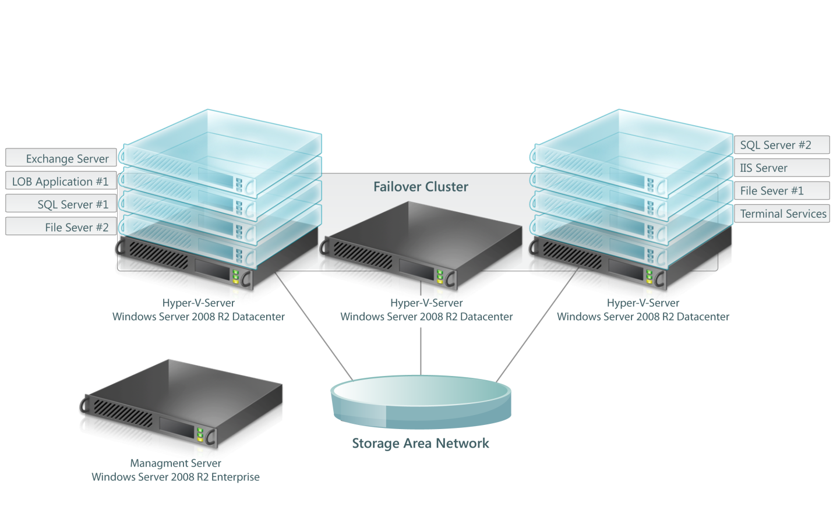
Illustration 1

The following products will be used in this virtualization implementation:
Approach A | Approach B
1 x Windows Server 2008 R2 Enterprise Edition | 1 x Windows Server 2008 R2 Enterprise Edition
3 - 4 x Windows Server 2008 R2 Datacenter Edition | 2 x Windows Server 2008 R2 Datacenter Edition
1 x System Center Essentials + VMM | 1 x System Center Essentials + VMM
 | 2 x Hyper-V Server (free)

Virtualization Savings and Benefits
After implementing Hyper-V and System Center in the Woodgrove Bank environment, the IT department will realize the following savings and benefits:
- Number of physical servers managed goes from nine to four.
- Electrical costs and cooling requirements are reduced.
- All VM workloads can be migrated to another server with no user downtime. This facilitates:
  - Greater application uptime when a Hyper-V host needs to be serviced.
  - More dynamic load handling. For example, when load on a VM spikes, other VMs that are sharing the Hyper-V host can be migrated away, temporarily or permanently, to provide the heavily loaded VM with a greater share of processing power and memory.
In addition, the IT department at Woodgrove Bank gains additional operational flexibility:
- VMs can be backed up while running. This makes it easier to recover from a VM failure.
- Because the Hyper-V hosts are clustered, all VMs are highly available with no extra configuration. If a Hyper-V host fails, Failover Clustering will restart the VMs that were running on that host on a surviving Hyper-V host.
- New servers can be more rapidly deployed as VMs. New server deployment times can be reduced from days or weeks to hours.
- Both physical and virtual machines are managed by a single management product. Even if Woodgrove Bank later decides to deploy other virtualization software, both Hyper-V and competeing virtualization solutions can be managed by System Center.
- Ongoing server hardware upgrades are significantly simplified. VMs can easily be live migrated or moved to newer, more powerful Hyper-V hosts as they become available.

After implementing Hyper-V in the Woodgrove Bank environment, users will realize the following benefits:
- Higher uptime for applications that run in Hyper-V VMs.
- A greater level of support from their IT department, who can now spend less time managing servers and more time supporting users and other business needs.

Summary
By using Hyper-V to virtualize their infrastructure and System Center to manage it, Woodgrove Bank is able to begin realizing significant ongoing savings immediately. Consolidating multiple physical servers into VMs running on fewer Hyper-V hosts saves electricity costs and eases management. In addition, the organization is able to allocate resources more efficiently, because less effort is required to manage and upgrade IT operations. Server maintenance and unplanned downtime are all less disruptive to business operations because Hyper-V live migration and Windows Failover Clustering help keep VMs available.
Woodgrove Bank has also lowered the cost of using their legacy LOB application by moving it to a VM running on a more modern, reliable VM. In addition, remote users experience a higher level of consistency and availability because of the new features of Windows Server 2008 R2 Remote Desktop Services. By adopting Windows Server 2008 R2 Hyper-V, any SMB can reduce costs, ease management, and keep valuable applications and services available.

