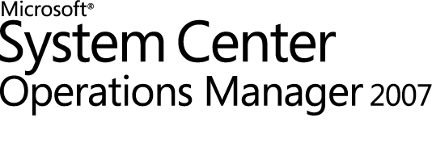

MOM 2005 to Operations Manager 2007 Migration Guide
Microsoft Corporation
Published July 2009
Author
Chris Fox
Feedback
Send suggestions and comments about this document to momdocs@microsoft.com.

The information contained in this document represents the current view of Microsoft Corporation on the issues discussed as of the date of publication. Because Microsoft must respond to changing market conditions, it should not be interpreted to be a commitment on the part of Microsoft, and Microsoft cannot guarantee the accuracy of any information presented after the date of publication.
Microsoft may have patents, patent applications, trademarks, copyrights, or other intellectual property rights covering subject matter in this document. Except as expressly provided in any written license agreement from Microsoft, the furnishing of this document does not give you any license to these patents, trademarks, copyrights, or other intellectual property.
Unless otherwise noted, the companies, organizations, products, domain names, e-mail addresses, logos, people, places, and events depicted in examples herein are fictitious. No association with any real company, organization, product, domain name, e-mail address, logo, person, place, or event is intended or should be inferred.
© 2009 Microsoft Corporation. All rights reserved.
Microsoft, Active Directory, ActiveSync, Internet Explorer, JScript, SharePoint, SQL Server, Visio, Visual Basic, Visual Studio, Win32, Windows, Windows PowerShell, Windows Server, and Windows Vista are trademarks of the Microsoft group of companies.
All other trademarks are property of their respective owners.
Revision History

Release Date | Changes
August, 2007 | Original release of this guide
September, 2007 | Moved uninstall MOM 2005 order to new section.
July 2009 | Reviewed and re-released

Contents
MOM 2005 to Operations Manager 2007 Migration Guide 1
MOM 2005 to Operations Manager 2007 Migration Guide 5
Introduction to the Operations Manager 2007 Migration Guide 5
MOM 2005 to Operations Manager 2007 Migration Overview 5
Infrastructure Components 6
Infrastructure Migration Considerations 6
Consolidation Factors 6
Management Packs 7
Converted Management Packs and Operations Manager 2007 Native Management Packs 8
Migration Order of Operations 8
MOM 2005 to Operations Manager 2007 Infrastructure Migration 9
New Systems 9
Existing Systems 10
Uninstall MOM 2005 11
Comparing MOM 2005 and Operations Manager 2007 Management Packs 12
Choosing Management Packs to Convert 12
Management Pack Formats 13
Side by Side Comparison of Management Pack Objects 14
Computer Groups 15
Discovery 15
Rules 15
Filter Rules 16
Views 16
Knowledge 17
Tasks 17
Notifications 17
Operators 17
Console Scopes 18
Scripts 18
Using the Migration Wizard 18
Installing the Migration Tool 18
Migrating your Management Configuration 19

MOM 2005 to Operations Manager 2007 Migration Guide

Introduction to the Operations Manager 2007 Migration Guide
The Operations Manager 2007 Migration guide is intended to help you understand the migration process from Microsoft Operations Manager 2005 (MOM 2005) to Operations Manager 2007 and the tools that are used in the process. A migration process is used because the architectural difference between the two products is significant, and there is no upgrade path from MOM 2005 to Operations Manager 2007. This guide includes the following:
• A summary of the MOM 2005 to Operations Manager 2007 infrastructure migration options and considerations.
• A detailed comparison between a MOM 2005 management pack and an Operations Manager 2007 management pack.
• A step-by-step overview of what happens to MOM 2005 management pack objects during the management pack conversion.
• A step-by-step walkthrough that shows how to use the Operations Manager 2007 Migration Wizard to migrate a management pack.
Note
When you install and start the Migration Wizard, you will see that it is initially called the System Center Operations Manager Migration Tool.
You should follow this guide from beginning to end. This guide is intended for individuals who have significant MOM 2005 experience and are already familiar with Operations Manager 2007 components and features. An overview is not provided here. For more information, see the MOM 2005 documentation at http://go.microsoft.com/fwlink/?LinkId=96760 and the Operations Manager 2007 Design guide at http://go.microsoft.com/fwlink/?LinkId=158867.

MOM 2005 to Operations Manager 2007 Migration Overview
In the migration process from Microsoft Operations Manager 2005 (MOM 2005) to Operations Manager 2007, there are two aspects that must be addressed. The first aspect is the MOM 2005 infrastructure components, including the database server and its hardware, the management servers and their hardware, and so on. The second aspect is the MOM 2005 management packs that have been deployed in your environment.

Infrastructure Components
There is no upgrade path from MOM 2005 to Operations Manager 2007. To avoid interrupting your monitoring and alerting services, you must deploy Operations Manager 2007 in your environment and support both MOM 2005 and Operations Manager 2007 while they co-exist. When you can confirm that Operations Manager 2007 is providing you with all the necessary information and services, you can then start removing your MOM 2005 implementation.
Deploying Operations Manager 2007 in a MOM 2005 environment can be accomplished in one of two ways. You can either install Operations Manager 2007 server components on the same hardware that contains the MOM 2005 server components or you can install Operations Manager 2007 on hardware that is dedicated to your Operations Manager 2007 infrastructure. For information about these methods, see the next section, "MOM 2005 to Operations Manager 2007 Infrastructure Migration."
Note
The two products can both run on the same hardware without any conflicts, if the hardware meets the requirements of both products.

Infrastructure Migration Considerations
Before you can decide which way to deploy Operations Manager 2007 in a MOM 2005 environment, you must first re-evaluate your company's monitoring and alerting needs as they relate to the features of Operations Manager 2007. If you have deployed multiple MOM 2005 management groups for security, scalability, or redundancy reasons, you can probably consolidate those multiple groups into fewer Operations Manager 2007 management groups. For more information about Operations Manager components and the design process, see the Operations Manager 2007 Design Guide at http://go.microsoft.com/fwlink/?LinkId=96761.

Consolidation Factors
The first factor to consider is that Operations Manager 2007 implements role-based security. A role in Operations Manager 2007 consists of a profile and a scope. A profile, such as Operations Manager Administrator or Operations Manager Operator, defines what actions can be taken in the Operations console. The scope defines which objects those actions can be taken on. Operations Manager 2007 Roles provide a security boundary between users who are in different roles. For example, you can use a profile, such as Operations Manager Operator, which allows the user to monitor and respond to alerts. You can combine this profile with a scope, such as all monitored servers that are running Microsoft Exchange Server, which results in an Exchange Operators Role. Any user accounts that are assigned to this role can see and interact with operations data only from the servers that are running Exchange Server. These user accounts do not have access to data from any other servers. Because role-based security is enforced by the System Center Data Access service that is running on the root management server, it is applied to all methods of accessing data, including the Operations console, command line, script, Web access, and programmatically. Because security is role-based in Operations Manager 2007, it is no longer necessary to partition management groups for security purposes.
The second factor that influences consolidation is the introduction of the gateway server. A gateway server acts as a consolidation point for communications between agents and management servers that are on opposite sides of a Kerberos trust boundary. Agents communicate with the gateway and the gateway server communicates with the management servers.
The third factor that you should consider about server consolidation is the overall increase in scalability of all the Operations Manager 2007 components. For more information about scalability, see the Operations Manager 2007 Design guide at http://go.microsoft.com/fwlink/?LinkID=158867 .
Note
Remember that although Operations Manager 2007 delivers better performance and scalability than MOM 2005, Operations Manager 2007 has higher minimum hardware requirements than MOM 2005. For more information, see Operations Manager 2007 Supported Configurations at http://go.microsoft.com/fwlink/?LinkId=89360.

Management Packs
Over the lifecycle of your MOM 2005 implementation, you have probably invested the most time and effort in customizing vendor-written management packs and in developing custom management packs for your company-developed applications. Because your MOM 2005 management packs currently provide information that is used daily, you probably want to use the customizations in these management packs in Operations Manager 2007.
Note
MOM 2005 management packs cannot be imported into Operations Manager 2007. They must be converted to the Operations Manager 2007 format first.
You can use the Operations Manager Migration Wizard to convert management packs from the MOM 2005 format to Operations Manager 2007 format and to extract a list of MOM 2005 agent-managed computers that you can import into the Operations Manager 2007 Discovery Wizard. Operations Manager 2007 also provides command-line utilities, which are described in Operations Manager 2007 Help.
Note
When you install and start the Migration Wizard, you will see that it is initially called the System Center Operations Manager Migration Tool.
Before you begin converting MOM 2005 management packs to the Operations Manager 2007 format, you must inventory all of the management packs that have been deployed and document all of the modifications that have been made to them. You need to know these modifications when you modify the Operations Manager 2007 versions of those management packs in your migration testing lab. Overrides are not converted as part of the management pack conversion because they are not stored in management packs in MOM 2005.

Converted Management Packs and Operations Manager 2007 Native Management Packs
Operations Manager takes a fundamentally different approach to monitoring than MOM 2005. The basic structure of Operations Manager 2007 management packs and their components has changed. For more information, see the "Comparing MOM 2005 and Operations Manager 2007 Management Packs" section of this document. The tools and the object model that are used to produce the Operations Manager 2007 management packs are different than those of MOM 2005. A MOM 2005 management pack that has been converted to the Operations Manager 2007 format is not the same as a management pack created in Operations Manager 2007.
Microsoft-produced management packs that are converted by Microsoft are supported for a limited time. Microsoft provides Operations Manager 2007 native versions of management packs. For more information, see http://go.microsoft.com/fwlink/?LinkId=89473 for the current catalog.
There are two methods to convert MOM 2005 management packs, developed by your company, to Operations Manager. You can use the Operations Manager Migration Wizard to convert the management packs, apply your customizations, and import them into Operations Manager. This method gives you functionality that is equivalent to what you had in MOM 2005. To take advantage of the full Operations Manager 2007 object model, you should redevelop the management pack by using the Operations Manager 2007 tools. For more information, see the Operations Manager 2007 Management Pack Authoring Guide at http://go.microsoft.com/fwlink/?LinkId=158876.

Migration Order of Operations
How an organization uses MOM 2005 and integrates it into its daily process is unique to each organization. Guidance on how you have to adapt and integrate your existing process to Operations Manager 2007 is beyond the scope of this document because each company uses MOM 2005 uniquely.
However, when you are developing your MOM 2005 to Operations Manager 2007 migration plan, be sure to include the following tasks:
1. Evaluate Operations Manager 2007, and create an infrastructure design. For more information, see the Operations Manager 2007 Design Guide.
2. Evaluate and document your current MOM 2005 implementation and process.
3. Implement Operations Manager 2007 in a test environment according to the design you developed in step 1. For more information, see the Operations Manager 2007 Deployment Guide.
Note
Be sure to include any connectors and tiered management groups, and plan to reproduce any customized MOM 2005 Reports with Operations Manager reports.
4. Download the Operations Manager 2007 versions of all available MOM 2005 management packs. Check for new management packs regularly. Modify these in your test environment.
5. Convert and modify any management packs (including custom management packs) that were not covered in the previous step, by using the Operations Manager Migration Wizard, and then implement them in your test environment.
6. Implement Operations Manager 2007 in your production environment according to your design and migration plan (using the same hardware or different hardware). For more information, see the Operations Manager 2007 Deployment Guide.
7. Configure Operations Manager 2007 for production use. For more information, see the Operations Manager 2007 Operations Guide.
8. Deploy the new and converted management packs. For more information, see the Operations Manager 2007 Operations Guide.
9. Confirm all functionality in Operations Manager 2007 and test the integration of your monitoring, alerting and, reporting processes.
10. Uninstall MOM 2005 components in the correct order. This process is described later in this guide.

MOM 2005 to Operations Manager 2007 Infrastructure Migration
There are two options for migration from MOM 2005 to Operations Manager 2007.
• Install Operations Manager 2007 on new systems.
• Install Operations Manager 2007 on existing MOM 2005 systems.

New Systems
Installing Operations Manager on new systems involves creating a new management group for Operations Manager components.
Figure 1 Using New Systems
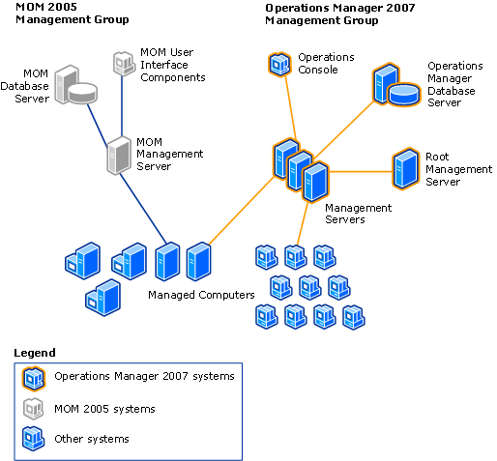

Existing Systems
You can also install Operations Manager on an existing system by performing a side-by-side migration.
Figure 2 Using Existing Operations Manager 2007 systems
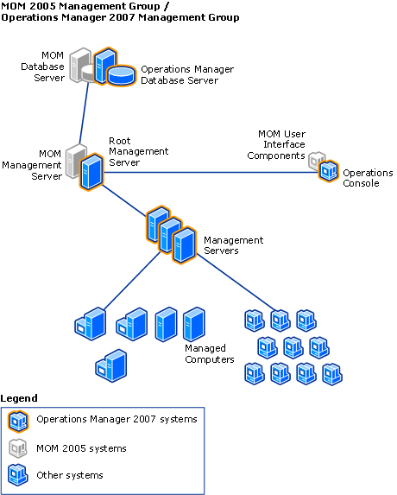

Before you attempt a side-by-side migration, review the hardware recommendations.

Uninstall MOM 2005
Uninstall MOM 2005 components in the following order.
1. Active Directory Helper Object
2. Agents
3. Reporting Server
4. Web console
5. management server(s)
6. Operations console
7. Operational database
8. Data warehouse
Note
In a tiered environment, we recommend that you uninstall the child management groups and then the parent management group.

Comparing MOM 2005 and Operations Manager 2007 Management Packs
Operations Manager 2007 is a redesigned product that is architecturally different from Microsoft Operations Manager 2005. There is no upgrade from an Operations Manager 2005 Management Pack to an Operations Manager 2007 management pack. However, if you have a custom management pack that you created for MOM 2005, then it can be converted by using the Operations Manager 2007 Migration Wizard.
Note
When you start the Migration Wizard, it is initially called the System Center Operations Manager Migration Tool.

Choosing Management Packs to Convert
Before using the migration tool, you must create a list of the management packs that you plan to convert. There are many factors to consider. You should weigh the benefits and drawbacks of converting each management pack before you add it to the list.
Management pack conversion is designed for custom management packs for applications or services that do not have an Operations Manager 2007 management pack available. Because of the difference in architecture between MOM 2005 and Operations Manager 2007 and the many enhancements available in Operations Manager 2007, conversion is often not the best choice for vendor management packs.
If there is an Operations Manager 2007 management pack available, then it is recommended that you use the new Operations Manager 2007 management pack instead of converting an existing MOM 2005 management pack. For a list of available Operations Manager 2007 management packs, see the Microsoft Management Pack Catalog at http://go.microsoft.com/fwlink/?LinkId=71124.
Even if you have a number of customizations it is still not recommended that you convert the MOM 2005 versions of the Active Directory, Microsoft Exchange Server, Internet Information Services, or Microsoft SQL Server management packs.

Management Pack Formats
The native format of an Operations Manager 2005 management pack is a binary file in an .akm file format. This is the only format that MOM 2005 management servers accept as valid. Operations Manager 2007 does not use the .akm file format; instead, it uses XML as the format for management packs. During the management pack conversion process, the MOM 2005 management pack file is first converted from .akm file format to XML format. Then the MOM 2005 XML management pack file is converted to an Operations Manager 2007 XML management pack.

Side by Side Comparison of Management Pack Objects
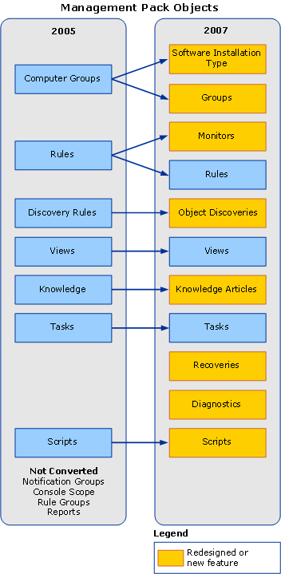

Computer Groups
In MOM 2005, computer groups are used to group computers with similar characteristics. Processing rule groups are then used to target groups of rules to these computers. Operations Manager 2007 focuses on monitoring individual services and applications instead of computer objects. This approach allows Operations Manager 2007 to monitor a physical server separately from the software that is installed on the computer. When a computer group is converted, two object types are created. One object type is for the physical computer, and the other one is for the software that is monitored.
For example, the MOM 2005 version of the Microsoft SQL Server 2000 management pack contains a computer group for servers that are running SQL Server 2000. After conversion, the Operations Manager 2007 management pack contains a Microsoft SQL Server 2000 Computer Group and also an object type called Microsoft SQL Server 2000 Installation.

Discovery
Discovery is the process of finding objects that Operations Manager is configured to monitor. In MOM 2005, population of computer groups is done by computer discovery rules, although the discovery of a computer's role is accomplished through service discovery scripts.
When a MOM 2005 computer group is converted, two discovery rules are created for use in Operations Manager 2007. One rule controls membership in the computer group, and the other rule finds installed versions of the software that belong to the software installation class.
Discovery of a computer's role is accomplished through the use of service discovery scripts. These scripts are not changed during the conversion process. These scripts use the MOM 2005 Backward Compatibility management pack to work the same way in Operations Manager 2007 that they do in MOM 2005. No conversion is necessary.

Rules
Rules in MOM 2005 gather and analyze data, change the state of a monitored object, or generate alerts. The health state of a monitored object is displayed with colors in MOM 2005 and Operations Manager 2007. These colors are green (running and healthy), yellow (in danger of a failure), or red (failed). Rules that are designed to change the health state of a monitored object in MOM 2005 are converted into monitors in Operations Manager 2007. Monitors calculate and display the state of a monitored object in Operations Manager 2007.
In MOM 2005, rules that do not change state look for a specific event and react to that event in a defined way. An example of this type of rule is one that looks for a specific event in the event log and then generates an alert when that event is found. These types of rules are converted into Operations Manager 2007 rules. However, in MOM 2005, these rules are targeted to computer groups. After conversion, these rules are targeted to monitor software installations in Operations Manager 2007.
Note
Each rule is contained within a rule group, and rule groups, in turn, are usually targeted to monitor a computer group. Because rule groups are not used in Operations Manager 2007, rules that are not targeted to anything or that belong to rule groups that are not targeted in MOM 2005 are not converted.

Filter Rules
MOM 2005 uses filter rules. There are three distinct types of filter rules:
• Prefilter
• Conditional filter
• Database filter
Filters are not used in Operations Manager 2007, and these rules are dropped during conversion.

Views
Some view types are converted to an Operations Manager 2007 view type, but others are not. The following table lists each view type in MOM 2005 and, if it is converted, which view type it is converted to in Operations Manager 2007. For a list of view types available in Operations Manager 2007, see the Views in Operations Manager 2007 topic in the Operations Manager 2007 Online Help.
Note
During the conversion process one State view and one Task Status view is created and added to the Operations Manager 2007 version of the management pack.

Operations Manager 2005 View Type | Operations Manager 2007 View Type
Alert view | Alert view
Attribute view | Not converted
Computer view | Not converted
Computer Group view | Not converted
Diagram view | Not converted
Event view | Event view
Performance view | Not converted
Performance Data view | Performance view
State view | If the Operations Manager 2005 management pack has a view that displays service discovery information, that view is converted to a State view that displays computer roles in Operations Manager 2007.

Knowledge
Knowledge from a MOM 2005 management pack is converted to an Operations Manager 2007 knowledge article. Both the product and company knowledge are combined into a single Operations Manager 2007 knowledge article.

Tasks
Tasks in MOM 2005 are actions that are started by users to diagnose or resolve a problem or to automate repetitive actions. Tasks are configured to run on Operations Manager management servers or agents in the MOM 2005 Operator console.
Tasks that are agent tasks in MOM 2005 are converted into Operations Manager 2007 tasks. These tasks are then targeted to either the software installation object type or to a service discovery object type. Tasks in MOM 2005 that are set to run against a management server rather than an Operations Manager agent are not converted. Additionally, managed code tasks and tasks that are started from the MOM 2005 Operator console are not converted.
There are two new types of tasks in Operations Manager 2007; diagnostics and recoveries. Diagnostics are actions that are designed to troubleshoot a degraded health state of a monitored object. Recoveries are actions designed to run in reaction to a state change with the purpose of fixing a diagnosed issue. Both diagnostic and recovery tasks can be run automatically or on demand from the Operations console. A converted management pack does not contain any diagnostics or recoveries, although they can be added later.

Notifications
The notification engine is redesigned in Operations Manager 2007. As a result, notification groups are not contained in Operations Manager 2007 management packs. Notification groups that are defined in a MOM 2005 management pack are not converted.

Operators
Operators should not be defined in vendor management packs. However, customers can export operators as part of a MOM 2005 management pack. Also, any operator that is part of a notification group used by a rule in a MOM 2005 management pack is exported automatically. Operators are no longer contained in the management pack in Operations Manager 2007, and as a result, operators are not converted as part of the conversion process.

Console Scopes
Console scopes in MOM 2005 are used to control user access to Operations Manager functions. Console scopes are not contained in a MOM 2005 management pack file and are not converted.

Scripts
Scripts are distinct objects that are referenced by rules in MOM 2005. Scripts are often run on a timed basis for use in service discovery and monitoring, but they are also used as responses to observed conditions and as tasks. Scripts are converted into module types in Operations Manager 2007. These module types are used by one or more rules to pass configuration data for script parameters.
Most MOM 2005 scripts continue to function in Operations Manager 2007 without modification by using MOM 2005 Backward Compatibility management pack. Operations Manager 2007 has a redesigned scripting model, and any new scripts should be written to this new model. For more information about scripting in Operations Manager 2007, see the Operations Manager 2007 SDK documentation.

Using the Migration Wizard
Operations Manager 2007 Service Pack 1 (SP1) provides the Operations Manager Migration Wizard to assist you in migrating management packs from Microsoft Operations Manager 2005 (MOM 2005) to Operations Manager 2007. The Migration Wizard converts management packs from the .akm file format to the XML format for use with Operations Manager 2007. The Migration Wizard can also export a list of managed computers to simplify system discovery.
Note
When you install and start the Migration Wizard, you will see that it is initially called the System Center Operations Manager Migration Tool.

Installing the Migration Tool
The MOM 2005 to Operations Manager 2007 Migration tool requires both MOM 2005 user interfaces and Operations Manager 2007 Operations console. The Migration tool uses the MPConvert.exe utility. For more information, see the Help for that utility.
Note
The Migration Wizard cannot be installed on an x64-based system. If necessary, install Operations Manager 2007 Operations console on the MOM 2005 system and install the Migration Wizard there.
To install the MOM 2005 to Operations Manager 2007 Migration tool
1. Use local administrator privileges to log on to the system with Operations Manager 2007.
2. On the Operations Manager 2007 installation media, double-click the SetupOM.exe file.
3. In the System Center Operations Manager 2007 Setup dialog box, click Install MOM 2005 to OpsMgr 2007 Migration tool.
The installation process creates a shortcut in the System Center Operations Manager 2007 group in the Start menu.
After you install the Migration Wizard, you can run it as part of your migration process.

Migrating your Management Configuration
This walkthrough uses the Migration Wizard to migrate management packs from a MOM 2005 management group, called MOMServer77, to XML format. This walk-through also exports a list of managed servers for use in setting up the Operations Manager 2007 management group.
The wizard offers four paths for migration of management packs.
• MOM 2005 file to Operations Manager 2007 file
• MOM 2005 file to Operations Manager 2007 management group
• MOM 2005 management group to Operations Manager 2007 file
• MOM 2005 management group to Operations Manager 2007 management group
Migrating to a file then requires importing the management pack into Operations Manager 2007, by using the same procedure as importing any management pack.
Note
It is recommended that you migrate to files, except for test management groups.
From Start, select Programs, select System Center Operations Manager 2007, and click Migration Tool.
The Welcome page provides information about using the wizard. After you review this information, click Next.
In the Source page, enter the name of your management server or use Browse to select it, and then click Next. This is the management server for your MOM 2005 management group, in this example called MOMServer77.
The Source page also provides the option of starting with management packs that are saved as .akm files. If you select Migrate Management Packs for a file, a later page in the wizard allows you to select the .akm files that you want to migrate.
Figure 4 Migration Source
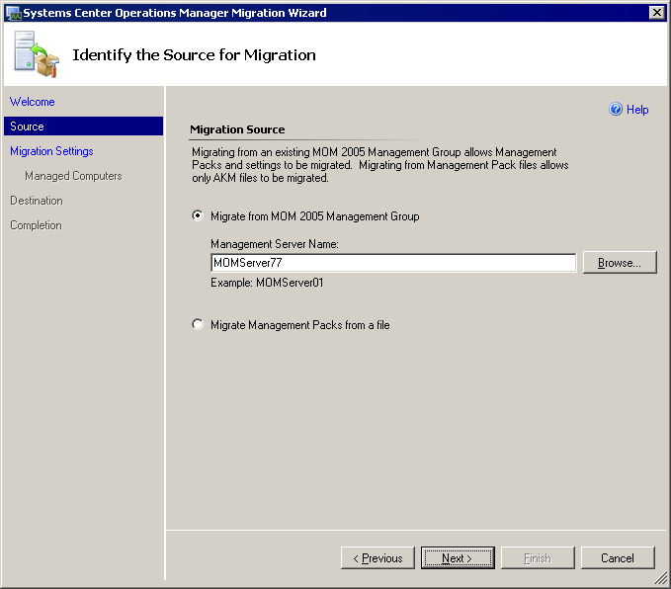

The Migration Settings page specifies which elements to migrate. In this example, you migrate managed computers and management packs. Management packs contain all of the custom groups and monitors that you have saved. You can select individual management packs under Select the data to be migrated. After you select management packs, click Next.
Figure 5 Migration Settings
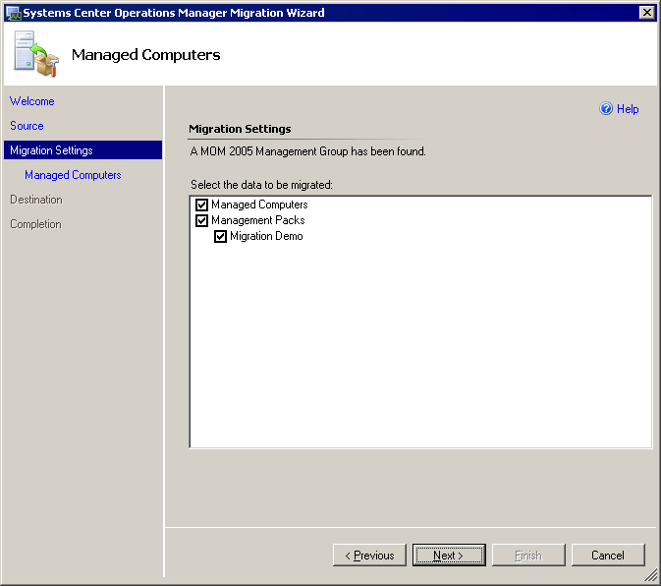

In this example, you export the list of managed computers to a file. That file can be copied into the Discovery Wizard Discovery Method page. Enter a name for the Managed Computer Export File, and then click Next.
Figure 6 Managed Computers
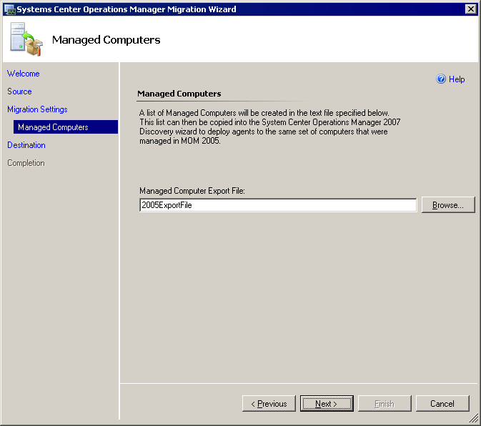

In the Destination page, the Migration Wizard provides two options for the output of management packs. You can migrate directly to an Operations Manager 2007 management server, or you can export the management packs to files for importing into your management server.
If you select Migrate to a System Center Operations Manager 2007 Management Group, enter the name of the management server, or click Browse to select it.
In this example management packs are migrated to files. Enter a destination directory for the management packs, and then click Next.
Figure 7 Migration Destination
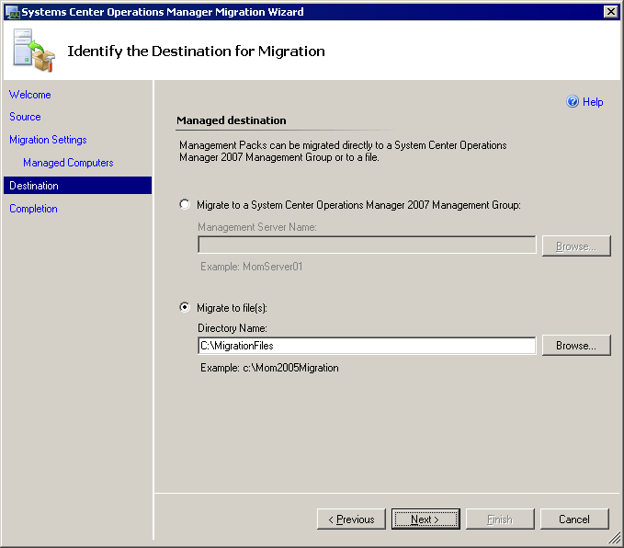

The Completion page displays your selected migration actions for review. If these are correct, click Migrate.
Figure 8 Completing the Migration
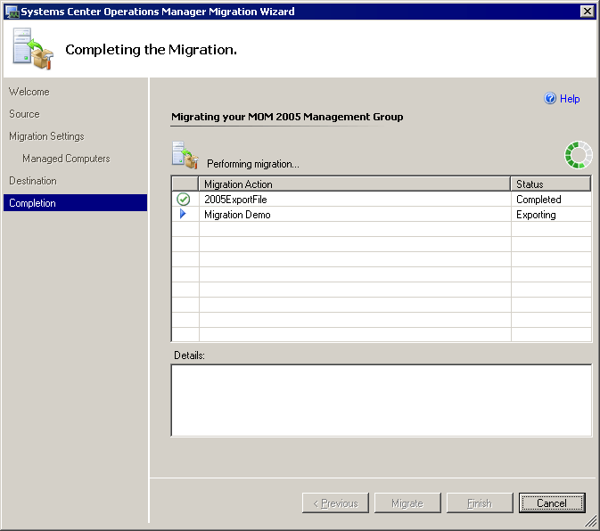

After migration is complete, the wizard displays the status of the migration actions. When each action is complete, the wizard marks it with a check for success or an X for failure. Click Finish to close the wizard.
After completing conversion, import into Operations Manager 2007 the management packs that have been exported to file. See http://go.microsoft.com/fwlink/?LinkId=98348.

