A solution for Small and midsize organizations
The Microsoft® Open Value program is for small to midsize commercial and government organizations that want to acquire licenses for five or more desktop PCs and want simplified license management and better control of their licensed product costs and investment. Open Value provides flexibility to acquire and add product licenses as needed. Additional cost savings are available when standardizing on Microsoft products across your organization.
Microsoft Software Assurance for Volume Licensing is also included with Open Value so you have access to a broad range of value-added benefits to help you manage costs, get the most out of new technologies, and improve employee and organizational productivity.

Better Management of Your Software Costs
Open Value helps you to plan and manage your licensed product budget with even more certainty.
- The Software Assurance Spread Payments benefit enables you to spread payments which reduces up-front costs and helps forecast annual budget requirements with predictable annual payments.
- Software Assurance also includes New Version Rights, which means you have rights to new software version releases to help you lower the costs associated with software acquisition while simplifying procurement and forecasting.The Company-wide option helps provide additional savings.
- Open Value Subscription offers significant discounts when standardizing across the organization.

Simplified License Management
Open Value helps make it easier and less time-consuming to track your licenses. You can be confident that you are not over- or under-licensed.
- One agreement for all Microsoft licensed product in your organization, including qualified affiliates in other regions.
- Upgrade any time—no need to track versions or open new agreements. Microsoft Volume License Services (MVLS) helps make it easy for you to download licensed products and quickly track and manage your licenses online.

Ability to Take Control of Your Investment
Immediate access to upgrades and new versions means you can keep your IT infrastructure current, helping to make it more secure and easier to support.
- The single platform option offers the flexibility to choose components from the Windows Desktop Operating System, Microsoft Office, and Client Access Licenses (CALs), to ensure you have the technology you need to meet your business requirements.
- With the Software Assurance New Version Rights benefit, rights to new versions of licensed products are available to deploy at your convenience.
- Plus, Software Assurance offers benefits such as Packaged Services, Training Vouchers and 24x7 Problem Resolution Support so you can take advantage of consulting services, training and support to help with the deployment of new software.
- Upgrade licensed product across your organization while staying within budget.
Open Value Licensing Options At-A-Glance
The Open Value program offers three options to choose from: Company-wide, Non-Company-wide, and Subscription.

Company-Wide Option
Open Value Company-wide option offers predictable annual payments, low long-term costs, and a simple way to manage licenses. Features include:
- Additional savings on company-wide licenses.
- Desktop PC count at the beginning of your agreement determines your annual cost.
- Add software products at any time and pay for it in the month of installation. Spread out the costs over the remaining years of your agreement.
- Original equipment manufacturer (OEM) licenses can be transitioned onto your Open Value agreement by purchasing Software Assurance.

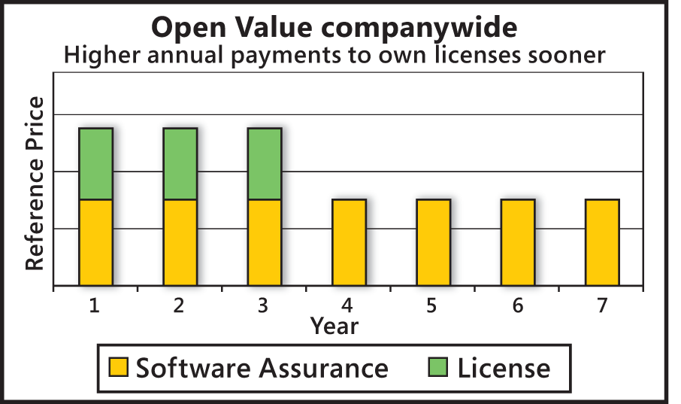

At the end of the three-year agreement, you have two options: 1) Renew for another three years, paying only for Software Assurance, with continued rights to the latest licensed product versions and other benefits. 2) End your agreement and own the licenses for the most current product versions.

Non-Company-Wide Option
Open Value Non–Company-wide option is available for any licensed product purchases. If you need licenses for servers, or for just some of your desktop PCs, you can open a Non- Company-wide agreement. You cannot track all of your licenses under one agreement; however, you can open a Company-wide or Subscription agreement, and then add Non–Company-wide licenses to that agreement.

Subscription Option
Open Value Subscription can help provide the lowest up-front costs of the Open Value options, annual payments, and the ability to track all licenses on a single agreement. Features include:
- Customers with existing OEM, FPP (Retail), or Volume Licenses can receive a discount of up to 50 percent² off their year one payment when signing an Open Value Subscription Agreement with the Up-to-Date discount.
- Your total licensing costs can decline in years when your desktop PC count declines.
- Add the company-wide licensed products you have selected on new desktop PCs during the year with no additional cost that year.
- Annual payment made based on your desktop PC count for that year.
² Resellers set customer prices, which may vary. Must have the current product version or one version back to qualify.

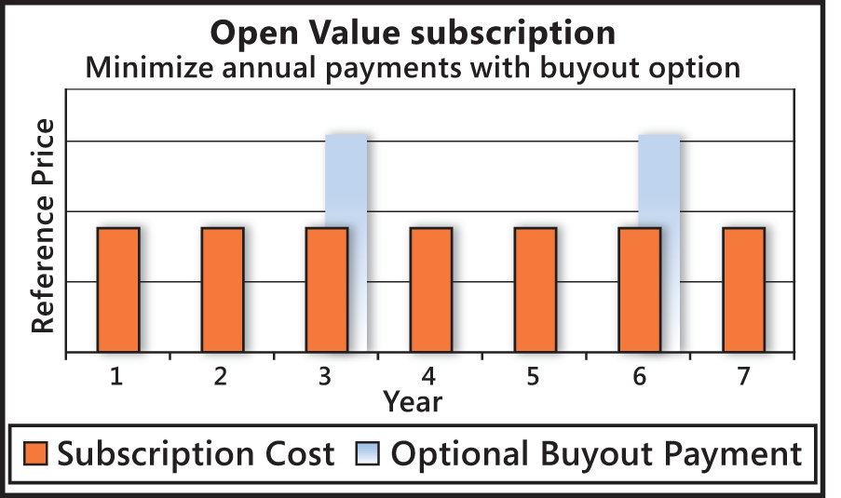

At the end of your three-year agreement, you can renew for another three years or make a final buyout payment and own the licenses for the latest product version.

Standardize your desktop PCs and save money by adding the platform option
With both Open Value Subscription and Open Value Company-wide options, choose to standardize desktop PC licensed products across your organization on all three components on the platform and receive additional savings. The single platform model allows you to choose components from the Windows Desktop Operating System, Microsoft Office, and Client Access Licenses (CALs).
The custom platform option allows customers with the Company-wide option to continue Software Assurance coverage on multiple product versions rather than only on the latest version. The custom platform option also allows you to purchase additional Client Access Licenses (CALs) to cover Mobile Clients.
See How Option Benefits Stack Up
Compare the benefits of the Open Value, Open Value Subscription option, and Open License programs.
 | Open Value Subscription | Open Value | Open License
Initial purchase | More than five licenses with Software Assurance | More than five licenses with Software Assurance | More than five licenses
Agreement term | Three years, non-perpetual;  One-year option for government | Three years;  One year option for government | Two years
Payment options | Spread anually | Spread annually or up-front | Up-front
Single agreement for multiple entities | Yes | Yes | No
Reordering | Yes, until three years after initial agreement | Yes, until three years after initial agreement | Yes, until two years after initial agreement
Products offered | Nearly all business-related products | Nearly all business-related products | Nearly all business-related products
Software Assurance | Included (premier benefits) | Included (premier benefits) | Optional (basic benefits)
Downgrade rights | Yes | Yes | Yes
Subscription | Yes | Optional | No
Spread payments | Yes, optional | Yes, optional | No
Price protection | Yes | Yes | No
Standardization benefits | Yes, including reduced pricing, annual payments, and Software Assurance benefits | Yes, including reduced pricing, price protection, and Software Assurance benefits | No
Install before you order | Yes | Yes, monthly ordering | No
Online license management | Yes | Yes | Yes
Product media included | Yes, also for new versions | Yes, also for new versions | No

Compare costs— first year and beyond

You can significantly reduce first-year costs with Open Value, as shown in the following graph.

You can significantly reduce first-year costs with Open Value. The following Lifetime Costs graph shows how costs compare within the Open Value program during the lifetime of the agreement. The graph assumes that the payments are spread throughout the agreement’s term. During the first three years, the total license cost is split between each year and is in addition to the annual cost of Software Assurance benefits. After the first three years, you own the licenses outright for the latest versions of the product. If you renew your agreement and Software Assurance benefits, you only pay the annual cost of Software Assurance and the cost to acquire any new licensed product.

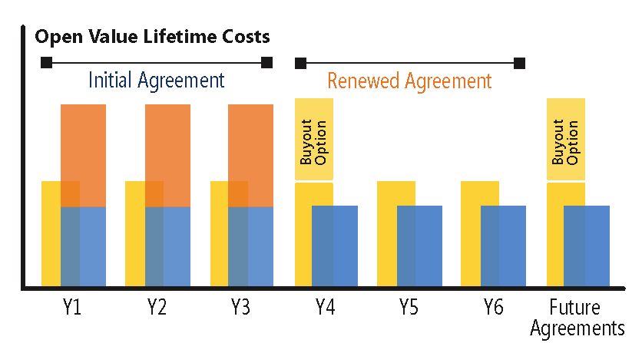
Maximize Value with Software Assurance
Open Value includes Software Assurance, Microsoft’s comprehensive offering that helps you get the most out of your software investment. More than just maintenance, Software Assurance is a complete solution that delivers both software and services to bring more value to your business. Software Assurance combines a broad range of benefits including rights to new software versions, training, deployment services and support. Benefits cover all phases of the software lifecycle—plan, deploy, use, maintain, and transition—so you can get help when you need it. Access to these valuable benefits can help you manage costs, get the most out of new technologies, and improve employee and organizational productivity.
Some of the many Software Assurance benefits are:
- New Version Rights
- Packaged Services
- Windows Vista Enterprise
- Training Vouchers
- E-Learning
- Home Use Program
- 24x7 Problem Resolution Support
Manage Licenses with Microsoft Volume License Services
Online tracking through Microsoft Volume License Services (MVLS) can help make managing your licenses easier. The MVLS license management tool is a password-protected Web site that lets you download licensed products, view your license agreements and status, online records, Software Assurance benefits, and other license information. You can access the MVLS site at: http://licensing.microsoft.com/. You will need a Windows Live™ ID to access the site.
Additional Resources
Microsoft Volume Licensing Programs: http://www.microsoft.com/licensing/
Microsoft Open Value: http://www.microsoft.com/licensing/programs/open/openvalue.mspx
Microsoft Software Assurance for Volume Licensing: http://www.microsoft.com/licensing/sa/

© 2008 Microsoft Corporation

This document is for informational purposes only. MICROSOFT MAKES NO WARRANTIES, EXPRESS OR IMPLIED, IN THIS SUMMARY.
Microsoft provides this material solely for informational and marketing purposes. Customers should refer to their agreements for a full understanding of their rights and obligations under Microsoft’s Volume Licensing programs. Microsoft software is licensed not sold. The value and benefit gained through use of Microsoft software and services may vary by customer. Customers with questions about differences between this material and the agreements should contact their reseller or Microsoft account manager.
The contents of this guide are subject to change. Please contact your Microsoft account manager or Reseller for the most current version of this guide.

0908
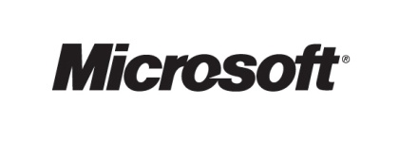

Microsoft Open Value for Government is not available in all regions. Please check with your reseller regarding availability in your country.

