

2007 Microsoft® Office System Business Intelligence Integration
White Paper
Published: February 1, 2007
Author: Anthony T. Mann, President
Mann Publishing Group

For the latest information, please see:
http://www.microsoft.com/sql/
http://www.microsoft.com/BI

Contents
Overview 3
Introduction 3
The Microsoft Vision for Business Intelligence 4
Analyzing Business Data 5
The BI Platform 5
The End-User Tools 6
Reporting Services 2005 and Office SharePoint Server 2007 6
Analysis Services 2005 and Office Excel 2007 7
Microsoft SQL Server 2005 Data Mining Add-ins for Office 2007 8
Microsoft SQL Server 2005 Reporting Services and Microsoft Office SharePoint Server 2007 8
Office SharePoint Server 2007 Integration Features and Benefits 8
Integration with Report Center 9
Selecting the Right Mode 11
Native Mode 11
SharePoint Integration Mode 11
Installation Components and Setup 12
Report Server Configuration 12
SharePoint Server Configuration 13
Creating Reports 14
Developers 15
End-Users 15
Viewing Reports 16
Managing Reports 17
Microsoft SQL Server 2005 Analysis Services and Microsoft Office Excel 2007 19
Microsoft Office Excel 2007 Integration Features and Benefits 20
Installation Components and Setup 23
Using Office Excel 2007 with Analysis Services 23
Analysis Services 2005 Data Mining Add-ins for Office 2007 25
Installation Components 25
Using Data Mining Add-ins 26
Table Analysis Tools for Excel 26
Data Mining Client for Excel 29
Data Mining Templates for Visio 30
Conclusion 32
Appendix - SQL Server 2005 Editions 33

Overview
Business Intelligence (BI) just became a lot easier! The release of the 2007 Microsoft® Office system, used in conjunction with Microsoft® SQL Server 2005, delivers numerous benefits in terms of Return on Investment (ROI) for a company, design and implementation for its Information Technology (IT) department, and ease of use for end-users.

According to the research firm IDC, Microsoft’s BI tools are growing at more than twice the rate of the overall market. Microsoft technologies are at the forefront of the BI market and are continuing to grow in breadth and capabilities. This paper discusses the important drivers, reasons, and technology features when integrating SQL Server 2005 and the 2007 Office system. To keep this paper as brief as possible, it references some additional Web sites that you can visit for more information.

This paper is divided into two main sections. The first shows an overview of the three main BI integration points between Microsoft SQL Server 2005 and the 2007 Microsoft Office system:
- Microsoft® SQL Server™ 2005 Reporting Services and Microsoft® Office SharePoint® Server 2007
- Microsoft® SQL Server™ 2005 Analysis Services and Microsoft® Office Excel® 2007
- Microsoft SQL Server 2005 Data Mining Add-Ins for Office 2007

The second part of the paper breaks down each of the above integration points by showing what software components are needed, features and benefits, how to install and configure the components, and how to use them.

Introduction
Business Intelligence is considered by some to be an elusive and mysterious technology. Users who think that BI is too difficult may be reluctant to use it. Businesses that think BI is too expensive may never implement it. When using Microsoft technologies, these fears become moot. SQL Server 2005 provides an enterprise-ready BI platform (the “hard” part of BI) while the 2007 Office system provides familiar front-end tools for end-users to easily access data from the BI platform of SQL Server 2005. In many cases, comprehensive BI solutions can be developed, deployed, and used in a matter of hours or days, instead of weeks, months, or years.

This section introduces Microsoft’s vision for Business Intelligence, the keys to analyzing business data, and an overview of the Business Intelligence technologies available in SQL Server 2005.

The Microsoft Vision for Business Intelligence
Microsoft’s vision for BI is to:

“Improve organizations by providing business insights to all employees leading to better, faster, more relevant decisions”

Many BI vendors aim to enable employees to make better, faster, and more relevant decisions, but Microsoft’s vision is to extend this statement to all employees – not just business analysts, financial analysts, or executives. Every employee needs to make business decisions every day. However, the impact and scope of those decisions differ. For example, an executive has to make decisions on whether to acquire a competitor. On the other hand, a product manager has to decide how to price products. The list of decisions, whether conscious or not, is endless, so employees need help from software.

Microsoft tackles the challenge of making BI accessible to all employees by addressing key issues to enable them to have the right information at the right time in the right format:

- Total Cost of Ownership (TCO) is too high – By building BI into the core SQL Server platform, TCO is low. This covers all aspects of total cost, including software, tools, development, installation, uptime, maintenance, support, and training.
- BI tools are too difficult to use – By enabling the 2007 Microsoft Office system as one of the end-user tools, employees can access and analyze BI information using tools they already have on their desktops and already know how to use.
- Complete offering – Microsoft offers a complete end-to-end solution to ensure that all employees have access to BI data, including:
  - SQL Server database platform – Platform for database and application designers, developers, and network administrators. This same platform that runs an organization’s Line of Business applications offers high scale data warehousing. The platform can leverage built-in BI features, such as Analysis Services, Reporting Services, and Integration Services. All BI technologies are tightly integrated into the Microsoft Visual Studio® development environment for software developers and designers.
  - 2007 Microsoft Office system – End-user tools for general users and business executives that enable access to business insight from every desktop.
  - Performance management applications – Delivered with Microsoft® Office PerformancePoint™ Server 2007 for end-users and business executives. Office PerformancePoint Server 2007 is designed to help improve performance by integrating monitoring, analysis, and planning into a single application.

This paper focuses on the integration between the 2007 Office system and the SQL Server 2005 back-end BI technologies. The goal is to show how simple it is to bring BI to every desktop in every organization. In most cases, a few simple mouse clicks put information into the hands of even the most skeptical and novice users.

Analyzing Business Data
Businesses need to constantly analyze their efficiency and profitability to streamline their operations. The only way to adequately do this is to analyze the Line of Business (LOB) data to find answers to questions like:
- Which products/services are the most profitable and what factors determine their profitability?
- How can non-profitable products/services become profitable?
- How well are customer service programs operating?
- How effective are business processes, including sales cycles, fulfillment timeliness, customer satisfaction, and employee retention?

There are two key parts in using technology to help businesses analyze their business data to answer the questions presented above – the BI platform and the end-user tools.

The BI Platform
The back-end BI platform performs complex calculations and analytics. SQL Server 2005 forms the core of the Microsoft Business Intelligence platform, enabling end-users to analyze their consolidated enterprise data through the 2007 Office system. SQL Server 2005 is a complete BI platform that includes these technologies:
- SQL Server Relational Database – Technology that provides a robust, scalable, and enterprise-ready Data Warehouse platform. SQL Server 2005 has substantial enhancements in partitioning, manageability, and query optimizations to streamline data warehouse operations and increase performance. Additional information about data warehousing can be found at the Microsoft Web site at: http://www.microsoft.com/sql/solutions/dw/default.mspx.
- SQL Server Analysis Services – Technology that enables businesses to analyze its corporate data by using Online Analytical Processing (OLAP). Analysis Services includes advanced analytical features such as complete data mining and key performance indicator frameworks, enabling organizations to accommodate multiple analytic needs within one solution. Additional information about Analysis Services can be found throughout this paper and from the Microsoft Web site at:
http://www.microsoft.com/sql/technologies/analysis/overview.mspx and http://www.microsoft.com/sql/technologies/dm/default.mspx
- SQL Server Reporting Services – Technology that serves as a complete reporting platform so that end-users can view data using a Web browser or custom application. Reporting Services includes report authoring tools for software developers and end-users themselves. More information about Reporting Services can be found throughout this paper and from the Microsoft Web site at:
http://www.microsoft.com/sql/technologies/reporting/default.mspx.
- SQL Server Integration Services – Technology that can be used to move and transform data between sources and destinations, regardless of format. It can also cleanse data and ensure data integrity to allow organizations to integrate heterogeneous data sources when building data warehouse solutions. Integration Services is not the focus of this paper, but more information can be found on the Microsoft Web site at:
http://www.microsoft.com/sql/technologies/integration/default.mspx.

The SQL Server Business Development Studio is a common, Visual Studio-based development environment that extends across all of the SQL Server BI technologies. The familiar Visual Studio environment provides great developer productivity and is optimized to provide a true application development environment that supports the full project development lifecycle.

The End-User Tools
End-user tools are used by employees to access and analyze complex business data stored on the BI platform. The new release of the 2007 Office system has been optimized to make it very easy for users to access the server-based data hosted on the BI platform. End-users can use a familiar desktop environment to enable them to be more productive without learning new software.

In addition to the 2007 Microsoft Office system for end-user analysis, the end-to-end BI solution from Microsoft also includes Microsoft Office PerformancePoint Server 2007. Office Performance Point Server is an integrated performance management application that helps organizations drive alignment across the enterprise, while allowing business executives and end-users to monitor, analyze, and plan key business activities.

Even though this paper focuses on the capabilities of the 2007 Office system, it is important to note that this is not the only Microsoft offering for accessing BI data on the SQL Server platform. Additional details on the components of the complete Microsoft BI offering can be found at: http://www.microsoft.com/BI/default.mspx.

Reporting Services 2005 and Office SharePoint Server 2007
SQL Server 2005 Service Pack 2 (SP2) enables deep integration between Reporting Services and the Microsoft SharePoint technologies (Windows SharePoint Services 3.0 and Office SharePoint Server 2007). This integration enables an end-user to view and manage reports completely from within a SharePoint document library.

Integrating Reporting Services with Office SharePoint Server 2007 is referred to as SharePoint Integration Mode. Having Reporting Services host reports in the reporting services database only and not integrating with Office SharePoint Server 2007 is referred to as Native Mode.

Additional information about integration mode and native mode, specific integration features between Reporting Services 2005 and Office SharePoint Server 2007, installation and configuration, and the usage of Reporting Services 2005 is discussed in the second part of this paper.

Analysis Services 2005 and Office Excel 2007
The release of Office Excel 2007 greatly enhances a user’s ability to access and analyze data from SQL Server 2005 Analysis Services. With Office Excel 2007, end-users can browse data stored in multidimensional OLAP cubes in Analysis Services. Office Excel 2007 enables users to easily build PivotTable views to “slice and dice” data any way they wish. Figure 1 shows a PivotTable™ in Office Excel 2007 that connects to Analysis Services sample data.

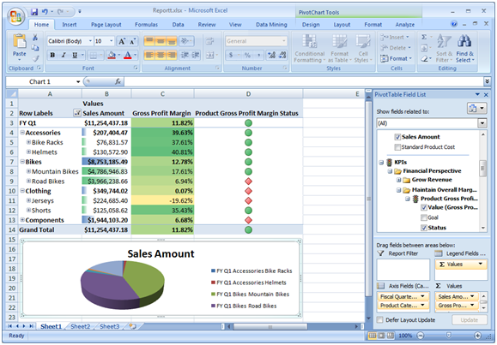
Figure 1: PivotTable in Office Excel 2007.

Using Office Excel 2007 to access Analysis Services data is significantly easier than it was with prior versions of Excel. With only a couple of mouse clicks, the PivotTable Field List exposes a user-friendly metadata layer of Analysis Services to the end-user (see Figure 1). The PivotTable Field List enables end-users to quickly select important business data that they want to include in the PivotTable for further analysis.

Additional information about the specific features that enrich the end-user analysis experience, installation, configuration, and using Office Excel 2007 with Analysis Services 2005 is discussed in the second part of this paper.

Microsoft SQL Server 2005 Data Mining Add-ins for Office 2007
It can be quite easy to write a report to view any data metrics that you are looking for. For example, if you want to view all sales in a given fiscal year grouped by division and quarter, this would be a very simple report to create. Using Reporting Services, you could create and deploy such a report in a matter of only minutes. Developers can also quickly create an Analysis Services cube that can be browsed by end-users to display this type of data.

However, what if you didn’t know what you were looking for? What if there was a way to spot trends in data that you didn’t even know existed? That’s where data mining comes into play. Data mining uses machine learning algorithms to analyze existing data and to build models that represent the patterns found in the data. This technology alone can help increase a company’s bottom-line and become more efficient.

The Data Mining Add-ins for Office 2007 is comprised of three separate components:
- Table Analysis Tools for Excel –Allows you to analyze your spreadsheet data in powerful ways with just a few mouse clicks, by employing SQL Server Data Mining behind the scenes.
- Data Mining Client for Excel – Enables you to create and manage the entire lifecycle of a data mining project, including preparing data, building and managing mining models, and predicting results.
- Data Mining Templates for Visio – Enables you to render graphical Visio diagrams to communicate the results of data mining operations to others in your company.

Additional information about specific features, installation and configuration, and using the data mining add-ins is discussed in the second part of this paper.

Microsoft SQL Server 2005 Reporting Services and Microsoft Office SharePoint Server 2007
The first part of this paper gave you an overview of integrating Reporting Services and Office SharePoint Server 2007. Integration between Reporting Services and Office SharePoint Server 2007 is simple to implement, but requires some configuration before it will work. You must install specific components on the Reporting Services and Office SharePoint server 2007. Then, you must configure each server. This part of the paper dives into the details to show the benefits of integrating the two products and the configurations needed to perform the integration.

Office SharePoint Server 2007 Integration Features and Benefits
There are numerous benefits and advantages to integrating Reporting Services with Office SharePoint Server 2007. Prior to SP2, Reporting Services reports were published to a report server and were executed solely in that environment. The integration point between Reporting Services and SharePoint was two separate Web Parts: Report Explorer and Report Viewer. These Web Parts made it possible to view reports within SharePoint, but presented these challenges:
- The report content source was always separate from the SharePoint content source.
- Reports were hosted on a report server and were only displayed within the SharePoint environment.
- Security of reports was managed by the report server, so there was no unified security model.
- The user interface was not consistent between managing and viewing reports because each was performed in a separate environment.
- Filtering of report data could only be done by using report parameters that had to be defined in the reports themselves.
- Internet-facing SharePoint sites required deploying the report server outside the firewall.

With SQL Server 2005 SP2, deep integration with Office SharePoint Server 2007 offers numerous advantages, including:
- Single consistent user interface for managing and viewing reports.
- A much richer user experience.
- Storing reports in Office SharePoint Server 2007 document libraries. This allows a report to use standard Office SharePoint Server 2007 features, such as workflow, versioning, and collaboration.
- Reports and all associated resources are stored within the Office SharePoint Server 2007 database and are automatically synchronized with the same reports that are stored and executed from the report server. Scheduling, caching, and subscriptions are stored in the report server database only because this functionality is not available natively in a SharePoint document library.
- Single security model for reports because they are treated like any other document inside a SharePoint document library.
- Common report filtering paradigm that is used in SharePoint document libraries and filtering Web Parts.

Integration with Report Center
While Reporting Services reports can be managed in any site or document library, Office SharePoint Server 2007 includes out of the box functionality for reporting, referred to as the Report Center. Report Center is delivered as a site template to enable you to easily create an Office SharePoint Server 2007 site for hosting reports. When you create a site using this template, navigation bar links are added to manage reporting resources, as shown in Figure 2. Figure 2 also shows a sample dashboard with defined Key Performance Indicators (KPIs).

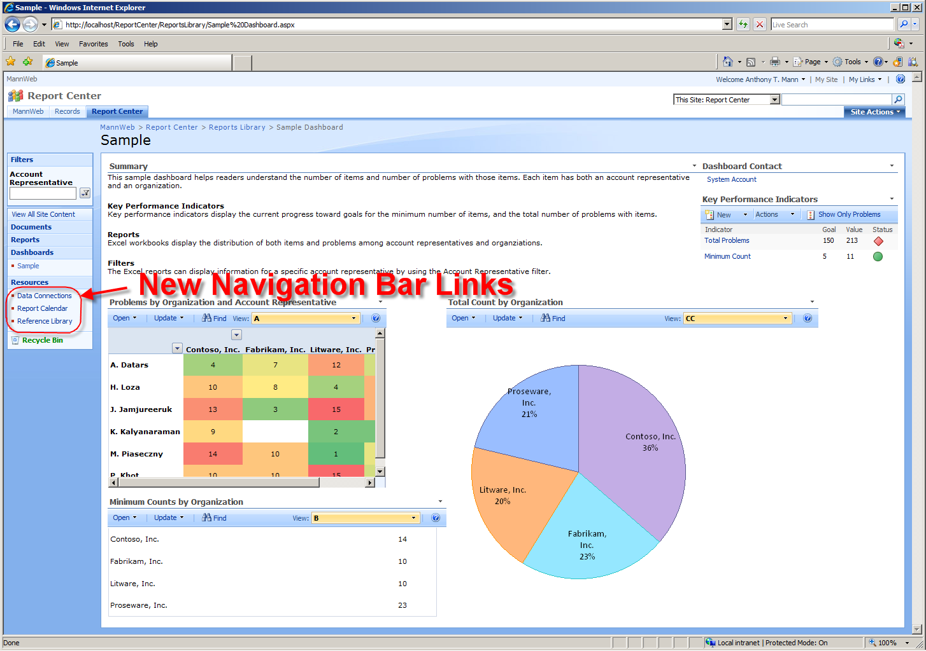
Figure 2: Navigation Bar Links Highlighting New Resources Category.

The navigation bar links in the Report Center site template are:
- Documents – Document library to store a collection of documents.
- Reports – Document library that can be used for managing Reporting Services and Excel Services reports.
- Dashboards – Listing of all dashboards that you can configure for your users. For example, you can have one dashboard that shows executives the report KPIs that are useful to them. However, project managers need to see more detailed information about their projects, so they would need a different dashboard with different KPIs.
- Resources – Folder containing these types of resources that can be used with Reporting Services reports:
  - Data Connections – Document library that contains shared data sources and/or report models that can be used among all reports.
  - Report Calendar – Calendar list that can contain any date-related information for a report or report schedule. For example, you can indicate on which dates report data is refreshed or loaded. This item has no specific integration points with Reporting Services.
  - Reference Library – Document library for you to place documents that can help end-users with the navigation and usage of the report center. This item has no specific integration points with Reporting Services.

Having resources stored in separate document libraries enables you to configure versioning, workflow, and security separately for each resource. For example, you can configure security to only allow members of the IT department to modify or upload data connections. Likewise, you can configure workflow in Office SharePoint Server 2007 to require approval for new reports.

Selecting the Right Mode
SQL Server 2005 Reporting Services can operate in either Native Mode or SharePoint Integration Mode. As Reporting Services supports multiple instances, you also have the option of using both modes simultaneously on a single server. This section outlines some considerations you should think about to help determine which mode to use in your organization.

Native Mode
The term Native Mode in Reporting Services 2005 Service Pack 2 refers to the existing way that Reporting Services operates. The report server is responsible for management of all Reporting Services functionality, including report storage, rendering, scheduling, subscriptions, security, and administration. Reports, data sources, and report models are all stored in the report server database.

Native Mode is appropriate for any organization that does not implement Windows SharePoint Services 3.0 or Office SharePoint Server 2007, or does not need the added functionality of Integration Mode (see next section). If your organization uses Windows SharePoint Services 2.0 or SharePoint Portal Server 2003, you will not be able to leverage the additional productivity and security features of Integration Mode until you upgrade to Windows SharePoint Services 3.0 or SharePoint Portal Server 2007.

SharePoint Integration Mode
Using Reporting Services 2005 in SharePoint Integration Mode enables some significant benefits to the end-user and the organization as a whole, as follows:
- Uses SharePoint document libraries to store reports, data sources, and report models.
- Enables publishing, viewing, management, and delivery of Reporting Services reports from the same user interface used for managing Office documents.
- Enables organizations to construct BI dashboards with rich reports.
- Leverages workflow and collaboration capabilities that are already available in Office SharePoint Server 2007.

When using SharePoint Integration Mode, some features that are available in Native Mode are replaced with comparable functionality in Office SharePoint Server 2007 or are no longer available. The Reporting Services features that are not available in Integration Mode are:
- Report Manager
- Management Studio
- My Reports
- Linked Reports
- Job Management

Note: There is no support for migrating native mode reports to SharePoint integration mode. You can use those reports, but you must manually republish them to the Office SharePoint Server 2007.

Installation Components and Setup
Integrating Reporting Services with Office SharePoint Server 2007 requires these components to be installed:
- SQL Server 2005 Reporting Services – hosts Reporting Services reports and communicates with Office SharePoint Server 2007 using a Web Services interface. The Reporting Services server also manages subscriptions and report caching. This server can be separate from the Office SharePoint Server 2007, but if it is, you must also do a basic install of Office SharePoint Server 2007 on the Reporting Services server to ensure that the Windows SharePoint Services (WSS) 3.0 object model is installed.
- SQL Server 2005 Service Pack 2 – enables Office SharePoint Server 2007 and Reporting Services integration on the report server.
- Office SharePoint Server 2007 –Serves as the central access point for all reports and business data. Alternately, you can use Windows SharePoint Services 3.0.
- Microsoft SQL Server 2005 Reporting Services Add-in for Microsoft SharePoint Technologies - This feature includes the Report Viewer Web Part and the new report management user interface.

After installing the required components to integrate Reporting Services with Office SharePoint Server 2007, both the report server and SharePoint server need to be configured. The following sections outline the configurations necessary to achieve integration.

Report Server Configuration
After installing SQL Server 2005 Service Pack 2 on the Reporting Services server, a new configuration option becomes available, called SharePoint Integration, as shown in Figure 3.

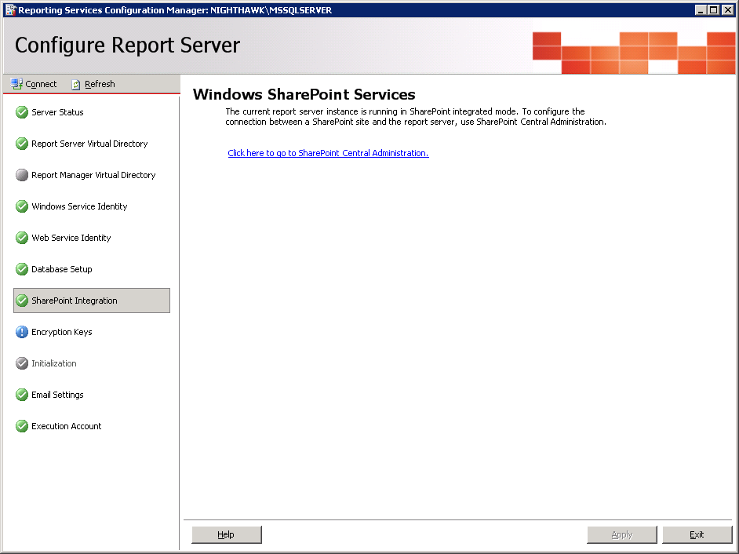
Figure 3: Configuring Report Server SharePoint Integration.

SharePoint Server Configuration
After installing the Microsoft SQL Server 2005 Reporting Services Add-in for Microsoft SharePoint Technologies feature of the Feature Pack for SQL Server 2005 Service Pack 2, a new application becomes available under the Application Management tab. This new application is shown in Figure 4.
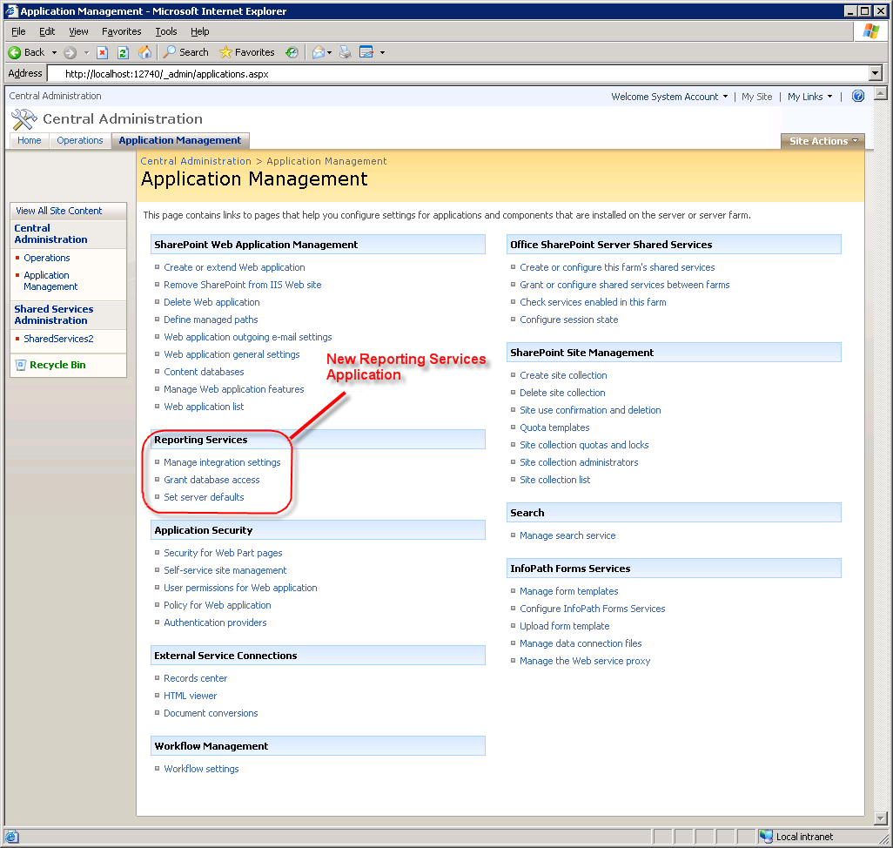
Figure 4: Configuring the Reporting Services Application in Office SharePoint Server 2007.

To configure Reporting Services, you must set each of the options shown in Figure 4, as follows:
- Manage integration settings – To configure the Report Server Web Service URL and Authentication Mode (either Windows or other trusted account).
- Grant database access – To configure the name of the report server database server instance name.
- Set server defaults – To configure report server timeouts and other options.

Creating Reports
Once Reporting Services and Office SharePoint Server 2007 integration is setup, reports can be created and deployed to the Office SharePoint Server 2007. Creation of reports can be done in one of two ways: one for developers and one for end-users. Each is discussed in the following sections.

Developers
Developers use Visual Studio®-based SQL Server Business Intelligence Development Studio to create reports. After installing the SQL Server 2005 workstation components, many business intelligence project templates become available, as shown in Figure 5.

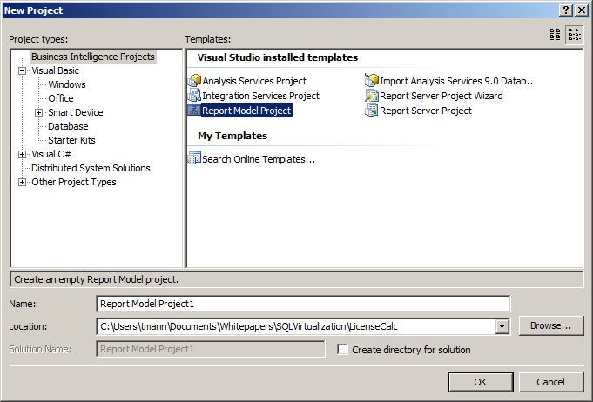
Figure 5: Visual Studio 2005 Business Intelligence Project Types.

Note in Figure 5 that Report Model Project is selected. A Report Model is a way to define the data which can be used by end-users to create reports (see next section). Alternatively, developers can create a blank Report Server Project or use the Report Server Project Wizard to help guide the user through the process of creating reports and specifying data sources.

End-Users
End-Users can create reports as well as developers, but a developer must first make the data available to those users. Making data available is done using a Report Model. A Report Model defines the data source of a report, the security parameters for the data source, and the tables, fields, and relationships used for the model. This model is then published to an Office SharePoint Server 2007.

Once the Report Model is published to the Office SharePoint Server 2007, end-users can create reports using Report Builder. This is a ClickOnce application that is downloaded automatically from the Office SharePoint Server 2007 and installed as a component on the user’s workstation. Report Builder enables the end-user to create and publish reports to the Office SharePoint Server 2007 using the Report Model that the developer created. Figure 6 shows the Report Builder tool.

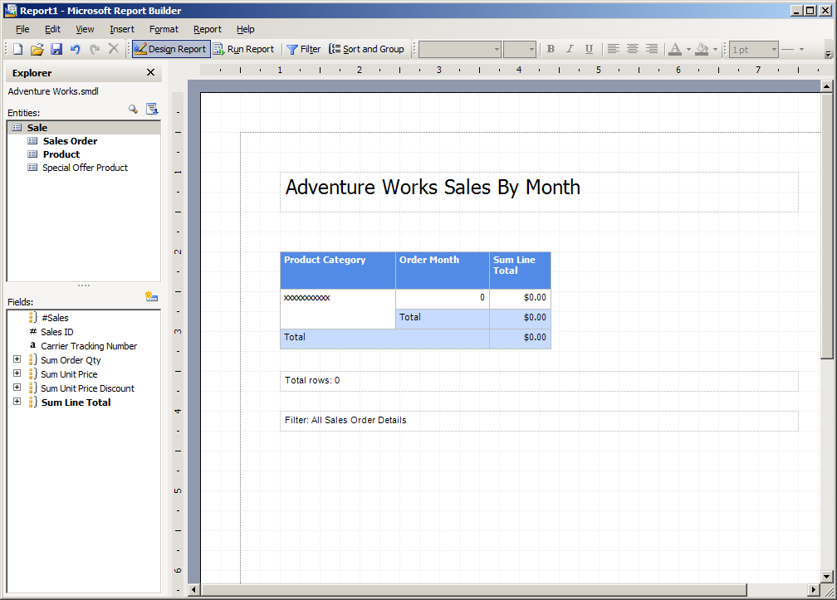
Figure 6: Designing Reports in Report Builder.

Viewing Reports
Once reports are created and deployed to the Office SharePoint Server 2007, they are ready to be viewed. Report security is set the same way it is for any SharePoint document. You can set security permissions on libraries, folders, or individual files.

If a user navigates to a report in a report library on the Office SharePoint Server 2007, the reports can be viewed simply by clicking the desired file name. The integration components know how to connect to the report server Web Service to render the report from within the Office SharePoint Server 2007 environment. Figure 7 shows a rendered report in Office SharePoint Server 2007.

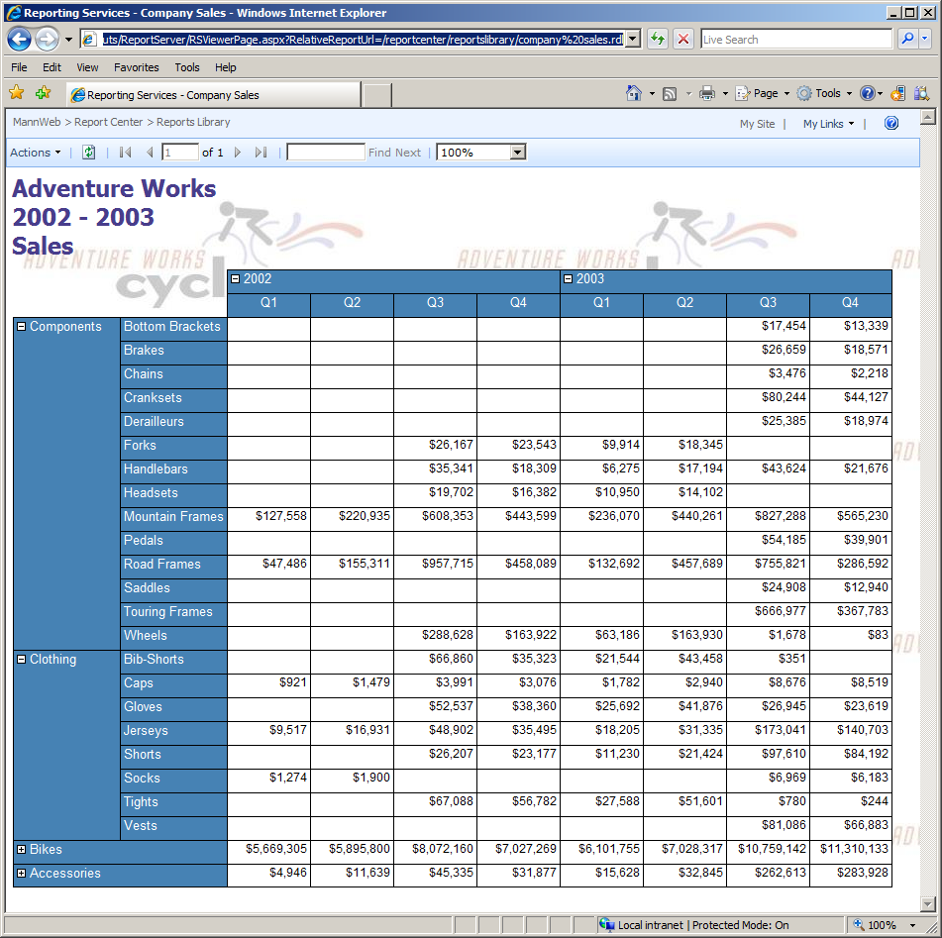
Figure 7: Rendered Report within the Office SharePoint Server 2007 Environment.

Reports in a report library are rendered using a Report Viewer Web Part. Any SharePoint page can also be modified to display reports by using the Report Viewer Web Part. Report Viewer Web Parts can also be connected to SharePoint Filter Web Parts to limit the data displayed in reports.

Managing Reports
When Reporting Services is integrated with Office SharePoint Server 2007, report management is then performed using the same SharePoint document library as the one used to launch reports. Managing reports is as simple as navigating to the correct report in the SharePoint document library and clicking the down arrow. The user is presented with a host of options, as shown in Figure 8.

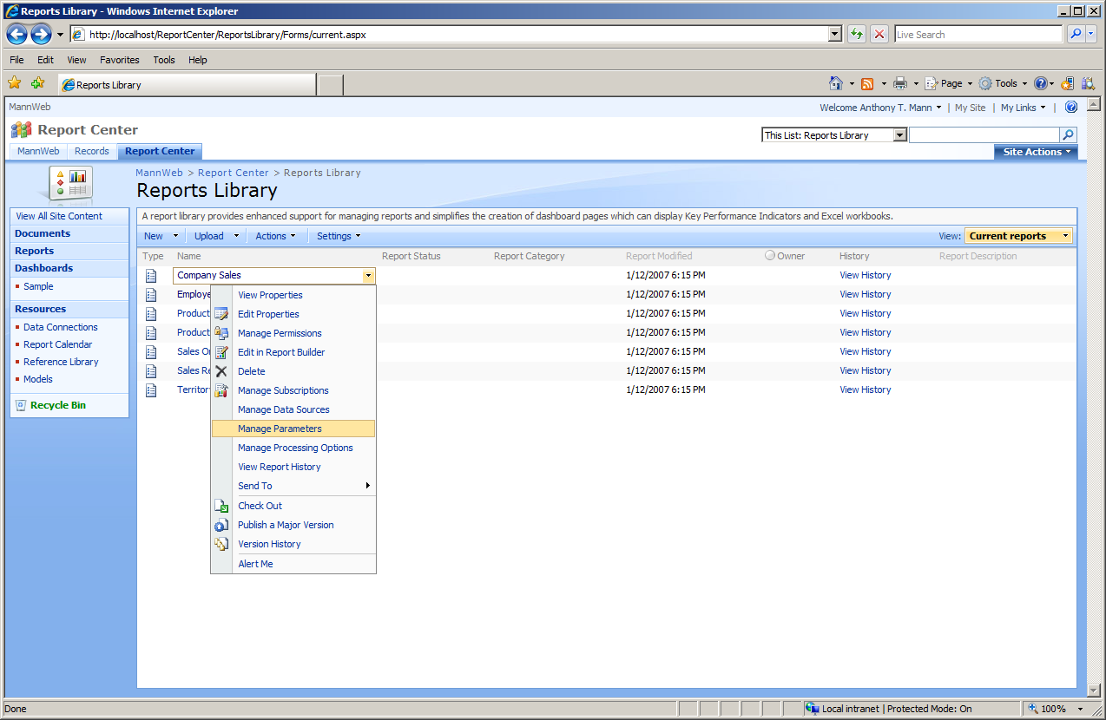
Figure 8: Managing Reports in Office SharePoint Server 2007.

Figure 8 shows these possible report management actions:
- View Properties – Standard Office SharePoint Server 2007 functionality to view document properties. Organizations can employ standardization for properties that will be used in reports, such as including categories, sub-categories, timestamps, approvals, and more.
- Edit Properties – Standard Office SharePoint Server 2007 functionality to edit document properties. SharePoint Office Server 2007 can be configured to make properties mandatory. This can enable organizations to provide valid metadata for each report in the report library.
- Manage Permissions – Standard Office SharePoint Server 2007 functionality to manage the permissions of the document. This is one of the main benefits of integrating Reporting Services with Office SharePoint Server 2007. A common security model is used to secure reports, folders, files, and libraries. System Administrators can easily assign security and troubleshoot report execution problems.
- Edit in Report Builder – Reporting Services functionality to launch the Report Builder tool to edit the definition of the report (see Figure 6). Report Builder enables end-users to easily modify or create reports and publish them to the Office SharePoint Server 2007.
- Delete – Standard Office SharePoint Server 2007 functionality to delete the document from the document library.
- Manage Subscriptions – Reporting Services functionality to add, edit, and delete report subscriptions. Users that subscribe to reports can automatically be notified when data changes in reports. For example, sales people can subscribe to a report to automatically receive their weekly sales figures via email.
- Manage Data Sources – Reporting Services functionality to select a shared or custom data source for the report. Shared data sources enable one data source definition to be used across multiple reports.
- Manage Parameters – Reporting Services functionality to manage the values and prompts for all parameters passed into the report. Parameters are a way to limit the data that is displayed in a report. For example, a report parameter named Year can be specified to limit the report data to the selected year when the report is run.
- Manage Processing Options – Reporting Services functionality to choose processing and snapshot options and timeouts. Snapshots and timeouts affect the performance of the Reporting Services server. It is important to consider these options to keep the server performing as well as possible.
- View Report History – Reporting Services functionality to view the history of report processing.
- Send To – Standard Office SharePoint Server 2007 functionality to send the document to another location.
- Check Out – Standard Office SharePoint Server 2007 functionality to check out the document in order to publish changes. The ability to check out, and then publish a report, data source, or data model is one of the major advantages to integrating Reporting Services with Office SharePoint Server 2007. A report, or any other document, can be checked out, modified, and have workflow optionally applied to the document before it is published back into the Office SharePoint Server 2007.
- Publish a Major Version – Standard Office SharePoint Server 2007 functionality to publish a version of a checked-out document. When significant changes to a document occur, it can be helpful to flag the document as a major version so that users have an indication as to the scope of changes in the document. A major version uses the format of version 1.x, 2.x, 3.x, etc.
- Version History – Standard Office SharePoint Server 2007 functionality to view the published versions of a document.
- Alert Me – Standard Office SharePoint Server 2007 functionality to alert a user to changes in the document. This option notifies a user when there is a change to the report definition itself, as opposed to the data being changed in a report.

Microsoft SQL Server 2005 Analysis Services and Microsoft Office Excel 2007
Analysis Services enables companies to build and deploy cubes to analyze enterprise-wide data. Analysis Services cubes are built by developers and published to an Analysis Services server to consolidate, aggregate, and instantly present complex business data to end-users in meaningful ways. Using Office Excel 2007 these users can easily create PivotTable views to analyze the data that pertains to them. For example, an executive can quickly and easily create a PivotTable in Office Excel 2007 to view all sales by division, and by quarter. However, if the executive wants to drill-down into the details that make up those sales, no recalculation or additional work has to take place. This is because the Analysis Services cube already contains detail and pre-aggregated data that is accessible to the end-user.

Using the familiar Excel environment, a user can leverage Analysis Services data to quickly and easily analyze critical business data. In only minutes, the features of Office Excel 2007 make it possible to create professional-looking reports of complex Analysis Services data.

Microsoft Office Excel 2007 Integration Features and Benefits
In SQL Server 2005 SP2 Analysis Services is designed to work seamlessly with Office Excel 2007 to provide end-users with a rich analysis experience. SQL Server 2005 Analysis Services and Office Excel 2007 each contain too many features and benefits to list in this one paper, but the following features specifically come to life as results of the enhanced interoperability points between the two products:
- Get External Data – A new enhancement introduced with Office Excel 2007 to allow end-users to leverage predefined data source connections to eliminate the complexity of connecting to external data sources. This feature is not specific to connecting solely to Analysis Services, but is included here due to the major impact this poses on a business’ ability to enable more users than ever to access data. The benefit of connecting to Analysis Services data using existing connections is that users no longer need to know anything about the server, the data sources, or the connection strings required to create a connection to the back-end data.
- PivotTable Creation – Numerous advances have been made in the area of PivotTable creation, including the following:
  - PivotTable Field List – Enables easy access to all the measure groups and dimensions of the Analysis Services cubes that are available for analysis. When connecting to the cube from Office Excel 2007, the PivotTable Field List is automatically displayed. Clicking fields to display in a PivotTable yields near instantaneous updates of the data in the spreadsheet.
  - Display Folders – Organize and display cube information into logically named folders corresponding to business, functional, or logical areas. With display folders, Analysis Services can determine how information is presented to client applications. For example, geographic-related content, such as hierarchies and attributes can become part of a display folder called Location.
  - Conditional Formatting – Applies strong visual cues to the PivotTable for an at-a-glance view of specific conditions, such as negative numbers and missed sales projections. Conditional formatting is a general Office Excel 2007 feature that is available to all users, regardless of data origin. However, as an additional benefit for users working with Analysis Services data, conditional formatting is automatically activated when a user interacts with KPIs stored in Analysis Services. With conditional formatting being activated automatically, end-users are empowered to manage KPI rules directly from Office Excel 2007. For example users are able to change icon styles and value thresholds to immediately apply those changes to their current worksheet.
  - Server based formatting – Enriches the end-user experience and removes redundant formatting tasks across all users. Analysis Services offers multiple server-side formatting options. One formatting option is Measure Formatting, which enables productivity-enhancing formatting of individual measures directly in the cube. For example, all measures related to sales can be formatted and automatically retrieved as dollar amounts. This server-based formatting of measures directly in the cube saves users time, while increasing overall performance. Another server-side formatting option is called Bubble up Exceptions, which enables issues and problems in data that reside at low levels in the cube to rise (or bubble up) to the high level summary data. This prevents the possibility of data issues being hidden just because a user did not drill-down into the data.
  - Calculated Members – Eliminates the need for time-consuming and repetitive calculations for end-users. As an example, suppose end-users need to see total sales amounts in the same spreadsheet as individual sales period values by division. The total sales amount needs to be added as a separate column representing the summed value of the individual sales values. In Analysis Services these types of calculations, called calculated members, can be created on the server, thereby extending the analytical capabilities of the OLAP engine. The calculated members can then be exposed directly to Office Excel 2007, where they are easily extracted in one single operation every time a client application or user needs the total sales amount.
  - Named Sets – Predefined calculations of complex or commonly used expressions defined and stored in Analysis Services. An example of a Named Set could be one called Top Ten Products that contains a calculation retrieving the ten best-selling products at the time the query is executed. Names Sets add enhanced power to the Office Excel 2007 client by enabling end-users to easily reuse these predefined queries to ask common, but complex questions.
  - Member Properties – Enriches the end-user experience of analyzing server-based data. Analysis Services stores all the attributes for each member of a given dimension and are made available to the end-users through the contextual tooltips in Office Excel 2007. Examples of attributes for a product dimension could be existing stock levels of the product, production time, and retail price. Member properties can be leveraged on multiple levels. They can be shown when a user hovers over a cell in a report to provide contextual insight on each member, added as additional columns in a PivotTable, or applied as a filter to PivotTable views. Member properties add an additional level of insight to the Office Excel 2007 analysis environment.
  - KPI Framework – Centrally-managed framework for defining, storing and managing Key Performance Indicators (KPIs). KPIs are designed to enable users to monitor key enterprise metrics. KPIs can be consumed via a variety of end-user tools including Office Excel 2007, Office SharePoint Server 2007, Microsoft® Office Business Scorecard Manager 2005, and Microsoft Office PerformancePoint Server 2007.
  - Server Actions – Supports seamless navigation across diverse sets of data. Server Actions are commands that are defined and stored in Analysis Services and can be executed by users through Office Excel 2007 or other client applications supporting this functionality. Server Actions enable users to launch other reporting applications, navigate to certain URLs, or drill through to other detailed data that isn’t included in the cube.
  - OLAP Formulas – A new set of formulas introduced with Office Excel 2007 that enables users to access data from Analysis Services at the cell level. Cube functions such as CUBESET, CUBEVALUE, CUBEMEMBER, CUBEMEMBERPROPERTY, and CUBERANKEDMEMBER can be applied to specific cells. Users are able to create sophisticated free-form reports using any layout they wish without being bound by the PivotTable layout. A PivotTable view can be converted to a free-form report if advanced analysis is required. This option is shown in the Options ribbon in the section, “Using Office Excel 2007 with Analysis Services,” later in this paper.
  - Formula Authoring – A context-based AutoComplete feature that enables users to write formulas using the proper syntax when creating free-form reports. The formula authoring feature in Office Excel 2007 provides an expanded set of functions, including new cube functions to query data contained within Analysis Services.
- Perspectives – Offers user-differentiated perspectives across one model. Similar to database views, Analysis Services enables an organization to create perspectives to help alleviate the complexity of data that can reside in a cube. A perspective can be created for each job role to enable users to see only the data that pertains to them. As an example, an organization with various sales channels may find it useful to create one perspective per channel. Doing so would enable users engaged with a specific sales channel, such as a partner channel, to view the Analysis Services objects that pertain only to that channel. When a data connection is defined, a list of perspectives is displayed. The selected perspective is stored along with the data connection definition to enable users to work with Analysis Services data using Office Excel 2007.
- Translations – Enables users across multiple geographic locations to access local versions of one centrally-managed data model. Analysis Services supports translation of any object that is exposed to the end-users, such as a cube, dimensions, hierarchies, attributes, and measures. When using a localized version of Office Excel 2007 to access an Analysis Services cube, the client application automatically checks for available translations. Data is returned in the applicable locale, if available. This is a powerful capability to support global scalability for end-users, while eliminating the prior requirement of creating and maintaining multiple cubes – one for each language.
- Excel Services – A shared service available as part of Office SharePoint Server 2007 that enables Office Excel 2007 and Analysis Services to quickly integrate, analyze, and report against data from across the enterprise, regardless of where it resides. Excel Services helps to extend the capabilities of Microsoft Office Excel 2007 by allowing the broad sharing of spreadsheets, improving manageability and security, and re-using spreadsheet models. These capabilities are accomplished by using a scalable server-based calculation service and an interactive Web-based user interface. With Excel Services, organizations can broaden the access and availability of analysis. Analysis Services empowers users to incorporate interactive Excel-based analysis spreadsheets into business intelligence portals and dashboards. Excel Services also ensures that all users are working with consistent, up-to-date information.

Installation Components and Setup
Using Analysis Services with Office Excel 2007 requires these components to be installed:
- SQL Server 2005 Analysis Services – stores and manages all Analysis Services data. It also manages the processing of data and cubes that can be viewed with the 2007 Office system programs.
- SQL Server 2005 Service Pack 2 – enables Analysis Services features and integration with the 2007 Office system.
- Microsoft Office Excel 2007 (included in the Microsoft Office 2007 system) – workstation BI environment for end-users to view and analyze BI data.

After installing the required software, there is nothing specific to configure or setup before using Office Excel 2007 with Analysis Services.

Using Office Excel 2007 with Analysis Services
Accessing Analysis Services data through Office Excel 2007 is done through the Data ribbon in Office Excel 2007. This ribbon enables users to, among other actions, select data sources from a common Data Connection Library that can be located anywhere on the corporate network. A Data Connection Library enables the IT department to create shared data sources for all users to access, where informative names and explanatory descriptions eliminate the need for users to understand server names and data locations.

Through the Data ribbon in Office Excel 2007, the icons are divided into a logical and organized fashion. The Data ribbon is shown in Figure 9.

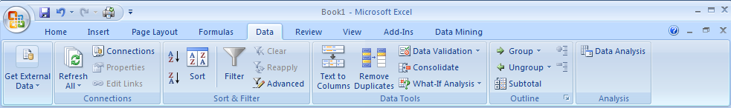
Figure 9: Data Ribbon in Office Excel 2007 Used for Analysis Services Connections.

The Data ribbon organizes common tasks for accessing Analysis Services data as follows:
- Get External Data – Allows end-users to create their own data connections to an Analysis Services server, a relational server, XML data, and more. Once Office Excel 2007 accesses external data, it creates a PivotTable and opens a field list for the user to select the fields to show in the PivotTable. Alternatively more advanced users have the ability to create a connection without displaying the PivotTable layout and the field list. This enables a user to leverage new OLAP formulas and cube functions of Office Excel 2007 to build more complex and free-form reports.
- Connections – Single place to manage connections to external data.
- Sort & Filter – Generic sorting and filtering options available to any user.
- Data Tools – Not used for PivotTables.
- Outline – Generic option for grouping and summarizing data

Once the PivotTable is created, additional PivotTable ribbons become available. The options on these ribbons enable users to quickly control the behavior of the PivotTable. Figure 10 shows the PivotTable Tools Options ribbon.

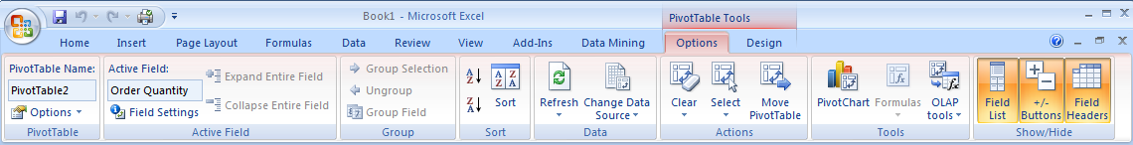
Figure 10: PivotTable Tools Options Ribbon.

These categories are available on the Options ribbon to enable a user to configure a PivotTable:
- PivotTable – Generic properties for the PivotTable and lets the user select printing options.
- Active Field – Options for the selected field, such as the field name, and how to summarize.
- Group – Grouping for numeric and date fields and allows for the manual grouping of any field type.
- Sort – Used to apply sorting and to specify sorting options.
- Data – Enables a user to refresh or change the data source.
- Actions – Allows for moving, structured selections, and clearing of a PivotTable and filters.
- Tools – Used for inserting graphs and charts, in addition to specifying formulas. Users can also take OLAP data offline using these tools. More advanced users can even convert a PivotTable into a free-form report, enabling them to with OLAP formulas directly.
- Show/Hide – Enables a user to define whether to show or hide the field list, drill down buttons, and/or field headers.

Figure 11 shows the PivotTable Tools Design ribbon.

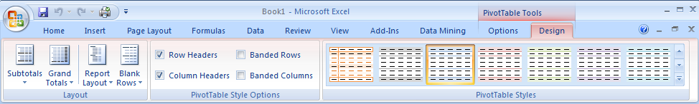
Figure 11: PivotTable Tools Design Ribbon.

These categories are available on the Design ribbon to enable a user to configure the look and feel of a PivotTable:
- Layout – Enables a user to select from many options to control the display of the PivotTable, including total and subtotal options and how to display columns of data.
- PivotTable Style Options – For selecting row and column options for PivotTable styles.
- PivotTable Styles – For selecting the display style of the PivotTable. Hovering the mouse over a style displays the selected style using Live Preview.

Analysis Services 2005 Data Mining Add-ins for Office 2007
Before a user can access SQL Server 2005 Data Mining features from the 2007 Office system, the client workstation needs to have additional software installed. Server software may also need to be installed, as outlined in the next section.

Installation Components
Using Data Mining Add-ins for Office 2007 requires these components to be installed:
- SQL Server 2005 Analysis Services Server – stores and manages all analysis services data. It also manages the processing of data and cubes that can be viewed with the 2007 Office system. Data mining components in Analysis Services provide predictive analysis functionality based on historical data.
- Feature Pack for SQL Server 2005 Service Pack 2 – You only need the Microsoft SQL Server 2005 Data Mining Add-ins for Office 2007 feature. This feature includes three add-ins: Table Analysis Tools for Excel, Data Mining Client for Excel, and Data Mining Templates for Visio.
- Microsoft Office 2007 (Office Excel 2007 and/or Office Visio 2007) – workstation BI environment for end-users to view and analyze BI data.

After you install the Microsoft SQL Server 2005 Data Mining Add-ins for Office 2007, the required components will already be placed on the client workstation. You only need to create a connection to the Analysis Services database and configure the database to support the add-ins. You can perform these configurations using the Getting Started wizard to guide you through the entire process. The Getting Started wizard can be accessed from the All Programs menu. It will also launch automatically when you open Office Excel 2007 the first time after installing the Data Mining Add-ins for Office 2007.

Using Data Mining Add-ins
Using the Data Mining Add-ins is dependent on which add-in you wish to use. Therefore, these Add-ins are specified individually in the next sections.

Table Analysis Tools for Excel
Businesses need to constantly analyze LOB data to determine its ultimate profitability and effectiveness. Imagine if a company could discover that its products sell better during the summer months, but only to people who have never purchased from them before and to those who earn less than $50K/year. Such data might help a company to understand that its products are of great value, but that customers do not give the company repeat business. This would be extremely valuable information and would help a company to alter its business practices to increase revenue. This scenario is just one in a sea of scenarios that can benefit from the Data Mining capabilities of SQL Server 2005 Analysis Services.

The Table Analysis Tool for Excel is very easy to use and is designed to hide the complexity of data mining. It makes data mining available to every end-user – even if they have no previous experience with data mining. With only a few mouse clicks, data in a spreadsheet can be easily analyzed by Analysis Services and can display predictive results. Behind the scenes there is much that needs to happen to make this work. A temporary data mining model is automatically created for the user, enabling the user to not have to worry about choosing any specific algorithm to perform the analysis.

Before the Table Tools ribbon is shown, a data table must be created in an Office Excel 2007 spreadsheet, as shown in Figure 12.

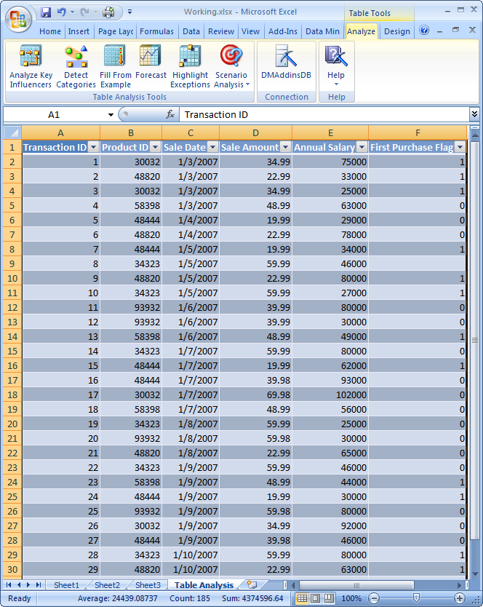
Figure 12: Creating a Data Table in Office Excel 2007.

Once the data table is created, the Table Tools Analyze ribbon is shown. The tools on this ribbon are:
- Analyze Key Influencers – Analyzes the patterns in data that have the strongest influence on a certain outcome. For example, if you have a list of sales for all customers, Table Analysis Tools for Excel can analyze the factors that are key to determining which customers will spend the most money. It may not be obvious which fields are the key influencers. For example, a field representing annual income may not be the biggest factor for customers who spend the most money. It could be other factors, such as number of children in the household, geographic location, or a combination of these fields.
- Detect Categories – Analyzes and detects the rows in the data table that contain similar characteristics and groups them into categories. Each category identified is described by the distinguishing characteristics of the rows assigned to the category. Based on those characteristics, you may choose to give the category a more understandable name. For example, a category that contains Age=45-60 and Income>100000 could be renamed to Affluent Baby Boomers. Breaking the data into categories enables you to quickly identify the natural groupings in your data. This identification can be useful in helping you run targeted marketing campaigns.
- Fill From Example – Enables a user to fill-in missing data for rows in a specific column, based on patterns of data.
- Forecast – Predicts future values based on trends in existing time series data. For example, you can forecast what annual sales will be two years from now, based on current conditions and factors in your data. Additional forecasting options can be used in the scenario analysis tools (shown below).
- Highlight Exceptions – Analyzes and highlights data that does not appear to match the general patterns found in the rest of the table or range. These values could be due to data entry errors, anomalies, or unusual values. Highlighting exceptions can be useful because these values can significantly skew averages and trends. If exceptions are caused by data entry errors, it is likely that you will want to fix these errors before doing additional analysis or trending.
- Scenario Analysis – Contains these two separate scenarios:
  - Goal Seek – Analyzes and reports the factors that need to change to achieve a specific goal. For example, if a company wants to grow from ten million dollars to fifty million dollars, this tool can help to determine how to reach this goal, based on factors that it analyzes in your data.
  - What-If – Analyzes and reports the impact of a proposed or hypothetical change. For example, you can see the effect of change in sales for your target customers if the price of a product increases. With “what-if” scenarios, you can determine, for example, that increasing price does not achieve the results you need, but increasing the warranty period might.

While this paper cannot show the results of each individual Table Analysis option, Figure 13 shows the result of analyzing the categories shown in the data table in Figure 12.

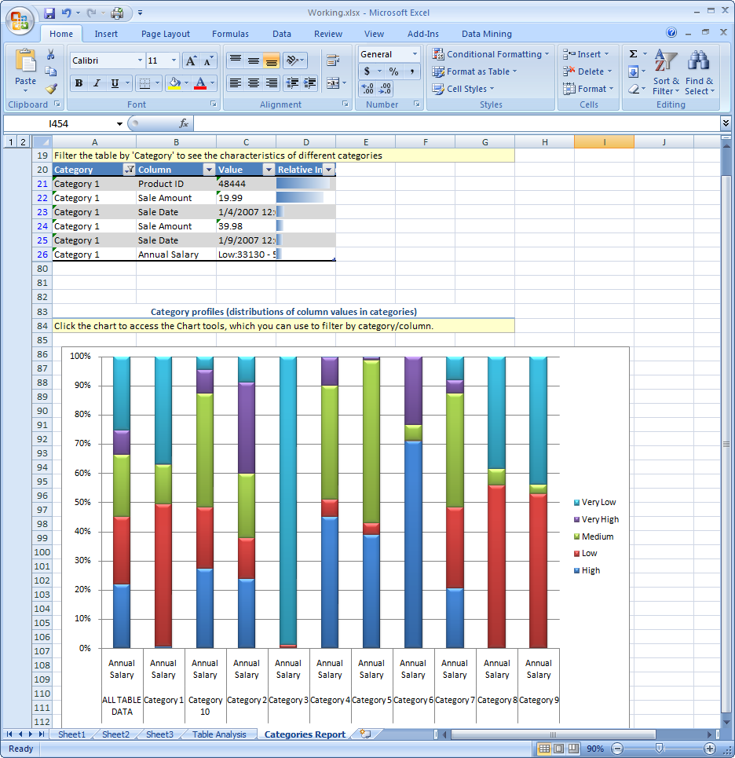
Figure 13: Results of Running the Detect Categories Tool.

Data Mining Client for Excel
The Data Mining Client for Excel is an end-user tool that is available to more advanced users who are familiar with data mining concepts. Users have much more control over the options selected to mine data over those that are available in the Table Analysis Tools for Excel.

After you install the Data Mining Add-ins, a new Data Mining ribbon is installed in Office Excel 2007 and is shown in Figure 14.

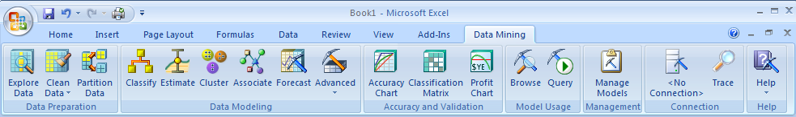
Figure 14: Data Mining Ribbon in Office Excel 2007.

Through this ribbon in Office Excel 2007, the icons are divided into a logical and organized fashion that mimics the typical order of tasks a user would go through when performing data mining. This organization makes it very easy for users to complete the lifecycle of these tasks:
- Data Preparation – Acquires and prepares data for analysis. Preparation includes cleaning and partitioning data.
- Data Modeling – Selects the algorithm to choose for mining data.
- Accuracy and Validation – Tests and validates the mining model against real data before you deploy the model into production.
- Model Usage – Queries and browses the Analysis Services server for existing mining models.
- Management – Enables you to manage mining models. You can rename, delete, clear, reprocess, export, or import mining models.
- Connection – Establishes and manages connections to the Analysis Server.
- Help – Provides context-sensitive help.

Using the Data Mining Client for Excel is similar to using the Table Analysis tools, but contains more options. This paper cannot go through all the options, but to demonstrate an example of how the Data Mining Client works, a cluster data mining model was created from the Analysis Services Adventure Works sample database. The Cluster Wizard was then run to display the Cluster Profiles shown in Figure 15.

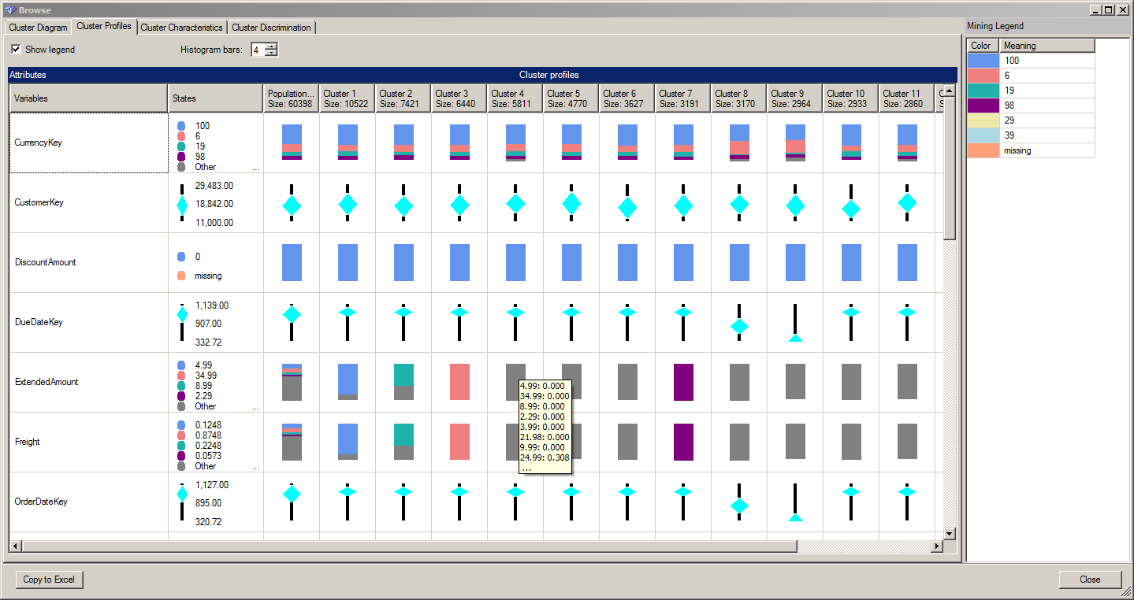
Figure 15: Cluster Profiles Shown in the Cluster Wizard.

Figure 15 shows the cluster profiles of data in the mining model and the distribution of data for each of the variables selected for input in the mining model.

Data Mining Templates for Visio
To use the Data Mining Templates for Visio, you create a new Visio diagram using the template that is installed with the data mining add-ins. Once you open the template, you have the choice of types of these tools to drag onto the design surface:
- Decision Tree – Creates diagrams from mining models that were created using the Microsoft Decision Trees, Microsoft Linear Regression, and Microsoft Logistical Regression algorithms.
- Dependency Network – Creates diagrams from mining models that were created using the Microsoft Naive Bayes, Microsoft Decision Trees, and Microsoft Association Rules algorithms.
- Cluster – Creates diagrams from mining models that were created using the Microsoft Clustering algorithm.

After creating a mining model using the Microsoft Decision Trees algorithm from the Analysis Services Adventure Works database, the decision tree diagram in Figure 16 is created.

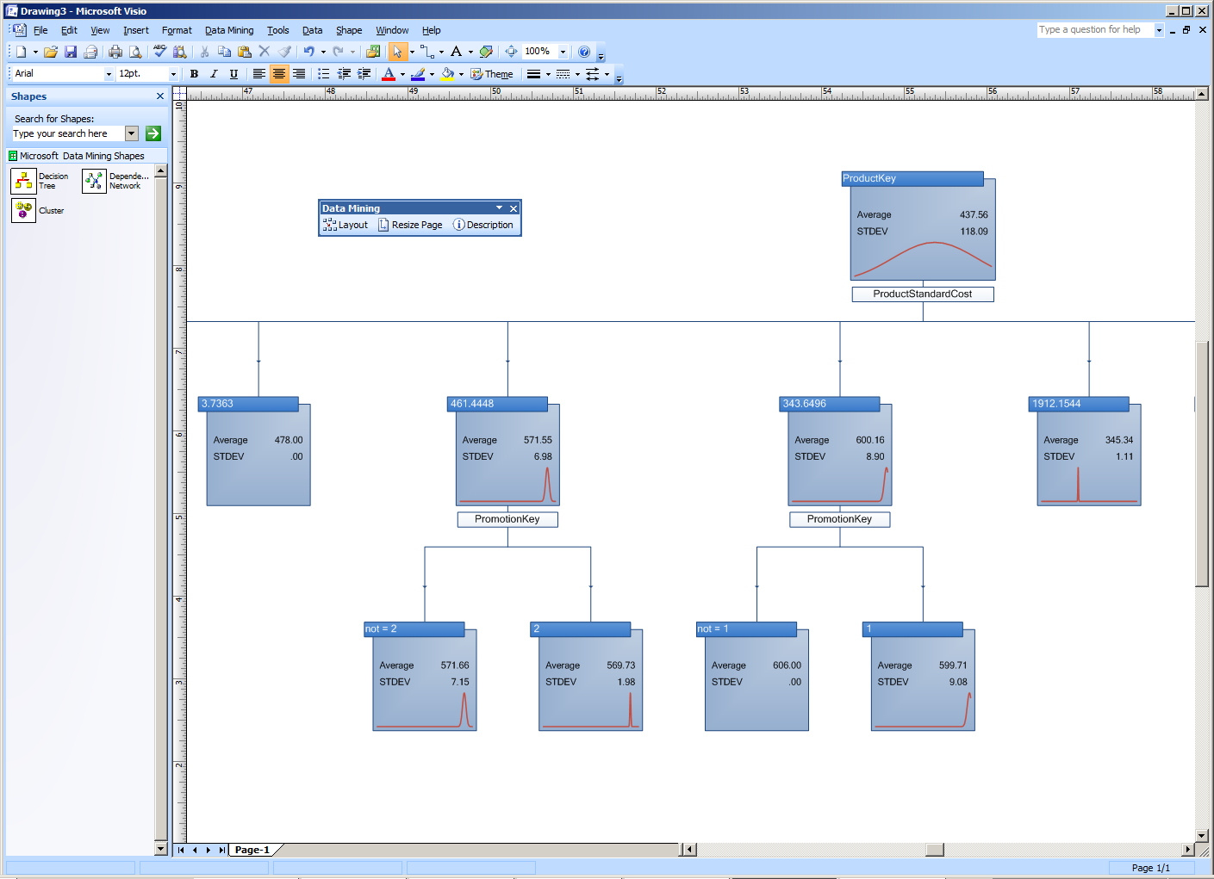
Figure 16: Decision Tree Data Mining Shape in Office Visio 2007.

Note that when you drag a shape onto the design surface, Office Visio 2007 queries the Analysis Services server to determine which mining models exist on the server and lets you choose only the correct types for the tool that you selected. To create mining models using Office Excel 2007, use the Data Mining Client tool.

Conclusion
SQL Server 2005, Microsoft’s BI platform, makes it very easy to design, develop, deploy, and use BI solutions. SQL Server 2005 includes Analysis Services, Reporting Services, and Integration Services technologies to completely support the BI needs of any business. When paired with the capabilities and ease-of-use of the 2007 Office system, small, mid-sized, and large organizations can benefit from BI, enabling the delivery of intelligence to the desktop of every end-user.

Reporting Services can be integrated with Office SharePoint Server 2007 to enable a common, rich environment from which users can view, create, and manage reports. End-users can easily access BI data from Analysis Services using Office Excel 2007 to gain valuable business insight through the Data Mining Add-ins for Office 2007. All of these tools put BI at the user’s fingertips to enable them to make better business decisions. By providing an end-to-end platform on which to design, develop, and deploy BI solutions, TCO is lowered and productivity is raised – effectively bringing BI to all employees in an organization.

For more information:
http://www.microsoft.com/sql/
http://www.microsoft.com/BI

The information contained in this document represents the current view of Microsoft Corporation on the issues discussed as of the date of publication. Because Microsoft must respond to changing market conditions, it should not be interpreted to be a commitment on the part of Microsoft, and Microsoft cannot guarantee the accuracy of any information presented after the date of publication.
This white paper is for informational purposes only. MICROSOFT MAKES NO WARRANTIES, EXPRESS OR IMPLIED, IN THIS DOCUMENT.
Complying with all applicable copyright laws is the responsibility of the user. Without limiting the rights under copyright, no part of this document may be reproduced, stored in, or introduced into a retrieval system, or transmitted in any form or by any means (electronic, mechanical, photocopying, recording, or otherwise), or for any purpose, without the express written per of Microsoft Corporation.
Microsoft may have patents, patent applications, trademarks, copyrights, or other intellectual property rights covering subject matter in this document. Except as expressly provided in any written license agreement from Microsoft, the furnishing of this document does not give you any license to these patents, trademarks, copyrights, or other intellectual property.
© 2005 Microsoft Corporation. All rights reserved.
The example companies, organizations, products, domain names, e-mail addresses, logos, people, places, and events depicted herein are fictitious. No association with any real company, organization, product, domain name, e-mail address, logo, person, place, or event is intended or should be inferred.
Microsoft, Visual Basic, Visual Studio, Win32, Windows, and Windows Server, SQL Server are either registered trademarks or trademarks of Microsoft Corporation in the United States and/or other countries.
All other trademarks are property of their respective owners.

Appendix - SQL Server 2005 Editions
Depending on business needs and company size, Microsoft has a SQL Server 2005 edition that is the right tool for the job. The following is a quick glance at the BI capabilities in each edition:
- Express – Entry-level database platform that is available free from Microsoft. This edition can be used by Independent Software Vendors (ISVs) to distribute their applications. The Express edition contains no support for Analysis Services or Data Mining (DM). However, it does support basic Reporting Services features.
- Workgroup – Can be used in small departments or workgroups to store relational data. The Workgroup edition does not support Analysis Services or Data Mining. This edition does contain support for Reporting Services and end-user report creation.
- Standard – Can be used in small and medium-sized organizations as the platform for LOB applications that are not considered to be mission-critical. The Standard edition adds support for Integration Services, Analysis Services, Data Mining, and data warehousing. Standard edition is required for Reporting Services integration with Office SharePoint Server 2007.
- Enterprise – Can be used in businesses of all sizes as a database platform for mission-critical applications. The Enterprise edition contains advanced support for scaling-out BI features and advanced analytics.
- Developer – Contains the same features as the Enterprise edition, but can only be used in a development environment. It cannot be used in a production environment.

For a complete list of features for each edition, visit the Microsoft Web site at http://www.microsoft.com/sql/prodinfo/features/compare-features.mspx.

Note that any analytical client that supports the specific functionality of SQL Server 2005 Analysis Services described in this paper will be able to expose these features. Likewise, Excel 2007 will expose the described features with any OLAP server that supports the specific functionality.

