
Windows Virtual PC and Windows XP Mode
By Byron Hynes
Published October 09
Abstract
This paper examines the use of Windows® Virtual PC and Windows XP Mode in the Windows 7 operating system and describes how to set up a proof-of-concept test. It also introduces considerations for planning a virtualized solution for your environment.

The information contained in this document represents the current view of Microsoft Corporation on the issues discussed as of the date of publication. Because Microsoft must respond to changing market conditions, it should not be interpreted to be a commitment on the part of Microsoft, and Microsoft cannot guarantee the accuracy of any information presented after the date of publication.
This white paper is for informational purposes only. MICROSOFT MAKES NO WARRANTIES, EXPRESS OR IMPLIED, IN THIS DOCUMENT.
Complying with all applicable copyright laws is the responsibility of the user. Without limiting the rights under copyright, no part of this document may be reproduced, stored in or introduced into a retrieval system, or transmitted in any form or by any means (electronic, mechanical, photocopying, recording, or otherwise), or for any purpose, without the express written permission of Microsoft Corporation.
Microsoft may have patents, patent applications, trademarks, copyrights, or other intellectual property rights covering subject matter in this document. Except as expressly provided in any written license agreement from Microsoft, the furnishing of this document does not give you any license to these patents, trademarks, copyrights, or other intellectual property.
© 2009 Microsoft Corporation. All rights reserved. Microsoft, Hyper-V, Internet Explorer, SharePoint, Windows, Windows Server, Windows Vista, and the Windows logo and are either registered trademarks or trademarks of Microsoft Corporation in the United States and/or other countries.
The names of actual companies and products mentioned herein may be the trademarks of their respective owners. Microsoft Corporation • One Microsoft Way • Redmond, WA 98052-6399 • USA

Contents
Contents 2
Introduction 3
Virtualization in Windows 7 4
Microsoft’s View of Virtualization 4
What Is Windows Virtual PC? 4
What Is Windows XP Mode? 4
How Do These Features Relate? 5
Virtualization Included with Windows 7 5
Building a Test Environment for Windows XP Mode 6
Planning and Considerations 6
Hardware Requirements 6
Table 1. Windows Virtual PC Hardware Requirements 6
Operating Systems 6
Security Risks and Management Challenges 8
Installing Windows Virtual PC and Windows XP Mode 9
Download and Install Windows Virtual PC 9
Choose a Windows XP Image 10
Configuring Windows XP Mode 12
Locking Down the Guest 12
Future Publications 14
Additional Resources 15

Introduction
With the introduction of the Windows® 7 operating system, Windows Virtual PC, and Windows XP Mode, Microsoft offers new virtualization options that give businesses the flexibility and opportunity to use the best features of Windows 7 and modern application software while maintaining the critical ability to retain and use essential applications that may require specific operating systems or configurations.
With this opportunity for flexibility, however, comes risk. This paper briefly explains some of the options available to you, and then guides you through setting up a small test or proof-of-concept (PoC) environment. The bulk of this paper focuses on using Windows XP Mode to enable corporate uses to seamless run one or more legacy applications. Windows Virtual PC supports many other scenarios and other Windows technologies. For additional references, see the Resources section.

Virtualization in Windows 7

Microsoft’s View of Virtualization
At Microsoft, we see virtualization as much more than just a remotely hosted client computer or an on-demand server. We view virtualization as a complete spectrum that spans the enterprise.
Microsoft Virtualization includes the following major concepts:
- Profile virtualization. Find technologies that make users’ files and settings, such as folder redirection and offline files, available wherever they log in.
- Presentation virtualization. Use Remote Desktop Service (RDS)—formerly Terminal Services—to provide users with remote access to desktops or applications running on servers.
- Server virtualization. Windows Server® 2008 R2 Hyper-V™ technology allows new solutions in consolidation, continuity, development, and virtual desktop scenarios.
- Desktop virtualization. Technologies such as Windows Virtual PC, Microsoft Virtual PC 2007, and Microsoft Enterprise Desktop Virtualization (MED-V) create flexibility by allowing you to create different desktops as and where needed.
- Application virtualization. Microsoft Application Virtualization (App-V) allows for centralized management and distribution of executable files to be run on demand where needed.
You can combine these concepts, features, and products to meet the changing needs of your dynamic organization. For example, many Virtual Desktop Infrastructure (VDI) applications use a combination that includes all these types of virtualization.

What Is Windows Virtual PC?
Windows Virtual PC, an optional component of Windows 7, helps you maintain the compatibility of legacy and custom applications in Windows 7 without additional application compatibility, testing, or training costs. You can run key Windows XP or Windows Vista® applications in Windows 7 in a seamless way.
With Windows Virtual PC, you can create and run one or more virtual machines (VMs), each with its own operating system (Windows XP, Windows Vista, or Windows 7), as a secure, private virtual environment that is accessible and easy to use yet tightly integrated with the Windows 7 host.
Windows Virtual PC is an optional component of Windows 7 and an evolution of Virtual PC 2007. While Virtual PC 2007 will be qualified to run under Windows 7, Windows Virtual PC and Virtual PC 2007 cannot co-exist on the same Windows 7 installation. Windows Virtual PC does not run on versions of the Windows operating system prior to Windows 7.
To learn more about Windows Virtual PC, see Windows XP Mode and Windows Virtual PC at http://go.microsoft.com/fwlink/?LinkID=149077.

What Is Windows XP Mode?
Windows XP Mode is a Windows 7 benefit that allows you to seamlessly integrate applications running on Windows XP with a user’s Windows 7 desktop and menus. The Windows XP Mode download includes a prepackaged VM of Windows XP with Service Pack 3 (SP3) that is preinstalled as a virtual hard disk (VHD) and licensed specifically for use with Windows 7 Professional, Ultimate, and Enterprise. This guest machine is used to run the productivity business applications.

How Do These Features Relate?
Windows Virtual PC is the virtualization runtime engine for Windows 7. In some ways, it is similar to Virtual PC 2007, but it is specifically designed and optimized for Windows 7. It supports the integration of Windows XP applications with the Windows 7 Explorer and shell, adds support for USB devices in the guest, and allows users to operate applications seamlessly between the two operating systems. In most circumstances, performance is improved compared to Virtual PC 2007.
Windows XP Mode is a Windows 7 benefit that utilizes virtualization technology, such as Windows Virtual PC, to provide tight integration for productivity business applications. The term Windows XP Mode refers primarily to the user experience of this integration along with the available Windows XP with SP3 image.
An enterprise-level solution is also available. MED-V is built on Virtual PC 2007 and is specially designed to provide enterprises with the capability to centrally manage and deploy virtual Windows environments. Currently, MED-V is available for Windows Vista; a future version will be released to support Windows 7 and Windows Virtual PC.

Virtualization Included with Windows 7
Windows 7 has been extensively tested with thousands of applications, including applications written by Microsoft and hundreds of Independent Software Vendors (ISVs). The majority of applications will run under Windows 7 without modification. Windows 7 also includes a number of application compatibility ("app compat") tools and features to help you seamlessly integrate existing applications into Windows 7.
For those few applications that cannot be supported under Windows 7, Windows XP Mode provides a way to use those applications -- in a Windows XP instance -- from Windows 7.
Windows Virtual PC and Windows XP Mode are not available for all editions of Windows 7. Windows XP mode is available for Windows 7 Professional, Enterprise, and Ultimate. (For more information, see the section, “System Requirements,” later in this paper.) Windows Virtual PC and the Windows XP Mode image are available for download from http://www.windows.com/xpmode. You must install them on each Windows 7 computer or include them in your Windows 7 deployment images.

Building a Test Environment for Windows XP Mode
As with any technology, it is important to test Windows XP Mode in a controlled environment. This section shows you how to do so.

Planning and Considerations
Among the first considerations is the compatibility of the hardware and the operating systems to be used as hosts and as guests.

Hardware Requirements
Table 1 lists the minimum system requirements for installing and running Windows Virtual PC for Windows XP Mode. In some cases, Windows Virtual PC may be installed if some of the minimum recommendations are not met; however, functionality and performance would be significantly affected.

Table 1. Windows Virtual PC Hardware Requirements
Client computer requirements | Description
Processor | Hardware-Assisted Virtualization (HAV)–enabled Intel, AMD or VIA processor (32 or 64 bit)
Memory | Additional 1GB above Windows 7 requirements
Hard disk space | 15 GB of additional hard disk space to run one (supported) guest operating system

Operating Systems
Windows Virtual PC is available for Windows 7 Ultimate, Enterprise, Professional, Home Basic, and Home Premium. However, Windows XP Mode functionality is only available if the host is Windows 7 Ultimate, Enterprise, or Professional.
The support matrix in Table 2 shows which combinations are available.
Table 2. Support Matrix
 | Windows 7 Ultimate, Enterprise | Windows 7 Professional | Windows 7 Home Basic, Home Premium
Windows Virtual PC is supported on these Windows 7 Editions (SKUs). It installs on both 32 bit and 64 bit versions of Windows 7 | Yes | Yes | Yes
Windows XP Mode is supported on these Windows 7 Editions | Yes | Yes | No

 | Windows 7 Ultimate, Enterprise | Windows 7 Professional | Windows 7 Home Basic, Home Premium | Windows Vista Business | Windows Vista Enterprise, Ultimate | Windows XP SP3 Professional
Following Guest OS are supported to run in WVPC. Only 32 bit Guest OS are supported. | Yes | Yes | Yes | Yes | Yes | Yes
Virtual Application: feature is available for the following Guest OS | Yes | No | No | No | Yes | Yes
Integration Feature: supported on the following Guest OS | Yes | Yes | No | Yes | Yes | Yes

Beyond the limits of what will and will not work, you must take the following considerations into account:
- How will you deploy Windows Virtual PC to Windows 7 clients computers? Does your organization have a management tool? As with any new technology, an effective deployment plan and the right tools can make the difference between quick success and long bouts of frustration.
- Will users do their own application testing, or will testing be partially or totally centralized? It is important to define who is responsible for determining whether applications need to run under Windows XP Mode, run directly under Windows 7 (with or without application compatibility settings), or even retired.
- Will you allow any application to run in Windows XP Mode, or only approved applications? This is a logical extension of your existing policies about approved applications. However, some users may think it is acceptable to run anything under Windows XP Mode, even if it's not allowed under Windows 7.
- Will you run Windows XP Mode only, or will other operating systems (such as Windows Vista) also be available to users? There are licensing, deployment, supportability and security concerns with each operating system that you might make available to be used under Windows Virtual PC.
- Will you use the preconfigured Windows XP with SP3 image or build your own? Some organizations prefer a totally customized image, as discussed below, but be aware of licensing requirements and the increased overhead of maintaining your own image.
- How will you deploy guest operating system images to the Windows 7 host computers? If not using the provided Windows XP mode images and wizards, there will be more deployment efforts required.
- By default, the first time Windows XP Mode is used, the interactive user is required to perform some configuration steps. How will this be handled? Microsoft solutions help enterprises to minimize the need for end-users to be involved in the configuration of Windows XP mode, but may require more initial planning prior to deployment. Conversely, users who are administrators on their computers can install Windows XP Mode with a wizard. In that scenario, help desk staff should be trained to field questions or issues that may arise.
The use of a second operating system, albeit virtual, introduces significant risks and challenges, particularly regarding security and management. These are discussed in the next section.

Security Risks and Management Challenges
Many IT pros—even experienced professionals—fail to fully consider the security implications of virtualization in their environment. It is vital to realize that any guest running under Windows Virtual PC is a full computer in its own right. Although it uses hardware on the host client computer—processor, memory, disk space—it is not governed by security policies applied to the host, nor is it automatically given access to resources on the host or the host’s networks. This means that you must manage the images in several ways:
- If the applications running on the guest require access to network resources, the guest operating system will probably need to be joined to the domain.
- The guest operating system will require IP addressing, Domain Name System (DNS) assignments, and other such infrastructure services. Depending on the number in use on your network, that may require additional resources.
- Since it is a full operating system, each XP Mode image requires anti-virus, firewall configurations, and the application of recommended security settings.
There are two important security concerns to address at this stage. First, Windows XP Mode requires that the user logged in to the Windows Virtual PC host (the Windows 7 computer) have certain rights on the guest operating system (the Windows XP image). To use an application on the guest—and have it integrated with the Windows 7 desktop (that is, to use Windows XP Mode)—the user must log in to the guest operating systems as an administrator of that guest or as a member of the Remote Desktop users group on the guest, and the user must have a password that is not blank.
By default, the Windows XP Mode Wizard creates a new user, named XPMUser, in the Windows XP guest operating system and makes it a member of the local Administrators group on the Windows XP VM. Also by default, a user logged in to the Windows 7 host who runs a Windows XP Mode application does so in the security context of the XPMUser.
Instead of using the default XPMUser, join the Windows XP guest to your corporate domain. This allows the user to log in to both the Windows 7 host and the Windows XP guest operating system with his or her own domain credentials. You must add the domain user account to the Administrators or Remote Desktop Users group on the guest.
If desired, Windows Virtual PC can save credentials to allow automatic login to the guest. This creates a small administrative burden, as passwords are changed and require updating.
You must also determine how to manage updates to the virtual images. This presents a particular problem in that the image may not be loaded (that is, Windows Virtual PC may not be running, and that guest may not be started) when you want to perform the update. It is true that in many cases, the risk profile is reduced, because the Windows XP guest is not being used for general-purpose computing. In other cases, particularly those where Web browsing is performed in the Windows XP guest, updating is essential. Microsoft recommends including the Windows XP images in your patching plans. Your patch-management scheme may involve using a management tool, such as Microsoft System Center Operations Manager 2007, both to start Windows Virtual PC on the host and to patch the guest. (By default, when Windows XP Mode is run for the first time, the user is prompted to turn on Automatic Updates.)
Options include offline patching of the VHDs using tools such as Microsoft System Center Virtual Machine Manager 2008.

Locking Down the Guest
The guest operating system is a full, running operating system on your network. However, because most interaction with this VM will be limited to a single application’s window, it may not be obvious to most users that it is a full computer.
Because the guest operating system is most likely being used to support a legacy application or Web site, it is unlikely that it will have the benefit of the latest designs in security features, even if it has been recently patched.
In addition, by using a common File command (such as Open) or the Web browser (by default, Windows Internet Explorer® version 6), a user could navigate—intentionally or accidentally—to a resource or application that you prefer not be accessed from the guest operating system.
Microsoft recommends that you consider “locking down” the guest operating system using features such as Group Policy, software restriction policies, and Internet Explore policies to control how the guest operating system can be used. Note especially, though, that policies applied to the host operating system are not automatically applied to the guest operating system or vice versa. (Some policies can be applied to both if the computer domain accounts are subject to them, but they are applied independently from one another.)

Installing Windows Virtual PC and Windows XP Mode
This section provides the steps required to download, install, configure, and use Windows Virtual PC and Windows XP Mode on a Windows 7 client computer.

Download and Install Windows Virtual PC
Windows Virtual PC is not included with Windows 7 but is available as a free download from Microsoft at http://go.microsoft.com/fwlink/?LinkID=149077. Windows Virtual PC is provided as a Microsoft Update (MSU) file, allowing it to be distributed and installed with any number of installation tools.
For this walk-through, install Windows Virtual PC by double-clicking the MSU file on a Windows 7 client. This method uses the stand-alone update installer and looks similar to the installation of any update, as shown in Figure 1. To complete the installation of Windows Virtual PC, a restart is required.
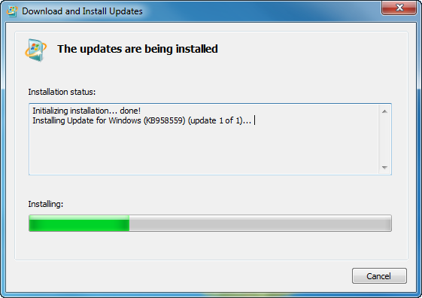
Figure 1. Installation of Windows Virtual PC

Choose a Windows XP Image
For simple testing and uncomplicated scenarios, the preconfigured Windows XP with SP3 image is the simplest and most direct way to get started with Windows XP Mode. However, many enterprises will prefer to customize and create their own Windows XP image, including required applications.

Download and Install the Windows XP Mode Preconfigured Guest Operating System
You can download the executable file from the Windows site at http://go.microsoft.com/fwlink/?LinkID=149077. Since Windows Virtual PC is packaged as a Microsoft Update with the update stand-alone installer, you can deploy it directly to computers by using any common deployment technology that supports Windows updates.
The Windows XP Mode installer copies the preconfigured Windows XP with SP3 VHD to the location you specify.
Since copying the files can be time-consuming, a tutorial is presented while Windows XP Mode is installed. A sample of the tutorial is shown in Figure 2.
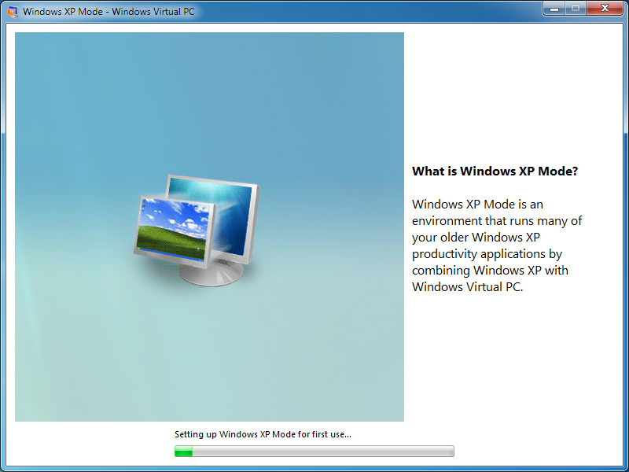
Figure 2. Windows XP Mode tutorial

At the end of the installation, you can choose to launch the Windows XP Mode Wizard, as shown in Figure 3.
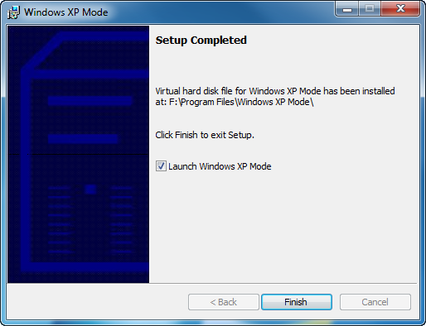
Figure 3. Completion of Windows XP Mode installation

Create a Custom Windows XP Image
The full details of everything that you can do when creating a custom deployment of Windows XP is outside the scope of this document. However, since many administrators are already well-versed in creating custom Windows XP deployments, let's consider the concept of a custom Windows XP VHD from a high level
One very important thing to bear in mind is that creating your own VHD for Windows XP mode requires that your virtual machines be licensed. There are many different types of licensing options available, but it is quite clear that only the XP Mode pre-configured VHD provides a free license.
The following steps are a high-level overview of creating a custom VHD. Microsoft is planning to release a more detailed document, as described later in the section "future publications".
If you do create a custom XP image for use with Window Virtual PC or XP Mode, because the image is specifically for a virtualized environment, be sure to include the integration components as described below.
Note It is possible to use the provided image of Windows XP with SP3 as a starting point for your custom image rather than installing Windows XP from installation media. However, if you do so, you will still need to install custom applications, merge the changes to the VHD, and use the System Preparation Tool (Sysprep) as discussed below.
Complete the following steps:
- Create a new VM, and install Windows XP.
The VM settings are stored as a .vmc file, and a VHD is stored as a .vhd file. Ensure that you create both files in the same folder you want to use when you deploy them to each target computer. For example, if you want to deploy these files to C:\VirtualMachines on each target computer, create the files in C:\VirtualMachines on your computer.
- When the Windows XP installation is successfully completed, log on to the virtual machine to complete first run tasks, and then turn off the virtual machine.
Note: The administrator password should be blank. If you assign an administrator password during the installation, set it to blank before using Sysprep.
5. On the virtual machine toolbar, click Tools, and then click Install Integration Components.
6. On the virtual machine, download the Update for Windows XP SP3 to enable RemoteApp™ from http://go.microsoft.com/fwlink/?LinkId=140339. This update allows you to run many Windows XP productivity applications on a Windows 7 computer using WVPC by launching the application from the Windows 7 Start menu.
7. Restart the virtual machine to complete the Integration Components and RemoteApp update installation.
8. Install and configure the Line of Business (LOB) applications used in your organization on the virtual machine.
9. Download the Windows XP Professional sysprep files from the Microsoft Web site to your Windows XP virtual machine. Ensure that you download the version that corresponds to your guest operating system. For example, you can download the sysprep utility for Windows XP Service Pack 3 at http://www.microsoft.com/downloads/details.aspx?familyid=673A1019-8E3E-4BE0-AC31-70DD21B5AFA7&displaylang=en.
10. Copy all of the files from Deploy.cab to the directory c:\sysprep on the virtual machine’s hard drive.
11. Turn off the virtual machine.
12. Copy the sysprep.inf file to the C:\sysprep directory on the virtual machine’s hard drive.
Note
You can use the sample sysprep.inf file included with the sysprep download, or you can create a custom sysprep.inf file.
13. Start the Windows XP virtual machine and log on. In Windows Explorer, navigate to the directory c:\sysprep and double-click Sysprep.exe. The System Preparation Tool dialog box will open so that you can prepare the VHD for distribution.
14. Select Don’t reset grace period for activation.
15. Select Use Mini-Setup.
16. Click Reseal, and then click OK. Wait for the sysprep operation to finish.
17. Turn off the virtual machine.
Note
If you have enabled Undo Disks for the virtual machine, be sure to commit changes to the VHD.

Integration Components
Integration components are a set of low-level software, such as device drivers, that allow seamless integration between the guest operating system and the host. These components are installed by default in the preconfigured Windows XP guest provided for Windows XP Mode. When building your own guest VHD, Microsoft recommends that you install them.

Configuring Applications
Applications installed with shortcuts in the Programs folder of the All Users Start menu folder in the Windows XP image will automatically be published to the host’s Start menu. Consider carefully the division of applications from the data they use. Any data stored on the “local” drive of a VM is lost if that machine is destroyed. Typically, any enterprise data would be store centrally on a server, in a database, in e-mail, or in Windows SharePoint® Services. In addition to protecting against data loss, this also allows for simpler patching and updating. If you do not need to worry about local data, you can simply distribute a new Windows XP image when it has been updated.

Configuring Windows XP Mode
After you have installed Windows XP Mode using either the Microsoft image or your own, you must configure it. If you are installing Windows XP Mode manually, you are prompted for configuration at the end of installation, as shown in Figure 2 above.
The initial wizard prompts you to accept the Windows XP Mode License Agreement, setting the location in which the Windows XP Mode VM configuration (VMC) files will be stored, and prompts you to activate Automatic Updates. Behind the scenes, the wizard then configures Windows XP Mode for use.
If you are deploying a custom VHD instead, or if you do not want your users to see this wizard, then you can use the scripts provided by Microsoft in the Proof-of-Concept Guide (see the “Resources” section).

Additional Resources
IT pros evaluating and using Windows Virtual PC and Windows XP Mode may find the following resources useful:
- Windows Virtual PC Proof-of-Concept Guide, available at http://go.microsoft.com/fwlink/?LinkID=167125
- Windows Virtual PC Tips, available at -http://www.microsoft.com/downloads/details.aspx?displaylang=en&FamilyID=ffc6c931-6216-4a1d-bdab-936fef353060
- Windows Virtual PC Evaluation Guide, available from Microsoft TechNet at http://go.microsoft.com/fwlink/?LinkID=140338
The Proof-of-Concept Guide, listed above, is a detailed guide packaged with resources and scripts to allow you to configure Windows XP Mode easily in your organization.
Microsoft is also planning to release an updated version of MED-V as part of it ongoing commitment to Microsoft Software Assurance and the Microsoft Desktop Optimization Pack (MDOP). This updated version is planned to support Windows Virtual PC and Windows XP Mode. For more information, visit http://www.microsoft.com/windows/enterprise/products/mdop/med-v.aspx.

