

Driving Efficiency and Reliability in the Data Center
Published September 09

Executive Summary
Information technology (IT) organizations today must provide efficient and effective services while contending with pressures to reduce operating costs, ensure compliance, and add value to the business. Microsoft® System Center Service Manager 2010, through the power of its integrated platform, orchestrates people, processes, and technology across the Microsoft platform. System Center Service Manager reduces costly downtime and improves the quality of IT services by automating processes and activities across the System Center family of products.

The information contained in this document represents the current view of Microsoft Corporation on the issues discussed as of the date of publication. Because Microsoft must respond to changing market conditions, it should not be interpreted to be a commitment on the part of Microsoft, and Microsoft cannot guarantee the accuracy of any information presented after the date of publication.
This white paper is for informational purposes only. MICROSOFT MAKES NO WARRANTIES, EXPRESS OR IMPLIED, IN THIS DOCUMENT.
Complying with all applicable copyright laws is the responsibility of the user. Without limiting the rights under copyright, no part of this document may be reproduced, stored in or introduced into a retrieval system, or transmitted in any form or by any means (electronic, mechanical, photocopying, recording, or otherwise), or for any purpose, without the express written permission of Microsoft Corporation.
Microsoft may have patents, patent applications, trademarks, copyrights, or other intellectual property rights covering subject matter in this document. Except as expressly provided in any written license agreement from Microsoft, the furnishing of this document does not give you any license to these patents, trademarks, copyrights, or other intellectual property.
© 2009 Microsoft Corporation. All rights reserved. Microsoft, Active Directory, SQL Server, and Windows PowerShell are either registered trademarks or trademarks of Microsoft Corporation in the United States and/or other countries.
The names of actual companies and products mentioned herein may be the trademarks of their respective owners. Microsoft Corporation • One Microsoft Way • Redmond, WA 98052-6399 • USA

Contents
Contents 3
Introduction 4
What Is System Center Service Manager? 4
Optimizing Data Center Management Scenarios 6
Conclusion 9
For More Information 9

Introduction
Data centers provide the foundation for the applications and services that information technology (IT) organizations deliver, and organizations need those data centers to be reliable, compliant, and cost-effective. Efficient and effective service management in data centers is essential both because of the mission-critical business applications data centers host and because of the number of customers and users potentially affected by any service outages or performance issues. IT departments must ensure that the people, processes, and technology within their data centers operate at optimal levels and work as a cohesive unit.
Microsoft® System Center Service Manager 2010, through the power of its integrated platform, orchestrates and unifies knowledge, processes, and activities across the data center, resulting in reduced costs, reduced time to resolution, and decreased compliance complexity.

What Is System Center Service Manager?
System Center Service Manager is an integrated platform for automating and adapting IT service management best practices, such as those found in Microsoft Operations Framework (MOF) and IT Infrastructure Library (ITIL), to your organization’s requirements. It provides built-in processes for incident and problem resolution, change control, and asset life cycle management. Through its configuration management database (CMDB) and process integration, System Center Service Manager automatically connects knowledge and information from Microsoft System Center Operations Manager 2007, System Center Configuration Manager 2007 R2, and Active Directory® Domain Services (AD DS). System Center Service Manager delivers integration, efficiency, and business alignment of data center IT services by:
- Optimizing processes and ensuring their use through templates that effectively guide IT analysts through best practices for change and incident management.
- Reducing resolution times by cutting across organizational silos, ensuring that the right information from incident, problem, change, or asset records is accessible through a single pane.
- Extending the value of the System Center platform through automated generation of incidents from alerts and the coordination of activities among System Center products.
- Enabling informed and cost-effective decision-making through its Data Warehouse repository database, which integrates knowledge from disparate IT management systems and delivers out-of-the-box reporting and flexibility of data analysis through Microsoft SQL Server® 2008 Reporting Services.
Table 1 lists the service management challenges data centers face and describes how System Center Service Manager addresses them.

Table 1. Data Center Service Management Challenges and How System Center Service Manager Addresses Them
Service management challenge | How System Center Service Manager addresses them
Adhering to compliance standards. Today, most organizations must adhere to a number of compliance standards and new internal policies. | System Center Service Manager can help IT organizations collect and report compliance with these standards by ensuring that relevant information, known decision paths, clear roles, and embedded processes are in place to effectively and efficiently meet compliance requirements.
Automating service management processes, activities, and tasks. As the number of applications and services supported in the data center increases, the number of administrative tasks grows exponentially. Service management processes that are performed manually create extra effort and frustration for IT pros. Also, manual processes are prone to the introduction of configuration errors, which can result in service outages or data loss. Finally, manual process can be inconsistent and do not easily allow transition among IT pros. | System Center Service Manager can help automate service management processes by using automated workflows and integration with other products and technologies, such as System Center products and AD DS.
Reducing the risk of unauthorized or inadvertent changes to the data center. An unauthorized or inadvertent configuration change in the data center can cause disruption of services or even data loss. The appropriate change-management processes are necessary to help allow only authorized configuration changes. | System Center Service Manager can help ensure that the appropriate change-management processes are followed by using automated workflows and templates.
Identifying service dependencies for applications and services. Identifying the possible failure points in applications and services requires knowledge of all the dependencies for those applications and services. For example, Microsoft Exchange Server 2007 requires working network infrastructure services (such as name-resolution services and Internet Protocol [IP] configuration) and AD DS. A failure in the networking infrastructure services or AD DS can cause outages or a total Exchange Server failure. | System Center Service Manager can import service maps from System Center Operations Manager and extend them to include relevant business, user, and service information. Service maps in System Center Service Manager allow IT pros to better understand how issues affect services, perform root cause analysis faster, and quickly identify the right course for remediation.
Responding more rapidly to changes in business requirements. Providing a data center that can adapt to changing business requirements is essential to modern IT operations. Acting in partnership with IT, an organization wants a predictable, compliant, and repeatable process for responding to new requirements. Performing proper change-management processes requires that IT accurately assess risk by identifying the affected IT components, the configuration settings to be monitored, the approval process for performing changes, and the corresponding activities required to perform the change. | IT pros can use the predefined templates, integrated CMDB knowledge, and service maps in System Center Service Manager to ensure an efficient and effective change-management process for the organization. System Center Service Manager is highly extensible. Through the authoring tool and the Windows Workflow Foundation, IT pros can create custom automated activities that execute workflows, code, and automated scripts using the Windows PowerShell™ command-line interface—all without having to write custom code.

Optimizing Data Center Management Scenarios
System Center Service Manager can help solve many of the data center service-management challenges IT operations experiences, as the scenario illustrated in Figure 1 shows. In this scenario, System Center Operations Manager is monitoring a line-of-business (LOB) application. System Center Operations Manager is configured to generate an alert if the application experiences performance problems or stops. The connector between System Center Service Manager and System Center Operations Manager automatically generates an incident from that alert so that IT operations can quickly resolve the incident using the embedded knowledge and incident templates in System Center Service Manager.
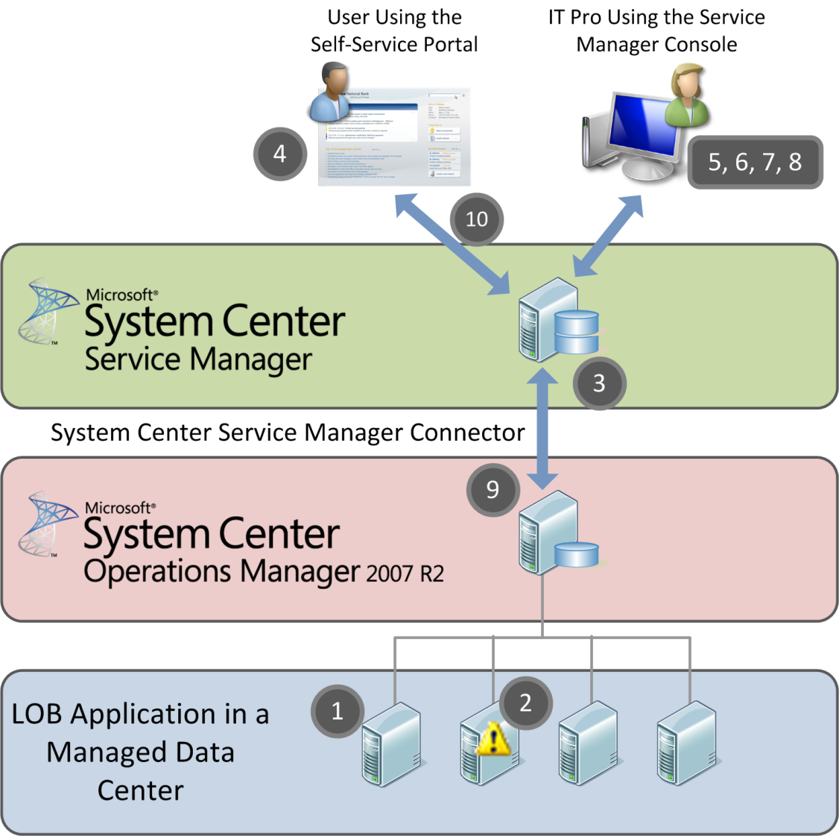
Figure 1. Scenario for automatically responding to service performance problems
Table 2 provides the high-level process and detailed steps for automatically responding to service performance problems.
Table 2. Responding to Service Performance Problems in System Center Service Manager
High-level process | Detailed steps
Create service management incidents from an automated alert. | - System Center Operations Manager monitors an application.  - System Center Operations Manager detects that the application is experiencing performance problems and generates an alert.  - System Center Operations Manager through the connector send the alert to System Center Service Manager which then automatically generates a new incident based on the alert, and assigns the incident to the designated IT pro.
A user creates an incident ticket based on performance. | - A user experiences a performance problem with the application and creates an incident ticket using the Service Manager Self-Service portal.
Resolve the incident using integrated knowledge and workflows. | - The IT pro opens receives the incident and, through the embedded knowledge in the incident template, sees which IT service is affected.  - The IT pro views the service map information within the CMDB to identify the dependent technical components and the business metadata, as shown in Figure 2.  - The IT pro checks the related application components within the CMDB and notices that users have generated related incidents through the Self-Service portal that indicate slow performance of the application.  - Using the information from the two related incidents and the knowledge base, the IT pro resolves the incident and restores service.  - System Center Service Manager automatically closes the alert in System Center Operations Manager through the System Center Service Manager connector.  - The IT pro generates an announcement to the users and posts an announcement on the Self-Service portal.

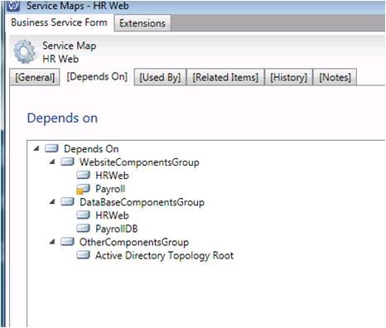
Figure 2. Service map in Service Manager Console

Conclusion
System Center Service Manager helps IT organizations automate the service management process by orchestrating knowledge, processes, and activities. This level of automation helps reduce the effort required to perform service management processes as well as the time to resolution and potential configuration conflicts.
The integration of the CMDB with AD DS, System Center Operations Manager, System Center Configuration Manager, and other systems using connectors provides the IT organization with the relevant information required to make decisions and take action using highly automated, integrated processes. System Center Service Manager connectors provide higher levels of automation by automatically generating incidents from System Center Operations Manager alerts or detected drift from System Center Configuration Manager Desired Configuration Management (DCM) baselines.
Deploying System Center Service Manager can help IT organizations improve their service management processes today, which can help them be more efficient and productive in the future. And that increased efficiency and productivity translates to lowering IT operations costs while improving the quality of the IT services delivered.

For More Information
For more information on System Center Service Manager:
- Visit the System Center Service Manager home page at http://www.microsoft.com/systemcenter/en/us/service-manager.aspx.
- Obtain the System Center Service Manager download from Microsoft Connect at https://connect.microsoft.com.
- Visit the System Center team blog at http://blogs.technet.com/systemcenter.
For more information on the System Center family of products, visit:
- System Center Configuration Manager at http://www.microsoft.com/systemcenter/configmgr/default.mspx.
- System Center Operations Manager at http://www.microsoft.com/systemcenter/opsmgr/default.mspx.
- Microsoft System Center Data Protection Manager 2007 at http://www.microsoft.com/systemcenter/dpm/default.mspx.
- Microsoft System Center Virtual Machine Manager 2008 R2 at http://www.microsoft.com/systemcenter/scvmm/default.mspx.
- Microsoft System Center Essentials 2007 at http://www.microsoft.com/systemcenter/essentials/default.mspx.
- Microsoft System Center Mobile Device Manager 2008 at http://www.microsoft.com/systemcenter/mobile/default.mspx.
- Microsoft System Center Capacity Planner 2007 at http://www.microsoft.com/systemcenter/sccp/default.mspx.
For more information on MOF, visit http://www.microsoft.com/mof.
For more information on ITIL, visit http://www.itil-officialsite.com/home/home.asp.

