Reading and Editing E-mail in Microsoft® Office Outlook® 2007

Contents
Introduction 3
Reading E-mail in Office Outlook 2007 3
New reading features in Office Outlook 2007 3
Other improved user experience options 3
Administrator and Developer improvements 4
Migration and Compatibility information 4
Office Outlook 2007 default editing experience 4
Experience with Office Word 2007 installed 4
Save As Options 4
New features using Office Outlook 2007 editing experience 4
Experience without Office Word 2007 installed 9
Performance 9
Method for determining Office Word install 9
Disabled Commands 9
Scenarios 10
Appendix 11

Introduction

Microsoft Office Outlook 2007 has incorporated many new changes to improve the editing and reading experience of Outlook items in Office Outlook 2007. Office Outlook 2007 not only embraces the Microsoft Office Fluent™ user interface in both the compose and reading experience for all Outlook item types (e-mail, calendar items, contacts, tasks and more), but when installed with Microsoft Office Word 2007, Outlook also takes advantage of a number of new features. These changes provide a richer set of editing and reading commands than ever before, all presented to the user in an accessible and intelligent manner.

This document outlines the changes in reading and editing items in Office Outlook 2007. It will also cover the different experiences that users will encounter depending on the version of Word that is installed alongside Office Outlook 2007.

Reading E-mail in Office Outlook 2007

There are a number of new features in Office Outlook 2007 that are targeted at improving the e-mail reading and navigation experience. Much of this is made possible in Outlook by using the same technology that Office Word 2007 uses, creating a consistent rendering engine for all Outlook items. In addition, familiar commands available in the Ribbon remain consistent for all item types and item formats (HTML, Rich Text, and Plain Text).

From the developer perspective, all forms are now hosted by Office Outlook 2007 with a single editing and rendering engine so that duplication of custom solutions is no longer necessary. The Office Fluent user interface is fully extensible so that developers can shape the user experience for their solutions in an intuitive and consistent manner.

The Ribbon interface used for reading and composing a new e-mail, meeting request, task, or other Outlook item should feel natural to any 2007 Office system user. Few other e-mail applications allow the user to craft a professional-looking e-mail or correspondence with such a wealth of features and capabilities.

New reading features in Office Outlook 2007
- Improved E-mail thread navigation using thread shading
- Panning through threads on tablet PCs
- Hit highlighting for Instant Search results
- New and improved fonts for all mail formats
- Smart Tag recognition

Other improved user experience options
- Consistent printing experience
- Print previews
- Smart scaling of images when resizing reading pane
- Consistent commands for HTML, Rich Text and Plain Text
- Enhancements for blocking external content ie. forwarding without downloading content
- Security enhancements to prevent scripts from running

Administrator and Developer improvements
- Extensibility works one way with a single form customizing experience instead of a form for the Office Outlook editor and yet another for Office Word as the Outlook editor
- E-mail rendering and editing use the Office Word technology and are not dependent on Internet Explorer updates
- All E-mail is rendered on a surface where Office manages the security settings

Migration and Compatibility information
- The following MSDN articles give specific details on HTML and CSS specifications. The articles provide information on supported and unsupported HTML and CSS properties as compared to HTML 4.01, CSS 1.0 and 2.0 specifications.
  - Part 1 of 2: http://msdn2.microsoft.com/en-us/library/aa338201.aspx
  - Part 2 of 2: http://msdn2.microsoft.com/en-us/library/aa338200.aspx
- The following validator tools will compare HTML and CSS against Word’s HTML and CSS schema. Validation tools are available to work with the following applications:
  - Microsoft Visual Studio 2007
  - Microsoft Office SharePoint Designer 2007
  - Microsoft Expression Web Designer 2007
  - Macromedia Dreamweaver MX 2004
  - Macromedia Dreamweaver 8
  - 2007 Office System Tool: Outlook HTML and CSS Validator: http://www.microsoft.com/downloads/details.aspx?familyid=0b764c08-0f86-431e-8bd5-ef0e9ce26a3a

Office Outlook 2007 default editing experience

In previous versions of Outlook the editing experience varied depending on the type of item you were editing. For example, bulleted lists in mail items worked differently than bulleted items in meeting requests. The new experience makes editing all item types consistent and provides a familiar vocabulary of commands and functions that a 2007 Office system user will easily recognize.

The following is a list of enhancements available in Office Outlook 2007 with or without Office Word 2007 installed.

New features using Office Outlook 2007 editing experience
- Office Fluent user interface with consistent commands and consistent behavior on all item types
- Inline Spell Checking for all item types
- Shared custom dictionary for Office Word 2007 and Office Outlook 2007

Save As Options
When a user wants to save a message in a different format, the following options will be available.
  - HTML (.htm) if the format of the message is HTML
  - Rich Text Format (.rtf) if the format of the message is Rich Text
  - Text only (.txt)
  - Office Outlook template (.oft)
  - Office Outlook message format (.msg)
  - Office Outlook message format – Unicode (.msg)

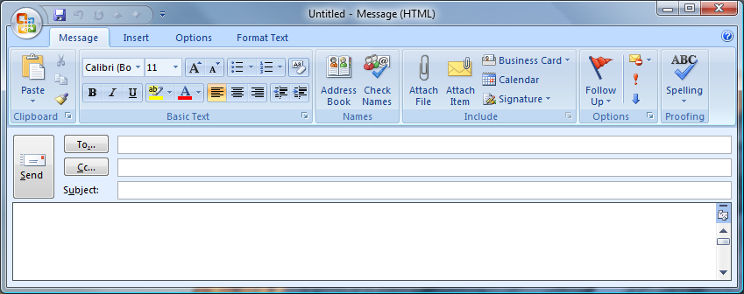
Figure 1. Office Fluent user interface in Office Outlook e-mail composing (Message tab)

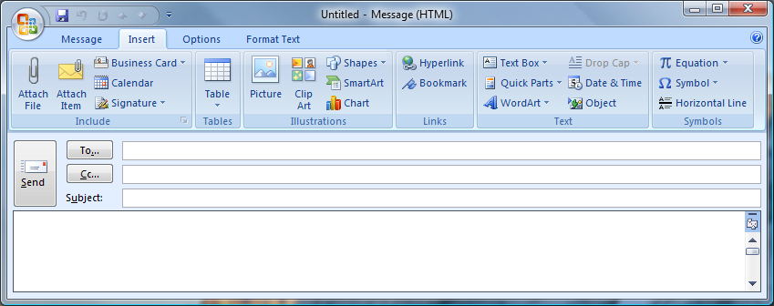
Figure 2. Office Fluent user interface in Office Outlook e-mail composing (Insert tab)

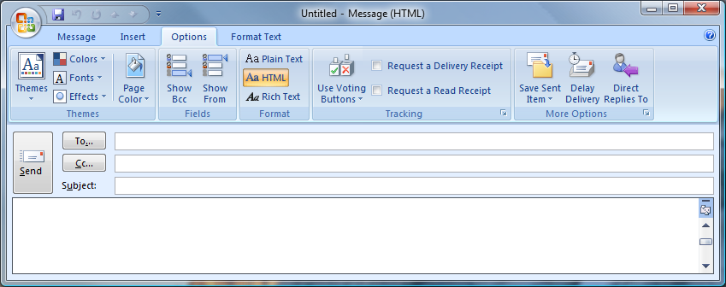
Figure 3. Office Fluent user interface in Office Outlook e-mail composing (Options tab)

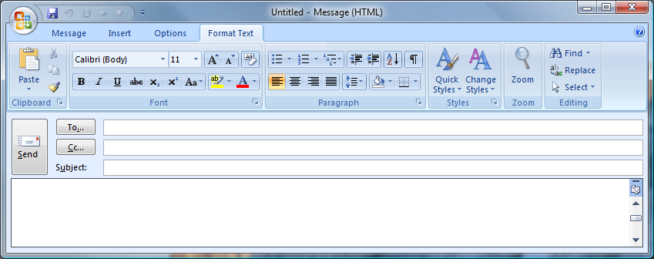
Figure 4. Office Fluent user interface in Office Outlook e-mail composing (Format Text tab)

Experience with Office Word 2007 installed

When Office Outlook 2007 is installed alongside Office Word 2007, more rich functionality is enabled in the Office Outlook 2007 editing experience. The following highlights the editing experience of Office Outlook 2007 when installed alongside Office Word 2007 such that all editing features are fully enabled.

New features using Office Outlook 2007 editing experience
- WordArt formatting galleries
- Improved drawing tools and new effects (3D, shadow, etc)
- Improved charting tools and new effects (3D, shadow, etc)
- New diagramming tools and new effects (3D, shadow, etc)
- Improved table tools and new effects (3D, shadow, etc)
- Smart and contextual editing functionality (On Object User Interface)
- New Equation Builder
- Data binding and document parts

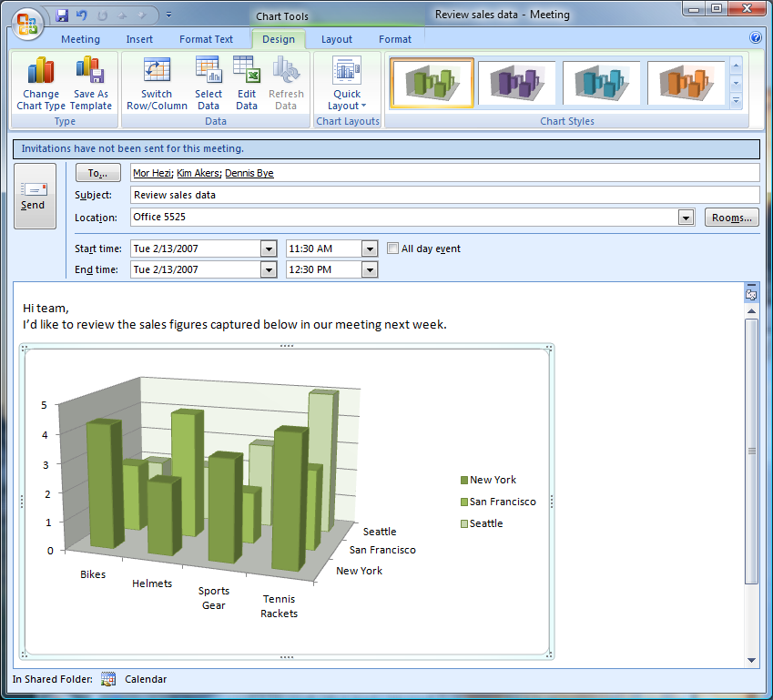
Figure 3. Improved editing capabilities in Outlook meeting requests

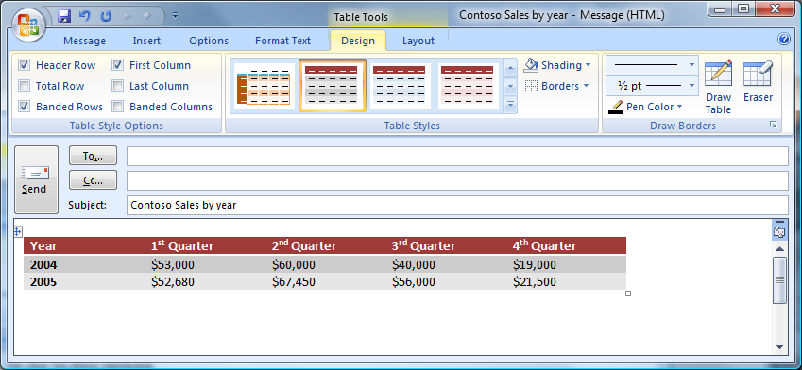
Figure 4. Improved table and formatting tools in Outlook e-mail
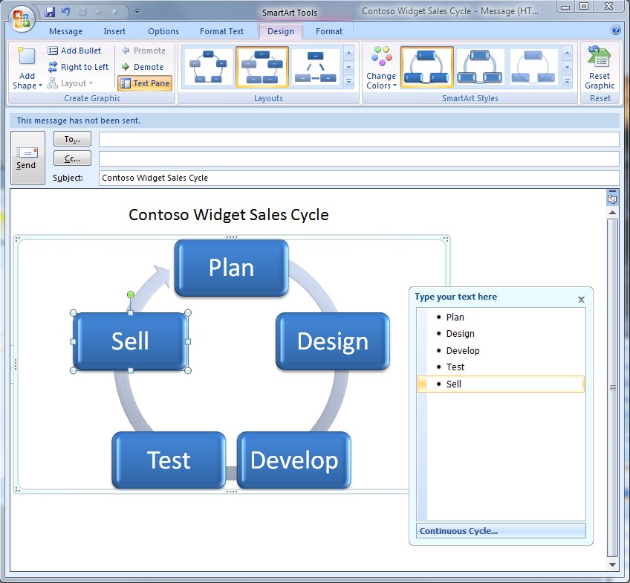
Figure 5. Improved graphics capabilities in Outlook e-mail editing

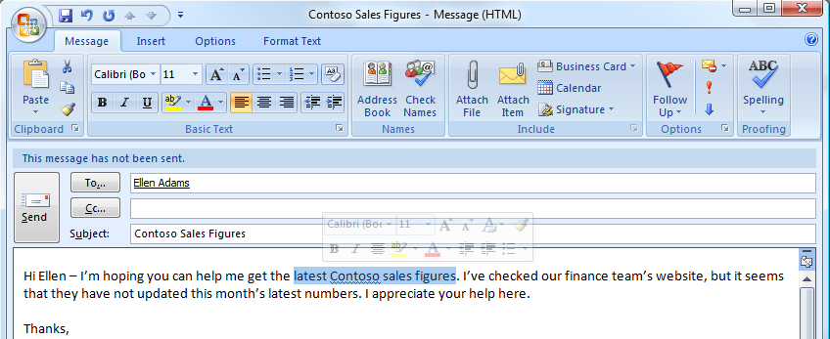
Figure 6. The Mini Toolbar gives you quick access to formatting changes in Office Outlook e-mail editing

Experience without Office Word 2007 installed

Performance
Office Outlook 2007 will respond with the same performance regardless of whether or not Office Word 2007 is installed on the machine.

Method for determining Office Word install
Office Outlook will check which version of Office Word is installed to determine what features will be enabled in the Outlook e-mail editor. The experience and features available should feel similar for users who previously installed only Outlook and not Word. The previous release experience was the model used to design the experience for Office Outlook 2007.

When Word is not installed on the same machine as Office Outlook 2007, or is an earlier version of Word (Word 2003, Word 2002, Word 2000), some of the rich editing capabilities and item manipulation functionality that rely on Office Word 2007 are not available. The features detailed below will not be present within the Office Fluent user interface. For more information about the Word features described below, please review the Microsoft Office Word 2007 Product Guide (link: http://www.microsoft.com/office/word)

NOTE: All Outlook 2007 items composed with or without Word installed will be compatible with previous versions of Outlook.

Commands Not Available

Object Model manipulation

Parts of the Word object model will not be accessible. This may mean that existing solutions built upon the Word object model may have reduced functionality or may cease to work.

Auto-Formatting options
No auto-formatting behaviors (with the exception of hyperlinks) will be available. This includes:
- Auto-Indent for tabs
- Bullets & numbering auto-formatting

Native table functionality
There will be no support for inserting and working with tables from within Outlook without Word installed. A user may copy and paste a table from another program or application, but will not be able to adjust row, column, cell or table dimensions.

Viewing and reading tables from other recipients will be a full fidelity experience.

Proofing Tools
- Background spelling will not be available
Outlook 2007 will support spell check (function F7), but there will be no visual indication (red underline) or background spelling.
- Thesaurus will not be available
The ability to right-click on a word and look up synonyms for that word will not be available.
- Translate will not be available
The ability to select a phrase or words and translate to a different language will not be available.
- Grammar checker will not be available
The automatic grammar checker (visually marked by green underline) will not be available
- Research functionality will not be available
The ability to research terms, ideas or concepts directly from the Outlook e-mail will not be available.

Document Parts
- AutoText will not be available
All autotext functionality and the new Word 2007 building block functionality will not be available from the user interface.
- Document Properties will not be available
The use of document properties like author, date, and others will not be available.
- Data-binding and Placeholders will not be available
There will be powerful solutions that are possible with data-binding and placeholders in Word 2007. One example of this is the improvements planned for e-mail signatures, where an e-mail signature can contain an Electronic Business Card. This formatting functionality for signatures and other data-binding features require Word 2007.
NOTE: The ability to attach an Electronic Business Card Outlook will NOT be disabled

Diagramming and charting tools
The ability to create and insert diagrams and charts will not be available.

“Go-To” feature
The “Go To” feature under the Find & Select drop down gallery will not be available.

Captions
The ability to insert captions for tables, pictures, graphics, or any other items will not be available.

Equation Editor
Use of the Equation Editor will not be available.

WordArt
The ability to select WordArt styles (warp, 3D effects, shadow) from a gallery within the Outlook composing interface will not be available.

Smart and contextual editing functionality (On Object User Interface)
Contextual editing functionality will not be available. This includes any of the smart paste functionality and the mini-toolbar.

Scenarios

Without Word installed
- Tim just purchased Exchange Server 2007 CALs (Client Access License). His company, Fabrikam, has decided to upgrade to Outlook 2007, but not the rest of the 2007 Office suite at the same time and thus, still have Word 2003 installed on their machines. Fabrikam’s users benefit from the improved default editing experience native to Office Outlook 2007, but cannot take advantage of the new diagramming, charting, formatting and other options reliant on Office Word 2007 as described above.

With Word installed
- Sondra, an office manager, spends much of her day filling out and sending around time and expense reports and employee schedules. Her system administrator had disabled Word as an e-mail editing in Office Outlook 2003, so she had to create tables and charts in Word, save them, and then attach them to e-mails to send them to her employees. This was time consuming and tedious for her. Now that Sondra is using Office Outlook 2007 with Office Word 2007 installed, she can start a new e-mail message, create a table or chart directly in the message and send.

Appendix
Feature | Without Word installed (default experience) | With Word installed
Thread Shading | yes | yes
Panning Through Thread | yes | yes
Hit highlighting for Instant Search | yes | yes
New/Improved Fonts | yes | yes
Smart Tag Recognition | yes | yes
Nine “Save As” Options | yes | yes
User Interface Customization | yes | yes
Quick Access Toolbar Customization | yes | yes
Quick Styles | yes | yes
Auto-formatting | no | yes
Table Manipulation | no | yes
Proofing Tools | no | yes
Document Parts | no | yes
Smart Art Diagramming and Charting | no | yes
“Go-To” Options | no | yes
Captions | no | yes
Equation Editor | no | yes
Smart Tags | no | yes
Word Art | no | yes
Contextual editing | no | yes

