Discover Tropical Rainforests Tools

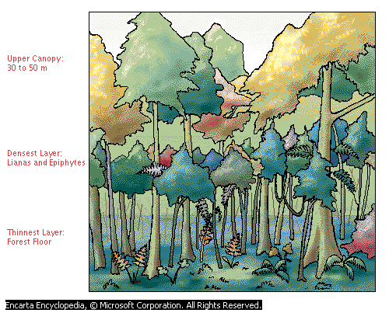

How to Access the Tropical Rainforest Plants Video
- Launch Microsoft Student 2008. Type your search words (rain forest plants) in the search box at the top of the page.

- Press Enter or click 

The search results list displays the closest matches to the term you searched for. Results are divided into categories:
- Articles | - Dictionaries
- Maps | - Web Links
- Photos & More  (This includes the videos) | - Quotations

The video will be listed under Photos and More.
Hint: to browse other videos, type “video” into the search box. Another way to find videos is to go to the Student Homepage>Discover and Learn>Games and Fun Stuff>Videos Folder.

Other tools that are helpful in research projects like this include:

How to Use the Ecoregions World Map
- On any page of Encarta, click the Homework Tools button at the top.  - Under Geography Tools, click World Atlas | 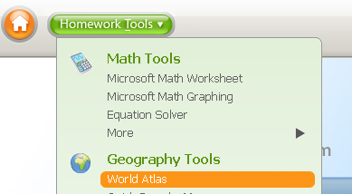
- In the list on the right of map styles, scroll down and find Ecoregions. Click on it to open.

How to Navigate Ecoregions World Map

You can use the following buttons to navigate the map.
Button | Description
 | To move the map, click this button, and then drag the hand across the map.
 | Drag the pointer over the globe in the direction you want to move the map.
Click the plus and minus signs, or drag the slider, to zoom.

When you zoom in and out on the center of a map, the zoom tool slider displays the distance above the Earth from which the map is viewed.
 | To select a part of the map for copying, printing, or magnification, click this button, and then drag a box around the area of the map that you want to use.
 | View latitude-longitude information on an atlas map.
 | Measure the distance between two or more points on an atlas map.
 | Add a note to a location on the map.
Map Legend | See what the map’s colors mean.

How to Use Map Trek
- Click the Homework Tools button. Under Geography Tools, click Map Treks. | 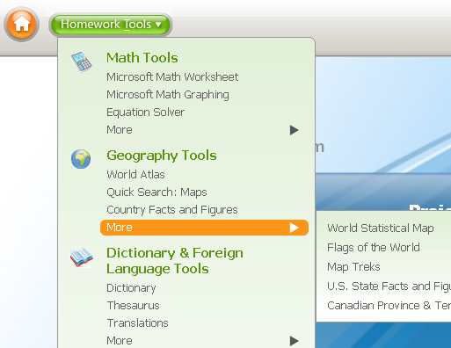
- Click on the Ecoregions File.

