Discover Tropical Rainforests
Student Handout
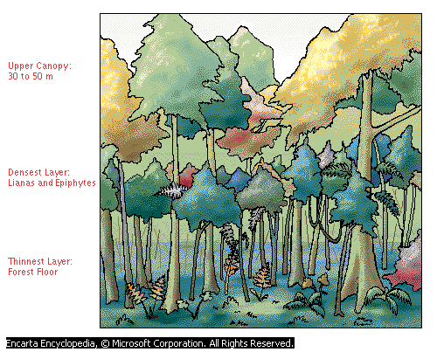

Step 1: Research tropical rainforests

- What is a tropical rain forest? (Summarize what you learned from the video on rainforest plants. If you need to, you can watch the video again.)
___________________________________________________________________
___________________________________________________________________
___________________________________________________________________
___________________________________________________________________
- Where are the world’s tropical rain forests located? For help with this, use the Ecoregions World Map in Microsoft Student.
___________________________________________________________________
___________________________________________________________________
___________________________________________________________________
___________________________________________________________________
- What is the physical structure of a tropical rain forest? Use Map Trek to find this information. ____________________________________________________________________________________________________________________________________________________________________________________________________________________________________________________________________________

- Describe the temperature, rain, and soil in a tropical rain forest. Use Map Trek in Microsoft Student for this. ___________________________________________________________________________________________________________________________________________________________________________________________________________________________________________________________________________
- Describe the plant and animal life of a tropical rain forest. Use Map Trek or other Encarta tools to find this information.
_________________________________________________________________________________________________________________________________________________________________________________________________________
___________________________________________________________________
- What is the economic value of tropical rain forests? Use Map Trek or other Encarta tools to help find this information.
____________________________________________________________________________________________________________________________________________________________________________________________________________________________________________________________________________
- What is deforestation, and what are its consequences? Use Map Trek or other Encarta tools to find this information.
____________________________________________________________________________________________________________________________________________________________________________________________________________________________________________________________________________
- Describe conservation efforts to save tropical rain forests. Use Map Trek or other Encarta tools to find this information.
____________________________________________________________________________________________________________________________________________________________________________________________________________________________________________________________________________
Step 2: Summarize, organize, and present your research

- Summarize your research orally and organize it into a logical sequence that others can easily follow.
- Use the summary of your research to create a five-minute multimedia presentation that you can present to the class.

For help creating a powerful presentation, follow the instructions for How to Access Tutorials and Templates for Presentations. To find these instructions in Microsoft Student, click Homework Tools, click Other Homework Tools, click More, and then click Learning Essentials.

