Graph Dynamic Linear
Equations
Student Handout

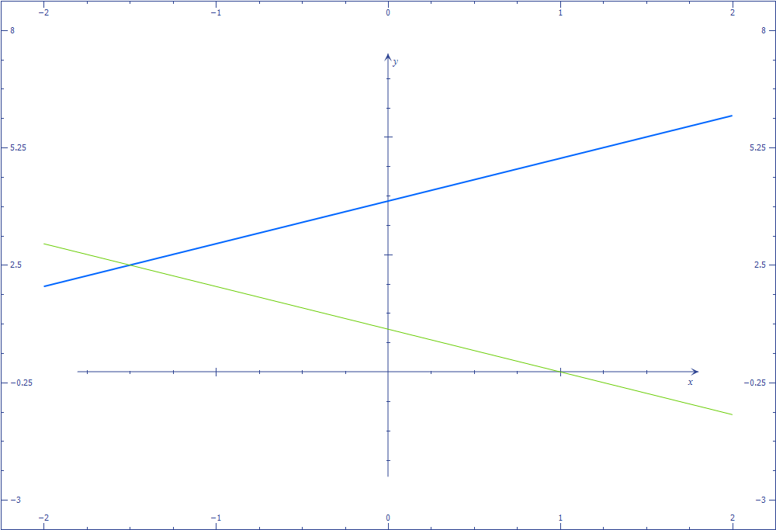
Activity 1: Investigate dynamic linear equations by graphing them

- Graph y = mx +b in Microsoft Math. Animate b from -2 to 2.
Describe what happens to the graph when b = -2.
Describe what happens to the graph when b = 0.
Describe what happens to the graph when b = +2.
- Animate m from -2 to 2.
Describe what happens to the graph when m = -2.
Describe what happens to the graph when m = 0.
Describe what happens to the graph when m = +2.
- Now graph y = -3x + 5 on the same axes. Set m and b for y = mx + b so that both graphs coincide. What are m and b when the graphs become the same line? ______________________________________________________________
- Now set m and b so that the two lines are parallel. What are m and b when the lines are parallel?
Is there more than one correct answer for m or b?
Explain why.
- Now set m and b so that the two lines appear to be perpendicular. (Be sure to click on the Proportional Display Button.) What are m and b when the lines appear to be perpendicular?
Is there more than one correct answer for m or b?
Explain why.

Activity 2: Check for understanding
Answer the following questions. Graph on Microsoft Math if you need to confirm your thinking.
- T or F The graph of y = 2x + 1 crosses the y axis at (0,2).
- T or F The graphs of y = -x – 1 and y= -x+1 are parallel.
- T or F The graph of y =3x -1 is rising from left to right.
- T or F The graph of y = -3x + 1 is falling from left to right.
- What has to be true of y = mx + b so that its graph will fall from left to right?
- Write the equation for a line that is horizontal.
- Where does y = -x -3 cross the y axis?
- Write a linear function that has a graph that is steeper than the graph of y = x + 1.
- Write a linear function that has a graph that is falling from left to right and crosses the y axis at (0, -4)
- Write a linear function that has a graph that is parallel to y = x - 4.
- Write a linear function that has a graph that is perpendicular to y = -2x + 1.

Activity :3 Use a dynamic linear equation to solve a problem in real life
Read the following scenario and answer the questions:
Excellence Rental Car charges $35 per day + $0.19 mile for its Premier Plan. Excellence Rental Car has other rental plans that charge different amounts. To show customers the differences in the plans, the owner wanted to create a graph of her plans and run the graph as part of an advertisement in the newspaper.
She started playing around with the Premier Plan charges on a graph.
- First, she reduced the amount of the per-day charges. What was the effect on the graph of the Premier Plan when she did this?____________________________________
________________________________________________________________
- Next, she increased the cost per mile. What was the effect on the graph of the Premier Plan?_____________________________________________________________
_________________________________________________________________
When she looked at the graphs of her other car rental plans, one plan turned out to be parallel to the graph of the Premier Plan.
- What can you conclude about this other plan? ______________________________
_________________________________________________________________
Activity 4: Explain the conditions and effects of graphing linear equations

Write a paragraph explaining what happens to the graph of y = mx + b when the parameters m and b are changed. Imagine you are explaining it to a classmate who was not at school today.
Write a paragraph explaining the requirements on y = mx + b for two lines that are parallel or perpendicular.

