 |  | How to Graph an Inequality in Microsoft Math
One of the great features of Microsoft Math is how easily it graphs inequalities.  - To open the Microsoft Math graphing calculator: click the Homework Tools button on any page, and then click Microsoft Math Graphing under Math Tools. The Functions graphing window will open as the default. | 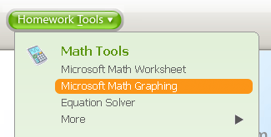
- Expand the Inequalities section. | 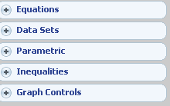
- To graph an inequality, for example, y < 2x + 1, click in box number 1. Enter the inequality in the pop-up input dialog box, and then click Enter. | 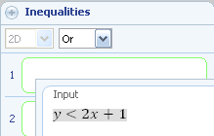
- Then click Graph. | 
Important:
For perpendicular graphs to display properly, be sure to click the Proportional Display Button.

How to Graph Another Inequality on the Same Axis
- Click on the Inequalities button to expand.
- Then click in Box 2 and type the second function into the input window. Hit Enter. Then Graph. | 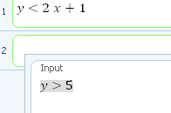

How to Graph More Than Two Equations on the Same Axis
- Click the Add button. | 

How to Graph on a New Set of Axes
- Click the Reset Graphing Tab at the bottom. | 

