 |  | How to Graph a Function in Microsoft Math
- To open the Microsoft Math graphing calculator: click the Homework Tools button on any page, and then click Microsoft Math Graphing under Math Tools. The functions graphing window will open as the default. | 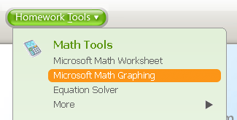
- To graph y = mx + b: click in the box beside y =. Enter the function in the pop-up dialog box, and then click Enter.
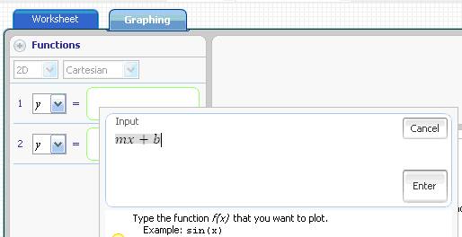
Click in here and this box will open.

- Then click Graph. | 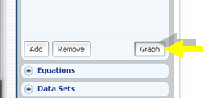

How to Animate the Graph
- Make sure the Graph Controls are expanded.  - In the Parameter list, make sure “b” is selected.  - In the Lower Bound box, enter -2 as a lower bound for the parameter. The default is 0.  - The Upper Bound box should also be 2. (The default is 2.)  - To animate the graph, either click the arrow or drag the slider.  - To animate the graph as m varies, click on the down arrow and select m from the Parameter list. | 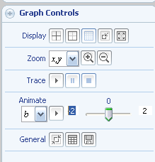

How to Graph Another Graph on the Same Axes
- Click on the Functions button to expand. | 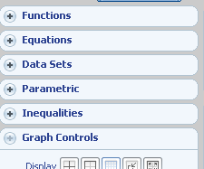
- Then click in Line 2 and type the second function into the pop-up window. Hit Enter. Then Graph.

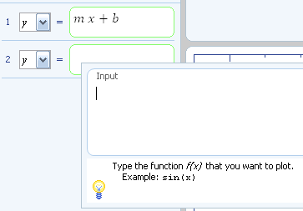

How to Make the Graph Proportional
- Select the Use a Proportional Display button in the Graph Controls. | 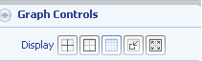

How to Graph on a New Set of Axes
- Click the Reset Graphing Tab at the bottom. | 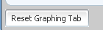

How to Save a Worksheet
(All the work you have done is stored in a worksheet.)
- Click the Worksheet tab at the top to see the worksheet.

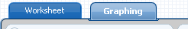

- On the File menu, click Save.

If you are saving the worksheet for the first time, the Save As dialog box appears.

