

Overview
Businesses of all sizes experience tremendous cost and complexity when extending and customizing their applications today. Given the constraints of the economy, IT must increasingly find new ways to do more with less but at the same time simultaneously find new innovative ways to keep up with the changing needs of the business. Developers are now starting to evaluate newer cloud-based platforms as a way to gain greater efficiency and agility; the promised benefits of cloud development are impressive, by enabling greater focus on the business and not in the running of infrastructure.
However, customers already have a very large base of existing heterogeneous and distributed business applications spanning different platforms, vendors and technologies. The use of cloud adds complexity to this environment, since the services and components used in cloud applications are inherently distributed across organizational boundaries. Understanding all of the components of your application – and managing them across the full application lifecycle – is tremendously challenging. Finally, building cloud applications often introduces new programming models, tools and runtimes making it difficult for customers to transition from their existing server-based applications.
To address these challenges, Microsoft has delivered Windows Azure AppFabric.

Windows Azure AppFabric: Comprehensive Cloud Middleware
Windows Azure AppFabric provides a comprehensive cloud middleware platform for developing, deploying and managing applications on the Windows Azure Platform. It delivers additional developer productivity, adding in higher-level Platform-as-a-Service (PaaS) capabilities on top of the familiar Windows Azure application model. It also enables bridging your existing applications to the cloud through secure connectivity across network and geographic boundaries, and by providing a consistent development model for both Windows Azure and Windows Server. Finally, it makes development more productive by providing a higher abstraction for building end-to-end applications, and simplifies management and maintenance of the application as it takes advantage of advances in the underlying hardware and software infrastructure.
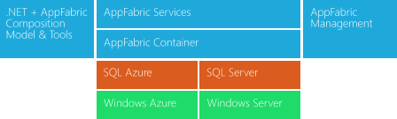
There are three key components of Windows Azure AppFabric:
Middleware Services: platform capabilities as services, which raise the level of abstraction and reduce complexity of cloud development.
Composite Applications: a set of new innovative frameworks, tools and composition engine to easily assemble, deploy, and manage a composite application as a single logical entity
Scale-out application infrastructure: optimized for cloud-scale services and mid-tier components.
Following is a high-level overview of these Windows Azure AppFabric components and features.

Middleware Services
Windows Azure AppFabric provides pre-built, higher level middleware services that raise the level of abstraction and reduce complexity of cloud development. These services are open and interoperable across languages (.NET, Java, Ruby, PHP…) and give developers a powerful pre-built “class library" for next-gen cloud applications. Developers can use each of the services stand-alone, or combine services to provide a composite solution.
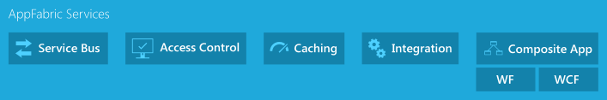
Service Bus (Commercially available now; updated CTP delivered October 2010) provides secure messaging and connectivity capabilities that enable building distributed and disconnected applications in the cloud, as well as hybrid applications across both on-premise and the cloud. It enables using various communication and messaging protocols and patterns, and removes the need for the developer to worry about delivery assurance, reliable messaging and scale.
Access Control (Commercially available now; updated CTP delivered August 2010) enables an easy way to provide identity and access control to web applications and services, while integrating with standards-based identity providers, including enterprise directories such as Active Directory®, and web identities such as Windows Live ID, Google, Yahoo! and Facebook.
Caching (New CTP service delivered October 2010; commercially available in H1 CY11) accelerates performance of Windows Azure and SQL Azure based apps by providing a distributed, in-memory application cache, provided entirely as a service (no installation or management of instances, dynamically increase/decrease cache size as needed). Pre-integration with ASP.NET enables easy acceleration of web applications without having to modify application code.
Integration (New CTP service coming in CY11) will provide common BizTalk Server integration capabilities (e.g. pipeline, transforms, adapters) on Windows Azure, using out-of-box integration patterns to accelerate and simplify development. It will also deliver higher level business user enablement capabilities such as Business Activity Monitoring and Rules, as well as self-service trading partner community portal and provisioning of business-to-business pipelines.
Composite App (New CTP service coming in H1 CY11) will provide a multi-tenant, managed service which consumes the .NET based Composition Model definition and automates the deployment and management of the end to end application - eliminating manual steps needed by both developers and ITPros today. It also executes application components to provide a high-performance runtime optimized for cloud-scale services and mid-tier components (automatically delivering scale out, availability, multi-tenancy and sandboxing of application components). Finally, it delivers a complete hosting environment for web services built using Windows Communication Foundation (including WCF Data Services and WCF RIA Services) and workflows built using Windows Workflow Foundation.
It’s a key characteristic of all AppFabric Middleware Services that they are consistently delivered as true multi-tenant services – you simply provision, configure, and use (no installation or management of machines/instances).

Composite Applications
As developers build next-generation applications in the cloud, they are increasingly assembling their application as a composite from many pre-built components and services (either developed in house or consumed from third parties cloud services). Also, given that many cloud applications need to access critical on-premises business applications and data, there is a need to be able to compose from on-premises services easily and securely. Finally, the highly distributed nature of these composite applications require more sophisticated deployment and management capabilities for managing all of the distributed elements that span the web, middle-tier and database tier.
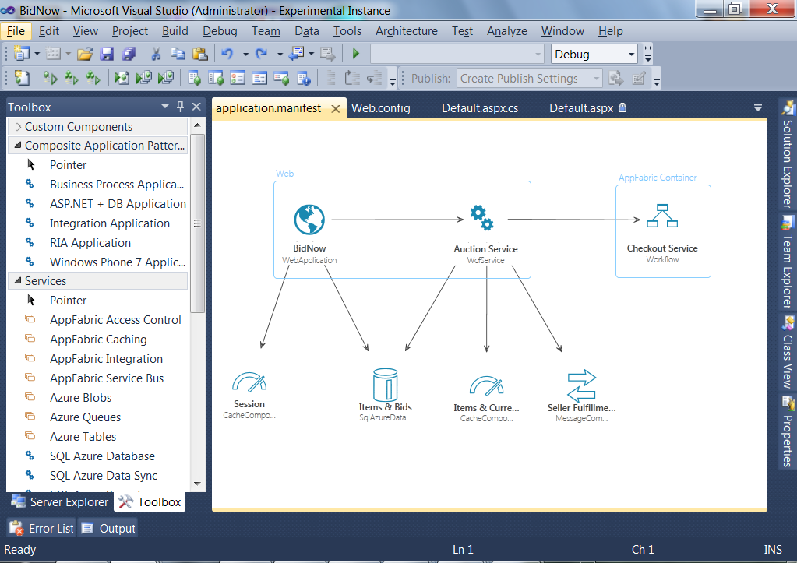
AppFabric Composition Model
& Visual Designer

Microsoft is advancing its Windows Azure AppFabric cloud middleware platform to provide a full composite application environment for developing, deploying and managing composite applications. The AppFabric composition environment delivers three main benefits:
Composition Model A set of .NET Framework extensions for composing applications on the Windows Azure platform. This builds on the familiar Azure Service Model concepts and adds new capabilities for describing and integrating the components of an application. It also provides a consistent composition model for both Windows Azure and Windows Server.
Visual Design Experience A new Visual Studio based designer experience allows you assemble code from your existing application components, along with newer cloud services, and tie them together as a single logical entity.
Managed as a service The Composite Application service is a multi-tenant, managed service which consumes the Composition Model definition and automates the deployment and management of the end to end application - eliminating manual steps needed by both developers and ITPros today.
The composite application environment offers the following benefits:
- Greater developer productivity through rapid assembly, linking of components and automated deployment of the entire end-to-end application;
- Easier configuration and control of entire application and individual components;
- End-to-end application monitoring (events, state, health and performance SLAs);
- Easier troubleshooting (through richer diagnostics and debugging of the whole application);
- Performance optimization of the whole application (scale-out/in, fine-tuning, migration, etc);
- Integrated operational reporting (usage, metering, billing).

Scale-out Application Infrastructure
Both the AppFabric Services and your own composite applications built using the Composition Model are built upon an advanced, high-performance application infrastructure that has been optimized for cloud-scale services and mid-tier components. The AppFabric Container provides base-level infrastructure such as automatically ensuring scale out, availability, multi-tenancy and sandboxing of your application components. The main capabilities provided by the AppFabric Container are:
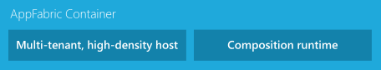
Composition Runtime This manages the full lifecycle of an application component including loading, unloading, starting, and stopping of components. It also supports configurations like auto-start and on-demand activation of components.
Sandboxing and Multi-tenancy This enables high-density and multi-tenancy of the hosted components. The container captures and propagates the tenant context to all the application and middleware components.
State Management This provides data and persistence management for application components hosted in the container.
Scale-out and High Availability The container provides scale-out by allowing application components to be cloned and automatically distributed; for stateful components, the container provides scale-out and high availability using partitioning and replication mechanisms. The AppFabric Container shares the partitioning and replication mechanisms of SQL Azure.
Dynamic Address Resolution and Routing In a fabric-based environment, components can be placed or reconfigured dynamically. The container automatically and efficiently routes requests to the target components and services.

Bridging On-Premises and Cloud
Finally, one of the important capabilities needed by businesses as they begin their journey to the cloud is being able to leverage existing on-premise LOB systems and to expose them selectively and securely into the cloud as web services. However, since most organizations are firewall protected, the on-premise LOB systems are typically not easily accessible to cloud applications running outside the organization’s firewall.
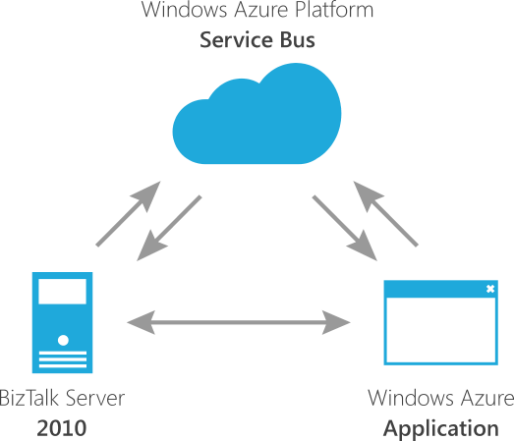
AppFabric Connect allows you to leverage your existing LOB integration investments in Windows Azure using the Windows Azure AppFabric Service Bus, and Windows Server AppFabric. This new set of simplified tooling extends BizTalk Server 2010 to help accelerate hybrid on/off premises composite application scenarios which we believe are critical for customers starting to develop hybrid applications.
(AppFabric Connect is available now as a free add-on for BizTalk Server 2010 to extend existing systems to both Windows Azure AppFabric and Windows Server AppFabric.)

