

Microsoft Business Intelligence

September 2006

Table of Contents

Overview of Microsoft Business Intelligence 4
Performance Management 5
Simplified Collaboration 5
Rich Scorecard Functionality 5
Powerful Analytics 6
Scalable Platform 6
Enhanced Performance Management Tools 7
Reporting and Analysis 7
Manage Data More Effectively 7
Advanced Analysis Capabilities 8
Smooth Integration of Data 8
Document Management 8
Share Analysis over the Web 9
Data Warehousing 9
SQL Server 2005 Integration Services 9
SQL Server Business Intelligence Development Studio 10
SQL Server 2005 Analysis Services 10
SQL Server 2005 Reporting Services 10
Relational Data Warehouse 11
Performance Management 12
Simplified Collaboration 15
Rich Scorecard Functionality 16
Flexible Scorecards 16
Customized Views 17
Deep Contextual Insight 17
KPI Grouping 17
Simplified Indicators 18
Strategy Map Visualization 20
Powerful Analytics 20
Advanced, Patented Data Visualization 21
Extend Analytics Beyond the Firewall 22
“Click to Analyze” Functionality 22
Centrally Managed, Shared Business Logic 23
Scalable Platform 25
Web-Based Development and Administration 25
Integration with SQL Server 2005 Analysis Services 26
Integration with Office SharePoint Server 2007 26
Enhanced Performance Management Tools 27
Improved Compliance and Control 27
Increased Time Savings 27
Improved Collaboration 27
Improved Business Management 27
Improve Decision Making 28
Reporting and Analysis 29
Manage Data More Effectively 29
Microsoft Office Fluent User Interface 29
Increased Spreadsheet Row and Column Capacity 30
Faster Performance 31
Improved Formula Authoring 31
Enhanced Sorting and Filtering 32
Enhanced PivotTable Views and PivotChart Views 34
Simplified Conditional Formatting 35
Support for SQL Server 2005 Analysis Services 35
Improved Charting Tools 37
Data Connection Library 38
Advanced Analytics 38
Advanced Data Visualization 39
Zero-Footprint Dashboards 39
Build a Fully Integrated Enterprise Portal 40
Tight Integration of Data 41
Business Data Catalog 41
Simplified Dashboard Building 42
Content Reuse and Distribution 42
Document Management 42
Enhanced Privacy and Security 43
Records Management 43
Audit and Policy Reporting Tools 43
Information Rights Management 43
Search Center 43
Share Analysis over the Web 44
Server-Based Spreadsheets 44
Excel Web Access 45
Excel Web Services Application Programming Interface (API) 46
Streamlined Business Processes 46
Zero Footprint Analytics 46
Data Warehousing 47
SQL Server 2005 Integration Services 47
Rich Development Environment 47
Visual Debugging 47
Data Quality 47
Extensible Architecture 48
Out-of-the-Box, High Performance Transformations 48
SQL Server Business Intelligence Development Studio 48
Solution Explorer 49
Properties Window 49
Designer Window 49
Customized Environment 50
Project Templates 50
SQL Server 2005 Analysis Services 50
Data Mining Algorithms 50
Unified Dimensional Modeling 51
Proactive Caching 51
Enhanced Security Design 51
SQL Server 2005 Reporting Services 52
Wizard-Based Report Design 52
Embedded Reporting 53
End-User Authoring 53
Web Services Support 55
Managing Reports 55
Scalability 56
Relational Data Warehouse 56
Partitioned Tables and Indexes 56
Online Index Operations 57
Transact-SQL Improvements 57
Database Snapshots 57
Data Mirroring 57
Snapshot Isolation 58
Support for 64-bit 58
SQL Server Management Studio 58
Summary 59
System Requirements 60

Overview of Microsoft Business Intelligence
Microsoft® Business Intelligence offers a complete suite of products that supports all facets of decision making. Through tight integration with the powerful, proven, and scalable Microsoft SQL Server™ 2005 platform, Microsoft Office® SharePoint® Server 2007, Microsoft Office Business Scorecard Manager 2005, ProClarity Analytics 6, and Microsoft Office PerformancePoint™ Server 2007, Microsoft provides complete business intelligence (BI) capabilities that deliver the right information, at the right time, and in the right format.
Building on the innovative features in SQL Server 2005 that help businesses understand and analyze large volumes of rapidly changing data, the 2007 Microsoft Office system enables decision makers to predict and harness the power of change to create competitive advantages, achieve corporate objectives, and make better decisions, faster. Now, with tighter integration with SQL Server 2005, the 2007 Microsoft Office system empowers people to be more productive by answering their own questions in a security-enhanced, familiar, and easier-to-use environment. This enables IT to focus their resources on higher-value BI projects and enables everyone else to focus on doing their jobs and less on getting the information needed to do their jobs.
New to the 2007 Microsoft Office system is a product called Office PerformancePoint Server, an extension and evolution of Microsoft Office Business Scorecard Manager and ProClarity Analytics. Office PerformancePoint Server is a performance management application that enables businesses to improve their performance by providing all employees with the ability to plan, budget, forecast, report, analyze and scorecard their activities using the familiar Microsoft Office system and SQL Server technology. Office PerformancePoint Server will help companies align metrics to strategy and improve performance by enabling every employee to understand business drivers, shape solutions, and execute shared plans.
In addition, Office SharePoint Server 2007 introduces Microsoft Excel® Services, which delivers the power, functionality, and accessibility of Microsoft Office Excel 2007 in a zero-client format. Now everyone can easily interact with live data over the Web.
Microsoft Business Intelligence in Action
Claus Hansen is president of Blue Yonder Airlines, a low-fare airline offering service throughout the United States. With more than 30 years of experience in the travel industry, Hansen knows that a travel business lives and dies on reliable service. To this end, Hansen is constantly tracking his fleet’s performance. Are his planes on time? What routes perform better than others and at what times of the day? He also is a firm believer in knowing his customers. Hansen uses Microsoft Business Intelligence so he and his employees can get anytime, anywhere access to customer and flight information and collaborate on improving his business.

Performance Management
In any business, aligning employee activities to company objectives can be a challenging task. An integrated approach to performance management that includes Business Scorecard Manager, ProClarity, and Office PerformancePoint Server will provide greater insight into business performance with less cost and effort than traditional solutions. With Business Scorecard Manager, your business can effectively and efficiently track performance against company goals. ProClarity provides your decision makers with powerful yet simple-to-use analytic tools for exploring large quantities of data in a way that provides rapid insight into trends, patterns, opportunities and challenges in your business environment. By also deploying Office PerformancePoint Server, your business can reduce the time and effort required to plan, budget, and forecast financial data, leading to a leaner and more agile business that can take advantage of quickly changing market conditions.

Simplified Collaboration
With Business Scorecard Manager, you can share strategies, monitor tasks, annotate scorecards, establish discussions, and put insight into action by tying strategy to accountability so you can execute on your strategic plans. Information is delivered in a collaborative environment for effective business management in your performance-driven organization.

Rich Scorecard Functionality
Business Scorecard Manager is based on scorecarding best practices and is certified by the Balanced Scorecard Collaborative. By combining full scorecard functionality with reports, charts, graphs, and analysis tools, you can evaluate relationships between key performance indicators (KPIs) and tangible business objectives.
- Flexible scorecards are easy to read and customize.
- Customized views empower you to choose how to present your information.
- Customized KPIs enable you to measure what’s important to your organization and gain deep contextual insight.
- KPI grouping helps you place individual KPIs into one objective, so you can compare parts to the whole.
- Enhanced central security capitalizes on data security at the row and column level.
- Simplified indicators help make it easier to understand the relative values of your data and enhance your visual presentation.
- Strategy Map visualization through applications such as Microsoft Office Visio® and Microsoft MapPoint® enable you to present a precise interpretation of data in a way that makes sense to you while maintaining the connection to the underlying data.

Powerful Analytics
ProClarity Analytics empowers your decision makers to monitor business performance, visualize and explore multi-dimensional data, understand root cause, and share definitions and analysis best practices to make consistently better decisions. Intuitive data navigation, powerful calculation and patented advanced visualization tools are the core components that make ProClarity Analytics the best at helping your business users answer the question “Why?” when it comes to business change.
- Advanced data visualization helps your users easily navigate through data and expertly analyze root cause.
- Extend analytics beyond the firewall - deployment options provide Web-based analysis to any audience, anywhere through a zero-Footprint interface and flexible, Web-optimized dashboard content
- “Click to Analyze” functionality helps users jump from monitoring KPIs to full ad hoc analysis in their favorite Microsoft BI product.
- Centrally managed, shared Business Logic helps your company align common definitions for business logic and share analysis best practices across the organization.

Scalable Platform
Business Scorecard Manager and ProClarity fully integrate with Office SharePoint Server 2007 and Microsoft SQL Server 2005 Analysis Services, the industry-leading online analytical processing (OLAP) engine, providing easily deployed scorecards and analytic views that show multi-dimensional data for collaboration through SharePoint sites.
- Web-enabled capabilities provide security-enhanced and easy-to-use access to scorecards and analytics through the Internet.
- SQL Server Analysis Services integration enables you to draw data from a multi-dimensional database as the source for scorecard KPIs and in-depth analysis.
- SQL Server Reporting Services integration enables you to schedule delivery of scorecards and use scorecards in disconnected mode. ProClarity integrates with Reporting Services to help expedite the reporting process and integrate analytic functionality into reports.
- SharePoint site integration enables broad scorecard and analytic view deployment and teamwork that ultimately leads to better decision making.

Enhanced Performance Management Tools
Office PerformancePoint Server combines all of the powerful functionality of Business Scorecard Manager and ProClarity Analytics with new financial budgeting, planning, and forecasting features, giving your business the competitive advantage it needs to succeed. With Office PerformancePoint Server you’ll get the tools and resources you need to help drive corporate performance, accelerate management decision making, and improve collaborative performance analysis.

Reporting and Analysis
Microsoft Office Excel has long been a favorite tool for analyzing multi-dimensional data and gaining business insight to make more informed decisions. Office Excel 2007 brings new, more intuitive visualization features and tighter integration with the portal and database. Now, employees can more securely access, analyze, and share information from data warehouses and enterprise applications.
Using the Microsoft Windows® SharePoint Services framework, Office SharePoint Server 2007 has enhanced features and new additions that provide you with all the necessary components to build a true enterprise portal platform.
Excel Services, part of Office SharePoint Server 2007, provides new server-based Excel functionality you can use to manage, consume, calculate, and share spreadsheets through a Web browser.
ProClarity Analytics, now a key component of the Microsoft Business Intelligence stack, provides advanced analysis tools that help you explore large quantities of data in a way that provides rapid insight.

Manage Data More Effectively
In Office Excel 2007, you can more easily discern trends from complex data. You can view metadata stored in SQL Server 2005 Analysis Services from within the actual Excel report. In addition, you can quickly add and move dimensions presented in business terms, and report from multiple data sources within a single Excel report. As a result, you can present your analysis with greater clarity and confidence.
- The Microsoft Office Fluent™ user interface presents the right tools when you need them most, exposing the extensive features of Office Excel 2007.
- Increased spreadsheet row and column capacity enables you to import and work with up to 1 million rows and 16,000 columns of data.
- Multi-threaded chipsets provide faster calculations by running formulas on multiple processors simultaneously.
- Formulae authoring experience, including a resizable formulae bar and context-based Formulae AutoComplete that exposes column headings while you write the formulae. This helps you write the proper formulae syntax the first time, every time.
- Sorting and filtering helps you quickly find the information you need. Office Excel 2007 supports up to 64 levels to sort data, including the ability to sort by color.
- Enhanced Microsoft PivotTable® views and Microsoft PivotChart® views use data fields to quickly explore and analyze your data.
- Simplified conditional formatting such as heat maps, colored icons, and arrows help you discover trends, exceptions, and patterns in your information.
- Full support for SQL Server Analysis Services enables you to easily connect to a central metadata repository in SQL Server Analysis Services, quickly extract information from your OLAP cube, and expose it within Office Excel 2007 and ProClarity, providing context for the data being analyzed.
- Improved charting tools make it easier to summarize your analysis results in professional-looking charts.
- The data connection library simplifies finding and connecting to external data sources.

Advanced Analysis Capabilities
ProClarity Analytics gives your analysts and other business professionals a simple, powerful, and adaptable toolset to analyze data and gain the insight they need into corporate performance.
- Advanced data visualization helps your users easily navigate through data and expertly analyze root cause.
- Zero-Footprint dashboards simplify the creation and deployment of data for monitoring and analysis

Smooth Integration of Data
Office SharePoint Server 2007 comes with new and advanced collaboration features so you can integrate data; interact with spreadsheets, KPIs, and scorecards; and easily update and maintain version control of constantly changing documents.
- Business Data Catalog enables integration between the enterprise portal and line-of-business (LOB) programs.
- Excel Services enables interaction with your spreadsheets through a Web browser or programmatically through a Web service.
- Content reuse and distribution features enable you to copy documents to another SharePoint location and easily update those copies to match any changes that are later made to the original document.

Document Management
Document Management in Office SharePoint Server 2007 provides you with better control, organization, publishing, offline capabilities, enhanced draft item security, and rights management tools than previous versions.
- Records management features help you maintain your company's most important information in the most organized way.
- Information rights management verifies that a user has permission to view a file and issues a license to the user to access that file.
- Search Center is a fully customizable search tool that helps you quickly and easily search for information.

Share Analysis over the Web
Excel Services, part of Office SharePoint Server 2007, provides new server-based Excel functionality with which you can manage, consume, calculate, and share spreadsheets through a Web browser, giving you a more secure and centrally managed environment for your BI reports.
- Improved management and control of business-critical information enables you to broadly share Excel spreadsheets while helping to protect proprietary information.
- Browser-based access enables viewing and interacting with spreadsheet data from within BI dashboards while maintaining context with structured and unstructured information surrounding the scorecard, such as Microsoft Office Word and Microsoft Office PowerPoint® documents.
- Excel Web Services application programming interface (API) enables developers to incorporate the Excel models and business logic maintained by Excel users within spreadsheets without the need to recode the logic outside of Excel.
- Improved performance and efficiency enable you to calculate better in server-accessed spreadsheets.
- Zero-Footprint analytics and dashboards help you to deliver powerful analytics or dashboards while meeting strict business requirements.

Data Warehousing
Microsoft SQL Server 2005 empowers your company by providing a security-enhanced, reliable, scalable, and productive platform for enterprise data management and business intelligence applications. BI enhancements within SQL Server 2005 help deliver an end-to-end solution with integrated analytics including OLAP; data mining; extract, transformation, and load (ETL) tools; data warehousing; and reporting functionality.

SQL Server 2005 Integration Services
Microsoft SQL Server 2005 Integration Services (SSIS) offers a redesigned and highly scalable enterprise ETL platform for building high-performance data integration solutions for data warehousing. As a result, you get a more holistic understanding of your business.
- Rich development environment uses Microsoft Visual Studio® 2005 as a collaborative stage for dependable and relevant solutions.
- Visual debugging tools help you set breakpoints on packages, containers, task events, and data viewers for watching data as it moves through the data flow
- Data quality tools such as Fuzzy Lookup and Fuzzy Grouping components provide inexact matching and de-duplication.
- Extensible architecture includes a completely rewritten object model that makes extending and programming packages easier, more flexible, and more powerful.
- Out-of-the-box, high-performance transformations include a great range of productive and powerful components such as data and character conversions, calculated columns, conditional operations for partitioning and filtering, lookups, sorting, aggregation, and merges.

SQL Server Business Intelligence Development Studio
Business Intelligence Development Studio offers the first integrated development environment designed specifically for the BI developer. Built on Visual Studio 2005, Business Intelligence Development Studio delivers a rich, integrated platform for developing business intelligence applications.
- Solution Explorer helps you manage all your different projects in a solution from a single window.
- The Properties window enables you to view and change the properties of objects, such as packages, that are open in editors and designers.
- The Designer window helps you create or modify business intelligence objects and provides both a code view and a design view of an object.
- Simple customization provides easy-to-use configurations that suit your working style.
- Project templates for SQL Server Analysis Services, Integration Services, and Reporting Services provide a context for developing specific constructs.

SQL Server 2005 Analysis Services
Microsoft SQL Server 2005 Analysis Services (SSAS) data mining and OLAP capabilities help you build complex analytical models that you can integrate with your business operations. Easy to use, extensible, and flexible capabilities make data mining more accessible than ever before.
- Unified Dimensional Model provides a central metadata repository defining business entities, business logic, calculations, and metrics.
- Data mining algorithms help you discover patterns and uncover business data to reveal hidden trends.
- Proactive caching delivers a highly compressed and optimized data cache that is automatically maintained as the data in the underlying source databases changes.
- Advanced BI capabilities such as KPIs, translations, semi-additive measures, and multi-dimensional expressions (MDX) scripts help improve your decision making.

SQL Server 2005 Reporting Services
SQL Server 2005 Reporting Services (SSRS) offers a complete and comprehensive reporting solution for creating, managing, and delivering traditional managed reports, interactive end-user reports, and embedded reports.
- Report authoring uses a graphical report designer tool with easy-to-use report wizards.
- Embedded reports use client-side reporting controls to embed real-time reports into an application at design time.
- Report Builder provides an ad hoc reporting tool that enables business users to create their own reports and explore corporate data.
- SharePoint integration provides out-of-the-box Web Parts to deliver reports directly in Office SharePoint Server 2007.
- Management Studio enables administrators to organize reports and data sources, schedule report execution and delivery, and track reporting history.
- Flexible and extensible reporting for both traditional and interactive reports offers numerous formats with extensible delivery options.
- Scalability enables SQL Server 2005 to support high-volume environments.

Relational Data Warehouse
SQL Server 2005 offers a security-enhanced, scalable, and highly available relational database engine with improved performance and support for structured and unstructured XML data.
- Table and index partitioning enables fast data load and simplified maintenance for large tables.
- Online index operations help you create, rebuild, or drop an index online.
- Enhanced Transact-SQL (T-SQL) language capabilities offer error handling, recursive queries, and XML support.
- Database mirroring provides a quick standby system for high availability.
- Database snapshots create quick, read-only views of a database.
- Snapshot isolation enables read operations to access the last-committed row even if a write operation has the row locked for an update at that time.
- Support for 64-bit opens the door to new levels of application scalability.
- SQL Server Management Studio helps you operate and maintain BI database objects.

Performance Management
In order to build and maintain profitability, every company strives to maximize operational efficiencies, while delivering a stellar level of service that keeps customers coming back. To that end, Microsoft Business Intelligence includes a cost-effective, streamlined suite of integrated products that help decision makers manage business performance. Microsoft BI provides uninterrupted access to widespread intelligence, supporting all aspects of the decision making process.
Microsoft Office Business Scorecard Manager empowers your organization by helping your employees to gain insight into business drivers and execute shared plans that help shape BI solutions. With Business Scorecard Manager, your company can align action with strategy to help improve performance. Business Scorecard Manager provides a powerful environment for collaboration and analysis. Your employees can not only build and manage scorecards, they can also deploy the scorecards to a SharePoint site or an SSRS report.
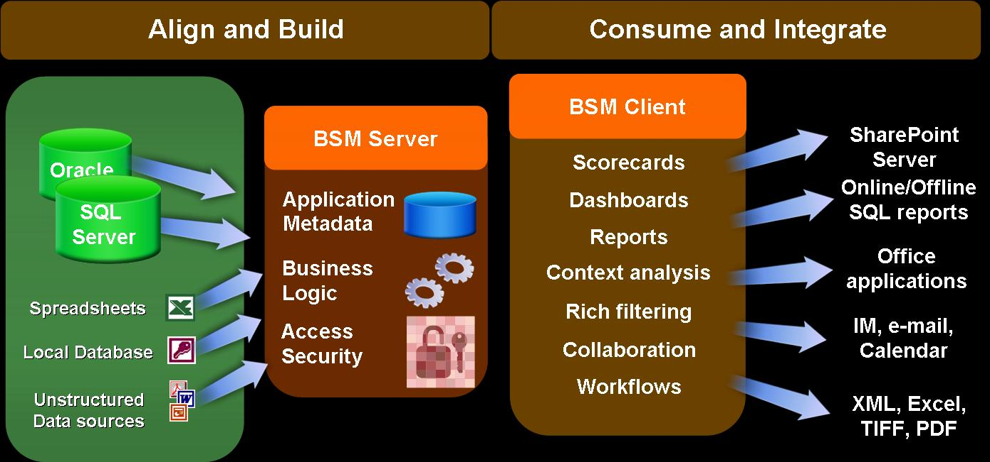
Figure 1: Business Scorecard Manager architecture
Business Scorecard Manager provides easy access to security-enhanced and easy-to-use performance and financial data for scorecards, analysis, and reporting. Rich integration with the Microsoft Office system makes information easily accessible and convertible into graphical reports, charts, and presentations. Seamless integration with ProClarity Analytics enables employees to easily move from monitoring performance in the scorecard to full ad hoc analysis. This helps them gain a complete understanding of the drivers behind KPIs so they can take action on the results. In addition, tight integration with SSRS makes scorecards portable and accessible to employees while they’re traveling.
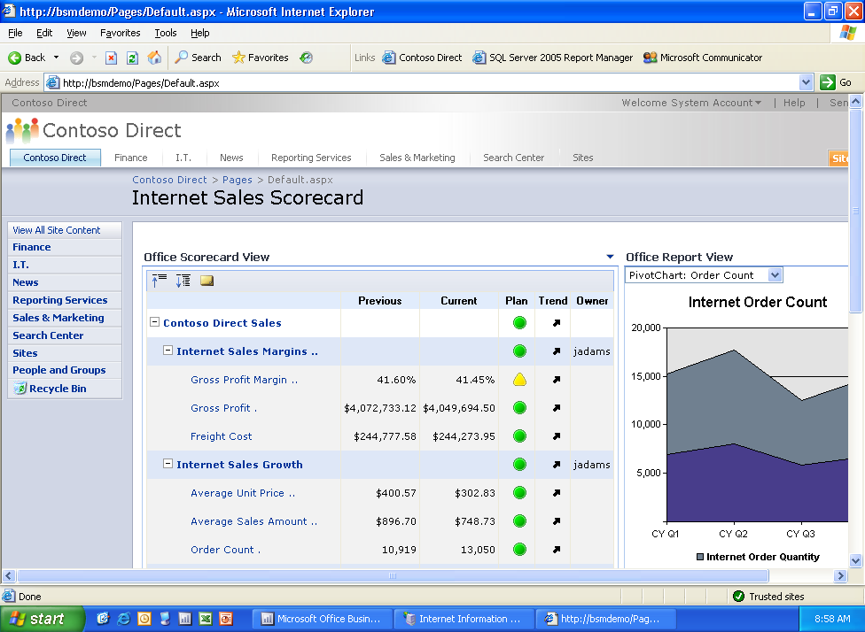
Figure 2: Consuming a scorecard in Office SharePoint Server 2007
Because Business Scorecard Manager supports Microsoft Office system programs such as Office Word 2007, Office Excel 2007, Office PowerPoint 2007, Microsoft Office Outlook® 2007, Office Visio 2007, and Office MapPoint 2007, you can open material created in various formats and present multi-dimensional views of scorecard data that you can focus on in a manner that’s similar to an actual scorecard. New integration with SSRS and SSAS enables you to create interactive reports and sophisticated analyses for large volumes of performance data. You can also filter, slice, and dice scorecards and all related content such as associated reports, associated lists of documents, and so on.
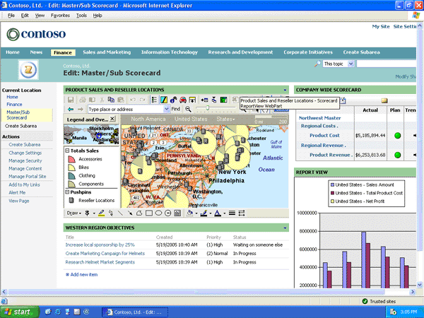
Figure 3: Business Scorecard Manager provides deep, contextual insight.
Microsoft Business Intelligence in Action
Claus Hansen used to track basic airline information such as on-time arrivals and percentage of booked seats. But he was never able to pinpoint his customer demographics. Who were his average customers? What kept them loyal to his airline? Why were they traveling? How was his airline perceived in relation to other low-fare airlines? Using the flexible scorecards within Business Scorecard Manager, Hansen was able to gain a better understanding of his client base. He used this information to analyze meaningful ways to reach out to other consumers outside his core clientele.

Simplified Collaboration
Business Scorecard Manager enables you to improve business performance with collaborative group analysis. Smooth compatibility with the 2007 Microsoft Office system, including Office SharePoint Server 2007, Microsoft Office Live Meeting, and Office Outlook 2007, makes it easy for teams and lines of business to share insight across an organization. In addition, you can assign tasks specifically related to a KPI or a scorecard. As a result, you can not only control who has access to information but you can also get the right people the information they need to do their jobs. Business Scorecard Manager also enables KPI owners to attach comments to KPIs. This enables management to review KPI performance along with the “soft reasons,” or explanations of the factors that impacted performance.

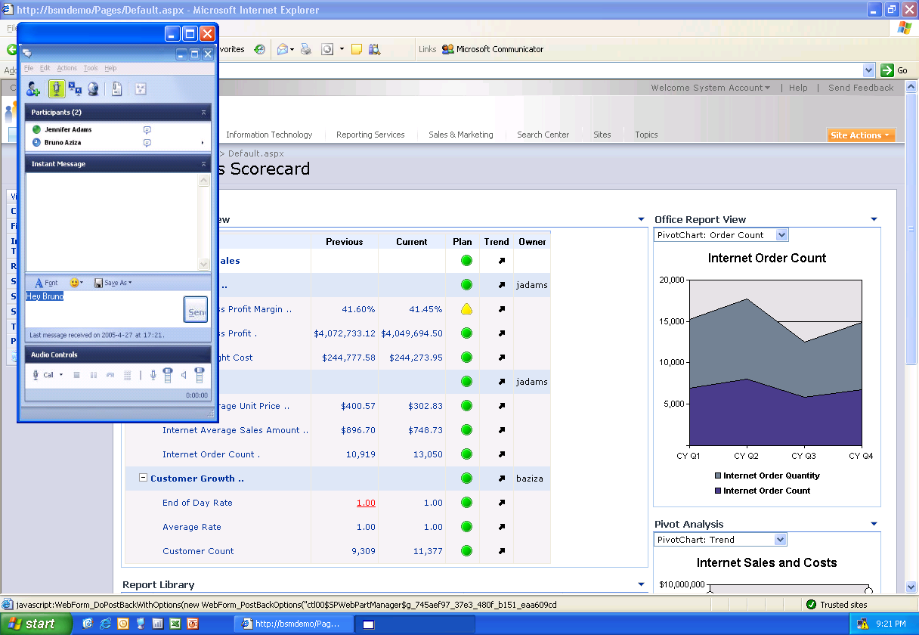
Figure 4: Communicating through Instant Messenger

Figure 5: Communicating through Office Outlook 2007

Rich Scorecard Functionality
Business Scorecard Manager empowers you to build your own scorecards using the familiar Microsoft Office interface and tools. With Business Scorecard Manager, you get extensive capabilities for creating new workspaces that include all of the necessary elements for building scorecards. Take advantage of a wide variety of data sources such as databases, spreadsheets, or other electronic formats from which you can derive numeric values for mapping KPIs to data.

Flexible Scorecards
Capitalizing on the power of the Microsoft Office system, Business Scorecard Manager enables you to customize scorecards to suit your business needs. Some of the features include:
- Business definitions that cascade and roll up across organizations.
- Views that support easy browsing (such as by time or location.
- Templates that can be easily created and reused.
- A single interface for viewing operational status, enabling companies to combine real-time data with historical data, analytical tools, policies, and processes.
Business Scorecard Manager provides Web Parts to easily deploy scorecard report views directly to a SharePoint site. Users can also deliver scorecard information directly to applications such as the Microsoft Office system.

Customized Views
Customized views in Business Scorecard Manager give different views of the same scorecard, providing a deeper understanding of business information. For example, using the configuration setting, you can produce a wide range of views of the KPIs relevant to a scorecard. Or view only a subset of the KPIs. You won’t have to worry about losing information regardless of your viewing instance, all of the information located in one scorecard element remains intact.

Deep Contextual Insight
The KPI framework within Business Scorecard Manager provides a central repository for defining key metrics and scorecards. With all of their powerful capabilities, the KPIs can be reused and customized, potentially saving your employees hours of time. Some of the features available for KPIs include:
- Multiple-targeting available out of the box.
- Metadata definitions for drilling down into supporting documentation, reports, and charts.
- Role-based permissions.

KPI Grouping
To eliminate the hassle of searching through individual KPIs for specific data, Business Scorecard Manager enables you to group KPIs into objectives. You also get quick access to overall performance summary. Objectives enable you to compare a summary to one of the source elements, giving you a better indication of a part in relation to the whole piece of data.

Figure 6: Hierarchies and business logic build across multiple data sources.

Simplified Indicators
To effectively display your KPIs, Business Scorecard Manager comes with easy-to-understand icons such as stoplights (red, yellow, and green), gauges, and heat maps that show the relative significance of a KPI metric against a target benchmark. These easily-customized indicators provide great graphical, textual, and color representations of the status of elements in a scorecard. They’re also easy to share within a business. Scorecards can be exported to Excel with a simple right-click.

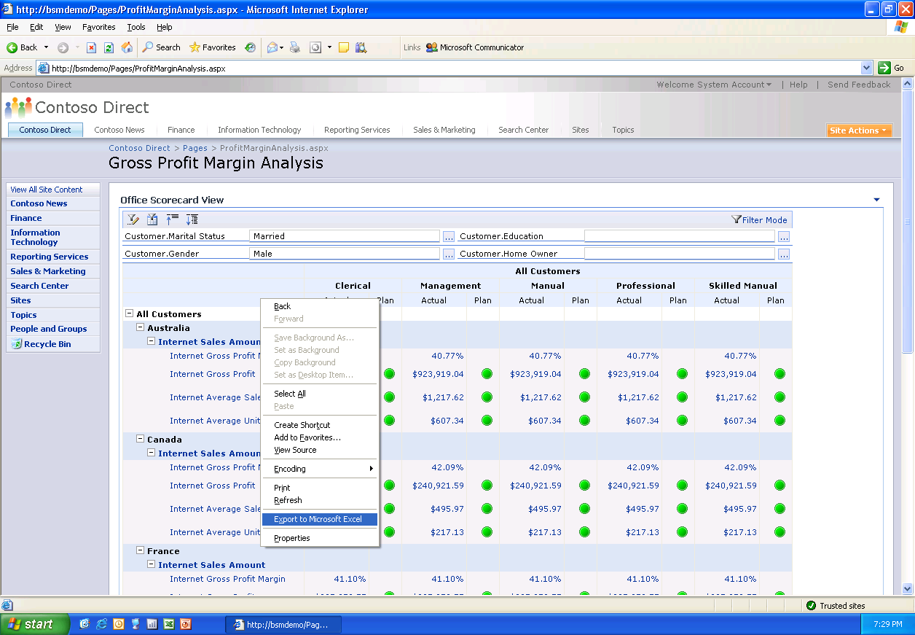
Figure 7: Red, yellow, and green icons help display KPIs exportable to Excel.
Microsoft Business Intelligence in Action
Claus Hansen hopes to book more than 40 million passengers in 2006. To monitor his progress, he creates a scorecard for each of the 30 cities that his airline serves across the country. He can then track which of the cities are meeting the necessary numbers that will enable him to meet his goal and which cities are lagging behind. The simplified icons summarize performance in a clear and easy-to-understand format. Green means the route is meeting its percentage goal and red means a route is not. Yellow serves as a warning that a route is either slightly above or below expectations. These icons make it much easier for Hansen to know where to focus his energy on driving business with discounts or special offers.

Strategy Map Visualization
To create a powerful visual representation of your strategy, Business Scorecard Manager offers Strategy Map Builder. This feature enables you to use the rich functionality of Office Visio 2007 to publish your KPIs and corporate initiatives in a process flow diagram. The clear graphical interface provides precise interpretation of data and easy-to-understand graphical representations. Sales results tracked in Business Scorecard Manager can also be presented in a geographical context through Office MapPoint 2007.
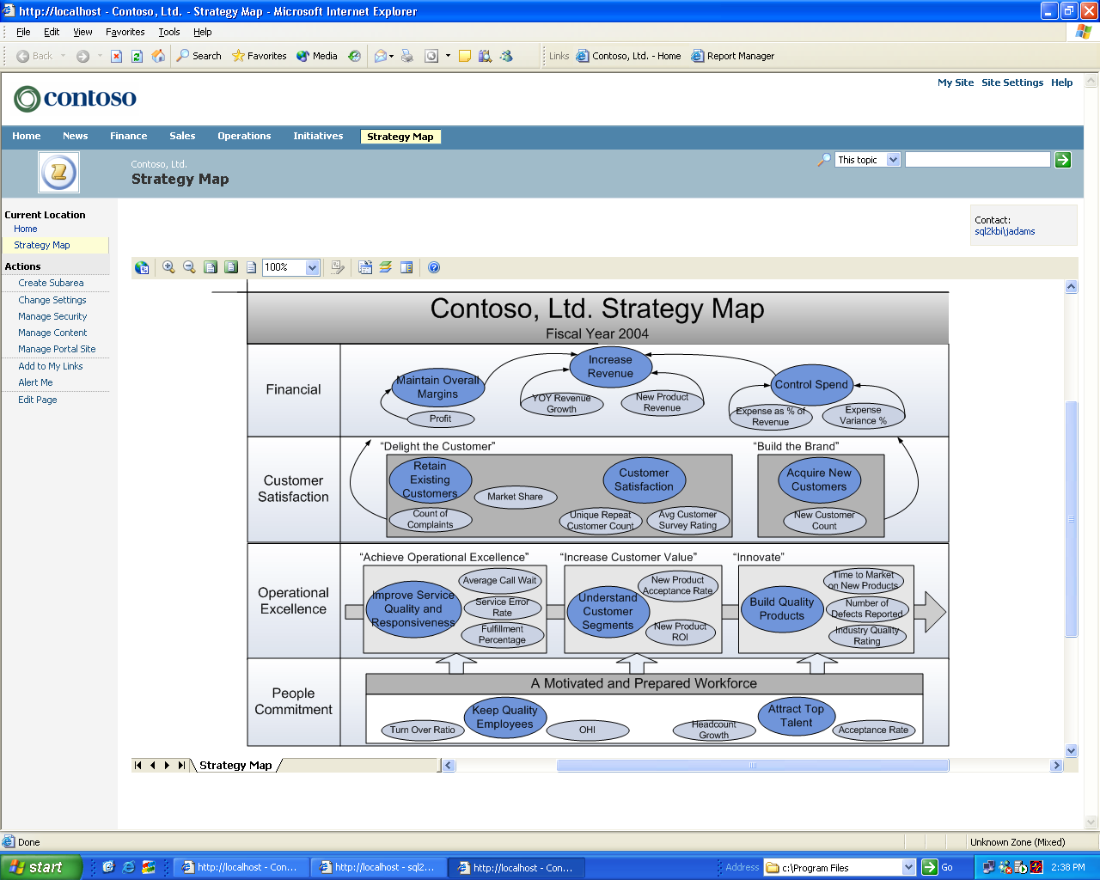
Figure 8: Viewing a strategy map in Business Scorecard Manager

Powerful Analytics
ProClarity Analytics provides your organization with powerful yet simple-to-use analysis tools ranging from ad hoc querying to sophisticated analytic modeling, built on the Microsoft Business Intelligence platform. ProClarity provides unique tools for your decision makers to explore large quantities of data in a way that provides rapid insight. Intuitive data navigation, powerful calculation, and patented advanced visualizations are the core components that allow ProClarity Analytics to help your decision makers answer the question “Why?” regarding business change.
The ProClarity Analytics Server is the central component of the ProClarity solution that provides simple access and use of data cubes and Unified Dimensional Models (UDM) from Microsoft SQL Server 2005 Analysis Services. ProClarity Analytics Server comes with a repository, the Analytics Server database, which facilitates more secure storage, as well as exchange and management of business logic, metadata, and analytic data views. The Analytics Server delivers relevant data views to end-user clients more securely in the form of Briefing Books.

Advanced, Patented Data Visualization
Your employees need to quickly make sense of the large amounts of data generated by their business systems. They need more than a report, more than an indicator, more than a trend line, and more than a data dump. They need the access to move quickly from seeing what is happening to clearly understanding why. ProClarity’s patented data visualizations enable your decision makers to quickly understand complex data, and spot trends, patterns and outliers in your business data for making more informed decisions.
- Decomposition Tree - This patented feature is one of ProClarity’s most popular visualizations. As you focus through layers of information to analyze root cause, each step is graphically displayed, showing the path you took. The tree can be saved for future reference, or shared with others. A tree can be initiated from any point on any ProClarity-linked business chart.
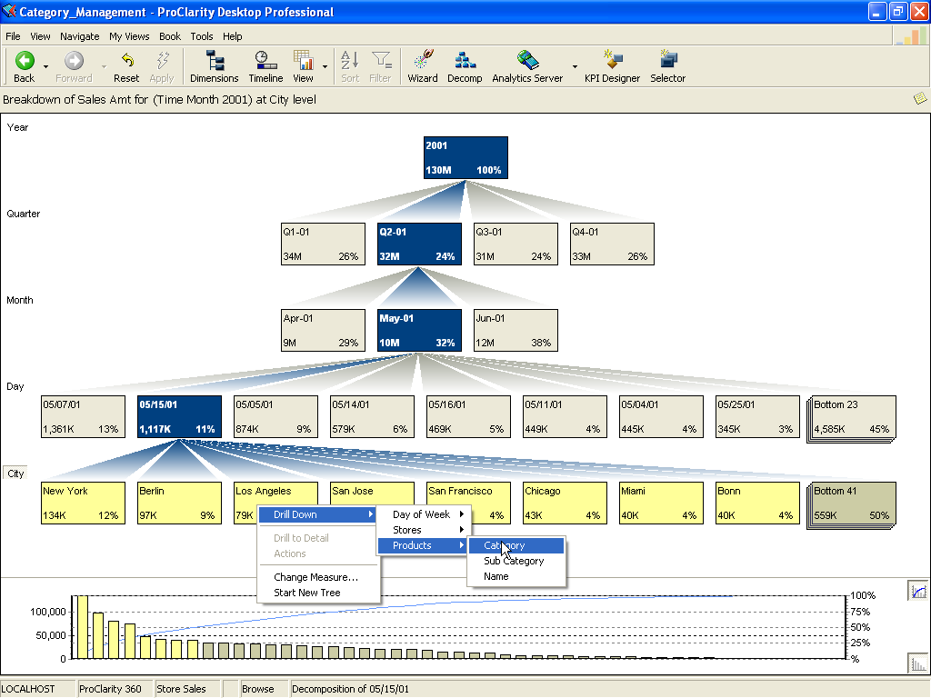
Figure 9: ProClarity’s Decompositon Tree allows users to more easily perform root-cause analysis.
- Performance Map – Using heat map technology with the Performance Map, you can quickly see the relevance of large quantities of data. Based on parameters you define, it allows you to easily compare two measures at one time. This visualization uses size (bigger shapes mean bigger impacts) and color (indicating the level of performance) to determine performance.
- Perspective View - Using quadrant analysis, the Perspective View helps you quickly see patterns in the data, identify trends, and isolate outliers. The lines that delineate the quadrants are even movable so you can instantly view different scenarios.

Extend Analytics Beyond the Firewall
ProClarity was designed with your decision makers in mind; it empowers them to investigate, understand, and take action on their business data. ProClarity’s powerful analytic features are also available as zero footprint or “thin” analytic components. When used within Office SharePoint Server, these ProClarity components provide a solution for distributing insight outside your firewall (extranet or intranet). This enables your partners, suppliers, and customers to perform the same types of analysis that your decision makers do. In addition, it adds a layer of collaboration to your relationship.
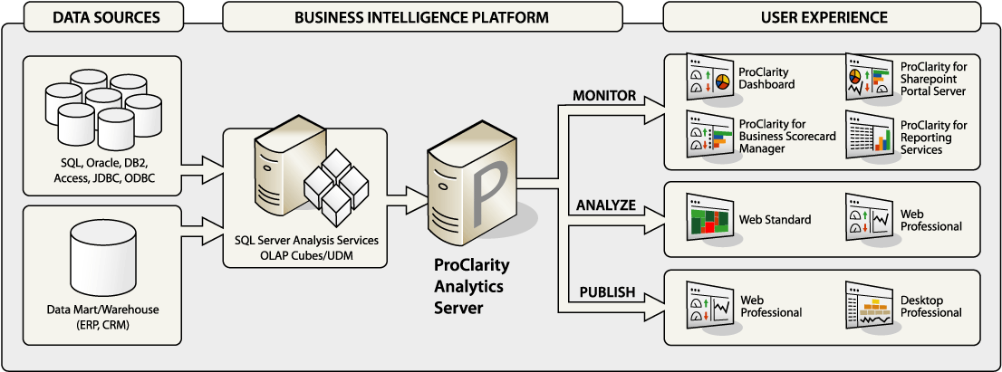
Figure 10: ProClarity architecture diagram with end user deployment options

“Click to Analyze” Functionality
ProClarity integrates seamlessly with the other Microsoft business intelligence products including Microsoft Office, SQL Server Reporting Services, Office SharePoint Server and Business Scorecard Manager for providing analytics within the applications your decision makers use daily. ProClarity helps your decision makers go beyond simply monitoring their data in other applications to quickly investigating the data drivers on their own using ProClarity’s “click to analyze” functionality. This feature opens a ProClarity view of the data they were monitoring. Simple interfaces and powerful advanced visualizations help reduce the amount of time your decision makers spend sorting through large quantities of data.
For example, business managers who need to conduct additional analysis on performance metrics in a Business Scorecard Manager scorecard can seamlessly jump from basic monitoring to full ad hoc analysis in one of the zero footprint ProClarity Web clients. This process retains the context of the analysis by passing along all the parameters from the scorecard, including filtering and drilling down on the charts. This powerful connection between monitoring performance and uncovering underlying trends in the data leads to better decision making and a more successful overall scorecard solution.
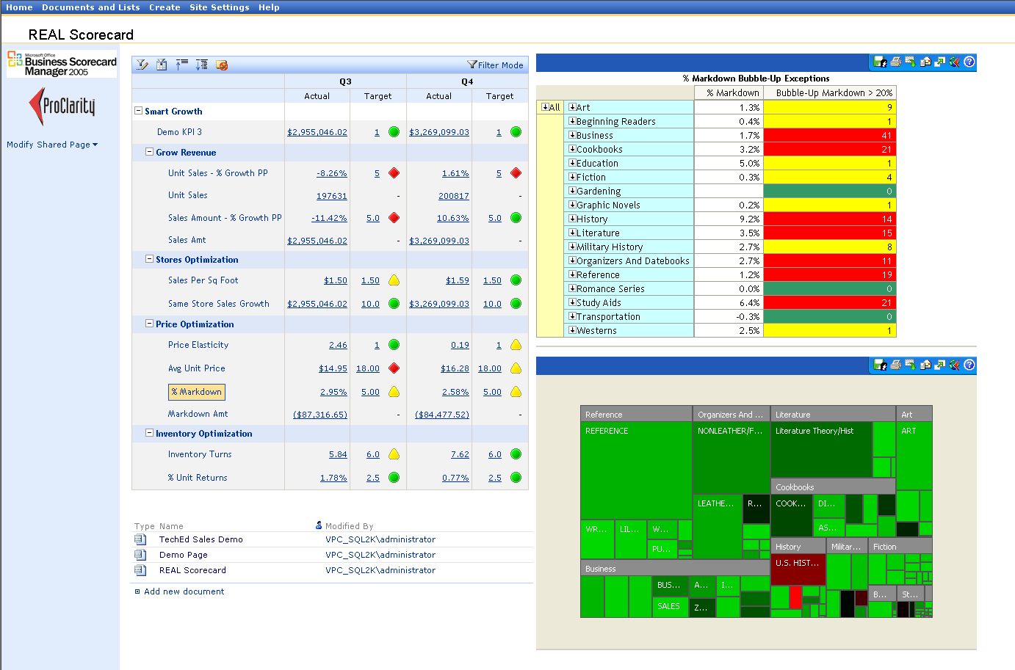
Figure 11: ProClarity Analytic views embedded in a Business Scorecard Manager scorecard running in Microsoft SharePoint Portal Server for monitoring business performance

Centrally Managed, Shared Business Logic
Your organization needs to align on common definitions for business logic, and propagate best practices in analysis across your organization. In other words, you want to rely on ‘one version of the truth.’ By making use of centralized business logic that is built and managed by decision makers, you have a simpler process for creating custom KPIs and filtered sets without knowing MDX. It all starts with the ProClarity Business Logic Server.
The ProClarity Business Logic Server is a middle-tier server component that delivers strategic value to enterprises in its ability to centrally store, manage, and propagate centralized business logic, views, sets, and KPIs. ProClarity Professional users can create, publish, and manage analytic logic using the KPI Designer or the Selector.
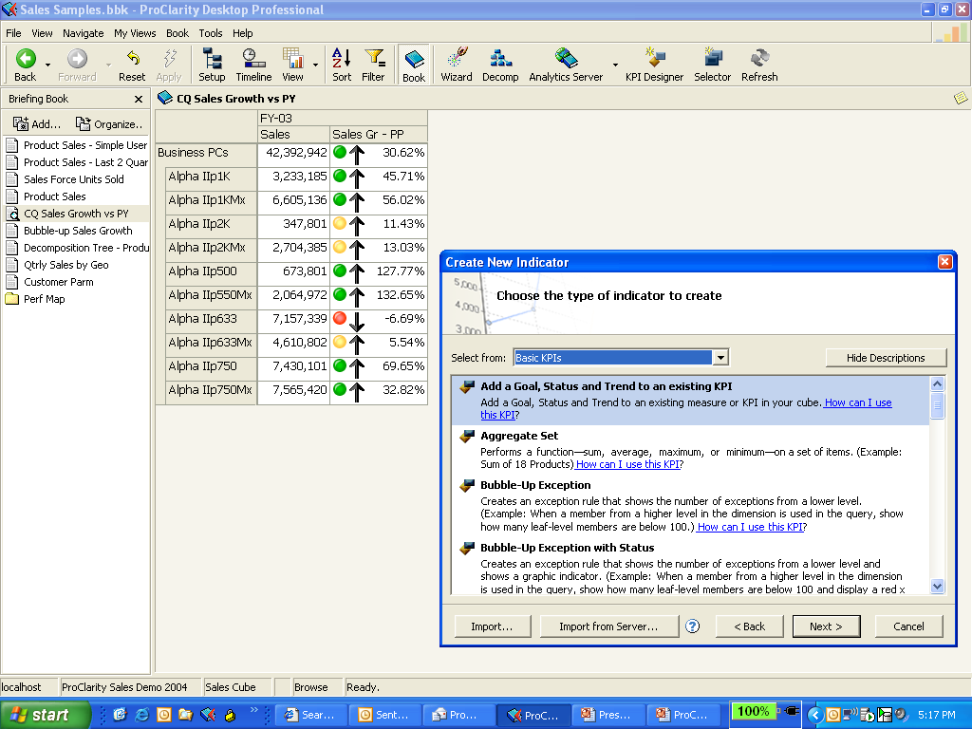
Figure 12: ProClarity KPI designer comes with templates that contain KPI formulas and parameters that can be easily edited to conform to your data model and best practices.
The KPI Designer and Selector are tools that employ wizards to guide users through creating, managing, and publishing analytic definitions—without having to know the underlying query language. Users can work independently, without burdening your information technology professionals. Analysts create the business logic that is stored to the Business Logic Server and published throughout the enterprise to ensure everyone is using ‘one version of the truth.’
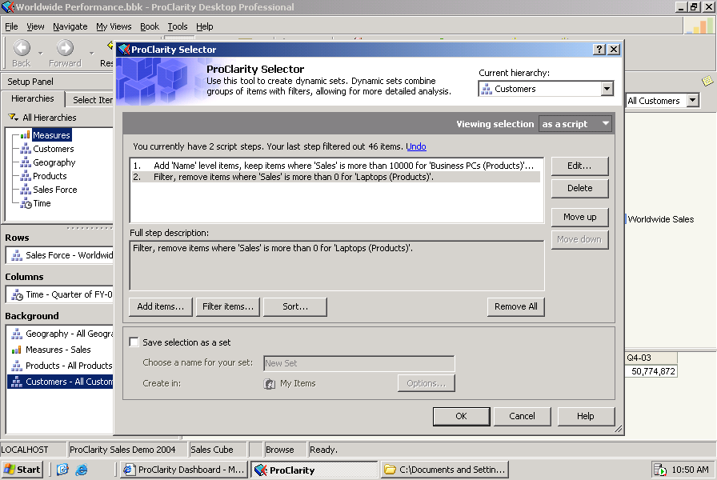
Figure 13: ProClarity Selector makes it easier for your users to create specific data sets, such as at-risk customers or best customers, without having to know the underlying query language.

Scalable Platform
Tight integration with other Microsoft programs makes Business Scorecard Manager and ProClarity extendable and customizable. End user resources such as Office SharePoint Server 2007 and Excel Services enable browser-based access for loading, calculating, rendering, and interacting with Office Excel 2007 spreadsheets on servers. A complete and fully integrated BI platform including integrated reporting, analysis, and database services in SQL Server 2005 supports all facets of decision making. You can also extend your solution to performance management applications such as budgeting, planning, and forecasting.

Web-Based Development and Administration
Business Scorecard Manager comes with Web-enabled capabilities that provide you with authorized access to scorecards through the Internet, giving you quick access to analysis functionality for filtering, sorting, and ranking. Microsoft provides two Web Parts for Business Scorecard Manager: Office Scorecard View Web Part and Office Report View Web Part. Both components can be added to a page on a SharePoint site. You can also create your own Web Parts that integrate with Business Scorecard Manager. This functionality can be used to incorporate your own charting controls or a third-party analysis tool.
ProClarity for SharePoint Portal Server is a Web part that displays ProClarity analytic views within a SharePoint Portal system. It enables the deployment of a zero-footprint Web client with centrally managed business logic, making it easier for IT staff, business users, and analysts to publish meaningful analytic views to a SharePoint Portal Server with zero code. It also allows for thorough analysis of enterprise data from a variety of sources and provides “one version of the truth” in your portal.

Integration with SQL Server 2005 Analysis Services
Business Scorecard Manager integrates with SQL Server 2005 Analysis Services (SSAS), enabling you to use an Analysis Services OLAP database as the source for your scorecard KPIs and benchmark data. Data source modules help you map scorecard definitions to the SSAS cube that you’re using as your source. The server uses the metadata to link to data sources, as well as to determine how scorecards are to be rendered on a SharePoint site.
ProClarity takes advantage of the significant BI enhancements in SQL Server 2005. ProClarity simplifies the UDM for your decision-makers by showing relationships between dimension hierarchies, attribute hierarchies and measures through context filters that focus the information your users receive.

Integration with Office SharePoint Server 2007
By integrating Business Scorecard Manager and ProClarity with an Office SharePoint Server 2007–based Web site, scorecard KPIs and ProClarity analytic views can be displayed in SharePoint sites using specific scorecard or ProClarity Web Parts. While scorecards tend to be highly summarized, the SharePoint Scorecard Web Parts are interactive so you can filter the views or drill down to see different levels of scorecard detail. Embedding a ProClarity view in a SharePoint site through a ProClarity Web Part enables you to include as much or as little analytic horsepower in the portal as users require—from static data views to full ad hoc interactivity. Advanced collaboration features in Office SharePoint Server 2007—such as document sharing, live chat, and links to subject matter expert sites—help make it easier for managers to establish chains of responsibility based on their strategy map. To help maintain security, organizations can provide authorized access to scorecard projects through the Internet.
Microsoft Business Intelligence in Action
The sales force at Blue Yonder Airlines is constantly on the road, working on corporate deals that establish Blue Yonder as the preferred airline for business travelers. The roll-up functionality of Business Scorecard Manager scorecards enables sales team leaders and executives to see the big picture, while the detail functionality helps them to identify what, or who, is causing a margin or revenue problem. To make real use of this information, the sales leaders need anytime, anywhere access to their information. Having key information posted on a SharePoint site enables them to stay current, minimize errors, and feel confident that everyone is working from the same information.

Enhanced Performance Management Tools
Microsoft Office PerformancePoint Server 2007 is an integrated performance management program that helps you align your business activities with corporate strategy. Using the familiar Microsoft Office system and SQL Server applications, you can provide all employees with the ability to plan, budget, forecast, report, and scorecard their activities. Improved control, collaboration, efficiency, and business management features help improve your overall business performance and decision making. Office PerformancePoint Server will combine the power and functionality of both Office Business Scorecard Manager and ProClarity Analytics along with a new planning module.

Improved Compliance and Control
Office PerformancePoint Server offers a variety of features that help measure performance as well as help ensure compliance and control over financial information. With Office PerformancePoint Server, you can model and plan different views of your business at multiple levels using budgets, KPIs, and scorecards. Develop scorecards and management reports that track financial and organizational performance against corporate, departmental, and workgroup goals. Create plans, budgets, and performance measures for multiple organizations and business processes. Office PerformancePoint Server also supports generally accepted accounting principles (GAAP) and statutory reporting.

Increased Time Savings
Office PerformancePoint Server is in step with the rhythm of your business. Using Office PerformancePoint Server workflow, approvals, templates, and forms, you can make integrated planning, budgeting, forecasting, scorecarding, and reporting a central part of your regular management process. With Office PerformancePoint Server you can provide your business with guided analysis and rich context that helps improve the speed and depth of your work. For example, alerting and notification features automatically track changes in KPIs and detect business-critical events.

Improved Collaboration
Office PerformancePoint Server empowers all employees with improved collaboration tools, so everyone can contribute to business management. Choose from familiar communication tools such as Office Outlook, or for real-time collaboration, Microsoft MSN® Messenger and Office Live Meeting. All three options enrich your regular performance management process, providing you with efficient communication. Your employees can also use annotations and discussions to enhance the value of analyses.

Improved Business Management
Office PerformancePoint Server helps your employees manage their own activities and make meaningful contributions to managing your business. A user-friendly design and easy-to-understand wizards enable employees to create their own budgets, plans, scorecards, and business rules without the need for programming. Transparent set-up plans, budgets, and KPIs help everyone in the organization understand performance. Synchronization capabilities enable people to work either online or offline without missing a beat. And because Office PerformancePoint Server helps push KPIs and analytics data into the familiar Microsoft Office system environment, users can better focus their energies on interpreting data.

Improve Decision Making
Office PerformancePoint Server helps you unlock the value of information in enterprise resource planning (ERP) systems. A single view of information enables you to integrate information from multiple data sources and multiple copies of plans and budgets. Centralized management provides one place for IT to set up, deploy, administer, and manage performance management solutions. Tight integration with Microsoft Office brings the power and accessibility of the Microsoft Office system into performance management. Smooth integration with SQL Server applications enables you to use the performance, scalability, and enhanced security of SQL Server to gain valuable insight into your business.

Reporting and Analysis
Organizing and analyzing large amounts of data can be a challenging task. Microsoft Business Intelligence provides an effective and efficient way to work with all of your data in one location. Tight integration between Office Excel 2007 and SQL Server Analysis Services and SQL Server Reporting Services enables you to use the familiar Excel spreadsheet environment for exploratory data analysis. Most important, you get easy delivery of business intelligence to where you work.
Office Excel 2007, part of the 2007 Microsoft Office system, offers a powerful and comprehensive set of analytical tools that helps you efficiently work with complex data. Office Excel 2007 can connect to enterprise data and maintain a security-enhanced and persistent connection between spreadsheets and the back-office data source. This not only enables you to make easy updates to Excel worksheets, it gives you the ability to focus within Excel to more detailed levels of information to spot exceptions and trends.

Manage Data More Effectively
Office Excel 2007 and ProClarity offer sophisticated calculation capabilities and powerful analytic tools that help you explore complex data relationships quickly and easily.

Microsoft Office Fluent User Interface
Office Excel 2007 offers the Microsoft Office Fluent™ user interface, which presents the appropriate tools at the right time so you can produce your best work more quickly. With the Office Fluent user interface, all important features are organized and presented in context. For example, intuitive Table Galleries show you how a table will look before you make your final selection.
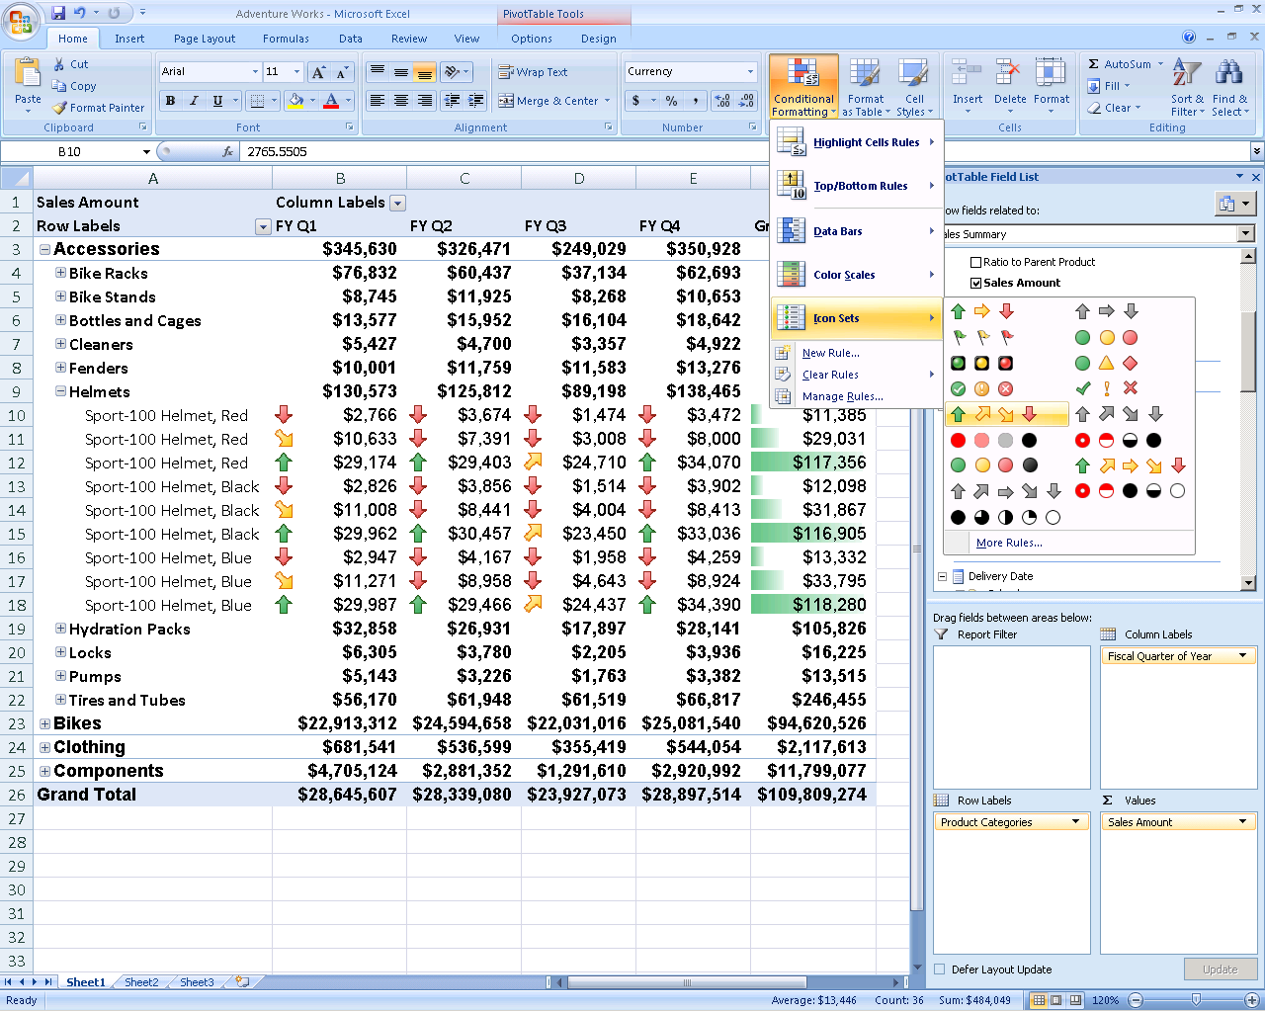
Figure 14: New Office Excel 2007 visualization

Increased Spreadsheet Row and Column Capacity
To facilitate importing and working with large amounts of data, Office Excel 2007 offers a larger spreadsheet capacity—1 million rows by 16,000 columns—than previous releases. As a result, you rarely need multiple spreadsheets to contain your data.
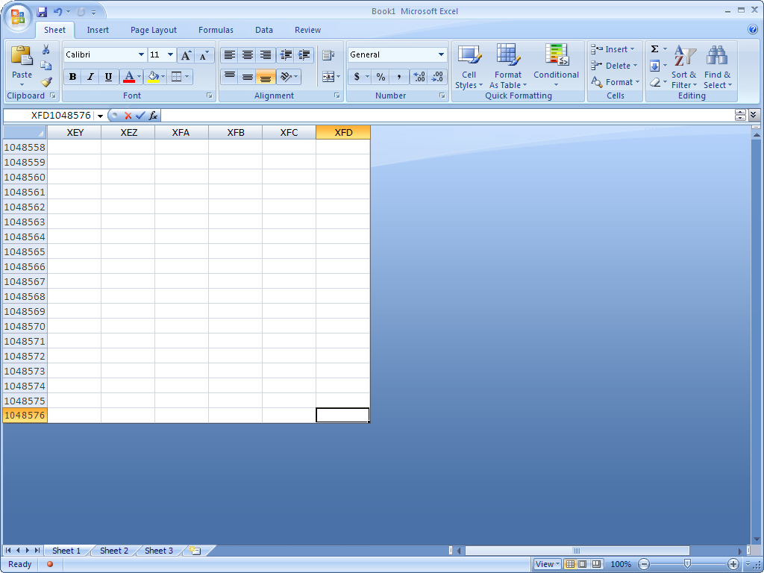
Figure 15: Increased row and column capacity

Faster Performance
Office Excel 2007 provides the fastest Microsoft Office spreadsheet calculation to date. Using multi-threaded recalculations, Office Excel 2007 spots formulas that can be calculated concurrently and then runs those formulas on multiple processors simultaneously. The number of processors depends on the number of available processors on a computer.

Improved Formula Authoring
Improved formula authoring in Office Excel 2007 means you can use an expanded set of functions, including new cube functions, to query data contained within SSAS. A context-based Formulae AutoComplete enables you to write the proper formulae syntax the first time, every time. A resizable formulae bar helps prevent long, complex formulae from spilling over onto your spreadsheet.
In addition, Office Excel 2007 offers structured referencing for citing named ranges and tables within formulae and functions. The Name Manager feature helps you organize, update, and manage multiple name ranges from a central location.
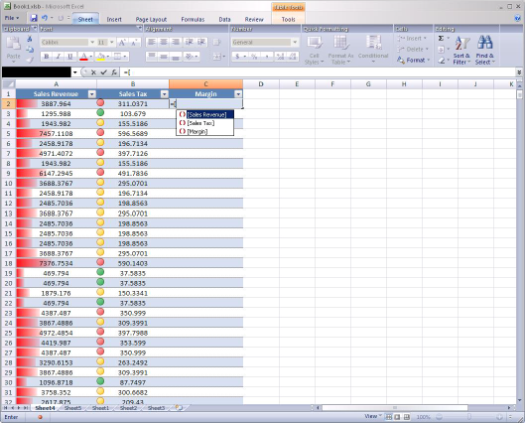
Figure 16: Drop-down formulae creation

Enhanced Sorting and Filtering
New and improved sorting and filtering options within Office Excel 2007 help you better organize and work with data contained in tables. Sort your information by date, selection, or even color if you choose. You can manage up to 64 sorting levels from a single central location. In addition, an AutoFilter feature simplifies complex filtering, such as applying custom filters to more than two items.
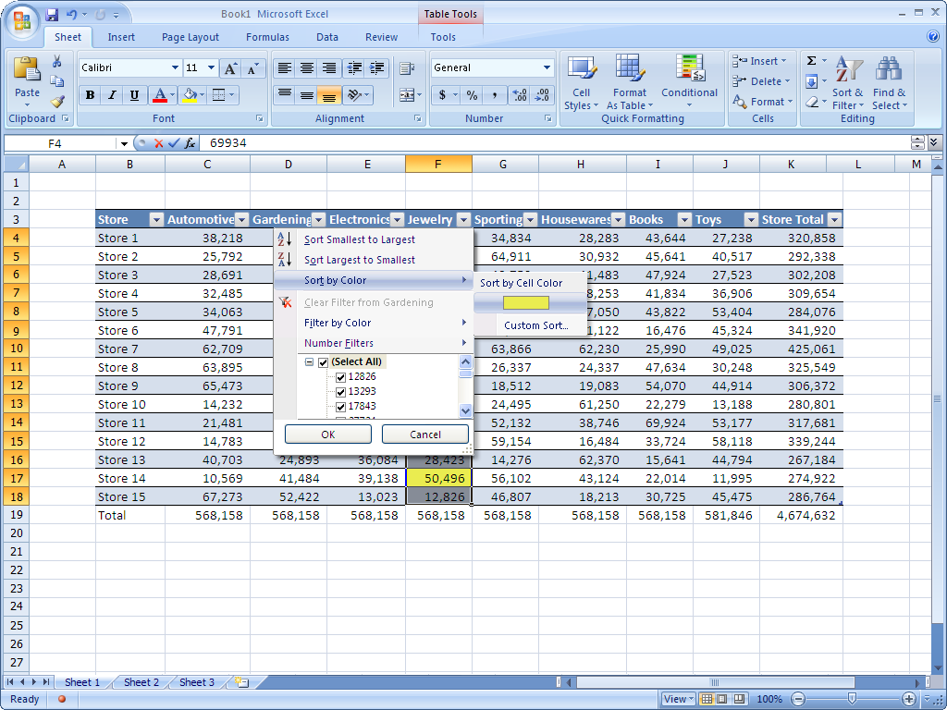
Figure 17: Enhanced filtering and sorting
Microsoft Business Intelligence in Action
Claus Hansen used to grow frustrated with his inability to find more meaning in his statistical data. By using enhanced filtering and sorting features in Office Excel 2007, he can sort his passenger information by date. With the ability of Office Excel 2007 to sort by color, Hansen can better identify airports that consistently have the highest sales volume. He can then share this insight with the sales and marketing teams, and with board members during their next meeting.

Enhanced PivotTable Views and PivotChart Views
Office Excel 2007 offers new tools for exploring and analyzing with PivotTable views and PivotChart views.
With the PivotTable Field List, you can use a clear, side-by-side view to select the fields you want to include in a list. You can also drag fields in different orders to alter the hierarchy of your information. In addition, a Chart Gallery can help you quickly modify the look of a PivotTable view.
Enhanced filtering tools enable you to date and label filters, select multiple items, and reveal filter entry points. You can also sort by various fields, such as color or compact axis, and then view your results.
In Office Excel 2007, you can take advantage of these features while working within a browser so you can interact with a PivotTable view smoothly—whether you are working with Office Excel 2007 on a desktop or in a Web browser.
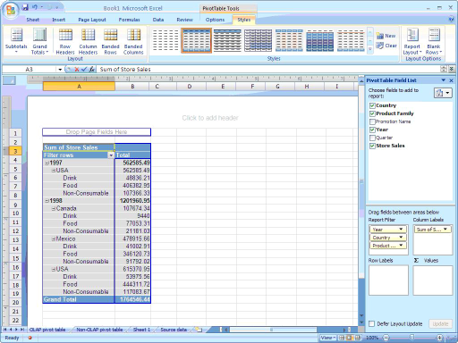
Figure 18: Creating a PivotTable view

PivotTable view enhancements make them more readable and presentable. For example, compact row axes display multiple fields in one column. New style options available from the Table Gallery make it easy for you choose a style that is consistent with the look of your table or other aspects of your spreadsheet.

Simplified Conditional Formatting
Office Excel 2007 offers simplified conditional formatting that can be represented in various new data visualization schemes. Discover important trends and highlight exceptions in your data. Identify and illustrate your results with colored gradients, data bars, and icons. You can then reorganize the data with sorting options like Sort by Smallest to Largest or Cell Color.
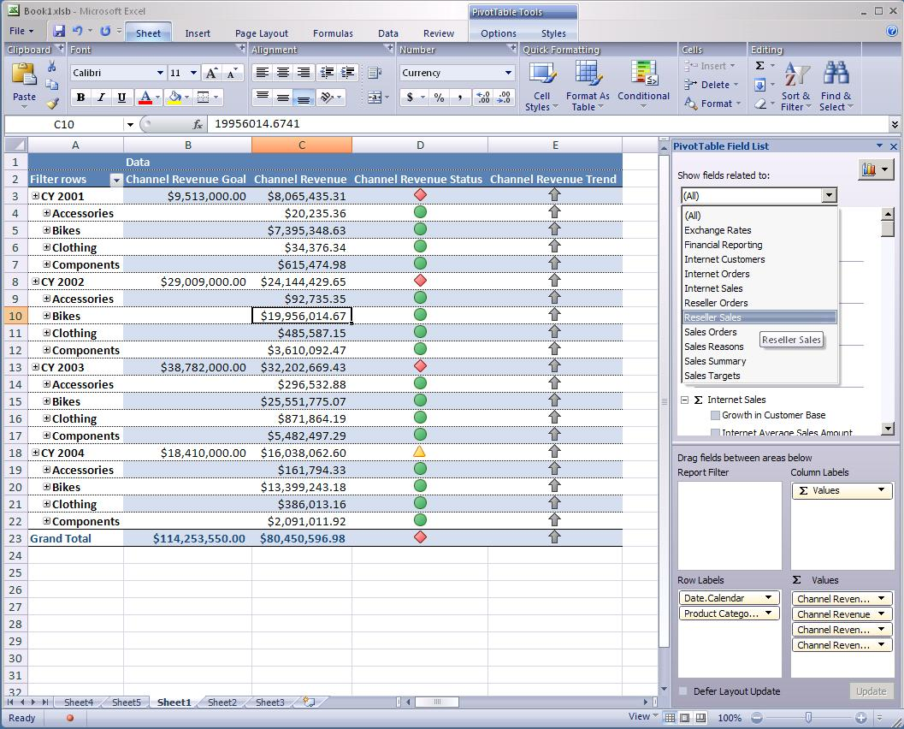
Figure 19: Unified Dimensional Model exposing data as a PivotTable report

Support for SQL Server 2005 Analysis Services
Office Excel 2007 and ProClarity integrate smoothly with SQL Server 2005 Analysis Services to help you easily extract information from your data warehouse. As a result, end users can better understand the context for the data they are analyzing.
SSAS provides a metadata model, called a Unified Dimensional Model (UDM), for defining business logic, calculations, and metrics. The UDM serves as the central metadata repository for all reports, spreadsheets, OLAP browsers, and KPIs. By being connected to the UDM in SSAS instead of the data in a spreadsheet, you can quickly find what you need by using a field list. PivotTable views and PivotChart views in Office Excel 2007 expose three types of fields—measures, KPIs, and dimensions for slicing data (time, geography, product, and so on). All three groups have different icons. Different components of a KPI (Value, Goal, Status, and Trend) can be added to the Values area of a PivotTable view so you can track the latest values of your key business metrics.
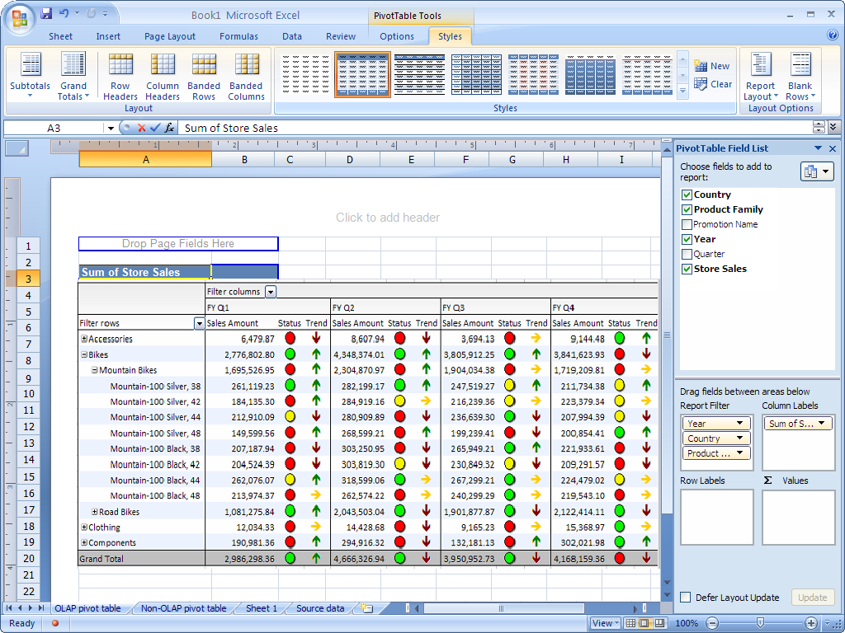
Figure 20: Integration with SQL Server 2005 Analysis Services
ProClarity provides further functionality and tools that make it easier to use, share, understand, and explore data in the UDM. ProClarity helps reduce potential end user confusion by simplifying the UDM through context filters and advanced visualizations for ad hoc data investigation.
ProClarity context filters help your organization harness the power of the UDM while simplifying the way that end users see and analyze the data. They enable your business analysts to manually restrict the measures, dimensions, and hierarchies that end users see; they also filter out irrelevant hierarchies when users are working with a specific measure group.
Office Excel 2007 and ProClarity also support perspectives, subset views of a cube (defined in SSAS) that only contain information needed for a given purpose. In Office Excel 2007, a perspective looks like any other data source.

Improved Charting Tools
Dramatically improved charting tools within Office Excel 2007 help you easily summarize your analysis in professional-looking charts. Format axes, titles, and other chart labels with a few simple clicks. Add visual enhancements like 3-D effects, shadows, and glow. It’s that easy.
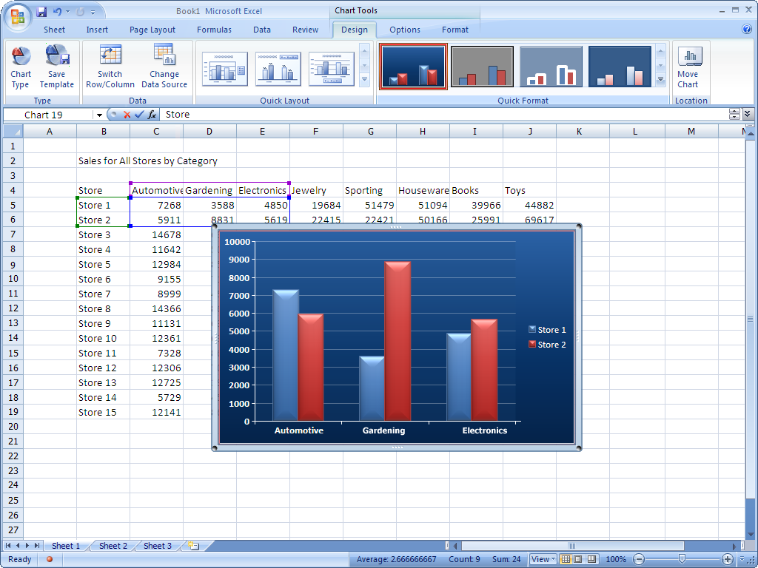
Figure 21: Charting tools
The improved charting capabilities in Office Excel 2007 are shared across the 2007 Microsoft Office system, meaning that when you copy tables and objects between programs, the items maintain their appearance. As a result, working simultaneously with different programs becomes more consistent and less frustrating.

Data Connection Library
The Data Connection Library in Office Excel 2007 simplifies how you connect to external data sources. The library centralizes storage of Business Data Catalog connections to external data, making it easy to discover new sources of data. You can use Data Connection Library to import external data directly into your spreadsheet—without having to provide password authentication.
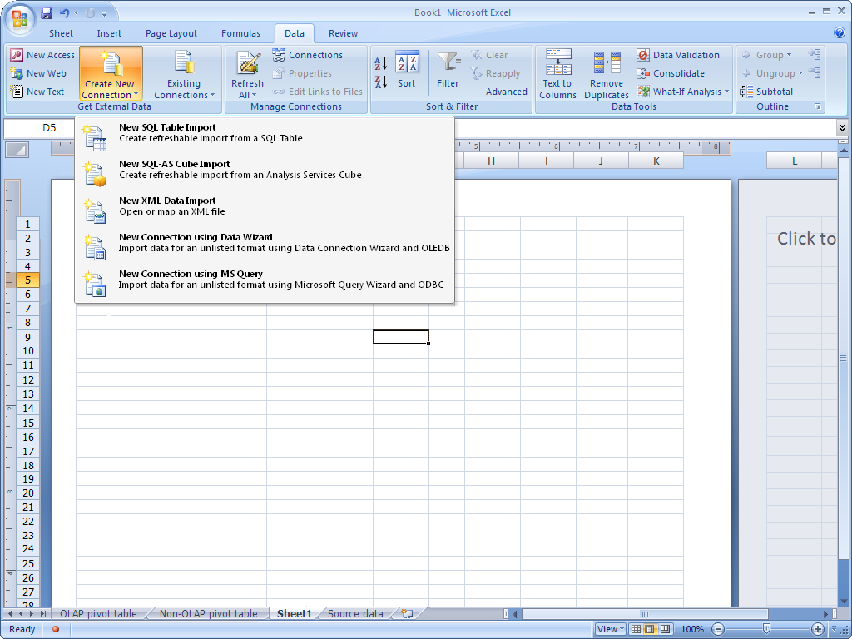
Figure 22: Data Connection Library
The Data Connection Library also simplifies the maintenance of data connections. If a connection changes, it needs only to be updated in the library instead of in the individual spreadsheets that are linked to the original data source.

Advanced Analytics
As a key component of the Microsoft BI offering, ProClarity Analytics gives your analysts and business professionals a simple, powerful, and adaptable tool to analyze data and gain the insight they need into corporate performance. Analytics are critical for helping your users understand the drivers behind KPIs and take action on the results. ProClarity moves your decision makers beyond monitoring ‘what’ is happening in the business, to understanding ‘why.’

Advanced Data Visualization
More information means richer analysis but it also can lead to more time spent navigating through data. ProClarity includes advanced visualizations, such as the patented Decomposition Tree, Performance Map, and Perspective View to help your users more quickly understand the driving forces behind their business data. They are designed to present large amounts of data and multiple measurements in a way that helps your decision-makers understand why the key metrics driving your business are changing, and quickly identify trends, opportunities and threats.
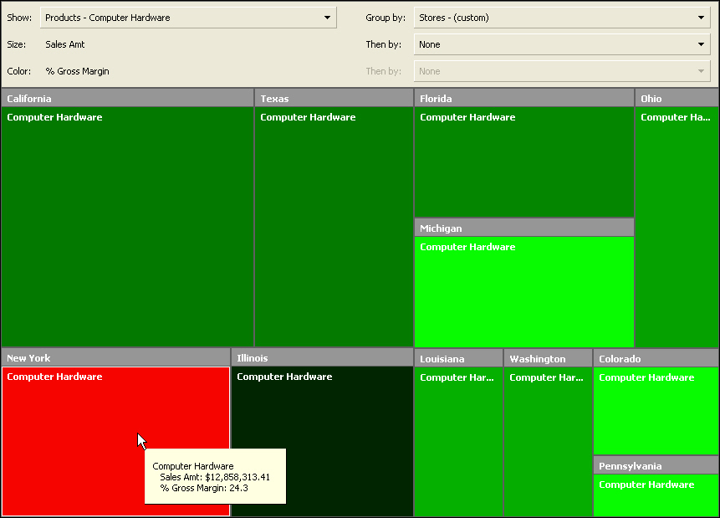
Figure 23: ProClarity Performance Map is a powerful visualization tool for analyzing large data sets.

Zero-Footprint Dashboards
ProClarity dashboards simplify the creation and deployment of data for monitoring and analysis. The dashboard works in conjunction with the ProClarity Analytics Server to deliver data to your decision makers who need simple access to data in order to monitor and analyze corporate performance. ProClarity dashboards are optimized for Web deployment; provide interactive, on-chart navigation; and integrate data views created in a ProClarity client as well as other URL-addressable content like Reporting Services reports, and Web sites. This is a perfect starting place for your users who need to monitor data. With ProClarity dashboards, your users can easily access prebuilt dashboards, conduct light analysis, and launch into full ad hoc analysis to investigate root cause when necessary.
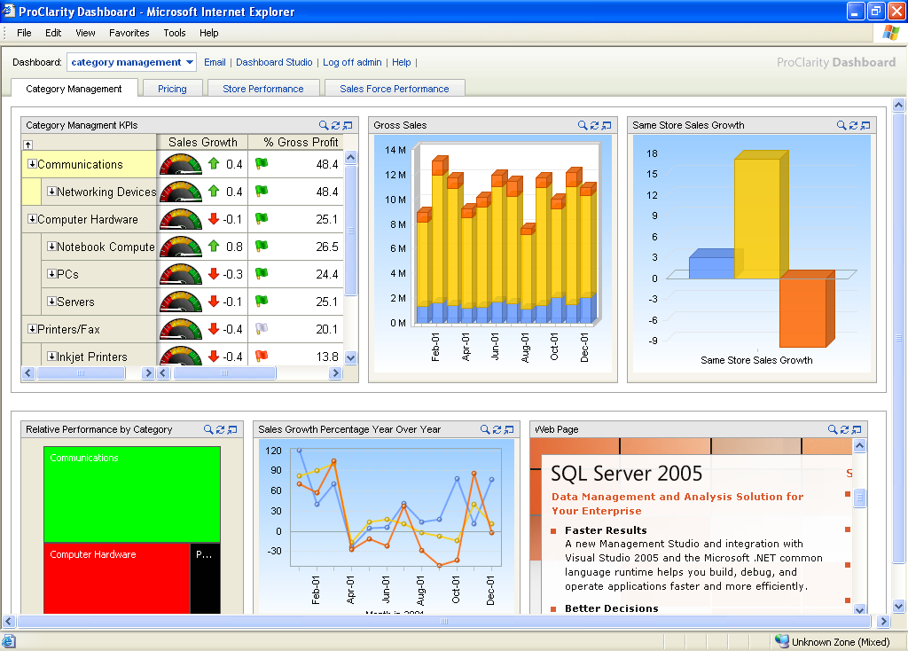Figure 24: ProClarity Dashboards include charts optimized for Web deployments and interactive, on-chart navigation. They give users easy access to relevant, centrally-managed content.

Build a Fully Integrated Enterprise Portal
Collaboration and communication resources are important components of every successful business. Office SharePoint Server 2007 enables you to improve employee interaction with a fully integrated enterprise portal. Reduce the cost of dashboard creation and maintenance by building a custom Web-based dashboard without writing any code. Capitalize on your existing Excel knowledge to access data, perform calculations, and format the spreadsheets that are shown in the dashboard. Office SharePoint Server 2007 also provides a set of client and server document services to help you manage, work on, and search through all of your content.
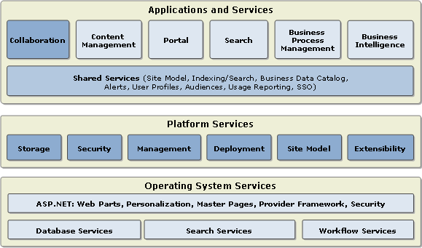
Figure 25: Office SharePoint Server 2007 architecture overview

Tight Integration of Data
Office SharePoint Server 2007 introduces new technologies that provide advanced and interactive collaboration features that enable you to integrate data and see different levels of detail. Document sharing and links to subject matter expert sites also help make it easier for you to establish chains of responsibility.

Business Data Catalog
Office SharePoint Server 2007 provides an easy way for you to integrate business data from SAP, Siebel, or similar applications with your corporate portal. Create metadata that describes the database or Web Service and then register the exposed data in Business Data Catalog. Business Data Catalog can use this metadata to retrieve relevant data.
After you register a data source in Business Data Catalog, the business data entities are available for use by any of the following business data features:
- Business Data Web Parts display any entity from Business Data Catalog without deploying new code. The Web Parts provide customization, connections, and the standard look and feel of Microsoft Windows SharePoint Services.
- Business Data in Lists enables you to add any entity defined in the Business Data Catalog to a SharePoint list or document library.
- Business Data Actions provide a link to the back-end data source. Actions are implemented as links, so you can also use actions to perform simple procedures such as sending an e-mail message or opening a customer’s home page.
- Business Data Search offers a full-text search of the data sources registered in Business Data Catalog.

Simplified Dashboard Building
Using Office SharePoint Server 2007, employees with the appropriate SharePoint permissions can create a dashboard with just a few clicks. Once you’ve created the dashboard, you can choose which Web Parts you want to display as well as where they’re displayed. You then configure the dashboard within your Web browser by setting up which spreadsheets are shown (and how), what KPIs are shown in the KPI list, and what filters should be made available. None of the procedures require you to write code.
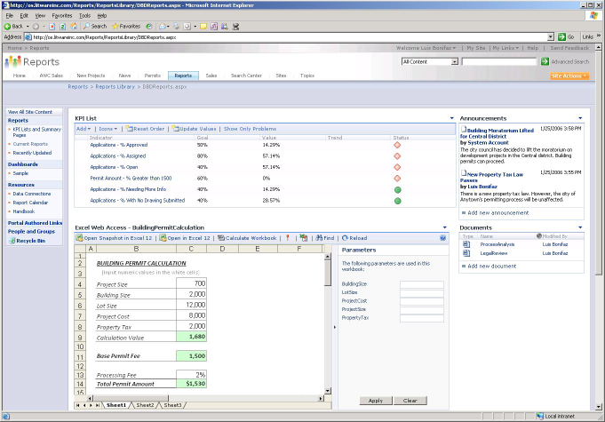
Figure 26: Excel Services with a KPI list

Content Reuse and Distribution
Office SharePoint Server 2007 supports the distribution and reuse of content by using “live copies.” A live copy is a document a user copies to another SharePoint site location that retains a pointer to the original document. When the original document is edited, Office SharePoint Server 2007 notifies the user, who has the option of updating the copy. In addition, Office SharePoint Server 2007 offers rendition support, which enables users to locate the same content that has been saved in a different file format.

Document Management
Office SharePoint Server 2007 provides a set of powerful and scalable client and server document services that help users manage and work with large volumes of content.

Enhanced Privacy and Security
Office SharePoint Server 2007 enables you to set privacy policies on user profile properties, colleagues, and memberships, and restrict who can access personal information. Draft item security gives a site administrator the ability to review submitted content before making it visible on the site. You can limit the visibility of properties, colleagues, links, and memberships to Only Me, My Manager, My Workgroup, My Colleagues, or Everyone.

Records Management
Information technology breeds a glut of information. Records management in Office SharePoint Server 2007 helps with deleting, managing, and long-term content storage. Making use of Office SharePoint Server 2007, records managers can set up a records repository according to their organization’s file plan, which helps ensure that the records in the repository are not altered. In addition, you can create multiple libraries for organizing different types of business records. You can also capture records from external sources such as document management systems, e-mail messaging servers, and Outlook and route them to the correct location in the repository.

Audit and Policy Reporting Tools
Office SharePoint Server 2007 provides tools for both audit and policy reporting. Audit reporting enables you to track events that occur on documents within a site. Policy reporting helps you to gather information on how policies are being implemented within a site. Policy reporting examines an entire site and returns information concerning policies in use and each policy’s percentage of use.

Information Rights Management
New to Office SharePoint Server 2007 is the ability to make information rights management (IRM) available for document libraries. When a user attempts to download a file from a library, Office SharePoint Server 2007 first verifies that the user has permissions to the given file and then issues a license to the user that enables access to the file at the appropriate permissions level. Office SharePoint Server 2007 then downloads the file to the user's computer in an encrypted, rights-managed file format. The user has access to the file only as long as his or her license remains valid. The site administrator can select one of two ways to determine when the license expires:
- Specify a date when file accessibility for the user expires.
- Specify that the user must renew the license every set number of days or they will lose accessibility.

Search Center
Office SharePoint Server 2007 simplifies how you search for information, enhancing your capabilities in portal sites, team sites, content management sites, and custom headless search applications. A new search home page called the “Search Center” serves as an entry point for any type of search-related task. The standard Search Center functionality includes general purpose searches, people-based searches, and distribution list and discussion board searches. You can also fully customize Search Center to create your own specific search scenarios.

Share Analysis over the Web
Excel Services, a new shared service of Office SharePoint Server 2007, provides access to real-time, interactive Office Excel 2007 spreadsheets from a Web browser. By providing centralized access to a spreadsheet, you can more effectively manage business information by helping ensure that everyone is using the most current, accurate information. You can also easily choose what you want to show and how other users can interact with your spreadsheets.

Server-Based Spreadsheets
Excel Services enables you to support, load, calculate, and render Excel workbooks on Office SharePoint Server 2007. Using Excel Services helps you maintain a single updated version of a spreadsheet so everyone is accessing the same information for their business purposes. Server-based storage, management, calculation, and interaction over the Web provides you with enhanced security and broad access to spreadsheets. You can also share results with customers and partners while helping to protect any proprietary information, such as financial models or confidential business logic that is embedded in documents with object-based, enhanced security.
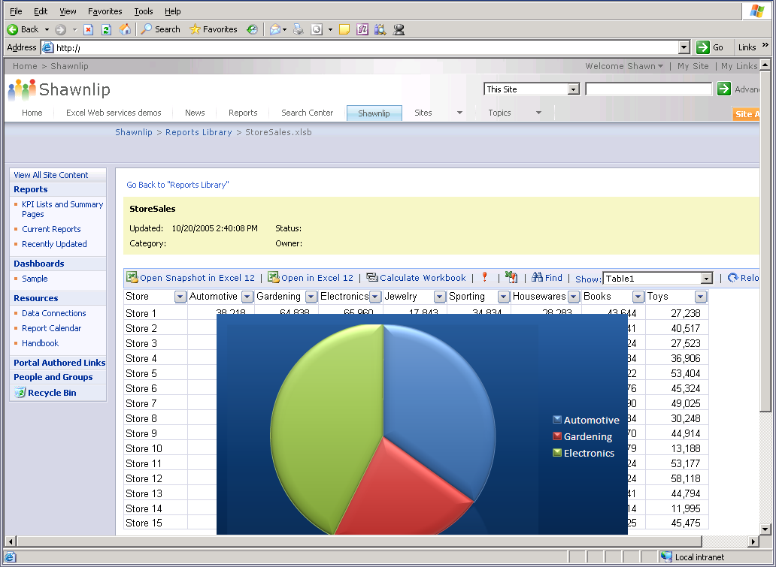
Figure 27: Accessing a published spreadsheet through a Web browser
Enhanced control and management features mean you can determine which portions of your spreadsheets should be viewable through a browser—entire spreadsheets, specific sheets within a spreadsheet, charts, tables, PivotTable views, or Named Ranges within a spreadsheet. You can also decide whether or not to enable data-only snapshots of the spreadsheets, monitor audit logs of spreadsheet usage, and build rule-based workflows, archive processes, and retention policies around business-critical spreadsheets.

Excel Web Access
Excel Web Access running on Office SharePoint Server 2007 makes it easier to create rich, customized BI dashboards that incorporate dynamic KPIs, scorecards, Office Excel 2007 workbooks, and SSRS reports without writing or developing code. This greatly reduces the cost of dashboard creation and maintenance. You can specify particular sections that should be rendered, such as a chart or table, while concealing other sections that contain confidential data.
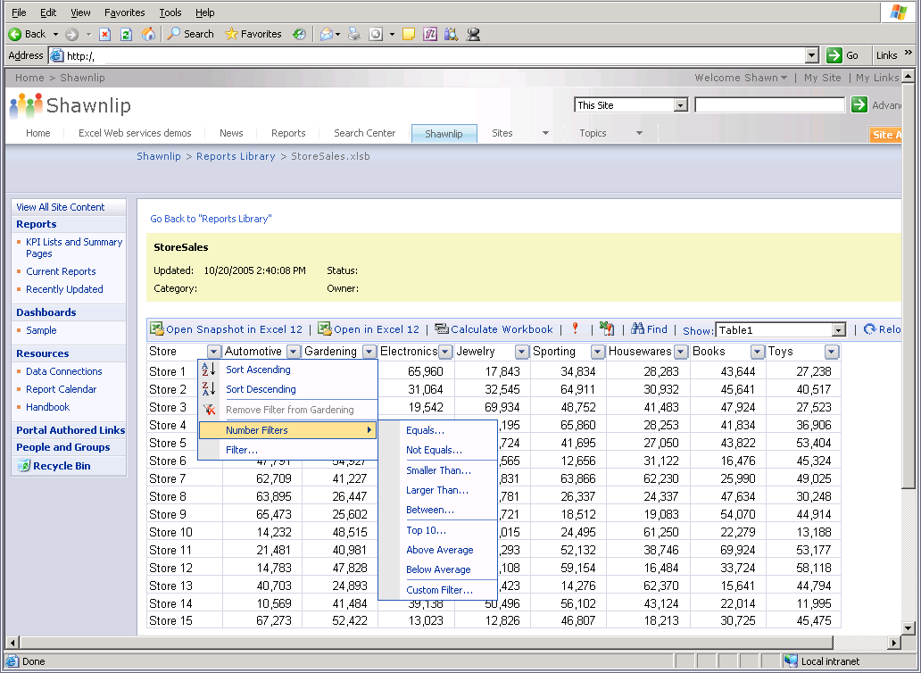
Figure 28: PivotTable view interactivity in a Web browser

Microsoft Business Intelligence in Action
Claus Hansen had his CFO prepare a series of financial dashboards to track KPIs. Web-based dashboards simplified the task. Now, Hansen can closely monitor the health of the business by using a Web browser. He also published a portion of the dashboard so that potential investors can track the company’s profitability. Enhanced protection helps ensure confidentiality of data contained in the spreadsheet’s macros.

Excel Web Services Application Programming Interface (API)
Excel Services includes a Web Services API that enables developers to connect calculations and business models defined in Excel models with their custom applications. In addition, users can use the API to change the values of a spreadsheet parameter and recalculate the spreadsheet based on these new values. Users can also retrieve all or part of a spreadsheet for viewing or for use within a larger business process. This helps workers across any organization take advantage of the same calculation model by simply entering their own values for the parameters.

Streamlined Business Processes
You can add enhanced security to your Office Excel 2007 spreadsheets by managing document approval, storage, use, and destruction on the server. When creating spreadsheets, you can send them in an e-mail message to colleagues to gather feedback. For a faster response, take advantage of the built-in review or approval workflows available from Office Excel 2007 and Office SharePoint Server 2007.
To initiate a review or approval process, simply select the appropriate Office SharePoint Server 2007 workflow from within Office Excel 2007. The workflow creates a task for each participant and notifies them with an e-mail message of a new document for review. When participants receive the notification and open the spreadsheet, they can complete their review and indicate their status on a workflow completion form.

Zero Footprint Analytics
The end user experience in ProClarity is designed to simplify how individuals receive and interact with data. ProClarity also provides zero-footprint thin client capabilities for accessing and analyzing your business data without having to download or install software. Eliminating end user download requirements makes management simpler for your IT division. ProClarity’s interactive charts effectively utilize space and provide completely thin, on-chart navigation, including support for thin extranet deployments.

Data Warehousing
Microsoft SQL Server 2005 offers a complete and scalable BI platform that provides you with the features and functionality you need to put critical, timely information in the hands of employees across your organization. With new innovations in reporting, data integration, development tools, and rich analytics, SQL Server 2005 enables your organization to extend the value of your enterprise data and analytical applications, helping your company make better decisions faster.

SQL Server 2005 Integration Services
SQL Server 2005 offers a new data ETL platform, SSIS. Formerly known as Data Transformation Services (DTS) in previous versions of SQL Server, SSIS has been redesigned to provide the functionality and high-scale performance necessary to be an enterprise ETL platform. SSIS performs complex data integration, transformation, and synthesis at high speeds for very large data volumes, enabling you to more easily integrate and analyze data from multiple information sources. SSIS is fully programmable, embeddable, and extensible—characteristics that make it an ideal ETL platform.

Rich Development Environment
Tight integration with Visual Studio 2005 provides development teams that are building data-centric applications with a platform that enables a productive and collaborative environment for building solutions. Visual Studio 2005 directly supports all of the new SQL Server 2005 data types, such as native XML. Developers can also deploy new database objects directly from Visual Studio 2005 without having to switch tools.

Visual Debugging
SSIS comes with powerful debugging capabilities that help your designers visualize data during transformation using grids, graphs, and charts. With SSIS, developers can use the Visual Studio debugging interface to debug the Common Language Runtime (CLR) application code and Transact-SQL (T-SQL) database code—whether the code is located on the developer’s machine or is stored in the SQL Server 2005 database. You can set breakpoints on packages, containers, task events, and data viewers for watching data as it moves through the data flow. The breakpoint can be defined before, after, or at several points during the task's execution in the debugging process. Variable watches and the call stack also provide powerful debugging capabilities.

Data Quality
Some data transformation tasks require complex logic. The Fuzzy Lookup and Fuzzy Grouping transformations within SSIS provide inexact matching and de-duplication. Use predictive models to assign incomplete and missing data, or use association and clustering models to identify anomalies for data quality issues. All models are captured with rigorous audit and execution metadata.

Extensible Architecture
SSIS includes a completely rewritten object model that makes extending and programming packages easier, more flexible, and more powerful. With SSIS, developers can extend and program almost every aspect of Integration Services packages including tasks, log providers, enumerators, connection managers, and data flow components. These custom objects can be integrated into the user interface of Business Intelligence Development Studio.

Out-of-the-Box, High Performance Transformations
SSIS includes a great range of productive and powerful components that are available right out of the box—data and character conversions, calculated columns, conditional operations for partitioning and filtering, lookups, sorting, aggregation, and merges. These advanced components can simplify otherwise complex operations such as Slowly Changing Dimension loading.

SQL Server Business Intelligence Development Studio
Business Intelligence Development Studio offers the first integrated development environment designed for the business intelligence developer. Built on Visual Studio 2005, Business Intelligence Development Studio provides a rich, common design environment for building BI solutions—database engines, analysis services, integrations services, and reporting services. Debugging, source control, and script and code development are available for all components of the BI platform. You can also manage multiple projects as a unit and view and modify the properties of objects in projects.
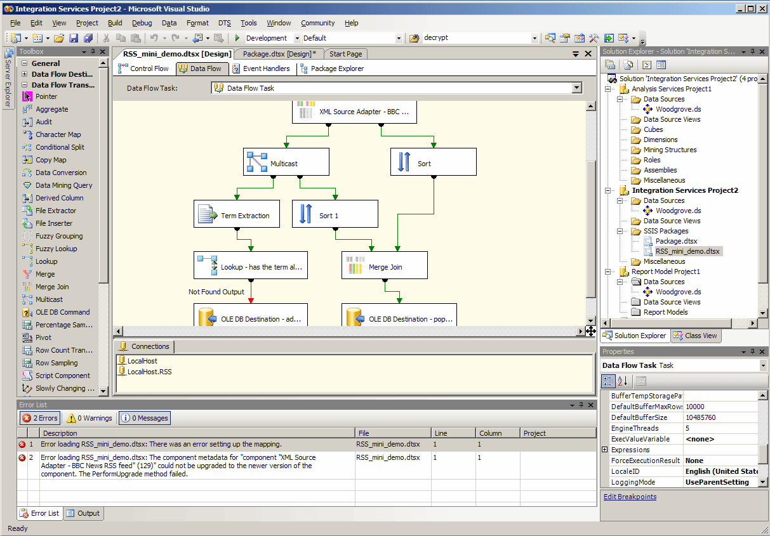
Figure 29: Business Intelligence Development Studio interface in Visual Studio

Solution Explorer
Solution Explorer enables you to manage all the different projects in a solution within BI Development Studio from a single window. You can open project items for modification and perform other management tasks directly from this view.

Properties Window
Business Intelligence Development Studio comes with a Properties window that you can use to view and change the properties of objects such as packages that are open in editors and designers. You can also use the Properties window to edit and view file, project, and solution properties.

Designer Window
With Business Intelligence Development Studio, you can use the Designer window to create or modify business intelligence objects. The designer provides both a code view and a design view of an object. When you open an object in a project, the object opens within a specialized designer in this window. For example, if you open a data source view in any of the business intelligence projects, the designer window opens using the Data Source View designer.

Customized Environment
Business Intelligence Development Studio can be easily configured to suit your working style. The studio environment comes with a collection of settings customized for SQL Server 2005 BI development. You can also configure the overall development environment and its behavior and make changes to its tools and windows.

Project Templates
Project templates in Business Intelligence Development Studio provide a context for developing specific constructs and functionality for BI applications. You can also develop projects as part of a solution that is independent of any particular server. For example, you can include an Analysis Services project and a Reporting Services project in the same solution. You can deploy the objects to a test server for testing during development, and later you can deploy the output from the projects to one or more staging or production servers.
- Analysis Services project includes the templates for cubes, dimensions, mining models, data sources, data source views, and roles, and provides the tools for working with these objects.
- Integration Services project helps develop ETL solutions. This project type includes templates for packages, data sources, and data source views, and provides the tools for working with these objects.
- Reporting Services includes the Report Model and Report projects for developing reporting solutions. You get templates for report models, data sources, and data source views, and the tools for working with these objects. The Report project includes templates for working with reports and shared data sources.

SQL Server 2005 Analysis Services
By creating an easy-to-use, extensible, and flexible platform, SQL Server 2005 Analysis Services (SSAS) introduces data mining to organizations that previously would never have considered a data mining solution.
For example, SSAS improves access to critical, timely business data. Using multidimensional storage, SSAS provides rapid and sophisticated analysis of large and complex datasets. Through an enterprise-class architecture; a deep integration with the SQL Server family of BI tools; and a rich set of tools, APIs, and algorithms, SSAS helps provide customized data-driven solutions to a broad range of business problems.

Data Mining Algorithms
SSAS provides multiple algorithms for use in your data mining solutions. These algorithms are a subset of all the algorithms that can be used for data mining. They include the following:
- Microsoft Naive Bayes Algorithm
- Microsoft Association Algorithm
- Microsoft Sequence Clustering Algorithm
- Microsoft Time Series Algorithm
- Microsoft Neural Network Algorithm
- Microsoft Logistic Regression Algorithm
- Microsoft Decision Trees Algorithm Enhancements
- Microsoft Linear Regression Algorithm

Different algorithms are preferred for different goals and each algorithm can be used for multiple problems. Because each model returns a different type of result, SSAS provides a separate viewer for each algorithm. Third-party independent software vendors (ISVs) can develop algorithms that smoothly fit into the SSAS data mining framework.
Microsoft Business Intelligence in Action
Claus Hansen is thinking about company expansion, but he doesn’t know if the additional airfares and routes would pay for the extra airplanes. He uses the Data Mining Wizard in SSAS to add a new mining structure. By using the Microsoft Time Series Algorithm on historical data from the past five years, he can forecast future sales with and without expansion. The results help him conclude that higher overhead brought by expansion at this time would minimize any future profits.

Unified Dimensional Modeling
Combining the best aspects of traditional OLAP analysis and relational reporting, SSAS offers a central metadata repository, the Unified Dimensional Model (UDM), which defines business entities, business logic, calculations, and metrics. The UDM also serves as the single data source for all reports, spreadsheets, OLAP browsers, KPIs, and analytical applications. UDM is mapped to a host of diverse back-end data sources, providing a complete and integrated picture of your business, regardless of the location of your data.

Proactive Caching
Proactive caching combines real-time updates with OLAP class performance. SSAS maintains a highly compressed and optimized data cache that is automatically maintained as the data in the underlying source databases changes. The cache provides superb query performance and isolates the back-end source systems from the load of the analytical queries.

Enhanced Security Design
SSAS contains over 150 security design changes, including the following:
- Out-of-the-box "secure by default" mode with multiple lines of defense
- Fine-grained administrative permissions
- Encrypted local cubes
- The lowest possible level of permissions
- Encrypted and signed client server communications to help secure against packet sniffing, spoofing, tampering, and repudiation

SQL Server 2005 Reporting Services
SQL Server 2005 Reporting Services (SSRS) uses flexible subscription and delivery mechanisms to help make it easy to create both traditional and interactive reports and deliver them to a wide range of people. SSRS combines the benefits of a centrally managed reporting system with the flexibility and on-demand nature of desktop and Web-based programs.
Embedded and managed through Web Services, SSRS offers a server-based enterprise reporting environment. You can personalize and deliver reports in a variety of formats, with a range of interactivity and printing options. Complex analyses can reach a broad audience through the distribution of reports as a data source for downstream business intelligence.

Wizard-Based Report Design
With SSRS you can rapidly build reports with easy-to-use wizards and designers. Report on data from multiple data sources including Relational and Multidimensional cubes. Specify flexible report layout and behavior. Preview and publish reports directly from the Report Designer. The wizards and designers make it all simpler and more convenient for you.
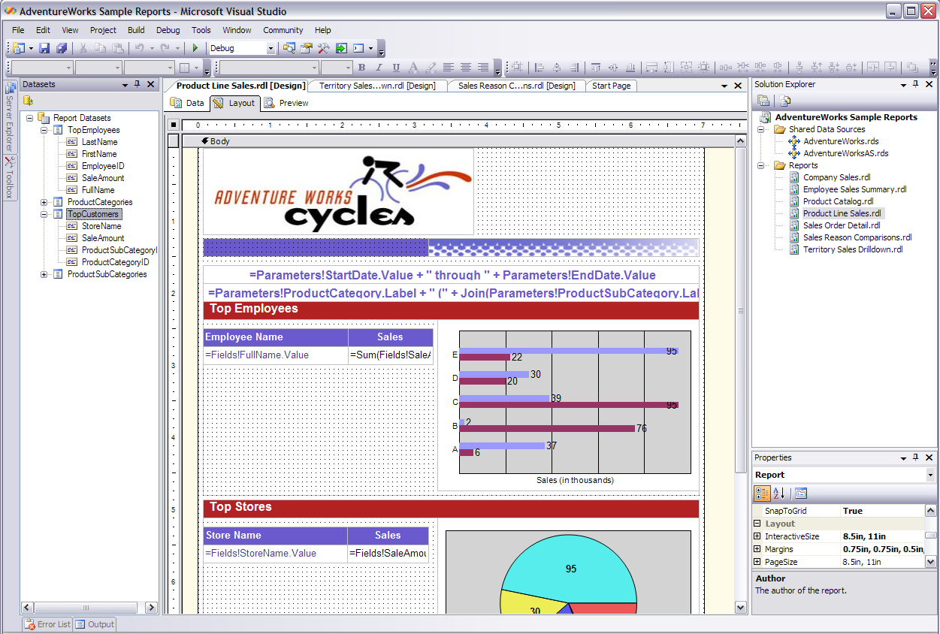
Figure 30: Report Designer enables faster designing and publishing of reports.

Embedded Reporting
ISVs can use SSRS to deliver predefined or ad hoc reports as part of a packaged application. The customer's information services (IS) organization can access these reports as is, customize the reports, or create new ones for specific business needs.

End-User Authoring
Report Builder, a new feature of SSRS, enables you to modify and author your own reports by using a simplified model of your data. Report Builder is a ClickOnce application that is deployed through the browser.
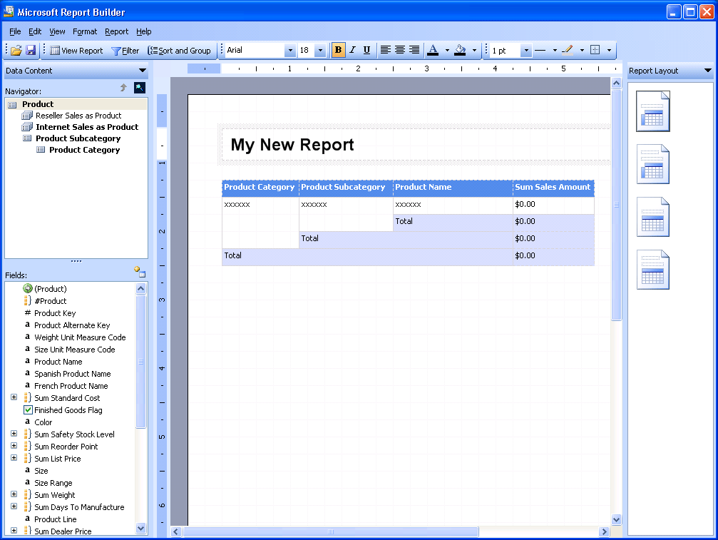
Figure 31: Report Builder interface for ad hoc reporting
The Report Builder enables users to:
- Add text and formatting to reports.
- Create new fields and defined calculations using the model.
- Preview, print, and publish reports.
- Export report data to formats such as Office Excel 2007.

Microsoft Business Intelligence in Action
Claus Hansen used to assign employees to do reports for him. But with the Report Builder component in Reporting Services, he can easily perform the task himself. Today he’s researching customer satisfaction at Los Angeles International Airport. He clicks on Report Builder, which guides him through the process of selecting report layout templates. Each template contains predefined data sections such as tables, matrices, and charts. Hansen drags report items from the template model to the design surface and sets time constraints to filter the report data. The model contains all of the necessary information for the Report Builder to automatically generate the source query and retrieve the requested data.

Web Services Support
SQL Server 2005 provides SOAP/HTTP access, an open and documented protocol that enables a broader range of clients to access SQL Server, including Web Services applications. Because this new connectivity is based on well-known technologies such as XML and HTTP, it facilitates interoperability with Microsoft .NET, SOAP Toolkit, and other protocols on a variety of platforms. Any device that can parse XML and submit HTTP requests can now access SQL Server 2005.

Managing Reports
SSRS includes Report Server Web Application, a Web-based tool for managing reports.. Administrators can use Report Server Web Application to define role-based security for reports and resources, schedule report execution and delivery, and track reporting history. This can be tailored to meet a wide variety of security needs. It includes extensible interfaces for integrating other security models, if necessary. An enterprise or ISV can use the Reporting Services Web Services APIs to write customized management tools.
Because the report definitions, folders, and resources are stored in a SQL Server 2005 database, you can use other tools such as SQL Server Management Studio to manage metadata, or use third-party applications that take advantage of published APIs.

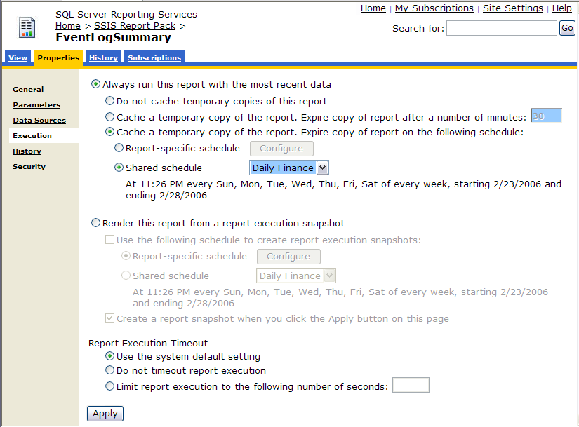
Figure 32: Report Manager options for managing reports

Scalability
The modular, Web-based design in SSRS scales easily to support high-volume environments. For example, you could create a reporting server farm with multiple report servers accessing the same core reports, serving thousands of Web-based clients.

Relational Data Warehouse
SQL Server 2005 blurs the lines between relational and multidimensional databases. You can store data in the relational database, in the multidimensional database, or use the new Proactive Cache feature to get the best of both worlds.

Partitioned Tables and Indexes
In SQL Server 2005, table and index partitioning significantly enhances query performance by breaking down large databases into smaller, more manageable pieces. New functionality enables you to partition tables across file groups in a database. Horizontal partitioning enables you to divide a table into smaller groupings so that groups of rows are mapped into individual partitions. Operations performed on the data, such as queries, are executed as if the entire table or index is a single entity. In addition, partitions can be switched into or out of an existing partition scheme very quickly, eliminating the need to create and index new tables.

Online Index Operations
Online Index Operations enhance the indexing capabilities of earlier releases of SQL Server. With Online Index Operations, you can create, rebuild, or drop an index online without interfering with access to tables or other existing indexes. Other capabilities include the following:
- Enables concurrent modifications (updates, deletes, and inserts) to any associated indexes during index data definition language (DDL) execution.
- Provides parallel processing.
- Performs a restore operation while an instance of SQL Server 2005 is running. Only data that is being restored is unavailable. The rest of the database remains online and available.

Transact-SQL Improvements
SQL Server 2005 provides many new language capabilities for developing scalable database applications. The T-SQL enhancements in SQL Server 2005 increase your expressive powers in query writing so you can improve code performance and enhance your error management capabilities. New data types can be used to hold extended metadata and other descriptive information in a data warehouse. New analytic functions can be used during data staging to develop valuable data attributes. They also provide basic analytic capabilities within T-SQL, which is useful for enabling user queries in the relational database rather than exclusively through SSAS.

Database Snapshots
SQL Server 2005 introduces database snapshots, a quick and easy way to create read-only views of a database. Database snapshots eliminate the need to create a whole copy of the database and its accompanying storage. You get a stable view without the time or storage overhead required when creating a complete copy of the database. As changes are made to the database, the snapshot receives its own copy of the original page from the database. The snapshot may be used to quickly recover from an accidental change to a database by reapplying the original pages from the snapshot to the primary database.

Data Mirroring
By creating a database snapshot on a database mirror, you effectively create a standby server on a secondary system running SQL Server, giving you high system availability. You also create a reporting server. The secondary database is always updated with the current transaction that’s being processed on the primary database server. In the event that your primary database fails, database mirroring enables the second standby database to be almost instantly available. All work is automatically shifted over to the backup server.

Microsoft Business Intelligence in Action
Blue Yonder Airlines stores all reservations, past and present, in its data warehouse. To stay up to date with customers’ needs and to maintain a high level of customer service, the airline cannot afford system failures. One of the main reasons Claus Hansen invested in SQL Server 2005 was its high rate of availability. Should Hansen’s primary database ever encounter downtime, features such as failover clustering and data mirroring create quick back-up copies. As a result, the database is always available, helping Blue Yonder provide better service.

Snapshot Isolation
With SQL Server 2005 snapshot isolation, all the data you read during the course of the transaction remains in the state it was in at the start of the transaction, even if the row is locked for updates being made concurrently by other users. For many applications, the very short-term inaccuracy between access and update is acceptable for queries that are designed to show orders of magnitude rather than to report individual row values.

Support for 64-bit
Optimized for the Intel Itanium processor x64 environments, SQL Server 2005 (64-bit) uses advanced memory addressing capabilities for essential resources such as buffer pools and caches. This functionality reduces the need to perform multiple input and output (I/O) operations to bring data in and out of memory from disk. Greater processing capacity without the penalties of I/O latency opens the door to new levels of application scalability.

SQL Server Management Studio
SQL Server Management Studio integrates the management of Enterprise Manager, Query Analyzer, and Analysis Manager from previous releases of SQL Server into a single environment. Combining easy-to-use graphical tools with rich scripting capabilities, SQL Server Management Studio provides a management infrastructure that can be easily programmed using SQL Management Objects. BI practitioners will benefit from the extension of the server abilities they expect from the relational engine—scalability, reliability, availability, programmability, and so on—to the full set of BI platform components.

Summary
Microsoft Business Intelligence offers a complete, integrated, and fully scalable BI solution that can support your entire organization. Through integration with the 2007 Microsoft Office system, Microsoft Business Intelligence provides a familiar environment for delivering information directly to the place where you work, collaborate, and make decisions.
Tight integration with the SQL Server 2005 business intelligence platform supports the development and use of business intelligence for organizations of all sizes, and for employees at all levels. You gain tools and resources you need to make better and faster decisions, based on sound data. By using powerful end user reporting and analysis tools, Microsoft Business Intelligence technologies can enable your organization to improve its strategic decision making and business efficiency.

System Requirements
For complete system requirements, visit http://www.microsoft.com/bi.

This document was developed prior to the product’s release to manufacturing, and as such, we cannot guarantee that all details included herein will be exactly as what is found in the shipping product. The information contained in this document represents the current view of Microsoft Corporation on the issues discussed as of the date of publication. Because Microsoft must respond to changing market conditions, this document should not be interpreted to be a commitment on the part of Microsoft, and Microsoft cannot guarantee the accuracy of any information presented after the date of publication. The information represents the product at the time this document was printed and should be used for planning purposes only. Information is subject to change at any time without prior notice.

This document is for informational purposes only. MICROSOFT MAKES NO WARRANTIES, EXPRESS OR IMPLIED, IN THIS DOCUMENT.

© 2006 Microsoft Corporation. All rights reserved.

Microsoft, Excel, Fluent, MapPoint, MSN, the Office logo, Outlook, PivotChart, PivotTable, PowerPoint, SharePoint, Visio, Visual Studio, and Windows are either registered trademarks or trademarks of Microsoft Corporation in the United States and/or other countries. All other trademarks are property of their respective owners.

