

A Guide to Group Policy Preferences for Users of PolicyMaker Standard Edition
Microsoft Corporation
Published: July 2008
Author: Mark Gray
Abstract
To help prepare Group Policy administrators who are familiar with PolicyMaker Standard Edition to upgrade to Group Policy preferences, this document provides a guide to the differences between Group Policy preferences and PolicyMaker Standard Edition.

The information contained in this document represents the current view of Microsoft Corporation on the issues discussed as of the date of publication. Because Microsoft must respond to changing market conditions, it should not be interpreted to be a commitment on the part of Microsoft, and Microsoft cannot guarantee the accuracy of any information presented after the date of publication.
This White Paper is for informational purposes only. MICROSOFT MAKES NO WARRANTIES, EXPRESS, IMPLIED OR STATUTORY, AS TO THE INFORMATION IN THIS DOCUMENT.
Complying with all applicable copyright laws is the responsibility of the user. Without limiting the rights under copyright, no part of this document may be reproduced, stored in or introduced into a retrieval system, or transmitted in any form or by any means (electronic, mechanical, photocopying, recording, or otherwise), or for any purpose, without the express written permission of Microsoft Corporation.
Microsoft may have patents, patent applications, trademarks, copyrights, or other intellectual property rights covering subject matter in this document. Except as expressly provided in any written license agreement from Microsoft, the furnishing of this document does not give you any license to these patents, trademarks, copyrights, or other intellectual property.

© 2008 Microsoft Corporation. All rights reserved.

Microsoft, Windows, Windows Server, and Windows Vista are trademarks of the Microsoft group of companies.
All other trademarks are property of their respective owners.

Contents
Introduction 4
New folders 5
New locations for extensions 5
New preference item types 6
Changes to item types 6
Changes to Common tab 7
Targeting replaces filtering 8
Removed features 9
Other changes 9
Operating system support 9
GPMC changes 9
Software development kit 10

A Guide to Group Policy Preferences for Users of PolicyMaker Standard Edition

Introduction
In October 2006, Microsoft acquired DesktopStandard Corporation, a developer of Group Policy–based enterprise desktop management software. PolicyMaker Standard Edition and PolicyMaker Share Manager were among the products that Microsoft acquired with DesktopStandard.
With improvements and necessary changes, Microsoft has incorporated most of the functionality of PolicyMaker Standard Edition and PolicyMaker Share Manager into Group Policy preferences. Group Policy preferences can be managed using Windows Server 2008 or Remote Server Administration Tools (RSAT) for Windows Vista with Service Pack 1 (SP1). The preference extensions (formerly PolicyMaker extensions) are available when editing Group Policy objects (GPOs) in the Group Policy Management Editor window of the Group Policy Management Console (GPMC). However, preference extensions are not available in Local Group Policy.
To help prepare Group Policy administrators who are familiar with PolicyMaker Standard Edition to upgrade to Group Policy preferences, this document provides a guide to the differences between Group Policy preferences and PolicyMaker Standard Edition. These differences include the following:
- New folders have been added to the editing window of the GPMC, and extensions familiar from PolicyMaker Standard Edition have been incorporated.
- New preference item types (formerly policy item types) have been added to support Windows Server 2008, Windows Vista, and Internet Explorer 7. Additionally, the Network Shares extension, previously available as PolicyMaker Share Manager, has been included with Group Policy preferences.
- The names of some preference item types have been modified to specify which operating systems or Web browsers they support.
- Filtering has been renamed item-level targeting, and the Targeting Editor window provides an improved user interface for configuring targeting for each preference item (formerly policy item).
- The names of some options on the Common tab have been changed to clarify their purpose.
- Features related to the Applications extension and Mail Profiles extension will be available for download separately to adhere to legal requirements, and Message Box filtering has been removed to improve security.
- Support has been added for new operating systems, and support for some earlier operating systems has been deprecated and removed. However, client-side extensions (CSEs) for Group Policy preferences are available for download for many earlier operating systems. Additionally, GPMC reporting has been updated to support Group Policy preferences, and the Group Policy Software Development Kit (SDK) will be updated to replace the PolicyMaker SDK.

New folders
To clearly distinguish between policy settings and preference settings in the GPMC, folders for Policies and Preferences have been added. The Policies folders contain policy settings, such as Administrative templates, most of which cannot be changed by the end user. The Preferences folders contain extensions familiar from PolicyMaker Standard Edition and PolicyMaker Share Manager.
Figure 1 New folders in the Group Policy Management Editor window of the GPMC
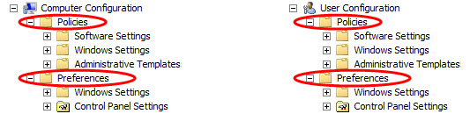

New locations for extensions
The locations of preference extensions differ from those of PolicyMaker extensions. Figure 2 shows the locations of preference extensions in the Group Policy Management Editor window of the GPMC.
Figure 2 Locations of preference extensions in the GPMC
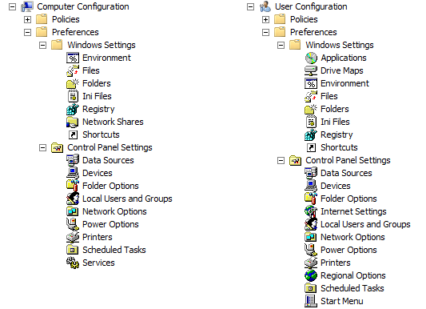
Note: The Network Shares extension was previously included only with PolicyMaker Share Manager.

New preference item types
New preference item type | Description
Network Share | Provides the ability to manage network shares, including the ability to restrict the visibility of shared resources and to configure Access-Based Enumeration. The Network Shares extension, previously available as PolicyMaker Share Manager, has been included in Group Policy preferences.
Folder Options (Windows Vista) | Provides the ability to configure Folder Options for Windows Server 2008 and Windows Vista.
Internet Explorer 7 | Provides the ability to configure Internet Explorer 7 settings using Group Policy preferences. Preference settings that are disabled are not supported at this time.
Start Menu (Windows Vista) | Provides the ability to configure Start menu settings for Windows Server 2008 and Windows Vista.

Changes to item types
PolicyMaker item type | Preference item type | Explanation
Folder Options | Folder Options (Windows XP) | Preference items of this type configure settings for Windows Server 2003 and Windows XP.  For Windows Server 2008 and Windows Vista, the new Folder Options (Windows Vista) type is available.
Internet Explorer | Internet Explorer 5 and 6 | Preference items of this type configure settings for both Internet Explorer 6 and Internet Explorer 5.  For Internet Explorer 7, the new Internet Explorer 7 item type is available.
Power Options,  Power Scheme | Power Options (Windows XP),  Power Scheme (Windows XP) | The preference item types for the Power Options extension have been renamed to indicate that they only support configuring power options for client computers running Windows Server 2003 or Windows XP.  For Windows Server 2008 and Windows Vista, Power Options can be configured through Group Policy using new Administrative template settings.
Immediate Task | Immediate Task (Windows XP) | The Immediate Task item type has been renamed because it is supported only for configuring client computers running Windows Server 2003 or Windows XP.  Scheduled Task preference items can be created for all supported operating systems.
Start Menu | Start Menu (Windows XP) | Preference items of this type configure settings for Windows Server 2003 and Windows XP.  For Windows Server 2008 and Windows Vista, the new Start Menu (Windows Vista) item type is available.

Changes to Common tab
PolicyMaker feature | Preference feature
Abort the rest of this group if an error occurs on this setting | Stop processing items in this extension if an error occurs
Treat this setting as a preference (do not enforce) | Apply once and do not reapply

Targeting replaces filtering
PolicyMaker feature | Preference feature | Explanation
Filtering | Item-level targeting | Filtering has been renamed to item-level targeting to more accurately reflect the functionality of the feature. As in PolicyMaker Standard Edition, it is available from the Common tab for each preference item. The UI has been changed to fully support localization, accessibility, and ease of use. The new UI (shown in Figure 3) adds support for new operating systems and computer hardware.
Filter Groups | Targeting Collections | Filter Groups have been renamed to Targeting Collections.
Recur Every filtering | Date Match targeting | To more accurately reflect the functionality of the targeting item type, Recur Every filtering has been renamed to Date Match targeting.

Figure 3 The Targeting Editor window replaces the PolicyMaker Filtering window

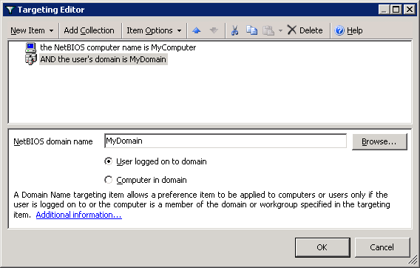

Removed features
Removed features | Explanation
Application item types | The Application item types related to Microsoft Office have been removed from the Applications extension.
Mail Profiles extension | The Mail Profiles extension has been removed.
Message Box filtering | Because of security concerns, Message Box filtering is not included with Group Policy preferences.

Other changes

Operating system support
In PolicyMaker Standard Edition, the snap-in extensions that allowed Group Policy administrators to create and manage PolicyMaker items required a separate installation. Additionally, the client-side extensions (CSEs) required deployment to each client computer for that computer to recognize PolicyMaker items.
In Windows Server 2008, the snap-in extensions and CSEs for Group Policy preferences are integrated into the operating system, so no additional installation or deployment is necessary. In Windows Vista with SP1, the snap-in extensions are included with RSAT and must be installed. For Windows Vista and earlier operating systems, the CSEs to support Group Policy preferences are available for download and must be deployed to allow client computers running those operating systems to recognize preference items. Table 1 shows which operating systems support Group Policy preferences.
Table 1 Supported operating systems for Group Policy preferences
Operating system | Client-side extensions | Snap-in extensions
Windows Server 2008 (32-bit and 64-bit) | Integrated | Integrated
Windows Vista with SP1 (32-bit and 64-bit) | Supported¹ | Supported²
Windows Vista with no service packs  (32-bit and 64-bit) | Supported¹ | Not supported
Windows Server 2003 with SP1 (32-bit and 64-bit) | Supported¹ | Not supported
Windows XP with SP2 (32-bit and 64-bit) | Supported¹ | Not supported
Windows 2000 Server | Not supported | Not Supported
Windows 2000 Professional | Not supported | Not Supported
¹ The CSEs for this operating system are available for download and must be installed.
² Snap-in extensions are included with RSAT, which is available for download.

GPMC changes
GPMC reporting has been updated to support preference extensions natively, and GPMC reporting (settings, Reporting, and Modeling) has been updated to interpret preference settings. GPMC reporting was also updated to support the new folder hierarchy so that paths in reports run from the new GPMC (Windows Server 2008 and RSAT version) reflect the folder changes outlined in this document. However, these changes are not reflected in reports run from earlier versions of the GPMC. Therefore, a GPO settings report run from the new version of the GPMC includes the new Policies folder, but the same GPO settings report run from an earlier version of the GPMC does not.

Software development kit
To replace the PolicyMaker Software Development Kit (SDK), the Group Policy SDK has been updated. The Applications extension of Group Policy preferences is extendable, and the update to the Group Policy SDK provides the information necessary for software developers to extend the Applications extension, creating preference item types for other applications. The Group Policy SDK is available at http://go.microsoft.com/FWLink/?LinkID=144.

