

Microsoft® Office Small Business 2007

September 2006

Table of Contents

Cover is for
position only

Introduction to Microsoft Office Small Business 2007 1
The Small Business Marketplace 1
Office Small Business 2007 2
What Is Included 2
Save Time and Stay Organized 3
Work More Efficiently Using the Microsoft Office Fluent User Interface 3
Easily Manage Your Daily Priorities 4
Reduce Junk E-Mail Messages 5
Track Tasks More Effectively with the New To-Do Bar 5
Schedule Tasks on Your Outlook Calendar 6
Instant Search 7
Organize E-Mail Messages Using Color Categories 8
Create Professional-Quality Business Documents 9
Format Documents in a Snap with Quick Styles 9
Save Time with Building Blocks 10
Save as PDF or XPS 11
Get a Clear View of Your Business Information 11
Simple, Custom Charting Tools 12
Conditional Formatting 13
Centralize Contact and Customer Management 14
Centralize Contact and Customer Information 15
Organize Accounts and Business Contacts 15
Share Customer Information Throughout Your Organization 16
Effectively Track Leads and Forecast Sales Opportunities 17
Sales Leads and Opportunities 17
Sales Leads Reports 18
Information Dashboard 19
Market More Effectively 20
From Custom Mailing Lists to Personalized Campaigns 21
Improve Project Management 23
Produce Professional-Quality Marketing Communications In-House 25
Create Designer-Quality Marketing Materials 25
Get Started with Publisher Tasks 26
Use Designer-Quality Templates or Build Your Own 26
Promote Your Company Brand 27
Use Existing Content 28
Easily Share, Publish, and Print 29
Personalize Distribution 29
Publish as PDF or XPS 30
Build Effective Presentations 31
Use Slide Layout and Prebuilt Slides 31
Create Impact with Document Themes 32
Graphics, Tables, and Charts 33
Product Highlights 34
Office Excel 2007 34
Office Outlook 2007 with Business Contact Manager 35
Office PowerPoint 2007 38
Office Publisher 2007 40
Office Word 2007 42
Resources 44
System Requirements 45

Introduction to Microsoft Office Small Business 2007
Welcome to Microsoft® Office Small Business 2007, an accessible and comprehensive set of productivity and contact management tools designed for small businesses that rely on technology to work efficiently and serve their customers.

The Small Business Marketplace
Small businesses face a unique set of challenges. Attracting new customers is of the utmost importance, but marketing budgets are limited and competition is fierce. Building customer loyalty helps a business thrive, but finding the time to respond to customer inquiries and manage customer relations can be challenging. Employees are often stretched to capacity and have difficulty getting the information they need to complete important business activities.
While technology can help small businesses address some of these challenges, too often business software can be difficult to use, and small business employees do not have a lot of time to learn new tools. Customer relationship management (CRM) software packages can be a huge investment and may not integrate well with a company’s existing programs. Small business owners and employees need the software they already know and use every day to address their key challenges, such as:
- Prioritizing tasks and managing time.
- Finding the right information quickly to take more effective action.
- Analyzing information easily so they can make better informed decisions.
- Keeping track of customer information in one place, so commitments and opportunities do not fall through the cracks.
- Creating high-quality marketing materials that boost brand identity.
- Eliminating the expense and long lead times associated with outsourcing sales and marketing materials.
- Enabling employees to be more efficient, whether working in the office or remotely.

Office Small Business 2007
Office Small Business 2007 focuses on meeting the needs of small businesses that have up to 50 employees.
This complete, easy-to-use set of productivity and contact management tools helps small businesses to:
- Save time and stay organized.
- Effectively manage contact and customer information.
- Produce professional-quality marketing communications and campaigns in-house.
This guide provides an overview of each of the programs included in Office Small Business 2007, with an emphasis on new and improved features. It also provides a close look at each of the programs in action, including guidance on specific details that demonstrate its new capabilities.

What Is Included
Office Small Business 2007 includes the following Microsoft Office system programs:
- Microsoft Office Excel® 2007
- Microsoft Office Outlook® 2007 with Business Contact Manager
- Microsoft Office PowerPoint® 2007
- Microsoft Office Publisher 2007
- Microsoft Office Word 2007
For details about the new and improved features in each program, see Product Highlights.

Save Time and Stay Organized
In most small business environments, individuals shoulder multiple responsibilities—everything from sales and marketing to project management, accounting, and IT support. It is no surprise then that people are often stretched thin with back-to-back meetings; hundreds of e-mail messages to sort through each day; and loads of data to process, analyze, and communicate. To help ensure successful business operations, they must track critical information, prioritize tasks, and produce communications with skill and efficiency.
Office Small Business 2007 provides the tools you need to act quickly and efficiently, so you have more time to spend on your most important job: developing new business and building customer relationships.
Office Small Business 2007 in Action: Getting more done in less time
Carol Philips works for Contoso Landscape Design, a small residential and commercial landscape design firm with 10 employees. As the senior designer at Contoso, Carol is frequently out in the field doing site assessments and overseeing site installations. Carol gets only a little desk time each day. When she is in the office, she optimizes her time by using Office Small Business 2007 to respond to e-mail inquiries from prospective clients, plan and complete tasks, and write up project proposals and status reports.

Work More Efficiently Using the Microsoft Office Fluent User Interface
People often don’t use software as efficiently as they could simply because they do not have the time to invest in learning all the tools and shortcuts available. Office Small Business 2007 can take the time out of learning new tools and performing old tasks.
The Microsoft Office Fluent™ user interface of the Microsoft Office system helps you to work more efficiently by automatically displaying the appropriate tools for your current task. You no longer have to navigate complex menus or open multiple toolbars to make a minor format change or to adjust a drawing. Microsoft Office system programs recognize the features you are currently using and tailor the interface accordingly.
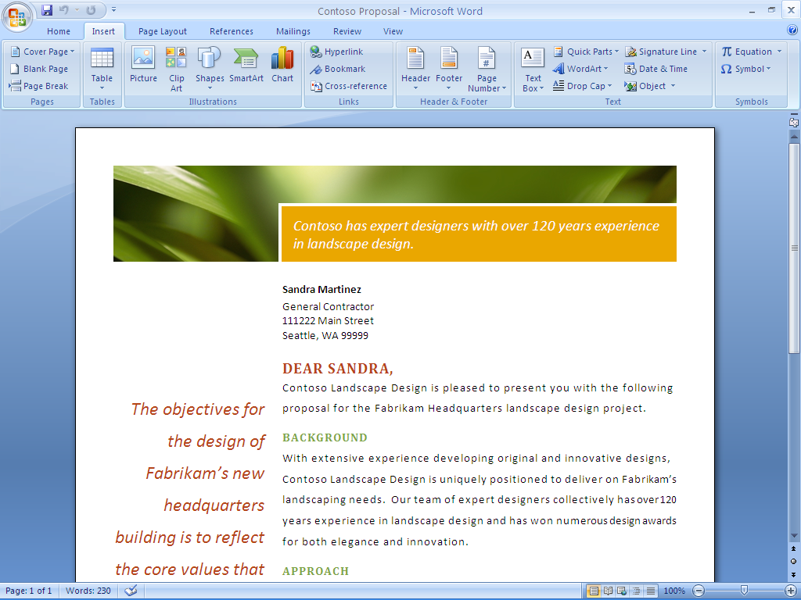
Figure 1: The Office Fluent user interface in Office Word 2007 makes tools available
to you when you need them.

Easily Manage Your Daily Priorities
For many small business employees, it is an ongoing challenge to process e-mail and voice mail messages quickly without losing track of critical work. The number of hours in a day remains the same; the amount of information employees have to process in that time continues to multiply at a rapid rate. Office Outlook 2007 includes many new and improved features to help you control e-mail and prioritize your tasks.

Reduce Junk E-Mail Messages
If you are in the business of managing customers, making business decisions, or handling day-to-day operations, you cannot afford to waste time sorting through junk e-mail messages. An improved junk e-mail filter sorts out unwanted e-mail messages based on your preferences. Outlook also helps protect you against e-mail phishing scams by automatically disabling links within any suspicious messages and warning you of potentially threatening or malicious links.

Track Tasks More Effectively with the New To-Do Bar
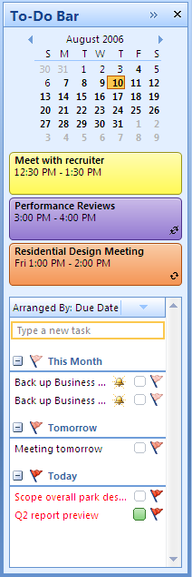
It is hard to stay on top of daily tasks when your to-do list is scattered across multiple locations. The new To-Do Bar consolidates task and appointment information from Office Outlook 2007, Office Outlook 2007 with Business Contact Manager, Microsoft Office OneNote® 2007, and Microsoft Office Project 2007 in one convenient place, giving you a complete view of your priorities for the day. It shows tasks, including e-mail messages you have flagged as tasks, and upcoming appointments. And the To-Do Bar is integrated with your Outlook calendar, so you can easily schedule and block off time to follow up on items.
Quick calendar view
Upcoming appointments
Flagged mail items can be sorted in a number of ways, including by due date.

Figure 2: The To-Do Bar in Office Outlook 2007 gives you a consolidated view of your priorities.

Schedule Tasks on Your Outlook Calendar
Office Outlook 2007 integrates your To-Do Bar task list with your calendar, so you can better schedule your time. When you complete a task on a given day, the task "sticks" to that day, providing a visual record of the work you performed. Tasks you do not complete roll over to the next day and accumulate until you finish them.
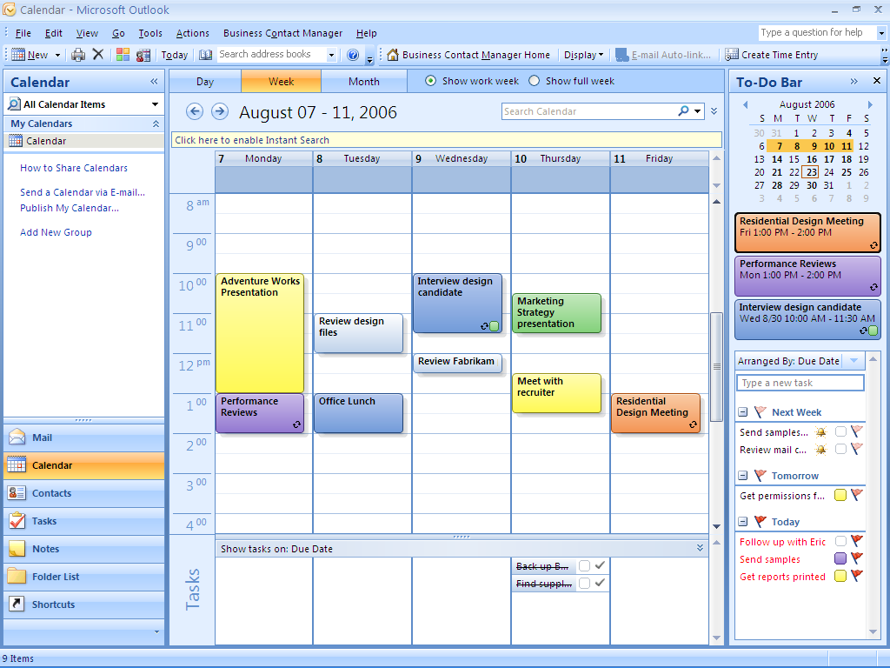
Tasks that appear on the To-Do Bar also appear in your daily task list below the calendar. This way, you can drag tasks from the daily task list onto the calendar and easily block off time to complete them.
Figure 3: View and work with your tasks and your calendar in an integrated manner.

Instant Search
With new and powerful integrated Instant Search, you can quickly find the information you need, whether it is in your e-mail, calendar, contacts, or tasks. Type in a keyword and Instant Search quickly searches all your Outlook data. Results begin to appear as soon as you start typing your search terms. You also have the flexibility to create queries with different Outlook criteria, such as date, Color Categories, and mail importance.
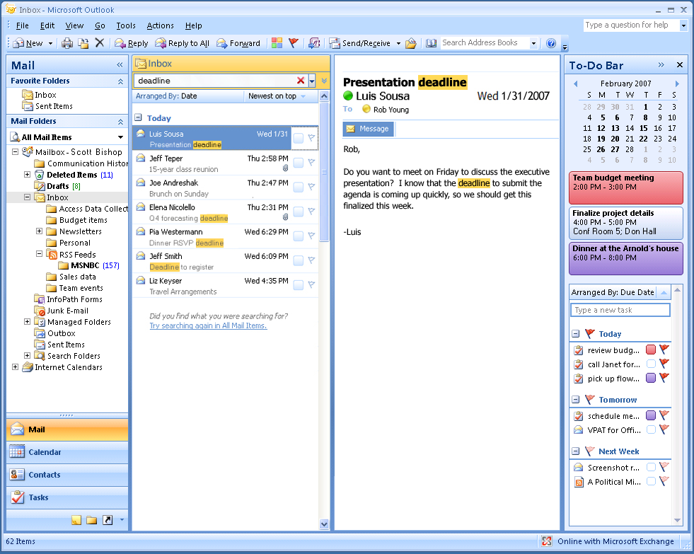
Figure 4: Instant Search, a new feature in Office Outlook 2007, helps you quickly find the information you need.

Organize E-Mail Messages Using Color Categories
The new Color Categories feature in Office Outlook 2007 gives you a quick, visual way to distinguish types of e-mail items from one another, making it easier to sort and find information. For example, you could assign a Color Category to all items related to a certain project. Simply right-click each e-mail message, calendar item, or contact related to that project, and select a color. Later, when you need to find information related to that project, you can sort by Color Categories to quickly and visually identify what you are looking for.
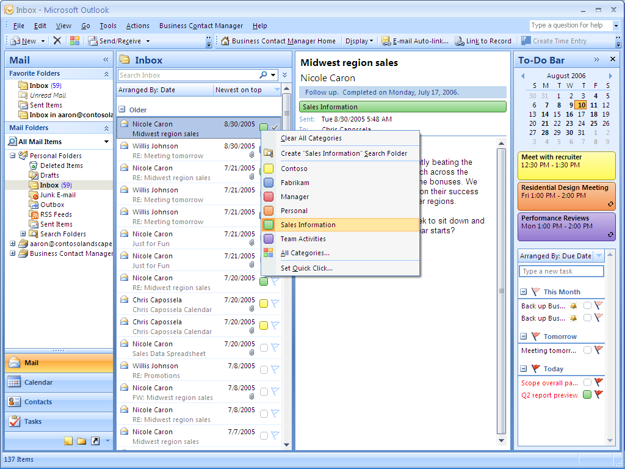
Figure 5: Color categories can help you search and organize your inbox.

Office Outlook 2007 in Action: Better time management
Each morning, as Carol reads through her mail, she uses Color Categories to visually identify messages related to specific projects, so she can find pertinent information faster when completing her project reports. Next, she flags important messages for follow-up. That is one less thing she has to remember: Outlook reminds her when she must act on a critical e-mail message. Finally, Carol uses Instant Search to quickly find a particular message she received several months ago.

Create Professional-Quality Business Documents
Office Word 2007 includes many new and improved features to expedite the process of creating and formatting polished business documents. The new task-based menus, for example, automatically display the tools you need for whatever task you might be doing. Quick Styles and Building Blocks enable you to spend more time writing and less time formatting documents. And with the Live Preview feature, you can view your changes easily, so you no longer have to undo or redo them.

Format Documents in a Snap with Quick Styles
You can use the new Quick Styles feature in Office Word 2007 to change how documents look with a single click. You can modify fonts, colors, margins, table formatting, and other elements by simply choosing a different style. Simply select the text you want to change and then choose the style you want from the Quick Style gallery.
You can also create a style and add it to a gallery that shows your frequently used styles. Quick Styles provide the added benefit of being very flexible; you can update them whenever you need to from within Office Word 2007.
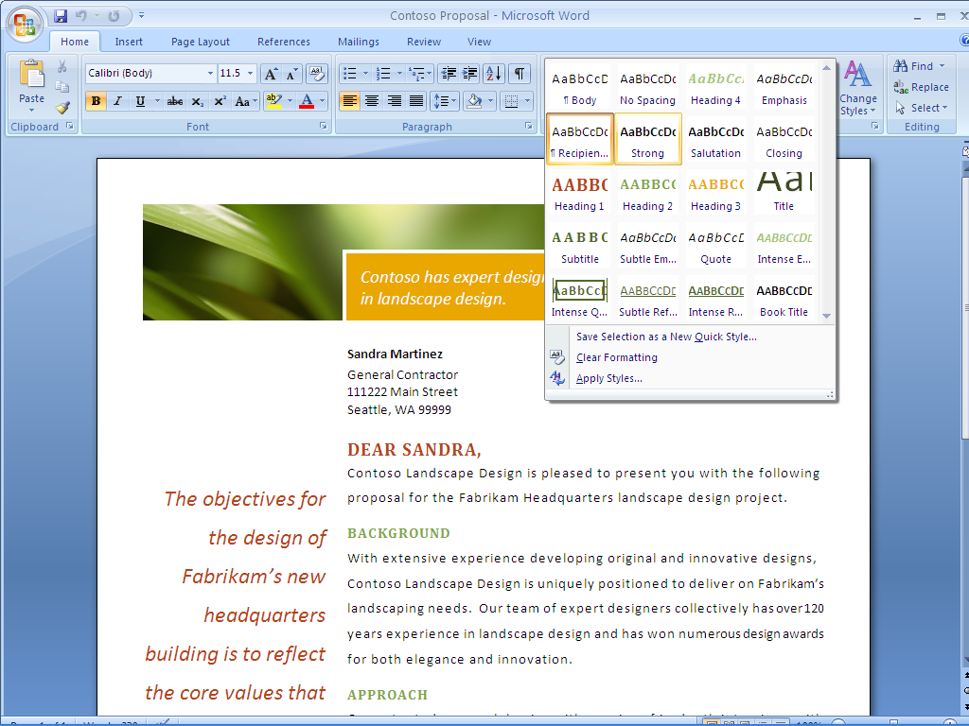
Figure 6: Quick Styles make it easy to format your Word documents.

Save Time with Building Blocks
Most organizations use some of the same information—company address or profile, team bios, and legal disclaimers—in all their business documents. New Building Blocks in Office Word 2007 help you save time and reduce errors by creating Building Blocks of frequently used information that everyone in your company can access. Simply select the content you want from the Building Blocks menu and insert it into your document.

Save as PDF or XPS
Sometimes you may need to save your Word document in a “fixed” file format so other people who may not have Word can view them. Office Word 2007 now supports saving your document as a Portable Document Format (PDF) or XML Paper Specification (XPS) file. Now you can post documents on the Internet or share them knowing that people can view them regardless of the type of computer or programs they are using.
Office Word 2007 in Action: Create professional-quality documents quickly
Carol uses Building Blocks to insert company contact information and past project descriptions into all her project proposals. After she completes the proposal content, Carol likes to format the document in a style evocative of the landscape design she is proposing. She has a set of company-approved design styles stored in the new Quick Styles gallery that helps her to set the font, colors, and table formatting with just a few clicks. And with Live Preview, Carol can see the effect of her changes to be sure that her formatting looks exactly the way she wants it before applying it. After she is satisfied with the content and format of a proposal, she can publish the document as a PDF to help ensure her customer will see it exactly the way she intended.

Get a Clear View of Your Business Information
You rely on data to make critical business decisions. You need to be able to easily view and analyze that data to make the best decisions for your business, and you need to communicate results in a manner that your colleagues, customers, and business associates understand.
Office Excel 2007 includes new and enhanced tools that help you analyze, communicate, and manage your data. The enhanced task-based user interface presents the tools you need when you need them so you can complete even the most complex tasks in minimal time. Office Excel 2007 also has a greater spreadsheet capacity so you have more room to work on larger data sets.

Simple, Custom Charting Tools
Nothing communicates business data as clearly as a chart, and now it is easy to create professional charts and graphs in Office Excel 2007. With easy charting tools available from the newly redesigned interface of the Microsoft Office system, you can create more professional-looking charts with just a few clicks of your mouse. In your charts, you can use 3-D, soft shadowing, and anti-aliasing effects to identify key data trends or focus on future projections.
Improved charting capabilities are shared with other Microsoft Office system programs, which means that you can create and interact with charts the same way—regardless of the program you are using.
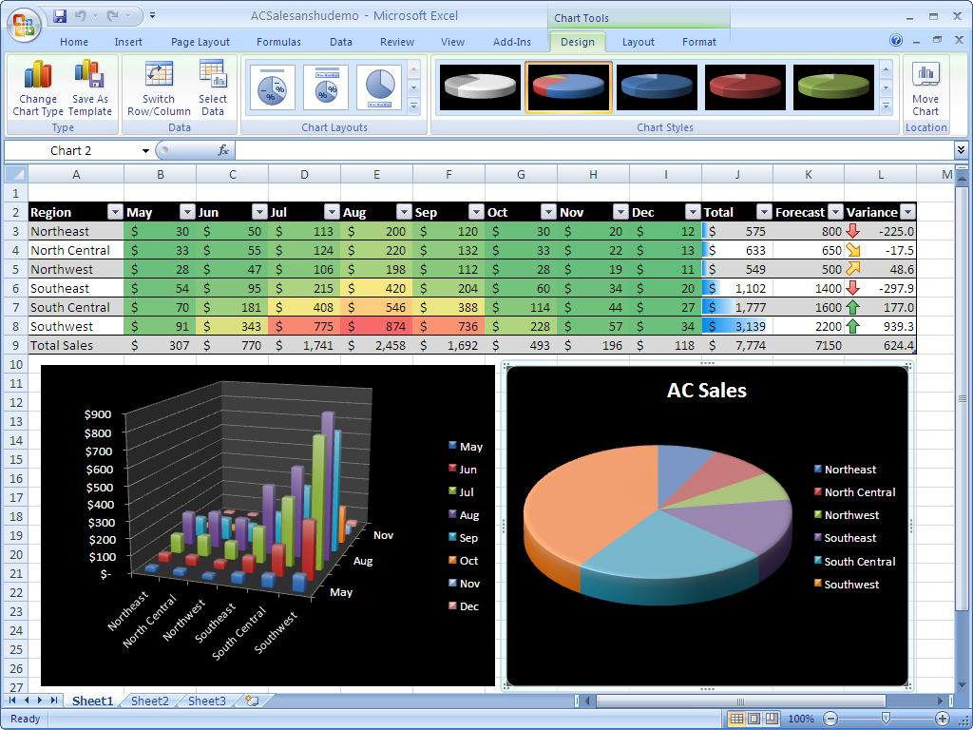
Figure 7: Charting tools in Office Excel 2007 make it easy to create and format charts.

Conditional Formatting
You can now discover and illustrate important trends and highlight exceptions in your data by using conditional formatting. You can apply conditional formatting easily and identify trends by using colors, rules, data bars, and icons. You can also reorganize this data with sorting options like Sort by Smallest to Largest or Cell Color.
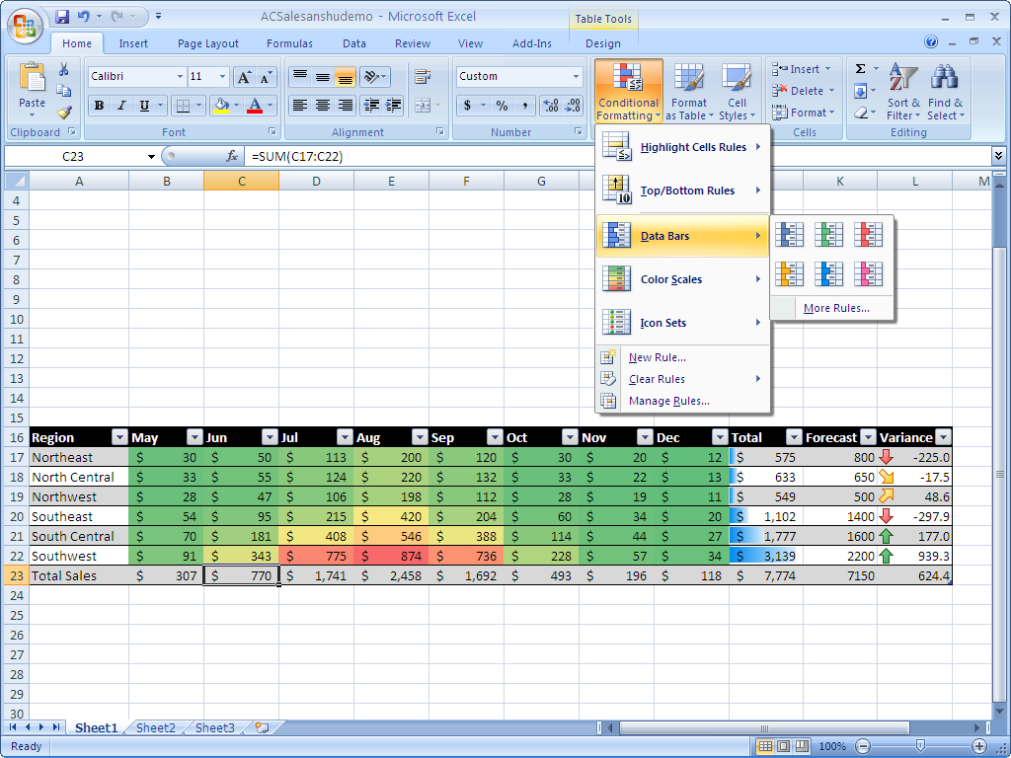
Figure 8: Use conditional formatting to visualize data trends.

Centralize Contact and Customer Management
To provide consistent, effective customer service and to close sales, a business must manage its customer contacts, track customer commitments, and follow up promptly on sales opportunities. Without the right tools, that is a Herculean task. Office Small Business 2007 provides a practical, attractively priced solution for managing customer relations. Office Outlook 2007 with Business Contact Manager extends the functionality of Outlook to provide a complete contact and customer management solution with the familiar Outlook environment.
Office Outlook 2007 with Business Contact Manager gives you the tools you need to better manage customer information and communications history from one place and to share business contacts, accounts, and opportunities across your organization. Now you can more easily and effectively track, prioritize, and manage leads and sales opportunities from the initial opportunity through closing, while keeping your sales processes organized and productive. You can also create and monitor marketing campaigns and track their overall effectiveness using Office Outlook 2007 with Business Contact Manager.
Office Outlook 2007 with Business Contact Manager in Action: Centralize customer information
Contoso account managers Sandra Martinez and Michael Holm used to rely on improvised methods for managing their customer accounts. This worked when the company had only a few active projects at a time, but Sandra and Michael now find it increasingly difficult to track their many customers and prospects. Office Outlook 2007 with Business Contact Manager helps them increase sales and provide better customer service by effectively managing each opportunity throughout the sales cycle.

Centralize Contact and Customer Information
Many companies have leads and customer information spread all over the place—in e-mail, spreadsheet lists, custom software or databases, and even handwritten notes. With critical contact information located in so many different places, important sales calls and followup with customers can happen slowly, if they happen at all.
Office Outlook 2007 with Business Contact Manager can change that. It adds complete contact management capabilities to Outlook so you can organize your accounts, centralize critical business information, and improve customer service across your organization.

Organize Accounts and Business Contacts
Office Outlook 2007 with Business Contact Manager helps you organize and track all your customer and prospect information from one location. You can link information such as notes, appointments, documents, and tasks to the appropriate record. Office Outlook with Business Contact Manager can also automatically associate incoming and outgoing e-mail messages to a contact. You can even link a Word document or Excel spreadsheet directly back to a related Outlook contact while you are working in the document or spreadsheet.
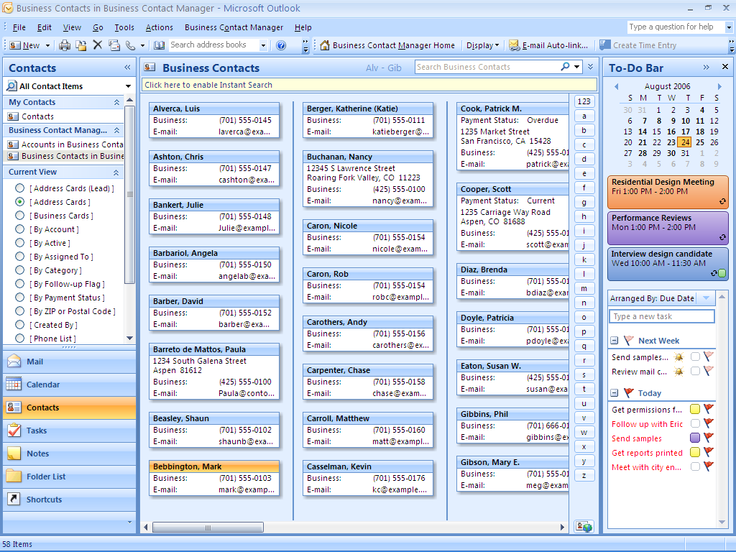
Figure 9: Office Outlook 2007 with Business Contact Manager gives you a consolidated view
of all your business contact information.

Share Customer Information Throughout Your Organization
Office Outlook 2007 with Business Contact Manager offers multiuser capabilities that make it easy to share information with coworkers. You can grant access to important customer information to other people in your organization. As an added bonus, when you work in multiuser mode, you can work offline on your portable computer or Pocket PC and synchronize your changes when you reconnect to your network.

Effectively Track Leads and Forecast Sales Opportunities
It is a challenge to succeed at sales. Salespeople have to attend to every step in the sales cycle and follow up on every lead. They cannot afford to waste valuable time chasing down sales-related data. It needs to be available at the drop of a hat. Office Outlook 2007 with Business Contact Manager helps to organize the information associated with managing and following up on sales opportunities so you can work more efficiently.
Just as you can associate e-mail messages, phone logs, documents, notes, and more with your contacts, you can also track sources of leads and even the probability of closing a sale by using Office Outlook 2007 with Business Contact Manager. This can help you forecast sales more effectively so you have a clear view of business development. You can also get a consolidated view of your sales pipeline across the company so you can easily follow up with prospects and determine where to focus your efforts.

Sales Leads and Opportunities
Get the help you need to stay on top of every opportunity and maximize sales potential. In Office Outlook 2007 with Business Contact Manager, a contact page contains essential information for each business opportunity, and it uses reminders, rules, and alerts to help you manage the opportunity throughout the sales cycle. An opportunity form provides a complete activity history for each lead, including the products or services being sold, product pricing, the sales stage, and the probability of closing the sale. Sales managers can use that information to assess revenue potential, build accurate quotes, and provide fast, accurate answers to questions from customers.

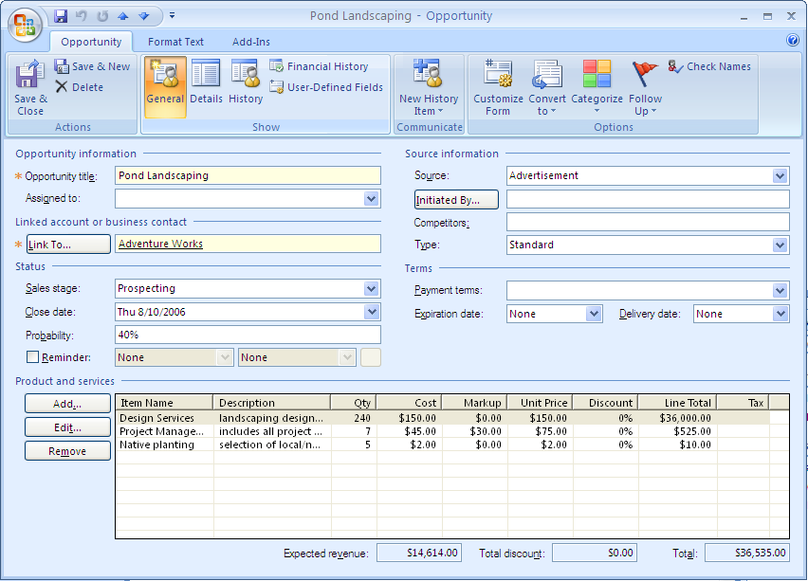
Figure 10: Track new sales opportunities in Office Outlook 2007 with Business Contact Manager.

Sales Leads Reports
Office Outlook 2007 with Business Contact Manager provides more than 50 customizable customer and prospect business reports to help you stay on top of the entire sales cycle. To accurately measure and predict sales activity across opportunities, you can run reports that show sales status, order information, and probability of closing for all opportunities and accounts or for a subset that you define. You can filter data to view the status of specific accounts or to show customers and opportunities that have not been contacted recently, and then export the results to Office Excel 2007 for further analysis. Equipped with this information, you can set priorities for sales efforts, organize daily tasks, and make sure that your important customer requests and sales opportunities do not fall through the cracks.

Information Dashboard
Get the data you need to plan and manage your daily activities. A fully customizable reporting solution, the information dashboard gives you a complete at-a-glance view of customer and prospective customer information. You and your coworkers can choose the metrics that are most important to your roles and define the scope of the reports.
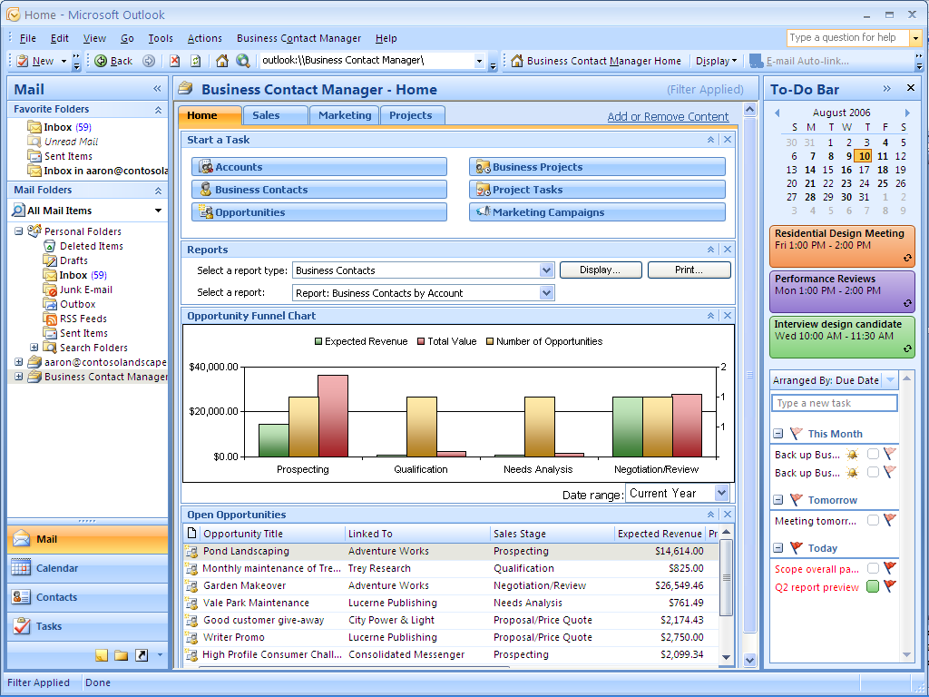
Figure 11: The information dashboard in Office Outlook 2007 with Business Contact Manager gives you a complete view of customer information.
Office Outlook 2007 with Business Contact Manager in Action: Streamline the flow of information across the sales pipeline
Now that Contoso employees use Office Outlook 2007 with Business Contact Manager to track contact information, the whole sales cycle is much smoother. When Michael Holm gets a call from a former client interested in additional services, he just clicks the appropriate form in Office Outlook 2007 with Business Contact Manager to get a complete history of that account, including the design work Contoso completed for that client two years earlier. Michael uses the design information to generate a new opportunity for the customer, and this information is automatically included along with other information from the conversation in the client’s contact record. Carol Philips is then able to access the opportunity information when she writes up the project design proposal for this customer.

Market More Effectively
A good marketing campaign helps small businesses promote products and services, keep in touch with existing customers, generate new leads, and convey a consistent and professional business identity. A good marketing campaign can be even more effective when you personalize communications.
Office Outlook 2007 with Business Contact Manager can help you manage your marketing campaign activities for better results. Office Outlook 2007 with Business Contact Manager includes tools to help you compile your mailing list, distribute distributing materials, and track the results.

From Custom Mailing Lists to Personalized Campaigns
Developing a mailing list for a marketing campaign does not have to be a manual, time-consuming task. With improved filtering capabilities in Office Outlook 2007 with Business Contact Manager, you can create custom recipient lists based on the customer and prospect data you specify. And thanks to the tight integration with all the Microsoft Office system programs, you can now use Mail Merge capabilities to personalize all the marketing materials that you create in Publisher or Word. The E-Mail Merge Wizard in Publisher takes you through the process of creating a custom mailing list and personalizing messages for your e-mail marketing campaigns. After you have sent a campaign to a list, a record of that campaign automatically becomes part of your contact’s history. You can also track responses to your campaigns to assess which campaigns have been the most effective.
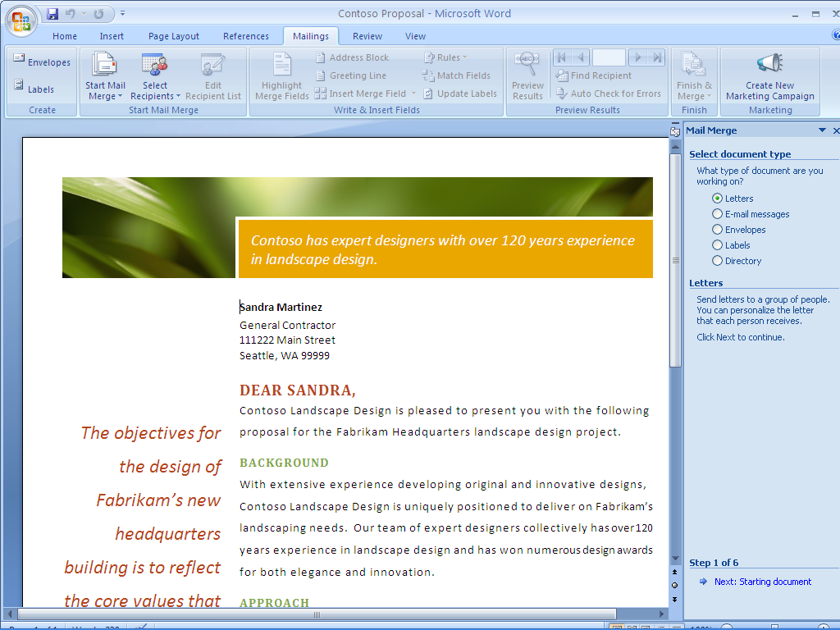
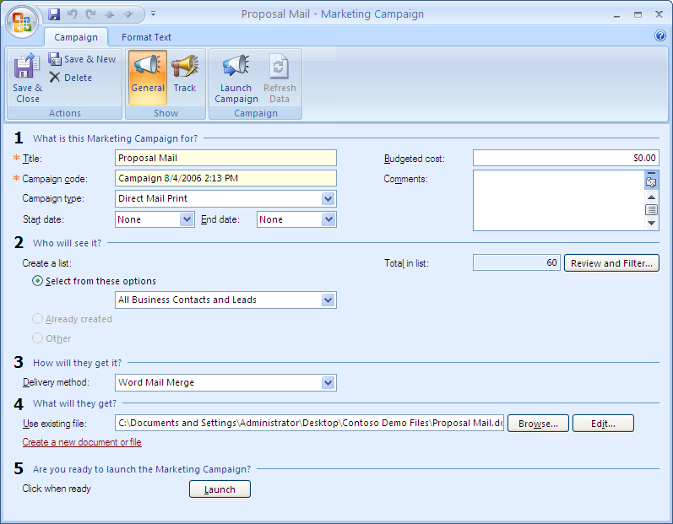

Figure 12: Create a marketing campaign mailing list using Office Outlook 2007 with Business Contact Manager.

Improve Project Management
Keeping customer information stored across multiple applications, spreadsheets, and databases hampers effective project management and creates risks. When employees do not have timely access to project-related information, critical tasks often take longer than they should, or they don’t get done at all.
Using Office Outlook 2007 with Business Contact Manager you can track project activities and manage project tasks in one central location. Your team can view and share the complete history of project-related communications from Office Outlook 2007 with Business Contact Manager, including e-mail messages, phone calls, notes, meetings, and documents. You can also assign project tasks to team members from Outlook; these tasks will appear on your To-Do Bar as well as the To-Do Bar of the person assigned to complete the task, so you will remember to follow up on those important project deliverables.
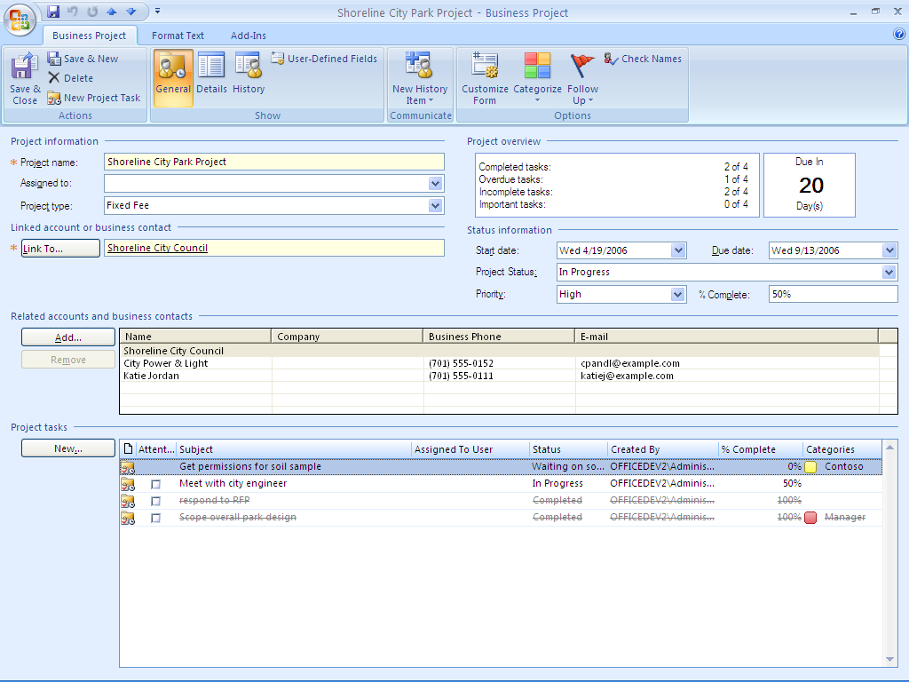
Figure 13: Collect all of your project information in one place with Office Outlook 2007 with Business Contact Manager.

Produce Professional-Quality Marketing Communications In-House
Sales and marketing materials help you promote your business, keep in touch with existing customers, generate new leads, and convey a consistent and professional business identity. But hiring a vendor to create brochures, Web sites, and other communications can be both expensive and time-consuming, and the results are not guaranteed. Office Small Business 2007 provides the powerful features you need to easily and confidently create designer-quality communications in-house.
Office Publisher 2007 in Action: Building new marketing materials
Contoso Landscape Design recently added commercial landscape design to its portfolio of services and wants to market this new service, but doesn’t have the budget to hire a marketing firm. Michael Holm, the commercial accounts manager, has volunteered to tackle the marketing campaign himself. Aside from a few marketing classes in college, Michael has no experience with creating and distributing marketing materials, but he knows that Office Publisher 2007 includes easy-to-use guides to lead him through the process, from concept to delivery.

Create Designer-Quality Marketing Materials
Your business collateral and marketing materials can enhance or damage your company’s image. Well-designed brochures, postcards, catalogs, and e-newsletters can help boost your professional image, support your creativity, and deliver your message with clarity. Office Publisher 2007 has the tools you need to project the right image for your business and make an impact with customers in person or online. With Office Publisher 2007 you can easily and confidently design and publish professional sales and marketing materials in-house.
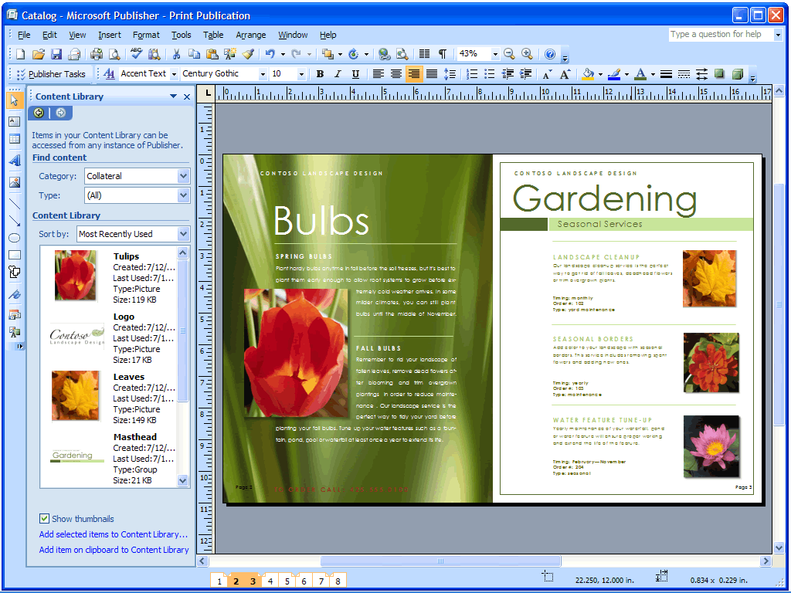
Figure 14: Store reusable layout elements such as logos, pictures, lists, and text in the new Content Library.

Get Started with Publisher Tasks
To help guide you through the most common procedures, new Publisher Tasks expose you to the features you will most likely need to use during creation, distribution, and follow-up of marketing materials. Publisher Tasks also include tips for personalizing your publication, preparing your mailing lists, preparing publication for commercial printing, tracking its effectiveness, working with images, and more.

Use Designer-Quality Templates or Build Your Own
Choose from an extensive library of designer-quality templates that you can customize, or begin with one of the many formatted documents for newsletters, brochures, flyers, postcards, Web sites, e-mail, and other publications. You can categorize, preview, open, and save the publication templates you create from My Templates. You can also preview and open templates from the Microsoft Office Online Template Gallery within Office Publisher 2007.
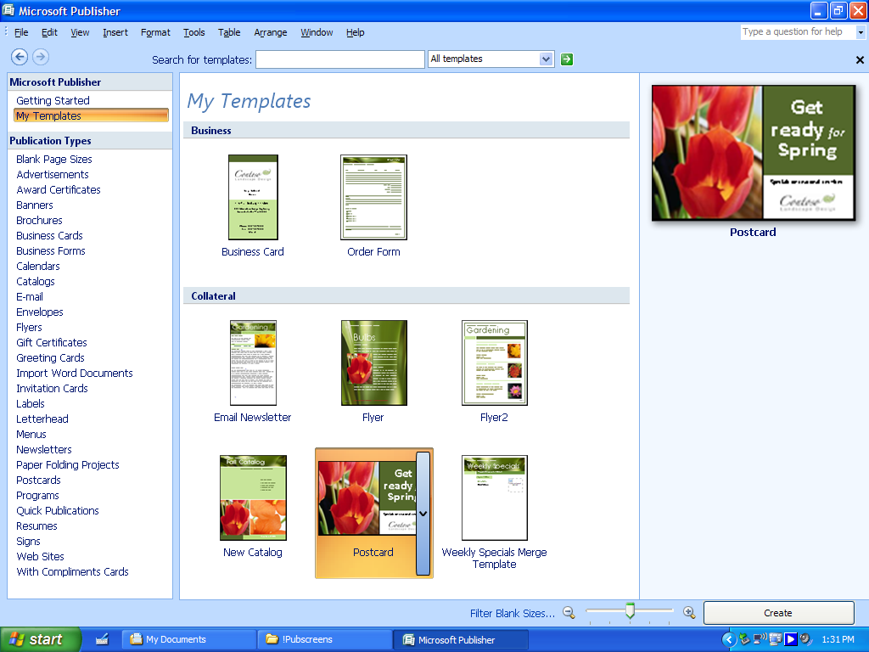
Figure 15: Save new or modified Office Publisher templates in My Templates.

Promote Your Company Brand
The new Getting Started experience provides dynamic previews so you can easily create and apply your brand elements to all Publisher templates before you begin. Develop your brand identity using custom color and font schemes, your logo, and your business information, and create a professional look for all of your publications. After you have created your business identity, you can apply it to all the Publisher templates and save these customized templates in the library.
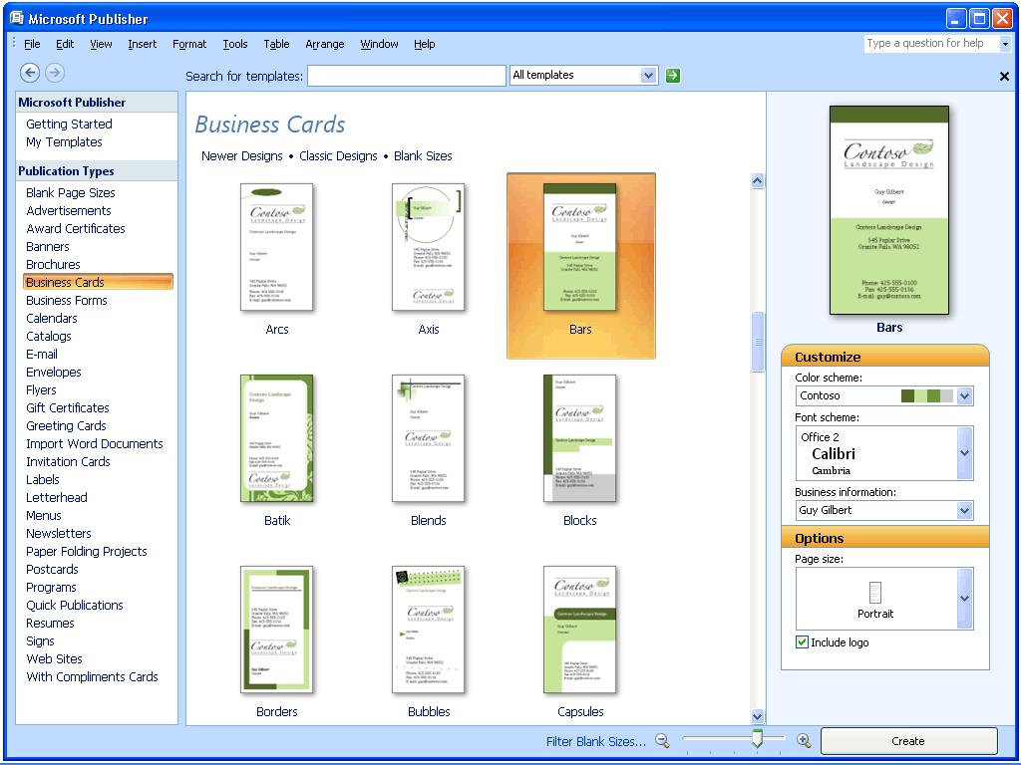
Figure 16: Create publications faster. Apply your own brand—colors, fonts, logo, business information—to all Publisher templates in one step.

Use Existing Content
With Office Publisher 2007, you can make the most of the time you invest in your work by publishing a single publication in multiple ways and reusing content and design elements across publications. Using the new Content Library, you can access and save frequently used design elements, text, and graphics for use in other Publisher publications. You can also quickly reuse content from one publication type to another by simply changing the template. Just a few mouse clicks turns your multipage newsletter into an e-mail publication, or your letterhead into a business card, or the latest postcard into a flyer.
Office Publisher 2007 in Action: Quick and easy design
Michael decides to kick off the campaign with a small targeted e-mail message to existing clients of Contoso Landscaping. He plans to use an e-mail template from the template library in Publisher, but it does not quite match the Contoso brand, so Michael creates a business identity in Publisher and applies it to the e-mail template. Now the e-mail message has the right color scheme and includes the company logo. Michael saves the business identity he created so he can use it for other projects in the future.

Easily Share, Publish, and Print
The last thing you need after taking the time to create a polished set of marketing materials is a problem with printing or sharing them. To help ensure that what you see is what your customers get, Office Publisher 2007 offers new capabilities to help you easily share, publish, and print marketing publications.

Personalize Distribution
Office Publisher 2007 helps you give your customers the individual attention they deserve. Use enhanced Mail Merge, Catalog Merge, and new E-Mail Merge with bookmarks and personalized hyperlinks to create personalized publications or mailings for print or e-mail distribution. Merge task pane options guide you through the process of selecting lists, adding text and image fields, and completing your mailing. Improvements in e-mail distribution and viewing, including support for sending multipage publications as a single page message, make it easier than ever to create and send publications as e-mail messages.
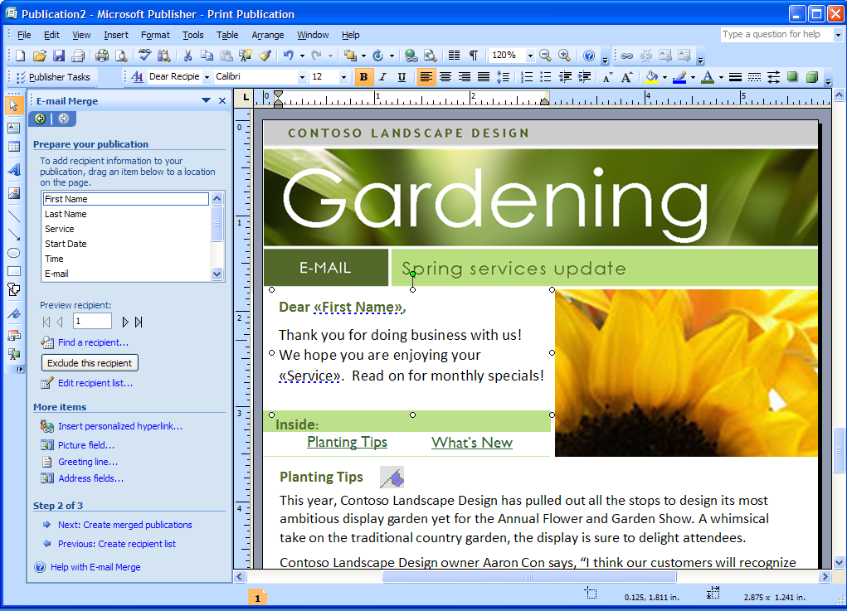
Figure 17: Create personalized e-mail marketing campaigns using new Publisher E-Mail Merge.

Publish as PDF or XPS
As with other Microsoft Office system programs, Office Publisher 2007 includes the option to convert your publications to PDF or XPS. This is especially useful when you want to share your publications with customers or business partners or make them ready for commercial printing. You can choose to optimize these formats for commercial press, high-quality desktop printing, online distribution, or on-screen display.

Office Publisher 2007 in Action: Getting it right
Michael is pleased with the results of the e-mail campaign, so he decides to use the content for a printed direct mail to targeted business districts. Publisher Tasks guides him through the process of converting the e-mail message to a printed letter. From there, it is a simple click to convert the file to a PDF and send it to the printer.

Build Effective Presentations
When you give a presentation to your customers, partners, or investors, you want it to have an impact. To communicate effectively, your slides need to be crisp, clear, and polished. You can get just the look you want with the new and enhanced features in Office PowerPoint 2007.

Use Slide Layout and Prebuilt Slides
Get started by choosing from the library of professionally designed slide layouts in PowerPoint. You can customize slides to get exactly the layout you want, or use new prebuilt slide layouts for the most common topics. You can also create layouts with multiple charts, tables, and text, and then save them as templates.
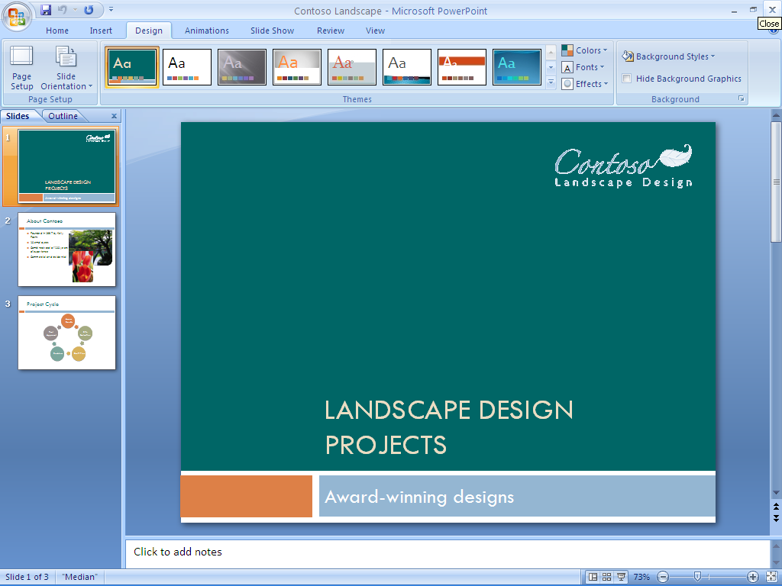
Figure 18: Choose from a selection of prebuilt slides in Office PowerPoint 2007.

Create Impact with Document Themes
New Document Themes help ensure a consistent appearance between the documents you create in Office Word 2007, Excel spreadsheets, and the slides you create in Office PowerPoint 2007. Now, instead of manually applying the same colors, fonts, and special effects that you used in your Word document to your PowerPoint presentation, you can just select the Theme you used to format the Word document, and Office PowerPoint 2007 does the rest.

Graphics, Tables, and Charts
You can build tables and charts in Office PowerPoint 2007 using the same easily accessible tools you have come to depend upon in Office Word 2007. And using improved graphics capabilities, you can add to, edit, and modify images in your slides. With new AutoShape enhancements and improvements in the selection and manipulation of objects, you no longer have to worry about getting the picture you want on the page.
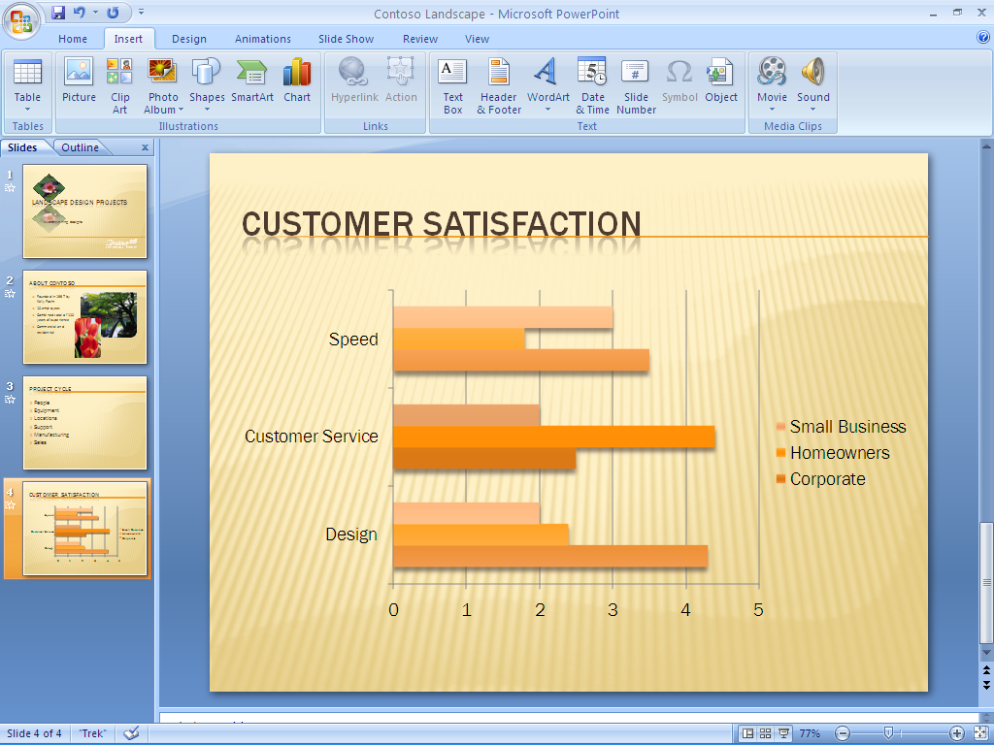
Figure 19: Including charts in Office PowerPoint 2007 is easy.

Product Highlights

Office Excel 2007
Key enhancements to Office Excel 2007 include:
- New! Office Fluent user interface presents accessible, task-based tools at the right time.
- New! Shared charting engine across the Microsoft Office system helps you to create and interact with charts the same way, regardless of the program.
- Improved! Accessible charting tools help you create professional-looking charts and format axes, titles, and other chart labels—all by using fewer clicks.
- Improved! More styles and effects, such as 3-D, soft shadowing, and anti-aliasing, simplify the process of formatting charts.
- Improved! Customization with Microsoft Office Art, predefined styles, and integrated graphics help you quickly apply a consistent, professional look to your spreadsheets.
- Improved! Printing experience with a new Page Layout view to help ensure that what you see on the screen is what you will get in printed output.
- New! Browser-based data access helps you share business information more safely, without revealing confidential data.
- New! PivotTable® support helps you to navigate, sort, filter, and interact with any PivotTable view by using a browser.
- New! Ecma Open XML Formats reduce file sizes, improve data recovery, and give you greater data interoperability.
- New! Binary file format helps you avoid extensive load times so you can open large spreadsheets faster.
- Improved! Support for PDF and XPS file formats helps you convert your spreadsheet into a fixed file format for easier sharing.
- Improved! Faster calculations in large, formulae-intensive spreadsheets because of support for dual processors and multithreaded chipsets.
- New! Increased row and column capacity of 1 million rows by 16,000 columns enables you to work with massive amounts of data.
- New! Enhanced table tools help you create a table in just one click and format it quickly. Column headings remain in view as you scroll, and Auto Fill populates and expands any table automatically.
- New! Structured referencing helps you to refer to tables, column headings, or the information they contain when you are writing formulae.
- Improved! Formulae and range management tools include a resizable formulae bar, a central location for managing multiple ranges, and context-based formulae AutoComplete. These tools can help you write the proper syntax the first time, every time.
- Improved! Conditional formatting offers new visual enhancements, such as gradients and icons, for highlighting data trends.
- Improved! Sorting and filtering helps you find the information you need, quickly and easily. Sort by using up to 64 sorting fields—including color—and apply multiple filters to a column by using AutoFilter.
- Improved! PivotTable views and PivotChart® views offer greater automation and tools that make them easier to work with—regardless of your skill level.
- New! Permissions-based control enables you to manage which users can view and modify spreadsheets on the server.
- New! Data Connection Libraries enable you to connect to external data sources quickly and with enhanced safety.
- New! Support for Web services enables you to publish Excel results into a server-based or client-based application by using Web services.

Office Outlook 2007 with Business Contact Manager
Office Outlook 2007 provides an integrated solution to help you better manage your time and information and improve your security. Office Outlook 2007 with Business Contact Manager adds complete business contact management capabilities to Office Outlook 2007, so you can more easily manage contact information and sales opportunities in one centralized location. Key enhancements to Office Outlook 2007 with Business Contact Manager include:
- New! Office Fluent user interface makes composing, formatting, and acting upon e-mail easier and more intuitive.
- New and improved! Anti-phishing and junk e-mail technologies help reduce the amount of junk and malicious e-mail messages that enter your inbox.
- New! Instant Search enables you to search through your e-mail, e-mail attachments, calendar, contacts, and tasks simultaneously, so you can find the information you need faster than ever.
- New! Flagging E-Mail as Tasks helps you to create tasks from e-mail in one simple step.
- New! To-Do Bar efficiently centralizes calendar and task management. The integration with tasks from other programs gives users a consolidated view of their daily priorities.
- New! Task integration on the calendar provides an interactive way to work with your tasks and flagged mail by dragging them onto your calendar in order to schedule time to complete them.
- New! Color Categories help you assign categories to any type of information, so you can quickly identify and visually distinguish related items.
- New! Calendar snapshots provide an easy and visual way to share calendar information with others outside of your organization.
- New! Calendar publishing through Microsoft Office Online gives you an easy and more secure way to post and share information.
- New and Improved! Sharing requests make it easy for you to share your information by giving permissions to any Office Outlook 2007 folder to anyone using Microsoft Exchange. You can ask the recipient to share the same folder in return.
- New! Integration with Microsoft Windows® SharePoint® Services information enables you to import SharePoint calendars, contacts, or tasks into Office Outlook 2007 and have full editing capabilities whether you’re online or offline. You can make edits to this information right from within Office Outlook 2007 and take it offline, helping to ensure any changes you make in Office Outlook 2007 are reflected on the server version.
- New! Attachment Previewer enables you to preview attachments in the reading pane, giving you insight into e-mail attachments and speeding decision-making.
- New! Mini navigation bar speeds access to important Office Outlook 2007 information.
- New! Sender Contact Photo displays a picture of the person who is sending you e-mail within that message, enabling you to scan your e-mail messages by photo and quickly identify the sender.
- New! Office Outlook 2007 E-Mail Postmark helps ensure that e-mail messages that reach your inbox are legitimate and that e-mail messages sent by Office Outlook 2007 will be trusted by the recipient’s computer.

Key features of Office Outlook 2007 with Business Contact Manager include:
- Improved! Contact management tracking features help you more easily track contact information and communications history.
- Improved! Sales Leads and Opportunity tracking helps you respond and close the sale more quickly.
- Improved! Integration with Microsoft Office Accounting enables you to view financial data in Office Outlook 2007 with improved data sharing features.
- New! Customization helps you to change fields, reports, and more to meet your specific needs.
- New! Business Contacts dashboard gives you a comprehensive view of your sales pipeline.
- Improved! Report filters help you to view data according to what metrics you need.
- Improved! Export reports to Office Excel 2007 for more detailed analysis whenever you need it.
- New! Marketing Campaign guides you through the process of compiling lists, personalizing, and tracking campaigns.
- New! Marketing Campaign personalization tools help you personalize your marketing campaigns using mail merge integration with Office Word 2007, Publisher, List Builder, and HTML.
- New! Marketing Campaign tracking features help you determine which marketing efforts were successful and which weren’t.
- New! Business Projects helps you track all you project related information in one place.
- New! Business Project Tasks appear on your To-Do Bar and Reminders, so you remain efficient.
- New! Offline Access helps you can access your business contacts when you’re on the road. Use your laptop or Pocket PC—and then synchronize when you get back to the office.
- New! Software development kit (SDK) helps software developers to integrate Office Outlook 2007 with Business Contact Manager with their software.

Office PowerPoint 2007
Office PowerPoint 2007 makes it easier than ever to create dynamic and professional-looking presentations. The Office Fluent interface offers new graphic styles, more presentation themes, and custom layout support so you can create more effective presentations. Key enhancements include:
- New! Custom layouts help you quickly create precisely the layout you envision without being bound by one of the prepackaged standard layouts.
- New! Graphics and text effects and better shape and drawing tools help you create professional diagrams and flow models.
- New! Rich text and typography boost the impact of your design.
- New! Quick Styles help ensure a consistent appearance between the diagrams, tables, and shapes you create in Word and Excel and paste into presentations in PowerPoint.
- New! Office XML Formats are more compact so you can share presentations more effectively.
- New! Slide Libraries help you store and share slide layouts and easily access other presentations.
- New! Print as PDF of XPS functionality helps you to share your presentations with customers or clients on other platforms.
- Improved! Revised user interface streamlines workflow and boosts productivity.
- New! Improved styles help ensure a consistent appearance between the documents you create in Word, spreadsheets you create in Excel, and presentations you create in PowerPoint.
- Improved! Presenter View gives you more information to plan and deliver effective live presentations.

Office Publisher 2007
With Office Publisher 2007 you can create and publish professional sales and marketing communications that are ready for desktop printing, commercial printing, e-mail distribution, or viewing on the Web. Office Publisher 2007 offers professional design template collections, built-in design expertise, and the familiar user interface, menus, tools, and features of other Microsoft Office system programs within Office Small Business 2007. Key enhancements include:
- New! See dynamic previews of Office Publisher 2007 templates with your brand elements applied, including your colors, fonts, logo, and business information before choosing a template.
- Improved! A template library gets you started quickly by supplying hundreds of customizable design templates and blank publications, including newsletters, brochures, flyers, postcards, Web sites, e-mail formats, and more.
- Improved! Create a business identity for all your business and personal needs, including company name, contact information, and logo. Maintain a consistent, professional look by applying your business identity, as well as custom color schemes and font schemes, to all your publications.
- New! Instant Search can help you quickly locate and preview high-quality Publisher templates from Microsoft Office Online right within the Publisher Catalog. You can also now efficiently categorize, preview, open, and save your templates within My Templates for fast retrieval.
- New! Content Store saves time and effort by storing frequently used text, design elements, and graphics in an easy location for use in other publications.
- Improved! Reuse content for other publication types and distribution methods. For example, easily place content from a multipage newsletter into an e-mail template or Web layout for online distribution.
- Improved! Choose color schemes from more than 70 designer-created color schemes or create one of your own. If you are using Pantone colors, choose them from within Publisher.
- New! Publisher Tasks provide assistance with common procedures, such as inserting images, creating a Mail Merge, and reusing content.
- Improved! Catalog Merge helps you quickly build custom materials such as datasheets or catalogs by merging text and images from a database.
- Improved! Design tools can help you customize your publication. Use the collection of intuitive design and graphics tools to adjust tracking and kerning, insert images from a scanner or digital camera, recolor and crop images, and more.
- Improved! Design Checker identifies common problems in commercial print files, Web files, and e-mail. Use it prior to distributing or printing your publication to quickly identify and fix any design errors.
- New! Save Publisher files in a fixed-file format, such as PDF or XPS, for hassle-free sharing. PDF settings within Office Publisher 2007 include options for online viewing, desktop printing, and commercial press-ready printing.
- Improved! For large quantities and high-quality printing, Office Publisher 2007 offers full commercial printing support including 4-color process printing, spot color printing, CMYK composite PostScript and more. Use the improved Pack and Go Wizard to prepare your Publisher files, including a press-ready PDF file, for a commercial printer.
- Improved! Improvements in e-mail distribution and viewing, including support for sending multipage publications as a single-page message, make it easier than ever to create and send publications as e-mail messages that appear exactly as you intended.
- Improved! Convert publications for viewing on the Web and easily update, edit, post, and add navigation.

Office Word 2007
Office Word 2007 adds new, easy-to-use quick formatting controls, mathematical equation editing, and predefined and customizable Building Blocks for adding commonly used content, like citations, references, headers, and footers. Word document templates can be structured and deployed across organizations to standardize document formats, and they can be used to connect and present information stored in back-end systems using new data-binding capability. Key enhancements include:
- New! Quick Styles save you time by helping you quickly format text and tables throughout your document.
- New! Building Blocks of predefined content reduce the errors associated with copying and pasting commonly used content.
- New! Equation editing boosts the capabilities of Word with a comprehensive equation editor built right into the familiar Word environment.
- New! Citations and references help you to add citations and references to your document with a single click.
- New! SmartArt™ graphics add a professional look to documents.
- New! A results-oriented user interface streamlines workflow and boosts your productivity.
- New! Live word count keeps track of the number of words in your document as you type.
- New! Save as PDF or XPS option helps you to use the file format that is most convenient for you.
- Improved! Bullets and numbering now offer more choices and are easier to use.
- New! The tri-pane review panel helps you to quickly identify the differences between documents.
- New! The Document Comparison feature helps you to conduct more thorough reviews by tracking moved, updated, or deleted text.
- New! An immersive full-screen reading experience makes reading online easier, reducing the need to print.
- New! A simple, step-by-step interface helps you make sense out of the changes of multiple reviewers by merging their changes.
- New! Improved styles help you to manage large documents more easily.
- New! Integration between Office Outlook 2007 and Windows SharePoint Services helps you to conduct and administer document review cycles.
- New! Mail Merge tab on the new Office Word 2007 user interface simplifies mailings.

Resources
For more information about Office Small Business 2007 and the 2007 Microsoft Office system, please visit http://www.microsoft.com/office/suites/smallbusiness.

System Requirements
For complete system requirements, visit http://www.microsoft.com/office/suites/smallbusiness.

This document is developed prior to the product’s release to manufacturing, and as such, we cannot guarantee that all details included herein will be exactly as what is found in the shipping product. The information contained in this document represents the current view of Microsoft Corporation on the issues discussed as of the date of publication. Because Microsoft must respond to changing market conditions, this document should not be interpreted to be a commitment on the part of Microsoft, and Microsoft cannot guarantee the accuracy of any information presented after the date of publication. The information represents the product at the time this document was printed and should be used for planning purposes only. Information is subject to change at any time without prior notice.

This document is for informational purposes only. MICROSOFT MAKES NO WARRANTIES, EXPRESS OR IMPLIED, IN THIS DOCUMENT.

© 2006 Microsoft Corporation. All rights reserved. Microsoft, Excel, Fluent, the Office logo, OneNote, Outlook, PivotChart, PivotTable, PowerPoint, SharePoint, and Windows are either registered trademarks or trademarks of Microsoft Corporation in the United States and/or other countries. All other trademarks are property of their respective owners.

You can save as a PDF or XPS file from a 2007 Microsoft Office system program only after you install an add-in. For more information, see Install and use a PDF or XPS add-in.

