 | 



  - A Developer's Guide to the Service Bus in Windows Azure AppFabric
  - Software + Services on the Windows Azure platform

Aaron Skonnard, Pluralsight
June 2010

Contents
Abstract 3
An Overview of the Service Bus 3
The Enterprise Service Bus Pattern 4
Moving towards an Internet Service Bus 5
Introducing the Service Bus 7
Getting Started with the Service Bus 8
Your First Service Bus Application 10
Naming and Discovery 15
Naming System 15
Service Registry 17
Messaging 21
The Relay Service 21
Choosing Service Bus Addresses 21
Ports Required by the Relay Service 22
WCF Relay Bindings 23
NetOnewayRelayBinding 23
System Connectivity Mode 26
NetEventRelayBinding 27
NetTcpRelayBinding 30
HTTP Relay Bindings 35
Access Control 39
Authentication and Authorization 39
Configuring WCF Clients and Services 40
Message Buffers 41
Understanding Message Buffers 41
Programming Message Buffers 42
Guidance 45
Summary 47
Additional Resources 47
About the Author 47
Acknowledgements 48

Abstract
As applications begin moving towards the cloud computing platform offered by Windows® Azure, they will need the ability to bridge their existing on-premises software with any new assets running in the cloud, a strategy commonly referred to as software + services today. This type of integration can be accomplished through standard protocols assuming bidirectional connectivity is possible. While it’s usually simple to initiate communication from on-premises applications to services running in the cloud, the reverse is more difficult because on-premises software is usually running behind multiple firewalls or NAT devices. The Service Bus in the Windows Azure AppFabric addresses this problem space by making it easy to create secure bidirectional communication channels between on-premises software and services running in the cloud.

An Overview of the Service Bus
The Service Bus in the Windows Azure AppFabric (henceforth referred to as 'Service Bus') is a highly scalable developer-oriented service running in Microsoft data centers as a constituent of the Windows Azure™ platform. The primary purpose of the Service Bus is to “relay” messages through the cloud to services running on-premises behind firewalls and NAT devices. on-premises. The Service Bus is complemented by Access Control, another constituent of the Windows Azure platform. The Service Bus relies on Access Control for securing access to endpoints through a claims-based security model. Together these services provide a valuable development fabric required by most cloud applications today, thereby simplifying development by allowing you to focus more on business needs.
This whitepaper focuses on how you can use the Service Bus to overcome some of the most common Internet connectivity challenges inherent in today’s world. First, we’ll discuss the motivation for the Service Bus, the ESB-like architectural pattern it embodies, and the key aspects of the architecture you’ll need to understand before diving in. Then, after taking a quick lap around your first Service Bus application, we’ll dive deeper into each area of the Service Bus, exploring the different messaging options it offers, and discussing how it integrates with Access Control. And finally, towards the end of the paper we’ll provide some guidance on how to best use the Service Bus in your applications.

The Enterprise Service Bus Pattern
There’s a reason Microsoft decided to call what we’re talking about here the Service Bus. The “Service Bus” moniker was chosen to emphasize certain characteristics of its underlying architecture. These architectural characteristics are actually quite common today through the various product incarnations of the Enterprise Service Bus (ESB) architectural pattern. The ESB pattern defines a model for integrating enterprise applications through a common messaging fabric or “bus” (see Figure 1).
The ESB pattern typically calls for a federated identity and access control mechanism, a common service naming mechanism, a discoverable service registry, and a common messaging fabric that provides a variety of communication options. This model introduces a level of indirection between the various services found on the bus, and between composite applications and the services they consume. The ESB pattern helps broker differences across services in terms of identity management, naming conventions, message formats, and communication protocols. Once a service gets on the bus, anything else on the bus can connect to it even if it wouldn't normally be able to communicate with the service directly.
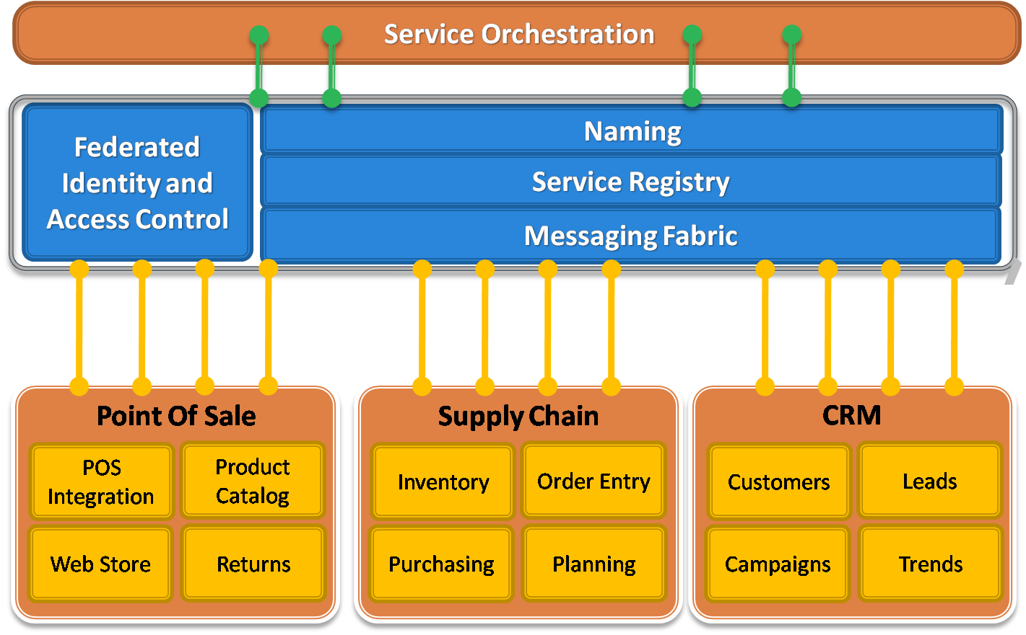
Figure 1: The Enterprise Service Bus Pattern
The ESB pattern has grown in popularity over the years because it simplifies the management of multiple service connections. One way it does this is by enabling publish/subscribe architectures, which provides for even looser-coupling throughout an enterprise. With a publish/subscribe architecture, consumers no longer have to be directly connected to services anymore – everything just needs a connection to the bus – and nodes can be added or removed at will over time. This type of architecture also enables event distribution. You can have multiple subscribers to a single message type, and you can also have multiple publishers of that same message type, giving you N-to-N multicast capabilities.
Most ESB environments are enhanced with a service orchestration layer that provides a process flow engine for orchestrating the messaging interactions that make up a business process or “workflow”.
There are a variety of different products and technologies that can be used to implement an ESB including things like Active Directory, UDDI, BizTalk Server, MSMQ and WCF, and there are many equivalent offerings available on other platforms as well. In most ESB environments, the messaging fabric is simply rooted in Ethernet and TCP/IP. This raw messaging foundation is then enhanced by a variety of server products and messaging technologies that provide different messaging semantics.
You might use MSMQ for durable asynchronous messaging semantics or BizTalk Server when you want to employ a hub-and-spoke integration model. You could also use peer-to-peer messaging techniques through WCF, or a more RESTful model built primarily in terms of HTTP communication. The ESB messaging fabric can support all of these messaging options and shield you from their differences.
The ESB pattern has proven valuable for managing on-premises applications, however, as more software assets begin to move towards the cloud, a new set of challenges arise that must be addressed.

Moving towards an Internet Service Bus
Microsoft has been actively working on making the ESB pattern a reality at Internet scope. When you consider what this would entail, you’ll realize that the same ESB architectural components are going to be necessary, specifically identity and access control, naming, a service registry, and a common messaging fabric. The primary difference is one of scope: in this case the various ESB components must be designed to operate in the cloud, at Internet scope, in a highly scalable and federated manner. This is what Microsoft has referred to in the past as an Internet Service Bus implementation (see Figure 2).
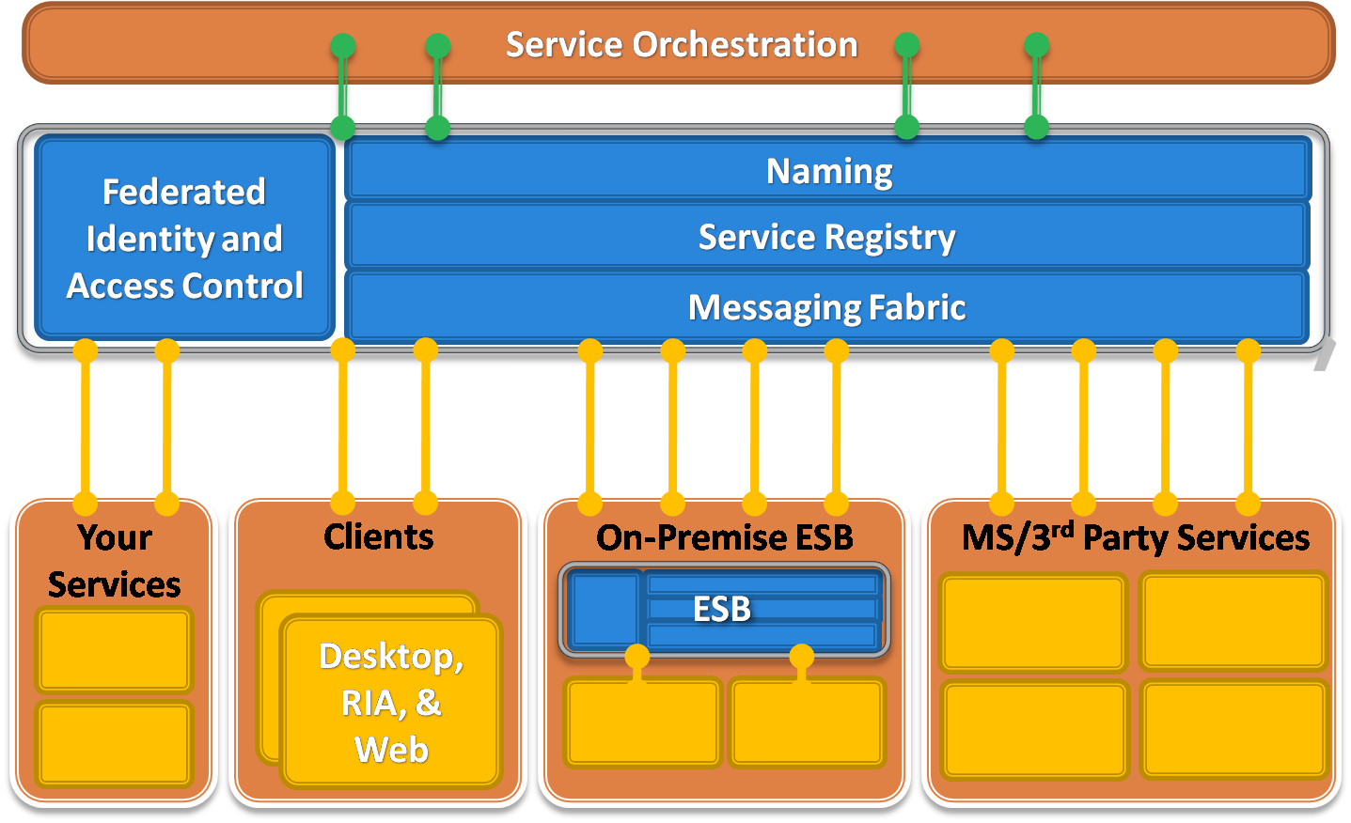
Figure 2: The Internet Service Bus
An Internet Service Bus would make it possible to integrate your on-premises ESB with your services running in the cloud, with a variety of 3rd party services provided by Microsoft or other vendors (such as those offered within the Windows Azure platform), and with a variety of desktop, RIA, and Web applications that may be running in satellite locations outside of the enterprise firewall. In order to make this possible, the implementation needs to provide federated solutions based on open Internet standards and a robust messaging fabric capable of bidirectional communication at Internet scope.
Tackling bidirectional communication at Internet scope is not trivial due to some of today’s realities. The first problem is the shortage of IPv4 addresses. For all practical purposes, we’ve run out. It’s difficult to acquire a public IPv4 address anymore. Instead, most Internet providers, corporate networks, and wireless networks use dynamic IP address allocation and network address translation (NAT) techniques. Such IP addresses are private to those networks and are not publicly addressable from the outside.
Another challenge is related to security. In most enterprise environments, on-premises software is almost completely shielded from the outside world by layers and layers of firewalls and other protective network devices. This is necessary because of the widespread security threats inherent in the Internet. Most network environments allow a variety of outbound ports through their firewalls but highly constrain the number of allowed inbound ports. Ports 80 (HTTP) and 443 (HTTPS) are often the only sanctioned inbound ports, presenting a big challenge for different types of bidirectional communication.
Imagine a situation where a sales person is traveling and she’s using your application on a wireless network in random hotel somewhere in the world (see Figure 3). In scenarios like this, it can be very difficult to establish communication with machines sitting behind these various network layers.
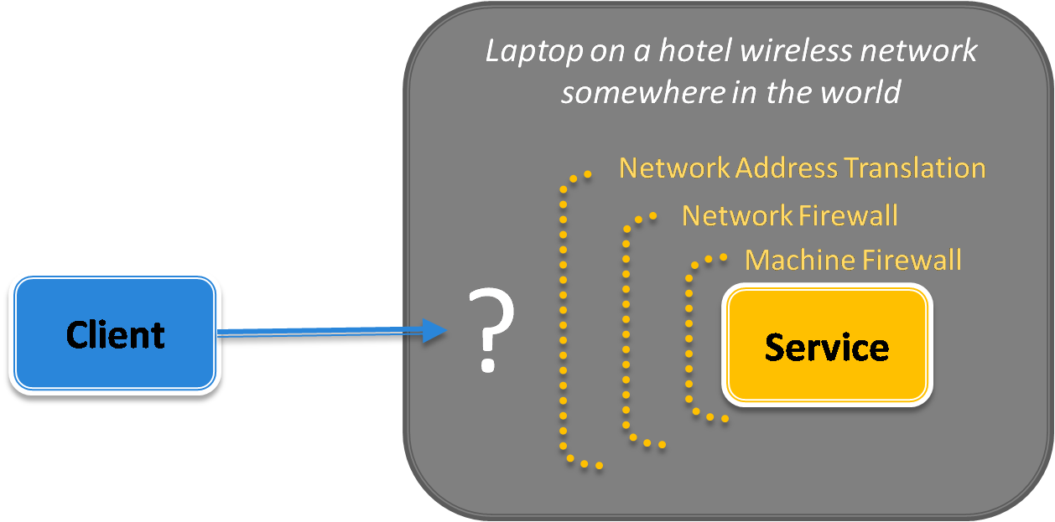
Figure 3: Internet Connectivity Challenges
Companies often deal with these connectivity challenges by opening inbound firewall ports (much to their system administrator’s dismay) or by using different workarounds like dynamic DNS, NAT port mappings, or UPnP, all of which are brittle, difficult to manage, and susceptible to security threats. As more and more applications are requiring this type of bidirectional communication, we’re experiencing a growing tension here, especially since the mentioned workarounds are often completely impractical.
Despite these challenges, some of today’s most popular Internet applications are inherently bidirectional. Consider things like instant messaging, online multiplayer games, and peer-to-peer file sharing applications that use protocols like BitTorrent, which account for a large percentage of all Internet traffic today. These applications have written the low-level networking logic to traverse firewalls and NAT devices, and to create direct connections when possible. They often accomplish this through a centralized relay service that provides the connectivity logic (see Figure 4).
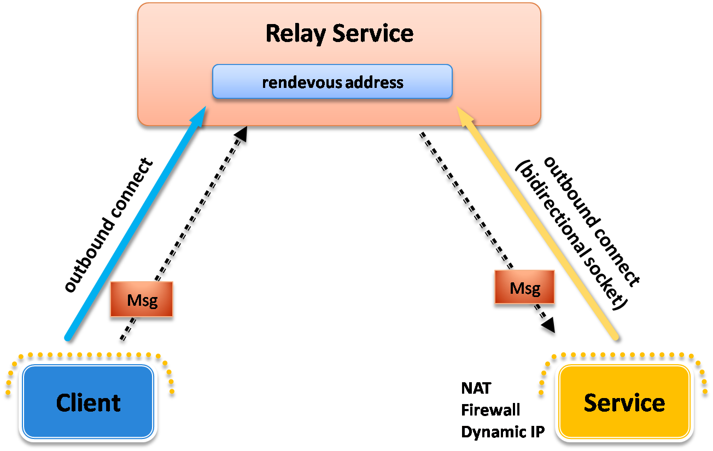
Figure 4: A Relay Service
Here’s how it works: the on-premises service connects to the relay service through an outbound port and creates a bidirectional socket for communication tied to a particular rendezvous address. The client can then communicate with the on-premises service by sending messages to the relay service targeting the rendezvous address. The relay service will then “relay” messages to the on-premises service through the bidirectional socket already in place. The client does not need a direct connection to the on-premises service nor does it need to know where it resides. The on-premises service doesn’t need any inbound ports open on the firewall. This is how most instant messaging applications work today.
Ultimately, a “service bus” that successfully operates at Internet scope must provide a messaging fabric capable of dealing with these connectivity challenges through a relay service in the cloud.

Introducing the Service Bus
The Service Bus is a concrete implementation of the service bus pattern designed to operate at Internet scope within highly-scalable Microsoft data centers as a constituent of the Windows Azure platform. The Service Bus provides a federated identity and access control mechanism through Access Control, a federated naming system, a dynamic service registry, and a robust messaging fabric capable of overcoming the various connectivity challenges described throughout the previous section.
A central component of the Service Bus messaging fabric is a centralized (but highly load-balanced) relay service that supports a variety of different transport protocols and Web services standards, including SOAP, WS-*, and even REST. The relay service provides a variety of different relay connectivity options and can even help negotiate direct peer-to-peer connections when possible.
The Service Bus was designed for all developers, regardless of platform, but was highly optimized for .NET developers using Windows Communication Foundation (WCF), both in terms of performance and usability. The Service Bus provides full access to its relay service through SOAP and REST interfaces. This makes it possible for any SOAP or REST programming environment to integrate with it.
You can download several SDK’s for integrating with the Service Bus that target different programming environments. Today there are SDKs available for .NET, Java, and even Ruby. If you’re a .NET developer comfortable with WCF, the Service Bus and Access Control SDK (from here on, I’ll simply refer to this as the “SDK”) will make working with the Service Bus feel like its second nature.
The SDK installs a set of new WCF “relay” bindings (and underlying channel components) that know how to integrate with the Service Bus behind the scenes so you’re shielded from all those details. This makes programming the Service Bus feel just like working with traditional WCF clients and services.

Getting Started with the Service Bus
Before you can begin working with the Service Bus, you’ll first need to sign-up for an account within the AppFabric portal at https://appfabric.azure.com. You will be required to sign-in with a Windows Live ID (WLID), which will be associated with your AppFabric account. Once you’ve done that, you can create a new AppFabric project. In the future, whenever you login with your WLID, you will have access to all of the AppFabric projects associated with your account.
Once you have an AppFabric project in place, you can create a new service namespace. You’ll need to give your new service namespace a unique name across all AppFabric accounts. Each service namespace acts as a container for a set of AppFabric endpoints. See Figure 6 for an example of what this page looks like when creating a service namespace called “pluralsight”.
Once you press Create, the portal will begin activating your new service namespace. After the activation process is complete, you can begin using your new service namespace to host Service Bus endpoints. The portal will indicate that the new service namespace is “Active” once it’s ready to use. If you click on the service namespace, you can view the service namespace details. This page gives you specific information about your service namespace including things like the management key, the Service Bus issuer name/key, the registry URL, the Access Control endpoints, as well as other details.
The base URI for all endpoints within my “pluralsight” service namespace is http://pluralsight.servicebus.windows.net/. If you browse to this base address, you’ll receive an Atom feed representing your Service Bus registry. It will be empty right now because I haven’t registered any endpoints within the “pluralsight” service namespace yet (see Figure 7).
Now, before you can begin programming against the Service Bus you should download and install the SDK. With that in place, you’re ready to bring the Service Bus to life in your applications.
For a more detailed walkthrough on getting started with the Service Bus, read an Introduction to the Service Bus and Access Control (see Additional Resources).

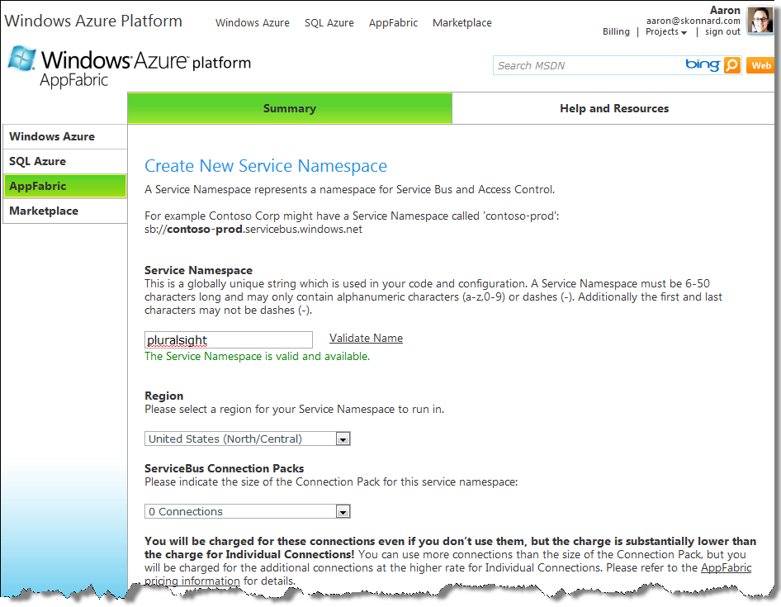
Figure 6: Creating a Service Namespace
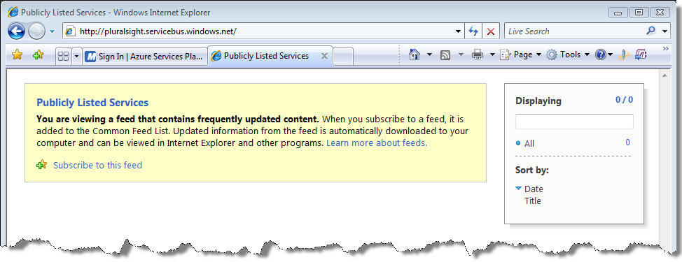
Figure 7: Browsing to Registry URL

Your First Service Bus Application
Now you’re ready to write code to register service endpoints within your Service Bus namespace. Let me show you a quick example of how you can configure an existing WCF application to take advantage of the Service Bus. We’ll start with the following simple WCF service contract and implementation:
[ServiceContract]
public interface IHelloServiceBus
{
[OperationContract]
string SayHello(string name);
}

public class HelloServiceBus : IHelloServiceBus
{
public string SayHello(string name)
{
string greeting = string.Format("Hello {0}!", name);
Console.WriteLine("Returning: {0}", greeting);
return greeting;
}
}
We’ll host this service in the following console application that reads the service configuration details from the application configuration file:
class Program
{
static void Main(string[] args)
{
Console.WriteLine("**** Service ****");
ServiceHost host = new ServiceHost(typeof(HelloServiceBus));
host.Open();

Console.WriteLine("Press [Enter] to exit");
Console.ReadLine();

host.Close();
}
}
And we’ll start by using the following endpoint definition in the application configuration file. Notice how the endpoint uses NetTcpBinding and a local address of net.tcp://localhost:8080/helloservicebus:
<configuration>
<system.serviceModel>
<services>
<service name="HelloServiceBus">
<endpoint address="net.tcp://localhost:8080/helloservicebus"
binding="netTcpBinding"
contract="IHelloServiceBus" />
</service>
</services>
</system.serviceModel>
</configuration>
Next, we can write a client application that invokes the service. The following code shows how to do this using the same IHelloServiceBus contract definition. It also assumes that the endpoint details (for “DirectEndpoint”) will be read from the client’s application configuration file:
class Program
{
static void Main(string[] args)
{
Console.WriteLine("**** Client ****");
Console.WriteLine("Press <Enter> to run client.");
Console.ReadLine();

ChannelFactory<IHelloServiceBus> channelFactory =
new ChannelFactory<IHelloServiceBus>("DirectEndpoint");
IHelloServiceBus channel = channelFactory.CreateChannel();

string response = channel.SayHello("Service Bus");
Console.WriteLine(response);

channelFactory.Close();
}
}
And finally, the client’s application configuration file needs to have the equivalent endpoint definition in order to communicate with the service via the TCP endpoint it exposes:
<configuration>
<system.serviceModel>
<client>
<endpoint address="net.tcp://localhost:8080/helloservicebus"
binding="netTcpBinding"
contract="IHelloService"
name="DirectEndpoint" />
</client>
</system.serviceModel>
</configuration>
If you run the two applications, you’ll see “Hello Service Bus!” displayed in both console windows. In this case there’s a direct TCP connection between the client and the service applications.
Now let’s look at what it takes to introduce the Service Bus as a relay between the client and service applications. First we’ll need to reconfigure the service host to listen on the Service Bus, and then we’ll need to reconfigure the client to send messages through the Service Bus.
We can reconfigure the service to listen on the Service Bus by simply changing the binding from NetTcpBinding to NetTcpRelayBinding. The NetTcpRelayBinding knows how to bootstrap the underlying WCF channel infrastructure in order to listen on the Service Bus. When using this binding, we’ll also need to specify a valid Service Bus address for the endpoint.
Since I have a service namespace of “pluralsight", I can use an address of sb://pluralsight.servicebus.windows.net/helloservicebus for my “helloservicebus” endpoint. Notice, I’ve changed the protocol scheme from “net.tcp” to “sb”, a special TCP-based protocol scheme used by the Service Bus – all Service Bus endpoints, expect HTTP endpoints, must use the “sb” protocol scheme.
When connecting to the Service Bus, I need to prove that I’m allowed to listen within the “pluralsight” namespace. This is accomplished through Access Control. Here’s how it works: my Service Bus application provides credentials to Access Control; then, Access Control authenticates those credentials and issues a token that will be presented to the Service Bus. The token issued by Access Control indicates if I’m allowed to “listen” on, “send” to, or “manage” the service namespace. If my credentials prove that I own “pluralsight”, the issued token will indicate I have full control over that namespace.
Access Control supports several different types of client credentials today, the simplest being a “shared secret” credential. You can supply these credentials to Access Control via code or configuration.
In the following example, I’m supply “shared secret” credentials through the <transportClientEndpointBehavior> behavior in configuration. When you create a service namespace, you are automatically assigned a shared secret to use with the Service Bus – navigate to the service namespace page in the portal and you’ll find it listed under “Default Issuer Name” and “Default Issuer Key”. These are the values you want to use in the <sharedSecret> element below.
<configuration>
<system.serviceModel>
<services>
<service name="HelloServiceBus">
<endpoint address=
"sb://pluralsight.servicebus.windows.net/helloservicebus"
behaviorConfiguration="sharedSecretClientCredentials"
binding="netTcpRelayBinding"
contract="IHelloServiceBus" />
</service>
</services>
<behaviors>
<endpointBehaviors>
<behavior name="sharedSecretClientCredentials">
<transportClientEndpointBehavior credentialType="SharedSecret">
<clientCredentials>
<sharedSecret issuerName="[Enter your issuer name]"
issuerSecret="[Enter your issuer key]" />
</clientCredentials>
</transportClientEndpointBehavior>
</behavior>
</endpointBehaviors>
</behaviors>
</system.serviceModel>
</configuration>
When the WCF service host opens with this configuration, it first sends the “shared secret” to Access Control to acquire a token for “listening” on the Service Bus. It will then establish a TCP connection with the relay service and present the token it acquired. Assuming we’re allowed to listen on this address (e.g., the token contains the necessary “listen” claim), the Service Bus will create a listener for relaying messages to our on-premises WCF service, thereby connecting our WCF service to the cloud.
Reconfiguring the client application is very similar. First, we need to change the endpoint to use the NetTcpRelayBinding and the same Service Bus address that we configured our service to listen on (again, notice the “sb” protocol scheme). We also need to configure the client with credentials. Clients must also prove that they are allowed to send messages to a particular address on the Service Bus by acquiring a token from Access Control. For this example, we’ll use the same “shared secret” that we used to configure the service application. The following shows the complete client-side configuration:
<configuration>
<system.serviceModel>
<client>
<endpoint address=
"sb://pluralsight.servicebus.windows.net/helloservicebus"
binding="netTcpRelayBinding"
contract="IHelloServiceBus"
behaviorConfiguration="sharedSecretClientCredentials"
name="RelayEndpoint" />
</client>
<behaviors>
<endpointBehaviors>
<behavior name="sharedSecretClientCredentials">
<transportClientEndpointBehavior credentialType="SharedSecret">
<clientCredentials>
<sharedSecret issuerName="[Enter your issuer name]"
issuerSecret="[Enter your issuer key]" />
</clientCredentials>
</transportClientEndpointBehavior>
</behavior>
</endpointBehaviors>
</behaviors>
</system.serviceModel>
</configuration>
With these changes in place, we can run the service host application followed by the client application, and we’ll see the same result as before only this time the communication was relayed through the Service Bus (see Figure 8), making it possible to traverse a variety of network obstacles in the way.
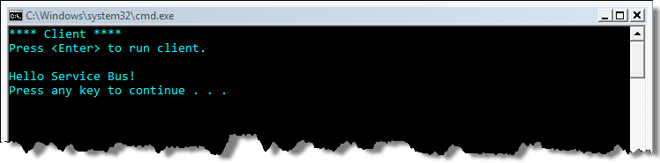
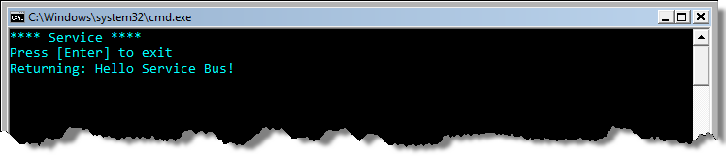
Figure 8: HelloServiceBus Sample in Action
Now that you’re familiar with the various Service Bus concepts and how to get started with a complete application, we’re ready to dive deeper into the details. The following sections will explore the key areas of the Service Bus architecture along with their features and capabilities.

Naming and Discovery
Understanding how to name your services on the Service Bus is of central importance. Before exploring the Service Bus approach, let’s consider how the Domain Naming System (DNS) works.
DNS is designed to map domain names to IP addresses. When you browse to a Web site, the first thing that happens is a DNS lookup to figure out what IP address the human friendly domain name resolves to. Since DNS relies on public IP addresses, it doesn’t work for identifying hosts sitting behind NAT devices without the help of a layered service like Dynamic DNS. Today it’s common for a single IP address to identify an entire network of hosts sitting behind a single NAT device. Ultimately, the DNS model is less than ideal for naming and identifying endpoints in a service oriented world.
Unlike DNS, the Service Bus naming system is optimized for naming service endpoints in a host-independent fashion. You can think of the naming system as a global forest of federated naming trees projected onto host-independent URI’s. Each service namespace maps to a naming tree, hence, each service namespace must have a globally unique name. The naming trees are federated because each namespace owner controls the names within his namespace. They are “trees” because of the hierarchical nature of the namespace (names within name within names).
There’s a natural projection for these names onto URI’s, but the resulting URI’s are completely host-independent – you can have multiple services all running on different hosts that share the same solution name, which opens up interesting opportunities. These characteristics of the Service Bus naming system provide a more granular, endpoint-level approach that complements DNS nicely.

Naming System
The root of the Service Bus naming system is resolvable through traditional DNS techniques. The naming system then relies on host-independent criteria – specifically the service namespace – to distinguish between different domains of control within the naming system. It’s up to namespace owners to control the names with their respective service namespaces as illustrated in Figure 9.
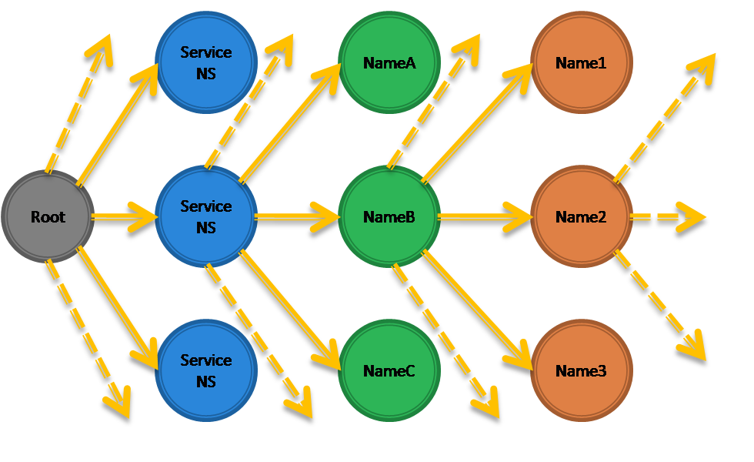
Figure 9: Service Bus Naming System
The way you project Service Bus names onto URI’s is as follows:
[scheme]://[service-namespace].servicebus.windows.net/[name1]/[name2]/...

The Service Bus supports three URI schemes: “sb”, “http”, and “https”. You’ll use “http” and “https” for all HTTP-based endpoints and the “sb” scheme for all other TCP-based endpoints. The service-namespace portion of the host name identifies a unique naming tree within the entire Service Bus namespace, which is completely controlled by the namespace owner.
For example, all names within my “pluralsight” namespace must start with either sb://pluralsight.servicebus.windows.net/ or http(s)://pluralsight.servicebus.windows.net/, depending on the protocol. Everything after the base URI is part of the user-defined namespace. I can create a very large number of names within my namespace through name hierarchies. For example, suppose we have an office in Boston, Salt Lake City, and Los Angeles, and each one needs to publish endpoints. We could assign each office a unique name and give the office control over defining names within its hierarchy:
sb://pluralsight.servicebus.windows.net/boston/
sb://pluralsight.servicebus.windows.net/saltlakecity/
sb://pluralsight.servicebus.windows.net/losangeles/

Then suppose each of the offices needs to expose an endpoint for a (location specific) training registration service. They could accomplish that by adding “training” to the end of their URI’s:
sb://pluralsight.servicebus.windows.net/boston/training
sb://pluralsight.servicebus.windows.net/saltlakecity/training
sb://pluralsight.servicebus.windows.net/losangeles/training

And if the Boston office, as the headquarters, needs to expose a payment processing service, it can simply create another endpoint name using “payment” within its namespace:
sb://pluralsight.servicebus.windows.net/boston/training/payment

These different service endpoints don’t have to be hosted on the same server, on the same network or even in the same geography. It’s the job of the Service Bus, and specifically the relay service, to determine where the endpoints are physically located at resolution time.
The Service Bus does not provide an API for directly interacting with the naming system. Instead, you access the naming system through the service registry functionality.

Service Registry
The Service Bus provides a service registry for publishing and discovering service endpoint references within a service namespace. Others can then discover the endpoints within a service namespace by browsing to the service namespace base address and retrieving an Atom feed.
The service registry exposes a namespace’s endpoints through a linked tree of Atom 1.0 feeds. You navigate the service registry by simply navigating the naming system via HTTP, browsing to each level within a solution’s naming structure you wish to inspect. When you browse to the service namespace base HTTP address, you’ll receive the root Atom 1.0 feed describing the first level of nested names. If you then browse to one of the nested names, you’ll receive another Atom 1.0 feed that describes the second level of nested names. This continues until you reach a leaf name in the tree.
The Service Bus can take care of publishing endpoint information into the registry whenever you register new endpoints. If you want a particular endpoint to be discoverable, you need to associate the ServiceRegistrySettings behavior with the WCF endpoint, setting its DiscoveryMode property to DiscoveryType.Public. The following code shows how to do this within the WCF host application:
class Program
{
static void Main(string[] args)
{
Console.WriteLine("**** Service ****");
ServiceHost host = new ServiceHost(typeof(HelloServiceBus));
host.Open();

ServiceRegistrySettings settings = new ServiceRegistrySettings();
settings.DiscoveryMode = DiscoveryType.Public;
foreach(ServiceEndpoint se in host.Description.Endpoints)
se.Behaviors.Add(settings);

Console.WriteLine("Press [Enter] to exit");
Console.ReadLine();

host.Close();
}
}
With this behavior in place, the relay service automatically populates the service registry with information about the endpoint in question. For example, if I re-run the host for my HelloServiceBus service shown earlier and then browse to my solution’s base HTTP address, I see an Atom 1.0 feed rendered within Internet Explorer listing a single endpoint reference (see Figure 10).
If you don’t add this endpoint behavior, your Service Bus endpoints will not be discoverable through the Atom Feed by default (DiscoveryType.Private is the default setting).
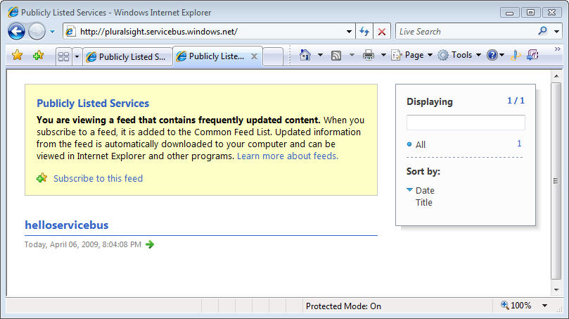
Figure 10: Browsing to a Solution's Service Registry
Let’s look at a more interesting example. Suppose you were to reconfigure the HelloServiceBus host application shown earlier with the following endpoint configuration:
<configuration>
<system.serviceModel>
<services>
<service name="HelloServiceBus">
<endpoint address=
"sb://pluralsight.servicebus.windows.net/boston/training"
behaviorConfiguration="default"
binding="netTcpRelayBinding"
contract="IHelloServiceBus" />
<endpoint address=
"sb://pluralsight.servicebus.windows.net/boston/payment"
behaviorConfiguration="default"
binding="netTcpRelayBinding"
contract="IHelloServiceBus" />
<endpoint address=
"sb://pluralsight.servicebus.windows.net/saltlakecity/training"
behaviorConfiguration="default"
binding="netTcpRelayBinding"
contract="IHelloServiceBus" />
<endpoint address=
"sb://pluralsight.servicebus.windows.net/losangeles/training"
behaviorConfiguration="default"
binding="netTcpRelayBinding"
contract="IHelloServiceBus" />
</service>
</services>
...
</system.serviceModel>
</configuration>
Now when you run the service host application and browse to the service namespace address, you’ll see the root Atom 1.0 feed shown in Figure 11. Notice how the root feed only contains the first level of names from the endpoints we defined, specifically “boston”, “losangeles”, and “saltlakecity”.
If you click on “boston”, you’ll issue a request for another Atom 1.0 feed describing the names within “boston” level of the hierarchy. Figure 12 shows what the nested feed for “boston” looks like. If we were to browse to the “losangeles” or “saltlakecity” feeds, you’d only see “training” in the feed.
This model gives consumers an easy way to discover the public endpoints available within your service namespace at runtime, and since it’s based on ATOM feeds, it’s possible from any platform.

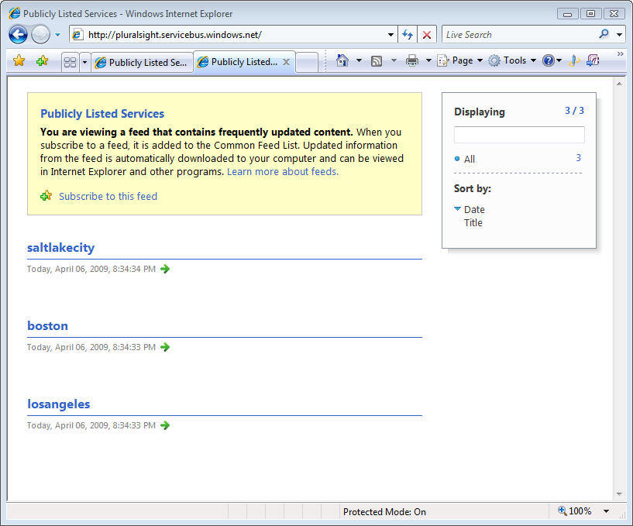
Figure 11: The Root Atom 1.0 Feed
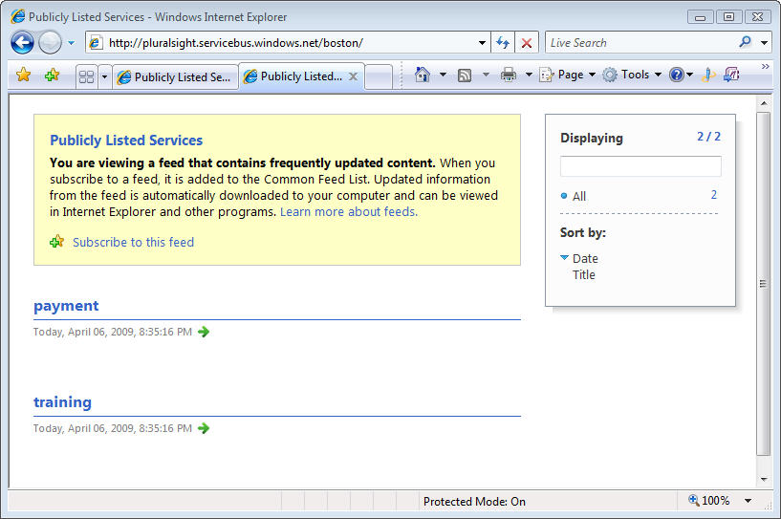
Figure 12: A Nested Atom 1.0 Feed

Messaging
At the heart of the Service Bus you’ll find a scalable, general purpose relay service (see Figure 4) that provides a variety of advanced messaging features for flexible Internet connectivity.

The Relay Service
The relay service makes it easy to build solutions capable of communicating through firewalls and NAT devices using a variety of different messaging patterns. The relay service supports traditional one-way messaging, request/response messaging, and peer-to-peer messaging. It also supports event distribution at Internet-scope to enable publish/subscribe scenarios and bi-directional socket communication for increased point-to-point efficiency. And finally, the relay service supports message buffers for scenarios where the service isn’t capable of using the SDK for integration, and is only capable of HTTP.
When using the relay service, you’re essentially delegating the transport-level “listening” responsibility to the relay service in the cloud. In this case, your services no longer have to create local transport listeners; instead they rely on the relay service to handle the specified transport communication details. It’s the relay service’s responsibility to simply forward incoming messages to your on-premises service.
The relationship between your on-premises services and the relay service is analogous to the relationship between Windows applications that build on top of HTTP.SYS. Applications that use HTTP.SYS don’t actually create HTTP transport listeners themselves. Instead, they register an address with the HTTP.SYS driver and ask it to forward along all messages it receives on the registered address. This allows for centralization of the HTTP transport logic and reduces surface area, which is good from a security perspective. The relay service plays a similar role to that of HTTP.SYS but it resides up in the cloud and your local services register to have it pass along messages received at a particular address.
You must initiate the connection between your on-premises service and the relay service. When using the SDK, you’ll accomplish this via a new suite of WCF “relay” bindings. Behind the scenes, the relay bindings map to new transport binding elements designed to create WCF channel components that integrate with the Service Bus in the cloud. In most connection modes, the WCF creates a secure outbound socket connection into the relay service that supports bidirectional communication. During the process it authenticates, specifies a name to listen on, and tells it what type of listener to establish.
The WCF relay bindings provide a variety of messaging options that make it easy to overcome a variety of tough Internet connectivity challenges even in the most locked-down environments. We’ll be discussing these options in detail throughout the following sections.

Choosing Service Bus Addresses
When choosing addresses for your Service Bus endpoints, follow the guidelines we discussed in the Naming section. Although you can organize your addresses by whatever criteria makes sense for your application, it’s important to realize that only a single on-premises service can listen on a particular endpoint address, except when using the NetEventRelayBinding, which is specifically designed to allow multiple services to “listen” on a single endpoint address.
However, in all other cases, if you attempt to use the same address that’s already being used by another service, the attempt to register the second endpoint will fail. Furthermore, if the second address is within the URI scope of the first address, it will also fail. For example, if the first endpoint uses an address of /foo/bar and the second endpoint attempts to use /foo/bar/baz, the attempt will fail. Multiple endpoints can use addresses that share the same base address, as is the case with /foo/bar and /foo/baz, but one address cannot be the complete prefix of another address or you’ll see an error.
The relay service routes messages using a longest-prefix-match algorithm (not necessarily an exact match), which also makes it possible for the on-premises service to directly inspect the URI path segments and the query string to do custom processing, which comes in handy for RESTful scenarios.

Ports Required by the Relay Service
The relay service only requires a few outbound ports to be open, specifically ports 9350, 9351, 9352, 9353, depending on the features you choose to use, and the standard HTTP ports 80/443. It uses ports 9350 for one-way TCP connections and port 9351 for one-way TCP/SSL connections. They use ports 9352 and 9353 for bidirectional TCP connections and a more advanced connectivity mode we’ll discuss later. It’s important to note that you don’t have to open any inbound ports on your firewall or perform any kind of port mapping on your NAT/router device in order to use the relay service.
If you’re operating in a tightly managed network environment that blocks all outbound socket connections, except for those used by HTTP/HTTPS, you can use a special connectivity option known as “Web sockets” where the on-premises service connects to the relay service over ports 80 (HTTP) or 443 (HTTPS). This approach usually always works even the most locked-down network environments.
From a security perspective, the relay service functions as a demilitarized zone (DMZ), completely isolated from the service's local environment. The DMZ handles all network traffic externally, making it possible to filter out unwanted traffic in the cloud before it enters your service environment.
Furthermore, the relay service hides all details about the network location of the on-premises service (in effect making it anonymous), thereby reducing the potential surface area for attack (a la HTTP.SYS). The relay service is integrated with Access Control, which provides sophisticated authentication and authorization features, giving you a flexible security gate in the cloud that is quite simple to manage.
If you’re concerned by the idea of the relay service “punching” holes in your firewall, it’s important to consider the security features provided by the relay service. A firewall is designed to block access to network resources at the port level. Conceptually, the relay service (combined with the security features offered by Access Control) is similar to a firewall in that sense, only the relay service is designed to block undesired access to your service resources on an endpoint by endpoint basis.

WCF Relay Bindings
The primary programming model for working with the Service Bus on the .NET platform is WCF. The SDK comes with a set of new WCF bindings that automate the integration between your WCF services and clients with the relay service offered by the Service Bus. In most cases, all you need to do is replace the current WCF binding that you’re using with one of the Service Bus “relay” bindings.
Figure 13 lists all of the Service Bus WCF bindings and the standard WCF bindings they correspond to. The most commonly used WCF bindings, such as BasicHttpBinding, WebHttpBinding, WS2007HttpBinding, and NetTcpBinding, all have a corresponding Service Bus binding with a very similar name (just insert “Relay” before “Binding”). There are only a few new relay bindings – NetOnewayRelayBinding and NetEventRelayBinding – that don’t have a corresponding WCF binding.
Standard WCF Binding | Equivalent Relay Binding
BasicHttpBinding | BasicHttpRelayBinding
WebHttpBinding | WebHttpRelayBinding
WS2007HttpBinding | WS2007HttpRelayBinding
NetTcpBinding | NetTcpRelayBinding
N/A | NetOnewayRelayBinding
N/A | NetEventRelayBinding
Figure 13: WCF Relay Bindings
The relay bindings work just like the standard WCF bindings for the most part. For example, they support the different WCF message versions (SOAP 1.1, SOAP 1.2, and None), the various WS-* security scenarios, reliable messaging, streaming, metadata exchange, the Web programming model (e.g., [WebGet] and [WebInvoke]), and many more standard WCF features. There are only a few WCF features not supported by design including atomic transaction flow and transport level authentication.
In the following sections, we’re going to dive into the details of the new WCF relay bindings listed above and show how to begin using them in your applications.

NetOnewayRelayBinding
The NetOnewayRelayBinding is the most constrained of the all the relay bindings because it only supports one-way messages, but it’s also specifically optimized for that scenario. By default, the NetOnewayRelayBinding uses SOAP 1.2 over TCP along with a binary encoding of the messages, although these communication settings are configurable through standard binding configuration techniques. Services that use this binding must always use the “sb” protocol scheme.
When using this binding in the default configuration, the on-premises WCF service attempts to establish an outbound connection with the relay service in order to create a bidirectional socket. In this case, it always creates a secure TCP/SSL connection through outbound port 9350. During the connection process the WCF service authenticates (by supplying a token acquired from Access Control), specifies a name to listen on within the relay service, and tells the relay service what type of listener to create.
When a WCF client uses this binding in the default configuration, it creates a TCP connection with the relay via port 9350 (TCP) or 9351 (TCP/SSL), depending on the binding configuration. During the connection process it must authenticate with the relay by supplying a token acquired from Access Control. Once the client has successfully connected, it can begin sending one-way messages to the Service Bus to be “relayed” to the on-premises service through its TCP connection (see Figure 15).
Figure 15 illustrates something important about the Service Bus architecture. When clients and services establish connections with the relay service, they are load balanced across an array of front-end nodes, which collectively provide the necessary scalability for this type of service. When the client sends a message, the client’s front-end node communicates with the backend naming and routing fabric in order to successfully relay the message to the other front-end node the service is attached to – in other words, clients and services are usually connected to different front-end nodes. This approach ultimately provides a scalable communication path between a large number of client and service applications.
If you set the binding’s security mode property to Transport, the channel will require SSL protection. In this case, all traffic sent to and from the relay service will be protected via SSL, however, it’s important to realize that the message will pass through the relay service in the clear. If you want to ensure full privacy, you’ll want to use the Message security mode, in which case you can encrypt everything but the addressing information within the message passing through the relay service.
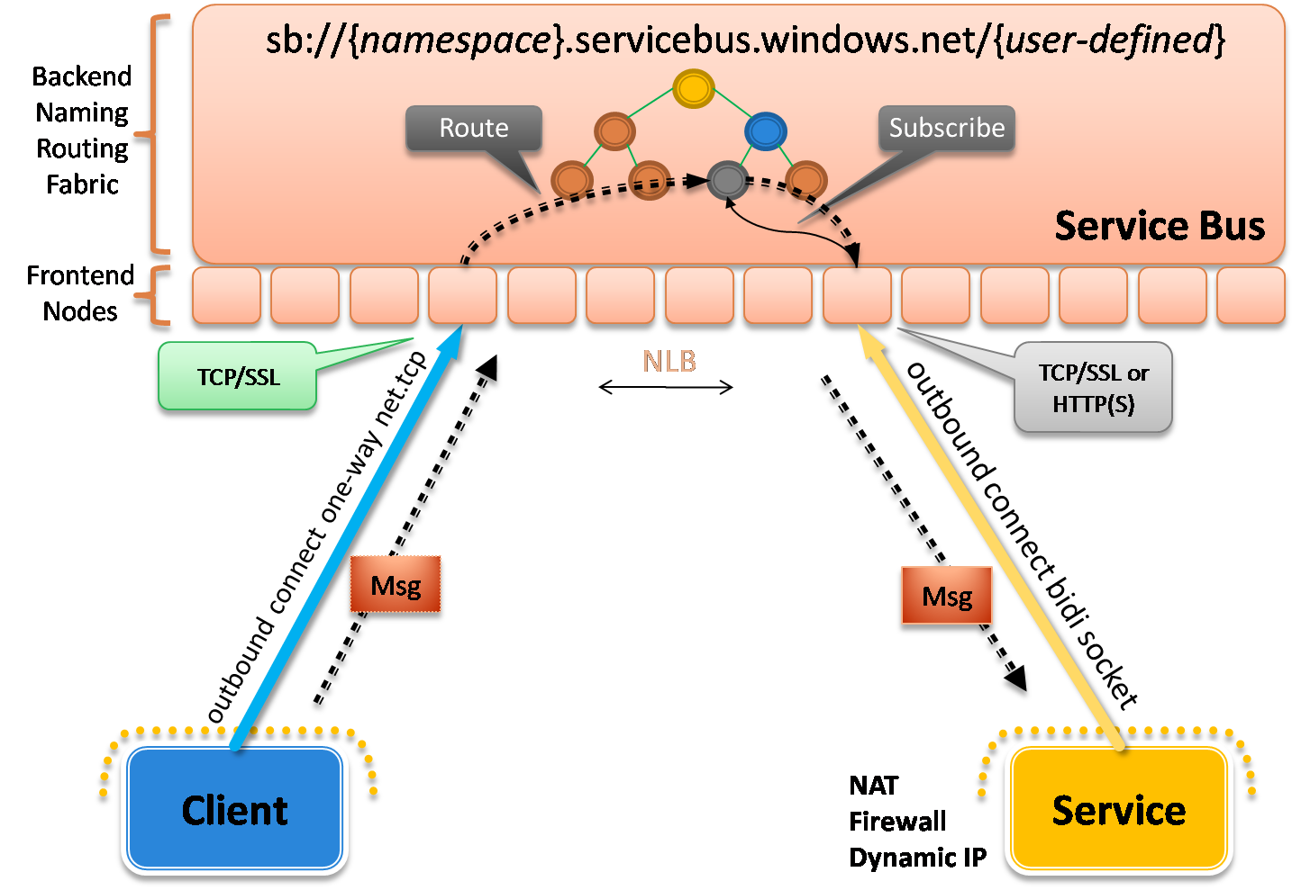
Figure 15: NetOnewayRelayBinding
The NetOnewayRelayBinding requires all operations on the service contract to be marked as one-way operations (IsOneWay=true). Assuming that’s the case, using this WCF binding is as simple as specifying it on your endpoint definitions and supplying the necessary credentials.
The SDK comes with a simple sample that illustrates how the NetOnewayRelayBinding works. It defines a one-way service contract that looks like this:
[ServiceContract(Name = "IOnewayContract",
Namespace = "http://samples.microsoft.com/ServiceModel/Relay/")]
public interface IOnewayContract
{
[OperationContract(IsOneWay = true)]
void Send(int count);
}
The service implementation simply prints the supplied count to the console window. The service host application configures the service with a single endpoint using NetOnewayRelayingBinding:
<configuration>
<system.serviceModel>
<services>
<service name="Microsoft.ServiceBus.Samples.OnewayService">
<endpoint address=
"sb://pluralsight.servicebus.windows.net/oneway"
behaviorConfiguration="credentials"
binding="netOnewayRelayBinding"
contract="Microsoft.ServiceBus.Samples.IOnewayContract" />
</service>
</services>
...
</system.serviceModel>
</configuration>
The client application is configured with an equivalent endpoint configuration (also based on NetOnewayRelayBinding), and it sends 25 messages to the relay service through the endpoint. You will need to add your “shared secret” credentials to the client/service configuration files before running the sample. Figure 16 shows the console applications after running the sample. All 25 messages sent by the client successfully pass through the relay and arrive at our local WCF service.
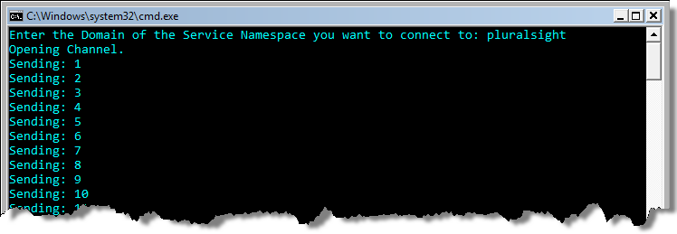
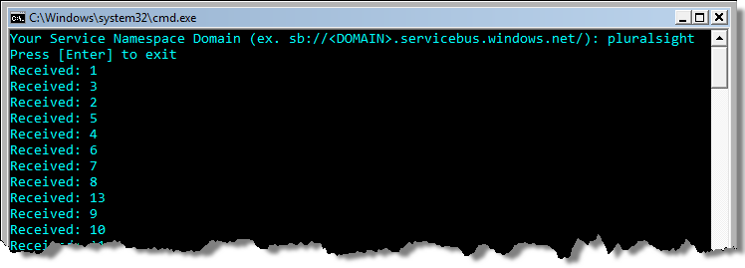
Figure 16: Running the NetOnewayRelayBinding Sample

System Connectivity Mode
When using NetOnewayRelayBinding, the on-premises WCF service connects to the relay service over TCP by default. If you’re operating in a locked down network environment that doesn’t allow any outbound TCP connections beyond HTTP(S), you can configure the various relay bindings to use a more aggressive connection mode that usually does a good job of working around those constraints.
This is made possible by configuring the on-premises WCF service to establish an HTTP connection with the relay service (instead of a TCP connection). The Service Bus provides a system-wide ConnectivityMode setting that you can configure with one of three values: Tcp, Http, and AutoDetect (see Figure 17). If you want to ensure your services connect over HTTP, set this property to Http.
ConnectivityMode | Description
Tcp | Services create TCP connections with the relay service through port 828 (SSL).
Http | Services create an HTTP connection with the relay service making it easier to work around TCP port constraints.
AutoDetect (Default) | This mode automatically selects between the Tcp and Http modes based on an auto-detection mechanism that probes whether either connectivity option is available for the current network environment and prefers Tcp.
Figure 17: ConnectivityMode Values
AutoDetect is the default mode, which means the relay bindings will automatically determine whether to use TCP or HTTP for connecting the on-premises service to the relay service. If TCP is possible on the given network configuration, it will use that mode by default (e.g., it attempts to use TCP by sending a ping message to a connection detecting URL). If the TCP connection fails, it will automatically switch to the HTTP mode behind the scenes. Hence, in most situations, you don’t have to set this property explicitly because the default “auto detect” behavior figures things out for you. In fact, the only time you need to set this property explicitly is when you want to force either TCP or HTTP all the time.
You set the connectivity mode at the AppDomain-level through the static ServiceBusEnvironment class. It provides a SystemConnectivity property where you can specify one of the three ConnectivityMode values shown above. This seems like a reasonable design since all Service Bus connections within a particular AppDomain reside on the same network and deal with the same network challenges. The following code illustrates how to modify an application to use the HTTP connectivity mode:
...
ServiceBusEnvironment.SystemConnectivity.Mode = ConnectivityMode.Http;
ServiceHost host = new ServiceHost(typeof(OnewayService), address);
host.Open();
...
This connectivity mode feature is supported on all of the relay bindings we’ll be discussing below. Whatever you set for the system connectivity mode will take effect on all of the relay bindings.

NetEventRelayBinding
The NetEventRelayBinding is very similar to the NetOnewayRelayBinding in terms of how it’s implemented. The binding defaults and security options are identical to those for NetOnewayRelayBinding. In addition, the mechanics around how clients/services interact with the relay service are essentially the same as for the NetOnewayRelayBinding (review the previous section for details). In fact, the NetEventRelayBinding class actually derives from the NetOnewayRelayBinding class.
The main difference with the NetEventRelayBinding is that is allows you to register multiple WCF services with the same Service Bus address (see Figure 18). When a client sends a message to such an address, the relay multicasts the message to all WCF services currently subscribed to that address.
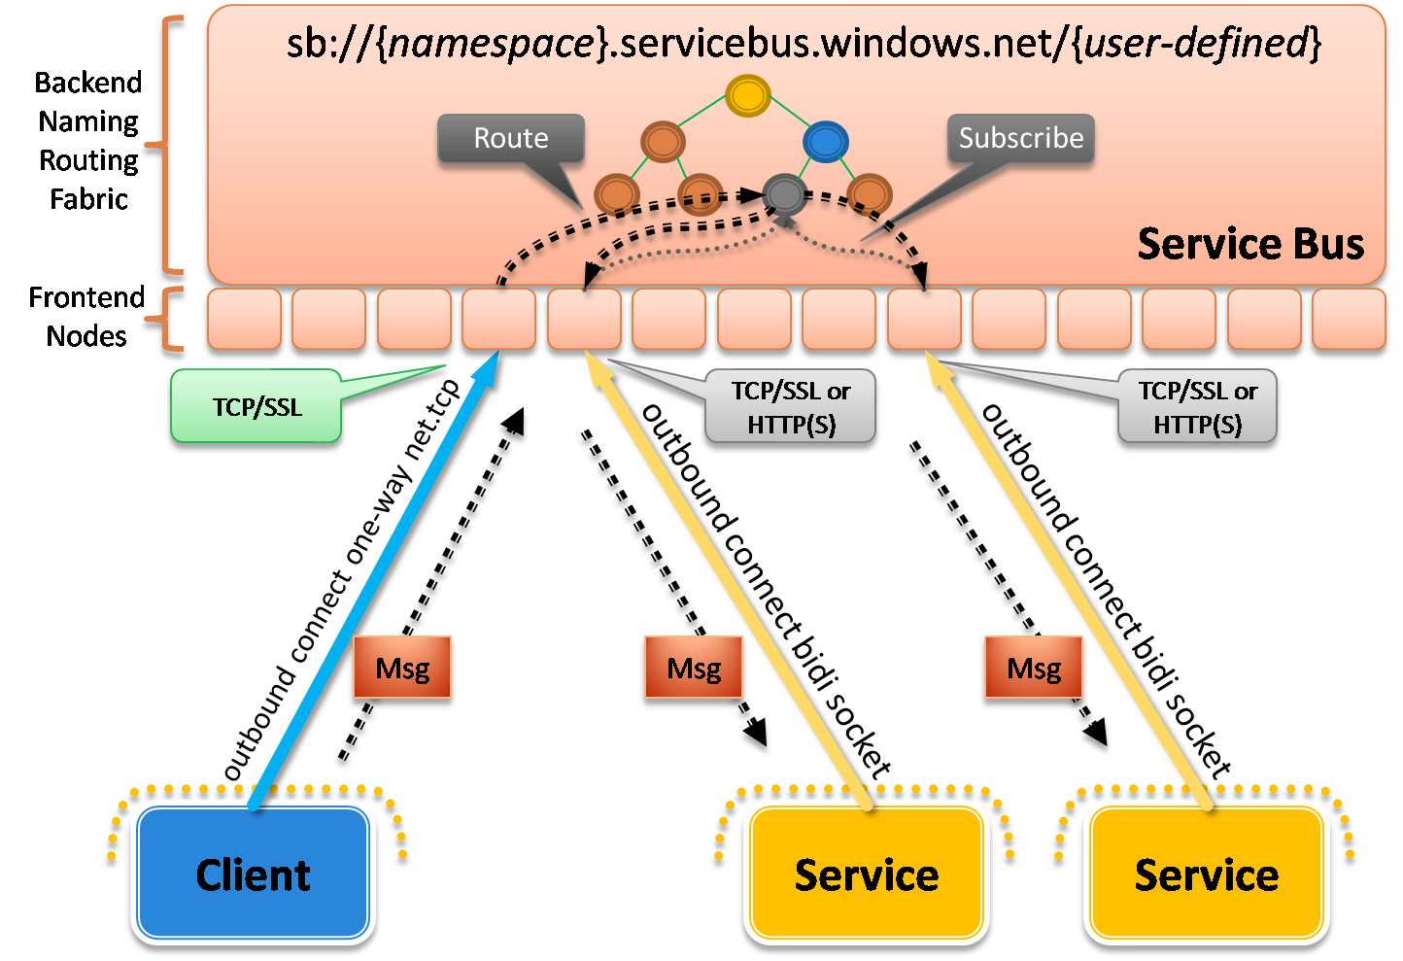
Figure 18: NetEventRelayBinding
This binding gives you the foundation for implementing publish/subscribe architectures but it doesn’t provide any assurances around message delivery or order. This reality makes it feel more like UDP multicasting but it’s not quite as error-prone since the relay service relies on TCP for communication.
The NetEventRelayBinding supports the same ServiceBusEnvironment.SystemConnectivity options as the NetOnewayRelayBinding. When you configure the SystemConnectivity property on the ServiceEnvironment class, it takes effect for all endpoints. Hence, you can use the aggressive HTTP connectivity mode for all of your on-premises NetEventRelayBinding endpoints if they are being hosted within a locked-down network environment that blocks outbound TCP connections.
The SDK comes with another sample that illustrates how to use NetEventRelayBinding to build a simple chat room application. It contains a single console application project that acts as both the client and the service. Each instance of the chat room application registers itself with the same Service Bus address. The application then lets you enter chat messages, and it sends them to the relay service targeting the “chat room” address, at which point the relay service distributes the message to all running chat room applications subscribed to that same address.
The following sample illustrates what the WCF configuration looks like for the chat room console application. The chat program will prompt the user for a chat session name and will dynamically add that name to the endpoint address – that way the program can support multiple chat sessions.
<configuration>
<system.serviceModel>
<client>
<endpoint name="RelayEndpoint"
contract="Microsoft.ServiceBus.Samples.IMulticastContract"
binding="netEventRelayBinding"
bindingConfiguration="default"
address="sb://pluralsight.servicebus.windows.net/chat/" />
</client>
<services>
<service name="Microsoft.ServiceBus.Samples.MulticastService">
<endpoint name="RelayEndpoint"
contract="Microsoft.ServiceBus.Samples.IMulticastContract"
binding="netEventRelayBinding"
bindingConfiguration="default"
address="sb://pluralsight.servicebus.windows.net/chat/" />
</service>
</services>
</system.serviceModel>
</configuration>
If you run three instances of the chat room application and enter some messages in one of them, you will see the messages show up in the other chat room windows as illustrated in Figure 19.
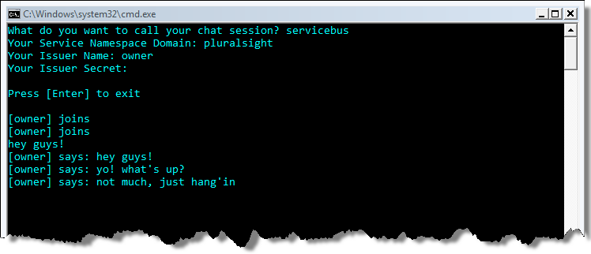
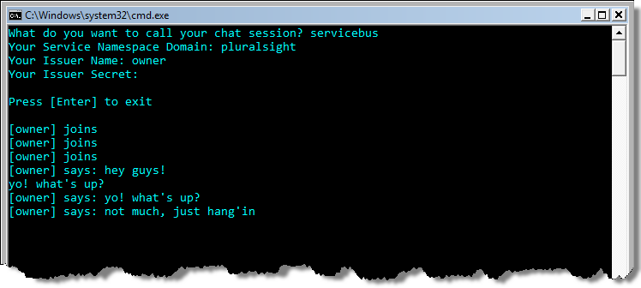
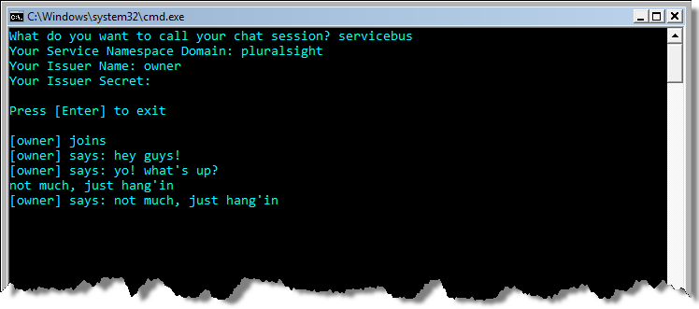
Figure 19: NetEventRelayBinding Chat Room Sample
Both the NetOnewayRelayBinding and the NetEventRelayBinding are designed for flexible unicast and multicast one-way messaging. They don’t correspond directly to any of the standard WCF bindings but are loosely related to NetMsmqBinding and NetPeerTcpBinding in terms of their messaging semantics.

NetTcpRelayBinding
The NetTcpRelayBinding is the one I used in the first HelloServiceBus sample towards the beginning of this paper. It’s also the one Microsoft recommends that you use by default unless you have a good reason to do otherwise. The reason is because the NetTcpRelayBinding supports two-way messaging semantics and it’s very closely aligned with the standard WCF NetTcpBinding – the key difference is that NetTcpRelayBinding creates a publicly-reachable TCP endpoint in the relay service.
By default, the NetTcpRelayBinding supports SOAP 1.2 over TCP and it uses binary serialization for efficiency. Although its configuration is very similar to that of the NetTcpBinding, their underlying TCP socket layers are different and are therefore not directly compatible with one another. This means that client applications will also need to be configured with NetTcpRelayBinding in order to integrate.
Let’s look at how this binding works when used with the default “relayed” connection mode (see Figure 20). First the on-premises WCF service establishes a secure outbound TCP connection with the relay service. During the process, it must authenticate, specify an address to listen on, and specify what type of listener to create within the relay. Up to this point, it’s very similar to the NetOnewayRelayBinding.
When an incoming message arrives on one of the front nodes, a control message is then routed down to the on-premises WCF service indicating how to create a rendezvous connection back with the client’s front-end node, thereby establishing a direct socket-to-socket forwarder for relaying TCP messages. This is precisely what happened behind the scenes in the HelloServiceBus example I showed you earlier.
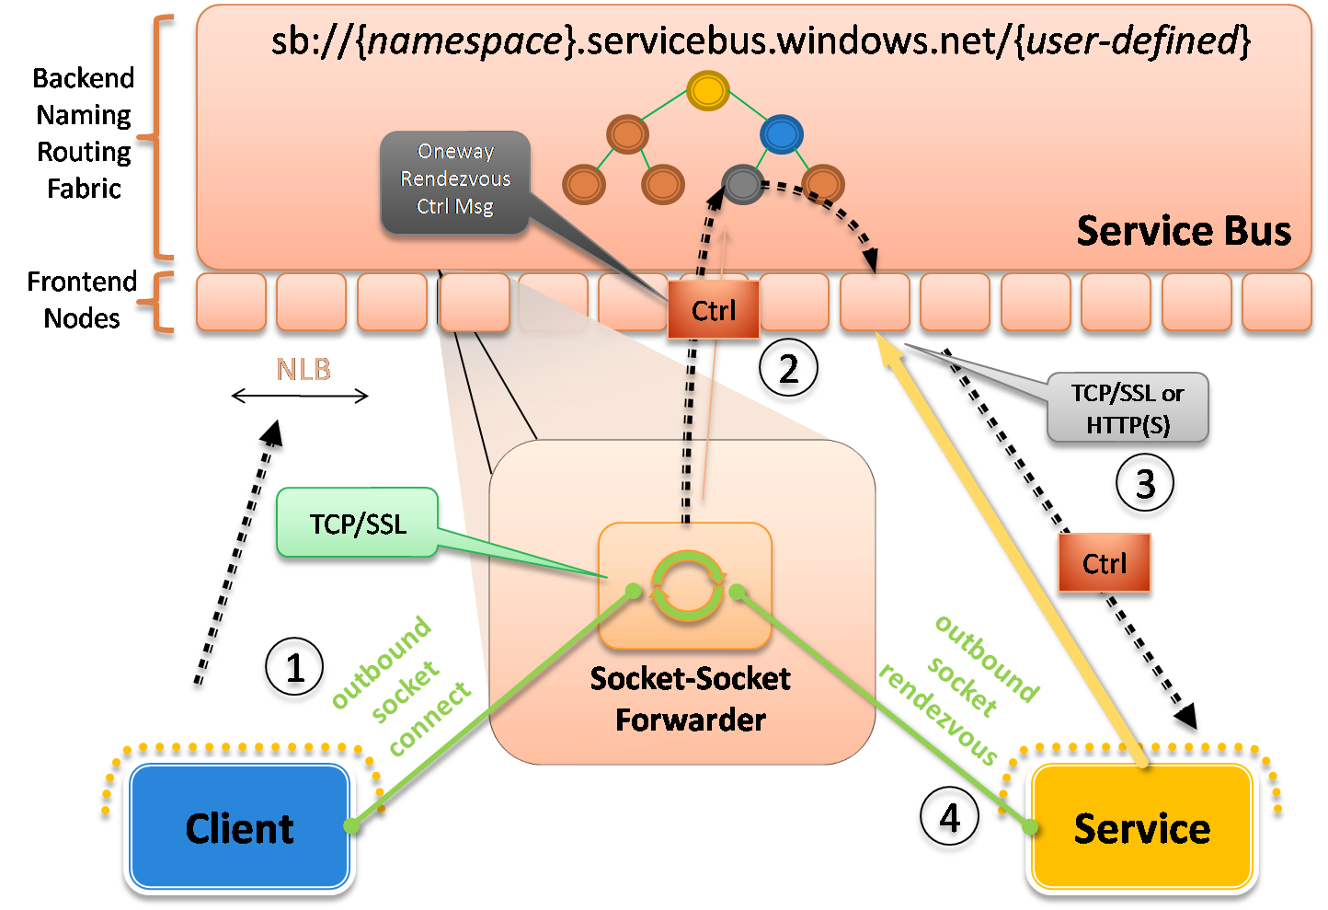
Figure 20: NetTcpRelayBinding – Relayed Mode
The NetTcpRelayBinding supports two connection modes (see TcpRelayConnectionMode) that control how the client/service communicate with one another through the relay service (see Figure 21).
TcpConnectionMode | Description
Relayed (default) | All communication is relayed through the relay service. The SSL-protected control connection is used to negotiate a relayed end-to-end socket connection that all communication flows through. Once the connection is established the relay service acts like a socket forwarder proxy relaying a bi-directional byte stream.
Hybrid | The initial communication is relayed through the relay service infrastructure while the client/service negotiate a direct socket connection to each other. The coordination of this direct connection is governed by the relay service. The direct socket connection algorithm is capable of establishing direct connections between two parties that sit behind opposing firewalls and NAT devices. The algorithm uses only outbound connections for firewall traversal and relies on a mutual port prediction algorithm for NAT traversal. Once a direct connection can be established the relayed connection is automatically upgraded to a direct connection without message or data loss. If the direct connection cannot be established, data will continue to flow through the relay service as usual.
Figure 21: TcpRelayConnectionMode Options
The Relayed mode I just described is the default. It also supports an interesting Hybrid mode, which instructs the relay service to do its best to establish a direct connection between the client and service applications, so no data needs to pass through the relay anymore. It’s considered a “hybrid” mode because it starts by relaying information through the relay while it attempts to upgrade to a direct connection. If successful, it will switch over to a direct connection without any data loss (see Figure 22). If it cannot establish a direct connection for whatever reason, it will continue to use the relay service.
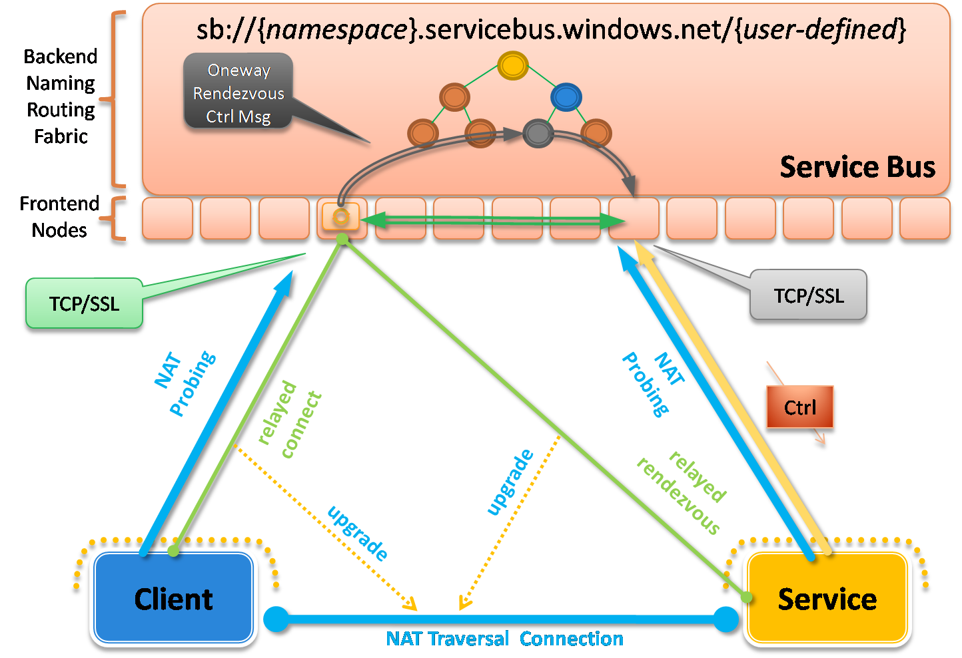
Figure 22: NetTcpRelayBinding – Hybrid Mode
The way the relay service accomplishes this is through a special mutual port prediction algorithm based on probing information from the client and service. The relay service looks at this probing information and does its best to predict what ports are going to be open on their respective NAT devices. It can then provide that information to the client/service so that they can attempt to establish a direct connection with one another. If the relay service predicts correctly, the connection will succeed, otherwise it can try again until it decides to give up and to stick with the relayed connection.
This approach is similar to the approach used by many of today’s instant messaging applications when transferring files between users. Next time you use that feature, pay attention to the initial file transfer speed and whether or not it significantly speeds up at some point during the process. If you notice a significant boost in transfer speed, you just witnessed the upgrade to a direct connection.
The NetTcpRelayBinding also supports the ServiceBusEnvironment.SystemConnectivity feature when you need to configure the on-premises service to connect to the relay service over HTTP. When you configure the SystemConnectivity property, it takes effect for all endpoints. Hence, you can use the aggressive HTTP connectivity mode for all of your on-premises NetTcpRelayBinding endpoints if they are being hosted within a locked-down network environment that blocks outbound TCP connections.

There’s a sample that ships with the SDK that illustrates how this works. The on-premises WCF service is configured with a single NetTcpRelayBinding endpoint configured to use the Hybrid mode:
<configuration>
<system.serviceModel>
<bindings>
<netTcpRelayBinding>
<binding name="default" connectionMode="Hybrid">
<security mode="None" />
</binding>
</netTcpRelayBinding>
</bindings>
<services>
<service name="Microsoft.ServiceBus.Samples.HelloService">
<endpoint address=
"sb://pluralsight.servicebus.windows.net/direct"
contract="Microsoft.ServiceBus.Samples.IHelloContract"
binding="netTcpRelayBinding"
bindingConfiguration="default" />
</service>
</services>
...
</system.serviceModel>
</configuration>
The corresponding client application is also configured with an equivalent endpoint definition (using the Hybrid connection mode as well). The service implementation actually does nothing in this sample. The sample is designed to measure how many messages the client can send to the service’s “no-op” operation every 250 milliseconds. It prints the number to the client’s console window (see Figure 23).
Notice how the number of messages sent by the client dramatically jumps several seconds into running the program. This highlights exactly when the connection was upgraded to a direct connection.
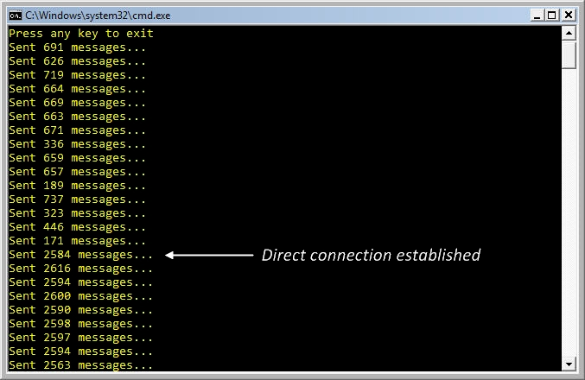
Figure 23: Running the NetTcpRelaying Binding "Hybrid" Sample
It’s also possible to register an event handler that will be notified when the connection status changes at runtime. When using this binding, the client side channel has a property of type IHybridConnectionStatus that exposes a ConnectionStateChanged event. Here’s an example that shows how to setup a custom event handler on the client connection:
...
ChannelFactory<IHelloChannel> channelFactory = new ChannelFactory<IHelloChannel>("RelayEndpoint", new EndpointAddress(serviceUri));
channelFactory.Endpoint.Behaviors.Add(relayCredentials);
IHelloChannel channel = channelFactory.CreateChannel();
channel.Open();

IHybridConnectionStatus hybridConnectionStatus =
channel.GetProperty<IHybridConnectionStatus>();
hybridConnectionStatus.ConnectionStateChanged += ( o,e ) =>
{
Console.WriteLine("Upgraded!");
};

// use the channel here...

If you re-run the sample with this event handler in place, you’ll see the “Upgraded!” notification in the console window right when the connection is upgraded (see Figure 24).
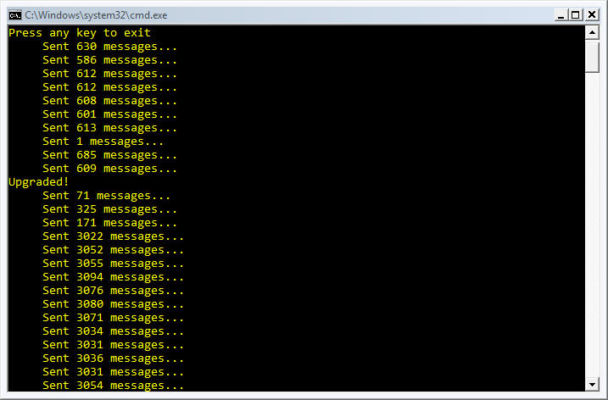
Figure 24: Using the IHybridConnectionStatus.ConnectionStateChanged Event
Since it’s always possible to drop the socket connection during a lengthy transmission, you may want to employ WS-ReliableMessaging with the NetTcpRelayBinding. When using WS-ReliableMessaging, the underlying WCF channel stack will automatically try to reestablish any failed connections on your behalf thereby making the direct connection “reliable”. You don’t have to make any changes to your application code besides configuring the NetTcpRelayBinding to use WS-ReliableMessaging.
Throughout this section, we’ve been discussing how to relay TCP messages between clients and on-premises services. When you need to relay HTTP messages between clients and on-premises services, you’ll want to use one of the various HTTP relay bindings, which we’ll discuss next.

HTTP Relay Bindings
All of the bindings discussed thus far require clients to use WCF on the clients-side of the interaction. When you need non-WCF clients to integrate with your Service Bus endpoints, you’ll want to support relaying HTTP-based messages. This is when you want to choose one of the various HTTP relay bindings.
The Service Bus comes with several HTTP bindings – WebHttpRelayBinding, BasicHttpRelayBinding, and WS2007HttpRelayBinding – that all offer wider reach and more interoperability because they can support any client that knows how to use the standard protocols supported by each of these bindings.
WebHttpRelayBinding and BasicHttpRelayBinding provide the greatest reach because they’re based on simple HTTP/REST and basic SOAP respectively. The WS2007HttpRelayBinding is capable of providing additional layers of functionality through the WS-* protocols. When using the WS2007HttpRelayBinding, clients will have to support the same suite of WS-* protocols enabled on the endpoint.
Regardless of which HTTP relay binding you use, the mechanics of what happens within the relay service is largely the same (see Figure 25). The on-premises WCF service first establishes either a TCP or HTTP connection with the relay service depending on the SystemConnectivityMode setting in use. The SystemConnectivityMode functionality works the same on all HTTP relay bindings.
Then, clients begin sending messages to the HTTP endpoint exposed by the relay service using. This means WCF is no longer necessary on the client – any HTTP/SOAP compatible library will do.
When an incoming message arrives on one of the front nodes, a control message is then routed down to the service indicating how to create a rendezvous connection back with the client’s front-end node, thereby establishing a direct HTTP-to-socket forwarder for relaying the HTTP messages.
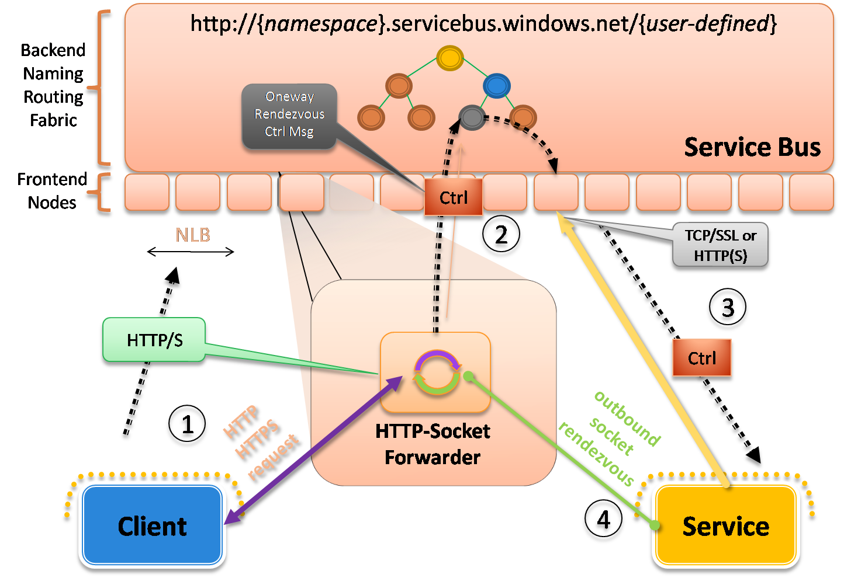
Figure 25: HTTP Relay Bindings
The relay service knows how to route SOAP 1.1, SOAP 1.2, and plain HTTP (REST) messages transparently. You control the messaging style and the various WS-* protocols you wish to employ by configuring one of the HTTP relay bindings like you would any other WCF binding.
Let’s start with an example of how you can publish a RESTful HTTP service through the Service Bus. The SDK comes with a complete sample called WebHttpSample that makes it possible to retrieve an image through the Service Bus over HTTP. The on-premises WCF service exposes a simple RESTful service contract using the WCF 3.5 Web programming model as shown in the code below. And the implementation of the GetImage method simply returns an image file as a Stream to the caller.
[ServiceContract(Name = "ImageContract",
Namespace = "http://samples.microsoft.com/ServiceModel/Relay/")]
public interface IImageContract
{
[OperationContract, WebGet]
Stream GetImage();
}
The host application is configured with a single WebHttpRelayBinding endpoint that looks something like the following example. The service endpoint is configured with a “shared secret” credential and the WebHttpRelayBinding has been configured to not require authentication from incoming clients. This means that clients will not have to authenticate with Access Control in order to use our endpoint.
<configuration>
<system.serviceModel>
<bindings>
<!-- Application Binding -->
<webHttpRelayBinding>
<binding name="default">
<!-- Turn off client authentication -->
<security relayClientAuthenticationType="None" />
</binding>
</webHttpRelayBinding>
</bindings>
<services>
<service name="Microsoft.ServiceBus.Samples.ImageService">
<endpoint name="RelayEndpoint"
contract="Microsoft.ServiceBus.Samples.IImageContract"
binding="webHttpRelayBinding" bindingConfiguration="default"
behaviorConfiguration="sharedSecretClientCredentials"
address=
"https://pluralsight.servicebus.windows.net/Image/" />
</service>
</services>
...
</system.serviceModel>
</configuration>
Once the WCF service application is up and running, anyone can browse to https://pluralsight.servicebus.windows.net/Image/GetImage to retrieve the image on-premises(see Figure 26).
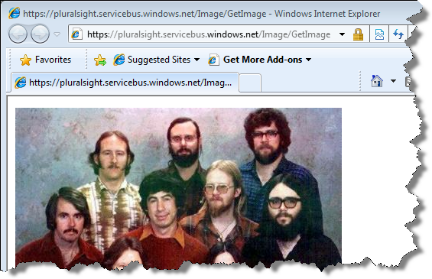
Figure 26: Browsing to the HTTP Endpoint
Now let’s look at an example of how you can also use WS2007HttpRelayBinding to take advantage of the latest WS-* protocols. The following example shows how to configure a WS2007HttpRelayBinding endpoint to use message-based security, with username tokens, and a customer validator component:
<configuration>
<system.serviceModel>
<behaviors>
<serviceBehaviors>
<behavior name="usernamePasswordServiceBehavior">
<serviceCredentials>
<serviceCertificate findValue="localhost"
storeLocation="LocalMachine"
storeName="My" x509FindType="FindBySubjectName" />
<userNameAuthentication userNamePasswordValidationMode="Custom"
includeWindowsGroups="false" customUserNamePasswordValidatorType=
"SimpleUsernamePasswordValidator, WSHttpRelayMsgSecUserNameService" />
</serviceCredentials>
</behavior>
</serviceBehaviors>
</behaviors>
<bindings>
<ws2007HttpRelayBinding>
<binding name="default">
<security mode="Message" relayClientAuthenticationType="None">
<message clientCredentialType="UserName"/>
</security>
</binding>
</ws2007HttpRelayBinding>
</bindings>
<services>
<service name="Microsoft.ServiceBus.Samples.EchoService"
behaviorConfiguration="usernamePasswordServiceBehavior">
<endpoint name="RelayEndpoint"
contract="Microsoft.ServiceBus.Samples.IEchoContract"
binding="wsHttpRelayBinding"
bindingConfiguration="default"
address=
"http://pluralsight.servicebus.windows.net/echo" />
</service>
</services>
...
</system.serviceModel>
</configuration>
You simply configure the WS2007HttpRelayBinding endpoint for security and reliable messaging features like you normally would for the WS2007HttpBinding. In the above example, the relay service does not perform any authentication – it simply relays the messages and lets the service take care of it.
In general, the BasicHttpRelayBinding and WS2007HttpRelayBinding are closely aligned with the equivalent standard WCF bindings and their various options. The main feature not supported by the WS2007HttpRelayBinding is transaction flow and that’s by design. Be sure to check out the other SDK samples for more examples on how you can use these HTTP bindings in various configurations.

Access Control
The Service Bus requires each on-premises service to be authenticated and authorized to “listen” on a particular address before establishing a new relay connection. Clients must also be authenticated and authorized, by default, before the Service Bus will relay messages on their behalf. You can, however, disable client authentication altogether in the relay service like I showed in the previous example.

Authentication and Authorization
Authentication and authorization have traditionally been very distinct concerns. Authentication is about identifying the client whereas authorization is about deciding what each client is allowed to do. Service Bus authentication can be performed by any identity provider trusted by Access Control. It’s the job of Access Control to produce the claims required by the Service Bus for authorization purposes.
Access Control implicitly trusts Windows Live ID (WLID) as an identity provider. And through the next version of Active Directory Federation Services (code-named “Geneva Server”), you’ll be able to use your own Active Directory identities as well. Access Control can federate with multiple identity providers at the same time, thereby acting as a central access control authority. In addition to these options, Access Control includes a built-in identity provider based on “shared secrets”, where it authenticates using issuer names and keys that you can manage through the Access Control management interface.
The Service Bus has been specifically designed to trust Access Control. This means that the Service Bus looks for specific claims in the security tokens provided by clients and services, which they in turn acquired from Access Control. The primary claims it looks for in the security token are “listen”, “send”, and “manage”. When an on-premises service attempts to “listen” on the relay service, the Service Bus looks for the “listen” claim within the security token provided by Access Control. If it finds it, and the token hasn’t been tampered with, it authorizes the creation of a new listener. The same thing happens with the client application, only in this case, the Service Bus looks for the “send” claim. When an application attempts to manage a service namespace, the Service Bus looks for the “manage” claim.
Whenever a client or service presents a credential to Access Control, it makes a rules-driven decision about whether to issue an authorization token (e.g., a token containing one or more of the claims just mentioned) to the target service, which is in this case the Service Bus. As long as you’ve provided a valid identity, Access Control will issue the appropriate token for authorization in the Service Bus.
When issuing tokens, Access Control signs the resulting token so the Service Bus can verify that no one tampered with the message. Since Access Control doesn’t encrypt the token, you’ll want to use transport security when you want to prevent eavesdroppers from recording and replaying tokens. Once the Service Bus processes the claims found in the token, it removes the token before relaying the message on to the service. The Service Bus token would have no meaning to the service anyway.
Figure 27 illustrates the Service Bus access control model I’ve been describing from both the client (blue) and service (yellow) perspectives. The numbered yellow boxes enumerate the steps taken by the service while the number blue boxes enumerate the steps taken by the client.
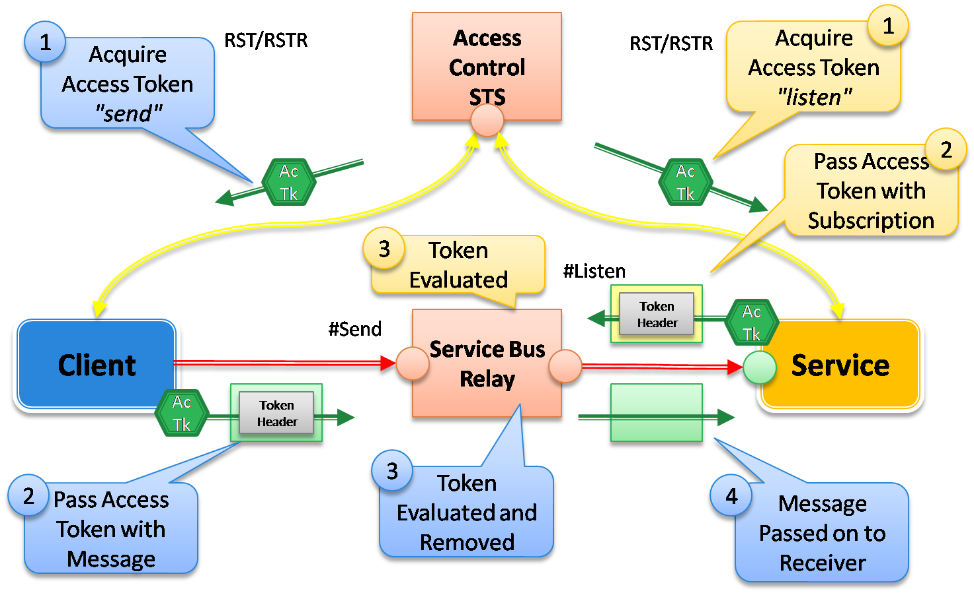
Figure 27: Access Control Model for the Service Bus

Configuring WCF Clients and Services
The WCF programming model for the Service Bus provides a few simple abstractions that make it easy to influence the access control model shown above. You specify what credentials to use for a particular Service Bus endpoint through the TransportClientEndpointBehavior, which I showed how to use in the very first HelloServiceBus example. The credentialType property can be set to one of the several values including SharedSecret, SimpleWebToken, Saml, and Unauthenticated. There are several SDK samples that illustrate how to use these different credential types.
You can also control whether or not clients are required to authenticate with the Service Bus by configuring the binding for the service. You do this through the relayClientAuthenticationType property on the <security> element supported by each relay binding. If you set the property to “None”, clients will not be required to authenticate (see the earlier WebHttpRelayBinding example). If you set it to “RelayAccessToken”, clients will be required to present authorization tokens to the relay service.
It’s also possible to implement a “hybrid” security mode by combining message-based security (WS-Security) with a relay client authentication mode of “RelayAccessToken”. In order to accomplish this you would specify a standard security mode of “Message” (on the binding) along with “RelayAccessToken” for the relay client authentication mode. And then you’d need to configure the client with two separate credentials: one via the regular WCF ClientCredentials property (for gaining access to the target service) and the other via the TransportClientEndpointBehavior (for gaining access to the Service Bus).
The WCF relay bindings take care of obtaining tokens from Access Control behind the scenes. However, you can also obtain tokens from Access Control directly through the REST interface it provides. This makes it easy to integrate Access Control with non-WCF applications. For more information on Access Control, and how you can use it in conjunction with your own services (not just through the Service Bus), see the accompanying whitepaper called A Developer’s Guide to Access Control.

Message Buffers
As you’ve seen throughout this article, the Service Bus focuses primarily on acting as a relay between two parties. This core function requires on-premises WCF services to “listen” on the relay service before clients can begin communicating with them. But what if the on-premises application isn’t capable of using the WCF “relay” bindings capable of creating these “listener” components? This will be the situation whenever the on-premises applications are running on platforms unable to use the SDK and the new WCF “relay” bindings that come with it (e.g., Silverlight, Flash, Ruby, Perl, etc).
In situations like this, you’ll want to turn to the message buffers feature, which allows both clients and services to operate over a simple HTTP-based rendezvous point within the Service Bus.

Understanding Message Buffers
The Service Bus provides message buffers to support interoperability with platforms unable to consume the SDK and the WCF “relay” bindings within the on-premises application. A client sends messages to the message buffer and an on-premises application retrieves messages from the same message buffer – it’s probably better to call these applications “message producers” and “message consumers” respectively. The difference is the message consumer application doesn’t require a WCF-based connection to the relay service –the “receive” logic happens over HTTP(S) requests – which simplifies interoperability. The message consumer simply polls for messages using an HTTP-based REST API.
Message buffers, as their name suggests, provide a data structure with FIFO semantics for “buffering” messages in transit to an on-premises application. The message consumer controls the lifetime of the message buffer. When the application creates a new message buffer it specifies how long a message buffer should live after it stops polling for messages. You do this through what’s called a message buffer policy (see the ExpiresAfter property). Every time the on-premises application polls for messages, the message buffer expiration clock automatically resets, extending the lifetime of the message buffer.
But once the on-premises application stops polling for messages, the message buffer will eventually go away and message producers will no longer be able to send messages to it.
You register a new message buffer within your service namespace by picking a name for the message buffer, defining a message buffer policy (more on this shortly), and then sending a request to create the message buffer at that location using the supplied policy (see Figure 28). Once created, message producers can send messages to your message buffer and the message consumer can retrieve messages from it using simple HTTP(S) requests. Either side can be running on any HTTP-compatible platform.
The contents of a message buffer are stored in memory. Therefore, it is important to note that the Service Bus does not provide any fault tolerance or reliability guarantees. If the server hosting a message buffer crashes, you may lose messages. In the event of a server crash, you will not necessarily lose the buffer itself: knowledge of the buffer, including policy settings, is distributed across multiple servers and may be recovered. However, any messages in your buffer at the time of the crash will be lost. Therefore, if you are designing an application that needs a high degree of message reliability, it is recommended that you provide for message redundancy and recovery through other means.
Also, it’s important to note that message buffers support peeks with locks, making it possible to ensure that messages aren’t lost when the message consumer fails after successfully retrieving a message.
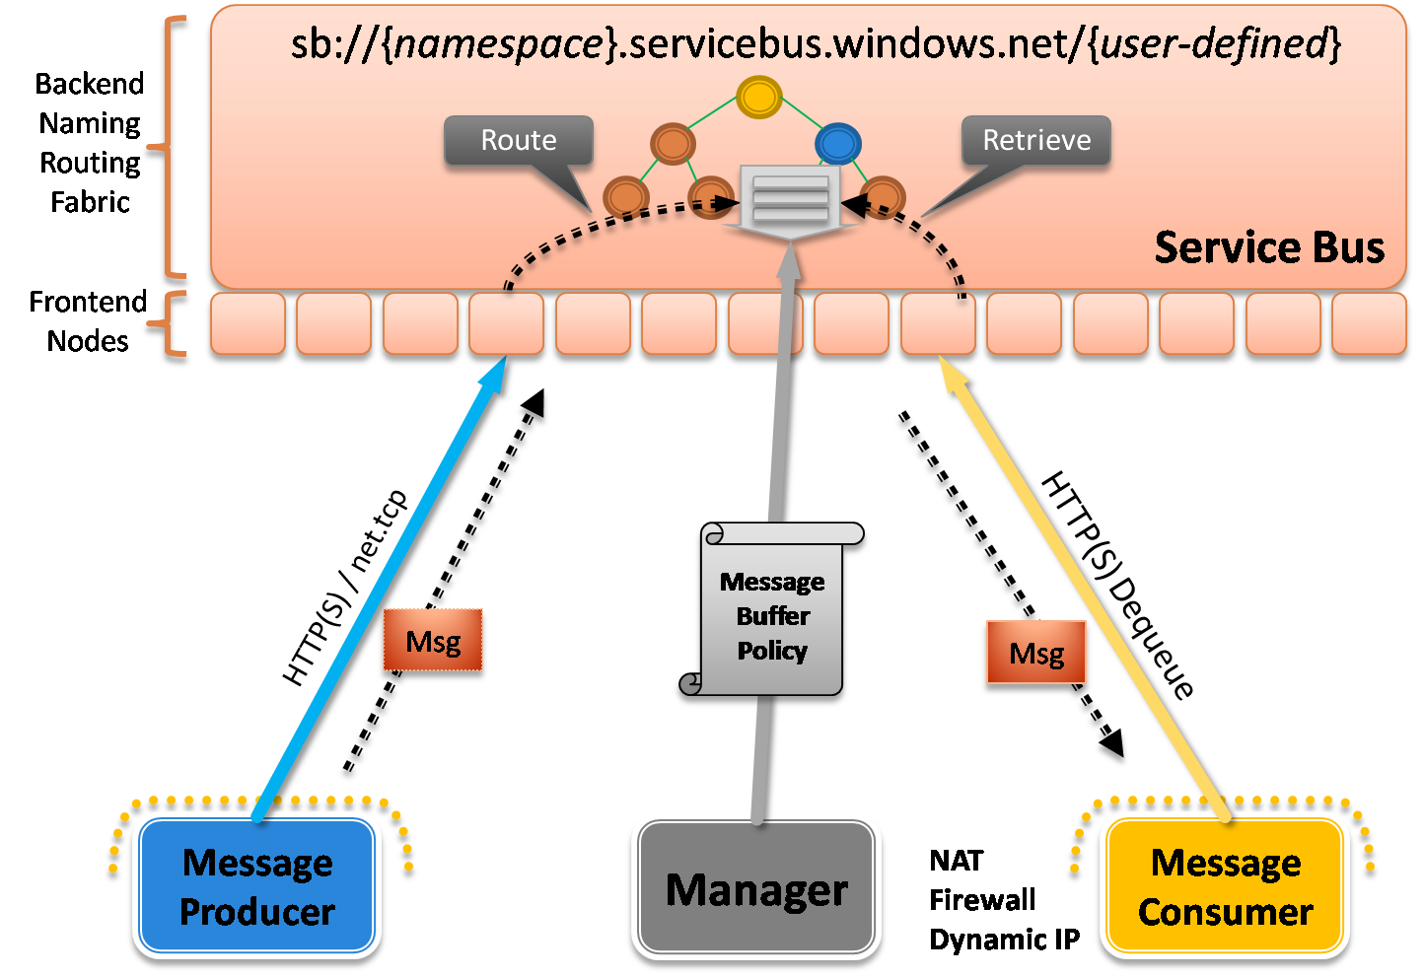
Figure 28: Message Buffers in the Service Bus

Programming Message Buffers
Like I’ve mentioned, the fundamental API for interacting with message buffers is based on REST. When working with message buffers on platforms that don’t support the SDK, you’ll need to program against them using the REST API directly. However, if you’re a .NET developer, you can use the MessageBufferClient class (and supporting classes) found in the SDK to abstract away the underlying REST/HTTP protocol details, providing for a much better .NET developer experience.
Let me walk you through a complete example that illustrates how to create a new message buffer, send messages to a message buffer, and retrieve messages from a message buffer. We’ll leverage the SDK classes to perform these tasks for simplicity’s sake, but remember it’s all possible through REST.
In order to create a message buffer, we’ll use the MessageBufferClient class, which provides various methods for creating, retrieving, and deleting message buffers and their policies. The MessageBufferPolicy class represents the message buffer policy information used by the Service Bus to manage message buffers. This class makes it easy to define and manipulate policies. The MessageBufferPolicy properties allow you to control various aspects of the message buffer’s behavior.
With these two classes in place, creating a new message buffer is simply a matter of creating a new MessageBufferPolicy and calling CreateMessageBuffer. The following code shows how to do this:
...
// create the policy for the message buffer
this.policy = new MessageBufferPolicy();
this.policy.Discoverability = DiscoverabilityPolicy.Public;
this.policy.Authorization = AuthorizationPolicy.Required;
this.policy.MaxMessageCount = 10;
// message buffer expires 5 minutes after the app stops retrieving messages
this.policy.ExpiresAfter = TimeSpan.FromMinutes(5);
this.policy.TransportProtection = TransportProtectionPolicy.None;

// create the credentials object for the endpoint
this.credential = new TransportClientEndpointBehavior();
this.credential.CredentialType = TransportClientCredentialType.SharedSecret;
this.credential.Credentials.SharedSecret.IssuerName = issuerName;
this.credential.Credentials.SharedSecret.IssuerSecret = issuerSecret;

// create the URI for the message buffer
this.uri = ServiceBusEnvironment.CreateServiceUri(
"http", serviceNamespaceDomain, "MessageBuffer");
// create the client for the message buffer
this.client = MessageBufferClient.CreateMessageBuffer(
this.credential, this.uri, this.policy);
Console.WriteLine("Message buffer created at '{0}'.",
this.client.MessageBufferUri);

...
Notice how we’re also using ServiceBusEnvironment.CreateServiceUri to create an appropriate message buffer URI within my service namespace. We’re also providing the “shared secret” credentials through the TransportClientEndpointBehavior behavior, like we’ve done in the prior examples. This policy specifies the message buffer should be discoverable and it should require authorization. It also specifies that it should expire in 5 minutes after the application stops polling for messages. Every time the application polls for messages, the expiration clock is automatically reset and the lifetime renewed.
Assume this code is running. Since we made the buffer discoverable, we can browse to the solution’s service registry and we’ll see the new message buffer listed in the ATOM feed.
Now, if you were to view the source of this ATOM feed, you’d see the following XML document that fully describes the message buffer we just created within the <entry> element you see below:
<feed xmlns="http://www.w3.org/2005/Atom">
<title type="text">Publicly Listed Services</title>
<subtitle type="text">This is the list of publicly-listed ...</subtitle>
<id>uuid:d6d4c0c8-4a98-4701-a4f0-0d880db11bf4;id=80</id>
<updated>2009-10-30T21:53:40Z</updated>
<generator>...</generator>
<entry>
<id>uuid:d6d4c0c8-4a98-4701-a4f0-0d880db11bf4;id=81</id>
<title type="text">messagebuffer</title>
<updated>2009-10-30T21:53:40Z</updated>
<link rel="alternate"
href="http://pluralsight.servicebus.windows.net/MessageBuffer/"/>
<link rel="self"
href="http://pluralsight.servicebus.windows.net/MessageBuffer/"/>
<link rel="head"
href="http://pluralsight.servicebus.windows.net/MessageBuffer//messages"/>
<content type="text/xml">
<MessageBufferPolicy
xmlns="http://schemas.microsoft.com/netservices/2009/05/servicebus/connect">
<Authorization>Required</Authorization>
<Discoverability>Public</Discoverability>
<TransportProtection>None</TransportProtection>
<ExpiresAfter>PT5M</ExpiresAfter>
<MaxMessageCount>10</MaxMessageCount>
</MessageBufferPolicy>
</content>
</entry>
</feed>
The <entry> element provides everything a client would need to know in order to interact with the message buffer. The message buffer address is represented in the first <link> element (rel=”alternate”) and the policy is fully described in the <MessageBufferPolicy> element towards the bottom. The <entry> element also provides links to the resources that make up the anatomy of every message buffer.
Now let’s look at how to send messages to our new Service Bus message buffer. We’ll need to retrieve a MessageBufferCient object using the GetMessageBuffer method. MessageBufferClient provides numerous methods for interacting with a message buffer. We’re going to use the Send method to send a string-based message to our message buffer. You can use Message.CreateMessage to create a message. The following code shows a complete example of sending three messages to the buffer:
...
// create the client for the message buffer
this.client = MessageBufferClient.GetMessageBuffer(this.credential, this.uri);
Console.WriteLine("Message buffer at '{0}' retrieved.", this.client.MessageBufferUri);

Console.Write("Press [Enter] to send messages to the message buffer: ");
Console.ReadLine();

// send three messages to the message buffer
for (int i = 1; i <= 3; ++i)
{
Message message = Message.CreateMessage(MessageVersion.Default, string.Empty,
string.Format("<<MESSAGE {0}>>", i));
this.client.Send(message);
Console.WriteLine(
"Sent message with body '<<MESSAGE {0}>>' to the message buffer.", i);
message.Close();
}
...
Retrieving messages from the message buffer is similar. You simply retrieve the MessageBufferClient object and call Retrieve multiple times until there’s nothing left to retrieve. Here’s a simple example:
...
this.client = MessageBufferClient.GetMessageBuffer(this.credential, this.uri);
while (true)
{
Message msg = client.Retrieve();
Console.WriteLine(msg.GetBody<string>());
}
...
The SDK also comes with a complete message buffer sample illustrating the various features and communication possibilities. Remember, since you can interact with message buffers using plain HTTP requests, you don’t have to install the SDK within client or service applications to take advantage of this feature, which means it’s very straightforward to leverage this capability on other platforms.

Guidance
One of the hardest questions to answer when moving towards the Service Bus is: which binding should I use? This section provides some general guidance to help answer that important question.
Microsoft recommends you use the NetTcpRelayBinding by default unless you specifically need a communication feature provided by one of the other bindings. This was the binding that I used in the HelloServiceBus example towards the beginning of the paper. The NetTcpRelayBinding supports two-way messaging and it provides the most compact wire format and the most efficient communication path through the relay infrastructure. It will therefore yield the highest throughput of all the WCF relay bindings and it will impose the lowest amount of processing overhead on the listening service.
In addition, if your scenario requires transferring large messages in a peer-to-peer fashion, you should prefer the Hybrid connectivity mode when using the NetTcpRelayBinding.
In scenarios that only call for one-way TCP messaging, you should consider the NetOnewayRelayBinding, which has been optimized for that scenario. And in one-way messaging scenarios that call for multicast delivery (e.g., multiple on-premises services listening on the same address), you should use NetEventRelayBinding, which was designed specifically for supporting publish/subscribe semantics.
Although all of these bindings require clients to use TCP, they each provide an HTTP connectivity mode that allows on-premises services to connect to the Service Bus over HTTP ports (80/443) in order to get through locked-down NAT/firewall configurations by creating listeners that receive messages. When on-premises applications are operating under those constraints, you’ll want to enable the HTTP mode.
When you need to relay HTTP messages from clients to on-premises services, you should use one of the various HTTP relay bindings. The HTTP relay bindings expose HTTP-based endpoints through the Service Bus based on open standards including SOAP 1.1, SOAP 1.2, and WS-*. When you use the HTTP relay bindings, any compatible HTTP-based client will be able to communicate with these endpoints. The primary downside to using the HTTP relay bindings is they come with the greatest processing overhead.
Choosing between the various HTTP relay bindings boils down to what style of service you’re trying to expose to your clients. If your requirements call for REST, you want to use the WebHttpRelayBinding. If your requirements call for SOAP, you have a few different choices. You’ll want to use the BasicHttpRelayBinding when you’re building basic profile compliant SOAP services, and the WS2007HttpRelayBinding when you’re building more advanced SOAP-based services that leverage the layered WS-* protocols. The binding you choose controls the client experience.
In the area of security, Microsoft encourages you to take full advantage of message-based security techniques by signing and encrypting your messages that will pass through the service relay (this is the “hybrid” mode I referred to in the Access Control section). The relay security model composes nicely with WS-Security thereby making it possible to ensure privacy and tamper protection. The service relay does not read or touch any of the information within the body of your messages – it only looks at the URI and, in some cases, the WS-Addressing headers in order to determine how to relay the message.
In situations where you need to support on-premises services running on platforms unable to use the SDK and the WCF “relay” bindings, use message buffers. Message buffers make it possible to receive messages from the Service Bus on any platform capable of using HTTP. The main benefit is you no longer need a WCF connection to receive messages – instead message retrieval happens over a simple HTTP REST API, which greatly increases interoperability in the on-premises application.
One final important note: the current release does not support hosting your on-premises WCF services within IIS/WAS. As mentioned earlier, the on-premises service host process is responsible for initiating the relationship with the Service Bus. Since IIS/WAS services rely on a process activation model, the host process doesn’t actually run until the first message arrives. This presents a dilemma when using the Service Bus. Microsoft is actively working on a solution for a future release but as of this CTP release, you should avoid hosting your services in IIS/WAS when using the Service Bus.

Summary
The Service Bus provides a secure, standards-based messaging fabric for connecting applications across the Internet, making it possible to traverse difficult firewall and NAT obstacles when necessary. It consists of global naming system, a discoverable service registry, numerous messaging and connectivity options, and a claims-based access control mechanism. .NET developers can take advantage of the Service Bus by simply choosing from a new set of WCF “relay” bindings and the rest of their WCF code remains essentially the same. Ultimately, the messaging fabric offered by the Service Bus dramatically reduces the barriers for making software + services a reality on the Windows platform.

Additional Resources
We’ve provided links to several resources below that will further your education on the Service Bus.
- An Introduction to Windows Azure AppFabric for Developers
  - http://go.microsoft.com/fwlink/?LinkID=150833
- A Developer’s Guide to Access Control in Windows Azure AppFabric
  - http://go.microsoft.com/fwlink/?LinkID=150835
- Windows Azure
  - http://www.microsoft.com/windowsazure/
- Windows Azure AppFabric
  - https://appfabric.azure.com/

About the Author
Aaron Skonnard is a cofounder of Pluralsight, a premier Microsoft .NET training provider offering both instructor-led and online training courses. Aaron is the author of numerous books, articles, and whitepapers, as well as Pluralsight’s REST, Windows Communication Foundation, and BizTalk courses. Aaron has spent years developing courses, speaking at conferences, and teaching developers throughout the world. You can reach him at http://pluralsight.com/aaron.

Acknowledgements
Clemens Vasters deserves significant credit for the content found in this whitepaper. Thanks to Clemens for his various conference sessions, blog entries, and willing assistance that made my job that much easier. In addition, thanks to Anjan Das, Ronen Hilewicz, Xuehai Zhang, Janice Wang, Yi Huang, and Seth Manheim for their time and helpful feedback throughout the process.

This terminology was used in the early BizTalk Services documentation but is no longer an official term used by Microsoft.
RIA = Rich Internet Application
The Internet is full of bad guys. These days, if you have anything of value, you must design against the threat of being attacked. Hence, most corporate environments shield themselves heavily with multiple firewall layers.
An inbound port is required for an external node to initiate communication with an application sitting within the firewall.
The fact that you can define name hierarchies within your service namespaces gives you the opportunity to further delegate control over specific sub-trees to different groups or teams within your organization.
This can be done programmatically by simply issuing an HTTP GET request to the solution’s base address.
Although visible, Microsoft has stated that the relay service does not observe the messages passing through it.
Note that I’ve inserted an example address for my service namespace here. The SDK samples prompt you for your service namespace and dynamically generate the Service Bus addresses. Throughout the following examples, I will provide a sample address to show you what kind of address to expect at runtime.
This is essentially the opposite of what happens with the NetOnewayRelayBinding when using the HTTP connection mode. In that case, the client creates a TCP connection with the relay service while the on-premise service listens over HTTP.
Transaction flow requires the distributed transaction coordinators of the communicating parties to establish a communication path to each other. When going through the Service Bus, establishing this relationship is very challenging. In addition, since atomic transactions require resources to be locked, it’s general not a recommended practice at Internet scope where latency is an issue. Thus, transaction flow is not supported by any of the bindings at this time.
Most of the samples that ship with the SDK use the “shared secret” provider built into Access Control.
Using ServiceBusEnvironment.CreateServiceUri is a good practice in general for creating new Service Bus URI’s.

