Overview  Partner Description  Clearway Technology Partners Inc. is a technology services firm that provides clients with innovative Microsoft-based business solutions that generate sustainable competitive advantages. Monitor Analytics, a subsidiary of Clearway, is a leading developer of powerful business intelligence visualization solutions, including GeoAnalyzer, to help companies plan, understand, predict, and manage financial and operational performance.  Market Opportunity  For any size business, it is imperative in this new economy to be able to use its own data for gaining a strategic business advantage. The geography element of organization data in the interactions with customers, partners, prospects, and suppliers is key to driving business strategy. Visually reviewing these interactions on a map provides insight that would otherwise be difficult to identify.  Solution  Monitor Analytics GeoAnalyzer is a location intelligence solution that mashes geographic data coming from data stored in SharePoint Online lists with Microsoft Virtual Earth. Built with Microsoft Silverlight technology, GeoAnalyzer makes it easy for users to visually analyze and filter the data inside Virtual Earth.  Benefits  - Easily see patterns in dealings with customers, partners or suppliers on a map  - Quickly see clusters of customer behavior across geographies  - Identify new locations to target for business opportunity  - Highlight exceptions to see best and worst performers |  |  | “Monitor Analytics has built a portfolio of rich interactive applications for SharePoint Online that enhance business users’ ability to gain valuable insight from data to drive strategic business decisions. At Monitor Analytics, we see SharePoint Online and Silverlight as key technology platforms that enable us to deliver powerful visualization of enterprise data at low cost for pervasive use. SharePoint Online is a natural fit for Monitor Analytics to extend our products to support complete online information visualization mashups. This is pure Software + Services in action!”  - Raheel Retiwalla, Chief Technology Officer, Clearway Technology Partners  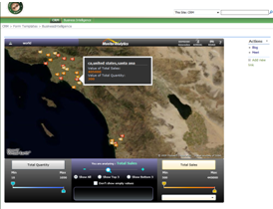  Companies must be able to analyze their own business data for strategic planning, but the geography element in data is rarely used because it is too difficult to conceptualize in flat reports. Monitor Analytics extended GeoAnalyzer, their enterprise-scale mashup tool, to integrate with the Business Online Productivity Suite. GeoAnalyzer takes business data stored in Microsoft® SharePoint® Online lists and displays it on a Microsoft Virtual Earth™ map inside a Web Part that sits on a company’s SharePoint Online Web site. Built with Microsoft Silverlight™ technology, GeoAnalyzer helps businesses visually analyze their data and filter it in many different ways to quickly extract its meaning.  GeoAnalyzer helps businesses quickly analyze various metrics such as sales, profit margin, and more. It enables users to quickly identify patterns and correlations that otherwise would be hard to perceive.

Solution
Clearway Technology Partners and Monitor Analytics Corp. jointly developed this solution that integrates with the Business Productivity Online Suite. Clearway offers prebuilt CRM, project management, financial, and business intelligence templates for the Business Productivity Online Suite that include visualization products from Monitor Analytics built specifically for the Suite.

Monitor Analytics GeoAnalyzer for SharePoint Online is a location intelligence product in a SharePoint Web Part that mashes geographic data coming from SharePoint Online lists with Microsoft Virtual Earth. Built with Microsoft Silverlight technology, GeoAnalyzer makes it easy for users to visually analyze and filter the data inside Virtual Earth and SharePoint Online.

Key Features
Analysis Control Panel
Analysis Control Panel built in Silverlight enables rich interaction with data displayed in Virtual Earth and enables users to perform the following functions:
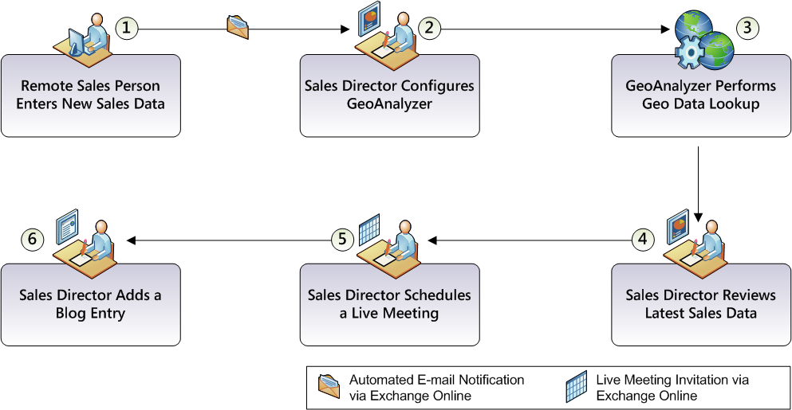
- Multiple measures (numeric values) with a heat map for each measure on the map enable analyzing data in a variety of ways
- One-click access to the top and bottom five values on the map based on measure thresholds
- One-click access to hide empty data values
- Mini world map with built in zoom capabilities allows user to navigate across regions and countries with ease
- Bread crumbs offer backtrack navigation
- Hover functionality over any data point on the map highlights details of the two selected data categories

Visualizing Sales Data to Drive Sales Strategy Scenario
As an example of how visualizing data can benefit a company, the following scenario describes a sales director reviewing the company’s latest sales information. Steps in this data visualization scenario are described below.

Remote Sales Person Enters New Sales Data
A sales person in the Western U.S. Region has finalized a new sale and enters the sales data into SharePoint Online.

Sales Director Configures GeoAnalyzer
The addition of a new sale initiates a SharePoint workflow that automatically notifies the sales director via Microsoft Exchange Online.

The sales director accesses GeoAnalyzer and configures it to review appropriate sales information.

GeoAnalyzer Performs Geo Data Lookup
GeoAnalyzer quickly scans through the SharePoint Online list of sales data and obtains latitude and longitude information for the location of each sale. The resulting geocoded information is stored as a file attachment in XML format on SharePoint Online.

Sales Director Reviews Latest Sales Data
After GeoAnalyzer loads the information into the Web Part, the sales director uses the tool to:
- Zoom in to review individual sales
- Filter sales to display the top five locations with the highest sales in dollar amount
- Identify top performing locations by color
- Filter sales and quantity to show top five in gross profit, and then sales that are losing money

Sales Director Schedules a Live Meeting
The sales director wants to discuss this latest information with his regional sales managers, so he uses Live Meeting to schedule a meeting.

Sales Director Adds a Blog Entry
The sales director wants to recognize accomplishments as well as share best practices and lessons learned, so he uses blogging capabilities in SharePoint Online to add a new blog.
Solution Development and Implementation
As shown in the flow chart at the top of this page, the development effort to extend GeoAnalyzer to the Business Productivity Online Suite and build a simple custom CRM solution was divided into six main steps.

Step 1: Define Technical Requirements
There were three key areas that Monitor Analytics identified in order to successfully extend GeoAnalyzer to integrate with the Business Productivity Online Suite:
- Consume data from the cloud without connecting to corporate data repositories.
- Deploy Silverlight-based applications to SharePoint Online.
- Write back configuration data needed to store geo codes for location.

Step 2: Map Current GeoAnalyzer Architecture to SharePoint Online
GeoAnalyzer for Windows® SharePoint Services 3.0 was originally designed leveraging Silverlight technology. Because data interaction with Silverlight is very much Web services-driven, GeoAnalyzer’s architecture was already well suited for a Software + Services solution.
- Monitor Analytics leveraged SharePoint Online Web services to gain access to SharePoint Online lists. The SharePoint Online Web services layer was used to manage the creation and modification of a list as well as to manipulate data in a list.
- The transition to consume data from SharePoint lists was very straightforward. This architecture also paves the way for future versions of GeoAnalyzer to potentially consume data directly from applications such as Microsoft Dynamics® CRM Online, or from other cloud-based data sources that are part of the Azure data platform (such as SQL Data Services).
- One of the other areas to consider when extending GeoAnalyzer for SharePoint Online is the ability to deploy Silverlight applications to SharePoint Online. Monitor Analytics found that the ability to interact directly with the site enabled Monitor Analytics to manage deploying the Silverlight application with ease.

Step 3: Modify GeoAnalyzer Architecture to Support the Suite
Once the major requirements were explored, it took one developer just under three days to build a working prototype. An additional week of development time was needed in order to complete the necessary changes to extend GeoAnalyzer for SharePoint Online.
- SharePoint APIs were used to code the means by which GeoAnalyzer would write back geo-coded latitude and longitude information to SharePoint Online.
- GeoAnalyzer was modified to generate its XML-based location data list on SharePoint Online, and then attach the XML configuration file to a SharePoint Online list.
- GeoAnalyzer was configured to read the configuration file and display the location data correctly on the Virtual Earth map that is embedded in a SharePoint Online Web Part.

Step 4: Build and Deploy Custom CRM Solution Using InfoPath Client
Clearway built out a simple CRM solution using Microsoft Office InfoPath®.
- Built InfoPath forms to allow entering contacts, opportunities, and sales for a customer. These forms provide a nested user experience to allow entering of various types of data relating to a customer.
- The use of InfoPath enables users to enter customer relationship management data in the InfoPath Client, which then passes the data to SharePoint Online to be analyzed using GeoAnalyzer.

Step 5: Use SharePoint Designer to Build Sales Review Workflow
Building workflow with SharePoint Designer for SharePoint Online was the same experience as building workflows for an on-premise SharePoint environment.

- A Clearway Technology Partners SharePoint developer used SharePoint Designer to develop a workflow that uses Exchange Online to automatically notify a specific user or a set of users whenever a new sale is entered into the CRM system.

Step 6: Use SharePoint Designer to Build and Apply New Master Page Template for CRM Site Look and Feel
Clearway Technology Partners took an already customized Master page for Windows SharePoint Server 3.0 and, with minimal effort, deployed the same Master page to a SharePoint Online site.

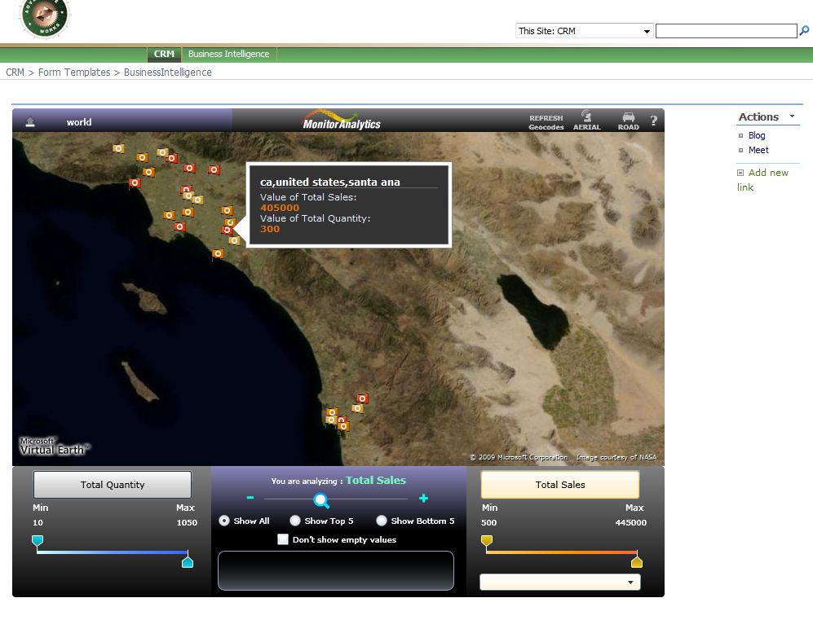
Benefits
Customer Benefits
- Easily see patterns in dealings with customers, partners, or suppliers on a map
- Quickly see clusters of customer behavior across geographies
- Identify new locations to target for business opportunities
- Highlight exceptions to see best and worst performing locations for specific metrics of interest

Partner Benefits
- Enables one of the first to market in delivering Software + Services solutions with SharePoint Online
- Minimizes development effort to extend existing solutions to SharePoint Online
- Allows Monitor Analytics and Clearway to offer wide range of solutions to a broad customer base thereby enhancing appeal to rich interactive business applications
- Provides incredible time to market and ROI for the customer

Introducing the Business Productivity Online Suite
Microsoft Online Services provides software delivered as a hosted service directly from Microsoft data centers, managed by Microsoft staff, and with a guaranteed 99.9 percent Service Level Agreement. These standardized solutions are designed so that partners can rapidly deploy services for their customers at a low, up-front investment with predictable, recurring costs.

The all-new Business Productivity Online Suite provides streamlined communication, simplified management, and business-class reliability and security. The customers can order this service for as little as five seats at a time.

The Business Productivity Online Suite includes the following services, which can be purchased on a monthly subscription basis, either separately or as part of the Suite:

Microsoft Exchange Online, based on Microsoft Exchange Server 2007, offers business e-mails, calendaring, other messaging-based capabilities, and archiving. It also enables coexistence, which means new online users can interact with the users on local servers.

Introducing the Business Productivity Online Suite, (Continued)

Microsoft SharePoint Online, based on Microsoft Office SharePoint Server 2007, provides a single, integrated location where employees can efficiently collaborate with team members, find organizational resources, search, and manage content and workflow.

Microsoft Office Communications Online enables people to communicate easily with their colleagues across locations and time zones via instant messaging (text), voice, and video.

For More Information
For more information about Microsoft products and services, call the Microsoft Sales Information Center at (800) 426-9400. In Canada, call the Microsoft Canada Information Centre at (877) 568-2495. Customers who are deaf or hard-of-hearing can reach Microsoft text telephone (TTY/TDD) services at (800) 892-5234 in the United States or (905) 568-9641 in Canada. Outside the 50 United States and Canada, please contact your local Microsoft subsidiary. To access information using the World Wide Web, go to: www.Microsoft.com

For more information about Microsoft Online Services, visit the Web site at:
www.Microsoft.com/online

Monitor Analytics builds products and offers solutions that address the information management needs of businesses to collaborate and make educated and timely business decisions. They deliver consumer product ease of use to help solve business challenges.

To download a trial version of GeoAnalyzer, visit www.MonitorAnalytics.com

For more information about Clearway Technology Partners services, visit www.ClearwayPartners.com

Microsoft Office Live Meeting is a hosted Web conferencing service that connects people in online meetings, training, and events through a reliable, enterprise-class hosted service.

Microsoft Exchange Hosted Filtering protects businesses’ inbound and outbound e-mail from spam, viruses, phishing scams, and e-mail policy violations.

About the Microsoft Business Productivity Online Suite
The Microsoft Business Productivity Online Suite provides businesses with virtually anywhere access to rich communication, collaboration, and productivity applications via subscription-based, Microsoft-hosted online services. This hosted solution helps organizations offset the burden of managing and maintaining business systems, freeing information technology (IT) resources to focus on initiatives that can deliver competitive advantage to the business. The solution is part of the Microsoft’s Software-plus-Services delivery model to provide customers with more choices than the traditional, hosted or on-premises solutions, allowing them to make deployment decisions that best fit the needs of their organization.

For more information about the partner opportunities provided by the Business Productivity Online Suite, see http://partner.microsoft.com/online.
© 2009 Microsoft Corporation. All rights reserved. This solution brief is for informational purposes only. MICROSOFT MAKES NO WARRANTIES, EXPRESS OR IMPLIED, IN THIS SUMMARY. Microsoft, InfoPath, Microsoft Dynamics, SharePoint, Silverlight, SQL Server, Virtual Earth, and Windows are either registered trademarks or trademarks of Microsoft Corporation in the United States and/or other countries. The names of actual companies and products mentioned herein may be the trademarks of their respective owners.

Document published March 2009
Microsoft Business Productivity Online Suite
- Microsoft Exchange Online
- Microsoft SharePoint Online
- Microsoft Office Communications Online
- Microsoft Office Live Meeting
- Microsoft Exchange Hosted Filtering

