Overview  Market Opportunity  SharePoint® Online creates a compelling option for providing scalable access to SharePoint®. How do you guarantee that all users, including those on limited or intermittent bandwidth, can share the collaborative experience?  Solution  Infonic Geo-Replicator™ software uniquely provides two modes of replication within the same product:  - Replication of the SharePoint® server for distributed access to a group of users.  - Replication of SharePoint® server content to end users’ laptops for access when offline.  Benefits  - Ensure that all users, irrespective of the availability of network connection, have guaranteed access to key data  - Enhance decision making by making up-to-date information always available  - Allow offline and remote SharePoint® user access to access central data at LAN speeds  - Reduce WAN and server costs through server content replication  - Guaranteed service even when there is no network  - Where SharePoint® is being accessed via satellite cut communication costs by up to 90% |  |  | “We have been supporting remote users on the end of the corporate network to access and contribute to SharePoint® for many years. We look forward to our products ensuring that all users irrespective of network availability have guaranteed access to BPOS content.”  Lawrence Poynter - Product Manager  Infonic Geo-Replicator™ provides secure, automated, transparent and managed access to SharePoint® Online for remote users with limited or intermittent access to networks. To guaranteed availability to business content the Geo-Replicator™ product creates and efficiently maintains a local replica of data on the end users laptop or local office server to deliver content during times of limited network bandwidth or disconnection.  Typically the users who benefit from this capability fall into following categories:-  - Travelling executives:  - Field service engineers:  - Consultants:  - Sales people:  - Charity workers:  - Defense personnel  Infonic’s customers include professional and commercial companies worldwide, and defense organizations in the USA, UK and Singapore; applications range from auditors’ documentation to command and control systems. Users of Microsoft SharePoint® Online with low or intermittent network connectivity, or on expensive links such as satellites, can work remotely with a fuller experience of SharePoint’s rich functionality.

Solution Description
Infonic’s Geo-Replicator™ software uniquely provides two modes of replication within the same product:
- replication to a virtualised server
- replication of server content for offline users.

The Infonic solution incorporates two primary technologies:
- Epsilon (the patented differencing and compression system)
- Web Virtualization

These provide the engines which enable only data changes to be replicated and web based enterprise applications to be used through a standard browser by users who have no network connection.

Solution Components
Server to server
For remote users who do not benefit from fast and efficient access to the online resources, server to server replication provides a mechanism for positioning SharePoint® content locally, so that they can be included as part of the SharePoint® collaborative community. Content and data can all be replicated to local virtualized SharePoint® environment using unique compression and web virtualization technologies. Terabytes of data can be efficiently replicated and efficiently updated even over the most limited and challenging network environments. As a result remote users benefit from dramatically faster access to corporate business data.

With one-way Broadcast replication, updates are sent from SharePoint® Online via the Infonic Publisher modules to remote servers This solution is perfect for publishing guidelines, information packs, compliance information manuals or providing a Continuation of Operation (CooP) capability for organizations that are unable to guarantee corporate-wide 100% WAN up-time. The diagram illustrates how the Infonic Publisher is used to define the scope of content that is required to be replicated to the remote replica. Once configured the publisher is scheduled to review the online source of content to compile a list of updates for the remote server. These updates are efficiently compressed using the industry leading Epsilon compression algorithm so that the impact on the network is minimized. Once replicated the remote users can access the SharePoint® Online content even though they are physically disconnected from the online world.
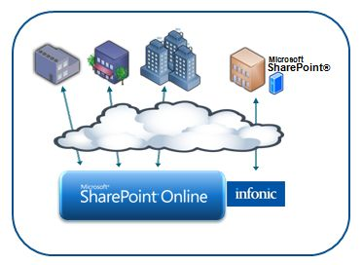
This solution allows true global and full collaboration between a global workforce who primarily are using the SharePoint® Online method for accessing business content and remote users interfacing with locally installed virtual SharePoint® environment.

Server to laptop
Additionally, Infonic Geo-Replicator™ can be used to create virtualized copies of SharePoint® Online deployments on end users’ laptops. By replicating SharePoint® content to the laptop, Infonic Geo-Replicator™ allows mobile workers to continue using and accessing the critical business content stored in the SharePoint® Online, even when they're offline.

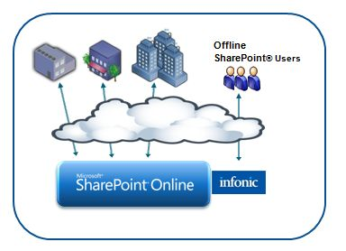

Infonic Geo-Replicator™ replicates all of the SharePoint® data structures and content directly onto the laptop over any network connection, using Infonic's unique compression and web virtualization technologies. Huge volumes of content can be very efficiently replicated on laptops - giving users 24/7 access to vital information, even when they have no network connection. The patented Epsilon compression not only reduces the size of the update amendment, it also has a dramatic affect on the local storage requirements for the offline repository.

Infonic Geo-Replicator™ provides offline support for any combination of SharePoint® Online content, enabling remote SharePoint® Online user access for remote workers even when disconnected. The solution can also be configured to synchronize updates that are completed offline when the laptop or mobile device next has access to a network connection – effectively uploading the data up to the SharePoint® Online corporate repository.

In addition where compliance with corporate guidelines held within to the SharePoint® environment is an important consideration, the delivery of offline content can be recorded for later audit.

Solution Development and Implementation

Primary System Components
The Infonic Geo-Replicator™ solution comprises two primary modules.

Infonic Publisher
The Infonic Publisher software is used to create Infonic “publications” - these are the units of replication that are delivered to a disconnected server or laptop. The same Publisher platform can be used to create and distribute both server to server and server to laptop publications.

Infonic Client
Infonic Client applies the amendments (files that detail changes on the master server) distributed by the Infonic Publisher to update locally installed publications. Typically the Infonic Client operates in the background; end users and master and replica server managers do not need to be aware of its presence.

Solution Implementation
Step 1 Decide which Geo-Replicator™ software is most suitable for solving the end users’ problem. Where all the users in a branch office require reliable and consistent access to SharePoint® Online, Geo-Replicator™ Server to Server would be most appropriate. This would also be the case where security or cost considerations prevent constant access to SharePoint® Online. Where there is no branch office, Geo-Replicator™ Server to Laptop would be deployed.

Step 2 Decide which elements of the SharePoint® Online portal need to be replicated. Considerations would include security, exclusion of unnecessary content and other end users’ needs.

Step 3 Decide the frequency and periodicity of the replication cycle. This will depend on a number of factors, including the volatility of the SharePoint® Online content. Additionally the quantity of data that is required to be synchronized with the disconnected replicas will be taken into consideration.

Step 4 After ensuring operating system requirements are in order, install the Geo-Replicator™ software as decided in Step 1.

Step 5 Configure the Infonic Publisher to produce publications as decided in Step 2. This is performed using the in-built publication configuration wizard that includes pre-created templates for known configurations of SharePoint®. The Infonic Publisher is also used to define the scope of the SharePoint® Online content to be replicated. Typically for SharePoint® Online configurations the definition of the depth of capture is defined to restrict the Infonic Publisher from delving too deeply into the SharePoint® content when not required to do so. Finally, the Distribution Server, ie the means of distributing amendment files to the Infonic Client, is defined.

Step 6 Run the Infonic Publisher to create the initial publication. The initial publication can on occasion be quite large, so usually this is installed on the disconnected platform using the corporate network or a DVD. Once this has been installed on the replica users are free to browse the content without the requirement of a network connection to SharePoint® Online.

Step 7 Set up the replication cycle using the Windows Server Task Scheduler. This is the standard Windows scheduler program.

Step 8 Configure the Infonic Client software to change any default settings, including the frequency of checking the Infonic distribution server for the availability of publication amendments. Note that the Infonic Client will check for availability automatically on the recovery of network connectivity following a period of disconnection.

Step 9 The replication cycle may now commence. The Infonic Publisher will run according to the Windows Tasks that have been as scheduled, and will automatically produce amendment files and upload them to the distribution server.

Step 10 The Infonic Client will continue to update the disconnected replica (on branch office servers or remote users’ laptops) with the latest content generated from the amendment files on the distribution server, using BITS to ensure that foreground bandwidth consuming activities are not affected.

Step 11 Users are free to browse SharePoint® Online data without the need for a network connection.

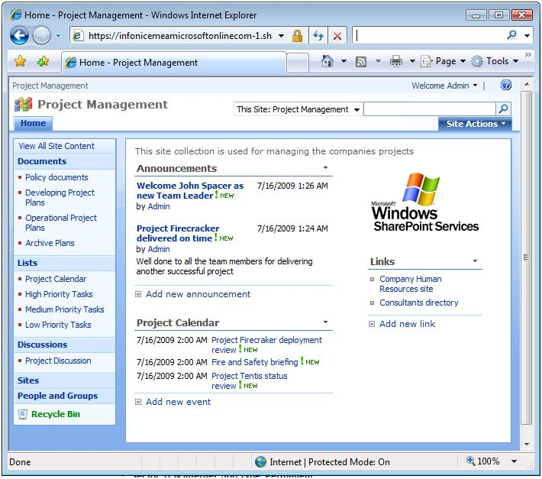
Introducing the Business Productivity Online Suite
Microsoft Online Services provide software delivered as a hosted service directly from Microsoft data centers, managed by Microsoft staff, and with a guaranteed 99.9 percent Service Level Agreement. These standardized solutions are designed so that partners can rapidly deploy services to their customers at a low, up-front investment with predictable, recurring costs.

The all-new Business Productivity Online Suite provides streamlined communications, simplified management, and business-class reliability and security.

The customer can order this service for as few as five seats at a time.

The Business Productivity Online Suite includes the following services, which can be purchased on a monthly subscription basis either separately or as part of a suite:

Microsoft Exchange Online, based on Microsoft Exchange Server 2007, offers businesses e-mail, calendaring, other messaging-based capabilities, and archiving. It also enables coexistence, which means new online users can interact with users on local servers.
(Introducing the Business Productivity Online Suite, Continued)
For More Information
For more information about Microsoft products and services, call the Microsoft Sales Information Center at (800) 426-9400. In Canada, call the Microsoft Canada Information Centre at (877) 568-2495. Customers who are deaf or hard-of-hearing can reach Microsoft text telephone (TTY/TDD) services at (800) 892-5234 in the United States or (905) 568-9641 in Canada. Outside the United States and Canada, please contact your local Microsoft subsidiary. To access information using the World Wide Web, go to www.microsoft.com

For more information about Microsoft Online Services, visit the Web site at
www.microsoft.com/online

Infonic’s customers include defense organizations in the USA, UK and Singapore, and professional and commercial companies worldwide; applications range from auditors’ documentation to top secret command and control systems. Users of Microsoft SharePoint® with low or intermittent network connectivity, or on expensive links such as satellites, can work remotely with a fuller experience of SharePoint’s rich functionality.

For more information about Infonic products and services, visit the Web site at www.Infonic-geo-replication.com
Microsoft Business Productivity Online Suite

- Microsoft Exchange Online
- Microsoft SharePoint Online
- Microsoft Office Communications Online
- Microsoft Office Live Meeting
- Microsoft Exchange Hosted Filtering

Microsoft SharePoint Online, based on Microsoft Office SharePoint Server 2007, provides a single integrated location where employees can efficiently collaborate with team members, find organizational resources, search, and manage content and workflow.

Microsoft Office Communications Online enables people to communicate easily with their colleagues across locations and time zones via instant messaging (text), voice, and video.

Microsoft Office Live Meeting is a hosted Web conferencing service that connects people in online meetings, training, and events through a reliable, enterprise-class hosted service.

Microsoft Exchange Hosted Filtering protects businesses’ inbound and outbound e-mail from spam, viruses, phishing scams, and e-mail policy violations.

About the Microsoft Business Productivity Online Suite
The Microsoft Business Productivity Online Suite provides businesses with virtually anywhere access to rich communication, collaboration, and productivity applications via subscription-based, Microsoft-hosted, online services. This hosted solution helps organizations offset the burden of managing and maintaining business systems, freeing information technology (IT) resources to focus on initiatives that can deliver competitive advantage to the business. The solution is part of the Microsoft’s Software-plus-Services delivery model to provide customers more choices than traditional, hosted, or on-premises solutions, allowing them to make deployment decisions that best fit the needs of their organization.

For more information about the partner opportunities provided by the Business Productivity Online Suite, see http://partner.microsoft.com/online.
© 2009 Microsoft Corporation. All rights reserved. This solution brief is for informational purposes only. MICROSOFT MAKES NO WARRANTIES, EXPRESS OR IMPLIED, IN THIS SUMMARY. Microsoft, SharePoint, Win32, and Windows are either registered trademarks or trademarks of Microsoft Corporation in the United States and/or other countries. The names of actual companies and products mentioned herein may be the trademarks of their respective owners.

Document published February 2009

